The roots of the rotation effect

Obj 1: report CC penalty over time from 14 long term experiments. Has it change over 15 years? Straightforward question of much interest. Laila has a 35 year irrigated CC vs CS long term exp from NE and the penalty is 10 bu/ac. I guess we can get this dataset into this paper and add Laila as a co-author. Also, converting the bu/ac penalty to $/ac and multiplying with the area under CC you can provide a value that decision makers cannot ignore!

1. Obj 2: what causing it? simple statistical / regression analysis (e.g. 14 d prior weather) assessing people believes and empirical data did not work as expected but showed some interesting trends. A step forward.
2. Obj 3: can modeling help understand the penalty? We computerized hypotheses from Obj 2, run APSIM sims and we found that and that. End of story. From what I have seen so far the answer is that APSIM helps to some degree (see in attach).

Our objectives were to:

1. Identify trends in the continuous corn yield penalty from experimental data
2. Identify pathways by which the CC yield penalty may be enacted
3. Using modelling and field-data, explore evidence for pathway contributions
4. Identify future research goals based on our findings

**Intro stuff, just for myself right now**

However, understanding if genetic improvements have led to changes in the continuous corn penalty over time remains unknown, and could help shed light on possible mechanisms.

**Exploring the continuous corn penalty**

Both satellite and experimental data have shown the continuous corn penalty does not compound with the number of years in corn (Meese et al. 1991, Crookston et al. 1991, Porter et al. 1997, Seifert et al. 2017), with an average yield depression of 15% (Fig X).

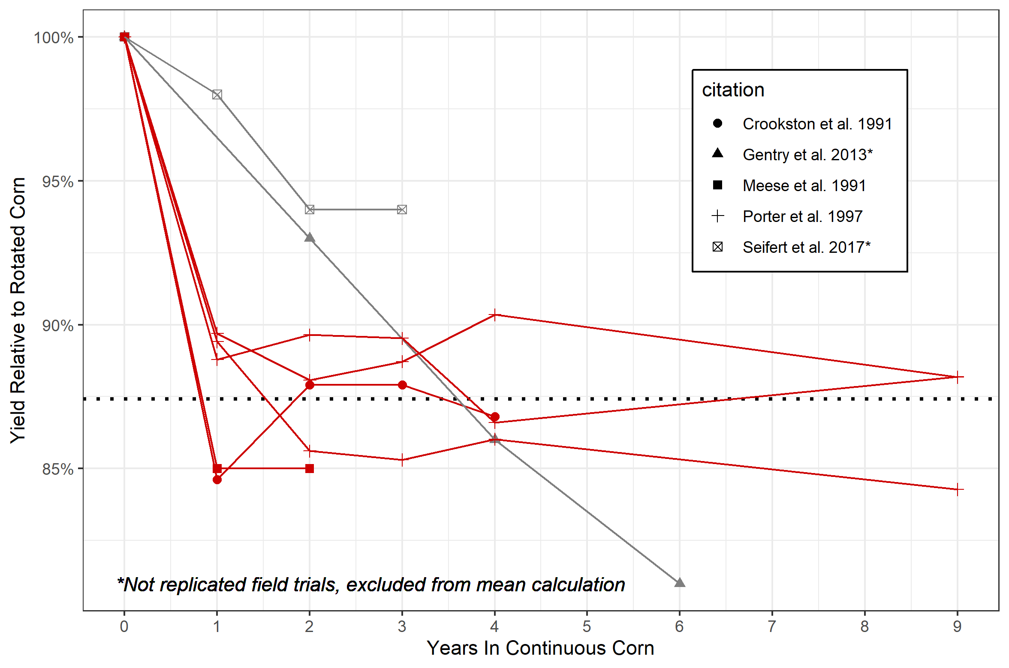

To our knowledge, the longest duration of reported data on the continuous corn penalty spans 9 years, and in order to maintain experimental consistency the studies utilized the same hybrid for the entire duration (Crookston et al. 1991, Porter et al. 1997). Our dataset includes sites with 8-16 years of data at a range of nitrogen fertilizations, with hybrids updated to reflect the most modern genetics, albeit with the same hybrid used for both continuous and rotated corn systems. It is possible by using a different hybrid for continuous corn versus rotated corn systems could reduce the penalty. Indeed, a study using satellite data found a smaller yield penalty than that reported in controlled field studies (7% versus 15%; Fig. 1), suggesting farmers are reducing the penalty through management, which may include hybrid choice. However, even with farmer management the penalty is consistently observed, indicating it cannot currently be overcome through hybrid choice. In our dataset, 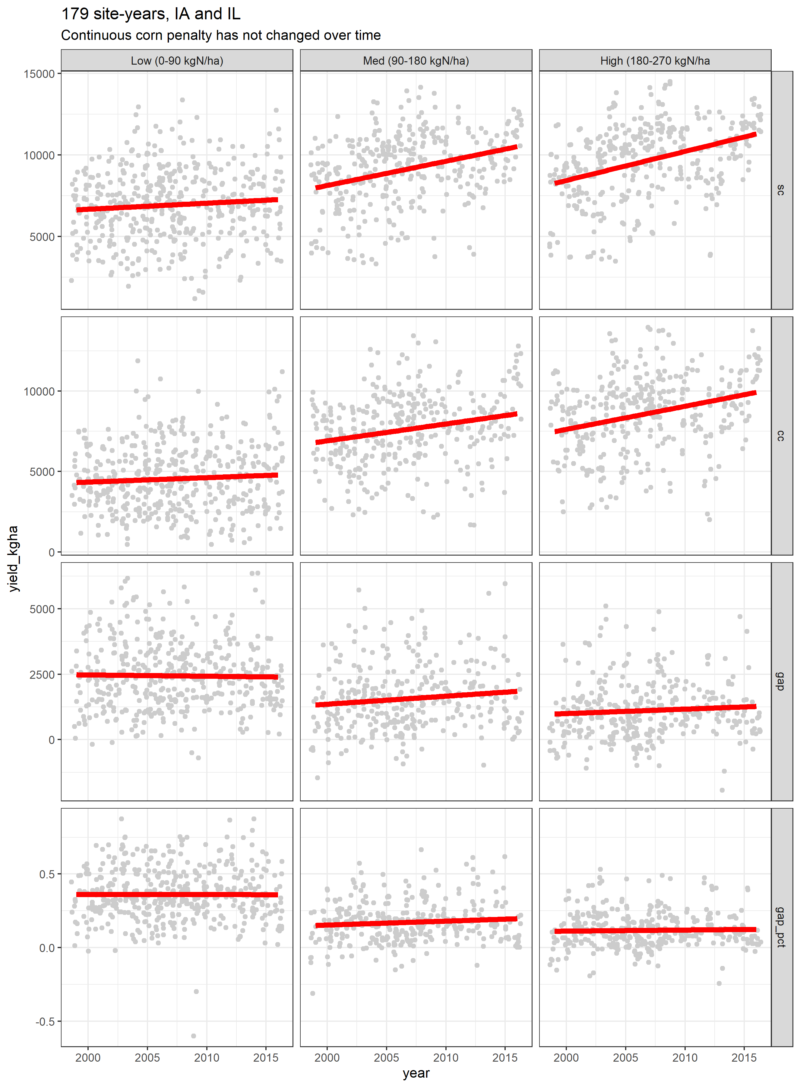both continuous- and rotated-corn yields have remained steady over time at low nitrogen rates, leading to an equally steady penalty at low nitrogen rates. Conversely, at high nitrogen rates, yields of both continuous- and rotated-corn yields have increased at rates of 176 (SE:27) and 174 (SE:23) kg grain yield/year, respectively. As a result of the equal rates of increases, the continuous corn penalty at high nitrogen rates has likewise remained constant over the years, estimated at 2350 (SE:191) and 1035 (SE:145) kg/ha at low and high nitrogen rates, respectively.

It is well-known that the agronomically-optimum nitrogen rate for corn grown following corn is higher than for corn following soybean (CITE). However, to our knowledge the ability of nitrogen application to overcome the yield penalty has not been examined. Using 177 site-years of nitrogen-response curves, we calculated the percentage of the yield gap at the rotated corn’s AONR that could be overcome with fertilization (schematic 1).

Previous research has suggested that lower-yielding environments benefit more from crop rotation, indicating higher-yielding environments have lower penalties (e.g. Seifert et al. 2017, Gentry et al. 2013). Often studies average all rotation’s corn yields to quantify high and low-yielding environments. Our data demonstrate that this approach may be misleading. By taking the rotated corn yields to be more representative of a site-year’s yield potential, the penalty does not decrease as a site-year’s yield potential increases (Fig. X). We found the penalty, either as a percentage or as kg/ha, is, on average, higher and more consistently observed in site-years yielding more than 9000 kg/ha compared to site-years yielding less.

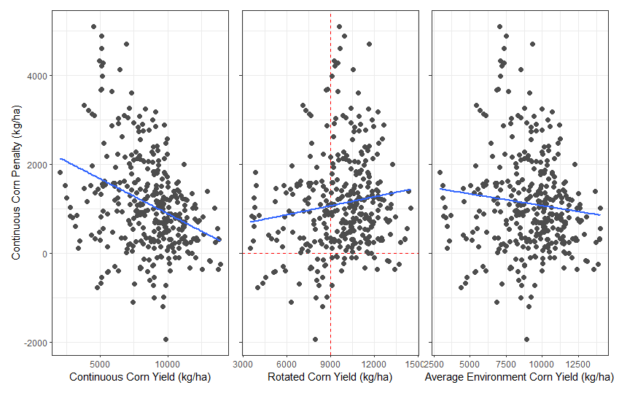

These analyses indicate the continuous corn penalty is both persistent, regardless of improvements in management and genetics, and, contrary to previous findings, may be a bigger concern for producers in high-yielding environments.

**Pathways**

The effect of the previous crop (corn, or soybean) may be mediated through three main mediators: (i) above-ground organic matter (i.e. crop residue), (ii) below-ground organic matter (roots, tilled residue), and (iii) soil nitrogen pool legacies. Each of these mediators provides unique paths for the previous crop to affect the subsequent corn crop’s yield. Additionally, there are path by which mediators interact.

**Pathway contributions**

*Aboveground*

Corn foliar diseases require inoculum to be transferred from corn residue to the above-ground biomass of an activity growing corn plant. As a result, severity of corn foliar diseases are generally related to the amount of residue on the soil surface (cite). However, severity of foliar corn diseases is not only a function of corn residue on the surface, but is also a function of environmental conditions and use of fungicides. In our dataset, the size of the continuous corn penalty was not related to the amount of stover produced (modelled), the amount of residue on the surface at planting (modelled), nor the previous crop’s yield (experimental).

Experimental data collected from 17 sites years in Iowa showed tillage, and therefore residue cover, had no effect on stand counts of continuous corn systems. IN other words, tillage did not change stand counts in continuous corn systems, indicating above-ground residue is not affecting corn seedling establishment.

Speed of emergence – do that math. The previous crop, and therefore the potential amount of residue on the soil surface may affect soil temperatures, subsequently affecting the speed of corn seed germination. Field data shows the effect of corn versus soybean residue on soil temperatures at 4-10 cm depths are inconsistent, and are erased by tillage. When present, the soil temperature differences were less than 1 deg C. This could result in a XX day delay in corn germination in continuous compared to rotated corn systems. Modelling results showed this delay would have small, and inconsistent effects on crop yields, meaning delayed germination in continuous corn is not likely a strong cause of the continuous corn yield penalty. To our knowledge, there are no published studies regarding the effect of soybean rotation on corn emergence dates relative to continuous corn.

Soil moisture….need to read…

*Belowground*

The carbon-to-nitrogen ratio of roots and incorporated stover will impact the soil nitrogen pool throughout the growing season (cite). Additionally, roots can serve as hosts for soil-borne disease that affect the root structure of the growing crops (cite). Compromised root architecture can limit the corn crop’s access to both water and nutrients. Studies in irrigated and high-input systems have shown the continuous corn penalty persists even in those conditions, suggesting the corn crop’s access to resources may be compromised in the continuous corn systems. Field studies in both Minnesota and Wisconsin have shown corn roots are thicker and shallower in continuous corn systems compared to rotated corn, further suggesting this is a potentially major pathway affecting the size of the penalty.

*Soil nitrogen pool*

Need help here.

We used 117 site-years of nitrogen response data to estimate the percentage of the penalty that can be overcome with additional nitrogen application over the rotated corn’s agronomically-optimum rate.

The value varied from year to year. For example in brow 2004, the gap

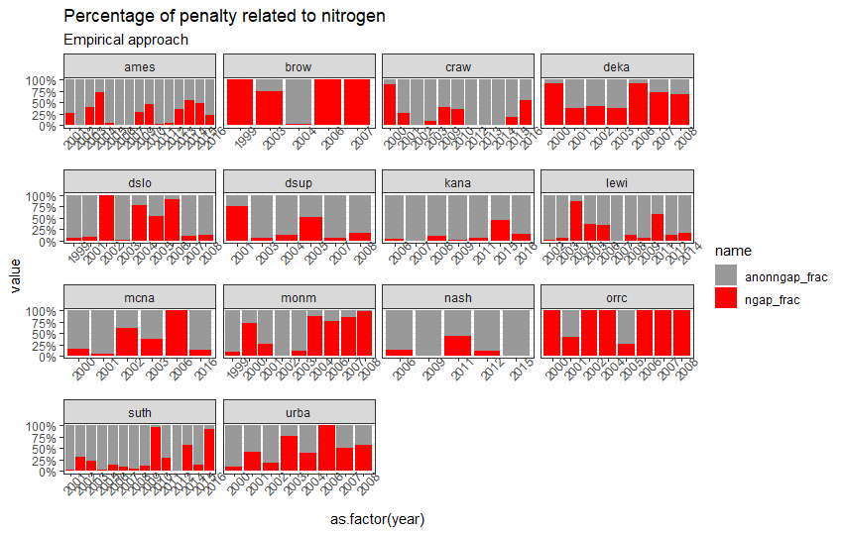

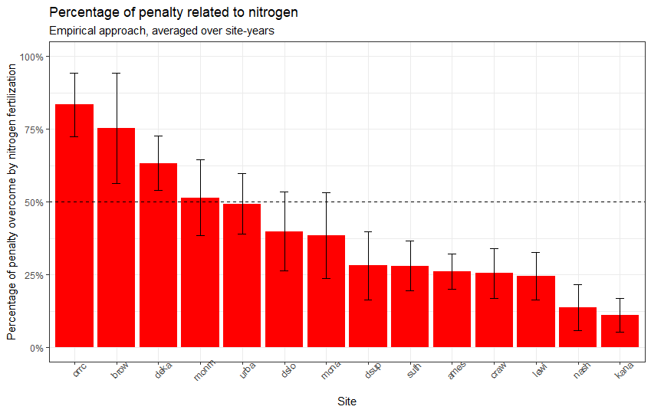

*Interactions*

Residue type (corn versus soybean) has a stronger effect on soil moisture than soil temperature (CITE). Increased soil moisture levels can promote soil-borne diseases, fomenting root disease and it’s affects on root architecture.