# Appendix. Supplementary Material

The following figures are included as supplementary material:

**Figure S1** – Maximum rooting depth over time, raw dataset and unsmoothed fitted values

**Figure S2** - Yields, biomass over time, growth rate over time, harvest index, 500-kernal grain weight

**Figure S3** – Root to shoot ratios for 2019 and 2020

**Figure S4** - Soil penetration resistance by depth at various sampling points, approximate depths of tillage operations are provided for reference

**Figure S5** - Soil moisture and temperature at 30 and 45 cm depths in the maize phase of the short and extended rotations

**Figure S6 –** Data from Lazicki et al. 2016

**Figure S7 –** Simulatedimpact of changes in root front velocity on maize yield and a conceptual figure of our hypothesis

The following tables are included as supplementary material:

**Table S1** – Summary of above-ground growth-analysis and rooting depth non-linear parameter fits

**Table S2** - Summary of ‘background’ root samples taken shortly after maize planting

**Table S3** - Summary of fixed effect tests on root mass

**Table S4** - Summary of contrasts for the complex versus short rotation for root mass added at each depth

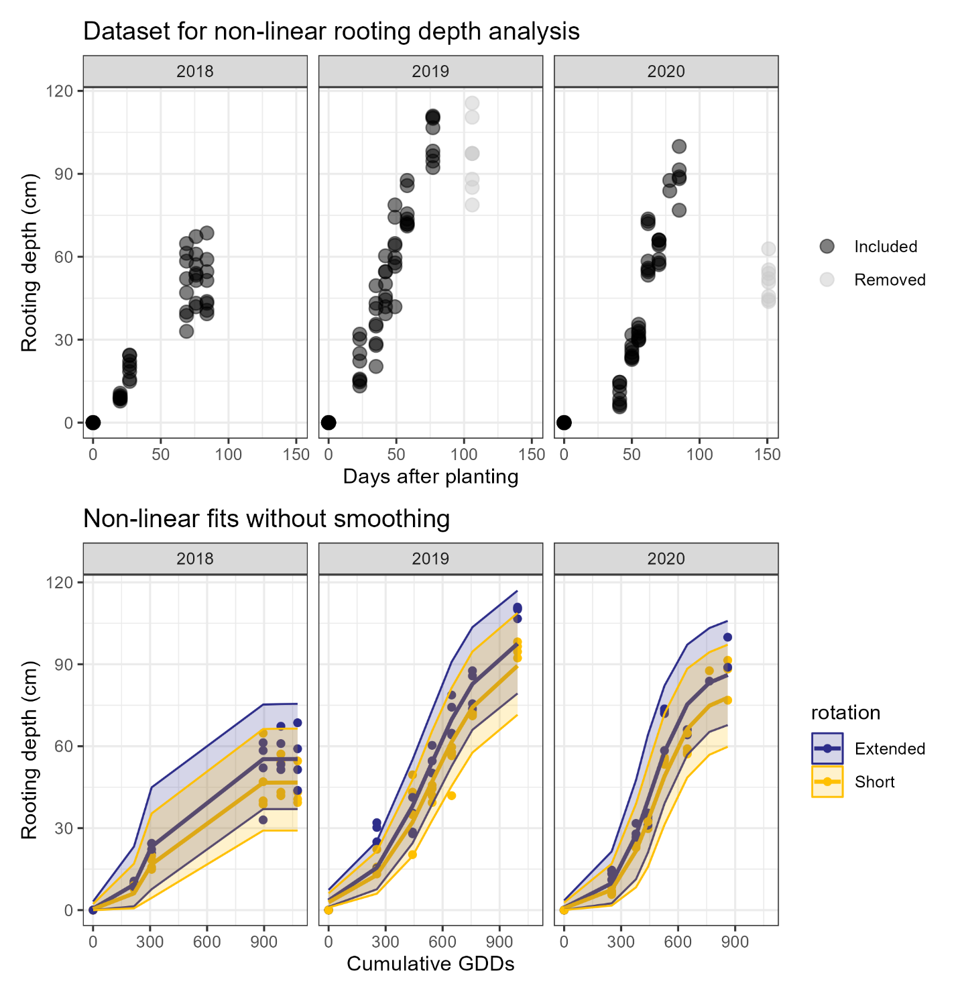

**Figure S1** – Maximum rooting depth over time, raw dataset and unsmoothed fitted values.

**Figure S2**. Yields, biomass over time, growth rate over time, harvest index, 500-kernal grain weight for the extended 4-year rotation (dark blue) and short 2-year rotation (yellow). The reader is directed to the manuscript text for indications of significant differences.

Figure S3. Root to shoot ratios for 2019 and 2020, with different background root decomposition assumptions.

Figure S4. Soil penetration resistance by depth at various sampling points, approximate depths of tillage operations are provided for reference.

**Figure S5**. Soil measurements at 30 and 45 cm depths in the maize phase of the two rotations; (top) soil moisture in the extended (dark blue) and short (yellow) rotations,

points represent individual sensor values, lines the estimated values, and ribbons the 95% confidence interval around the estimates; (bottom) differences in soil temperature in the extended rotation compared to the short rotation as estimated by GAM with 95% confidence intervals.

***Figure S6 –*** *Data from Lazicki et al. 2016 shows differences in maize root structures coinciding with maize yield differences in short and extended maize rotations in 2009.*

***Figure S7 – (Top)*** *Simulated**impact of changes in root front velocity on maize yield. Simulations are derived from results supporting the publication of Archontoulis et al. (2020), and the reader is directed to that publication for more details.* ***(Bottom)*** *Conceptual figure.*

Archontoulis SV, Castellano MJ, Licht MA, Nichols V, Baum M, Huber I, Martinez‐Feria R, Puntel L, Ordóñez RA, Iqbal J, Wright EE. Predicting crop yields and soil‐plant nitrogen dynamics in the US Corn Belt. Crop Science. 2020 Mar;60(2):721-38.

Keating BA, Carberry PS, Hammer GL, Probert ME, Robertson MJ, Holzworth D, Huth NI, Hargreaves JN, Meinke H, Hochman Z, McLean G. An overview of APSIM, a model designed for farming systems simulation. European journal of agronomy. 2003 Jan 1;18(3-4):267-88.

**Table S1.** Summary of 3-parameter logistic curve fits for rooting depth analyses and above-ground growth-analyses, parameters that differed significantly by rotation (p<0.05) are bolded.

|  |  |  |  |  |
| --- | --- | --- | --- | --- |
| **Year** | **Rotation** | **Asym** | **xmid** | **scal** |
|  |  | *(cm)* | *(GDDs)* |  |
| *Rooting depth analysis* | | | | |
|  | Short | **74 (CI:50-98)** | 455 (CI:357-553) | 109 (CI:65-152) |
|  | Extended | **82 (CI:59-106)** | 436 (CI:338-534) | 109 (CI:65-153) |
| *Above-ground growth analysis* | | | | |
| 2013 | Short | **201 (CI:197-205)** | **210 (CI:209-211)** | 10.9 (CI:9.9-11.9) |
| Extended | **253 (CI:244-264)** | **207 (CI:205-210)** | 13.3 (CI:11.5-15.3) |
|  |  |  |  |  |
| 2014 | Short | **326 (CI:316-336)** | 204 (CI:203-206) | 16.3 (CI:15-17.6) |
| Extended | **351 (CI:341-363)** | 205 (CI:203-207) | 17.1 (CI:15.8-18.6) |
|  |  |  |  |  |
| 2018 | Short | **237 (CI:231-244)** | **191 (CI:190-193)** | 12.6 (CI:11.6-13.7) |
| Extended | **286 (CI:280-292)** | **196 (CI:195-197)** | 13.7 (CI:12.8-14.8) |
|  |  |  |  |  |
| 2019 | Short | 316 (CI:307-325) | 218 (CI:216-219) | 14.6 (CI:13.3-15.9) |
| Extended | 312 (CI:299-234) | 219 (CI:217-222) | 15.9 (CI:14.2-17.8) |
|  |  |  |  |  |
|  |  |  |  |  |
| 2020 | Short | 289 (CI:283-295) | 205 (CI:204-207) | 12.4 (CI:9.7-14.7) |
| Extended | 299 (CI:292-307) | 206 (CI:205-208) | 12.7 (CI:9.5-15.2) |

***Table S2.***  *Summary of ‘background’ root samples taken shortly after maize planting.*

|  |  |  |  |
| --- | --- | --- | --- |
| **Year** | **Replicate** | **Short rotation** | **Extended rotation** |
|  |  | *Root Material (kg ha-1)* | |
| 2019 | 1 | 542 | 740 |
|  | 2 | 158 | 1028 |
|  | 3 | 119 | 248 |
|  | 4 | 68 | 441 |
|  | *Mean* | *222* | *614* |
| 2020 | 1 | 2753 | 281 |
|  | 2 | 136 | 483 |
|  | 3 | 182 | 982 |
|  | 4 | 159 | 2048 |
|  | *Mean* | *807* | *949* |

**Table S3**. Summary of fixed effect tests on root mass assuming no background root decomposition.

|  |  |  |
| --- | --- | --- |
| **Source** | **Assuming 0% background root decomposition** | **Assuming 100% background root decomposition** |
|  | *p-value* | *p-value* |
| Year | 0.12 | 0.05 |
| Rotation | 0.76 | 0.87 |
| Year x Rotation | 0.91 | 0.15 |
| Depth | 0.58 | <0.01 |
| Year x Depth | 0.31 | 0.92 |
| **Rotation x Depth** | **0.01** | **0.07** |
| Year x Rotation x Depth | 0.25 | 0.76 |
| *\*DF = Degrees of freedom* |  |  |

**Table S4**. Summary of root mass added contrasts for the extended versus short rotation at each depth; denominator degrees of freedom differ by depth due to missing data.

|  |  |  |  |  |
| --- | --- | --- | --- | --- |
| **Depth** | **Numerator DF\*** | **Denominator DF** | **F Ratio** | **p-value** |
| Assuming no background root decomposition | | | | |
| 0-15 cm | 1 | 14.77 | 6.69 | 0.02 |
| 15-30 cm | 1 | 16.07 | 0.08 | 0.78 |
| 30-45 cm | 1 | 16.07 | 0.14 | 0.71 |
| 45-60 cm | 1 | 16.07 | 0.56 | 0.47 |
| Assuming 100% background root decomposition | | | | |
| 0-15 cm | 1 | 36.72 | 5.60 | 0.02 |
| 15-30 cm | 1 | 37.64 | 1.59 | 0.21 |
| 30-45 cm | 1 | 37.64 | 0.25 | 0.62 |
| 45-60 cm | 1 | 37.64 | 0.68 | 0.41 |
| *\*DF = Degrees of freedom* | | | | |