Doing more with less: Maize grown in complex rotations has lower root biomass and higher grain yields compared to simple rotations
Virginia Nichols, William Osterholtz, Sotirios Archontoulis, Matt Liebman

Abstract
It is well-established that maize (Zea mays L.) grown in complex cropping systems requires less external nitrogen inputs to produce equal or higher grain yields compared to maize grown in simple systems. Understanding the mechanisms behind this phenomenon, commonly referred to as ‘the rotation effect’, is crucial for designing cropping systems that use land efficiently. However, the mechanisms driving the effect are unclear. To examine the possible role of maize roots in the rotation effect we measured root biomass, maximum rooting depth, and grain yields in the maize phase of two contrasting rotations: a simple 2-year rotation of maize-soybean (Glycine max [L.] Merr), and an extended 4-year rotation of maize-soybean-oat (Avena sativa L.)/alfalfa (Medicago sativa L.)-alfalfa. Additionally, we measured soil penetration resistance, soil moisture, and performed a maize growth analysis. From 2013-2020, maize grain yields in the complex rotation averaged 8% higher than the simple (11.0 and 10.2 Mg ha⁻¹, respectively). The timing (e.g. early season, late) of the complex rotation’s maize growth advantage over the simple was not consistent across years. The maximum rooting depth of maize in the complex rotation was consistently deeper by an average of 11% (8 cm). From planting to maturity, maize grown in the simple system added an average of 1.7 times more root mass compared to the complex, with the majority of the additional root investment occurring in the top 15 cm of the soil profile. Compared to the complex system, soil penetration resistances in the simple rotation from 0-30 cm depth were 30% higher. Early in the season, the simple system also consistently had wetter soils compared to the complex. We posit that maize grown in the complex rotation invested less resources in roots, but achieved a deeper and more functional root structure compared to maize in the simple rotation. Under certain conditions, this ‘steep and cheap’ root layout was better able to take advantage of favorable conditions regardless of timing, leading to increased resource acquisition and significantly higher grain yields in select years. Process-based models could aid in supporting or refuting this hypothesis, and greenhouse experiments could indicate whether the root differences observed in the field reflect chemical, physical, and/or biological characteristics of the soil. To our knowledge, this is the first report of cropping system complexity impacting maize rooting depth, and similar measurements taken in other Midwestern locations would aid in understanding the role of maize rooting depth in the rotation effect in other contexts.

Intro
In the Midwestern United States (US), a substantial portion of agricultural land is dedicated to maize-(Zea mays L.) based systems (Boryan et al., 2011; USDA National Agricultural Statistics Service Cropland Data Layer, 2021). Over the past 60 years these systems have been reduced from diversified rotations that included small grains and forage legumes to maize monocultures or simple alterations of maize and soybean (Glycine max [L.] Merr) (Aguilar et al., 2015; Hijmans et al., 2016; Crossley et al., 2021). Several undesirable effects have accompanied this simplification including but not limited to increased rates of soil erosion, increased risk of flooding, increased risks of nitrate pollution, and a decline in rural quality-of-life (Peters, 2002; Arbuckle and Kast, 2007; Hatfield et al., 2009, 2013; Schilling et al., 2010; Jones et al., 2018; Pasley et al., 2021). While there are numerous barriers to re-diversifying Midwestern systems (Mortensen and Smith, 2020; Weisberger et al., 2021), there is value in understanding the mechanisms that would enable diversification to mitigate these negative outcomes.
Midwestern maize-based systems fall into three main categories: (1) continuous maize systems, wherein maize is grown for two or more consecutive seasons, (2) rotated maize systems, wherein maize is rotated with soybean, and (3) extended maize rotations, wherein maize is grown in a rotation with two or more years between maize crops, often including a small grain and/or a forage. As maize cropping systems move from monocultures to simple rotations, and simple to extended rotations, maize yields increase by approximately 10 and 5%, respectively (Liebman et al., 2008; Davis et al., 2012; Nichols in prep). The former phenomenon is commonly referred to as the ‘continuous maize penalty’, and the latter ‘the rotation effect’. To our knowledge it is unclear whether they are distinct expressions of unique mechanisms, or if they represent a continuum of the same mechanistic underpinnings.
There have been numerous studies in the Midwest exploring the continuous maize penalty (Dick and Doren, 1985; Peterson et al., 1990; Meese et al., 1991; Crookston et al., 1991; Porter et al., 1997; Varvel, 2000; Stanger and Lauer, 2008; Gentry et al., 2013; Al-Kaisi et al., 2015; Farmaha et al., 2016; Seifert et al., 2017; Vogel and Below, 2018; Bowles et al., 2020). There is strong evidence it is due to yield suppressive mechanisms in the monoculture system, potentially due to soil biological conditions constraining root development (Crookston et al., 1988; Johnson et al., 1992; Nickel et al., 1995; Goldstein, 2000; Nichols, in prep).
The maize yield advantage of extending simple rotations to include small grains and forage legumes has received less attention compared to the continuous maize penalty, but has likewise been well-documented (Liebman et al., 2008; Stanger and Lauer, 2008; Coulter et al., 2011). However, to our knowledge the driving mechanisms behind the rotation effect remain uncertain. In a long-term cropping systems research experiment in Iowa (Liebman et al., 2008; Davis et al., 2012) researchers have found differences in the distributions of resources and nutrient cycling activity in simple and complex maize systems (Lazicki et al., 2016; King and Hofmockel, 2017; Osterholz et al., 2018; Poffenbarger et al., 2020), but it is unclear how these altered distributions translate to higher maize yields in the complex rotations. There is evidence that suggests there are differences in maize root distributions in the Iowa systems (Lazicki et al., 2016), but the data is limited to shallow depths and does not control for extraneous organic matter. It is feasible that, similarly to the continuous maize penalty, differences in maize root structures are contributing to increased resource capture in complex rotations, thus driving higher maize yields compared to the simpler system.
When above-ground crop products are valued, it is desirable for plants to optimize investments in belowground growth. In nitrogen or water limiting environments, ‘steep, cheap and deep’ root ideotypes have been identified as the most efficient use of root investments (Lynch, 2013; Tron et al., 2015). We hypothesized that maize grown in complex rotations creates a root structure that is better able to capture resources with less investment compared to the simple rotation. To test this hypothesis, we made the following measurements in the maize phase of a simple (maize-soybean) and complex (maize-soybean-oats/alfalfa-alfalfa) rotation:
- Maize grain yields (2013-2020)
- Maize root biomass as a proxy for the resources invested by the maize crop into roots (2019-2020)
- Maximum maize rooting depth as a proxy for the soil space that investment opens up for resource capture (2018-2020)
Additionally, we complemented these three core measurements with measurements of partitioned aboveground biomass throughout five seasons, soil penetration resistance at two time points in the growing season (2018-2020), and hourly measurements of soil moisture at 15 and 45 cm depths (2018-2019).

Methods and Materials

Sampling
Treatments consisted of two maize-based rotations: a 2-year rotation of maize-soybean (hereafter the simple rotation), and a 4-year rotation of maize-soybean-oat/alfalfa-alfalfa that periodically received cattle manure (hereafter the complex rotation). Detailed accounts of plot management are reported elsewhere (Liebman et al., 2008; Hunt et al., 2020) and a brief summary is presented in Table X.

Table 1 Summary of rotation treatment managements
Rotation | Crop sequence | Nitrogen sources | Tillage regime
Simple 2-year | Soybean-  Maize | Mean total of 180 kg ha⁻¹ mineral nitrogen, with 112 kg ha⁻¹ applied at planting and the remaining at V6 side-dressing based on soil nitrate sampling | Fall chisel plowing and spring field cultivation preceding soybean planting, spring cultivation preceding maize planting
Complex 4-year | Soybean-Oats/Alfalfa-Alfalfa-  Maize | Mean of 140 kg ha⁻¹ organic nitrogen applied as composted cattle manure the fall preceding the maize phase, and 32 kg ha⁻¹ inorganic N applied at V6 side-dressing | Fall chisel plowing and spring field cultivation preceding soybean planting, no tillage events preceding oat/alfalfa planting, fall moldboard plowing of the alfalfa crop followed by spring discing and field cultivation preceding maize planting

Each phase of the rotation treatments was present every year in four replicate blocks within a 9-hectare experiment established in 2001 at the Iowa State University Marsden Farm in Boone County, Iowa. Weather data was collected from a weather station less than one mile from the field site (Iowa Environmental Mesonet, 2021). Maize grain yield was measured 2013-2020, and additional measurements were taken in select years during that period.
PUT TABLE IN SIDEWAYS
Table 1. Summary of measurements used for this study
Measurement | Measurement years | Description
Maize grain yield | 2013-2020 | Maize grain yield was determined using a 6-row combine equipped with a yield monitor and moisture meter. Sampling areas for yield were the middle rows of the plots, approximately 4.6 m x 84 m. All yields are reported on a dry weight basis.
Full soil nutrient test | 2018 | Soil samples from 0-90 cm were analyzed in 30 cm increments for macro- and micro-nutrients. Six soil samples from each replicate taken immediately following planting and were combined for analysis.
Maize above-ground biomass | 2013, 2014, 2018, 2019, 2020 | Maize above-ground biomass was measured periodically throughout the season. Eight plants were cut at ground level, separated into leaf, stem, and reproductive components, dried at 60⁰C for at least 72 hours, then weighed.
Maize maximum rooting depth | 2018, 2019, 2020 | Maximum maize rooting depth was measured starting at 20, 23, and 41 days after planting in 2018, 2019, and 2020 respectively. Sampling was repeated approximately every 2 weeks until 84, 106, and 151 days after planting in 2018, 2019, and 2020, respectively. Maximum rooting depth was determined visually using the protocol of Ordóñez et al., 2018. A soil core was drawn with a 19-mm-diameter soil probe, white roots were identified, and their depth estimated to the nearest inch using a meter stick. Samples were repeatedly taken from the same core location until no white roots were identified in the core. Four cores were taken per plot at each sampling date.
Soil moisture at 15 and 45 cm depths | 2018, 2019 | 5TM soil moisture and temperature sensors (METER Group Inc., Pullman, WA, USA) were installed at two depths (15 and 45 cm) in each plot. Data were recorded hourly during the growing season using EM50 data loggers.
Penetration resistance | 2018, 2019 | Penetration resistance was measured using a FieldScout 900 Soil Compaction Meter (Spectrum Technologies, Inc., Aurora, IL, USA). Values were recorded every 2.54 cm to 45 cm depth immediately following planting and/or approximately 60 days after planting. Ten measurements were taken randomly throughout each plot. Measurements were taken after a saturating rain to avoid capturing differences due to soil moisture.
Maize root mass 0-60 cm | 2019, 2020 | Maize root mass to a soil depth of 60 cm was measured at 3 and 105 days after planting in 2019, and at 4 and 117 days after planting in 2020. Four soil samples per plot were drawn at a location 10 cm from maize rows in 15 cm depth increments using a 32-mm-diameter soil probe. Soil from each depth increment within a plot was composited and roots were recovered using a sequence of elutriation (washing), flotation, recovery from organic debris using tweezers and a stereo microscope, drying, and weighing (Dietzel et al., 2017)

Statistical Analysis
All statistics were done using R version 4.0.2 (R Core Team, 2020) and the tidyverse suite of packages (Wickham et al., 2019). The lme4 package (Bates et al., 2015) was used for linear mixed model fitting, and the nlraa package (Miguez, 2021) was used for non-linear mixed model fitting. The emmeans (Lenth et al., 2018) and lmerTest (Kuznetsova et al., 2017) packages were used for comparisons and statistical summaries of the models. Other packages were used for specific analyses as described below.

Grain yields, harvest indices, grain weights
In all instances, several models were fit and compared using Akaike’s Information Criteria (AIC; Kuha, 2004). Here we report only the model chosen as the best fit.
The overall effect of rotation treatment on historical maize grain yields was assessed using a mixed effects linear model with rotation as a fixed effect and block nested within a year-factor as a random intercept. Estimates for the marginal effect of rotation were produced using the emmeans package. The effect of rotation treatment in individual years was assessed using a fixed effects model with rotation, a year-factor, and their interaction as fixed effects. Pairwise comparisons within a year were made using the emmeans package using an adjustment for multiple comparisons.
Differences in harvest indices and 500-grain weights were assessed using a mixed effects model with rotation, a year-factor, their interaction as fixed effects and a random intercept of block.

Rooting depth
We chose to model rooting depth as a function of the cumulative maize growing-degree-days (GDDs) accrued since planting (base temperature 10⁰C, maximum temperature 30⁰C) to facilitate comparisons between years. We tried several non-linear models fit to both the raw data and to data filtered to remove measurements taken after the season’s maximum depth had been reached (Fig. S1). We found a three-parameter logistic curve (Archontoulis et al., 2015) fit to the filtered data produced the best fit according to AIC and inspection of residuals:
Eqn. 1 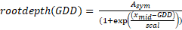
Where rootdepth(GDD) is the maximum rooting depth at a given cumulative GDD after planting and A_{sym}, x_{mid}, and scal are estimated parameters. A_{sym} represents the maximum rooting depth achieved, x_{mid} represents the cumulative GDD value at which half of the maximum rooting depth is achieved, and scal describes the steepness of the curve (Miguez et al., 2018). We found the best model fit when incorporating a fixed effect of rotation on A_{sym}, scal, and x_{mid},; a random effect of a year-factor on A_{sym}, x_{mid}, and scal, a random effect of block on A_{sym}; and a power variance structure.

Root mass
Root mass data was analyzed using linear fixed or mixed effect models as appropriate. Two modelling approaches were used. In one approach root data was analyzed as a function of fixed effects of rotation treatment (simple, complex), sampling date (beginning of season, end of season), a year-factor (2019, 2020), depths (0-15 cm, 15-30 cm, 30-45 cm, 45-60 cm), and their interactions. Additionally, the difference between the beginning and end of season values calculated by block were modelled as a function of rotation treatment, depth, a year-factor, and their interaction. Marginal means and comparisons were estimated using the emmeans package.

Growth analysis
Above-ground biomass as a function of day-of-year was modelled separately for each rotation in each year using a three-parameter logistic curve (Eqn. 1). The first- and second-order derivatives of the fitted equation were used as estimates of the absolute and relative growth rates, respectively. There was a large amount of variability in the data compared to the treatment effect, and parameter estimates had large amounts of uncertainty. We were interested in comparing rotations relative to each other within a year, and therefore chose to visually assess trends in each year rather than report non-significant differences in parameter estimates, but include those estimates in supplementary material (Table SX). We acknowledge the limitations of this approach, and present the data as supplementary rather than conclusive.

Penetration resistance
Penetration resistance was statistically modelled separately for each year and date of sampling using a generalized additive mixed model with a fixed intercept effect of rotation treatment, a fixed ‘wiggle’ component of rotation treatment, 5 knots, and a random ‘wiggle’ effect of block. The gamm function of the R package mgcv (McCulloch and Neuhaus, 2005; Wood, 2011) was used, and the emmeans package was used to assess pairwise comparison significance. Models were fit using both the raw and square-root-transformed data – although the model on the transformed data produced a better fit according to inspection of residuals, statistical conclusions were not different in the two models so the results from the untransformed data are presented for ease in interpretation.
Soil moisture
Soil moisture data was averaged to daily values. Daily means were statistically modelled separately for each year and depth using a generalized additive mixed model with a fixed intercept effect of rotation treatment, a fixed ‘wiggle’ component of rotation treatment, 35 knots, and a random ‘wiggle’ effect of block using the mgcv package mentioned above.

Results

Historical yields
Historical grain yields from 2004-2013 (Liebman et al., 2008; Davis et al., 2012) exhibited the same trends compared to the 2013-2020 yield data used for this study (Fig X). From 2013-2020, maize yields ranged from 7.0-12.7 Mg ha⁻¹, with the complex rotation producing 8% higher yields (p<0.001; 11 Mg ha⁻¹ and 10.2 Mg ha⁻¹ in the complex and simple, respectively).
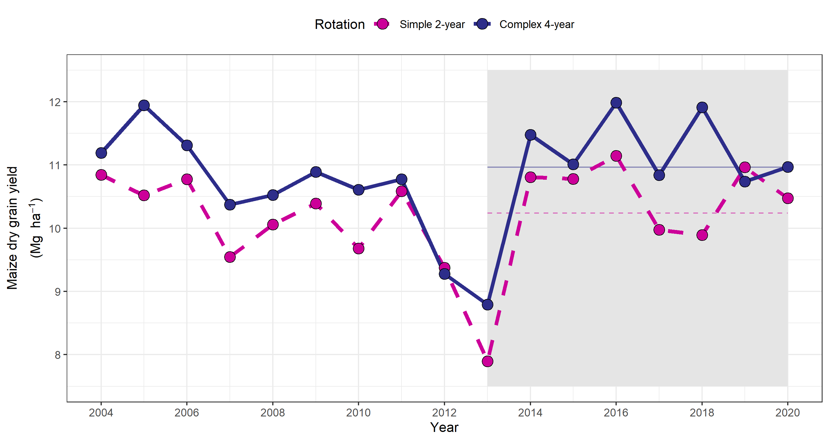
Figure 0-1 Historical (2004-2020) maize yields in the complex (dark blue, solid) and simple (pink, dashed) rotations. Data from 2013-2020 (gray box) was included in this study, and marginal mean yield estimates during this period are presented for each rotation as horizontal lines.

Study yields and weather
Over the seven years of yield data used for this study, weather conditions encompassed all combinations of hot/cool (mean air temperatures) and wet/dry (total precipitation) conditions (Figure X).
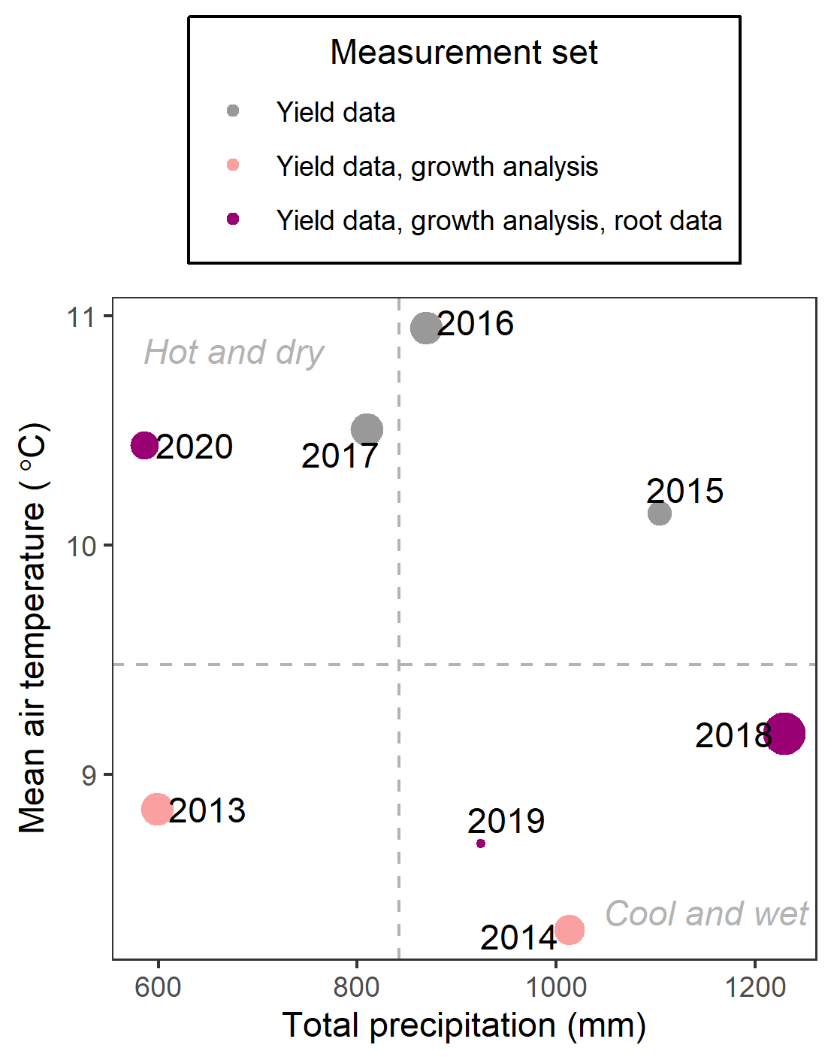
Figure 0-2 Total precipitation and mean air temperatures of each measurement year as compared to 30-year means (dotted lines); size of points represent the size of the complex system’s maize yield advantage over the simple, point color represents the measurement set for that year.

Rooting depth
The maximum rooting depth of the complex rotation was deeper than the simple rotation in all three years of measurement (Fig. S2). Rotation affected maximum rooting depth (A_{sym}; p<0.01), with a marginal estimated maximum rooting depth 11% deeper in the complex rotation compared to the simple (Figure X). While the complex rotation roots also descended faster, the effect was not statistically significant (x_{mid}; p=0.19).

Root mass
There was a significant depth-by-rotation-by-sampling time interaction (p = 0.06) for the root mass measurements. Year effects were not significant, so results are presented as estimates marginal over years (Fig. X).
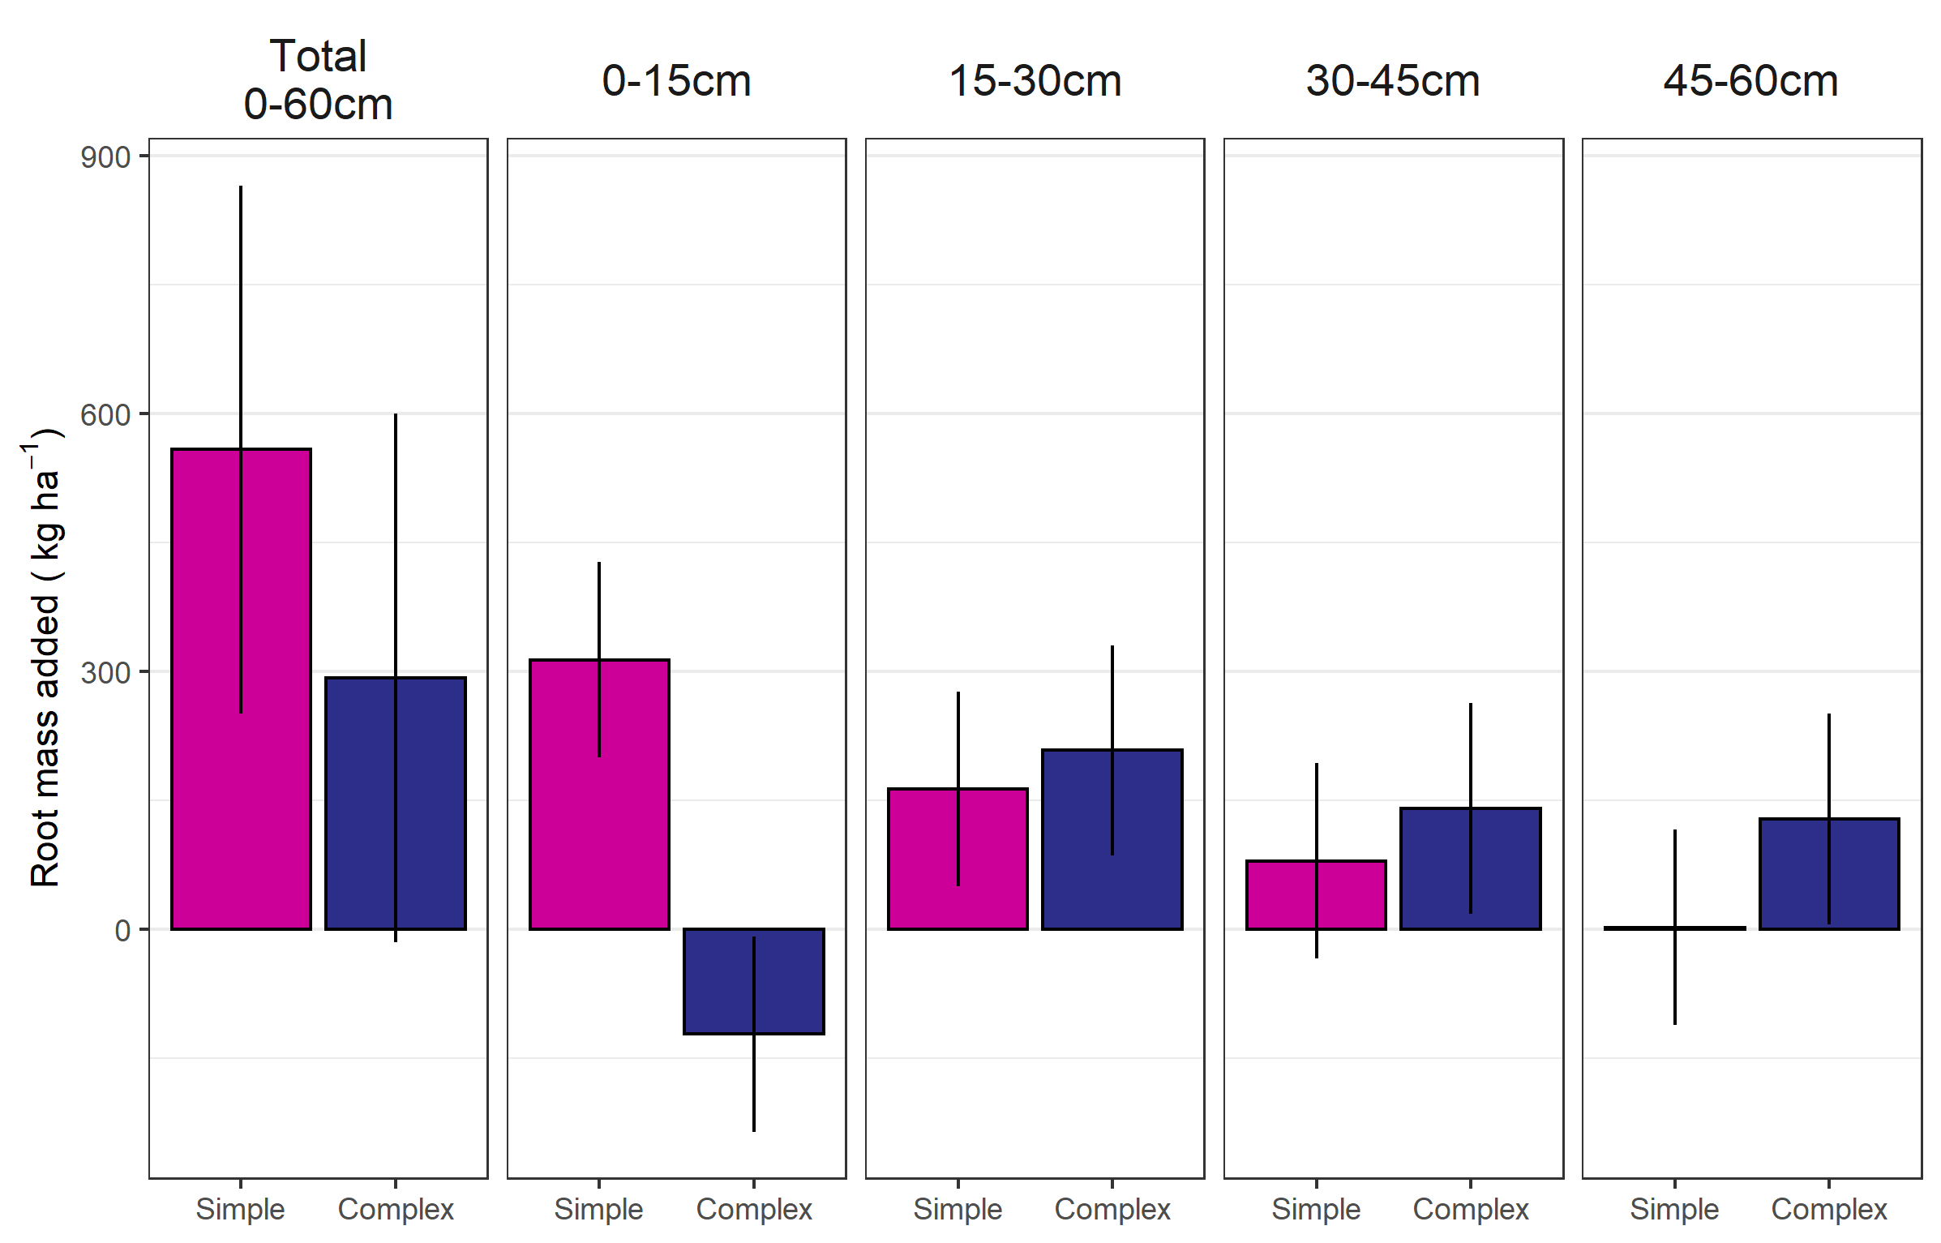
Figure 3 Root mass added (root mass at maturity less root mass present at planting) for the total profile and 15 cm increments for maize grown in the simple (2-year rotation) and complex (4-year rotation) systems, bars represent marginal means and vertical lines the standard error of the mean.
At the 0-15 cm depth increment, the root mass added in the two systems differed significantly (p = 0.10), with the simple system increasing by 314 kg ha⁻¹ (SE:114) from the baseline measurements, while the complex rotation’s root mass decreased by 122 kg ha⁻¹ (SE:114) from the baseline measurement. At all other depths, the difference between the complex and simple system’s additions were not statistically significant, but the trend was consistent in that the complex system added more root mass than the simple at these depths. Over the entire profile, the complex system had higher baseline levels of root mass at planting compared to the simple (781 and 515 kg ha⁻¹, respectively). Maize root mass in the 0-60 cm soil profile increased 108% in the simple rotation to 1073 kg ha⁻¹, compared to a 49% increase to 1115 kg ha⁻¹ in the complex rotation.

Growth analysis
In the years of yield data with accessory growth analysis data, 2018, 2013, and 2014 had the highest magnitudes of rotation effects (Table X). Within the years exhibiting significant rotation effects, the timing of higher crop growth rates in the complex rotation were not consistent. However, the harvest index and 500-kernal weights were consistently higher in years with large rotation effects on grain yield, but did not differ in years without a strong rotation effect.

Table 2 Summary of growth analysis changes in complex rotation maize compared to simple rotation
Year | Increase in maize yield in complex rotation | Timing of complex rotation’s maize growth advantage | Increase in harvest index in complex rotation | Increase in 500-kernal weight in complex rotation
 | Mg ha⁻¹ |  |  | grams
2018 | 2.02*** | Late season | 0.05*** | 20**
2013 | 0.90** | Early season | 0.02** | ND
2014 | 0.67* | NS | NS | ND
2020 | NS | NS | NS | NS
2019 | NS | NS | NS | NS
ND – no data was collected, NS – not significant
* p<0.10, **p<0.05, ***p<0.01

Penetration
Penetration resistance above 30 cm soil depth was consistently lower in the complex rotation, regardless of year or sampling period (planting, late season). From 0-30 cm, the simple and complex rotations had mean penetration resistances of 0.7 and 0.6 MPa at planting, and 1.5 and 1.1 MPa at late season sampling, respectively. This corresponded to a 23 and 37% increase in resistance in the simple system at planting and late-season sampling, respectively. Below 30 cm, the complex system tended to have higher penetration resistances by an average of 15% regardless of year or sampling time.
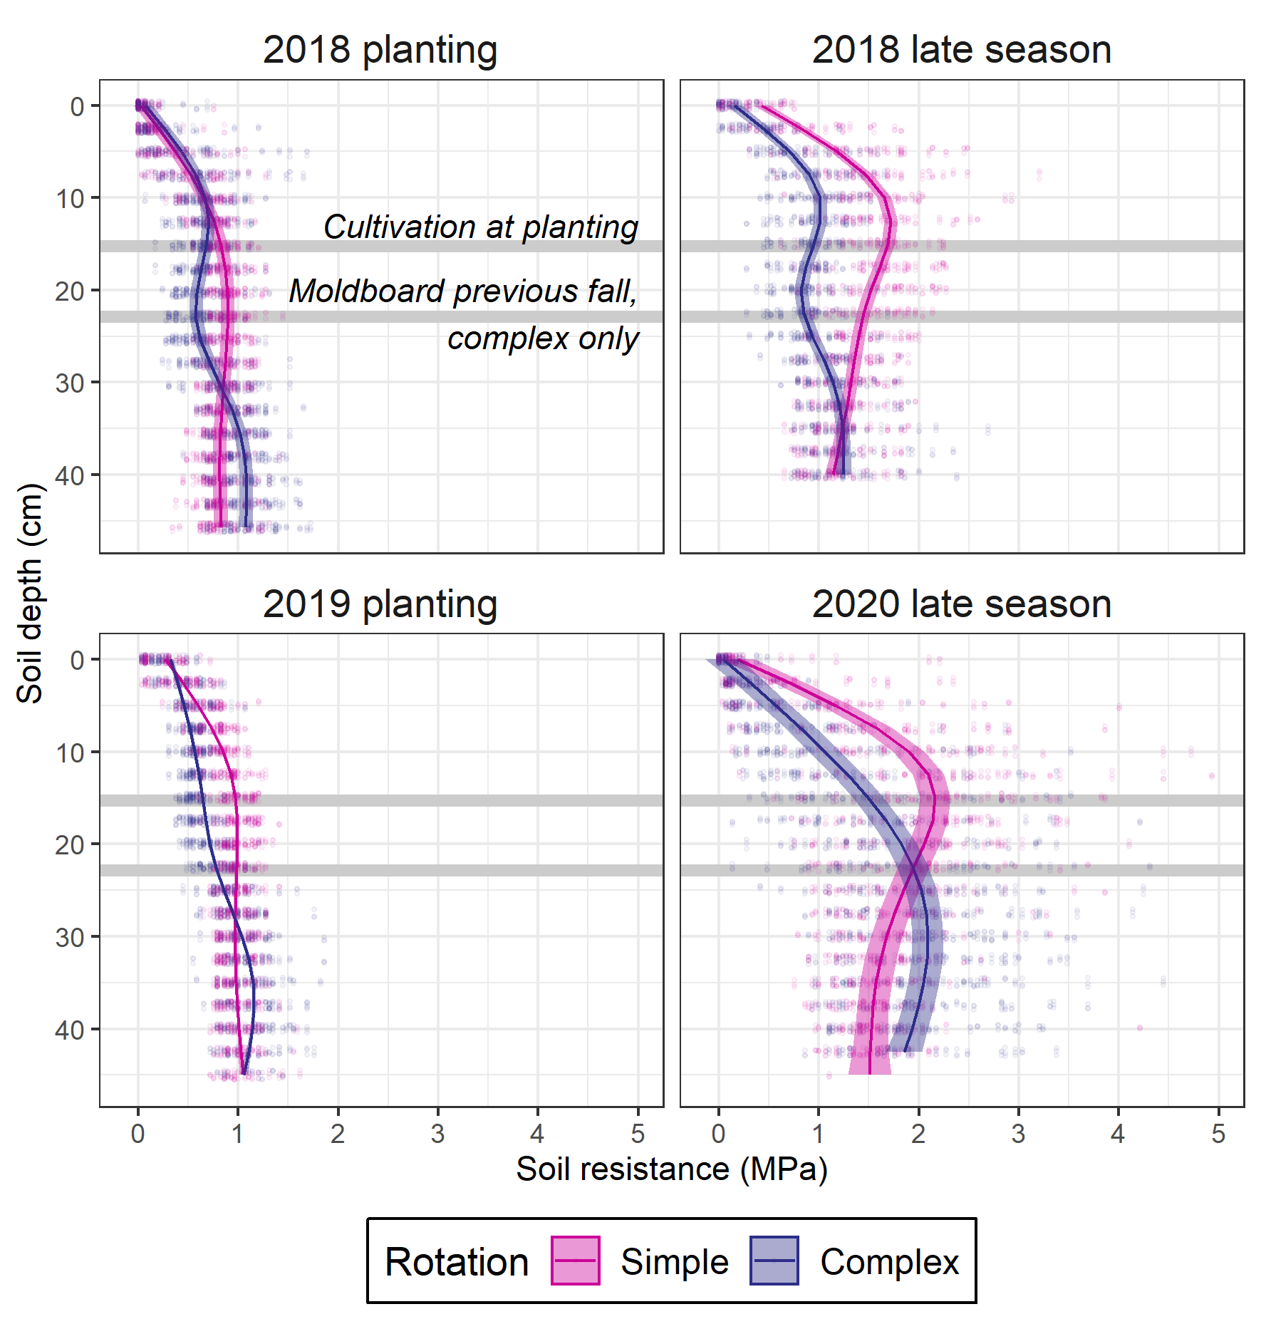

Soil moisture
In both years of measurement, the complex system’s soil moisture at 15 cm depth was significantly lower for the first month following planting (Fig. X). After that period, the effects were not consistent across years; in 2018 the simple system soil was consistently wetter than the complex system’s soil, but in 2019 there was no difference. At 45 cm depth, the complex system was likewise drier than the simple in 2018, but there was no difference in 2019 (Fig. S3).

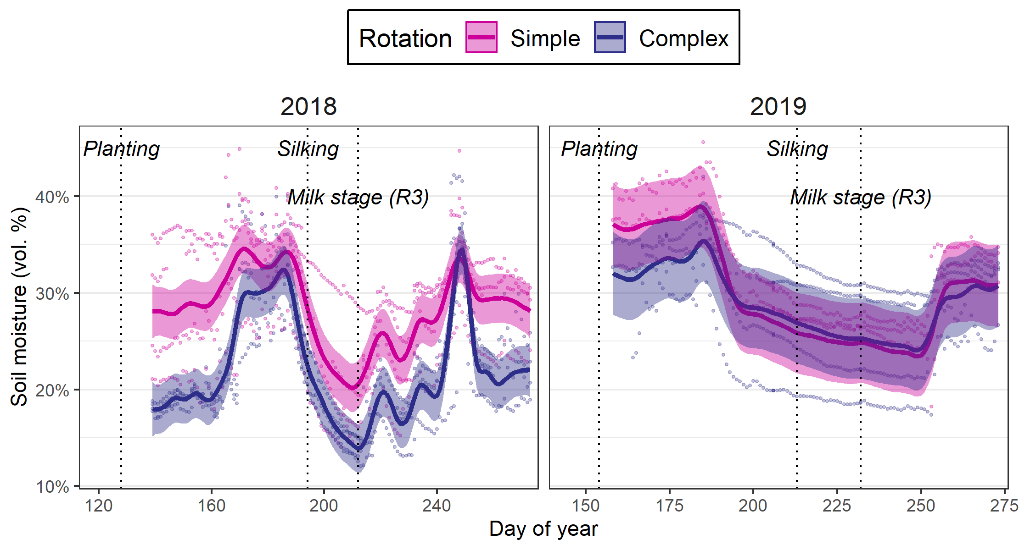
Figure 0-4 Soil moisture at 15 cm depth in the maize phase of the complex and simple rotations; points represent individual sensor values, lines the estimated values and ribbons the 95% confidence interval around the estimates.

Synthesis
In this study, we tested the hypothesis that the complex-maize invests less resources into root growth but achieves a root system that is better able to take advantage of favorable conditions. While our data does not establish direct cause-effect relationships, we find it is consistent with this hypothesis. In the two years when root biomass was measured, there was a greater increase in root material from the baseline level taken at planting in the simple compared to the complex rotation. Assuming the initial levels of root material present at maize planting decayed at equal rates, this data suggests the simple rotation maize added 1.7 times more root mass compared to the complex rotation maize, and that over half that investment was isolated to the top 0-15 cm of the soil profile. Conversely, while the complex rotation’s maize produced less total root biomass, it produced 50 times more biomass in the deepest soil increment measured (45-60 cm), and achieved a deeper maximum rooting depth (Fig. X).
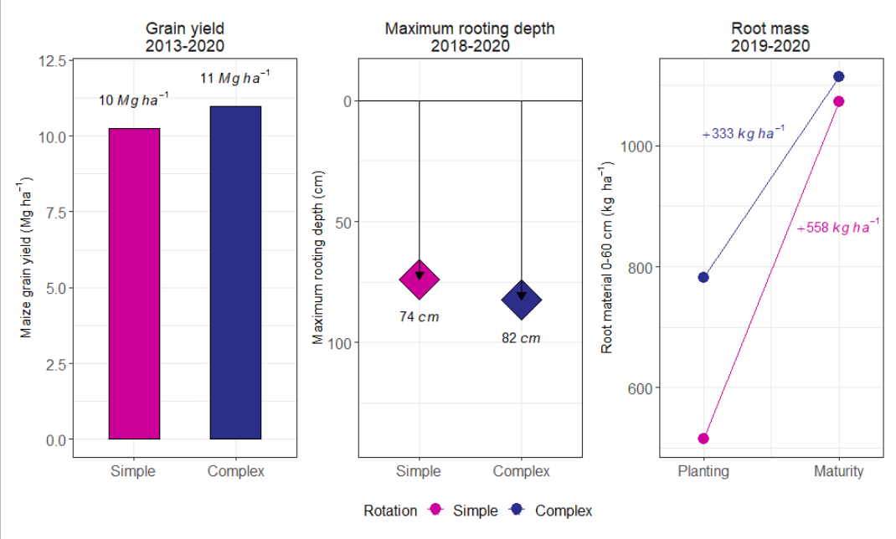
Figure 0-5 Maize grain yield (left), maximum rooting depth (center), and root mass (right) for maize grown in a simple (maize-soybean) or complex (maize-soybean-oat/alfalfa-alfalfa) rotation; all differences are significant.

We posit that the investment in deeper roots in the complex system does not guarantee higher maize yields, but rather it positions the plants to take advantage of favorable conditions when present. In 2018, a very wet year, there was a large rotation effect; the complex system’s maize roots were deeper, the plants grew faster later in the season, the 500-kernal weight was larger, and the soil moisture data suggests the plants were able to extract more water from the complex rotation’s soil across the entire season (Fig X). In contrast, in 2019 there was no effect of rotation despite the complex system’s maize roots still being deeper than the simple system’s, and there was no difference in soil water. Although there is no root data available for 2013, the year was drier than average but the rotation effect was large, and there was an early season growth advantage rather than a late season.
The causes for the deeper and cheaper root investments in the complex rotation cannot be discerned from this study alone, and could be physical, chemical, or biological. It is likely that moldboard plowing alfalfa the fall prior to maize planting in the complex rotation results in lower soil bulk densities, demonstrated by the lower penetration resistance at planting above the moldboard plowing depths. Neither system had resistances high enough to meaningfully impede root penetration, but the differences (X-X MPa) are of a magnitude that could affect root elongation; a study done with intact soil cores found resistances of only 0.26-0.47 MPa reduced maize seeding root elongation by 50-60% in a sandy loam (Bengough and Mullins, 1991). Additionally, lower resistances could be indicative of better aeration, and possibly better water drainage. Indeed, the soil water profiles showed drier soils after planting in the complex-rotation compared to the simple-rotation in both years of measurement. This is consistent with the lower bulk densities of the complex-rotation soils reported in previous studies (Baldwin-Kordick, 2019). It is possible the drier soils are driving deeper root exploration in the complex-maize, or that higher soil temperatures promote faster root growth. Additionally, some studies have shown ethylene build-up in soils can encourage thickening of roots and reduced branching (X). The better aerated soils in the complex-maize may be contributing to both the deeper exploration, and a lower resource demand for creating the root system. A previous study that measurement root length, rather than root mass, found the complex-maize had higher root lengths in the X-Xcm depth range compared to the simple-maize, again suggesting that the complex-maize root system is achieving a more efficient root system with less resource investment.
A greenhouse study took soil from the two rotation treatments’ plots and homogenized it to remove the physical effects (Halverson, unpublished data). They found differences in maize roots even after soil homogenization – the maize grown in the complex rotation’s soil had deeper and thinner roots compared to the maize grown in the simple system’s soil (Table S1). This indicates the effect is at least in part biological or chemical. Growing maize in sterilized soil would aid in parsing these effects, and certainly merits further investigation.
Process-based models could also aid in supporting or refuting the hypothesis of ‘steep and cheap’ roots in more complex rotations positioning maize crops to take advantage of favorable growing environments.
The finding of higher harvest indices is in contrast to previous studies showing no difference in the harvest indices in maize plants grown in monoculture compared to when rotated with soybean (CROOKSTON).

References
Aguilar, J., G.G. Gramig, J.R. Hendrickson, D.W. Archer, F. Forcella, et al. 2015. Crop Species Diversity Changes in the United States: 1978–2012. PLOS ONE 10(8): e0136580. doi: 10.1371/JOURNAL.PONE.0136580.
Al-Kaisi, M.M., S. v. Archontoulis, D. Kwaw-Mensah, and F. Miguez. 2015. Tillage and Crop Rotation Effects on Corn Agronomic Response and Economic Return at Seven Iowa Locations. Agronomy Journal 107(4): 1411–1424. doi: 10.2134/AGRONJ14.0470.
Arbuckle, J., and C. Kast. 2007. Quality of Life on the Agricultural Treadmill: Individual and Community Determinants of Farm Family Well-Being. Journal of Rural Social Sciences 27(1). https://egrove.olemiss.edu/jrss/vol27/iss1/4 (accessed 4 August 2021).
Archontoulis, S.V.S., F.E. Miguez, S.V.S. Archontoulis, and F.E. Miguez. 2015. Nonlinear regression models and applications in agricultural research. Agronomy Journal 107(2): 786–798. doi: 10.2134/agronj2012.0506.
Baldwin-Kordick, R. 2019. Soil health and root-influenced biochemical dynamics in conventional and integrated livestock systems in central Iowa. Graduate Theses and Dissertations. https://lib.dr.iastate.edu/etd/16969 (accessed 9 August 2021).
Bates, D., M. Mächler, B. Bolker, and S. Walker. 2015. Fitting Linear Mixed-Effects Models using lme4. Journal of Statistical Software 67(1): 1–48. doi: 10.18637/jss.v067.i01.
Bengough, A.G., and C.E. Mullins. 1991. Penetrometer resistance, root penetration resistance and root elongation rate in two sandy loam soils. Plant and Soil 1991 131:1 131(1): 59–66. doi: 10.1007/BF00010420.
Boryan, C., Z. Yang, R. Mueller, and M. Craig. 2011. Monitoring US agriculture: the US Department of Agriculture, National Agricultural Statistics Service, Cropland Data Layer Program. http://dx.doi.org/10.1080/10106049.2011.562309 26(5): 341–358. doi: 10.1080/10106049.2011.562309.
Bowles, T.M., M. Mooshammer, Y. Socolar, F. Calderón, M.A. Cavigelli, et al. 2020. Long-Term Evidence Shows that Crop-Rotation Diversification Increases Agricultural Resilience to Adverse Growing Conditions in North America. One Earth 2(3): 284–293. doi: 10.1016/j.oneear.2020.02.007.
Coulter, J.A., C.C. Sheaffer, D.L. Wyse, M.J. Haar, P.M. Porter, et al. 2011. Agronomic Performance of Cropping Systems with Contrasting Crop Rotations and External Inputs. Agronomy Journal 103(1): 182–192. doi: 10.2134/AGRONJ2010.0211.
Crookston, R.K., J.E. Kurle, P.J. Copeland, J.H. Ford, and W.E. Lueschen. 1991. Rotational Cropping Sequence Affects Yield of Corn and Soybean. Agronomy Journal 83(1): 108–113. doi: 10.2134/AGRONJ1991.00021962008300010026X.
Crookston, K.R., J.E. Kurle, and E. Lueschen. 1988. Relative Ability of Soybean, Fallow, and Triacontanol to Alleviate Yield Reductions Associated with Growing Corn Continously. Crop Science 28(1): 145–147. doi: 10.2135/CROPSCI1988.0011183X002800010031X.
Crossley, M.S., K.D. Burke, S.D. Schoville, and V.C. Radeloff. 2021. Recent collapse of crop belts and declining diversity of US agriculture since 1840. Global Change Biology 27(1): 151–164. doi: 10.1111/GCB.15396.
Davis, A.S., J.D. Hill, C.A. Chase, A.M. Johanns, and M. Liebman. 2012. Increasing Cropping System Diversity Balances Productivity, Profitability and Environmental Health. PLOS ONE 7(10): e47149. doi: 10.1371/JOURNAL.PONE.0047149.
Dick, W.A., and D.M. van Doren. 1985. Continuous Tillage and Rotation Combinations Effects on Corn, Soybean, and Oat Yields1. Agronomy Journal 77(3): 459–465. doi: 10.2134/AGRONJ1985.00021962007700030023X.
Dietzel, R., M. Liebman, and S. Archontoulis. 2017. A deeper look at the relationship between root carbon pools and the vertical distribution of the soil carbon pool. SOIL 3(3): 139–152. doi: 10.5194/soil-3-139-2017.
Farmaha, B.S., K.M. Eskridge, K.G. Cassman, J.E. Specht, H. Yang, et al. 2016. Rotation impact on on-farm yield and input-use efficiency in high-yield irrigated maize–soybean systems. Agronomy Journal 108(6): 2313–2321. doi: 10.2134/AGRONJ2016.01.0046.
Gentry, L.F., M.L. Ruffo, and F.E. Below. 2013. Identifying factors controlling the continuous corn yield penalty. Agronomy Journal 105(2): 295–303. doi: 10.2134/agronj2012.0246.
Goldstein, W.A. 2000. The effect of farming systems on the relationship of corn root growth to grain yields.pdf. American Journal of Alternative Agriculture 15(3): 101–109. doi: 10.1017/S0889189300008602.
Hatfield, J.L., R.M. Cruse, and M.D. Tomer. 2013. Convergence of agricultural intensification and climate change in the Midwestern United States: implications for soil and water conservation. Marine and Freshwater Research 64(5): 423. doi: 10.1071/MF12164.
Hatfield, J.L., L.D. McMullen, and C.S. Jones. 2009. Nitrate-nitrogen patterns in the Raccoon River Basin related to agricultural practices. Journal of Soil and Water Conservation 64(3): 190–199. doi: 10.2489/JSWC.64.3.190.
Hijmans, R.J., H. Choe, and J. Perlman. 2016. Spatiotemporal Patterns of Field Crop Diversity in the United States, 1870–2012. Agricultural & Environmental Letters 1(1): 160022. doi: 10.2134/AEL2016.05.0022.
Hunt, N., M. Liebman, S. Thakrar, and J. Hill. 2020. Fossil Energy Use, Climate Change Impacts, and Air Quality-Related Human Health Damages of Conventional and Diversified Cropping Systems in Iowa, USA. Environmental science & technology 54(18): 11002–11014. doi: 10.1021/ACS.EST.9B06929.
Iowa Environmental Mesonet. 2021. National Weather Service Cooperative Observer Program (COOP). Iowa State University. https://mesonet.agron.iastate.edu/ (accessed 9 August 2021).
Johnson, N.C., P.J. Copeland, R.K. Crookston, and F.L. Pfleger. 1992. Mycorrhizae: Possible Explanation for Yield Decline with Continuous Corn and Soybean. Agronomy Journal 84(3): 387. doi: 10.2134/agronj1992.00021962008400030007x.
Jones, C.S., J.K. Nielsen, K.E. Schilling, and L.J. Weber. 2018. Iowa stream nitrate and the Gulf of Mexico (X. Wang, editor). PLoS ONE 13(4): 1–17. doi: 10.1371/journal.pone.0195930.
King, A.E., and K.S. Hofmockel. 2017. Diversified cropping systems support greater microbial cycling and retention of carbon and nitrogen. Agriculture, Ecosystems and Environment 240: 66–76. doi: 10.1016/j.agee.2017.01.040.
Kuha, J. 2004. AIC and BIC: Comparisons of assumptions and performance. Sociological Methods and Research 33(2): 188–229. doi: 10.1177/0049124103262065.
Kuznetsova, A., P.B. Brockhoff, and R.H.B. Christensen. 2017. lmerTest Package: Tests in Linear Mixed Effects Models. Journal of Statistical Software 82(13). doi: 10.18637/jss.v082.i13.
Lazicki, P.A., M. Liebman, and M.M. Wander. 2016. Root parameters show how management alters resource distribution and soil quality in conventional and low-input cropping systems in central iowa. PLoS ONE 11(10): 1–19. doi: 10.1371/journal.pone.0164209.
Lenth, R., H. Singmann, and J. Love. 2018. Emmeans: Estimated marginal means, aka least-squares means. https://cran.r-project.org/web/packages/emmeans/index.html#:~:text=emmeans%3A%20Estimated%20Marginal%20Means%2C%20aka%20Least%2DSquares%20Means&text=Compute%20contrasts%20or%20linear%20functions,Plots%20and%20other%20displays. (accessed 28 June 2021).
Liebman, M., L.R. Gibson, D.N. Sundberg, A.H. Heggenstaller, P.R. Westerman, et al. 2008. Agronomic and Economic Performance Characteristics of Conventional and Low-External-Input Cropping Systems in the Central Corn Belt. Agronomy Journal 100(3): 600–610. doi: 10.2134/AGRONJ2007.0222.
Lynch, J.P. 2013. Steep, cheap and deep: An ideotype to optimize water and N acquisition by maize root systems. Annals of Botany 112(2): 347–357. doi: 10.1093/aob/mcs293.
McCulloch, C.E., and J.M. Neuhaus. 2005. Generalized Linear Mixed Models. Encyclopedia of Biostatistics. John Wiley & Sons, Ltd, Chichester, UK
Meese, B.G., P.R. Carter, E.S. Oplinger, and J.W. Pendleton. 1991. Corn/Soybean Rotation Effect as Influenced by Tillage, Nitrogen, and Hybrid/Cultivar. jpa 4(1): 74. doi: 10.2134/jpa1991.0074.
Miguez, F. 2021. nlraa: Nonlinear Regression for Agricultural Applications.
Miguez, F., S. Archontoulis, H. Dokoohaki, B. Glaz, and K.M. Yeater. 2018. Chapter 15: Nonlinear Regression Models and Applications. Applied Statistics in Agricultural, Biological, and Environmental Sciences. American Society of Agronomy, Crop Science Society of America, and Soil Science Society of America, Inc. p. 401–448
Mortensen, D.A., and R.G. Smith. 2020. Confronting Barriers to Cropping System Diversification. Frontiers in Sustainable Food Systems 4. doi: 10.3389/FSUFS.2020.564197/PDF.
Nickel, S.E., R.K. Crookston, and M.P. Russelle. 1995. Root growth and distribution are affected by corn-soybean cropping sequence. Agronomy Journal 87(5): 895–902. doi: 10.2134/agronj1995.00021962008700050020x.
Ordóñez, R.A., M.J. Castellano, J.L. Hatfield, M.J. Helmers, M.A. Licht, et al. 2018. Maize and soybean root front velocity and maximum depth in Iowa, USA. Field Crops Research 215(September 2017): 122–131. doi: 10.1016/j.fcr.2017.09.003.
Osterholz, W.R., M. Liebman, and M.J. Castellano. 2018. Can soil nitrogen dynamics explain the yield benefit of crop diversification? Field Crops Research 219: 33–42. doi: 10.1016/J.FCR.2018.01.026.
Pasley, H., V. Nichols, M. Castellano, M. Baum, E. Kladivko, et al. 2021. Rotating maize reduces the risk and rate of nitrate leaching. Environmental Research Letters 16(6): 064063. doi: 10.1088/1748-9326/ABEF8F.
Peters, D.J. 2002. Revisiting the Goldschmidt Hypothesis: The effect of economic structure on socioeconomic conditions in the rural Midwest Sustainable tourism View project Revisiting the Goldschmidt Hypothesis: The Effect of Economic Structure on Socioeconomic Conditions in the Rural Midwest †*. Missouri Department of Economic Development. https://www.researchgate.net/publication/228858680 (accessed 4 August 2021).
Peterson, T.A., C.A. Shapiro, and A.D. Flowerday. 1990. Rainfall and previous crop effects on crop yields. American Journal of Alternative Agriculture 5(1): 33–37. doi: 10.1017/S0889189300003209.
Poffenbarger, H.J., D.C. Olk, C. Cambardella, J. Kersey, M. Liebman, et al. 2020. Whole-profile soil organic matter content, composition, and stability under cropping systems that differ in belowground inputs. Agriculture, Ecosystems & Environment 291: 106810. doi: 10.1016/J.AGEE.2019.106810.
Porter, P.M., J.G. Lauer, W.E. Lueschen, J.H. Ford, T.R. Hoverstad, et al. 1997. Environment affects the corn and soybean rotation effect. Agronomy Journal 89(3): 441–448. doi: 10.2134/agronj1997.00021962008900030012x.
R Core Team. 2020. R: A language and environment for statistical computing. R foundation for Statistical Computing. http://www.r-project.org/.
Schilling, K.E., K.S. Chan, H. Liu, and Y.K. Zhang. 2010. Quantifying the effect of land use land cover change on increasing discharge in the Upper Mississippi River. Journal of Hydrology 387(3–4): 343–345. doi: 10.1016/j.jhydrol.2010.04.019.
Seifert, C.A., M.J. Roberts, and D.B. Lobell. 2017. Continuous corn and soybean yield penalties across hundreds of thousands of fields. Agronomy Journal 109(2): 541–548. doi: 10.2134/agronj2016.03.0134.
Stanger, T.F., and J.G. Lauer. 2008. Corn Grain Yield Response to Crop Rotation and Nitrogen over 35 Years. Agronomy Journal 100(3): 643–650. doi: 10.2134/AGRONJ2007.0280.
Tron, S., G. Bodner, F. Laio, L. Ridolfi, and D. Leitner. 2015. Can diversity in root architecture explain plant water use efficiency? A modeling study. Ecological Modelling 312: 200–210. doi: 10.1016/J.ECOLMODEL.2015.05.028.
USDA National Agricultural Statistics Service Cropland Data Layer. 2021. Published corn data layer [Online]. USDA-NASS, Washington, DC. https://nassgeodata.gmu.edu/CropScape/ (accessed 10 August 2021).
Varvel, G.E. 2000. Crop Rotation and Nitrogen Effects on Normalized Grain Yields in a Long-Term Study. Agronomy Journal 92(5): 938–941. doi: 10.2134/AGRONJ2000.925938X.
Vogel, A.M., and F.E. Below. 2018. Hybrid Selection and Agronomic Management to Lessen the Continuous Corn Yield Penalty. Agronomy 2018, Vol. 8, Page 228 8(10): 228. doi: 10.3390/AGRONOMY8100228.
Weisberger, D.A., M.D. McDaniel, J.G. Arbuckle, and M. Liebman. 2021. Farmer perspectives on benefits of and barriers to extended crop rotations in Iowa, USA. Agricultural & Environmental Letters 6(2): e20049. doi: 10.1002/AEL2.20049.
Wickham, H., M. Averick, J. Bryan, W. Chang, L. McGowan, et al. 2019. Welcome to the Tidyverse. Journal of Open Source Software 4(43): 1686. doi: 10.21105/joss.01686.
Wood, S.N. 2011. Fast stable restricted maximum likelihood and marginal likelihood estimation of semiparametric generalized linear models. Journal of the Royal Statistical Society. Series B: Statistical Methodology 73(1): 3–36. doi: 10.1111/J.1467-9868.2010.00749.X.

Supplementary Material

Figure S1. Maximum rooting depth over time dataset

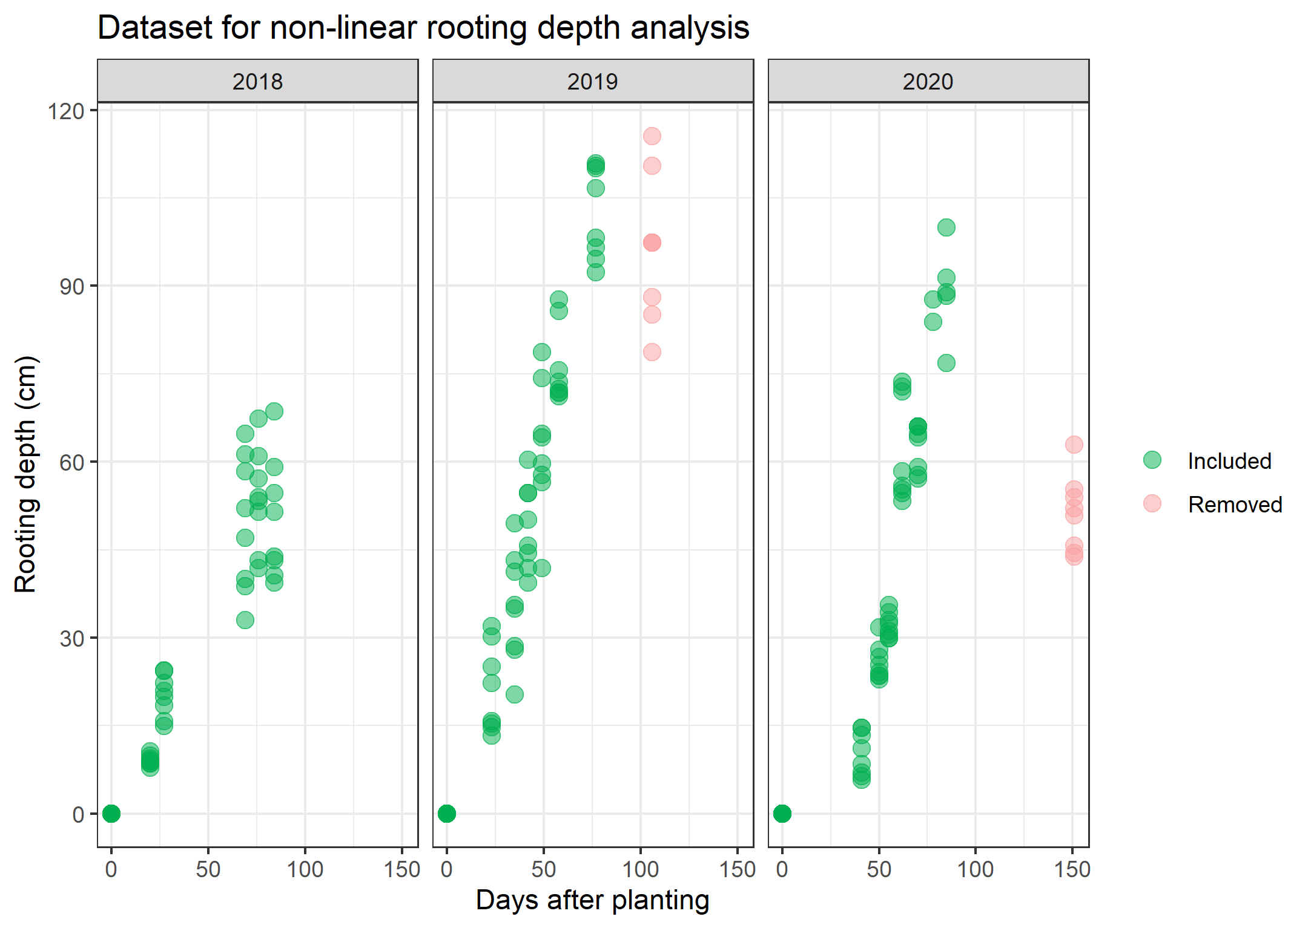

Figure S2. Maximum rooting depth by year
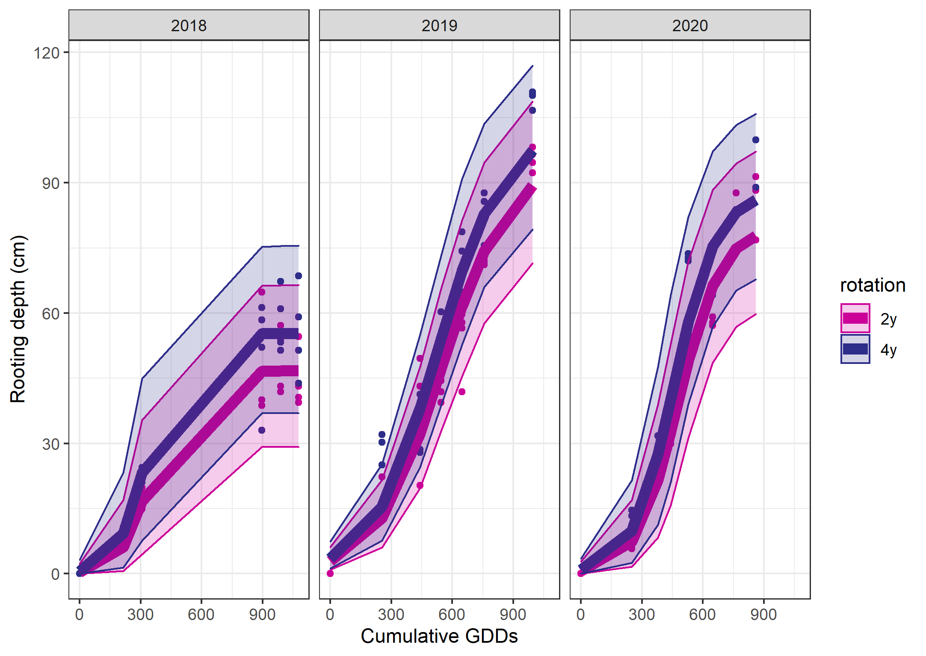

Figure S3. Soil moisture at 45 cm depth
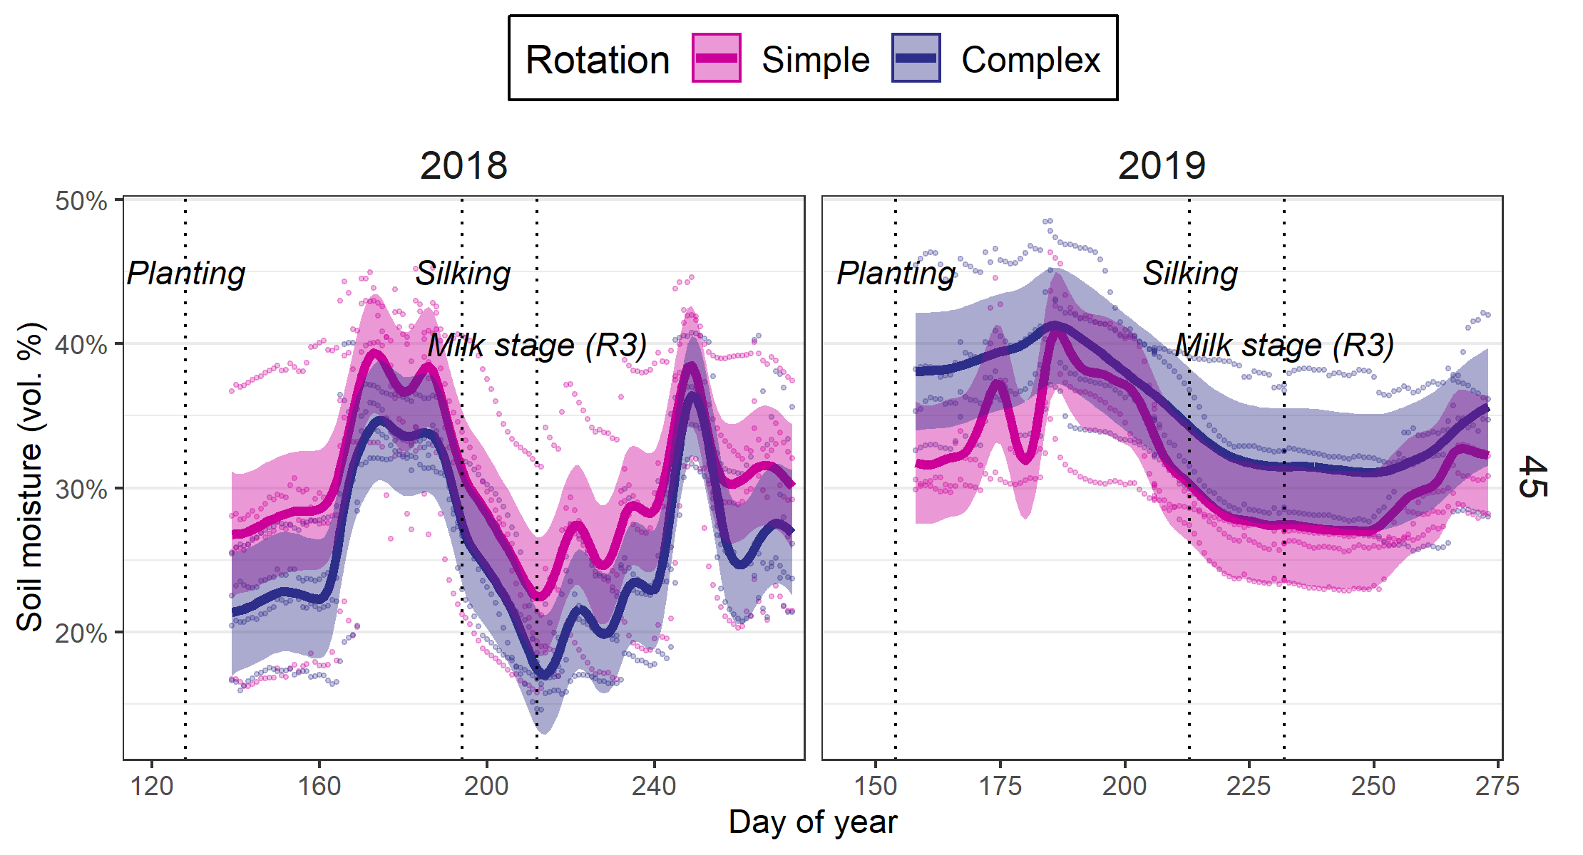

Figure S1. Yields, biomass over time, growth rate over time, harvest index, 500-kernal grain weight
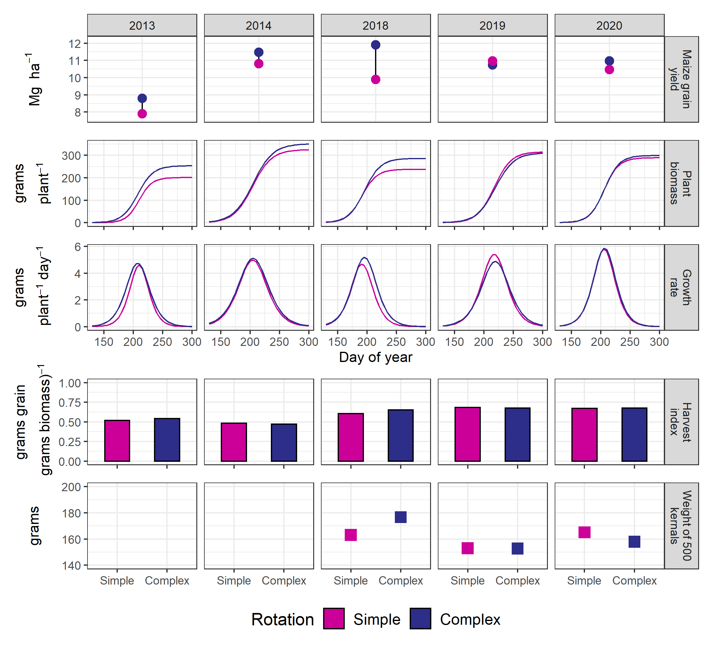

Table S1. Summary of growth-analysis curve fits

