Doing more with less: Maize grown in complex rotations has less but deeper roots and higher grain yields compared to simple rotations

Virginia Nichols, Sotirios Archontoulis, Matt Liebman

Abstract

It is well-established that maize (*Zea mays* L.) grown in complex cropping systems requires less external nitrogen inputs and often exhibits higher grain yields compared to maize grown in simple systems. However, the driving mechanisms behind this phenomenon, ‘the rotation effect’, are poorly understood. To examine the possible role of maize roots in the rotation effect we measured root biomass, maximum rooting depth, and grain yields in the maize phase of two contrasting rotations: a simple 2-year rotation of maize-soybean (*Glycine max (*(L.) Merr), and an extended 4-year rotation of maize-soybean-oat (*Avena sativa* L.)/alfalfa (*Medicago sativa* L.)-alfalfa. Additionally, we measured soil penetration resistance, soil moisture, and performed a maize growth analysis. From 2013-2020, maize grain yields in the complex rotation were 8% higher than the simple (11.0 and 10.2 Mg ha-1, respectively). The timing of the maize growth advantage in the complex system over the simple was not consistent across years. In contrast, the maximum rooting depth of maize in the complex rotation was consistently deeper by an average of 14% (10 cm) over the three years of measurement. Maize grown in the simple system added an average of 1.5 times more root biomass over the growing season compared to the complex rotation in the two years of measurement. We posit that maize grown in the complex rotation achieved equal or better root resource-acquisition potential with less investment compared to maize grown in the simple rotation. Understanding whether these root differences reflect chemical, physical, and/or biological characteristics of the soil merits further investigation.

**Intro**

In the Midwestern United States (US), a substantial portion of agricultural land is dedicated to maize-(*Zea mays* L.) based systems (Boryan et al., 2011). Over the past 60 years these systems have been reduced from diversified rotations that included small grains and forage legumes to maize monocultures or simple alterations of maize and soybean (Aguilar et al., 2015; Hijmans et al., 2016; Crossley et al., 2021). Several undesirable effects have accompanied this simplification including but not limited to increased rates of soil erosion, increased water pollution, increased flooding risks, and a decline in rural quality-of-life (Peters, 2002; Arbuckle and Kast, 2007; Hatfield et al., 2009, 2013; Schilling et al., 2010; Jones et al., 2018). Additionally, maintaining high productivity in simplified systems often requires larger investments in external inputs that are accompanied by higher risks for nitrate pollution and nitrous oxide emissions (Millar et al., 2010; Hunt et al., 2019; Pasley et al., 2021). Understanding the mechanisms that allow diversified maize systems to use resources more efficiently will be crucial for designing systems that can support food production with limited land resources.

There have been numerous studies in the Midwest exploring differences between maize grown in monoculture compared to in alteration with soybean inputs (Dick and Doren, 1985; Peterson et al., 1990; Meese et al., 1991; Crookston et al., 1991; Porter et al., 1997; Varvel, 2000; Stanger and Lauer, 2008; Gentry et al., 2013; Al-Kaisi et al., 2015; Farmaha et al., 2016; Seifert et al., 2017; Vogel and Below, 2018; Bowles et al., 2020). While the maize yield advantage of further extending rotations to include small grains and forage legumes has likewise been well-documented (Liebman et al., 2008; Stanger and Lauer, 2008; Coulter et al., 2011), to our knowledge the driving mechanisms behind the yield advantages remain unclear. In a long-term cropping systems research experiment in Iowa (Davis et al., 2012) researchers have found differences in the distributions of resources and nutrient cycling activity in simple and complex maize systems (Lazicki et al., 2016; King and Hofmockel, 2017; Osterholz et al., 2018; Poffenbarger et al., 2020), but it is unclear how these differences translate to higher maize yields. Additionally, there is evidence that suggests there are differences in maize root distributions in the simple and complex rotations, but without controlling for extraneous organic matter or measurements of root biomass it is difficult to draw conclusions (Lazicki et al., 2016). Another study in Wisconsin found monoculture maize had increased root growth compared to two extended 3-year maize rotations (Goldstein, 2000), and the researcher attributed the increased growth to poor root health, and therefore perhaps poor resource capture in the monoculture system. It is possible that differences in maize root structures are contributing to increased resource capture in complex rotations, driving higher maize yields compared to the simple systems. When above-ground crop products are valued, it is desirable for plants to efficiently invest resources in belowground growth. In nitrogen or water limiting environments, ‘steep cheap and deep’ root ideotypes have been identified as the most efficient use of root investments (Lynch, 2013; Tron et al., 2015).

Based on the current literature, we hypothesized that maize grown in complex rotations is investing less resources in root systems without compromising function. To test this hypothesis, we made the following measurements in a simple maize rotation (maize-soybean), and a complex rotation (maize-soybean-oats/alfalfa-alfalfa):

1. Maize grain yields (2013-2020)
2. Maximum maize rooting depth as a proxy for the soil space that investment opens up for resource capture (2018-2020)
3. Maize root biomass as a proxy for the resources invested by the maize crop into roots (2019-2020)

Addiitionally, we complemented these core measurements with XXXX

**Methods and Materials**

***Sampling***

Treatments consisted of two maize-based rotations: a 2-year rotation of maize-soybean (hereafter the simple rotation), and a 4-year rotation of maize-soybean-oat/alfalfa-alfalfa that periodically received cattle manure (hereafter the complex rotation). Detailed accounts of plot management are reported elsewhere (Hunt et al., 2020). Each phase of the rotation treatments was present every year in four replicate blocks within a 9-hectare experiment established in 2001 at the Iowa State University Marsden Farm in Boone County, Iowa. The mean precipitation XX. Maize grain yield was measured 2013-2020, and additional measurements were taken in select years during that period (Table 1).

Table 1. Summary of measurements used for this study

|  |  |  |
| --- | --- | --- |
| Measurement | Measurement years | Description |
| Maize grain yield | 2013-2020 | Maize grain yield was determined using a 6-row combine equipped with a yield monitor and moisture meter. Sampling areas for yield were the middle rows of the plots, approximately 4.6 m x 84 m. All yields are reported on a dry weight basis. |
| Maize above-ground biomass | 2013, 2014, 2018, 2019, 2020 | Maize above-ground biomass was measured periodically throughout the season. Eight plants were cut at ground level, separated into leaf, stem, and reproductive components, dried at 60 deg C for at least 72 hours, then weighed. |
| Maize maximum rooting depth | 2018, 2019, 2020 | Maximum maize rooting depth was measured starting at 20, 23, and 41 days after planting in 2018, 2019, and 2020 respectively. Sampling was repeated approximately every 2 weeks until 84, 106, and 151 days after planting in 2018, 2019, and 2020, respectively. Maximum rooting depth was determined visually using the protocol of Ordóñez et al., 2018. A soil core was drawn with a 19-mm-diameter soil probe, white roots were identified, and their depth estimated to the nearest inch using a meter stick. Samples were repeatedly taken from the same core location until no white roots were identified in the core. Four cores were taken per plot at each sampling date. |
| Soil moisture at 15 and 45 cm depths | 2018, 2019 | 5TM soil moisture and temperature sensors (METER Group Inc., Pullman, WA, USA) were installed at two depths (15 and 45 cm) in each plot. Data were recorded hourly during the growing season using EM50 data loggers. |
| Penetration resistance | 2018, 2019 | Penetration resistance was measured using a FieldScout 900 Soil Compaction Meter (Spectrum Technologies, Inc., Aurora, IL, USA). Values were recorded every 2.54 cm to 45 cm depth immediately following planting and approximately 60 days after planting. Ten measurements were taken randomly throughout each plot. |
| Maize root mass 0-60 cm | 2019, 2020 | Maize root mass to a soil depth of 60 cm was measured at 3 and 105 days after planting in 2019, and at 4 and 117 days after planting in 2020. Four soil samples per plot were drawn at a location 10 cm from corn rows in 15 cm depth increments using a 32-mm-diameter soil probe. Soil from each depth increment within a plot was composited and roots were recovered using a sequence of elutriation (washing), flotation, recovery from organic debris using tweezers and a stereo microscope, drying, and weighing (Dietzel et al., 2017) |

***Statistical Analysis***

All statistics were done using R version 4.0.2 (R Core Team, 2020) and the *tidyverse* suite of packages (Wickham et al., 2019).

The effect of rotation treatment on maize grain yields was assessed using a mixed effects linear model with rotation as a fixed effect and block and a year factor as random intercepts. The *lme4* package (Bates et al., 2015) was used for model fitting, and the *emmeans* (Lenth et al., 2018)and *lmerTest* (Kuznetsova et al., 2017) packages were used for comparisons and statistical summaries.

For modeling rooting depth, we chose to filter the data to remove measurements taken after the maximum seasonal depth had been reached. We chose to model rooting depth as a function of the cumulative maize growing-degree-days (GDDs) accrued since planting (base temperature 10 deg C, maximum temperature X deg C) to facilitate comparisons between years. A three-parameter logistic curve (Archontoulis et al., 2015) was found to be the best fit according to Akaike’s Information Criteria (AIC; Kuha, 2004):

$$rootdepth(GDD)= \frac{A_{sym}}{(1+\exp\left(\frac{\left(x_{mid}-GDD\right)}{scal}\right))}$$

Where *rootdepth(GDD)* is the maximum rooting depth at a given cumulative GDD after planting and *Asym*, *xmid*, and *scal* are estimated parameters. *Asym* represents the maximum rooting depth achieved, *xmid* represents the cumulative GDD value at which half of the maximum rooting depth is achieved, and scal describes the steepness of the curve (Miguez et al., 2018). Models were fit using the *nlraa* package (Miguez, 2021). We found the best model fit when incorporating a fixed effect of rotation on *Asym*, *xmid*, and *scal*; a random effect of year on *Asym*, *xmid*, and *scal*, a random effect of block on *Asym*; and a power variance structure.

No year effect on corn root mass was detected (p=0.65). In contrast, we found a significant sampling date x rotation interaction (p=0.015). Corn root mass increased 108%, from 515 to 1,073 kg ha-1, in the 2-year rotation, whereas root mass increased 49%, from 782 to 1,160 kg ha-1, in the 4-year rotation. If the initial levels of root residue decayed at an equal rate in the two rotation treatments, or if they persisted equally in the two rotations, these results would indicate that the 2-year rotation added more root mass during the growing season than did the 4-year rotation.

Maximum corn root depth was measured throughout the 2018-2020 cropping seasons in both rotation systems. Maximum root depth was determined five times in 2018, seven times in 2019, and eight times in 2020, based on four cores per plot drawn with a 19-mm-diameter soil probe. Maximum root extension was determined visually and quantified with a meter stick. Maximum root depth differed among years (p<0.0001) and rotation systems (p=0.0013), but no year x rotation system interaction occurred (p=0.66). Averaged over rotation treatments, root depth was greatest in 2019 (102.5 cm), least in 2018 (53.7 cm), and intermediate in 2020 (90.0 cm). Averaged over years, maximum root depth was 14% higher in the 4-year rotation (87.4 cm) than in the 2-year rotation (76.7 cm). These observations corroborated our hypothesis that maximum corn root depth would be greater for corn following alfalfa in the 4-year rotation than following soybean in the 2-year rotation.

. Corn yield was affected by a significant year x rotation interaction (p=0.0096): yield was 23% greater (p=0.0006) in the 4-year rotation (14.0 Mg ha-1) than in the 2-year rotation (11.3 Mg ha-1) in 2018 but did not differ between rotation systems in 2019 (p=0.62) and 2020 (p=0.56). Averaged over rotation systems, mean corn yield in both of the latter two years was 12.6 Mg ha-1.

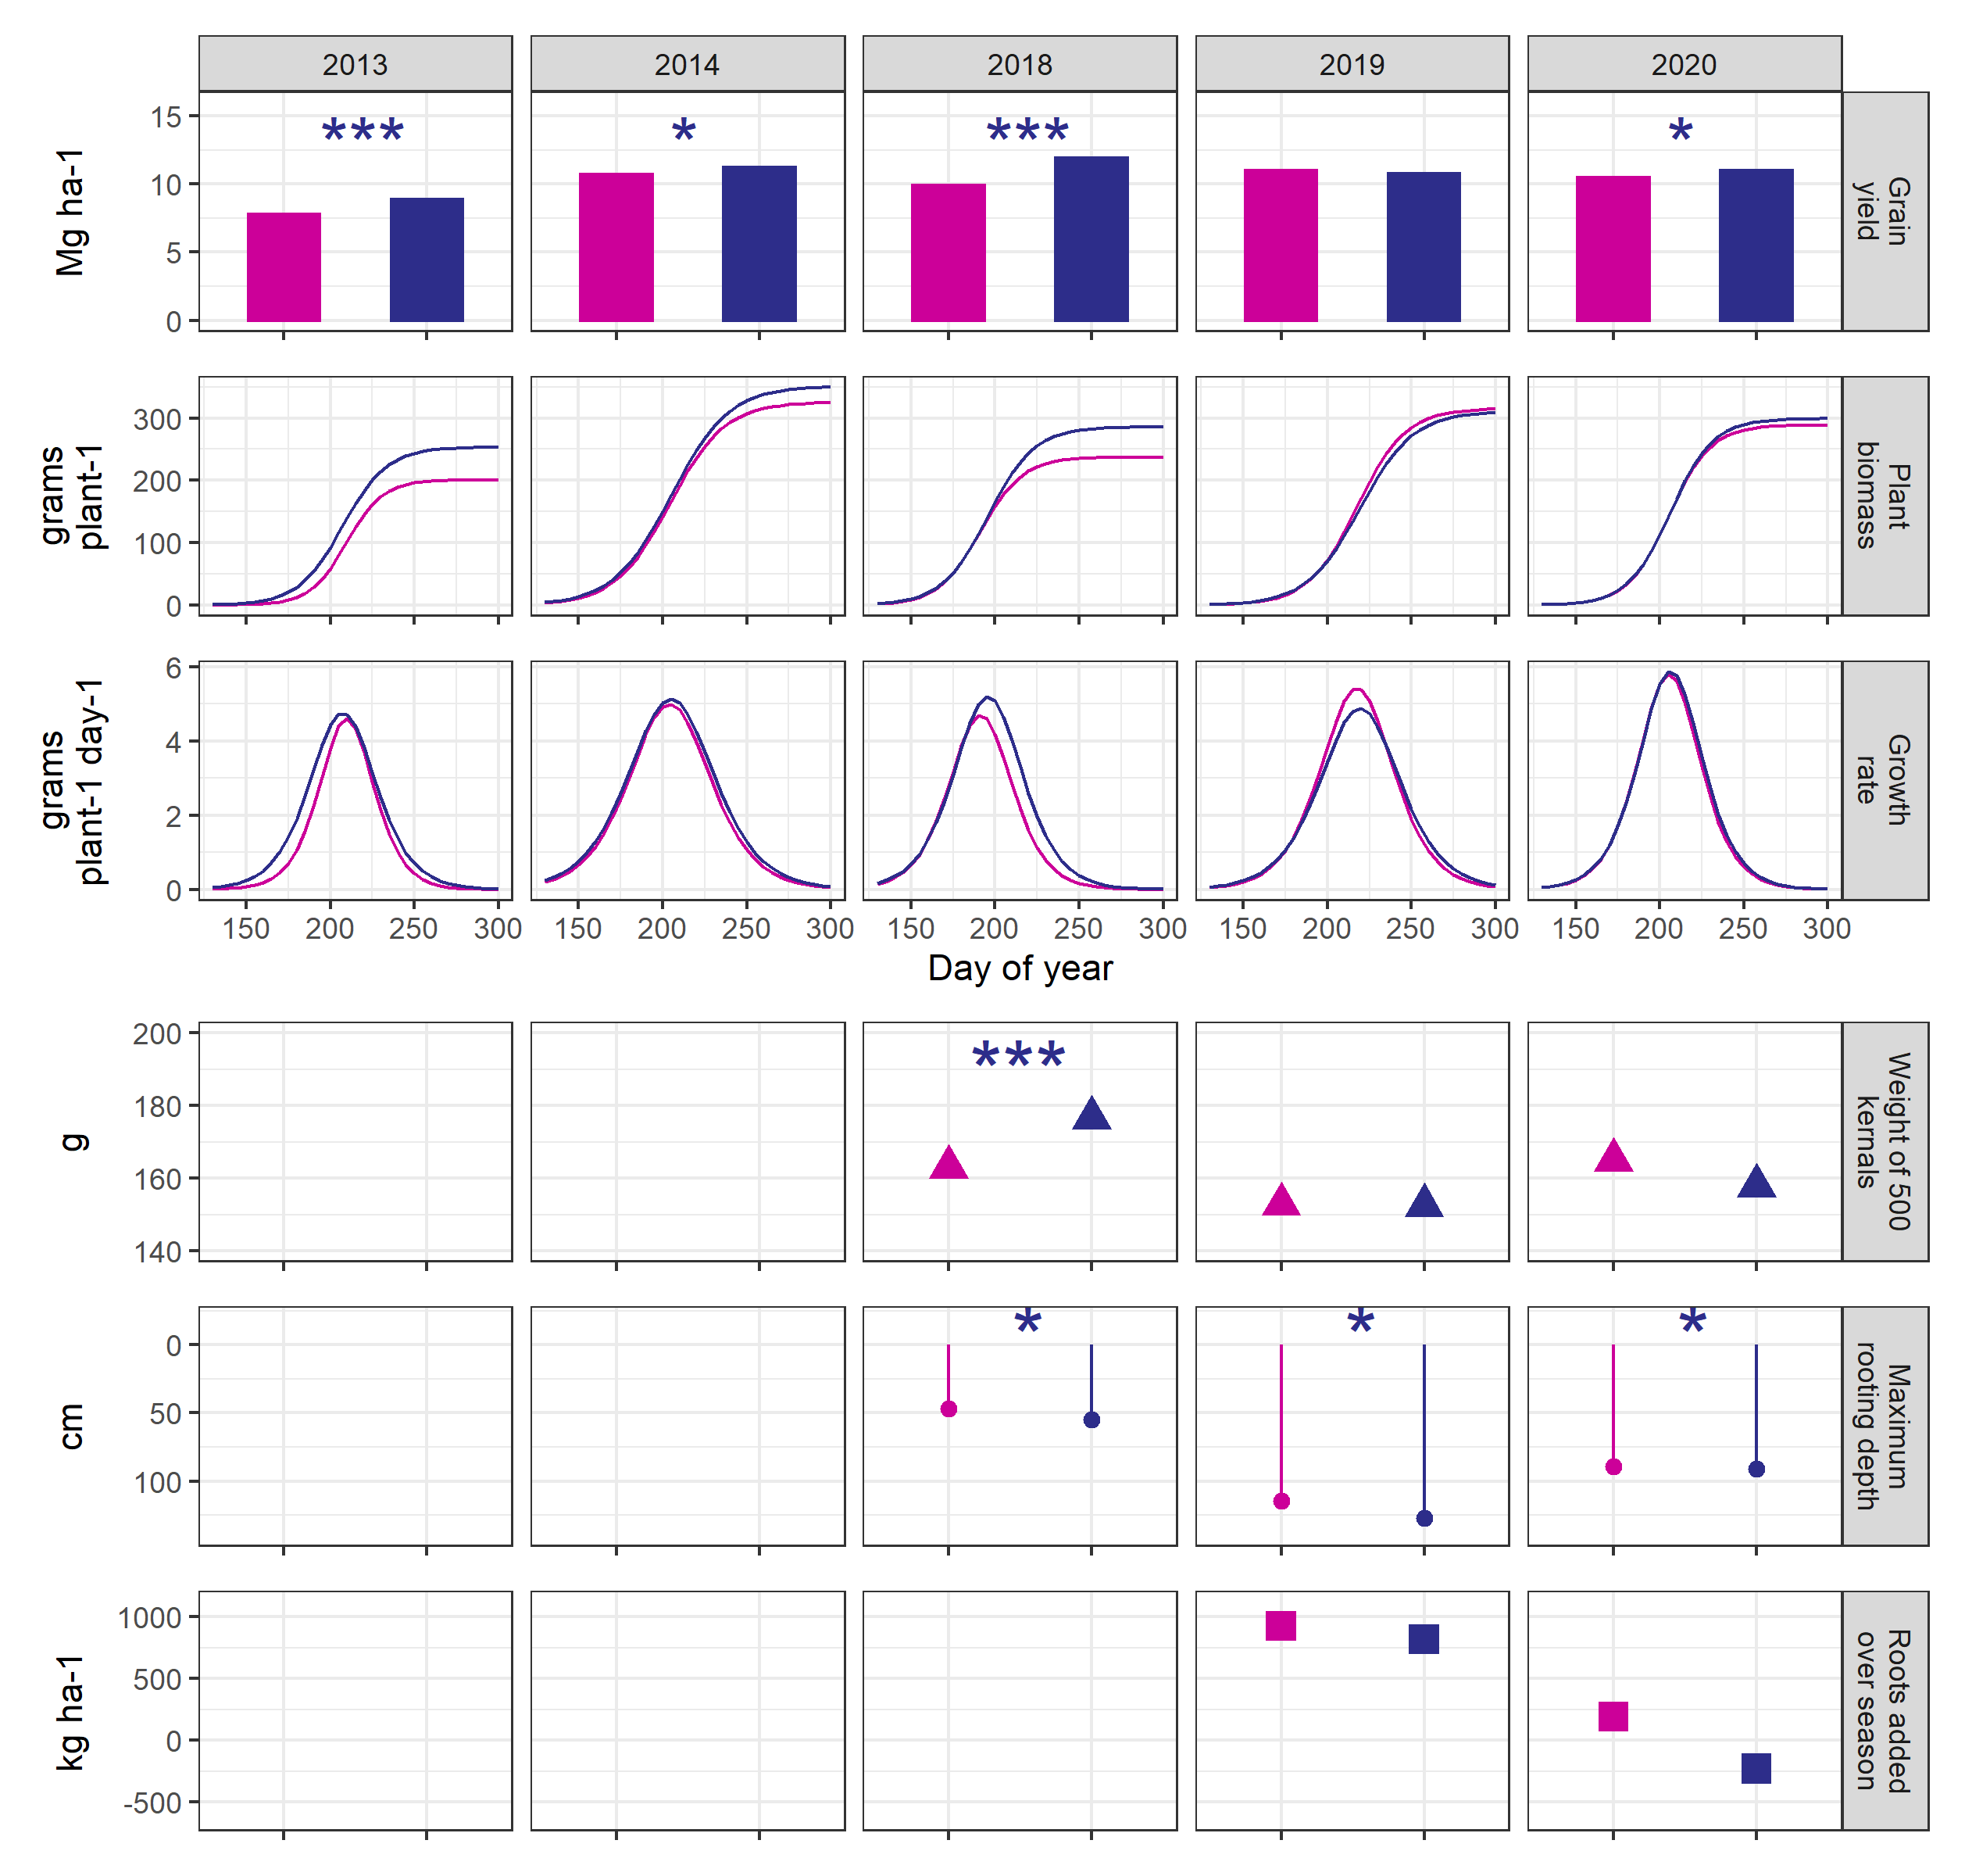

Could show root depth over time instead of maximum rooting depth

Results and Discussion?

From 2013-2020, maize grown in the complex rotation yielded X% more (X Mg ha-1) than maize grown in the simple rotation (p<X). In the five years with data available for growth analysis, biomass accumulation and growth patterns showed inconsistent timing for the growth advantage of the complex rotation maize, with one year showing an early season advantage (2013), one year a late season (2018), and no trend towards either in the remaining years. Harvest indices of the maize plants did not differ by rotation treatment in any year (data not shown).

We test the hypothesis that the complex-maize invests less resources into root growth, and concomitantly achieves a root system that is better able to take advantage of favorable conditions.

While the data is not conclusive, we find it is consistent with this hypothesis. In the two years when root biomass was measured, there was a greater increase in root material from the baseline level taken at planting in the simple-maize (at every timepoint?) compared to the complex-maize. Assuming the baseline material decayed at the same rates, this suggests the simple-maize added more root biomass over the growing season compared to the complex-maize. Despite the increased investments in simple-maize roots, the complex-maize root system was consistently deeper across the season, achieving a mean maximum rooting depth 10 cm deeper than the simple-maize root system.

The deeper rooting system was not always associated with higher grain yields; although the complex-maize root system was deeper in all three years of measurement, over those same years the complex- maize grain yields were X%, X%, and X% higher than the simple-maize, respectively. We therefore posit that the deeper root systems provide an opportunity for the crop to take *advantage* of favorable conditions for crop growth, but do not themselves *create* favorable conditions.

We observed significantly less soil penetration resistance in the 0-X cm soil profile at maize planting in the complex- versus simple-rotation. Neither system had resistances high enough to meaningfully impede root penetration, but in addition to physical constraints the lower resistances could be indicative of better aeration, and possibly better water drainage. Indeed, the soil water profiles showed drier soils after planting in the complex-rotation compared to the simple-rotation in both years of measurement. This is consistent with the lower bulk densities of the complex-rotation soils reported in previous studies (X). It is possible the drier soils are driving deeper root exploration in the complex-maize, or that higher soil temperatures promote faster growth (X). Additionally, some studies have shown ethylene build-up in soils can encourage thickening of roots and reduced branching (X). The better aerated soils in the complex-maize may be contributing to both the deeper exploration, and a lower resource demand for creating the root system. A previous study that measurement root length, rather than root mass, found the complex-maize had higher root lengths in the X-Xcm depth range compared to the simple-maize, again suggesting that the complex-maize root system is achieving a more efficient root system with less resource investment.

The highest yield advantage of complex-maize was observed in 2018. In that year, the complex-maize had higher later season growth rates, and the 500-kernal weight of the complex-maize was X g higher (p=xx) than the simple-maize.