Doing more with less: Maize grown in complex rotations has lower root biomass and higher grain yields compared to simple rotations

Virginia Nichols, Sotirios Archontoulis, William Osterholtz, Matt Liebman

# Abstract

It is well-established that maize (*Zea mays* L.) grown in complex cropping systems requires less external nitrogen inputs to produce equal or higher grain yields compared to maize grown in simple systems. Understanding the mechanisms behind this phenomenon, commonly referred to as ‘the rotation effect’, is crucial for designing cropping systems that use land efficiently. However, to our knowledge, the mechanisms remain unclear. To examine the possible role of maize roots in the rotation effect we measured root biomass, maximum rooting depth, and grain yields in the maize phase of two contrasting rotations: a simple 2-year rotation of maize-soybean (*Glycine max (*(L.) Merr), and an extended 4-year rotation of maize-soybean-oat (*Avena sativa* L.)/alfalfa (*Medicago sativa* L.)-alfalfa. Additionally, we measured soil penetration resistance, soil moisture, and performed a maize growth analysis. From 2013-2020, maize grain yields in the complex rotation were 8% higher than the simple (11.0 and 10.2 Mg ha-1, respectively). The timing (e.g. early season, late) of the complex rotation’s maize growth advantage over the simple was not consistent across years. The maximum rooting depth of maize in the complex rotation was consistently deeper by an average of 11% (8 cm). From planting to maturity, maize grown in the simple system added an average of 1.7 times more root mass compared to the complex. Compared to the complex system, soil penetration resistance in the simple rotation from 0-30 cm depth were 23% and 37% higher at planting and late season samplings, respectively. Early in the season, the complex system also tended to have drier soils compared to the simple. We posit that maize grown in the complex rotation invested less resources in roots, but achieved a deeper and more functional root structure compared to maize in the simple rotation. Under certain conditions, this ‘steep and cheap’ root layout was better able to take advantage of favorable conditions regardless of timing, leading to increased resource acquisition and significantly higher grain yields in select years. Process-based models could aid in supporting or refuting this hypothesis, and greenhouse experiments could indicate whether the root differences observed in the field reflect chemical, physical, and/or biological characteristics of the soil. To our knowledge, this is the first report of cropping system complexity impacting maize rooting depth, and similar measurements taken in other Midwestern locations would aid in understanding the role of maize rooting depth in the rotation effect in other contexts.

# Intro

In the Midwestern United States (US), a substantial portion of agricultural land is dedicated to maize-(*Zea mays* L.) based systems (Boryan et al., 2011). Over the past 60 years these systems have been reduced from diversified rotations that included small grains and forage legumes to maize monocultures or simple alterations of maize and soybean (Aguilar et al., 2015; Hijmans et al., 2016; Crossley et al., 2021). Several undesirable effects have accompanied this simplification including but not limited to increased rates of soil erosion, increased water pollution, increased flooding risks, and a decline in rural quality-of-life (Peters, 2002; Arbuckle and Kast, 2007; Hatfield et al., 2009, 2013; Schilling et al., 2010; Jones et al., 2018). Additionally, maintaining high productivity in simplified systems often requires larger investments in external inputs that are accompanied by higher risks for nitrate pollution and nitrous oxide emissions (Millar et al., 2010; Hunt et al., 2019; Pasley et al., 2021). Understanding the mechanisms that allow diversified maize systems to use resources more efficiently will be crucial for designing systems that can support food production with limited land resources.

There have been numerous studies in the Midwest exploring differences between maize grown in monoculture compared to in alteration with soybean inputs (Dick and Doren, 1985; Peterson et al., 1990; Meese et al., 1991; Crookston et al., 1991; Porter et al., 1997; Varvel, 2000; Stanger and Lauer, 2008; Gentry et al., 2013; Al-Kaisi et al., 2015; Farmaha et al., 2016; Seifert et al., 2017; Vogel and Below, 2018; Bowles et al., 2020). While the maize yield advantage of further extending rotations to include small grains and forage legumes has likewise been well-documented (Liebman et al., 2008; Stanger and Lauer, 2008; Coulter et al., 2011), to our knowledge the driving mechanisms behind the yield advantages of extended rotations remain uncertain. In a long-term cropping systems research experiment in Iowa (Davis et al., 2012) researchers have found differences in the distributions of resources and nutrient cycling activity in simple and complex maize systems (Lazicki et al., 2016; King and Hofmockel, 2017; Osterholz et al., 2018; Poffenbarger et al., 2020), but it is unclear how these differences translate to higher maize yields. Additionally, there is evidence that suggests there are differences in maize root distributions in the simple and complex rotations, but without controlling for extraneous organic matter or measurements of root biomass it is difficult to draw conclusions (Lazicki et al., 2016). Another study in Wisconsin found monoculture maize had increased root growth compared to two extended 3-year maize rotations (Goldstein, 2000), and the researcher attributed the increased growth to poor root health, and therefore perhaps poor resource capture in the monoculture system. It is possible that differences in maize root structures are contributing to increased resource capture in complex rotations, driving higher maize yields compared to the simple systems. When above-ground crop products are valued, it is desirable for plants to efficiently invest resources in belowground growth. In nitrogen or water limiting environments, ‘steep cheap and deep’ root ideotypes have been identified as the most efficient use of root investments (Lynch, 2013; Tron et al., 2015).

Based on the current literature, we hypothesized that maize grown in complex rotations is investing less resources in root systems without compromising function. To test this hypothesis, we made the following measurements in a simple maize rotation (maize-soybean), and a complex rotation (maize-soybean-oats/alfalfa-alfalfa):

1. Maize grain yields (2013-2020)
2. Maximum maize rooting depth as a proxy for the soil space that investment opens up for resource capture (2018-2020)
3. Maize root biomass as a proxy for the resources invested by the maize crop into roots (2019-2020)

Additionally, we complemented these core measurements with measurements of partitioned aboveground biomass throughout five seasons, soil penetration resistance at several time points in the growing season (2018-2020), and hourly measurements of soil moisture at 15 and 45 cm depths (2018-2019).

# Methods and Materials

***Sampling***

Treatments consisted of two maize-based rotations: a 2-year rotation of maize-soybean (hereafter the simple rotation), and a 4-year rotation of maize-soybean-oat/alfalfa-alfalfa that periodically received cattle manure (hereafter the complex rotation). Detailed accounts of plot management are reported elsewhere (Hunt et al., 2020), Liebman 2008) and a brief summary is presented in Table X.

|  |  |  |  |
| --- | --- | --- | --- |
| Rotation | Crop sequence | Nitrogen sources | Tillage regime |
| Simple 2-year | Soybean-**Maize** | Mean total of 180 kg ha-1 mineral nitrogen, with 112 kg ha-1 applied at planting and the remaining at V6 side-dressing based on soil nitrate sampling | Fall chisel plowing and spring field cultivation following maize crop, spring cultivation following soybean crop |
| Complex 4-year | Soybean-Oats/Alfalfa-Alfalfa-  **Maize** | Mean of 140 kg ha-1 organic nitrogen applied as composted cattle manure the fall preceding the maize phase, and 32 kg ha-1 inorganic N applied at V6 side-dressing | Fall chisel plowing and spring field cultivation following maize, zero tillage following soybean harvest, fall moldboard plowing followed by spring discing and field cultivation following alfalfa. |

Each phase of the rotation treatments was present every year in four replicate blocks within a 9-hectare experiment established in 2001 at the Iowa State University Marsden Farm in Boone County, Iowa. The mean precipitation XX. Maize grain yield was measured 2013-2020, and additional measurements were taken in select years during that period (Table 1).

Table 1. Summary of measurements used for this study

|  |  |  |
| --- | --- | --- |
| **Measurement** | **Measurement years** | **Description** |
| Maize grain yield | 2013-2020 | Maize grain yield was determined using a 6-row combine equipped with a yield monitor and moisture meter. Sampling areas for yield were the middle rows of the plots, approximately 4.6 m x 84 m. All yields are reported on a dry weight basis. |
| Full soil nutrient test | 2018 | Soil samples from 0-90 cm were analyzed in 30 cm increments for macro- and micro-nutrients. Six soil samples from each replicate taken immediately following planting and were combined for analysis. |
| Maize above-ground biomass | 2013, 2014, 2018, 2019, 2020 | Maize above-ground biomass was measured periodically throughout the season. Eight plants were cut at ground level, separated into leaf, stem, and reproductive components, dried at 60 deg C for at least 72 hours, then weighed. |
| Maize maximum rooting depth | 2018, 2019, 2020 | Maximum maize rooting depth was measured starting at 20, 23, and 41 days after planting in 2018, 2019, and 2020 respectively. Sampling was repeated approximately every 2 weeks until 84, 106, and 151 days after planting in 2018, 2019, and 2020, respectively. Maximum rooting depth was determined visually using the protocol of Ordóñez et al., 2018. A soil core was drawn with a 19-mm-diameter soil probe, white roots were identified, and their depth estimated to the nearest inch using a meter stick. Samples were repeatedly taken from the same core location until no white roots were identified in the core. Four cores were taken per plot at each sampling date. |
| Soil moisture at 15 and 45 cm depths | 2018, 2019 | 5TM soil moisture and temperature sensors (METER Group Inc., Pullman, WA, USA) were installed at two depths (15 and 45 cm) in each plot. Data were recorded hourly during the growing season using EM50 data loggers. |
| Penetration resistance | 2018, 2019 | Penetration resistance was measured using a FieldScout 900 Soil Compaction Meter (Spectrum Technologies, Inc., Aurora, IL, USA). Values were recorded every 2.54 cm to 45 cm depth immediately following planting and/or approximately 60 days after planting. Ten measurements were taken randomly throughout each plot. Measurements were taken after a saturating rain to avoid capturing differences due to soil moisture. |
| Maize root mass 0-60 cm | 2019, 2020 | Maize root mass to a soil depth of 60 cm was measured at 3 and 105 days after planting in 2019, and at 4 and 117 days after planting in 2020. Four soil samples per plot were drawn at a location 10 cm from maize rows in 15 cm depth increments using a 32-mm-diameter soil probe. Soil from each depth increment within a plot was composited and roots were recovered using a sequence of elutriation (washing), flotation, recovery from organic debris using tweezers and a stereo microscope, drying, and weighing (Dietzel et al., 2017) |

***Statistical Analysis***

All statistics were done using R version 4.0.2 (R Core Team, 2020) and the *tidyverse* suite of packages (Wickham et al., 2019). The *lme4* package (Bates et al., 2015) was used for linear mixed model fitting, and the *nlraa* package (Miguez, 2021) was used for non-linear mixed model fitting. The *emmeans* (Lenth et al., 2018)and *lmerTest* (Kuznetsova et al., 2017) packages were used for comparisons and statistical summaries of the mixed models. Other packages were used for specific analyses as described below.

Grain yields

The effect of rotation treatment on maize grain yields was assessed using a mixed effects linear model with rotation as a fixed effect. We fit (i) a model with block and a year-factor as random intercepts and (ii) a model with block nested within a year-factor and a year-factor as random intercepts. The models were compared using Akaike’s Information Criteria (AIC; Kuha, 2004) which showed the model with a nested block effect was a better fit.

Rooting depth

We chose to model rooting depth as a function of the cumulative maize growing-degree-days (GDDs) accrued since planting (base temperature 10 deg C, maximum temperature 30 deg C) to facilitate comparisons between years. We tried several non-linear models fit to both the raw data and data filtered to remove measurements taken after the season’s maximum depth had been reached. We found a three-parameter logistic curve (Archontoulis et al., 2015) fit to the filtered data produced the best fit according to AIC and inspection of residuals:

$$rootdepth(GDD)= \frac{A_{sym}}{(1+\exp\left(\frac{\left(x_{mid}-GDD\right)}{scal}\right))}$$

Where *rootdepth(GDD)* is the maximum rooting depth at a given cumulative GDD after planting and *Asym*, *xmid*, and *scal* are estimated parameters. *Asym* represents the maximum rooting depth achieved, *xmid* represents the cumulative GDD value at which half of the maximum rooting depth is achieved, and scal describes the steepness of the curve (Miguez et al., 2018). We found the best model fit when incorporating a fixed effect of rotation on *Asym*, *xmid*, and *scal*; a random effect of a year-factor on *Asym*, *xmid*, and *scal*, a random effect of block on *Asym*; and a power variance structure.

Root mass

Root mass data was analyzed using linear fixed or mixed effect models as appropriate. Two modelling approaches were used. To investigate total root investment, root data was summed over the entire profile and analyzed as a function of fixed effects of rotation treatment (simple, complex), sampling date (beginning of season, end of season), and a year-factor (2019, 2020). Depth approach…needs work.

Penetration resistance

Penetration resistance was statistically modelled separately for each year and date of sampling using a generalized additive mixed model with a fixed intercept effect of rotation treatment, a fixed ‘wiggle’ component of rotation treatment, 5 knots, and a random ‘wiggle’ effect of block. The *gamm* function of the R package *mgcv* (CITE) was used, and the *emmeans* package was used to assess pairwise comparison significance. Models were fit using both the raw and square-root-transformed data – although the model on the transformed data fit better, conclusions were not different, so the results from the untransformed data are presented for ease in interpretation.

Soil moisture

Soil moisture data was statistically modelled separately for each year and depth using a generalized additive mixed model with a fixed intercept effect of rotation treatment, a fixed ‘wiggle’ component of rotation treatment, 35 knots, and a random ‘wiggle’ effect of block using the same mgcv package mentioned above.

# Results

*Historical yields*

Historical grain yields from 2004-2013 exhibited the same trends compared to the 2013-2020 yield data used for this study (Fig X). From 2013-2020, maize yields ranged from 7.0-12.7 Mg ha-1, with the complex rotation producing 8% higher yields (p<0.001; 11 Mg ha-1 and 10.2 Mg ha-1 in the complex and simple, respectively).

Figure ‑ Historical (2004-2020) maize yields in the complex (dark blue, solid) and simple (pink, dashed) rotations. Data from 2013-2020 (gray box) was included in this study, and marginal mean yield estimates during this period are presented for each rotation are presented as horizontal lines.

*Study yields and weather*

Over the 7 years of yield data used for this study, weather conditions encompassed all combinations of hot/cool (mean air temperatures) and wet/dry (total precipitation) conditions (Figure X).

Figure ‑ Total precipition and mean air temperatures of each measurement year as compared to 30-year means (dotted lines); size of points represent the size of the complex system’s maize yield advantage over the simple, point color represents the measurement set for that year.

*Rooting depth*

Rotation affected maximum rooting depth (*Asym*; p<0.01), with a maximum rooting depth 11% deeper in the complex rotation compared to the simple (Figure X). While the complex rotation roots also descended faster, the effect was not statistically significant (*xmid*; p=0.19).

*Root mass*

Maize root mass in the 0-60 cm soil profile increased 108% from 515 to 1073 kg ha-1 in the simple rotation, compared to 49%, from 781 to 1115 kg ha-1 in the complex rotation. Assuming the initial levels of root material present at maize planting decayed or persisted at equal rates, this data suggests the simple rotation added 1.7 times more root mass (558 versus 333 kg ha-1 in the simple and complex rotations, respectively; Figure X).

Figure ‑ Maize grain yield (left), maximum rooting depth (center), and root mass (right) for maize grown in a simple (maize-soybean) or complex (maize-soybean-oat/alfalfa-alfalfa) rotation; all differences are significant.

*Growth analysis*

In the years of yield data with accessory growth analysis data, 2018, 2013, and 2014 had the highest magnitudes of rotation effects, respectively (Table X). Within the years exhibiting significant rotation effects, the timing of higher crop growth rates in the complex rotation were not consistent. However, the harvest index and 500-kernal weights were consistently higher in years with large rotation effects on grain yield, but did not differ in years without a strong rotation effect. The finding of higher harvest indices is in contrast to previous studies showing no difference in the harvest indices in maize plants grown in monoculture compared to when rotated with soybean (CROOKSTON).

|  |  |  |  |  |
| --- | --- | --- | --- | --- |
| **Year** | **Yield advantage of complex rotation** | **Timing of complex rotation maize growth advantage** | **Increase in harvest index in complex rotation** | **Increase in 500-kernal weight in complex rotation** |
|  | *Mg ha-1* |  |  | *grams* |
| 2018 | 2.02*** | Late season | 0.05*** | 20** |
| 2013 | 0.90** | Early season | 0.02** | *ND* |
| 2014 | 0.67* | NS | NS | *ND* |
| 2020 | NS | NS | NS | NS |
| 2019 | NS | NS | NS | NS |
| *ND* – no data was collected, NS – not significant  * p<0.10, **p<0.05, ***p<0.01 | | | | |

*Penetration*

Penetration resistance above 30 cm soil depth was consistently lower in the complex rotation, regardless of year or sampling period (planting, late season). From 0-30 cm, the simple and complex rotations had mean penetration resistances of 0.7 and 0.6 MPa at planting, and 1.5 and 1.1 MPa at late season sampling, respectively. This corresponded to a 23 and 37% increase in resistance in the simple system at planting and late-season sampling. Below 30 cm, the complex system tended to have higher penetration resistances by an average of 15% regardless of year or sampling time.

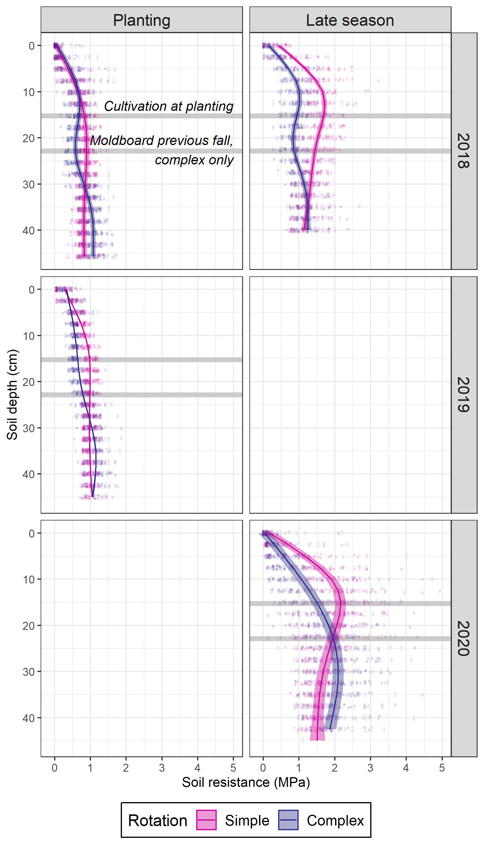

*Soil moisture*

In both years of measurement, the complex system’s soil moisture at 15 cm depth was significantly lower for the first month following planting (Fig. X). After that period, the effects were not consistent across years. In 2018, the complex rotation maize yielded 2 Mg ha-1 higher than the simple, and the soil moisture in the complex rotation was consistently lower. In 2019 there was not a significant difference in maize yields between the two systems, and the soil moisture values in the systems were statistically equivalent beginning one month following planting.

Figure ‑ Soil moisture at 15 cm depth in the maize phase of the complex and simple rotations; points represent individual sensor values, lines the estimated values and ribbons the 95% confidence interval around the estimates.

# Synthesis

The two cropping rotation systems

A study done with intact soil cores found resistances of only 0.26-0.47 reduced maize seeding root elongation by 50-60% in a (Bengough).

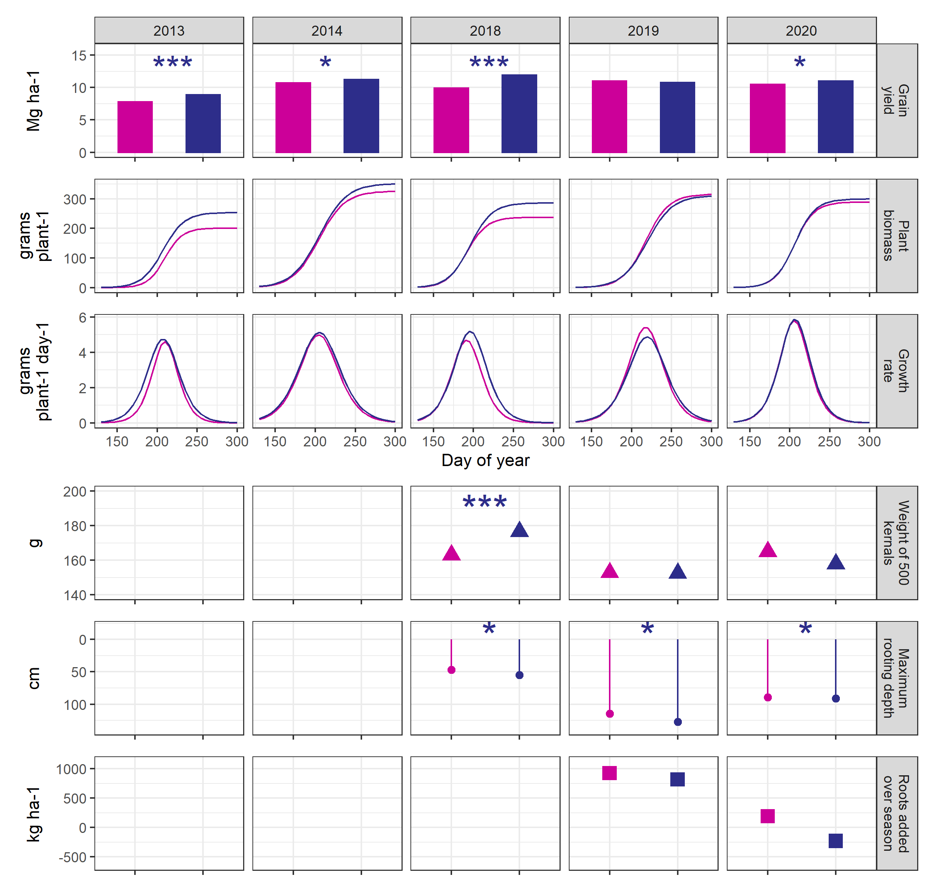

Could show root depth over time instead of maximum rooting depth

Results and Discussion?

From 2013-2020, maize grown in the complex rotation yielded X% more (X Mg ha-1) than maize grown in the simple rotation (p<X). In the five years with data available for growth analysis, biomass accumulation and growth patterns showed inconsistent timing for the growth advantage of the complex rotation maize, with one year showing an early season advantage (2013), one year a late season (2018), and no trend towards either in the remaining years. Harvest indices of the maize plants did not differ by rotation treatment in any year (data not shown).

We test the hypothesis that the complex-maize invests less resources into root growth, and concomitantly achieves a root system that is better able to take advantage of favorable conditions.

While the data is not conclusive, we find it is consistent with this hypothesis. In the two years when root biomass was measured, there was a greater increase in root material from the baseline level taken at planting in the simple-maize (at every timepoint?) compared to the complex-maize. Assuming the baseline material decayed at the same rates, this suggests the simple-maize added more root biomass over the growing season compared to the complex-maize. Despite the increased investments in simple-maize roots, the complex-maize root system was consistently deeper across the season, achieving a mean maximum rooting depth 10 cm deeper than the simple-maize root system.

The deeper rooting system was not always associated with higher grain yields; although the complex-maize root system was deeper in all three years of measurement, over those same years the complex- maize grain yields were X%, X%, and X% higher than the simple-maize, respectively. We therefore posit that the deeper root systems provide an opportunity for the crop to take *advantage* of favorable conditions for crop growth, but do not themselves *create* favorable conditions.

We observed significantly less soil penetration resistance in the 0-X cm soil profile at maize planting in the complex- versus simple-rotation. Neither system had resistances high enough to meaningfully impede root penetration, but in addition to physical constraints the lower resistances could be indicative of better aeration, and possibly better water drainage. Indeed, the soil water profiles showed drier soils after planting in the complex-rotation compared to the simple-rotation in both years of measurement. This is consistent with the lower bulk densities of the complex-rotation soils reported in previous studies (X). It is possible the drier soils are driving deeper root exploration in the complex-maize, or that higher soil temperatures promote faster growth (X). Additionally, some studies have shown ethylene build-up in soils can encourage thickening of roots and reduced branching (X). The better aerated soils in the complex-maize may be contributing to both the deeper exploration, and a lower resource demand for creating the root system. A previous study that measurement root length, rather than root mass, found the complex-maize had higher root lengths in the X-Xcm depth range compared to the simple-maize, again suggesting that the complex-maize root system is achieving a more efficient root system with less resource investment.

The highest yield advantage of complex-maize was observed in 2018. In that year, the complex-maize had higher later season growth rates, and the 500-kernal weight of the complex-maize was X g higher (p=xx) than the simple-maize.

# Supplementary Material

## Figure S1. Yields, biomass over time, growth rate over time, harvest index, 500-kernal grain weight

