Anything but simple:
Using models and field studies to explore the effects of cropping system diversification in the upper Midwestern United States

by

Virginia Anne Nichols

A dissertation submitted to the graduate faculty
in partial fulfillment of the requirements for the degree of
DOCTOR OF PHILOSOPHY

Major: Crop Production & Physiology

Program of Study Committee:
Sotirios Archontoulis, Co-major Professor
Matt Liebman, Co-major Professor
Jerry Hatfield
Michael Castellano
Jarad Niemi

The student author, whose presentation of the scholarship herein was approved by the program of study committee, is solely responsible for the content of this dissertation. The Graduate College will ensure this dissertation is globally accessible and will not permit alterations after a degree is conferred.

Iowa State University
Ames, Iowa
2021

Copyright © Virginia Anne Nichols, 2021. All rights reserved.

DEDICATION
This dissertation is dedicated to my mom, Janet Nichols, who has been unwavering in her support over the past four years. Although dedicating this work to you does not begin to express my thanks, it is a start. I also dedicate it to my brother, Dan Nichols, who is the smartest person I know, and who always reminds me there is more to learn. Finally, I would also like to dedicate this dissertation to the memory of my dad, John Nichols. I know he too would have been supportive, and my work will forever be influenced by his legacy of kindness to people and his belief that everyone has a right to enjoy being outside.

A model is something nobody believes except the person who built it, while data is something everyone believes except the person who collected it.
-Twitter

TABLE OF CONTENTS
Page
LIST OF FIGURES vii
LIST OF TABLES ix
ACKNOWLEDGMENTS x
ABSTRACT xiii
CHAPTER 1. GENERAL INTRODUCTION 1
References 4
CHAPTER 2. COVER CROPS AND WEED SUPPRESSION IN THE US MIDWEST: A META-ANALYSIS AND MODELING STUDY 7
Abstract 7
Introduction 8
Methods 9
Meta-analysis of weed-responses to cover crops 9
Simulation of cover crop biomass 10
Results 10
Meta-analysis results 10
Simulation model results 12
Discussion 13
Conclusions 15
References 16
Appendix 20
Data Availability 20
Supplementary Information 20
CHAPTER 3. EFFECTS OF LONG-TERM COVER CROPPING ON WEED SEEDBANKS 21
Abstract 21
Introduction 22
Methods and Materials 24
Site descriptions 24
Weed Seedbank Sampling 26
Germinable Seedbank Measurements 27
Cover crop biomass sampling 28
Data Analysis 29
Seedbank size 29
Seedbank community composition 31
Results 33
Weed seedbank size 33
Weed seedbank community 34
Risk of increasing seedbanks 38
Discussion 39
Cover crop interactions with waterhemp 39
Cover crop mechanisms of weed suppression 40
Cover crop effects on weed seed communities 41
Conclusions 42
References 43
Appendix 49
Data Availability Statement 49
Supplementary Material 50
CHAPTER 4. WINTER COVER CROPPING EFFECTS ON SOIL WATER STORAGE VARY BY SITE: FIELD MEASUREMENTS AND A PROPOSED CAUSAL MODEL 51
Abstract 51
Introduction 52
Materials and Methods 54
Site descriptions 54
Soil Sampling 57
Soil-water-retention curve 57
Soil Texture 58
Organic carbon 58
Statistical analysis 59
Results and Discussion 61
Soil texture, organic matter, and bulk density 61
Soil hydrological properties 63
Causal model 66
Conclusions 70
References 70
Appendix 76
Supplementary Information 76
CHAPTER 5. DOES DIVERSIFYING CROP ROTATIONS SUPPRESS WEEDS? A META-ANALYSIS. 77
Abstract 77
Introduction 78
Materials and Methods 79
Literature Search 79
Data extraction and processing 80
Data analysis 82
Results and discussion 83
Conclusions 90
References 91
Appendix 95
Supporting Information 95
CHAPTER 6. ARE ROOTS THE DRIVERS OF THE ROTATION EFFECT IN MAIZE? 96
Abstract 96
Introduction 97
Methods and Materials 100
Sampling 100
Statistical Analysis 101
Results 106
Grain yields and weather 106
Rooting depth and root mass 107
Growth analysis 109
Penetration resistance 109
Soil moisture 110
Discussion 110
Conclusion 113
References 113
Appendix 118
CHAPTER 7. GENERAL CONCLUSION 125

LIST OF FIGURES
Page
Figure 2-1. (Top) Factors significantly influencing weed responses 12
Figure 2-2. Effects of planting and termination dates on rye cover crop biomass 13
Figure 3-1. Weed seed densities for no cover and winter rye (Secale cereal) treatments 33
Figure 3-2. Differences in winter rye (Secale cereal) cover crop and no-cover treatments 36
Figure 3-3. Nonmetric multidimensional scaling (NMDS, stress = 0.102) applied to weed seedbank communities. 37
Figure 3-4. Risk of increased seedbanks under each cover crop treatment. 38
Figure 4-1 Map of Iowa showing locations of the three experimental sites (West, Central, East), with the Central site containing two trials. 55
Figure 4-2 Soil texture components varied by trial and cover crop treatment 62
Figure 4-3 Soil volumetric water contents 64
Figure 4-4 The Gardner equation was fit to each experimental unit, with four or five replicates for each cover crop treatment 66
Figure 4-5 Replicate (point) and treatment mean (bars) percentage macropores (>30 µm) for each trial; 67
Figure 4-6 Pathways by which cover crops may affect the pore size distributions, the amount of water stored at field capacity, and the amount of water at saturation in no-till systems 68
Figure 5-1. Map of meta-analysis study locations 80
Figure 5-2. Histogram of weed response (weed density and biomass) to diversifying from a simple rotation 84
Figure 5-3. Relationship between weed biomass and weed density (natural log scale) for studies (n=11) that reported both values. Line represents Spearman correlation fit. 85
Figure 5-4. Scaled importance of nine predictors for weed density response to increased rotational diversity. Variable importance derived from a generalized boosted regression tree. 86
Figure 5-5. Weed density and biomass responses to increased rotational diversity as affected by weed measurement unit and tillage system 87
Figure 6-1 Maize yields and growing season weather 107
Figure 6-2 Root mass added (root mass at maturity less root mass present at planting) at each soil depth 108

LIST OF TABLES
Page
Table 3-1 Summary of the four trials sampled 25
Table 3-2 Summary of herbicide active ingredients applied at each site 26
Table 3-3 Summary of weed species identified in this study in order of prevalence 35
Table 3-4 Estimates, standard errors (SEs), and p-values for models of diversity, richness, and evenness for each trial 37
Table 4-1 Geographical, experimental, soil, weather, and sampling information for the four trials 56
Table 4-2 Support for inclusion of causal relationships presented in Figure 4-6 69
Table 6-1 Summary of rotation managements 100
Table 6-2 Summary of measurements used for this study 103
Table 6-3 Summary of complex rotation’s effects on grain yields, growth analysis, and yield components for years with growth analysis data, ordered by magnitude of rotation effect 109

ACKNOWLEDGMENTS
It truly takes a village to get someone through graduate school, and I have many to acknowledge.
I must thank everyone directly involved in my education. I thank my PhD advisors: Matt Liebman was steadfastly dedicated to my success, and I sincerely thank him for his generosity in sharing time and resources, his honesty in sharing his experiences, and his philosophical guidance throughout my time at ISU. Sotirios Archontoulis was likewise fully dedicated to my success and I gratefully thank him for his patience, his encouragement, his support, and his wonderful Greek barbecues. I also thank my committee members: Jerry Hatfield for encouraging me to always think about how my research fits into the bigger picture; Michael Castellano for sending me opportunities, papers, and book recommendations; Jarad Niemi for teaching me what data management means and what a FOIA is; and Neil Huth for his ideas, thoughts, and approaches that were refreshingly un-burdened by US norms. I would also like to thank Fernando Miguez, who generously offered his time and knowledge to support my growth as a teacher and scientist. Phillip Dixon was a dedicated LunchinatoRs attendee, and helped me repeatedly with statistics questions with both gusto and grace. Heike Hoffman was a patient teacher and a thoughtful mentor who provided me with the opportunity to work with the Data Science for Public Good program, which expanded my research bubble considerably, and helped me remember the human dimensions of all research. Ranae Dietzel was my biggest fan, and brought me to tears with her kindness and support on multiple occasions. Stefan Gailans was always ready to talk shop and help me work out ideas on napkins, for which I am very grateful.
I also want to thank Mike Roberts for providing fresh reads of drafts and project ideas despite having little interest in agriculture, and Nate Ryan for being both supportive and reliably critical of my research; you both continually teach me what it means to be a good friend. Matt Herman likewise showed a surprising interest in everything I produced, and I am thankful for his encouragement and willingness to celebrate the small victories that make up an academic pursuit. I also want to thank Uncle Steve for supporting my interests in learning R and buying me the book that sent me down the path of creating R packages.
I want to thank the Practical Farmers of Iowa staff and members, both in general for the work they do to support Iowa farmers, and specifically for the work they did to support me and my work. Stefan Gailans, Sarah Carlson, and Lydia English made a concerted effort to integrate me into PFI’s network, and I am a better researcher for it. I would also like to thank Rob Stout, Sam Bennet, Keith Kohler, and Nathan Anderson, who took the time to talk to me about my work and to share their thoughts and experiences about farming. I also want to acknowledge Green Lands Blue Waters for creatively using their un-usable travel funds to support the Civic Scientist series and for the opportunity to participate in writing a white paper; these experiences added both breadth and depth to my education, and I am grateful for the opportunity and for the work they do.
I want to thank the Graduate Program in Sustainable Agriculture faculty and students for all the work they do, and for providing a welcoming community that enables a rich, diverse experience for students. Additionally, I thank the Liebman and Archontoulis lab members (former and current) for always taking an interest in my work and supporting me in any way they could. I also thank the Miguez lab members for allowing me to crash their book clubs. Cynthia Lidtke, Mary Anne Grapp, Mary Davis, Rita Brueland, Patrick Golus, Deb Hop, Michelle Miller, and Kevin Desjeans all went out of their way for me on numerous occasions, and did so with a smile.
I would also like to acknowledge the Ames community at large. Mustard Seed Community Farm, the Ames Bicycle Coalition, Ignite Yoga, and Food at First all provided me with opportunities to participate in the Ames community, for which I am inexpressibly grateful. In particular, I want to thank Jessica Nelson and Cole Dutter for spearheading the Food at First garden revival – that garden was a source of respite I may never be able to recreate. I would also like to acknowledge my friendly neighbor Susan for adding color to my life, and my landlord Mark Kassis for providing me with the motivation to learn about Iowa’s landlord-tenant laws. I must also acknowledge Chris and his Iowa Explorer’s Club for helping me see the treasures of the Iowan landscape and meet other Iowans who love the outdoors. Lastly, I would be remiss in forgetting to acknowledge the ISU Parking Division’s unwavering dedication to parking regulation enforcement, even during the COVID-19 pandemic.
Finally, there are numerous others who positively contributed to my PhD experience, and their names will come to me after this dissertation is published – thank you to the unnamed, and I apologize for lack of explicit inclusion.

ABSTRACT
Cropping systems are composed of a set of crops and their attendant management practices. Addition or removal of a crop from a cropping sequence results in both biophysical and managerial changes, creating complex interactions that can be difficult to study. Long-term field experiments provide a crucial resource for examining differences between cropping systems, and models (e.g., conceptual, process-based, statistical) can aid in dissecting complex problems and in distilling results into actionable gains in knowledge. In this dissertation, I used field studies and various models to look at two general categories of cropping sequence changes: (i) addition of a cover crop between cash crops (Chapters 2-4), and (ii) extension of rotation lengths through addition of cash crops (Chapters 5-6).
Over-wintering cover crops such as cereal rye (Secale cereale L.) present a potentially beneficial addition to cropping systems consisting of summer annuals, such as the maize (Zea mays L.)-soybean [Glycine max (L.) Merr.] rotation prevalent in the Midwestern United States (US). However, several questions regarding the impacts of this addition, particularly in the long-term, remain unanswered. My colleagues and I used a meta-analysis to synthesize the current state of knowledge regarding winter cover crops’ effects on weeds in maize-soybean rotations from studies conducted in the Midwestern US (Chapter 2). This analysis showed that, on average, cover cropping reduced weed biomass but had no effect on weed density. Additionally, using a process-based model, we found achieving sufficient cover crop biomass for significant weed suppression may be challenging within the managerial and climatic constraints of a Midwestern maize-soybean system. While we found no consistent effect of cover cropping on weed density, the majority of studies had been in place for less than three years. The most common Midwestern weed seeds persist in the soil for several years, suggesting the short-term nature of the studies may preclude detecting effects on weed densities. To address the lack of data on the effect of long-term cover crop on weeds, my colleagues and I used four rye cover crop experiments that had been in place at least 10 years (Chapter 3). We found long-term use of cover crops can significantly reduce weed seedbank densities compared to winter fallows. These reductions were driven by decreased numbers of waterhemp [Amaranthus tuberculatus (Moq.)] seeds, a problematic weed with resistance to multiple groups of herbicides, implying cover crops can be an effective complement to herbicide-based weed control. Through additional collaborations, we used these same four experiments to look at how cover crops alter soil structures in ways that affect soil hydrological parameters (Chapter 4). Using non-linear statistical models, we found the cover crop’s effect on the soil structure depended on the site, and by proposing a causal model we provided a framework for identifying measurements to help understand site-specific effects. This work helps to identify ways in which crop models could incorporate cover crops’ effects on soil structure to better predict how cover crop use can contribute to cash crop yield resilience.
Extending crop rotations through inclusion of additional cash crops has agronomic implications that are not well understood. In Chapter 5, we used a meta-analytic approach to quantify the effect of diversifying cash crop rotation on weed biomass and density and found a more consistent reduction in weed density compared to weed biomass. We used a statistical model to rank covariates in their ability to predict weed suppressiveness of a given rotation and identified the variation in months between planting activities (planting-interval-variation-index; PIVI) as a useful metric for describing cropping systems with respect to weed dynamics. In addition to impacting weeds, crop yields are also affected by extending crop rotations. In maize, as the number of years between maize crops increases, maize yields likewise increase. While this phenomenon is well-known and documented, its driving mechanisms have remained elusive. In Chapter 6 we used multiple years of field data collected from a long-term experiment to investigate differences in soil and crop characteristics that occur when a simple maize-soybean rotation is extended to a more complex 4-year rotation. We found maize roots in the extended rotation had maximum rooting depths 8 cm deeper than maize roots in the simpler rotation. Maximum rooting depth is a critical parameter in several cropping systems models, so this data supports improvement of these models in their ability to reflect complex cropping sequences and their effects on keystone crops such as maize.
In summary, we identified benefits and challenges to increasing cropping system complexity in the Midwest. Inclusion of cover crops in the traditionally winter fallow periods of Midwestern cropping systems can reduce weed pressure but has variable effects on soil structure and more context-specific information is needed to understand the factors driving this variability. Utilizing sequences of crops with different planting dates may help reduce weed densities, and examining root form and function of maize in different rotation sequences may provide insight into the drivers of the rotation effect in maize. Adjusting maize root characteristics in response to crop history may be a promising avenue for including these phenomena in process-based models. Overall, the work presented in this dissertation utilized novel approaches to leverage models and field data to advance our knowledge of the complex interactions involved in cropping systems research, providing significant contributions to the pursuit of more sustainable agricultural systems in the upper Midwestern US.

GENERAL INTRODUCTION
Over the past half-century, the upper Midwestern region of the United States (US) has undergone a drastic simplification of agricultural land management, mirroring changes seen in agricultural regions worldwide. In the Midwest, this simplification has occurred on several levels; landscapes are less patchworked, cropping systems include fewer crops, farm sizes have increased, and farm income sources are less diverse (MacDonald et al., 2013; Aguilar et al., 2015; Hijmans et al., 2016; USDA National Agricultural Statistics Service, 2020; Crossley et al., 2021). Much of this change has been driven and enabled by policies that value and reward specialization and efficiency (Mortensen and Smith, 2020). In much of the upper Midwest, the result has been a distillation of previously complex cropping systems integrated with natural areas into a landscape dominated by agriculture and specializing in just two annual crops: maize (Zea mays L.) and soybean [Glycine max (L.) Merr.].
This unrelenting drive towards simplification and efficiency has been unquestionably effective in achieving certain goals. Firstly, the upper Midwestern Corn Belt produces a large amount of agricultural products; the region contributes approximately one-third of the world’s yearly maize and soybean harvests, respectively, and is a significant producer of animal protein (FAO, 2020). Additionally, its production per unit land area is extremely high, routinely producing some of the highest rainfed crop yields on the globe. While production has increased dramatically, the percentage of the total population in the US living on farms has dropped from approximately 40% in the 1900s to less than 1% in 2020 (USDA National Agricultural Statistics Service, 2020), meaning the US requires fewer people to produce more product. However, there are trade-offs to these efficiencies, as we have defined them, including increased production risk, redistribution of rural populations to urban centers, and severely compromised environmental quality.
It is widely recognized in a variety of sectors there is a trade-off between efficiency and resiliency (Ackley, 2013; Martin, 2019; Gölgeci et al., 2020). This is because efficiency is achieved through optimal adaptation to an existing environment, while resilience requires the capacity to adapt to changes in an environment. The system characteristics that impart resilience (e.g., diversity, redundancy, reserve resource stocks, spare capacity) are undesirable from an efficiency standpoint (Korhonen and Seager, 2008). One could argue that while agricultural systems in the US are extremely efficient, they are not resilient. Lack of resilience can manifest as increased exposure to risk. On the farm level, producers are exposed to increasing amounts of risk in five major categories: production risk, market risk, institutional risk, personal risk, and financial risk (Komarek et al., 2020). The increased producer risk associated with these highly efficient systems has largely been recompensed through government programs. The US government subsidizes insuring precariously simple crop portfolios that have higher risk of failure (e.g., Bowles et al., 2020) and provides Market Facilitation Payments to compensate for the simplified system’s sensitivity to inevitable market volatility (e.g., Environmental Working Group, 2020). For example, in 2020 direct government aid accounted for 39% of net farm income (Schnepf and Rosch, 2020).
There are currently efforts to change government subsidy programs so as to reward what are thought to be more resilient cropping systems (e.g., Woodward and Marlow, 2017; Herzberger, 2019). However, defining and designing resilient cropping systems requires a deep understanding of the mechanisms that impart resilience. Despite a rich body of literature showing diversifying cropping systems offers numerous benefits (Hunt et al., 2017, 2019, 2020; Weisberger et al., 2019; Tamburini et al., 2020), there is still a lack of mechanistic understanding concerning how these benefits are manifested on local scales. While there are significant barriers to using crop diversification as a tool for increased resilience that cannot be addressed with agronomic research (Mortensen and Smith, 2020; Weisberger et al., 2021), increasing knowledge concerning the mechanisms through which cropping system diversity can impart agronomic resilience is important. In addition to reducing producer risk, shifting towards production systems that are more resilient may also ameliorate unintended reductions in environmental quality and rural quality of life that have accompanied simplified agricultural systems in this region (Arbuckle and Kast, 2007; Peters, 2002).
As cropping systems increase in complexity, the complexity of researching those systems likewise increases. Cropping system research has historically benefited from tools such as process-based modelling, meta-analyses, and causal models, but as those fields continue to advance, their potential to address agricultural problems remains largely untapped. Furthermore, cropping system research is inherently noisy, with large amounts of both year-to-year variability and within-field variability that requires more data to detect signals. Additionally, questions of resilience often require answering questions about the variability of yields, which is a second-order statistic and thus requires more data to be accurately estimated and compared. Leveraging analytical tools and long-term data is arguably one of the most effective ways to approach cropping systems research and to further our understanding of resilience.
This work seeks to use a variety of tools to understand how cropping system diversification changes agronomic performance, with a focus on metrics that relate to cropping system resilience – the ability to perform well in uncertain conditions. This research utilizes meta-analyses, process-based model predictions, long-term research plots, and causal models to extract generalizable trends and identify targeted measurements to advance the state of knowledge regarding the benefits and challenges of cropping system diversification in the upper Midwestern US.

References
Ackley, D.H. 2013. Beyond efficiency. Communications of the ACM 56(10): 38–40. doi: 10.1145/2505340.
Aguilar, J., G.G. Gramig, J.R. Hendrickson, D.W. Archer, F. Forcella, et al. 2015. Crop species diversity changes in the United States: 1978–2012. PLOS ONE 10(8): e0136580. doi: 10.1371/JOURNAL.PONE.0136580.
Arbuckle, J., and C. Kast. 2007. Quality of life on the agricultural treadmill: Individual and community determinants of farm family well-being. Journal of Rural Social Sciences 27(1). https://egrove.olemiss.edu/jrss/vol27/iss1/4 (accessed August 2021).
Bowles, T.M., M. Mooshammer, Y. Socolar, F. Calderón, M.A. Cavigelli, et al. 2020. Long-term evidence shows that crop-rotation diversification increases agricultural resilience to adverse growing conditions in North America. One Earth 2(3): 284–293. doi: 10.1016/j.oneear.2020.02.007.
Crossley, M.S., K.D. Burke, S.D. Schoville, and V.C. Radeloff. 2021. Recent collapse of crop belts and declining diversity of US agriculture since 1840. Global Change Biology 27(1): 151–164. doi: 10.1111/GCB.15396.
Environmental Working Group. 2020. Farm Subsidy Database. https://farm.ewg.org/ (accessed August 2021).
Food and Agriculture Organization of the United Nations (FAO). 2020. FAOSTAT Statistical Database. [Rome] FAO. Accessed August 2021. http://www.fao.org/faostat/en/#home
Gölgeci, I., H.E. Yildiz, and U. Andersson. 2020. The rising tensions between efficiency and resilience in global value chains in the post-COVID-19 world. Transnational Corporations Journal 27(2).
Herzberger, A. 2019. Integrated crop-livestock systems: Strategies to reduce risk and increase farm resilience. AGree. https://foodandagpolicy.org/wp-content/uploads/sites/4/2019/09/2019-April-Integrated-Crop-Livestock-Systems_Strategies-to-Reduce-Risk-Increase-Farm-Resilience.pdf. (Accessed Aug 2021)
Hijmans, R.J., H. Choe, and J. Perlman. 2016. Spatiotemporal patterns of field crop diversity in the United States, 1870–2012. Agricultural & Environmental Letters 1(1): 160022. doi: 10.2134/AEL2016.05.0022.
Hunt, N.D., J.D. Hill, and M. Liebman. 2017. Reducing freshwater toxicity while maintaining weed control, profits, and productivity: Effects of increased crop rotation diversity and reduced herbicide usage. Environmental Science and Technology 51(3): 1707–1717. doi: 10.1021/ACS.EST.6B04086.
Hunt, N.D., J.D. Hill, and M. Liebman. 2019. Cropping system diversity effects on nutrient discharge, soil erosion, and agronomic performance. Environmental Science and Technology 53(3): 1344–1352. doi: 10.1021/ACS.EST.8B02193.
Hunt, N., M. Liebman, S. Thakrar, and J. Hill. 2020. Fossil energy use, climate change impacts, and air quality-related human health damages of conventional and diversified cropping systems in Iowa, USA. Environmental science & technology 54(18): 11002–11014. doi: 10.1021/ACS.EST.9B06929.
Komarek, A.M., A. de Pinto, and V.H. Smith. 2020. A review of types of risks in agriculture: What we know and what we need to know. Agricultural Systems 178: 102738. doi: 10.1016/J.AGSY.2019.102738.
Korhonen, J., and T.P. Seager. 2008. Beyond eco-efficiency: A resilience perspective. Business Strategy and the Environment 17(7): 411–419. doi: 10.1002/BSE.635.
Martin, R.L. 2019. The high price of efficiency. Harvard Business Review 97(1): 42–55.
MacDonald, J.M., Korb, P. and Hoppe, R.A. 2013. Farm size and the organization of US crop farming (No. 1477-2017-3987). https://ageconsearch.umn.edu/record/262221/ (accessed August 2021).
Mortensen, D.A., and R.G. Smith. 2020. Confronting barriers to cropping system diversification. Frontiers in Sustainable Food Systems 4. doi: 10.3389/FSUFS.2020.564197/PDF.
Peters, D.J. 2002. Revisiting the Goldschmidt Hypothesis: The effect of economic structure on socioeconomic conditions in the rural Midwest. Missouri Department of Economic Development. https://www.researchgate.net/publication/228858680 (accessed August 2021).
Schnepf, R., and S. Rosch. 2020. U.S. Farm Income Outlook: December 2020 Forecast. Congressional Research Service. https://crsreports.congress.gov/product/pdf/R/R46676 (Accessed August 2021).
Tamburini, G., R. Bommarco, T.C. Wanger, C. Kremen, M.G.A. van der Heijden, et al. 2020. Agricultural diversification promotes multiple ecosystem services without compromising yield. Science Advances 6(45): eaba1715. https://advances.sciencemag.org/lookup/doi/10.1126/sciadv.aba1715.
USDA National Agricultural Statistics Service. 2020. NASS - Quick Stats. . https://data.nal.usda.gov/dataset/nass-quick-stats (accessed August 2021).
Weisberger, D.A., M.D. McDaniel, J.G. Arbuckle, and M. Liebman. 2021. Farmer perspectives on benefits of and barriers to extended crop rotations in Iowa, USA. Agricultural & Environmental Letters 6(2): e20049. doi: 10.1002/AEL2.20049.
Weisberger, D., V. Nichols, and M. Liebman. 2019. Does diversifying crop rotations suppress weeds? A meta-analysis. PLoS ONE 14(7): 1–12. doi: 10.1371/journal.pone.0219847.
Woodard, J.D., and S. Marlow. 2017. Crop insurance, credit, and conservation. AGree. https://foodandagpolicy.org/wp-content/uploads/sites/4/2019/09/2017-April-Crop-Insurance-Credit-and-Conservation.pdf. (Accessed August 2021).

COVER CROPS AND WEED SUPPRESSION IN THE US MIDWEST: A META-ANALYSIS AND MODELING STUDY
Virginia Nichols¹, Rafael Martinez-Feria², David Weisberger³, Sarah Carlson⁴, Bruno Basso^{2,5}, Andrea Basche⁶
¹Department of Agronomy, Iowa State University
² Department of Earth and Environmental Sciences, Michigan State University
³Department of Crop and Soil Sciences, University of Georgia
⁴Practical Farmers of Iowa
⁵W.K. Kellogg Biological Station, Michigan State University
⁶Department of Agronomy and Horticulture, University of Nebraska - Lincoln
Modified from a manuscript published in Agricultural & Environmental Letters

Abstract
In addition to soil health and conservation benefits, cover crops (CCs) may offer weed control in the Midwestern United States (Midwest), but individual studies report varying effects. We conducted a meta-analysis of studies measuring weed biomass (WBIO) or density (WDEN) in paired CC and no-cover treatments in corn (Zea mays L.)-soybean (Glycine max [L.] Merr) rotations in the Midwest. Fifteen studies provided 123 paired comparisons of WBIO and 119 of WDEN. Only grass CCs significantly reduced WBIO, while no CC reduced WDEN. We found no evidence CC management factors (e.g., termination method) directly impacted outcomes. Our dataset showed a 75% reduction in WBIO requires at least 5 Mg ha⁻¹ of CC. Simulations from a process-based model (SALUS) indicated achieving 5 Mg ha⁻¹ requires substantially earlier fall planting and later spring termination in most years, conflicting with typical cash-crop planting and harvesting. We conclude CCs significantly reduce WBIO, but current CC management constraints render these reductions variable and uncertain.

Introduction
Winter annual cover crops (CCs) have been heavily promoted in the Midwestern ‘Corn Belt’ region of the United States (Midwest) due to an increasing need for practices that enhance soil health and water quality. Despite clear environmental benefits (Daryanto et al., 2018; Kaspar and Singer, 2011), less than 10% of Midwestern cropland is currently managed with CCs (Seifert et al., 2018). The lack of short-term economic returns from growing CCs overwhelms long-term environmental benefits, creating a major barrier to wide adoption (Plastina et al., 2018; Roesch-Mcnally et al., 2018). If CCs can reduce weed management costs, this could provide immediate monetary incentives for adoption. Previous literature syntheses have found CCs reduce weed pressure across various cropping systems, but the direction and magnitude of effects are context-specific (Osipitan et al., 2018). Given its ubiquity and significance in the Midwest, the corn (Zea mays L.)-soybean (Glycine max [L.] Merr) production system merits explicit examination. Unfavorable fall/winter climatic conditions in the Midwest are known to limit CC establishment and growth (Baker and Griffis, 2009; Strock et al., 2004), which in turn may affect factors governing CC performance relative to weed management. Region-specific analyses can provide more precise CC biomass (CCBIO) production targets for weed suppression (Baraibar et al., 2018; Mirsky et al., 2013) and explore how planting or termination timing affects the feasibility of achieving those targets.
To address these gaps, we synthesized data from published field studies measuring weed responses to CCs in corn-soybean systems in the Midwest. Our objectives were to (1) quantify how environmental conditions and management practices affect weed responses to CCs, (2) identify Midwest-specific CCBIO targets for providing significant weed suppression; and (3) evaluate the feasibility of achieving these targets under different CC planting/termination scenarios.

Methods

Meta-analysis of weed-responses to cover crops
We conducted a systematic search of literature using ISI Web of Knowledge (WoS, available online) Core Collection and CAB Direct databases. Search details are in supplementary text, including a PRISMA diagram and list of included publications (S1). In our database, we included weed biomass (WBIO), weed density (WDEN), and cash-crop yield as response variables. We recorded values in a paired format, requiring each pair of response variables to be measured in the same crop at the same time with all aspects of management held constant except for a treatment of a fall-planted CC. Ancillary data included geographical location, climate, and soil characteristics of the study site; cash-crop and CC management including species, tillage system, planting and termination methods and dates; and experimental information such as timing of weed measurements and type of weed (S1). The complete database is published and available on Iowa State University’s DataShare platform (Nichols et al., 2020).
All data manipulation and statistical modelling were done in R version 3.6.1 (R Core Team) using the tidyverse meta-package (Wickham et al., 2019) and others (Grolemund and Wickham, 2011; Firke, 2019). A detailed account of statistical methods is presented in supplementary material (S2), and all R code is available on github at (https://github.com/vanichols/ccweedmeta-analysis). In brief, all statistical models used the log-transformed response ratio (measurement in the CC-treatment over measurement in the no-cover treatment) as the response variable (Gurevitch et al., 2018). Mixed-effect models were used with the modifier of interest as a fixed effect and a random intercept for each study using non-parametric weighting based on the number of replicates (Adams et al., 1997). All linear models were fit using the lme4 package (Bates et al., 2015), and results were analyzed using lmerTest (Kuznetsova et al., 2017) and emmeans (Lenth et al., 2018). Means and 95% confidence intervals were back-transformed for reporting purposes. To identify suites of practices predictive of achieving both a reduction in weeds and an increase in cash-crop yield with CCs, we fit random forest models (Kuhn and Johnson, 2013) using several R packages (Hothorn et al., 2006). All statistical results are in supplementary materials (S3).

Simulation of cover crop biomass
To investigate the feasibility of growing CCs for effective weed control in the Midwest, we used the System Approach to Land Use Sustainability (SALUS) model (Basso and Ritchie, 2015) to simulate winter rye (Secale cereale L.) biomass across a range of soils and weather conditions of the Midwest. Rye is the most prevalent CC species used in the Midwest (Singer, 2008) and represents the best choice for maximizing CCBIO production in this region (Appelgate et al., 2017; Ruis et al., 2019). Specific simulation details are provided in supplementary text (S4). Three CC planting dates were explored: 15-Sep (optimistic), 7-Oct (realistic), and 1-Nov (late).

Results

Meta-analysis results
Fifteen articles fit our criteria, producing 123 response ratios for WBIO and 119 response ratios for WDEN (Nichols et al., 2020). The studies include a range of site characteristics and management representative of Midwestern corn-soybean production systems (S1). Overall, CCs significantly reduced WBIO (p=0.02), which was robust against publication bias (>3000 unpublished null-studies needed; Rosenthal, 1979) and the removal of individual studies (p-values ranged from 0.01-0.04). There was no evidence CCs reduced WDEN (p=0.98). Neither WBIO nor WDEN responses were affected by the subsequent cash-crop (corn or soybean), meaning the response of weeds to CCs was not confounded by differences in cash-crop competition with weeds.
The following categorical modifiers had levels with significantly different effects on WBIO (Figure 2-1): CC type (after controlling for CCBIO production; grass, non-grass), measurement in reference to cash-crop planting (before, after), and weed growth habit (winter annual, summer annual, perennial). WDEN had no significant modifiers. For WBIO, grass monoculture CCs reduced WBIO by 68% (CI:41-82%) compared to a non-significant reduction of 33% for mixtures and other types of CCs (p<0.01; Figure 2-1). Measurements taken before cash-crop planting showed a 74% (CI:51-85%) reduction in WBIO, compared to only 44% (CI:12-64%) in measurements taken after planting (p<0.01). Winter annual weeds showed the largest reductions (65%; CI:27-83%), followed by summer annuals (47%; CI:10-68%), with perennial weeds being unaffected by CCs.
Weed suppression was significantly affected by CCBIO for both WBIO (p=0.03) and WDEN (p<0.01). We found an estimated 5 Mg ha⁻¹ of CCBIO at termination reduced WBIO by 75% for grass CCs, but only 40% for other CCs (Figure 2-1). The response of WBIO/WDEN to CC did not depend on any other modifiers tested. A full list of non-significant modifiers can be found in supplemental material (S3) and included production system tillage regime; CC planting/termination method; termination-planting gap; study-site latitude, aridity, and soil type.
In our database only 23% of the comparisons exhibited a ‘win-win’ situation, with a concomitant increase in cash-crop yield and decrease in weed pressure (Figure 2-1). Using a random forest model, we found no scenarios that were strong predictors of whether an observation would fall in the win-win category, suggesting maximizing cash-crop yields and weed suppression may not have overlapping CC management strategies.

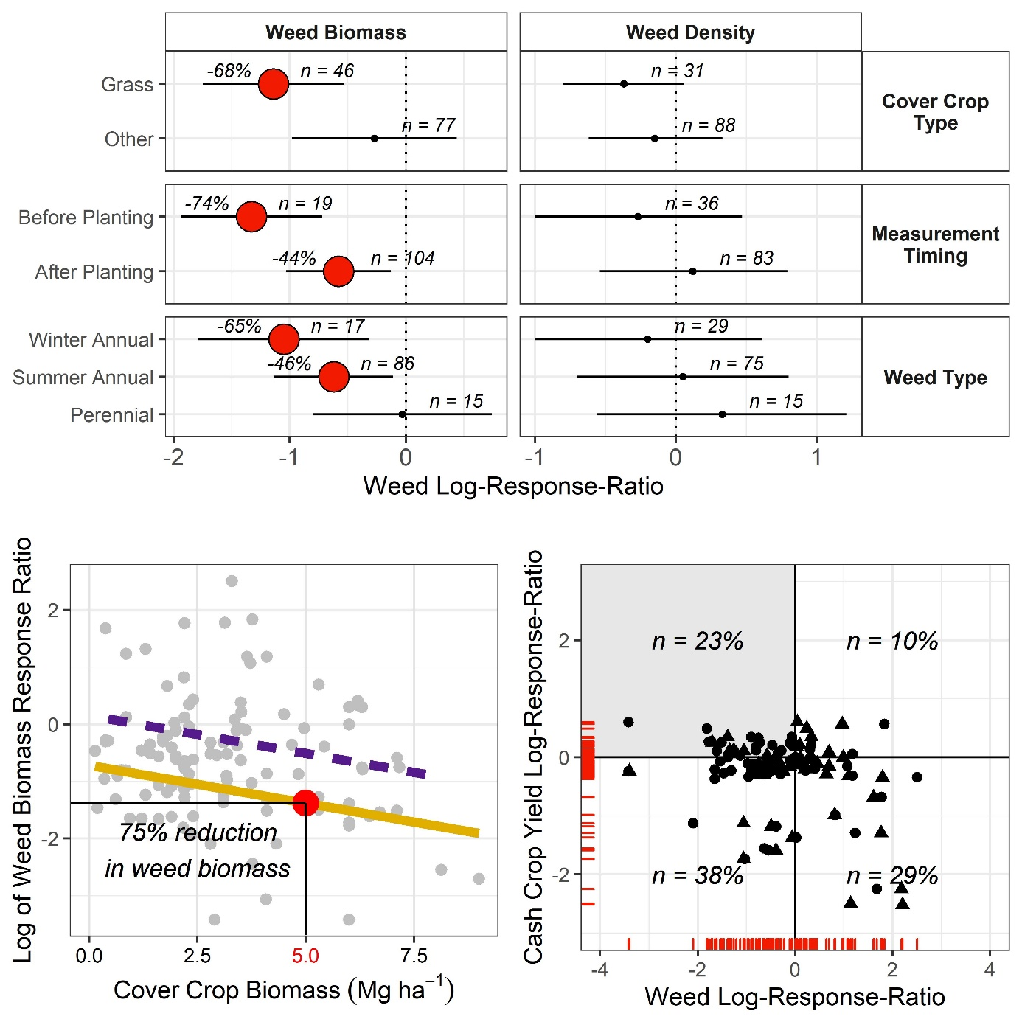
Figure 2-1. (Top) Factors significantly influencing weed responses

(Bottom left) Linear regressions of weed biomass to grass (yellow solid) and other (dotted purple) cover crop biomass. (Bottom right) Effect of cover crop on cash-crop yields and weed biomass (circles) or weed density (triangles), with positive results making up 23% of the points (gray quadrant).

Simulation model results
For the ‘realistic’ planting date (7-Oct), 2% of counties achieved 5 Mg ha⁻¹ by 1-May in ≥ 80% of the weather-years, increasing to only 30% under an ’optimistic’ CC-planting scenario (15-Sep; Figure 2-2). With ‘late’ planting (1-Nov), none of the counties reached the threshold by 1-May, and only half did so by 1-Jul. Aggregated on a state-level, Illinois, Missouri, and Kansas were the only states that could consistently achieve 5 Mg ha⁻¹ of biomass before typical cash-crop planting dates of early May with ’optimistic’ CC planting dates (Figure 2-2).
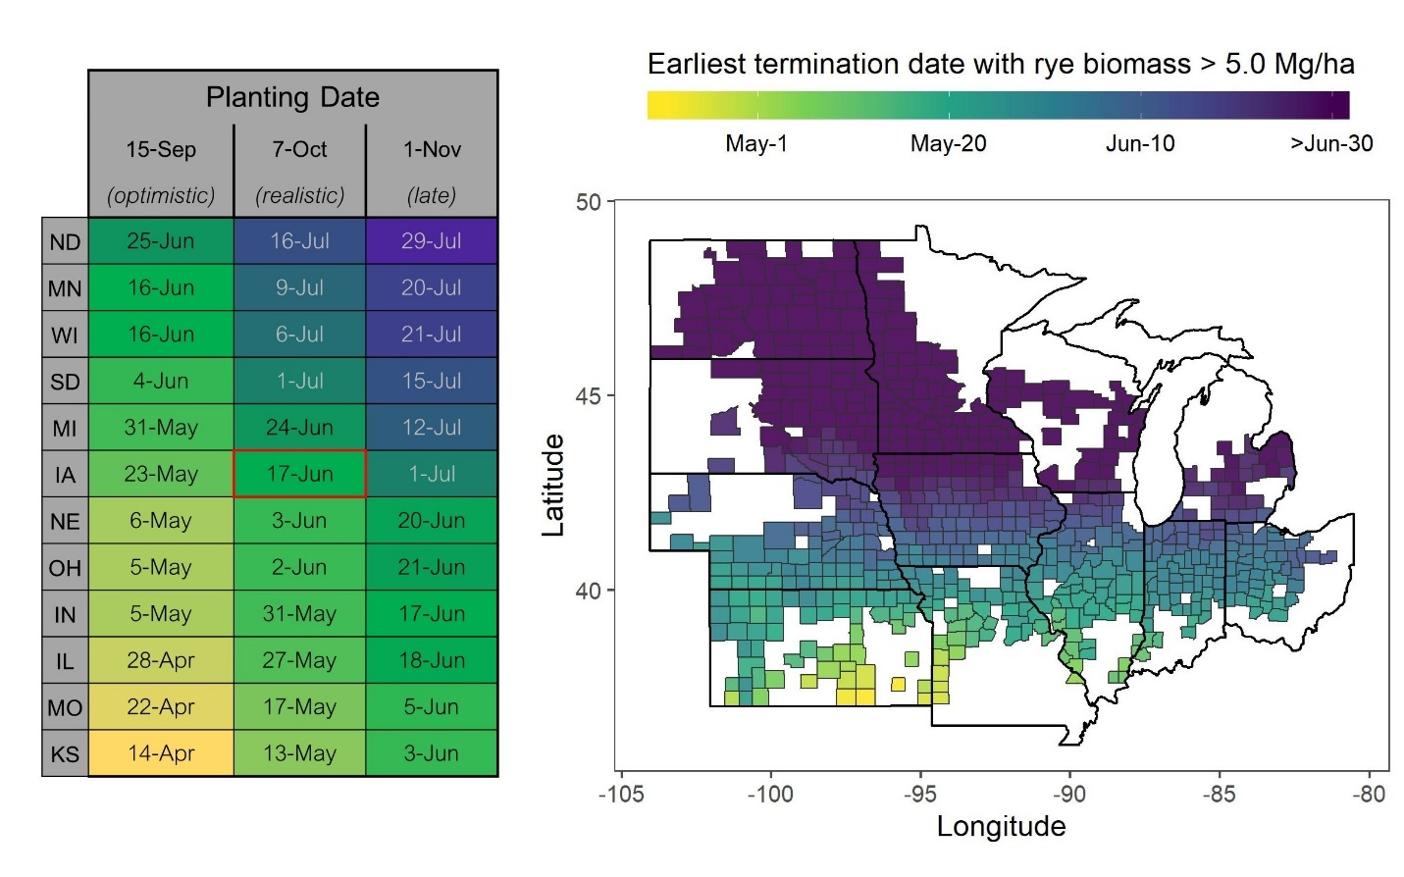
Figure 2-2. Effects of planting and termination dates on rye cover crop biomass

(Left) Earliest termination dates with rye cover crop biomass greater than 5 Mg ha⁻¹ in 80% of simulations based on 30-year historical weather data. (Right) Visualization of results averaged by county for the 7-Oct planting scenario.

Discussion
Cover crops affect weeds through interference mechanisms of resource competition and allelopathy (Teasdale and Mohler, 1993), delaying weed germination and development that manifests as lower WBIO. Management that disrupts rather than interferes with weed trajectories, such as crop rotation, may be more effective at reducing WDEN (Weisberger et al., 2019). However, given that reductions in WBIO can increase susceptibility to herbicides (Wallace et al., 2019) and weed size is directly related to seed output (Thompson et al., 1991), reductions in WDEN may be possible with long-term CC-use. More long-term (> 5 years) work is needed to answer this question.
Monocultures of grass CCs significantly reduced WBIO (by 68%), while other CCs did not (Fig. 1), consistent with recent studies (MacLaren et al., 2019; Smith et al., 2020). Cover-crops interfere with weeds via physical and chemical means, and grasses such as rye may be more effective than legumes and brassicas at both (Creamer et al., 1996; Smith et al., 2020). Furthermore, higher carbon-to-nitrogen ratios of grass CCs (Martinez-Feria et al., 2019; Quemada and Cabrera, 1995) potentially increase residence time of residue and thus suppress weeds longer after CC termination (Ruffo and Bollero, 2003; Teasdale and Mohler, 1993).
While CCs had a stronger effect on weeds before cash-crop planting (Figure 2-1), weeds measured after planting are likely of more interest to producers, as they directly represent resource competition with the cash-crop. The stronger reduction in winter annual weeds is not surprising, given the winter growth period of the CC.
The environmental context of the studies had no significant effect on the weed responses nor on CCBIO. This could simply reflect the lack of plot specific information (Eagle et al., 2017; Gerstner et al., 2017), but does suggest environmental context has only an indirect effect on CC-mediated weed suppression.
To prevent an increase in weed seedbanks, reductions in WDEN of 90% (comparable to herbicide effectiveness) are needed (Liebman and Nichols, 2020); our study shows even with 5 Mg ha-1 of CCBIO producers are unlikely to achieve this level of weed control, consistent with studies from other areas (Baraibar et al., 2018; Mirsky et al., 2013). Moreover, our SALUS simulations indicate achieving 5 Mg ha⁻¹ of rye CCBIO regularly under typical Midwest production scenarios and climates would be challenging (Figure 2-2). Even with optimistic CC planting dates (15-Sep), achieving 5 Mg ha⁻¹ of CCBIO would require a mid-May or later termination date most years (≥80%) in the majority of counties, well after typical cash-crop planting dates. It should be noted our simulations assumed direct CC seeding with uniform germination (S4) and are therefore not to be extrapolated to other planting methods. While aerial- or inter-seeding can be used to establish CCs into standing crops, these methods are often unreliable (Wilson et al., 2014), and standing crops prevent full sunlight penetration for CC growth well into October. Delayed corn and soybean planting consistently reduces yields (Baum et al., 2019; De Bruin and Pedersen, 2008), and delayed CC termination could be hindered by concerns over crop insurance eligibility (USDA-NRCS, 2019). High CCBIO production could increase other ecosystem services (Blanco-Canqui et al., 2015; Thapa et al., 2018), but may also introduce issues with nitrogen immobilization and CC termination (Whalen et al., 2020). Other studies have examined the effects of CCs on subsequent cash-crop yields (Marcillo and Miguez, 2017), showing no yield benefit from grass CCs. Choosing a CC species to maximize cash-crop yields versus weed suppression may be at odds, and while no-till may amplify yield responses (Marcillo and Miguez 2017) it may not enhance weed control from CCs. The existence of these tradeoffs is supported by the low percentage of observations with a ‘win-win’ scenario (Figure 2-1) in our database.

Conclusions
Our study, which synthesized work from the ‘Corn Belt’ region of the US Midwest, shows grass CCs effectively reduce WBIO. We estimated 5 Mg ha⁻¹ of grass CCBIO decreases WBIO by 75%, a threshold at which reduction of herbicide-use is possible, but not always advisable. Furthermore, consistently achieving that level of CCBIO in the Midwest may not be feasible within the traditional corn/soybean fallow season. In our dataset, concomitant increases in yields and decreases in weeds with the use of CCs were minimal, highlighting the need to evaluate CC practices using multiple metrics. Therefore, we conclude that although CCs significantly reduce WBIO, which may render other weed management strategies more effective and reduce WDEN in the long-term, current CC management does not consistently suppress weeds. Optimizing CCs for weed suppression will entail both agronomic (e.g., use of different cash-crop maturity groups) and policy (change in insurance structure around CC termination requirements) changes at a broad scale.

References
Adams, D.C., J. Gurevitch, and M.S. Rosenberg. 1997. Resampling tests for meta-analysis of ecological data. Ecol. 78(5): 1277–1283
Appelgate, S.R., A.W. Lenssen, M.H. Wiedenhoeft, and T.C. Kaspar. 2017. Cover crop options and mixes for upper midwest corn–soybean systems. Agron. J. 109(3): 968–984. doi: 10.2134/agronj2016.08.0453.
Baker, J.M., and T.J. Griffis. 2009. Evaluating the potential use of winter cover crops in corn-soybean systems for sustainable co-production of food and fuel. Agric. For. Meteorol. 149(12): 2120–2132. doi: 10.1016/j.agrformet.2009.05.017.
Baraibar, B., D.A. Mortensen, M.C. Hunter, M.E. Barbercheck, J.P. Kaye, et al. 2018. Growing degree days and cover crop type explain weed biomass in winter cover crops. Agron. Sustain. Dev. 38(6): 1–9. doi: 10.1007/s13593-018-0543-1.
Basso, B., and J.T. Ritchie. 2015. Simulating crop growth and biogeochemcial fluxes in response to land management using the SALUS model. The Ecology of Agricultural Landscapes: Long-term Research on the Path to Sustainability. Oxford University Press, New York, NY USA. p. 252–274
Bates, D., M. Mächler, B. Bolker, and S. Walker. 2015. Fitting linear mixed-effects models using lme4. J. Stat. Softw. 67(1): 1–48. doi: 10.18637/jss.v067.i01.
Baum, M.E., S. V. Archontoulis, and M.A. Licht. 2019. Planting date, hybrid maturity, and weather effects on maize yield and crop stage. Agron. J. 111(1): 303–313. doi: 10.2134/agronj2018.04.0297.
Blanco-Canqui, H., T.M. Shaver, J.L. Lindquist, C.A. Shapiro, R.W. Elmore, et al. 2015. Cover crops and ecosystem services: Insights from studies in temperate soils. Agron. J. 107(6): 2449–2474. doi: 10.2134/agronj15.0086.
De Bruin, J.L., and P. Pedersen. 2008. Soybean seed yield response to planting date and seeding rate in the upper midwest. Agron. J. 100(3): 696–703. doi: 10.2134/agronj2007.0115.
Creamer, N.G., M.A. Bennett, B.R. Stinner, J. Cardina, and E.E. Regnier. 1996. Mechanisms of weed suppression in cover crop-based production systems. HortScience 31(3): 410–413. doi: 10.21273/hortsci.31.3.410.
Daryanto, S., B. Fu, L. Wang, P.A. Jacinthe, and W. Zhao. 2018. Quantitative synthesis on the ecosystem services of cover crops. Earth-Science Rev. 185: 357–373. doi: 10.1016/j.earscirev.2018.06.013.
Eagle, A.J., L.E. Christianson, R.L. Cook, R.D. Harmel, F.E. Miguez, et al. 2017. Meta-analysis constrained by data: Recommendations to improve relevance of nutrient management research. Agron. J. 109(6): 2441–2449. doi: 10.2134/agronj2017.04.0215.
Firke, S. 2019. janitor: Simple tools for examining and cleaning dirty data. Comprehensive R Archive Network (CRAN). https://cran.r-project.org/package=janitor.
Gerstner, K., D. Moreno-Mateos, J. Gurevitch, M. Beckmann, S. Kambach, et al. 2017. Will your paper be used in a meta-analysis? Make the reach of your research broader and longer lasting (D. Warton, editor). Methods Ecol. Evol. 8(6): 777–784. doi: 10.1111/2041-210X.12758.
Grolemund, G., and H. Wickham. 2011. Dates and times made easy with lubridate. J. Stat. Softw. 40(3). doi: 10.18637/jss.v040.i03.
Gurevitch, J., J. Koricheva, S. Nakagawa, and G. Stewart. 2018. Meta-analysis and the science of research synthesis. Nature 555(7695): 175–182. doi: 10.1038/nature25753.
Hothorn, T., K. Hornik, A. Zeileis, K.H. and A.Z. Torsten Hothorn, T. Hothorn, et al. 2006. Unbiased recursive partitioning: A conditional inference framework. J. Comput. Graph. Stat. 15(3): 651–674. doi: 10.1198/106186006X133933.
Kaspar, T., and J. Singer. 2011. The use of cover crops to manage soil. Publications from the USDA-ARS/UNL Faculty. p. 1382. https://digitalcommons.unl.edu/usdaarsfacpub/1382/ (Accessed August 2021).
Kuhn, M., and K. Johnson. 2013. Applied predictive modeling. Vol. 26. Springer, New York.
Kuznetsova, A., P.B. Brockhoff, and R.H.B. Christensen. 2017. lmerTest Package: Tests in linear mixed effects models. J. Stat. Softw. 82(13). doi: 10.18637/jss.v082.i13.
Lenth, R., H. Singmann, and J. Love. 2018. Emmeans: Estimated maringal means, aka least-squares means. Comprehensive R Archive Network (CRAN). https://cran.r-project.org/web/packages/emmeans/index.html
Liebman, M. and V. Nichols. 2020. Cropping system redesign for improved weed management: A modeling approach illustrated with Giant Ragweed (Ambrosia trifida). Agronomy 10(2): 262. doi: 10.3390/agronomy10020262.
MacLaren, C., P. Swanepoel, J. Bennett, J. Wright, and K. Dehnen-Schmutz. 2019. Cover crop biomass production is more important than diversity for weed suppression. Crop Sci. 59(2): 733–748. doi: 10.2135/cropsci2018.05.0329.
Marcillo, G.S, and F.E. Miguez. 2017. Corn yield response to winter cover crops: An updated meta-analysis. J. Soil Water Conserv. 72(3): 226–239. doi: 10.2489/jswc.72.3.226.
Martinez-Feria, R., V. Nichols, B. Basso, and S. Archontoulis. 2019. Can multi-strategy management stabilize nitrate leaching under increasing rainfall? Environ. Res. Lett. 14(12): 124079. doi: 10.1088/1748-9326/ab5ca8.
Mirsky, S.B., M.R. Ryan, J.R. Teasdale, W.S. Curran, C.S. Reberg-Horton, et al. 2013. Overcoming weed management challenges in cover crop–based organic rotational no-till soybean production in the Eastern United States. Weed Technol. 27(1): 193–203. doi: 10.1614/wt-d-12-00078.1.
Nichols, V., A.D. Basche, and D. Weisberger. 2020. Effect of cover crops on weed biomass and density in the US Midwest Corn Belt meta-analysis dataset. Iowa State Univ. Dataset. doi: 10.25380/iastate.11933214.v1.
Osipitan, O.A., J.A. Dille, Y. Assefa, and S.Z. Knezevic. 2018. Cover crop for early season weed suppression in crops: Systematic review and meta-analysis. Agron. J. 110(6): 2211–2221. doi: 10.2134/agronj2017.12.0752.
Plastina, A., F. Liu, F. Miguez, and S. Carlson. 2018. Cover crops use in Midwestern US agriculture: perceived benefits and net returns. Renew. Agric. Food Syst.: 1–11. doi: 10.1017/S1742170518000194.
Quemada, M., and M.L. Cabrera. 1995. Carbon and nitrogen mineralized from leaves and stems of four cover crops. Soil Sci. Soc. Am. J. 59(2): 471–477. doi: 10.2136/sssaj1995.03615995005900020029x.
R Core Team. R: A language and environment for statistical computing. R Foundation for Statistical Computing, Vienna, Austria.
Roesch-Mcnally, G.E., A.D. Basche, J.G. Arbuckle, J.C. Tyndall, F.E. Miguez, et al. 2018. The trouble with cover crops: Farmers’ experiences with overcoming barriers to adoption. Renew. Agric. Food Syst. 33(4): 322–333. doi: 10.1017/S1742170517000096.
Rosenthal, R. 1979. The file drawer problem and tolerance for null results. Psychol. Bull. 86(3): 638–641. doi: 10.1037/0033-2909.86.3.638.
Ruffo, M.L., and G.A. Bollero. 2003. Modeling rye and hairy vetch residue decomposition as a function of degree-days and decomposition-days. Agron. J. 95(4): 900–907. doi: 10.2134/agronj2003.9000.
Ruis, S.J., H. Blanco-Canqui, C.F. Creech, K. Koehler-Cole, R.W. Elmore, et al. 2019. Cover crop biomass production in temperate agroecozones. Agron. J. 111(4): 1535–1551. doi: 10.2134/agronj2018.08.0535.
Seifert, C.A., G. Azzari, and D.B. Lobell. 2018. Satellite detection of cover crops and their effects on crop yield in the Midwestern United States. Environ. Res. Lett. 13(6): 064033. doi: 10.1088/1748-9326/aac4c8.
Singer, J.W. 2008. Corn belt assessment of cover crop management and preferences. Agron. J. 100(6): 1670–1672. doi: 10.2134/agronj2008.0151.
Smith, R.G., N.D. Warren, and S. Cordeau. 2020. Are cover crop mixtures better at suppressing weeds than cover crop monocultures? Weed Sci.: 1–33. doi: 10.1017/wsc.2020.12.
Strock, S.J., P.M. Porter, and M.P. Russelle. 2004. Cover cropping to reduce nitrate loss through subsurface drainage in the northern U.S. corn belt. J. Environ. Qual. 33(3): 1010–1016. doi: 10.2134/jeq2004.1010.
Teasdale, J.R., and C.L. Mohler. 1993. Light transmittance, soil temperature, and soil moisture under residue of hairy vetch and rye. Agron. J. 85(3): 673. doi: 10.2134/agronj1993.00021962008500030029x.
Thapa, R., S.B. Mirsky, and K.L. Tully. 2018. Cover crops reduce nitrate leaching in agroecosystems: A global meta-analysis. J. Environ. Qual. 47(6): 1400–1411. doi: 10.2134/jeq2018.03.0107.
Thompson, B.K., J. Weiner, and S.I. Warwick. 1991. Size-dependent reproductive output in agricultural weeds. Can. J. Bot. 69(3): 442–446. doi: 10.1139/b91-061.
USDA-NRCS. 2019. NRCS Cover Crop Termination Guidelines.
Wallace, J.M., W.S. Curran, and D.A. Mortensen. 2019. Cover crop effects on horseweed (Erigeron canadensis ) density and size inequality at the time of herbicide exposure. Weed Sci. 67(3): 327–338. doi: 10.1017/wsc.2019.3.
Weisberger, D., V. Nichols, and M. Liebman. 2019. Does diversifying crop rotations suppress weeds? A meta-analysis. PLoS One 14(7): 1–12. doi: 10.1371/journal.pone.0219847.
Whalen, D.M., M.D. Bish, B.G. Young, S.P. Conley, D.B. Reynolds, et al. 2020. Herbicide programs for the termination of grass and broadleaf cover crop species. Weed Technol. 34(1): 1–10. doi: 10.1017/wet.2019.73.
Wickham, H., M. Averick, J. Bryan, W. Chang, L. McGowan, et al. 2019. Welcome to the tidyverse. J. Open Source Softw. 4(43): 1686. doi: 10.21105/joss.01686.
Wilson, M.L., D.L. Allan, and J.M. Baker. 2014. Aerially seeding cover crops in the northern US Corn Belt: Limitations, future research needs, and alternative practices. J. Soil Water Conserv. 69(3): 67A-72A. doi: 10.2489/jswc.69.3.67A.

Appendix

Data Availability
All data associated with this analysis has been published (Nichols et al., 2020) and is publicly available at https://iastate.figshare.com/. Additionally, the data is available as an R package on github (https://github.com/vanichols/ccweedmetapkg), and all R code used to analyze the data is available in a github repository (https://github.com/vanichols/ccweedmeta-analysis).

Supplementary Information
All supplementary information is available in a PDF accompanying the published manuscript, and can be found at the following link: https://acsess.onlinelibrary.wiley.com/doi/full/10.1002/ael2.20022. The document consists of four sections: (S1) Literature search methodology and results, (S2) Fitting statistical models, (S3) Results from statistical model-fitting, (S4) SALUS model calibration.

EFFECTS OF LONG-TERM COVER CROPPING ON WEED SEEDBANKS
Virginia Nichols¹, Lydia English¹, Sarah Carlson², Stefan Gailans², Matt Liebman¹
¹Department of Agronomy, Iowa State University
²Practical Farmers of Iowa
Modified from a manuscript published in Frontiers in Agronomy

Abstract
Cool-season cover crops have been shown to reduce soil erosion and nutrient discharge from maize (Zea mays L.) and soybean (Glycine max [L.] Merr.) production systems. However, their effects on long-term weed dynamics are not well understood. We utilized five long-term research trials in Iowa to quantify germinable weed seedbank densities and compositions after 10+ years of cover cropping treatments. All five trials consisted of zero-tillage maize-soybean rotations managed with and without the inclusion of a yearly winter rye (Secale cereale L.) cover crop. Seedbank sampling was conducted in the early spring before crop planting at all locations, with three of the five trials having grown a soybean crop the preceding year, and two a maize crop. Two of the trials (both previously soybean) showed significant and biologically relevant decreases (4070 and 927 seeds m⁻², respectively) in seedbank densities in cover crop treatments compared to controls. In another two trials, one previously maize and one previously soybean, no difference was detected in seedbank densities. In the fifth trial (previously maize), there was a significant, but biologically unimportant increase of 349 seeds m⁻². All five trials’ weed communities were dominated by common waterhemp (Amaranthus tuberculatus [Moq.]), and changes in seedbank composition from cover-cropping were driven by changes in this species. Although previous studies have shown that increases in cover crop biomass are strongly correlated with weed suppression, in our study we did not find a relationship between seedbank changes and the mean amount of cover crop biomass produced over a 10-year period (experiment means ranging from 0.5-2.0 Mg ha⁻¹ yr⁻¹), the stability of the cover crop biomass production, nor the amount produced going into the previous crop’s growing season. We conclude that long-term use of a winter rye cover crop in a maize-soybean system has the potential to meaningfully reduce the size of weed seedbanks compared to winter fallows. However, identifying the mechanisms by which this occurs requires further research into processes such as seed predation and seed decay in cover cropped systems.

Introduction
One-third of the global maize (Zea mays L.) and soybean (Glycine max [L.] Merr.) production comes from the United States (US; FAOSTAT 2020). The majority of US production occurs in the Midwest region (USDA 2020a), and over 80% of the agricultural land in the two top-producing states, Iowa and Illinois, is dedicated to a rotation consisting solely of these two crops (USDA 2020b). Maize-soybean cropping systems traditionally leave the soil fallow over the winter and early spring, resulting in high levels of nutrient and soil export that render the sustainability of the system questionable (Nearing et al. 2017, Dold et al. 2017, Jones et al. 2018). Incorporation of an over-wintering rye (Secale cereale L.) cover crop into these systems can significantly reduce soil erosion and nutrient leaching (Strock et al., 2004; Kaspar and Singer, 2011; Kaspar et al. 2012), and may offer additional long-term benefits to the soil (Moore et al. 2014; Basche et al. 2016). Surveys indicate farmers consider cover crops to be a valuable component of an integrated approach to weed management (Arbuckle and Lasley, 2013). Moreover, ecologically-based approaches to weed management such as cover crops are becoming more critical as weeds develop herbicide resistance to multiple modes of action (Patzoldt et al., 2005; Price et al., 2011; Bunchek et al. 2020). However, the effects of over-wintering cover crops on weed dynamics in these systems is not well understood.
There is evidence cover crops can reduce weed biomass in many production contexts (Baraibar et al. 2018, MacLauren et al. 2019, Smith et al. 2020), and specifically in midwestern maize-soybean systems (Nichols et al. 2020a). In other production systems, there is evidence cover crops can reduce weed seed densities in the soil (Moonen and Bàrberi, 2004; Mirsky et al., 2010; Alonso-Ayuso et al., 2018) and decrease the survival success of herbicide-resistant weeds (Cholette et al., 2018; Wallace et al., 2019). However, most relevant studies have been conducted in plots where cover crop treatments were in place less than three years, so the long-term effect of cover cropping on weed dynamics in these systems is unclear. The density and species composition of emerged weeds can vary greatly from year to year based on weather conditions, rendering the more subtle effects of management practices more difficult to discern in short-term studies (Teasdale et al., 2018). Additionally, weed seeds can persist in the soil for several years, creating legacy effects that can overwhelm short-term changes in management. Measurements taken in long-term, replicated settings may therefore more accurately reflect management-induced changes.
Aboveground measurements of weeds are useful, but the potential for annual weed species to interfere with crop growth and yield is ultimately an expression of the weed seedbank. In the Midwestern US, management practices that target weed seedbanks are particularly relevant, as the majority of problematic weeds are annual species whose persistence depends on replenishing seedbanks (Davis, 2006). While seedbank sizes are of primary concern, the seedbank composition can provide insight into weed dynamics and differences in composition can be used to assess the relative strength of the filters defining the weed community (e.g., Ryan et al. 2010). Additionally, there is some evidence that crop yield loss and weed diversity are negatively correlated (Adeux et al., 2019) and more diverse assemblages of weed seeds in the soil may reflect the impacts of more sustainable management strategies (Storkey and Neve, 2018). Information about the size and composition of weed seedbanks after two or more full crop rotation sequences may therefore provide a more complete picture of weed responses to cover cropping.
To address the lack of data concerning long-term effects of cover cropping on weed seedbanks in maize-soybean systems, we measured the size and composition of the germinable weed seedbank sampled from five trials in Iowa where rye cover crop treatments had been in place for at least 10 years. We hypothesized that long-term use of over-wintering rye cover crops in maize-soybean rotation systems would: (1) reduce the size and (2) increase the species diversity of the weed seedbank.

Methods and Materials

Site descriptions
Three research sites were used for this study (Table 3-1). The West and East sites were grain production fields on commercial farms, and only one phase of the maize-soybean rotation was present each year. The Central site had both a grain-based maize-soybean rotation and a silage-based rotation. In the silage rotation, the maize phase was harvested for silage at the milk stage (R3; Abendroth et al., 2011). The trials were part of a larger study (Kaspar et al., 2007, 2012) and had both phases of the rotations of both systems (grain- and silage-based) present each year, but each phase was in a separate field.
All trials consisted of two treatments that had been in place for at least 10 years: (1) a maize/soybean rotation (either grain- or silage-based) with a winter rye cover crop planted in the fall following cash crop harvest and terminated in the spring, and (2) the same rotation without a cover crop. Every trial was arranged in a randomized complete block design with four (West and East) or five (Central) replicates. More detailed accounts of agronomic management at the Central site have been published elsewhere (Moore et al., 2014). None of the studies were originally set-up with the goal of assessing weed dynamics; as such there are unfortunately no baseline measurements of the weed seedbank available.
Table 3-1 Summary of the four trials sampled
Trial | Longitude Latitude | Year Started | # of Reps. | Plot Size | 30-year Annual Mean |  | Mean Cover Crop Biomass (Mg ha⁻¹) |  | 2018 Crop | Sample Date
 |  |  |  |  | Air Temp (⁰C) | Precip (mm) | 5-year | 10-year | 2018 Crop | Sample Date
West (Commercial production field)
1 | 42⁰03’N  94⁰20’W | 2008 | 4 | 25 x 250 m | 9.5 | 880 | 0.24 | 0.45 | Soybean | April 17 2019
Central (Research plots)
2 | 42⁰00’N  94⁰12’W | 2002 | 5 | 3.8 x 55 m | 9.8 | 907 | 2.56 | 2.04 | Maize Silage | April 16 2019
3 | 42⁰00’N  94⁰12’W | 2009 | 5 | 3.8 x 55 m | 9.8 | 907 | 1.72 | 1.03 | Soybean | April 8 2019
 |  |  |  |  |  |  |  |  | Maize | April 9 2019
East (Commercial production field)
4 | 41⁰19’N  92⁰17’W | 2009 | 4 | 25 x 275 m | 10.2 | 947 | 1.73 | 1.32 | Maize | April 6 2019

The plots within each trial were managed identically except for the planting of the cover crop in the fall. All sites applied herbicide 1-2 weeks before maize or soybean planting to all plots and in certain years an additional herbicide application shortly after cash crop planting (Table 3-2). The exact herbicide and nutrient programs varied by site, reflective of their managers and contexts (supplementary material). All sites had sub-surface tile drainage and were managed without tillage since initiation of the trials.

Table 3-2 Summary of herbicide active ingredients applied at each site

The same herbicide treatments were applied to the cover-crop and no-cover plots.
 | Maize Year |  |  | Soybean Year
Site | Pre-plant | At planting/post-emergence |  | Pre-plant | At planting/post-emergence
West | Glyphosate | Metolachlor  Atrazine  Mesotrione |  | Glyphosate | Glyphosate  Fluthiacet-methyl
Central | Glyphosate | Metolachlor  Atrazine  Mesotrione |  | Glyphosate | Glyphosate  Hand weeding
East | Glyphosate  Acetochlor | Atrazine  Acetochlor  Glyphosate |  | Glyphosate  Chlorimuron-ethyl  Flumioxazin  Pyroxasulfone | Dicamba  Acetochlor

Weed Seedbank Sampling
Midwestern row crop production fields typically have early spring seedbank densities well above 500 seed m⁻² in the top 10 cm of the soil profile (Forcella et al., 1992; Felix and Owen, 2001). For these expected values, 20 soil samples 5 cm in diameter are expected to provide a high level of precision when estimating seedbank densities (Dessaint et al., 1996; Forcella et al., 2003). We used these estimates to guide our sampling protocol.
A soil sampler was constructed using PVC pipe with an inner diameter of 5.25 cm and a line indicating 10 cm sampling depth to extract a total of 52.5 cm³ of soil per core. In no-till systems, this represents a generous depth from which most midwestern U.S. weed seedlings can emerge (Mohler, 1993), so we assumed our sampling efforts accurately recovered seeds with the potential to contribute to weed infestations in maize and soybean crops.
Sampling was done in April 2019 at all locations. Each plot was divided longitudinally into five sampling areas. Within each sampling area, four cores were taken. The East and West locations’ plots were wide, so the cores were taken randomly within each of the five sampling areas. For the Central sites, which had narrower plots, the cores were taken from the middle of the sampling area to minimize edge effects. Within each sampling area, four cores were taken and the soil was emptied into a bucket, thoroughly mixed, then placed in a sealed polyethylene bag and stored for a maximum of 5 hours in a cooler for transportation. Each plot had a total of 1050 cm3 of soil sampled (20 cores, each 52.5 cm³). Sampling occurred before maize (West, Central-grain) or soybean (East, Central-grain, Central-silage) planting at each site. At the Central site, both phases of the grain rotation were sampled, while only one phase of the silage rotation was sampled due to time constraints (Table 3-1).

Germinable Seedbank Measurements
The germinable seedbank method was chosen over the extractable seedbank method based on practicality, and its applicability for assessing treatment differences (Reinhardt and Leon, 2018). Soil processing, as described below, occurred on the same day as collection.
The field-wet soil was weighed to ensure each plot had approximately the same mass of soil sampled (supplementary material). The soil from each plot’s five sampling points was then combined and sieved through a 5 mm wire mesh screen into a bucket and transported to a greenhouse.
Plastic 25 cm x 50 cm trays with drainage holes were filled with vermiculite to a depth of 1 cm (Greenhouse Megastore, Danville, Illinois, US). The bulked soil from each plot was evenly distributed into three trays, creating a 1 cm soil layer covering the vermiculite. The soil was saturated using a three-hole fine-mist brass nozzle (Greenhouse Megastore). The greenhouse area had no artificial lighting and was maintained near 28°C. Germination from soil samples occurred between April and July, during a period with 13-15 hours of daylight.
Trays were checked 1-3 times per day to ensure proper germination conditions. Weed seedlings were identified, counted, and pulled daily, after which the trays were randomly relocated within the greenhouse to avoid the effects of micro-environments on germination. When no new seedlings appeared for at least three days, the tray was allowed to dry to avoid conditions that would promote decay of un-germinated seeds. Once all trays were dried (approximately two months after sampling), each tray’s soil was recollected, re-sieved, redistributed into the same tray, and again saturated. This process was repeated twice, and after the second soil re-sieving no seedlings emerged. The total number of emerged seedlings was reported as the seedbank density.

Cover crop biomass sampling
Cover crop biomass was sampled in each trial since initiation. For the East and West experiments, four 76 cm x 48 cm quadrats were collected per plot before cover crop termination. For the Central experiments, cover crop biomass was sampled before cover crop termination using an 81 cm x 30 cm quadrat, with two quadrat samples per plot. Only two quadrats were used at this site because the plots were small and removing more biomass could affect the long-term plots’ integrity. Biomass from all sites was dried at 60°C for at least 48 hours and then weighed. Carbon-to-nitrogen ratios of the biomass were collected in select years, but due to the inconsistency of data collection those results are not presented here. No other cover crop metrics were collected (e.g., height, stand count, stage). Mean values at each trial for each year are available in supplementary material and the published dataset (Nichols et al. 2020b).

Data Analysis
The raw dataset is available on Iowa State University’s DataShare platform (Nichols et al. 2020b) and as an R package available on github (https://github.com/vanichols/PFIweeds2020). All data management, visualization, and statistical analyses were conducted using R version 3.6.1 (R Core Team 2016); all code is publicly available (https://github.com/vanichols/PFIweeds2020_analysis). The tidyverse meta package (Wickham et al., 2019) was used for data manipulation and visualization, in addition to several other packages (Becker et al., 2018; Wickham and Bryan, 2018; Wilke, 2019). All packages used for statistical analyses are cited below.

Seedbank size
The number of emerged seedlings was assumed to represent the seedbank density. The distribution of measured seedbank densities exhibited a high right-skewness and over-dispersion typical of count data. Several candidate statistical models were evaluated, and the detailed exploration process can be found in an online format (https://lydiae.com/2020/04/22/many-models/). We chose to use a generalized linear mixed-effect model (McCulloch and Neuhaus, 2005) using a log-linked Poisson distribution and observation-level random effects to account for overdispersion (Harrison, 2014), fit using the glmer function from the lme4 package (Bates et al., 2015). We used the trial as a fixed effect, which had five levels (West, Central-grain/soybean, Central-grain/maize, Central-silage/soybean, East). Additionally, the cover crop treatment (cover, no-cover) and its interaction with the trial were included as fixed effects. In addition to the random intercept for each observation to address overdispersion, we included a random intercept term for the blocks nested within the trial. All pair-wise comparisons were conducted using the emmeans package (Lenth et al., 2018), which calculates the least-squares means and computes contrasts. Raw seedling counts were converted to seeds m⁻² based on the PVC sampling tube diameter.
We ran a leave-one-out sensitivity analysis wherein the statistical model was run on datasets with one observation removed to explore the sensitivity of our results to any single experimental unit. One cover-cropped plot in the West location had a waterhemp (Amaranthus tuberculatus [Moq.]) seed count of more than 16,000 seeds m⁻², while the plot with the next highest observed waterhemp density at that site (a no-cover plot) was less than 10,000 seeds m⁻². We ran all models both with and without the outlier (supplementary material), and found it did affect the magnitude of the cover crop treatment effect in that experiment, but not the direction of the effect. We felt this large value may not be a realistic representation of the actual seed density in the plot, as the producer did not recall that plot having twice the weed biomass of other plots (personal comm). Due to the mixing of individual soil cores that was done in the field, it is not possible to isolate whether this large value was caused by a single core. Waterhemp plants grown in highly competitive environments can still produce 10,000 seeds (Schwartz et al. 2016), so it is conceivable we captured the seed rain from a single plant. We chose to present the results with the outlier removed as we felt it was more representative, but note the effect of the outlier when relevant throughout the results.
We used a first- and second-order stochastic dominance analysis to compare the cumulative distribution curves of seedbank size for no-cover and cover-cropped production systems (Levy, 1992). Stochastic dominance is a tool commonly used in risk-assessments to identify scenarios with a higher probability of favorable outcomes (e.g., Goplen et al., 2018). We assumed producers want to minimize the size of the weed seedbank, and therefore used the inverse of the cumulative probability distributions to assess outcomes from using a cover crop compared to no cover crop. Comparing the cumulative distributions at a given value of weed seedbank densities provides information concerning outcomes of a practice (first-order), while comparing the area under the cumulative probability curves provides information about the risk associated with a particular practice (second-order).
To quantify cover crop biomass production for each trial, we calculated different metrics to capture varying functional aspects of the cover crop that might affect weed seedbanks. Using cover crop biomass data from 2009 through 2019, we calculated the following metrics using both the previous 10 years of data and only the previous 5 years: (1) mean biomass production, (2) variance in biomass production, (3) maximum biomass production, (4) number of years with >1 Mg ha-1 production, (5) number of years with >2 Mg ha⁻¹ production, (6) mean-to-standard-deviation ratio of biomass production (stability), and (7) biomass production the year of sampling, as well as the year prior. We used non-parametric Spearman rank correlations to assess the association between the metrics listed above and cover crop effect on seedbank densities (relative and absolute).

Seedbank community composition
Changes in the weed seedbank community were assessed using both uni- and multivariate approaches. For the univariate approach, linear mixed-effect models with trial, cover crop treatment, and their interaction as fixed effects and random intercepts for nested blocks were used to assess the impact of cover cropping on seedbank diversity metrics. Our diversity metrics included species richness, Shannon Hill Diversity and evenness (Jost, 2006) for each experimental unit (a plot) using the raw seedling counts and the following equations:

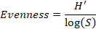

where
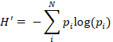
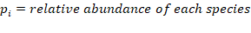
Evenness describes how a given species richness is distributed and ranges from 0-1, with 1 signifying all species are equally present. Shannon Hill Diversity can be interpreted as the ‘effective’ number of species; when evenness is 1, Shannon Hill Diversity is equal to species richness.
For the multivariate approach, species composition was compared across trials and cover crop treatments using non-metric multidimensional scaling (NMDS) implemented through the vegan package (Oksanen et al., 2019). NMDS assists in visualizing and analyzing similarities between groups of individuals (Prentice 1977). The removal of rare species from multi-variate analyses can impact interpretations (Poos and Jackson 2012), so we performed all analyses on both the full dataset and on a dataset containing only the species comprising more than 5% of the observations and found the results did not change. Bray-Curtis dissimilarities were calculated on raw seed counts. Variation in distance matrices were partitioned into trial and cover crop contributions using permutations implemented through the adonis function of the vegan package. The adonis function works by creating permutations of the raw data wherein data is randomly assigned to a group. It finds the centroids and squared-deviations for each permutation, and by comparing those values to the raw data, the significance tests reflect the probability of observing the true data assuming no group structure exists.

Results

Weed seedbank size
The West (previous crop of soybean) trial had the largest estimated mean seedbank size (5647 seeds m⁻²), followed by the Central-silage (previously soybean; 935 seeds m⁻²), with the Central-grain (previously maize, soybean) and East (previously maize) locations having similarly low mean densities (382-482 seeds m⁻²; Figure 3-3). Due to a significant interaction between trial and cover crop treatment, all results are reported on a per-trial basis.
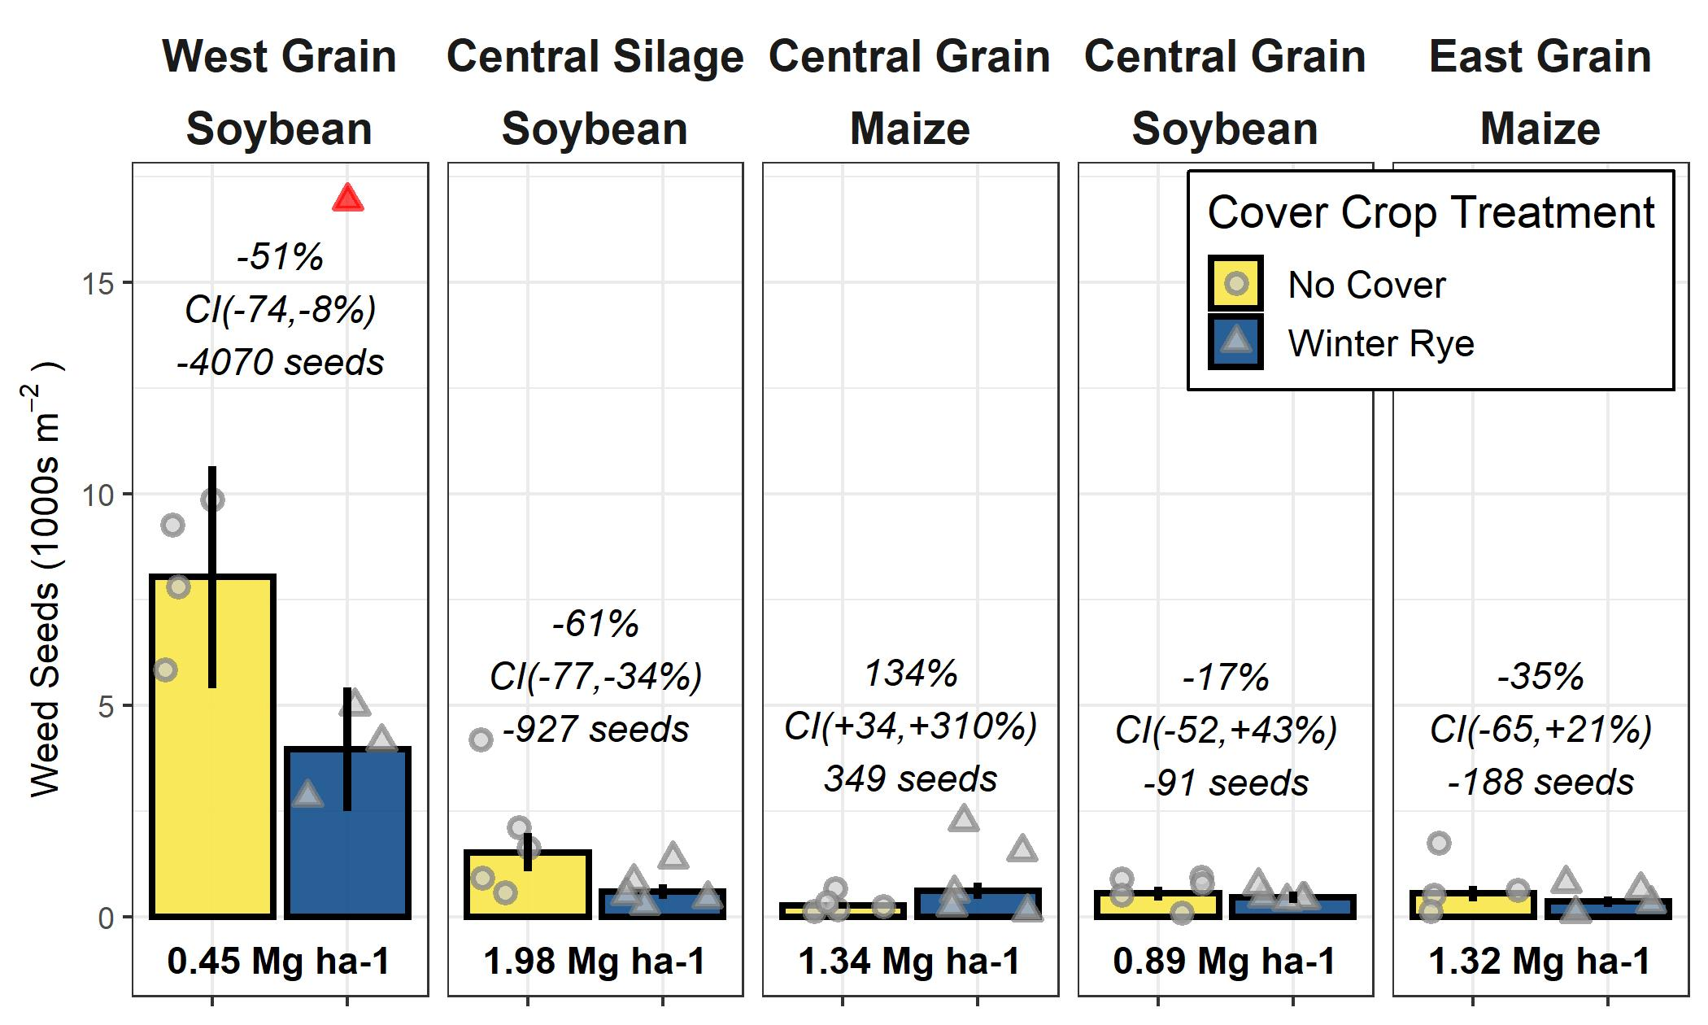
Figure 3-3. Weed seed densities for no cover and winter rye (Secale cereal) treatments

with removed outlier in red; panel titles indicate previous year’s cash crop; italic text is the mean relative change and 95% confidence interval, and the absolute change in seeds m⁻²; bold text is the 10-year mean rye biomass production.
In the three trials with a soybean crop the preceding year, the seedbank density was lower in the cover crop treatment compared to the no-cover treatment by 91 (Central-grain), 927 (Central-silage), and 4070 (West) seeds m⁻², respectively, corresponding to a 17, 61, and 51% reduction. The magnitude of the West results was sensitive to the inclusion of the outlier (supplementary material), but the direction of the effect was not. In the trials previously planted to maize, seedbank densities in cover cropped plots were lower in one trial (East; reduced by 188 seeds m-2, 35%) and increased in another (Central-grain; increased by 349 seeds m⁻², 134%).
Neither the absolute nor relative differences between the cover crop and control treatments were meaningfully related to any of the cover crop biomass metrics we calculated (supplementary material).

Weed seedbank community
A total of 4677 seedlings were counted, consisting of 16 identified species (Table 3-3). Seven seedlings were identified as belonging to the Setaria genus, but the species was unclear. The two species common to the Midwest, Setaria faberi Herrm. and Setaria viridis (L.) P. Beauv are ecologically similar; for this reason we combined the Setaria seedlings into one category for reporting and analysis. Unidentified dicotyledon seedlings were classified as ‘unknown dicotyledon (UD)’ and accounted for 8 of the seedlings, respectively, representing less than 0.2% of the data (Table 3-3). Because they made up such a small contribution to the overall community we left them in the analysis, but labeled as unknown.
We note that using the germination-method is known to cause varying underestimation of species. The method can bias counts towards species responsive to the conditions used, for example by specifically underestimating species with long seed dormancies or seeds that were not sufficiently stratified the previous winter (Gross 1990).
Table 3-3 Summary of weed species identified in this study in order of prevalence
Code | Scientific Name | Common Name | Description | Percent of Total Found
AMATU | Amaranthus tuberculatus (Moq.) J. D. Sauer | Waterhemp | C₄ forb | 88.58%
CHEAL | Chenopodium album L. | Lamb’s quarters | C₃ forb | 6.67%
POROL | Portulaca oleracea L. | Purslane | C₄ grass | 1.28%
DIGSA | Digitaria sanguinalis (L.) Scop. | Large crabgrass | C₄ grass | 1.00%
EPHMA | Euphorbia maculata L. | Spotted spurge | C₄ forb | 0.41%
PLAMA | Plantago major L. | Plantain | C₃ forb | 0.41%
SOPT7 | Solanum ptychanthum Dunal | Eastern black nightshade | C₃ forb | 0.34%
ERICA | Erigeron canadensis L. | Horseweed | C₃ forb | 0.32%
SETFA | Setaria faberi Herrm. | Giant foxtail | C₄ grass | 0.24%
UD¹ | - | - | - | 0.17%
SETVI | Setaria viridis (L.) P. Beauv. | Green foxtail | C₄ grass | 0.15%
UM² | - | - | - | 0.15%
POLAV | Polygonum aviculare L. | Prostrate knotweed | C₃ forb | 0.11%
SECCE | Secale cereale L. | Cereal rye | C₃ grass | <0.10%
ABUTH | Abutilon theophrasti Medik. | Velvet leaf | C₃ forb | <0.10%
OXAST | Oxalis stricta L. | Yellow woodsorrel | C₃ forb | <0.10%
RAPSR | Raphanus sativus L. | Radish | C₃ forb | <0.10%
TAROF | Taraxacum officinale F. H. Wigg. | Dandelion | C₃ forb | <0.10%
¹Unknown dicot
²Unknown monocot

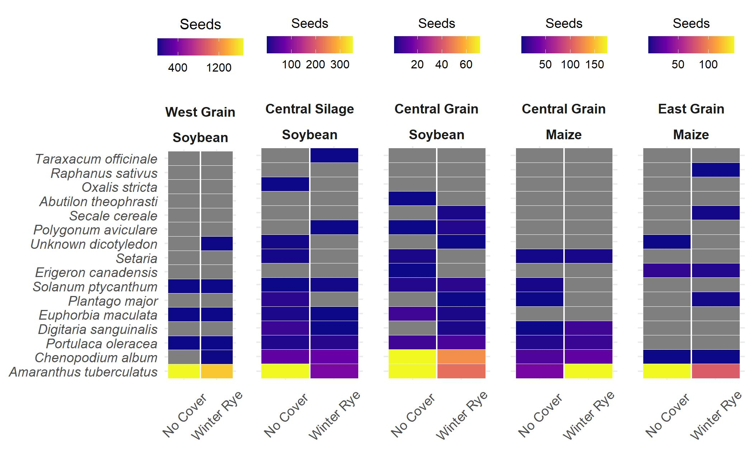
Figure 3-4. Differences in winter rye (Secale cereal) cover crop and no-cover treatments

were mainly observed in common waterhemp (Amaranthus tuberculatus [Moq.]), with the cover crop treatment having lower numbers of waterhemp seeds in four of the five trials sampled.
The changes in seedbanks were driven by changes in the number of waterhemp (Amaranthus tuberculatus, AMATU) seeds (Figure 3-4). Differences in seedbank composition were strongest at the trial level (p<0.01) and were not statistically significant for cover crop treatment. In the trials with significant cover cropping effects, community changes were again driven mainly by a decrease in waterhemp (Figs. 3-2, 3-3) which resulted in a slight shift towards a more grass-dominated community, but the effect was not strong.
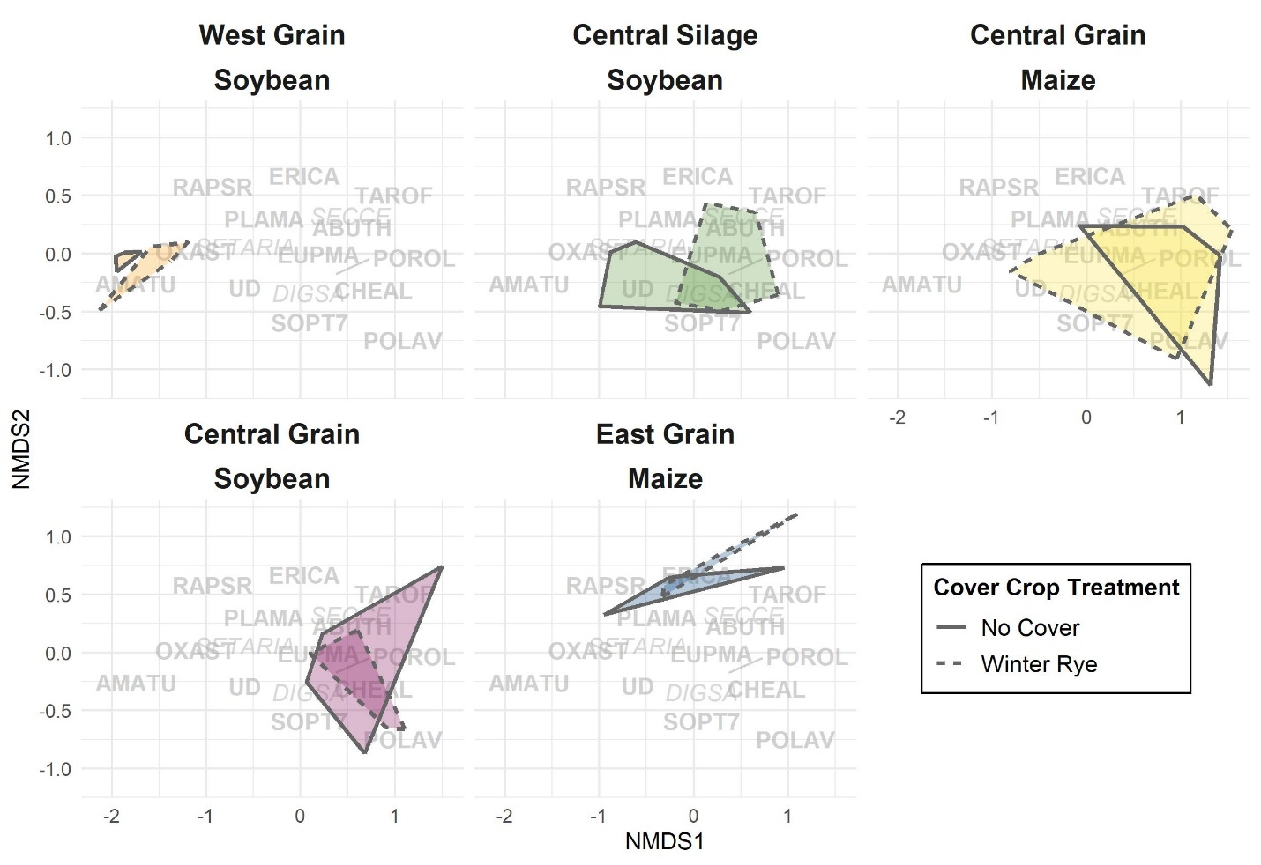
Figure 3-5. Nonmetric multidimensional scaling (NMDS, stress = 0.102) applied to weed seedbank communities.

Overlap of regions indicates degree of similarity between communities. Text represents Bayer weed codes (italics: monocots, bold: dicots; Table 3-3)
Table 3-4 Estimates, standard errors (SEs), and p-values for models of diversity, richness, and evenness for each trial

Estimate values show expected changes with the inclusion of a cover crop (ex. positive values indicate that metric increased with the inclusion of a cover crop). Trials are listed in descending order of absolute reduction in seedbank size with cover cropping. Significant differences at p<0.10 are indicated with bold italics.
 | Shannon Hill Diversity |  |  | Richness |  |  | Evenness
 | Estimate (SE) | P-value |  | Estimate (SE) | P-value |  | Estimate (SE) | P-value
West-grain | 0.05 (0.49) | 0.92 |  | 1.5 (0.87) | 0.10 |  | 0.03 (0.13) | 0.82
Central-silage | -0.22 (0.44) | 0.62 |  | -2.2 (0.77) | 0.01 |  | 0.18 (0.1) | 0.10
Central-grain | 0.05 (0.31) | 0.89 |  | 0.5 (0.55) | 0.37 |  | -0.07 (0.07) | 0.39
East-grain | 0.18 (0.49) | 0.71 |  | 0.75 (0.87) | 0.39 |  | 0.03 (0.12) | 0.82

Community shifts were not consistently associated with an increase in the Shannon-Hill diversity index, species evenness, nor species richness (Table 3-4), but these results must be taken in context of the herbicide programs (Table 3-2).

Risk of increasing seedbanks
Results from the stochastic dominance analysis indicate that at low weed seedbank densities (< 300 seeds m⁻²), cover cropping and control treatments did not differ, whereas at higher weed seedbank densities (> 300 seeds m⁻²), cover cropping consistently exhibited lower densities than the no-cover treatments (Figure 3-6).
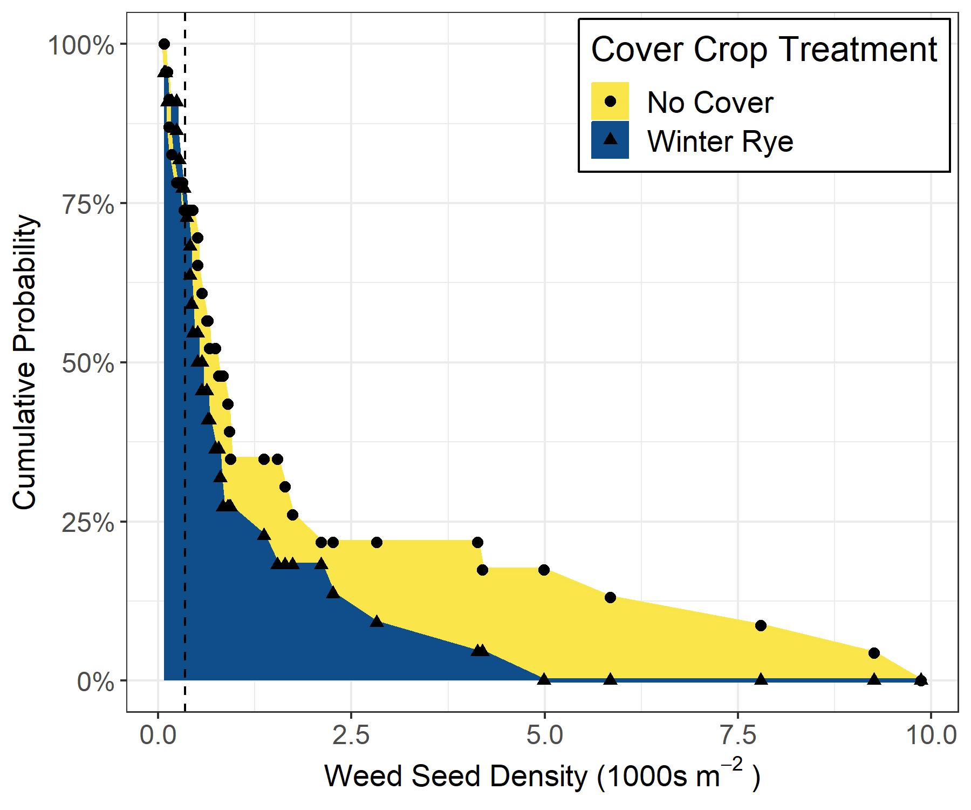
Figure 3-6. Risk of increased seedbanks under each cover crop treatment.

Each point represents the cumulative probability of having a weed seedbank of that density or higher; the area under the curve is proportional to the risk of having large weed seedbank densities; the two systems cross at seedbank densities of 300 seeds m⁻² (dashed line)

Discussion

Cover crop interactions with waterhemp
As is the case in many midwestern maize and soybean fields, waterhemp was the driver weed species in the locations sampled in this study (Van Wychen 2017, 2019). Due to the dominance of waterhemp in the weed communities of this study, the herbicide programs implemented at each trial may have provided contexts where cover crop effects on weeds would vary. Waterhemp populations with resistance to seven herbicide groups have been identified (Tranel 2020), with populations resistant to one or more are prevalent in the Midwest (Patzoldt et al. 2005, Chatham et al. 2015, Oliveira et al. 2017). While we did not measure the presence of resistance genes, resistances to herbicide groups 5, 9, 14 and 27 were likely present (Owen 2017) with possible resistances to group 15 (Hager 2019). The varying levels of waterhemp control via herbicides and the use of residuals in the different trials may have rendered cover cropping more or less effective (Table 2). The West site, where the largest absolute reduction in waterhemp with the use of cover cropping was observed (Fig. 1), did not utilize chemistries that would reliably kill resistant waterhemp plants that had already emerged, nor a residual herbicide to suppress future waterhemp emergence. Of the sites included in this study, the West site was therefore most susceptible to waterhemp living and setting seed, and therefore may have provided the biggest opportunities for cover cropping effects to manifest. The Central trials utilized hand-weeding in soybean phases late in the season, which may have reduced the opportunities for cover crops effects to be expressed. The East site, which had the lowest average seedbank densities observed in this study, utilized a herbicide program that would control resistant waterhemp biotypes and included residual herbicide that would also reduce/delay waterhemp emergence, perhaps leaving little room for cover cropping effects. While the previous crop of the individual trials may also play a role in dictating the weed responses to cover cropping, in the present study the previous crop is confounded with site effects, so it is difficult to draw conclusions from what may be spurious associations.
Regardless of the mechanisms involved, we believe our results regarding reductions in waterhemp seed densities are robust. Under no-till management and in the absence of new inputs to the seedbank, waterhemp seed densities can decline >99% after five years (Steckel et al., 2007). Our plots have been in place long enough (>10 years) for treatment effects to be detected despite possible legacy effects of the original seedbanks.

Cover crop mechanisms of weed suppression
Previous research indicates a cover crop’s potential for in-season weed suppression is strongly related to the cover crop’s biomass production (Baraibar et al. 2018, MacLauren et al. 2019, Smith et al. 2020, Nichols et al. 2020a). Cover crops might reduce weed seedbank densities via several mechanisms, all of which could conceivably be intensified with increases in the quantity of cover crop biomass produced. It is thus surprising that in the present study neither the absolute nor relative effects of cover cropping on the weed seedbank was related to any of the cover crop biomass production metrics we evaluated. For example, while the West trial consistently produced less than 1 Mg ha-1 of cover crop biomass, it exhibited the largest absolute decreases in weed seedbank size from cover cropping (Fig. 1). Even considering the herbicide program, it is surprising such small amounts of cover crop biomass could have meaningful effects on the weed seedbank.
The pattern in the present study might also be related to the emergence timing of waterhemp, which can extend well beyond the time the cover crop is killed while maintaining high reproductive success (Wu and Owen 2014). In other studies, weed communities may not have been dominated by late germinating weed species such as waterhemp, and the communities might have therefore been more directly responsive to cover crop biomass.
It is also possible cover crops affected weeds in ways less directly dependent upon the amount of cover crop biomass produced. The act of planting the cover crop itself may have provided some weed control. Additionally, even modest amounts of biomass present over the winter may provide enough ground cover to promote seed mortality through granivore activity (Carmona and Landis, 1999; Heggenstaller et al., 2006), and in the spring cover crop mulch can provide habitat for seed-eating invertebrates (Pullaro et al., 2006). Allelopathic compounds from rye residue may catalyze pathogen attack on seeds and reduce the vigor of germinated seeds (Barnes and Putnam, 1983; Mohler et al., 2012), and production of these compounds may be more dependent upon growing conditions compared to rye biomass production per se (Mwaja et al., 1995). While our study did not test these effects directly, our data suggest these mechanisms should be considered when assessing the effects of cover cropping on weed communities.
We note that with endpoint sampling, as we did in the present study, it is difficult to link the cumulative effect of 10 years of biomass production with one season’s weed seedbank. Sampling weed seedbanks yearly would enable a more direct connection to be drawn between cover crop biomass production and seedbank densities. However, our data show that in the contexts we sampled, the weed suppressive potential of cover crops in the long-term was not directly related to cover crop biomass production.

Cover crop effects on weed seed communities
The lack of a consistent and significant effect of cover cropping on the structure of the weed seed communities in the present study is consistent with the findings of other studies (Moonen and Bàrberi, 2004; Smith et al., 2015; Alonso-Ayuso et al., 2018). It is unsurprising that an over-wintering cover crop would be a weak filter in systems dominated by summer annuals that are well adapted for regeneration in maize-soybean rotations (Tranel 2020). In systems with more diverse cropping systems or seedbanks, cover crops might create more marked shifts in weed communities.
While the germination method may have failed to identify or underestimated weed species resulting in an underestimation of weed species richness, the number of weed species found in each plot (ranging from 1-8) matches field-based observations of maize-soybean rotations (Hirsh et al., 2013). Additionally, the dominance of common waterhemp rendered the Shannon Hill diversity and evenness metrics insensitive to small contributions by other species. Accordingly, our results may be due to the already-simplified nature of the communities, where random variation easily obscures subtle signals in the less prevalent species.

Conclusions
Our study is the first we are aware of that quantifies the long-term impacts of cover cropping on weeds in the midwestern United States. We found evidence that cover cropping can meaningfully reduce the size of the weed seedbank compared to a no-cover control in certain contexts. More research in long-term plots comparing cover crop effects in various cropping systems and management regimes is needed to identify conditions in which cover crops are most effective at reducing and/or preventing weed seed deposits. Endpoint sampling, used in our study, is useful in assessing whether systems merit more attention, but longitudinal samplings of weed seedbanks in long-term studies are needed to better assess the seedbank trajectories of these systems.
Changes in seedbanks were driven by change in densities of common waterhemp, a weed resistant to multiple herbicide modes of actions. We found that when weed seed densities are above 300 seeds m-2, cover cropping exhibits no risk of enlarging weed seedbanks compared to no-cover systems.
In the production contexts examined, the amount of cover crop biomass produced was not associated with the magnitude of cover crop effects on weed seedbanks. The lack of relationship suggests cover crop biomass may not be the best metric for predicting long-term impacts of cover-cropping on weeds in all systems, particularly those dominated by late-germinating species such as waterhemp. Cover crops may suppress weeds through a combination of mechanisms, and the relative contribution likely varies by site and/or year. Parsing out these effects could aid in the design of systems better able to take advantage of cover crop weed suppression.

References
Abendroth, L., R. Elmore, M. Boyer, and S. Marlay. 2011. Corn growth and development. https://www.researchgate.net/profile/Lori_Abendroth/publication/280092215_In_Corn_Growth_and_Development/links/5a984384a6fdccecff0d2320/In-Corn-Growth-and-Development.pdf (accessed 20 July 2020).
Adeux, G., E. Vieren, S. Carlesi, P. Bàrberi, N. Munier-Jolain, et al. 2019. Mitigating crop yield losses through weed diversity. Nat. Sustain. 2019 211 2(11): 1018–1026. doi: 10.1038/s41893-019-0415-y.
Alonso-Ayuso, M., J.L. Gabriel, I. García-González, J.P. Del Monte, and M. Quemada. 2018. Weed density and diversity in a long-term cover crop experiment background. Crop Prot. 112: 103–111. doi: 10.1016/j.cropro.2018.04.012.
Arbuckle, J.G. 2014. Farmer Perspectives on Pesticide Resistance. http://lib.dr.iastate.edu/extension_communities_pubs (accessed 28 May 2020).
Arbuckle, J.G., and P. Lasley. 2013. Iowa Farm and Rural Life Poll: 2013 Summary Report 2013 Summary Report. https://lib.dr.iastate.edu/extension_communities_pubs/26/. (Accessed August 2021).
Baraibar, B., M.C. Hunter, M.E. Schipanski, A. Hamilton, and D.A. Mortensen. 2018. Weed suppression in cover crop monocultures and mixtures. Weed Sci. 66(1): 121–133. doi: 10.1017/wsc.2017.59.
Baraibar, B., D.A. Mortensen, M.C. Hunter, M.E. Barbercheck, J.P. Kaye, D.M. Finney, W.S. Curran, J. Bunchek, C.M. White. 2018. Growing degree days and cover crop type explain weed biomass in winter cover crops. Agron. Sustain. Dev. 38(65). https://doi.org/10.1007/s13593-018-0543-1
Barnes, J.P., and A.R. Putnam. 1983. Rye residues contribute weed suppression in no-tillage cropping systems. J. Chem. Ecol. 9(8): 1045–1057. doi: 10.1007/BF00982210.
Basche, A.D., S. V. Archontoulis, T.C. Kaspar, D.B. Jaynes, T.B. Parkin, et al. 2016. Simulating long-term impacts of cover crops and climate change on crop production and environmental outcomes in the Midwestern United States. Agric. Ecosyst. Environ. 218: 95–106. doi: 10.1016/j.agee.2015.11.011.
Basche, A.D., Kaspar, T.C., Archontoulis, S.V., Jaynes, D.B., Sauer, T.J., Parkin, T.B. and Miguez, F.E., 2016. Soil water improvements with the long-term use of a winter rye cover crop. Agric. Water Manag. 172:40-50.
Bates, D., M. Mächler, B. Bolker, and S. Walker. 2015. Fitting linear mixed-effects models using lme4. J. Stat. Softw. 67(1): 1–48. doi: 10.18637/jss.v067.i01.
Becker, R.A., A.R. Wilks, R. Brownrigg, T.P. Minka, and A. Deckmyn. 2018. maps: Draw Geographical Maps. Comprehensive R Archive Network (CRAN). https://rdrr.io/cran/maps/man/map.html
Blanco-Canqui, H., T.M. Shaver, J.L. Lindquist, C.A. Shapiro, R.W. Elmore, et al. 2015. Cover crops and ecosystem services: Insights from studies in temperate soils. Agron. J. 107(6): 2449–2474. doi: 10.2134/agronj15.0086.
Boerboom, C.M. 1999. Nonchemical options for delaying weed resistance to herbicides in Midwest cropping systems. Weed Technol. 13(3): 636–642. doi: 10.1017/s0890037x00046327.
Bunchek, J.M., J.M. Wallace, W.S. Curran, D.A. Mortensen, M.J. VanGessel, and B.A. Scott. (2020) Alternative performance targets for integrating cover crops as a proactive herbicide-resistance management tool. Weed Sci. 68(5): 1-11. doi:10.1017/wsc.2020.49
Carmona, D.M., and D.A. Landis. 1999. Influence of refuge habitats and cover crops on seasonal activity-density of ground beetles (Coleoptera: Carabidae) in field crops. Environ Entolomol. 28(6): 1145-1153.
Chatham, L.A., K.W. Bradley, G.R. Kruger, J.R. Martin, M.D.K. Owen, et al. 2015. A multistate study of the association between glyphosate resistance and EPSPS gene amplification in waterhemp (Amaranthus tuberculatus) . Weed Sci. 63(3): 569–577. doi: 10.1614/ws-d-14-00149.1.
Cholette, T.B., N. Soltani, D.C. Hooker, D.E. Robinson, and P.H. Sikkema. 2018. Suppression of glyphosate-resistant Canada fleabane (Conyza canadensis) in corn with cover crops seeded after wheat harvest the previous year. Weed Technol. 32(3): 244–250. doi: 10.1017/wet.2018.19.
Davis, A.S. 2006. When does it make sense to target the weed seed bank? Weed Sci. 54(3): 558–565. doi: 10.1614/ws-05-058r.1.
Dessaint, F., G. Barralis, M.L. Caixinhas, J.P. Mayor, J. Recasens, et al. 1996. Precision of soil seedbank sampling: How many soil cores? Weed Res. 36(2): 143–151. doi: 10.1111/j.1365-3180.1996.tb01810.x.
Dold, C., H. Büyükcangaz, W. Rondinelli, J.H. Prueger, T.J. Sauer, J.L. Hatfield. 2016. Long-term carbon uptake of agro-ecosystems in the Midwest. Agric For Meteorol. 232:128-140
Felix, J., and M.D.K. Owen. 2001. Weed seedbank dynamics in post conservation reserve program land. Weed Sci. 49(6): 780–787. doi: 10.1614/0043-1745(2001)049[0780:wsdipc]2.0.co;2.
Food and Agriculture Organization of the United Nations. FAOSTAT Statistical Database. [Rome]:FAO, 2020. (Accessed September 2020)
Forcella, F., T. Webster, and J. Cardina. 2003. Protocols for weed seed bank determination in agro-ecosystems. FAO Plant Prod. Prot. Pap.: 3–18.
Forcella, F., R.G. Wilson, K.A. Renner, J. Dekker, R.G. Harvey, et al. 1992. Weed seedbanks of the U.S. Corn Belt: Magnitude, variation, emergence, and application. Weed Sci. 40(4): 636–644. doi: 10.1017/s0043174500058240.
Goplen, J.J., J.A. Coulter, C.C. Sheaffer, R.L. Becker, F.R. Breitenbach, et al. 2018. Economic performance of crop rotations in the presence of herbicide-resistant giant ragweed. Agron. J. 110(1): 260–268. doi: 10.2134/agronj2016.09.0536.
Gross, K.L., 1990. A comparison of methods for estimating seed numbers in the soil. J. Ecol. 78(4):1079-1093. doi: 10.2307/2260953
Hager, A. (2019) Waterhemp resistance to group 15 herbicides. Department of Crop Sciences, University of Illinois at Urbana-Champaign. https://farmdoc.illinois.edu/field-crop-production/weeds/waterhemp-resistance-to-group-15-herbicides.html. (Accessed August 2021).
Gross, K.L., 1990. A comparison of methods for estimating seed numbers in the soil. J. Ecol. 78(4):1079-1093. doi: 10.2307/2260953
Harrison, X.A. 2014. Using observation-level random effects to model overdispersion in count data in ecology and evolution. PeerJ 2014(1): e616. doi: 10.7717/peerj.616.
Heggenstaller, A.H., F.D. Menalled, M. Liebman, and P.R. Westerman. 2006. Seasonal patterns in post-dispersal seed predation of Abutilon theophrasti and Setaria faberi in three cropping systems. J. Appl. Ecol. 43(5): 999–1010. doi: 10.1111/j.1365-2664.2006.01198.x.
Hirsh, S.M., C.M. Mabry, L.A. Schulte, and M. Liebman. 2013. Diversifying agricultural catchments by incorporating tallgrass prairie buffer strips. Ecol. Restor. 31(2): 201–211. doi: 10.3368/er.31.2.201.
Johnson, W.G., and K.D. Gibson. 2006. Glyphosate-resistant weeds and resistance management strategies: An Indiana grower perspective. Weed Technol. 20(3): 768–772. doi: 10.1614/wt-05-122r1.1.
Jones, C.S., J.K. Nielsen, K.E. Schilling, and L.J. Weber. 2018. Iowa stream nitrate and the Gulf of Mexico. PloS one 13(4). doi: 10.1371/journal.pone.0195930
Jost, L. 2006. Entropy and diversity. Oikos 113(2): 363–375. doi: 10.1111/j.2006.0030-1299.14714.x.
Kaspar, T.C., D.B. Jaynes, T.B. Parkin, and T.B. Moorman. 2007. Rye cover crop and gamagrass strip effects on NO₃ concentration and load in tile drainage. J. Environ. Qual. 36(5): 1503–1511. doi: 10.2134/jeq2006.0468.
Kaspar, T.C., D.B. Jaynes, T.B. Parkin, T.B. Moorman, and J.W. Singer. 2012. Effectiveness of oat and rye cover crops in reducing nitrate losses in drainage water. Agric. Water Manag. 110(3): 25–33. doi: 10.1016/j.agwat.2012.03.010.
Kaspar, T., and J. Singer. 2011. The Use of Cover Crops to Manage Soil. Publications from the USDA-ARS/UNL Faculty. p. 1382. https://digitalcommons.unl.edu/cgi/viewcontent.cgi?article=2387&context=usdaarsfacpub (Accessed August 2021).
Lenth, R., H. Singmann, and J. Love. 2018. Emmeans: Estimated maringal means, aka least-squares means. Comprehensive R Archive Network (CRAN). https://rdrr.io/cran/emmeans/
Levy, H. 1992. Stochastic Dominance and Expected Utility: Survey and Analysis. Manage. Sci. 38(4): 555–593. doi: 10.1287/mnsc.38.4.555.
MacLaren, C., Swanepoel, P., Bennett, J., Wright, J. and Dehnen-Schmutz, K., 2019. Cover crop biomass production is more important than diversity for weed suppression. Crop Sci., 59(2):733-748. doi: 10.2135/cropsci2018.05.0329
MacLaren, C., J. Storkey, A. Menegat, H. Metcalfe, and K. Dehnen-Schmutz. 2020. An ecological future for weed science to sustain crop production and the environment. A review. Agron. Sustain. Dev. 40(4). doi: 10.1007/s13593-020-00631-6.
McCulloch, C.E., and J.M. Neuhaus. 2005. Generalized Linear Mixed Models. Encyclopedia of Biostatistics. John Wiley & Sons, Ltd, Chichester, UK
Mirsky, S.B., E.R. Gallandt, D.A. Mortensen, W.S. Curran, and D.L. Shumway. 2010. Reducing the germinable weed seedbank with soil disturbance and cover crops. Weed Res. 50(4): 341–352. doi: 10.1111/j.1365-3180.2010.00792.x.
Mohler, C.L. 1993. A model of the effects of tillage on emergence of weed seedlings. Ecol. Appl. 3(1): 53–73. doi: 10.2307/1941792.
Mohler, C.L., C. Dykeman, E.B. Nelson, and A. Ditommaso. 2012. Reduction in weed seedling emergence by pathogens following the incorporation of green crop residue. Weed Res. 52(5): 467–477. doi: 10.1111/j.1365-3180.2012.00940.x.
Moonen, A.C., and P. Bàrberi. 2004. Size and composition of the weed seedbank after 7 years of different cover-crop-maize management systems. Weed Res. 44(3): 163–177. doi: 10.1111/j.1365-3180.2004.00388.x.
Moore, E.B., M.H. Wiedenhoeft, T.C. Kaspar, and C.A. Cambardella. 2014. Rye cover crop effects on soil quality in no-till corn silage-soybean cropping systems. Soil Sci. Soc. Am. J. 78(3): 968–976. doi: 10.2136/sssaj2013.09.0401.
Mwaja, V.N., J.B. Masiunas, and L.A. Weston. 1995. Effects of fertility on biomass, phytotoxicity, and allelochemical content of cereal rye. J. Chem. Ecol. 21(1): 81–96. doi: 10.1007/BF02033664.
Nearing, M.A., Y. Xie, B. Liu, Y. Ye. 2017. Natural and anthropogenic rates of soil erosion. Int. Soil Water Conserv. Res. 5(2), 77-84. doi: 10.1016/j.catena.2005.03.003
Nichols, V., R. Martinez‐Feria, D. Weisberger, S. Carlson, B. Basso, et al. 2020a. Cover crops and weed suppression in the U.S. Midwest: A meta‐analysis and modeling study. Agric. Environ. Lett. 5(1). doi: 10.1002/ael2.20022.
Nichols, V., L.E. English, M. Liebman. 2020b. Long Term Cover Cropping Effects on Weed Seedbanks. Iowa State University Dataset. 2020. doi: 10.25380/iastate.12762011
Oksanen, J., F.G. Blanchet, M. Friendly, R. Kindt, P. Legendre, et al. 2019. vegan: Community Ecology Package. Comprehensive R Archive Network (CRAN). https://cran.r-project.org/package=vegan.
Oliveira, M.C., A.J. Jhala, T. Gaines, S. Irmak, K. Amundsen, J.E. Scott, and S.Z. Knezevic. 2017. Confirmation and control of HPPD-inhibiting herbicide–resistant waterhemp (Amaranthus tuberculatus) in Nebraska. Weed Tech. 31(1):67-79.
O'Neal, M.R., M.A. Nearing, R.C. Vining, J. Southworth, R.A. Pfeifer. 2005. Climate change impacts on soil erosion in Midwest United States with changes in crop management. Catena, 61(2-3):165-184. doi:10.1016/j.catena.2005.03.003
Owen, M.D. 2017. Weed management update for 2018 and beyond: The more things change. Proceedings of the 29th Annual Integrated Crop Management Conference. doi:10.31274/icm-180809-242
Patzoldt, W.L., P.J. Tranel, and A.G. Hager. 2005. A waterhemp (Amaranthus tuberculatus) biotype with multiple resistance across three herbicide sites of action. Weed Sci. 53(1): 30–36. doi: 10.1614/ws-04-087r.
Poos, M.S., D.A. Jackson. 2012. Addressing the removal of rare species in multivariate bioassessments: the impact of methodological choices. Ecological Indicators 18(1): 82-90. doi: 10.1016/j.ecolind.2011.10.008
Prentice, I.C. 1977. Non-metric ordination methods in ecology. J. Ecol. 85-94.
Price, A.J., K.S. Balkcom, S.A. Culpepper, J.A. Kelton, R.L. Nichols, et al. 2011. Glyphosate-resistant Palmer amaranth: A threat to conservation tillage. J. Soil Water Conserv. 66(4): 265–275. doi: 10.2489/jswc.66.4.265.
Pullaro, T.C., P.C. Marino, D.M. Jackson, H.F. Harrison, and A.P. Keinath. 2006. Effects of killed cover crop mulch on weeds, weed seeds, and herbivores. Agric. Ecosyst. Environ. 115(1–4): 97–104. doi: 10.1016/j.agee.2005.12.021.
R Core Team, 2016. R: A Language and environment for statistical computing, Vienna, Austria. Available at https://www.R-project.org/.
Reinhardt, T., and R.G. Leon. 2018. Extractable and germinable seedbank methods provide different quantifications of weed communities. Weed Sci. 66(6): 715–720. doi: 10.1017/wsc.2018.56.
Ryan, M.R., R.G. Smith, S.B. Mirsky, D.A. Mortensen, and R. Seidel. 2010. Management filters and species traits: weed community assembly in long-term organic and conventional systems. Weed Sci. 58(3):265-277.
Schwartz, L.M., J.K. Norsworthy, B.G. Young, K.W. Bradley, G.R. Kruger, et al. 2016. Tall waterhemp (Amaranthus tuberculatus) and Palmer amaranth (Amaranthus palmeri) seed production and retention at soybean maturity. Weed Technol. 30(1): 284–290. doi: 10.1614/wt-d-15-00130.1.
Shaner, D.L., and H.J. Beckie. 2014. The future for weed control and technology. Pest Manag. Sci. 70(9): 1329–1339. doi: 10.1002/ps.3706.
Smith, R.G., L.W. Atwood, F.W. Pollnac, and N.D. Warren. 2015. Cover-crop species as distinct biotic filters in weed community assembly. Weed Sci. 63(1): 282–295. doi: 10.1614/ws-d-14-00071.1.
Smith, R.G., N.D. Warren, and S. Cordeau. 2020. Are cover crop mixtures better at suppressing weeds than cover crop monocultures? Weed Sci 68(2): 1–33. doi: 10.1017/wsc.2020.12.
Steckel, L.E., C.L. Sprague, E.W. Stoller, L.M. Wax, and F.W. Simmons. 2007. Tillage, cropping system, and soil depth effects on common waterhemp (Amaranthus rudis) Seed-Bank Persistence. Weed Sci. 55(3): 235–239. doi: 10.1614/ws-06-198.
Storkey, J., and P. Neve. 2018. What good is weed diversity? Weed Res. 58(4): 239–243. doi: 10.1111/wre.12310.
Strock, Jeffrey S., Paul M. Porter, and M. P. Russelle. 2004. Cover cropping to reduce nitrate loss through subsurface drainage in the northern US Corn Belt. J. Environ. Qual. 33(3): 1010-1016.
Teasdale, J.R., S.B. Mirsky, and M.A. Cavigelli. 2018. Meteorological and management factors influencing weed abundance during 18 years of organic crop rotations. Weed Sci. 66(4): 477–484. doi: 10.1017/wsc.2018.15.
Tranel, P.J. (2020) Herbicide Resistance in Amaranthus tuberculatus. Pest Manag Sci. doi:10.1002/ps.6048
USDA National Agricultural Statistics Service Cropland Data Layer. 2020a. Published crop-specific data layer [Online]. Available at https://nassgeodata.gmu.edu/CropScape/ Accessed September 2020. USDA-NASS, Washington, DC.
USDA National Agricultural Statistics Service. 2020b. NASS - Quick Stats. USDA National Agricultural Statistics Service. Accessed September 2020. USAD-NASS, Washington, DC.
Van Wychen, L. (2017) Survey of the most common and troublesome weeds in grass crops, pasture and turf in the United States and Canada. Weed Science Society of America National Weed Survey Dataset. Available: http://wssa.net/wp-content/uploads/2017-Weed-Survey_Grass-crops.xlsx
Van Wychen, L (2019) WSSA survey ranks most common and most troublesome weeds in broadleaf crops, fruits and vegetables. Available: http://wssa.net/wp-content/uploads/2019-Weed-Survey_broadleaf-crops.xlsx
Wallace, J.M., W.S. Curran, and D.A. Mortensen. 2019. Cover crop effects on horseweed (Erigeron canadensis) density and size inequality at the time of herbicide exposure. Weed Sci. 67(3): 327–338. doi: 10.1017/wsc.2019.3.
Wickham, H., M. Averick, J. Bryan, W. Chang, L. McGowan, et al. 2019. Welcome to the Tidyverse. J. Open Source Softw. 4(43): 1686. doi: 10.21105/joss.01686.
Wickham, H., and J. Bryan. 2018. readxl: Read Excel Files. Comprehensive R Archive Network (CRAN). https://cran.r-project.org/package=readxl.
Wilke, C. 2019. cowplot: Streamlined Plot Theme and Plot Annotations for “ggplot2”. https://rdrr.io/github/wilkelab/cowplot/man/cowplot.html
Wu, C., and Owen M.D. 2014. When is the best time to emerge: reproductive phenology and success of natural common waterhemp (Amaranthus rudis) cohorts in the Midwest United States? Weed Sci. 62(1):107-117. doi: 10.1614/WS-D-13-00079.1

Appendix

Data Availability Statement
The generated datasets for this project are available at Iowa State University’s DataShare platform (Nichols et al. 2020b) and as an R package stored on github (https://github.com/vanichols/PFIweeds2020). A detailed walk-through of the statistical model linear uni-variate fitting is available online (https://lydiae.com/2020/04/22/many-models/), and a github repository contains all code used to analyze the data and create figures for the manuscript and supplementary material (https://github.com/vanichols/PFIweeds2020_analysis)

Supplementary Material
Available at https://www.frontiersin.org/articles/10.3389/fagro.2020.591091/full

WINTER COVER CROPPING EFFECTS ON SOIL WATER STORAGE VARY BY SITE: FIELD MEASUREMENTS AND A PROPOSED CAUSAL MODEL
Virginia Nichols¹, Eric B. Moore¹, Stefan Gailans², Matt Liebman¹
¹Department of Agronomy, Iowa State University
²Practical Farmers of Iowa
Modified from a manuscript submitted to Agrosystems, Geosciences & Environment

Abstract
Addition of an over-wintering cereal rye (Secale cereal L.) cover crop (CC) to Midwestern maize (Zea mays L.)-based systems offers several environmental benefits, but the long-term effects on soil hydrological properties are not well-understood. We utilized four long-term (10+ year) no-till trials in Iowa, USA that included a replicated winter rye CC and no-cover treatment in systems with a maize crop (grain or silage) rotated with soybean (Glycine max [L.] Merr). At each trial, we took intact 7.62 cm diameter soil samples from a 10-18 cm depth increment shortly after cash crop planting in the spring of 2019. We measured the volumetric soil water content at saturation and matric potentials of -3.8, -10, -25, -50, -100, -200 and -500 cmH2O. Additionally, we measured organic matter, soil texture, and bulk densities of the samples. Pore-size distribution indices and air-entry potentials were estimated from non-linear models fit to the soil water retention curves, and percent macropores (>30 um) was estimated from the capillary rise equation. Water contents at saturation and at field capacity (0 and -100 cmH₂O, respectively) were taken directly from the data. Neither pore-size distribution nor air-entry potential (modeled parameters) were affected by CCs. At the depth sampled, CCs did not meaningfully affect bulk density or water contents at saturation at any trial, nor did CCs increase the percentage of macropores. At two trials, soil water content at field capacity increased with CCs by 2.5 vol% (SE: 1.2%) and 2.4 vol% (SE:1.3%), respectively, which could meaningfully reduce the amount of water drained from a field after a saturating rain. The presence or absence of a CC effect on field capacity was not related to CC above-ground biomass production, previous cash crop, or soil texture at the trial sites. We propose a causal model relating CCs to soil properties relevant to soil water that indicates CC root characteristics may be key to understanding variable effects of CCs on soil water storage. Our results indicate more research is needed on the exact mechanisms by which CCs can affect soil water storage, as well as when and where potential benefits may be most easily realized.

Introduction
Addition of an over-wintering cereal rye (Secale cereal L.) cover crop (CC) to Midwestern maize (Zea mays L.)-based systems potentially offers several environmental benefits including reduced soil erosion and nutrient pollution (Strock et al., 2004; Kaspar et al., 2007; Kaspar and Singer, 2011; Kladivko et al., 2014). On average, rye CCs have no effect on maize yields compared to winter fallow in the short term (Marcillo and Miguez, 2017), but it is possible that long-term cover cropping could stabilize crop yields. In Midwestern rain-fed systems, crops rely on stored soil water and often suffer from drought stress (Campos et al., 2006). In these systems, CCs may induce changes in soil characteristics such as increased organic matter, lower bulk densities, and more macro-pores (Haruna et al., 2020a). In theory, these changes could result in more water storage capacity (Hudson, 1994; Minasny and McBratney, 2018; King et al., 2020), and therefore buffer crop yields against drought stress (Williams et al., 2016; Kane et al., 2021). Cover crops might also benefit crop-water relations by increasing water infiltration or reducing evaporation through a mulching effect (Unger and Vigil, 1998; Leuthold et al., 2021). Two global meta-analyses suggest CCs increase soil’s capacity to store water and increase infiltration rates (Basche and DeLonge, 2017, 2019). However, to our knowledge there are few studies supporting these findings in Midwestern cover cropping contexts, and the few existing studies report contradicting results (Villamil et al., 2006; Haruna and Nkongolo, 2015; Basche et al., 2016; Rorick and Kladivko, 2017; Irmak et al., 2018). Region-specific studies are needed, as climatic and managerial constraints of maize-soybean rotations can limit CC options and growth potential (Strock et al., 2004; Baker and Griffis, 2009; Nichols et al., 2020b).
In addition to regional differences in CC effects, the duration of cover cropping may also influence whether changes in soil are detected. Long-term studies on tillage have shown significant, but slow changes to the soil after implementing no-till (Al-Kaisi et al., 2014; Cusser et al., 2020). Addition of CCs might likewise require several years before changes in soil hydrological properties can be detected, necessitating data collection from long-term experiments. Furthermore, while shallow soil depths (0-10cm) may be more responsive to CC effects e.g., (Atwood and Wood 2021,; Kaspar et al., 2006; Moore et al., 2014), deeper depths may be more important when considering the soil’s contribution to the crop’s water supply (Williams et al., 2008; Asbjornsen et al., 2008; Rizzo et al., 2018).
Lastly, to our knowledge the causal relationships between CCs and soil water storage have not been explicitly presented. Causal models can help identify data needs, and when sufficient data is available can be used to construct structural equation models that estimate the relative strength of causal paths (Smith et al., 2014). Casual modelling can also be used to frame hypotheses, resulting in more targeted research questions that directly test the presence or absence of causal links. Therefore, a credible causal model can greatly aid in advancing future research.
Given the need to quantify long-term benefits of cover cropping, the scarcity of Midwest-specific data, and lack of a framework for organizing relevant knowledge, the objectives of our study were to (1) determine what aspects of a soil’s hydrological characteristics are affected by long-term cover cropping at a depth relevant to crop production, and (2) use our findings to propose a causal model connecting CCs to changes in soil properties to aid in targeting future research. We collected soil samples at a 10-18 cm depth increment from four long-term (10+ years) no-till cover crop trials located in Iowa, USA. Two trials were on-farm production fields, and two trials were part of a larger research experiment. We assessed the effects of long-term cover cropping on soil water content at saturation, soil water content at matric potentials approximating field capacity on the shallow water tables that characterize landscapes in this region (-100 cm H2O, Moore 2021), and pore-size distributions as estimated by the soil water retention curve. To complement and contextualize these data, we also measured soil texture, soil organic matter, and bulk densities of the soil samples. We used our results in combination with previous literature to construct a proposed causal model (Pearl, 2010).

Materials and Methods

Site descriptions
Three long-term sites were used for this study (Figure 4-1), with one site having two trials. Therefore, a total of four trials were sampled (Table 4-5). Each trial consisted of two treatments that had been in place for at least 10 years: (1) a maize/soybean rotation (either grain- or silage-based) with a winter rye CC planted yearly in the fall following cash crop harvest and terminated in the spring, and (2) the same rotation without a CC. Every trial was arranged in a randomized complete block design with four (West and East) or five (Central) replicates. The plots within each trial were managed identically save for the planting of the CC in the fall. The exact herbicide and nutrient programs varied by site, reflective of their managers and contexts (Supplementary Tables S1, S2, S3). More detailed accounts of agronomic management have been published elsewhere for the research and commercial farm sites (Moore et al., 2014; Nichols et al., 2020a). All sites had sub-surface tile drainage and were managed without tillage since initiation of the trials.
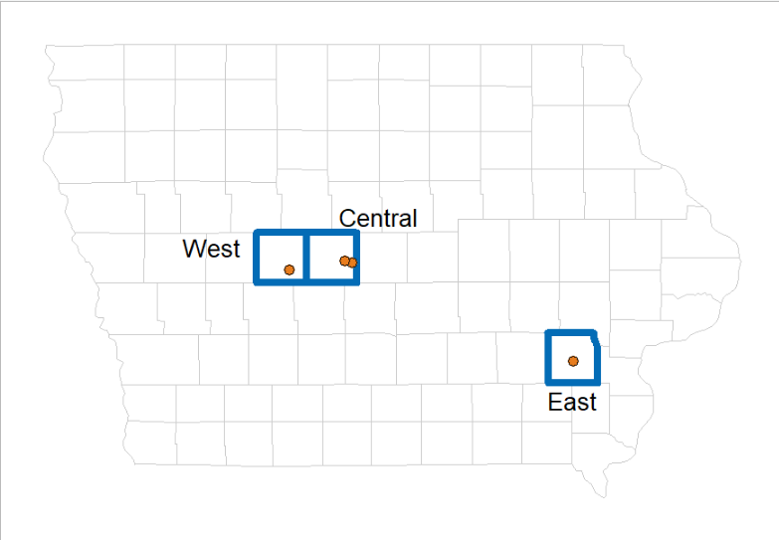
Figure 4-7 Map of Iowa showing locations of the three experimental sites (West, Central, East), with the Central site containing two trials.
The West-grain and East-grain trials were production fields on commercial farms, and only one phase of the maize/soybean rotation was present each year. The Central site was a larger research study managed by the United States Department of Agriculture (USDA) and included both phases of each rotation (Kaspar et al., 2007, 2012). For the present study, only the soybean phase of the USDA site was sampled due to time constraints. Cover crop biomass sampling occurred each spring at every trial; details about methodology are reported elsewhere (Nichols et al., 2020a) and historical values are available (Supplementary Table S4).

Table 4-5 Geographical, experimental, soil, weather, and sampling information for the four trials
Plot Size and Average Slope* | Treatment Replications | Dominant Soil Types* | Average Depth to Water Table* | 30-year Annual Mean |  |  | Mean Cover Crop Biomass |  | 2018 Crop | 2019 Sample Date
 |  |  |  | Air Temperature | Precipitation |  | 5-year | 10-year | 2018 Crop | 2019 Sample Date
m |  |  | cm | ⁰C | mm |  | Mg ha⁻¹ | Mg ha⁻¹
West-grain (commercial farm), 41⁰55’N 94⁰36’W, initiated in 2008
25 x 250  (1-3%) | 4 | Nicollet loam | 67 | 9.5 | 880 |  | 0.24 | 0.45 | Soybean | May 23
Central-silage (research plots); 42⁰00’N 93⁰48’W; initiated in 2002
3.8 x 55  (1-3%) | 5 | Clarion loam | 100 | 9.8 | 907 |  | 2.38 | 1.98 | Maize | June 6
Central-grain (research plots); 42⁰00’N 93⁰48’W; initiated in 2009
3.8 x 55  (1-3%) | 5 | Clarion loam | 100 | 9.8 | 907 |  | 1.53 | 0.88 | Maize | June 6
East-grain (commercial farm); 41⁰18’N 92⁰48’W; initiated in 2009
25 x 275  (0-2%) | 4 | Taintor silty clay loam | 0 | 10.2 | 947 |  | 1.73 | 1.32 | Maize | June 10

Soil Sampling
An aluminum ring 7.62 cm in diameter and 7.62 cm in length was used to extract intact soil samples. Sampling occurred in May or June of 2019 after maize (West) or soybean (East, Central-grain, Central-silage) emergence at each site. Sampling was conducted immediately following crop emergence to minimize the effects of live roots in the samples, and a few days following a rain to ensure the soil was fully drained, but wet enough to remain in the ring during sampling (Al-Shammary et al., 2018).
At all trials, samples were taken in the middle of the plots between planted rows. To get intact soil cores, a hole 10 cm deep was dug, and soil was smoothed by hand to create a flat area approximately 30 cm square. The ring was placed on the soil surface in the center of the flat area, a hollow metal cap was placed on it, and a 15 kg weight was used to evenly drive the ring into the undisturbed soil. Once the ring was fully inserted into the soil, a hole was dug around the ring. A flat sheet of metal was slid under the ring to extract it, and a knife was used to remove soil from the top and bottom of the ring using a Z-cutting motion. The ring was wrapped in aluminum foil with the soil orientation (top, bottom) marked. The foil-wrapped ring was then placed in an individual plastic container and placed in a cooler. This process was repeated for each plot. Samples remained in the cooler for no more than four hours before being placed in a refrigerator.

Soil-water-retention curve
Analytical equipment could accommodate 12 samples at a time, so each trial’s samples were run together for a total of four batches (e.g., the eight samples from the West trial were run together in one batch). Our interest was in comparing relative effects within a trial, so variation between runs was statistically included in variation between trials. The samples were analyzed in the order they were collected. A given trial’s cores had cheesecloth taped to the bottom of each core and an additional ring taped to the top. Each full batch of samples (eight samples for East and West, 10 for Central) was then placed in a vacuum chamber for at least 12 hours in a solution of 0.01 M CaCl2 filled to the top of the first ring, allowing the samples to saturate with minimal air entrapment. The top ring was removed from the cores, then the saturated cores were weighed, then transferred to a custom-built pressure cell apparatus (Ankeny et al. 1992). Measurements were made according to the protocol described by Kool et al. (2019). Cores were drained at atmospheric pressure for 12 hours to obtain a measurement for gravity-drained values (Ψm = -3.8 cmH2O). Subsequent measurements were taken at matric potentials (Ψm) of -10, -25, -50, -100, -200, and -500 cmH2O. The samples were then oven dried at 60 ⁰C for at least 48 hours, then weighed. Bulk densities were estimated by dividing the oven-dried weight of soil by the ring volume (347.5 cm3; Han et al. 2016). A water balance was constructed for each core individually as quality control, resulting in the removal of one replicate from the no-cover treatment of the Central-silage trial, which had a large visible hole in the center of the core upon destructive inspection, confirming its justified removal from the dataset.

Soil Texture
The oven-dried soil was ground and passed through a 2 mm sieve. Two teaspoons of soil (~10 grams) from each core were used for soil texture measurements. Soil texture was quantified using laser diffractometry (Miller and Schaetzl, 2012) with a Malvern Mastersizer 3000 and a HydroEV attachment (Malvern Panalytical Ltd, UK), producing estimates for the percentage of the soil that was sand (50-2000 µm), silt (6-50 µm), and clay (0.1-6 µm).

Organic carbon
Half of the remaining oven-dried soil cores were sent for organic matter analysis (Agsource, Ellsworth Iowa, USA) using the loss-on-ignition method (Nelson and Sommers, 1983). While this method may not produce reliable absolute estimates of organic matter (Hoogsteen et al., 2015), our interest was in pairwise comparisons of treatments rather than in obtaining absolute estimates of organic matter.

Statistical analysis
All data manipulation, figure creation, and model fitting were done using R version 4.0.3 (R Core Team, 2020) and the tidyverse meta-package (Wickham et al., 2019). Non-linear models were fit using the nlraa (Miguez, 2021) package functionality, with specific equation fits from the HydroMe (Omuto et al., 2021) and soilphysics (de Lima et al., 2021) packages. Linear models were fit and summarized using the lme4 (Bates et al., 2015) package, which fits mixed effects models, and the emmeans (Lenth et al., 2018) package which estimates both marginal and conditional means and confidence intervals and performs pairwise comparisons.
We fit the Gardner (Gardner, 1958) and van Genutchen (van Genuchten, 1980) models to describe the relationship between soil moisture and soil water matric potential in our datasets. We found the models produced similar Akaike’s Information Criteria (AIC; Bozdogan, 1987) values, with the Gardner model showing a slightly better fit. The Gardner equation is as follows:
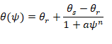
where θ is the volumetric moisture content at a given soil water potential ψ; the remaining variables are fitted parameters, θr and θs are the residual and saturated water contents, respectively, a is the inverse of the air-entry potential, and n is an index for the pore size distribution, with higher values indicating a broader distribution of pore sizes. We fit the Gardner model to each experimental unit, then analyzed the air-entry and pore-size distribution parameters as response variables, described below.
Residual water contents (θr) are estimated by the model, but can also be experimentally measured at -15,000 cmH2O, i.e., the permanent wilting point (SSSA, 2008). The highest pressure applied to samples in this study was -500 cmH2O, which could lead to less stable model fits due to lack of an anchoring value (Groenevelt and Grant, 2004). To determine whether the model produced reasonable estimates without these anchoring values, we compared the model-estimated saturated water contents with the data, as well as the pore-size distribution parameter estimate against values estimated using capillary rise equations, which assumes the mean pore neck diameter (in cm) of drained pores at a given pressure is equal to 0.3 divided by the head pressure (cmH2O). Pores with mean neck diameters greater than 30 µm were considered macropores (Kirkham, 2014). The percent macropores was assessed as a response variable, described below.
Volumetric water contents at saturation were extracted directly from the data. Volumetric water contents at field capacity were estimated as the volumetric water content at a matric potential of -100 cmH2O (Moore 2021). We used this approximation because the actual matric potential that represents field capacity depends on the depth to the water table. The trials sampled all had artificial tile drainage installed at ~1.2 meter depths and shallow water tables (Table 1), meaning field capacity will be at matric potentials less negative than the commonly assumed value of -330 cmH2O (Bonfante et al., 2020). Soil water retention curve data from Moore (2021), suggests that -100 cmH2O is a better approximation for field capacity in mollic epipedons with shallow water tables, such as those sampled in the present study.
The effects of trial, CC treatment, and their interaction on response variables (soil texture, organic matter, water contents at saturation and field capacity, air-entry pressures, pore-size distribution index, percent macropores) were assessed using mixed-effect models. Trial, CC treatment, and their interaction were included as fixed effects. Percent sand was investigated as a covariate in appropriate models because texture is the dominant driver of water retention curve parameters (de Jong et al., 1983; Saxton and Rawls, 2006). Models without a sand covariate had random intercept effects for replicates nested within location (East, Central, West), and models that included a sand covariate had fixed effects only. Models were compared using AIC. All results are available in Supplementary Tables S5-S11.

Results and Discussion

Soil texture, organic matter, and bulk density
All plots had textures within ranges classified as silty-clay-loams. Texture varied most strongly by trial, with the East-grain trial having the lowest amount of sand and highest silt component. In the two commercial production field trials, the sample’s texture also varied by CC treatment. The CC plots had a significantly higher sand component, and significantly lower clay component than the no-cover plots in the West-grain and East-grain trials (Table 4-5, Figure 4-8). While the plots in the commercial production fields were randomly assigned a CC treatment, the East-grain site’s treatments were regularly alternating strips with blocks laid out laterally, and the West-grain sites were close to regular alternations likewise laid out laterally. In fields with a uniform texture gradient perpendicular to the blocking with only two treatments, this regularly alternating pattern could result in one treatment having significantly different textures compared to the other. The Central site had several treatments in small plots and the blocks were in quadrants within the field, which may have better randomized spatial patterns in the soil.
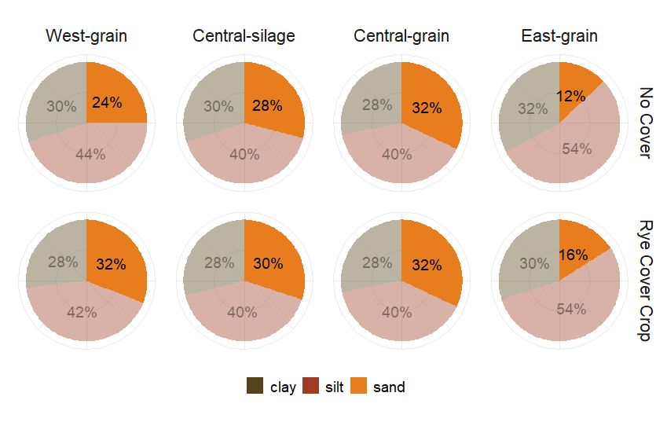
Figure 4-8 Soil texture components varied by trial and cover crop treatment

with the cover cropped plots having significantly more sand (bolded orange color) and significantly less clay at the West-grain and East-grain trials (both commercial production fields).
Based on these results, sand was investigated as a covariate in statistical models for response variables thought to be affected by soil texture. Soil texture is the dominant factor determining soil water retention (de Jong et al., 1983; Saxton and Rawls, 2006), particularly under wet conditions (i.e., saturation and field capacity; Manns and Berg, 2014), so statistical comparisons of soil water at saturation and field capacity are reported from models that include the sand co-variate.
Organic matter concentrations ranged from 1.8 to 4.6 mg (g soil)⁻¹. The models testing the significant effects of cover cropping on organic matter were very sensitive to inclusion of sand as a covariate. The two trials with significantly different sand components in the cover crop and winter fallow treatments (West-grain, East-grain) had lower organic matter in the cover crop treatments without a sand-correction, but higher organic matter with a sand correction. We therefore choose not to report the results from the statistical analyses, but results are available (Supplementary Table S7).
Bulk densities varied from 1.2 g cm⁻³ to 1.7 g cm⁻³. The large size of sand particles reduces packing efficiencies compared with clay, meaning a sandy soil may have lower bulk densities simply due to packing arrangements. However, regardless of the statistical model fit, all estimated CC effects were less than measurement precision of the core method for measuring bulk density (±0.12 g cm⁻³; Han et al., 2016), rendering their interpretation questionable. A recent summary of research on the effects of CCs on bulk densities found few studies where an overwintering rye CC grown in the US reduced bulk densities more than typical measurement errors (Haruna et al., 2020b).

Soil hydrological properties
Due to the high amount of variability associated with soils, we assigned significance at p-values less than 0.10. With or without a sand correction, no trial exhibited a significant increase in water held at saturation with the use of cover cropping (Figure 4-9). Water held at saturation is largely dependent on bulk density, so these findings are consistent with the lack of meaningful effect of CCs on bulk densities in our study.
Field capacities were significantly higher in the cover cropped plots at both the West-grain (p = 0.07) and Central-silage (p = 0.05) trials. At the West-grain trial, the soil water at field capacity was increased (after sand correction) from 33.6 to 36.0 vol%, and at the Central-silage trial from 38.1 to 40.6 vol%, respectively. The West-grain trial consistently produced the lowest above-ground CC biomasses, and the Central-silage trial the highest (Table 1), indicating the changes in water held at field capacity could not be predicted based on CC above-ground biomass production. Likewise, there was no pattern between soil textural characteristics and presence or absence of a CC effect on water held at field capacity, meaning that knowledge of a soil’s texture did not help predict whether a CC would affect water held at field capacity.
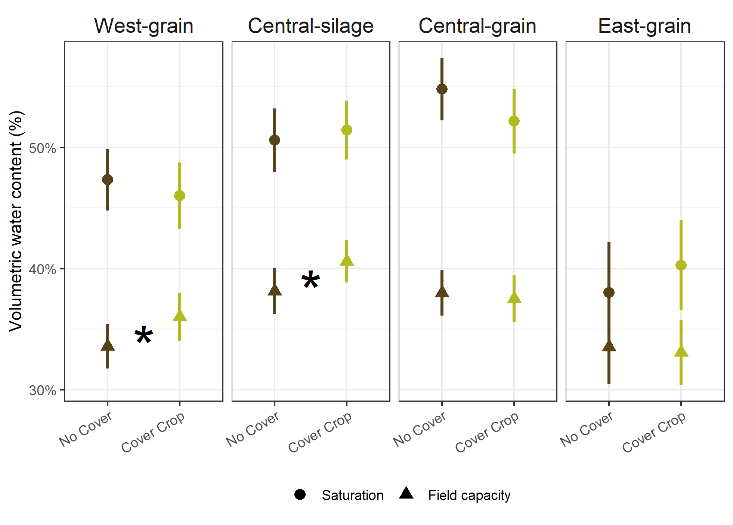
Figure 4-9 Soil volumetric water contents

at saturation (circles) and field capacity (-100 cmH2O, triangles) with 10+ years of winter rye cover cropping (green) or winter fallow (brown) in a maize-soybean rotation at four trials. Points are estimated means, line ranges are the 95% confidence intervals around the mean. Stars indicate significant differences at p<0.10 with the sand adjustment.
While the West-grain results were not significant without a sand correction, the trial exhibited the same trend of increased water at field capacity with cover cropping regardless of whether the sand correction was included or not. These results suggest that at the 10-18cm depth increment, CCs may have a larger impact on water at field capacity compared to water held at saturation. To our knowledge there are limited studies examining the potential for CCs to reduce flood damage in the Midwest, but the few that do account for only the increased evapotranspiration with the use of CCs (Antolini et al., 2020). An increase in the soil’s ability to hold water after gravity drainage may also contribute to peak water flow regulation. By increasing volumetric water content at field capacity by 2 vol%, CC fields could hold an additional 200,000 L of water in each 100-cm hectare slice. For comparison, an over-wintered rye cover crop might have an evapotranspiration rate of approximately 24,000 L ha⁻¹ day⁻¹ (Qi and Helmers 2010), and water volumes from sub-surface drainage tiles can reach approximately 22,000 L ha⁻¹ hour⁻¹ in Iowa (Daigh et al. 2014). This means the additional water 200,000 L of water holding capacity could meaningfully reduce the amount of water drained from a field after a saturating rain. Our study suggests considering how CC-induced increases to the amount of water held in a soil at field capacity affect flood incidence and severity would be worth investigating.
The Gardner equation fit converged for all experimental units (Figure 4-10). The a parameter is the inverse of air-entry potential, meaning lower values indicate a larger minimum pore size, ranged from 0.001 to 0.284. The n parameter is the pore-size distribution index, with larger values indicating more heterogeneous pore sizes, ranged from 0.45 to 1.49. While the parameters did differ by trial, cover cropping did not significantly affect either parameter in any trial.
Manual estimation of the pore-size distribution confirmed CCs did not increase the percentage of macropores in any trial (Figure 4-11). In fact, in the West-grain trial the number of macropores significantly decreased with cover cropping, with 61% macropores in the control treatment compared with 48% in the CC treatment.
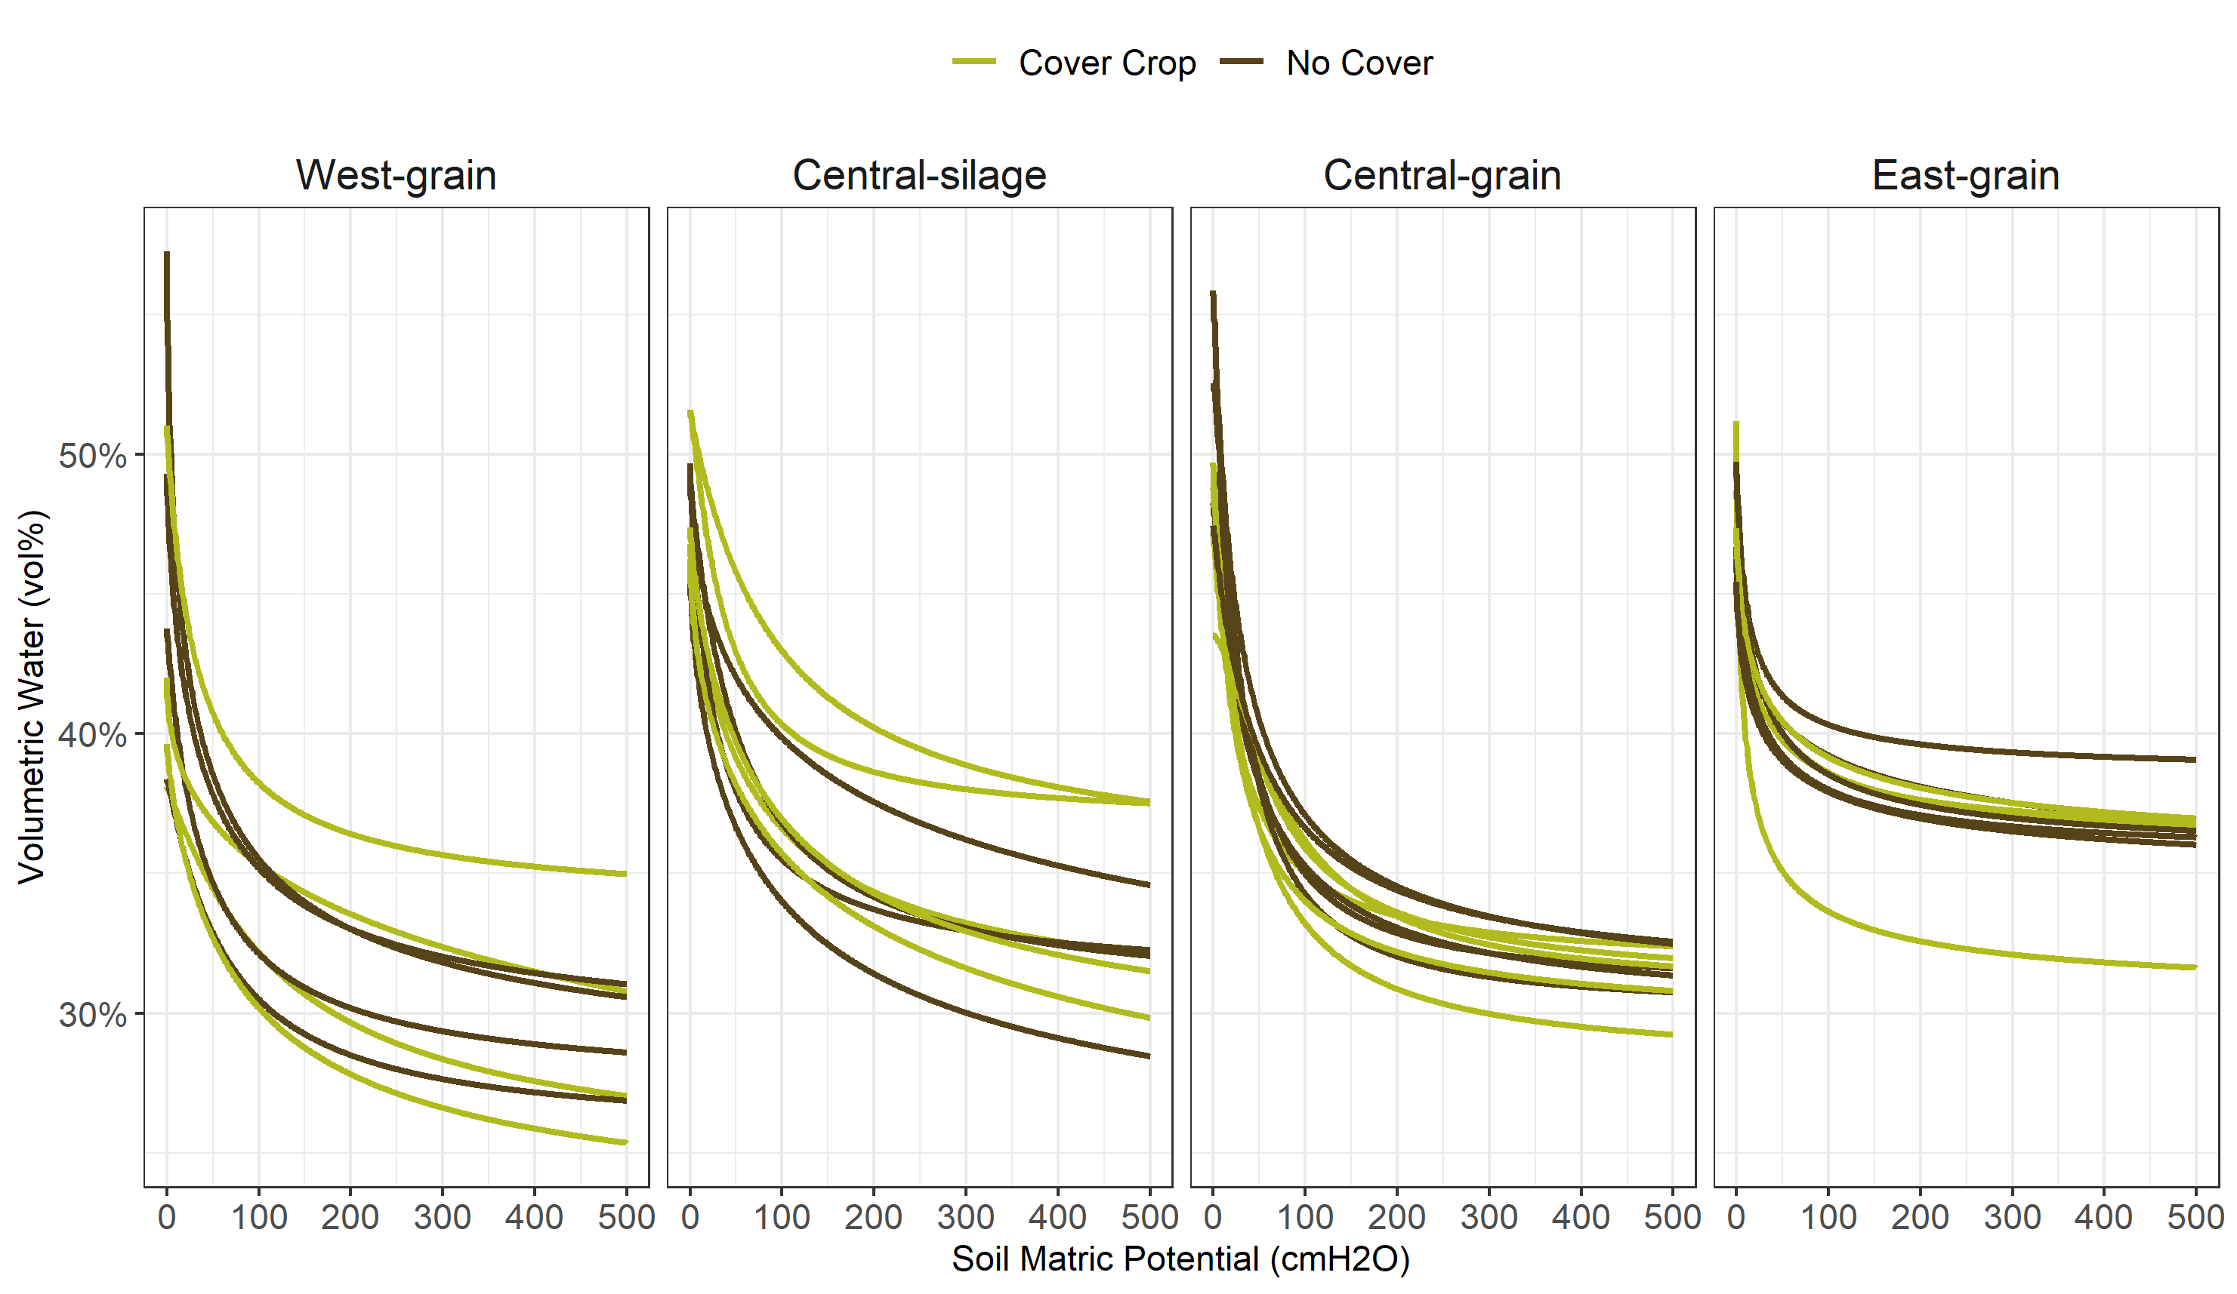
Figure 4-10 The Gardner equation was fit to each experimental unit, with four or five replicates for each cover crop treatment
In a review of published studies, Haruna et al. (2020) found the effect of CCs on macropore makeup of the soil highly variable, but with an overall average increase. The wide variation may be partially due to varying cut-offs in pore sizes for macropore categorization (Luxmoore, 1981), but the variability in combination with our results again demonstrates using literature averages to predict CC impacts in Midwestern systems may be inappropriate.

Causal model
There are several pathways by which CCs might affect a soil’s capacity to hold water (Figure 4-6, Table 4-6). The causal model was built using literature relevant to Midwestern systems, and when applicable was limited to evidence drawn from research conducted with a cereal rye cover crop (Table 4-2). The model is simplified to exclude the effects of soil erosion, soil texture, tillage, and landscape position, which are all factors that could potentially influence how soil responds to cover cropping (Moore 2021). Rather, we present this simple causal model to provide a base from which to build.
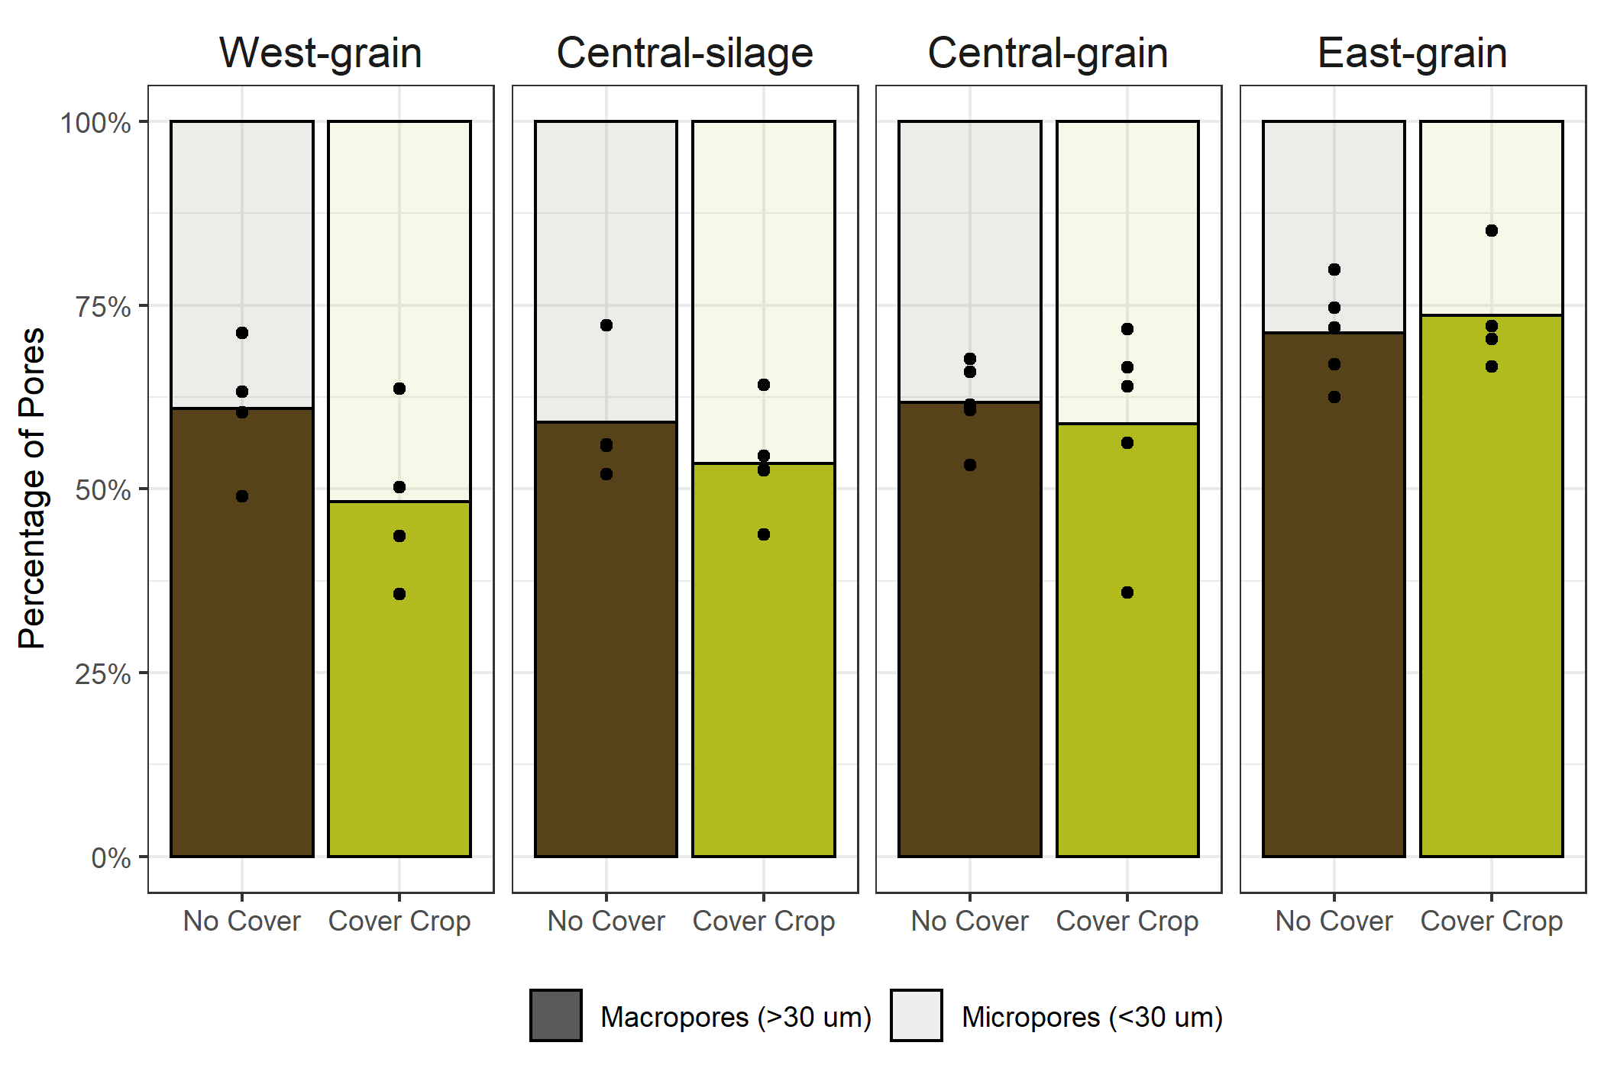
Figure 4-11 Replicate (point) and treatment mean (bars) percentage macropores (>30 µm) for each trial;

percent macropores in the cover crop treatment was significantly lower (p=0.04) at the West-grain trial compared to the control treatment.
Causal diagrams such as Figure 4-6 are the basis for constructing structural equation models, which can greatly enhance researchers’ ability to address complex research questions in agriculture (Smith et al., 2014; Wade et al., 2020). For example, in our proposed causal diagram, below-ground biomass measurements are necessary for estimating direct effects of cover cropping on pore size distributions, field capacity, and saturation. This is further supported by recent studies and reviews that identify CC roots as being a crucial component to understanding CC effects on soil properties (Williams and Weil, 2004; Haruna et al., 2020b; Ogilvie et al., 2021).
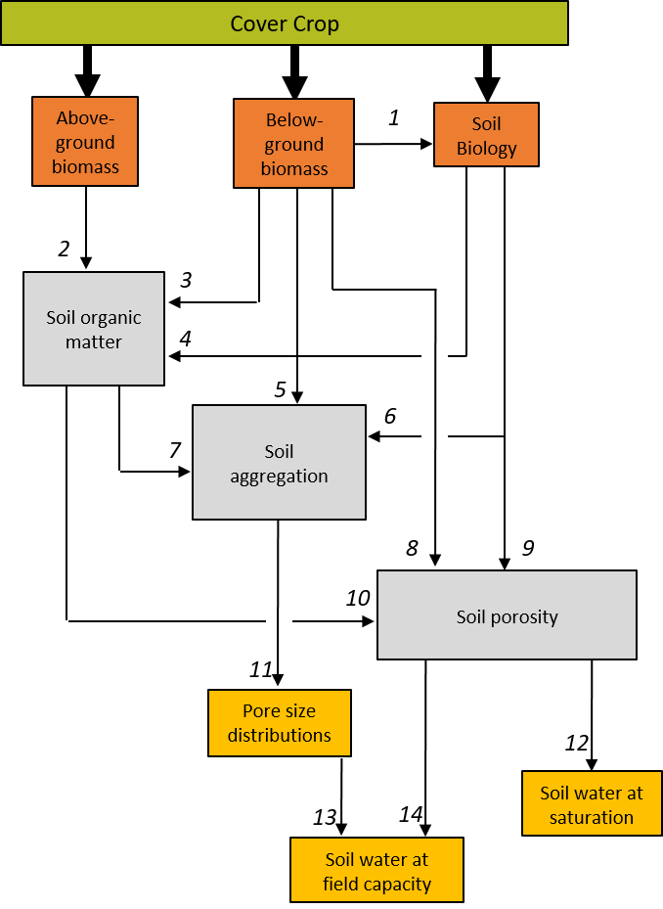
Figure 4-12 Pathways by which cover crops may affect the pore size distributions, the amount of water stored at field capacity, and the amount of water at saturation in no-till systems

The effects of soil erosion are not included. X→Y should be read as ‘X affects Y’.
While there is limited data available on both above- and below-ground biomass of CCs, data collected over the period of five years in Iowa showed no relationship between above- and below-ground rye biomass, with root-to-shoot ratios varying from 0.16-1.94 at similar levels of aboveground biomass production (Martinez-Feria et al., 2016). Therefore, above-ground biomass production cannot be used as a proxy for below-ground production with much confidence, and studies that pair above- and below-ground CC biomass with soil measurements would be advantageous in enhancing our understanding of CC effects on soil.
Table 4-6 Support for inclusion of causal relationships presented in Figure 4-6
Casual Arrow | Causal relationship | Citation(s)
1 | CC below-ground biomass affects soil biology | (Leslie et al., 2017; Kim et al., 2020)
2 | CC above-ground biomass affects soil organic matter | (Austin et al., 2017)
3 | CC below-ground biomass affects soil organic matter, more strongly than above-ground biomass | (Austin et al., 2017)
4 | Soil biology affects soil organic matter cycling | (Cotrufo et al., 2013)
5 | CC below-ground biomass (root exudates) affect soil aggregation | (Cotrufo et al., 2013; Austin et al., 2017)
6 | Soil biology affects soil aggregation | (Cotrufo et al., 2013)
7 | Soil organic matter affects soil aggregation | (Boyle et al., 1989; Kay et al., 1997; Abiven et al., 2009)
8 | Root channels affect soil porosity | (Williams and Weil, 2004; Ogilvie et al., 2021)
9 | Soil biology (e.g., worm activity) affects soil porosity | (Edwards et al., 1988)
10 | Soil organic matter affects bulk density, which affects soil porosity | (Ruehlmann and Körschens, 2009)
11 | Soil aggregation affects pore sizes | (Boyle et al., 1989)
12 | Soil water at saturation is affected by soil porosity
13 | Pore size distributions affect capillary forces, which affect soil water at field capacity
14 | Soil porosity affects space available for water which affects soil water at field capacity

Conclusions
Context-specific effects of growing over-wintering CCs need to be explicitly investigated, as the constraints of the Midwestern maize-soybean system may render the effects smaller in magnitude compared to averages reported by global meta-analyses. In our study we found CCs have a more pronounced effect on water held at field capacity compared to water contents at saturation, suggesting changes in pore networks and sizes are stronger compared to changes in bulk density. However, we found CCs increased water held at field capacity in only two of the four trials, further demonstrating the need to understand causal mechanisms to better predict where and when CCs might provide the most benefit.

References
Abiven, S., S. Menasseri, and C. Chenu. 2009. The effects of organic inputs over time on soil aggregate stability - A literature analysis. Soil Biology and Biochemistry 41(1): 1–12. doi: 10.1016/j.soilbio.2008.09.015.
Al-Kaisi, M.M., A. Douelle, and D. Kwaw-Mensah. 2014. Soil microaggregate and macroaggregate decay over time and soil carbon change as influenced by different tillage systems. Journal of Soil and Water Conservation 69(6). doi: 10.2489/jswc.69.6.574.
Al-Shammary, A.A.G., A.Z. Kouzani, A. Kaynak, S.Y. Khoo, M. Norton, et al. 2018. Soil Bulk Density Estimation Methods: A Review. Pedosphere 28(4): 581–596. doi: 10.1016/S1002-0160(18)60034-7.
Antolini, F., E. Tate, B. Dalzell, N. Young, K. Johnson, et al. 2020. Flood Risk Reduction from Agricultural Best Management Practices. Journal of the American Water Resources Association 56(1): 161–179. doi: 10.1111/1752-1688.12812.
Asbjornsen, H., G. Shepherd, M. Helmers, and G. Mora. 2008. Seasonal patterns in depth of water uptake under contrasting annual and perennial systems in the Corn Belt Region of the Midwestern U.S. Plant and Soil 308(1–2): 69–92. doi: 10.1007/s11104-008-9607-3.
Atwood, L.W., and S.A. Wood. 2021. AgEvidence: Agro-environmental responses of conservation agricultural practices in the US Midwest published from 1980 to 2017. Knowledge Network for Biocomplexity.
Austin, E.E., K. Wickings, M.D. McDaniel, G.P. Robertson, and A.S. Grandy. 2017. Cover crop root contributions to soil carbon in a no-till corn bioenergy cropping system. GCB Bioenergy 9(7): 1252–1263. doi: 10.1111/gcbb.12428.
Baker, J.M., and T.J. Griffis. 2009. Evaluating the potential use of winter cover crops in corn-soybean systems for sustainable co-production of food and fuel. Agricultural and Forest Meteorology 149(12): 2120–2132. doi: 10.1016/j.agrformet.2009.05.017.
Basche, A., and M. DeLonge. 2017. The Impact of Continuous Living Cover on Soil Hydrologic Properties: A Meta-Analysis. Soil Science Society of America Journal 81(5): 1179–1190. doi: 10.2136/sssaj2017.03.0077.
Basche, A.D., and M.S. DeLonge. 2019. Comparing infiltration rates in soils managed with conventional and alternative farming methods: A meta-analysis. PLoS ONE 14(9): 1–22. doi: 10.1371/journal.pone.0215702.
Basche, A.D., T.C. Kaspar, S. v. Archontoulis, D.B. Jaynes, T.J. Sauer, et al. 2016. Soil water improvements with the long-term use of a winter rye cover crop. Agricultural Water Management 172: 40–50. doi: 10.1016/j.agwat.2016.04.006.
Bates, D., M. Mächler, B. Bolker, and S. Walker. 2015. Fitting Linear Mixed-Effects Models using lme4. Journal of Statistical Software 67(1): 1–48. doi: 10.18637/jss.v067.i01.
Bonfante, A., A. Basile, and J. Bouma. 2020. Exploring the effect of varying soil organic matter contents on current and future moisture supply capacities of six Italian soils. Geoderma 361: 114079. doi: 10.1016/j.geoderma.2019.114079.
Boyle, M., W.T. Frankenberger, and L.H. Stolzy. 1989. The Influence of Organic Matter on Soil Aggregation and Water Infiltration. Journal of Production Agriculture 2(4): 290–299. doi: 10.2134/jpa1989.0290.
Bozdogan, H. 1987. Model selection and Akaike’s Information Criterion (AIC): The general theory and its analytical extensions. Psychometrika 52(3): 345–370. doi: 10.1007/BF02294361.
Campos, H., M. Cooper, O. Edmeades, C. Loffler, J.R. Schussler, et al. 2006. Changes in drought tolerance in maize associated with fifty years of breeding for yield in the US corn belt. . Maydica 51(2).
Cotrufo, M.F., M.D. Wallenstein, C.M. Boot, K. Denef, and E. Paul. 2013. The Microbial Efficiency-Matrix Stabilization (MEMS) framework integrates plant litter decomposition with soil organic matter stabilization: Do labile plant inputs form stable soil organic matter? Global Change Biology 19(4): 988–995. doi: 10.1111/gcb.12113.
Cusser, S., C. Bahlai, S.M. Swinton, G.P. Robertson, and N.M. Haddad. 2020. Long‐term research avoids spurious and misleading trends in sustainability attributes of no‐till. Global Change Biology 26(6). doi: 10.1111/gcb.15080.
Daigh, A.L., Zhou, X., Helmers, M.J., Pederson, C.H., Ewing, R. and Horton, R., 2014. Subsurface drainage flow and soil water dynamics of reconstructed prairies and corn rotations for biofuel production. Vadose Zone Journal, 13(4). doi: 10.2136/vzj2013.10.0177
Edwards, W.M., L.D. Norton, and C.E. Redmond. 1988. Characterizing Macropores that Affect Infiltration into Nontilled Soil. Soil Science Society of America Journal 52(2): 483–487. doi: 10.2136/sssaj1988.03615995005200020033x.
Gardner, W.R. 1958. Some steady-state solutions of the unsaturated moisture flow equation with application to evaporation from a water table. Soil Science 85(4): 228–232. doi: 10.1097/00010694-195804000-00006.
van Genuchten, M.Th. 1980. A Closed-form Equation for Predicting the Hydraulic Conductivity of Unsaturated Soils. Soil Science Society of America Journal 44(5): 892–898. doi: 10.2136/sssaj1980.03615995004400050002x.
Groenevelt, P.H., and C.D. Grant. 2004. A new model for the soil-water retention curve that solves the problem of residual water contents. European Journal of Soil Science 55(3): 479–485. doi: 10.1111/j.1365-2389.2004.00617.x.
Han, Y., J. Zhang, K.G. Mattson, W. Zhang, and T.A. Weber. 2016. Sample Sizes to Control Error Estimates in Determining Soil Bulk Density in California Forest Soils. Soil Science Society of America Journal 80(3): 756–764. doi: 10.2136/sssaj2015.12.0422.
Haruna, S.I., S.H. Anderson, R.P. Udawatta, C.J. Gantzer, N.C. Phillips, et al. 2020a. Improving soil physical properties through the use of cover crops: A review. Agrosystems, Geosciences & Environment 3(1). doi: 10.1002/agg2.20105.
Haruna, S.I., S.H. Anderson, R.P. Udawatta, C.J. Gantzer, N.C. Phillips, et al. 2020b. Improving soil physical properties through the use of cover crops: A review. Agrosystems, Geosciences & Environment 3(1). doi: 10.1002/agg2.20105.
Haruna, S.I., and N. v. Nkongolo. 2015. Cover Crop Management Effects on Soil Physical and Biological Properties. Procedia Environmental Sciences 29: 13–14. doi: 10.1016/j.proenv.2015.07.130.
Hoogsteen, M.J.J., E.A. Lantinga, E.J. Bakker, J.C.J. Groot, and P.A. Tittonell. 2015. Estimating soil organic carbon through loss on ignition: Effects of ignition conditions and structural water loss. European Journal of Soil Science 66(2): 320–328. doi: 10.1111/ejss.12224.
Hudson, B.D. 1994. Available water capacity and soil organic matter. Journal of Soil and Water Conservation 49(2): 189–194. doi: 10.1081/E-ESS-120018496.
Irmak, S., V. Sharma, A.T. Mohammed, and K. Djaman. 2018. Impacts of Cover Crops on Soil Physical Properties: Field Capacity, Permanent Wilting Point, Soil-Water Holding Capacity, Bulk Density, Hydraulic Conductivity, and Infiltration. Transactions of the ASABE 61(4). doi: 10.13031/trans.12700.
de Jong, R., C.A. Campbell, and W. Nicholaichuk. 1983. Water retention equations and their relationship to soil organic matter and particle size distribution for disturbed samples. Canadian Journal of Soil Science 63(2): 291–302. doi: 10.4141/cjss83-029.
Kane, D.A., M.A. Bradford, E. Fuller, E.E. Oldfield, and S.A. Wood. 2021. Soil organic matter protects US maize yields and lowers crop insurance payouts under drought. Environmental Research Letters 16(4). doi: 10.1088/1748-9326/abe492.
Kaspar, T.C., D.B. Jaynes, T.B. Parkin, and T.B. Moorman. 2007. Rye cover crop and gamagrass strip effects on NO3 concentration and load in tile drainage. Journal of environmental quality 36(5): 1503–1511. doi: 10.2134/jeq2006.0468.
Kaspar, T.C., D.B. Jaynes, T.B. Parkin, T.B. Moorman, and J.W. Singer. 2012. Effectiveness of oat and rye cover crops in reducing nitrate losses in drainage water. Agricultural Water Management 110(3): 25–33. doi: 10.1016/j.agwat.2012.03.010.
Kaspar, T.C., T.B. Parkin, D.B. Jaynes, C.A. Cambardella, D.W. Meek, et al. 2006. Examining Changes in Soil Organic Carbon with Oat and Rye Cover Crops Using Terrain Covariates. Soil Science Society of America Journal 70(4): 1168–1177. doi: 10.2136/sssaj2005.0095.
Kaspar, T., and J. Singer. 2011. The Use of Cover Crops to Manage Soil. Publications from the USDA-ARS/UNL Faculty. p. 1382
Kay, B.D., A.P. da Silva, J.A. Baldock, D. Silva, A.P. And Baldock, et al. 1997. Sensitivity of soil structure to changes in organic carbon content: Predictions using pedotransfer functions. Canadian Journal of Soil Science 77(4): 655–667.
Kim, N., M.C. Zabaloy, K. Guan, and M.B. Villamil. 2020. Do cover crops benefit soil microbiome? A meta-analysis of current research. Soil Biology and Biochemistry 142: 107701. doi: 10.1016/j.soilbio.2019.107701.
King, A.E., G.A. Ali, A.W. Gillespie, and C. Wagner-Riddle. 2020. Soil Organic Matter as Catalyst of Crop Resource Capture. Frontiers in Environmental Science 8. doi: 10.3389/fenvs.2020.00050.
Kirkham, M.B. 2014. Principles of soil and plant water relations, 2nd Edition. Elsevier Inc.
Kladivko, E.J., T.C. Kaspar, D.B. Jaynes, R.W. Malone, J. Singer, et al. 2014. Cover crops in the upper midwestern United States: Potential adoption and reduction of nitrate leaching in the Mississippi River Basin. Journal of Soil and Water Conservation 69(4): 279–291. doi: 10.2489/jswc.69.4.279.
Kool, D., B. Tong, Z. Tian, J.L. Heitman, T.J. Sauer, et al. 2019. Soil water retention and hydraulic conductivity dynamics following tillage. Soil and Tillage Research 193: 95–100. doi: 10.1016/j.still.2019.05.020.
Lenth, R., H. Singmann, and J. Love. 2018. Emmeans: Estimated maringal means, aka least-squares means.
Leslie, A.W., K.H. Wang, S.L.F. Meyer, S. Marahatta, and C.R.R. Hooks. 2017. Influence of cover crops on arthropods, free-living nematodes, and yield in a succeeding no-till soybean crop. Applied Soil Ecology 117–118: 21–31. doi: 10.1016/j.apsoil.2017.04.003.
Leuthold, S.J., M. Salmerón, O. Wendroth, and H. Poffenbarger. 2021. Cover crops decrease maize yield variability in sloping landscapes through increased water during reproductive stages. Field Crops Research 265. doi: 10.1016/j.fcr.2021.108111.
de Lima, R.P., A.R. da Silva, and Á.P. da Silva. 2021. soilphysics: An R package for simulation of soil compaction induced by agricultural field traffic. Soil and Tillage Research 206: 104824. doi: 10.1016/j.still.2020.104824.
Luxmoore, R.J. 1981. Micro-, Meso-, and Macroporosity of Soil. Soil Science Society of America Journal 45(3): 671–672. doi: 10.2136/sssaj1981.03615995004500030051x.
Manns, H.R., and A.A. Berg. 2014. Importance of soil organic carbon on surface soil water content variability among agricultural fields. Journal of Hydrology 516: 297–303. doi: 10.1016/j.jhydrol.2013.11.018.
Marcillo, G.S.S., and F.E.E. Miguez. 2017. Corn yield response to winter cover crops: An updated meta-analysis. Journal of Soil and Water Conservation 72(3): 226–239. doi: 10.2489/jswc.72.3.226.
Martinez-Feria, R.A., R. Dietzel, M. Liebman, M.J. Helmers, and S. v Archontoulis. 2016. Rye cover crop effects on maize: A system-level analysis. Field Crops Research 196: 145–159. doi: 10.1016/j.fcr.2016.06.016.
Miguez, F. 2021. nlraa: Nonlinear Regression for Agricultural Applications.
Miller, B.A., and R.J. Schaetzl. 2012. Precision of Soil Particle Size Analysis using Laser Diffractometry. Soil Science Society of America Journal 76(5): 1719. doi: 10.2136/sssaj2011.0303.
Minasny, B., and A.B. McBratney. 2018. Limited effect of organic matter on soil available water capacity. European Journal of Soil Science 69(1): 39–47. doi: 10.1111/ejss.12475.
Moore, E.B., M.H. Wiedenhoeft, T.C. Kaspar, and C.A. Cambardella. 2014. Rye Cover Crop Effects on Soil Quality in No-Till Corn Silage-Soybean Cropping Systems. Soil Science Society of America Journal 78(3): 968–976. doi: 10.2136/sssaj2013.09.0401.
Nelson, D.W., and L.E. Sommers. 1983. Total Carbon, Organic Carbon, and Organic Matter. John Wiley & Sons, Ltd. p. 539–579
Nichols, V., L. English, S. Carlson, S. Gailans, and M. Liebman. 2020a. Effects of Long-Term Cover Cropping on Weed Seedbanks. Frontiers in Agronomy 2: 591091. doi: 10.3389/fagro.2020.591091.
Nichols, V., R. Martinez‐Feria, D. Weisberger, S. Carlson, B. Basso, et al. 2020b. Cover crops and weed suppression in the U.S. Midwest: A meta‐analysis and modeling study. Agricultural & Environmental Letters 5(1). doi: 10.1002/ael2.20022.
Ogilvie, C.M., W. Ashiq, H.B. Vasava, and A. Biswas. 2021. Quantifying root-soil interactions in cover crop systems: A review. Agriculture (Switzerland) 11(3). doi: 10.3390/agriculture11030218.
Omuto, C. T., and L. O. Gumbe. 2009. Estimating water infiltration and retention characteristics using a computer program in R. Computers & Geosciences 35(3): 579-585.
Qi, Z., and M.J. Helmers. 2010. Soil water dynamics under winter rye cover crop in central Iowa. Vadose Zone Journal 9(1): 53-60.
Pearl, J. 2010. An introduction to causal inference. International Journal of Biostatistics 6(2). doi: 10.2202/1557-4679.1203.
Rizzo, G., J.I.R. Edreira, S. v. Archontoulis, H.S. Yang, and P. Grassini. 2018. Do shallow water tables contribute to high and stable maize yields in the US Corn Belt? Global Food Security 18: 27–34. doi: 10.1016/J.GFS.2018.07.002.
Rorick, J.D., and E.J. Kladivko. 2017. Cereal rye cover crop effects on soil carbon and physical properties in southeastern Indiana. Journal of Soil and Water Conservation 72(3). doi: 10.2489/jswc.72.3.260.
Ruehlmann, J., and M. Körschens. 2009. Calculating the Effect of Soil Organic Matter Concentration on Soil Bulk Density. Soil Science Society of America Journal 73(3): 876–885. doi: 10.2136/sssaj2007.0149.
Saxton, K.E., and W.J. Rawls. 2006. Soil Water Characteristic Estimates by Texture and Organic Matter for Hydrologic Solutions. Soil Science Society of America Journal 70(5): 1569–1578. doi: 10.2136/sssaj2005.0117.
Smith, R.G., A.S. Davis, N.R. Jordan, L.W. Atwood, A.B. Daly, et al. 2014. Structural equation modeling facilitates transdisciplinary research on agriculture and climate change. Crop Science 54(2): 475–483. doi: 10.2135/cropsci2013.07.0474.
SSSA. 2008. Glossary of Soil Science Terms 2008. American Society of Agronomy and Soil Science Society of America, Madison, WI, USA.
Strock, S.J., P.M. Porter, and M.P. Russelle. 2004. Cover cropping to reduce nitrate loss through subsurface drainage in the northern U.S. corn belt. Journal of environmental quality 33(3): 1010–1016. doi: 10.2134/jeq2004.1010.
Unger, P.W., and M.F. Vigil. 1998. Cover crop effects on soil water relationships. Journal of Soil and Water Conservation 53(3): 200–207.
Villamil, M.B., G.A. Bollero, R.G. Darmody, F.W. Simmons, and D.G. Bullock. 2006. No-Till Corn/Soybean Systems Including Winter Cover Crops. Soil Science Society of America Journal 70(6): 1936–1944. doi: 10.2136/sssaj2005.0350.
Wade, J., S.W. Culman, J.A.R. Logan, H. Poffenbarger, M.S. Demyan, et al. 2020. Improved soil biological health increases corn grain yield in N fertilized systems across the Corn Belt. Scientific Reports 10(1): 3917. doi: 10.1038/s41598-020-60987-3.
Wickham, H., M. Averick, J. Bryan, W. Chang, L. McGowan, et al. 2019. Welcome to the Tidyverse. Journal of Open Source Software 4(43): 1686. doi: 10.21105/joss.01686.
Williams, A., M.C. Hunter, M. Kammerer, D.A. Kane, N.R. Jordan, et al. 2016. Soil water holding capacity mitigates downside risk and volatility in US rainfed maize: Time to invest in soil organic matter? PLoS ONE 11(8): 1–11. doi: 10.1371/journal.pone.0160974.
Williams, C.L., M. Liebman, J.W. Edwards, D.E. James, J.W. Singer, et al. 2008. Patterns of regional yield stability in association with regional environmental characteristics. Crop Science 48(4): 1545–1559. doi: 10.2135/cropsci2006.12.0837.
Williams, S.M., and R.R. Weil. 2004. Crop Cover Root Channels May Alleviate Soil Compaction Effects on Soybean Crop. Soil Science Society of America Journal 68(4): 1403–1409. doi: 10.2136/sssaj2004.1403.

Appendix

Supplementary Information
Detailed management of trials (Tables S4-1 through S4-3), historical cover crop biomass production (Table S4-4), and statistical results (Tables S4-5 through S4-11) are available in a PDF at the following link: https://github.com/vanichols/ghproj_sare18/blob/master/03_supp-mat/rmd-supp-mat.pdf.
All data is available in an R package (https://github.com/vanichols/PFIswhc) and code repository (will be created once paper is accepted) available on github. Additionally, the data will be available as a downloadable csv file in supplementary material of the published manuscript.

DOES DIVERSIFYING CROP ROTATIONS SUPPRESS WEEDS? A META-ANALYSIS.
Virginia Nichols¹, David Weisberger², Matt Liebman¹
¹Department of Agronomy, Iowa State University
²Department of Crop and Soil Sciences, University of Georgia
Modified from a manuscript published in PLOS ONE

Abstract
Over the past half-century, crop rotations have become increasingly simplified, with whole regions producing only one or two crops in succession. Simplification is problematic from a weed management perspective, because it results in weeds’ repeated exposure to the same set of ecological and agronomic conditions. This can exacerbate weed infestations and promote the evolution of herbicide resistance. Diversifying crop rotations through addition of crop species and their associated managements may suppress weeds and reduce selection pressure for herbicide resistance by altering stress and mortality factors affecting weed dynamics. Here we report the results of a meta-analysis using 298 paired observations from 54 studies across six continents to compare weed responses in simple and more diverse crop rotations. We found diversifying from simple rotations reduced weed density (49%), but did not have a significant effect on weed biomass. We investigated the effect of management practices, environmental factors, and rotation design on this effect. Diversification that increased the variance around crop planting dates was more effective in suppressing weeds than increasing crop species richness alone. Increasing rotational diversity reduced weed density more under zero-tillage conditions (65%) than tilled conditions (41%), and did so regardless of environmental context and auxiliary herbicide use. Our findings highlight the value of diversifying crop rotations to control weed populations, and support its efficacy under varied environmental conditions and management scenarios.

Introduction
Weed management is an essential part of crop production. Crop yield reductions from weeds average 40% on a global scale, and costs associated with management inputs represent a major economic expense for farmers [1, 2]. Broadly speaking, many major agricultural regions produce only one or two economically-important crops [3]. This reduction of crop rotational diversity has been largely due to the adoption of herbicides and herbicide-resistant crops [4, 5]. While the shifts in crop and weed management practices have been generally effective in controlling weeds and minimizing labor costs, heavy reliance on herbicides has led to adverse environmental and human-health outcomes and an expedited development of herbicide-resistant weeds [6-13]. Conversely, increasing cropping diversity can subject weeds to a greater number of stress and mortality factors [14, 15], and may be critically important for addressing threats from herbicide resistance [12, 14, 15].
Although qualitative and semi-quantitative reviews have described the weed-related effects of crop rotational diversity [15, 16], a quantitative analysis of its efficacy has been lacking. Here, we present the results of a meta-analysis conducted with an extensive data set derived from field studies, representing the first quantitative synthesis of peer-reviewed literature concerning the effects of diversifying crop rotations on weeds in agroecosystems. Our goal was to answer the following questions: (a) Compared to simple rotations of one or two crops, do diverse rotations suppress weeds? (b) What is the magnitude of the suppression if it occurs? (c) Under what conditions is the suppression most pronounced? We quantified weed responses using weed density, an important metric for understanding demographic trajectories, and weed biomass, a proxy for the competitive effect of weeds on crops.

Materials and Methods

Literature Search
We conducted a systematic search of relevant literature using ISI Web of Knowledge (WoS, available online). A search was conducted in January 2018, using the following Boolean string: ("crop rotation*" OR "crop sequence*" OR "multiple cropping*" OR “organic”) AND (management* OR control*) AND ("weed biomass*" OR "weed density*" OR "weed seed bank*") NOT (orchard* OR vineyard* OR agroforestry*). No geographical or language restrictions were applied to the screening process, and the search period in ISI WoS, in both cases, was “All years” (i.e. 1864-2018). This search resulted in a total of 1276 articles. An additional 10 records came from the authors' collections of relevant literature. After removing duplicates, this resulted in a total of 885 articles, whose titles and abstracts were screened for eligibility. Articles were screened using guidelines [17] based on the following criteria: (a) articles were published in peer-reviewed journals (as opposed to book chapters or conference abstracts), (b) articles were based on studies conducted with structured experimental designs in a field setting, (c) articles reported one or both of the following response variables: weed biomass and weed density, (d) studies included a simplified rotation (control) and a diversified rotation (treatment). This produced 102 full-text articles which were further screened. We then eliminated studies where rotational diversity was enhanced only by inclusion of a non-harvested cover crop. While cover crops increase the diversity of crop rotations, our goal in this study was to examine rotations that increased diversity via harvested crops; other meta-analyses have looked specifically at cover crop-weed interactions [18, 19]. No screening was done with respect to the type of crop harvested (grain, fruit, tuber, root, and forage biomass were included). Less than 10% of the studies that we reviewed reported crop yields, and due to this small and un-representative sample size we chose not to include crop yield in our analyses. This resulted in 54 studies being selected for our database. A full list of included publications and the PRISMA flow diagram [20] detailing the literature search process is provided (S1 Text, S1 Fig, S1 Table). A map showing the geographic locations of studies included in our dataset is presented in Fig. 5-1.
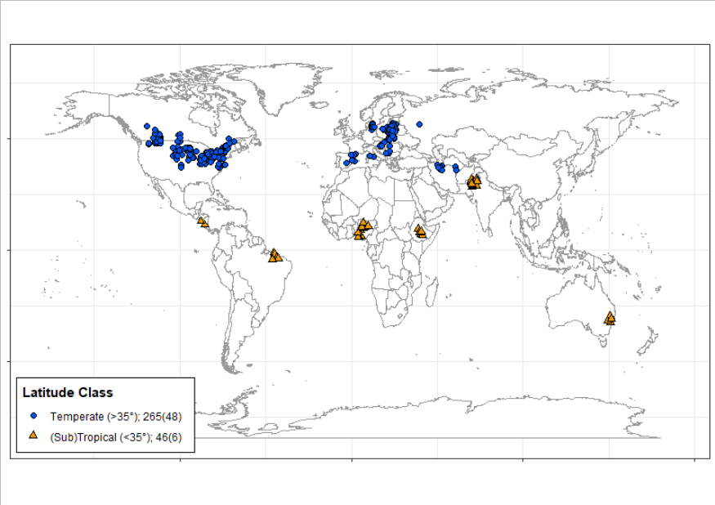
Figure 5-13. Map of meta-analysis study locations

Temperate (blue circles, >35° latitude) and sub-tropical/tropical (orange triangles, <35°) study locations with number of data points and number of studies (in parentheses) for each latitude class.

Data extraction and processing
Data was extracted from text, figures (GetData graph digitizer, http:// http://getdata-graph-digitizer.com/), and datasets acquired through personal communication when necessary. All data manipulation, analysis and graphics were completed with the R (version 3.5.1) [21] packages readxl [22] and tidyverse [23]. A complete description of the extraction process and resulting information is provided (S2 Text). Weed response variables were biomass (g m⁻²) or density (plants m-2). The resulting raw dataset (n=891) is available through Iowa State University’s DataShare [24].
Comparisons of simple versus diverse rotations were determined on a per-paper basis using the number of species present in the rotation as a guide. Within studies, this resulted in the following rotations identified as simple: (a) monocrop (1 species, n = 265), (b) monocrop with alternating years of fallow (1 species, n = 19), and (c) a two-year rotation (2 species grown over two years, n = 63). Continuously growing one crop or two crops in succession (a and c) are salient examples of simple rotations within contemporary agricultural production. Intermittent fallow systems (b) are a form of a simple rotation that is commonplace in arid regions worldwide [5, 25]. If more than one diverse rotation was present in the study, the simple rotation was compared to each diverse rotation separately. Our classification scheme resulted in a total of 64 comparisons for weed biomass and 247 for weed density.
For each comparison, we used the extracted information to create nine factors that could potentially influence the effect of crop diversification on weed dynamics. These included seven categorical variables: (a) latitude class (temperate vs. sub-tropical and tropical), (b) tillage regime (tilled vs. zero-tillage), (c) use of herbicides (yes vs. no), (d) use of fallowing in the simple rotation (yes vs. no), (e) use of a perennial in the diverse rotation (yes vs. no), (f) diversifying from a monoculture (yes vs. no), and (g) the unit of weed measurement (single species vs. sum of multiple species). We also assessed the influence of two continuous variables: the ratio of the number of species in the diverse rotation to the simple rotation and the difference in the coefficient-of-variation of months between planting operations in the diverse versus the simple rotation [26].

Data analysis
Eleven studies reported both weed density and biomass. Using the raw dataset [24], the Spearman rank correlation (ρ) between weed density and weed biomass (n = 236) was calculated in base R [21] using the cor and cor.test functions. In nine comparisons either the treatment or control value was zero. These points were removed from the analysis, similar to Verrett et al. (2017) [27], as adding an arbitrary value can result in comparisons changing from negative to positive or produce unrealistic effect sizes. The response of weed biomass or density to crop rotational diversity was represented by the ratio of the weed response in the diverse rotation to the response in the simple rotation [28-30]. Only nine of the 54 studies reported variances in some form, so we used non-parametric weighting based on sample sizes [29].
To identify the factors with the strongest effects on weed density, we fit a generalized boosted regression tree (BRT) model [31] with the nine modifiers as predictors using the R package gbm [32] and caret for model tuning [33]. For this model, we eliminated comparisons with incomplete moderator information (n=41 removed). We calibrated the model to minimize the bootstrapped root-mean-square-error (RMSE). The final model was fit to the data (n=206) using model parameters of 0.01 shrinkage, 3 node tree depth, and 200 trees with a Gaussian distribution. Variable importance was quantified using the relative influence metric [34]. This model was not fit to weed biomass responses because of insufficient data points with fully defined variables (n=55).
To estimate effect sizes, we took the natural log of the response ratio and fit a linear mixed-model in R using the lme4 package [35], with study as a random effect and weighting as described above. A separate model was fit to each response variable. Initial analyses were conducted without moderators to assess overall effects. A potential weakness of meta-analyses is that it relies on published literature, which may bias results towards significance. To estimate the robustness of our results against publication bias, we calculated the Rosenthal fail-safe number [36] using the metafor package [37].
To evaluate the effect of moderators identified as important by the BRT, mixed-effect models were fit for responses using each moderator as a single fixed effect, study as a random effect, and non-parametric weighting. Significance of results was calculated using the emmeans package [38], estimating and comparing mean values to zero using the lsmeans function, and comparing them to each other using the contrast function with Satterthwaite degrees of freedom. Results were converted to a percentage change in weed response in diverse rotations relative to simple rotations.
To ensure the robustness of our results, we tested the sensitivity of mean effect sizes to included studies by performing a leave-one-out analysis [30, 39], using the same procedure described above to estimate means and confidence intervals for each subset of data. Based on the sensitivity analysis, we found results were consistent at a significance level of p < 0.01, and thus chose this threshold to assign significance. Estimates and 99% confidence intervals were back-transformed and expressed as a percentage change from the control (simple rotation). Statistical summaries are provided in S1 Tables. All R code and data related to the analyses described above can be found in a Github repository (https://github.com/vanichols/Weisberger-et-al-2019).

Results and discussion
Diversification of crop rotations significantly reduced weed density compared to simple rotations (Fig. 5-2), with a mean reduction of 49% (n = 247, p < 0.001). In contrast, the effect of diversification on weed biomass was weaker (-21%) and non-significant (n = 64, p = 0.22). The fail-safe analysis indicated the significant effect observed for weed density was robust against publication bias; at least 12,905 non-significant comparisons would have to have remained unpublished during the time frame to negate our findings.

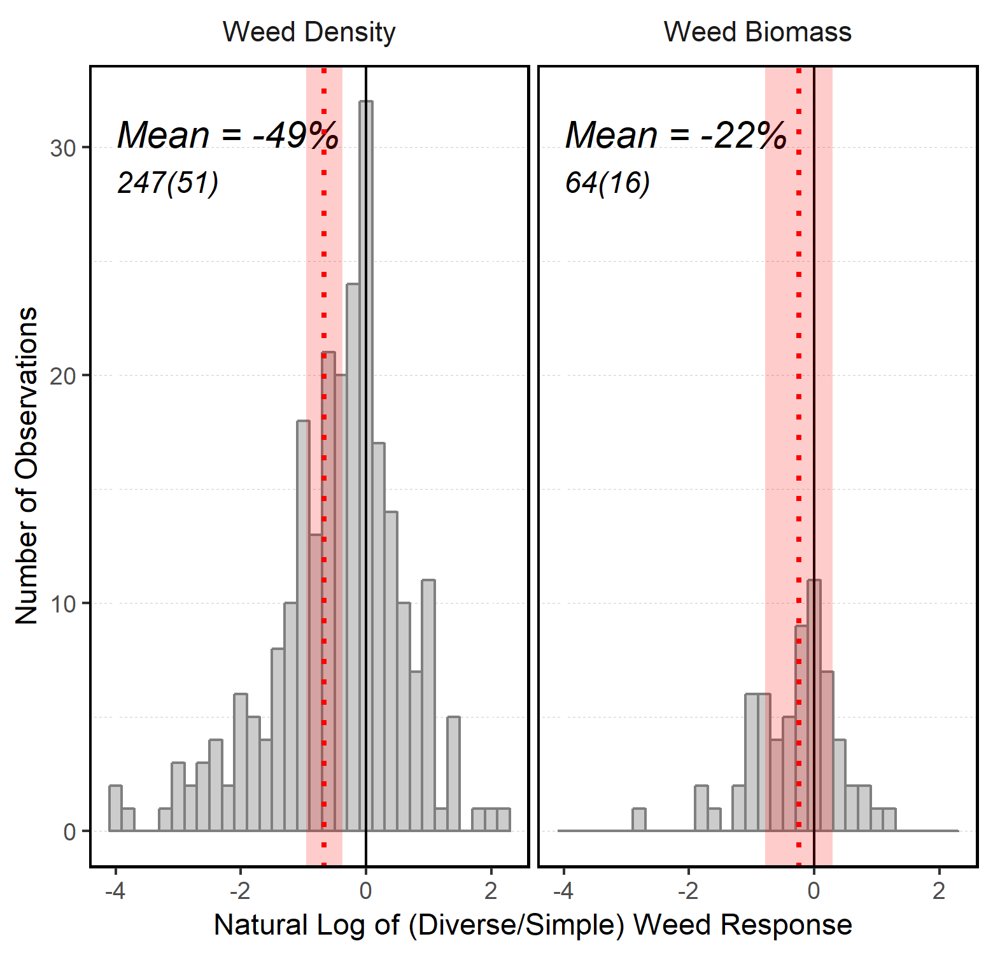
Figure 5-14. Histogram of weed response (weed density and biomass) to diversifying from a simple rotation

Means (dotted lines) and standard errors of the means (shaded areas) on a natural log scale, mean value on a percent change scale, total number of observation
When looking at effect estimates based on studies available in a given year, the estimate for weed density plateaued over time and had sufficient points for high precision (S2 Fig). The estimated response of weed biomass did not have the same precision as density due to the lower number of studies, but leveled off. This suggests that diverse rotations may indeed reduce weed biomass compared to simple rotations, but that the smaller number of studies reporting weed biomass limited our ability to detect a significant effect. In studies that measured both response variables, weed biomass was correlated with weed density (Fig. 5-3, ρ = 0.67, p < 0.001). This indicates that reductions in weed density were not associated with compensatory growth, and that lower weed densities equated to lower weed biomass.
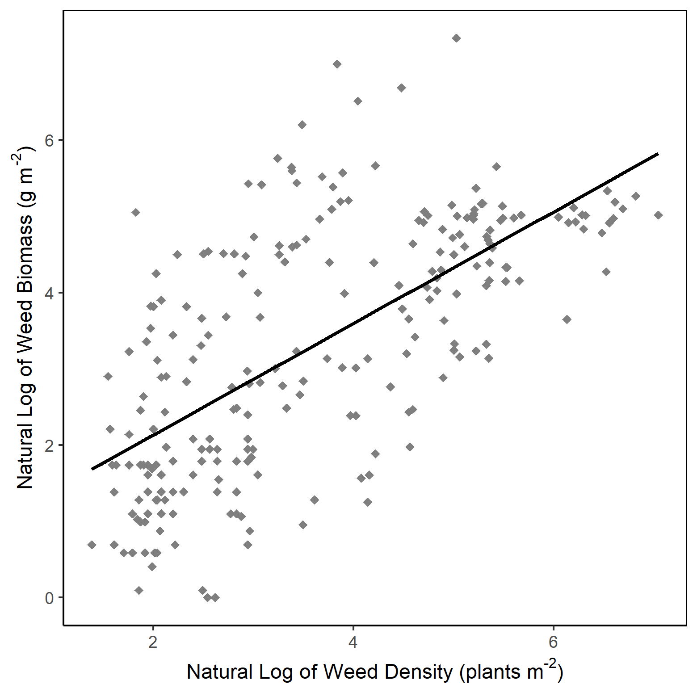
Figure 5-15. Relationship between weed biomass and weed density (natural log scale) for studies (n=11) that reported both values. Line represents Spearman correlation fit.
The BRT analysis demonstrated that three moderators were most important in describing the response of weed density to rotational diversification: (a) weed measurement unit, (b) increased planting-interval variation, and (c) tillage system (Fig. 5-4). The remaining six moderators had small importance, with a combined contribution of <15%.
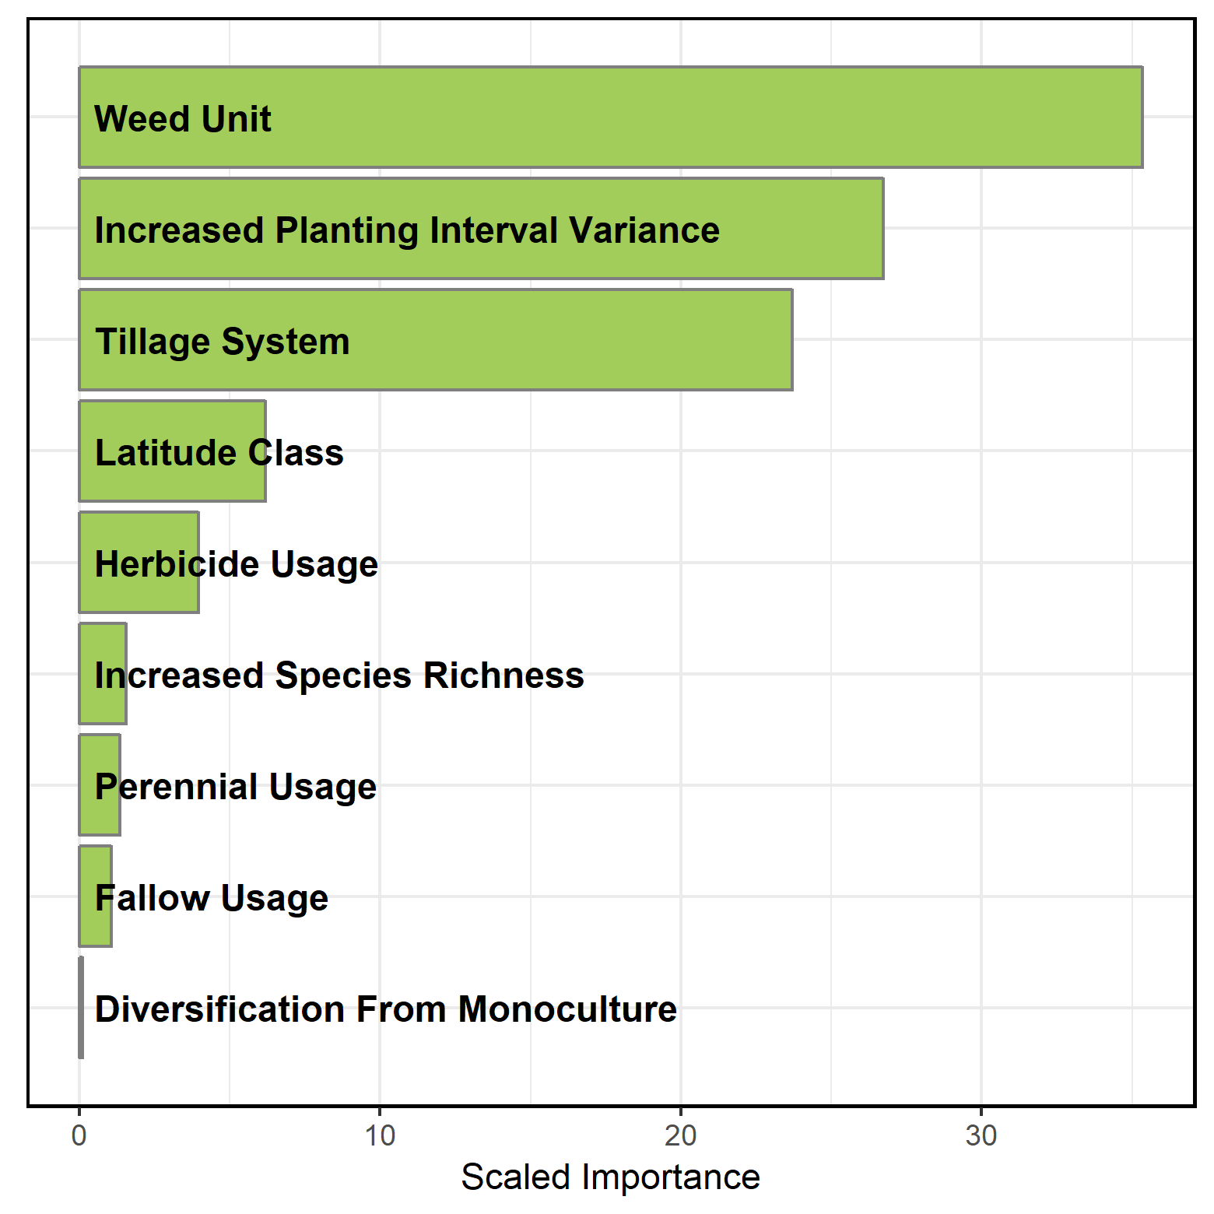
Figure 5-16. Scaled importance of nine predictors for weed density response to increased rotational diversity. Variable importance derived from a generalized boosted regression tree.
The importance of temporal variance around crop planting dates (Fig. 5-4) agrees with the assessment of Gaba et al. (2014) [26], who suggested that the effects of different cropping systems on weed dynamics could be captured by quantifying the magnitude of changes in sowing dates between successive crops. Consequently, much of the rotation diversification effect on weed density that we observed (Fig. 5-2) is likely linked to associated increases in heterogeneity in the timing of disturbance events, such as planting and herbicide application, as well as temporal variation in periods of crop growth and resource capture. Our results show these complex changes can be captured in the simple metric of variation in intervals between planting activities. In contrast, the relative number of crop species in diversified versus simple rotations was relatively unimportant for explaining weed suppression (Fig.6-4). Thus, the functional characteristics of a given rotation system, including temporal patterns of disturbance and resource capture, were more important in determining weed density than was crop species richness per se.
The importance of the two categorical variables, weed measurement unit and tillage system, is demonstrated through differences in weed suppression between groups within them (Fig. 5-5).
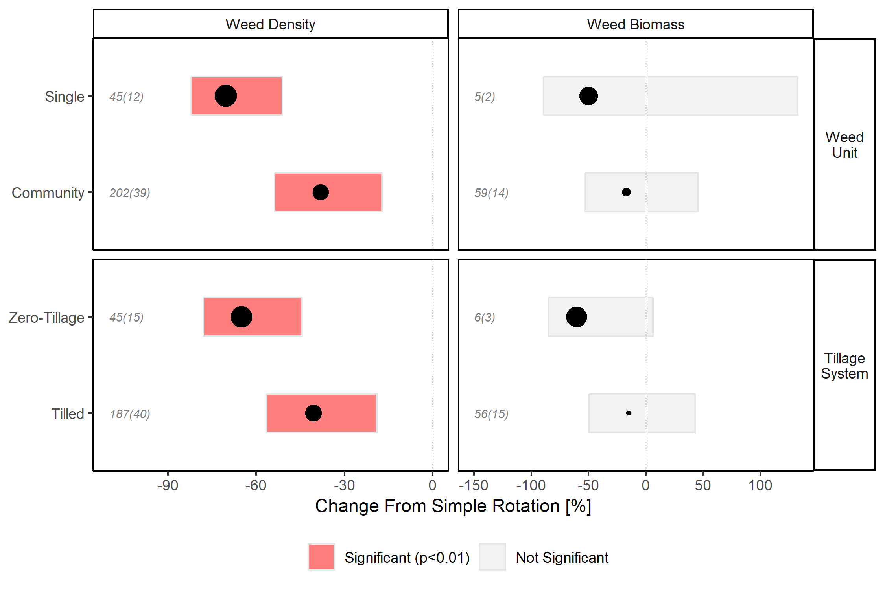
Figure 5-17. Weed density and biomass responses to increased rotational diversity as affected by weed measurement unit and tillage system

Mean values (point sizes scaled to absolute values), 99% confidence intervals, and number of observations (italics) and number

Suppression of weed density was greater (p = 0.001) in diverse rotations where individual weed species were measured (-70%, n = 45) compared to those where multiple weed species were measured together (-38%, n=202). This could represent a biological phenomenon, or simply be an artifact of study designs. Studies that evaluate management options for problematic single species often focus on practices that are intended to provide effective control of those species specifically, which would result in the relatively larger reductions. Alternatively, due to the increased range of stress and mortality factors introduced by diverse rotations, community compositions may shift to include more species at lower total densities. Recent work has suggested that shifts in weed community composition may be an important indicator of weed management systems that do not place constant uniform selection pressures on weeds [40], which is supported by our results.
Tillage system was highly important in predicting the weed density response to rotational diversification (Fig. 5-4). We found that the effect of crop diversification on weed density was stronger (p=0.003) for zero-tillage systems (-65%, n = 45) compared to tilled systems (-41%, n=187) (Fig. 5-5). Tillage can have a major impact on the size and structure of weed communities. It does so by altering the vertical distribution of seeds in the soil, and physically terminating both germinated seeds and emerged plants [41-43]. Across all rotations in our data set, mean weed density in zero-tillage systems was lower than in tilled systems, however the effect of rotational diversification was amplified by zero-tillage management. This agrees with literature reviews that suggest that weed management in reduced or zero-tillage systems may benefit from rotation diversification [44, 45]. Other reviews have shown that diversifying crop rotations can also reduce or eliminate crop yield reductions in zero-tillage systems relative to tilled systems [46, 47]. Zero-tillage systems have been recognized broadly for their positive contribution on soil conservation and fuel use efficiency [48]. Our results, coupled with those mentioned above, suggest synergies between zero-tillage and crop rotation in maintaining or improving crop yield and in suppressing weeds. Further research could examine in more detail how, and to what extent, different weed life history stages are affected by zero-tillage management within diverse rotations. In particular, more attention could be directed toward ways to optimize weed seed mortality in zero-tillage systems.
The remaining six moderators (increased crop species number, latitude classification, fallow inclusion in simple rotations, diversification from monoculture, herbicide usage, and perennial inclusion in diverse rotations) were not important for predicting weed responses in our dataset (Fig. 5-4). As previously noted, crop species richness was much less important than crop-planting interval in explaining weed suppression. This demonstrates that the functional characteristics of diverse crop rotations are more important for determining weed responses than the number of crop species. Latitude’s lack of influence suggests that the effects of crop diversification on weeds are consistent across a wide range of environmental conditions. Our results also showed that replacing fallow in simple rotations with a more diverse crop rotation does not compromise weed control. The minimal influence of whether diversification occurred from a monoculture suggests that our detection of a diversification effect on weed density was not an artifact of including extremely simple cropping systems in our analysis.
The lack of importance of herbicide use for determining the response of weed density to rotational diversification is of particular interest. Herbicides have become the dominant tool for weed management in most modern agricultural systems. Doucet et al. (1999) showed that the suppressive effects of rotation diversification could be erased in the presence of strong management filters, such as herbicides [49]. While this phenomenon was observed for that study in particular, our results, which consider studies from a broader geographical extent, indicate that the weed suppressive effect offered by crop rotational diversification is evident irrespective of herbicide use. This finding supports the use of diverse rotations as an important practice in weed management irrespective of ancillary practices and management preferences. It also suggests that diverse rotations may become increasingly important for weed control as more herbicides lose efficacy due to evolving weed resistances.
Inclusion of perennials has been suggested as an important strategy within integrated weed management systems [13-15, 50]. However, in our BRT analysis, this moderator had minimal importance (Fig. 5-4). Nonetheless, given the positive contribution of perennial forages to soil properties and hydrological processes [51, 52], additional work on how rotations that include perennials affect weed seed dynamics would be beneficial. Additionally, due to the large amount of variability we observed in weed responses to perennial inclusion, a more thorough examination of how other management factors interact (fertilization, duration of perennial crop growth, disturbance events, such as mowing and forage harvest) is warranted.

Conclusions
Our results are consistent with the findings of prior qualitative reviews [15, 16] that indicate diverse rotations are more effective in suppressing weeds relative to simpler ones. However, our results paint a more nuanced picture. Diverse rotations may impact processes affecting weed density, such as weed seed germination and seedling mortality, but diversification may not be as powerful in limiting the growth of established weed seedlings. Other management practices, such as targeted herbicide or mechanical intervention, altered crop sowing density or row spacing configurations, or the selection of more competitive crop genotypes [10, 53], may play a stronger role in suppressing weed biomass. Additional studies measuring the effects of crop rotational diversity on weed biomass are needed. Based on our findings, rotational diversification strategies should carefully consider how to maximize temporal variance around crop planting dates. Implementing effective crop rotations that optimize planting-interval variation will entail site-specific considerations, and will require an amalgam of extension and outreach services, farmer-to-farmer learning communities, economic incentives, expanded market opportunities, and well-conceived regulatory mechanisms. The diversification of crop rotations can, and should, serve as an organizing principle, under which technological innovations and ecological insights can be joined to manage weeds and contribute to the sustainable management of agricultural systems.

References
1. Oerke EC. Crop losses to pests. The Journal of Agricultural Science. 2006 Feb; 144:31-43.
2. Atwood, D, Paisley-Jones, C. Pesticides industry sales and usage: 2008–2012 market estimates. U.S. Environmental Protection Agency, Washington, DC, USA, 2017. https://www.epa.gov/pesticides/pesticides-industry-sales-and-usage-2008-2012-market-estimates.
3. Carpenter JE. Impact of GM crops on biodiversity. GM crops. 2011 Jan 1; 2:7-23.
4. Hurley TM, Frisvold G. Economic barriers to herbicide-resistance management. Weed Science. 2016 Jul; 64:585-94.
5. Ramankutty N, Mehrabi Z, Waha K, Jarvis L, Kremen C, Herrero M, et al. Trends in global agricultural land use: implications for environmental health and food security. Annual review of plant biology. 2018 Apr 29; 69:789-815.
6. Heap I. Global perspective of herbicide‐resistant weeds. Pest management science. 2014 Sep; 70:1306-15.
7. Liebman M, Baraibar B, Buckley Y, Childs D, Christensen S, Cousens R, et al. Ecologically sustainable weed management: How do we get from proof‐of‐concept to adoption?. Ecological Applications. 2016 Jul 1; 26(5):1352-69.
8. Davis AS, Frisvold GB. Are herbicides a once in a century method of weed control? Pest management science. 2017 Nov; 73:2209-20.
9. Bagavathiannan MV, Davis AS. An ecological perspective on managing weeds during The Great Selection for Herbicide Resistance. Pest management science. 2018 Mar 23.
10. Westwood JH, Charudattan R, Duke SO, Fennimore SA, Marrone P, Slaughter DC, Swanton C, Zollinger R. Weed Management in 2050: Perspectives on the Future of Weed Science. Weed Science. 2018 May; 66:275-85.
11. Neve P, Vila‐Aiub M, Roux F. Evolutionary‐thinking in agricultural weed management. New Phytologist. 2009 Dec 1; 184:783-93.
12. Beckie HJ, Harker KN. Our top 10 herbicide‐resistant weed management practices. Pest management science. 2017 Jun; 73:1045-52.
13. Beckie HJ, Johnson EN, Leeson JY, Shirriff SW, Kapiniak A. Selection and evolution of acetyl-CoA carboxylase (ACC)-inhibitor resistance in wild oat (Avena fatua L.) in a long-term alternative cropping systems study. Canadian journal of plant science. 2014 May; 94: 727-31.
14. Liebman, M, Staver, CP. Crop diversification for weed management. In Liebman, M, Mohler, CL, Staver, CP, editors. Ecological management of agricultural weeds. Cambridge, Cambridge University Press. 2001. pp. 322-63.
15. Teasdale, JR. The use of rotations and cover crops to manage weeds. In Zimdahl RL, editor. Integrated weed management for sustainable agriculture. Cambridge, Burleigh Dodds. 2017. pp. 227-60.
16. Liebman M, Dyck E. Crop rotation and intercropping strategies for weed management. Ecological applications. 1993 Feb; 3: 92-122.
17. Koricheva J, Gurevitch J. Uses and misuses of meta‐analysis in plant ecology. Journal of Ecology. 2014 Jul; 102:828-44.
18. Osipitan OA, Dille JA, Assefa Y, Knezevic SZ. Cover crop for early season weed suppression in crops: Systematic review and meta-analysis. Agronomy Journal. 2018 Aug 1.
19. Toler, H. D., R. M. Augé, V. Benelli, F. L. Allen, and A. J. Ashworth. Global meta-analysis of cotton yield and weed suppression from cover crops. Crop Science. 2019. 59:1-13.
20. Moher, D, Liberati, A, Tetzlaff, J, Altman, DG, Group, TP. Preferred reporting items for systematic reviews and meta-analyses: the PRISMA statement. Physical Therapy. 2009 Sep; 89: 873-80.
21. R Core Team. R: A language and Environment for Statistical Computing. http:// www.R-project.org (R Foundation for Statistical Computing. 2013.
22. Wickham, H, Bryan, J. readxl: Read Excel Files. R package v.1.1.0. 2018.
23. Wickham, H. tidyverse: Easily Install and Load the 'Tidyverse'. R package v.1.2.1. 2017.
24. Nichols, V, Weisberger, D, Liebman, M. Effect of crop rotation on weed biomass and density literature summary. Iowa State University. Dataset. 2013. httpsL//doi.org/10.25380/iastate.7771010.v1
25. Rosenzweig ST, Stromberger ME, Schipanski ME. Intensified dryland crop rotations support greater grain production with fewer inputs. Agriculture, Ecosystems & Environment. 2018 Sep; 264:63-72.
26. Gaba S, Fried G, Kazakou E, Chauvel B, Navas ML. Agroecological weed control using a functional approach: a review of cropping systems diversity. Agronomy for sustainable development. 2014 Jan 1; 34(1):103-19.
27. Verret V, Gardarin A, Pelzer E, Médiène S, Makowski D, Valantin-Morison M. Can legume companion plants control weeds without decreasing crop yield? A meta-analysis. Field Crops Research. 2017 Mar; 204:158-68.
28. Borenstein, M, Hedges, LV, Higgins, JP T, Rothstein, HR. Introduction to meta-analysis. Hoboken, John Wiley & Sons. 2009.
29. Lajeunesse, MJ. Recovering missing or partial data from studies: A survey of conversions and imputations for meta-analyses. In Koricheva, J, Gurevitch, J, Mengersen, K, editors. Handbook of meta-analysis in ecology and evolution. Princeton, Princeton University Press. 2014. pp. 195-206.
30. Gurevitch J, Koricheva J, Nakagawa S, Stewart G. Meta-analysis and the science of research synthesis. Nature. 2018 Mar; 555: 175.
31. Elith J, Leathwick JR, Hastie T. A working guide to boosted regression trees. Journal of Animal Ecology. 2008 Jul; 77(4):802-13.
32. Greenwell, B, Boehmke, B, Cunningham, J, GBM Developers. gbm: Generalized Boosted Regression Models. R package version 2.1.4. 2018. https://CRAN.R-project.org/package=gbm. . 2018.
33. Kuhn, M, caret: Classification and Regression Training. R package version 6.0-81. https://CRAN.R-project.org/package=caret. 2018.
34. Friedman, J. Greedy Function Approximation: A Gradient Boosting Machine. Annals of Statistics. 2001; 29(5):1189-1232.
35. Bates D, Maechler M, Bolker B, Walker S. Fitting linear mixed-effects models using lme4. Journal of Statistical Software. 2015; 67: 1-48.
36. Rosenthal R. The file drawer problem and tolerance for null results. Psychological bulletin. 1979 86(3):638.
37. Viechtbauer W. Conducting meta-analyses in R with the metafor package. J Stat Softw. 2010; 36(3):1-48.
38. Length, R. emmeans: Estimated Marginal Means, aka Least-Squares Means. R package v.1.3.0. 2018.
39. Philibert A, Loyce C, Makowski D. Assessment of the quality of meta-analysis in agronomy. Agriculture, Ecosystems & Environment. 2012 Feb; 148: 72-82.
40. Storkey, J, Neve, P. What good is weed diversity? Weed Research. 2018 Aug; 58:239–243.
41. Mohler, CL. Mechanical management of weeds. In Liebman, M, Mohler, CL, Staver, CP, editors. Ecological management of agricultural weeds. Cambridge, Cambridge University Press. 2001. pp. 139-192.
42. Schutte BJ, Tomasek BJ, Davis AS, Andersson L, Benoit DL, Cirujeda A, et al. An investigation to enhance understanding of the stimulation of weed seedling emergence by soil disturbance. Weed Research. 2014; 54(1):1-2.
43. Cordeau S, Smith RG, Gallandt ER, Brown B, Salon P, DiTommaso A, et al. Timing of tillage as a driver of weed communities. Weed science. 2017 Jul; 65(4):504-14.
44. Chauhan BS, Singh RG, Mahajan G. Ecology and management of weeds under conservation agriculture: a review. Crop Protection. 2012 Aug; 38: 57-65.
45. Nichols V, Verhulst N, Cox R, Govaerts B. Weed dynamics and conservation agriculture principles: A review. Field Crops Research. 2015 Nov; 183: 56-68.
46. Pittelkow CM, Liang X, Linquist BA, Van Groenigen KJ, Lee J, Lundy ME, Van Gestel N, Six J, Venterea RT, Van Kessel C. Productivity limits and potentials of the principles of conservation agriculture. Nature. 2015 Jan; 517: 365.
47. Pittelkow CM, Linquist BA, Lundy ME, Liang X, van Groenigen KJ, Lee J, van Gestel N, Six J, Venterea RT, van Kessel C. When does no-till yield more? A global meta-analysis. Field Crops Research. 2015 Nov 1; 183:156-68.
48. Hobbs PR, Sayre K, Gupta R. The role of conservation agriculture in sustainable agriculture. Philosophical Transactions of the Royal Society B: Biological Sciences. 2007 Jul 24; 363(1491):543-55.
49. Doucet C, Weaver SE, Hamill AS, Zhang J. Separating the effects of crop rotation from weed management on weed density and diversity. Weed science. 1999 Nov; 47: 729-35.
50. Meiss H, Médiène S, Waldhardt R, Caneill J, Munier-Jolain N. Contrasting weed species composition in perennial alfalfas and six annual crops: implications for integrated weed management. Agronomy for sustainable development. 2010 Sep; 30:657-66.
51. King AE, Blesh J. Crop rotations for increased soil carbon: perenniality as a guiding principle. Ecological applications. 2018 Jan 1; 28(1):249-61.
52. Basche AD, Edelson OF. Improving water resilience with more perennially based agriculture. Agroecology and Sustainable Food Systems. 2017 Aug 9; 41(7):799-824.
53. Liebman, M. Cultural techniques to manage weeds. In Zimdahl RL, editor. Integrated weed management for sustainable agriculture. Cambridge, Burleigh Dodds. 2017. pp. 203-25.

Appendix

Supporting Information
All supplementary information is available at the following link, accompanying the published manuscript: https://journals.plos.org/plosone/article?id=10.1371/journal.pone.0219847#sec008
The information includes:
S1 Text. Full list of studies included in the meta-analysis (n = 54).
S2 Text. Description of study identification, data extraction, and S1 Fig. PRISMA flow diagram of screening process for studies included in meta-analysis.
S1 Table. PRIMSA checklist for meta-analyses and systematic reviews.
S1 Tables. Statistical summaries
S2 Fig. Effect sizes over time
Both the raw and working database are available as part of this publication. The code used to process the raw data, perform statistical analyses, and produce figures is available in a repository at https://github.com/vanichols titled ‘Weisberger-et-al-2019’.

ARE ROOTS THE DRIVERS OF THE ROTATION EFFECT IN MAIZE?
Virginia Nichols¹, William Osterholtz², Sotirios Archontoulis¹, Matt Liebman¹
¹Department of Agronomy, Iowa State University, Ames, Iowa, USA
²Soil Drainage Research, USDA ARS, Columbus, Ohio, USA
Modified from a manuscript in preparation

Abstract
It is well-established that maize (Zea mays L.) grown in complex cropping systems can require less external nitrogen inputs to produce equal or higher grain yields compared to maize grown in simple systems. Understanding the mechanisms driving this phenomenon, commonly referred to as ‘the rotation effect’, is crucial for designing cropping systems that use land efficiently. To examine the possible role of maize roots in the rotation effect we measured root biomass in 15 cm increments from 0-60 cm, maximum rooting depth, and grain yields in the maize phase of two contrasting rotations: a simple 2-year rotation of maize-soybean (Glycine max [L.] Merr), and an extended 4-year rotation of maize-soybean-oat (Avena sativa L.)/alfalfa (Medicago sativa L.)-alfalfa. Additionally, we measured soil penetration resistance and soil moisture, and performed a growth analysis on aboveground maize biomass. From 2013-2020, maize grain yields in the complex rotation were significantly higher in five of the eight years, with overall yields averaging 8% higher in the complex compared to the simple rotation (11.0 and 10.2 dry Mg ha⁻¹, respectively). The timing (e.g., early season, late season) of the complex rotation’s maize growth advantage over the simple rotation was not consistent across years. The maximum rooting depth of maize in the complex rotation was consistently deeper by an average of 11% (82 versus 76 cm, respectively). From planting to approximately 100 days after planting, maize grown in the complex system added significantly less root mass (436 kg ha⁻¹) than the maize grown in the simple system in the surface soil layer (0-15 cm), but the two systems’ root investments did not differ below that depth. Soil penetration resistances from 0-30 cm were 30% lower in the complex versus simple system. Early in the season, the complex system also consistently had drier soils compared to the simple system. We posit that maize grown in the complex rotation invested less resources in shallow roots and achieved a deeper and more functional root structure compared to maize in the simple rotation. It is possible that this ‘deeper and cheaper’ root layout provided resilience against un-favorable growing conditions, regardless of their timing, leading to increased resource acquisition and significantly higher grain yields in some years. Process-based models could aid in supporting or refuting this hypothesis, and greenhouse experiments could indicate whether the root differences observed in the field reflect chemical, physical, and/or biological characteristics of the soil. To our knowledge, this is the first report of cropping system complexity impacting maize rooting depth. Similar measurements taken in other Midwestern locations would aid in understanding the role of maize rooting depth in the rotation effect in other contexts.

Introduction
In the Midwestern United States (US), a substantial portion of agricultural land is dedicated to maize-(Zea mays L.) based systems (Boryan et al., 2011; USDA National Agricultural Statistics Service Cropland Data Layer, 2021). Over the past 60 years the diversity of these maize systems has been reduced from multi-species rotations that included small grains and forage legumes to maize monocultures or simple alterations of maize and soybean (Glycine max [L.] Merr) (Aguilar et al., 2015; Hijmans et al., 2016; Crossley et al., 2021). Several undesirable effects have accompanied this simplification including but not limited to increased rates of soil erosion, increased risk of flooding, increased risks of nitrate pollution, and a decline in rural quality-of-life (Peters, 2002; Arbuckle and Kast, 2007; Hatfield et al., 2009, 2013; Schilling et al., 2010; Jones et al., 2018; Pasley et al., 2021). While there are numerous barriers to re-diversifying Midwestern systems (Mortensen and Smith, 2020; Weisberger et al., 2021), there is value in understanding the mechanisms that would enable diversification to mitigate these negative outcomes.
Midwestern maize-based systems fall into three main categories: (1) continuous maize systems, wherein maize is grown for two or more consecutive seasons, (2) rotated maize systems, wherein maize is rotated with soybean, and (3) extended maize rotations, wherein maize is grown in a rotation with two or more years between maize crops, often including a small grain and/or a forage. As maize cropping systems move from monocultures to simple rotations, and simple to extended rotations, maize yields increase by approximately 10 and 5%, respectively (Crookston et al. 1991; Gentry et al. 2013; Liebman et al., 2008; Davis et al., 2012). The former phenomenon is commonly referred to as the ‘continuous maize penalty’, and the latter ‘the rotation effect’. To our knowledge it is unclear whether they are distinct expressions of unique mechanisms, or if they represent a continuum of the same mechanistic underpinnings.
There have been numerous studies in the Midwest exploring the continuous maize penalty (Dick and Doren, 1985; Peterson et al., 1990; Meese et al., 1991; Crookston et al., 1991; Porter et al., 1997; Varvel, 2000; Stanger and Lauer, 2008; Gentry et al., 2013; Al-Kaisi et al., 2015; Farmaha et al., 2016; Seifert et al., 2017; Vogel and Below, 2018; Bowles et al., 2020). There is strong evidence it is due to yield suppressive mechanisms in the monoculture system, potentially due to soil biological conditions constraining root development (Crookston et al., 1988; Johnson et al., 1992; Nickel et al., 1995; Goldstein, 2000). The maize yield advantage accrued from extending simple rotations to include small grains and forage legumes has received less attention compared to the continuous maize penalty, but has likewise been well-documented (Liebman et al., 2008; Stanger and Lauer, 2008; Coulter et al., 2011). However, to our knowledge the driving mechanisms behind the rotation effect remain uncertain. In a long-term cropping systems research experiment in Iowa (Liebman et al., 2008; Davis et al., 2012) researchers have found differences in the distributions of resources and nutrient cycling activity in simple and complex maize systems (Lazicki et al., 2016; King and Hofmockel, 2017; Osterholz et al., 2018; Poffenbarger et al., 2020), but it is unclear how these altered distributions translate to higher maize yields in the complex rotations. There is evidence that suggests there are differences in maize root distributions in the Iowa systems (Lazicki et al., 2016), but the data is limited to shallow depths and does not control for previous crop root carryover. It is feasible that, similarly to the continuous maize penalty, differences in maize root structures are contributing to increased resource capture in complex rotations, thus driving higher maize yields compared to the simpler system.
When above-ground crop products are valued, it is desirable for plants to optimize investments in belowground growth. In nitrogen- or water-limited environments, ‘steep, cheap and deep’ root ideotypes have been identified as the most efficient use of root investments (Lynch, 2013; Tron et al., 2015). We hypothesized that maize grown in complex rotations creates a root structure that is better able to capture resources in certain environments with less investment compared to the simple rotation. To test this hypothesis, we made the following measurements in the maize phase of a simple (maize-soybean) and complex (maize-soybean-oats/alfalfa-alfalfa) rotation:
- Maize grain yields (2013-2020)
- Maize root biomass as a proxy for the resources invested by the maize crop into roots (2019-2020)
- Maximum maize rooting depth as a proxy for the soil space made available for resource capture by that investment (2018-2020)
Additionally, we complemented these three core measurements with measurements of partitioned aboveground biomass throughout five seasons, soil penetration resistance at two time points in the growing season (2018-2020), and hourly measurements of soil moisture at 15 and 45 cm depths (2018-2019).

Methods and Materials

Sampling
Treatments consisted of two maize-based rotations: a 2-year rotation of maize-soybean (hereafter the simple rotation), and a 4-year rotation of maize-soybean-oat/alfalfa-alfalfa that periodically received cattle manure (hereafter the complex rotation). Detailed accounts of plot management are reported elsewhere (Liebman et al., 2008; Hunt et al., 2020) and a summary is presented in Table 6-7.
Table 6-7 Summary of rotation managements
Rotation | Crop sequence | Nitrogen sources | Tillage regime
Simple 2-year | Soybean-  Maize | Mean total of 180 kg ha⁻¹ mineral nitrogen applied to maize phase, with 112 kg ha⁻¹ applied at planting and the remaining at V6 side-dressing based on soil nitrate sampling | Fall chisel plowing and spring field cultivation preceding soybean planting, spring cultivation preceding maize planting
Complex 4-year | Soybean-Oats/Alfalfa-Alfalfa-  Maize | Mean of 140 kg ha⁻¹ organic nitrogen applied as composted cattle manure the fall preceding the maize phase, and 32 kg ha⁻¹ inorganic N applied at V6 side-dressing | Fall chisel plowing and spring field cultivation preceding soybean planting, no tillage events preceding oat/alfalfa planting, fall moldboard plowing of the alfalfa crop followed by spring discing and field cultivation preceding maize planting

Each phase of the rotation treatments was present every year in four replicate blocks within a 9-hectare experiment established in 2001 at the Iowa State University Marsden Farm in Boone County, Iowa. Weather data was collected from a weather station approximately one kilometer from the field site (Iowa Environmental Mesonet, 2021). Maize grain yield was measured in 2013-2020, and additional measurements (Table 6-8) were taken in select years during that period.

Statistical Analysis
Statistical analyses were conducted using R version 4.0.2 (R Core Team, 2020) with the tidyverse suite of packages (Wickham et al., 2019) or JMP Pro 15.0 (SAS Institute, Cary, North Carolina, USA). Additional R packages were used for specific analyses as described below. Significance for statistical tests was set at α=0.05 unless noted otherwise. In all cases several models were fit and compared using Akaike’s Information Criteria (AIC; Kuha, 2004) and residual plots, but only the model chosen as providing the best fit is reported.

Grain yields, harvest indices, grain weights
The effect of rotation treatment (simple, complex) on maize grain yields was assessed using a linear mixed effects model with rotation, year-factor, and their interaction as fixed effects, and block nested within a year-factor as a random intercept using R package lme4 (Bates et al., 2015). The R packages emmeans (Lenth et al., 2018) and lmerTest (Kuznetsova et al., 2017) were used for comparisons and statistical summaries of the model, using a Tukey adjustment for multiple comparisons.

Table 6-8 Summary of measurements used for this study
Measurement | Years | Description
Maize grain yield | 2013-2020 | Maize grain yield was determined using a 6-row combine equipped with a yield monitor and moisture meter. Sampling areas for yield were the middle rows of the plots, approximately 4.6 m x 84 m. All yields are reported on a dry weight basis.
Full soil nutrient test | 2018 | Soil samples from 0-90 cm were analyzed in 30 cm increments for macro- and micro-nutrients. Six soil samples from each replicate taken immediately following planting and were combined for analysis.
Maize above-ground biomass | 2013, 2014, 2018, 2019, 2020 | Maize above-ground biomass was measured periodically throughout the season. Eight plants were cut at ground level, separated into leaf, stem, and reproductive components, dried at 60⁰C for at least 72 hours, then weighed.
Maize maximum rooting depth | 2018, 2019, 2020 | Maximum maize rooting depth was measured starting at 20, 23, and 41 days after planting in 2018, 2019, and 2020, respectively. Sampling was repeated approximately every 2 weeks until 84, 106, and 151 days after planting in 2018, 2019, and 2020, respectively. Maximum rooting depth was determined visually using the protocol of Ordóñez et al., 2018. A soil core was drawn with a 19-mm-diameter soil probe, white roots were identified, and their depth estimated to the nearest cm using a meter stick. Samples were repeatedly taken from the same core location until no white roots were identified in the core. Four cores were taken per plot at each sampling date.
Soil moisture at 15 and 45 cm depths | 2018, 2019 | 5TM soil moisture and temperature sensors (METER Group Inc., Pullman, WA, USA) were installed at two depths (15 and 45 cm) in each plot. Data were recorded hourly during the growing season using EM50 data loggers.
Penetration resistance | 2018, 2019 | Penetration resistance was measured using a FieldScout 900 Soil Compaction Meter (Spectrum Technologies, Inc., Aurora, IL, USA). Values were recorded every 2.54 cm to 45 cm depth immediately following planting and/or approximately 60 days after planting. Ten measurements were taken randomly throughout each plot. Measurements were taken after a saturating rain to avoid capturing differences due to soil moisture.
Maize root mass 0-60 cm | 2019, 2020 | Maize root mass to a soil depth of 60 cm was measured at 3 and 105 days after planting in 2019, and at 4 and 117 days after planting in 2020. Four soil samples per plot were drawn at a location 10 cm from maize rows in 15 cm depth increments using a 32-mm-diameter soil probe. Soil from each depth increment within a plot was composited and roots were recovered using a sequence of elutriation (washing), flotation, recovery from organic debris using tweezers and a stereo microscope, drying, and weighing (Dietzel et al., 2017)

Differences in harvest indices and 500-grain weights were assessed using a linear mixed effects model with rotation, a year-factor, and their interaction as fixed effects and a random block intercept, with a Tukey adjustment for multiple comparisons.

Rooting depth
We chose to model rooting depth as a function of the cumulative maize growing-degree-days (GDDs) accrued since planting (base temperature 10⁰C, maximum temperature 30⁰C) to facilitate comparisons between years. Non-linear models were fit using the R package nlraa package (Miguez, 2021). We tried several non-linear models fit to both the raw data and the data filtered to remove measurements taken after the season’s maximum depth had been reached (Figure S6-1). We found a three-parameter logistic curve (Archontoulis et al., 2015) fit to the filtered data produced the best fit according to AIC and inspection of residuals:
Eqn. 1 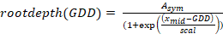
where rootdepth(GDD) is the maximum rooting depth at a given cumulative GDD after planting and A_{sym}, x_{mid}, and scal are estimated parameters. A_{sym} represents the maximum rooting depth achieved, x_{mid} represents the cumulative GDD value at which half of the maximum rooting depth is achieved, and scal describes the steepness of the curve (Miguez et al., 2018). We found the best model fit incorporated a fixed effect of rotation on A_{sym}, scal, and x_{mid}; a random effect of a year-factor on A_{sym}, x_{mid}, and scal; a random effect of block on A_{sym}; and a power variance structure.

Root mass
The Restricted Maximum Likelihood (REML) method for linear mixed effect models in JMP Pro 15.0 was used to evaluate the effects of rotation treatment on maize root mass production within four soil depth increments (0-15 cm, 15-30 cm, 30-45 cm, and 45-60 cm). Maize root production was estimated as the change in root mass from the start of each growing season (3 days after planting (DAP) in 2019 and 4 DAP in 2020; Table 6-8) and the last sampling date. Thus, the amount of root mass retained in the soil of each plot from the previous crops was used as a baseline for assessing subsequent changes in root mass during the maize growing season. Year, rotation system, soil depth, and date were treated as fixed factors, and block and its interactions with the fixed factors were treated as random effects. Sampling depth was nested within year and rotation.

Growth analysis
Above-ground biomass as a function of day-of-year was modelled separately for each rotation in each year using a three-parameter logistic curve (Eqn. 1). A model using GDDs produced similar results, but we chose to report the model using calendar days for ease in interpretation. We chose a three-parameter logistic curve based on AIC criteria. The first- and second-order derivatives of the fitted equation were used as estimates of the absolute and relative growth rates, respectively. The effect of rotation on fitted parameters was assessed using the confint function of R.

Penetration resistance
Penetration resistance was statistically modelled separately for each year and date of sampling using a generalized additive mixed model with a fixed intercept effect of rotation treatment, a fixed ‘wiggle’ component of rotation treatment, five knots, and a random ‘wiggle’ effect of block. Generalized additive models can model highly non-linear relationships and are useful when the goal is to compare treatments rather than to create predictions. The gamm function of the R package mgcv (McCulloch and Neuhaus, 2005; Wood, 2011) was used, and the emmeans package was used to assess pairwise comparison significance. Models were fit using both the raw and square-root-transformed data. Although the model on the transformed data produced a better fit according to inspection of residuals, statistical conclusions were not different in the two models so the results from the untransformed data are presented for ease in interpretation.

Soil moisture
The hourly soil moisture data was averaged over a 24-hour period (12:00 am to 11:59 pm) for analysis. The daily means were statistically modelled as a function of day-of-year separately for each year and depth using a generalized additive mixed model with a fixed intercept effect of rotation treatment, a fixed ‘wiggle’ component of rotation treatment, 35 knots, and a random ‘wiggle’ effect of block using the R package mgcv.

Results

Grain yields and weather
From 2013-2020, maize yields ranged from 7.0-12.7 Mg ha⁻¹. The effect of rotation depended on year (p<0.001; Figure 6-18), with the maize grown in the complex rotation producing significantly higher (p<0.01) grain yields in five (2013, 2014, 2016, 2017, and 2018) of the eight years. Averaged over all years, maize grown in the simple rotation yielded a mean of 10.2 Mg ha⁻¹, while maize grown in the complex rotation yielded 8% higher with a mean grain yield of 11 Mg ha⁻¹.
Over the past 30 years, from 15-Apr through 15-Oct the research site averaged 597 mm of precipitation with a mean air temperature of 19⁰C. From 2013-2020, growing season weather conditions varied considerably compared to these long-term averages, with the grain yield dataset capturing conditions in all four temperature/precipitation combinations (Figure 6-18). Years that included growth analyses were likewise represented in all four quadrants, and the three years with full datasets (grain yields, growth analysis, root data) represented all but cool and wet conditions.
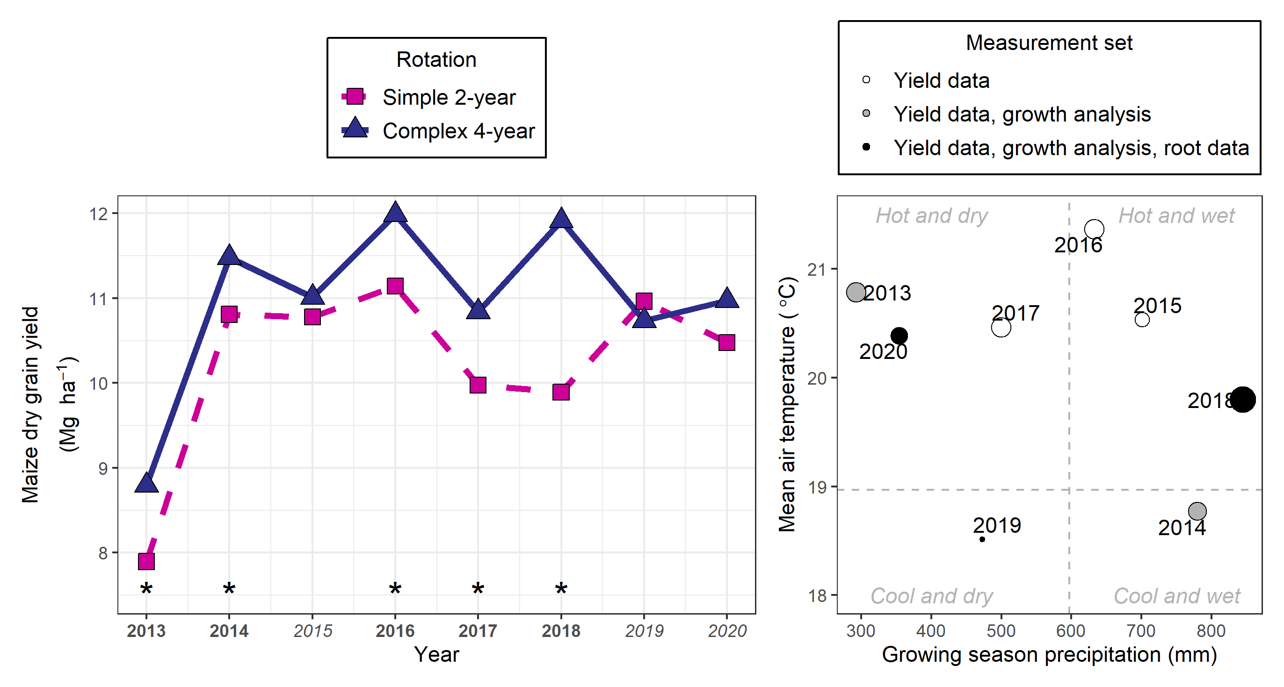
Figure 6-18 Maize yields and growing season weather

; (left) mean maize grain yields (n = 4) in the complex (dark blue, solid, triangles) and simple (pink, dashed, squares) rotations from 2013-2020 with lines connecting points for ease in viewing and significantly different yields (p<0.01) indicated with stars and bolded year font; (right) growing season precipitation and mean air temperatures of each measurement year as compared to 30-year mean (dotted lines) with size of points proportional to the complex system’s maize mean yield advantage over the simple system and point color representing the measurement set for that year.

Rooting depth and root mass
Rotation affected maximum rooting depth (A_{sym}; p<0.01), with an estimated maximum rooting depth 11% deeper in the complex rotation compared to the simple rotation (82 cm and 76 cm, respectively). While the complex rotation roots also descended faster, the effect was not statistically significant (x_{mid}; p=0.19; Table S6-1).
The effect of rotation treatment on root mass differed significantly by sampling depth (p=0.01). Year and its interactions did not have significant effects (Table S6-2), so results are presented as marginal estimates over years (Figure 6-19).

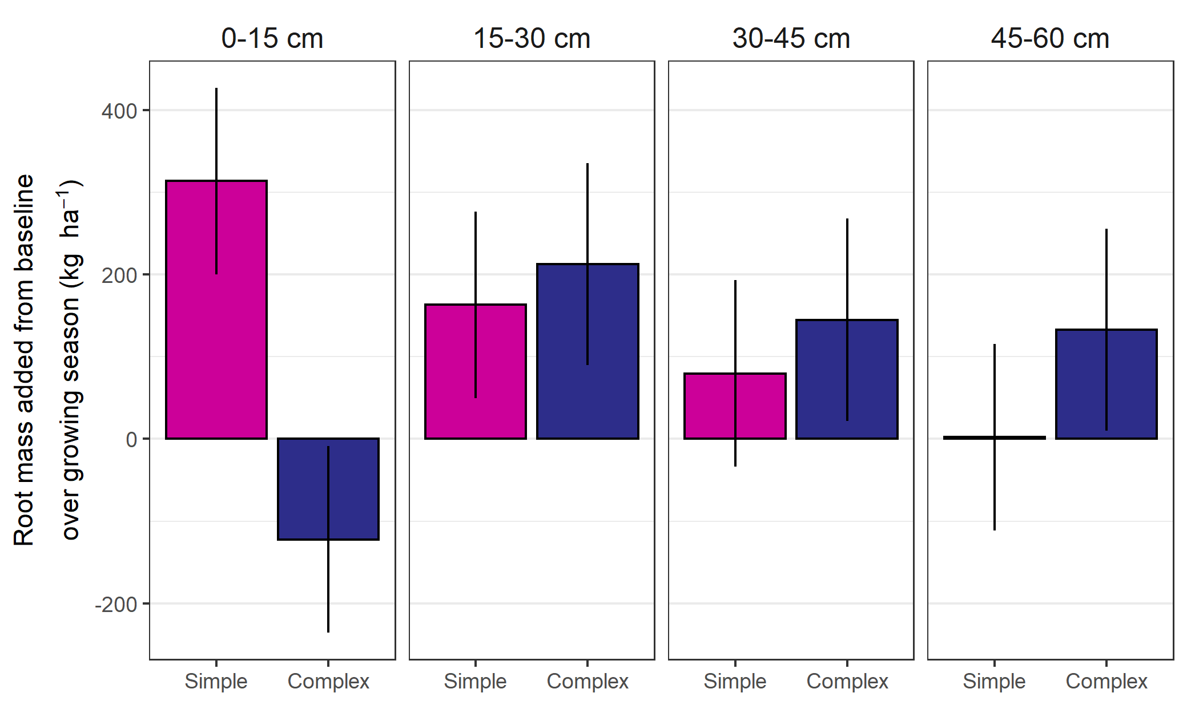
Figure 6-19 Root mass added (root mass at maturity less root mass present at planting) at each soil depth

for maize grown in the simple (2-year rotation, pink) and complex (4-year rotation, dark blue) systems, bars represent marginal means and vertical lines the standard error of the mean.
At the 0-15 cm depth increment, the root mass added in the two systems differed significantly (p = 0.02), with the simple system increasing by 314 kg ha⁻¹ (SE:113) from the baseline measurements, while the complex rotation’s root mass decreased by 122 kg ha⁻¹ (SE:113) from the baseline measurement. At all other depths, the difference between the complex and simple system’s additions were not statistically significant (Table S6-3).

Growth analysis
The maximum aboveground maize biomass as estimated from the growth analysis was significantly higher in the complex rotation in the years when the complex rotation yielded significantly higher grain yields (Table 6-9; Table S6-1). The date at which the maize achieved half of its maximum biomass (xmid) was significantly earlier in the complex system in 2013 (p = 0.05), significantly later in 2018 (p < 0.01), and was not significantly different in any other year. The maximum growth rates in the two systems (scal) were not significantly different in any year. The harvest index and 500-kernal weights were consistently higher in years with large rotation effects on grain yield but did not differ in years without a strong rotation effect.
Table 6-9 Summary of complex rotation’s effects on grain yields, growth analysis, and yield components for years with growth analysis data, ordered by magnitude of rotation effect
Year† | Ratio of complex:simple system maize grain yield | Timing of complex rotation’s maize growth advantage | Ratio of complex:simple harvest index | Ratio of complex:simple 500-kernal weight
 | Ratio
2018 | 1.20*** | Late season*** | 1.08*** | 1.13**
2013 | 1.10** | Early season** | 1.04** | -
2014 | 1.06* | ns | ns | -
2020 | ns | ns | ns | ns
2019 | ns | ns | ns | ns
†Ordered by largest to smallest estimated rotation effect on maize grain yield
* p<0.10, **p<0.05, ***p<0.01, ns: not significant
- indicates no data was collected that year

Penetration resistance
Penetration resistance above 30 cm soil depth was consistently lower in the complex rotation, regardless of year or sampling period (planting, late season; Figure S6-4). From 0-30 cm, the simple and complex rotations had mean penetration resistances of 0.7 and 0.6 MPa at planting, and 1.5 and 1.1 MPa at late season sampling, respectively. This corresponded to a 23 and 37% increase in resistance in the simple system at planting and late-season sampling, respectively. Below 30 cm, the complex system tended to have higher penetration resistances by an average of 15% regardless of year or sampling time.

Soil moisture
In both years of measurement, the complex system’s soil moisture at 15 cm depth was significantly lower for the first month following planting (Figure S6-5). After that period, the effects were not consistent across years; in 2018 the simple system soil was consistently wetter than the complex system’s soil, but in 2019 there was no difference. The same patterns were mirrored at the 45 cm depth.

Discussion
In this study, we tested the hypothesis that maize grown in a more complex rotation system invests less resources into root growth but achieves a root system that increases the likelihood of higher grain yields. While our data does not establish direct cause-effect relationships, it is consistent with this hypothesis. In the two years of root mass measurement, there was a greater increase in root mass at 0-15 cm depth in the simple compared to the complex rotation, and no differences detected between systems at greater depths. This indicates the investment in total maize root mass to 60 cm was greater in the simple rotation than in the more complex rotation. There was no significant effect of year on the differences in root mass, suggesting the root differences may be consistent across years. Additionally, the complex rotation’s maize achieved a deeper maximum rooting depth in all three years of measurement, which covered widely ranging environmental conditions (Figure 6-18).
While the lower investment in shallow roots and increase in maximum rooting depth may be consistent characteristics of maize grown in the more complex rotation compared to the simple, these differences did not always correspond with higher grain yields – i.e., not all growing season dynamics offer a yield benefit to ‘steeper and cheaper’ roots. However, the fact that the maize growth advantage was not consistently timed in the years when there was a large rotation effect on maize yield (Table 6-9) suggests this root layout may provide the plant with resilience against unfavorable conditions, regardless of their timing. Again, while our dataset is not conclusive, it is consistent with our hypotheses. Thus, we posit that the investment in roots deeper in the soil profile seen in the complex system does not guarantee higher maize yields, but rather it increases the likelihood the plant can withstand certain un-favorable growing conditions and produce higher grain yields compared to the maize grown in the simpler rotation. Our study suggests this is a ‘no-cost’ benefit, as evidenced by the maize grown in the complex system achieving equal or higher grain yields compared to the maize grown in the simple system (Figure 6-1).
The causes for the deeper and cheaper root investments in the complex rotation cannot be discerned from this study alone, and might be physical, chemical, or biological. Both the moldboard plowing of the alfalfa crop during the fall prior to maize planting and the higher particulate organic matter from manure additions in the complex rotation (Poffenbarger et al. 2020) might have contributed contribute to lower soil bulk densities, demonstrated by the lower penetration resistance at planting above the moldboard plowing depths. Neither system had resistances high enough to meaningfully impede root penetration, but the differences (0.1-0.4 MPa) are of a magnitude that could affect root elongation; a study done with intact soil cores found resistances of only 0.3-0.5 MPa reduced maize seeding root elongation by 50-60% in a sandy loam soil (Bengough and Mullins, 1991). Additionally, lower resistances could be indicative of better aeration, and possibly better water drainage. Indeed, the soil water profiles showed drier soils after planting in the complex-rotation compared to the simple-rotation in both years of measurement. This is consistent with the lower bulk densities of the complex-rotation soils reported in previous studies (Baldwin-Kordick, 2019). It is possible that the drier soils drove deeper root exploration by maize in the complex system, or that higher soil temperatures promoted faster root growth. Additionally, some studies have shown ethylene build-up in soils can encourage thickening of roots and reduced branching (Moss et al. 1988). The better aerated soils for maize in the complex system may have contributed to both the deeper exploration, and a lower resource demand for creating the root system. A previous study that measured root length, rather than root mass, found that maize grown in the more complex system had higher root lengths in the 10-20 cm depth range compared to maize in the simple system (Lazicki et al. 2016), again suggesting that the root system of maize in the complex rotation achieved a more efficient root system with less resource investment.
A greenhouse study took soil from the two rotation treatments’ plots used in the present study and homogenized it to remove the physical effects (Bay et al., in press). The researchers found differences in maize roots even after soil homogenization. In particular, maize grown in the complex rotation’s soil had deeper and thinner roots compared to maize grown in the simple system’s soil, while simultaneously having less root biomass. This indicates the effect is at least in part biological or chemical, and supports our findings in the field. Growing maize in sterilized soil would aid in parsing these effects, and certainly merits further investigation. Process-based models could also aid in supporting or refuting the hypothesis of ‘deeper and cheaper’ roots in more complex rotations positioning maize crops to be better buffered against unfavorable growing environments.

Conclusion
This study provides evidence that growing maize in more complex rotations can result in changes to maize root structure. These changes may affect below-ground resource acquisition by the crop, which may in turn result in higher maize grain yields under certain conditions. More research is needed to understand the contributions of the soil’s physical, biological, and chemical characteristics in simple and more complex rotations to these changes.

References
Aguilar, J., G.G. Gramig, J.R. Hendrickson, D.W. Archer, F. Forcella, et al. 2015. Crop species diversity changes in the United States: 1978–2012. PLOS ONE 10(8): e0136580. doi: 10.1371/JOURNAL.PONE.0136580.
Al-Kaisi, M.M., S. v. Archontoulis, D. Kwaw-Mensah, and F. Miguez. 2015. Tillage and crop rotation effects on corn agronomic response and economic return at seven Iowa locations. Agronomy Journal 107(4): 1411–1424. doi: 10.2134/AGRONJ14.0470.
Arbuckle, J., and C. Kast. 2007. Quality of life on the agricultural treadmill: Individual and community determinants of farm family well-being. Journal of Rural Social Sciences 27(1). https://egrove.olemiss.edu/jrss/vol27/iss1/4. (Accessed August 2021).
Archontoulis, S.V.S., F.E. Miguez, S.V.S. Archontoulis, and F.E. Miguez. 2015. Nonlinear regression models and applications in agricultural research. Agronomy Journal 107(2): 786–798. doi: 10.2134/agronj2012.0506.
Baldwin-Kordick, R. 2019. Soil health and root-influenced biochemical dynamics in conventional and integrated livestock systems in central Iowa. Graduate Theses and Dissertations. https://lib.dr.iastate.edu/etd/16969 (accessed 9 August 2021).
Bates, D., M. Mächler, B. Bolker, and S. Walker. 2015. Fitting Linear Mixed-Effects Models using lme4. Journal of Statistical Software 67(1): 1–48. doi: 10.18637/jss.v067.i01.
Bengough, A.G., and C.E. Mullins. 1991. Penetrometer resistance, root penetration resistance and root elongation rate in two sandy loam soils. Plant and Soil. 131(1): 59–66. doi: 10.1007/BF00010420.
Boryan, C., Z. Yang, R. Mueller, and M. Craig. 2011. Monitoring US agriculture: the US Department of Agriculture, National Agricultural Statistics Service, Cropland Data Layer Program. http://dx.doi.org/10.1080/10106049.2011.562309 26(5): 341–358. doi: 10.1080/10106049.2011.562309.
Bowles, T.M., M. Mooshammer, Y. Socolar, F. Calderón, M.A. Cavigelli, et al. 2020. Long-term evidence shows that crop-rotation diversification increases agricultural resilience to adverse growing conditions in North America. One Earth 2(3): 284–293. doi: 10.1016/j.oneear.2020.02.007.
Coulter, J.A., C.C. Sheaffer, D.L. Wyse, M.J. Haar, P.M. Porter, et al. 2011. Agronomic performance of cropping systems with contrasting crop rotations and external inputs. Agronomy Journal 103(1): 182–192. doi: 10.2134/AGRONJ2010.0211.
Crookston, R.K., J.E. Kurle, P.J. Copeland, J.H. Ford, and W.E. Lueschen. 1991. Rotational cropping sequence affects yield of corn and soybean. Agronomy Journal 83(1): 108–113. doi: 10.2134/AGRONJ1991.00021962008300010026X.
Crookston, K.R., J.E. Kurle, and E. Lueschen. 1988. Relative ability of soybean, fallow, and triacontanol to alleviate yield reductions associated with growing corn continously. Crop Science 28(1): 145–147. doi: 10.2135/CROPSCI1988.0011183X002800010031X.
Crossley, M.S., K.D. Burke, S.D. Schoville, and V.C. Radeloff. 2021. Recent collapse of crop belts and declining diversity of US agriculture since 1840. Global Change Biology 27(1): 151–164. doi: 10.1111/GCB.15396.
Davis, A.S., J.D. Hill, C.A. Chase, A.M. Johanns, and M. Liebman. 2012. Increasing cropping system diversity balances productivity, profitability and environmental health. PLOS ONE 7(10): e47149. doi: 10.1371/JOURNAL.PONE.0047149.
Dick, W.A., and D.M. van Doren. 1985. Continuous tillage and rotation combinations effects on corn, soybean, and oat yields1. Agronomy Journal 77(3): 459–465. doi: 10.2134/AGRONJ1985.00021962007700030023X.
Dietzel, R., M. Liebman, and S. Archontoulis. 2017. A deeper look at the relationship between root carbon pools and the vertical distribution of the soil carbon pool. SOIL 3(3): 139–152. doi: 10.5194/soil-3-139-2017.
Farmaha, B.S., K.M. Eskridge, K.G. Cassman, J.E. Specht, H. Yang, et al. 2016. Rotation impact on on-farm yield and input-use efficiency in high-yield irrigated maize–soybean systems. Agronomy Journal 108(6): 2313–2321. doi: 10.2134/AGRONJ2016.01.0046.
Gentry, L.F., M.L. Ruffo, and F.E. Below. 2013. Identifying factors controlling the continuous corn yield penalty. Agronomy Journal 105(2): 295–303. doi: 10.2134/agronj2012.0246.
Goldstein, W.A. 2000. The effect of farming systems on the relationship of corn root growth to grain yields.pdf. American Journal of Alternative Agriculture 15(3): 101–109. doi: 10.1017/S0889189300008602.
Hatfield, J.L., R.M. Cruse, and M.D. Tomer. 2013. Convergence of agricultural intensification and climate change in the Midwestern United States: implications for soil and water conservation. Marine and Freshwater Research 64(5): 423. doi: 10.1071/MF12164.
Hatfield, J.L., L.D. McMullen, and C.S. Jones. 2009. Nitrate-nitrogen patterns in the Raccoon River Basin related to agricultural practices. Journal of Soil and Water Conservation 64(3): 190–199. doi: 10.2489/JSWC.64.3.190.
Hijmans, R.J., H. Choe, and J. Perlman. 2016. Spatiotemporal patterns of field crop diversity in the United States, 1870–2012. Agricultural & Environmental Letters 1(1): 160022. doi: 10.2134/AEL2016.05.0022.
Hunt, N., M. Liebman, S. Thakrar, and J. Hill. 2020. Fossil energy use, climate change impacts, and air quality-related human health damages of conventional and diversified cropping systems in Iowa, USA. Environmental science & technology 54(18): 11002–11014. doi: 10.1021/ACS.EST.9B06929.
Iowa Environmental Mesonet. 2021. National Weather Service Cooperative Observer Program (COOP). Iowa State University. https://mesonet.agron.iastate.edu/ (accessed August 2021).
Johnson, N.C., P.J. Copeland, R.K. Crookston, and F.L. Pfleger. 1992. Mycorrhizae: Possible explanation for yield decline with continuous corn and soybean. Agronomy Journal 84(3): 387. doi: 10.2134/agronj1992.00021962008400030007x.
Jones, C.S., J.K. Nielsen, K.E. Schilling, and L.J. Weber. 2018. Iowa stream nitrate and the Gulf of Mexico (X. Wang, editor). PLoS ONE 13(4): 1–17. doi: 10.1371/journal.pone.0195930.
King, A.E., and K.S. Hofmockel. 2017. Diversified cropping systems support greater microbial cycling and retention of carbon and nitrogen. Agriculture, Ecosystems and Environment 240: 66–76. doi: 10.1016/j.agee.2017.01.040.
Kuha, J. 2004. AIC and BIC: Comparisons of assumptions and performance. Sociological Methods and Research 33(2): 188–229. doi: 10.1177/0049124103262065.
Kuznetsova, A., P.B. Brockhoff, and R.H.B. Christensen. 2017. lmerTest Package: Tests in linear mixed effects models. Journal of Statistical Software 82(13). doi: 10.18637/jss.v082.i13.
Lazicki, P.A., M. Liebman, and M.M. Wander. 2016. Root parameters show how management alters resource distribution and soil quality in conventional and low-input cropping systems in central iowa. PLoS ONE 11(10): 1–19. doi: 10.1371/journal.pone.0164209.
Lenth, R., H. Singmann, and J. Love. 2018. Emmeans: Estimated marginal means, aka least-squares means. Comprehensive R Archive Network (CRAN). https://cran.r-project.org/web/packages/emmeans/index.html
Liebman, M., L.R. Gibson, D.N. Sundberg, A.H. Heggenstaller, P.R. Westerman, et al. 2008. Agronomic and economic performance characteristics of conventional and low-external-input cropping systems in the central Corn Belt. Agronomy Journal 100(3): 600–610. doi: 10.2134/AGRONJ2007.0222.
Lynch, J.P. 2013. Steep, cheap and deep: An ideotype to optimize water and N acquisition by maize root systems. Annals of Botany 112(2): 347–357. doi: 10.1093/aob/mcs293.
McCulloch, C.E., and J.M. Neuhaus. 2005. Generalized linear mixed models. Encyclopedia of Biostatistics. John Wiley & Sons, Ltd, Chichester, UK
Meese, B.G., P.R. Carter, E.S. Oplinger, and J.W. Pendleton. 1991. Corn/soybean rotation effect as influenced by tillage, nitrogen, and hybrid/cultivar. jpa 4(1): 74. doi: 10.2134/jpa1991.0074.
Miguez, F. 2021. nlraa: Nonlinear Regression for Agricultural Applications. Comprehensive R Archive Network (CRAN). https://cran.r-project.org/web/packages/nlraa/index.html
Miguez, F., S. Archontoulis, H. Dokoohaki, B. Glaz, and K.M. Yeater. 2018. Chapter 15: Nonlinear Regression Models and Applications. Applied Statistics in Agricultural, Biological, and Environmental Sciences. American Society of Agronomy, Crop Science Society of America, and Soil Science Society of America, Inc. p. 401–448
Mortensen, D.A., and R.G. Smith. 2020. Confronting Barriers to Cropping System Diversification. Frontiers in Sustainable Food Systems 4. doi: 10.3389/FSUFS.2020.564197/PDF.
Moss, G. I., Hall, K. C., & Jackson, M. B. (1988). Ethylene and the responses of roots of maize (Zea mays L.) to physical impedance. New Phytologist, 109(3), 303-311.
Nickel, S.E., R.K. Crookston, and M.P. Russelle. 1995. Root growth and distribution are affected by corn-soybean cropping sequence. Agronomy Journal 87(5): 895–902. doi: 10.2134/agronj1995.00021962008700050020x.
Ordóñez, R.A., M.J. Castellano, J.L. Hatfield, M.J. Helmers, M.A. Licht, et al. 2018. Maize and soybean root front velocity and maximum depth in Iowa, USA. Field Crops Research 215(September 2017): 122–131. doi: 10.1016/j.fcr.2017.09.003.
Osterholz, W.R., M. Liebman, and M.J. Castellano. 2018. Can soil nitrogen dynamics explain the yield benefit of crop diversification? Field Crops Research 219: 33–42. doi: 10.1016/J.FCR.2018.01.026.
Pasley, H., V. Nichols, M. Castellano, M. Baum, E. Kladivko, et al. 2021. Rotating maize reduces the risk and rate of nitrate leaching. Environmental Research Letters 16(6): 064063. doi: 10.1088/1748-9326/ABEF8F.
Peters, D.J. 2002. Revisiting the Goldschmidt Hypothesis: The effect of economic structure on socioeconomic conditions in the rural Midwest. Missouri Department of Economic Development. https://www.researchgate.net/publication/228858680 (accessed August 2021).
Peterson, T.A., C.A. Shapiro, and A.D. Flowerday. 1990. Rainfall and previous crop effects on crop yields. American Journal of Alternative Agriculture 5(1): 33–37. doi: 10.1017/S0889189300003209.
Poffenbarger, H.J., D.C. Olk, C. Cambardella, J. Kersey, M. Liebman, et al. 2020. Whole-profile soil organic matter content, composition, and stability under cropping systems that differ in belowground inputs. Agriculture, Ecosystems & Environment 291: 106810. doi: 10.1016/J.AGEE.2019.106810.
Porter, P.M., J.G. Lauer, W.E. Lueschen, J.H. Ford, T.R. Hoverstad, et al. 1997. Environment affects the corn and soybean rotation effect. Agronomy Journal 89(3): 441–448. doi: 10.2134/agronj1997.00021962008900030012x.
R Core Team. 2020. R: A language and environment for statistical computing. R foundation for Statistical Computing. http://www.r-project.org/.
Schilling, K.E., K.S. Chan, H. Liu, and Y.K. Zhang. 2010. Quantifying the effect of land use land cover change on increasing discharge in the Upper Mississippi River. Journal of Hydrology 387(3–4): 343–345. doi: 10.1016/j.jhydrol.2010.04.019.
Seifert, C.A., M.J. Roberts, and D.B. Lobell. 2017. Continuous corn and soybean yield penalties across hundreds of thousands of fields. Agronomy Journal 109(2): 541–548. doi: 10.2134/agronj2016.03.0134.
Stanger, T.F., and J.G. Lauer. 2008. Corn grain yield response to crop rotation and nitrogen over 35 Years. Agronomy Journal 100(3): 643–650. doi: 10.2134/AGRONJ2007.0280.
Tron, S., G. Bodner, F. Laio, L. Ridolfi, and D. Leitner. 2015. Can diversity in root architecture explain plant water use efficiency? A modeling study. Ecological Modelling 312: 200–210. doi: 10.1016/J.ECOLMODEL.2015.05.028.
USDA National Agricultural Statistics Service Cropland Data Layer. 2021. Published corn data layer [Online]. USDA-NASS, Washington, DC. https://nassgeodata.gmu.edu/CropScape/ (accessed 10 August 2021).
Varvel, G.E. 2000. Crop rotation and nitrogen effects on normalized grain yields in a long-term study. Agronomy Journal 92(5): 938–941. doi: 10.2134/AGRONJ2000.925938X.
Vogel, A.M., and F.E. Below. 2018. Hybrid selection and agronomic management to lessen the continuous corn yield penalty. Agronomy 2018, Vol. 8, Page 228 8(10): 228. doi: 10.3390/AGRONOMY8100228.
Weisberger, D.A., M.D. McDaniel, J.G. Arbuckle, and M. Liebman. 2021. Farmer perspectives on benefits of and barriers to extended crop rotations in Iowa, USA. Agricultural & Environmental Letters 6(2): e20049. doi: 10.1002/AEL2.20049.
Wickham, H., M. Averick, J. Bryan, W. Chang, L. McGowan, et al. 2019. Welcome to the Tidyverse. Journal of Open Source Software 4(43): 1686. doi: 10.21105/joss.01686.
Wood, S.N. 2011. Fast stable restricted maximum likelihood and marginal likelihood estimation of semiparametric generalized linear models. Journal of the Royal Statistical Society. Series B: Statistical Methodology 73(1): 3–36. doi: 10.1111/J.1467-9868.2010.00749.X.

Appendix
The following figures are included as supplementary material:
Figure S6-1 – Maximum rooting depth over time dataset
Figure S6-2 - Maximum rooting depth by year
Figure S6-3 - Yields, biomass over time, growth rate over time, harvest index, 500-kernal grain weight
Figure S6-4 - Soil penetration resistance by depth at various sampling points, approximate depths of tillage operations are provided for reference
Figure S6-5 - Soil moisture at 30 and 45 cm depths in the maize phase of the complex (dark blue) and simple (pink) rotations;

points represent individual sensor values, lines the estimated values, and ribbons the 95% confidence interval around the estimates

The following tables are included as supplementary material:

Table S6-1 - Summary of growth-analysis curve fits
Table S6-2 - Summary of fixed effect tests on root mass
Table S6-3 - Summary of root mass added contrasts for the complex versus simple rotation at each depth

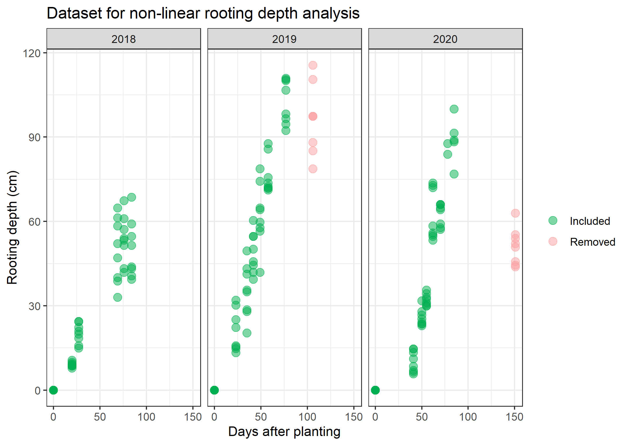
Figure S6-1. Maximum rooting depth over time dataset

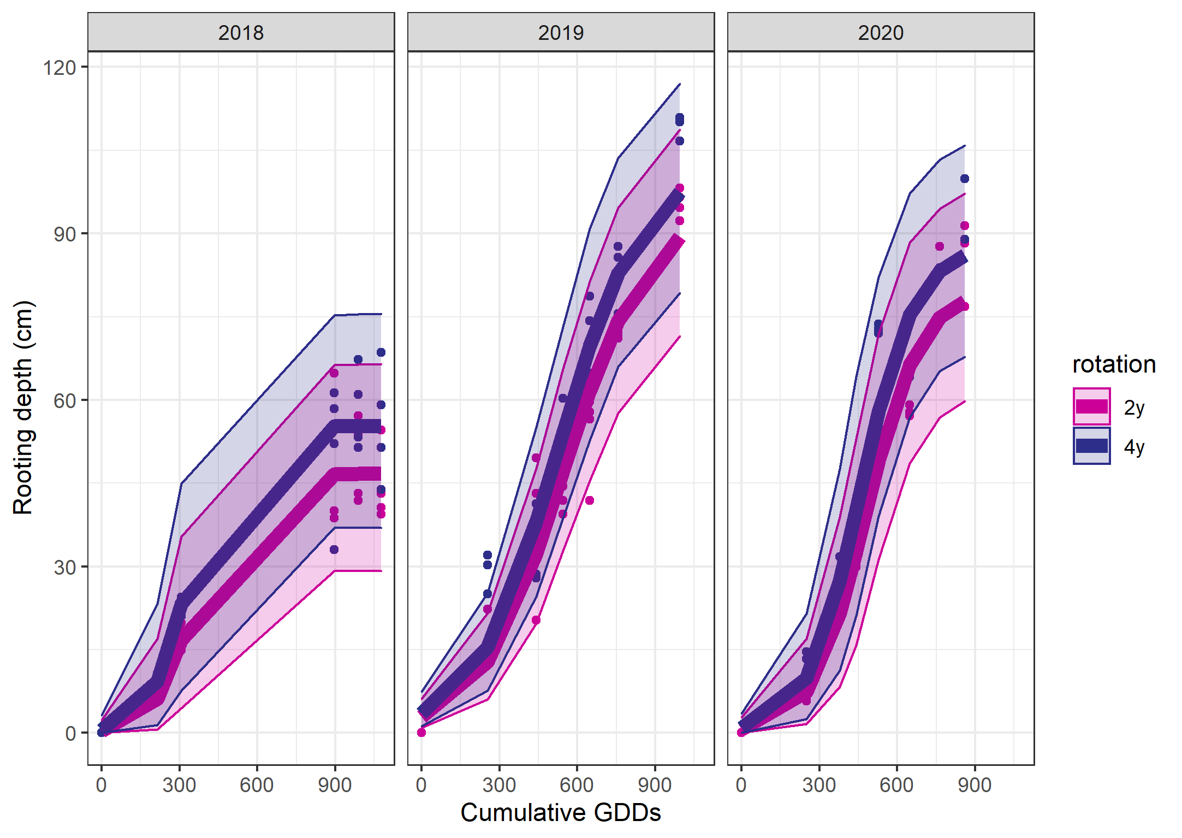
Figure S6-2. Maximum rooting depth by year
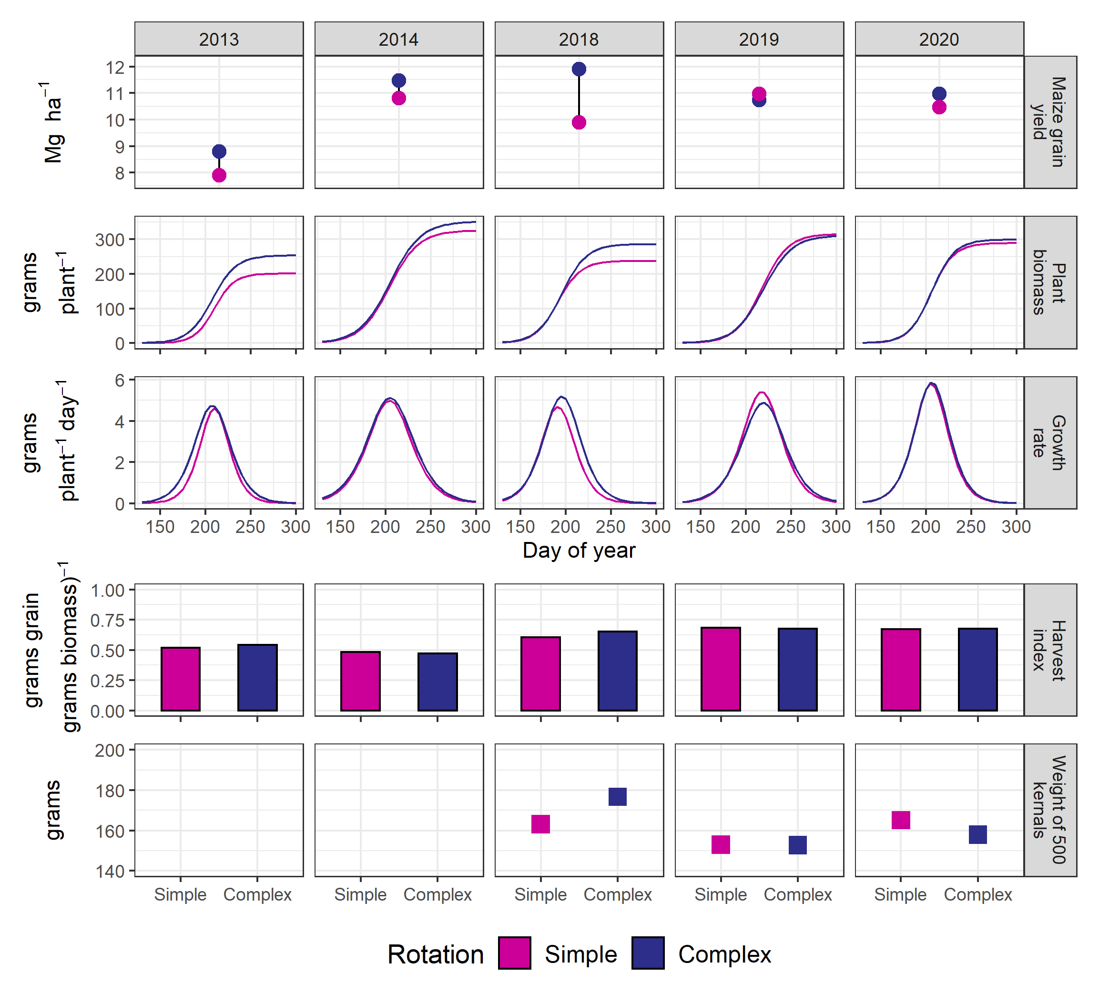
Figure S6-3 Yields, biomass over time, growth rate over time, harvest index, 500-kernal grain weight
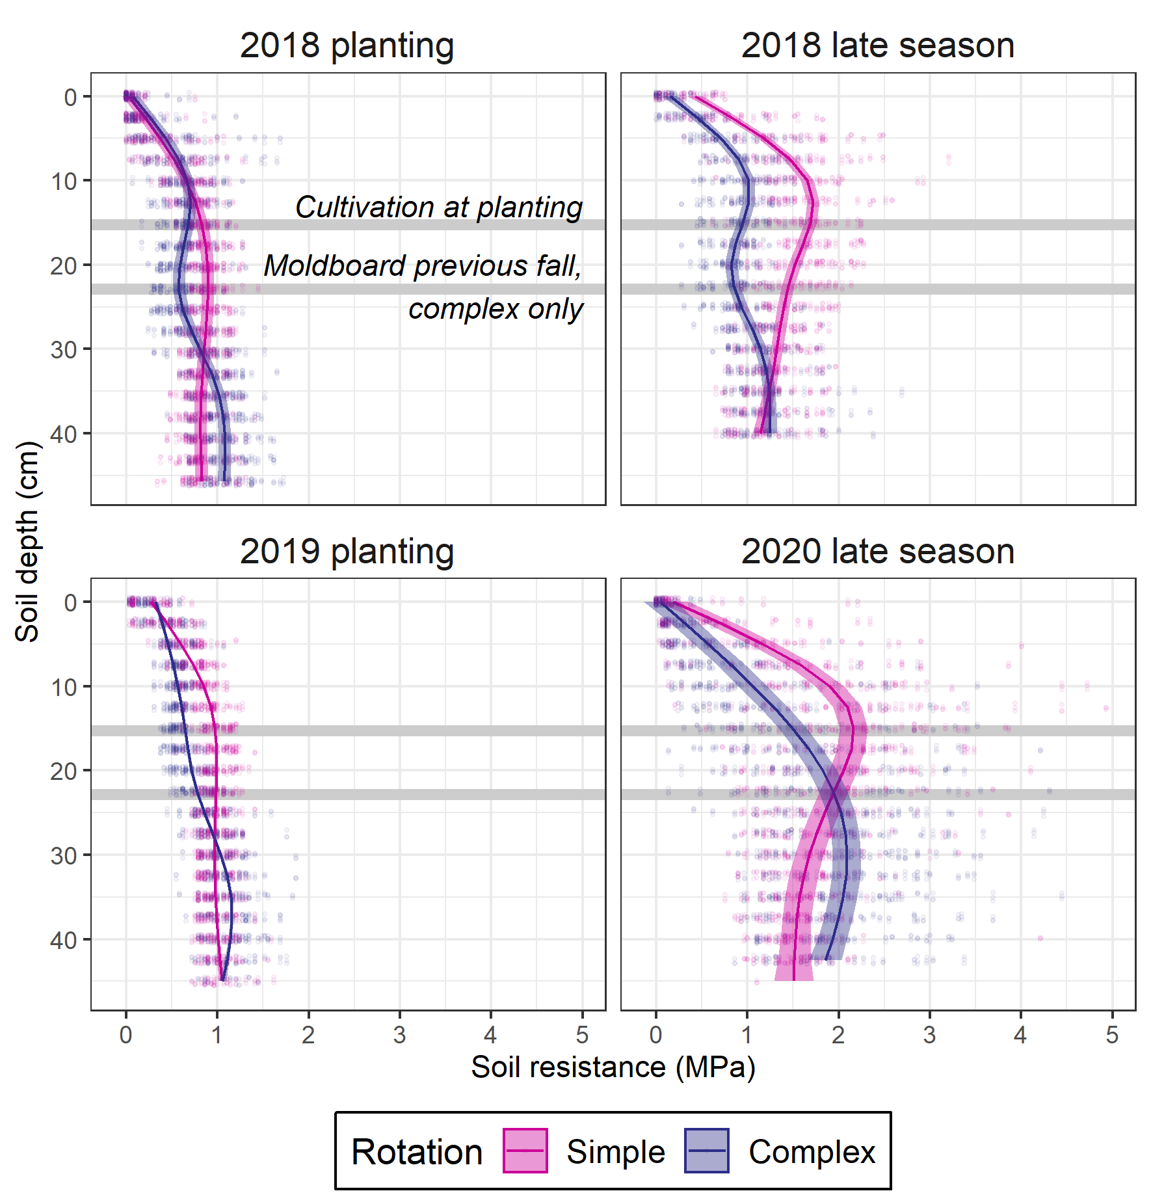
Figure S6-4 Soil penetration resistance by depth at various sampling points, approximate depths of tillage operations are provided for reference

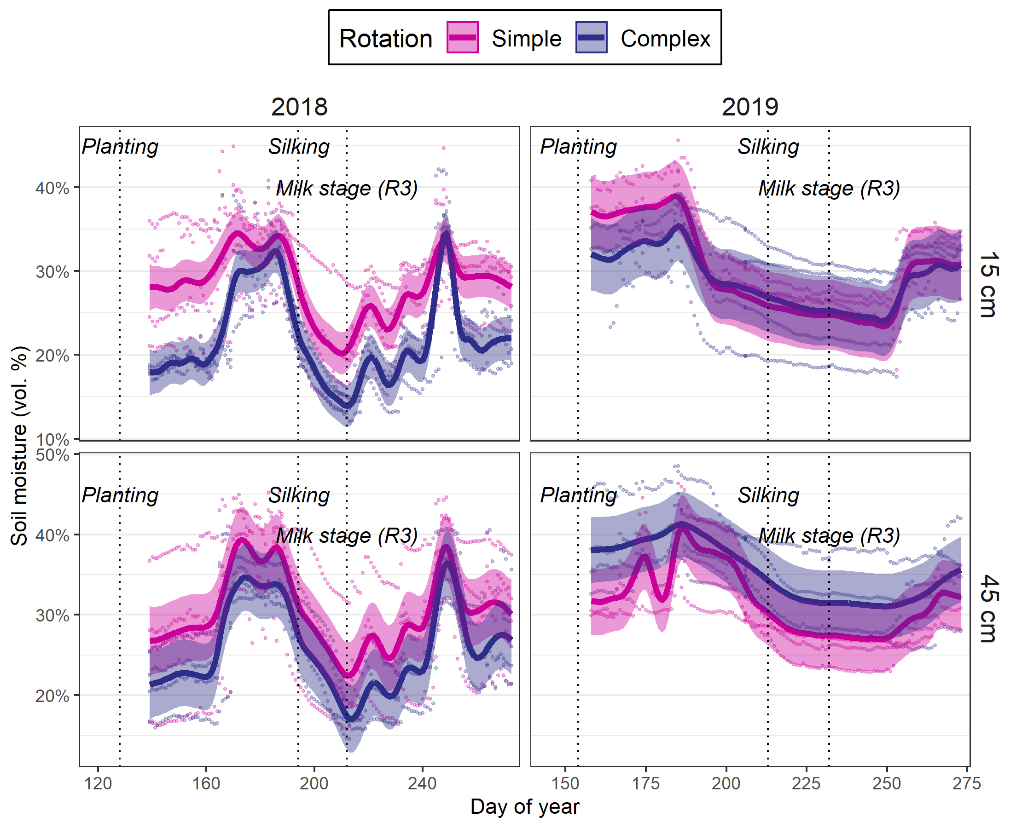
Figure S6-5. Soil moisture at 30 and 45 cm depths in the maize phase of the complex (dark blue) and simple (pink) rotations;

points represent individual sensor values, lines the estimated values, and ribbons the 95% confidence interval around the estimates

Table S6-1. Summary of growth-analysis curve fits
Year | Rotation | Asym | xmid | scal
 |  | (cm) | (GDDs)
2013 | Simple | 201 (CI:197-205) | 210 (CI:209-211) | 10.9 (CI:9.9-11.9)
2013 | Complex | 253 (CI:244-264) | 207 (CI:205-210) | 13.3 (CI:11.5-15.3)
2014 | Simple | 326 (CI:316-336) | 204 (CI:203-206) | 16.3 (CI:15-17.6)
2014 | Complex | 351 (CI:341-363) | 205 (CI:203-207) | 17.1 (CI:15.8-18.6)
2018 | Simple | 237 (CI:231-244) | 191 (CI:190-193) | 12.6 (CI:11.6-13.7)
2018 | Complex | 286 (CI:280-292) | 196 (CI:195-197) | 13.7 (CI:12.8-14.8)
2019 | Simple | 316 (CI:307-325) | 218 (CI:216-219) | 14.6 (CI:13.3-15.9)
2019 | Complex | 312 (CI:299-234) | 219 (CI:217-222) | 15.9 (CI:14.2-17.8)
2020 | Simple | 289 (CI:283-295) | 205 (CI:204-207) | 12.4 (CI:9.7-14.7)
2020 | Complex | 299 (CI:292-307) | 206 (CI:205-208) | 12.7 (CI:9.5-15.2)

Table S6-2. Summary of fixed effect tests on root mass
Source | DF* | Denominator DF | F Ratio | p-value
Year | 1 | 1.88 | 6.257 | 0.14
Rotation | 1 | 6.21 | 0.127 | 0.73
Year x Rotation | 1 | 6.21 | 0.024 | 0.88
Depth | 3 | 30.65 | 0.6517 | 0.59
Year x Depth | 3 | 30.65 | 1.1693 | 0.34
Rotation x Depth | 3 | 30.65 | 4.2414 | 0.013
Year x Rotation x Depth | 3 | 30.65 | 1.4503 | 0.25
*DF = Degrees of freedom

Table S6-3. Summary of root mass added contrasts for the complex versus simple rotation at each depth
Depth | Numerator DF* | Denominator DF | F Ratio | p-value
0-15 cm | 1 | 14.77 | 6.69 | 0.02
15-30 cm | 1 | 16.07 | 0.08 | 0.78
30-45 cm | 1 | 16.07 | 0.14 | 0.71
45-60 cm | 1 | 16.07 | 0.56 | 0.47
*DF = Degrees of freedom

GENERAL CONCLUSION
There are benefits and challenges to increasing cropping system complexity in the Midwest. Inclusion of cover crops in the traditionally winter fallow periods of Midwestern cropping systems can reduce weed pressure, particularly in fields with populations of herbicide-resistant weeds. Cover crops have variable effects on soil structure and more context-specific information is needed to understand the factors driving this variability. Extending crop sequences to include crops with variable planting dates may reduce weed densities in those systems. Examining root form and function of maize in different rotation sequences may provide insight into the drivers of the rotation effect. Adjusting maize root characteristics in response to crop history may be a promising avenue for including these phenomena into process-based models.
This work utilized novel approaches to leverage models and field data to advance our knowledge of the complex interactions involved in cropping systems research, providing significant contributions to the pursuit of more sustainable agricultural systems in the upper Midwestern US. As social, economic, and political forces continue to drive simplification of agricultural systems, it is necessary for public research to continue to document the impacts this simplification has on farmers, their communities, and society. Researching the benefits and challenges of diversifying agricultural systems both clarifies the benefits we are sacrificing to simplification, and provides a scientific basis for creating policies that favor diversification, should the public demand such policies be enacted.

