Target Journal: Agriculture, Ecosystems and Environment
Title: Open to suggestions, I’m going to crowd source it ☺
Cover crops reduce weed biomass in maize-based Midwestern systems
Authors: Virginia Nichols, Rafael Martinez-Feria, David Weisberger, Sarah Carlson, Bruno Basso, Andrea Basche

Abstract (<300 words)
Use of winter annual cover crops (CCs) in the United States (US) Corn Belt has increased steadily over the past decade. In addition to their soil conservation benefits, CCs may also offer a non-chemical form of weed control, potentially providing quantifiable reductions in other weed control costs. However, literature regarding the effectiveness of winter CCs for weed control in this region reports wide-ranging results. Thus, a better understanding of the factors influencing weed responses to CCs in maize (Zea mays)-soybean (Glycine max) systems is needed. We conducted a meta-analysis of studies that measured weed biomass or density in both a CC and no-cover treatment in maize-soybean rotations in the Midwestern United States. Fifteen studies met our criteria, resulting in 123 paired comparisons of weed biomass and 119 of weed density. We found CCs significantly reduced weed biomass, but not weed density. CCs were most effective in suppressing winter annual weeds, having less effect on summer annuals, and no effect on perennial weeds. We found no evidence that management factors (termination method, planting method, tillage system) directly affected CC weed suppression. Even after accounting for differences in CC biomass production, grass CCs reduced weed biomass more than non-grasses. Higher CC biomass was associated with more weed control, and a 75% reduction in weed biomass required 5 Mg ha⁻¹ of grass CC residue. While these analyses suggest it is possible to manage CCs for significant weed control, ancillary use of a process-based model (SALUS) demonstrated achieving the quantity of CC biomass needed for considerable weed control requires substantially delayed termination in most years. Therefore, we conclude that CCs significantly reduce weed biomass, which may render other weed managements more effective, but CCs alone cannot consistently control weeds in this region.

Introduction

Use of winter annual cover crops (CCs) has been increasing in the Corn Belt region of the United States (US) over the last decade, mainly due to an increasing need for practices that improve soil and water quality. Cover crops have been found to decrease nitrate export from fields, reduce soil erosion, and increase soil water-holding-capacity and infiltration rates (Kaspar and Singer 2011; Blanco-Canqui et al. 2015; Basche and DeLonge 2019). While these benefits have been quantified and are beneficial to long-term yield maintenance and the public good, they are not easily monetizable to farmers in the short term. A recent study using partial budgets showed that annual net returns to CCs are negative for most Midwestern producers (Plastina et al. 2018).

The potential impact of CCs on weed management in the Corn Belt are not clearly understood. One area in which CCs may provide short-term economic benefits is by reducing the need for other weed management strategies (chemical, mechanical). Cover crops have been explored as a component of integrated approaches to weed management for some time (Teasdale 1996; Liebman et al. 1997). Managing CCs such that they replace weed control costs of chemical- or tillage-based methods can offset CC establishment costs under certain circumstances (Mischler et al. 2010)(Gailans and Haley(?) 2018). Additionally, given the threat posed by herbicide-resistant weeds, CCs may become a requisite strategy in their management (Cholette et al. 2018; Price et al. 2011; Wallace et al. 2019).

Recent global meta-analyses have shown diversification of cash crop rotations (Weisberger et al. 2019) and use of CCs (Osipitan et al. 2018) can offer weed suppression in a range of production systems. However, the maize (Zea mays)-soybean (Glycine max) production system ubiquitous in the US Corn Belt merits specific consideration, as context-specific analyses can offer insights not accessible when global scopes are considered. For example, a state-specific synthesis paper found grass and broadleaf CCs were equally weed-suppressive in Pennsylvania’s production systems (Baraibar et al. 2018), in contrast to results from a world-wide meta-analysis that found grass CCs were not effective at reducing either weed biomass or density (Osipitan et al. 2018). Specific environmental and agronomic conditions in the US Corn Belt may constrain CC establishment and thus CC biomass production, which in turn may affect factors governing CC performance relative to weed management. Additionally, while cash crop diversification offers higher weed suppression in no-till systems (Weisberger et al. 2019), to our knowledge the effect of system tillage on CC weed suppression has not been examined for the Corn Belt. Questions also remain about how CC interactions with the cash crop can affect weed suppression (e.g. termination-to-planting gaps, crop residue). Furthermore, it is unclear whether managing CCs for weed control is antagonistic to CC managements that maximize cash crop yields. Finally, CC weed research employs varying methodologies regarding when weeds are measured, and it is unclear how this can affect results and interpretation.

Region-specific analyses can also provide more precise and refined information on CC production targets that effectively suppress weeds. For example, data from studies conducted in the Northeastern US suggest that CC biomass >5 Mg ha⁻¹ at termination is necessary to provide weed control equivalent to that of herbicides (Mischler et al. 2010; Mirsky et al. 2013). Similar recommendations are currently unavailable for maize-soybean systems of the Corn Belt. Moreover, previous reviews of literature and multi-year trials have produced wide ranges in CC production estimates for this region (Snapp et al. 2005; Silva 2014; Kaspar and Bakker 2015), and it unknown whether achieving high biomass levels in the Corn Belt is feasible given the limited spring growth period before cash crop planting. Process-based simulation models have been used to explore agronomic and environmental questions in the US Corn Belt (Basche et al. 2016; Martinez-Feria et al. 2016), but to our knowledge no studies have applied these tools to explore the feasibility of achieving adequate CC biomass for a meaningful reduction in weeds.

To address these research gaps we synthesized data from published field-study-based literature on weed control by CCs in maize-soybean systems of the US Corn Belt. Our objectives were to (1) examine factors that may influence CC weed control effectiveness, including (i) environmental growing conditions, (ii) management choices, (iii) trade-offs between managing for yields versus weed suppression, and (iv) experimental design; (2) identify Corn Belt-specific CC biomass targets for providing significant weed suppression in the Corn Belt; and (3) evaluate the feasibility of achieving these targets under the current climate.

Methods

Database search

We conducted a systematic search of relevant literature using ISI Web of Knowledge (WoS,
available online). A literature search was conducted in October 2018 using the following Boolean string: (weed* AND ("cover crop*" OR "green manure" OR "catch crop*") AND ("corn" OR "maize" OR "soybean*")). This resulted in a total of 676 studies that were screened for eligibility based on the following three criteria:
(1) Studies must have been conducted in a US ‘Corn Belt’ state, defined as a state in the contiguous Midwestern region with the largest acreages of maize acres harvested in the most recent five years of available data (US Department of Agriculture National Agricultural Statistics Service) including: Illinois, Indiana, Iowa, Kansas, Michigan, Minnesota, Missouri, Nebraska, North Dakota, Ohio, South Dakota, and Wisconsin (Fig. 1);
(2) Studies must have measured weed biomass and/or weed density;
(3) Studies must have included a treatment that tested the effects of a fall-planted CC followed by either maize or soybean against a treatment that included no CC holding all other factors constant.
From this search, we screened the full text of 220 articles for inclusion in the database. From this, 15 articles met our three criteria (S1).

Database development

We included weed biomass, weed density, and cash crop yield as response variables in our database. Values were recorded in a paired format, requiring the response variable to be measured in the same crop at the same time with all aspects of management held constant except for a treatment of a fall-planted CC. Data were recorded for each site-year separately or averaged, depending on how they were reported. No zero values were reported. Extracted data included information pertaining to geographical location and soil characteristics of the study; cash and CC management such as tillage system, CC termination method, planting and termination dates, and species; and experimental information such as timing of weed measurements and type of weed (Table 1). Aridity index, an integrated measure of temperature, precipitation and potential evapotranspiration, were derived from location coordinates using the CGIAR-CSI Global-Aridity and Global-PET databases (Zomer et al. 2008). All measurements were taken in plots where the treatments had been in place for five or less years, with over 95% of the measurements being taken in treatments imposed the same or previous calendar year; we were therefore unable to include the duration of the experiment as a possible explanatory variable.

Statistical analysis

All data manipulation and statistical modelling was done in R version 3.6.1 (R Core Team) using the tidyverse meta-package (Wickham et al. 2019) and other data manipulation packages (Wickham and Bryan 2018)(Grolemund and Wickham 2011; Bryan and Zhao 2018; Firke 2019). Specific statistical packages are referenced below.
The response (y) variable in all statistical analyses was the response ratio, defined as the value of the response in the CC treatment divided by the value in the no-cover treatment (Gurevitch et al. 2018). The ratios exhibited a log-normal distribution, and were therefore log-transformed (log-response-ratio, LRR) for all statistical analyses. Values were back-transformed and presented as a percent change for interpretation purposes and reported as geometric means. To estimate overall effect sizes, we fit a linear mixed-model using the lmer4 package (Bates et al. 2015) using the LRR as the response variable and a random intercept for each study with non-parametric weighting based on sample sizes (Adams et al. 1997). We used this weighting method because only three of the 15 studies reported variances on weed measurements. Results were analyzed using the lmerTest (Kuznetsova et al. 2017) and emmeans (Lenth et al. 2018) packages. For all linear mixed models fit in this paper, a random intercept for each study and non-parametric weighting was used.

Cover crop biomass is already known to have a strong effect on weed suppression (Mirsky et al. 2013; Baraibar et al. 2018; Wallace et al. 2019). To assess an individual modifiers’ effect on weed responses, we first assessed whether the CC biomass produced at each modifier level was significantly different by fitting a mixed linear model with CC biomass as the response and an individual modifier as a predictor. In the weed biomass dataset, CC type (grass and non-grass) significantly affected CC biomass production (p=0.01). When testing for the effect of CC type on weed suppression, we therefore chose to include CC biomass as a covariate to control for these differences. We did so by including CC type (grass and non-grass), CC biomass at termination, and their interaction as fixed effects (plus the random effect of study as previously described). The interaction was not significant based on nested model comparison, so the interaction was not included in the final model. For all other modifiers, they were assessed individually using a linear mixed model as described above with only one fixed effect modifier included at a time.

Significance was assigned at a p-value <0.05, but intermediate p-values (0.05-0.10) were investigated (Ho et al. 2019). The robustness of our results was assessed by removing one study at a time from the dataset and fitting the statistical model for each dataset individually (Philibert et al. 2012). Additionally, select individual points were assessed for disproportionately influencing results in the same manner. For significant results, robustness against possibly un-published non-significant results was assessed using a fail-safe number (Rosenthal 1979).

Previous CC studies have failed to define what constitutes a ‘significant’ reduction in weeds. For weed density, reductions comparable to herbicide effectiveness (>90%) are appropriate. However, the effect of CCs on weed density was not significant (see Fig. 1). Determining a meaningful threshold reduction for weed biomass was less straightforward. Only nine comparisons showed >90% reductions in weed biomass in response to CCs, so estimating the amount of CC biomass needed to achieve this reduction would be accompanied by a high degree of uncertainty. Model predictions are most accurate near the mean response value; the mean reduction in weed biomass from grass CCs was 68% (see Figure 2). We therefore chose to estimate the amount of CC biomass required to achieve a 75% reduction in weed biomass. We felt this was still a significant reduction in weed biomass, but decreases the uncertainty surrounding the estimate compared to an estimate at >90% reduction. To estimate the amount of grass CC biomass needed at termination to achieve a 75% reduction in weed biomass, we fit a linear mixed model with CC type and CC biomass at termination as predictors (with study as a random effect). The unconditioned fitted parameters were used to back-calculate the grass CC biomass at a CC-induced 75% reduction in weed biomass. The uncertainty around this value was estimated using the delta method (Ver Hoef 2012).

Finally, each point was categorized based on cash crop yield and weed pressure responses; if the comparison exhibited both an increase in cash crop yield and a decrease in weed pressure it was assigned ‘win-win’, otherwise it was assigned a value of ‘other’. To explore possible predictor combinations for win-win scenarios, we fit random forest models (Kuhn and Johnson 2013) using several R packages (Hothorn et al. 2006).

Simulation of rye cover crop biomass
To investigate whether it is feasible to manage CCs for effective weed control in the US Corn Belt, we used the System Approach to Land Use Sustainability (SALUS) model to simulate winter rye (Secale cereal) biomass across a range of soils and weather conditions in the Midwestern US. We chose to model winter rye growth because it is one of the most prevalent CC species used in the US Corn Belt (Singer 2008), and rye represents the most optimistic cover crop choice for maximizing biomass production in this region (Kaspar and Bakker 2015).

SALUS is a cropping system modeling platform, widely used to simulate crop growth and other plant-soil-atmosphere processes in the US Corn Belt and elsewhere (Basso and Ritchie 2015). The model is composed of a suite of soil, crop and hydrological process-based models that run on a daily time-step using daily weather data, information on soil characteristics, and management. The platform allows the use of a simple crop model, which provides great flexibility to represent many annual crops given the relatively low number of crop-specific parameters needed for simulation (Dzotsi et al. 2013). For this study, we developed the crop-specific parameters for winter rye cover crop using measurements of biomass at termination from published literature studies (S2). For brevity, all the details on SALUS model set up, crop-specific parameter estimation, and performance against the observed data are included in the supplementary information (S2).

Simulations of rye CC growth were performed for 0.125 x 0.125 degree grid (~9.5 km) encompassing the area within the 12 Corn Belt states in our study. Daily weather data (1989-2018) at each grid cell were from the the North American Land Data Assimilation System project phase 2 (NLDAS-2) dataset (Xia et al. 2012). Soil data for the simulations were retrieved from the gridded Soil SURvey GeOgraphic database (Soil Survey Staff). For each grid cell, we extracted soil data for the most prevalent soil map unit in SSURGO that was identified as maize or soybean cropland during the last 5 years in the CropScape data layer(Han et al. 2012).

At each grid cell, we simulated three CC planting date scenarios: September 15 (optimistic), October 7 (realistic), and November 1 (late). Each scenario was run for the 30 years of historical data to obtain a distribution of biomass growth curves for each planting date scenario and grid cell. Then each CC growth curve was examined to identify the date when 5 Mg ha-1 of growth was achieved. This represents earliest date in which the CC can be terminated and still achieve effective weed control (see results). The termination dates for each year were aggregated by county, so each county in each scenario had a distribution of 30 values of termination dates. We removed counties that had less than 30,000 ha of maize-soybean planted during the last 5 years. Finally, county-level effective weed-control termination dates were summarized at the 20, 50 and 80% probability levels.

3. Results and Discussion

3.1 Database overview

Fifteen articles (S1) fit our criteria, producing 123 response ratios for weed biomass and 119 response ratios for weed density. The studies include a range of site characteristics and managements representative of maize-soybean production systems of the Corn Belt (Fig 1; Table 1). Although the subsequent cash crop’s planting density can affect a CC’s weed suppression effectiveness (Ryan et al. 2011), we were unable to assess that aspect of the cropping systems due to a paucity of such data reporting.

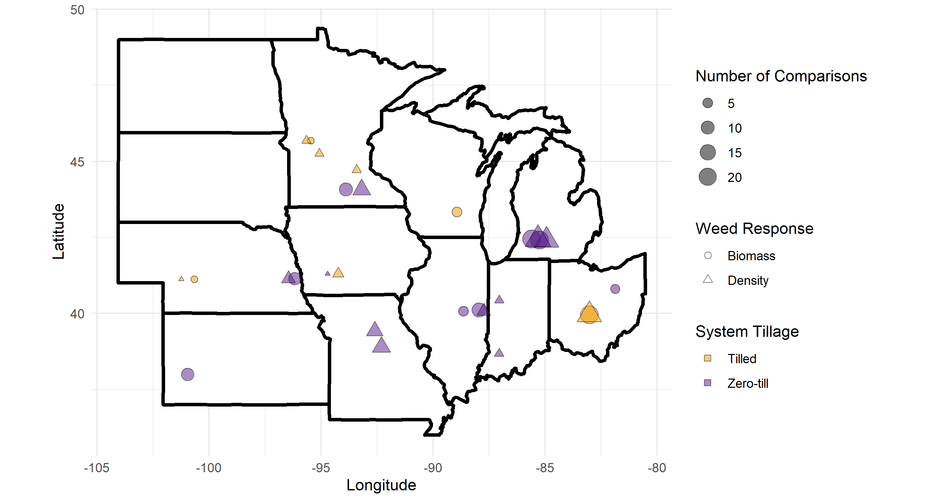
Figure 1 Our database comprised 15 published studies done in one of the 12 Corn Belt states that measured weed biomass or weed density in a winter cover cropped and no-cover treatment of maize or soybean; point shape indicates the weed response reported, point size the number of comparisons extracted from the study location, and point color the tillage classification of the study. No studies from North and South Dakota met our selection criteria.

Table 1. Management, experimental design, and site characteristics were extracted from each publication; weed biomass and weed density responses were separated into two datasets. The full databases are available in Iowa State University’s DataShare repository (CITE).

Category | Factor | Biomass (n = 123) | Density (n = 119)
Management
System | Tillage | Tilled (n=30)  Zero-till (n=93) | Tilled (n=31)  Zero-till (n=88)
 | Time between cover crop termination and cash crop planting | -31 – 29 days | -31 – 13 days
Cover Crop | Type | Grass (n=46)  Non-grass (n=77)  Non-grass category includes brassicas (3), legumes (74) | Grass (n=31)  Non-grass (n=88)  Non-grass category includes brassicas (9), legumes (73), mixtures (6)
 | Planting date | Aug 15 – Oct 18 | Aug 15 – Oct 31
 | Planting density | 13.4 – 180 kg seed ha-1 | 9 – 135 kg seed ha-1
 | Termination date | April 18 – June 18 | April 18 – June 18
 | Termination method | Several methods (n = 3)  herbicides (n = 54)  mechanical (roller crimper, mowing; n = 29)  winterkill (n = 37) | Several methods (n = 3)  herbicides (n = 53)  mechanical (roller crimper, mowing; n = 22)  winterkill (n = 37)  none (n = 4)
 | Cover crop biomass at termination | 130 – 9003 kg ha-1 | 0 – 9003 kg ha-1
Cash crop | Subsequent crop | Maize (n=78)  Soybean (n=45) | Maize (n=73)  Soybean (n=42)  Averaged over maize and soybean phases† (n=4)
 | Cash crop planting date | April 20 – June 30 | April 27 – June 18
 | Corn yield | 40-13500 kg ha-1 | 40-11200 kg ha-1
 | Soybean yield | 300-3618 | 300-3310 kg ha-1
Site
 | State | Illinois (17)  Kansas (9)  Michigan (44)  Minnesota (12)  Nebraska (11)  Ohio (25)  Wisconsin (5) | Iowa (4)  Illinois (5)  Indiana (4)  Michigan (45)  Minnesota (16)  Missouri (18)  Nebraska (6)  Ohio (21)
 | Latitude | 38.0 - 45.7N | 38.7 - 45.7N
 | Longitude | 81.9 – 101W | 83.0 – 101W
 | Soil type | Loam (n = 46)  Sandy loam (n = 1)  Silt Loam (n = 67)  Silty Clay Loam (n = 9) | Loam (n = 59)  Silt Loam (n = 61)  Silty Clay Loam (n = 9)
 | Organic matter content | 1.5 - 4.15% | 1 – 3.4%
 | Aridity index* | 0.37 – 0.94 | 0.44 – 0.96
 | Publication year | 1993 - 2018 | 1993 - 2018
Experiment
Design | Number of replicates | 3 - 5 | 3 – 6
 | Type of weed(s) measured | Summer annual (86)  Winter annual (17)  Perennial (15)  Unknown (5) | Summer annual (75)  Winter annual (29)  Perennial (15)
 | Duration of experiment | 1-3 years (n=123)  4-5 years (n=0) | 1-3 years (n=115)  4-5 years (n=4)
Timing | Timing of weed measurement with respect to cash crop planting | Before (38)  After (119) | Before (38)  After (119)
 | Season of weed measurement** | Spring (January-June; n = 19)  Summer (June-September; n = 104)  Fall‡ (October – December; n = 4) | Spring (n = 36)  Summer (n = 79)
†The study (Mock et al. 2012) reported weed densities averaged over both phases, but did not report crop yields
‡This category was removed from analyses testing the significance of this modifier due to the small number of points representing the category
*an integrated measure of temperature, precipitation and potential evapotranspiration were derived from location coordinates using the CGIAR-CSI Global-Aridity and Global-PET databases (Zomer et al. 2008).
** Spring: January-June; Summer: June-September; Fall : September – December

One comparison resulted in an extremely low LRR due to a CC treatment weed biomass of 1 g m⁻² (SE = 1 g m⁻²) corresponding to a 99.9% reduction in weed biomass (Forcella 2013). This comparison was found to disproportionately influence results of the statistical models, and was therefore adjusted to equal the next highest reduction (97%) in weed biomass observed in the database.

3.2 Overall results
Overall, CCs significantly reduced weed biomass by a geometric mean of 51% (p=0.02), but the reduction in weed density was non-significant (p=0.98; S3). The significant reduction in weed biomass was robust against publication bias; more than 3000 non-significant un-published studies to nullify the result (Rosenthral 1979). The leave-one-study-out analysis identified one study (Gieske et al. 2016b) reporting only weed density that used a radish (Raphanus sativus) cover crop; removal of this study from the database drastically changed the p-value (lowered from 0.98 to 0.26). The significance of the reduction in weed biomass was robust against removal of each study (p-values ranging from 0.01-0.04). We found the cash crop following the CC (maize or soybean) had no effect on the measured response, meaning effects of the CC on weeds is not confounded by the differences in crop competition with weeds.

In the weed biomass database, the CC type significantly affected the amount of CC biomass produced (p = 0.01), with grass CCs producing a least-squared means estimated 3.95 Mg ha⁻¹ of biomass, compared to non-grass which produced 2.56 Mg ha⁻¹. Therefore, CC biomass was used as a covariate in the statistical model testing for differences in CC type with regard to suppression of weed biomass (see Methods and Materials). No other modifier significantly affected the amount of CC biomass. The following categorical modifiers had levels with significantly different effects on weed biomass: measurement season (spring, summer), measurement in reference to cash crop planting (before, after), CC type (after controlling for CC biomass production; grass, non-grass), and weed growth habit (winter annual, summer annual, perennial). Weed biomass and density responded with the same patterns to these modifiers, but weed density responses were not significantly different for any factor levels (Fig. 2).

The different responses of weed biomass versus density to CCs provides insight into the mechanisms by which CCs suppress weeds in the Corn Belt. Cover crops induce micro-environmental changes that can promote, delay, or inhibit weed seed germination, and the emergent effect depends heavily on the specific context of a given year. For example uptake of nitrogen creates a relatively nitrogen-free soil surface, and germination of certain weed seeds is suppressed under low nutrient soils (CITE, Matt would know). However, in the Corn Belt the nitrogen status of a soil is highly dependent upon the previous crop year and spring weather (Martinez-Feria et al. 2019), so whether nitrogen actually limits weed seed germination will vary year-to-year. The balance between inhibitory effects of CCs on weed seed germination (lower light, lower soil temperatures, smaller ranges in temperatures, lower soil nitrate concentrations, allelopathic chemicals) and stimulatory effects (increased soil moisture, protection from desiccation, protection from export via erosion) will depend on the context, and is therefore not consistent. Conversely, the suppressive effects of CCs on weed biomass (increased resource competition, delayed germination) are less dependent on the specific context, and therefore show a stronger, more consistent reduction.

For weed biomass, grass CCs reduced weed biomass by 68% compared to only 33% for non-grass (p<0.01; Fig. 2). Measurements taken before cash crop planting showed a 74% reduction in weed biomass, compared to only 44% in measurements taken after planting (p<0.01). Winter annuals showed the strongest reductions (65%), followed by summer annuals (47%), with perennial weeds being unaffected by CCs. For continuous variables, weed suppression was significant affected by CC biomass for both weed biomass (after controlling for CC type, p=0.03; Fig. 3) and weed density (p<0.01; S3).

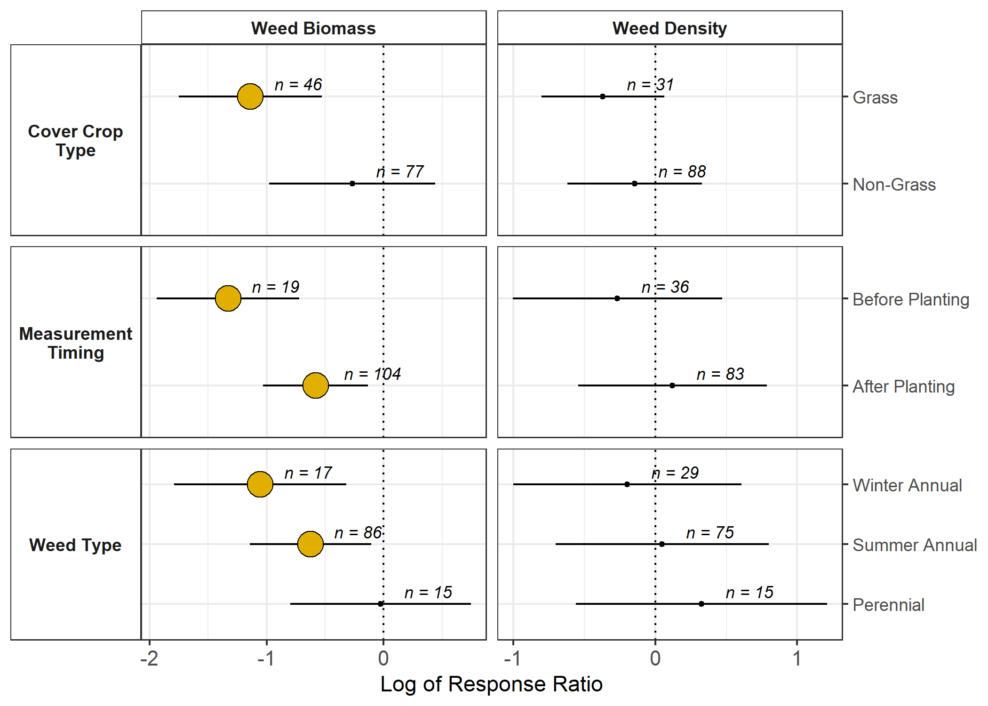
Figure 2 Significant categorical variables included cover crop type* (grass, non-grass), when the weed measurement occurred (before cash crop planting, after), and the type of weed (winter or summer annual, perennial); values less than 0 (dotted line) indicate cover crops reduced weeds, large yellow points indicate estimates that were significantly different from 0, n value indicates the number of observations used for the estimate, line-ranges represent 95% confidence intervals.
*After controlling for the amount of cover crop biomass production

3.3 Cover crop management approaches

3.3.1 Cover crop type

Even after controlling for the effect of CC biomass, grass CCs offered more weed suppression compared to non-grass (Fig. 2). This may have consequences for balancing yield maintenance and weed suppression goals (Section 3.4). With regards to weeds, CC-induced control is a combination of physical and chemical suppression, and grasses such as rye may be more effective than legumes on both fronts (Creamer et al. 1996; Gieske et al. 2016a; Smith et al. 2020). The carbon-to-nitrogen ratio of grass CCs can be twice as high as legumes, with grass ratios increasing with higher overall biomass production (Quemada and Cabrera 1995)(Martinez-Feria et al. 2016). The higher carbon-to-nitrogen ratios of grass residue increase the residence time of the CC residue compared to legume residue, thus potentially suppressing weeds longer after CC termination (Teasdale and Mohler 1993; Ruffo and Bollero 2003). Additionally, the structural arrangement of live grass plants could provide a larger amount of light interception per unit of live biomass compared to legumes (Andrew et al. 2015). Rye residue also exhibits an allopathic effect, which can inhibit weed seed germination and reduce weed biomass (Dhima et al. 2006; Teasdale et al. 2012). While brassica CCs may also suppress weeds via allelopathy (Haramoto and Gallandt 2005) only 9 of the 77 non-grass points were brassicas, and they did not exhibit significantly different suppressive effects compared to legumes (S3).

3.3.2 Tillage and termination method

Interestingly, in our database, the tillage regime of the overall system had no effect on the weed suppression of the CC (S3). A previous meta-analysis found cash crop diversification significantly reduced weed density, and this effect was amplified in no-till systems (Weisberger et al. 2019). For CCs, which did not reduce weed density in our study, no-till offers no advantages with regard to weed control. This is likely because cash crop diversification and incorporation of CCs are affecting different phases of the weed cycle, exemplified by the fact that cash crop diversification affected only weed density, and CC incorporation only weed biomass.

The CC biomass was an important predictor for weed suppression in our analysis and previous studies (Mirsky et al. 2013; Baraibar et al. 2018). Because herbicide-based termination leaves CC biomass on the soil surface, it was surprising herbicide termination did not enhance CC-induced weed suppression. The lack of significance of termination method may indicate both allelopathy and physical interference with weed growth are important components of CC weed suppression.

3.3.3 Cover crop biomass

The management factors most affecting CC-induced weed control were CC type and CC biomass at termination. There was no significant interaction, meaning weed biomass is negatively associated with CC biomass regardless of CC type. We found 5 Mg ha⁻¹ of biomass is predicted to reduce weed biomass by 75% for grass CCs, but only 40% for non-grass CCs (Fig. 3). There was a large amount of uncertainty associated with this estimate, but it is similar to values produced by other studies. Pennsylvania grain-production systems needed 2-6 Mg ha⁻¹ to achieve ‘significant’ weed suppression (Baraibar et al. 2018), and >5 Mg ha⁻¹ was required for CCs to be comparable to herbicide effectiveness in the Northeastern US (Mirsky et al. 2013).
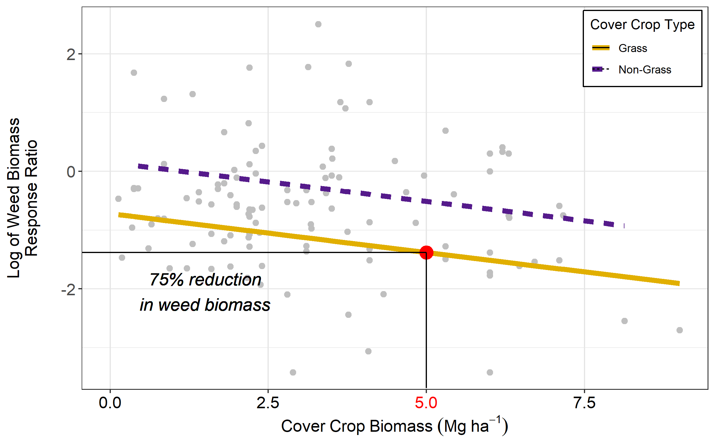
Figure 3 A 75% reduction in weed biomass required 5 Mg ha⁻¹ of grass cover crop biomass at termination.

In temperate regions, winter rye (Secale cereal L.) is consistently among the top biomass producers for winter CCs (Kaspar and Baker 2015; Appelgate 2017; Ruis et al. 2019) but with averages still well under 2 Mg ha⁻¹. Our simulation results using the SALUS model indicate achieving 5 Mg ha⁻¹ of rye CC biomass regularly under typical US Corn Belt production scenarios and climates would be challenging (Fig. 4). Even with optimistic CC planting dates (Sep-15), achieving 5 Mg ha-1 of CC biomass would require a mid-May or later termination date most of the years (80%) in half of the states, which is well after typical cash crop planting dates. A more realistic CC planting date (Oct-7) provides even less promising prospects, with only a few counties in Kansas and Missouri achieving the biomass needed before mid-May (Fig. 4b).
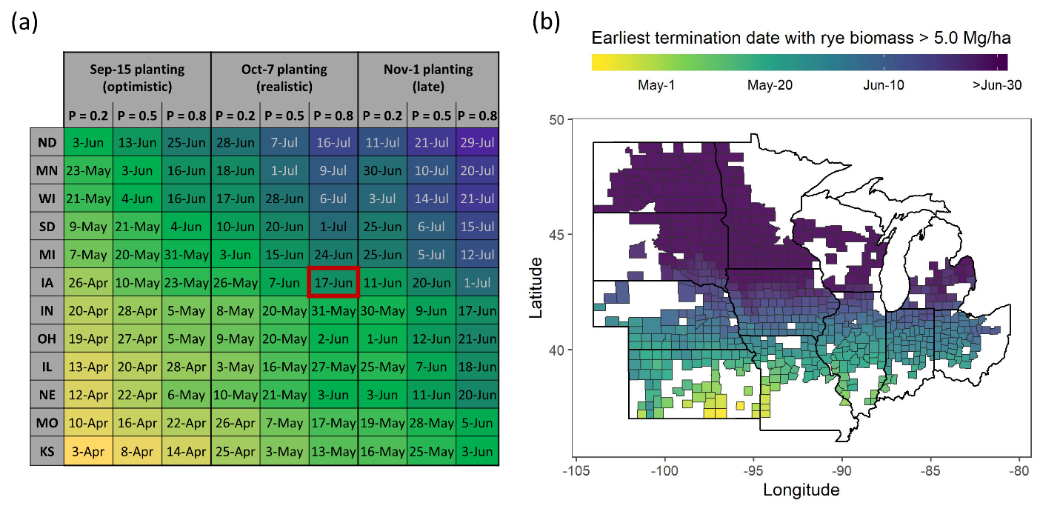
Figure 4. Earliest termination date with rye (Secale cereal) biomass in excess of 5 Mg ha⁻¹ as predicted by the SALUS crop model. Simulations were run for three rye planting date scenarios (Sep-15, Oct-7, and Nov-1), each one for 30 years of historical weather. Results in (a) are summarized by state at the 20, 50 and 80% probability levels. In Iowa, for example, rye biomass was greater than 5.0 Mg ha⁻¹ in 80% of the years, if planted on Oct-7 and terminated on or after Jun-17 (highlighted in red). Results in (b) correspond to the Oct-7 planting scenario, summarized by county at the 80% probability level.

Delaying spring planting to maximize CC biomass will almost always result in a loss of maize yield (Bollero and Bullock 1994; Baum et al. 2019). In maize, terminating a rye CC at least a week before planting is crucial to preventing yield drag (Gailans et al. 2019). In soybean, planting dates are less crucial through the end of May (Egli and Cornelius 2009; Kessler et al. 2020), and allowing the CC to continue growing even after soybean planting has shown no significant effect on yields and has anecdotally improved weed control (cite Sam’s PFI report). Unfortunately, producers in some conservation districts are required to terminate CCs within a pre-defined window before cash crop planting to remain eligible for subsidized crop insurance (CITE), which limits use of delayed termination as a method to increase weed suppression services of CCs.

Fertilization of CCs is also another tactic that may increase CC biomass (CITE), but would result in an additional cost to producers and may negate nutrient pollution mitigation services. Early fall planting may therefore be the best tactic for increasing weed suppression provided by CCs, although this is not always feasible because standing crops often preclude the establishment of CCs well into mid to late October. While aerial seeding and similar strategies can be used to establish cover crops into standing maize or soybeans, these methods are often unreliable (CITE). Further, it should be noted simulation in this study was performed assuming direct seeding with appropriate seed-to-soil contact so that germination occurs uniformly within a few days after planting (S2). Therefore, our results should not be extrapolated to estimate biomass levels using other planting methods. Other ecosystem services of CCs are strongly related to CC biomass, including reduced nitrate leaching and erosion control, meaning increasing CC biomass may represent a multiple-win situation for environmental services. Research supporting CC planting equipment, breeding, and other agronomic innovations will be needed to optimize CC services such as weed control.

3.4 Tradeoffs in managing weeds and cash crop yields

Other meta-analyses have looked specifically at the effects of CCs on subsequent cash crop yields (Miguez and Bollero 2005; Marcillo and Miguez 2017), showing grass CCs have a neutral effect on yields, while mixes and legumes have positive effects. However, assessing whether there is a trade-off in managing CCs for weed control versus yield maintenance is a useful question. In our database only 23% of the comparisons exhibited a ‘win-win’ situation, with a concomitant increase in cash crop yield and decrease in weed pressure (Fig. 5). Using a random forest model, we found no single nor combination of factors that were strong predictors of whether an observation would fall in the win-win category, suggesting maximizing cash crop yields and weed suppression may not have overlapping management strategies. Although we did not see a significant effect of CC type on yields in our dataset, yield-focused studies with more comparisons found the species of CC is one of the most important management choices affecting yields, with non-grasses being associated with the largest yield increases (Marcillo and Miguez 2017). In contrast, our study found non-grass CCs do not offer significant weed suppression. This indicates choosing a CC species to maximize cash crop yields versus weed suppression may be at odds.

One concerning trend is the extremeness of the responses for decreased yield. While other meta-analyses have looked at average yield responses, the question of whether CCs can stabilize yields or expose producers to additional risks has not been directly addressed. Our database indicates that while CCs have a slightly negative effect on yields on average (p=0.07), yield decreases, when they do occur, are more severe than yield increases (Fig. 5). A caveat to these results is that weed researchers may not manage experiments to maximize yields. For example, if a CC produces poor weed control, a producer would likely respond with additional weed control tactics, while in a research setting one may allow the weeds to continue to grow in order to assess what effect they would have on yield if not controlled. Never-the-less, the question of whether CCs affect yield stability merits further research.

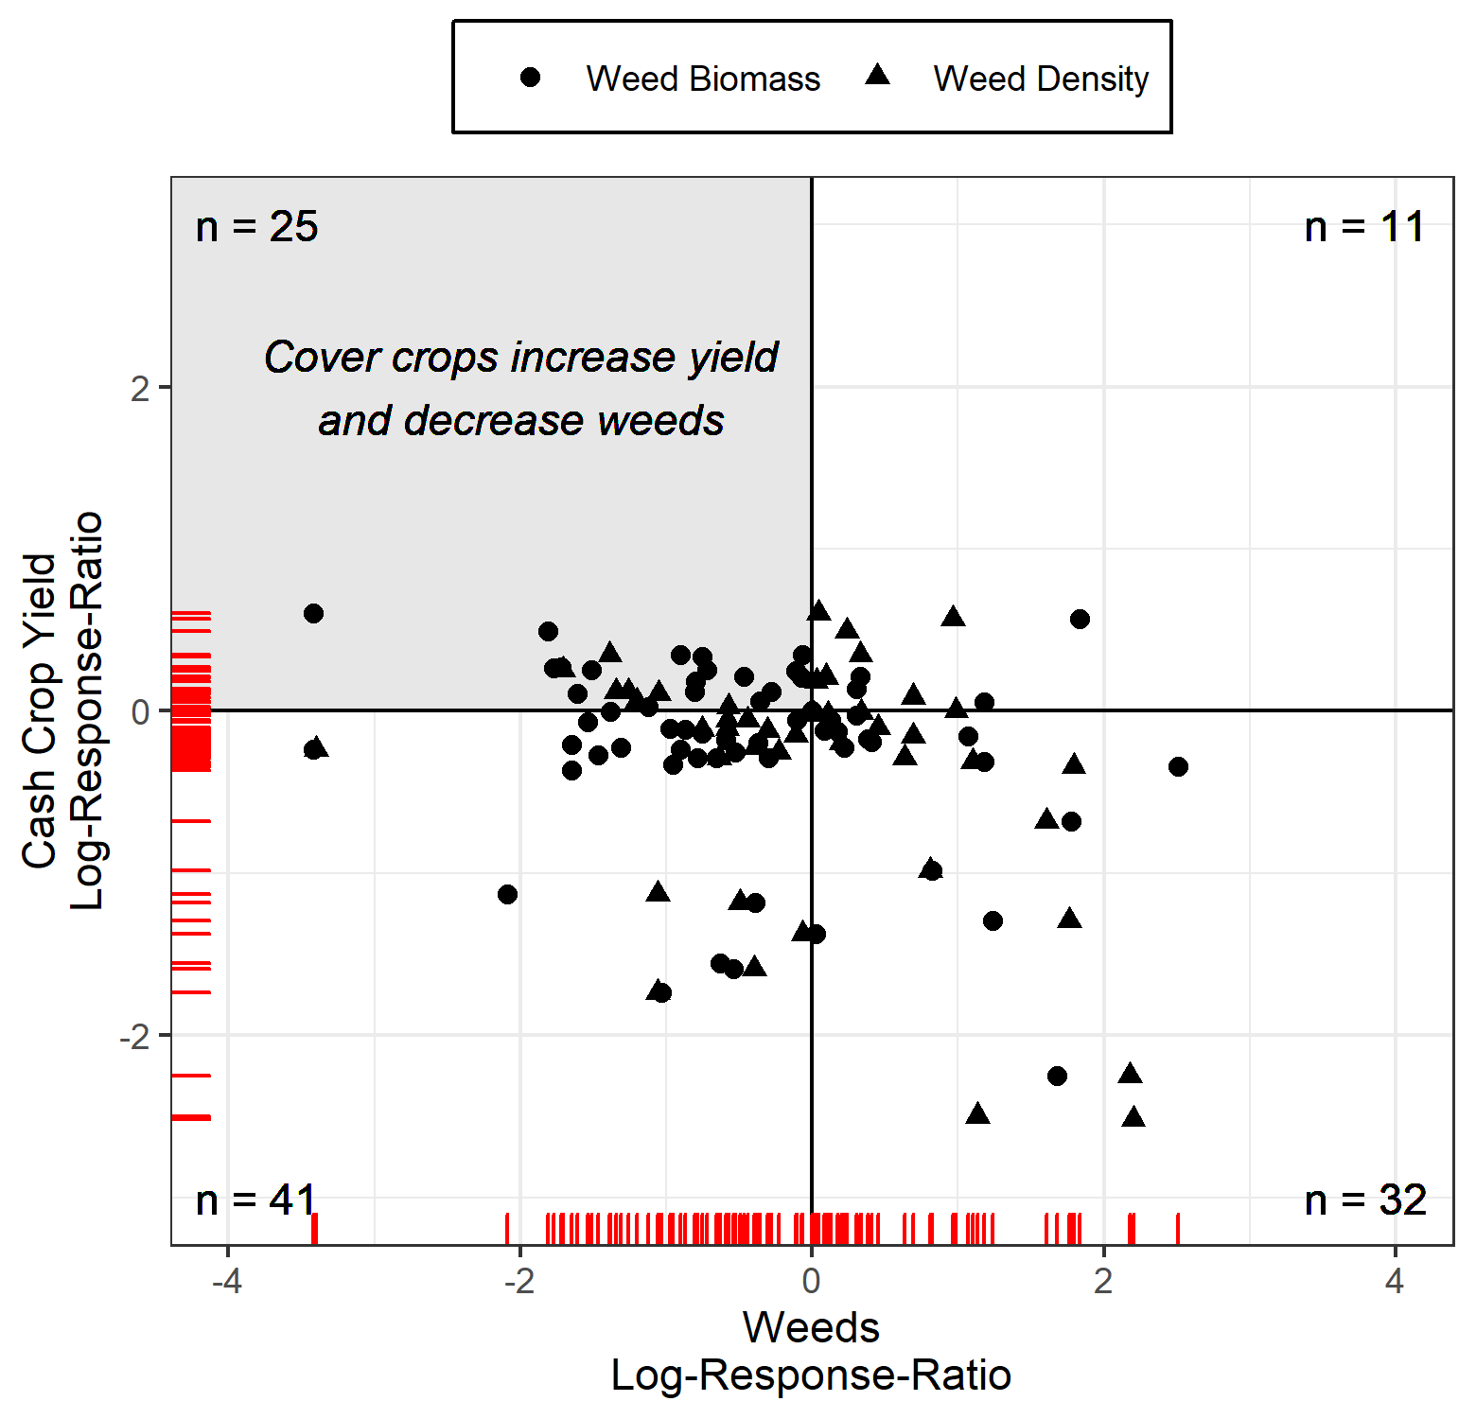
Figure 5 Comparisons where cover crops increased cash crop yields and reduced weed biomass (circles) or density (triangles) made up 23% of the points (gray quadrant), with yield decreases being equally as likely to be associated with an increase or decrease in weeds

3.5 Environmental and experimental context

We found the context under which the trials were done (aridity index, soil type, soil OM, latitude) had no significant effect on the weed responses nor the CC biomass productions (S3). In a global meta-analysis Basche and DeLonge (2019), similarly found that soil type and climate were not significant moderators of the efficacy of CCs to increase water infiltration. Alternatively, this could simply reflect the lack of measurement/reporting, plot specific information, and large dependence on weather rather than meta-data such as climate (Gerstner et al. 2017; Eagle et al. 2017). However, our results suggest that, within the Corn Belt, the environmental context under which a cover crop is grown is less important in determining its efficacy to control weeds than management factors. This indicates CC weed research done within the contiguous Corn Belt is valid for maize and soybean systems grown throughout, so open knowledge sharing via organizations such as the Midwest Cover Crops Council and university extension materials developed within this area may provide valuable recommendations for the entire region.

When designing CC experiments with regards to weeds, studies that measure weeds before cash crop planting may over-estimate the weed suppressive effects of CCs. Weeds measured after crop emergence are likely of more interest to producers, as they will have survived the stresses of CC termination, crop planting, and pre-emergent herbicide application, and thus may represent true resource competition with the cash crop.

4. Conclusions

Cover crops significantly reduced weed biomass, but had no significant effect on weed density. For a given amount of biomass, grass CCs are the most effective at suppressing weeds. Grass CC biomass production of at least 5 Mg ha⁻¹ is needed to see a meaningful decrease in weed pressure. As demonstrated here, however, consistently achieving these CC biomass levels within US Corn belt maize-soybean systems may not be feasible within the traditional cash crop harvest-to-termination window. Long term (+5 years) studies are needed to better understand if repeated reductions in weed biomass from CC use can translate to reduced weed densities over time. Less than 25% of the comparisons had concomitant increases in yields and decreases in weeds with the use of CCs (win-win), suggesting that although CCs reduce weed biomass, but this not always translates to increased yields. Therefore, we conclude that CCs significantly reduce weed biomass, which may render other weed managements more effective, but CCs alone cannot consistently control weeds in this region.

References
Adams DC, Gurevitch J, Rosenberg MS (1997) Resampling Tests for Meta-Analysis of Ecological Data. REPORTS Ecol 78:1277–1283
Andrew IKS, Storkey J, Sparkes DL (2015) A review of the potential for competitive cereal cultivars as a tool in integrated weed management. Weed Res 55:239–248. doi: 10.1111/wre.12137
Baraibar B, Mortensen DA, Hunter MC, et al (2018) Growing degree days and cover crop type explain weed biomass in winter cover crops. Agron Sustain Dev 38:1–9. doi: 10.1007/s13593-018-0543-1
Basche AD, Archontoulis S V., Kaspar TC, et al (2016) Simulating long-term impacts of cover crops and climate change on crop production and environmental outcomes in the Midwestern United States. Agric Ecosyst Environ 218:95–106. doi: 10.1016/j.agee.2015.11.011
Basche AD, DeLonge MS (2019) Comparing infiltration rates in soils managed with conventional and alternative farming methods: A meta-analysis. PLoS One 14:1–22. doi: 10.1371/journal.pone.0215702
Basso B, Ritchie JT (2015) Simulating Crop Growth and Biogeochemical Fluxes in Response to Land Management Using the SALUS Model
Bates D, Mächler M, Bolker B, Walker S (2015) Fitting Linear Mixed-Effects Models using lme4. J Stat Softw 67:1–48. doi: 10.18637/jss.v067.i01
Baum ME, Archontoulis S V., Licht MA (2019) Planting date, hybrid maturity, and weather effects on maize yield and crop stage. Agron J 111:303–313. doi: 10.2134/agronj2018.04.0297
Blanco-Canqui H, Shaver TM, Lindquist JL, et al (2015) Cover crops and ecosystem services: Insights from studies in temperate soils. Agron J 107:2449–2474. doi: 10.2134/agronj15.0086
Bollero GA, Bullock DG (1994) Cover cropping systems for the Central Corn Belt. J Prod Agric 7:55–58. doi: 10.2134/jpa1994.0055
Bryan J, Zhao J (2018) googlesheets: Manage Google Spreadsheets from R
Cholette TB, Soltani N, Hooker DC, et al (2018) Suppression of glyphosate-resistant Canada fleabane (Conyza canadensis) in corn with cover crops seeded after wheat harvest the previous year. Weed Technol 32:244–250. doi: 10.1017/wet.2018.19
Dhima K V., Vasilakoglou IB, Eleftherohorinos IG, Lithourgidis AS (2006) Allelopathic potential of winter cereals and their cover crop mulch effect on grass weed suppression and corn development. Crop Sci 46:345–352. doi: 10.2135/cropsci2005-0186
Dzotsi KA, Basso B, Jones JW (2013) Development, uncertainty and sensitivity analysis of the simple SALUS crop model in DSSAT. Ecol Modell 260:62–76. doi: 10.1016/j.ecolmodel.2013.03.017
Eagle AJ, Christianson LE, Cook RL, et al (2017) Meta-analysis constrained by data: Recommendations to improve relevance of nutrient management research. Agron J 109:2441–2449. doi: 10.2134/agronj2017.04.0215
Egli DB, Cornelius PL (2009) A Regional Analysis of the Response of Soybean Yield to Planting Date. Agron J 101:330–335. doi: 10.2134/agronj2008.0148
Firke S (2019) janitor: Simple Tools for Examining and Cleaning Dirty Data
Gailans S, Juchems L, Buman B, et al (2019) Winter Cereal Rye Cover Crop Effect on Cash Crop Yield, Year 10
Gerstner K, Moreno-Mateos D, Gurevitch J, et al (2017) Will your paper be used in a meta-analysis? Make the reach of your research broader and longer lasting. Methods Ecol Evol 8:777–784. doi: 10.1111/2041-210X.12758
Gieske MF, Ackroyd VJ, Baas DG, et al (2016a) Brassica cover crop effects on nitrogen availability and oat and corn yield. Agron J 108:151–161. doi: 10.2134/agronj2015.0119
Gieske MF, Wyse DL, Durgan BR (2016b) Spring- and Fall-Seeded Radish Cover-Crop Effects on Weed Management in Corn. Weed Technol 30:559–572. doi: 10.1614/wt-d-15-00023.1
Grolemund G, Wickham H (2011) Dates and Times Made Easy with lubridate. J Stat Softw 40:. doi: 10.18637/jss.v040.i03
Gurevitch J, Koricheva J, Nakagawa S, Stewart G (2018) Meta-analysis and the science of research synthesis. Nature 555:175–182. doi: 10.1038/nature25753
Han W, Yang Z, Di L, Mueller R (2012) CropScape: A Web service based application for exploring and disseminating US conterminous geospatial cropland data products for decision support. Comput Electron Agric 84:111–123. doi: 10.1016/j.compag.2012.03.005
Haramoto ER, Gallandt ER (2005) Brassica cover cropping: I. Effects on weed and crop establishment. Weed Sci 53:695–701. doi: 10.1614/ws-04-162r.1
Ho J, Tumkaya T, Aryal S, et al (2019) Moving beyond P values: data analysis with estimation graphics. Nat Methods 16:565–566. doi: 10.1038/s41592-019-0470-3
Hothorn T, Hornik K, Zeileis A (2006) Unbiased recursive partitioning: A conditional inference framework. J Comput Graph Stat 15:651–674. doi: 10.1198/106186006X133933
Kaspar T, Singer J (2011) The Use of Cover Crops to Manage Soil. In: Publications from the USDA-ARS/UNL Faculty. p 1382
Kaspar TC, Bakker MG (2015) Biomass production of 12 winter cereal cover crop cultivars and their effect on subsequent no-till corn yield. J Soil Water Conserv 70:353–364. doi: 10.2489/jswc.70.6.353
Kessler A, Archontoulis SV, Licht MA (2020) Soybean yield and crop stage response to planting date and cultivar maturity in Iowa, USA. Agron J agj2.20053. doi: 10.1002/agj2.20053
Kuhn M, Johnson K (2013) Applied predictive modeling, Vol. 26. Springer, New York
Kuznetsova A, Brockhoff PB, Christensen RHB (2017) lmerTest Package: Tests in Linear Mixed Effects Models. J Stat Softw 82:. doi: 10.18637/jss.v082.i13
Lenth R, Singmann H, Love J (2018) Emmeans: Estimated maringal means, aka least-squares means
Liebman M, Gallandt ER, Jackson LE (1997) Many little hammers: ecological management of crop-weed interactions. In: Ecology in agriculture. pp 291–343
Marcillo GSS, Miguez FEE (2017) Corn yield response to winter cover crops: An updated meta-analysis. J Soil Water Conserv 72:226–239. doi: 10.2489/jswc.72.3.226
Martinez-Feria R, Nichols V, Basso B, Archontoulis S (2019) Can multi-strategy management stabilize nitrate leaching under increasing rainfall? Environ Res Lett 14:124079. doi: 10.1088/1748-9326/ab5ca8
Martinez-Feria RA, Dietzel R, Liebman M, et al (2016) Rye cover crop effects on maize: A system-level analysis. F Crop Res 196:145–159. doi: 10.1016/j.fcr.2016.06.016
Miguez FE, Bollero G a. (2005) Review of Corn Yield Response under Winter Cover Cropping Systems Using Meta-Analytic Methods. Crop Sci 45:2318. doi: 10.2135/cropsci2005.0014
Mirsky SB, Ryan MR, Teasdale JR, et al (2013) Overcoming Weed Management Challenges in Cover Crop–Based Organic Rotational No-Till Soybean Production in the Eastern United States. Weed Technol 27:193–203. doi: 10.1614/wt-d-12-00078.1
Mischler RA, Curran WS, Duiker SW, Hyde JA (2010) Use of a Rolled-rye Cover Crop for Weed Suppression in No-Till Soybeans. Weed Technol 24:253–261. doi: 10.1614/wt-d-09-00004.1
Mock VA, Creech JE, Ferris VR, et al (2012) Influence of Winter Annual Weed Management and Crop Rotation on Soybean Cyst Nematode ( Heterodera glycines ) and Winter Annual Weeds: Years Four and Five . Weed Sci 60:634–640. doi: 10.1614/ws-d-11-00192.1
Osipitan OA, Dille JA, Assefa Y, Knezevic SZ (2018) Cover crop for early season weed suppression in crops: Systematic review and meta-analysis. Agron J 110:2211–2221. doi: 10.2134/agronj2017.12.0752
Philibert A, Loyce C, Makowski D (2012) Assessment of the quality of meta-analysis in agronomy. Agric Ecosyst Environ 148:72–82. doi: 10.1016/j.agee.2011.12.003
Plastina A, Liu F, Miguez F, Carlson S (2018) Cover crops use in Midwestern US agriculture: perceived benefits and net returns. Renew Agric Food Syst 1–11. doi: 10.1017/S1742170518000194
Price AJ, Balkcom KS, Culpepper SA, et al (2011) Glyphosate-resistant Palmer amaranth: A threat to conservation tillage. J Soil Water Conserv 66:265–275. doi: 10.2489/jswc.66.4.265
Quemada M, Cabrera ML (1995) Carbon and nitrogen mineralized from leaves and stems of four cover crops. Soil Sci Soc Am J 59:471–477. doi: 10.2136/sssaj1995.03615995005900020029x
R Core Team R: A language and environment for statistical computing. R Foundation for Statistical Computing, Vienna, Austria
Rosenthal R (1979) The file drawer problem and tolerance for null results. Psychol Bull 86:638–641. doi: 10.1037/0033-2909.86.3.638
Ruffo ML, Bollero GA (2003) Modeling rye and hairy vetch residue decomposition as a function of degree-days and decomposition-days. Agron J 95:900–907. doi: 10.2134/agronj2003.9000
Ruis SJ, Blanco-Canqui H, Creech CF, et al (2019) Cover crop biomass production in temperate agroecozones. Agron. J. 111:1535–1551
Ryan MR, Mirsky SB, Mortensen DA, et al (2011) Potential Synergistic Effects of Cereal Rye Biomass and Soybean Planting Density on Weed Suppression. Weed Sci 59:238–246. doi: 10.1614/ws-d-10-00110.1
Silva EM (2014) Screening Five Fall-Sown Cover Crops for Use in Organic No-Till Crop Production in the Upper Midwest. Agroecol Sustain Food Syst 38:748–763. doi: 10.1080/21683565.2014.901275
Singer JW (2008) Corn belt assessment of cover crop management and preferences. Agron J 100:1670–1672. doi: 10.2134/agronj2008.0151
Smith RG, Warren ND, Cordeau S (2020) Are Cover Crop Mixtures Better at Suppressing Weeds than Cover Crop Monocultures? Weed Sci 1–33. doi: 10.1017/wsc.2020.12
Snapp SS, Swinton SM, Labarta R, et al (2005) Evaluating cover crops for benefits, costs and performance within cropping system niches. Agron. J. 97:322–332
Soil Survey Staff Soil Survey Geographic (SSURGO) Database
Teasdale JR (1996) Contribution of cover crops to weed management in sustainable agricultural systems. J Prod Agric 9:475–479. doi: 10.2134/jpa1996.0475
Teasdale JR, Mohler CL (1993) Light Transmittance, Soil Temperature, and Soil Moisture under Residue of Hairy Vetch and Rye. Agron J 85:673. doi: 10.2134/agronj1993.00021962008500030029x
Teasdale JR, Rice CP, Cai G, Mangum RW (2012) Expression of allelopathy in the soil environment: soil concentration and activity of benzoxazinoid compounds released by rye cover crop residue. Plant Ecol 213:1893–1905. doi: 10.1007/s11258-012-0057-x
US Department of Agriculture National Agricultural Statistics Service (NASS) 2017 Census of Agriculture
Ver Hoef JM (2012) Who invented the delta method? Am Stat 66:124–127. doi: 10.1080/00031305.2012.687494
Wallace JM, Curran WS, Mortensen DA (2019) Cover crop effects on horseweed ( Erigeron canadensis ) density and size inequality at the time of herbicide exposure. Weed Sci 67:327–338. doi: 10.1017/wsc.2019.3
Weisberger D, Nichols V, Liebman M (2019) Does diversifying crop rotations suppress weeds? A meta-analysis. PLoS One 14:1–12. doi: 10.1371/journal.pone.0219847
Wickham H, Averick M, Bryan J, et al (2019) Welcome to the Tidyverse. J Open Source Softw 4:1686. doi: 10.21105/joss.01686
Wickham H, Bryan J (2018) readxl: Read Excel Files
Xia Y, Mitchell K, Ek M, et al (2012) Continental-scale water and energy flux analysis and validation for the North American Land Data Assimilation System project phase 2 (NLDAS-2): 1. Intercomparison and application of model products. J Geophys Res Atmos. doi: 10.1029/2011JD016048
Zomer RJ, Trabucco A, Bossio DA, Verchot L V. (2008) Climate change mitigation: A spatial analysis of global land suitability for clean development mechanism afforestation and reforestation. Agric Ecosyst Environ 126:67–80. doi: 10.1016/j.agee.2008.01.014

