Target Journal: MDPI Agronomy
Title: Cover cropping in the US Corn Belt for weed control? A meta-analysis (open to suggestions….)
Authors (order not yet determined): Gina Nichols, Andrea Basche, Rafa Martinez-Feria, David Weisberger, Bruno Basso (?) Sarah Carlson, Matt Liebman?

Abstract (<300 words)
Use of winter annual cover crops (CCs) in the US Corn Belt has increased steadily over the past decade. Winter CCing decreases soil nitrate leaching and erosion, and may offer an alternative to chemical- or tillage-based weed control. CCs have the potential to contribute positively to weed management by reducing input costs for farmers, and by adding an additional non-chemical ‘mode of action’. This may be especially important given both the scope and severity of herbicide resistant weeds. However, published literature regarding the effectiveness of CCs for weed control reports wide-ranging results. Thus, a better understanding of the factors influencing weed responses to CCs in these systems is needed. We conducted a meta-analysis of studies that measured weed biomass or density in both a CC and no-cover treatment under maize-soybean rotations in the United States Midwest. Fifteen studies met our criteria, resulting in 123 paired comparisons of weed biomass and 119 of weed density. After accounting for CC biomass production, we found that grass CCs reduced weeds more than non-grasses. Higher CC biomass was associated with more weed control, and a 75% reduction in weed biomass required 5 Mg ha⁻¹ of grass CC residue. CCs were most effective in suppressing winter annual weeds, having less effect on summer annuals, and no effect on perennial weeds. We found no evidence that management factors (termination method, planting method, tillage system, CC termination to cash crop planting gap) significantly impacted CC weed suppression. While these analyses suggest it is possible to manage CCs for significant weed control, ancillary use of a process-based model (SALUS) predicted it may be challenging to achieve the quantity of CC biomass needed under the current climate and management constraints of a contemporary Corn Belt system. In conclusion, CCs serve as a compliment to rather than a replacement for other weed control practices.

Introduction

Use of winter annual cover crops (CCs) has been increasing in the Corn Belt region of the United States (US) over the last decade due to an increasing awareness of and need for practices that improve soil and water quality (CITE). CCs have been found to decrease nitrate export from fields, reduce soil erosion, and increase both water holding capacity and infiltration rates (Kaspar and Singer 2011; Blanco-Canqui et al. 2015; Basche and DeLonge 2019). While these benefits have been quantified, the potential impact of CCs on weed management are less clearly understood. More so, while soil and water benefits are essential to the environmental health of a given watershed or region, these benefits may not be easily monetizable to farmers in the short term. A recent study using partial budgets showed that annual net returns to CCs are negative for most Midwestern producers (Plastina et al. 2018). One area in which CCs may provide near-term or same-year economic benefits is their potential in replacing or reducing herbicide use. CCs have been suggested as a component of integrated approaches to weed management for some time (Teasdale 1996; Liebman et al. 1997), and managing CCs such that they replace weed control costs may create net positive balances under certain circumstances (Mischler et al. 2010). Additionally, given the threat posed by herbicide-resistant weeds, CCs may become a requisite strategy in their management (Price et al. 2011; Wallace et al. 2019).

Recent global meta-analyses have shown diversification of cash crop rotations (Weisberger et al. 2019) and use of CCs (Osipitan et al. 2018) can offer weed suppression in a range of production systems. However, the maize-soybean production system production ubiquitous in the US Corn Belt merits specific consideration, as context-specific analyses can offer insights not accessible when global scopes are considered. For example, a state-specific synthesis paper found grasses and broadleaf CCs were equally and significantly weed-suppressive in their production systems (Baraibar et al. 2018), in contrast to results from a world-wide meta-analysis that found grass CCs were not effective at reducing either weed biomass or density (Osipitan et al. 2018). Specific environmental and agronomic conditions in the US Corn Belt may constrain CC establishment and biomass production, which in turn may affect CC performance relative to weed management. Additionally, while cash crop diversification offers higher weed suppression in no-till systems (Weisberger et al. 2019), to our knowledge the effect of system tillage on CC weed suppression has not been examined for the Corn Belt. Large questions also remain about how CC interactions with the cash crop can affect weed suppression (e.g. termination-to-planting gaps, crop residue). Finally, CC weed research employs varying methodologies, and it is unclear how these can affect results and interpretation.

Region-specific analyses also provide more specific and useful approximations of CC biomass necessary to suppress weeds. Estimates from the North-eastern US suggest that CC biomass necessary to provide weed control equivalent to that of herbicides requires in excess of 5 Mg ha⁻¹ (Mischler et al. 2010; Mirsky et al. 2013). Similar recommendations are currently unavailable for the Corn Belt. More-over, previous reviews of literature and multi-year trials have produced wide ranges in CC production estimates for this region (Snapp et al. 2005; Silva 2014; Kaspar and Bakker 2015). While process-based models have been used to explore agronomic and environmental questions in the US Corn Belt, none have used these tools to verify the feasibility of achieving adequate CC biomass for a meaningful threshold of weed suppression (Basche et al. 2016; Martinez-Feria et al. 2016).

To begin to address these research gaps we conducted a meta-analysis to understand the impact of (i) experimental design, (ii) environmental growing conditions, and (iii) managerial choices on CC weed control in maize-soybean systems in the Corn Belt. Additionally (iv), we sought to identify Corn Belt-specific CC biomass targets for providing significant weed suppression and, using a process-based model (SALUS; CITE), to evaluate the feasibility of achieving these statistically-determined targets.

Methods

Database search

We conducted a systematic search of relevant literature using ISI Web of Knowledge (WoS,
available online). A literature was conducted in October 2018 using the following Boolean string: (weed* AND ("cover crop*" OR "green manure" OR "catch crop*") AND ("corn" OR "maize" OR "soybean*")). This resulted in a total of 676 studies that were screened for eligibility based on the following three criteria:
(i) Studies must have been conducted in a US ‘Corn Belt’ state, defined as a state in the contiguous Midwestern region with the largest acreages of maize acres harvested in the most recent five years of available data (US Department of Agriculture National Agricultural Statistics Service) including: Illinois, Indiana, Iowa, Kansas, Michigan, Minnesota, Missouri, Nebraska, North Dakota, Ohio, South Dakota, and Wisconsin (Fig. 1)
(ii) Studies must have measured weed biomass and/or weed density
(iii) Studies must have included a treatment that tested the effects of a fall-planted CC followed by either maize or soybean against a treatment that included no CC holding all other factors constant.
From this search, we screened the full text of 220 articles for inclusion in the database. From this, 15 articles met our three criteria (Supplementary material 1).

Database development

We included weed biomass, weed density, and cash crop yield as our response variables in our database. Values were recorded in a paired format, requiring the response variable to be measured in the same crop at the same time with all aspects of management held constant save for a treatment of a fall-planted CC. Data were recorded for each site-year separately or averaged, depending on how they were reported. No zero values were reported. Extracted data included information pertaining to geographical location and soil characteristics of the study; cash and CC management such as tillage system, CC termination method, planting and termination dates, and species; and experimental information such as timing of weed measurements and type of weed (Table 1). Aridity index, an integrated measure of temperature, precipitation and potential evapotranspiration, was derived from location coordinates using the CGIAR-CSI Global-Aridity and Global-PET databases (Zomer et al. 2008). All measurements were taken in plots where the treatments had been in place five or less years, with over 95% of the measurements being taken in treatments imposed the same or previous crop year; we were therefore unable to include the duration of the experiment as a possible explanatory variable.

Statistical analysis

All data manipulation and statistical modelling was done in R version 3.6.1 (R Core Team) using the tidyverse meta-package (Wickham 2017) and other data manipulation packages (Wickham and Bryan 2018)(Grolemund and Wickham 2011; Bryan and Zhao 2018; Firke 2019). Specific statistical packages are referenced below.
The response ratio was defined as the value of the response in the CC treatment divided by the value in the no-cover treatment (Gurevitch et al. 2018). The ratios exhibited a log-normal distribution, and were therefore log-transformed (log-response-ratio, LRR) for all statistical analyses. Values were back-transformed and presented as a percent change for interpretation purposes and reported as geometric means. To estimate over-all effect sizes, we fit a linear mixed-model using the lmer4 package (Bates et al. 2015) in R using the LRR as the response variable and accounting for the random effect of study with non-parametric weighting based on sample sizes (Adams et al. 1997). We used this weighting method because only three of the 15 studies reported variances on weed measurements. Results were analyzed using the lmerTest (Kuznetsova et al. 2017) and emmeans (Lenth et al. 2018) packages.

Cover crop biomass is known to have a strong effect on weed suppression (Mirsky et al. 2013; Baraibar et al. 2018; Wallace et al. 2019). In order to assess individual modifiers’ effect on weed responses, we first assessed whether the CC biomass produced at each modifier level was significantly different by fitting a mixed effects model with CC biomass as the response, an individual modifier as a fixed effect, and a random effect of study. In the weed biomass dataset, CC type (grass and non-grass) significantly affected CC biomass production (p=0.01). When testing for the effect of CC type on weed suppression, we therefore chose to include CC biomass as a covariate to control for these differences. We did so by including CC type (grass and non-grass), CC biomass at termination, and their interaction as fixed effects and study as a random effect and weighting as described above. The interaction was not significant based on nested model comparison, so the interaction was not included in the final model. For all other modifiers, they were assessed individually using a linear mixed model as described above, but with only one fixed effect modifier included at a time.

Significance was assigned at a p-value less than 0.05, but intermediate p-values <0.10 were investigated (Ho et al. 2019). The robustness of our results was assessed by removing one study at a time from the dataset and fitting the statistical model for each dataset individually (Philibert et al. 2012). Additionally, select individual points were assessed for disproportionately influencing results in the same manner. For significant results, robustness against possibly un-published non-significant results was assessed using a fail-safe number (Rosenthal 1979).

To assess the amount of CC biomass required to achieve a 75% reduction in weed biomass, we fit a mixed effects model with CC biomass at termination as a fixed effect and study as a random effect. The unconditioned fitted parameters were used to back-calculate the amount of biomass needed to achieve an LRR of -1.38, which corresponds to a 75% reduction in weed biomass in the CC treatment. The uncertainty around this value was estimated using the delta method (Ver Hoef 2012).

Finally, each point was categorized as a ‘win-win’ or a ‘other’ category based on cash-crop yield and weed pressure responses; if the comparison exhibited both an increase in cash-crop yield and a decrease in weed pressure it was assigned ‘win-win’, otherwise it was assigned a value of ‘other’. To explore possible predictors for win-win scenarios, we fit random forest models (Kuhn and Johnson 2013) using several R packages (Hothorn et al. 2006).

Modelling Scenarios
To investigate the feasibility of producers managing CCs for weed control in the US Corn Belt we used the System Approach to Land Use Sustainability (SALUS) model to simulate winter rye (Secale cereal) biomass using 30 years of historical weather data. There is little information available about the most prevalent cover crop used in the Corn Belt, but a 2008 survey indicated rye was the most common across four of the states included in our target area (Singer 2008). Additionally, rye represents the most optimistic cover crop choice for maximizing biomass production in this region (Kaspar and Bakker 2015). Simulations were done on a field scale averaged at the county level within the 10 states included in our study area. Planting dates included were September 15 (optimistic), October 7 (realistic), and November 1 (late). The date when the CC reached a threshold value was recorded blah blah. Rafa? (Supplementary material 2).

3. Results and Discussion

3.1 Database overview

Fifteen articles (Supplementary material 3) fit our criteria, producing 123 response ratios for weed biomass and 119 response ratios for weed density. The studies represent a range of site characteristics and managements representative of maize-soybean production systems of the Corn Belt (Fig 1; Table 1). Although the subsequent cash crop’s planting density can affect a CC’s weed suppression effectiveness (Ryan et al. 2011), we were unable to assess that aspect of the cropping systems due to a paucity of reported cash crop planting densities in the papers.

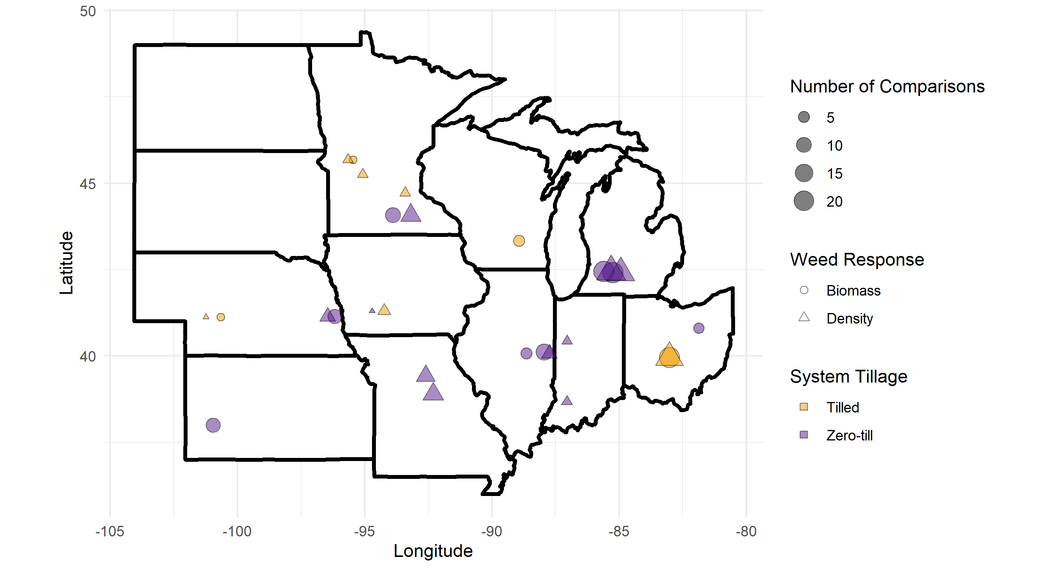
Figure 1 (rough draft). Our database comprised 15 published studies done in one of the 12 Corn Belt states that measured weed biomass or weed density in a winter cover cropped and no-cover treatment of maize or soybean; point shape indicates the weed response reported, point size the number of comparisons extracted from the study location, and point color the tillage classification of the study. No studies from North and South Dakota met our selection criteria.

Table 1. Management, experimental design, and site characteristics were extracted from each publication; weed biomass and weed density responses were separated into two separate datasets. The full database is available in Iowa State University’s DataShare repository (CITE).

Category | Factor | Biomass (n = 123) | Density (n = 119)
Management
System | Tillage | Tilled (n=30)  Zero-till (n=93) | Tilled (n=31)  Zero-till (n=88)
 | Time between cover crop termination and cash crop planting | -31 – 29 days | -31 – 13 days
Cover Crop | Type | Grass (n=46)  Non-grass (n=77)  Non-grass category includes brassicas (3), legumes (74) | Grass (n=31)  Non-grass (n=88)  Non-grass category includes brassicas (9), legumes (73), mixtures (6)
 | Planting date | Aug 15 – Oct 18 | Aug 15 – Oct 31
 | Planting density | 13.4 – 180 kg seed ha-1 | 9 – 135 kg seed ha-1
 | Termination date | April 18 – June 18 | April 18 – June 18
 | Termination method | Several methods (n = 3)  herbicides (n = 54)  mechanical (roller crimper, mowing; n = 29)  winterkill (n = 37) | Several methods (n = 3)  herbicides (n = 53)  mechanical (roller crimper, mowing; n = 22)  winterkill (n = 37)  none (n = 4)
 | Cover crop biomass at termination | 130 – 9003 kg ha-1 | 0 – 9003 kg ha-1
Cash crop | Subsequent crop | Maize (n=78)  Soybean (n=45) | Maize (n=73)  Soybean (n=42)  Averaged over maize and soybean phases† (n=4)
 | Cash crop planting date | April 20 – June 30 | April 27 – June 18
 | Corn yield | 40-13500 kg ha-1 | 40-11200 kg ha-1
 | Soybean yield | 300-3618 | 300-3310 kg ha-1
Site
 | State | Illinois (17)  Kansas (9)  Michigan (44)  Minnesota (12)  Nebraska (11)  Ohio (25)  Wisconsin (5) | Iowa (4)  Illinois (5)  Indiana (4)  Michigan (45)  Minnesota (16)  Missouri (18)  Nebraska (6)  Ohio (21)
 | Latitude | 38.0 - 45.7N | 38.7 - 45.7N
 | Longitude | 81.9 – 101W | 83.0 – 101W
 | Soil type | Loam (n = 46)  Sandy loam (n = 1)  Silt Loam (n = 67)  Silty Clay Loam (n = 9) | Loam (n = 59)  Silt Loam (n = 61)  Silty Clay Loam (n = 9)
 | Organic matter content | 1.5 - 4.15% | 1 – 3.4%
 | Aridity index* | 0.37 – 0.94 | 0.44 – 0.96
 | Publication year | 1993 - 2018 | 1993 - 2018
Experiment
Design | Number of replicates | 3 - 5 | 3 – 6
 | Type of weed(s) measured | Summer annual (86)  Winter annual (17)  Perennial (15)  Unknown (5) | Summer annual (75)  Winter annual (29)  Perennial (15)
 | Duration of experiment | 1-3 years (n=123)  4-5 years (n=0) | 1-3 years (n=115)  4-5 years (n=4)
Timing | Timing of weed measurement with respect to cash crop planting | Before (38)  After (119) | Before (38)  After (119)
 | Season of weed measurement** | Spring (January-June; n = 19)  Summer (June-September; n = 104)  Fall‡ (October – December; n = 4) | Spring (n = 36)  Summer (n = 79)
†The study (Mock et al. 2012) reported weed densities averaged over both phases, but did not report crop yields
‡This category was removed from analyses testing the significance of this modifier due to the small number of points representing the category
*an integrated measure of temperature, precipitation and potential evapotranspiration were derived from location coordinates using the CGIAR-CSI Global-Aridity and Global-PET databases (Zomer et al. 2008).
** Spring: January-June; Summer: June-September; Fall : September – December

One comparison resulted in an extremely low LRR due to a CC treatment weed biomass of 1 g m⁻² (SE = 1 g m⁻²) corresponding to a 99.9% reduction in weed biomass (Forcella 2013). This comparison was found to disproportionately influence results of the statistical models, and was therefore adjusted to equal the next highest reduction (97%) in weed biomass observed in the database.

3.2 Overall results
Overall, CCs significantly reduced weed biomass by a geometric mean of 51% (p=0.02), but the reduction in weed density was non-significant (p=0.98; supplementary material). The significant reduction in weed biomass was robust against publication bias; more than 3000 non-significant studies would need to have been performed but un-published to nullify the result (Rosenthral 1979). The leave-one-study-out analysis identified one study (Gieske et al. 2016) reporting only weed density that used a radish (Raphanus sativus) cover crop; removal of this study from the database drastically changed the p-value (lowered from 0.98 to 0.26). The significance of the reduction in weed biomass was robust against removal of each study (p-values ranging from 0.01-0.04). We found the cash crop following the cover crop (maize or soybean) had no effect on the measured response, meaning effects of the CC on weeds is not confounded by the differences in crop competition with weeds.
In the weed biomass database, the CC type significantly affected the amount of CC biomass produced (p = 0.01), with grass CCs producing a least-squared means estimated 3.95 Mg ha⁻¹ of biomass, compared to non-grass which produced 2.56 Mg ha⁻¹. Therefore, CC biomass was used as a covariate in the statistical model testing for differences in CC type with regard to suppression of weed biomass. No other modifier significantly affected the amount of CC biomass. The following categorical modifiers had levels with significantly different effects on weed biomass: measurement season (spring, summer), measurement in reference to cash crop planting (before, after), CC type (after controlling for CC biomass production; grass, non-grass), and weed growth habit (winter annual, summer annual, perennial). Weed biomass and density responded with the same patterns to these modifiers, but weed density responses were not significantly different for any factor levels (Fig. 2).

The different responses of weed biomass versus density to CCs provides insight into the mechanisms by which CCs suppress weeds in the Corn Belt. CC uptake of nitrogen creates a relatively nitrogen-free soil surface, and germination of certain weed seeds is suppressed under low nutrient soils (CITE). However, the lack of response of weed density indicates the low nutrient status is not inhibiting weed seed germination in Corn Belt weeds. It is possible inhibitory effects of the CCs on weed seed germination (low light, lower soil temperatures, smaller ranges in temperatures, lower soil nitrate concentrations, allelopathic chemicals) are balanced by stimulatory effects (increased soil moisture). Conversely, delay of weed seed germination along with reductions in light availability caused by CCs is consistent with our observations of lower weed biomass in cover crop treatments. Our results indicate that in the Corn Belt, CCs that compete with weeds for light will be most effective in suppressing weeds.

For weed biomass, grass CCs reduced weed biomass by 68% compared to only 33% for non-grass (p<0.01; Fig. 2). Measurements taken before cash crop planting showed a 74% reduction in weed biomass, compared to only 44% in measurements taken after planting (p<0.01). Winter annuals showed the strongest reductions (65%), followed by summer annuals (47%), with perennial weeds being unaffected by CCs. For continuous variables, weed suppression was significant affected by CC biomass for both weed biomass (after controlling for CC type, p<0.03; Fig. 3) and weed density (p<0.01).

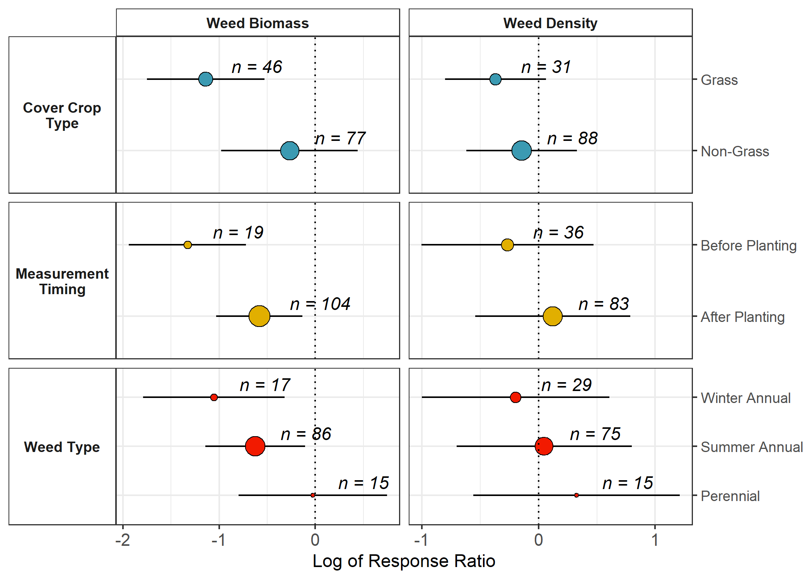
Figure 2 Significant categorical variables included cover crop type* (blue; grass, non-grass), when the weed measurement occurred (yellow; before cash crop planting, after), and the type of weed (red; winter or summer annual, perennial); values less than 1 indicate cover crops suppressed weeds, size of points and n value represent the number of observations used for the estimate, bars represent 95% confidence intervals.
*After controlling for the amount of cover crop biomass production

3.3 Cover crop management approaches

3.3.1 Cover crop type

Even after controlling for the effect of CC biomass, grass CCs offered more weed suppression compared to non-grass (Fig. 2). This may have consequences for balancing yield maintenance and weed suppression goals (Section 3.4). With regards to weeds, CC-induced control is a combination of physical and chemical suppression, and grasses such as rye may be more effective than legumes on both fronts (Creamer et al. 1996). The carbon-to-nitrogen ratio of grass CCs can be twice as high as legumes, with grass ratios increasing with higher overall biomass production (Quemada and Cabrera 1995)(Martinez-Feria et al. 2016). The higher carbon-to-nitrogen ratios of grass residue increase the residence time of the CC residue compared to legume residue, thus potentially suppressing weeds longer after CC termination (Teasdale and Mohler 1993)(Ruffo and Bollero 2003). Additionally, the structural arrangement of live grass plants could provide a larger amount of light interception per unit of live biomass compared to legumes (Andrew et al. 2015). Rye residue also exhibits an allopathic effect, which can inhibit weed seed germination and reduce weed biomass (Dhima et al. 2006; Teasdale et al. 2012). While brassica CCs may also suppress weeds via allelopathy (Haramoto and Gallandt 2005) only 9 of the 77 non-grass points were brassicas, and they did not exhibit significantly different suppressive effects compared to legumes (supplementary material).

3.3.2 Cover crop biomass

The largest management factors affecting CC-induced weed control were CC type and CC biomass at termination. There was no significant interaction, meaning weed biomass is negatively associated with CC biomass regardless of CC type. We found 5 Mg ha⁻¹ of biomass is predicted to reduce weed biomass by 75% for grass CCs, but only 40% for non-grass CCs (Fig. 3). This is within the range reported for Pennsylvania grain-production systems, which require 2-6 Mg ha-1 to achieve ‘significant’ weed suppression (Baraibar et al. 2018), as well as the estimate for north-eastern agriculture systems (Mirsky et al. 2013).
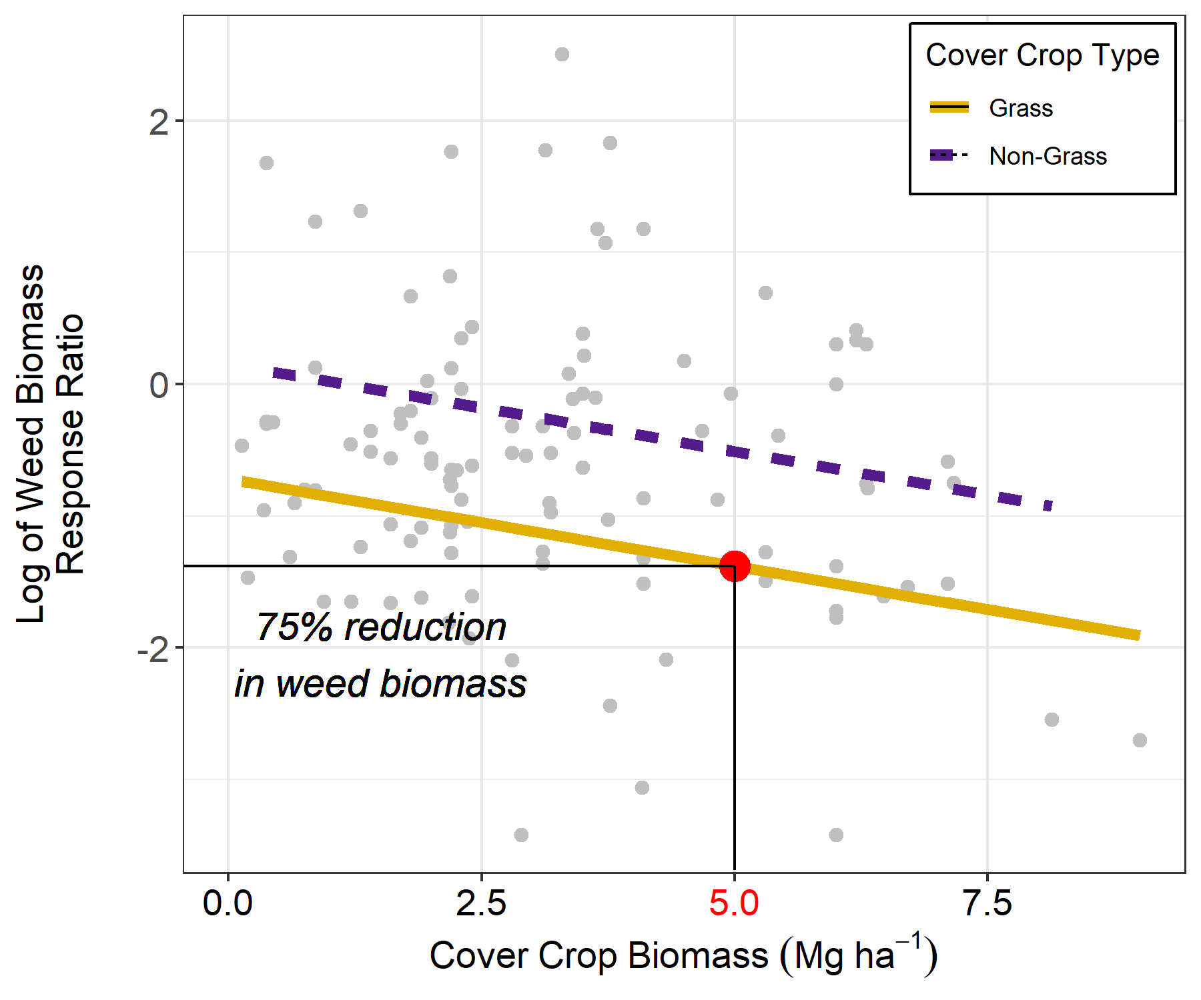
Figure 3 A 75% reduction in weed biomass required 5 Mg ha⁻¹ of grass cover crop biomass at termination.

In temperate regions, winter rye (Secale cereal L.) is consistently among the top biomass producers for winter CCs (Kaspar and Baker 2015, Appelgate 2017)(Ruis et al. 2019) but with averages still well under 2 Mg ha⁻¹. Our modelling results demonstrate achieving 5 Mg ha⁻¹ of rye CC biomass regularly under typical mid-western US production scenarios and climates would be challenging (Fig. 4). Even with optimistic CC planting dates of September 15, achieving 5 Mg ha-1 of CC biomass in the upper mid-west would require a mid-May or later termination date, which is well after typical cash crop planting dates.
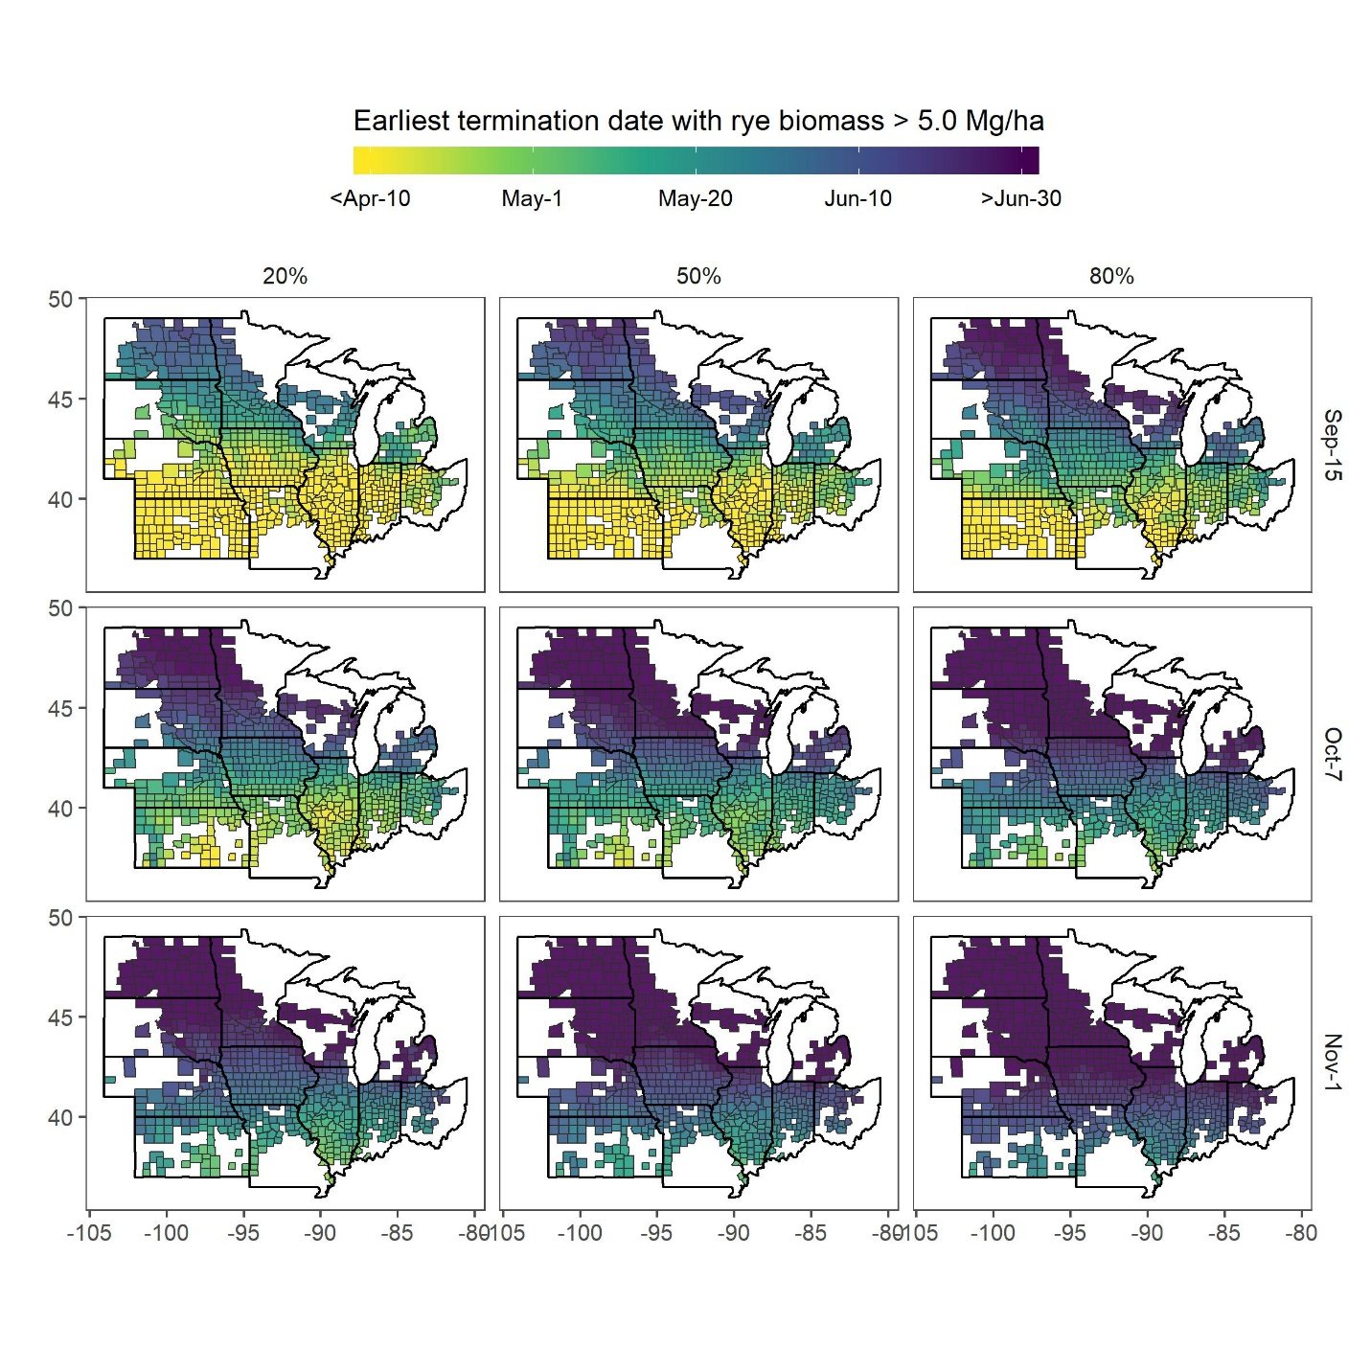
Figure 4 Probabilities of achieving 5 Mg ha⁻¹ rye (Secale cereal) biomass for a September 15, October 7, and November 1 planting date and given termination date; probabilities are based on 30 years of historical weather data using a process-based model SALUS (Rafa I need help with this label)

Delaying spring planting to maximize CC biomass will almost always result in a loss of cash crop yield (Bollero and Bullock 1994; Baum et al. 2019). In maize, terminating a rye CC at least a week before planting is crucial to preventing yield drag (Gailans et al. 2019). In soybean, however, allowing the CC to continue growing even after soybean planting has shown no significant effect on yields and has anecdotally improved weed control (cite PFI report). Unfortunately in some conservation districts producers are required to terminate CCs within a pre-defined window before cash crop planting to remain eligible for subsidized crop insurance (CITE), which limits use of delayed termination as a method to increase weed suppression services of CCs. Fertilization of CCs is also another tactic that may increase CC biomass, but would result in an additional cost to producers and may negate nutrient pollution mitigation services. Early fall planting may therefore be the best tactic for increasing weed suppression provided by CCs. Other ecosystem services of CCs are strongly related to CC biomass, including reduced nitrate leaching and erosion control, meaning increasing CC biomass may represent a multiple-win situation for environmental service. Research supporting CC planting equipment, breeding, and other agronomic innovations will be needed to optimize CC services such as weed control.

3.3.3 Tillage and termination method

Interestingly, in our database the tillage regime of the overall system had no effect on the weed suppression of the CC (supplemental table X). A previous meta-analysis found cash crop diversification significantly reduced weed density, and this effect was amplified in no-till systems (Weisberger et al. 2019). For CCs, which did not reduce weed density in our study, no-till offers no advantages with regard to weed control. This is likely because cash crop diversification and incorporation of CCs are affecting different phases of the weed cycle, exemplified by the fact that cash crop diversification affected only weed density, and CC incorporation only weed biomass.

The CC biomass was an important predictor for weed suppression in our analysis and previous studies (Mirsky et al. 2013; Baraibar et al. 2018). Because herbicide-based termination leaves CC biomass on the soil surface, it was surprising herbicide termination did not enhance CC-induced weed suppression. The lack of significance of termination method may indicate both allelopathy and physical interference with weed growth are both important components of CC weed suppression.

3.4 Tradeoffs in managing weeds and cash crop yields

Other meta-analyses have looked specifically at the effects of CCs on subsequent cash crop yields (Miguez and Bollero 2005; Marcillo and Miguez 2017), showing grass CCs have a neutral effect on yields, while mixes and legumes have positive effects. However, assessing whether there is a trade-off in managing CCs for weed control versus yield maintenance is a useful question. In our dataset, we had 71 comparisons for yield in CC and no-CC treatments. In our dataset, CCs had a borderline negative effect on yields (p=0.07), with a mean 27% reduction in cash crop yields. In our dataset, the type of CC did not significantly affect the yield response. Some yield comparisons had both weed biomass and density measurements, resulting in 109 comparisons where both a weed (biomass or density) and yield response to CCing were reported. Using this data, we found a no indication of a tradeoff between yield and weed control (Chi-square statistic = 1.78, p-value=0.18), with decreased cash crop yields being equally likely in scenarios with more or less weed pressure (supplementary material figure). Additionally, there was a borderline significant effect of CC biomass on yield response, with higher CC biomass being associated with less severe yield reductions (p = 0.09), again indicating that in our dataset better weed control from CCs did not correspond to higher yield penalties. While managing CCs for yield versus weed control may not be at odds, they may not be complimentary. In our database only 23% of the comparisons exhibited a ‘win-win’ situation, with a concomitant increase in cash crop yield and decrease in weed pressure (Fig. 4). Using a random forest model, we found no factors that were strong predictors of whether an observation would fall in the win-win category, suggesting maximizing cash crop yields and weed suppression may not have overlapping management strategies.

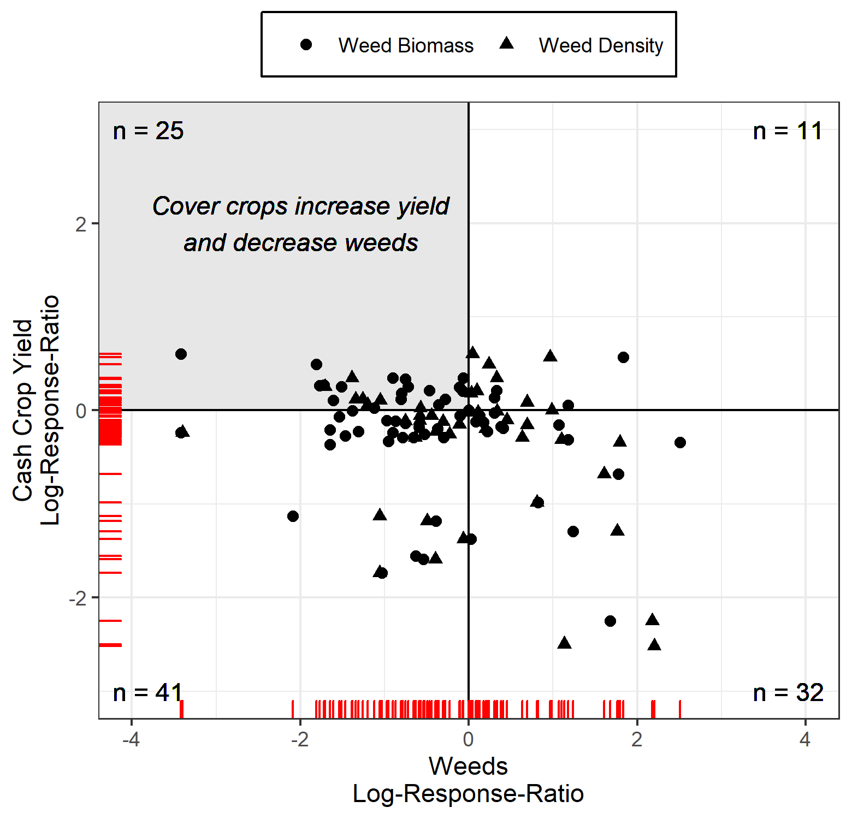
Figure 4 Comparisons where cover crops increased cash crop yields and reduced weed biomass (circles) or density (triangles) made up 23% of the points (gray quadrant), with yield decreases being equally as likely to be associated with an increase or decrease in weeds

Although we did not see a significant effect of CC type on yields, yield-focused studies with more comparisons found the species of CC is one of the most important management choices affecting CC services (Marcillo and Miguez 2017). This indicates choosing a CC species to maximize cash crop yields versus weed suppression may be at odds.

One concerning trend is the extremeness of the responses for decreased yield. While other meta-analyses have looked at average yield responses, the question of whether CCs can stabilize yields or expose producers to additional risks has not been directly addressed. Our database indicates that while CCs have a slightly negative effect on yields on average (p=0.07), yield decreases, when they do occur, are more severe than yield increases (Fig. 4). A caveat to these results is that weed researchers may not manage experiments to maximize yields. For example, if a CC produces poor weed control, a producer would likely respond with additional weed control tactics, while in a research setting one may allow the weeds to continue to grow in order to assess what effect they would have on yield if not controlled. This is an area that merits further research.
3.5 Environmental and experimental context

We found the context under which the trials were done (aridity index, soil type, soil OM) had no significant effect on the outcomes of the research (supplementary materials). In a global meta-analysis, Basche and DeLonge (2019) similarly found that soil type and climate were not significant moderators of the efficacy of CCs to increase water infiltration. Alternatively, this could simply reflect the lack of measurement/reporting, plot specific information, and large dependence on weather rather than meta-data such as climate (Gerstner et al. 2017; Eagle et al. 2017). However, our results suggest that, within the Corn Belt, the environmental context under which a cover crop is grown is less important in determining its efficacy to control weeds than management factors. This indicates CC weed research done within the contiguous Corn Belt is valid for maize and soybean systems grown throughout, so open knowledge sharing via organizations such as the Midwest CCs Council and University extension materials developed within this area may provide valuable recommendations for the entire region.

When designing CC experiments with regards to weeds, studies that measure weeds before cash crop planting may over-estimate the weed suppressive effects of CCs. Weeds measured after crop emergence are likely of more interest to producers, as they will have survived the stresses of CC termination, crop planting, and pre-emergent herbicide application, and thus may represent true resource competition with the cash crop.

4. Conclusions
Weed biomass and density responded similarly to CCs and their associated factors, with weed biomass responding more strongly. Independent of biomass production, grass species are the most effective at suppressing weeds. Grass CC biomass production of at least 5 Mg ha⁻¹ is needed to see a meaningful decrease in weed pressure. Reductions in weed density were likely less significant due to the short-term nature of the included studies, but this will require further research; long term (+5 years) studies are needed to better understand if repeated reductions in weed biomass from CC use can translate to reduced weed densities over time. Less than 25% of the comparisons had concomitant increases in yields and decreases in weeds with the use of CCs. In conclusion, CCs reduce weed biomass but this may not translate to increased yields. Sufficient CC-induced weed control to warrant substitution of traditional weed control strategies may be hard to achieve in typical Corn Belt production systems, and will require earlier planting and/or later termination than is typically afforded by cash crop harvest-to-planting intervals.

