1.What are the various elements of the Excel interface? **Describe how they're used?**

ANS1 **Also called a spreadsheet, the workbook is a unique file created by Excel.**

* Title bar. The title bar displays both the name of the application and the name of the spreadsheet.
* Menu bar. ...
* Column headings. ...
* Row headings. ...
* Name box. ...
* Formula bar. ...
* Cell. ...
* Navigation buttons and sheet tabs.
* **Toolbars, Ribbons and Tabs**
* The top of the Excel window includes three basic elements. The "Office" button in the upper left-hand corner contains some of the most common program commands, such as "Save" and "Print." Contextual tabs to the right of the "Office" button are labeled "Home," "Insert," "Page Layout," "Formulas," "Data," "Review," and "View." Each contextual tab includes a "Ribbon," which contains relevant commands. The ribbon on the "Home" tab, for example, includes basic commands for formatting; the ribbon on the "Insert" tab lets you put charts, tables and special objects into your spreadsheet.

## Name and Formula Boxes

The name box in the upper-left hand corner of the spreadsheet, just below the ribbon, indicates the cell where your cursor is located. When you open a spreadsheet, the default location will show "A1," for example. The formula box next to it displays the contents of the cell where your cursor is located. If cell A1, for example, contains the phrase "John Smith," the formula box will display the phrase "John Smith." If the cell contains a formula, even though the cell displays the formula's results, the formula box shows the formula itself.

## Rows and Columns

This is the heart of the spreadsheet, where the information is located. Columns are denoted by letters, A through XFD. Rows are referred to by numbers, 1 through 1,048,476. A cell is defined by the intersection of those two parts. For example, the intersection of the third row and second column would be defined as cell B3.

## Pages, Layout and Zoom

The lower left-hand corner of the spreadsheet includes tabs for each worksheet in the spreadsheet; the default spreadsheet includes three tabs, labeled "Sheet 1," "Sheet 2," and "Sheet 3." The lower right-hand corner of the spreadsheet contains three layout tabs, allowing you to display the worksheet in different formats, and a zoom slider that lets you magnify or reduce the size of the information on the worksheet.

* 2. Write down the various applications of Excel in the industry?.
* Data Entry and Storage
* Performing Calculations
* Data Analysis and Interpretation
* Reporting and Visualizations
* Accounting and Budgeting
* Collection and Verification of Business Data
* Calendars and Schedules
* Administrative and Managerial Duties
* Forecasting
* Automating Repetitive Tasks

3. On the ribbon, make a new tab. Add some different groups, insert commands in the groups and name them according to their commands added. Copy and paste the screenshot of the steps you followed?

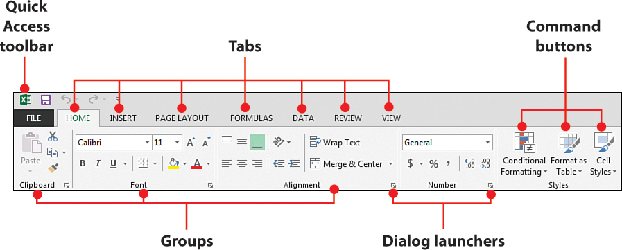

4. Make a list of different shortcut keys that are only connected to formatting with their functions.

1. CTRL+A=SELECT ALL
2. ALT+H+O+I=COLUMN WIDE
3. ALT+H+O+A=ROW WIDE
4. ALT+H+A+C=COLUMN WILL BE IN CENTER
5. ALT+H+M+M=MERGE AND CENTER
6. ALT+H+B+A=BORDER
7. ALT+H+H=COLOR CHANGE
8. ALT+H+O+R=RENAME
9. CTRL+SHIFT+_=REMOVE BORDERS
10. ALT+H+F+I+S=GENERATING THE LARGE SEQUENCE OF NUMBERS

5.What distinguishes Excel from other analytical tools?

* t builds the charts.
* It makes use of conditional formatting.
* It helps to organize the data.
* It will identify trends.
* It provides online access

**6. Create a table and add a custom header and footer to your table?**

