

**Excel Assignment - 12**

Dataset:

[https://docs.google.com/spreadsheets/d/1IRSEnmgz8Ro276GslknRNk0zlrB5CZH1YrnT71kqFM/edit?usp=sharing](https://docs.google.com/spreadsheets/d/1IRSEnmgz8Ro276-GslknRNk0zlrB5CZH1YrnT71kqFM/edit?usp=sharing)

Use the above dataset and answer the following questions.

1. What is the total amount of stationary bought from Madhya Pradesh?

Ans- 176971

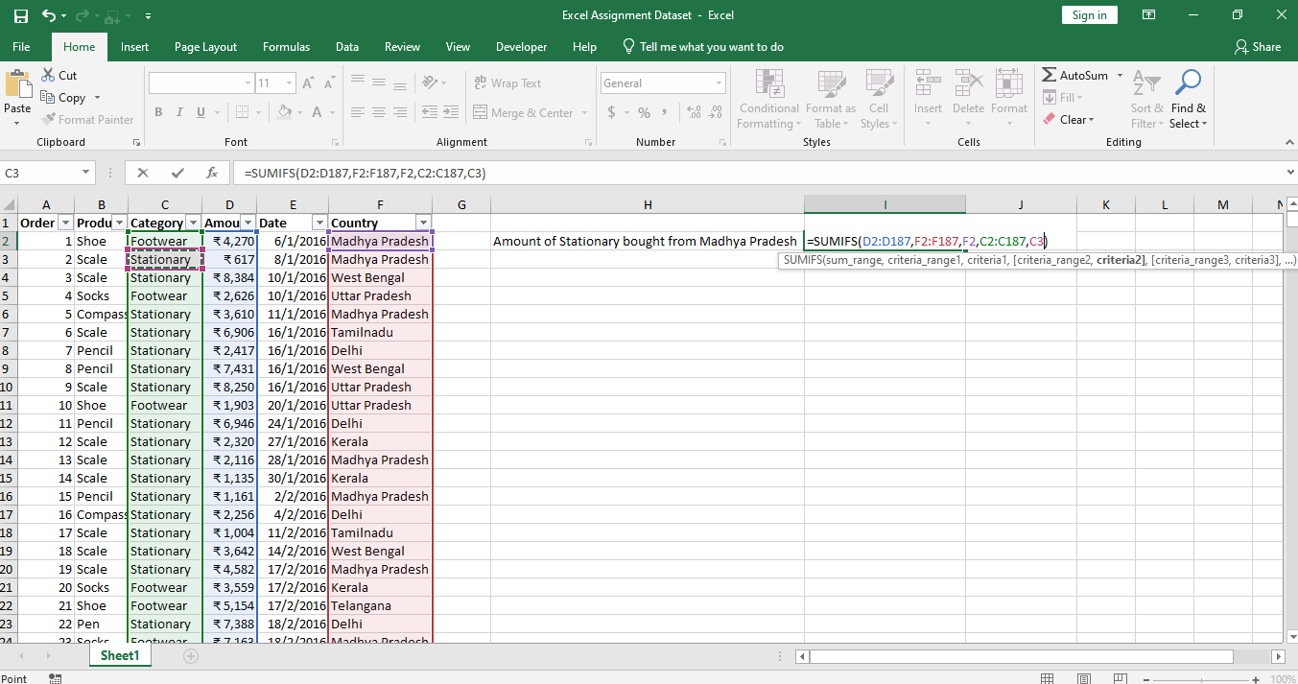

1. What is the total count of stationary bought from Tamil Nadu?

Ans-13

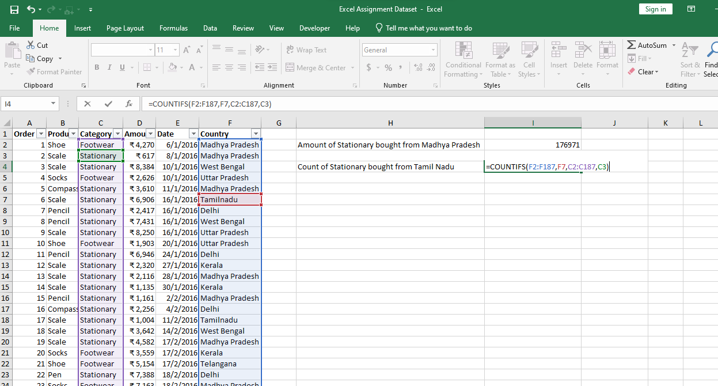

1. What is the total amount spent on footwear?

Ans- 194226

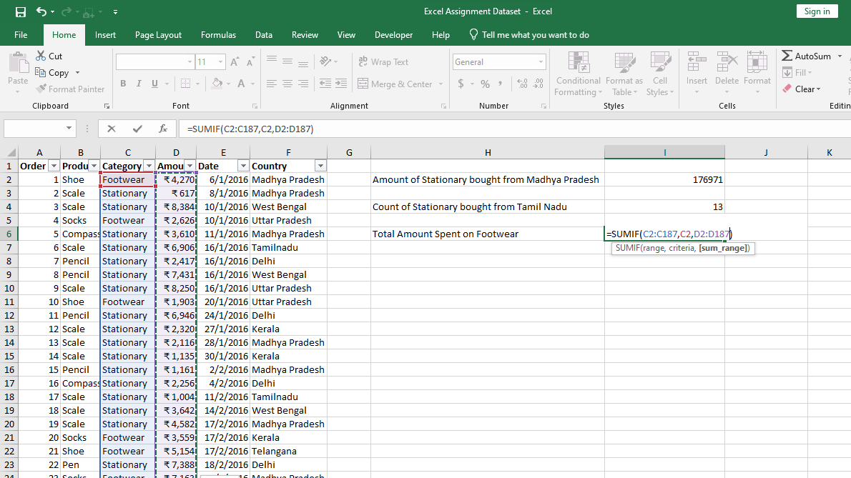

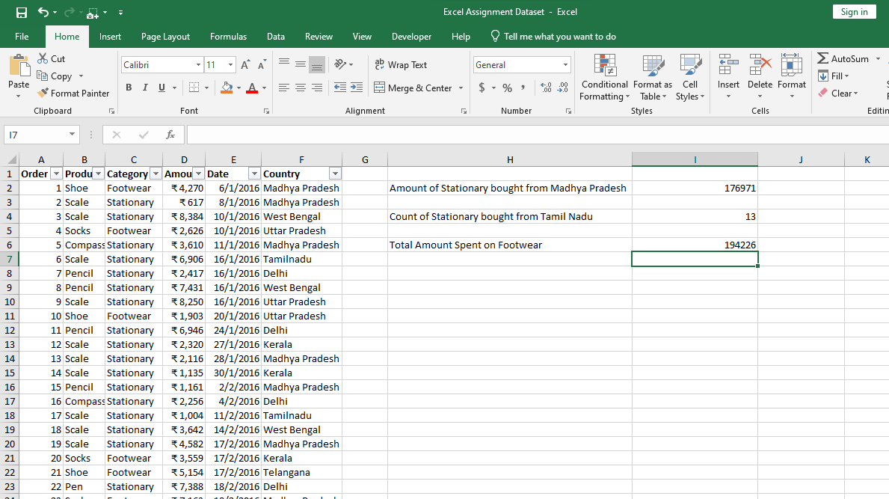

1. What is the total amount of money spent for stationary in July?

Ans- 53398

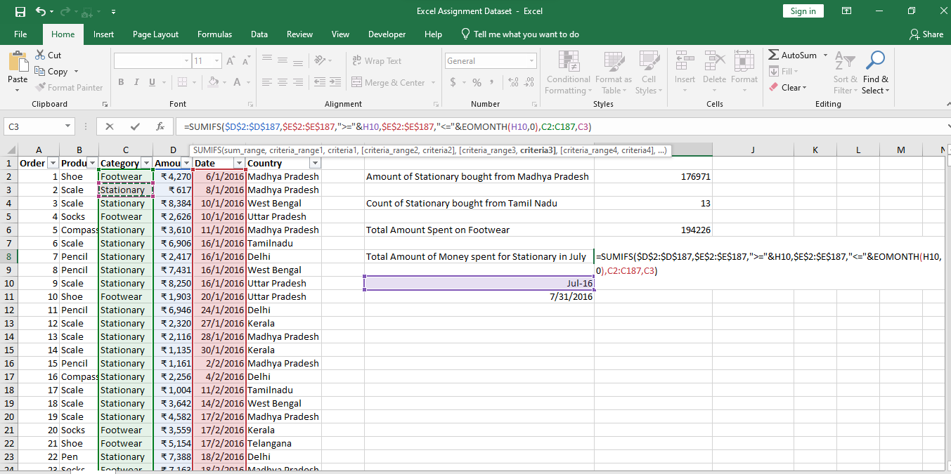

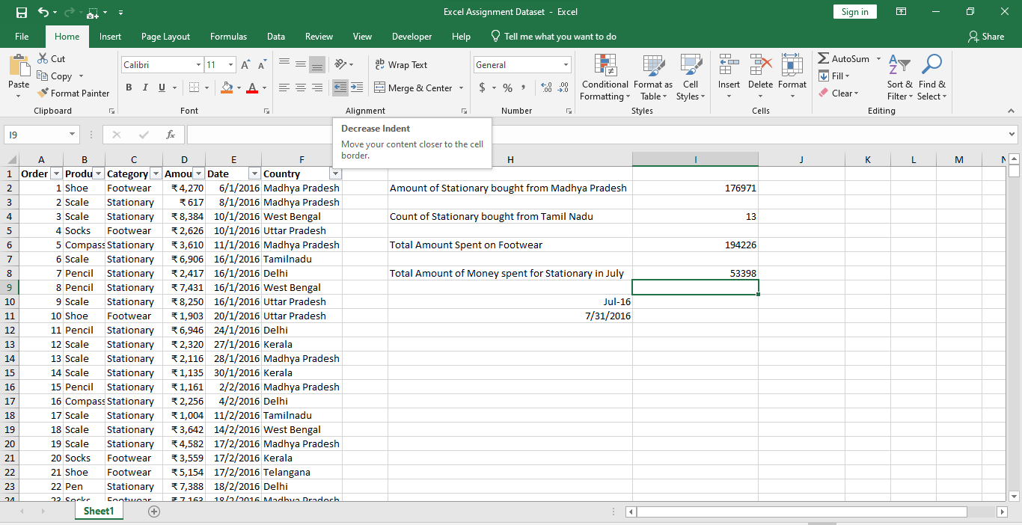

1. What is the count of footwear that is coming from Delhi?

Ans- 2

