

**Excel Assignment - 6**

1. What are the various elements of the Excel interface? Describe how they're used.

Ans- The Excel interface consists of various elements that help users navigate, input data, perform calculations, and visualize information effectively. Here's an overview of the main elements of the Excel interface and how they're used:  
  
**1. Ribbon:** The Ribbon is a graphical control element that contains tabs, groups, and commands. It provides access to various Excel features and functionalities organized into different tabs such as Home, Insert, Page Layout, Formulas, Data, Review, and View. Users can click on the tabs to access related commands and tools.

**2. Quick Access Toolbar (QAT):** The Quick Access Toolbar is located above the Ribbon and provides quick access to frequently used commands. Users can customize the QAT by adding or removing commands based on their preferences.

**3. Worksheet Area:** The Worksheet Area is the main area where users enter and manipulate data. It consists of a grid of cells organized into rows and columns. Users can enter text, numbers, formulas, and other data into cells to create worksheets and perform calculations.

**4. Formula Bar:** The Formula Bar is located above the Worksheet Area and displays the contents of the active cell. Users can enter or edit data, formulas, or text directly into the Formula Bar. It also displays the results of formulas when a cell containing a formula is selected.

**5. Name Box:** The Name Box is located next to the Formula Bar and displays the name or address of the active cell. Users can use the Name Box to navigate to specific cells or ranges by entering their names or addresses.

6. Column Headers: Column headers are located at the top of each column in the Worksheet Area and display letters (A, B, C, etc.) that represent column identifiers. Users can click on column headers to select entire columns or perform column-related actions.

**7. Row Headers:** Row headers are located on the left side of each row in the Worksheet Area and display numbers (1, 2, 3, etc.) that represent row identifiers. Users can click on row headers to select entire rows or perform row-related actions.

**8. Scroll Bars:** Scroll Bars are located on the right side and bottom of the Worksheet Area and allow users to scroll vertically or horizontally through large worksheets. Users can click and drag the scroll bars or use arrow buttons to navigate through the worksheet.

**9.Status Bar:** The Status Bar is located at the bottom of the Excel window and displays information about the current status of Excel, such as calculation mode, cell mode, and various notifications. Users can also customize the Status Bar to display additional information.

These are the main elements of the Excel interface that users interact with to create, edit, and analyze data in Excel worksheets. Each element serves a specific purpose and provides essential functionality to help users work efficiently with their data.

1. Write down the various applications of Excel in the industry.

Ans- Excel is widely used across various industries due to its versatility and robust features. Here are some common applications of Excel in different industries:  
  
1. **Finance and Accounting:** Excel is extensively used for financial modeling, budgeting, forecasting, financial analysis, and creating financial reports such as balance sheets, income statements, and cash flow statements. It's also used for accounting tasks such as tracking expenses, managing accounts payable and receivable, and preparing tax returns.

2**. Business Analysis:** Excel is used for analyzing business data, identifying trends, conducting SWOT analysis, performing market research, and making data-driven decisions. It's also used for creating business dashboards, KPI tracking, and performance monitoring.

3. **Sales and Marketing:** Excel is used for managing sales data, tracking leads and opportunities, creating sales forecasts, analyzing customer data, and evaluating marketing campaigns. It's also used for creating marketing budgets, tracking ROI, and generating sales reports.

4. **Human Resources:** Excel is used for managing employee data, tracking attendance, calculating payroll, creating employee schedules, and conducting HR analytics. It's also used for performance evaluations, employee training tracking, and workforce planning.

5. **Project Management:** Excel is used for creating project plans, tracking project tasks, managing project timelines, and analyzing project performance. It's also used for resource allocation, risk management, and project budgeting.

6. **Operations and Supply Chain Management:** Excel is used for inventory management, demand forecasting, supply chain optimization, logistics planning, and production scheduling. It's also used for analyzing supply chain data, vendor management, and procurement analysis.

7. **Education and Research:** Excel is used by educators and researchers for data analysis, statistical analysis, creating charts and graphs, and conducting experiments. It's also used for grading, student attendance tracking, and creating educational materials.

8. **Healthcare:** Excel is used for managing patient records, tracking medical expenses, analyzing healthcare data, and conducting medical research. It's also used for inventory management in healthcare facilities and analyzing clinical trial data.

9. **Real Estate:** Excel is used for property valuation, financial analysis of real estate investments, mortgage calculations, and property management. It's also used for tracking rental income, managing property listings, and analyzing market trends.

10. **Engineering and Manufacturing:** Excel is used for engineering calculations, product design, quality control, inventory tracking, and production planning. It's also used for analyzing manufacturing data, optimizing processes, and managing supply chain operations.

These are just a few examples of the diverse applications of Excel across different industries. Its flexibility and ease of use make it a valuable tool for a wide range of tasks and functions in various professional settings.

1. On the ribbon, make a new tab. Add some different groups, insert commands in the groups and name them according to their commands added. Copy and paste the screenshot of the steps you followed.

Ans- Steps followed are as follows-

1. **Open Excel:** Launch Microsoft Excel on your computer.

2. **Customize the Ribbon:** Right-click anywhere on the Ribbon and select "Customize the Ribbon..."  
This will open the Excel Options dialog box.

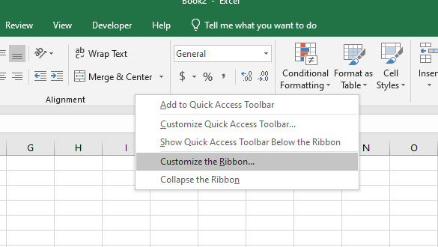

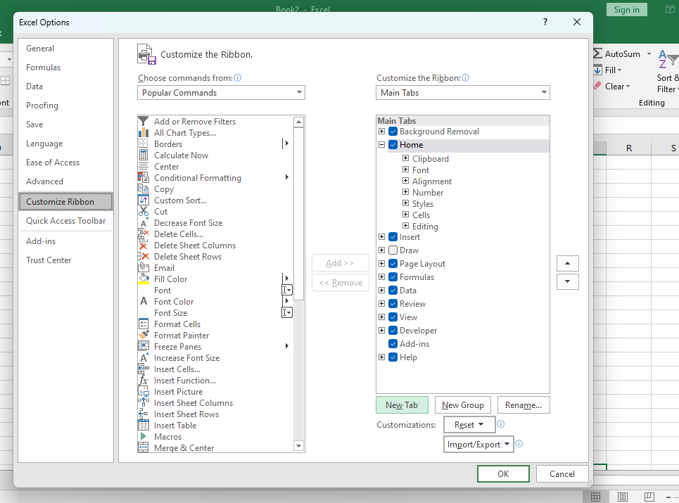

1. **Create a New Tab:** In the Excel Options dialog box, click on the "New Tab" button to create a new tab on the Ribbon. Rename the new tab to your desired name by selecting it and clicking the "Rename" button.

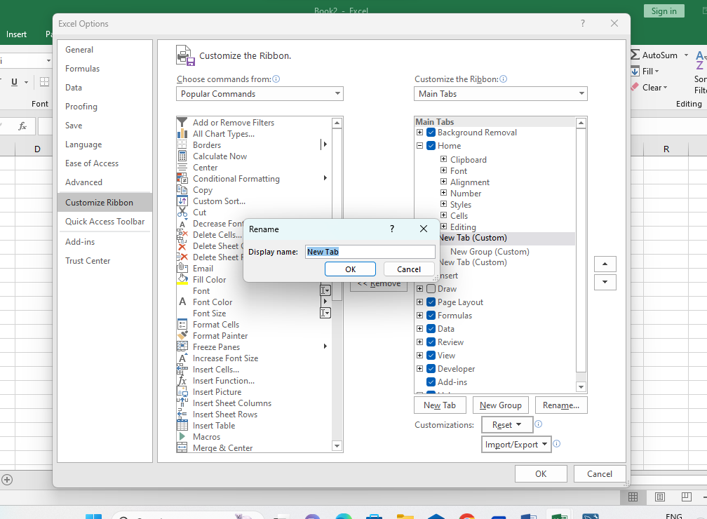

4.**Add Groups:** With the new tab selected, click on the "New Group" button to create new groups within the tab.You can rename each group by selecting it and clicking the "Rename" button.

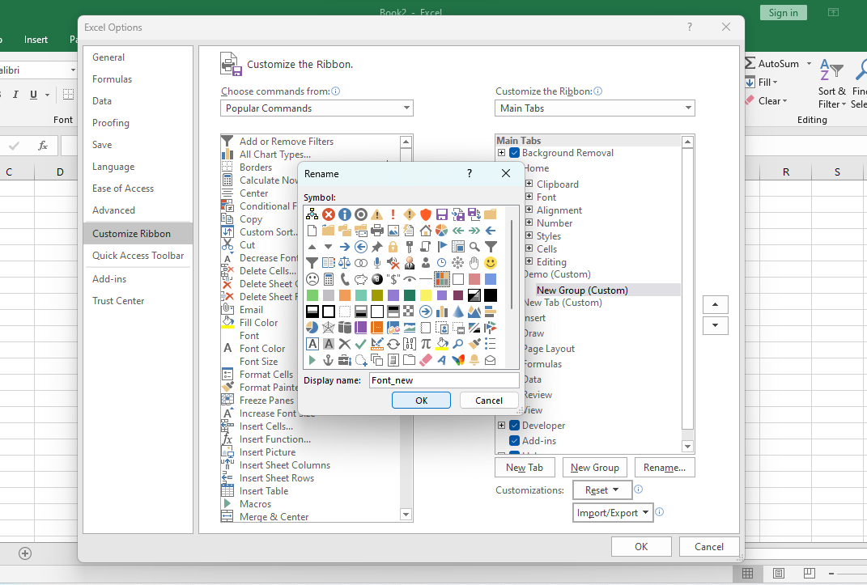

5**.Insert Commands:** With each group selected, click on the commands listed on the left side of the Excel Options dialog box to add them to the group.  
You can also use the "Choose commands from" dropdown menu to explore different categories of commands.

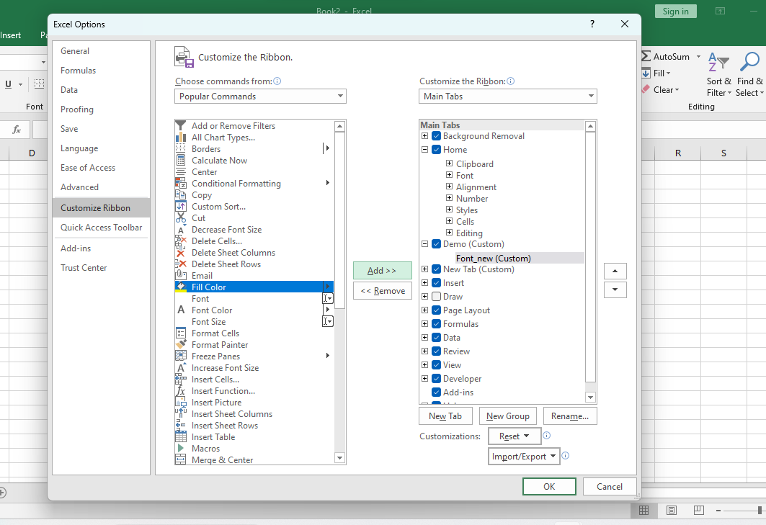

6. **Organize Commands**: Arrange the commands within each group by selecting them and using the up and down arrows to move them.

7.**Click OK:** Once you have added groups and commands as desired, click "OK" to apply the changes and close the Excel Options dialog box.

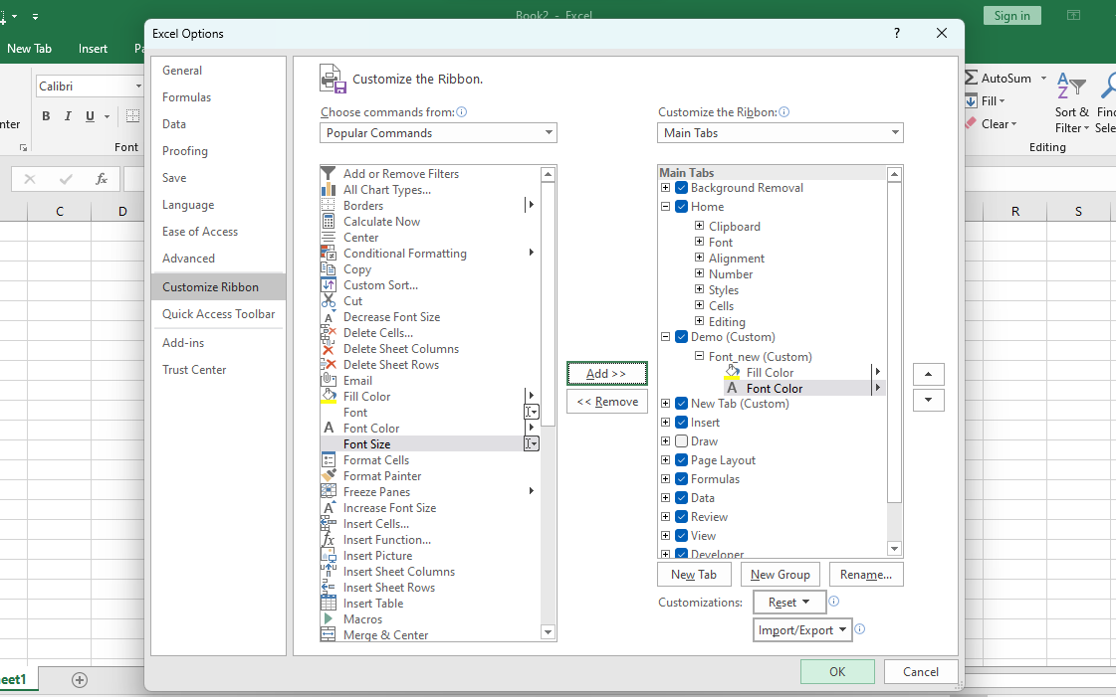

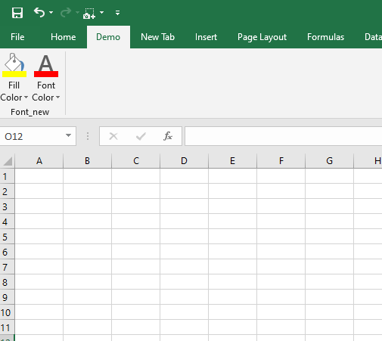

1. Make a list of different shortcut keys that are only connected to formatting with their functions.

Ans- List of different shortcut keys specifically connected to formatting in Excel, along with their functions and brief explanations:  
  
1. Ctrl + B: Bold  
Applies or removes bold formatting from the selected text.

2. Ctrl + I: Italic  
Applies or removes italic formatting from the selected text.

3. Ctrl + U: Underline  
Applies or removes underline formatting from the selected text.

4. Ctrl + 1: Format Cells dialog box  
Opens the Format Cells dialog box, allowing you to apply various formatting options to cells, including number, alignment, font, border, fill, and protection settings.

5. Ctrl + Shift + $: Currency format  
Applies the Currency format to the selected cells, displaying numbers with a currency symbol and two decimal places.

6. Ctrl + Shift + %: Percentage format  
Applies the Percentage format to the selected cells, multiplying the cell value by 100 and displaying it with a percentage symbol.

7. Ctrl + Shift + !: Comma format  
Applies the Comma format to the selected cells, displaying numbers with a thousands separator and two decimal places.

8. Ctrl + Shift + &: Apply outline border  
Applies an outline border to the selected cells.

9. Ctrl + Shift + _ (underscore): Remove outline border  
Removes the outline border from the selected cells.

10. Ctrl + Shift + + (plus): Insert  
Inserts cells, rows, or columns depending on the selection.

11. Ctrl + Shift + - (minus): Delete  
Deletes cells, rows, or columns depending on the selection.

12. Alt + H, H: Merge & Center  
Merges the selected cells and centers the content horizontally within the merged cell.

13. Alt + H, B, A: Add or remove cell borders  
Opens the Borders dropdown menu, allowing you to add or remove various border styles from the selected cells.

14. Alt + H, O, I: Format Painter  
Copies formatting from one cell or range and applies it to another cell or range.

15. Alt + H, O, W: Wrap Text  
Wraps text within a cell, allowing it to display on multiple lines within the cell.

16. Alt + H, H, C, S: Conditional Formatting  
Opens the Conditional Formatting menu, allowing you to apply formatting based on specific conditions.

17. Alt + H, F, P: Font color  
Opens the Font Color dropdown menu, allowing you to select a color for the font.

18. Alt + H, A, A, A: Clear All  
Clears all formatting, contents, and comments from the selected cells.

These shortcuts provide quick and efficient ways to apply various formatting options in Excel, enhancing productivity and ease of use when working with spreadsheets.

1. What distinguishes Excel from other analytical tools?

Ans- Excel stands out from other analytical tools in several ways:  
  
1**. User-Friendly Interface:** Excel offers a familiar spreadsheet interface that is widely used and understood by business professionals. Its interface is intuitive and requires minimal training for users to start analyzing data.

2. **Versatility:** Excel is a versatile tool that can handle a wide range of tasks, including data entry, analysis, visualization, and reporting. Users can perform complex calculations, create charts and graphs, and generate reports within the same application.

3. **Accessibility:** Excel is widely available and accessible across various platforms, including desktop computers, laptops, tablets, and smartphones. It is also supported by multiple operating systems, ensuring that users can access their data anytime, anywhere.

4. **Built-In Functions and Formulas:** Excel offers a vast library of built-in functions and formulas that enable users to perform a wide range of calculations and analyses. These functions cover mathematical, statistical, financial, and logical operations, among others, making it a powerful analytical tool.

5. **Integration with Other Microsoft Products:** Excel seamlessly integrates with other Microsoft Office products, such as Word, PowerPoint, and Outlook. This integration allows users to import and export data between applications, enhancing productivity and collaboration.

6. **Customization:** Excel allows users to customize their analytical workflows by creating custom templates, macros, and add-ins. This level of customization enables users to streamline repetitive tasks, automate processes, and tailor Excel to their specific analytical needs.

7. **Wide Adoption and Support:** Excel is widely adopted in business, education, and personal use, making it easy to find support, tutorials, and resources online. Users can leverage a vast community of Excel users and experts for help and guidance.

1. Create a table and add a custom header and footer to your table.

Ans- Steps involved in adding header and footer are:

1. **Create a Table:**  
  
a) Enter your data into Excel in a tabular format.

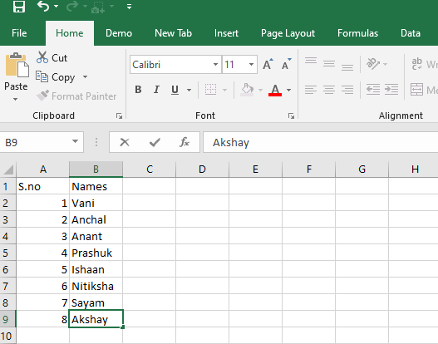

b) Select the range of cells containing your data.

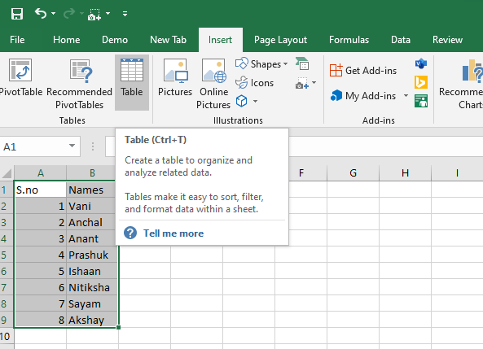

c) Go to the "Insert" tab in the Ribbon.  
d) Click on the "Table" command.

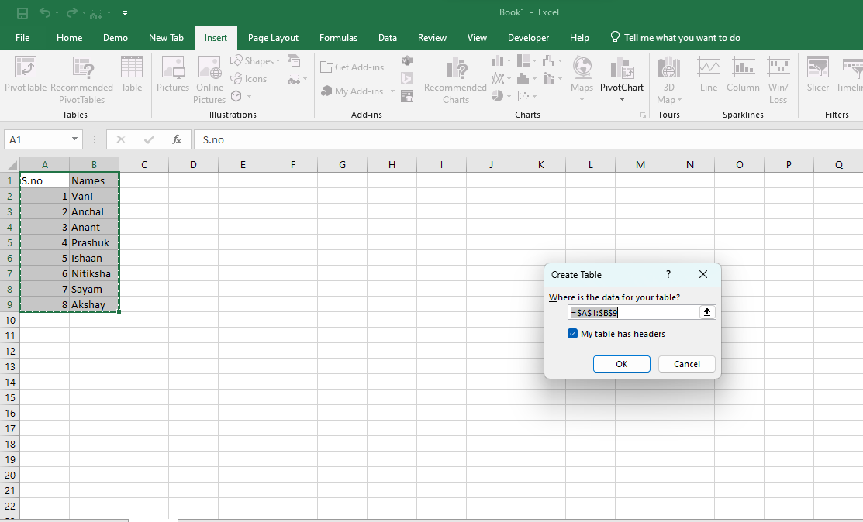  
e) Click "OK" to create the table.

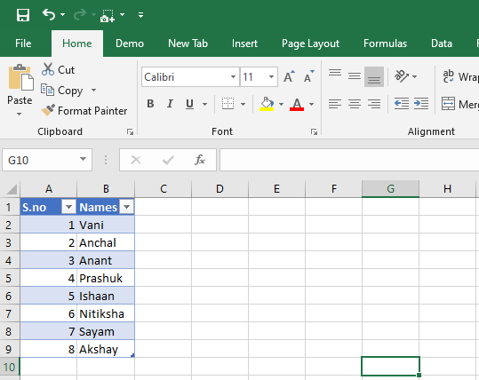

2. **Add Custom Header and Footer:**  
  
a) Click on any cell within the table to select it.  
b) Go to the "View" tab in the Ribbon.

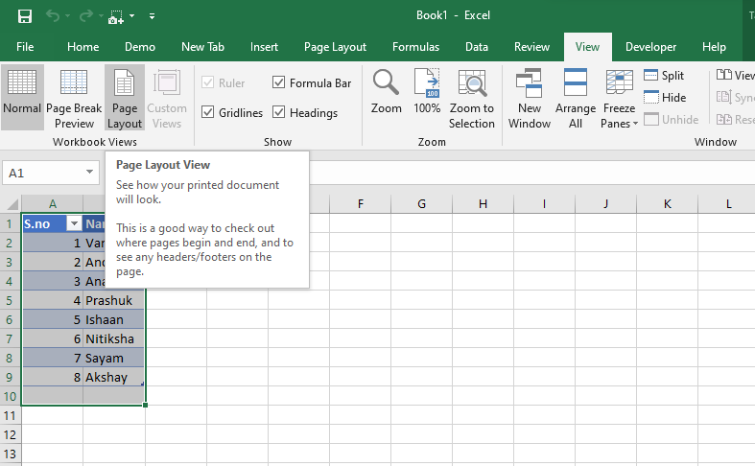  
c) In the "Workbook Views" group, click on "Page Layout" view.  
d) This will switch your view to the Page Layout view, where you can see the header and footer sections at the top and bottom of the worksheet.

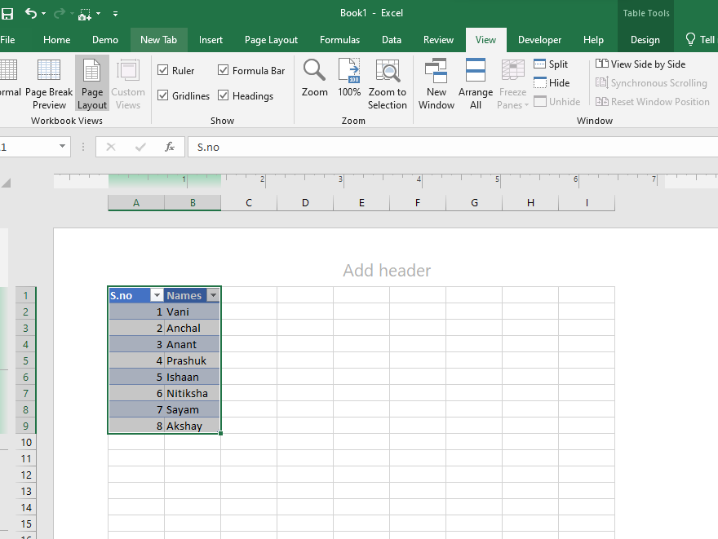

3. **Enter Custom Text:**  
  
a) Click on the header section at the top of the worksheet and enter your custom header text.  
b) Similarly, click on the footer section at the bottom of the worksheet and enter your custom footer text.