

**Excel Assignment - 8**

1.What do you mean by AutoComplete feature in Excel and what are the benefits of using this feature?

Ans- The AutoComplete feature in Excel helps users enter data more efficiently by automatically suggesting and completing entries based on previously entered values in the same column or row. When a user begins typing in a cell, Excel analyzes the existing data nearby and displays a drop-down list with matching entries. This list can include previously entered text, numbers, dates, or formulas.

Benefits of using the AutoComplete feature in Excel include:

**Time-Saving:** AutoComplete saves time by reducing the need to retype similar or repetitive data. Users can quickly select from the suggested options instead of manually entering each value.  
**Accuracy:** By suggesting previously entered values, AutoComplete helps ensure consistency and accuracy in data entry. This minimizes the risk of typographical errors or inconsistencies in data.  
**Efficiency:** The feature improves workflow efficiency by streamlining data entry processes. Users can quickly populate cells with relevant data without interruption or unnecessary keystrokes.

**Ease of Use:** AutoComplete enhances the user experience by providing a convenient and intuitive way to input data. Users can leverage the suggested options with minimal effort, even if they have a large dataset.

**Customization:** Excel allows users to customize AutoComplete settings to suit their preferences. Users can enable or disable the feature, adjust the number of suggestions displayed, or clear the AutoComplete list as needed.

Overall, the AutoComplete feature in Excel enhances productivity, accuracy, and user experience by providing intelligent suggestions and automating repetitive data entry tasks. It is a valuable tool for users working with large datasets or performing frequent data entry operations.  
 

2.Explain working with workbooks and working with cells.

Ans-

**Working with Workbooks:**  
  
**Definition:** Workbooks are Excel files that contain one or more worksheets where users can input and manipulate data.  
**Actions:** Creating a Workbook: Start a new workbook by selecting "Blank Workbook" or choose from various templates.  
**Opening a Workbook:** Access existing workbooks from the File tab or recent documents list.  
**Saving a Workbook:** Save your workbook with a specific name and location to preserve changes.  
**Navigating between Sheets**: Move between different worksheets within the same workbook.  
**Closing a Workbook:** Close the workbook to exit Excel or open a new one.

**Working with Cells:**  
  
**Definition:** Cells are individual boxes in Excel where data can be entered, stored, and manipulated.  
**Actions:** Entering Data: Input text, numbers, dates, or formulas directly into cells.  
**Selecting Cells:** Click on a cell to select it individually or drag to select a range of cells.  
**Editing Cells:** Double-click on a cell to enter edit mode or use the formula bar to edit content.  
**Formatting Cells:** Change the appearance of cells, including font, color, alignment, and borders.  
**Applying Formulas:** Use built-in functions and formulas to perform calculations or manipulate data within cells.  
**Copying and Pasting:** Copy content from one cell or range and paste it into another to duplicate data.  
**Moving Cells:** Cut and paste cells to rearrange data within a worksheet or between worksheets.  
**Filling Cells:** Use autofill or drag fill handle to quickly populate cells with sequential data or patterns.

1. What is fill handle in Excel and why do we use it?

Ans- The fill handle in Excel is a small square located at the bottom-right corner of a selected cell or range of cells. It is used to quickly and easily fill adjacent cells with data, formulas, or patterns.  
  
Here's why we use the fill handle:  
  
**1. AutoFill Series:** The fill handle allows users to create a series of data, such as numbers, dates, or text, by dragging the fill handle across adjacent cells. Excel automatically increments or adjusts the series based on the pattern detected.  
**2. Copy Formulas:** Users can copy formulas from one cell to adjacent cells by dragging the fill handle. Excel adjusts the cell references in the formula relative to the position of the new cells, ensuring that calculations are applied correctly.  
**3. Accelerate Data Entry:** Instead of typing the same value or formula repeatedly in multiple cells, users can use the fill handle to quickly populate adjacent cells with the same content.  
**4. Maintain Consistency:** By using the fill handle, users can maintain consistency in data entry and formulas across a range of cells. This reduces the risk of errors and ensures accuracy in calculations.  
**5. Efficiency:** The fill handle provides a fast and efficient way to populate cells with data or formulas, saving time and effort in data entry tasks.

Overall, the fill handle in Excel is a versatile tool that simplifies data entry, accelerates workflow, and helps maintain consistency and accuracy in worksheets..

1. Give some examples of using the fill handle.

Ans- Fill Handle in excel is used for filling up the data by creating a series of value which either follow a pattern or we can check if the values we entered are of series or not. It is very easy to implement. Fill Handle is available at the right bottom of any cell. Enter some values such as number or alphabets or dates in at least 3 cells to have a pattern. Select the cells with values and then either drag the Fill Handle or double click will also work here.

Here are some examples of using the fill handle in Excel:

**1. AutoFill Series:**

a) Fill a series of numbers: Type "1" in a cell, then drag the fill handle down to quickly fill the adjacent cells with the sequence of numbers (2, 3, 4, etc.).

b) Fill a series of dates: Enter a date (e.g., January 1, 2024) into a cell, then drag the fill handle across to automatically populate the adjacent cells with the following dates in the sequence.

**2. Copy Formulas:**

a) Copy a formula horizontally or vertically: Enter a formula (e.g., =A1+B1) into a cell, then drag the fill handle to copy the formula to adjacent cells. Excel automatically adjusts the cell references in the formula.

b) Fill a series using formulas: Enter a formula (e.g., =A1*2) into a cell, then drag the fill handle to fill adjacent cells with the results of the formula applied to each cell's respective value in column A.

c) Generate Patterns: Fill a repeating pattern: Enter a pattern (e.g., "Yes", "No") into two adjacent cells, then drag the fill handle down to quickly repeat the pattern in the adjacent cells.

d) Fill custom patterns: Enter a custom pattern (e.g., "Monday", "Tuesday") into two adjacent cells, then drag the fill handle to extend the pattern horizontally or vertically.

**3. Quick Data Entry:**

a) Fill a single value: Enter a value (e.g., "Total") into a cell, then drag the fill handle to quickly populate adjacent cells with the same value.

b) Fill a series of text: Type "Item 1" into a cell, then drag the fill handle to fill adjacent cells with a series of text (e.g., "Item 2", "Item 3", etc.).

c) Custom Lists: Create a custom list: Type a list of items (e.g., "January", "February", "March") into cells, then drag the fill handle to extend the list and quickly populate adjacent cells with the same sequence of items.

These examples demonstrate how the fill handle in Excel can be used to efficiently populate cells with data, formulas, or patterns, simplifying various tasks in spreadsheet creation and manipulation.

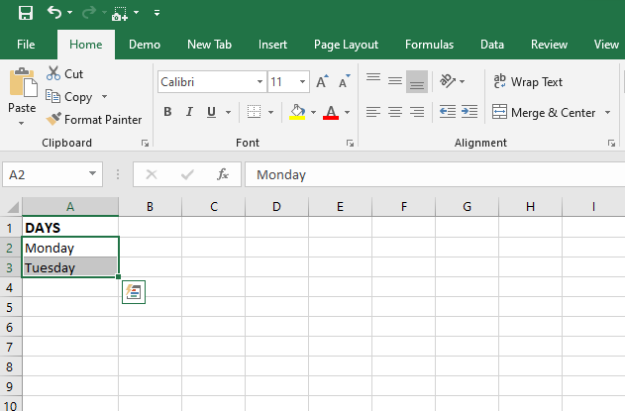

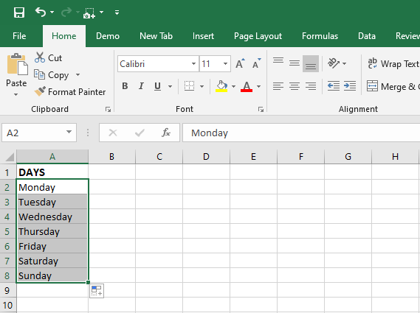

5.Describe flash fill and what the different ways to access the flash fill are.

Ans- Flash Fill is a feature in Excel that automatically fills in values in a column based on patterns or examples provided by the user. It analyzes the data entered in one column and attempts to recognize a pattern, then fills in the adjacent column(s) with corresponding data based on that pattern.  
  
Here's how Flash Fill works:

**Example-Based Filling:** Flash Fill uses the data entered in one column as an example to recognize patterns. Once it identifies a pattern, it applies that pattern to automatically fill in the adjacent column(s).  
**Automatic Detection:** Flash Fill automatically detects patterns in the data, such as splitting text into different parts, combining information from multiple columns, extracting specific elements from text, or formatting data in a consistent way.

**Dynamic Updating:** Flash Fill dynamically updates as you make changes to the source data or adjust the pattern. If you change the data in the source column, Flash Fill will update the filled values accordingly.

Ways to Access Flash Fill:

Automatic Trigger: In many cases, Flash Fill is automatically triggered when Excel detects a recognizable pattern in the data you are entering. It will display a preview of the suggested fill in adjacent cells, and you can press Enter to accept the suggestion.

Using the Ribbon:

1. Go to the "Data" tab in the Ribbon.
2. Click on the "Flash Fill" button in the "Data Tools" group.
3. Excel will automatically attempt to fill in the adjacent column(s) based on the pattern detected in the source column.

Using the Keyboard Shortcut:

a) After entering data in the source column, press Ctrl + E (Windows) or Command + E (Mac) to trigger Flash Fill.

b) Excel will attempt to fill in the adjacent column(s) based on the pattern detected in the source column.

Using the Context Menu:

a) Right-click on the first cell in the column where you want to apply Flash Fill.  
b) From the context menu, select "Flash Fill" to trigger the feature.  
c) Excel will attempt to fill in the adjacent column(s) based on the pattern detected in the source column.

These different methods provide flexibility in accessing Flash Fill, allowing users to choose the most convenient way to apply the feature based on their preferences and workflow.

6.Extract first name and last name from the mail id and then from the address column, extract the city, state, and pin code using the flash fill. Given below is an example of the columns you have to create. Paste the screenshot of what you have created using the flash fill command.

Example: Mail Id, Address, First name, Last name, State, City, Pincode

Ans- **Extracting First Name and Last Name from Email Id:**

1. Assuming the email id is in the "Mail Id" column, create two new columns titled "First Name" and "Last Name".

2. In the "First Name" column, manually enter the first name from the email id or use text functions like LEFT, MID, or FIND to extract the first name.  
3. In the "Last Name" column, manually enter the last name from the email id or use text functions like RIGHT, MID, or FIND to extract the last name.  
4. Once you have entered the first name and last name for one or two rows, Excel may automatically detect the pattern and suggest filling the remaining cells using Flash Fill. If not, you can manually trigger Flash Fill as described in the previous response.

**Extracting City, State, and Pin Code from Address:**

1. Assuming the address is in the "Address" column, create three new columns titled "City", "State", and "Pincode".

2.Manually enter the city, state, and pin code for one or two rows from the address column.  
Once you have entered the data for a few rows, Excel may automatically detect the pattern and suggest filling the remaining cells using Flash Fill. If not, you can manually trigger Flash Fill.

To use Flash Fill manually, you can follow these steps:

1.Select the first cell in the column where you want to apply Flash Fill.  
2.Go to the "Data" tab in the Ribbon.

3. Click on the "Flash Fill" button in the "Data Tools" group.  
4. Excel will attempt to fill in the adjacent cells based on the pattern detected in the source column.

