

**Excel Assignment - 9**

1. What are the different margins options and do we adjust the margins of the excel worksheet?

Ans- In Excel, you can adjust the margins when printing a worksheet, but there are no built-in margin options for the worksheet itself within the Excel interface. Instead, margins are adjusted as part of the printing settings.  
  
When printing a worksheet in Excel, you can adjust the following margin options:  
  
**Top Margin:** The distance between the top edge of the paper and the content on the printed page.  
**Bottom Margin:** The distance between the bottom edge of the paper and the content on the printed page.  
**Left Margin:** The distance between the left edge of the paper and the content on the printed page.  
**Right Margin:** The distance between the right edge of the paper and the content on the printed page.  
**Header Margin:** The distance between the top edge of the paper and the header content on the printed page.  
**Footer Margin:** The distance between the bottom edge of the paper and the footer content on the printed page.

Adjusting margins in Excel is useful for controlling the layout and appearance of printed worksheets. By adjusting the margins, you can ensure that content is properly aligned and fits within the printable area of the page when printing from Excel.

1. Set a background for your table created.

Ans- **Add a sheet background**

1. Click the worksheet that you want to display with a sheet background. Make sure that only one worksheet is selected.
2. On the Page Layout tab, in the Page Setup group, click Background.
3. Select the picture that you want to use for the sheet background, and then click Insert.

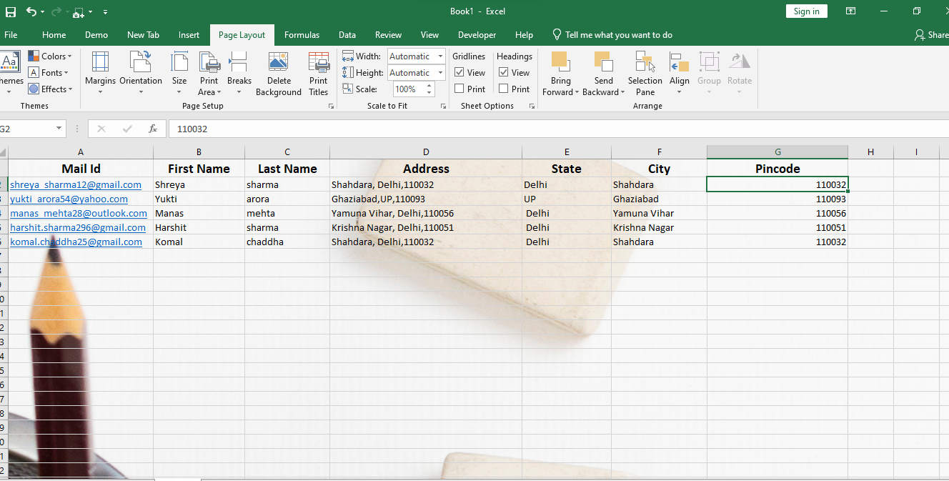

1. What is freeze panes and why do we use freeze panes? Give examples.

Ans- Freeze Panes is a feature in Excel that allows you to lock rows and/or columns in place so that they remain visible while scrolling through a worksheet. When you freeze panes, the frozen rows and/or columns stay visible at the top or left side of the worksheet, while the rest of the sheet scrolls normally.  
  
We use Freeze Panes to keep certain rows or columns visible while working with large datasets, making it easier to understand the data and maintain context.

Here are some examples of when you might use Freeze Panes:  
  
1**. Headers:** Freeze Panes is commonly used to keep headers (column titles) visible while scrolling through a large dataset. This ensures that you always know what each column represents, even as you navigate through a long list of data.  
  
Example: If you have a spreadsheet with sales data and you want to keep the column headers ("Date", "Product", "Price", etc.) visible while scrolling through the sales transactions.

**2. Totals:** Freeze Panes can be used to keep summary rows or columns visible while viewing detailed data. This allows you to see totals, subtotals, or other important summary information while analyzing individual records.  
  
Example: If you have a budget spreadsheet with monthly expenses and you want to keep the total expenses visible at the bottom while reviewing individual transactions.

**3. Comparisons:** Freeze Panes can help when comparing different sections of a large dataset. By freezing rows or columns that contain key reference points, you can easily compare data in one part of the worksheet with data in another part.  
  
Example: If you have a large table with monthly sales data and you want to compare the sales figures for different products or regions, you can freeze the row or column that contains the product names or region names.

1. What are the different features available within the Freeze Panes command?

Ans- Within the Freeze Panes command in Excel, there are three main options available:  
  
1. **Freeze Panes:**  
  
a) This option allows you to freeze both rows above and columns to the left of the selected cell. It locks both rows and columns, keeping them visible as you scroll through the worksheet.  
b) To use this option, select a cell below and to the right of the rows and columns you want to freeze, then choose "Freeze Panes".

2**. Freeze Top Row**:  
  
a) This option freezes the top row of the worksheet, keeping it visible as you scroll down. It locks only the rows above the selected cell.  
b) To use this option, select the row below the row you want to freeze, then choose "Freeze Top Row".

3. **Freeze First Column**:  
  
a) This option freezes the first column of the worksheet, keeping it visible as you scroll horizontally. It locks only the columns to the left of the selected cell.  
b) To use this option, select the column to the right of the column you want to freeze, then choose "Freeze First Column".

These options provide flexibility in controlling which rows and columns remain visible as you navigate through large datasets in Excel. By using Freeze Panes, you can ensure that important headers, labels, or summary information stay in view, making it easier to understand and analyze your data.

1. Explain what the different sheet options present in excel are and what they do?

Ans- In Excel, there are several sheet options available that allow you to customize various aspects of the worksheet. These options are typically found in the "Page Layout" tab and the "Page Setup" dialog box.

Here are some of the most common sheet options and what they do:  
  
**Orientation:**  
  
Allows you to choose between "Portrait" (vertical) and "Landscape" (horizontal) orientation for the printed worksheet. This option determines how the content will be arranged on the printed page.

**Size:**  
  
Allows you to specify the paper size for printing the worksheet, such as Letter, Legal, A4, etc. This option ensures that the content fits properly on the printed page.

**Margins:**  
  
Allows you to set the margins for the printed worksheet, including top, bottom, left, and right margins. Margins control the amount of space between the content and the edges of the printed page.

**Print Area:**  
  
Allows you to define a specific range of cells that will be printed. Only the selected print area will be printed when you print the worksheet. This option is useful for printing specific sections of a large worksheet.  
**Print Titles:**  
  
Allows you to specify rows or columns that should be repeated on every printed page. This option is useful for printing headers or labels at the top of each page to provide context for the printed content.

**Gridlines:**  
  
Allows you to control whether gridlines (the lines that separate cells) are printed along with the content of the worksheet. Gridlines make it easier to read and understand the printed data.

**Headings:**  
  
Allows you to control whether row and column headings (the numbers and letters that identify rows and columns) are printed along with the content of the worksheet. Headings provide additional context for the printed data.

**Background:**  
Allows you to specify a background color or image for the printed worksheet. This option can be used to add visual interest to the printed page.

These sheet options give you control over how the worksheet will appear when printed, allowing you to customize the layout, orientation, size, and appearance of the printed output to meet your specific needs.