There are a few ways to download weather station data. Summary data of daily meteorological conditions can be obtained through the National Oceanic and Atmospheric Administration. You can search for sites here: https://www.ncdc.noaa.gov/cdo-web/datatools/findstation

You can search for data based on location, the type of data (daily summaries will give you the most to work with), and the date range.

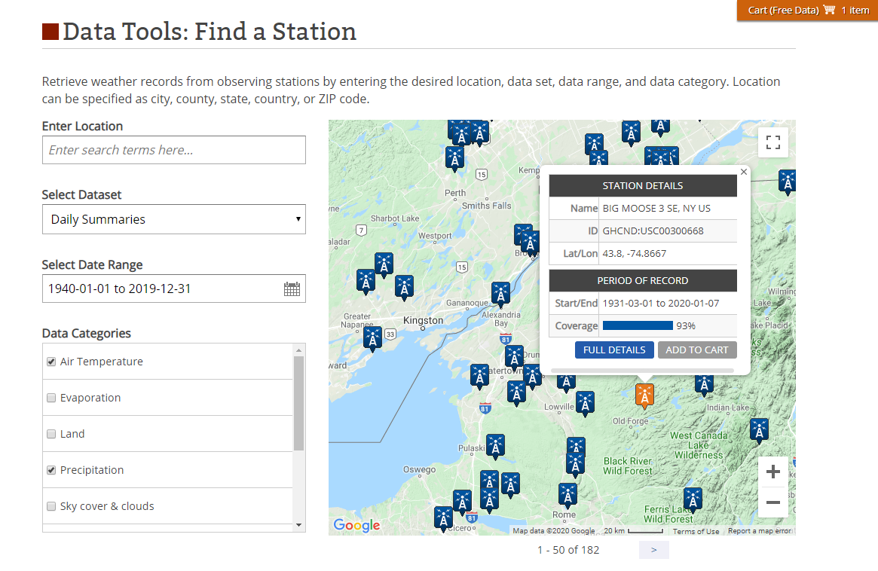

\*Note that as you zoom in and out of the map, it will change the number of stations displayed. Some stations are not displayed when you zoom out to the Northeast region.

You can click on a station and add it to your cart:

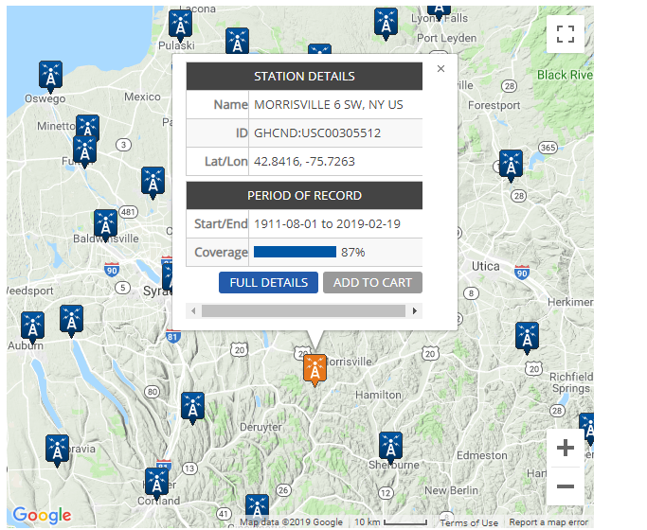

\*Note this data is free. That is just the terminology used.

You can add multiple items to your cart:

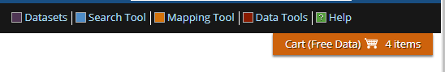

When you check out, indicate the csv option:

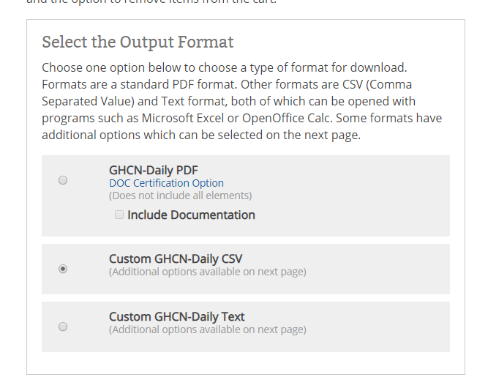

Include geographic information and check your data type:

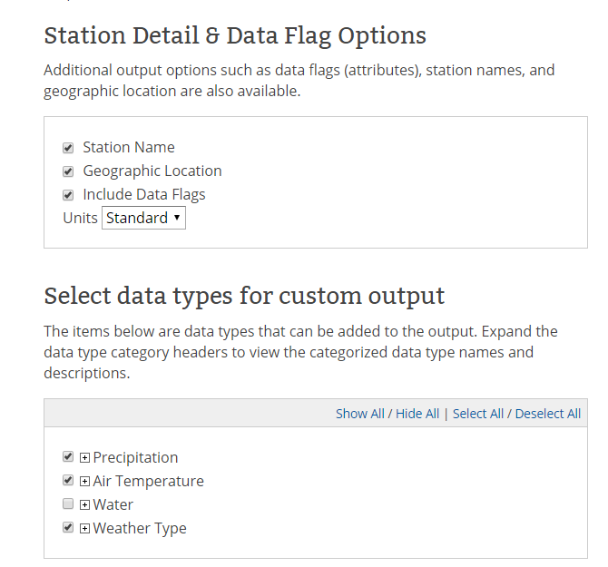

Finally check out:

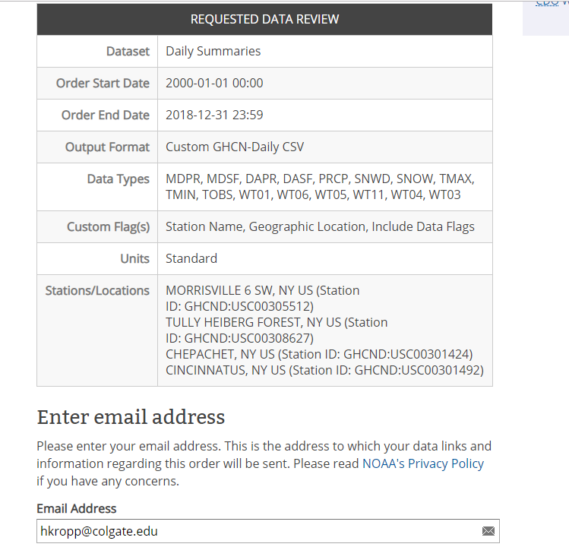

You will get datasets that look similar to this:

