Alexander Kimea

https://github.com/vanile/CS380EX6

1. Entering username ted with no password. We use ‘) to close the inner statement and since it seems to be using MySQL database assuming due to ‘mysql_query’, the # symbol it used to comment out. So in this statement it should comment out the next part of WHERE, where it compares the password, therefore we don’t need the password.

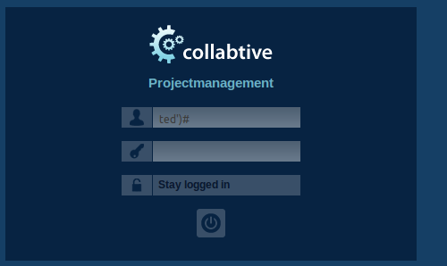

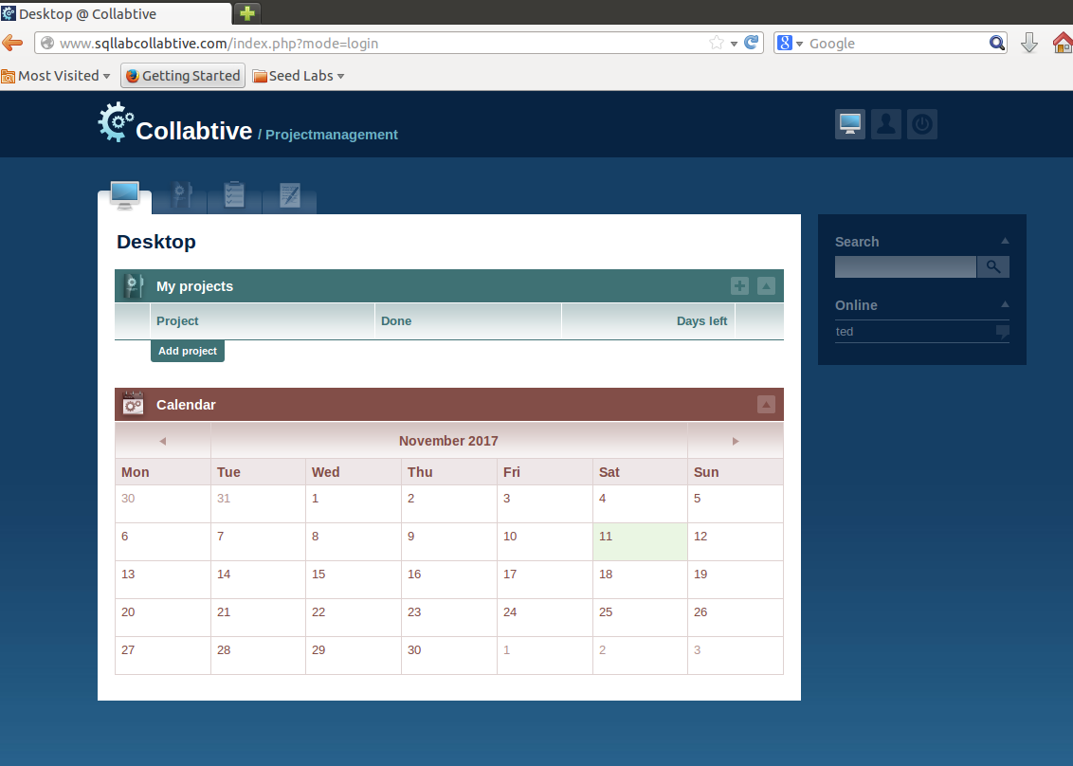

1. logging in as admin without password. Using the same method as above.

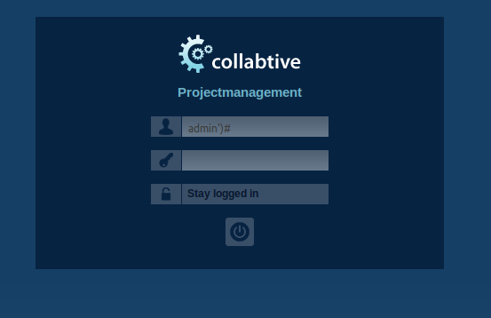

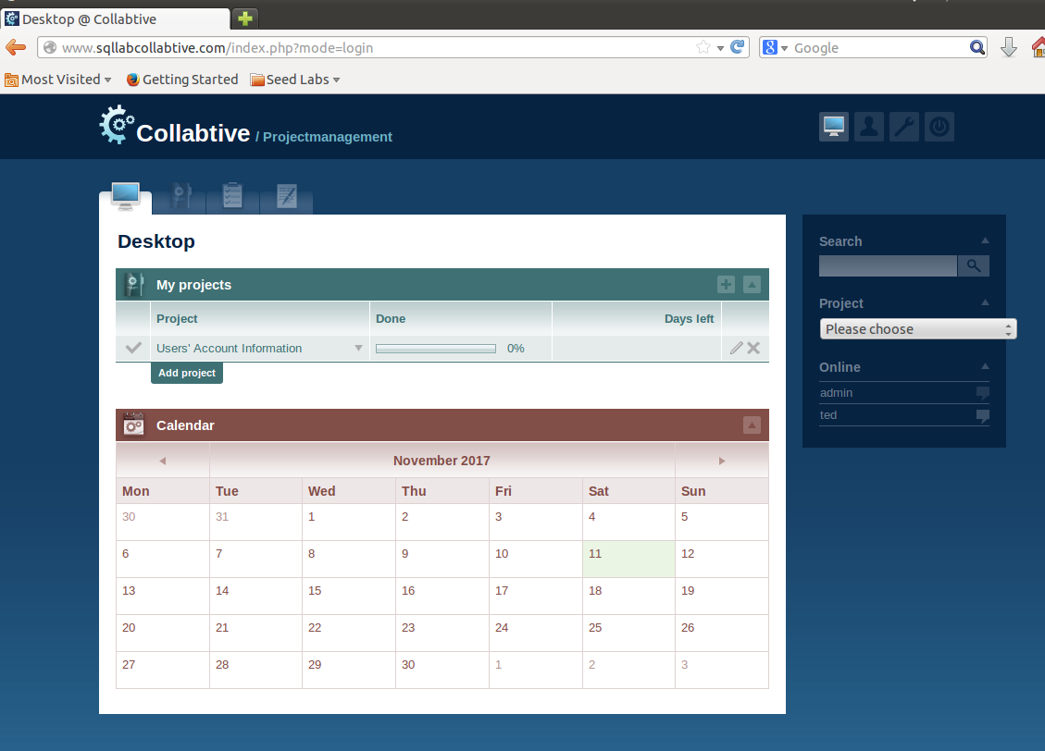

1. Logging in with blank username. The first quote denotes that the end of the username check part. We enter a true statement so that it is allowed and use # to comment out the password check section again.

