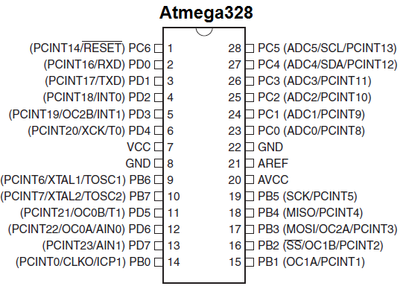

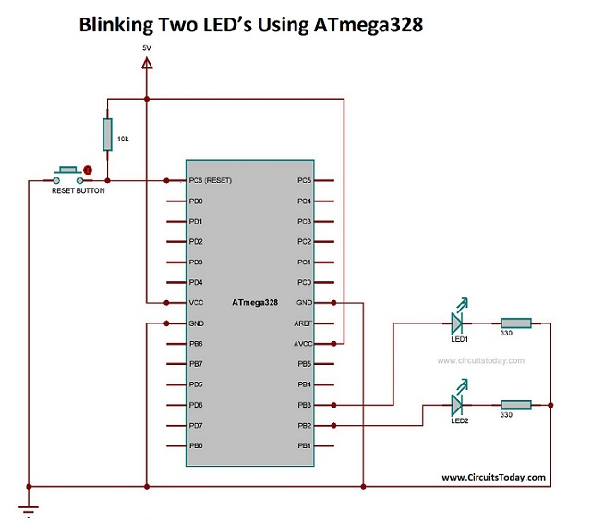

AVR microcontrollers are very easy to use. All AVR microcontrollers require Integrated Development Environment(IDE) such as Atmel Studio. Using this IDE, we can create, compile and debug program on all AVR microcontrollers.

How to blink two LEDs with AVR ATmega328 microcontroller. First, we will connect the 2 LED’s with PB2 and PB3 of  PORTB of the ATmega328 microcontroller. Then, we will make the 2 LED’s to blink with an interval of 1 second. It means, initially the 1st LED alone will glow and on the next second, it will turn off and the 2nd  one will glow. This process continues forever and in this way LEDs blinks continuously.

**DDRx** – Data Direction Register configures data direction of the port(Input/Output). The instruction “ DDRB |= (1<<DDB2)”  makes corresponding port pin as output.

**PORTx** – Port register is for assigning appropriate values for the port pins.

Writing to PORTx.n will immediately change state of the port pins according to given value. “PORTB |=(1<<PORTB2)” will generate a high signal at PB2. And “PORTB&=~(1<<PORTB3)” is for generating a low signal at PB3.