Name :- Vanita Dhage
Roll No :- 268148

DAY 1
4.0 Accept five double values from the user using Scanner and print their average.
Create a menu-driven food billing program. Accept item choices and quantities, and generate the bill when option 0 is selected.
Create a calculator that accepts an operation and two numbers and performs the selected arithmetic operation.

PACKAGE: com.cdac.day01
MODULE: DAY 1

CLASS: Calculator
File: com/cdac/day01/Calculator.java
package com.cdac.day01;
import java.util.Scanner;
public class Calculator {
public static void main(String[] args) {
try (Scanner sc = new Scanner(System.in)) {
while (true) {
System.out.print("Operation (add|subtract|multiply|divide, or exit): ");
String op = sc.next().toLowerCase();
if (op.equals("exit")) break;
if (!op.equals("add") && !op.equals("subtract") &&
!op.equals("multiply") && !op.equals("divide")) {
System.out.println("Unknown operation. Exiting.");
break;
}
System.out.print("Enter two numbers: ");
double a = sc.nextDouble(), b = sc.nextDouble();
switch (op) {
case "add" -> System.out.println("Result = " + (a + b));
case "subtract" -> System.out.println("Result = " + (a - b));
case "multiply" -> System.out.println("Result = " + (a * b));
case "divide" -> {
if (b == 0) System.out.println("Cannot divide by zero.");
else System.out.println("Result = " + (a / b));
}
}
}
}
}
}

CLASS: FoodBilling
File: com/cdac/day01/FoodBilling.java
package com.cdac.day01;
import java.util.Scanner;
public class FoodBilling {
public static void main(String[] args) {
final double dosa = 50, samosa = 20, idli = 35, vada = 25;
double total = 0;
try (Scanner sc = new Scanner(System.in)) {
while (true) {
System.out.println("\n--- FOOD MENU ---");
System.out.println("1. Dosa Rs." + dosa);
System.out.println("2. Samosa Rs." + samosa);
System.out.println("3. Idli Rs." + idli);
System.out.println("4. Vada Rs." + vada);
System.out.println("0. Generate bill");
System.out.print("Choose item: ");
int choice = sc.nextInt();
if (choice == 0) break;
if (choice < 1 || choice > 4) {
System.out.println("Invalid choice.");
continue;
}
System.out.print("Quantity: ");
int qty = sc.nextInt();
if (qty <= 0) {
System.out.println("Quantity must be positive.");
continue;
}
double price = switch (choice) {
case 1 -> dosa; case 2 -> samosa; case 3 -> idli; default -> vada;
};
total += price * qty;
System.out.printf("Added. Subtotal = Rs.%.2f%n", total);
}
System.out.printf("Final bill = Rs.%.2f%n", total);
}
}
}

CLASS: PrintAverage
File: com/cdac/day01/PrintAverage.java
package com.cdac.day01;
import java.util.Scanner;
public class PrintAverage {
public static void main(String[] args) {
try (Scanner sc = new Scanner(System.in)) {
double sum = 0;
for (int i = 1; i <= 5; i++) {
System.out.print("Enter double " + i + ": ");
sum += sc.nextDouble();
}
System.out.println("Average = " + (sum / 5));
}
}
}
OUTPUT: DAY 1 - Print Average
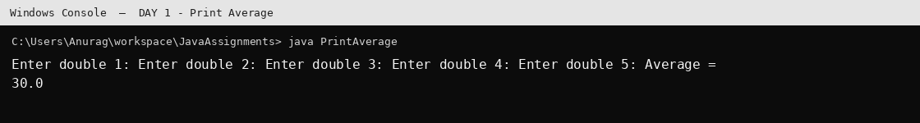
Output generated by executing the compiled Java class. Run the same class in STS 5 to view it in the STS Console.
OUTPUT: DAY 1 - Food Billing
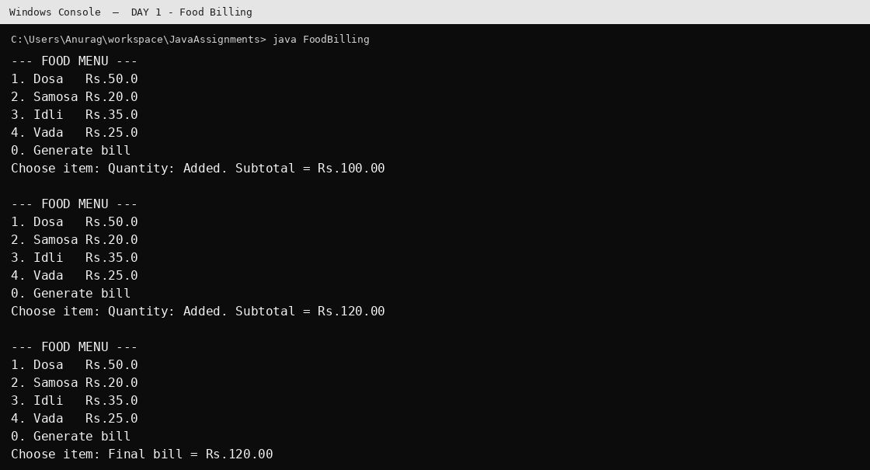
Output generated by executing the compiled Java class. Run the same class in STS 5 to view it in the STS Console.
OUTPUT: DAY 1 - Calculator
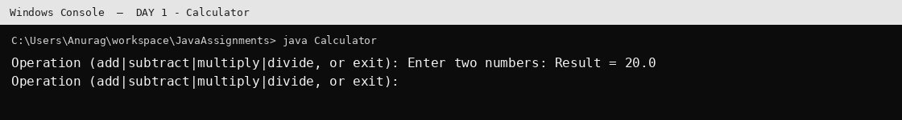
Output generated by executing the compiled Java class. Run the same class in STS 5 to view it in the STS Console.

DAY 2
Trace the Box reference assignment sequence and identify objects eligible for garbage collection.
Trace the Tank reference assignment sequence and identify objects eligible for garbage collection.
Create a Point2D class with encapsulated coordinates, constructor, show(), isEqual() and calculateDistance().

PACKAGE: com.cdac.day02.model
MODULE: DAY 2

CLASS: Box
File: com/cdac/day02/model/Box.java
package com.cdac.day02.model;
public class Box {
private double width, height, depth;
public Box(double width, double height, double depth) {
this.width = width; this.height = height; this.depth = depth;
}
public double getWidth() { return width; }
public void setWidth(double width) {
if (width <= 0) throw new IllegalArgumentException("Width must be positive");
this.width = width;
}
public double getVolume() { return width * height * depth; }
@Override public String toString() {
return "Box{width=" + width + ", height=" + height + ", depth=" + depth +
", volume=" + getVolume() + "}";
}
}

CLASS: Point2D
File: com/cdac/day02/model/Point2D.java
package com.cdac.day02.model;
public class Point2D {
private final int x, y;
public Point2D(int x, int y) { this.x = x; this.y = y; }
public String show() { return "(" + x + ", " + y + ")"; }
public boolean isEqual(Point2D anotherPoint) {
return anotherPoint != null && this.x == anotherPoint.x && this.y == anotherPoint.y;
}
public double calculateDistance(Point2D anotherPoint) {
if (anotherPoint == null) throw new IllegalArgumentException("Point cannot be null");
return Math.sqrt(Math.pow(this.x - anotherPoint.x, 2) +
Math.pow(this.y - anotherPoint.y, 2));
}
@Override public String toString() { return show(); }
}

CLASS: Tank
File: com/cdac/day02/model/Tank.java
package com.cdac.day02.model;
public class Tank {
private int level;
public Tank(int level) { this.level = level; }
public void setLevel(int level) { this.level = level; }
public int getLevel() { return level; }
}

PACKAGE: com.cdac.day02.tester
MODULE: DAY 2

CLASS: TestPoint
File: com/cdac/day02/tester/TestPoint.java
package com.cdac.day02.tester;
import java.util.Scanner;
import com.cdac.day02.model.Point2D;
public class TestPoint {
public static void main(String[] args) {
try (Scanner sc = new Scanner(System.in)) {
System.out.print("Enter x1 y1: "); Point2D p1 = new Point2D(sc.nextInt(), sc.nextInt());
System.out.print("Enter x2 y2: "); Point2D p2 = new Point2D(sc.nextInt(), sc.nextInt());
System.out.println("Point 1 = " + p1.show());
System.out.println("Point 2 = " + p2.show());
if (p1.isEqual(p2)) System.out.println("SAME");
else {
System.out.println("DIFFERENT");
System.out.println("Distance = " + p1.calculateDistance(p2));
}
}
}
}

CLASS: TestTank
File: com/cdac/day02/tester/TestTank.java
package com.cdac.day02.tester;
import com.cdac.day02.model.Tank;
public class TestTank {
public static void main(String[] args) {
Tank t1 = new Tank(10);
Tank t2 = new Tank(20);
System.out.println("1: t1=" + t1.getLevel() + ", t2=" + t2.getLevel());
t1 = t2;
System.out.println("2: t1=" + t1.getLevel() + ", t2=" + t2.getLevel());
t1.setLevel(27);
System.out.println("3: t1=" + t1.getLevel() + ", t2=" + t2.getLevel());
t2.setLevel(t1.getLevel() + 10);
System.out.println("4: t1=" + t1.getLevel() + ", t2=" + t2.getLevel());
System.out.println("One Tank object (the original level-10 object) is eligible for GC.");
}
}
OUTPUT: DAY 2 - Tank
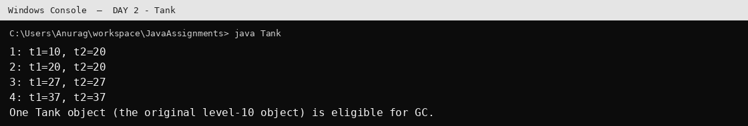
Output generated by executing the compiled Java class. Run the same class in STS 5 to view it in the STS Console.
OUTPUT: DAY 2 - Point2D
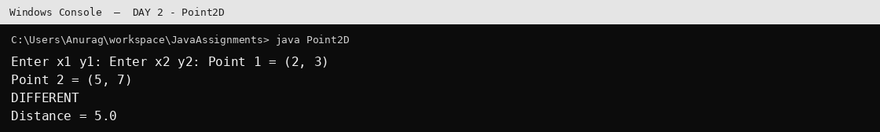
Output generated by executing the compiled Java class. Run the same class in STS 5 to view it in the STS Console.

DAY 3
Move Point2D into the geometry package and create a separate tester package. Compile and run using the fully qualified class name.
Create an array of Box references and double the width of boxes whose volume is greater than 100.

PACKAGE: com.cdac.day03.model
MODULE: DAY 3

CLASS: Box
File: com/cdac/day03/model/Box.java
package com.cdac.day03.model;
public class Box {
private double width, height, depth;
public Box(double width, double height, double depth) {
this.width = width; this.height = height; this.depth = depth;
}
public double getWidth() { return width; }
public void setWidth(double width) { this.width = width; }
public double getVolume() { return width * height * depth; }
@Override public String toString() { return "Box{w=" + width + ", h=" + height + ", d=" + depth + ", volume=" + getVolume() + "}"; }
}

PACKAGE: com.cdac.day03.tester
MODULE: DAY 3

CLASS: TestBoxArray
File: com/cdac/day03/tester/TestBoxArray.java
package com.cdac.day03.tester;
import com.cdac.day03.model.Box;
public class TestBoxArray {
public static void main(String[] args) {
Box[] boxes = {
new Box(2, 3, 4), new Box(5, 5, 5), new Box(1, 2, 3)
};
for (Box b : boxes) {
if (b.getVolume() > 100) b.setWidth(b.getWidth() * 2);
}
for (Box b : boxes) System.out.println(b);
}
}

CLASS: TestMultiplePoints
File: com/cdac/day03/tester/TestMultiplePoints.java
package com.cdac.day03.tester;
import java.util.Scanner;
import com.developers.geometry.Point2D;
public class TestMultiplePoints {
public static void main(String[] args) {
try (Scanner sc = new Scanner(System.in)) {
System.out.print("How many points? ");
int n = sc.nextInt();
if (n <= 0) { System.out.println("Count must be positive."); return; }
Point2D[] points = new Point2D[n];
for (int i = 0; i < n; i++) {
System.out.print("Enter x y for point " + (i + 1) + ": ");
points[i] = new Point2D(sc.nextInt(), sc.nextInt());
}
for (Point2D p : points) System.out.println(p.show());
}
}
}

PACKAGE: com.developers.geometry
MODULE: DAY 3

CLASS: Point2D
File: com/developers/geometry/Point2D.java
package com.developers.geometry;
public class Point2D {
private final int x, y;
public Point2D(int x, int y) { this.x = x; this.y = y; }
public String show() { return "(" + x + ", " + y + ")"; }
public boolean isEqual(Point2D p) { return p != null && x == p.x && y == p.y; }
public double calculateDistance(Point2D p) {
if (p == null) throw new IllegalArgumentException("Point cannot be null");
return Math.hypot(x - p.x, y - p.y);
}
@Override public String toString() { return show(); }
}

PACKAGE: com.developers.tester
MODULE: DAY 3

CLASS: TestPoint
File: com/developers/tester/TestPoint.java
package com.developers.tester;
import java.util.Scanner;
import com.developers.geometry.Point2D;
public class TestPoint {
public static void main(String[] args) {
try (Scanner sc = new Scanner(System.in)) {
System.out.print("Enter x1 y1: "); Point2D p1 = new Point2D(sc.nextInt(), sc.nextInt());
System.out.print("Enter x2 y2: "); Point2D p2 = new Point2D(sc.nextInt(), sc.nextInt());
System.out.println(p1.show()); System.out.println(p2.show());
System.out.println(p1.isEqual(p2) ? "SAME" : "DIFFERENT");
if (!p1.isEqual(p2)) System.out.println("Distance = " + p1.calculateDistance(p2));
}
}
}
OUTPUT: DAY 3 - Package Point2D
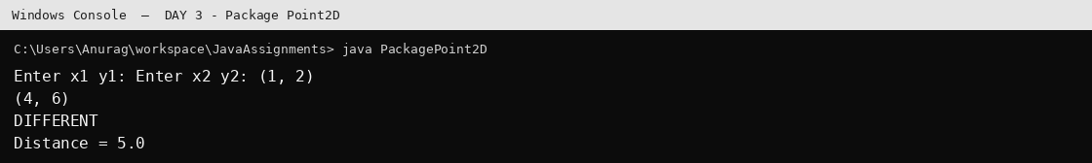
Output generated by executing the compiled Java class. Run the same class in STS 5 to view it in the STS Console.
OUTPUT: DAY 3 - Box Array
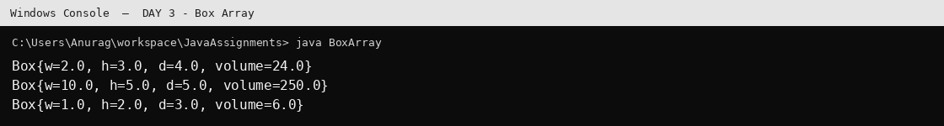
Output generated by executing the compiled Java class. Run the same class in STS 5 to view it in the STS Console.

DAY 4
Create BankAccount with account number, balance, customer name and phone number. Implement deposit, withdrawal and account summary.
Extend BankAccount using SavingAccount and CurrentAccount and demonstrate inheritance and polymorphism.

PACKAGE: com.cdac.day04.model
MODULE: DAY 4

CLASS: BankAccount
File: com/cdac/day04/model/BankAccount.java
package com.cdac.day04.model;
public class BankAccount {
private final int accountNumber;
private double balance;
private final String customerName, phoneNumber;
public BankAccount(int accountNumber, double balance, String customerName, String phoneNumber) {
if (accountNumber <= 0 || balance < 0) throw new IllegalArgumentException("Invalid account details");
this.accountNumber = accountNumber; this.balance = balance;
this.customerName = customerName; this.phoneNumber = phoneNumber;
}
public void deposit(double amount) {
if (amount <= 0) throw new IllegalArgumentException("Deposit must be positive");
balance += amount;
}
public boolean withdraw(double amount) {
if (amount <= 0 || amount > balance) return false;
balance -= amount; return true;
}
protected void setBalance(double balance) { this.balance = balance; }
public double getBalance() { return balance; }
public int getAccountNumber() { return accountNumber; }
public String getAccountSummary() {
return "Account No: " + accountNumber + "\nCustomer: " + customerName +
"\nPhone: " + phoneNumber + "\nBalance: " + balance;
}
@Override public boolean equals(Object obj) {
if (this == obj) return true;
if (!(obj instanceof BankAccount other)) return false;
return accountNumber == other.accountNumber;
}
@Override public int hashCode() { return Integer.hashCode(accountNumber); }
}

CLASS: CurrentAccount
File: com/cdac/day04/model/CurrentAccount.java
package com.cdac.day04.model;
public class CurrentAccount extends BankAccount {
private double overdraftLimit;
private boolean useOverdraftFacility;
public CurrentAccount(int no, double balance, String name, String phone,
double overdraftLimit, boolean useOverdraftFacility) {
super(no, balance, name, phone);
updateOverdraftLimit(overdraftLimit);
this.useOverdraftFacility = useOverdraftFacility;
}
public void updateOverdraftLimit(double limit) {
if (limit < 0) throw new IllegalArgumentException("Limit cannot be negative");
overdraftLimit = limit;
}
public void setUseOverdraftFacility(boolean enabled) { useOverdraftFacility = enabled; }
@Override public boolean withdraw(double amount) {
if (amount <= 0) return false;
double allowed = useOverdraftFacility ? getBalance() + overdraftLimit : getBalance();
if (amount > allowed) return false;
setBalance(getBalance() - amount);
return true;
}
@Override public String getAccountSummary() {
return super.getAccountSummary() + "\nOverdraft available: " + Math.max(0, overdraftLimit + getBalance()) +
"\nOverdraft enabled: " + useOverdraftFacility;
}
}

CLASS: SavingAccount
File: com/cdac/day04/model/SavingAccount.java
package com.cdac.day04.model;
public class SavingAccount extends BankAccount {
private final double interestRate;
public SavingAccount(int no, double balance, String name, String phone, double interestRate) {
super(no, balance, name, phone);
if (interestRate < 0) throw new IllegalArgumentException("Interest rate cannot be negative");
this.interestRate = interestRate;
}
public void applyInterest() { deposit(getBalance() * interestRate / 100.0); }
@Override public boolean withdraw(double amount) {
return amount > 0 && amount <= getBalance() && super.withdraw(amount);
}
@Override public String getAccountSummary() {
return super.getAccountSummary() + "\nInterest rate: " + interestRate + "%";
}
}

PACKAGE: com.cdac.day04.tester
MODULE: DAY 4

CLASS: TestBanking
File: com/cdac/day04/tester/TestBanking.java
package com.cdac.day04.tester;
import com.cdac.day04.model.*;
public class TestBanking {
public static void main(String[] args) {
SavingAccount savings = new SavingAccount(101, 10000, "Aarav", "9876543210", 4.5);
CurrentAccount current = new CurrentAccount(201, 1000, "Mira", "9123456780", 500, true);
savings.deposit(2000); savings.applyInterest();
System.out.println("Savings withdrawal: " + savings.withdraw(1500));
System.out.println(savings.getAccountSummary());
System.out.println("\nCurrent withdrawal 700: " + current.withdraw(700));
System.out.println("Current withdrawal 1200: " + current.withdraw(1200));
System.out.println("Current withdrawal 1600: " + current.withdraw(1600));
System.out.println(current.getAccountSummary());
}
}
OUTPUT: DAY 4 - Banking
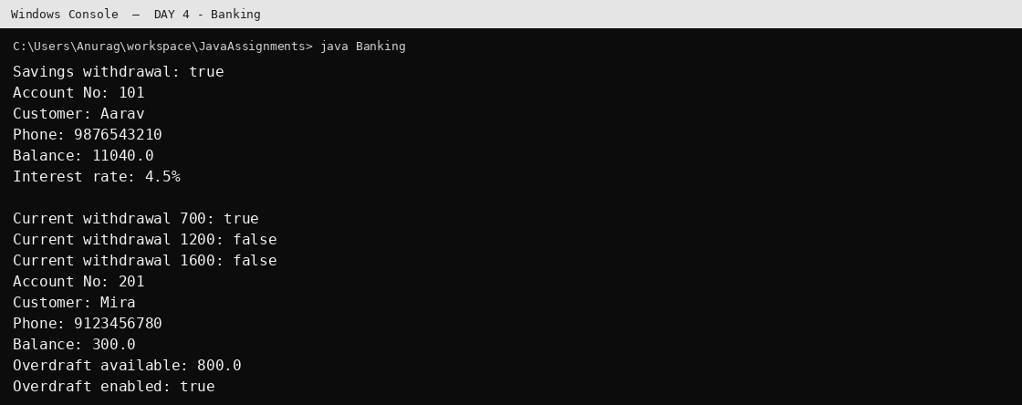
Output generated by executing the compiled Java class. Run the same class in STS 5 to view it in the STS Console.

DAY 5
Create a menu-driven Event Organizer application to register students/faculty, display participants, evaluate faculty and collect student feedback.

PACKAGE: com.cdac.day05.model
MODULE: DAY 5

CLASS: Faculty
File: com/cdac/day05/model/Faculty.java
package com.cdac.day05.model;
import java.util.LinkedHashMap;
import java.util.Map;
public class Faculty extends Participant {
private final String department;
private final Map<String, String> evaluations = new LinkedHashMap<>();
public Faculty(int seat, String name, String email, String department) {
super(seat, name, email); this.department = department;
}
public void evaluate(String studentName, String grade) { evaluations.put(studentName, grade); }
@Override public String getDetails() {
return "Faculty{seat=" + getSeatNo() + ", name=" + getName() + ", department=" + department +
", evaluations=" + evaluations + "}";
}
}

CLASS: Participant
File: com/cdac/day05/model/Participant.java
package com.cdac.day05.model;
public abstract class Participant {
private final int seatNo;
private final String name, email;
protected Participant(int seatNo, String name, String email) {
if (seatNo <= 0 || name == null || name.isBlank()) throw new IllegalArgumentException("Invalid participant");
this.seatNo = seatNo; this.name = name; this.email = email;
}
public int getSeatNo() { return seatNo; }
public String getName() { return name; }
public abstract String getDetails();
}

CLASS: Student
File: com/cdac/day05/model/Student.java
package com.cdac.day05.model;
import java.util.LinkedHashMap;
import java.util.Map;
public class Student extends Participant {
private final String course;
private final Map<String, String> facultyFeedback = new LinkedHashMap<>();
public Student(int seat, String name, String email, String course) {
super(seat, name, email); this.course = course;
}
public void addFeedback(String faculty, String comment) { facultyFeedback.put(faculty, comment); }
@Override public String getDetails() {
return "Student{seat=" + getSeatNo() + ", name=" + getName() + ", course=" + course +
", feedback=" + facultyFeedback + "}";
}
}

PACKAGE: com.cdac.day05.tester
MODULE: DAY 5

CLASS: EventOrganizerApp
File: com/cdac/day05/tester/EventOrganizerApp.java
package com.cdac.day05.tester;
import java.util.*;
import com.cdac.day05.model.*;
public class EventOrganizerApp {
public static void main(String[] args) {
try (Scanner sc = new Scanner(System.in)) {
System.out.print("Event capacity: "); int capacity = sc.nextInt(); sc.nextLine();
if (capacity <= 0) { System.out.println("Capacity must be positive."); return; }
Participant[] participants = new Participant[capacity];
int count = 0, nextSeat = 1;
while (true) {
System.out.println("\n1.Register Student 2.Register Faculty 3.Display All 4.Display by Seat");
System.out.println("5.Faculty Evaluation 6.Student Feedback 0.Exit");
System.out.print("Choice: "); int choice = sc.nextInt(); sc.nextLine();
if (choice == 0) break;
if (choice == 1 || choice == 2) {
if (count == capacity) { System.out.println("Event is full."); continue; }
System.out.print("Name: "); String name = sc.nextLine();
System.out.print("Email: "); String email = sc.nextLine();
if (choice == 1) {
System.out.print("Course: "); String course = sc.nextLine();
participants[count++] = new Student(nextSeat++, name, email, course);
} else {
System.out.print("Department: "); String dept = sc.nextLine();
participants[count++] = new Faculty(nextSeat++, name, email, dept);
}
System.out.println("Registered. Seat number = " + participants[count-1].getSeatNo());
} else if (choice == 3) {
for (Participant p : participants) if (p != null) System.out.println(p.getDetails());
} else if (choice == 4) {
System.out.print("Seat number: "); int seat = sc.nextInt(); sc.nextLine();
Participant p = find(participants, seat);
System.out.println(p == null ? "Participant not found." : p.getDetails());
} else if (choice == 5) {
System.out.print("Faculty seat no: "); int seat = sc.nextInt(); sc.nextLine();
Participant p = find(participants, seat);
if (!(p instanceof Faculty f)) { System.out.println("Faculty not found."); continue; }
System.out.print("Student name: "); String student = sc.nextLine();
System.out.print("Grade (A+, A, B+, B, C+, C): "); String grade = sc.nextLine().toUpperCase();
if (!List.of("A+", "A", "B+", "B", "C+", "C").contains(grade)) {
System.out.println("Invalid grade."); continue;
}
f.evaluate(student, grade);
} else if (choice == 6) {
System.out.print("Student seat no: "); int seat = sc.nextInt(); sc.nextLine();
Participant p = find(participants, seat);
if (!(p instanceof Student s)) { System.out.println("Student not found."); continue; }
System.out.print("Faculty name: "); String faculty = sc.nextLine();
System.out.print("Feedback: "); String feedback = sc.nextLine();
s.addFeedback(faculty, feedback);
} else System.out.println("Invalid choice.");
}
}
}
private static Participant find(Participant[] arr, int seat) {
for (Participant p : arr) if (p != null && p.getSeatNo() == seat) return p;
return null;
}
}
OUTPUT: DAY 5 - Event Organizer
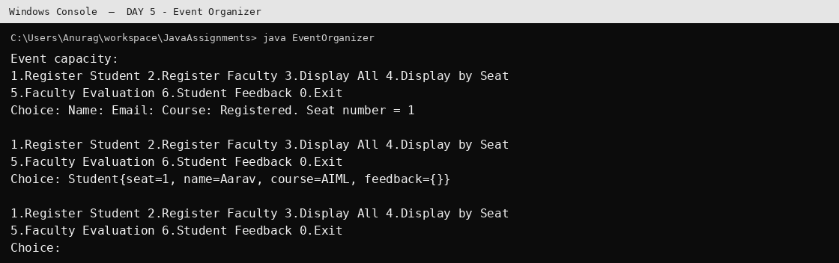
Output generated by executing the compiled Java class. Run the same class in STS 5 to view it in the STS Console.

DAY 6
Demonstrate interfaces, abstraction, implementation classes and runtime polymorphism.

PACKAGE: com.cdac.day06.model
MODULE: DAY 6

CLASS: Employee
File: com/cdac/day06/model/Employee.java
package com.cdac.day06.model;
public class Employee implements Payable {
private final String name; private final double monthlySalary;
public Employee(String name, double monthlySalary) {
if (monthlySalary < 0) throw new IllegalArgumentException("Salary cannot be negative");
this.name = name; this.monthlySalary = monthlySalary;
}
@Override public double calculatePay() { return monthlySalary; }
@Override public String toString() { return name + " pay=" + calculatePay(); }
}

CLASS: Freelancer
File: com/cdac/day06/model/Freelancer.java
package com.cdac.day06.model;
public class Freelancer implements Payable {
private final String name; private final int hours; private final double rate;
public Freelancer(String name, int hours, double rate) {
if (hours < 0 || rate < 0) throw new IllegalArgumentException("Invalid work details");
this.name = name; this.hours = hours; this.rate = rate;
}
@Override public double calculatePay() { return hours * rate; }
@Override public String toString() { return name + " pay=" + calculatePay(); }
}

CLASS: Payable
File: com/cdac/day06/model/Payable.java
package com.cdac.day06.model;
public interface Payable { double calculatePay(); }

PACKAGE: com.cdac.day06.tester
MODULE: DAY 6

CLASS: TestInterfaces
File: com/cdac/day06/tester/TestInterfaces.java
package com.cdac.day06.tester;
import com.cdac.day06.model.*;
public class TestInterfaces {
public static void main(String[] args) {
Payable[] payables = { new Employee("Riya", 45000), new Freelancer("Kabir", 30, 800) };
for (Payable p : payables) System.out.println(p);
}
}
OUTPUT: DAY 6 - Interfaces
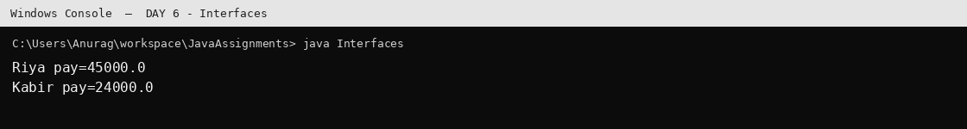
Output generated by executing the compiled Java class. Run the same class in STS 5 to view it in the STS Console.

DAY 7
Demonstrate a custom exception for speed validation and the use of finally.
Override equals() so two bank account objects with the same account number are considered equal.

PACKAGE: com.cdac.day07.exception
MODULE: DAY 7

CLASS: SpeedOutOfRangeException
File: com/cdac/day07/exception/SpeedOutOfRangeException.java
package com.cdac.day07.exception;
public class SpeedOutOfRangeException extends Exception {
public SpeedOutOfRangeException(String message) { super(message); }
}

PACKAGE: com.cdac.day07.service
MODULE: DAY 7

CLASS: VehicleValidation
File: com/cdac/day07/service/VehicleValidation.java
package com.cdac.day07.service;
import com.cdac.day07.exception.SpeedOutOfRangeException;
public class VehicleValidation {
public static void validateSpeed(int speed) throws SpeedOutOfRangeException {
if (speed < 0 || speed > 180)
throw new SpeedOutOfRangeException("Speed must be between 0 and 180 km/h.");
}
}

PACKAGE: com.cdac.day07.tester
MODULE: DAY 7

CLASS: TestSpeed
File: com/cdac/day07/tester/TestSpeed.java
package com.cdac.day07.tester;
import java.util.Scanner;
import com.cdac.day07.service.VehicleValidation;
public class TestSpeed {
public static void main(String[] args) {
try (Scanner sc = new Scanner(System.in)) {
System.out.print("Speed: "); int speed = sc.nextInt();
try { VehicleValidation.validateSpeed(speed); System.out.println("Valid speed."); }
catch (Exception e) { System.out.println(e.getMessage()); }
finally { System.out.println("Speed validation completed."); }
}
}
}
OUTPUT: DAY 7 - Custom Exception
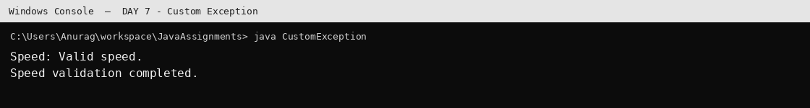
Output generated by executing the compiled Java class. Run the same class in STS 5 to view it in the STS Console.

DAY 8
Demonstrate equals()/hashCode() and two-dimensional arrays.
Create and display a 3 x 4 integer matrix populated sequentially from 100.

PACKAGE: com.cdac.day08.model
MODULE: DAY 8

CLASS: Employee
File: com/cdac/day08/model/Employee.java
package com.cdac.day08.model;
import java.util.Objects;
public class Employee {
private final int empId; private final String email;
public Employee(int empId, String email) { this.empId = empId; this.email = email; }
@Override public boolean equals(Object obj) {
if (this == obj) return true;
if (!(obj instanceof Employee other)) return false;
return empId == other.empId && Objects.equals(email, other.email);
}
@Override public int hashCode() { return Objects.hash(empId, email); }
}

PACKAGE: com.cdac.day08.tester
MODULE: DAY 8

CLASS: MatrixDemo
File: com/cdac/day08/tester/MatrixDemo.java
package com.cdac.day08.tester;
import java.util.Arrays;
public class MatrixDemo {
public static void main(String[] args) {
int[][] data = new int[3][4];
int counter = 100;
for (int i = 0; i < data.length; i++)
for (int j = 0; j < data[i].length; j++) data[i][j] = counter++;
System.out.println(Arrays.deepToString(data));
}
}
OUTPUT: DAY 8 - Matrix
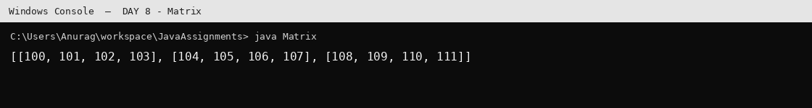
Output generated by executing the compiled Java class. Run the same class in STS 5 to view it in the STS Console.

DAY 9
Demonstrate enums, wrapper classes, autoboxing/unboxing, nested classes and generics.

PACKAGE: com.cdac.day09.model
MODULE: DAY 9

CLASS: Course
File: com/cdac/day09/model/Course.java
package com.cdac.day09.model;
public enum Course { CORE_JAVA, DBT, PYTHON, MERN, WEB_JAVA, DEV_OPS }

CLASS: Holder
File: com/cdac/day09/model/Holder.java
package com.cdac.day09.model;
public class Holder<T> {
private T value;
public Holder(T value) { this.value = value; }
public T get() { return value; }
public void set(T value) { this.value = value; }
}

CLASS: Student
File: com/cdac/day09/model/Student.java
package com.cdac.day09.model;
public class Student {
private final int rollNo; private final String name; private final Course course;
public Student(int rollNo, String name, Course course) { this.rollNo=rollNo; this.name=name; this.course=course; }
@Override public String toString() { return rollNo + " " + name + " " + course; }
}

PACKAGE: com.cdac.day09.tester
MODULE: DAY 9

CLASS: EnumWrapperDemo
File: com/cdac/day09/tester/EnumWrapperDemo.java
package com.cdac.day09.tester;
import com.cdac.day09.model.*;
public class EnumWrapperDemo {
public static void main(String[] args) {
Student s = new Student(1, "Anaya", Course.CORE_JAVA);
Integer boxed = 25; int primitive = boxed;
System.out.println(s); System.out.println("Autoboxed=" + boxed + ", unboxed=" + primitive);
System.out.println("Enum values:");
for (Course c : Course.values()) System.out.println(c + " ordinal=" + c.ordinal());
}
}

CLASS: GenericDemo
File: com/cdac/day09/tester/GenericDemo.java
package com.cdac.day09.tester;
import com.cdac.day09.model.Holder;
public class GenericDemo {
public static void main(String[] args) {
Holder<String> h = new Holder<>("Java");
System.out.println(h.get());
h.set("Generics are type-safe"); System.out.println(h.get());
}
}

CLASS: NestedClassDemo
File: com/cdac/day09/tester/NestedClassDemo.java
package com.cdac.day09.tester;
public class NestedClassDemo {
private int value = 10;
class Inner { void show() { System.out.println("Inner sees outer value=" + value); } }
static class Nested { void show() { System.out.println("Static nested class"); } }
public static void main(String[] args) {
NestedClassDemo outer = new NestedClassDemo();
outer.new Inner().show();
new Nested().show();
}
}
OUTPUT: DAY 9 - Enum and Wrapper
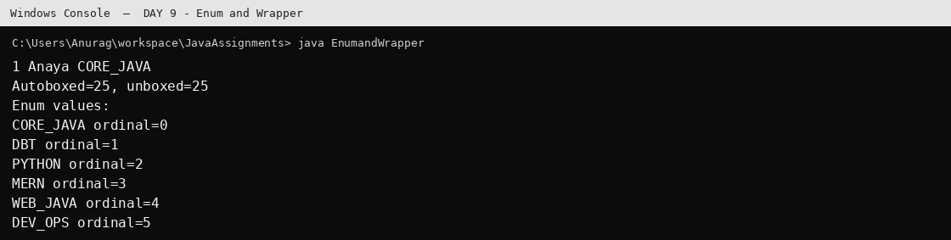
Output generated by executing the compiled Java class. Run the same class in STS 5 to view it in the STS Console.
OUTPUT: DAY 9 - Nested Classes
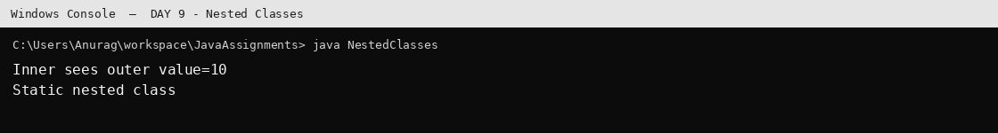
Output generated by executing the compiled Java class. Run the same class in STS 5 to view it in the STS Console.
OUTPUT: DAY 9 - Generics
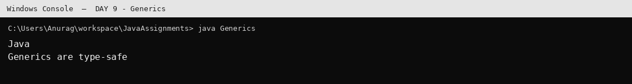
Output generated by executing the compiled Java class. Run the same class in STS 5 to view it in the STS Console.

DAY 10
Implement a Customer Management System with registration, display, search and customer operations.

PACKAGE: com.cdac.day10.model
MODULE: DAY 10

CLASS: Customer
File: com/cdac/day10/model/Customer.java
package com.cdac.day10.model;
import java.time.LocalDate;
import java.util.Objects;
public class Customer {
private final int id;
private final String name, email;
private final LocalDate dob;
private final double registrationAmount;
private String plan;
public Customer(int id, String name, String email, LocalDate dob, double amount, String plan) {
if (id <= 0 || name == null || name.isBlank() || !isValidEmail(email) || dob == null || amount < 0)
throw new IllegalArgumentException("Invalid customer details");
this.id=id; this.name=name; this.email=email; this.dob=dob;
this.registrationAmount=amount; this.plan=Objects.requireNonNull(plan);
}
public static boolean isValidEmail(String email) {
return email != null && email.matches("^[A-Za-z0-9+_.-]+@[A-Za-z0-9.-]+$");
}
public int getId(){return id;} public String getName(){return name;}
public String getEmail(){return email;} public LocalDate getDob(){return dob;}
public double getRegistrationAmount(){return registrationAmount;}
public String getPlan(){return plan;} public void setPlan(String plan){this.plan=plan;}
@Override public String toString(){return "Customer{id="+id+", name='"+name+"', email='"+email+
"', dob="+dob+", amount="+registrationAmount+", plan='"+plan+"'}";}
}

PACKAGE: com.cdac.day10.service
MODULE: DAY 10

CLASS: CustomerService
File: com/cdac/day10/service/CustomerService.java
package com.cdac.day10.service;
import java.util.*;
import com.cdac.day10.model.Customer;
public class CustomerService {
private final Map<Integer, Customer> customers = new LinkedHashMap<>();
public void register(Customer c) {
if (customers.containsKey(c.getId())) throw new IllegalArgumentException("Duplicate customer ID");
boolean duplicateEmail = customers.values().stream().anyMatch(x -> x.getEmail().equalsIgnoreCase(c.getEmail()));
if (duplicateEmail) throw new IllegalArgumentException("Email already registered");
customers.put(c.getId(), c);
}
public List<Customer> getAll(){return new ArrayList<>(customers.values());}
public Optional<Customer> find(int id){return Optional.ofNullable(customers.get(id));}
public boolean updatePlan(int id, String plan) {
Customer c=customers.get(id); if(c==null)return false; c.setPlan(plan); return true;
}
public boolean delete(int id){return customers.remove(id)!=null;}
public void upgradeSilverToGold(){
customers.values().stream().filter(c -> c.getPlan().equalsIgnoreCase("SILVER"))
.forEach(c -> c.setPlan("GOLD"));
}
public List<Customer> sortedByDob(){
return customers.values().stream().sorted(Comparator.comparing(Customer::getDob)).toList();
}
public List<Customer> sortedByAmountDesc(){
return customers.values().stream().sorted(Comparator.comparingDouble(Customer::getRegistrationAmount).reversed()).toList();
}
}

PACKAGE: com.cdac.day10.tester
MODULE: DAY 10

CLASS: CustomerManagementApp
File: com/cdac/day10/tester/CustomerManagementApp.java
package com.cdac.day10.tester;
import java.time.LocalDate;
import java.util.*;
import com.cdac.day10.model.Customer;
import com.cdac.day10.service.CustomerService;
public class CustomerManagementApp {
public static void main(String[] args) {
CustomerService service = new CustomerService();
try (Scanner sc = new Scanner(System.in)) {
while (true) {
System.out.println("\n1.Register 2.Display all 3.Search 4.Update plan 5.Delete 6.Upgrade SILVER 0.Exit");
System.out.print("Choice: "); int ch=sc.nextInt(); sc.nextLine();
try {
switch(ch) {
case 1 -> {
System.out.print("ID: "); int id=sc.nextInt(); sc.nextLine();
System.out.print("Name: "); String name=sc.nextLine();
System.out.print("Email: "); String email=sc.nextLine();
System.out.print("DOB (yyyy-mm-dd): "); LocalDate dob=LocalDate.parse(sc.nextLine());
System.out.print("Registration amount: "); double amount=sc.nextDouble(); sc.nextLine();
System.out.print("Plan: "); String plan=sc.nextLine();
service.register(new Customer(id,name,email,dob,amount,plan));
System.out.println("Registered.");
}
case 2 -> service.getAll().forEach(System.out::println);
case 3 -> {
System.out.print("ID: "); int id=sc.nextInt();
System.out.println(service.find(id).orElse(null));
}
case 4 -> {
System.out.print("ID: "); int id=sc.nextInt(); sc.nextLine();
System.out.print("New plan: "); String plan=sc.nextLine();
System.out.println(service.updatePlan(id,plan) ? "Updated." : "Not found.");
}
case 5 -> {
System.out.print("ID: "); int id=sc.nextInt();
System.out.println(service.delete(id) ? "Deleted." : "Not found.");
}
case 6 -> { service.upgradeSilverToGold(); System.out.println("Upgrade complete."); }
case 0 -> { return; }
default -> System.out.println("Invalid choice.");
}
} catch (RuntimeException ex) { System.out.println("Error: " + ex.getMessage()); }
}
}
}
}
OUTPUT: DAY 10 - Customer Management
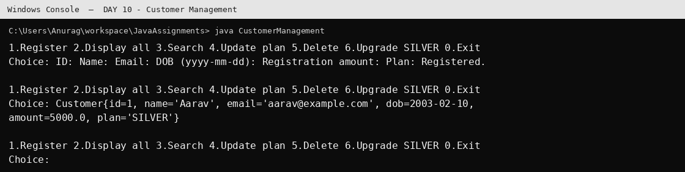
Output generated by executing the compiled Java class. Run the same class in STS 5 to view it in the STS Console.

DAY 11
Demonstrate List, Iterator and ListIterator operations, including safe removal while iterating.

PACKAGE: com.cdac.day11.tester
MODULE: DAY 11

CLASS: ListOperations
File: com/cdac/day11/tester/ListOperations.java
package com.cdac.day11.tester;
import java.util.*;
public class ListOperations {
public static void main(String[] args) {
List<Integer> numbers = new ArrayList<>(List.of(10, 20, 30, 20, 40));
// Safe removal while iterating: use Iterator.remove(), not list.remove().
Iterator<Integer> itr = numbers.iterator();
while (itr.hasNext()) if (itr.next() == 20) itr.remove();
System.out.println("After removing 20: " + numbers);
ListIterator<Integer> li = numbers.listIterator();
while (li.hasNext()) System.out.println("next: " + li.next());
while (li.hasPrevious()) System.out.println("previous: " + li.previous());
}
}
OUTPUT: DAY 11 - List Operations
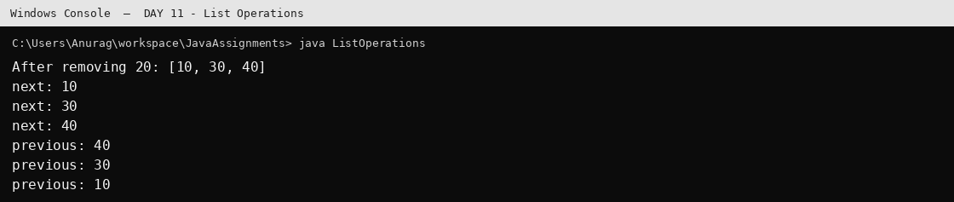
Output generated by executing the compiled Java class. Run the same class in STS 5 to view it in the STS Console.

DAY 12
Demonstrate Set implementations, uniqueness, sorting and HashMap frequency counting.

PACKAGE: com.cdac.day12.tester
MODULE: DAY 12

CLASS: SetHashingDemo
File: com/cdac/day12/tester/SetHashingDemo.java
package com.cdac.day12.tester;
import java.util.*;
public class SetHashingDemo {
public static void main(String[] args) {
Set<String> names = new HashSet<>(List.of("Asha", "Ravi", "Asha", "Neha"));
System.out.println("Unique names: " + names);
Set<Integer> ordered = new TreeSet<>(List.of(5, 1, 3, 1, 2));
System.out.println("Sorted unique numbers: " + ordered);
Map<String,Integer> frequency = new HashMap<>();
for (String n : List.of("java","sql","java","python","sql","java"))
frequency.merge(n, 1, Integer::sum);
System.out.println("Frequency: " + frequency);
}
}
OUTPUT: DAY 12 - Set and Hashing
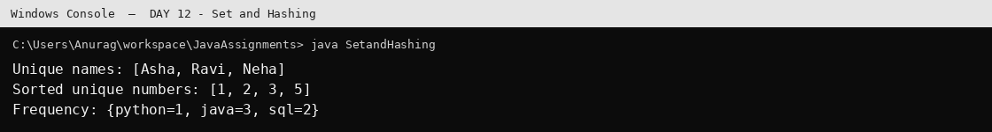
Output generated by executing the compiled Java class. Run the same class in STS 5 to view it in the STS Console.

DAY 13
Implement Student Management using Map operations and demonstrate filtering students by subject.

PACKAGE: com.cdac.day13.model
MODULE: DAY 13

CLASS: Student
File: com/cdac/day13/model/Student.java
package com.cdac.day13.model;
import java.util.Objects;
public class Student {
private final int rollNo; private final String name; private final String course;
public Student(int rollNo, String name, String course) {
if(rollNo<=0 || name==null || name.isBlank() || course==null || course.isBlank())
throw new IllegalArgumentException("Invalid student");
this.rollNo=rollNo; this.name=name; this.course=course;
}
public int getRollNo(){return rollNo;} public String getName(){return name;} public String getCourse(){return course;}
@Override public boolean equals(Object o){return o instanceof Student s && rollNo==s.rollNo;}
@Override public int hashCode(){return Objects.hash(rollNo);}
@Override public String toString(){return rollNo+" | "+name+" | "+course;}
}

PACKAGE: com.cdac.day13.service
MODULE: DAY 13

CLASS: StudentService
File: com/cdac/day13/service/StudentService.java
package com.cdac.day13.service;
import java.util.*;
import com.cdac.day13.model.Student;
public class StudentService {
private final Map<Integer,Student> students=new LinkedHashMap<>();
public void add(Student s){if(students.putIfAbsent(s.getRollNo(),s)!=null)throw new IllegalArgumentException("Duplicate roll number");}
public Student find(int roll){return students.get(roll);}
public boolean remove(int roll){return students.remove(roll)!=null;}
public List<Student> all(){return new ArrayList<>(students.values());}
public List<Student> byCourse(String course){return students.values().stream().filter(s->s.getCourse().equalsIgnoreCase(course)).toList();}
}

PACKAGE: com.cdac.day13.tester
MODULE: DAY 13

CLASS: StudentManagementDemo
File: com/cdac/day13/tester/StudentManagementDemo.java
package com.cdac.day13.tester;
import com.cdac.day13.model.Student;
import com.cdac.day13.service.StudentService;
public class StudentManagementDemo {
public static void main(String[] args) {
StudentService service=new StudentService();
service.add(new Student(1,"Aarav","Java"));
service.add(new Student(2,"Diya","Python"));
service.add(new Student(3,"Kabir","Java"));
service.all().forEach(System.out::println);
System.out.println("Java students:");
service.byCourse("Java").forEach(System.out::println);
}
}
OUTPUT: DAY 13 - Student Management
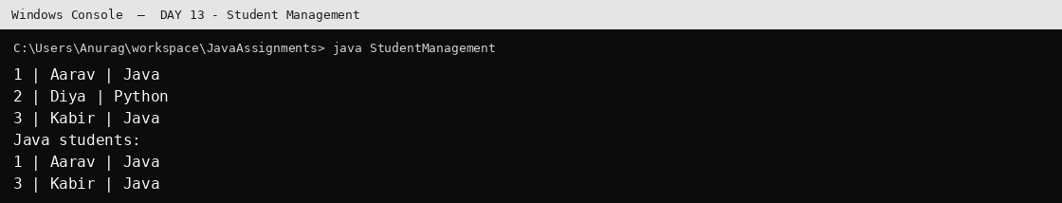
Output generated by executing the compiled Java class. Run the same class in STS 5 to view it in the STS Console.

DAY 15
Use Java Stream API to filter, sort, aggregate and collect student information.

PACKAGE: com.cdac.day15.model
MODULE: DAY 15

CLASS: Address
File: com/cdac/day15/model/Address.java
package com.cdac.day15.model;
public class Address {
private final String city,state;
public Address(String city,String state){this.city=city;this.state=state;}
public String getCity(){return city;} public String getState(){return state;}
@Override public String toString(){return city+", "+state;}
}

CLASS: Student
File: com/cdac/day15/model/Student.java
package com.cdac.day15.model;
import java.time.LocalDate;
public class Student {
private final int roll; private final String name; private final Address address;
private final Subject subject; private final double gpa; private final int marks; private final LocalDate dob;
public Student(int roll,String name,Address address,Subject subject,double gpa,int marks,LocalDate dob){
this.roll=roll;this.name=name;this.address=address;this.subject=subject;this.gpa=gpa;this.marks=marks;this.dob=dob;
}
public int getRoll(){return roll;} public String getName(){return name;} public Address getAddress(){return address;}
public Subject getSubject(){return subject;} public double getGpa(){return gpa;} public int getMarks(){return marks;}
public LocalDate getDob(){return dob;}
@Override public String toString(){return roll+" "+name+" "+address+" "+subject+" GPA="+gpa+" marks="+marks+" DOB="+dob;}
}

CLASS: Subject
File: com/cdac/day15/model/Subject.java
package com.cdac.day15.model;
public enum Subject { JAVA, DBT, PYTHON, WEB }

PACKAGE: com.cdac.day15.tester
MODULE: DAY 15

CLASS: StudentStreamApp
File: com/cdac/day15/tester/StudentStreamApp.java
package com.cdac.day15.tester;
import java.time.LocalDate;
import java.util.*;
import java.util.stream.Collectors;
import com.cdac.day15.model.*;
public class StudentStreamApp {
public static void main(String[] args) {
List<Student> students = List.of(
new Student(1,"Aarav",new Address("Pune","Maharashtra"),Subject.JAVA,8.7,91,LocalDate.of(2003,2,10)),
new Student(2,"Diya",new Address("Mumbai","Maharashtra"),Subject.PYTHON,9.1,95,LocalDate.of(2004,5,12)),
new Student(3,"Kabir",new Address("Pune","Maharashtra"),Subject.JAVA,4.8,45,LocalDate.of(2002,8,20)),
new Student(4,"Mira",new Address("Nashik","Maharashtra"),Subject.DBT,7.5,78,LocalDate.of(2003,11,1)),
new Student(5,"Ishaan",new Address("Indore","Madhya Pradesh"),Subject.WEB,8.2,84,LocalDate.of(2004,1,15))
);
Map<Integer,Student> studentMap = students.stream().collect(Collectors.toMap(Student::getRoll,s->s));
System.out.println("3.0 All students:");
studentMap.forEach((k,v)->System.out.println(v));
try (Scanner sc = new Scanner(System.in)) {
System.out.print("Subject (JAVA/DBT/PYTHON/WEB): ");
Subject subject=Subject.valueOf(sc.nextLine().trim().toUpperCase());
System.out.println("3.1 Students in subject:");
students.stream().filter(s->s.getSubject()==subject).forEach(System.out::println);
System.out.print("State: "); String state=sc.nextLine();
double sum=students.stream().filter(s->s.getAddress().getState().equalsIgnoreCase(state))
.mapToDouble(Student::getGpa).sum();
System.out.println("3.2 Sum of GPA = "+sum);
System.out.println("3.3 Topper: "+students.stream().filter(s->s.getSubject()==subject)
.max(Comparator.comparingInt(Student::getMarks)).map(Student::getName).orElse("No student"));
long failures=students.stream().filter(s->s.getSubject()==subject && s.getGpa()<5.0).count();
System.out.println("3.4 Failures = "+failures);
System.out.print("Minimum marks: "); int min=sc.nextInt(); sc.nextLine();
System.out.println("3.5 Students above marks:");
students.stream().filter(s->s.getSubject()==subject && s.getMarks()>min).forEach(s->System.out.println(s.getName()));
Set<Student> subjectStudents=students.stream().filter(s->s.getSubject()==subject).collect(Collectors.toSet());
System.out.println("3.6 Subject student set: "+subjectStudents);
System.out.println("3.7 Sorted by DOB descending:");
students.stream().filter(s->s.getSubject()==subject).sorted(Comparator.comparing(Student::getDob).reversed()).forEach(System.out::println);
System.out.println("3.8 Any GPA > 8: "+students.stream().filter(s->s.getGpa()>8).findAny().orElse(null));
System.out.println("3.9 Distinct cities:");
students.stream().map(s->s.getAddress().getCity()).distinct().forEach(System.out::println);
Map<Integer,Student> subjectMap=students.stream().filter(s->s.getSubject()==subject)
.collect(Collectors.toMap(Student::getRoll,s->s));
System.out.println("3.10 Subject map: "+subjectMap);
}
}
}
OUTPUT: DAY 15 - Stream API
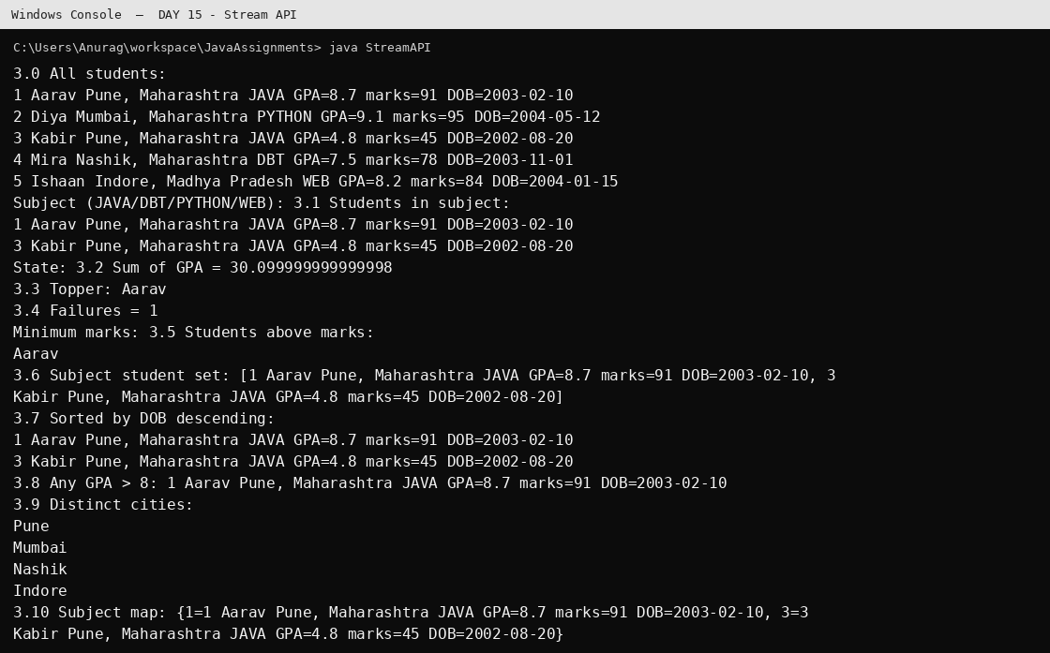
Output generated by executing the compiled Java class. Run the same class in STS 5 to view it in the STS Console.

DAY 16
Implement generic methods for numeric sum and maximum value, and demonstrate object serialization/deserialization.

PACKAGE: com.cdac.day16.model
MODULE: DAY 16

CLASS: SerializableStudent
File: com/cdac/day16/model/SerializableStudent.java
package com.cdac.day16.model;
import java.io.Serializable;
public class SerializableStudent implements Serializable {
private static final long serialVersionUID=1L;
private final int roll; private final String name; private final double gpa;
public SerializableStudent(int roll,String name,double gpa){this.roll=roll;this.name=name;this.gpa=gpa;}
@Override public String toString(){return roll+" "+name+" GPA="+gpa;}
}

PACKAGE: com.cdac.day16.tester
MODULE: DAY 16

CLASS: GenericsAndSerializationDemo
File: com/cdac/day16/tester/GenericsAndSerializationDemo.java
package com.cdac.day16.tester;
import java.util.*;
import java.io.*;
import com.cdac.day16.util.NumberUtils;
import com.cdac.day16.model.SerializableStudent;
public class GenericsAndSerializationDemo {
public static void main(String[] args) {
System.out.println("Integer sum="+NumberUtils.sumOfNumbers(new ArrayList<>(List.of(1,2,3))));
System.out.println("Float sum="+NumberUtils.sumOfNumbers(new LinkedList<>(List.of(1.5f,2.5f))));
System.out.println("Max="+NumberUtils.maxNumber(new Vector<>(List.of(10,50,20))));
List<SerializableStudent> students=List.of(new SerializableStudent(1,"Aarav",8.5),
new SerializableStudent(2,"Diya",9.2));
try(ObjectOutputStream out=new ObjectOutputStream(new FileOutputStream("students.bin"))){
out.writeObject(new ArrayList<>(students)); System.out.println("Serialized to students.bin");
}catch(IOException e){System.out.println("Serialization error: "+e.getMessage());}
try(ObjectInputStream in=new ObjectInputStream(new FileInputStream("students.bin"))){
System.out.println("Read back: "+in.readObject());
}catch(IOException|ClassNotFoundException e){System.out.println("Deserialization error: "+e.getMessage());}
}
}

PACKAGE: com.cdac.day16.util
MODULE: DAY 16

CLASS: NumberUtils
File: com/cdac/day16/util/NumberUtils.java
package com.cdac.day16.util;
import java.util.List;
public final class NumberUtils {
private NumberUtils() {}
public static double sumOfNumbers(List<? extends Number> numbers) {
return numbers.stream().mapToDouble(Number::doubleValue).sum();
}
public static <T extends Number & Comparable<T>> T maxNumber(List<T> numbers) {
if (numbers == null || numbers.isEmpty()) throw new IllegalArgumentException("List cannot be empty");
T max=numbers.get(0);
for (T n:numbers) if(n.compareTo(max)>0) max=n;
return max;
}
}
OUTPUT: DAY 16 - Generics Serialization
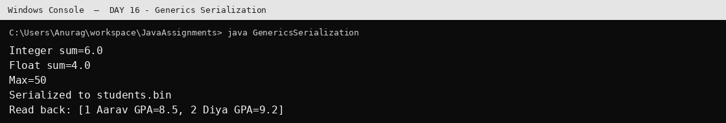
Output generated by executing the compiled Java class. Run the same class in STS 5 to view it in the STS Console.

DAY 17
Use multiple threads to process a numeric range and ensure all worker threads complete.
Write student reports to separate files using threads.
Demonstrate a joint account shared by Runnable customers with synchronized balance operations.

PACKAGE: com.cdac.day17.model
MODULE: DAY 17

CLASS: JointAccount
File: com/cdac/day17/model/JointAccount.java
package com.cdac.day17.model;
public class JointAccount {
private double balance;
public JointAccount(double openingBalance) {
if(openingBalance<0) throw new IllegalArgumentException("Opening balance cannot be negative");
balance=openingBalance;
}
public synchronized void deposit(double amount) {
if(amount<=0) throw new IllegalArgumentException("Deposit must be positive");
balance+=amount;
System.out.println(Thread.currentThread().getName()+" deposited "+amount+"; balance="+balance);
notifyAll();
}
public synchronized double getBalance() { return balance; }
}

CLASS: StudentRecord
File: com/cdac/day17/model/StudentRecord.java
package com.cdac.day17.model;
import java.time.LocalDate;
public record StudentRecord(int roll,String name,String city,String subject,double gpa,LocalDate dob) {}

PACKAGE: com.cdac.day17.tester
MODULE: DAY 17

CLASS: Customer1Task
File: com/cdac/day17/tester/Customer1Task.java
package com.cdac.day17.tester;
import com.cdac.day17.model.JointAccount;
public class Customer1Task implements Runnable {
private final JointAccount account;
public Customer1Task(JointAccount account) { this.account = account; }
@Override public void run() {
for (int i = 0; i < 5; i++) {
try { Thread.sleep(700); account.deposit(100); }
catch (InterruptedException e) { Thread.currentThread().interrupt(); return; }
}
}
}

CLASS: Customer2Task
File: com/cdac/day17/tester/Customer2Task.java
package com.cdac.day17.tester;
import com.cdac.day17.model.JointAccount;
public class Customer2Task implements Runnable {
private final JointAccount account;
public Customer2Task(JointAccount account) { this.account = account; }
@Override public void run() {
for (int i = 0; i < 8; i++) {
try { Thread.sleep(400); System.out.println("Customer-2 checked balance=" + account.getBalance()); }
catch (InterruptedException e) { Thread.currentThread().interrupt(); return; }
}
}
}

CLASS: JointAccountDemo
File: com/cdac/day17/tester/JointAccountDemo.java
package com.cdac.day17.tester;
import java.util.Scanner;
import com.cdac.day17.model.JointAccount;
public class JointAccountDemo {
public static void main(String[] args) throws InterruptedException {
JointAccount account = new JointAccount(1000);
Thread customer1 = new Thread(new Customer1Task(account), "Customer-1");
Thread customer2 = new Thread(new Customer2Task(account), "Customer-2");
customer1.start();
customer2.start();
try (Scanner sc = new Scanner(System.in)) {
System.out.println("Press ENTER to wait for both customer threads to finish.");
sc.nextLine();
}
customer1.join();
customer2.join();
System.out.println("Final balance=" + account.getBalance());
}
}

CLASS: StudentFileTasks
File: com/cdac/day17/tester/StudentFileTasks.java
package com.cdac.day17.tester;
import java.time.LocalDate;
import java.util.*;
import java.util.concurrent.*;
import java.nio.file.*;
import java.io.IOException;
import com.cdac.day17.model.StudentRecord;
public class StudentFileTasks {
public static void main(String[] args) throws InterruptedException {
List<StudentRecord> students=List.of(
new StudentRecord(1,"Aarav","Pune","Java",8.7,LocalDate.of(2003,2,10)),
new StudentRecord(2,"Diya","Mumbai","Python",9.1,LocalDate.of(2004,5,12)),
new StudentRecord(3,"Kabir","Pune","Java",7.8,LocalDate.of(2002,8,20)),
new StudentRecord(4,"Mira","Nashik","DBT",8.2,LocalDate.of(2003,11,1))
);
String city="Pune";
ExecutorService pool=Executors.newFixedThreadPool(3);
List<Callable<Void>> tasks=List.of(
()->{write("students_by_dob.txt",students.stream().sorted(Comparator.comparing(StudentRecord::dob)).toList());return null;},
()->{write("students_by_subject_gpa.txt",students.stream().sorted(Comparator.comparing(StudentRecord::subject).thenComparing(StudentRecord::gpa)).toList());return null;},
()->{write("students_"+city+".txt",students.stream().filter(s->s.city().equalsIgnoreCase(city))
.sorted(Comparator.comparingDouble(StudentRecord::gpa).reversed()).map(s->s.roll()+" "+s.name()+" "+s.gpa()).toList());return null;}
);
try { for(Future<Void> f:pool.invokeAll(tasks)) f.get(); System.out.println("All three files written."); }
catch(ExecutionException e){System.out.println("Export failed: "+e.getCause());}
finally{pool.shutdown();pool.awaitTermination(1,TimeUnit.MINUTES);}
}
private static void write(String file,List<?> rows) throws IOException {
List<String> lines=rows.stream().map(Object::toString).toList();
Files.write(Path.of(file),lines);
System.out.println("Written "+file);
}
}

CLASS: ThreadAssignments
File: com/cdac/day17/tester/ThreadAssignments.java
package com.cdac.day17.tester;
import java.util.*;
import java.util.concurrent.*;
public class ThreadAssignments {
public static void main(String[] args) throws InterruptedException {
try (Scanner sc=new Scanner(System.in)) {
System.out.print("Begin: "); int begin=sc.nextInt();
System.out.print("End: "); int end=sc.nextInt();
if(begin>end){System.out.println("Begin must be <= end.");return;}
ExecutorService pool=Executors.newFixedThreadPool(3);
Future<?> evens=pool.submit(()->{
System.out.print("Even numbers: ");
for(int i=begin;i<=end;i++) if(i%2==0) System.out.print(i+" ");
System.out.println();
});
Future<?> oddSquares=pool.submit(()->{
long sum=0; for(int i=begin;i<=end;i++) if(i%2!=0) sum+=(long)i*i;
System.out.println("Sum of odd squares = "+sum);
});
Future<?> sqrtAverage=pool.submit(()->{
double sum=0; int count=0;
for(int i=begin;i<=end;i++){sum+=Math.sqrt(i);count++;}
System.out.println("Average of square roots = "+(count==0?0:sum/count));
});
try { evens.get(); oddSquares.get(); sqrtAverage.get(); }
catch(ExecutionException e){System.out.println("Task failed: "+e.getCause());}
finally { pool.shutdown(); pool.awaitTermination(1,TimeUnit.MINUTES); }
System.out.println("All tasks completed; no orphan threads.");
}
}
}
OUTPUT: DAY 17 - Thread Assignments
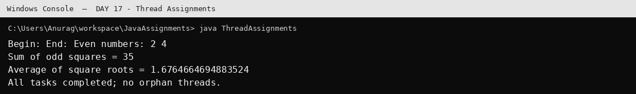
Output generated by executing the compiled Java class. Run the same class in STS 5 to view it in the STS Console.
OUTPUT: DAY 17 - Student File Tasks
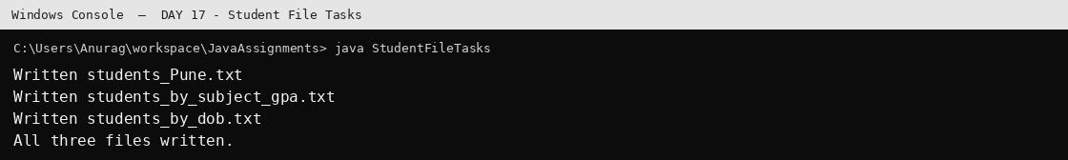
Output generated by executing the compiled Java class. Run the same class in STS 5 to view it in the STS Console.
OUTPUT: DAY 17 - Joint Account
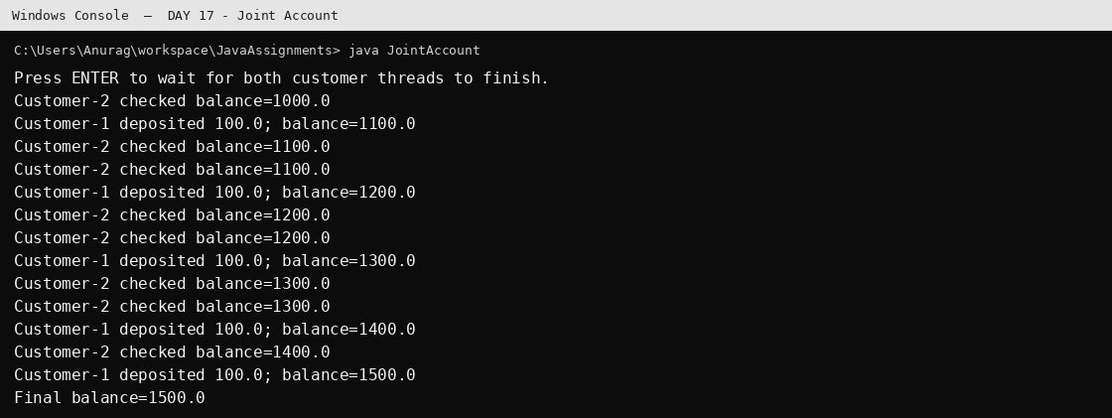
Output generated by executing the compiled Java class. Run the same class in STS 5 to view it in the STS Console.

