An AI-Assisted Smart Healthcare System Using 5G Communication
In propose work author combining latest technologies such as 5G network with AI algorithm to convert traditional health management system into smart health managements. Existing technologies were not supporting robust network connectivity and reliability to proves huge AI generated data so patients need to visit hospitals manually but latest 5G network support high connectivity and processing of AI mass data which enable all manual traditional works in to smart works such as Remote traffic monitoring, remote agriculture crop yield monitoring, smart patient healthcare monitoring and many more.
In propose paper author combining advances MIMO 5G network with AI algorithms to monitor patient smart health care system where IOT nodes obtain patient data from various body sensors and then send to nearest FOG nodes and this fog nodes will send all data to cloud servers for data processing and health prediction.
In paper author discussing about various fields where this 5G + AI algorithms can be applied to convert manual works to smart works. This fields includes Smart Healthcare, Autonomous vehicle traffic monitoring, Smart Cities 5G with AI, Industrial Automation AI-powered 5G networks, Smart Grids AI-driven 5G networks and many more.
In paper author evaluating propose 5G connectivity with various metrics such as PDR (packet delivery ratio), throughput and delay. Propose 5G network gaining PDR and throughput compare to 4G existing network for sending same amount of data. This evaluation were measured using IOT sensor network.
To predict health author has not given any specify AI algorithm and dataset for training and processing so we have used ‘Patient vital dataset’ to train AI SVM algorithm and then measured its performance in terms of accuracy and precision.
Patient Data Security
We don’t have real IOT sensors so we are using Random generated data as patient sensors IOT data and this Random data will be input to AI model to predict health status. All generated data and predicted values will be stored in MYSQL database which can be easily access by database administrator or hackers. So to provide security to such data we are applying data security algorithm on each generated data before saving to database.
Extension Concept
In paper author saying as future work he will improve AI algorithms by employing various enhancement techniques such as optimization, features selection, model hybridization etc. So as extension work we have employed hybrid AI by combining multiple algorithms such as Random Forest and XGBOOST and this hybrid model giving high accuracy compare to traditional AI algorithm.
Modules Information
To implement this project we have define two different applications such IOT simulation and web based IOT data access application to view patient data.
Simulation Application Modules
- Generate Smart Health IOT Network: using this module we can create IOT simulated networks which consists of Cloud Admin for data storage and processing, FOG nodes to accept data from IOT nodes and then IOT sensor nodes to collect patient data and then send to FOG nodes.
- Run AI Algorithm: this module will load and process dataset and then split data into train and test and then train AI model on training data and then evaluate performance using test data
- Transmit Sense Data: using this module we can generate random data as IOT sensing for any desired node and then send this data to FOG and ADMIN cloud node for storage. All generated data will be stored in cloud database server as encrypted format
- Throughput Graph: will plot PDR and throughput graph between propose and existing system
WEB based patient IOT data Access
- Homepage: using this module user can start home page of the application
- Access IOT Smart Health Data: using this module online patient can select his IOT ID and then system will fetch all vitals from cloud database and then display to patient in decrypted format. By seeing this records patient can know about his health.
SCREEN SHOTS
To run project install python 3.7.2 and then install all packages given in requirements.txt file and then install MYSQL database and then copy content from database.txt file and paste in MYSQL console to create database.
Now double click on ‘runSimulation.bat’ file to start simulation and then will get below page
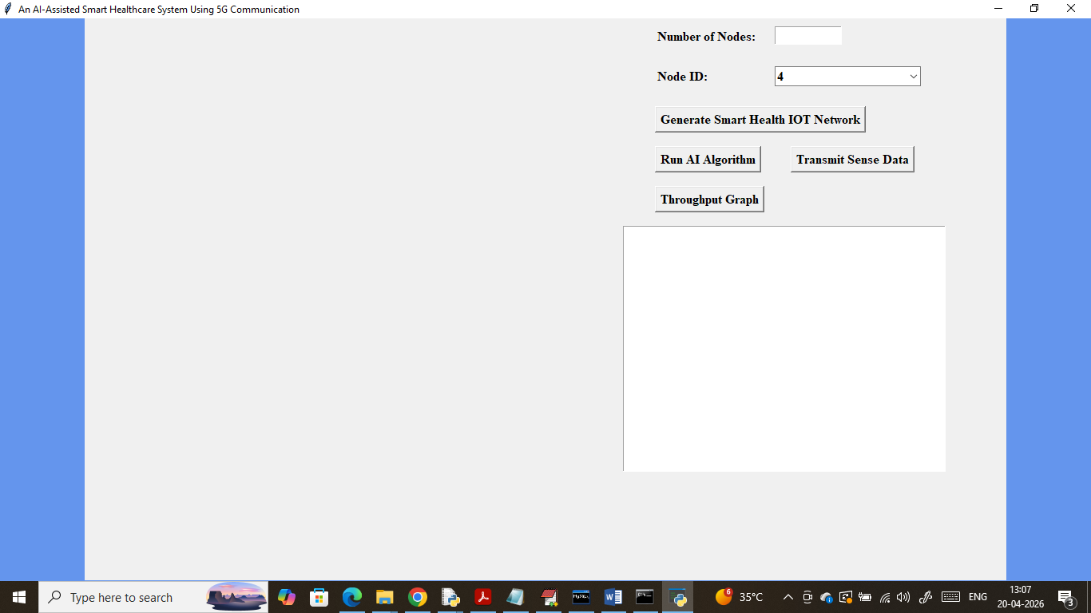
In above screen enter number of nodes in first text field
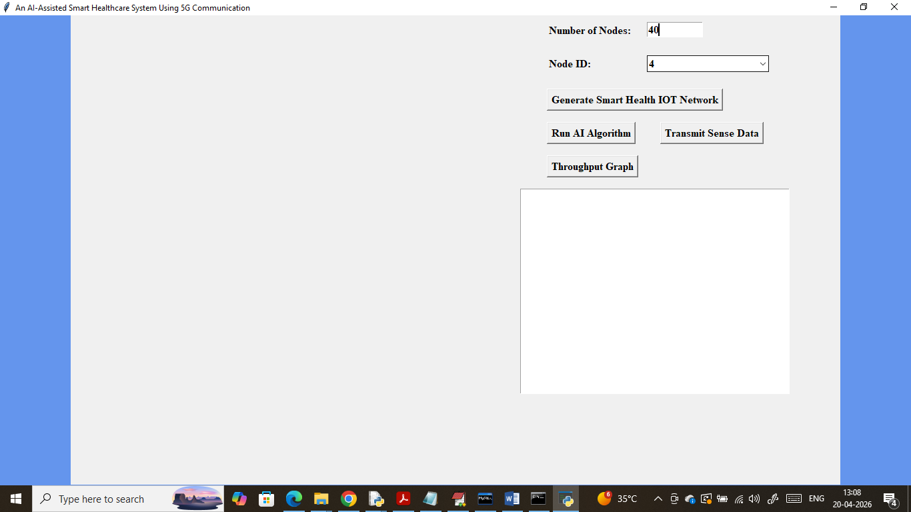
In above screen in first textfield I entered number of nodes as 40 and then click on ‘Generate Smart Health IOT Network’ button to get below page
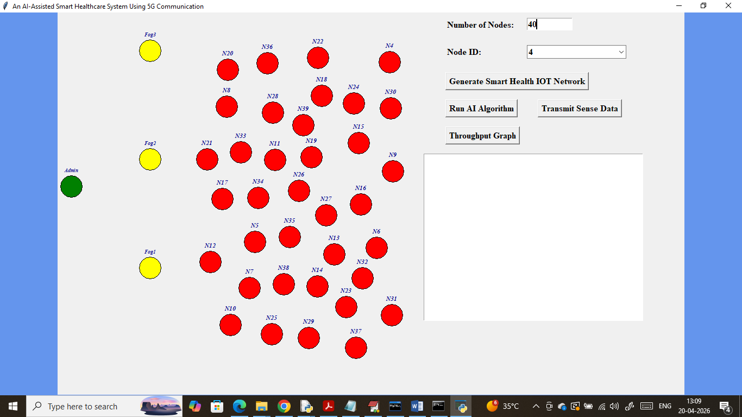
In above screen all red circles are the patient IOT nodes and yellow nodes are the FOG and green nodes are the cloud ADMIN for storage. Now click on ‘Run AI Algorithm’ button to train AI and then will get below page
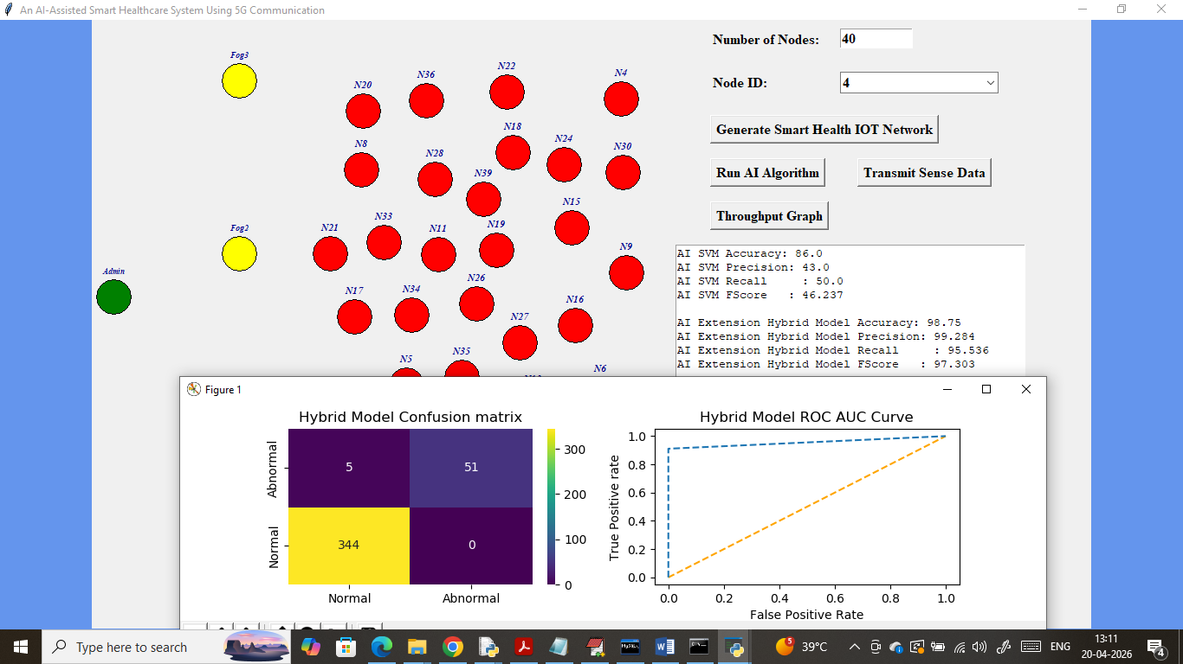
In above screen AI training completed where traditional AI SVM algorithm got 86% accuracy and extension hybrid model got 98% accuracy and can see other metrics like precision, recall and FSCORE. In above extension hybrid model confusion matrix graph x-axis represents Predicted Labels and y-axis represents True Labels and then dark blue and yellow colour boxes in diagonal represents correct prediction count and remaining all blue boxes represents incorrect prediction count which are very few. In ROC graph x-axis represents False Positive Rate and y-axis represents ‘True Positive Rate’. If blue line comes on top of orange line then all predictions are True else false. Now from drop down box select any IOT to send data
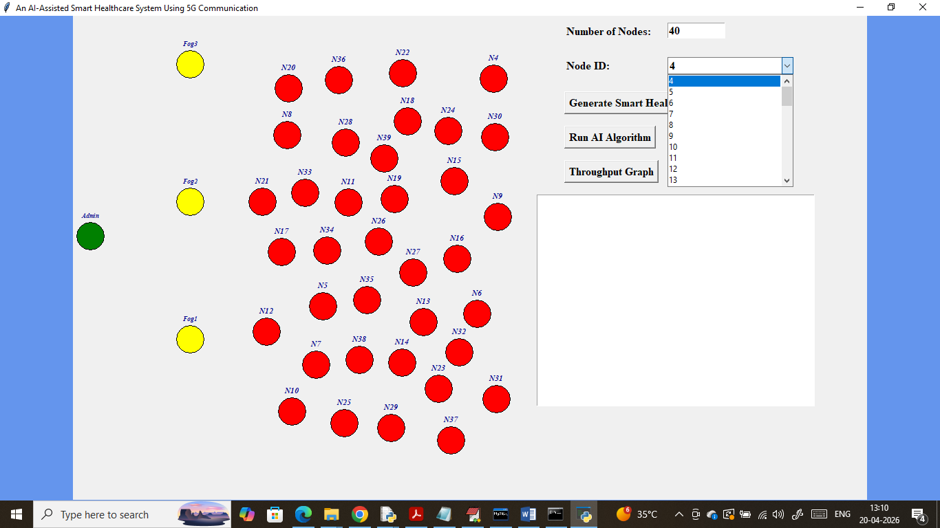
In above screen I am selecting IOT as 4 and then click on ‘Transmit Sense Data’ button to generate random data and then send to cloud
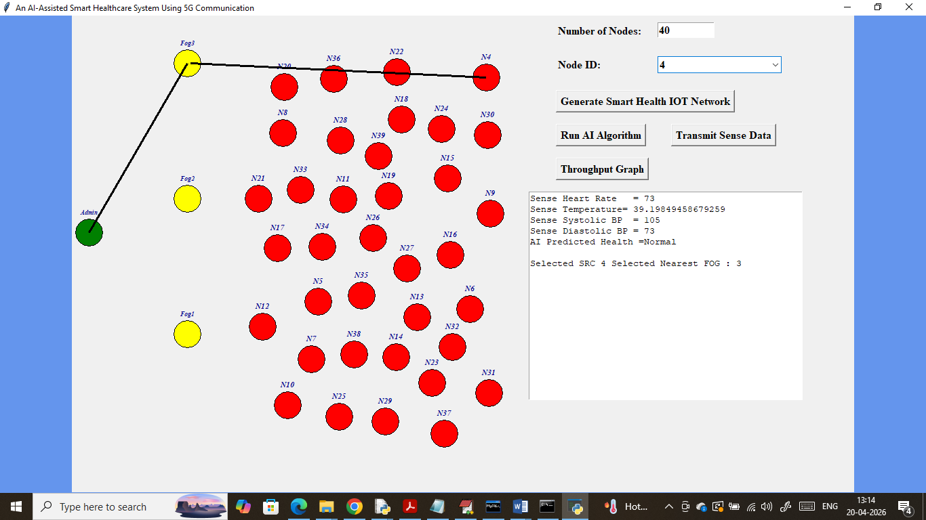
In above screen black connecting line indicating data sending from IOT to cloud using FOG node. In text area can see generated IOT random data such as Heart rate, temperature and BP and then AI predicted generated data as ‘Normal’ and then showing which nearest FOG selected to send data. Similarly you can select node and send data. in below screen showing another data sending
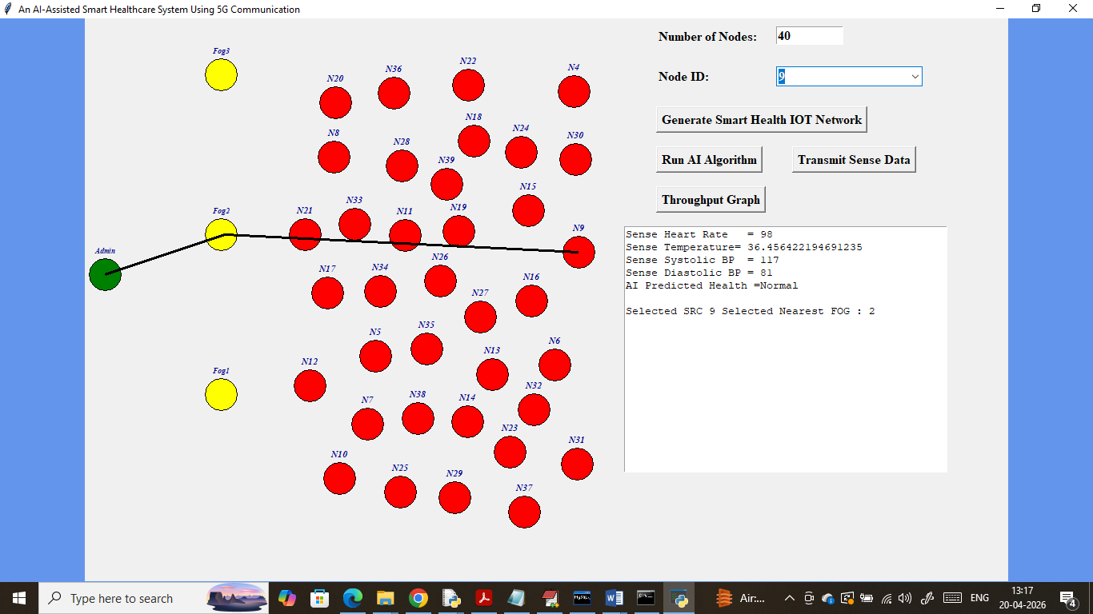
In above screen data sending from another IOT node
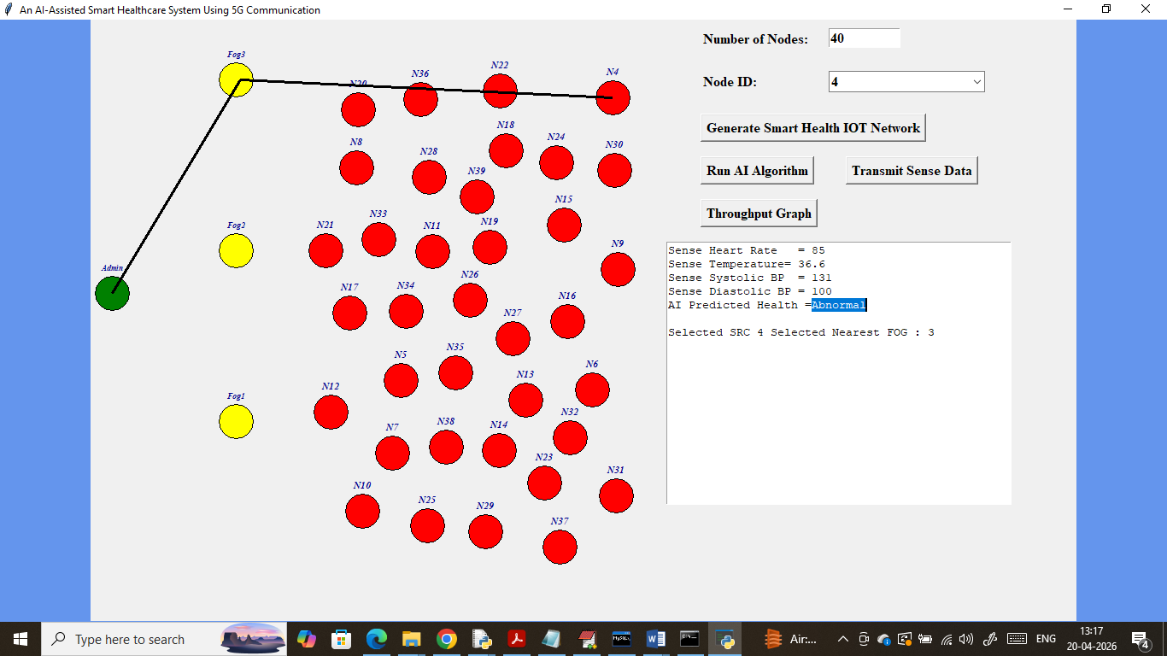
In above screen generated data is predicted as ‘Abnormal’ health. Now click on ‘Throughput Graph’ button to get below graph
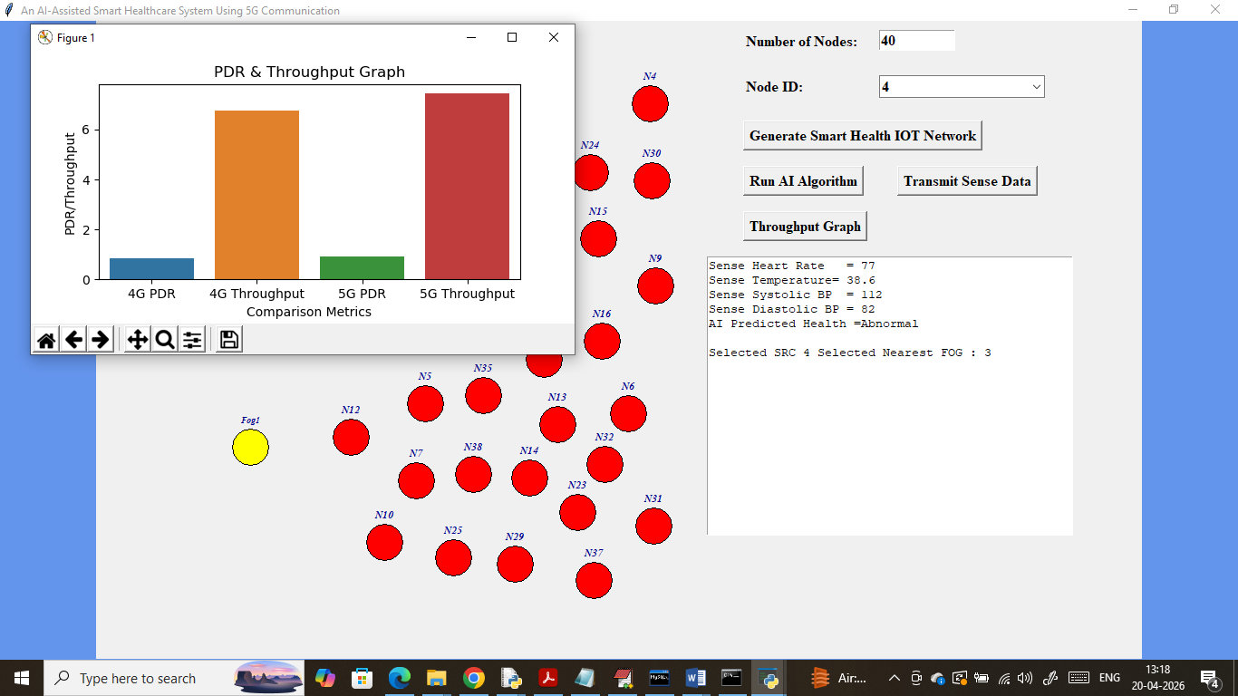
In above graph x-axis represents 4G and 5G PDR and throughput and y-axis represents values and in both networks 5G got high PDR and throughput.
Now we can check security of stored data in MYSQL by executing below query
Select * from patientdata;
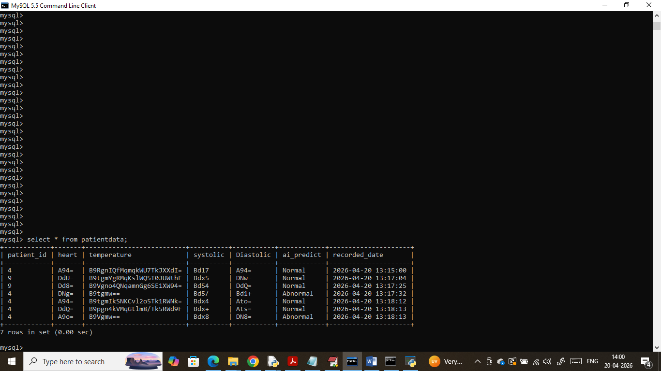
In above MYSQL records we can see all patient vital data is in encrypted format.
Now execute web application access above MYSQL data in plain format and to run web application double click on ‘runServer.bat’ file to get below page
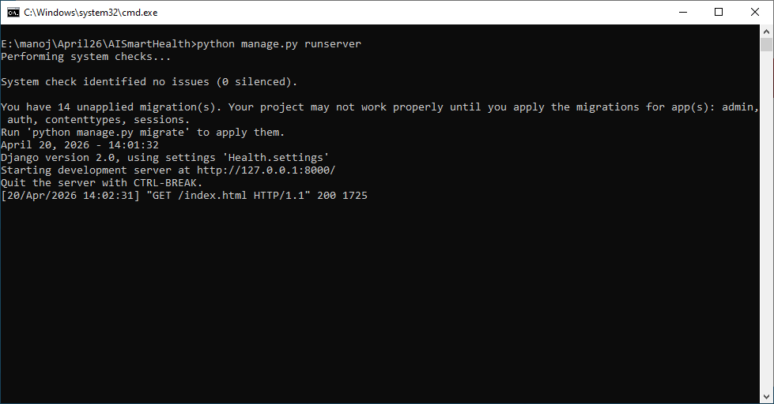
In above screen python server started and now open browser and enter URL as http://127.0.0.1:8000/index.html and then press enter key to get below page
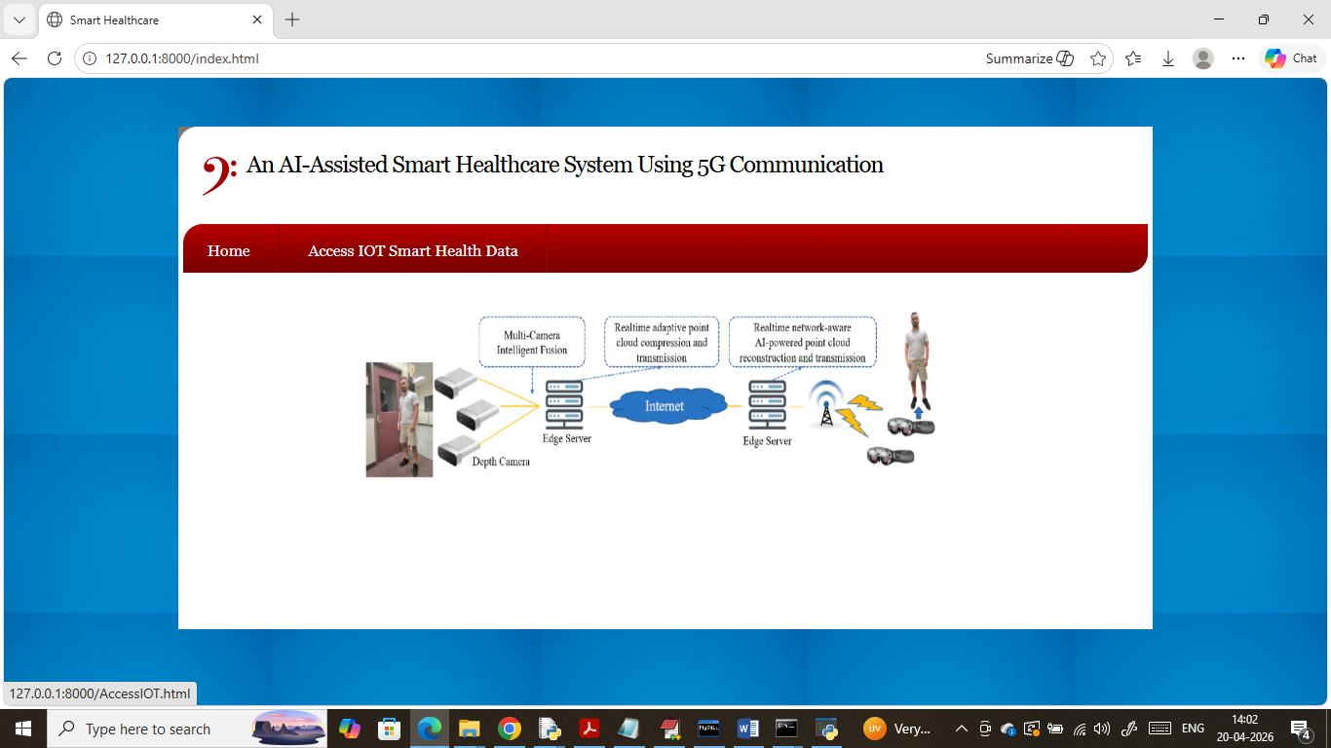
In above screen click on ‘Access IOT Smart Health Data’ link to get below page
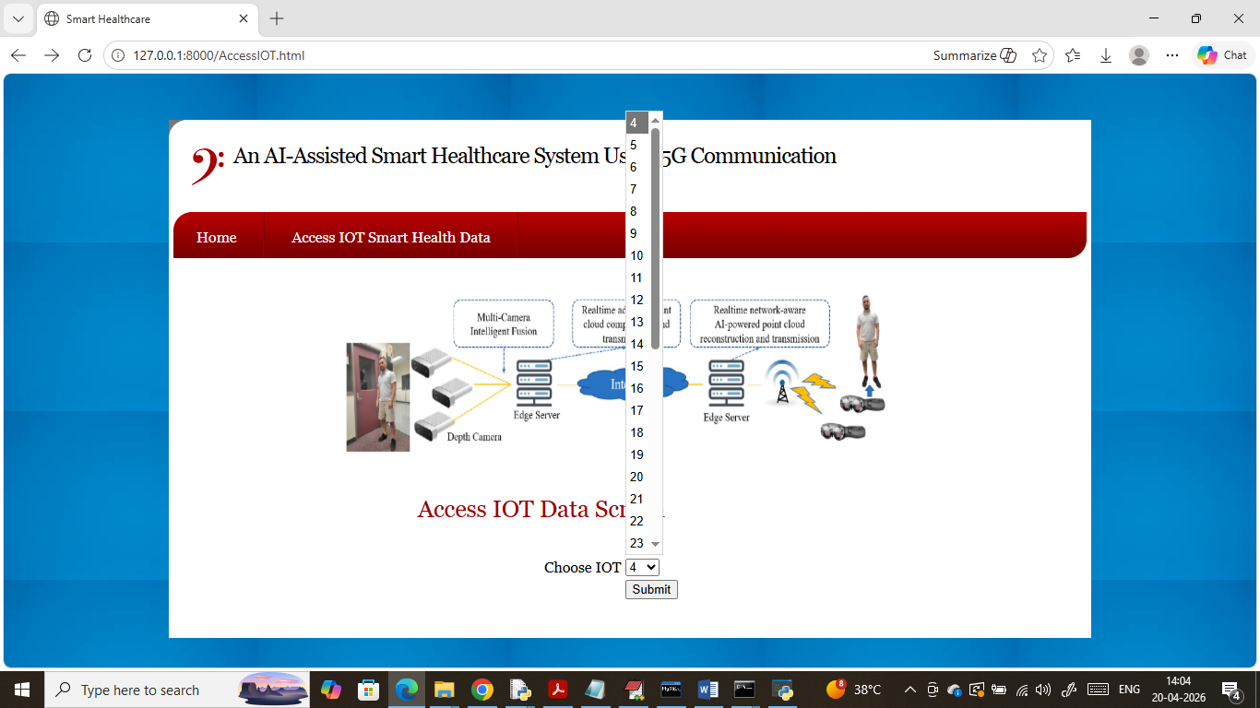
In above screen patient can select his IOT ID and then press button to get below page
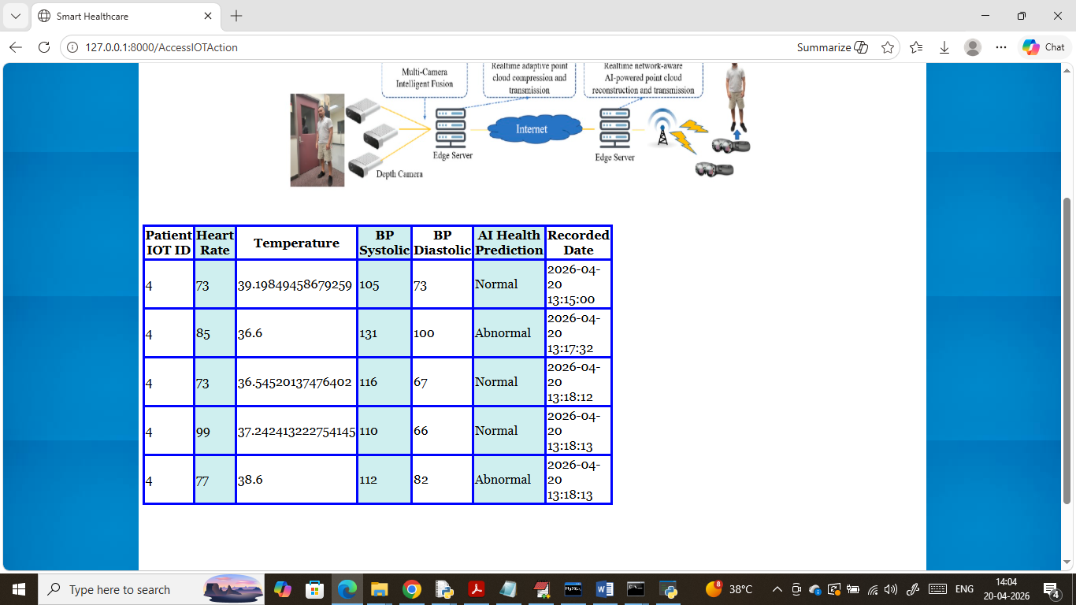
In above screen patient can view all his vitals in plain format with AI prediction as Normal or Abnormal health along with date and time.
So by using above application we can manage patient health virtual and smartly by using latest networks and AI algorithms.

