News Category Classification Using Machine Learning
B. Vanitha Vani
Department of Computer Science and Engineering
Email: vanithavanibellamkonda11@gmail.com

Abstract
The rapid growth of digital news has created a requirement for efficient methods of organizing large collections of textual information. News articles can belong to many categories, and manual classification is difficult to maintain when the volume of content increases. This project presents an automated News Category Classification system based on Natural Language Processing (NLP) and supervised machine learning. The system starts with the News_Category_Dataset_v3.json dataset, performs inspection and text preprocessing, and converts textual information into numerical features using Term Frequency-Inverse Document Frequency (TF-IDF). Three classification algorithms—Logistic Regression,

Multinomial Naive Bayes, and Linear Support Vector Machine—are trained and evaluated. The models are compared using Accuracy, Precision, Recall, F1-Score, and ROC-AUC. In addition to model development, the project preserves trained models and the TF-IDF vectorizer using Joblib and organizes source code, configuration, data, outputs, reports, tests, and logs into an MLOps-oriented directory structure. The final system provides a reproducible workflow for automatic news categorization and a foundation for future deployment.
Index Terms—News classification, Natural Language Processing, machine learning, TF-IDF, Logistic Regression, Naive Bayes, Linear SVM, ROC-AUC, MLOps.

I. INTRODUCTION
News portals publish thousands of articles covering politics, entertainment, sports, technology, business, science, lifestyle, and many other subjects. A news category provides an important organizational label that can be used for search, recommendation, filtering, personalization, and analytics. However, assigning these labels manually requires time and human effort.
Text classification provides a practical solution to this problem. In a supervised learning setting, a model is trained using previously categorized articles and learns statistical patterns associated with each category. After training, the model can predict the category of previously unseen news content.
The present project implements this complete workflow using Python. The work is not limited to training a single model; it compares several algorithms, evaluates their performance, saves the trained artifacts, and organizes the implementation so that it can later be converted into a reusable production pipeline.

II. MOTIVATION
The motivation for this project is to demonstrate how machine learning can reduce repetitive content-management tasks. An effective classifier can help automatically route incoming articles to appropriate categories. It can also provide a baseline for more advanced systems such as recommendation engines, semantic search, content dashboards, and automated editorial workflows.
Another motivation is reproducibility. A machine learning experiment is more useful when the dataset path, preprocessing decisions, feature-extraction parameters, models, evaluation results, and execution artifacts are organized clearly. Therefore, this project follows an MLOps-oriented structure in addition to the notebook-based experimental workflow.

III. PROBLEM STATEMENT
The problem addressed by this project is the automatic classification of news articles into their predefined categories based on textual information. Given the textual content of an article, the system must learn from labeled examples and predict the most appropriate category for unseen data.
The system must also provide measurable evidence of performance. Therefore, multiple models are trained under the same experimental conditions and compared using standard classification metrics. The selected model should be chosen from the actual experimental results rather than from an assumption about which algorithm is best.

IV. OBJECTIVES
- Load the News_Category_Dataset_v3.json dataset correctly from the raw-data directory.
- Inspect the dataset structure, available fields, category labels, and representative records.
- Clean and normalize the text before feature extraction.
- Create a reproducible training/testing split.
- Convert textual documents into numerical TF-IDF feature vectors.
- Train Logistic Regression, Multinomial Naive Bayes, and Linear SVM classifiers.
- Evaluate the classifiers using Accuracy, Precision, Recall, F1-Score, and ROC-AUC.
- Create clear visualizations for category distribution and model comparison.
- Save trained models and the TF-IDF vectorizer for future inference.
- Organize the project using configuration, source-code, testing, logging, output, and report directories.

V. DATASET DESCRIPTION
The project uses the News_Category_Dataset_v3.json dataset. The raw dataset is maintained under data/raw so that the original data is not modified during experimentation. The category field provides the target label, while relevant textual fields such as headline and description are used to construct the input representation.
Before training, the dataset is inspected to understand the number of records, column names, missing values, and distribution of labels. This inspection is important because class imbalance or incomplete text fields can affect model performance and interpretation.
A processed representation may be stored under data/processed. Keeping raw and processed data separate improves traceability because the original dataset can always be recovered and the preprocessing stage can be repeated.

VI. DATA PREPROCESSING

A. Text Cleaning
Raw news text can contain capitalization differences, URLs, punctuation, and inconsistent whitespace. The preprocessing stage normalizes the text so that the feature extractor focuses on useful lexical information. The implemented workflow includes lowercase conversion, URL removal, removal of unwanted characters, and whitespace normalization.

B. Text Construction
The relevant text fields are combined to provide the classifier with sufficient information. Combining headline and description can capture both the main topic of an article and additional context. The resulting cleaned text becomes the input to TF-IDF.

C. Label Preparation
The category field is converted into the target label representation used by the supervised learning algorithms. The project also checks the unique categories and their frequencies before training.

VII. TRAIN-TEST SPLIT
The dataset is divided into training and testing subsets. The training portion is used to learn the vocabulary and model parameters, while the testing portion is kept separate until evaluation. The project uses a test size of 20 percent and random_state=42, providing a reproducible split.
Separating training and testing data is essential because evaluating a model on the same records used for learning can produce overly optimistic results. The test set therefore provides an independent estimate of how the trained classifier performs on unseen articles.

VIII. TF-IDF FEATURE ENGINEERING
Machine learning algorithms cannot directly operate on raw sentences. The TF-IDF method transforms each document into a numerical vector. A term receives a higher weight when it is important to a document but relatively uncommon across the full collection.
The configured vectorizer uses unigram and bigram features, allowing the model to capture both individual words and two-word combinations. The project configuration uses up to 50,000 features, min_df=2, and max_df=0.95. These settings limit extremely rare and extremely common terms while controlling the dimensionality of the sparse feature matrix.
The vectorizer is fitted only on the training text. The learned vectorizer is then used to transform both training and testing text. This prevents information from the test set from influencing the feature-learning stage.

IX. MACHINE LEARNING MODELS

A. Logistic Regression
Logistic Regression is used as a strong linear baseline for multi-class text classification. With sparse TF-IDF features, the algorithm can learn weighted relationships between terms and target categories. Its probabilistic output also makes it useful for ROC-AUC analysis.

B. Multinomial Naive Bayes
Multinomial Naive Bayes is a probabilistic classifier that is widely used for document classification. It makes a conditional-independence assumption about features, which is a simplification but often performs effectively on high-dimensional text representations.

C. Linear Support Vector Machine
Linear SVM learns a decision boundary that attempts to maximize the separation between classes. It is particularly appropriate for high-dimensional sparse text data. The LinearSVC implementation is used in the project as a strong discriminative model.

X. MODEL TRAINING
Each classifier is trained using the same TF-IDF training matrix and target labels. Training results are retained so that the models can be evaluated consistently on the same test set. The experiment compares the models rather than relying on a single algorithm.
After training, the models are serialized with Joblib. The saved artifacts include logistic_regression.pkl, naive_bayes.pkl, linear_svm.pkl, and tfidf_vectorizer.pkl. These files allow the trained pipeline components to be loaded later without repeating the complete training process.

XI. EVALUATION METRICS

A. Accuracy
Accuracy represents the proportion of test examples that receive the correct category prediction. It is intuitive but should be interpreted together with other metrics, especially when category frequencies are not identical.

B. Precision
Precision measures how often predictions assigned to a class are correct. Weighted precision provides an overall score while accounting for the number of samples in each class.

C. Recall
Recall measures how effectively the model identifies examples that actually belong to each class. Weighted recall summarizes the performance across all categories.

D. F1-Score
F1-Score is the harmonic mean of Precision and Recall. It is useful when both types of classification error matter and provides a balanced summary of predictive performance.

E. ROC-AUC
ROC-AUC evaluates how well a model separates classes across different decision thresholds. For multi-class classification, a one-vs-rest strategy can be used to obtain an aggregate score. The project records ROC-AUC values separately so that model discrimination can be compared.

XII. EXPERIMENTAL RESULTS
The exact numerical results must be copied from the final notebook output or the generated CSV files. The following table is intentionally prepared for the project's actual values and should not be populated with estimated numbers.

Model | Accuracy | Precision | Recall | F1 | ROC-AUC
Logistic Regression | 0.602945 | 0.600484 | 0.602945 | 0.572937 | 0.957125
Naive Bayes | 0.458669 | 0.582339 | 0.458669 | 0.365576 | 0.928967
Linear SVM | 0.604806 | 0.587443 | 0.604806 | 0.589741 | 0.940726
TABLE I. PERFORMANCE COMPARISON OF CLASSIFICATION MODELS.

XIII. VISUALIZATION AND INTERPRETATION
Visual analysis provides a more understandable view of the experimental results. The category distribution chart shows whether some news categories contain substantially more articles than others. This is useful when interpreting aggregate evaluation metrics.
The model performance chart compares the major classification metrics across algorithms. A confusion matrix provides category-level information by showing which classes are correctly classified and which classes are frequently confused. The ROC-AUC chart provides an additional comparison of the models' class-separation capability.
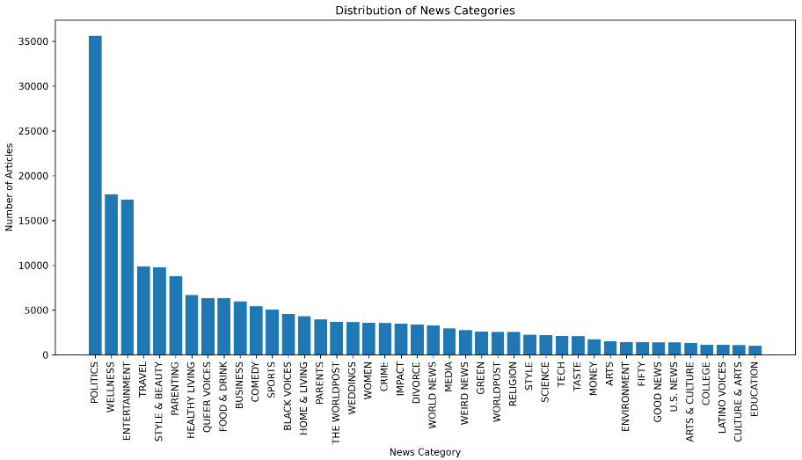
Fig. 1. News category distribution across the dataset.
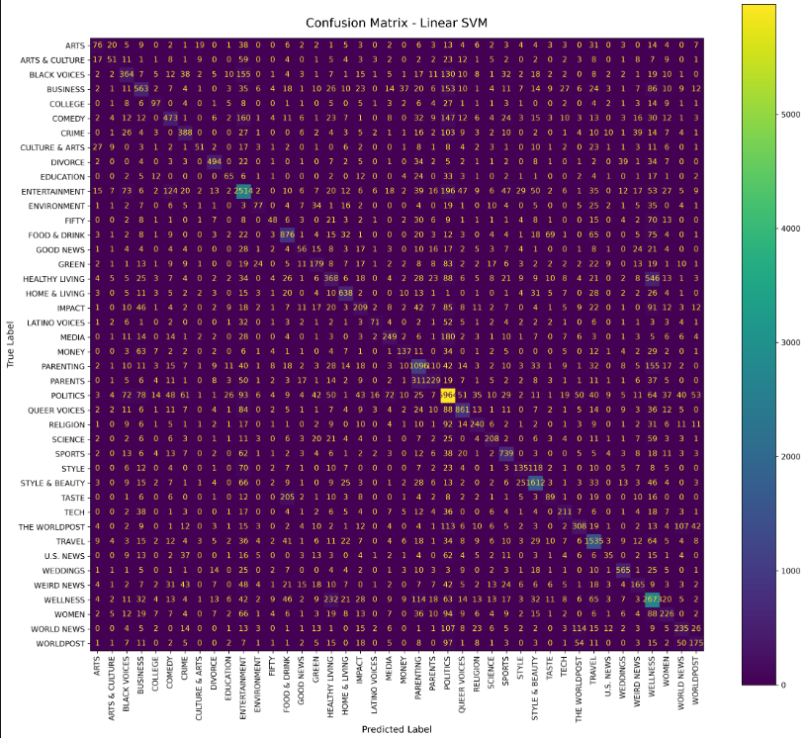
Fig. 2. Accuracy, Precision, Recall, and F1-Score comparison.
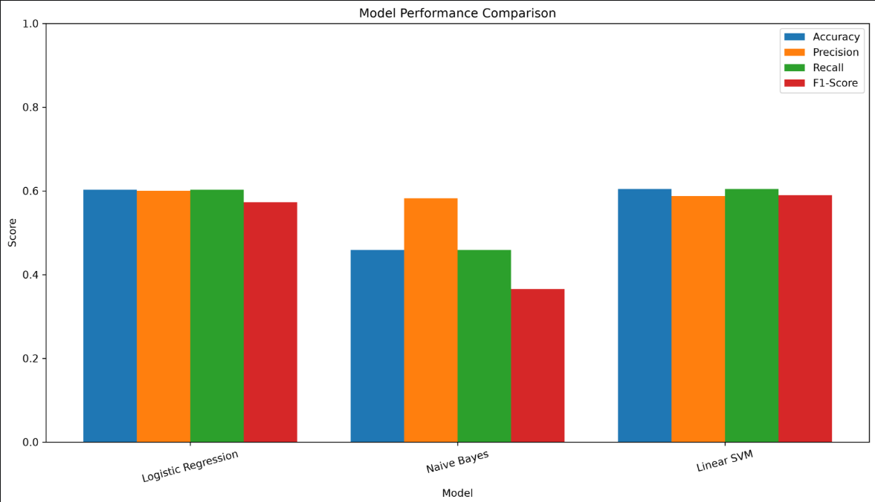
Fig. 3. Confusion matrix of the selected best-performing model.
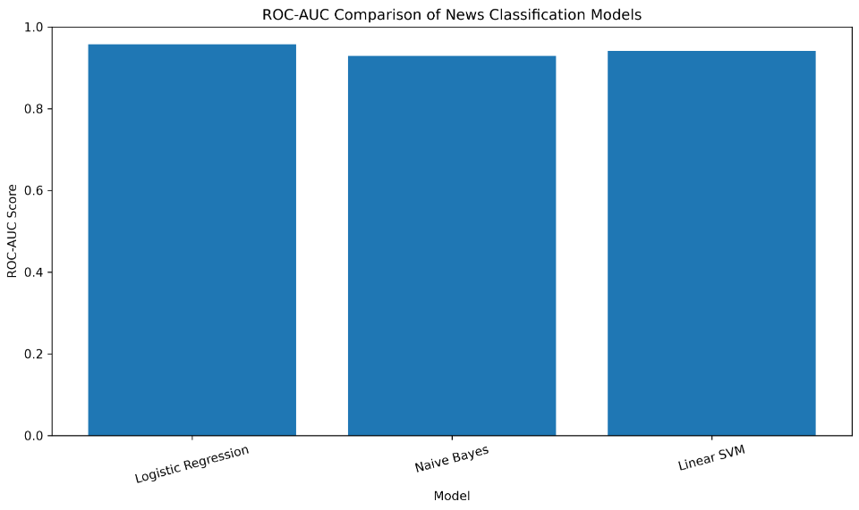
Fig. 4. ROC-AUC comparison of the trained models.

XIV. ERROR ANALYSIS
Classification errors are expected when two categories contain similar vocabulary or when an article discusses multiple topics. For example, an article may contain terms associated with business and technology at the same time. The confusion matrix can be used to identify these patterns and guide future improvements.
Additional error analysis can examine misclassified headlines, category-specific precision and recall, and the most informative terms for individual classes. Such analysis is useful for understanding whether errors originate from ambiguous content, insufficient text, class imbalance, or limitations of the chosen feature representation.

XV. MLOPS PROJECT STRUCTURE
The project is organized to separate experimentation from reusable implementation and generated artifacts. This structure makes it easier to maintain the project and supports future automation.
News_Category_Classification/
├── configs/
│ └── config.yaml
├── data/
│ ├── raw/
│ └── processed/
├── notebooks/
│ └── project_implementation.ipynb
├── src/
│ ├── preprocess.py
│ ├── train.py
│ ├── evaluate.py
│ └── predict.py
├── models/
├── outputs/
├── reports/
├── tests/
├── logs/
├── venv/
└── requirements.txt

XVI. CONFIGURATION MANAGEMENT
The configuration file is used to keep important project parameters in one location rather than hard-coding them throughout the implementation. Dataset paths, output locations, random state, test size, TF-IDF parameters, and model settings can be controlled through configuration.
Centralized configuration improves reproducibility because another user can understand which parameters were used without searching through many notebook cells.

XVII. MODEL PERSISTENCE
The trained models and vectorizer are stored in the models directory as Joblib files. The saved artifacts allow the prediction stage to load the already-trained components. This separation between training and inference is an important step toward deploying the classifier as a reusable application.

XVIII. TESTING
The tests directory is reserved for automated checks of reusable functions. Preprocessing tests can verify expected text-cleaning behavior, while future integration tests can verify that the complete prediction pipeline loads the vectorizer and model correctly.
Testing is important because changes to preprocessing can affect the feature representation and therefore the compatibility of saved models. Automated tests reduce the risk of introducing silent errors when the project is modified.

XIX. LOGGING AND TRACEABILITY
The logs directory is used to record training and execution information. A useful training log can record the start and end of training, dataset size, model name, important parameters, and evaluation completion status. Logs should contain actual execution information and should not be populated with invented metrics.

XX. LIMITATIONS
The current system relies primarily on lexical TF-IDF features. TF-IDF does not fully capture semantic meaning, word order beyond the configured n-grams, or deeper contextual relationships. Articles discussing similar subjects can therefore be difficult to separate.
The project also depends on the quality and distribution of the labeled dataset. If some categories are underrepresented or if category definitions overlap, performance can vary across classes.

XXI. FUTURE ENHANCEMENTS
- Experiment with word and character n-grams and alternative feature-selection strategies.
- Evaluate transformer-based models such as BERT-family architectures when additional computational resources are available.
- Add systematic hyperparameter tuning and experiment tracking.
- Create a reusable prediction API or web interface.
- Add automated data validation and schema checks.
- Add CI-based automated testing.
- Containerize the application with Docker.
- Implement model versioning, monitoring, and scheduled retraining.
- Track data drift and category-level performance after deployment.

XXII. CONCLUSION
This project presents a complete machine learning workflow for automatic news category classification. Starting from the News_Category_Dataset_v3.json dataset, the workflow performs data inspection, text preprocessing, reproducible train-test splitting, TF-IDF feature extraction, training of three supervised classification algorithms, and quantitative evaluation.
The project further extends the experimental workflow with visualization, model persistence, configuration management, testing, logging, and a structured directory layout. The resulting implementation provides both a practical classifier and a foundation for a more production-ready MLOps pipeline.

REFERENCES
[1] C. D. Manning, P. Raghavan, and H. Schütze, Introduction to Information Retrieval. Cambridge, U.K.: Cambridge University Press, 2008.
[2] F. Pedregosa et al., “Scikit-learn: Machine Learning in Python,” Journal of Machine Learning Research, vol. 12, pp. 2825–2830, 2011.
[3] T. Hastie, R. Tibshirani, and J. Friedman, The Elements of Statistical Learning, 2nd ed. New York, NY, USA: Springer, 2009.
[4] T. Joachims, “Text categorization with support vector machines: Learning with many relevant features,” in Proc. European Conf. Machine Learning, 1998, pp. 137–142.
[5] A. McCallum and K. Nigam, “A comparison of event models for naive Bayes text classification,” in Proc. AAAI-98 Workshop on Learning for Text Categorization, 1998, pp. 41–48.
[6] F. Sebastiani, “Machine learning in automated text categorization,” ACM Computing Surveys, vol. 34, no. 1, pp. 1–47, 2002.

