Phone Pe Transaction Insights
- Overview:
This project aims to analyze PhonePe's digital payment transactions data to uncover trends, user engagement, and insurance adoption assqcross geographical distribution to enhance services. Using Python, Pandas, SQL(MySQL), Streamlit, and Plotly, we'll extract insights from PhonePe Pulse GitHub data.
Deliverables:
- Extract the data source from GitHub Json format.
- Clean data using python/pandas and convert to data frame and store in MySQL DB.
- Prepare MySQL schema and for efficient querying.
- Create the streamlit application dashboard for visualization.
- Business Case study data exploration and analysis.
- Project documentation.

- Objectives
- Identify the transaction behavior across the states, quarters and payment categories for growth and decline.
- Identify device dominance and user engagement analysis to improve app performance.
- Insurance transaction analysis to identify top states, districts, pin codes.
- User registration analysis to provide insights for user engagement pattern and potential growth areas.
- Transaction analysis across states and districts

- Data Source and Extraction
- Data source: GitHub phone pe plus dataset.
- Data Extraction: Data extracted using python.
- Data Stored: Data loaded into MySQL phonepe database via notebook1.ipynb
- Data Visualization/App Development: Developing a dashboard using Streamlit, Plotly.
Tables creation:
- Data base created.
- 9 Tables are created using MySQL schemas and inserted data into the table.
- Agg_transcations
- Agg_user
- Agg_insurance
- Map_user
- Map_transcation
- Map_insuracnce
- Top insurance
- Top transactions
- Top users

- Data Analysis and Visualization (Insights)
- Top Insights: Top states transactions, transaction types (Merchant), and active users, App Opens
- Trends: Quarterly/yearly growth in transaction volume and value
- Visual Insights.

Home Page:

I have created side bar and created 4 radio buttons and their names Home, all_Datas,Data_Visulization,Top_charts and created Filter as well.

In home page I have created choropleth map in that I have visualized registered states across the map.

Next i created side bar on the right side in that I showed registered user for top state, district, pin code.

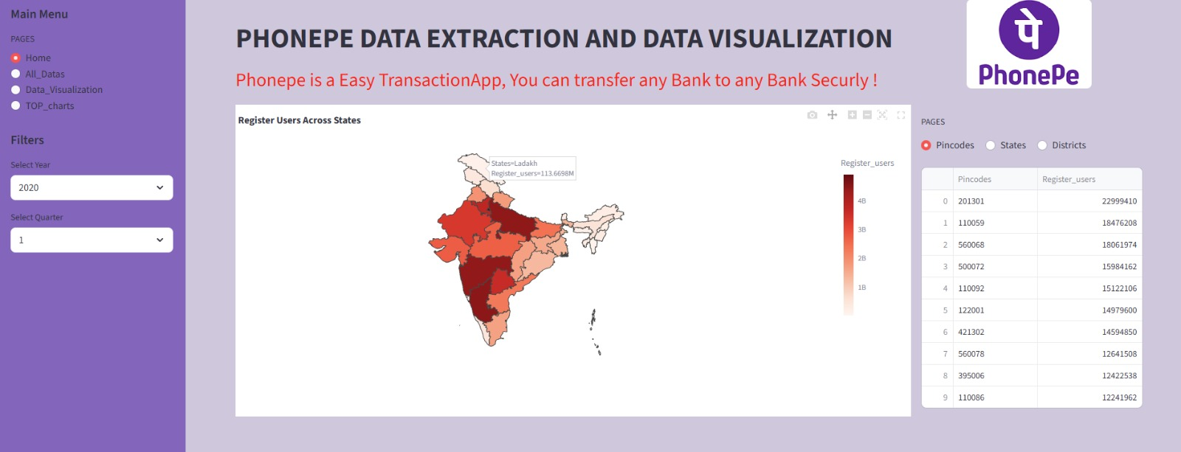

All Data:
Data cloned from github and stored in my local system then I extracted the data from the json file and created 9 different kind of data frames

Data Frames names:
- Agg_transcations
- Agg_user
- Agg_insurance
- Map_user
- Map_transcation
- Map_insuracnce
- Top insurance
- Top transactions
- Top users

Next, I have integrated mysql and python using mysql connector in python. Then I created one database in that I have created 9 tables and stored all the data in the table.

Then I populated data using streamlit application. Created one drop down menu to select years.

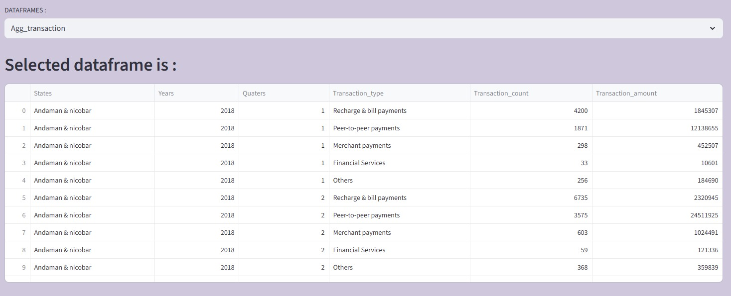

Business case Problems:
- Decoding transaction dynamics on phone pe.

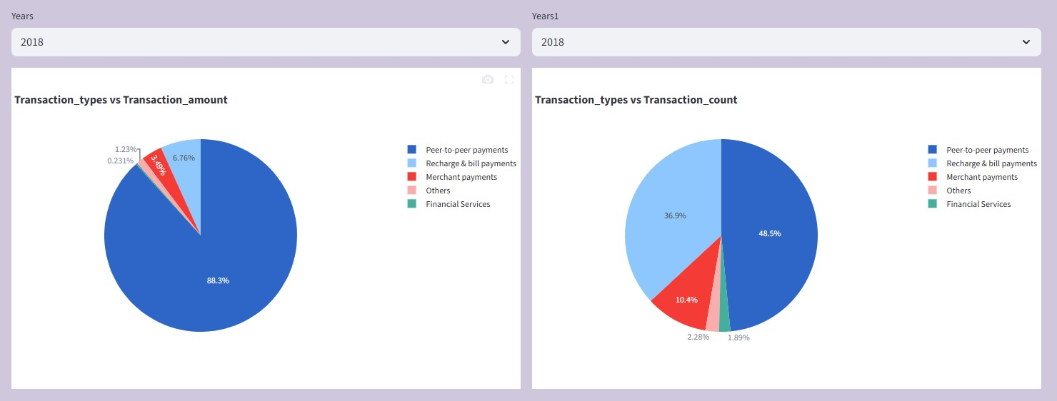

Transaction_Types vs Transaction_amounts vs Transaction_count

We can find here the truncation types which are mostly done using phone pe.
First one is peer-to-peer transaction type where most of transaction is done using this payment category, total value by money.

State wise transaction amount and count.
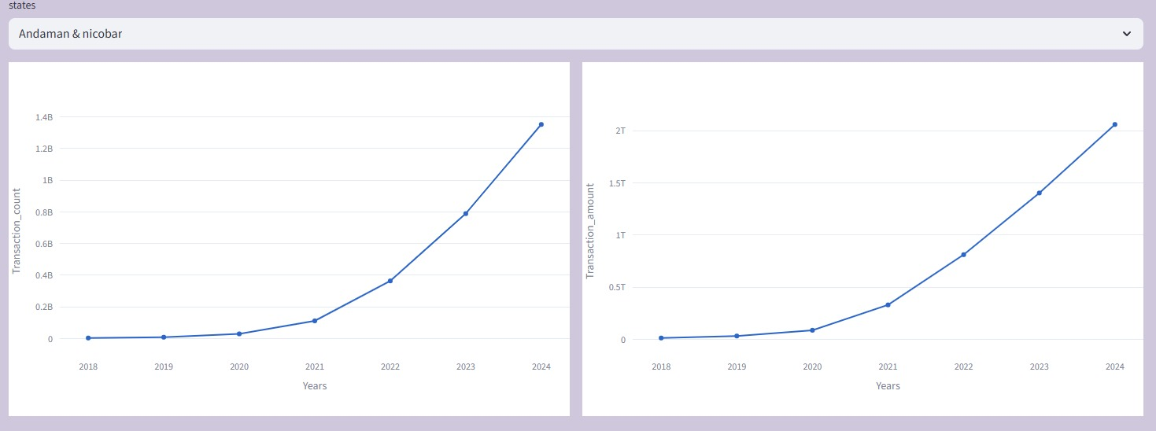
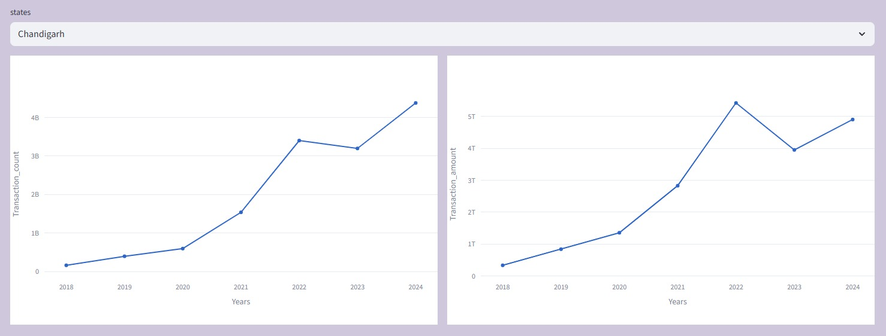

For example, you see above the plot for growth and decline status region wise.

- Device dominance and user Engagement analysis
We can find here the device dominance and user engagement with device model and app opens.

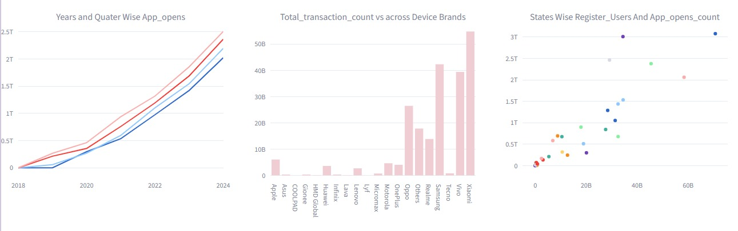

We can find in the line plot for the app opens usage in year and quarter analysis. We can see each year and in Q4 where app utilized more percentage.

Also, we can see the device dominance in the device plot. Where Xiaomi brand is the device dominance brand.

- Insurance Transcation Analysis.

We ca see in the above plot for top state, top district, top pin code code where most insurance transactions are done during specific quarter year combination.

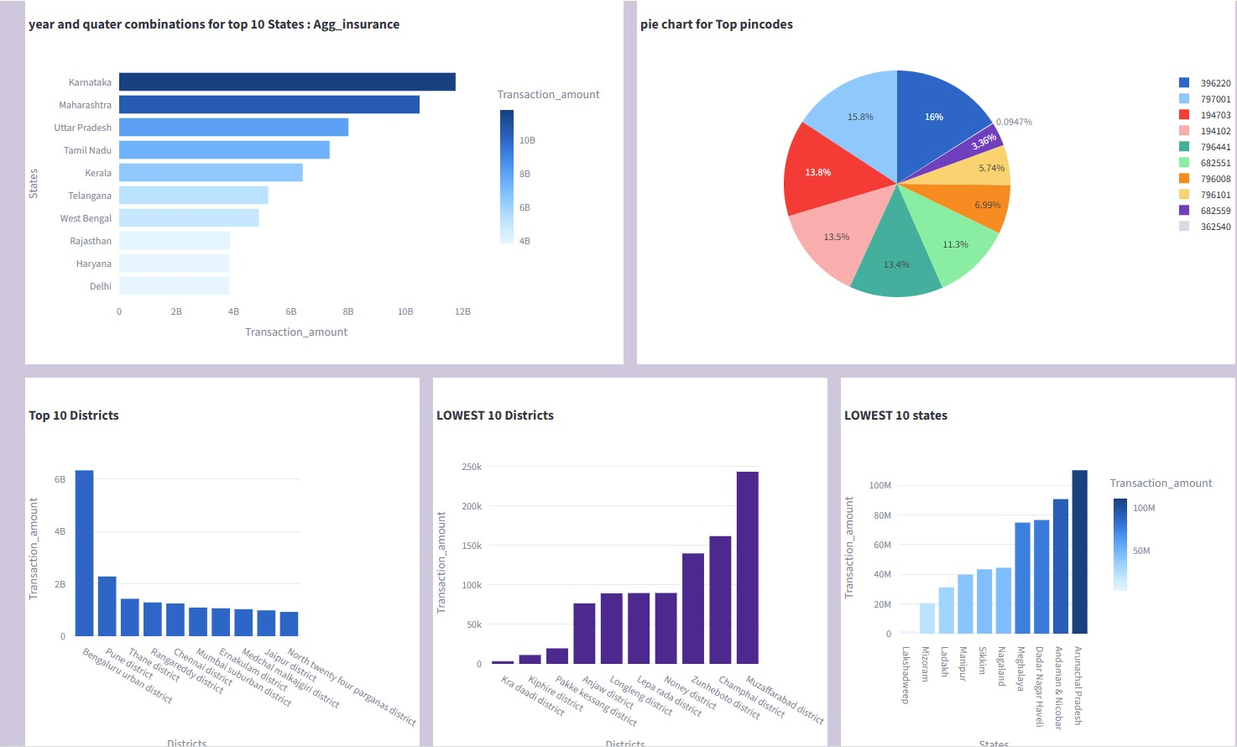

- User Registration Analysis.

We can find in the below plot for top state, district, pin code user registered during specific year quarter combinations.
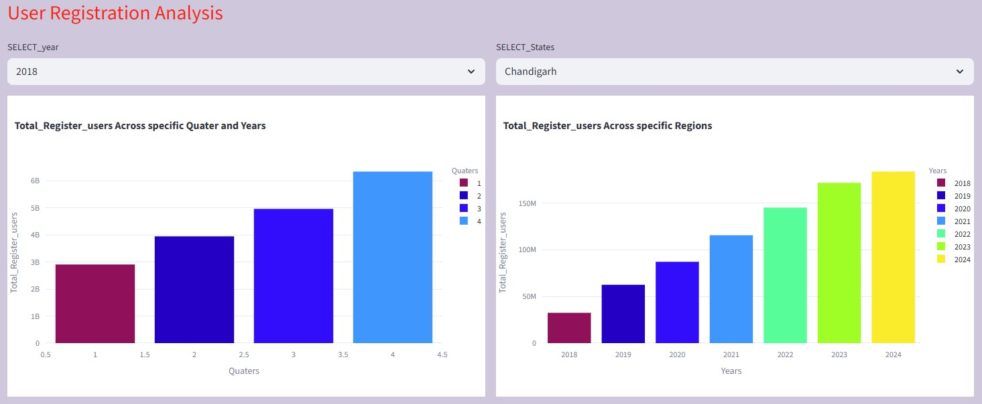
Top 10 pin code user registration status.
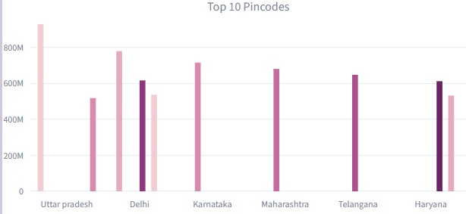
- Transaction Analysis volume and value.
We can find below plot for top 10 states, district, pin code status for insurance transaction volume and count.
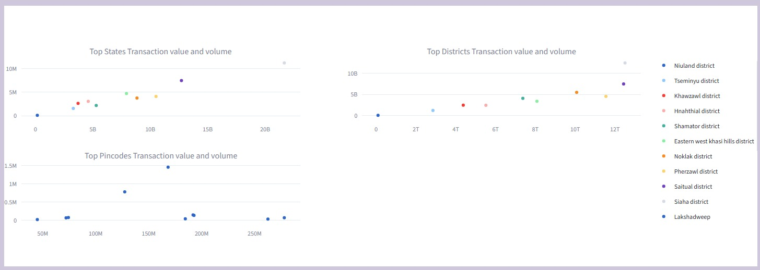
Total transaction count and volume year wise in the below plot.
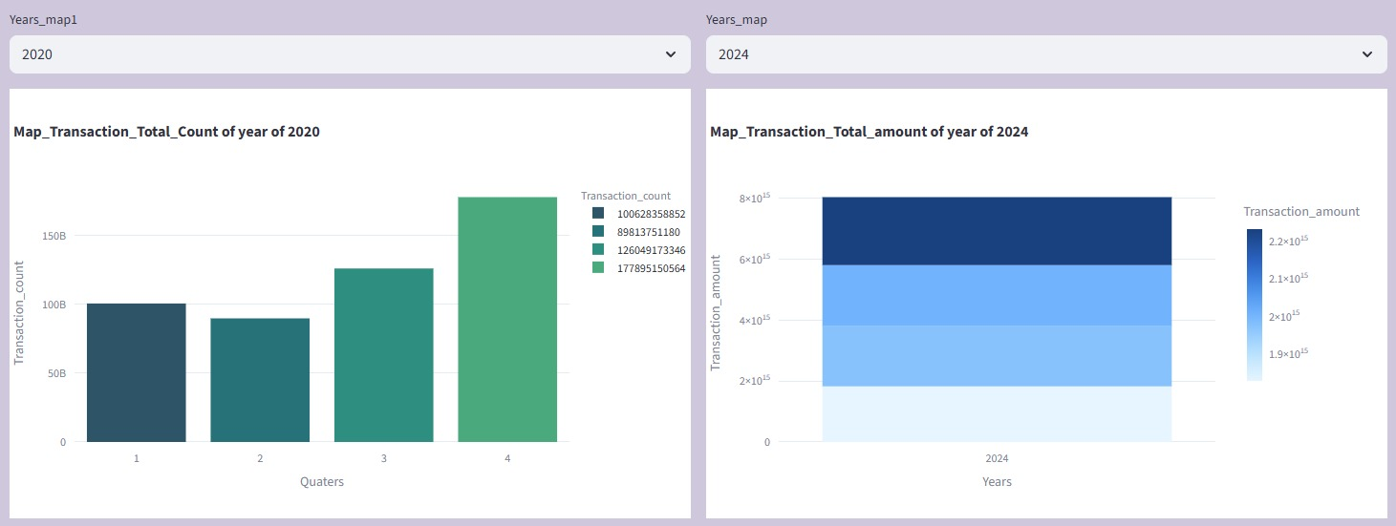
- Project Deliverables
- Interactive Dashboard: A web-based application (Streamlit) featuring map visualizations, bar charts, and dropdown filters for year and quarter.
- Data Insights Report: A summary document detailing findings on user behavior and transaction patterns.

- Tools & Technologies Detail
- Programming Language: Python
- Data Handling: Pandas
- Database: SQL
- Visualization/Dashboarding: Streamlit, Plotly
- Version Control: GitHub

- How to Run Project Code.
Prerequisite.
- Need a visual studio code env
- Python Version 3.13
- Install Library: Streamlit, Pandas, ploty, MySQL-connector-python
- Install MySQL DB
- Python file : phonepe.py, notebook1.ipynb

- Conclusion
- Conclusion: Summarize the effectiveness of the interactive dashboard in providing actionable insights.

