ReactJs:
React JS is a JavaScript library for creating user interfaces, making development of UI components easy and modular.
React JS was created by Jordan Walke, a software engineer at Facebook and open sourced to the world by Facebook and Instagram.

The key features of React are:
- Component-based: Components are the smallest unit in a React application. Anything that we want to render is rendered through components. Components help in maintainability and
- Virtual DOM: React uses virtual DOM concept for DOM manipulation which improves the performance of the application
- Unidirectional data flow: React’s one-way data flow (also called one-way binding) keeps everything modular and fast and easy for debugging.
- JSX syntax: React used JSX syntax which is similar to XML and HTML syntax which makes it easy for writing markup and binding events in components
- SEO performance: The SEO performance can be improved using the server-side rendering concept. We can develop isomorphic applications using React which increases the SEO performance.

Why React?
React JS library which optimizes DOM manipulation by writing very simple code.

System Configuration:

To install create-react-app, follow the below steps:
1. Install node.js with version 10+ from Node.js official site or from Software House
We can check the node version installed in the machine by running the following command which displays the node version as follows:
- D:\> node -v
- v10.15.0
Note: Installing the node modules is prevented if the system is connected to the Infosys network. To bypass that set the below proxy by typing the below-mentioned code in the node.js command prompt.
- D:\> npm config set registry https://infyartifactory.ad.infosys.com/artifactory/api/npm/npm

- D:\> npm login
2. Install create-react-app by running the following command:
- D:\>npm install -g create-react-app

3. Once the installation is done, create a React app using the below command:
- D:\>create-react-app my-app

The above command creates a project my-app with the below folder structure:

The description of the folder structure is:
Files | Purpose
node_modules | All the node module dependencies are created in this folder
public | This folder contains the public static assets of the application
public/index.html | This is the first page that gets loaded when we run the application
src | All application related files/folders are created in this folder
src/index.js | This is the entry point of the application
package.json | Contains the dependencies of the React application

4. To run the application, navigate to the folder my-app and run the command as shown below:
- D:/>my-app>npm start
After successful compilation, the application will be loaded in the browser at the port "http://localhost:3000" as shown below.

React application can also be created using create-react-app using the below command
- npx create-react-app my-app
where my-app is the name of the application

Observe the file src/index.js
- ReactDOM.render(<App />, document.getElementById('root'));
ReactDOM.render is used to render an element or component to the virtual DOM.
- The first argument specifies what needs to be rendered
- The second argument specifies where to render.
The root element is present inside index.html
- <body>
- <noscript>You need to enable JavaScript to run this app.</noscript>
- <div id="root"></div>
- </body>
We can render elements also using the render method as shown below
- ReactDOM.render(<h1>Hello React!<h1/>, document.getElementById('root'));

Why Components?
Let's have look at the below application where we have different sections as a list of items, feedback, and chatting.

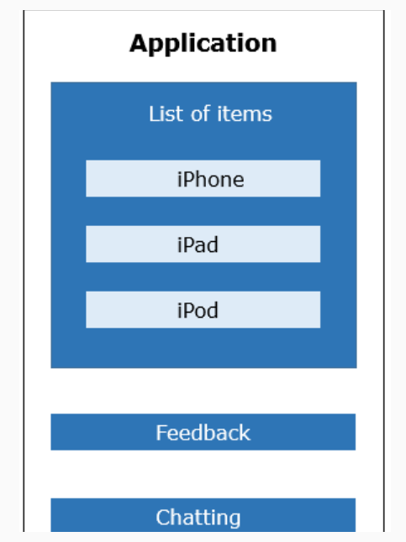

We have the following challenges in developing this application:
1. Entire page will get re-rendered even when a section of the page (eg. feedback section) undergoes changes
2. We will have to re-write code for each item even though they have similar behavior
3. We will have to take additional care to make sure that the functionality of one part of the application do not interfere with another part
If we implement the above wireframe by dividing them into components - encapsulating its own data and presentation logic then we can achieve modularity and re-usability.

What is React Component?
React components are the fundamental unit of any React application. They are capable of encapsulating data and view as a single unit. These components can work in conjunction with each other.
Components make code reusable, testing easy, and can take care of separation of concerns.
The capability of creating own components is a major productivity boost to any web application development.
Here, in ReactJS, components reside in virtual DOM and these components will be available as nodes in actual DOM.
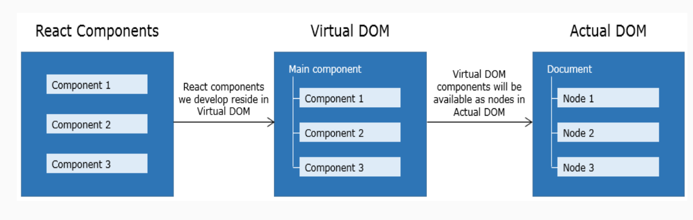
Before discussing the creation of components, let’s discuss what is Virtual DOM and why React uses Virtual DOM.
Virtual DOM is an abstraction of actual DOM, where components are the nodes. We can programmatically modify virtual DOM by updating components. These updates are internally handled by React and in turn, updated in actual DOM.
As we all know, DOM manipulation is expensive, because it requires traversal through entire DOM tree to find the element to be updated. If these updates are very frequent, this leads to a poor performance of an application.
Different frameworks handle above scenario in different ways like dirty checking, data-binding etc.
React, rather than updating DOM directly, builds an abstract version of it called Virtual DOM.
Below diagram illustrates the working of virtual DOM:
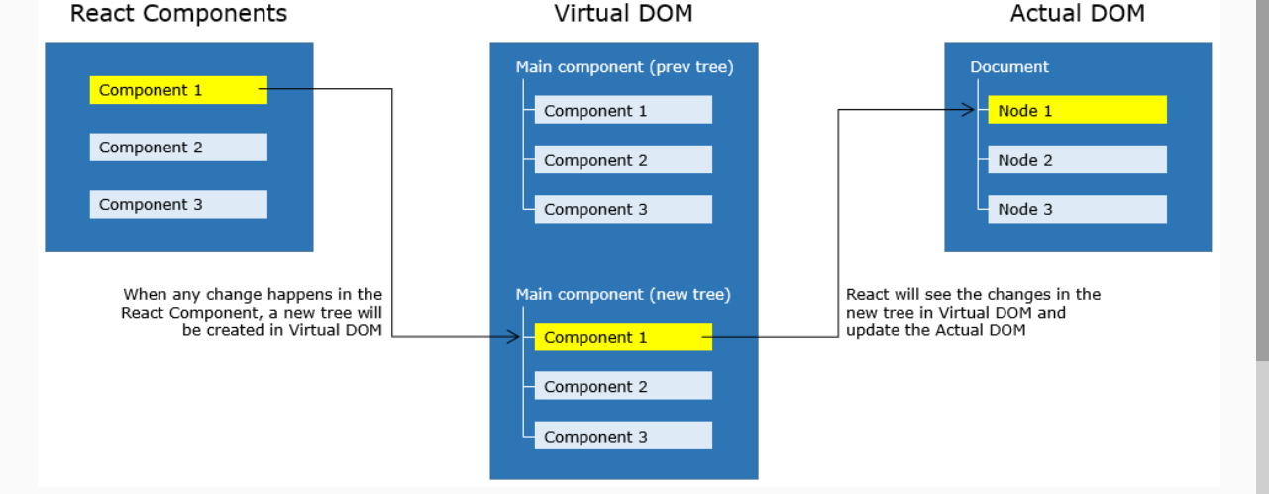

- Whenever any updates happens in the application, the virtual DOM gets modified. React computes the difference between the previous virtual tree and the current virtual tree
- Based on these differences React will figure out how to make updates to the actual DOM efficiently
- React does all the computations in its abstracted DOM and updates the DOM tree accordingly
- Virtual DOM enhances performance and efficiency by minimizing expensive updates in the actual DOM
- Hence React is said to be a great performer because it manages a Virtual DOM
App.js:
- import React from 'react';

- class App extends React.Component {
- render() {
- return React.createElement("h1", {}, "Hello World!!!");
- }
- }

- export default App;
- App - The component name should be in Pascal Casing
- render() - method will render the component’s elements
- React.createElement - helps to create an element in plain JavaScript
In the above code, React.createElement("h1", {}, "Hello World!!!");
h1 - is the HTML element to be used
{ } - Attributes of an element can be mentioned
"Hello World!!!" - Content to be appended to the h1 element
- export default App - App component has to be exported so that it could be used in any other files
To display elements of a component, the component has to be rendered.
For rendering a component, ReactDOM.render method is used as follows:

Syntax:
- ReactDOM.render(<parameter 1/>, parameter 2);
- ReactDOM.render method will take 2 parameters:
  - 'parameter 1' is the name of the component to be rendered
  - 'parameter 2' is the HTML node reference where the component to be rendered
So our final code would be as follows:

index.js:
- import React from 'react';
- import ReactDOM from 'react-dom';
- import './index.css';
- import App from './App';

- import * as serviceWorker from './serviceWorker';

- ReactDOM.render(<App/>, document.getElementById('root'));

'root' is the id referring to a node of index.html page.

Highlights:
- Creation of component
- Rendering a component
Demo steps:
1. Create App component in App.js and create an element to render "Hello World" in the heading format as shown below:
- import React from 'react';

- class App extends React.Component {
- render() {
- return React.createElement("h1", {}, "Hello World");
- }
- }
- export default App;
2. In main.js, render AppComp using the ReactDOM.render method as shown below:
- import React from 'react';
- import ReactDOM from 'react-dom';
- import './index.css';
- import App from './App';
- import * as serviceWorker from './serviceWorker';

- ReactDOM.render(<App />, document.getElementById('root'));

- serviceWorker.unregister();

3. Observe the below output:

JSX for React Components:-
Let us understand the need of JSX by taking the below example:
Code using pure JavaScript:
- class App extends React.Component{
- render(){
- return (
- React.createElement('form', {},
- React.createElement("h1", {}, "Login"),
- React.createElement('input', {type: 'text',placeholder:'Name', value: '',}),
- React.createElement('br', {}),React.createElement('br', {}),
- React.createElement('input', {type: 'password', placeholder: 'password',
- value: '',}),
- React.createElement('br', {}), React.createElement('br', {}),
- React.createElement('button', {type: 'submit'}, "Login"))
- )
- }
- };

- export default App;

We can observe from the above code, that we need to write more lines of JavaScript code to implement the Login component. The Code looks difficult to understand and hence productivity goes down.
JSX has been introduced in React to create elements that are very easy to read and write, which makes the component's code simple and understandable.
Let us see how to write the same above Login component using JSX in a easier way:
- class App extends React.Component{
- render(){
- return (<form><h2>Login</h2>
- <input type="text" placeholder="Name" /><br/><br/>
- <input type="password" placeholder="password" /> <br/><br/>
- <input type="submit" nvalue="log" />
- </form>);
- }
- };

- export default App;

This technique is a replacement for writing pure JavaScript code and hence enhances productivity.
How to create JSX elements?
JSX is a special syntax introduced in ReactJS to write elements of components. It is syntactically identical to HTML and hence it can be easily read and written. Code written using JSX helps in visualizing the DOM structure easily.

We can modify the demo-1 using JSX as follows:
- class App extends React.Component {
- render() {
- return <h1> Hello World </h1>
- }
- }

- export default App;

As the browser does not understand JSX code, this gets converted to JavaScript using the plugins of the babel.

Conversion of JSX to JavaScript happens as shown below:
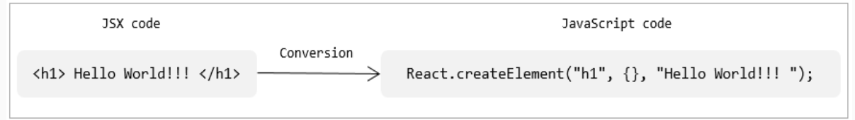

When working with React components, we may need to render multiple React elements. For example, let us consider the below code where we need to render multiple React elements:

class App extends React.Component {
render(){
return <h3>ReactJS:</h3>
<img src="./image/react.PNG" width="120" height="120"/>
<p> React is a JavaScript library for creating User Interfaces.</p>

}
}
The above code logs an error saying "Adjacent JSX elements must be wrapped in an enclosing tag". As per the JSX syntax, all the adjacent elements must be wrapped in an enclosing tag i.e. there should be only the outermost element. Hence the above code can be modified as follows:

class App extends React.Component {
render(){
return <div>
<h3>ReactJS:</h3>
<img src="./image/react.PNG" width="120" height="120"/>
<p> React is a JavaScript library for creating User Interfaces.</p>
</div>
}
}

By adhering to JSX syntax we use <div> for grouping the elements and this introduces an extra and unnecessary node into the DOM. As a solution to this, React Fragments are introduced which is a common pattern in React for a component to return multiple elements. React Fragments allows us to group a list of React elements without adding any extra node to the DOM.

Let us modify the previous code as follows using React Fragments:

class App extends React.Component {
render(){
return <React.Fragment>
<h3>ReactJS:</h3>
<img src="./image/react.PNG" width="120" height="120"/>
<p> React is a JavaScript library for creating User Interfaces.</p>
</React.Fragment>

}
}

Highlights:
- Creating elements in JSX
- How JSX code will be converted to JavaScript
Demo steps:
1. Modify the file App.js by writing the following code using JSX:
- import React from 'react';
- class App extends React.Component {
- render() {
- return <h1>Hello World </h1>
- }
- }
- export default App;
2. Render App component in index.js file as shown below:
- import React from 'react';
- import ReactDOM from 'react-dom';
- import './index.css';
- import App from './App';
- import * as serviceWorker from './serviceWorker';

- ReactDOM.render(<App />, document.getElementById('root'));

- serviceWorker.unregister();

3. Observe the below output:
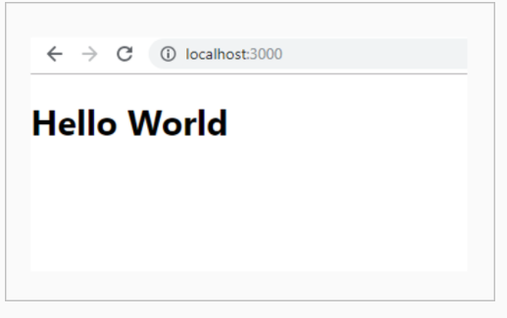

Highlights:
- How to render multiple elements
- Nesting JSX elements
Demo steps:
Create a component to render an image with its description as follows:

1. Modify App.js as shown below:
- import React from 'react';
- import logo from './image/react.PNG';
- class App extends React.Component {
- render(){
- return(<React.Fragment>
- <h3>ReactJS:</h3>
- <img src={logo} width="120" height="120" alt="React Logo"/>
- <p> React is a JavaScript library for creating User Interfaces, open sourced to the world by Facebook and Instagram team in 2013.<br/>
- React’s main goal is to make development of UI components easy and modular.
- It is intended to ease the process of building<br/> large applications using
- data that changes over time.</p>
- </React.Fragment>);
- }
- }
- export default App;
In order to use an image, the image has to be imported and the imported value should be provided to the src tag as an expression.
We will discuss how to use expressions in JSX in the next topic.

2. Render App Component in the index.js file as shown below:
- import React from 'react';
- import ReactDOM from 'react-dom';
- import './index.css';
- import App from './App';
- import * as serviceWorker from './serviceWorker';

- ReactDOM.render(<App />, document.getElementById('root'));

- serviceWorker.unregister();

3. Download the image react.PNG from the link - react.PNG and place it inside the image folder

We discussed how to use JSX to create React elements, we may also require to use JavaScript expressions in React elements, so let's see how to write JavaScript expressions in JSX.

JavaScript expressions to be evaluated should be wrapped within curly braces as follows:
- <h1> { Expression to be evaluated } </h1>

Content which has to be displayed as is will be written in double quotes, wrapped within curly braces as follows:
- <h1> {" Content to be displayed "} </h1>
Accessing a variable:
We can access the value of any variable within curly braces as shown below:
- class App extends React.Component {
- render() {
- let count = 5
- return(<React.Fragment>
- <h1>{count}</h1>
- <h2>{count*count}</h2>
- </React.Fragment>)
- }
- }
Arithmetic operators can also be used as shown above

Accessing an object:
The properties of an object can be accessed as shown below:
- class App extends React.Component {
- render() {
- let name = {
- firstName: 'Kavya',
- lastName: 'Ramakrishna'
- }
- return(<React.Fragment>
- <h1>{name.firstName} {name.lastName}</h1>
- </React.Fragment>)
- }
- }

Specifying attributes' expression:
We can provide dynamic values to attributes as shown below:
- class App extends React.Component {
- render() {
- let highlight = {
- color: 'green',backgroundColor:'grey'
- }
- return(<React.Fragment>
- <h1 style={highlight}>Welcome to React</h1>
- </React.Fragment>)
- }
- }
- export default App;

Highlights:
- Passing values to expression
- Evaluating the expression
Demo steps:

Create a component to display an algebraic expression as follows:

1. Modify AppComp component as shown below:
- import React from 'react';

- class App extends React.Component {
- render() {
- var x=25, y=30
- return (<div>
- <h2> Evaluating expression </h2>
- <h3> {x} {">"}{y} {":"} {x>y ? 'True' : 'False'} </h3>
- </div>)
- }
- }
- export default App;
2. Render App component in the index.js file as shown below:
- import React from 'react';
- import ReactDOM from 'react-dom';
- import './index.css';
- import App from './App';
- import * as serviceWorker from './serviceWorker';

- ReactDOM.render(<App />, document.getElementById('root'));

- serviceWorker.unregister();

Let us see, how to render the content conditionally.
In any web application, we may require to show and hide any content based on some condition. For example, if admin is logged in to an application it should display a message saying "Welcome" else it should display saying "Please Login". Similarly, displaying the list of products based on its availability.
To achieve these requirements, the if-else or ternary operator can be used for conditional rendering.
Using if-else:
- class App extends React.Component {

- render() {
- let isLoggedIn = true
- if(isLoggedIn) {
- return <h2>Welcome Admin</h2>
- }
- else{
- return <h2>Please Login</h2>
- }
- }
- }

The above code can also be written as shown below:
- class App extends React.Component {

- render() {
- let element = null;
- let isLoggedIn = false
- if(isLoggedIn) {
- element = <h2>Welcome Admin</h2>
- }
- else {
- element = <h2>Please Login</h2>
- }
- return (<React.Fragment>
- {element}
- </React.Fragment>)
- }
- }
- export default App;

Using ternary operator:
- class App extends React.Component {
- render() {
- let element = null;
- let isLoggedIn = false
- isLoggedIn ? element = <h2>Welcome Admin</h2> : element = <h2>Please Login</h2>

- return (<React.Fragment>
- {element}
- </React.Fragment>)
- }
- }

Let us see how to render lists in React, using map() method.
- class App extends React.Component {
- render() {
- var employees = [
- { empId: 1234, name: 'John', designation:'SE' },
- { empId: 4567, name: 'Tom', designation:'SSE'},
- { empId: 8910, name: 'Kevin',designation:'TA'}
- ]

- return (<React.Fragment>
- <table style={{width:'60%'}} className='table'>
- <thead className="thead-light">
- <tr>
- <th>EmpID</th>
- <th>Name</th>
- <th>Designation</th>
- </tr>
- </thead>
- <tbody>
- {employees.map(employee => {
- return (<tr>
- <td>{employee.empId}</td>
- <td>{employee.name}</td>
- <td>{employee.designation}</td>
- </tr>)
- })
- }
- </tbody>
- </table>
- </React.Fragment>)
- }
- }
- export default App;
The above code provides a warning in the console as shown below

To overcome the above error, we have to provide a unique key to each element in an array as shown below:
- <tbody>
- {employees.map(employee => {
- return (<tr key={employee.empId}>
- <td>{employee.empId}</td>
- <td>{employee.name}</td>
- <td>{employee.designation}</td>
- </tr>)
- })
- }
- </tbody>
Every item in an array will be rendered in <tr>, hence provided a key to <tr> tag in the above code.
Highlights:
- Usage of ternary operator for conditional rendering
- Usage of map function for looping
Demo Steps:
1. Create App component within App.js file as shown below
- import React from 'react';
- import 'bootstrap/dist/css/bootstrap.min.css';

- class App extends React.Component {
- render() {
- var employees = [
- { empId: 1234, name: 'Jack', designation:'SE', salary:23000},
- { empId: 4567, name: 'Johnson', designation:'SSE', salary:15000},
- { empId: 8910, name: 'Sachin',designation:'TA', salary:30000}
- ]

- return (<React.Fragment>
- <table style={{width:'60%'}} className='table'>
- <thead className="thead-light">
- <tr>
- <th>EmpID</th>
- <th>Name</th>
- <th>Designation</th>
- </tr>
- </thead>
- <tbody>
- {employees.map(employee => {
- return employee.salary > 15000 ? (<tr key={employee.empId}>
- <td>{employee.empId}</td>
- <td>{employee.name}</td>
- <td>{employee.designation}</td>
- </tr>) : null
- })
- }
- </tbody>
- </table>
- </React.Fragment>)
- }
- }
- export default App;
2. Render App component to the DOM in the index.js file
- import React from 'react';
- import ReactDOM from 'react-dom';
- import './index.css';
- import App from './App';
- import * as serviceWorker from './serviceWorker';

- ReactDOM.render(<App />, document.getElementById('root'));

- serviceWorker.unregister();
The output of the above code is
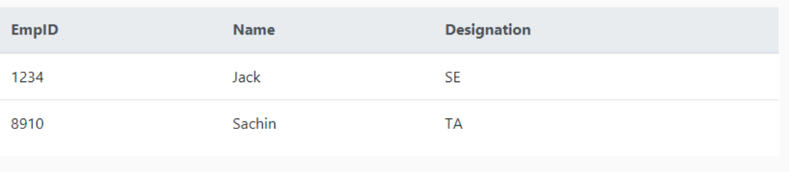

Styling Components:
In React, we can apply the styling using CSS or any styling libraries/frameworks like bootstrap, react-bootstrap, material UI etc.
Let us see how to use CSS inline styling to style React components.
In React, components will have inline styles and it should be specified as an object as shown below
- <h1 style={{color:'green'}}>Welcome to React</h1>
The CSS properties has to be mentioned within an object and the object has to be provided as a value to the style property within an expression. The 2 pairs of curly braces are used, where the first pair is the object with style properties and second pair is the JSX expression specified to the style property.
When we have CSS properties with multiple words like background-color, font--family etc, in React, those properties should be camelCased by removing hypen as shown below.
- <h1 style={{color:'green',fontFamily:'verdana'}}>Welcome to React</h1>

If you want to apply a style using CSS file, then you have to import the CSS file.
If you observe the folder structure of create-react-app, you can see that there is an index.css file

The index.css file is imported in the index.js file
- import React from 'react';
- import ReactDOM from 'react-dom';
- import './index.css';
- import App from './App';
- import * as serviceWorker from './serviceWorker';
So any styling written in the index.css file can be used in our components.
Remove the styling provided in the index.css file and add below code
- body {
- background-color:lightgrey;
- }

Now run the application, you can observe the background-color is grey when App component is rendered, as shown below
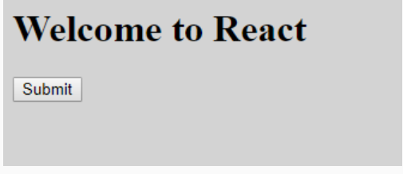
index.css is like a global CSS file for the application, any styling that is written within that file will be applied to all the components, since it is imported within the index.js file
If you want to create a specific CSS file for your component, create a css file and import the CSS file only within that component.s
The CSS class can be applied to any JSX element using className attribute as shown below
- <h1 className="highlight">Heading</h1>
Modify the CSS file App.css within the src folder and create a class button within App.css file as shown below
- .button {
- background-color:blue;
- color:white;
- border-radius:10px;
- width:100px;
- height:30px;
- }
Import the App.css file within the App component and apply the button class to the button element as shown below
- import './App.css';

- <button className="button">Submit</button>
To style components using the bootstrap library, we need to install the bootstrap library
- npm install bootstrap
Once you install bootstrap, the bootstrap CSS file will be present within the node_modules folder
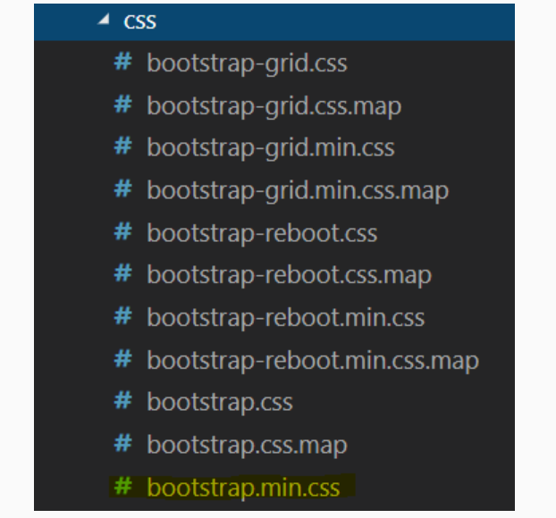

import the bootstrap CSS file within the AppComp component and apply the bootstrap btn btn-success class to the button as shown below
- import 'bootstrap/dist/css/bootstrap.min.css';

- <button className="btn btn-success">Submit</button>

If you are using the js file of Bootstrap then import the bootstrap js file but before that install jQuery, as the bootstrap JavaScript depends on jQuery
React-Bootstrap is a library of re-useable front-end components. We can have the look-and-feel of Twitter Bootstrap, but with much cleaner code, via Facebook's React JS framework.
React-bootstrap can be installed by running the below command
- npm install react-bootstrap bootstrap.
Whenever any react-bootstrap component is used in an application, the corresponding react-bootstrap library should be imported
For example, if react-bootstrap button is created, then the corresponding bootstrap library should be imported as follows:
- import Button from 'react-bootstrap/Button';

- <Button variant="warning"> Click here </Button>

Material-UI is a popular React UI framework which provides various components and themes for styling React components.
Material-UI can be installed by running the below command
- npm install @material-ui/core
Whenever any Material-UI component is used in an application, the corresponding Material-UI library should be imported. For example to style buttons Material-UI provides Button component, which has to be imported from @material-ui/core/Button library. The components provided by Material-UI would be present inside node_modules
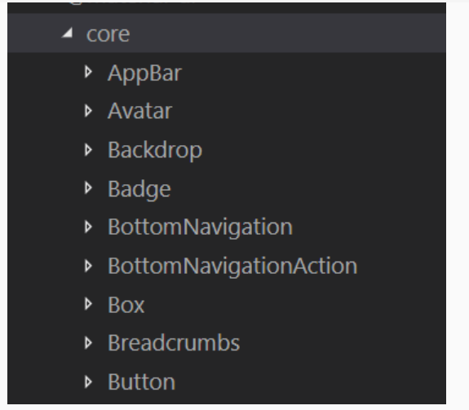s

- import Button from '@material-ui/core/Button';

Material-UI is designed considering Roboto font. By default, Material-UI will not load Roboto font.
We have to include Roboto font using the CDN link inside the index.html file as shown below
- <link rel="stylesheet" href="https://fonts.googleapis.com/css?family=Roboto:300,400,500,700&display=swap" />
Then import Typography component and use it within React component. We can display various typography variants like h1,h2,subtitle,body,caption using variant attribute as shown below
- <Typography variant="h4" gutterBottom>Welcome to React</Typography>
gutterBottom adds a margin-bottom of 0.35em.
Demo1:
Highlights:
- Use CSS inline styling
- Use CSS classes
Demo Steps:
1. Modify the App.css file as shown below
- .button {
- background-color:blue;
- color:white;
- border-radius:10px;
- width:100px;
- height:30px;
- }
2. Modify the AppComp component as shown below
- import React from 'react';
- import './App.css';

- class AppComp extends React.Component {
- render() {
- return(<React.Fragment>
- <h1 style={{color:'green',fontFamily:'verdana'}}>Welcome to React</h1>
- <button className="button">Submit</button>
- </React.Fragment>)
- }
- }
- export default AppComp;
3. Render the AppComp component in index.js file
- import React from 'react';
- import ReactDOM from 'react-dom';
- import './index.css';
- import App from './App';
- import * as serviceWorker from './serviceWorker';

- ReactDOM.render(<App />, document.getElementById('root'));

- serviceWorker.unregister();

The AppComp component will be styled as shown below
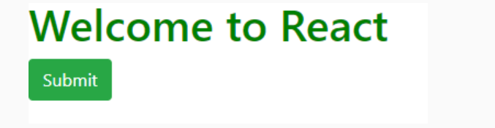

Demo 2:
Highlights:
- Styling the components using bootstrap library
Demo Steps:
1. Modify the AppComp component as shown below
- import React from 'react';
- import 'bootstrap/dist/css/bootstrap.min.css';

- class AppComp extends React.Component {
- render() {
- return(<React.Fragment>
- <h1>Welcome to React</h1>
- <button className="btn btn-success">Submit</button>
- </React.Fragment>)
- }
- }
- export default AppComp;
2. Render the AppComp component inside index.js file
The AppComp component is styled as shown below
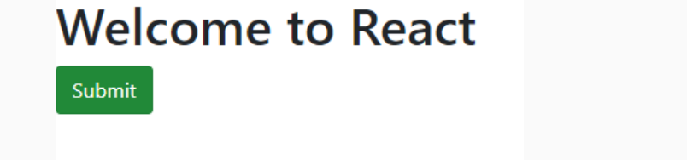

Highlights:
Styling the components using react-bootstrap library
Demo Steps:
1. Modify the AppComp component as shown below:
- import React from 'react';
- import 'bootstrap/dist/css/bootstrap.min.css';
- import Button from 'react-bootstrap/Button';

- class AppComp extends React.Component {
- render() {
- return(<React.Fragment>
- <h1>Welcome to React</h1>
- <Button variant="success">Submit</Button>
- </React.Fragment>)
- }
- }
- export default AppComp;
2. Render the AppComp component inside index.js file

The AppComp component is styled as shown below:

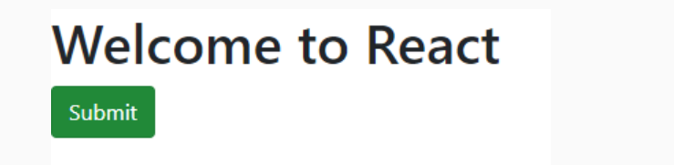

Highlights:
1. Style the components using the Material-UI library
Demo Steps
1. Modify the AppComp component as shown below
- import React from 'react';
- import Typography from '@material-ui/core/Typography';
- import Button from '@material-ui/core/Button'

- class AppComp extends React.Component {
- render() {
- return(<React.Fragment>
- <Typography variant="h4" gutterBottom>
- Welcome to React</Typography>
- <Button variant="contained" color="primary">Submit</Button>
- </React.Fragment>)
- }
- }
- export default AppComp;
2. Include Roboto font CDN link within index.html file as shown below
- <!DOCTYPE html>
- <html lang="en">
- <head>
- <meta charset="utf-8" />
- <link rel="shortcut icon" href="%PUBLIC_URL%/favicon.ico" />
- <link rel="stylesheet" href="https://fonts.googleapis.com/css?family=Roboto:300,400,500,700&display=swap" />
- <meta name="viewport" content="width=device-width, initial-scale=1" />
- <meta name="theme-color" content="#EC3224" />
- <link rel="manifest" href="%PUBLIC_URL%/manifest.json" />
- <title>React App</title>
- </head>
- <body>
- <noscript>You need to enable JavaScript to run this app.</noscript>
- <div id="root"></div>
- </body>
- </html>

3. Render AppComp component within index.js file as shown below
- import React from 'react';
- import ReactDOM from 'react-dom';
- import './index.css';
- import App from './App';
- import * as serviceWorker from './serviceWorker';

- ReactDOM.render(<App />, document.getElementById('root'));

- serviceWorker.unregister();

The AppComp component is styled as shown below
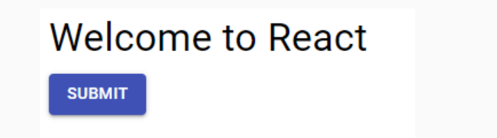

Why Props and State?
In a real-time application, we will be retrieving data from the server and will be passed as an array to components.
In order to bind the retrieved data to the component, we need two JS objects i.e. props and state.
What is State?
The state is an initial value set for a component, which is used for interactivity.
Let's see how to set the state of a component.
Using constructor, the state of a component is created and initialized using this.state as follows:
Syntax:
- constructor() {
- super();
- this.state = { counter: 1 };
- }

In the above code, the state 'counter' is set to 1 and 'counter' would be accessed as this.state.counter.
As the user-defined component extends React.Component, it becomes a child component of it. Hence, whenever a child component has a constructor, it has to call the parent class's constructor using the super() method. And super() method should be the first statement within a constructor.

Now let's create a Timer component where on clicking a button, the timer starts.
Below is the implementation to start the timer:
When a button is clicked, by invoking the handleClick() method - set the interval and pass it to start() method.
- handleClick(e) {
- this.interval = setInterval(this.start, 1000);
- }

In start() method, for every second, state will be updated using setState() method. Whenever setState() is called, it calls render() method to render the updated value on UI.
- start() {
- this.setState({ secondsElapsed: this.state.secondsElapsed + 1 });
- }

When an event occurs in the component, we will update the state of the component using the setState() method inside the event handler method as shown below:
- class Timer extends React.Component {
- constructor() {
- super ()
- this.state = {
- counter: 0
- }
- }
- handleClick(e){
- this.setState({counter:this.state.counter+1})
- }
- render() {
- return(<React.Fragment>
- <h2> Seconds Elapsed: {this.state.counter} </h2>
- <button onClick = {this.handleClick}> Increment Counter </button>
- </React.Fragment>)
- }
- }
When we run the above code and click on the increment counter button, it throws an error as shown below:
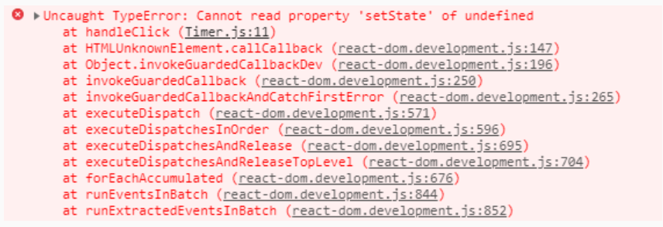

The above error is because this keyword is not pointing to the component
This error can be resolved using the arrow functions as shown below.
- handleClick = (e) => {
- this.setState({counter:this.state.counter+1})
- }
Now we would get the output as shown below after clicking on the increment counter button
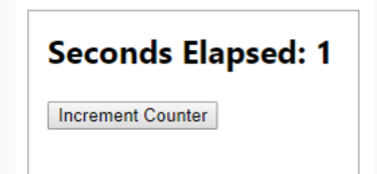

setState() is asynchronous:

Consider the below code snippet to understand how setState() is asynchronous:
- class App extends React.Component {
- constructor() {
- super()
- this.state = {
- quantity: 0,
- price:0
- }
- }
- update = () => {
- this.setState({quantity:5})
- if(this.state.quantity == 5) {
- this.setState({price:2000-100})
- }
- }
- render() {
- return(<React.Fragment>
- <h1>{this.state.quantity}</h1>
- <h1>{this.state.price}</h1>
- <button onClick={this.update}>Update</button>
- </React.Fragment>)}

- }
In the above code snippet, the price is updated based on quantity.
When we run the above code and click on the update button, below is the output we get:
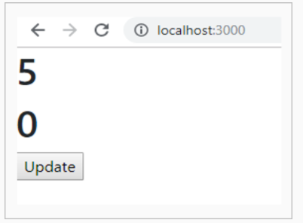
The price is not updated in the above screenshot. This is because setState() is asynchronous, the price gets updated before quantity gets updated.
To overcome the above problem, we can pass a callback function to the setState() method as shown below:
- update = () => {
- this.setState({quantity:5},()=>{
- if(this.state.quantity == 5) {
- this.setState({price:2000-100})
- }
- })
- }
Now, the price gets updated after the quantity is updated.
When we run the above code and click on the update button, the output is:
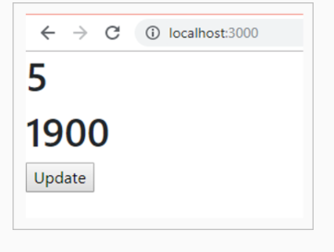

Highlights:
- Handling data in a component
- Making component interactive
- Usage of state
Demo steps:
Create a component to start the timer:
1. Create a component Timer inside the Timer.js file as shown below:
- import React from 'react';
- class Timer extends React.Component {
- constructor() {
- super();
- this.state = {
- secondsElapsed: 0
- };
- }
- start = () => {
- this.setState({
- secondsElapsed: this.state.secondsElapsed + 1
- });
- }
- handleClick = (e) => {
- this.interval = setInterval(this.start, 1000);
- }
- render() {
- return ( <React.Fragment><br/><br/>
- <button onClick = {this.handleClick}>Start timer</button><br/><br/>
- <h2> Seconds Elapsed:
- {this.state.secondsElapsed}
- </h2>
- </React.Fragment>);
- }
- }
- export default Timer;

2. Render Timer component to the DOM within the index.js file as shown below
- import React from 'react';
- import ReactDOM from 'react-dom';
- import './index.css';
- import Timer from './Timer';
- import * as serviceWorker from './serviceWorker';

- ReactDOM.render(<Timer />, document.getElementById('root'));

- serviceWorker.unregister();

3. Observe the below output:
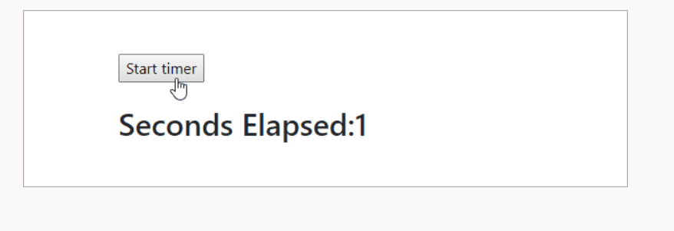

State: Key Points
Key points to be remembered while handling data in a component:

- States are mutable and only used on top level component
- They are reserved only for interactivity and component's event handlers may change to trigger a UI update
- The state will be set with a default value when component mounts and will mutate in time based on user events generated
Props:-
When we want to pass any data from one component to another component, it is passed as a prop.
- Props allow us to pass data from one component to another component
- Props are immutable - a component cannot change its props however it is responsible for putting together
- Props can be accessed as this.props
How to use props?
Let's now learn how to pass data to a component:
<App initial = {10} />
Here, we are passing a property 'initial' with a value '10', to a component App.
In the component App, this property would be accessed as this.props.initial
If we want to access props within constructor as shown below:
- constructor() {
- super()
- console.log(this.props.name)
- }

We get the below error:
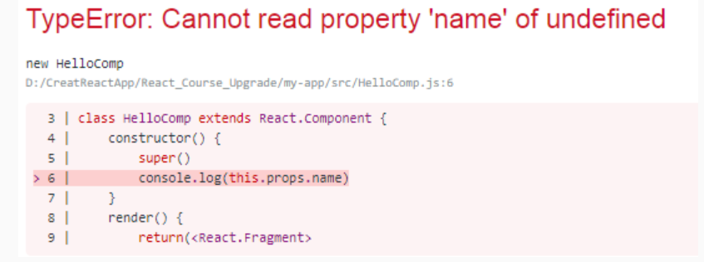

In order to access props within the constructor, we need to pass props as an argument to both the constructor() and super() as shown below:
- constructor(props) {
- super(props)
- console.log(this.props.name)
- }
Highlights:
- Passing data
- Accessing data
Demo steps:
Create 2 components as mentioned below:
1. Timer - It holds state and handles button click
2. Resultant - It takes result from Timer component and displays it

1. Modify Timer component as shown below:
- import React from 'react';

- class Timer extends React.Component {
- constructor() {
- super();
- this.state = {
- secondsElapsed: 0
- };
- }
- start = () => {
- this.setState({
- secondsElapsed: this.state.secondsElapsed + 1
- });
- }
- handleClick = (e) => {
- this.interval = setInterval(this.start, 1000);
- }
- render() {
- return ( <React.Fragment><br/>
- <button onClick = {this.handleClick}>
- Start Timer
- </button><br/><br/>
- <Resultant new = {this.state.secondsElapsed}/>
- </React.Fragment>);
- }
- }
- class Resultant extends React.Component {
- render() {
- return ( <div>
- <h3> Seconds Elapsed: {this.props.new} </h3>
- </div>);
- }
- }
- export default Timer;
As we want to display result from Resultant component, we are passing state (which holds result) to Resultant component.
- When data is passed from parent component to child component, it becomes property of child component
- These properties are immutable and are accessible as this.props.new in Resultant component

2. Render Timer component to the DOM within index.js as shown below
- import React from 'react';
- import ReactDOM from 'react-dom';
- import './index.css';
- import Timer from './Timer';

- import * as serviceWorker from './serviceWorker';

- ReactDOM.render(<Timer/>, document.getElementById('root'));

- serviceWorker.unregister();

3. Observe the below output:
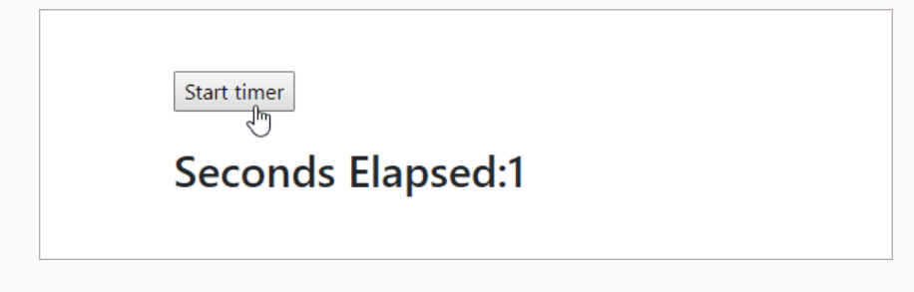
In the previous section, the way we passed the data explains about passing data from parent to child component. Similarly, we can also pass data from the child to the parent component. If the child component wants to send data to the parent component, it can send it by invoking a function that is passed as props from the parent component.
Let us understand by taking the below example:
Consider the below parent component
- import React from 'react';
- import Child from './Child';

- class App extends React.Component {
- constructor() {
- super()
- this.state = {
- name: 'John'
- }
- }
- update = (value) => {
- let newValue = value;
- this.setState({name:newValue})
- }
- render() {
- return ( <React.Fragment>
- <h1>{this.state.name}</h1><br/><br/>
- <Child nameValue={this.state.name} update={this.update}/>
- </React.Fragment>)
- }
- }
- export default App;

The Parent component contains the state 'name', which gets updated in the child component as shown below:
- import React from 'react';

- class Child extends React.Component {
- constructor() {
- super()
- this.state = {
- nameValue:null
- }
- }
- handleChange = () => {
- let newValue = 'Jack'
- this.setState({nameValue: newValue})
- this.props.update(newValue)
- }
- render() {
- return(<React.Fragment>
- <button onClick={this.handleChange}>Change</button>
- </React.Fragment>)
- }
- }
- export default Child;
In the child component on clicking of the change button, the value of the state 'nameValue' changes to 'Jack' and the same value is sent to the parent component by calling the update() method from Child component as this.props.update(newValue).
The update() method is a prop passed to the Child Component.
The Parent component gets the updated value from the child and updates its state.
Component Types:
In the previous module, we have discussed the need for state, props, and passing data between components through demos. We can categorize components as 2 types:
1. Functional Component:
- Created as a simple JavaScript function
- It just returns the valid JSX
The functional component can be created as follows:
- function Resultant(props){
- return (
- <h3> New Result: {props.new} </h3>
- )
- }
Props passed to the functional component, can be accessed as just props followed by name of the prop i.e. props.new
2. Class Component:
- Created as a class component
- It encapsulates interaction logic as well as renders data
- class App extends React.Component {
- render() {
- return (
- /* return JSX elements */
- )
- }
- }

Highlights:
- Creating a Functional component
- Accessing props within the functional component
Demo steps:
Revisiting the Props Demo with the below changes:
The Resultant component is written as a functional component
1. Modify the Timer component as shown below:
- import React from 'react';

- class Timer extends React.Component {
- constructor(props) {
- super(props);
- this.state = {
- secondsElapsed: 0
- };
- }
- start = () => {
- this.setState({
- secondsElapsed: this.state.secondsElapsed + 1
- });
- }
- handleClick = (e) => {
- this.interval = setInterval(this.start, 1000);
- }
- render() {
- return (<React.Fragment>
- <button onClick = {this.handleClick}>
- Start Timer
- </button>
- <Resultant new = {this.state.secondsElapsed}/>
- </React.Fragment>);
- }
- }

- function Resultant(data) {
- return ( <h2>
- Seconds Elapsed: {data.new}
- </h2>
- )
- }
- export default Timer;

2. Render Timer component to the DOM within index.js file as shown below:
- import React from 'react';
- import ReactDOM from 'react-dom';
- import './index.css';
- import Timer from './Timer';

- import * as serviceWorker from './serviceWorker';

- ReactDOM.render(<Timer/>, document.getElementById('root'));

- serviceWorker.unregister();

Highlights:
- Creating a Functional component
- Accessing props within the functional component
Demo steps:
Revisiting the Props Demo with the below changes:
The Resultant component is written as a functional component
1. Modify the Timer component as shown below:
- import React from 'react';

- class Timer extends React.Component {
- constructor(props) {
- super(props);
- this.state = {
- secondsElapsed: 0
- };
- }
- start = () => {
- this.setState({
- secondsElapsed: this.state.secondsElapsed + 1
- });
- }
- handleClick = (e) => {
- this.interval = setInterval(this.start, 1000);
- }
- render() {
- return (<React.Fragment>
- <button onClick = {this.handleClick}>
- Start Timer
- </button>
- <Resultant new = {this.state.secondsElapsed}/>
- </React.Fragment>);
- }
- }

- function Resultant(data) {
- return ( <h2>
- Seconds Elapsed: {data.new}
- </h2>
- )
- }
- export default Timer;

2. Render Timer component to the DOM within index.js file as shown below:
- import React from 'react';
- import ReactDOM from 'react-dom';
- import './index.css';
- import Timer from './Timer';

- import * as serviceWorker from './serviceWorker';

- ReactDOM.render(<Timer/>, document.getElementById('root'));

- serviceWorker.unregister();

Let's see how to access child nodes of a component.s
Consider an AppComp which has child nodes as shown below:
- <AppComp>
- <li> List element </li>
- <h4> Heading element </h4>
- <p> Paragraph element </p>
- <span> Span element </span>
- <Appcomp />

To access these child nodes of a component, React uses this.props.children.
React.Children provide utilities to deal with this.props.children.
React.Children.map can be used to iterate this.props.children as follows:
- React.Children.map (this.props.children, function fn (arg) { })

Function fn() will be invoked on every immediate child contained within children. If children is null or undefined, fn() returns null or undefined.
Highlights:
- Creating child nodes to a parent component
- Accessing child nodes from parent
Demo steps:
Create a component to access child nodes of a component:

1. Create App component as shown below
- import React from 'react';

- var count = 1;

- class App extends React.Component {
- render() {
- React.Children.map(this.props.children, () => {
- console.log('child', count++);
- });
- return ( <ul>
- {this.props.children}
- </ul>)
- }
- };
- export default App;
2. Render App component to the DOM within index.js as shown below:
- import React from 'react';
- import ReactDOM from 'react-dom';
- import './index.css';
- import App from './App';

- import * as serviceWorker from './serviceWorker';

- ReactDOM.render(<App>
- <li>List element</li>
- <h3>Heading element</h3>
- <p>Paragraph element</p>
- <span>Span element</span>
- </App>, document.getElementById('root'));

- serviceWorker.unregister();

3. Observe the below output:

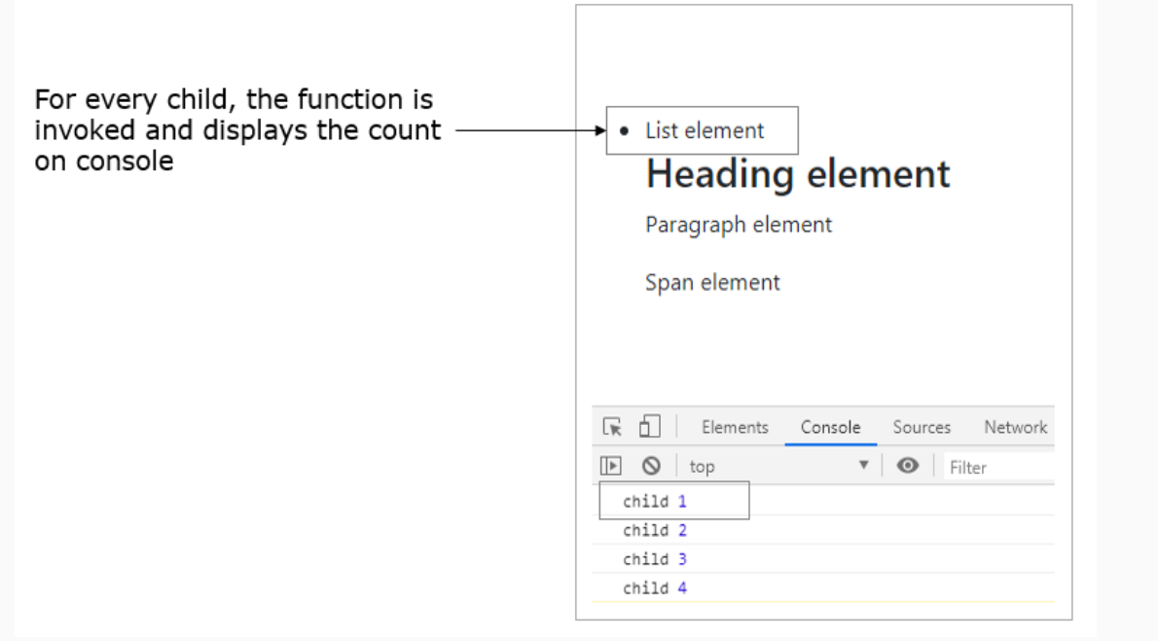

In this section, let us understand how to set a default value for a prop and validating its value.
We can set default values to the props using the defaultProps property as shown below:
Syntax:
- AppComp.defaultProps = {
- element1 : "Hello",
- element2: "default value",
- }

In case there is no value passed to the prop and if it is being accessed within the component, then the default values will be considered.
Here, we need to mention to which component, we need to set the default values for props.
Highlights:
- Setting default value for props
- Using defaultProps()
Demo steps:

1. Create App component as shown below:
- import React from 'react';

- class App extends React.Component {
- render() {
- return(<React.Fragment>
- <h1> {this.props.element1} </h1>
- <h1> {this.props.element2} </h1>
- </React.Fragment>);
- }
- }

- App.defaultProps = {
- element1 : "Hello",
- element2 : "World",
- }

- export default App;
2. Render App component within the index.js file as shown below:
- import React from 'react';
- import ReactDOM from 'react-dom';
- import './index.css';
- import App from './App';

- import * as serviceWorker from './serviceWorker';

- ReactDOM.render(<App element2="React"/>, document.getElementById('root'));

In this demo, the default value "Hello" will be taken for the prop element1, as we are not passing any value explicitly for it, and the value "React " will be taken for the element2 prop.

4. Observe the below output:
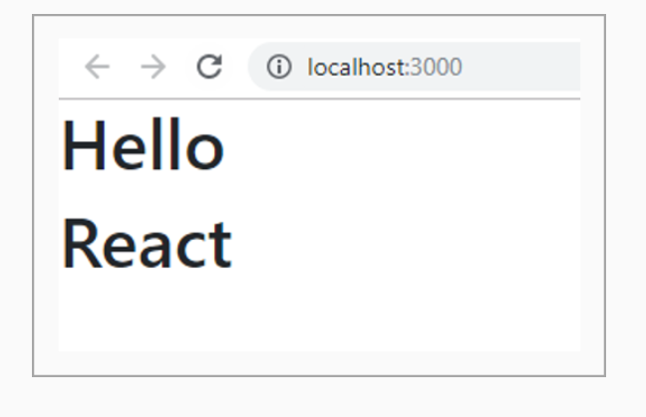
Highlights:
- Validating props using PropTypes
- Using different validators
Demo steps:

Create a component with properties defined for it and validate these props using PropTypes

1. Create App component as shown below:
- import React from 'react';
- import PropTypes from 'prop-types';

- class App extends React.Component {
- render() {
- return (
- <React.Fragment>
- <h3>Array: </h3> <p>{this.props.array}</p>
- <h3>Boolean: </h3><p>{this.props.boolean ? "True" : "False"}</p>
- <h3>Function: </h3><p>{this.props.function(10)}</p>
- <h3>Number: </h3><p>{this.props.number}</p>
- <h3>String: </h3><p>{this.props.string}</p>
- <h3>Object: </h3><p>{this.props.emp.empName} <br/>
- {this.props.emp.empId}< br/>
- {this.props.emp.unit}</p>
- </React.Fragment>
- );
- }
- }

- App.propTypes = {
- array: PropTypes.array,
- boolean: PropTypes.bool,
- function: PropTypes.func,
- number: PropTypes.number,
- string: PropTypes.string,
- emp: PropTypes.object
- }

- App.defaultProps = {
- array: "John",
- boolean: false,
- function: function(e){return e},
- number: 23,
- string: "React",

- emp: {
- empName:"John",
- empId: 123456,
- unit: "Systems Engineer"
- }
- }

- export default App;
2. Render App component within the index.js file as shown below:
- import React from 'react';
- import ReactDOM from 'react-dom';
- import './index.css';
- import App from './App';

- import * as serviceWorker from './serviceWorker';

- ReactDOM.render(<App/>, document.getElementById('root'));

- serviceWorker.unregister();

3. Observe the below output:
The data type of the array prop passed to the App component should be an array, but we are passing a string instead of an array

Observe the warning message logged when the invalid value is passed to the array props:
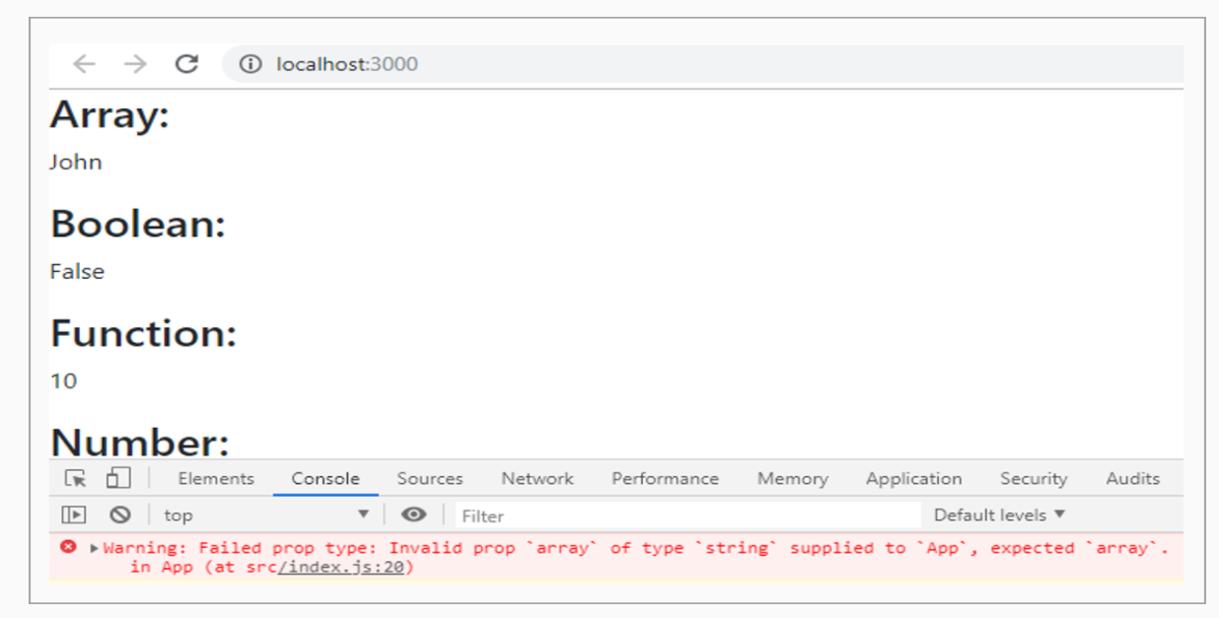
LifeCycle Methods:
Every component will have following phases in its Lifecycle:
- Mounting phase - when the component is mounted to DOM tree
- Updating phase - when component is being updated with new state, new props are being received
- Unmounting phase - destroying component from DOM tree
- Error Handling - Handling errors within React Component

Every phase in the lifecycle of a component has few methods which will be invoked during that phase of a component's lifecycle. We can override these methods to provide the desired functionality.

These methods can be used in the following cases:
- For making an Ajax call, to set timer and to integrate with other frameworks
- To avoid unnecessary re-rendering of a component
- To update the component, based on the props changes
- For clearing the values when component is unmounted
Mounting Phase:
At mounting phase of a component, following methods which will be invoked:
- constructor()
- static getDerivedStateFromProps()
- render()
- componentDidMount()

constructor(): Constructors are used only for the below 2 purposes which we have already seen in the state demo:
- Initializing state of a component
- For binding event handler methods to an instance

static getDerivedStateFromProps(): getDerivedStateFromProps() is invoked right before the render method. This method is called both in mounting and updating phase.
render(): Every React component must have render() method. render() method should be a pure function which returns the same result every time it is called which means, it doesn't modify any component's state.
componentDidMount():
- Invoked immediately after the component is mounted to DOM tree
- Now will have access to all the DOM nodes hence any initialization which requires DOM nodes should be done here
- Best place for setting timers and handling Ajax request
getDerivedStateFromProps() is a static method. Since it is a static method, we cannot access 'this' keyword within this method. Hence we cannot call setState method.
This method returns an object which will be the updated state and return null if there is no state update.
This method is used to update the state of a component based on the changes of the props as shown below
- class Employee extends React.Component {
- static getDerivedStateFromProps(props, state) {
- if (props.isLoggedIn !== state.isLoggedIn) {
- return {
- isLoggedIn: props.isLoggedIn,
- };
- }
- return null;
- }
- }
The above method introduces some complexity, hence it is rarely used.

Highlights:
- Understanding componentDidMount()
Demo steps:
Modify the Timer component by introducing lifecycle methods in it.
Here in this demo, Timer will start immediately after the component is mounted.

1. Modify the Timer component as shown below:
- import React from 'react';

- class Timer extends React.Component {
- constructor() {
- super();
- this.state = {
- secondsElapsed: 0
- };
- }
- start = () => {
- this.setState({
- secondsElapsed: this.state.secondsElapsed + 1
- });
- }
- componentDidMount() {
- this.interval = setInterval(this.start, 1000);
- }
- render() {
- return ( <React.Fragment>
- <h2> Seconds Elapsed: {this.state.secondsElapsed} </h2>
- </React.Fragment>);
- }
- }
- export default Timer;
2. Render Timer component to the DOM within the index.js file as shown below:
- import React from 'react';
- import ReactDOM from 'react-dom';
- import './index.css';
- import Timer from './Timer';

- import * as serviceWorker from './serviceWorker';

- ReactDOM.render(<Timer/>, document.getElementById('root'));

- serviceWorker.unregister();

3. Observe the below output:

The Timer will start as shown below, as soon as the component is mounted
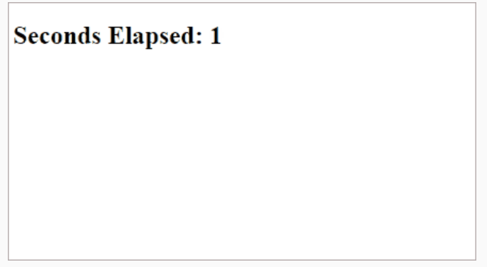
At updating phase of a component, below methods are executed based on props or state being received and updates happens in a component:
- static getDerivedStateFromProps()
- shouldComponentUpdate()
- render()
- getSnapshotBeforeUpdate()
- componentDidUpdate()

shouldComponentUpdate(nextProps, nextState):
- Executed before rendering when new state or props are being received
- By default it will return true by calling componentDidUpdate() method. If it returns false componentDidUpdate() method will not be invoked
- In case we want to skip re-rendering, this method could be used by returning false, so this would skip re-rendering
- This method only exists as a performance optimization

getSnapshotBeforeUpdate(prevProps, prevState):
- Invoked right before changes are made to the DOM
- It is recommended to return a value from this method which will be passed as a third parameter(as 'snapshot') to the componentDidUpdate()
- Once the updates flushed to the DOM, immediately next lifecycle method will be invoked
componentDidUpdate(prevProps, prevState, snapshot):
- Invoked immediately after the changes are updated

getSnapshotBeforeUpdate(prevProps, prevState): This method is called immediately after the render and before the changes are uodated to the DOM.
One of the use case of this method is to save the scroll position in chat application
This method is the last chance to get the prevState and prevProps values before the component is updated. The method can return values based on the prevState and prevProps values.
- getSnapshotBeforeUpdate(prevProps, prevState) {
- if (prevState.chats.length < this.state.chats.length) {
- const layout = this.layout.current;
- const isAtBottomOfChatWindow =
- window.innerHeight + window.pageYOffset === layout.scrollHeight;
- return { isAtBottomOfGrid };
- }
- return null;
- }
The above method checks whether the user is at the bottom of the chat window. If so, then the user should be scrolled to the bottom of the chat window, when new messages comes up in the chat window.
If user is not at the bottom of the chat window, then keep them there. Hence we return null
The snapshot returned from getSnapshotBeforeUpdate method will be passed as a third argument to the componentDidUpdate method as shown below
- componentDidUpdate(prevProps, prevState, snapshot) {

- if (snapshot.isAtBottomOfChatWindow) {
- window.scrollTo({
- top: this.layout.current.scrollHeight
- });
- }
- }
In the componentDidUpdate method, we check whether user was at the bottom on chat window using snapshot argument. If yes, we scroll the user to the bottom of the new messages that has come.

Highlights:
- Lifecycle methods usage at updating phase
Demo steps:
Add other lifecycle methods to Timer component and observe how the component will be updated:
Component will be updated only if the value is >3

1. Modify Timer component as shown below:
- import React from 'react';

- class Timer extends React.Component {
- constructor(props) {
- super(props);
- this.state = {
- count: 0
- };
- }
- start = () => {
- this.setState({
- count: this.state.count + 1
- });
- }
- componentDidMount() {
- this.interval = setInterval(this.start, 2000);
- }
- render() {
- return ( <React.Fragment>
- <Updates new = {this.state.count} />
- </React.Fragment>);
- }
- }
- class Updates extends React.Component {
- shouldComponentUpdate(newProps, newState) {
- if (this.props.new <= 3) {
- console.log('shouldComponentUpdate:', newProps);
- return false;
- } else {
- return true;
- }
- }
- componentDidUpdate(prevProps, prevState, snapshot) {
- console.log('Previous value destroyed:', prevProps);
- console.log('Updated');
- }
- render() {
- return ( <React.Fragment>
- <h2> Seconds Elapsed: {this.props.new} </h2>
- </React.Fragment>);
- }
- }
- export default Timer;
2. Render Timer component to the DOM as shown below:
- import React from 'react';
- import ReactDOM from 'react-dom';
- import './index.css';
- import Timer from './Timer';

- import * as serviceWorker from './serviceWorker';

- ReactDOM.render(<Timer/>, document.getElementById('root'));

- serviceWorker.unregister();

3. Observe the below output: It is updating the value from 4
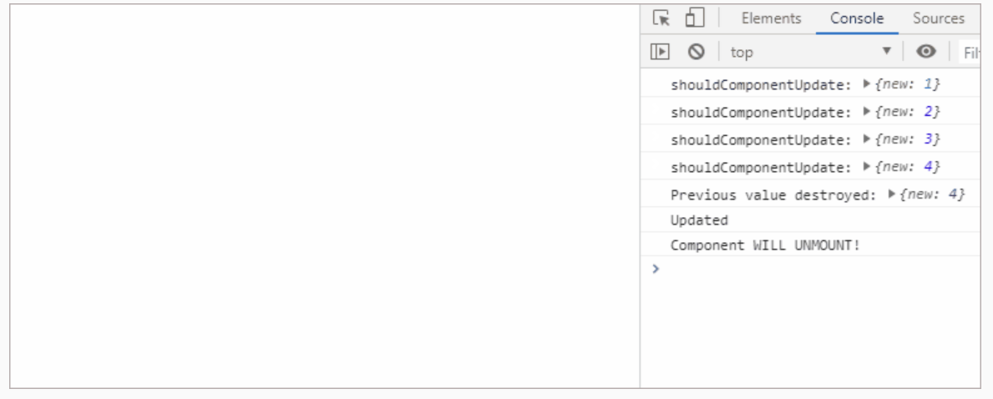
componentWillUnmount() method will be invoked immediately before a component is unmounted and destroyed.
- This method is used at the unmounting process of a component
- This is the place for performing any necessary cleanup. e.g: any subscription which was created in componentDidMount()
- A component can be unmounted from DOM using ReactDOM.unmountComponentAtNode()
In the previous demo, componentWillUnmount() can be added in the Timer component and updated as follows:
- componentWillUnmount(){
- console.log('Component WILL UNMOUNT!')
- //clean up code
- clearInterval(this.interval);
- }

Highlights:
Lifecycle methods usage at unmounting phase
Demo steps:
Revisiting the Updating Phase demo:
1. Add componentWillUnmount() lifecycle method to Timer component
2. Component will be unmounted from DOM after 15 seconds and observe how componentWillUnmount() is used for code cleanup
1. Update Timer component as shown below:
- import React from 'react';

- class Timer extends React.Component {
- constructor(props) {
- super(props);
- this.state = {
- count: 0
- };
- }
- start = () => {
- this.setState({
- count: this.state.count + 1
- });
- }
- componentDidMount() {
- this.interval = setInterval(this.start, 2000);
- }
- componentWillUnmount() {
- console.log('Component WILL UNMOUNT!')
- clearInterval(this.interval);
- }
- render() {
- return ( <React.Fragment>
- <Updates new = {this.state.count} />
- </React.Fragment>);
- }
- }
- class Updates extends React.Component {
- shouldComponentUpdate(newProps, newState) {
- if (this.props.new <= 3) {
- console.log('shouldComponentUpdate:', newProps);
- return false;
- } else {
- return true;
- }
- }
- componentDidUpdate(prevProps, prevState, snapshot) {
- console.log('Previous value destroyed:', prevProps);
- console.log('Updated');
- }
- render() {
- return ( <React.Fragment>
- <h2> Seconds Elapsed: {this.props.new} </h2>
- </React.Fragment>);
- }
- }

- export default Timer;
2. Render Timer component to the DOM and unmount the component after 15 seconds within the index.js file as shown below:
- import React from 'react';
- import ReactDOM from 'react-dom';
- import './index.css';
- import Timer from './Timer';

- import * as serviceWorker from './serviceWorker';

- ReactDOM.render(<Timer/>, document.getElementById('root'));
- setTimeout(() => {
- ReactDOM.unmountComponentAtNode( document.getElementById('root') );
- }, 15000);
- serviceWorker.unregister();

The output of the above code is:
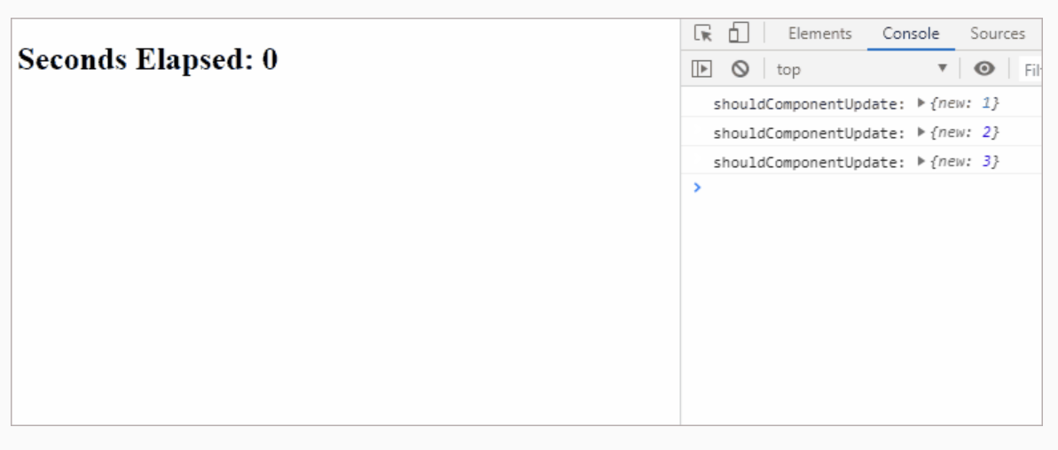

Error handling can be taken care in React using the below methods
- static getDerivedStateFromError()
- componentDidCatch()
Error boundaries should be defined in order to catch errors occurring within the child components. Whenever a component crashes because of a JavaScript error, the error will be logged and fall back UI is displayed.
Error boundaries are nothing but class components which defines either getDerivedStateFromError or componentDidCatch method
- class Timer extends React.Component {
- constructor(props) {
- super(props);
- this.state = {
- count: 0
- };
- }
- start = () => {
- this.setState({
- count: this.state.count + 1
- });
- }
- render() {
- if (this.state.count > 5) {
- throw new Error('Count cannot be greater than 5 ')
- }
- return ( <React.Fragment>
- <h1>{this.state.count}</h1><br/>
- <button onClick={this.start}>Update</button>
- </React.Fragment>);
- }
- }

The above component throws an error as shown below when the value of count is greater than 5

Here we will not be able to get to know, the error occurred in which component.
In order to know the component tree, we need to define Error boundaries, as shown below
- import React from 'react';

- class ErrorHandler extends React.Component {
- constructor(props) {
- super(props);
- this.state = {
- error: false,
- errorInfo: null,
- };
- }

- componentDidCatch(error, info) {
- this.setState({
- error: error,
- info: info,
- });
- }

- render() {
- if(this.state.error) {
- return (
- <React.Fragment>
- <h5>Sorry. Counter value is greater than 5</h5>
- <details style={{ whiteSpace: 'pre-wrap' }}>
- {this.state.error && this.state.error.toString()}
- <br />
- {this.state.errorInfo}
- </details>
- </React.Fragment>
- );
- }
- return this.props.children;
- }
- }
- export default ErrorHandler;
The ErrorHandler is just a class component which implements the componentDidCatch method. The componentDidCatch method receives the error and info as arguments.
error is the actual error message which tells the reason for the error and info contains stack trace of the error
Now wrap the Timer component within the ErrorHandler component as shown below
- ReactDOM.render(<ErrorHandler>
- <Timer/>
- </ErrorHandler>,document.getElementById('root'));
Now when the counter value is greater than 5, the error is displayed as shown below
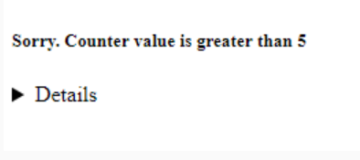

The stack trace is also displayed in the console, where it logs the exact component where the error occurred

If we render 2 components within a single error boundary as shown below
- ReactDOM.render(<ErrorHandler>
- <Timer/>
- <Timer/>
- </ErrorHandler>,document.getElementById('root'));
In the above example, if there is an error in one component then both the components will crash since the error boundary is the same.
To prevent the above problem, we need to wrap each component with it's own error boundary.
- ReactDOM.render(<div>
- <ErrorHandler>
- <Timer/>
- </ErrorHandler>
- <ErrorHandler>
- <Timer/>
- </ErrorHandler>
- </div>
- ,document.getElementById('root'));

Highlights:
- Error handling using the componentDidCatch method
Demo Steps
1. Modify the Timer Component which throws an error as shown below
- import React from 'react';

- class Timer extends React.Component {
- constructor(props) {
- super(props);
- this.state = {
- count: 0
- };
- }
- start = () => {
- this.setState({
- count: this.state.count + 1
- });
- }
- render() {
- if (this.state.count > 5) {
- throw new Error('Count cannot be greater than 5 ')
- }
- return ( <React.Fragment>
- <h1>{this.state.count}</h1><br/>
- <button onClick={this.start}>Update</button>
- </React.Fragment>);
- }
- }
- export default Timer;

2. Create an ErrorHandler component and implement the componentDidCatch method as shown below
- import React from 'react';

- class ErrorHandler extends React.Component {
- constructor(props) {
- super(props);
- this.state = {
- error: false,
- errorInfo: null,
- };
- }

- componentDidCatch(error, info) {
- this.setState({
- error: error,
- info: info,
- });
- }

- render() {
- if(this.state.error) {
- return (
- <React.Fragment>
- <h5>Sorry. Counter value is greater than 5</h5>
- <details style={{ whiteSpace: 'pre-wrap' }}>
- {this.state.error && this.state.error.toString()}
- <br />
- {this.state.errorInfo}
- </details>
- </React.Fragment>
- );
- }
- return this.props.children;
- }
- }
- export default ErrorHandler;

3. Render the Timer Component within the ErrorHandler Component
- import React from 'react';
- import ReactDOM from 'react-dom';
- import './index.css';
- import Timer from './Timer';

- import * as serviceWorker from './serviceWorker';
- import ErrorHandler from './ErrorHandler';

- ReactDOM.render(<ErrorHandler>
- <Timer/>
- </ErrorHandler>,
- document.getElementById('root'));
- serviceWorker.unregister();

The output of the above code is :
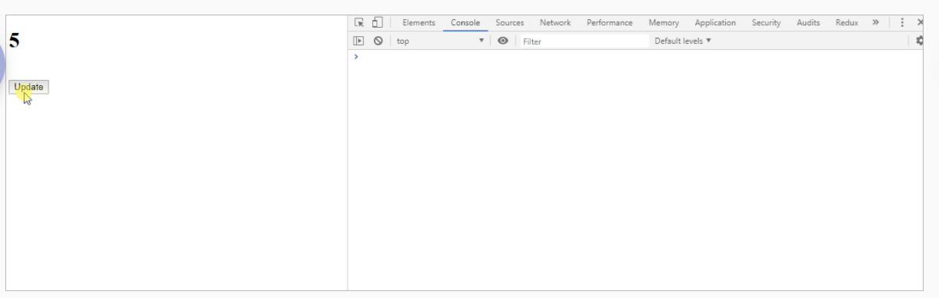
The entire rendering will be replaced with an error screen after a brief moment. The Error boundary message can be seen again by hitting escape.

Loading data using Ajax:
In this section, let us understand how to handle Ajax requests in React.
- React by default does not provide any helper method to manage Ajax requests
- Any other third party JavaScript library can be used to handle Ajax requests
- As we discussed already, in lifecycle methods, the componentDidMount method is the best place to handle Ajax request
- Using Ajax fetch the data in the event handler of componentDidMount()
- Once we have the data, make it available to our component by setting the state of a component to trigger re-render

In our course, we will be using Axios API for handling ajax requests.
Axios is a promise-based API that can be used to make asynchronous calls to the back end in our applications.
In order to use axios we need to install axios using the below command
- npm install axios
Axios offers the following methods:
axios.get()
axios.post()
axios.put()
axios.delete()
axios.patch()
axios.options()
Get request syntax
- axios.get('url')
- .then(result =>
- console.log(result.data)
- )
- .catch(error =>
- console.log(error)
- );
Post request syntax
- axios.post('url', { data }).
- then(result =>
- console.log(result.data)
- )
- .catch(error =>
- console.log(error)
- );
We can also use fetch for making API calls, but axios offers some advantages over axios
1. The response returned by axios is the response that we need, but with fetch we need to use .json method to get the actual response
Axios output
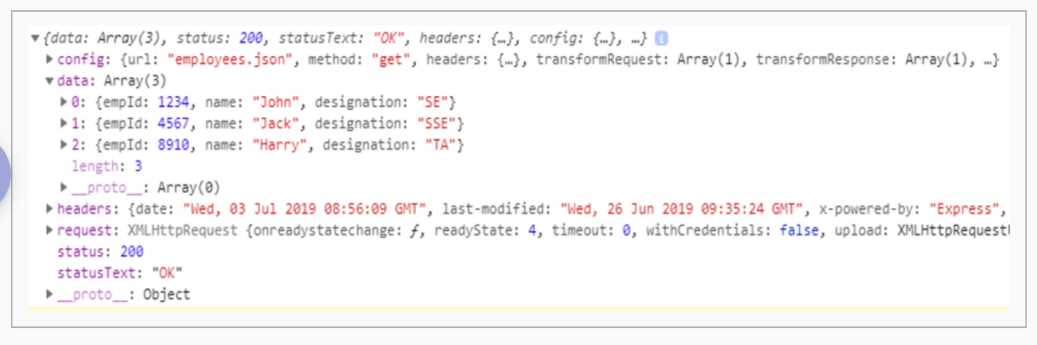
Fetch output
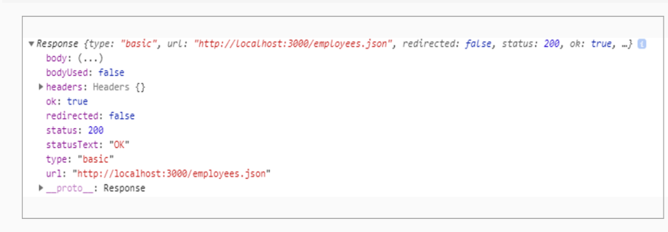
2. Axios is more secure than fetch and protects from XSRF attacks
3. Axios are supported by most of the browsers including Internet Explorer 8+
4. Axios has better error handling
For example, if we try to make the request to a non-existent JSON file employees1.json file
Axios returns
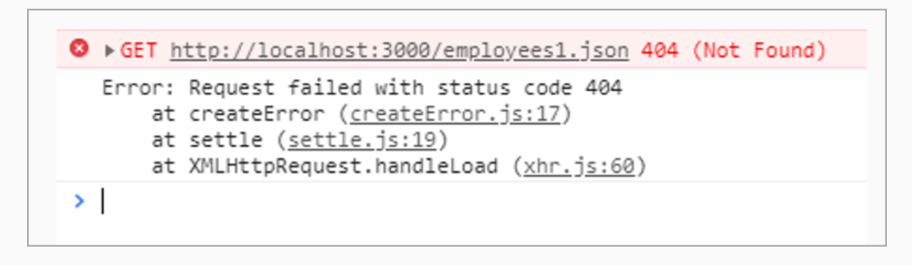
Fetch returns
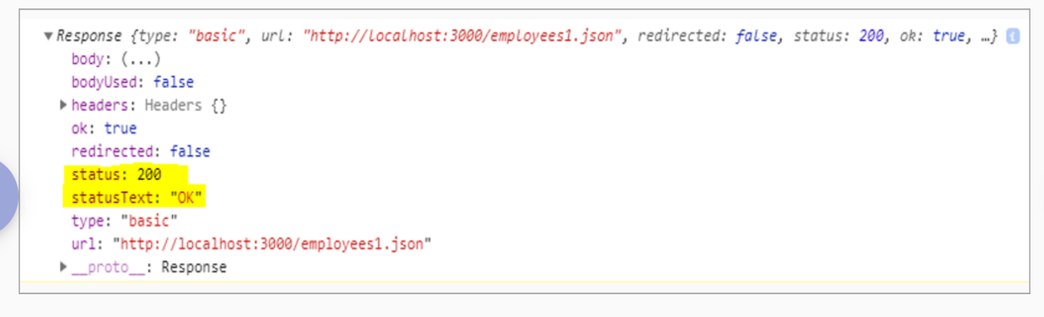

Highlights:
- Retrieving data
- Using Axios to fetch the data from the JSON file within the componentDidMount method
Demo steps:
Create Employees component and retrieve data from the employees.json file.

1. Create employees.json within the public folder as shown below:

- [
- { "empId": 1234, "name": "John", "designation":"SE" },
- { "empId": 4567, "name": "Jack", "designation":"SSE"},
- { "empId": 8910, "name": "Harry","designation":"TA"}
- ]
2. Create Employee component within Employee.js file as shown below:

- import React from 'react';
- import axios from 'axios';
- import 'bootstrap/dist/css/bootstrap.min.css';

- class Employee extends React.Component {
- constructor() {
- super()
- this.state = {
- employees: []
- }
- }
- componentDidMount() {
- this.setState({ isLoading: true });
- axios.get('employees.json')
- .then(result =>
- this.setState({
- employees: result.data,
- isLoading: false
- })
- )
- .catch(error =>
- this.setState({
- error,
- isLoading: false
- })
- );
- }
- render() {
- if(this.state.isLoading) {
- return "Loading..."
- }
- if(this.state.error) {
- return <p>{this.state.error.message}</p>
- }
- return (<React.Fragment>
- <table style={{width:'60%'}} className='table'>
- <thead className="thead-light">
- <tr>
- <th>EmpID</th>
- <th>Name</th>
- <th>Designation</th>
- </tr>
- </thead>
- <tbody>
- {this.state.employees ?
- this.state.employees.map(employee => {
- return (<tr key={employee.empId}>
- <td>{employee.empId}</td>
- <td>{employee.name}</td>
- <td>{employee.designation}</td>
- </tr>)
- }):<tr><td>No Data found</td></tr>
- }
- </tbody>
- </table>
- </React.Fragment>)
- }
- }
- export default Employee;

3. Render employees component to the DOM within the index.js file as shown below:

- import React from 'react';
- import ReactDOM from 'react-dom';
- import './index.css';
- import Employee from './Employee';

- import * as serviceWorker from './serviceWorker';

- ReactDOM.render(<Employee/>, document.getElementById('root'));
- serviceWorker.unregister();

4. Observe the below output:
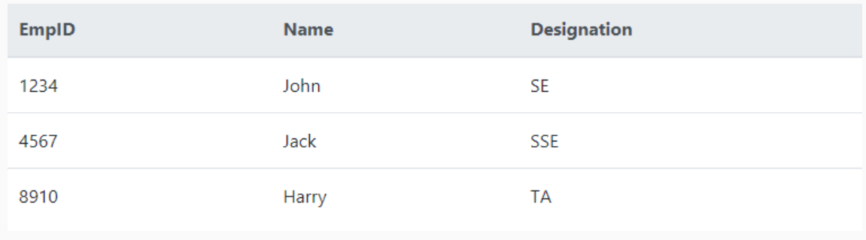

React onChange:
In most of the web applications, forms are required for taking user input, placing an order, booking tickets, etc.
Let us see how to handle forms in React applications, by taking a simple example.
Consider the below Login component:

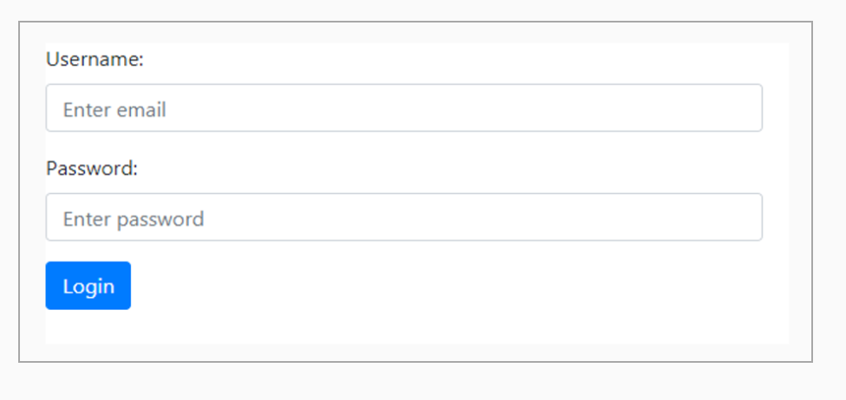
- The form that we create using React to accept user inputs is different from HTML forms
- Users will not be able to input value in the form input field because ReactJS uses unidirectional data flow

Before discussing Forms in React, let us first understand the unidirectional data flow.
Most of the frameworks follow two-way data binding. This would allow for updates from both the end i.e. changes can be done from view to model and vice versa.

In this approach state of the model could be mutated by both model and view, it would cause unpredictable data flow.
React uses unidirectional data flow pattern wherein the changes will be done only from component to view but not vice versa.
This would prevent unpredictable data flow and easy to debug.
So let's discuss how HTML form works in ReactJS through a demo, in the next section.

Forms:
Highlights:
- Creating forms in a component
- Creating form elements
Demo steps:

Create a Login component using form elements as shown below and observe how it works:



1. Create Login component within the Login.js file as shown below:
- import React from 'react';
- import 'bootstrap/dist/css/bootstrap.min.css';

- class Login extends React.Component {
- render() {
- return(<React.Fragment>
- <form>
- <div className="form-group">
- <label for="name">Username:</label>
- <input style={{width:'40%'}} type="text" className="form-control" id="name" placeholder="Enter Name" name="name" />
- </div>
- <div className="form-group">
- <label for="pwd">Password:</label>
- <input style={{width:'40%'}} type="password" className="form-control" id="pwd" placeholder="Enter password" name="password" />
- </div>
- <button type="submit" className="btn btn-primary">Login</button>
- </form>
- </React.Fragment>)
- }
- }
- export default Login;
2. Render Login component to the DOM within the index.js file as shown below:

- import React from 'react';
- import ReactDOM from 'react-dom';
- import './index.css';
- import Login from './Login'

- import * as serviceWorker from './serviceWorker';

- ReactDOM.render(<Login/>, document.getElementById('root'));
- serviceWorker.unregister();

How to work with React Form elements?
In the previous demo, the user will not able to interact with an input element.
We can make form elements interactive by setting a callback to the onChange prop. Form components listen for changes and this fires when,
- The value of <input> or <textarea> changes
- Checked state of <input> changes
- Selected state of <input> changes
For updating the value in response to user interaction, the onChange prop can be used as follows:
- <input type = "name"
- name = "username"
- placeholder = "Enter Name"
- onChange = {this.setEmpState}
- value = {this.state.name} />

On change of the input field, we call an event handler method setEmpState() and the value attribute of the input field is assigned to the corresponding state.

- setEmpState = (e) => {
- this.setState({name:e.target.value})
- }
Within the setEmpState() method, we will fetch the value of the input field using e.target.value and assign the value to one of the state property, as shown above.
When we have multiple input fields, we have to define onChange event handler methods for each input field, which becomes a tedious task. We can overcome the problem by defining a single method as shown below:
- setEmpState(e){
- const value = e.target.value;
- const field = e.target.name;
- this.setState({[field]:value})
- }
The setEmpState() method will fetch the 'name' and value of the input field, which has triggered the change event and update the state using [] brackets.
[ ] can be used to access each state and assign value to it.
Note that, the name attribute and the state property should be the same when we use [] brackets to update the state.
- constructor(props){
- super(props);
- this.state = { name: '', password: ''}
- }
- <form>
- <div className="form-group">
- <label for="name">Username:</label>
- <input style={{width:'40%'}} type="text" className="form-control" id="name" placeholder="Enter Name" name="name" />
- </div>
- <div className="form-group">
- <label for="pwd">Password:</label>
- <input style={{width:'40%'}} type="password" className="form-control" id="pwd" placeholder="Enter password" name="password" />
- </div>
- <button type="submit" className="btn btn-primary">Login</button>
- </form>
Highlights:
- Making form element interactive
- Using onChange props
Demo steps:
Revisit previous Login component and make it interactive using onChange props:

1. Modify the Login Component as shown below:
- import React from 'react';
- import 'bootstrap/dist/css/bootstrap.min.css';

- class Login extends React.Component {
- constructor(props){
- super(props);
- this.state = { name: '', password: ''}
- }
- setEmpState = (e) => {
- const value = e.target.value;
- const field = e.target.name;
- this.setState({[field]:value})
- }
- handleLogin = (e) => {
- e.preventDefault();
- alert('Logged in successfully');
- }
- render() {
- return(<React.Fragment>
- <form>
- <div className="form-group">
- <label>Username:</label>
- <input style={{width:'40%'}} type="text" className="form-control" value={this.state.name} id="name" placeholder="Enter Name" name="name" onChange={this.setEmpState} />
- </div>
- <div className="form-group">
- <label>Password:</label>
- <input style={{width:'40%'}} type="password" className="form-control" value={this.state.password} id="pwd" placeholder="Enter password" name="password" onChange={this.setEmpState} />
- </div>
- <button type="submit" className="btn btn-primary" onClick={this.handleLogin}>Login</button>
- </form>
- </React.Fragment>)
- }
- }
- export default Login;
2. Render Login Component to the DOM within the index.js file as shown below:
- import React from 'react';
- import ReactDOM from 'react-dom';
- import './index.css';
- import Login from './Login'

- import * as serviceWorker from './serviceWorker';

- ReactDOM.render(<Login/>, document.getElementById('root'));
- serviceWorker.unregister();

3. Observe the below output:
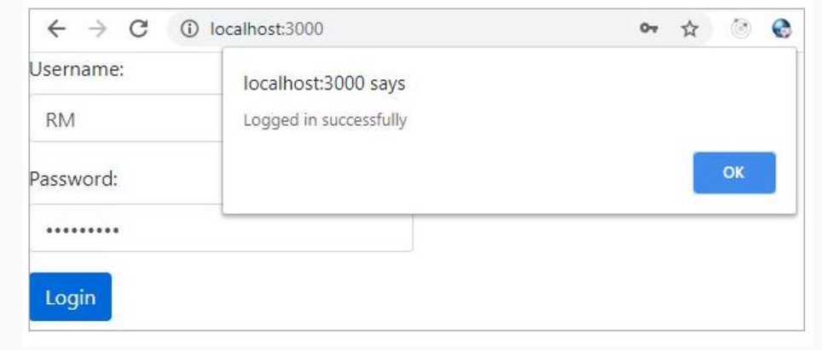

React refs:
We can create two different ways of forms in React:
1. Controlled component
2. Uncontrolled component

Controlled component: In HTML, form elements such as <input>, <textarea>, and <select> typically maintains their own state and that gets updated based on user input. But in React, we handle it using state and state gets updated using setState() method. So an input form element whose value is controlled by React in this way will be called a controlled component.
Below is an example of a controlled component where it has a value attribute and a handler function:
- <input type="text" value={this.state.name} onChange={this.handleData}/>

Uncontrolled component: The traditional HTML input elements are uncontrolled component, where the form data is handled by DOM itself. In uncontrolled component, we do not use the value attributes.
Below is the example for an uncontrolled component:
- <input type="text" />
Here, input will not have value attribute and event handler, instead to get the value from the DOM ref is used as follows:
- <input type="text" ref={this.input}/>

In React, ref provides a way to access the DOM node or the React elements, and helps in getting the value from the DOM.
refs are to be used when we have the below requirements:
1. Integrating with third-party libraries, like D3 which has it's own DOM manipulation API's
2. To use media playbacks like audio, video. refs provide control over the DOM API.
3. Trigger imperative animations
By using refs, we are deviating from the React way of handling data. In React we store data as state and when the state in updated component gets re-rendered. This follows a unidirectional data flow and the data is stored in a single source of truth i.e., state.

Let's see how ref and refs will be used to get the reference of a node.
We need to create a ref instance within the constructor as shown below:
- constructor(props) {
- super(props);
- this.nameRef = React.createRef();
- }

We need to assign the ref instance created in the constructor to the input field using ref attribute, as shown below:
- input type="text" ref={this.nameRef} />
When we assign a ref attribute to the input field, the ref created in the constructor will receive the DOM element.
We can access the value of the input field as shown below:
- this.nameRef.current.value;

Demo:
Highlights:
- How to refer a node element
- How to access the value of a node
Demo steps:

Add validations to the previous Login component and display values entered by the user:

1. Create Login component as shown below:
- import React from 'react';
- import 'bootstrap/dist/css/bootstrap.min.css';

- class Login extends React.Component {
- constructor(props){
- super(props);
- this.state = { name: '', password: ''}
- this.nameRef = React.createRef()
- this.pwdRef = React.createRef()
- }
- handleLogin = (e) => {
- e.preventDefault();
- if(this.nameRef.current.value==="" && this.pwdRef.current.value==="") {
- alert("Please enter username and password")
- }
- alert("Welcome " + this.nameRef.current.value);
- }
- render() {
- return(<React.Fragment>
- <form>
- <div className="form-group">
- <label>Username:</label>
- <input style={{width:'40%'}} type="text" className="form-control" id="name" placeholder="Enter Name" name="name" ref={this.nameRef}/>
- </div>
- <div className="form-group">
- <label>Password:</label>
- <input style={{width:'40%'}} type="password" className="form-control" id="password" placeholder="Enter password" name="password" ref={this.pwdRef} />
- </div>
- <button type="submit" className="btn btn-primary" onClick={this.handleLogin}>Login</button>
- </form>
- </React.Fragment>)
- }
- }
- export default Login;
2. Render Login component the DOM within the index.js file as shown below:
- import React from 'react';
- import ReactDOM from 'react-dom';
- import './index.css';
- import Login from './Login'

- import * as serviceWorker from './serviceWorker';

- ReactDOM.render(<Login/>, document.getElementById('root'));
- serviceWorker.unregister();

3. Observe the below output:
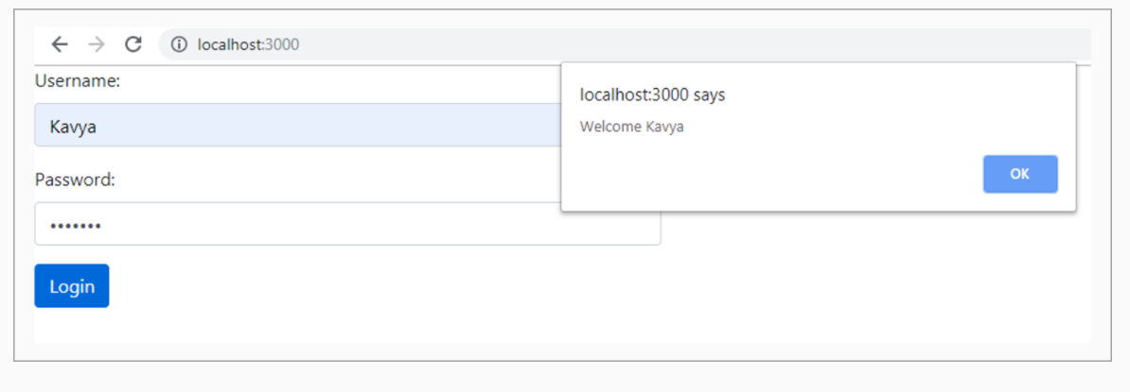
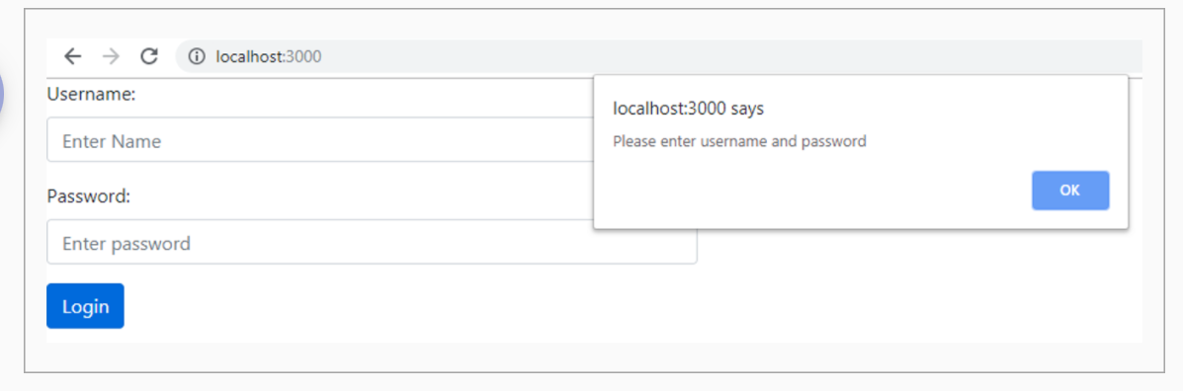

Highlights:
- Use refs within a functional component
Demo Steps
1. Create FormComponent as shown below
- import React from 'react';
- import TextInput from './TextInput';
- import 'bootstrap/dist/css/bootstrap.min.css';

- class FormComponent extends React.Component {
- handleLogin = (e) => {
- e.preventDefault();
- alert("Welcome " + this.nameRef.value);
- }
- render() {
- return(<React.Fragment>
- <form onSubmit={this.handleLogin}>
- <TextInput nameRef={input => this.nameRef = input}/><br/><br/>
- <button type="submit" className="btn btn-primary">Login</button>
- </form>
- </React.Fragment>)
- }
- }
- export default FormComponent;
2. Create TextInput child component as shown below
- import React from 'react';

- function TextInput(props) {
- console.log("Props")
- console.log(props.nameRef)
- return (
- <React.Fragment>
- <br/><br/><label>UserName:</label>
- <input type="text" ref={props.nameRef}/>
- </React.Fragment>
- );
- }
- export default TextInput;
3. Render the FormComponent to the DOM within the index.js file as shown below
- import React from 'react';
- import ReactDOM from 'react-dom';
- import './index.css';
- import FormComponent from './FormComponent';

- import * as serviceWorker from './serviceWorker';

- ReactDOM.render(<FormComponent/>, document.getElementById('root'));
- serviceWorker.unregister();

4. Observe the below output

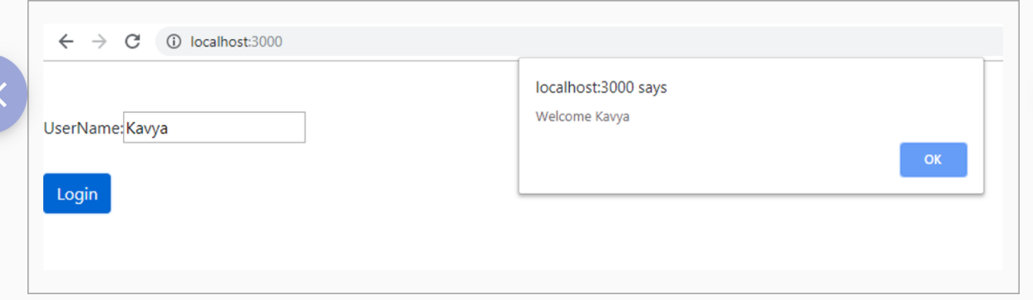

Styling Forms using react-bootstrap - Demo – 1
Highlights:
- Using react-bootstrap
- How to use bootstrap components in forms
Demo steps:

Create a component to learn the basics of react-bootstrap in forms:

1. Modify Login.js as shown below:
- import React from 'react';
- import Button from 'react-bootstrap/Button';
- import Alert from 'react-bootstrap/Alert';
- import Form from 'react-bootstrap/Form';
- import FormControl from 'react-bootstrap/FormControl';
- import Jumbotron from 'react-bootstrap/Jumbotron';

- class Login extends React.Component {
- render() {
- return (<div>
- <Jumbotron>
- <h2 style={{padding:"10px"}}>React Demo</h2>
- </Jumbotron>
- <Form style={{padding:"10px"}}>
- <h2>Login</h2><br/>
- <Form.Group>
- <Form.Control type="text" style={{width:"30%"}}
- placeholder="Enter Name"
- />
- </Form.Group><br/>
- <Form.Group>
- <Form.Control type="password" style={{width:"30%"}}
- placeholder="Enter Password"
- /><br/><br/>
- </Form.Group>
- <Form.Group >
- <Form.Check type="checkbox" label="Remember me" />
- </Form.Group>
- <Button type="submit" variant="primary" size="sm" > Login
- </Button>
- </Form>
- </div>);
- }
- }
- export default Login;

2. Render Login within the index.js file as shown below:
- import React from 'react';
- import ReactDOM from 'react-dom';
- import './index.css';
- import 'bootstrap/dist/css/bootstrap.min.css'
- import App from './App';
- import * as serviceWorker from './serviceWorker';

- import Login from './Login';

- ReactDOM.render(<Login/>, document.getElementById('root'));

- // If you want your app to work offline and load faster, you can change
- // unregister() to register() below. Note this comes with some pitfalls.
- // Learn more about service workers: https://bit.ly/CRA-PWA

- serviceWorker.unregister();

3. Observe the below output:
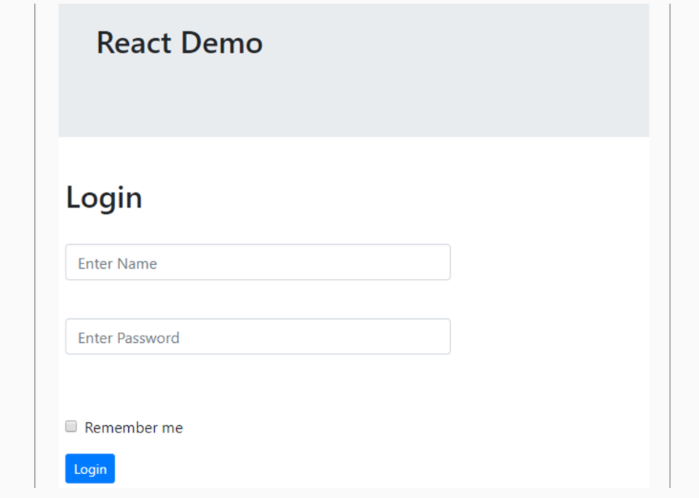

Demo 2: Styling Forms using react-bootstrap
Highlights:
- Using react-bootstrap
- Using react-bootstrap form components
- Observe styles applied based on validation
Demo steps:

1. Modify Login Component as shown below:
- import React from 'react';
- import Button from 'react-bootstrap/Button';
- import Alert from 'react-bootstrap/Alert';
- import Form from 'react-bootstrap/Form';
- import FormControl from 'react-bootstrap/FormControl';

- class Login extends React.Component {
- constructor(props){
- super(props);
- this.state = { isvalid: false, message:"" }
- this.handleLogin = this.handleLogin.bind(this);
- };

- handleLogin(event){
- event.preventDefault();
- const login = event.currentTarget;
- if (login.checkValidity() === false){
- event.preventDefault();
- event.stopPropagation();
- this.setState({message:""})
- }
- else{
- this.setState({message:"Form submitted successfully!"})
- }
- this.setState({ isvalid: true});
- }

- render(){
- const { isvalid } = this.state;
- return(<Form style={{backgroundColor:"#DCDCDC", width:"50%"}}
- noValidate validated={isvalid}
- onSubmit={e => this.handleLogin(e)}>

- <div style={{padding:"10px"}}>
- <h1> Login </h1><br/>
- <Form.Group>
- <label> Name </label>
- <Form.Control type="text" style={{backgroundColor:"##C0C0C0"}}
- name="name" placeholder="Enter Name" ref="name"
- required/>
- <Form.Control.Feedback type="invalid">
- UserName is required
- </Form.Control.Feedback>
- </Form.Group>
- <br/>

- <Form.Group >
- <label> Password </label>
- <Form.Control type="password" style={{backgroundColor:"##C0C0C0"}}
- name="password" placeholder="Enter Password"
- required />
- <Form.Control.Feedback type="invalid">
- Password is required
- </Form.Control.Feedback>
- </Form.Group>
- <br/>

- <Button type="submit" variant="primary"> Login </Button>
- </div>

- {this.state.message!=="" && <Alert variant="success"> {this.state.message} </Alert>}
- </Form>);
- }
- }
- export default Login;

2. Render the Login component within the index.js as shown below:
- import React from 'react';
- import ReactDOM from 'react-dom';
- import './index.css';
- import 'bootstrap/dist/css/bootstrap.min.css'
- import App from './App';
- import * as serviceWorker from './serviceWorker';

- import Login from './Login';

- ReactDOM.render(<Login/>, document.getElementById('root'));

- // If you want your app to work offline and load faster, you can change
- // unregister() to register() below. Note this comes with some pitfalls.
- // Learn more about service workers: https://bit.ly/CRA-PWA
- serviceWorker.unregister();

3. Observe the below output:
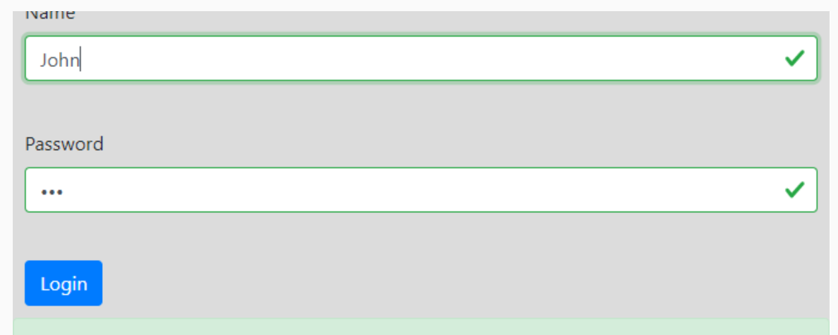

Form Validation – Demo
Highlights:
- Validate forms using state
- Validate email and password fields for required validation
- The email should contain @ and .com
Demo Steps:
1. Create FormValidation component as shown below
- import React from 'react';
- import 'bootstrap/dist/css/bootstrap.min.css';

- class FormValidation extends React.Component{
- constructor(){
- super();
- this.state = {
- email:'',
- password:'',
- message:'',
- textStyle:''
- }
- }

- handleChange = (e) => {
- this.setState({
- [e.target.name]:e.target.value,
- message:''})
- }
- handleSubmit = (e) => {
- e.preventDefault();
- const validateEmail = (email) => {
- var re = /^([\w.%+-]+)@([\w-]+\.)+([\w]{2,})$/i;
- return re.test(email);
- }
- if(this.state.email =='' || this.state.password==''){
- this.setState({message:"All fields are mandatory", textStyle:"danger"})
- }
- else {
- if(validateEmail(this.state.email)){
- this.setState({message:"Looks good!",
- textStyle:"success"
- })
- }
- else {
- this.setState({message:"Please enter a valid email id",
- textStyle:"danger"
- })
- }
- }
- }

- render(){
- return(
- <React.Fragment>
- <br/>
- <form style={{position:'relative',left:'50px'}} onSubmit={this.handleSubmit}>
- <h3>Login</h3><br/>
- <div className="form-group">
- <label>Email:</label>
- <input style={{width:'40%'}} className="form-control" name="email" type="text" onChange={this.handleChange}/>
- </div>
- <div className="form-group">
- <label>Password:</label>
- <input style={{width:'40%'}} className="form-control" name="password" type="password" onChange={this.handleChange}/>
- </div>
- {this.state.message !== '' && <div className={`text text-${this.state.textStyle}`}>{this.state.message}</div>}<br/>
- <button className="btn btn-success" onClick={this.handleSubmit}>Login</button>
- </form>
- </React.Fragment>
- )
- }
- }

- export default FormValidation;
2. Render FormValidation component within the index.js file as shown below
- import React from 'react';
- import ReactDOM from 'react-dom';

- import FormValidation from './FormValidation.js';

- import * as serviceWorker from './serviceWorker';

- ReactDOM.render(<FormValidation />, document.getElementById('root'));

3. Observe the below output
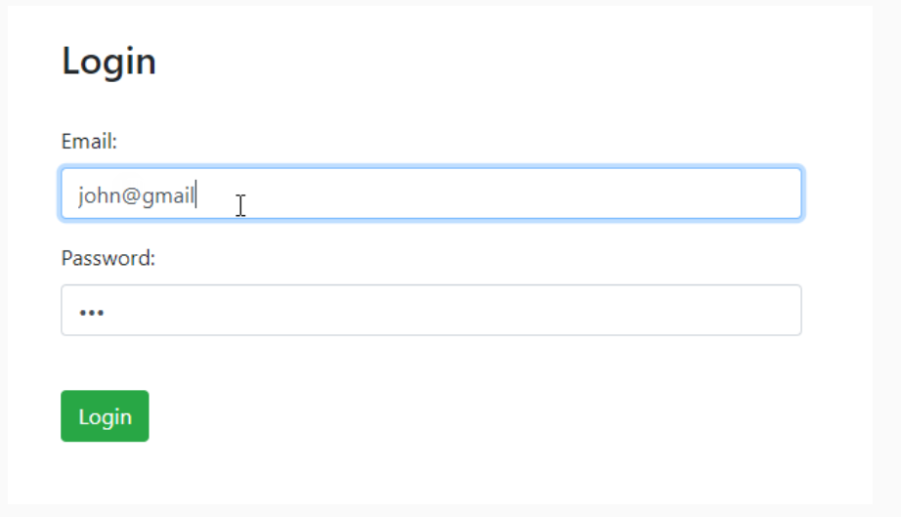

Why Hooks?
As we all know, we can create components in 2 different ways:
- Class component
- Functional component
In a component, if we need to use any lifecycle methods, state and any other React features, then we create it as a class component. But if a component has no state and lifecycle methods, then it can be created as a simple JavaScript function – functional component. And later if we want to add any lifecycle method or any other React features, then it has to be changed as a class component.
But without switching to a class component, we can have lifecycle methods, state and other React features in functional component itself, by using the new feature of React i.e. Hooks.
This feature has been added from React v16.8.0.

What are React Hooks?
React hooks are JavaScript functions, which allows the developer to interact with the state and lifecycle methods through functional components
Earlier we could associate state, modify the state, and implement lifecycle methods only in class components, whereas functional components were used only to present the UI content, but now with React 16.8 we can achieve the above-mentioned tasks in functional components using React hooks.
The different hooks available in React are
- useState()
- useEffect()
- useContext()

Let us discuss these hooks in detail in the next section.

useState():
useState hook is used to add or initialize state value within a functional component. It is equivalent to this.state statement of Class component which is used to initialize the state value. This hook helps to preserve the state value of a component.
Syntax - useState() can be written as follows:
- const [state, setState] = useState(initialState);

useState() is a function which takes ‘initialState’ as the initial value for the state variable and returns 2 values.
Where, ‘state’ is a state variable which holds the initial value passed to it i.e. ‘initialState’ and ‘setState’ is a function to update the ‘state’.
whenever we want to update the ‘state’ value then we can use the second parameter ‘setState’ which is returned from the useState() function, which is equivalent to this.setState statement of the Class component.
Let us understand useState() from the below example:
- import React, {useState} from 'react';

- function App() {
- const [name,setName] = useState("Jack")
- return (
- <div>
- Your Name is: {name}
- <button onClick={()=>setName("Jill")}>Change</button>
- </div>
- );
- }

- export default App;

In the above example useState() hook helps to set the initial value as "Jack".
Line 4: ‘name’ is the state of the component ‘App’. useState() returns a state ‘name’ with its initial value ‘Jack’ and ‘setName’ function.
Line 8: When user clicks on the button, Change event gets fired and due to which ‘name’ state value gets updated to Jill through setName method execution.
We can use useState() hook any number of times in any component to set multiple state variables as shown below:
- const [name,setName] = useState("Jack")
- const [age,setAge] = useState(0)

Let us discuss a demo on this concept in the next section.

Highlights:
- Understand the usage of useState method
- Update component's state using useState
Demo steps
1. Create Sample.js file within src folder and write the following code
- import React, {useState} from 'react';

- function Sample() {
- const [name,setName] = useState("Jack")
- return (
- <div>
- Your Name is: {name}
- <button onClick={()=>setName("Jill")}>Change</button>
- </div>
- );
- }

- export default Sample;

2. Render the Sample component within index.js
- import React from 'react';
- import ReactDOM from 'react-dom';
- import './index.css';
- import * as serviceWorker from './serviceWorker';;
- import Sample from './Sample';

- ReactDOM.render(<Sample />, document.getElementById('root'));

- // If you want your app to work offline and load faster, you can change
- // unregister() to register() below. Note this comes with some pitfalls.
- // Learn more about service workers: https://bit.ly/CRA-PWA
- serviceWorker.unregister();
3. Observe the output
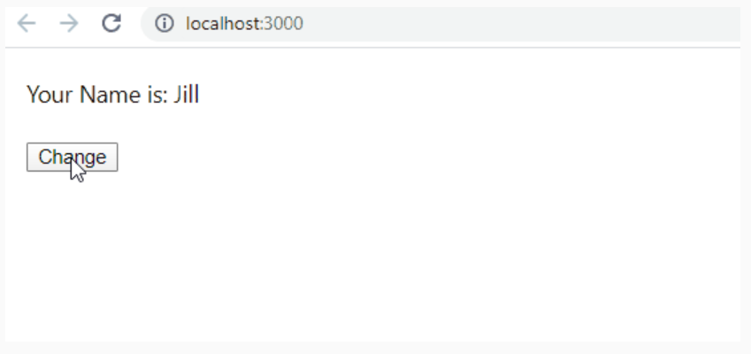

Highlights:
- Understand the usage of useState method
- Update component's state whose value is an array
Demo steps
1. Create Employees Component within src folder and write the following code
- import React, { useState } from 'react';
- import 'bootstrap/dist/css/bootstrap.min.css';
- const Employees = () => {

- const [employees,setEmployees] = useState([
- { empId: 1234, name: 'John', designation:'SE' },
- { empId: 4567, name: 'Tom', designation:'SSE'},
- { empId: 8910, name: 'Kevin',designation:'TA'}
- ])
- const addEmployee = () => {
- setEmployees([...employees, { empId:6789, name: 'Sam', designation:'TL' }]);
- };
- return (<>
- <table style={{width:'60%'}} className='table'>
- <thead className="thead-light">
- <tr>
- <th>EmpID</th>
- <th>Name</th>
- <th>Designation</th>
- </tr>
- </thead>
- <tbody>
- {employees.map(employee => {
- return (<tr>
- <td>{employee.empId}</td>
- <td>{employee.name}</td>
- <td>{employee.designation}</td>
- </tr>)
- })
- }
- </tbody>
- </table>
- <button onClick={addEmployee}>Add an Employee</button>
- </>)
- }
- export default Employees;
2. Render the Employees component within index.js
- ​import React from 'react';
- import ReactDOM from 'react-dom';
- import './index.css';
- import * as serviceWorker from './serviceWorker';;
- import Employees from './Employees';

- ReactDOM.render(<Employees/>, document.getElementById('root'));

- // If you want your app to work offline and load faster, you can change
- // unregister() to register() below. Note this comes with some pitfalls.
- // Learn more about service workers: https://bit.ly/CRA-PWA
- serviceWorker.unregister();

3. Observe the output
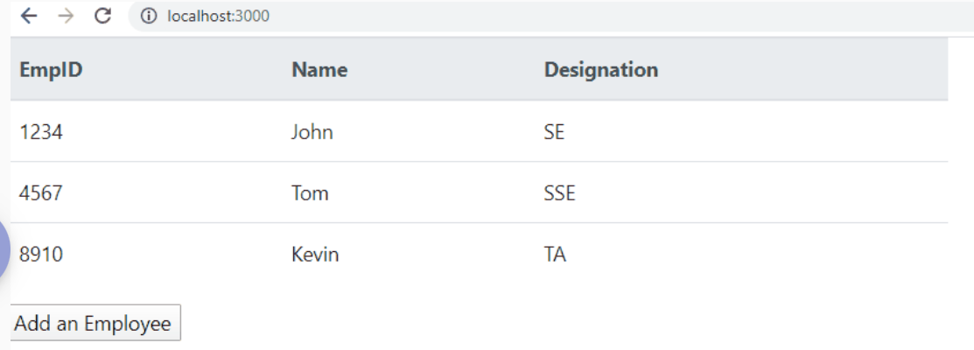

Highlights:
- Understand the usage of useState method with Forms
- Update component's state using useState
Demo steps
1. Let us create a new component AddEmployee component as seen below, which contains three input fields for EmpId, Name and Designation.
- import React, { useState } from 'react';

- const AddEmployee = ({ addEmployee }) => {
- const [empId, setEmpId] = useState('');
- const [name,setName] = useState('');
- const [designation,setDesignation] = useState('');

- const handleSubmit = (e) => {
- e.preventDefault();
- const newEmployee={empId:empId,name:name,designation:designation}
- addEmployee(newEmployee);
- setEmpId('');
- setName('');
- setDesignation('')
- }
- return (
- <form onSubmit={handleSubmit}>
- EmpId:<input type='text' value={empId} onChange={(e) => setEmpId(e.target.value)} /><br/><br/>
- EmpName: <input type='text' value={name} onChange={(e) => setName(e.target.value)} /><br/><br/>
- Designation: <input type='text' value={designation} onChange={(e) => setDesignation(e.target.value)} /><br/><br/>
- <input type='submit' value='Add Employee' />
- </form>
- );
- }

- export default AddEmployee;
Line 18,19 and 20 - Once user enters data in the form, state value of AddEmployee component gets updated through useState() hook
Line 11 - Once the form is submitted, the employee details is passed as an argument to the addEmployee() method, which is a prop passed from Employees parent component.
2. Let us modify the Employees.js file as shown below:
- import React, { useState} from 'react';
- import AddEmployee from './AddEmployee';

- const Employees = () => {

- const [employees, setEmployees] = useState([
- { empId: 1234, name: 'John', designation: 'SE' },
- { empId: 4567, name: 'Tom', designation: 'SSE' },
- { empId: 8910, name: 'Kevin', designation: 'TA' }
- ])
- const addEmployee = (newEmployee) => {
- setEmployees([...employees, newEmployee]);
- };
- return (<React.Fragment>
- <table style={{ width: '60%' }} className='table'>
- <thead className="thead-light">
- <tr>
- <th>EmpID</th>
- <th>Name</th>
- <th>Designation</th>
- </tr>
- </thead>
- <tbody>
- {employees.map(employee => {
- return (<tr>
- <td>{employee.empId}</td>
- <td>{employee.name}</td>
- <td>{employee.designation}</td>
- </tr>)
- })
- }
- </tbody>
- </table><br/><br/>
- <AddEmployee addEmployee={addEmployee} />
- </React.Fragment>)
- }
- export default Employees;
Line 12 - The addEmployee method adds the new employee to the existing employee state
Line 34 - The addEmployee method is passed as a prop to AddEmployee component.

3. Render the Employees component within index.js
- ​import React from 'react';
- import ReactDOM from 'react-dom';
- import './index.css';
- import * as serviceWorker from './serviceWorker';;
- import Employees from './Employees';

- ReactDOM.render(<Employees/>, document.getElementById('root'));

- // If you want your app to work offline and load faster, you can change
- // unregister() to register() below. Note this comes with some pitfalls.
- // Learn more about service workers: https://bit.ly/CRA-PWA
- serviceWorker.unregister();
4. Observe the output
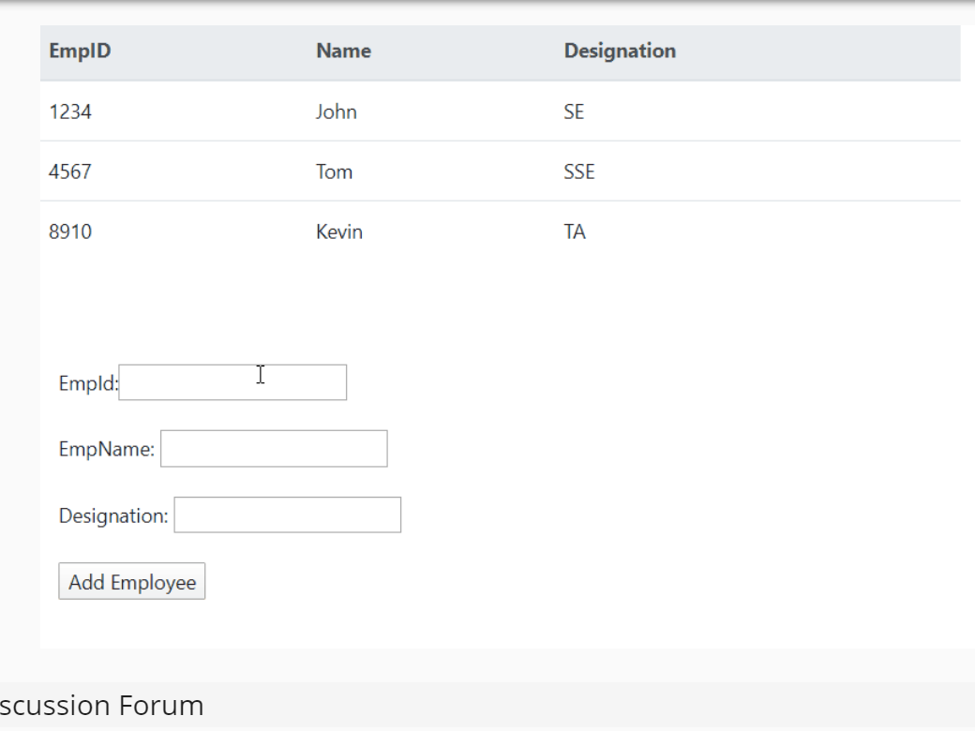
useEffect():-
useEffect()
In order to run some code after the component mounts or after the component updates, then we use componentDidMount and componentDidUpdate lifecycle methods in class based components respectively.
As we cannot use these lifecycle methods in functional components, we can use useEffect() hook instead.
useEffect() method gets executed in both cases i.e. after first render and every time the component gets updated.
Syntax - useEffect() can be written as follows:
- useEffect(()=>{

- //implementation

- })

The useEffect() method takes an array as a second argument:
- useEffect(()=>{

- //implementation

- },[])
If we pass an empty array as a second argument then the useEffect method runs only after the component mounts not after the component updates. It is equivalent to componentDidMount method in class based component.
When we pass a specific state as second argument as shown below, then the useEffect method will run once for the initial render and then every time when the specific state passed updates and not for other state updates.
- useEffect(()=>{
- //implementation
- },[age])

useEffect to make axios call:
We can handle asynchronous calls within the useEffect() method which is similar to how we handle asynchronous calls using componentDidMount() method in class based components.
We need to pass the second argument as an empty array to the useEffect() method, since we want the useEffect() method to be called only after the component mounts and not when the component updates.
syntax
- useEffect(()=>{
- // asynchronous calls
- },[])

Highlights:
- Understand the usage of useEffect method
Demo Steps:
1. Modify Sample.js file and write the below code
- import React, {useState, useEffect} from 'react';

- function Sample() {
- const [name,setName] = useState("Jack")
- const [age,setAge] = useState(20)
- useEffect(()=>{
- console.log("use Effect called")
- })
- return (
- <div>
- <h1>Your Name is: {name}</h1><br/>
- <h1>Your Age is: {age} </h1><br/>
- <button onClick={()=>setName("Jill")}>Change Name</button>
- <button onClick={()=>setAge(age+1)}>Change Age</button>
- </div>
- );
- }
2. Render the Sample component within index.js
- import React from 'react';
- import ReactDOM from 'react-dom';
- import './index.css';
- import * as serviceWorker from './serviceWorker';;
- import Sample from './Sample';
- ReactDOM.render(<Sample/>, document.getElementById('root'));
- // If you want your app to work offline and load faster, you can change
- // unregister() to register() below. Note this comes with some pitfalls.
- // Learn more about service workers: https://bit.ly/CRA-PWA
- serviceWorker.unregister();
3. Observe the output
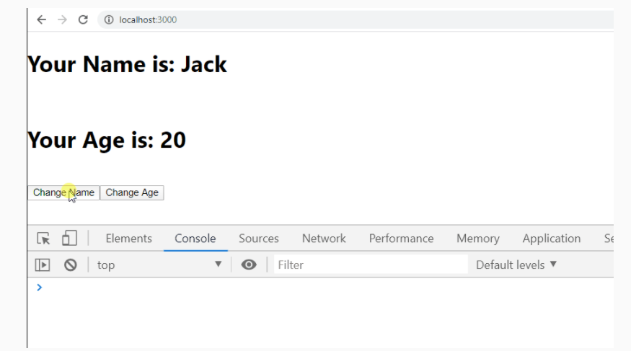
Highlights:
- Understand the usage of useEffect method as componentDidMount method
Demo steps
1. Modify the Sample.js file as shown below
- import React, {useState, useEffect} from 'react';

- function Sample() {
- const [name,setName] = useState("Jack")
- const [age,setAge] = useState(20)
- useEffect(()=>{
- console.log("use Effect called")
- },[])
- return (
- <div>
- <h1>Your Name is: {name}</h1><br/>
- <h1>Your Age is: {age} </h1><br/>
- <button onClick={()=>setName("Jill")}>Change Name</button>
- <button onClick={()=>setAge(age+1)}>Change Age</button>
- </div>
- );
- }
- export default Sample;
2. Render the Sample component within index.js
- import React from 'react';
- import ReactDOM from 'react-dom';
- import './index.css';
- import * as serviceWorker from './serviceWorker';;
- import Sample from './Sample';
- ReactDOM.render(<Sample/>, document.getElementById('root'));
- // If you want your app to work offline and load faster, you can change
- // unregister() to register() below. Note this comes with some pitfalls.
- // Learn more about service workers: https://bit.ly/CRA-PWA
- serviceWorker.unregister();
3. Observe the output

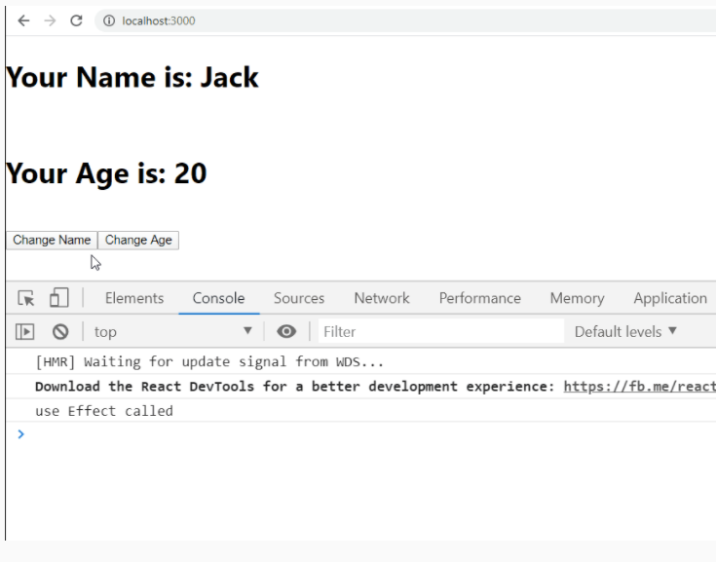
Highlights:
- Understand the usage of useEffect method as componenntDidUpdate method only when specific state gets updated
Demo steps
1. Modify the Sample.js file as shown below
- import React, {useState, useEffect} from 'react';

- function Sample() {
- const [name,setName] = useState("Jack")
- const [age,setAge] = useState(20)
- useEffect(()=>{
- console.log("use Effect called")
- },[age])
- return (
- <div>
- <h1>Your Name is: {name}</h1><br/>
- <h1>Your Age is: {age} </h1><br/>
- <button onClick={()=>setName("Jill")}>Change Name</button>
- <button onClick={()=>setAge(age+1)}>Change Age</button>
- </div>
- );
- }
- export default Sample;
2. Render the Sample component within index.js
- import React from 'react';
- import ReactDOM from 'react-dom';
- import './index.css';
- import * as serviceWorker from './serviceWorker';;
- import Sample from './Sample';
- ReactDOM.render(<Sample/>, document.getElementById('root'));
- // If you want your app to work offline and load faster, you can change
- // unregister() to register() below. Note this comes with some pitfalls.
- // Learn more about service workers: https://bit.ly/CRA-PWA
- serviceWorker.unregister();
3. Observe the output

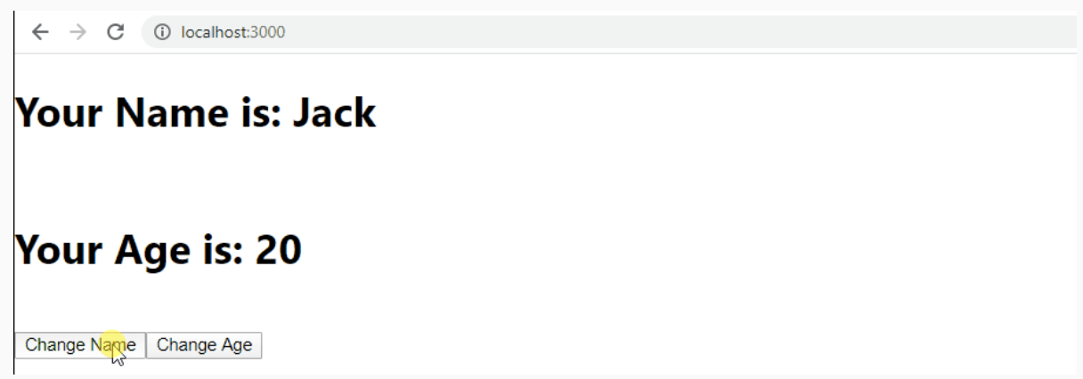

Highlights:
- Understand how to make asynchronous calls within useEffect method
Demo steps
1. Create employees.json file within the public folder and add the below employees data in JSON format
- [
- { "empId": 1234, "name": "John", "designation":"SE" },
- { "empId": 4567, "name": "Jack", "designation":"SSE"},
- { "empId": 8910, "name": "Harry","designation":"TA"}
- ]
2. Modify Employees.js file as shown below
- import React, { useState, useEffect } from 'react';
- import axios from 'axios';

- const Employees = () => {
- const [employees,setEmployees] = useState([
- ])
- const addEmployee = () => {
- setEmployees([...employees, { empId:6789, name: 'Sam', designation:'TL' }]);
- };
- useEffect(() => {
- axios.get('employees.json')
- .then(result =>
- setEmployees(result.data)
- )
- },[]);

- return (<React.Fragment>
- <table style={{width:'60%'}} className='table'>
- <thead className="thead-light">
- <tr>
- <th>EmpID</th>
- <th>Name</th>
- <th>Designation</th>
- </tr>
- </thead>
- <tbody>
- {employees.map(employee => {
- return (<tr>
- <td>{employee.empId}</td>
- <td>{employee.name}</td>
- <td>{employee.designation}</td>
- </tr>)
- })
- }
- </tbody>
- </table>
- <button onClick={addEmployee}>Add an Employee</button>
- </React.Fragment>)
- }
- export default Employees;
Line 11 - asynchronous call is made to the employees.json using axios
3. Render the Employees component within index.js
- import React from 'react';
- import ReactDOM from 'react-dom';
- import './index.css';
- import * as serviceWorker from './serviceWorker';;
- import Employees from './Employees';
- ReactDOM.render(<Employees/>, document.getElementById('root'));
- // If you want your app to work offline and load faster, you can change
- // unregister() to register() below. Note this comes with some pitfalls.
- // Learn more about service workers: https://bit.ly/CRA-PWA
- serviceWorker.unregister();
4. Observe the output
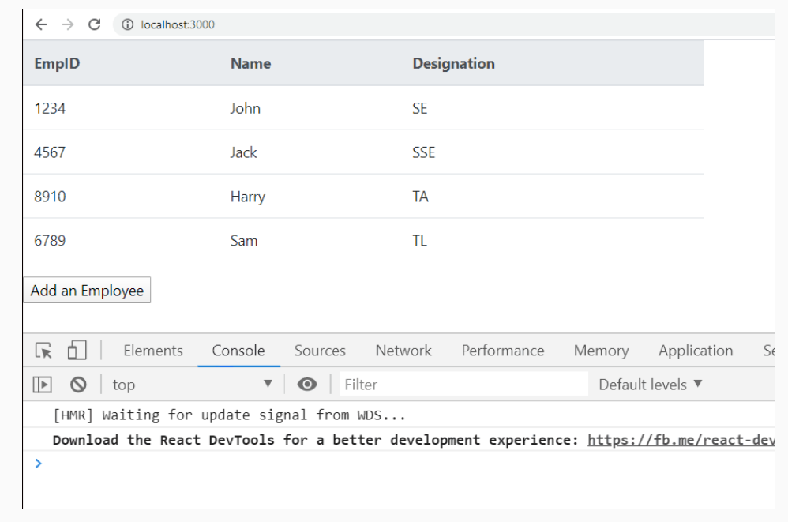
The useEffect method gets executed only once similar to componentDidMount method. Since [] is passed as a second argument to useEffect method, it doesn't gets executed when the employees state is modified
Redux:
Consider a React application developed with the below component architecture
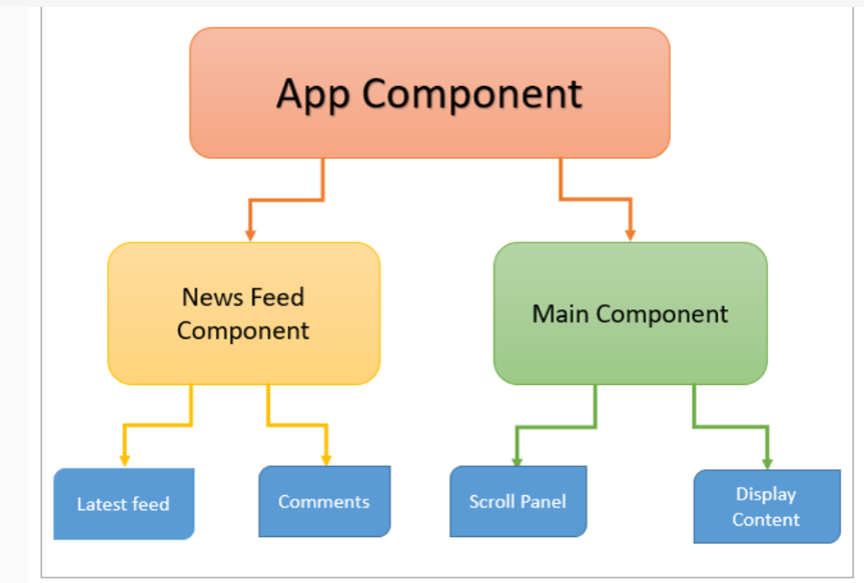

In the above application, the latest feed component displays the latest news feeds by receiving them as props from the News Feed parent component. Now, the Scroll Panel component also wants to display the latest feeds. There are 2 ways to achieve the above requirement
1. The Main component can get the news feed data and pass it to the Scroll Panel component, but this will be redundant as the data has been already fetched in News Feed component
2. The News Feed component can pass the data to the App parent component so that the Scroll Panel component can get the data as props. but the App component has to receive the data though it doesn't need it
To overcome the above problems we use Redux architecture which manages the entire data of the application in a single source.
Redux is an application data-flow architecture which is used for predicting state changes in JavaScript applications. Redux is not a framework. Redux can be used with any other View library but mostly used with React.
Dan Abramov created Redux in 2015. Redux was inspired greatly by functional programming language and FLUX architecture.
The main concepts of Redux architecture are:
Store: The place where the entire state of the application is stored
Actions: JS objects which encapsulate the events triggered within the application.
Reducers: Pure functions that modify the state of the application according to the actions triggered.
In Redux state is an immutable object. The state object cannot be changed directly in Redux. Triggering actions are the only way to modify the state. Every time the state is modified a new object should be returned which represents the modifications that are made to the state object.
Let us explore more on immutability
Immutability means, values cannot be changed. To change immutable objects we need to create a copy of it and modify the copy.
In Redux state is an immutable object. The state object cannot be changed directly in Redux. Triggering actions are the only way to modify the state. Every time the state is modified a new object should be returned which represents the modifications that are made to the state object.
Handling immutability
There are many ways to handle immutability. Object.assign and spread operator for arrays are the most popular approach when working in ES6.
Object.assign()
Consider state object a shown below
- state={status: 'logged out', value: 'guest',email:'',tel:''}

When Login action is triggered we want to change only the status and value properties. We can use Object.assign to create a copy and modify only a few properties as shown below.
- Object.assign({}, state, {
- status: 'logged in',
- value: action.value
- })

The first parameter to Object.assign is the target which is a new empty object, then we are mixing the new object together with our existing state and also changing the status and value properties. So the result is effectively a clone of our state object but with the state modified after login.
Spread(...) operator
The spread operator is represented using 3 dots (...)
It copies its own enumerable properties from a provided object onto a new object.
- var obj1 = { foo: 'bar', x: 42 };
- var obj2 = { foo: 'baz', y: 13 };
- var clonedObj = { ...obj1 };
- // Object { foo: "bar", x: 42 }
- var mergedObj = { ...obj1, ...obj2 };
- // Object { foo: "baz", x: 42, y: 13 }

The Redux data flow is represented below:
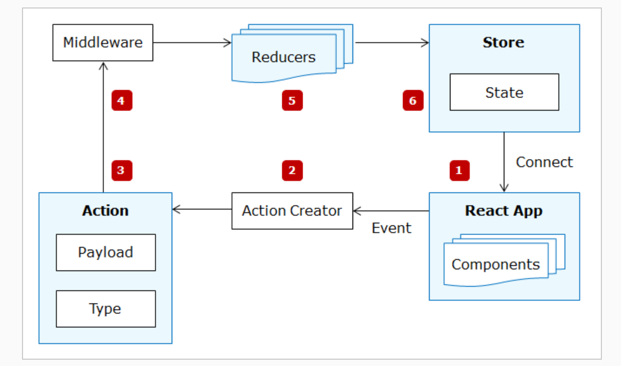
React Components: React components represent the UI rendered on the browser. Components would dispatch actions for events triggered within them and whenever the state changes the component renders the current state by connecting to the Redux store.
- Action Creators: Action creators are functions that wrap the actual action object.
- Action: Action is a plain JavaScript object. Action is a command to change the state when an event is triggered.
- Middleware: Middleware is a mediator between the action and reducer. Its purpose is to intercept the actions before it reaches the reducer.
- Reducer: Reducer changes the state of the application based on the action triggered. Reducer is a function that accepts action and current state and modifies the current state by creating a copy of it based on the action.
- Store: Store is responsible for managing the entire state of the application. State management is centralized in Redux. Action will be dispatched to the store using the dispatch method of the store.
Redux Data Flow explained with Login as an example
Let us observe the Redux data flow by considering Login as an example. The Login form is represented by the Login component.
- When the user clicks on the login button, the action is dispatched.
- The Action reaches an action creator that returns an action. Action object contains action type and payload information (if required)
- The action reaches Reducer which modifies the state
- If any operation needs to be performed before modifying state then action reaches middleware first and then reaches reducer
- Reducer updates the modified state to the store
- React components get the updated state from the store
Let us observe the Redux data flow by considering Login as an example. The Login form is represented by the Login component.
In React, components were associated with state and the state changes happen within the component.
In Redux since the state management is centralized, the components cannot modify the state directly. Hence Redux dispatches an action whenever there is an event triggered within a component.
An Action is a JavaScript object which describes an event. Action object must contain a type property which describes the type of the action triggered and optionally can have payload information.
- {
- type: 'ADD_TODO',
- todo: 'Shopping'
- }

Reducers accept 2 parameters the current state from the store and action object. We pass the initial state to the reducer which will be used when we run the application for the first time.
Look at the below example where we create ADD_TODO action and dispatch the ADD_TODO action.
myReducer accepts current state and action and logs the value of action and state to the console.
- import {createStore} from 'redux';

- const initState = {
- todos: []
- }
- function myReducer(state = initState, action) {
- console.log(action,state);
- }

- const store = createStore(myReducer)

- const todoAction = {type: 'ADD_TODO', todo: 'shopping'};

- store.dispatch(todoAction)
The above code snippet displays the below output
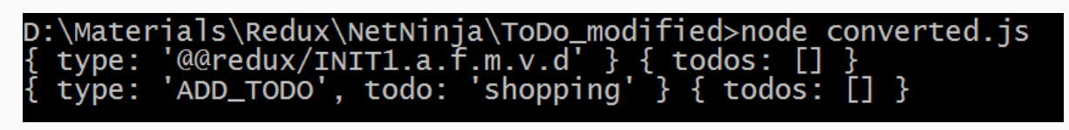

The ADD_TODO action object is displayed and the todos array is still an empty array as we have not modified the state yet in the reducer.
We will discuss above reducers and store in detail later.
Action creators are the functions that return the action object.
- export function AddToDo() {
- return {
- type: 'ADD_TODO',
- todo: 'Shopping'
- }
- }
Actions creators are called convenient functions. It is not mandatory to define action creators to return the action, rather we can just use the action object for dispatching an action, but action creators helps us in achieving maintainability, abstraction, encapsulation, and testability.
When an action is triggered within any component the state modification is done using Reducers in Redux.
Reducers contain the logic for modifying the state in Redux. The state is immutable in Redux, hence state cannot be directly modified by reducers. Reducers in Redux are responsible for copying the current state and modifying the copy and returning the new state.
Reducers are used to achieve immutability in Redux. Reducers are pure functions that are responsible for handling the actions and modify the state of the application based on the action triggered.
Reducers are functions that accept the current state and an action object as arguments and will return the new state.
The initial state of the application has to be passed to the reducer which will be used when we run the application for the first time
Forbidden in Reducers
- Mutating the arguments passed
- Performing side effects like API calls, AJAX call, etc
- Calling other non-pure functions (Ex: date.now(), Math.random())
Now let us modify the state in myReducer for the ADD_TODO action triggered
- import {createStore} from 'redux';

- const initState = {
- todos: []
- }
- function myReducer(state = initState, action) {
- if(action.type == 'ADD_TODO') {
- return {
- ...state,
- todos: [...state.todos, action.todo]
- }
- }
- }

- const store = createStore(myReducer)

- const todoAction = {type: 'ADD_TODO', todo: 'shopping'};

- store.dispatch(todoAction)
Let us now subscribe to the store changes and display the current state
- import {createStore} from 'redux';

- const initState = {
- todos: []
- }
- function myReducer(state = initState, action) {
- if(action.type == 'ADD_TODO') {
- return {
- ...state,
- todos: [...state.todos, action.todo]
- }
- }
- }

- const store = createStore(myReducer)

- store.subscribe(()=> {
- console.log('state updated');
- console.log(store.getState());
- })
- const todoAction = {type: 'ADD_TODO', todo: 'shopping'};

- store.dispatch(todoAction)
When we run the above code it displays the updated todos array by adding a shopping todo item to it as shown below
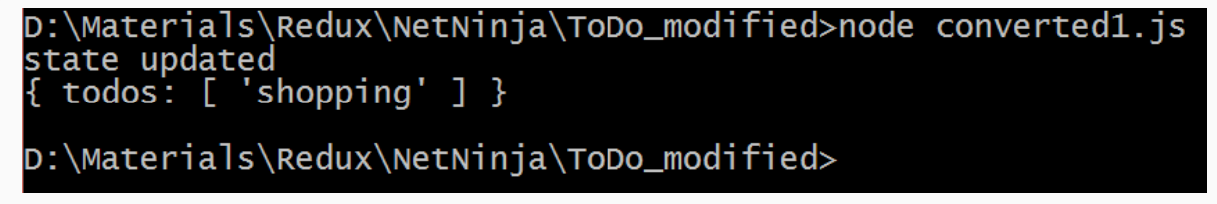
To achieve modularity we can write multiple reducers in Redux.
Though we split the reducers as our application grows, ultimately we can pass only one reducer object to the createStore method. We can use the combineReducers() method of Redux to combine multiple reducers into a single reducing function and then pass it to the createStore method.
Whenever an action is triggered the action would reach the root reducer first and then all the reducers get the action from root reducer.
The root reducer will combine the state from all the reducers and create a single new state object and will update the store with the new state.

The store is the container used to place the entire state of the application.
A Store can be created as shown below
- import {createStore} from 'redux';

- function myReducer() {

- }

- const store = createStore(myReducer)

The reducer is passed to the store. Since the state changes are done by reducer the reducer would update the store with the state changes done. Every time reducer changes the state it updates the store and the store would contain the current state.
Store Methods
1. getState(): This method can be used to get the current state from the store.
2. dispatch(action): React components should use this method to dispatch an action whenever an event occurs within the component. This method dispatches an action and then the reducer takes care of updating the state
3. subscribe(listener): Used for registering the listeners

We don't have any API's to change the data in the store. The only way to change the state present in the store is by dispatching actions. The store would handle actions using reducers.

Highlights
- Creation of actions, reducers, and store in Counter demo
- Creating Reducer for incrementing and decrementing the counter
- Combining inReducer and deReducer into a single reducer.
Demo Steps:
1. Create an application counter using create-react-app as shown below
- npx create-react-app counter
2. Install redux using the below command
- npm install redux
3. Create actions/actions.js within src as shown below
- export function onIncrement(step){
- return {
- type:"INC",
- step
- }
- }
- export function onDecrement(step){
- return {
- type:"DEC",
- step
- }
- }
4. Create reducers/inReducer.js within src as shown below
- const inReducer =(state={inCount:0},action)=>{
- var currentState=state.inCount;
- switch (action.type) {
- case "INC":
- return Object.assign({},state,
- {inCount:currentState+parseInt(action.step)});
- default:
- return state;
- }
- }
- export default inReducer;
5. Create reducers/deReducer.js within src as shown below
- const deReducer =(state={deCount:0},action)=>{
- var currentState=state.deCount;
- switch (action.type) {
- case "DEC":
- return Object.assign({},state,
- {deCount:currentState-parseInt(action.step)});
- default:
- return state;
- }
- }
- export default deReducer;
6. Create reducers/Reducer.js within src as shown below
- import {combineReducers} from 'redux';
- import inReducer from './inReducer.js';
- import deReducer from './deReducer.js';

- var reducer = combineReducers({
- inReducer,
- deReducer
- });

- export default reducer;
7. Create store within index.js as shown below
- import reducer from './reducers/Reducer';

- var store = createStore(reducer)

Middleware need not be a pure function like reducers. It can cause side effects. So whatever functionality we could not put into reducer because reducers are pure can be put in middleware.
Uses of middleware
- It provides functionality between action and reducer. After an action is triggered and before its reduced middleware can take action
- Organize all changes to the database (ajax calls) into one place
- Middleware allows pre-processing of actions. We can check for correct syntax, make sure they conform to your standards or edit them in some way like wrapping them in a function
- Perfect for debugging an application
- Allows us to keep actions clean so we need less boilerplate and fewer tests in our actions to make sure they are working correctly
- API calls are happening through middleware so if there is a mistake we can check middleware first.
Popular middleware Libraries
- Redux Thunk
- Redux Saga
The most common requirement to use middleware is to support asynchronous actions. Middleware lets us dispatch async actions in addition to our regular actions.
Middleware lets us wrap the dispatch method of the store. The most common requirement to use middleware is to support asynchronous actions. Middleware lets us dispatch async actions in addition to our regular actions.
Redux thunk middleware allows the developer to write action creators which returns a function instead of an action object. The middleware can be used to delay the dispatch of action or dispatch the actions based on certain conditions.
Each middleware receives Store's dispatch and getState functions as named arguments and returns a function.
The function which the action creator returns will receive these two arguments
1. dispatch method of store
2. getState method of store
createStore() method by default supports only synchronous data flow. In order to perform async actions, we can use applyMiddleware() function
When we create a middleware function, we would get an error because as per the Redux rules, action creators should always return an action object, not function.
To overcome the above error, we need to inform the store that we are using middleware using the applyMiddleware function as shown below
- var store = applyMiddleware(thunk)(createStore)(reducer);
To the applyMiddleware function, we need to pass the type of middleware we are using. Since we are using thunk middleware, we should pass thunk to the applyMiddleware.
Before passing thunk to the applyMiddleware method, we need to install redux-thunk package and import it as shown below
- npm install redux-thunk
- import thunk from 'redux-thunk';

It is possible to write our own middleware in Redux. The basic code for writing custom middleware is shown below
- const customMiddleware = store => next => action => {
- ...
- }
Custom middleware receives a store then returns a function that receives the next function and returns another function that receives an action.
next: This function is invoked when the middleware is done with the task assigned to do. This function forwards the actions to either reducer or another middleware.
action: That's our action currently being dispatched.
The custom middleware has access to the getState() method of the store to fetch the current state and dispatch() method of the store to dispatch actions if required.
Highlights:
1. Creating thunk middleware in Counter Example
2. Creating a Store for Counter Example
Demo Steps:
1. Create CallIncrement function in actions/Actions.js as shown below.
- export function CallIncrement(step){
- //asynchronous operations can be written here.
- return (dispatch)=>{
- setTimeout(()=>{
- dispatch(onIncrement(step));
- },3000)
- }
- }

2. Install redux-thunk using the below command
- npm install redux-thunk
3. Modify index.js as shown below
- import {createStore} from 'redux';
- import reducer from './Reducer.js';
- import {applyMiddleware} from 'redux';
- import thunk from 'redux-thunk';

- var store = applyMiddleware(thunk)(createStore)(reducer);

Since the state is managed by the Redux store. In order to access and render the state properties, the React components need to connect to the Redux store.
We can write React components as:
- Presentational components
- Container components
Presentational Components: Presentational components are used to present the markup and styles.
Container Components: Container components are responsible for connecting to the Redux store.
Container components are used to fetch the updated state from redux store. Once container components get the state from Redux store they pass the updated state to presentational components as props.
Container components can be written by the developer by subscribing to the store using the store.subscribe() and the current state can be fetched from the store using store.getState() method.
But React Redux has already implemented the necessary performance optimizations. Hence we generate container components using the methods provided by the react-redux library, rather than writing the container components by hand.
To generate container components the react-redux library provides connect() function
To use connect we need to define two functions
- mapStateToProps
- mapDispatchToProps
mapStateToProps: This function helps in transforming the current state present in the redux store as props and then the same is passed to its corresponding presentational component.
- var mapStateToProps = function(state){
- return {
- inCount:state.inReducer.inCount,
- deCount:state.deReducer.deCount
- };
- }

mapDispatchToProps: This function is used by container components to dispatch actions. The mapDispatchToProps() function accepts the dispatch() method as an argument and returns a callback. The callback returned from the mapDispatchToProps function can be injected into presentational components as props.
- var mapDispatchToProps = function(dispatch){
- return {
- onIncrement:(step)=>{
- dispatch(CallIncrement(step))
- },
- onDecrement:(step)=>{
- dispatch(onDecrement(step))
- }
- }
- }
The above 2 functions are passed as arguments to connect function
- var App= connect(mapStateToProps,mapDispatchToProps)
Whenever the state is updated by the Reducer the mapStateToProps method in the component is executed, then the container component would fetch the updated state from the store and passed as props to the presentational components. Whenever props change the presentational component is re-rendered with the updated values.
In order to subscribe to the store and get the state from the store, the container components need access to the Reduce store.
We can pass the store as a prop to all the container components, but it is not a feasible solution if the number of container components are more in number and the store needs to be passed to the presentational components as well.
Hence react-redux provides an in-built <Provider> component which provides access to the store to all the container components in an application. When rendering the root component to the DOM, the root component should be wrapped within the <Provider> component as shown below.
- ReactDOM.render(
- <Provider store={store}>
- <AppComp />
- </Provider>,
- document.getElementById('root')
- )
When we have used react-router then the <Router/> component should be wrapped within the <Provider /> components.
<Provider> component would provide access to the store to all the components within the <Router/> component.
- <Provider store={store}>
- <Router history={browserHistory} >
- <Route path="/login" component={Login} />
- <Route path="/home" component={Home} />
- </Router>
- </Provider>

Highlights:
- Creating a Container component and bind it with Redux store
- Implement the mapStateToProps method to fetch data from the store
- Implement the mapDispatchToProps method to dispatch actions
- Create a Presentational component and access the store values as props
Demo Steps:
1. Install react-redux package
- npm install react-redux
2. Create Components/App.js
- import { connect } from 'react-redux';
- import Counter from './components/Counter.js';
- import { CallIncrement,onDecrement } from './actions/Actions.js';

- var mapStateToProps = function(state){
- return {
- inCount:state.inReducer.inCount,
- deCount:state.deReducer.deCount
- };
- }

- var mapDispatchToProps = function(dispatch){
- return {
- onIncrement:(step)=>{
- dispatch(CallIncrement(step))
- },
- onDecrement:(step)=>{
- dispatch(onDecrement(step))
- }
- }
- }

- var App= connect(mapStateToProps,mapDispatchToProps)(Counter);

- export default App;

3. Create Components/Counter.js
- import React from 'react';

- class Counter extends React.Component{
- constructor() {
- super()
- this.stepRef = React.createRef()
- }
- render(){
- return (
- <div className="container"><br/>
- Enter the step value: <input type="number" ref={this.stepRef}/><br/><br/>
- <button className="btn btn-primary" onClick={()=>{
- this.props.onIncrement(this.stepRef.current.value)}
- }>Increment Count</button>&nbsp;&nbsp;&nbsp;
- <button className="btn btn-primary" onClick={()=>{
- this.props.onDecrement(this.stepRef.current.value)}
- }>Decrement Count</button><br/><br/>
- <h2>Incremented value:{this.props.inCount}</h2>
- <h2>Decremented value:{this.props.deCount}</h2>
- </div>
- )
- }
- }
- export default Counter;

4. Modify index.js file using Provider as shown below
- import React from 'react';
- import ReactDOM from 'react-dom';
- import * as serviceWorker from './serviceWorker';
- import 'bootstrap/dist/css/bootstrap.min.css';
- import { createStore, applyMiddleware } from 'redux';
- import { Provider } from 'react-redux';
- import thunk from 'redux-thunk';
- import reducer from './reducers/Reducer';
- import App from './components/App.js';

- var store = applyMiddleware(thunk)(createStore)(reducer);

- ReactDOM.render(<Provider store={store}><App/></Provider>, document.getElementById('root'));

- serviceWorker.unregister();

5. Observe the below output
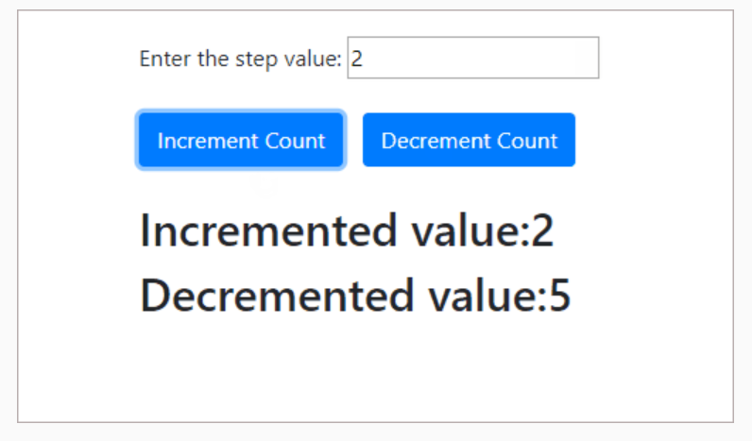

Debugging React and Redux application:
React Developer Tool

React Developer Tool is a chrome DevTools extension for the ReactJS, which helps us to inspect React component tree in chrome.

Installation and usage:
1. Add React Developer tools extension to chrome from chrome web store as shown below:

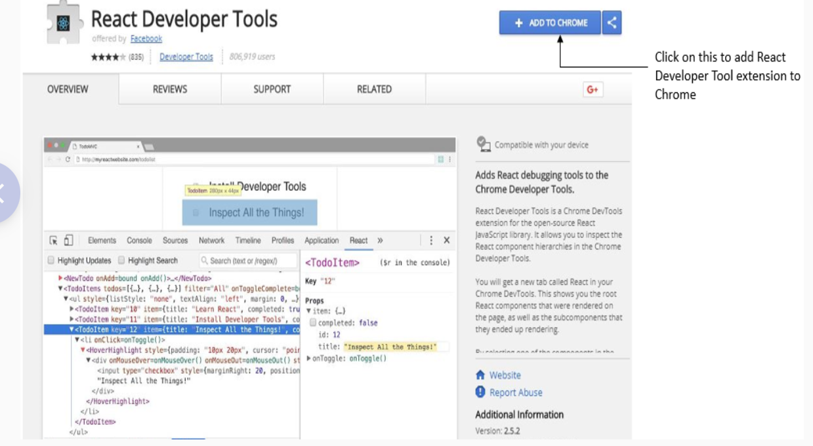

2. Once it is added, a new tab called React will appear on chrome developer tool as shown below:
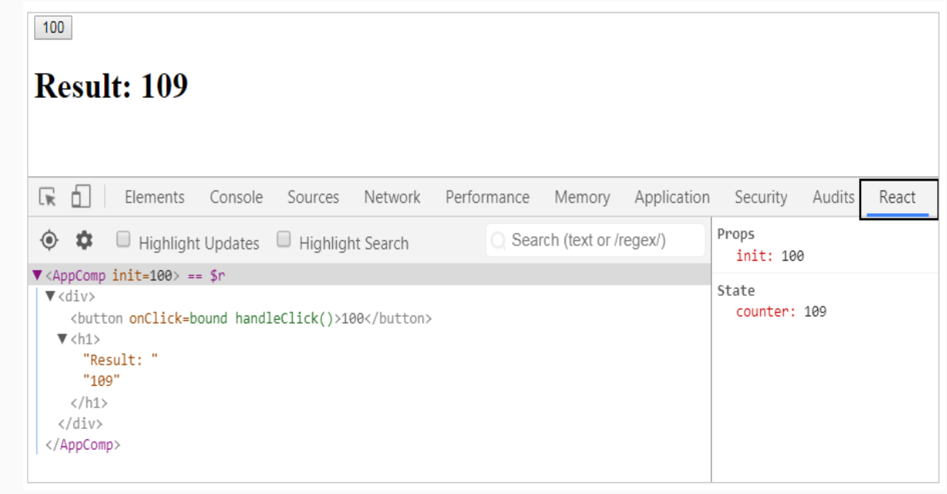

3. When something goes wrong in rendering, check the component responsible for rendering and check if the state and props are correct
4. By selecting the component in the tree displayed, we can inspect and edit the state and props

Time Travel Debugging: Time travel debugging is a powerful way to see exactly how your application state is changing over time. We can travel through time as you debug, so we can go back in history and see each specific state change. We can also undo specific state changes and observe how the final state changes. We can even turn off individual actions that occurred so you observe what would be the state object if a specific action had not happened. We can play all the interactions back with the click of a button and even select the speed at which it plays back.

Time Travel debugging can be done using Redux developer tools which is available as an add-on to the browser. Once the add-on is installed in the browser, we can use it to debug our Redux application as shown below.

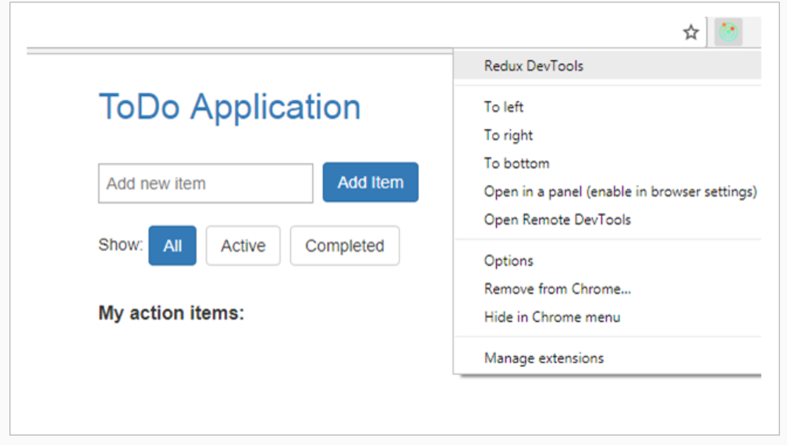

By clicking on the Redux dev tools we can debug our application as shown below.
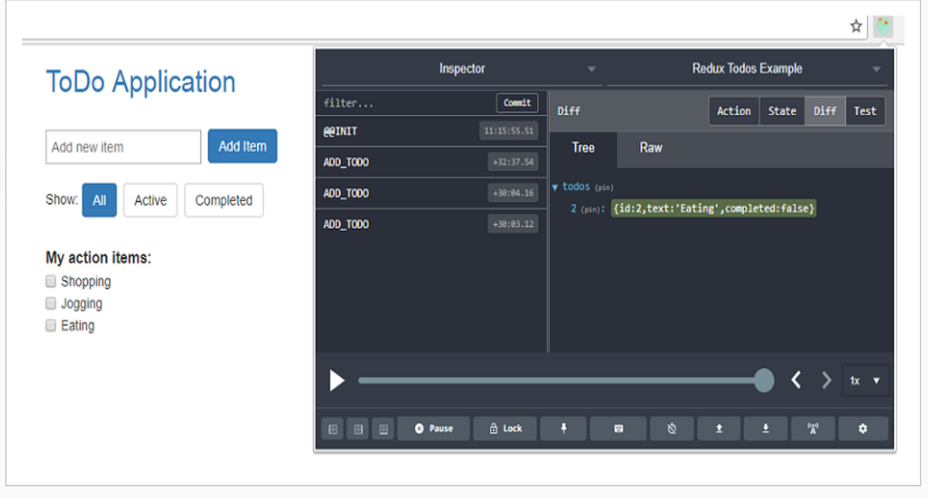
Time travel debugging we can go back to previous points of our state. This helps in testing very specific parts of our interaction.
In the todo application after adding a todo item, we can see the action by clicking on the Action tab in the Redux developer tools as shown below

