Apache Kafka:-

Apache Kafka is an open-source stream-processing software platform which is used to handle the real-time data storage. It works as a broker between two parties, i.e., a sender and a receiver. It can handle about trillions of data events in a day.

What is Apache Kafka?
Apache Kafka is a software platform which is based on a distributed streaming process. It is a publish-subscribe messaging system which let exchanging of data between applications, servers, and processors as well.

Developed by:
Apache Kafka was originally developed by LinkedIn, and later it was donated to the Apache Software Foundation. Currently, it is maintained by Confluent under Apache Software Foundation

What is a messaging system?
A messaging system is a simple exchange of messages between two or more persons, devices, etc. A publish-subscribe messaging system allows a sender to send/write the message and a receiver to read that message. In Apache Kafka, a sender is known as a producer who publishes messages, and a receiver is known as a consumer who consumes that message by subscribing it.

What is Streaming process?
A streaming process is the processing of data in parallelly connected systems. This process allows different applications to limit the parallel execution of the data, where one record executes without waiting for the output of the previous record. Therefore, a distributed streaming platform enables the user to simplify the task of the streaming process and parallel execution. Therefore, a streaming platform in Kafka has the following key capabilities:
- As soon as the streams of records occur, it processes it.
- It works similar to an enterprise messaging system where it publishes and subscribes streams of records.
- It stores the streams of records in a fault-tolerant durable way.

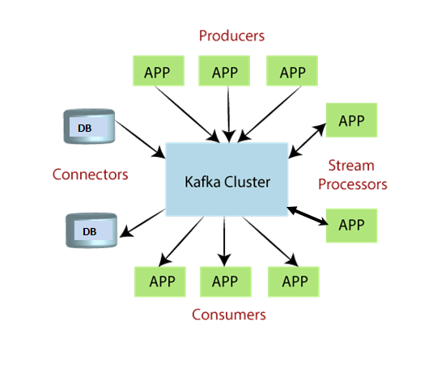

Why Apache kafka?
Applications now follow microservices architecture. So we have a distributed architecture where number of systems interact with each other. Applications now create and process lot of data. Complex web applications involving point to point data movement. This involves moving large amount of data from one point to another.

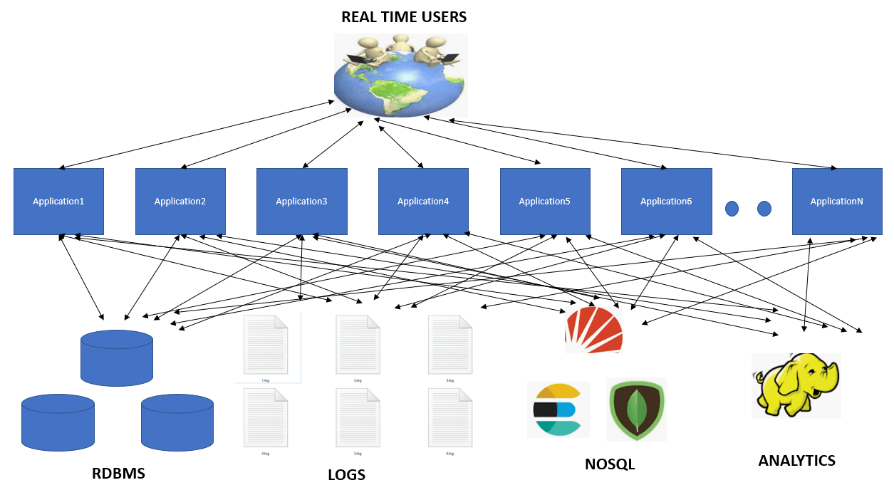
The obvious choice to resolve above issue is to use a messaging system. But traditional messaging systems have following drawbacks-
Traditional Messaging System | Apache Kafka
Limited Scalibility | Scalable
Transient in-memory persistence | Messages also stored in replicated log
Comparatively lower throughput | Comparatively higher throughput

So Apache Kafka is a much Reliable and high throughput streaming system that can move large amount of data between applications.

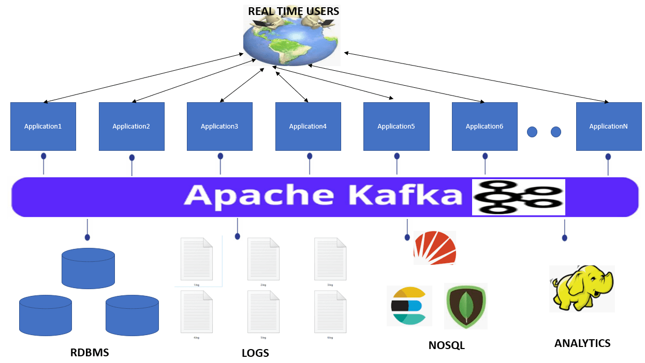
Real time example of Apache Kafka is Uber cab booking service. Uber makes use of Kafka to send User and Cab information to Uber Cab Booking System.
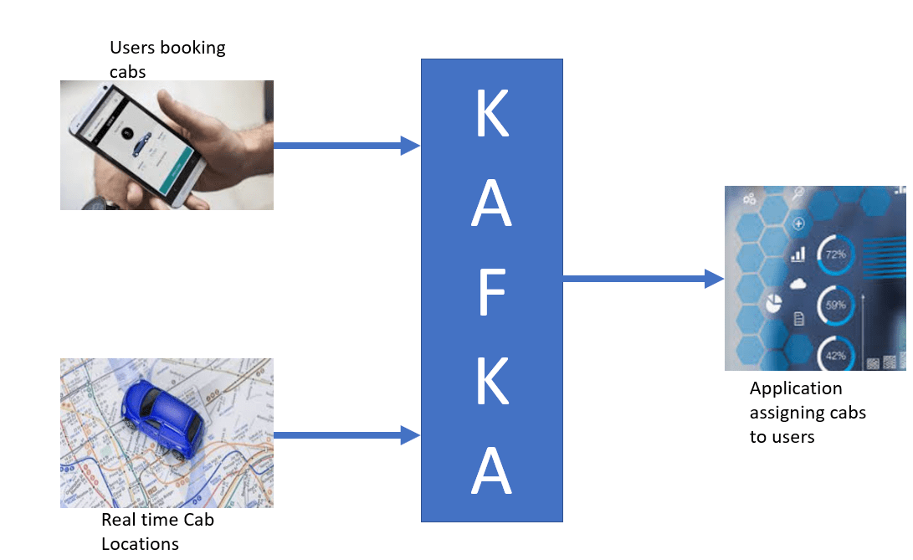

Kafka Architecture:-

As different applications design the architecture of Kafka accordingly, there are the following essential parts required to design Apache Kafka architecture.

- Data Ecosystem: Several applications that use Apache Kafka forms an ecosystem. This ecosystem is built for data processing. It takes inputs in the form of applications that create data, and outputs are defined in the form of metrics, reports, etc. The below diagram represents a circulatory data ecosystem for Kafka.
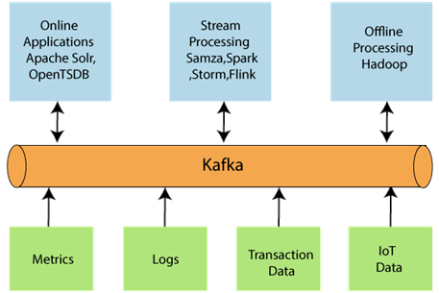
- Kafka Cluster: A Kafka cluster is a system that comprises of different brokers, topics, and their respective partitions. Data is written to the topic within the cluster and read by the cluster itself.
- Producers: A producer sends or writes data/messages to the topic within the cluster. In order to store a huge amount of data, different producers within an application send data to the Kafka cluster.
- Consumers: A consumer is the one that reads or consumes messages from the Kafka cluster. There can be several consumers consuming different types of data form the cluster. The beauty of Kafka is that each consumer knows from where it needs to consume the data.
- Brokers: A Kafka server is known as a broker. A broker is a bridge between producers and consumers. If a producer wishes to write data to the cluster, it is sent to the Kafka server. All brokers lie within a Kafka cluster itself. Also, there can be multiple brokers.
- Topics: It is a common name or a heading given to represent a similar type of data. In Apache Kafka, there can be multiple topics in a cluster. Each topic specifies different types of messages.
- Partitions: The data or message is divided into small subparts, known as partitions. Each partition carries data within it having an offset value. The data is always written in a sequential manner. We can have an infinite number of partitions with infinite offset values. However, it is not guaranteed that to which partition the message will be written.
- ZooKeeper: A ZooKeeper is used to store information about the Kafka cluster and details of the consumer clients. It manages brokers by maintaining a list of them. Also, a ZooKeeper is responsible for choosing a leader for the partitions. If any changes like a broker die, new topics, etc., occurs, the ZooKeeper sends notifications to Apache Kafka. A ZooKeeper is designed to operate with an odd number of Kafka servers. Zookeeper has a leader server that handles all the writes, and rest of the servers are the followers who handle all the reads. However, a user does not directly interact with the Zookeeper, but via brokers. No Kafka server can run without a zookeeper server. It is mandatory to run the zookeeper server.
Note: With Kafka version 0.10 and above, a Zookeeper does not store the consumer offset value. It is stored in the Kafka topics (as seen in Kafka topics section).
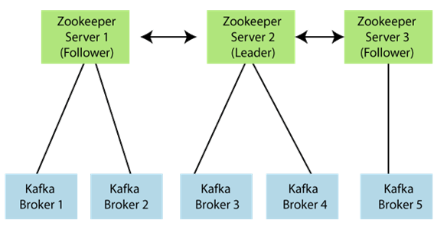
In the above figure, there are three zookeeper servers where server 2 is the leader, and the other two are chosen as its followers. The five brokers are connected to these servers. Automatically, the Kafka cluster will come to know when brokers are down, more topics are added, etc..

Hence, on combining all the necessities, a Kafka cluster architecture is designed.
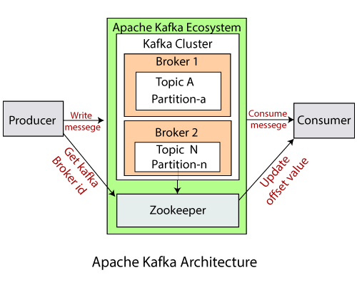

Advantages:-

- Clustering - Apache Kafka has a clustered set of brokers that work in unison.
- Distributed - The data in Apache Kafka is distributed in all the brokers. This is done by making use of partitions which are distributed across multiple brokers.
- Fault Tolerant - Apache Kafka maintains replicated copies of data. So if any broker in the cluster goes down, it does not affect the working of Apache Kafka Cluster. This is done by setting the replication value to greater than 1.
- Application scaling - Apache Kafka can be scaled horizontally. This increases the throughput.

Kafka Concepts:-
Topics:-
In Kafka, the word topic refers to a category or a common name used to store and publish a particular stream of data. Basically, topics in Kafka are similar to tables in the database, but not containing all constraints. In Kafka, we can create n number of topics as we want.

Partitions:
A topic is split into several parts which are known as the partitions of the topic. These partitions are separated in an order. The data content gets stored in the partitions within the topic. Therefore, while creating a topic, we need to specify the number of partitions(the number is arbitrary and can be changed later). Each message gets stored into partitions with an incremental id known as its Offset value. The order of the offset value is guaranteed within the partition only and not across the partition. The offsets for a partition are infinite.

Brokers
Here, comes the role of Apache Kafka.
A Kafka cluster is comprised of one or more servers which are known as brokers or Kafka brokers. A broker is a container that holds several topics with their multiple partitions. The brokers in the cluster are identified by an integer id only. Kafka brokers are also known as Bootstrap brokers because connection with any one broker means connection with the entire cluster. Although a broker does not contain whole data, but each broker in the cluster knows about all other brokers, partitions as well as topics.
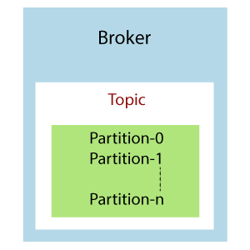
This is how a broker looks like in the figure containing a topic with n number of partitions.
Example: Brokers and Topics
Suppose, a Kafka cluster consisting of three brokers, namely Broker 1, Broker 2, and Broker 3.
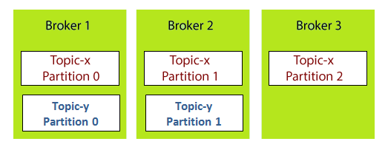
Each broker is holding a topic, namely Topic-x with three partitions 0,1 and 2. Remember, all partitions do not belong to one broker only, it is always distributed among each broker (depends on the quantity). Broker 1 and Broker 2 contains another topic-y having two partitions 0 and 1. Thus, Broker 3 does not hold any data from Topic-y. It is also concluded that no relationship ever exists between the broker number and the partition number.

Kafka Installation :-
Got to the Apache Kafka downloads page and download the https://kafka.apache.org/download the Scala 2.12 kafka_2.12-0.10.2.1.tgz
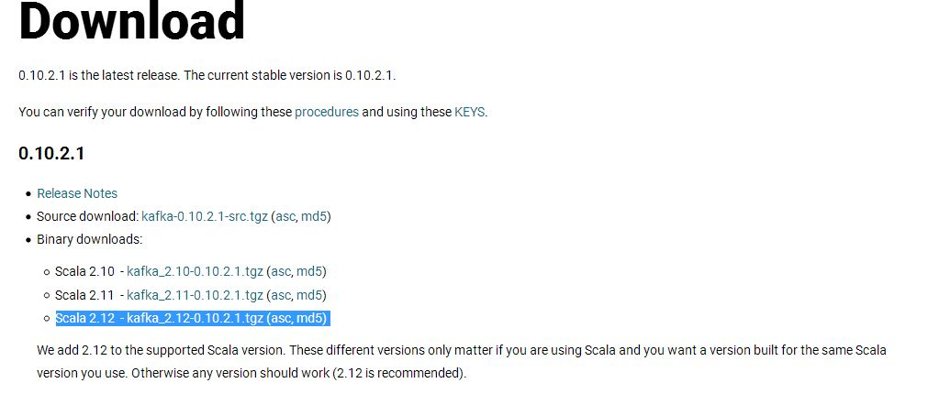
Next unzip it to a particular location-


Step7: Open Command Prompt, move to C:\ drive using 'cd..' command. Now, move to the Kafka directory with the help of the following command:
cd <kafka folder name>. Press enter. After entering, it will look like:
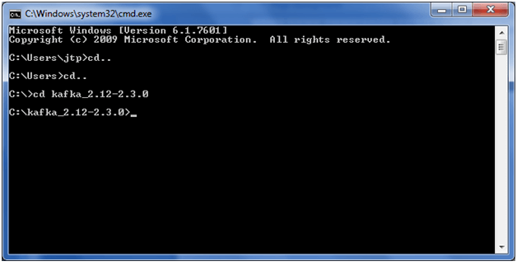
Step8: Check the java version. If correctly installed, the below output would be shown after applying the 'java -version' command. Else, an error will be shown.
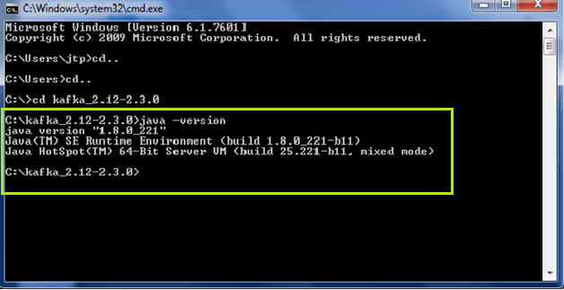
Step9: After successful installation of java8, try some Kafka commands within the kafka folder as: 'bin\windows\kafka-topics.bat'. It is shown below:
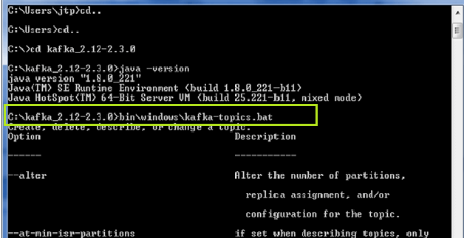
Use 'kafka-' command to view all the Kafka commands.

Setting Kafka directory path
Step1: Open Kafka folder>bin>windows and copy its address.
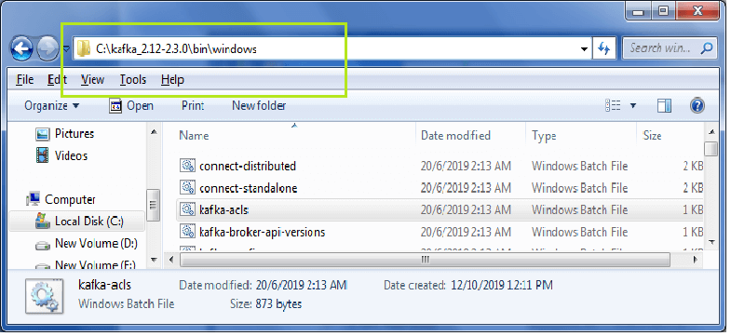
Step2: Go to My Computer, then right-click. A dialog box will open. Click on Properties>Advanced system settings>EnvironmentVariables.
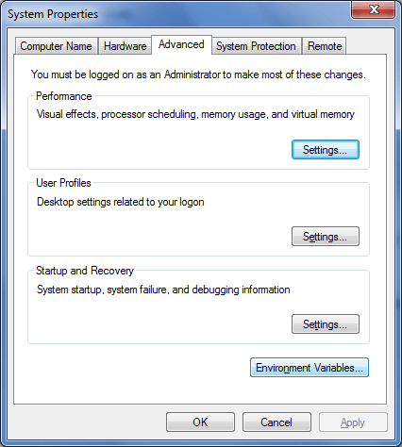
Step3: Edit the path variable by pasting the copied address. Click OK.
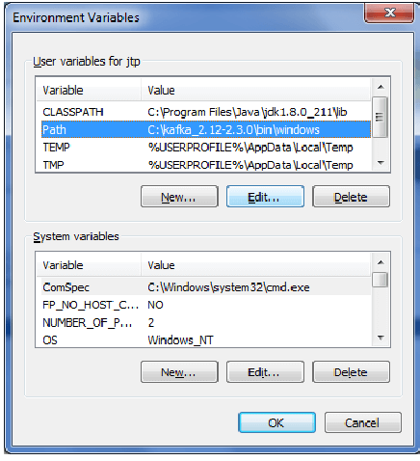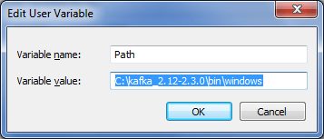
Step4: Open Command Prompt once again, apply the command 'kafka-topics.bat' from any drive. A sample is shown in the below snapshot:
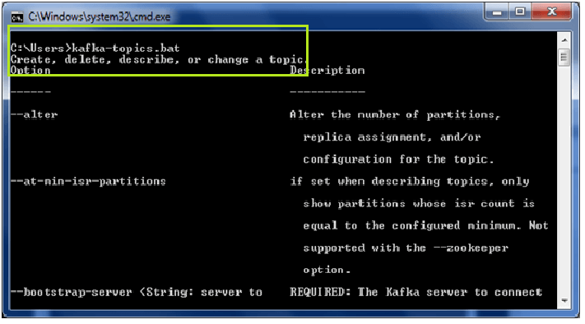
If the path is successfully set, it will display the above output. Now, the kafka commands can be executed from anywhere.

Installing Zookeeper

Apache Kafka is unable to run without installing the zookeeper. Therefore, to work with Kafka, the user need to start the zookeeper on the system.

Step1: Go to the Kafka directory and create a new folder as 'data'.
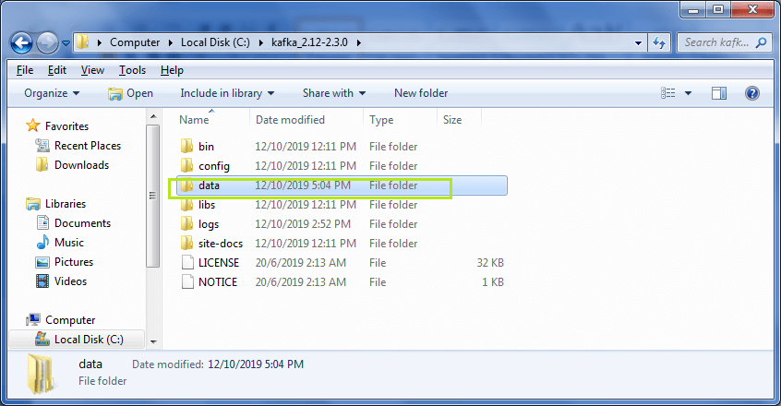
Step2: Open the newly created data folder and create two more folders under it. Name the folders as 'zookeeper' and 'kafka'.
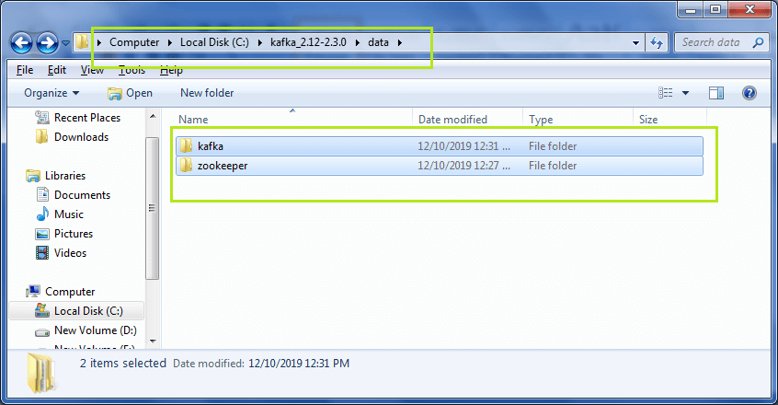
Step3: Now, copy the address of the zookeeper folder. After copying, go back to the Kafka directory.
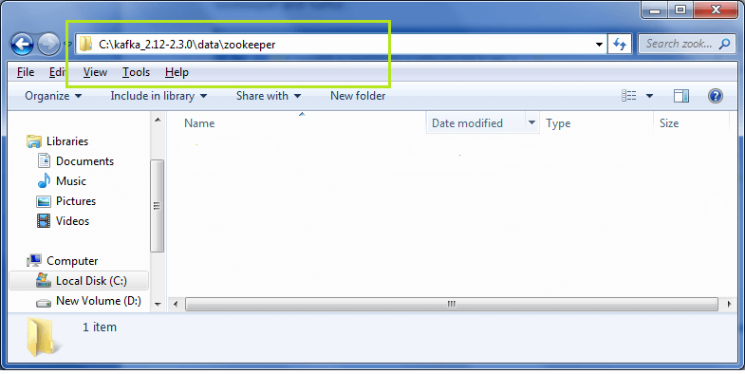
Step4: Move to the config folder under the Kafka directory.
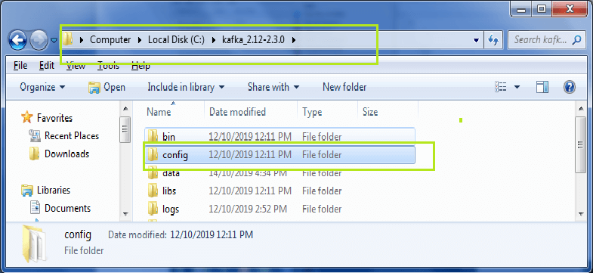
Open the config folder and go to the zookeeper.properties file. Right-click on the file and click on 'Edit with Notepad++' as shown below:
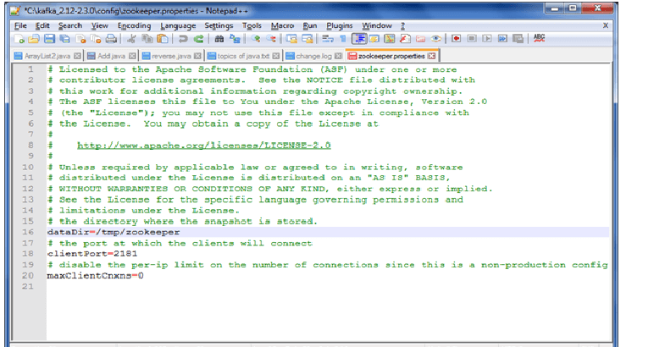
Note: Use Notepad++ for best view and easy editing of the file.
Step5: Edit the value of 'datadir' by pasting the zookeeper folder address. Save it. This address will be used for clients to get connected.
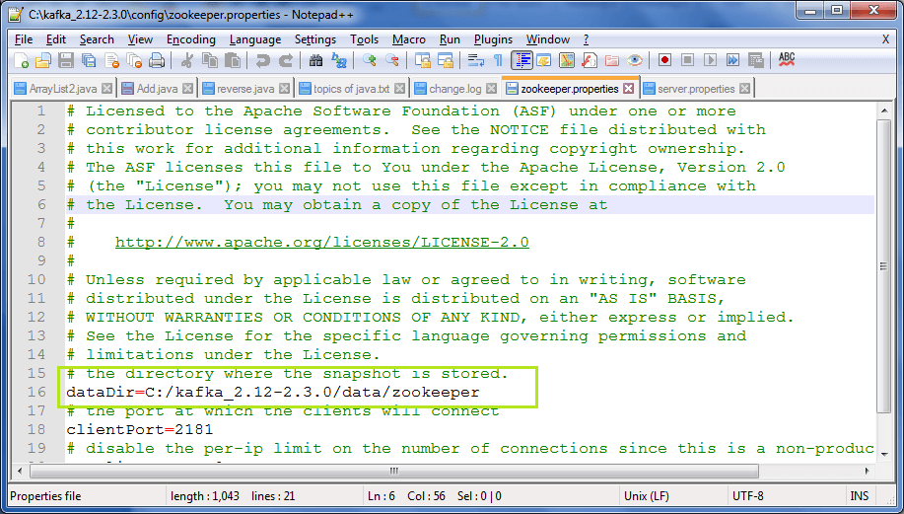
Step6: The Zookeeper server is ready to start. Open the command prompt and go to the Kafka directory. Then, type the command: 'zookeeper-server-start.bat config\zookeeper.properties'. Press enter.
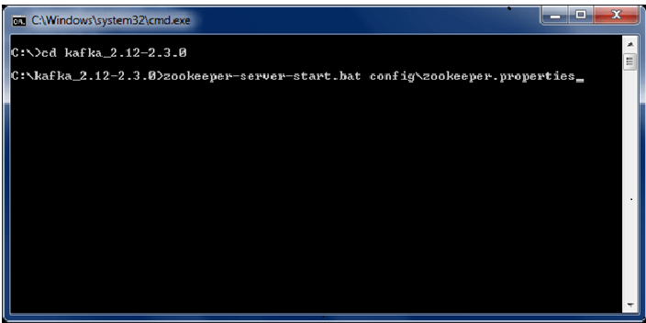
If the below shown output is displayed, it means the zookeeper server is successfully started. In the output screen, a port number 2181 is shown which tells the successful zookeeper server startup.
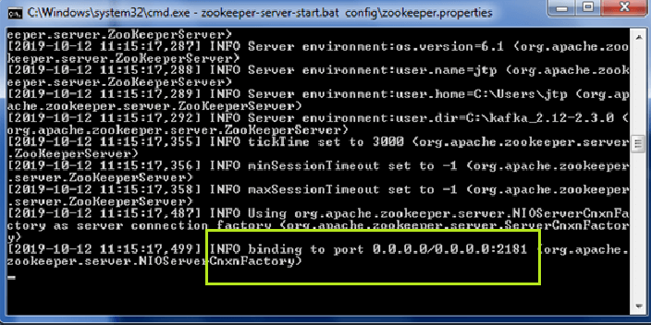
Otherwise, the port no.2181 is bind with some other applications.
Step7: Open data>zookeeper. A new folder, 'version-2' will be created automatically. If not so, something went wrong.
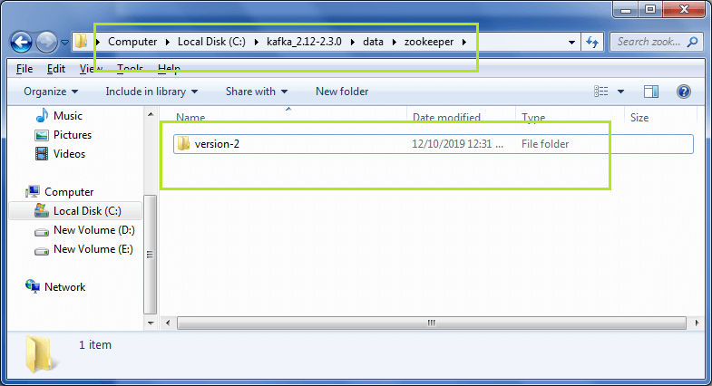
Step8: As the zookeeper server is started, go to the kafka directory>data>kafka. Copy the address of the kafka folder.
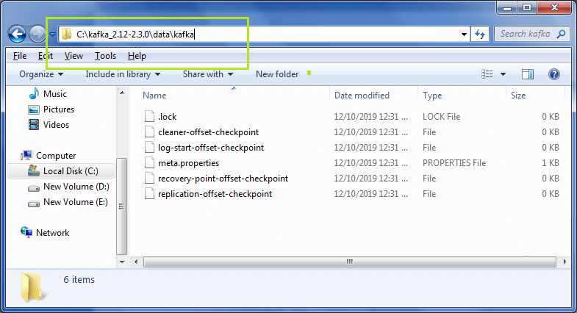
Step9: Move back to the Kafka directory>config>server.properties.
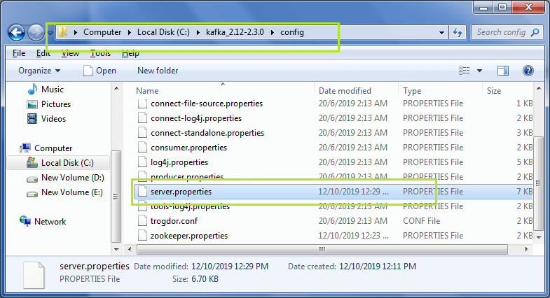
Right-click and click "Edit with Notepad++'. The below shown file will open.
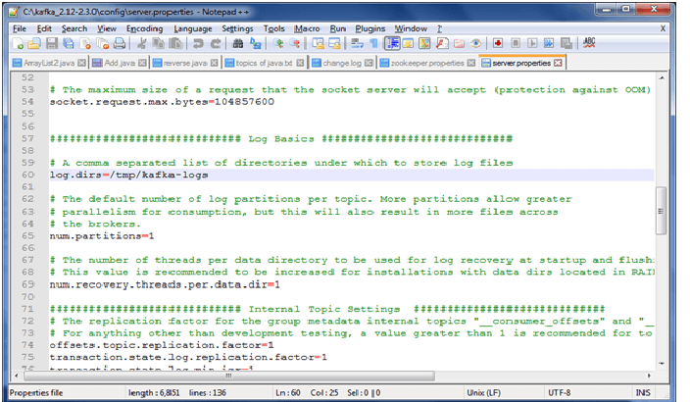
Step10: Again, paste the copied address of the kafka folder as a value of log.dirs.
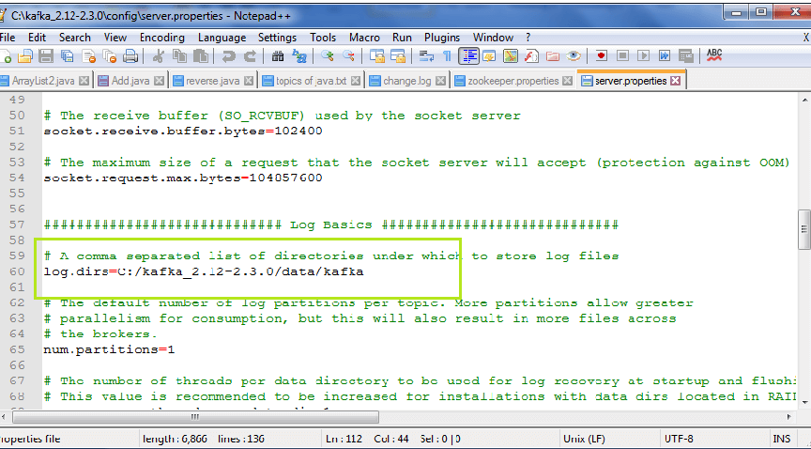
Step 11: Open the command prompt and move to the Kafka directory. Type the command: 'kafka-server-start.bat config\server.properties'. Look at the below snapshot:
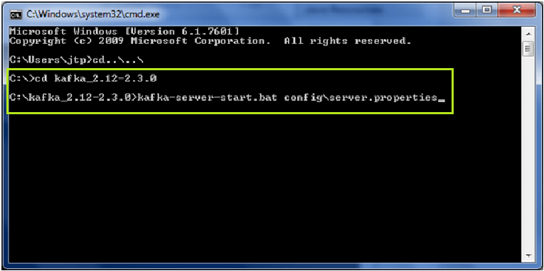
The output screen will be displayed, as shown in the below snapshot:
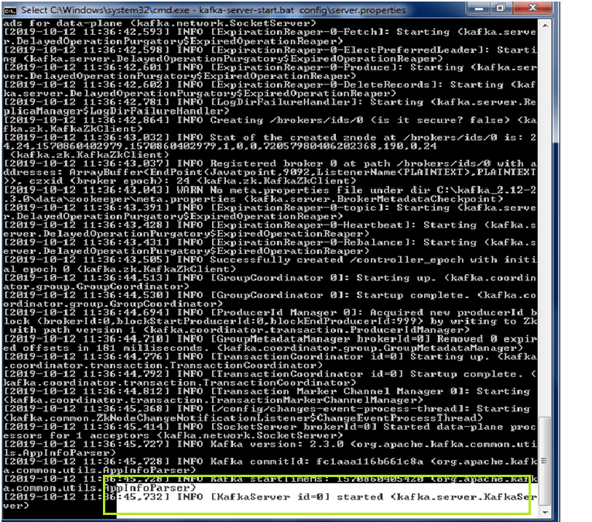
If the highlighted output is displayed, it means the kafka server is successfully started.
Step12: Open the Kafka directory>data>kafka. Here, the user will find some files, which will be generated on the successful startup of the Kafka server.
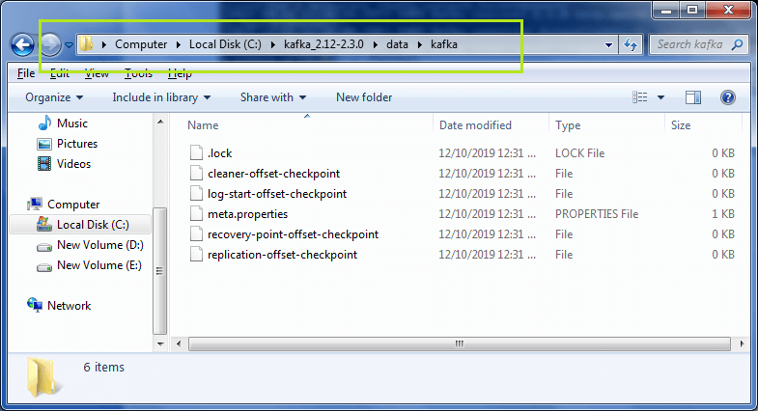
So, in this way, the Kafka server can be installed on the Windows operating system.

Or//
We will now start Apache Kafka-
- This Kafka installation comes with an inbuilt zookeeper. Zookeeper is mainly used to track status of nodes present in Kafka cluster and also to keep track of Kafka topics, messages, etc.
Open a command prompt and start the Zookeeper-
- C:\kafka_2.12-0.10.2.1>.\bin\windows\zookeeper-server-start.bat .\config\zookeeper.properties
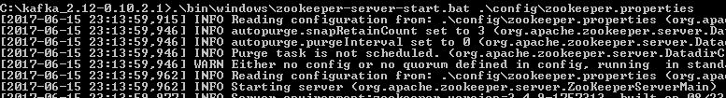
- Open a new command prompt and start the Apache Kafka-
- C:\kafka_2.12-0.10.2.1>.\bin\windows\kafka-server-start.bat .\config\server.properties
- Open a new command prompt and create a topic with name javainuse-topic, that has only one partition & one replica.
- C:\kafka_2.12-0.10.2.1>.\bin\windows\kafka-topics.bat --create --zookeeper localhost:2181 --replication-factor 1 --partitions 1 --topic javainuse-topic

Creating topic :-
If we configured the zookeeper and kafka in data folder then following commands are used or else the below command is used
.\bin\windows\kafka-topics.bat --create --zookeeper localhost:2181 --replication-factor 1 --partitions 1 --topic javainuse-topic.

Step1: Initially, make sure that both zookeeper, as well as the Kafka server, should be started.
Step2: Type 'kafka-topics -zookeeper localhost:2181 -topic -create' on the console and press enter. Here, the name of the topic is 'myfirst'
- kafka-topics -zookeeper localhost:2181 -topic <topic_name> -create
Note: Instead '.bat', use '.sh' while creating topics on Linux(accordingly).
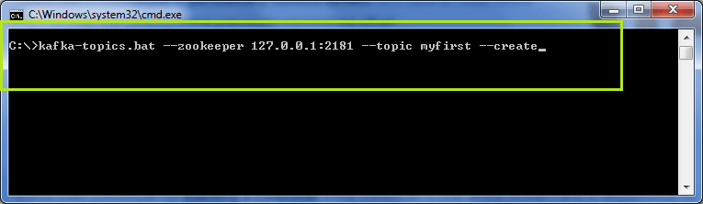
The output will be displayed as:
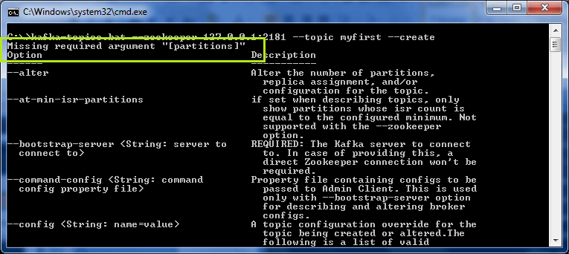
The above snapshot displays an error "missing required argument partitions". As it is necessary to declare the number of partitions and its ISR(replication factor), while creating a topic. If not declared, such type of errors will be thrown.
Step3: Now, rewrite the above command after fulfilling the necessities, as:
'kafka-topics.bat -zookeeper localhost:2181 -topic <topic_name> --create ?partitions <value> --replication-factor <value>'. Press enter.
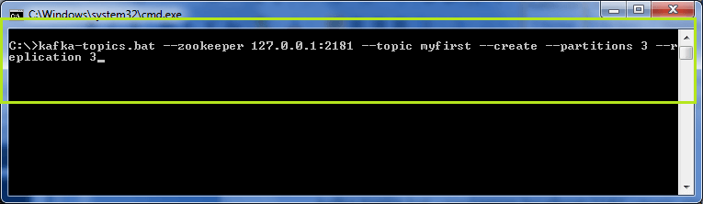
Again, an error will be thrown, indicating a replication factor greater than the number of brokers. Till now, we have started only a single broker, not multiple brokers. Thus, such type of error will appear.
Note: The replication factor can never be greater than the number of available brokers.
Step4: Consider the replication factor as 1 for now, and rewrite the above command. Press enter. The output will be displayed as:
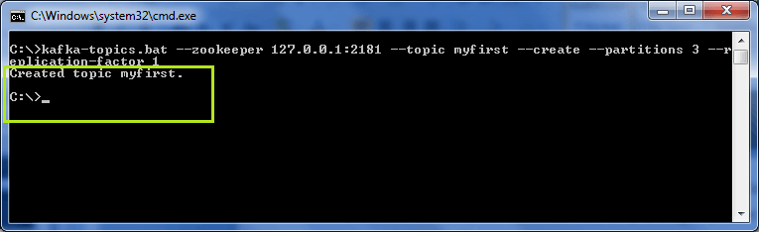
Thus, if all the steps are processed successfully, then the topic will be created successfully, as shown in the above output.
Topic already exists
In case the user creates another topic with the same name as the existing topic, an error " topic <topic_name> already exists" will be thrown.
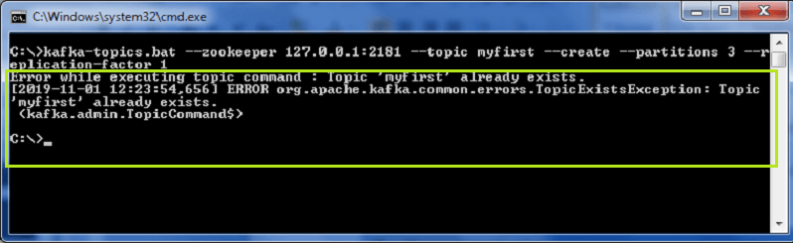
Few more about topics
1) Listing the number of Topics
To list the number of topics created within a broker, use '-list' command as:
'kafka-topics.bat -zookeeper localhost:2181 -list'.
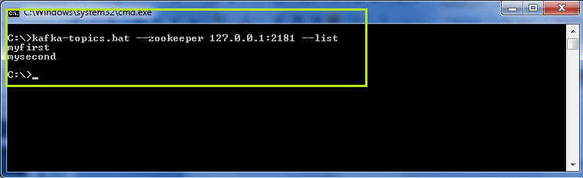
There are two topics 'myfirst' and 'mysecond' present in the above snapshot.
2) Describing a topic
To describe a topic within the broker, use '-describe' command as:
'kafka-topics.bat -zookeeper localhost:2181 -describe --topic <topic_name>'. This command gives the whole description of a topic with the number of partitions, leader, replicas and, ISR.
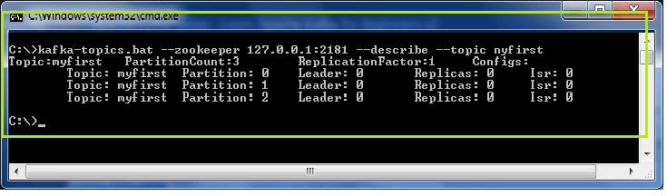
3) Deleting a topic
To delete a topic, use '-delete' command. The delete command is used as: 'kafka-topics.sh -zookeeper localhost:2181 -topic<topic_name> --delete'
Note: Window users will face issues while deleting any topic. So, prefer this command on Linux, or on macOS.
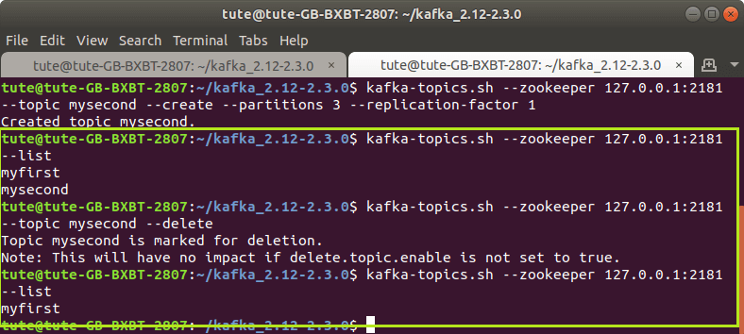
In the above snapshot, it is seen that there were two existing topics 'myfirst' and 'mysecond'. After deleting 'mysecond' topic, only 'myfirst' topic is listed by the '-list' command.
So, in this way, various topics can be created and several commands can be applied on different topics.

Creating a Producer

- Next Open a new command prompt and create a producer to send message to the above created javainuse-topic and send a message - Hello World Javainuse to it-
- C:\kafka_2.12-0.10.2.1>.\bin\windows\kafka-console-producer.bat --broker-list localhost:9092 --topic javainuse-topic
- Hello World Javainuse
- Finally Open a new command prompt and start the consumer which listens to the topic javainuse-topic we just created above. We will get the message we had sent using the producer
- C:\kafka_2.12-0.10.2.1>.\bin\windows\kafka-console-consumer.bat --bootstrap-server localhost:9092 --topic javainuse-topic --from-beginning

Spring boot with Kafka:

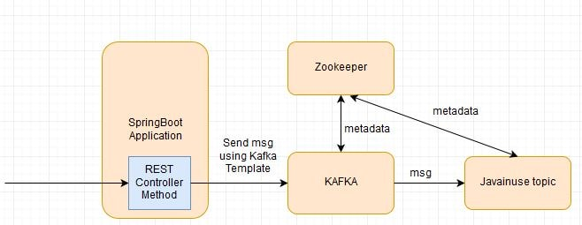
RabbitMQ - Table Of Contents

Lets Begin-
The project will be as follows-
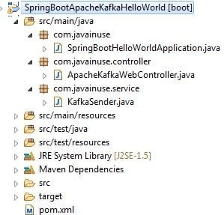
Define the pom.xml as follows- Add the spring-kafka dependency.
<project xmlns="http://maven.apache.org/POM/4.0.0" xmlns:xsi="http://www.w3.org/2001/XMLSchema-instance" xsi:schemaLocation="http://maven.apache.org/POM/4.0.0 http://maven.apache.org/xsd/maven-4.0.0.xsd">
<modelVersion>4.0.0</modelVersion>
<groupId>com.javainuse</groupId>
<artifactId>SpringBootApacheKafkaHelloWorld</artifactId>
<version>0.0.1-SNAPSHOT</version>

<packaging>jar</packaging>

<parent>
<groupId>org.springframework.boot</groupId>
<artifactId>spring-boot-starter-parent</artifactId>
<version>1.5.3.RELEASE</version>
<relativePath/>
</parent>

<properties>
<project.build.sourceEncoding>UTF-8</project.build.sourceEncoding>
<project.reporting.outputEncoding>UTF-8</project.reporting.outputEncoding>
<java.version>1.8</java.version>
</properties>

<dependencies>
<dependency>
<groupId>org.springframework.kafka</groupId>
<artifactId>spring-kafka</artifactId>
</dependency>
<dependency>
<groupId>org.springframework.boot</groupId>
<artifactId>spring-boot-starter-web</artifactId>
</dependency>
<dependency>
<groupId>org.springframework.boot</groupId>
<artifactId>spring-boot-starter-test</artifactId>
<scope>test</scope>
</dependency>
</dependencies>

<build>
<plugins>
<plugin>
<groupId>org.springframework.boot</groupId>
<artifactId>spring-boot-maven-plugin</artifactId>
</plugin>
</plugins>
</build>

</project>

Define the KafkaSender class to send message to the kafka topic named as java_in_use-topic.
package com.javainuse.service;

import org.springframework.beans.factory.annotation.Autowired;
import org.springframework.kafka.core.KafkaTemplate;
import org.springframework.stereotype.Service;

@Service
public class KafkaSender {

@Autowired
private KafkaTemplate<String, String> kafkaTemplate;

String kafkaTopic = "java_in_use_topic";

public void send(String message) {

kafkaTemplate.send(kafkaTopic, message);
}
}
Define a Controller which will pass the message and trigger the send message to the Kafka Topic using the KafkaSender class.
package com.javainuse.controller;

import org.springframework.beans.factory.annotation.Autowired;
import org.springframework.web.bind.annotation.GetMapping;
import org.springframework.web.bind.annotation.RequestMapping;
import org.springframework.web.bind.annotation.RequestParam;
import org.springframework.web.bind.annotation.RestController;

import com.javainuse.service.KafkaSender;

@RestController
@RequestMapping(value = "/javainuse-kafka/")
public class ApacheKafkaWebController {

@Autowired
KafkaSender kafkaSender;

@GetMapping(value = "/producer")
public String producer(@RequestParam("message") String message) {
kafkaSender.send(message);

return "Message sent to the Kafka Topic java_in_use_topic Successfully";
}

}
Finally Define the Spring Boot Class with @SpringBootApplication annotation
package com.javainuse;

import org.springframework.boot.SpringApplication;
import org.springframework.boot.autoconfigure.SpringBootApplication;

@SpringBootApplication
public class SpringBootHelloWorldApplication {

public static void main(String[] args) {

SpringApplication.run(
new Object[] { SpringBootHelloWorldApplication.class }, args);
}
}
Ad by Valueimpression

Ad by Valueimpression
We are done with the required Java code. Now lets start Apache Kafka. As we had explained in detail in the Getting started with Apache Kafka perform the following.
- Start Apache Zookeeper-
- C:\kafka_2.12-0.10.2.1>.\bin\windows\zookeeper-server-start.bat .\config\zookeeper.properties

- Start Apache Kafka-
- C:\kafka_2.12-0.10.2.1>.\bin\windows\kafka-server-start.bat .\config\server.properties
- Next start the Spring Boot Application by running it as a Java Application.
- Also Start the consumer listening to the java_in_use_topic-
- C:\kafka_2.12-0.10.2.1>.\bin\windows\kafka-console-consumer.bat --bootstrap-server localhost:9092 --topic java_in_use_topic --from-beginning

- Finally hit the url as follows- http://localhost:8080//javainuse-kafka/producer?message=test
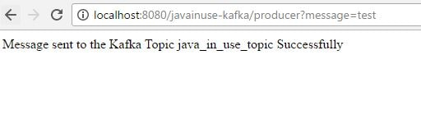
- This will trigger the message to be sent to the java_in_use_topic. We can see in the consumer started the message is recieved.

https://github.com/in28minutes/deploy-spring-microservices-to-aws-ecs-fargate

