Microservices:-

Monolithic:-
Monolithic architecture is like a big container in which all the software components of an application are clubbed into a single package.
Single jar/war file for whole application.

Less flexible for large team and code base
Overload IDE
Continuous development is difficult
Scaling the app is difficult
Scaling development is difficult
Technology stack change is difficult

Disadvantages:-
- Large and complex development
- Slow development
- Blocks continuous development
- Unscalable
- Unreliable
- Inflexible
Microservices:-
Microservices are an architectural style that develops a single application as a set of small services. Each service runs in its own process. The services communicate with clients, and often each other, using lightweight protocols, often over messaging or HTTP.
Microservices is a specialization of an implementation approach for service oriented architecture used to build flexible, independently deployable software system
Points to remember
- These are the services which are exposed by REST.
- These are small well-chosen deployable units.
- The services must be cloud-enabled.

Microservices is an architecture wherein all the components of the system are put into individual components, which can be built, deployed, and scaled individually.
Microservices is an architecture that allows the developers to develop and deploy services independently.

The most important feature of the microservice-based architecture is that it can perform continuous delivery of a large and complex application.

Advantages:
Easy deployment
Simple scalability
Compatible with containers
Minimum configuration
Lesser production time

Disadvantages:
- Microservices has all the associated complexities of the distributed system.
- There is a higher chance of failure during communication between different services.
- Difficult to manage a large number of services.
- The developer needs to solve the problem, such as network latency and load balancing.
- Complex testing over a distributed environment.

Challenges with building Microservices
- Identifying Microservice Boundaries - Implementing Bounded Context
- Having Proper Configuration Management
- Implementing Technology for Dynamic Scale Up And Scale Down
- Ensuring High Visibility
- Ensuring High Fault Tolerance

Bounded Context:-
We are aware that in a microservices architecture, instead of single big monolith application, we build several independent microservices talking with each other:
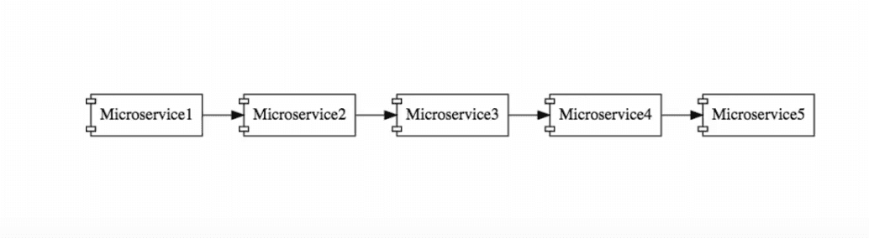
An important question one faces while designing such a system is, how do we define the boundaries of individual microservices?
How do you decide what one service does, and what it should not do?
This is particularly difficult for a new application, as there may not be enough business knowledge to establish the right boundaries.
The task of deciding the boundaries of microservices is an evolving process. It is not something you necessarily get right the first time.
It often involves using domain driven design while playing around the functionality of the microservices. As you gain design knowledge, you need to put that knowledge back into the microservices architecture.
The best practices include following domain driven design.

Having Proper Configuration Management
Configuration management poses quite a stiff challenge in implementing microservices.
Suppose that in our system, we have a few microservices, each of which has multiple instances in each environment: 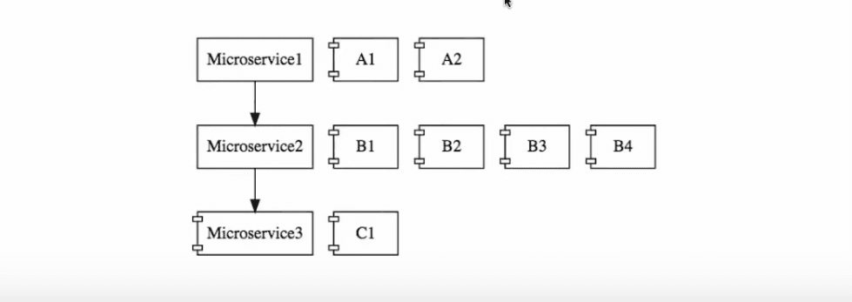
In a slightly larger system, there could be 10 microservices with 5 environments, and 50 instances at the least. We are talking about tons of configuration here!
This will involve a lot of work for the operations team, just to maintain all these configurations.
Typically, centralized configuration helps you manage configuration.

Implementing Technology for Dynamic Scale Up And Scale Down
For a microservices architecture, establishing the technology to do dynamic scaling of infrastructure, is a mountain to scale in itself.
The loads on different microservices could be different, at different instances of time: 
At a particular point of time, you may need 2 instances of Microservice2. However at a later point in time, that need may go up to 4. Again, it could shoot up to 10 later. In essence, we need to bring up new instances of a microservices when they are in demand, and bring them down when no longer needed.
All this scaling needs to be done with dynamic load balancing. At the point of time shown in the diagram, the load from Microservice1 needs to be distributed among the 4 instances of Microservice2. Later, when there are 10 instances of Microservice2, there needs to be another load redistribution among those 10 instances.
Building an architecture for this involves a number of technical components - Naming Server, Load Balancers, Monitoring tools to identify whether to scale in or scale out.
Ensuring High Visibility
Ensuring visibility is one of the most important challenges that needs to be addressed.

If we say that the functionality of the above system needs to be distributed among 10 microservices, but there is a bug, how do you identify where the bug is? There is clearly a need for a centralized log, where we need to find out what happened with a specific request.
We also need to have effective monitoring across the microservices.

Ensuring High Fault Tolerance
If not well designed, a microservices architecture can behave like a pack of cards. A microservice at the end of such a chain would be fundamental to the system behaving well.
Therefore, it is very important for you to have sufficient fault tolerance in place, in your system.

Introducing Spring Cloud:
Spring cloud is an Integration software that integrates with external systems. It allows microservices framework to build applications which perform restricted amounts of data processing.
Spring Cloud provides tools for developers to quickly build some of the common patterns in distributed systems (e.g. configuration management, service discovery, circuit breakers, intelligent routing, micro-proxy, control bus, one-time tokens, global locks, leadership election, distributed sessions, cluster state)
Spring Cloud is not a single project, rather a cluster of them.
Shown below is just a small sample of the projects present under this umbrella.
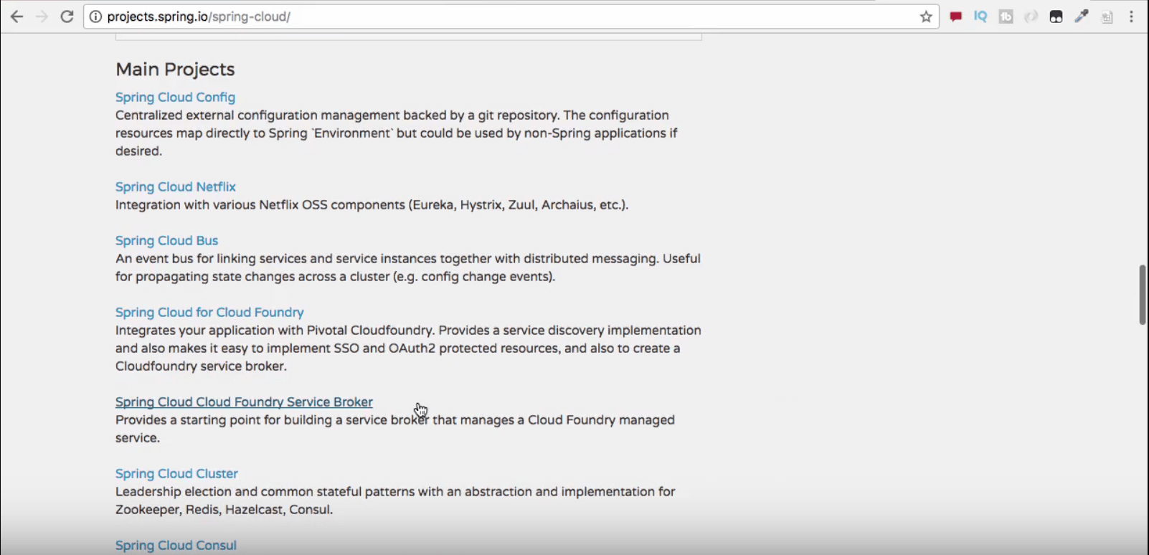

Let’s get a quick introduction to some of the important projects under Spring Cloud umbrella
Spring Cloud Netflix
Netflix was one of the first organizations to play around with microservices architecture. Under this project, a large number of projects have been open sourced for public use. Eureka, Hystrix and Zuul are popular ones among them.
Spring Cloud Config
This project provides a framework for centralized configuration management, making use of a Git or a SVN repository.
Spring Cloud Bus
This enables the microservices and infrastructure components to communicate with each other, in a distributed setup.

Challenges in Microservices Architectures
Let’s now have a look at the challenges we face while developing microservices applications, and the solutions offered by Spring Cloud for them

Configuration Management
In a system with a microservices architecture, there are a large number of small-sized microservices that communicate with each other:
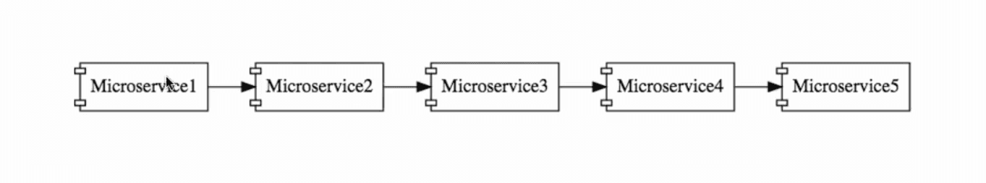
Each of these microservices needs to execute across multiple environments. In a given environment, there could be multiple instances of that microservice running. This means the operations team needs to manage a lot of configuration information for each microservice.
The Spring Config Server provides a Cloud solution to such configuration management
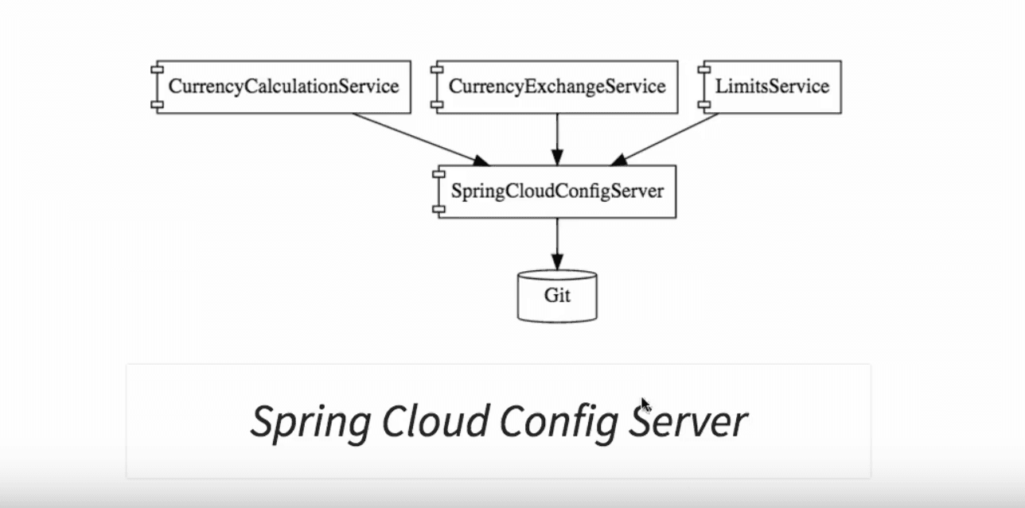
It provides an approach, where all the configurations across environments for all the microservices, is stored in a Git repository. The Spring Cloud Config Server then exposes this information to all the microservices.
Storing the configurations in such a centralized location makes it easier for the operations team to manage it.
Dynamic Scale Up And Down
Consider the following example:
The CurrencyCalculationService microservice talks to another microservice, the CurrencyExchangeService. Currently, three instances of CurrencyExchangeService are running. it is possible that at any point in time, more instances can be added in, or existing instances can be removed.
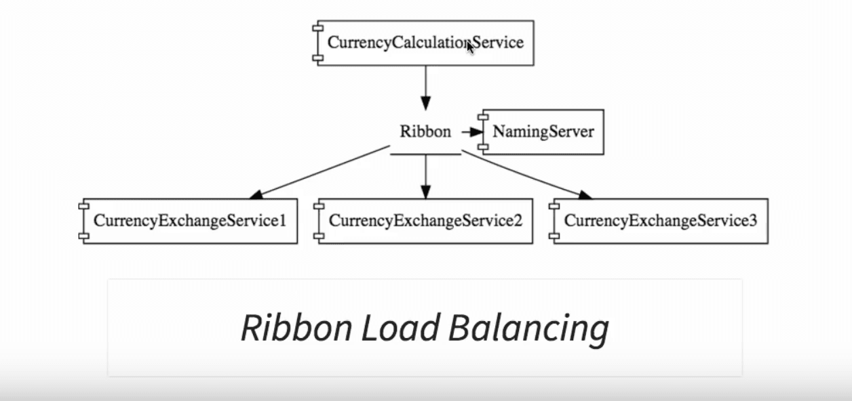
We need the CurrencyCalculationService to be able to distribute the load across the instances available at that point in time.
The need is to dynamically find out the number of instances of the CurrencyExchangeService at that time and distribute the load across them.
Solution involves multiple components.

Service Registration
All microservices register with a naming server. One of the options Spring Boot provides is Eureka.

Service Discovery
When any microservice wants to talk to another microservice, it asks the naming server. In the example above, the CurrencyCalculationService can ask the Eureka naming server, about the instances of the CurrencyExchangeService that are running. The naming service would, in turn, provide the URLs of those instances back to the CurrencyConversionService.
This helps establish a dynamic relationship between instances of the communicating microservices.
Load Balancing
When there are multiple instances of same microservice, you want to distribute load between them. One of the options Spring Cloud provides is a client side load balancing framework, Ribbon.
The CurrencyCalculationService uses Ribbon and distributes requests across instances of the CurrencyExchangeService.
The Feign framework helps us to write simpler RESTful clients.
Visibility And Monitoring
In Microservices Architectures, You would need to have complete visibility into what’s happening in your microservices.
In order to trace a request, you need to assign it a unique identifier. Spring Cloud Sleuth helps in assigning an identifier to every request. You can use a distributed tracing solution like Zipkin to trace the request across multiple components.

API Gateway
All micorservices have a few common features - security, logging, analytics, and so on. What is best place to implement these common features?
An API Gateway provides a great solution to this kind of a challenge.
The Netflix Zuul API gateway is a great solution to implement an API Gateway.

Fault Tolerance
What if a microservice is down? How do other microservices respond to it?
Hystrix helps in improving fault tolerance of your microservices.

Microservices Architectures - Advantages Of Microservices
- New Technology And Process Adoption
- Dynamic Scaling Up And Down
- Faster Release Cycles

Increased Technology Innovation due to New Technology And Process Adoption
A microservices architecture enables you to adopt new technology, and technical processes into your system.
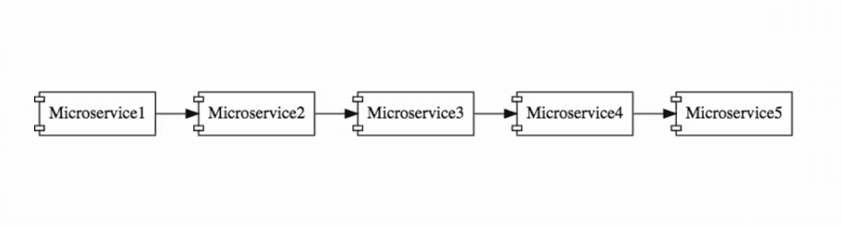
Microservices usually communicate with each other using simple messages. Each of these can then be built using different technologies.
For instance, it is possible to have Microservice1 written in Java, Microservice2 in NodeJS and Microservice3 in Kotlin.
Tomorrow, there may be a new language XYZ that is well suited for your application, and it could be used to write a new microservice for you.
In a typical monolith application, we would have no such flexibility.
In addition to this, we can bring in new processes - for development, testing and deployment - for the new microservices that we create.
Reduced Costs due to Dynamic Scaling Up And Down
Consider a large online shopping application, such as Amazon. They do not have the same number of users or amount of load, throughout the year. Usually, there is a lot of activity with the application during the holiday season, and not much at other times of the year. If your microservices are cloud enabled, they can scale dynamically.
This means there is no need to statically provision infrastructure to a fixed quantity for the entire year.
Infrastructure can be provisioned based on the load.
Increased Business Innovation due to Faster Release Cycles
Since you are developing your application in smaller components, its much easier to release microservices as compared to monolith applications. This means you can bring new features, faster to market. That’s a big advantage to have in the modern competitive business world.

Advantages of Microservices
- Microservices are self-contained, independent deployment module.
- The cost of scaling is comparatively less than the monolithic architecture.
- Microservices are independently manageable services. It can enable more and more services as the need arises. It minimizes the impact on existing service.
- It is possible to change or upgrade each service individually rather than upgrading in the entire application.
- Microservices allows us to develop an application which is organic (an application which latterly upgrades by adding more functions or modules) in nature.
- It enables event streaming technology to enable easy integration in comparison to heavyweight interposes communication.
- Microservices follows the single responsibility principle.
- The demanding service can be deployed on multiple servers to enhance performance.
- Less dependency and easy to test.
- Dynamic scaling.
- Faster release cycle.
Disadvantages of Microservices
- Microservices has all the associated complexities of the distributed system.
- There is a higher chance of failure during communication between different services.
- Difficult to manage a large number of services.
- The developer needs to solve the problem, such as network latency and load balancing.
- Complex testing over a distributed environment.

Components of Microservices
There are the following components of microservices:
- Spring Cloud Config Server
- Netflix Eureka Naming Server
- Hystrix Server
- Netflix ZuulAPI Gateway Server
- Netflix Ribbon
- Zipkin Distributed Tracing Server
Spring Cloud Config Server
Spring Cloud Config Server provides the HTTP resource-based API for external configuration in the distributed system. We can enable the Spring Cloud Config Server by using the annotation @EnableConfigServer.
Netflix Eureka Naming Server
Netflix Eureka Server is a discovery server. It provides the REST interface to the outside for communicating with it. A microservice after coming up, register itself as a discovery client. The Eureka server also has another software module called Eureka Client. Eureka client interacts with the Eureka server for service discovery. The Eureka client also balances the client requests.
Hystrix Server
Hystrix server acts as a fault-tolerance robust system. It is used to avoid complete failure of an application. It does this by using the Circuit Breaker mechanism. If the application is running without any issue, the circuit remains closed. If there is an error encountered in the application, the Hystrix Server opens the circuit. The Hystrix server stops the further request to calling service. It provides a highly robust system.
Netflix Zuul API Gateway Server
Netflix Zuul Server is a gateway server from where all the client request has passed through. It acts as a unified interface to a client. It also has an inbuilt load balancer to load the balance of all incoming request from the client.
Netflix Ribbon
Netflix Ribbon is the client-side Inter-Process Communication (IPC) library. It provides the client-side balancing algorithm. It uses a Round Robin Load Balancing:
- Load balancing
- Fault tolerance
- Multiple protocols(HTTP, TCP, UDP)
- Caching and Batching
Zipkin Distributed Server
Zipkin is an open-source project m project. That provides a mechanism for sending, receiving, and visualization traces.
One thing you need to be focused on that is port number.
Application | Port
Spring Cloud Config Server | 8888
Netflix Eureka Naming Server | 8761
Netflix Zuul API gateway Server | 8765
Zipkin distributed Tracing Server | 9411

Creating a Simple Microservice
Step 1: Create a Maven project using Spring Initializr https://start.spring.io/
Step 2: Choose the Spring Boot version 2.2.0 M6 or higher version. Do not choose the snapshot version.
Step 3: Provide the Group name. In our case om.javatpoint
Step 4: Provide the Artifact id. We have provided limits-service.
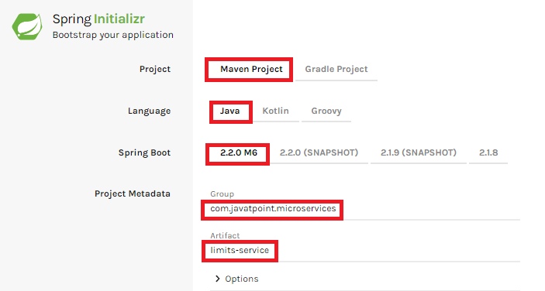
Step 5: Add the following dependencies: Spring Web, Spring Boot DevTools, Spring Boot Actuator, Config Client.
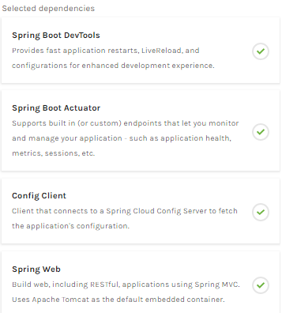
Step 6: Click on Generate the project button. A zip file will download, extract it into the hard disk.
Step 7: Now, open the eclipse. Import the created maven project. It takes some time to download the required files.
Step 8: Once the project is downloaded, go to src/main/java. Open the LimitsServiceApplication.
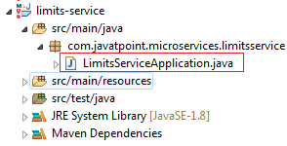
Step 9: Now run the LimitsServiceApplication.java as Java Application.
It started the Tomcat on port(s) 8080 (http).
Now we will add couple of services in the above project. For this we will have to follow the following steps:
Step 1: Open application.properties file and write the following code:
- spring.application.name=limits-service //name of application
Step 2: Create a class file with name LimitsConfigurationController.java in the folder src/main/java under the package com.javatpoint.microservices.limitsservice and write the following code:

package controller;

import org.springframework.web.bind.annotation.GetMapping;
import org.springframework.web.bind.annotation.RestController;

import bean.LimitConfiguration;

@RestController
public class LimitsConfigurationController {

@GetMapping("/limits")
public LimitConfiguration retrieveLimitsFromConfiguration(){
return new LimitConfiguration(1000, 1);

}
}

Step 3: Create a class file with name LimitConfiguration.java in the folder src/main/java under the package com.javatpoint.microservices.limitservice.bean and write the following code:

package bean;

import org.springframework.boot.context.properties.ConfigurationProperties;
import org.springframework.stereotype.Component;

@Component
@ConfigurationProperties("limits-service")
public class Configuration {

private int minimum;
private int maximum;
public int getMinimum() {
return minimum;
}
public void setMinimum(int minimum) {
this.minimum = minimum;
}
public int getMaximum() {
return maximum;
}
public void setMaximum(int maximum) {
this.maximum = maximum;
}

}

Type the localhost:8080/limits in the browser and press enter, we get the JSON response as output.
Output
{
maximum: 1000,
minimum: 1
}

Adding services to the application.properties
In the previous program, we will modify the code according to the requirement.
Now we call the limits-service from the application.properties file. In this file, we are configuring a couple of values.
- limits-service.minimum=99
- limits-service.maximum=9999
There is a better approach in Spring Boot to read values from the configuration using the annotation @ConfigurationProperties.
Step 1: Create a class with name Configuration.java in the folder src/main/java under the package com.javatpoint.microservices.limitservice.
Step 2: Add the annotations @Component and @ConfigurationProperties.
Step 3: Declare two variables minimum and maximum.
Step 4: If we are using the Configuration file, we need to generate getters and setters.
The Configuration.java file look like this.

package bean;

import org.springframework.boot.context.properties.ConfigurationProperties;
import org.springframework.stereotype.Component;

@Component
@ConfigurationProperties("limits-service")
public class Configuration {

private int minimum;
private int maximum;
public int getMinimum() {
return minimum;
}
public void setMinimum(int minimum) {
this.minimum = minimum;
}
public int getMaximum() {
return maximum;
}
public void setMaximum(int maximum) {
this.maximum = maximum;
}

}

Step 5: Now move to LimitsConfigurationController.java file and modify the code. In this we will use Configuration.

package controller;

import org.springframework.beans.factory.annotation.Autowired;
import org.springframework.web.bind.annotation.GetMapping;
import org.springframework.web.bind.annotation.RestController;

import bean.Configuration;
import bean.LimitConfiguration;

@RestController
public class LimitsConfigurationController {

@Autowired
private Configuration configuration;

@GetMapping("/limits")
public LimitConfiguration retrieveLimitsFromConfiguration(){
return new LimitConfiguration(configuration.getMaximum(), configuration.getMinimum());

}
}

Now refresh the browser page. It shows the JSON format of the updated values which are configured in application .properties file.
Output
{
maximum: 999,
minimum: 99
}

@ConfigurationProperties:- Annotation for externalized configuration
Spring Cloud Config Server
Spring Cloud Config Server provides the HTTP resource-based API for external configuration in the distributed system.
Spring's client/server approach for storing and serving distributed configurations across multiple applications and environments. This configuration store is ideally versioned under Git version control or SVN version control and can be modified at application runtime.
We can create a Spring Cloud Config Server which provides the configuration values for all of our microservices. We can use git, svn, database or Consul as a backend to store the configuration parameters. Then we can configure the location of Spring Cloud Config server in our microservice so that it will load all the properties when we start the application. In addition to that, whenever we update the properties we can invoke /refresh REST endpoint in our microservice so that it will reload the configuration changes without requiring to restart the application.

Setting up Spring Cloud Config Server
Step 1: Create a Maven project using Spring Initializr https://start.spring.io/
Step 2: Choose the Spring Boot version 2.2.0 M6 or higher version. Do not choose the snapshot version.
Step 3: Provide the Group name. In our case, com.javatpoint.microservices.
Step 4: Provide the Artifact id. We have provided spring-cloud-config-server.
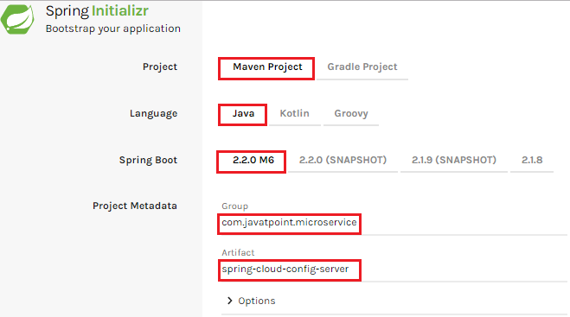
Step 5: Add the Spring Boot DevTools and Config Server dependencies.
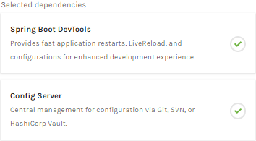
Step 6: Click on Generate the project button. A zip file will download, extract it in the hard disk.
Step 7: Now, open the eclipse. Import the downloaded maven project. It will download the required files.
In the next step, we will create a simple Git repository and configure the spring cloud config server to pick up the values from the particular Git repository. We need to install the local Git.

Installing Git and creating a local repository
Step 1: Download Git from https://git-scm.com/ and install it.
Step 2: Create a Git repository and store the files that we want to be able to configure a limits-service. We will try to access them from the spring-cloud-config-server. Open the Git bash and type the following commands:
Creating a new directory:
- mkdir git-localconfig-repo
- cd git-localconfig-repo/
Initializing a new Git repository:
- git init
It initializes an empty git repository.
Step 3: Now move to the spring-cloud-config-server project and add a link to the specific folder.
- Right-click on the spring-cloud-config-server project.
- Click on Build Path->Configure Build Path…
- Select the Source tab.
- Click on Link Source and browse the folder git-localconfig-repo.
- Right click on the folder-> New -> Other -> File -> Next -> Provide the file name: limits-service-properties-> Finish.
- Now write the following code in the properties file:
- limits-service.minimum=8
- limits-service.maximum=888
Step 4: Configure the user name and user email:
- git config -global user.email abc@example.com
- git config -global user.name "abc"
The command commits any file we have added with the git add command and also commits any files we have changed since then.
- git add -A
Now execute the command to commit the changes in the repository. It records or snapshots the file permanently in the version history.
- git commit -m "first commit"
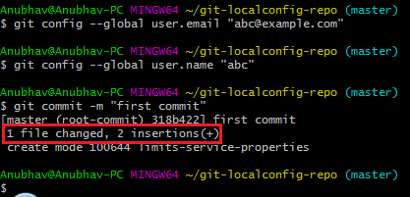
We can see that a file is changed with two new instructions. These instructions are changed in the local repository.

Connect Spring Cloud Config Server to Local Git Repository

In this section, we are going to learn how to connect spring-cloud-config-server to the local git repository. First, we will find the folder path.
Right-click on git-localconfig-repo -> Properties -> copy the Location label address and paste it into the application.properties file of spring-cloud-config-server service.
application.properties
spring.application.name=spring-cloud-config-server
server.port = 8888
spring.cloud.config.server.git.uri=file:///vani/work/springboot-microservices/git-localconfig-repo

Note:-
Make sure you are changing the correct properties file as there are multiple services of properties file.

Add the annotation @EnableConfigServer in the SpringCloudConfigServerApplication.java file.
Type the following URL in the browser:
localhost:8888/limits-service/default

output :-
{"name":"limits-service",
"profiles":["default"],
"label":null,
"version":"8d7a13ba65a36deb8ab7074498dbd99e3c76f6ef",
"state":null,
"propertySources":[{"name":"file:///vani/work/springboot-microservices/git-localconfig-repo/limits-service.properties",
"source":{"limits-service.minimum":"88","limits-service.maximum":"8888"}}]}

In this we have establish the connection between SprinCloudConfigServer and the Git repository.
We can see that it displays a set of property and values. It also retrieves the file name of the property file from where these values (minimum and maximum) are retrieved.
The important thing about SpringCloudConfigServer is that it stores configuration for multiple services. It can also store configuration for each of the services for different environments.
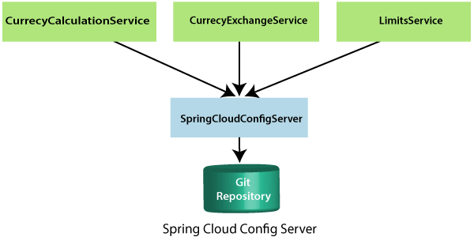
In the above figure, there are three services CurrencyCalculationService, CurrencyExchangeService, and LimitsService. The LimitsService has four environment services Dev, QA, Stage, and Production. We can configure these three services in SpringCloudConfigServer.

Configuration for Multiple Environment in Git Repository
services Dev, QA, Stage, and Production. We can configure these three services in SpringCloudConfigServer.
Configuration for Multiple Environment in Git Repository
In the spring-cloud-config-server project, we have added a link to git-localconfig-repo, which contains the limits-service.properties file. It becomes the default configuration for the limits-service.
However, we can overwrite them for a specific environment. To overwrite these values, copy the limits-service.properties and paste in the folder git-localconfig-reporename it with limits-service-dev.properties. Now update the minimum and maximum values.
- limits-service.minimum=1
- limits-service.maximum=111
Again copy the same file and paste it in the same folder. Rename it with limits-service-qa.properties. Now update the minimum and maximum values.
- limits-service.minimum=2
- limits-service.maximum=222
If we want to pick the default value of the maximum instead of modified value, put a introduction-to-currency-conversion-and-currency-exchange-service symbol at the starting of the statement. Now the second statement becomes a comment.
- limits-service.minimum=1
- introduction-to-currency-conversion-and-currency-exchange-servicelimits-service.maximum=111
When we execute it, it picks up the maximum value 888 from the default properties file instead of maximum value 111. Whenever we make the changes in the file, commit the changes in the local repository.
Now open the Git Bash and execute the following commands:
Create the directory in which we want to add files.
- cd git-localconfig-repo
Add the files into the Git repository.
- git add -A
Now check the status of the files that have to be committed.
- git status
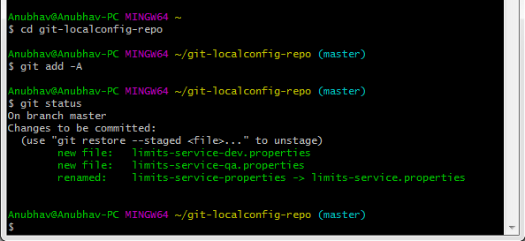
Now commit the changes
- git commit -m "Dev and QA"
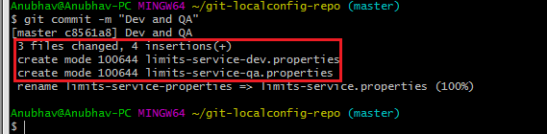
Now we can access the properties Dev and QA.
Type the following in the address bar of the browser.
localhost:8888/limits-service/qa

output:-
{"name":"limits-service",
"profiles":["qa"],
"label":null,
"version":"fbed3e3122e2a7a8b7db1696f9ebbb8014757c92",
"state":null,
"propertySources":[{"name":"file:///vani/work/springboot-microservices/git-localconfig-repo/limits-service-qa.properties",
"source":{"limits-service.minimum":"66","limits-service.maximum":"6666"}},
{"name":"file:///vani/work/springboot-microservices/git-localconfig-repo/limits-service.properties",
"source":{"limits-service.minimum":"88","limits-service.maximum":"8888"}}]}

We can observe that it is retrieving the property sources. These list of property are in the list of priority. The heights priority is whatever values are configured in the QA file.
If there is a value that is not present in the QA file, then the value from the default file will be picked up. So whatever is in the QA file gets the highest property.

Connect limits-service to Spring Cloud Config Server
In this section, we will connect limits-service to pick up the configuration from the spring-cloud-config-server. We do not need to configure values in the application.properties file. Move to the limits-service project and rename the application.properties file to bootstrap.properties. We do not need to configure values in the bootstrap.properties. All the configuration values picked from the spring-cloud-config-server. Specify the URI in the bootstrap.properties.

- spring.application.name=limits-service
- spring.cloud.config.uri=http://localhost:8888

limits-service is the critical path of the bootstrap.properties. Based on the application name, we are going to pick up values from the local Git repository. Now restart the LimitsServiceApplication.java

- Fetching config from the server at http://localhost:8888
- Located environment: name=limits-service, profiles=[default], label= null, version="0898c54ae1deb62733728e37e4c7962f529ee9ad", state=null

Configuring profiles for Limit Service
The point to understand here is that all the configuration for the limits-service is coming from the Git repository. We did not configure anything in the limits-service. The advantage of configuring stuff in the Git repository is that the entire configuration of limits-service is separated from the deployment of the limits-service. It will automatically pick up from the Git repository.
Now open the bootstrap.properties and add the dev profile into it.
- spring.profiles.active=dev
When we run the limits, it shows the following output:
- {
- maximum: 111,
- minimum:1
- }
If we look at the limits-service-dev.properties file, the values are fetching from there.

Suppose we want to pick a maximum value from the limits-service.properties and minimum value from limits-service-dev.properties then remove the maximum value from the limits-service-dev.properties. The limits-service-dev.properties file looks like this:
- limits-service-minimum: 1
Now commit the changes by using the following commands:
- git add *;
- git status
- git commit -m "removed configuration for maximum "
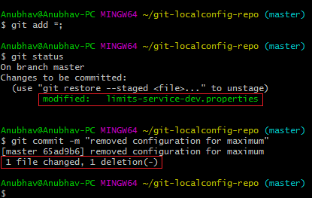
Now start the LimitsServiceApplication.java. When we start the LimitsServiceApplication, it picks values from the SpringCloudConfigServer. We can observe that it picks the maximum value from the limits-service.properties (default service) that is 888 and the minimum value from the limit-service-dev.properties that is 1. However, we have overwritten the minimum value of the default service.
Let's see what happens when we change the profile dev to qa. Open bootstrap.properties and write qa in place of dev. The application will start and pick up the changes. Now execute the limits.
Output
{
maximum: 222,
minimum: 2
}
These are the values that are coming from the qa environment configuration.

Steps to configure Spring cloud config server:-

We can enable the Spring Cloud Config Server by using the annotation @EnableConfigServer.
We created already Limits-service as microservice. Now will configure the spring cloud config server.
First create spring cloud config server service using spring boot.
Install git and link to the spring cloud config server
configure the location of git repository where we are storing all our configuration files in application.properties.
Ex:In spring-cloud-config server project , open the application .properties and configure as below.
application.properties:-
spring.application.name=spring-cloud-config-server
server.port = 8888
spring.cloud.config.server.git.uri=file:///F:/vani/work/springboot-microservices/git-localconfig-repo
Now annotate the entry point class with @EnableConfigServer in spring cloud config server service .
EX:- In my class below

package com.in28minutes.microservices.springcloudconfigserver;

import org.springframework.boot.SpringApplication;
import org.springframework.boot.autoconfigure.SpringBootApplication;
import org.springframework.cloud.config.server.EnableConfigServer;

@EnableConfigServer
@SpringBootApplication
public class SpringCloudConfigServerApplication {

public static void main(String[] args) {
SpringApplication.run(SpringCloudConfigServerApplication.class, args);
}

}

That’s it. This is all you need to do to create Spring Cloud Config Server and you just need to add application-specific config files in the git repository.
Refactor Limits-service to use spring cloud config server
Our Limits-service will become client for Spring cloud config server. So let us add config client client starter to limit-service which will add the below dependency if not added.
<dependency>
<groupId>org.springframework.cloud</groupId>
<artifactId>spring-cloud-starter-config</artifactId>
</dependency>
While using Spring Cloud Config Server the properties loading process happens at multiple stages, first loading bootstrap.properties/yml and then from config server.
So, let’s rename application.properties to bootstrap.properties and update it to have the following properties.
spring.application.name=limits-service
spring.cloud.config.uri=http://localhost:8888

Here, we have configured the location of our Config Server and gave the name as limits-service to our application using spring.application.name.

Now we need to add all the properties of our limits-service in limits-service.properties and commit/push it to our git repo git-local-config-repo.
git-localconfig-repo/limits-service.properties
limits-service.minimum=88
limits-service.maximum=8888
You can also add separate config files for different files like limits-service-qa.properties, limits-service-dev.properties etc.
Now first start spring-cloud-config Server application and then limits-service application. This should work fine. You can check the console logs that catalog-service is fetching the properties from config server http://localhost:8888/ at startup.

Introduction to Currency Conversion and Currency Exchange Service
In this section, we will create a couple of microservices: CurrencyCalculationService and CurrencyExchangeService.
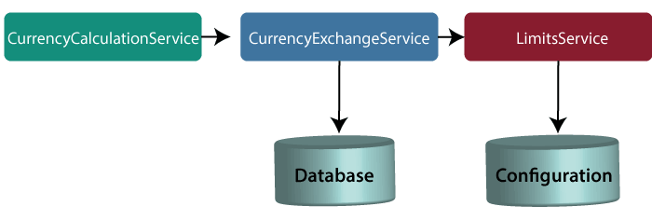
Note: In this tutorial, we have quoted currency conversion service as a currency calculation service. Both the services have the same meaning, so don't be confused.
Let's understand the functionality of these services.
In the above figure, the CurrencyExchangeService uses JPA to talk to the database and returns the exchange value of the specific currency. For example, USD to INR conversion.
When we invoke CurrencyExchangeService, we need to pass two parameters: from(convert from), and to (convert to). For example, if we want to convert currency from USD to INR.
Consider the URL http://localhost:8000/currency-exchange/from/USD/to/INR. It retunes the following response:
- {
- id: 101,
- from: "USD",
- to: "INR",
- conversionMultiple: 72,
- port: 8000
- }

The currency exchange service will return what the conversion multiple is. The conversion multiple means 1 USD is equal to 72 INR. The currency converter service uses a currency exchange service. Suppose the currency converter service wants to convert 100 USD to INR. So it will call the currency exchange service and will convert the specified amount that we have provided in the path parameter. For example:

http://localhost:8100/currency-converter/from/USD/to/INR/quantity/100
- {
- Id: 101,
- from: "USD",
- to: "INR",
- conversionMultiple: 72,
- quantity: 100
- totalCalculatedAmount: 7200,
- port: 8000
- }

We will implement these two services in our example using Spring Cloud.
Setting up a currency-exchange-service
Step 1: Open the spring initializer http://start.spring.io.
Step 2: Select the Project: Maven Project, Language: Java, and Spring Boot version 2.2.0 M6 or above. Provide the Group name and Artifact ID. We have provided com.javatpoint.microservices and currency-exchange-service, for group name and Artifact id respectively.
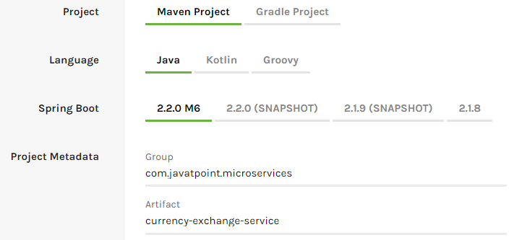
Step 3: Add the dependencies Web, DevTools, Actuator, and Config Client.
Step 4: Click on the Generate Project button. It will download the zip file of the project.
Step 5: Extract it in the local disk.
Step 6: Import the project.
Click on File menu-> Import -> Existing Maven Projects -> Next -> Browse ->Select the project ->Finish
It takes some time to import. When the project import is done, it shows the following project directory. Do not consider the data.sql file in the directory, because we will create it later.
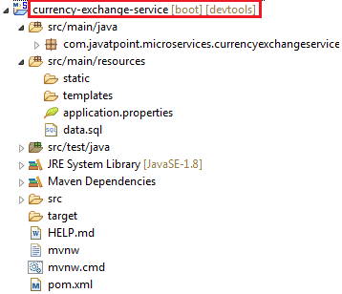
Step 7: Open the application.properties file and configure the application name and port number.
application.properties
- spring.application.name=currency-exchange-service.
- server.port=8000
When we run the currency-exchange-service, it runs but does not perform any service. In the next step, we will implement code in the currency-exchange-service.
Hardcoded the currency-exchange-service
Now we will create a service that converts the currency from USD to INR.
Step 1: Create a class file (REST Controller) with the name CurrencyExchangeController in the package com.javatpoint.microservices.currencyexchangeservice.
CurrencyExchangeController.java
- package com.javatpoint.microservices.currencyexchangeservice;
- import java.math.BigDecimal;
- import org.springframework.boot.SpringApplication;
- import org.springframework.boot.autoconfigure.SpringBootApplication;
- import org.springframework.web.bind.annotation.GetMapping;
- import org.springframework.web.bind.annotation.PathVariable;
- import org.springframework.web.bind.annotation.RestController;
- @SpringBootApplication
- @RestController
- public class CurrencyExchangeController
- {
- @GetMapping("/currency-exchange/from/{from}/to/{to}") //where {from} and {to} are path variable
- public ExchangeValue retrieveExchangeValue(@PathVariable String from, @PathVariable String to) //from map to USD and to map to INR
- {
- return new ExchangeValue(1000L, from, to, BigDecimal.valueOf(65));
- }
- }
Step 2: Create a class file with the name ExchangeValue.
ExchangeValue.java
- package com.javatpoint.microservices.currencyexchangeservice;
- import java.math.BigDecimal;
- public class ExchangeValue
- {
- private Long id;
- private String from;
- private String to;
- private BigDecimal conversionMultiple;

- public ExchangeValue()
- {
- }
- //generating constructor using fields
- public ExchangeValue(Long id, String from, String to, BigDecimal conversionMultiple) {
- super();
- this.id = id;
- this.from = from;
- this.to = to;
- this.conversionMultiple = conversionMultiple;
- }
- //generating getters
- public Long getId()
- {
- return id;
- }
- public String getFrom()
- {
- return from;
- }
- public String getTo()
- {
- return to;
- }
- public BigDecimal getConversionMultiple()
- {
- return conversionMultiple;
- }
- }
Step 3: Run the CurrencyExchangeServiceApplication.java. It runs on the port 8000 that we have configured in the application.properties file.
We get the following response on the browser:
- {
- id: 101,
- from: "USD",
- to: "INR",
- conversionMultiple: 72,
- port: 8000
- }

Setting up Dynamic port in the Response

The CurrencyExchangeService determines the exchange value of the currency. The CurrencyCalculationService uses the CurrencyExchangeService to determine the value of one currency in other currency. We will create multiple instances of the CurrencyExchangeService later in next topic.
At present, the service is running on port 8000. Later we will run it on port 8001, 8002, and so on. In the next step, we will set a port to the currency-exchange-service.
Step 1: Open the ExchangeValue.java file and add a port variable. Generate getters and setters for the port variable only.
ExchangeValue.java
- package com.javatpoint.microservices.currencyexchangeservice;
- import java.math.BigDecimal;
- public class ExchangeValue
- {
- private Long id;
- private String from;
- private String to;
- private BigDecimal conversionMultiple;
- private int port;
- public ExchangeValue()
- {
- }
- //generating constructor using fields
- public ExchangeValue(Long id, String from, String to, BigDecimal conversionMultiple) {
- super();
- this.id = id;
- this.from = from;
- this.to = to;
- this.conversionMultiple = conversionMultiple;
- }
- //generating getters
- public int getPort() {
- return port;
- }
- public void setPort(int port) {
- this.port = port;
- }
- public Long getId()
- {
- return id;
- }
- public String getFrom()
- {
- return from;
- }
- public String getTo()
- {
- return to;
- }
- public BigDecimal getConversionMultiple()
- {
- return conversionMultiple;
- }
- }
We have already configured the application name and port number in the application.properties file, so need not to configure again.
Now pick up port number from the environment.
Step 3: Open the CurrencyExchangeController.java and get the property of the environment.
CurrencyExchangeController.java.
- package com.javatpoint.microservices.currencyexchangeservice;
- import java.math.BigDecimal;
- import org.springframework.beans.factory.annotation.Autowired;
- import org.springframework.boot.autoconfigure.SpringBootApplication;
- import org.springframework.core.env.Environment;
- import org.springframework.web.bind.annotation.GetMapping;
- import org.springframework.web.bind.annotation.PathVariable;
- import org.springframework.web.bind.annotation.RestController;
- @SpringBootApplication
- @RestController
- public class CurrencyExchangeController
- {
- @Autowired
- private Environment environment;
- @GetMapping("/currency-exchange/from/{from}/to/{to}") //where {from} and {to} are path variable
- public ExchangeValue retrieveExchangeValue(@PathVariable String from, @PathVariable String to) //from map to USD and to map to INR
- {
- //taking the exchange value
- ExchangeValue exchangeValue= new ExchangeValue (1000L, from, to, BigDecimal.valueOf(65));
- //picking port from the environment
- exchangeValue.setPort(Integer.parseInt(environment.getProperty("local.server.port")));
- return exchangeValue;
- }
- }
When we refresh the browser, the URL changes to: http://localhost:8000/currency-exchange/from/USD/to/INR.
- {
- id: 1000,
- from: "USD",
- to: "INR"
- conversionMultiple: 65,
- port: 8000
- }
At present CurrencyExchangeServiceApplication is running on port 8000.
Now we will run CurrencyExchangeServiceApplication on a different port number. For this, we have to change the port in the application.properties file from 8000 to 8001, 8002, etc. whichever we want.
Suppose we want to create two instances of the CurrencyExchangeServiceApplication. For this, we have to set port externally.
Let's create an instance of the CurrencyExchangeServiceApplication that runs on the port 8001.
Step 1: Right-click on the project -> Run As -> Run Configurations.
Or click on the highlighted symbol -> Run Configurations.
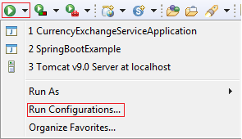
Step 2: Rename the CurrencyExchangeServiceAppication to CurrencyExchangeServiceAppication8000 and click on the Apply button.
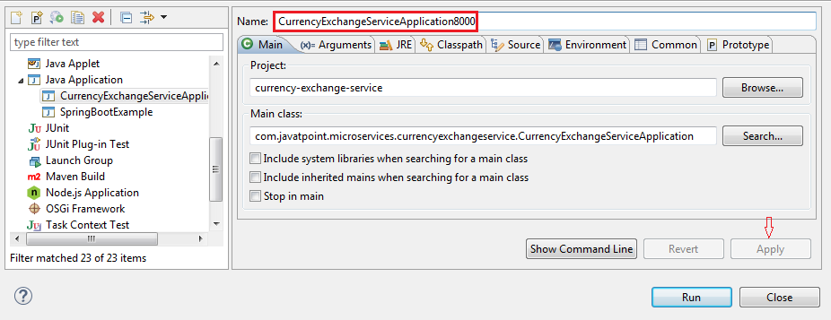
Step 3: Right-click on the CurrencyExchangeServiceApplication8000 -> Duplicate.
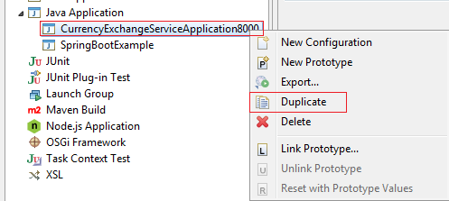
It generates the duplicate file of CurrencyExchangeServiceApplication8000. We will run it on port 8001.
Step 4: Click on the Arguments tab and write –Dserver.port=8001 in the VM arguments text box. Click on the Apply and Run button, respectively.

Note: Whatever value we are passing in the VM arguments, it overwrites the configuration of the application.properties file.
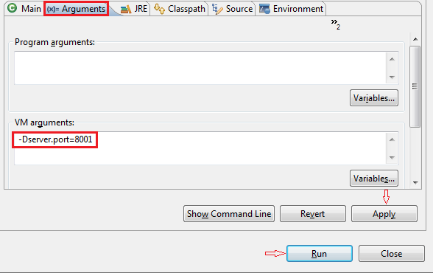
After clicking on the Run button, it starts running on port 8001.
Step 5: Change the port number in the URL http://localhost:8001/currency-exchange/from/USD/to/INR and press enter key. We get the following response:
- {
- id: 1000,
- from: "USD",
- to: "INR",
- conversionMultiple: 65,
- port: 8001
- }
Now we have two instances of CurrencyExchangeServiceApplication that are running on two different ports 8000 and 8001.

Configure JPA and Initialized Data
In the previous section, we have hardcoded the response for the exchange value. It comes from the database. In this section, we will create a connection to the in-memory database.
Let's see how to connect microservice to the H2 database. Follow the following steps to connect microservice to JPA in-memory database.
Step 1: Open pom.xml of currency-exchange-service and add the following two dependencies.

- <dependency>
- <groupId>com.h2database</groupId>
- <artifactId>h2</artifactId>
- <version>1.4.197</version>
- <scope>test</scope>
- </dependency>
- <dependency>
- <groupId>org.springframework.boot</groupId>
- <artifactId>spring-boot-starter-data-jpa</artifactId>
- <version>2.1.3.RELEASE</version>
- </dependency>

Once we have added the dependencies, now we have to define entity.
Step 2: Open the ExchangeValue.java file and do the following:
- Add @Entity annotation at the class level.
- Define the table name by using the annotation @Table.
- Define an Id for the entity by adding the annotation @Id.
- Define columns by adding the annotation @Column above each field and also specify the column name

package bean;

import java.math.BigDecimal;

import javax.persistence.Column;
import javax.persistence.Entity;
import javax.persistence.Id;

@Entity
public class ExchangeValue {

@Id
private Long id;

@Column(name="currency_from")
private String from;

@Column(name="currency_to")
private String to;

private BigDecimal conversionMultiple;
private int port;

public Long getId() {
return id;
}

public void setId(Long id) {
this.id = id;
}

public String getFrom() {
return from;
}

public void setFrom(String from) {
this.from = from;
}

public String getTo() {
return to;
}

public void setTo(String to) {
this.to = to;
}

public BigDecimal getConversionMultiple() {
return conversionMultiple;
}

public void setConversionMultiple(BigDecimal conversionMultiple) {
this.conversionMultiple = conversionMultiple;
}

public int getPort() {
return port;
}

public void setPort(int port) {
this.port = port;
}

public ExchangeValue(Long id, String from, String to, BigDecimal conversionMultiple) {
super();
this.id = id;
this.from = from;
this.to = to;
this.conversionMultiple = conversionMultiple;
}

protected ExchangeValue() {

}

}

We have created the entity, now we have to insert some data into the database.
Step 3: Create a data.sql file to insert data into database.
Right-click on the folder src/main/resources -> New -> File -> Provide the name data.sql -> Finish
Step 4: Insert the data into data.sql file. We have inserted the following data:
data.sql
- insert into exchange_value(id,currency_from,currency_to,conversion_multiple,port)
- values(10001,'USD', 'INR' ,65,0);
- insert into exchange_value(id,currency_from,currency_to,conversion_multiple,port)
- values(10002,'EUR', 'INR' ,75,0);
- insert into exchange_value(id,currency_from,currency_to,conversion_multiple,port)
- values(10003,'AUD', 'INR' ,25,0);

Step 5: Open application.properties file and enable H2 console, configure URL and datasource. The default JDBC URL is testdb. We can specify our own JDBC URL.
We have specified JDBS URL: jdbc:h2:mem:testdb
application.properties
spring.application.name=currency-exchange-service
server.port=8000

spring.datasource.url=jdbc:h2:mem:testdb;DB_CLOSE_ON_EXIT=FALSE;DB_CLOSE_DELAY=-1
spring.datasource.driverClassName=org.h2.Driver
spring.datasource.username=sa
spring.datasource.password=
spring.jpa.database-platform=org.hibernate.dialect.H2Dialect
spring.data.jpa.repositories.bootstrap-mode=default
spring.jpa.hibernate.ddl-auto=update

spring.jpa.show-sql=true
spring.h2.console.enabled=true

Step 6: Restart the application.
Step 7: Open the browser and type the URI http://localhost:8000/currency-exchange/from/USD/to/INR. It returns the response, as shown below:
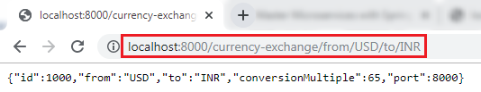
We can also see the data in the database which we have inserted in the data.sql file. To open the H2 Console, we have to do the following:
- In the browser type http://localhost:8000/h2-console. It displays the following page:
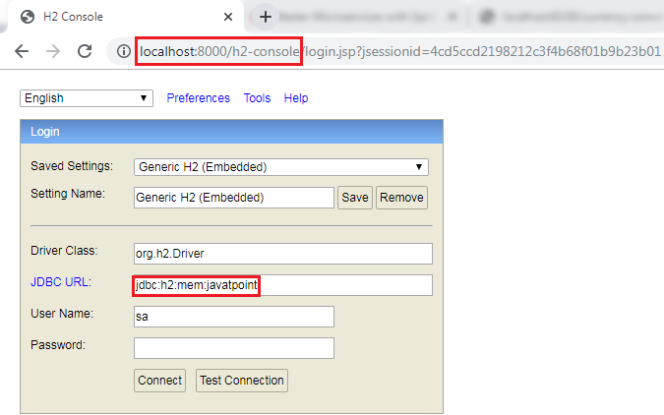
Remember: The JDBC URL must be the same as you have specified in the application.properties file. Do not write anything in the User Name and Password field. The default User Name is sa.
Now click on the Test Connection button; if the connection is successful, it shows the message Test Successful.
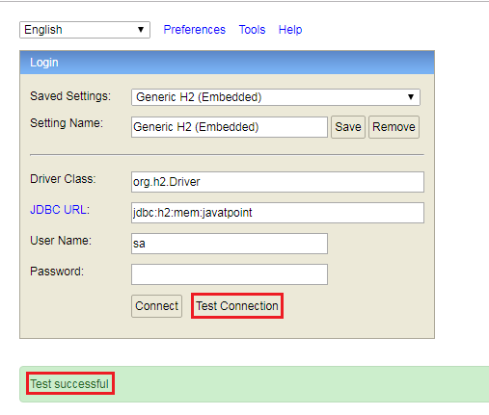
Step 8: Click on the Connect button. It shows the created table on the left-hand side of the page.
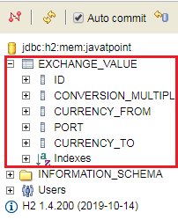
Step 9: Run the following query to view the data.
- SELECT *FROM EXCHANGE_VALUE;
It shows the data which we have inserted in the data.sql file.
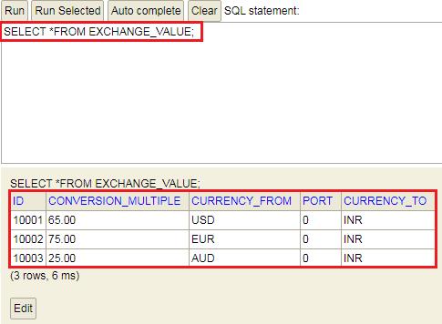
In this section, we have created the in-memory database and inserted some values in the database.

Creating a JPA Repository
In the previous section, we have created a table in-memory database and saw that all the data is populated correctly. In this section, we will create a repository that returns the response for the service.
Step 1: Create an interface with the name ExchangeValueRepository and extends the JpaRepository class. We have to pass two parameters: type of the entity that it manages and the type of the Id field.

- public interface ExchangeValueRepository extends JpaRepository<ExchangeValue, Long>

Step 2: Open CurrencyExchageController.java file and autowired the ExchageValueRepository.
@Autowired
private ExchangeValueRepository repository;

Step 3: Create a query method in the ExcahngeValueRepository.java file.

ExchangeValue findByFromAndTo(String from, String to);

In the above statement, ExchangeValue is the expected response. There are two columns that we have to find are from and to.
If we want to find data on the basis of single column, we can pass a column name. For example:
ExchangeValue findByFrom (String from);

ExcahngeValueRepository.java
package repository;

import org.springframework.data.jpa.repository.JpaRepository;
import org.springframework.stereotype.Repository;

import bean.ExchangeValue;

@Repository
public interface ExchangeValueRepository extends JpaRepository<ExchangeValue, Long> {

ExchangeValue findByFromAndTo(String from, String to);

}

Step 4: In the CurrencyExchangeController.java use the following statement:
ExchangeValue exchangeValue=repository.findByFromAndTo(from,to);
Instead of using the following statement:
ExchangeValue exchangeValue=new ExchangeValue(1000L, from, to, BigDecimal.valueOf(65));

CurrencyExchangeController.java
package controller;

import java.math.BigDecimal;

import org.springframework.beans.factory.annotation.Autowired;
import org.springframework.core.env.Environment;
import org.springframework.web.bind.annotation.GetMapping;
import org.springframework.web.bind.annotation.PathVariable;
import org.springframework.web.bind.annotation.RestController;

import bean.ExchangeValue;
import repository.ExchangeValueRepository;

@RestController
public class CurrencyExchangeController {

@Autowired
private Environment environment;

@Autowired
private ExchangeValueRepository repository;

@GetMapping("/currency-exchange/from/{from}/to/{to}")
public ExchangeValue retrieveExchangeValue(@PathVariable String from, @PathVariable String to) {
ExchangeValue exchangeValue= repository.findByFromAndTo(from, to);
exchangeValue.setPort(Integer.parseInt(environment.getProperty("local.server.port")));
return exchangeValue;
}

}

Note:-
Make sure in Spring boot Main application annotate the @EntityScan and @EnableJPARepositories to avoid the BeancreatioinException and also not created repository.
Ex:

package com.in28minutes.microservices.currencyexchangeservice;

import org.springframework.boot.SpringApplication;
import org.springframework.boot.autoconfigure.SpringBootApplication;
import org.springframework.boot.autoconfigure.domain.EntityScan;
import org.springframework.data.jpa.repository.config.EnableJpaRepositories;

@SpringBootApplication(scanBasePackages = {"bean","controller","repository"})
@EntityScan(basePackages = {"bean","controller","repository"})
@EnableJpaRepositories({"repository"})
public class CurrencyExchangeServiceApplication {

public static void main(String[] args) {
SpringApplication.run(CurrencyExchangeServiceApplication.class, args);
}

}

Step 5: Restart the application to pick up the changes. Open the browser and type the URI http://localhost:8000/currency-exchange/from/USD/to/INR. It returns the following response:

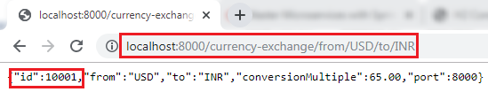
We can also try a different conversion by changing the currency USD to EUR in the URI.
http://localhost:8000/currency-exchange/from/EUR/to/INR.
It returns the following response:
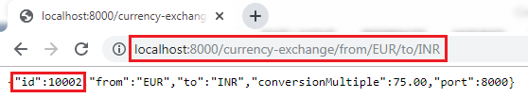
In this above response, we are retrieving the values from the database.
When we pass the currency in the URI (EUR/to/INR), the query gets fired to the database. To see which query gets fired, we can see the query in the log.
- Hibernate: select exchangeva0_.id as id1_0_, exchangeva0_.conversion_multiple as conversi2_0_, exchangeva0_.currency_from

Setting up Currency Conversion Microservice
In the previous section, we have created currency-exchange-service. Now we will create a currency-conversion-service that talks to currency-exchange-service.
Step 1: Open the browser and type https://start.spring.io/.
- Provide the Group name javatpoint.microservice and Artifact currency-conversion-service.
- Add the dependencies: Spring web, DevTools, Actuator, and Config Client.
- Click on the Generate It downloads the created project.

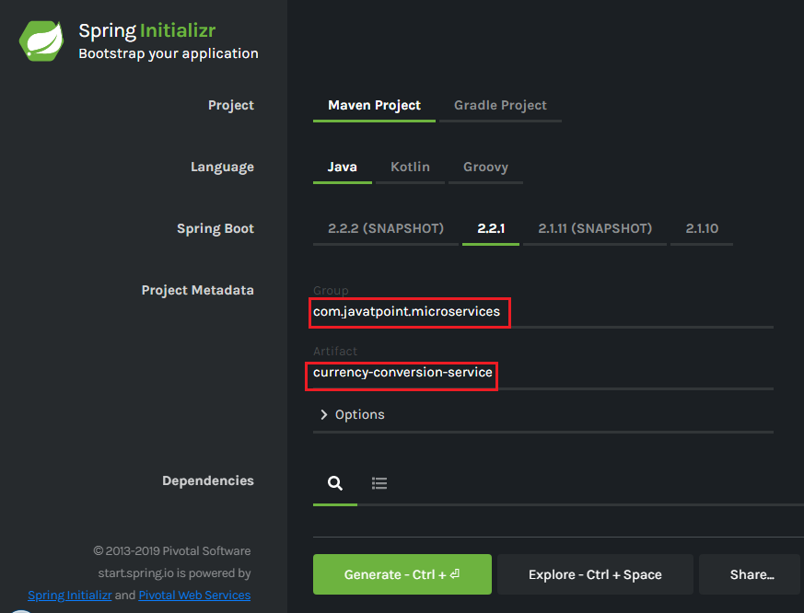
Step 2: Import the downloaded project in Spring Tool Suite (STS).
File -> Import -> Existing Maven Projects -> Next -> Browse -> Select the project -> Finish.
It takes some time to import the project.
Step 3: Open the application.properties file and configure the application name and port number.
application.properties
- spring.application.name=currency-conversion-service
- server.port=8100
The currency-conversion-service runs on port 8100.
In the next section, we will create a service that talks to the currency-exchange-service.

Creating a Service for currency-conversion-service
In the previous section, we have used EUR to INR that returns what the conversionMultiple is. The currency-exchange-service tells what is the exchange value when we convert currency from EUR to INR.
In this section, we will create CurrencyCalculationService. It defines a lot of functionality related to conversion.
We will create a service currency-converter that accepts two path parameters "from" and "to". It also accepts the quantity (amount which we want to convert).
Let's create a currency-conversion-service.
Step 1: Create a class with the name CurrencyConversionController.
Step 2: Add an annotation @RestController.
Step 3: Create a GetMapping.
CurrencyConversionController.java
package controller;

import java.math.BigDecimal;
import java.util.HashMap;
import java.util.Map;

import org.springframework.http.ResponseEntity;
import org.springframework.web.bind.annotation.GetMapping;
import org.springframework.web.bind.annotation.PathVariable;
import org.springframework.web.bind.annotation.RestController;
import org.springframework.web.client.RestTemplate;

import bean.CurrencyConversionBean;

@RestController
public class CurrencyConversionController {

@GetMapping("/currency-converter/from/{from}/to/{to}/quantity/{quantity}")
public CurrencyConversionBean convertCurrency(@PathVariable String from,
@PathVariable String to, @PathVariable BigDecimal quantity ) {

Map<String, String>uriVariables=new HashMap<>();
uriVariables.put("from", from);
uriVariables.put("to", to);

ResponseEntity<CurrencyConversionBean> responseEntity = new RestTemplate().getForEntity("http://localhost:8000/currency-exchange/from/{from}/to/{to}",
CurrencyConversionBean.class,uriVariables);

CurrencyConversionBean currencyConversionBean=responseEntity.getBody();
return new CurrencyConversionBean(1L, from,to,BigDecimal.ONE, quantity,quantity,0)
}
}

Step 4: Create a class with the name CurrencyConversionBean and define the following fields:
package bean;

import java.math.BigDecimal;

public class CurrencyConversionBean {

private Long id;
private String from;
private String to;
private BigDecimal conversionMultiple;
private BigDecimal quantity;
private BigDecimal totalCalculatedAmount;
private int port;

public Long getId() {
return id;
}

public void setId(Long id) {
this.id = id;
}
public String getFrom() {
return from;
}
public void setFrom(String from) {
this.from = from;
}
public String getTo() {
return to;
}
public void setTo(String to) {
this.to = to;
}
public BigDecimal getQuantity() {
return quantity;
}
public void setQuantity(BigDecimal quantity) {
this.quantity = quantity;
}
public BigDecimal getConversionMultiple() {
return conversionMultiple;
}
public void setConversionMultiple(BigDecimal conversionMultiple) {
this.conversionMultiple = conversionMultiple;
}
public BigDecimal getTotalCalculatedAmount() {
return totalCalculatedAmount;
}
public void setTotalCalculatedAmount(BigDecimal totalCalculatedAmount) {
this.totalCalculatedAmount = totalCalculatedAmount;
}
public int getPort() {
return port;
}
public void setPort(int port) {
this.port = port;
}

public CurrencyConversionBean(Long id, String from, String to, BigDecimal conversionMultiple, BigDecimal quantity,
BigDecimal totalCalculatedAmount, int port) {
super();
this.id = id;
this.from = from;
this.to = to;
this.conversionMultiple = conversionMultiple;
this.quantity = quantity;
this.totalCalculatedAmount = totalCalculatedAmount;
this.port = port;
}

public CurrencyConversionBean() {

}

}

Step 5: Generate Getters and Setters.
Step 6: Generate constructor and also create a default constructor.
Step 7: Restart the application and type the following URI in the browser:
http://localhost:8100/currency-converter/from/USD/to/INR/quantity/1000
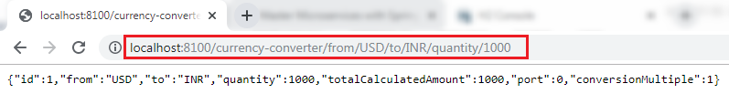
In the above response, "from," "to," and "quantity" variables picked up from the path. We have hardcoded the other variables.
In the next step, from the currency-conversion-service, we will call the currency-exchange-service. We will also determine what the conversion multiple is, and will use that amount (conversion multiple) to calculate the total amount. We will also use the port that comes in the response.

Invoking currency-exchange-service from currency-conversion-service

We have the currency-exchange-service ready, and we have set up a currency-calculation-service (currency-conversion-service). Now we will invoke the currency exchange service from the currency calculation service.
We use RestTemplate() constructor to invoke an external service. Let's create a RestTemplate and try to invoke currency-exchange-service.
Step 1: Select the currency-conversion-service project.
Step 2: Open the CurrencyConversionController.java and create a new RestTemplate that invokes the currency-exchange-service application.
Step 3: Invoke the getForEntity() method of RestTemplate class.
getForEntity(): It is a method of RestTemplate class that retrieves an entity by using the HTTPGET method for the specified URL. It converts and stores the response in the ResponseEntity. It returns the ResponseEntity.
Parameters: It accepts two parameters:
- URL: The URL.
- responseType: The type of the return value.
- ResponseEntity<CurrencyConversionBean>responseEntity=new RestTemplate().getForEntity("http://localhost:8000/currency-exchange/from/{from}/to/{to}", CurrencyConversionBean.class, uriVariables);

Step 4: In the URL parameter, put the URL of currency-converter-service that is http://localhost:8000/currency-exchange/from/{from}/to/{to}. It takes values from the variable {from} and {to} from the request. Whatever comes in the request we sent it to the currency-exchange-service.
Step 5: In the above URL, we need to pass two values "from" and "to." For passing the values, create a Map for URI variables. Pass the uriVariables in the URI as a parameter.
- Map<String, String>uriVariables=new HashMap<>();
- uriVariables.put("from", from);
- uriVariables.put("to", to);
Step 6: The response type that we are expecting back is CurrencyConversionBean, so store the response in the CurrencyConversionBean.
- CurrencyConversionBean response=responseEntity.getBody();

CurrencyConversionController.java

package controller;

import java.math.BigDecimal;
import java.util.HashMap;
import java.util.Map;

import org.springframework.http.ResponseEntity;
import org.springframework.web.bind.annotation.GetMapping;
import org.springframework.web.bind.annotation.PathVariable;
import org.springframework.web.bind.annotation.RestController;
import org.springframework.web.client.RestTemplate;

import bean.CurrencyConversionBean;

@RestController
public class CurrencyConversionController {

@GetMapping("/currency-converter/from/{from}/to/{to}/quantity/{quantity}")
public CurrencyConversionBean convertCurrency(@PathVariable String from,
@PathVariable String to, @PathVariable BigDecimal quantity ) {

Map<String, String>uriVariables=new HashMap<>();
uriVariables.put("from", from);
uriVariables.put("to", to);

ResponseEntity<CurrencyConversionBean> responseEntity = new RestTemplate().getForEntity("http://localhost:8000/currency-exchange/from/{from}/to/{to}",
CurrencyConversionBean.class,uriVariables);

CurrencyConversionBean currencyConversionBean=responseEntity.getBody();
return new CurrencyConversionBean(currencyConversionBean.getId(),from,to,currencyConversionBean.getConversionMultiple(),
quantity,quantity.multiply(currencyConversionBean.getConversionMultiple()),currencyConversionBean.getPort());
}
}

Step 7: Run the both services independently. When we run the currency conversion, it returns the response shown below:
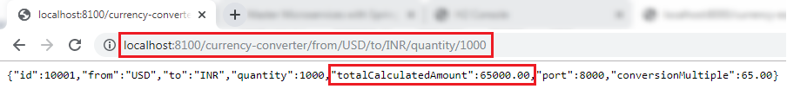
The conversion Multiple is multiplied by the quantity and returns the totalCalculatedAmount 65000.00. It means $1000 is equal to 65000.00 INR. It also shows the port 8000 that denotes the other service (currency-exchange-service) is running on port 8000.

Using Feign REST Client for Service Invocation
Feign:-
The Feign is a declarative web service (HTTP client) developed by Netflix. Its aim is to simplify the HTTP API clients. It is a Java to HTTP client binder. If you want to use Feign, create an interface, and annotate it. It provides pluggable annotation support, including Feign annotations and JAX-RS annotations.
It is a library for creating REST API clients. It makes web service clients easier. The developers can use declarative annotations to call the REST services instead of writing representative boilerplate code.
Feign also supports pluggable encoders and decoders. Spring Cloud adds support for Spring MVC annotations and for using the same HttpMessageConverters used by default in Spring Web. Spring Cloud integrates Eureka, as well as Spring Cloud LoadBalancer to provide a load-balanced http client when using Feign.
Spring Cloud OpenFeign
Spring Cloud OpenFeign provides OpenFeign integrations for Spring Boot apps through auto-configuration and binding to the Spring Environment. Without Feign, in Spring Boot application, we use RestTemplate to call the User service. To use the Feign, we need to add spring-cloud-starter-openfeign dependency in the pom.xml file.
In the previous section, one of the things that we had already encountered is when we were developing currency-conversion-service; how difficult it was to call the REST service. There is a lot of manuals that we have to do to call a very simple service. But still we have written a lot of code for it.
When we work with microservices, there will be a lot of calls to other services. We need not to code like the previous one. Feign is a component that solves this problem. Feign makes it easy to invoke other microservices.
The other additional thing that Feign provides is: it integrates with the Ribbon (client-side load balancing framework).
Let's implement the Feign in our project and invoke other microservices using Feign.

Step 1: Select currency-conversion-service project.
Step 2: Open the pom.xml and add the Feign dependency. Feign inherits from the Netflix.
<dependency>
<groupId>org.springframework.cloud</groupId>
<artifactId>spring-cloud-starter-openfeign</artifactId>
</dependency>

Step 3: Once the dependency is added, enable the Feign to scan the clients by adding the annotation @EnableFeignClients in the CurrencyConversionServiceApplication.java file.

Step 4: Define an attribute in the @EnableFeignClients annotation. The attribute is the name of the package that we want to scan.

CurrencyConversionServiceApplication.java
package com.in28minutes.microservices.currencyconversionservice;

import org.springframework.boot.SpringApplication;
import org.springframework.boot.autoconfigure.SpringBootApplication;
import org.springframework.cloud.openfeign.EnableFeignClients;

@SpringBootApplication(scanBasePackages = {"bean","controller","service"})
@EnableFeignClients("service")
public class CurrencyConversionServiceApplication {

public static void main(String[] args) {
SpringApplication.run(CurrencyConversionServiceApplication.class, args);
}

}

We have enabled the Feign in our project. Now, we will use the Feign to invoke the service.
Step 5: Create a Feign proxy that enables us to talk to external microservices. Let’s create an interface with the name CurrencyExchangeServiceProxy.
Step 6: Add an annotation @FeignClient. Pass the attributes name and URL.
In the name attribute, write the name of the service that we are going to consume. In our case, we are going to consume currency-exchange-service. In the URL attribute, write the port on which the currency-exchange-service is running.
- @FeignClient(name="currency-exchange-service", url="localhost:8000")

Step 7: Now, we need to define a method that talks to the currency-exchange-controller. Open the Currency-ConverterController.java file. Copy the currency-converter mapping and paste it in the same file.
Step 8: Change the mapping name to /currency-converter-feign/from/{from}/to/{to}/quantity/{quantity} and the method name to convertCurrencyFeign.
Step 9: Make the use of CurrencyExchangeServiceProxy and autowired it.
@Autowired
private CurrencyExchangeServiceProxy proxy;

Step 10: First, run the currency-exchange-service by invoking the URL http://localhost:8000/currency-exchange/from/USD/to/INR after that run the currency-conversion-service by using the URL http://localhost:8100/currency-converter/from/USD/to/INR/quantity/1000.
If we do not run the services in the order, the currency-conversion-service shows Whitelabel Error Page. It is because the currency-conversion-service uses the conversionMultiple of currency-exchange-service.
Step 11: Execute the feign service by using the URL http://localhost:8100/currency-converter-feign/from/USD/to/INR/quantity/1000. It returns the same response as currency-converter-service.
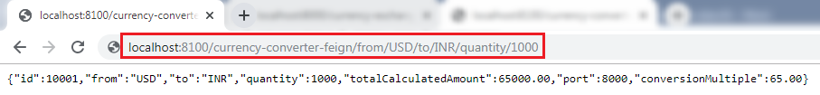
Change the currency USD to EUR in the above URL and again invoke the same URL. It takes the variable "from" from the currency-exchange-service and returns the totalCalculated Amount.
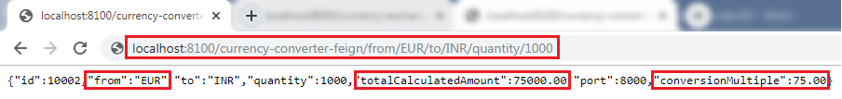
The request we are sending uses Feign. Feign is a REST Service client. Feign can call the RESTful web services easily. When we use the RestTemplate to call the RESTful service, it creates duplication of code that talks to RESTful services.
When we define Feign, we need only to define a proxy and define a single method into it. Feign helps us to simplify client code to talk to the RESTful web services.
Consider a scenario in which currency-exchange-service offers fifteen different services. All the details related to these services must be defined in one place that is CurrencyExchangeServiceProxy interface.

Client-Side Load Balancing with Ribbon

Netflix Ribbon
Netflix Ribbon is a Part of Netflix Open Source Software (Netflix OSS). It is a cloud library that provides the client-side load balancing. It automatically interacts with Netflix Service Discovery (Eureka) because it is a member of the Netflix family.
The Ribbon mainly provides client-side load balancing algorithms. It is a client-side load balancer that provides control over the behavior of HTTP and TCP client. The important point is that when we use Feign, the Ribbon also applies.

Features of Ribbon
- Load balancing
- Fault tolerance
- Multiple protocol support in Asynchronous model
- Caching and batching

Modules
- ribbon: It is an API that integrates load balancing, fault-tolerance, caching, and
- ribbon-loadbalancer: It is a Load balancer API that can be used independently or with other modules.
- ribbon eureka: It uses Eureka client that provides a dynamic server list for the Spring Cloud.
- ribbon-transport: It is a transport client that supports HTTP, TCP, and UDP These protocols use RxNetty with load balancing capability.
- ribbon-httpclient: It is a REST client built on top of Apache HttpClient integrated with load balancers.
- ribbon-core: It is a Client Configuration API

Types of Load Balancing:
- Server Side Load Balancing: Server side load balancing is a monolithic It applies between the client and the server. It accepts incoming network, application traffic, and distributes the traffic across the multiple backend servers by using various methods. The middle component is responsible for distributing the client requests to the server.
- Client-Side Load Balancing: The client holds the list of server’s IPs so that it can deliver the requests. The client selects an IP from the list, randomly, and forwards the request to the server.

Let's configure the Ribbon server in our project.
Step 1: Go to the project currency-conversion-service.
Step 2: Open pom.xml file and add the ribbon dependency.
- <dependency>
- <groupId>org.springframework.cloud</groupId>
- <artifactId>spring-cloud-starter-netflix-ribbon</artifactId>
- </dependency>

After adding the dependency, we need to enable ribbon on the proxy.
Step 3: Open the CurrencyExchangeServiceProxy.java file. Enable Ribbon by adding an annotation @RibbonClient and specify the name of the service which we want to talk to. Ribbon client provide the declarative configuration for a client.
@RibbonClient(name="currency-exchange-service")

CurrencyExchangeServiceProxy.java
package service;

import org.springframework.cloud.netflix.ribbon.RibbonClient;
import org.springframework.cloud.openfeign.FeignClient;
import org.springframework.web.bind.annotation.GetMapping;
import org.springframework.web.bind.annotation.PathVariable;

import bean.CurrencyConversionBean;

//@FeignClient(name="currency-exchange-service", url="localhost:8000")
@FeignClient(name="currency-exchange-service")
@RibbonClient(name="currency-exchange-service")
public interface CurrencyExchangeServiceProxy {

@GetMapping("/currency-exchange/from/{from}/to/{to}")
public CurrencyConversionBean retrieveExchangeValue(@PathVariable("from") String from,
@PathVariable("to") String to);
}

Step 4: In the annotation @FeignClient, remove the attribute URL. Because we do not need to talk with one particular service. We will configure that URL in the application.properties file.
Step 5: Open the application.properties file of the project currency-conversion-service and configure the servers. The property that we have to configure is:
name-of-the-application.ribbon.listOfServers=URLs
We have configured the two instances of currency-exchange-service that we want to invoke.
- currency-exchange-service.ribbon.listOfServers=http://localhost:8000, http://localhost:8001

application.properties
- spring.application.name=currency-conversion-service
- server.port=8100
- currency-exchange-service.ribbon.listOfServers=http://localhost:8000, http://localhost:8001

Running Client Side Load Balancing with Ribbon
We have two instances of CurrentlyExchangeServiceApplication.java, as shown in the following image:
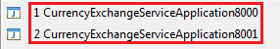
First, run the CurrencyExchangeServiceApplication on port 8000 and then run the CurrencyExchangeServiceApplication on port 8001.
After running the CurrencyExchangeServiceApplication on both the ports, run the CurrencyConversionServiceApplication.java by sending the request http://localhost:8100/currency-converter-feign/from/EUR/to/INR/quantity/10000. It returns the following response.
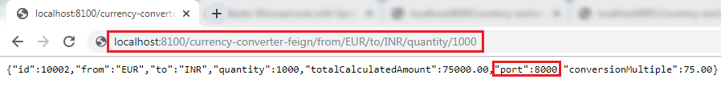
In the above image, the port 8000 represents that the currency-exchange-service is running on port 8000 and handling the current request.
Now, refresh the page. We get the same response except for the port number and quantity because we have changed the quantity in the request.
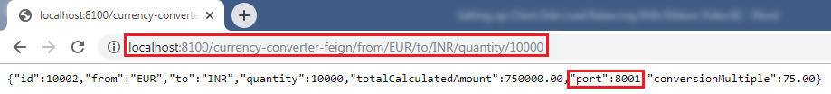
In the above image, the port 8001 represents that the currency-exchange-service is running on port 8001 and handling the current request.

Let's understand the load balancing through a figure:
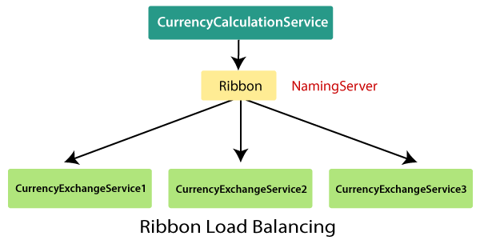
In the above figure, Ribbon is distributing the load between three active CurrencyExchangeServices. The CurrencyExchangeService1 is running on port 8000, and CurrencyExchangeService2 is running on port 8001, and so on. So whatever calls are made using Ribbon through the CurrencyCalculationService, are distributed among these three services.

Eureka Naming Server

Naming server
The naming server is a computer application that implements a network service for responding to queries against a directory service.

Eureka naming server
Eureka naming server is a REST-based server that is used in the AWS Cloud services for load balancing and failover of middle-tier services.
Eureka naming server is an application that holds information about all client service applications. Each microservice registers itself with the Eureka naming server. The naming server registers the client services with their port numbers and IP addresses. It is also known as Discovery Server. Eureka naming server comes with the bundle of Spring Cloud. It runs on the default port 8761. It also comes with a Java-based client component, the eureka client, which makes interactions with the service much easier.

The need of naming server
We have another load balancer application, which is known as AWS Cloud. Because of its inherent nature, server ups and down. There is no middle-tier load balancer. Eureka naming server fills the gap between the client and the middle tier load balancer.
Suppose that we want to start another instance of currency-exchange-service that is CurrencyExchangeService3 and launch it on port 8002. Here a question arises, will ribbon be able to distribute the load to it?
If the Ribbon wants to distribute the load to the new server, we need to add it to the configuration. Based on the load, we can increase or decrease the number of instances of the services.
In this section, we will be able to increase or decrease the number of instances dynamically.
If we keep on changing in the CurrencyCalulationService, based on how many CurrenyExchangeService are active right, then, it becomes very difficult to maintain.
The Eureka naming server comes into existence when we want to make maintenance easier. All the instances of all microservices will be register with the Eureka naming server. Whenever a new instance of a microservice comes up, it would register itself with the Eureka naming server. The registration of microservice with the naming server is called Service Registration.
Whenever a service wants to talk with another service, suppose CurrencyCalculationService wants to talk to the CurrencyExchangeService. The CurrencyCalculationService first talk with the Eureka naming server. The naming server provides the instances of CurrencyExchangeService that are currently running. The process of providing instances to other services is called Service Discovery.
Service registration and service discovery are the two important features of the naming server. In the next step, we will set up a Eureka naming server.

Setting up Eureka naming server

There are a lot of steps that are involved in setting up the Eureka naming server are as follows:
- Create a component for the Eureka naming server
- Update the CurrencyCalculationService to connect to the Eureka naming server
- Connect CurrencyExchangeService to the Eureka naming server
- Configure the Ribbon
Once the instances of currency-exchange-service are registered with the Eureka naming server, then we will use the Ribbon to find the detail from the naming server. Let’s follow the steps specified above:

Create a component for the Eureka naming server
Step 1: Open Spring Initializr https://start.spring.io.
Step 2: Provide the Group name. We have provided com.javatpoint.microservices.
Step 3: Provide the Artifact Id. We have provided netflix-eureka-naming-server.
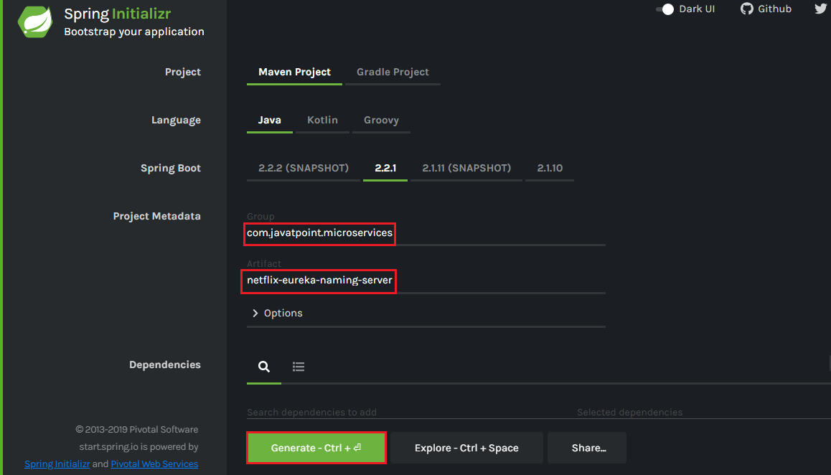
Step 4: Add the following dependencies: Eureka Server, Config Client, Actuator, and DevTools.
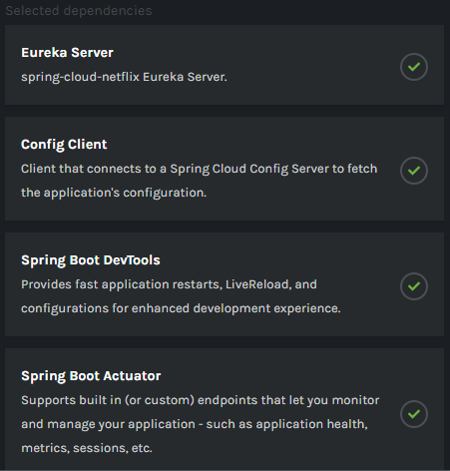
Step 5: Click on the Generate button. It downloads a zip file.
Step 6: Extract the zip file and paste the folder in the Spring Tool Suite (STS) workspace and then import it.
File -> Import -> Existing Maven Projects -> Next -> Browse -> Select the netflix-eureka-naming-server project -> Finish
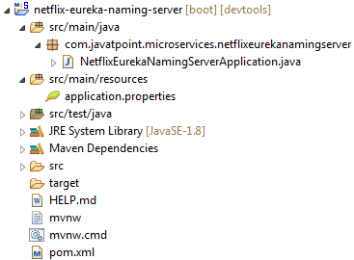
Step 7: Open the NetflixEurekaNamingServerApplication.java file and enable Eureka naming server by using an annotation @EnableEurekaServer.

NetflixEurekaNamingServerApplication.java

package com.in28minutes.microservices.netflixeurekanamingserver;

import org.springframework.boot.SpringApplication;
import org.springframework.boot.autoconfigure.SpringBootApplication;
import org.springframework.cloud.netflix.eureka.server.EnableEurekaServer;

@SpringBootApplication
@EnableEurekaServer
public class NetflixEurekaNamingServerApplication {

public static void main(String[] args) {
SpringApplication.run(NetflixEurekaNamingServerApplication.class, args);
}

}

Step 8: Open the application.properties file and configure the application name, port, and eureka server.
- spring.application.name=netflix-eureka-naming-server
- server.port=8761
- eureka.client.register-with-eureka=false
- eureka.client.fetch-registry=false
Port 8761 is the default port for the Eureka naming server.
Step 9: Run the NetflixEurekaNamingServerApplication.java file as Java Application.
Step 10: Open the browser and type the URL http://localhost:8761. It shows the Eureka server UI.
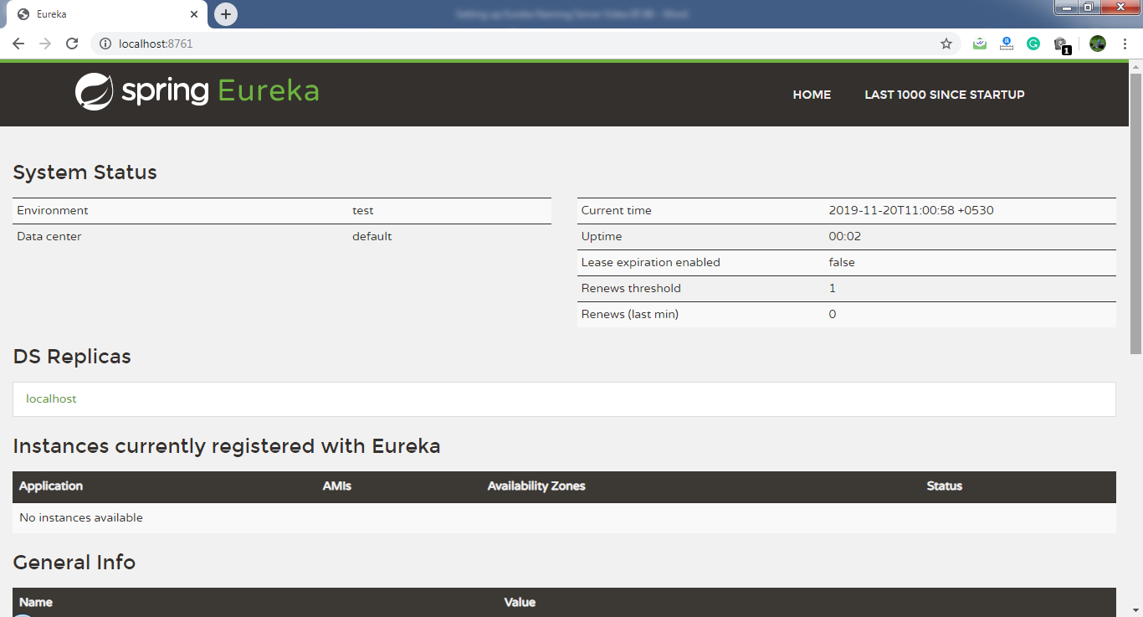
In this section, we have created a component Eureka naming server. In the next step, we will connect the microservices with the Eureka naming server.

Connecting Microservices to Eureka naming server
In this section, we will connect the currency-conversion-service and currency-exchange-service to the Eureka naming server.
First, we will connect the currency-conversion-service.
Step 1: Select the currency-conversion-service project.

Step 2: Open the pom.xml file and add the eureka-client dependency.
- <dependency>
- <groupId>org.springframework.cloud</groupId>
- <artifactId>spring-cloud-starter-netflix-eureka-client</artifactId>
- </dependency>
Step 3: Open CurrencyConversionServiceApplication.java file and enable discovery client by using the annotation @EnableDiscoveryClient.

CurrencyConversionServiceApplication.java
package com.in28minutes.microservices.currencyconversionservice;

import org.springframework.boot.SpringApplication;
import org.springframework.boot.autoconfigure.SpringBootApplication;
import org.springframework.cloud.client.discovery.EnableDiscoveryClient;
import org.springframework.cloud.openfeign.EnableFeignClients;

@SpringBootApplication(scanBasePackages = {"bean","controller","service"})
@EnableFeignClients("service")
@EnableDiscoveryClient
public class CurrencyConversionServiceApplication {

public static void main(String[] args) {
SpringApplication.run(CurrencyConversionServiceApplication.class, args);
}

}

After enabling the discovery client, configure the URL for the Eureka naming server.
Step 4: Open the application.properties file and configure the URL for the Eureka naming server.
application.properties
- spring.application.name=currency-conversion-service
- server.port=8100
- eureka.client.service-url.default-zone=http://localhost:8761/eureka
- currency-exchange-service.ribbon.listOfServers=http://localhost:8000, http://localhost:8001

If we look at the Eureka UI, we see that there is no instance registered with the Eureka server.
Step 5: Run the CurrencyConversionServiceApplication.java file.
Step 6: Open the browser and refresh the Eureka server page. It shows the instances of registered microservices.
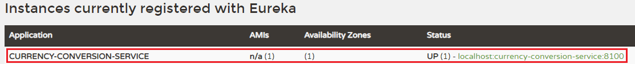
We see that an instance of currency-conversion-service is registered with the Eureka naming server, and running on port 8100.

Let's connect currency-exchange-service with Eureka naming server.
Step 1: Select the currency-exchange-service project.
Step 2: Open the pom.xml file and add the eureka-client dependency.
- <dependency>
- <groupId>org.springframework.cloud</groupId>
- <artifactId>spring-cloud-starter-netflix-eureka-client</artifactId>
- </dependency>
Step 3: Open CurrencyExchangeServiceApplication.java file and enable the discovery client by using the annotation @EnableDiscoveryClient.

CurrencyExchangeServiceApplication.java
package com.in28minutes.microservices.currencyexchangeservice;

import org.springframework.boot.SpringApplication;
import org.springframework.boot.autoconfigure.SpringBootApplication;
import org.springframework.boot.autoconfigure.domain.EntityScan;
import org.springframework.cloud.client.discovery.EnableDiscoveryClient;
import org.springframework.data.jpa.repository.config.EnableJpaRepositories;

@SpringBootApplication(scanBasePackages = {"bean","controller","repository"})
@EntityScan(basePackages = {"bean","controller","repository"})
@EnableJpaRepositories({"repository"})
@EnableDiscoveryClient
public class CurrencyExchangeServiceApplication {

public static void main(String[] args) {
SpringApplication.run(CurrencyExchangeServiceApplication.class, args);
}

}

Step 4: Open the application.properties file and configure the URL for Eureka naming server.
application.properties
spring.application.name=currency-exchange-service
server.port=8000

eureka.client.service-url.default-zone=http://localhost:8761/eureka

spring.datasource.url=jdbc:h2:mem:testdb;DB_CLOSE_ON_EXIT=FALSE;DB_CLOSE_DELAY=-1
spring.datasource.driverClassName=org.h2.Driver
spring.datasource.username=sa
spring.datasource.password=
spring.jpa.database-platform=org.hibernate.dialect.H2Dialect
spring.data.jpa.repositories.bootstrap-mode=default
spring.jpa.hibernate.ddl-auto=update

spring.jpa.show-sql=true
spring.h2.console.enabled=true

Step 5: Run the two instances of CurrencyExchangeServiceApplication.java. First instance on port 8000 and the second instance on port 8001.
Step 6: Open the browser and refresh the Eureka server. It shows the registered microservice.
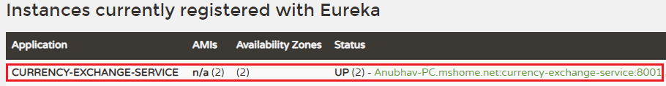
We see that the two instances of currency-exchange-service are registered with the Eureka naming server. The two instances are running on port 8001 and 8000.
In the following image, we can see that both the microservices has registered with the Eureka naming server.
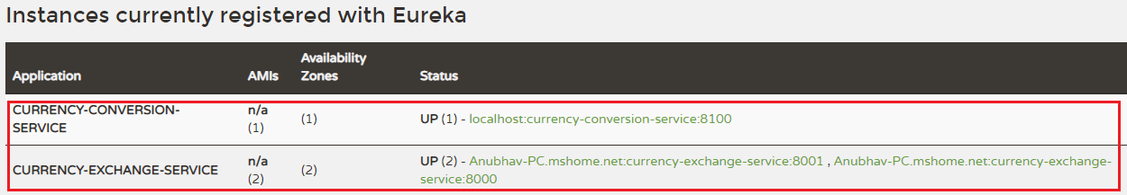

Distributing calls using Eureka and Ribbon

In the previous section, we have registered currency-exchange-service and currency-conversion-service with the Eureka naming server.
When CurrencyCalculationService (currency-conversion-service) invokes CurrencyExchangeService, the Eureka naming server finds the details of the currency-exchange-service.
Instead of hardcoding the URLs for Ribbon, the Ribbon talks to the Eureka naming server and retrieve the details of all the instances of microservices.

Step 1: Open the file application.properties.
In this file, we have configured the Eureka naming server and disable the list of servers that we have configured earlier. In the currency-conversion-service, we have already configured the URL for Eureka. Now, we have configured the Eureka naming server in both the services.
Now the CurrencyExchangeService, starts talking to the Eureka naming server.
application.properties
- spring.application.name=currency-conversion-service
- server.port=8100
- eureka.client.service-url.default-zone=http://localhost:8761/eureka
- #currency-exchange-service.ribbon.listOfServers=http://localhost:8000, http://localhost:8001

Here one thing is to notice that in the application.properties file, we don’t have any source of currency-exchange-service. We did not hardcode the URLs of currency-exchange-service in the currency-conversion-service.
Step 2: Kill all the running applications.
Step 3: First, run the NetflixEurekaNamingServerApplication.java.
Step 4: Open the browser and refresh the Eureka server.
Step 5: Run an instance of CurrencyExchangeServiceApplication.java on port 8000.
Step 6: Run the CurrencyConversionServiceApplication.java.
Step 7: Clear the console and let it be warm-up.
Step 8: Open the browser and type the URL http://localhost:8100/currency-converter-feign/from/EUR/to/INR/quantity/1000.
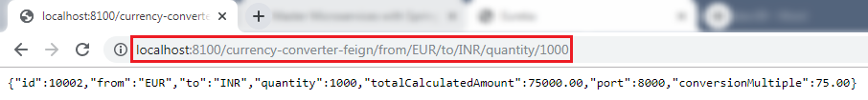
When we refresh the Eureka server, it always returns the port 8000 in the response.
Step 9: Run another instance of CurrencyExchangeServiceApplication.java on port 8001.
Step 10: Again, refresh the Eureka server. We see that there are two instances of currency-exchange-service that are running on port 8000 and 8001.
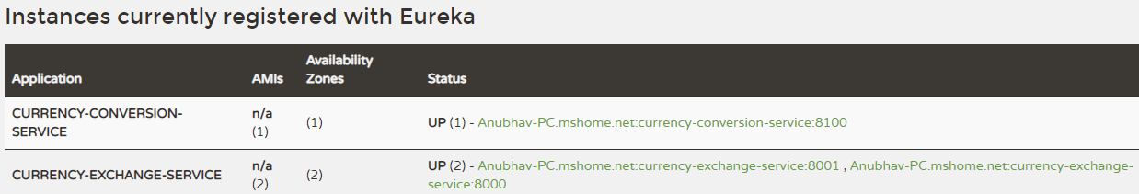
Step 11: Refresh the URL http://localhost:8100/currency-converter-feign/from/EUR/to/INR/quantity/1000.
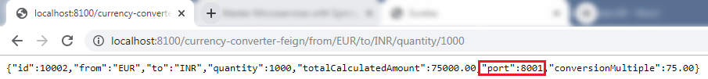
When we refresh the Eureka server, it changes the port again and again.
Step 12: Kill the CurrencyExchangeServiceApplication8000.
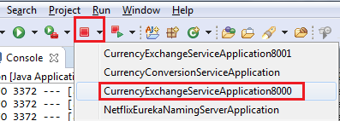
Step 13: Again, refresh the URL http://localhost:8100/currency-converter-feign/from/EUR/to/INR/quantity/1000. It returns the port 8001 in the response.
Hence, service will never go down even if an instance of the same service is down or interrupted by other reasons.

Introduction to API Gateways

What is an API Gateway?
An API stands for Application Program Interface. It is a set of instructions, protocols, and tools for building software applications. It specifies how software components should interact.
The API Gateway is a server. It is a single entry point into a system. API Gateway encapsulates the internal system architecture. It provides an API that is tailored to each client. It also has other responsibilities such as authentication, monitoring, load balancing, caching, request shaping and management, and static response handling.
API Gateway is also responsible for request routing, composition, and protocol translation. All the requests made by the client go through the API Gateway. After that, the API Gateway routes requests to the appropriate microservice.

The API Gateway handles the request in one of the two ways:
- It routed or proxied the requests to the appropriate service.
- Fanning out (spread) a request to multiple services.
The API Gateway can provide each client with a custom API. It also translates between two protocols, such as HTTP, WebSockets, and Web-Unfriendly protocols that are used internally.

Example
The popular example of API Gateway is Netflix API Gateway. The Netflix streaming services are available on hundreds of different kinds of devices such as televisions, set-top boxes, smartphones, tablets, etc. It attempts to provide a one-size-fits-all API for its streaming service.
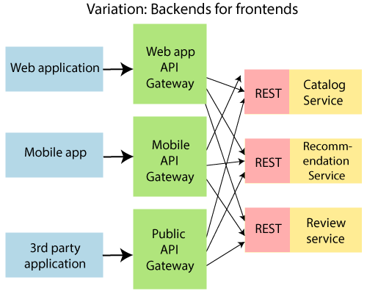
An API Gateway includes:
- Security
- Caching
- API composition and processing
- Managing access quotas
- API health monitoring
- Versioning
- Routing
Advantages of API Gateway
- The most important advantage of API Gateway is that it encapsulates the internal structure of the application.
- Rather than invoking the specific service, the client directly talks to the API Gateway.
- It reduces the number of round trips between client and application.
- It simplifies the client code.
- It reduces coding efforts, makes the application more efficient, decreases errors all at the same time.
- It provides each kind of client with a specific API.
Disadvantages
- It requires routing rules.
- There is a possibility of a single point of failure.
- Risk of complexity due to all the API rules are in one place.
Working of API Gateway
In microservices, we route all the requests through an API. We can implement common features like authentication, routing, rate limiting, auditing, and logging in the API Gateway.
Consider a scenario in which we do not want to call a microservice more than five times by a particular client. We can do it as a part of the limit in the API Gateway. We can implement the common features across microservices in the API gateway. The Zuul API Gateway is a popular API Gateway implementation.
We must implement the following features in all the microservices:
- Service Aggregation
- Authentication, authorization and Security
- Rate Limits
- Fault Tolerance
Suppose there is an external consumer who wants to call fifteen different services as part of one process. It is better to aggregate those fifteen services and provide one service call for the external consumer. These are the kinds of features that are common across all the microservices. These features are implemented at the level of API.
Instead of allowing microservices to call each other directly, we would do all the calls through API Gateway. API Gateway will take care of common features like authentication, fault tolerance, etc. It also provides aggregation services around all microservices because all calls get routed through the API Gateway.

Zuul API Gateway
What is Zuul?
Zuul Server is an API Gateway application. It handles all the requests and performs the dynamic routing of microservice applications. It works as a front door for all the requests. It is also known as Edge Server.
Zuul is built to enable dynamic routing, monitoring, resiliency, and security. It can also route the requests to multiple Amazon Auto Scaling Groups.
For Example, /api/products are mapped to the product service and /api/user is mapped to the user service. The Zuul Server dynamically routes the requests to the respective backend application.
Why we use Zuul?
The volume and variety of Netflix API traffic sometimes result in production issues that arises quickly and without warning. So we need a system that allows us to rapidly change behavior in order to react to these situations.
Zuul provides a range of different types of filters that allows us to quickly and nimbly apply functionality to our edge service. The filters perform the following functions:
- Authentication and Security: It provides authentication requirements for each resource.
- Insights and Monitoring: It tracks meaningful data and statistics that give us an accurate view of production.
- Dynamic Routing: It dynamically routes the requests to different backed clusters as needed.
- Stress Testing: It increases the traffic to a cluster in order to test performance.
- Load Shedding: It allocates capacity for each type of request and drops a request that goes over the limit.
- Static Response Handling: It builds some responses directly at the edge instead of forwarding them to an internal cluster.
- Multi-region Resiliency: It routes requests across AWS regions in order to diversify our ELB usage

Zuul Components
Zuul 2.x components:
- zuul-core: It is a library that contains the core functionality of Zuul 2.0.
- zuul-sample: It is a sample driver application for Zuul 2.0
Zuul 1.x components:
- zuul-core: It defines the core functionality.
- zuul-simple-webapp: A web app that shows a simple example of how to build an application with zuul-core.
- zuul-netflix: It is a library that adds other NetflixOSS components to Zuul.
- zuul-netflix-webapp: It is a webapp that packages zuul-core and zuul-netflix together.

Implementing Zuul Logging Filter

In this section, we will implement the logging functionality in the Zuul API Gateway.
Let's implement the logging in the Zuul API Gateway.

Step 1: In the netflix-zuul-api-gateway-server project, create a new class file with the name ZuulLoggingFilter.
Step 2: Add an annotation @Componenet.
Step 3: Extend the ZuulFilter class. There are some abstract methods in the ZuulFilter class. These abstract methods must be implemented in the ZuulLoggingFilter class.
Step 4: Move your cursor over the ZuulLoggingFilter class. It suggests two quick fixes, as shown in the following image. Click on the Add unimplemented methods. We get the default implementation of all the abstract methods of the ZuulFilter class.
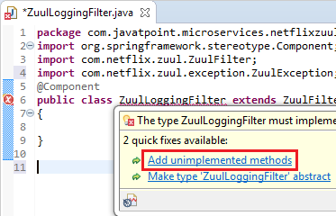

ZuulFilter class has four abstract methods that are listed below:
- shouldFilter(): The shouldFilter() method checks the request and decides whether filter to be executed or not.
- run(): The run() method invokes, if both !isFilterDisabled() and shouldFilter() methods returns true.
- filterType(): The filterType() method classify a filter by type. There are four types of standard filters in Zuul: pre for pre-routing filtering, route for routing to an origin, post for post-routing filters, and error for error handling. Zuul also supports a static type for static responses. Any filter type can be created or added and run by calling the method runFilters(type).
- filterOrder(): The filter order must be defined for a filter. Filters may have the same filter order if the precedence is not important for the filters. The filter order does not need to be sequential.

Step 5: Create the Logger class object and invoke getLogger() method to create a logger.
- private Logger logger=LoggerFactory.getLogger(this.getClass());
Remember: Import Logger class of org.slf4j package.
Step 6: Implement the logic in the run() method.
- public Object run() throws ZuulException
- {
- //getting the current HTTP request that is to be handle
- HttpServletRequest request=RequestContext.getCurrentContext().getRequest();
- //printing the detail of the request
- logger.info("request -> {} request uri-> {}", request, request.getRequestURI());
- return null;
- }

ZuulLoggingFilter.java
package com.in28minutes.microservices.netflixzuulapigatewayserver;

import javax.servlet.http.HttpServletRequest;

import org.slf4j.Logger;
import org.slf4j.LoggerFactory;
import org.springframework.stereotype.Component;

import com.netflix.zuul.ZuulFilter;
import com.netflix.zuul.context.RequestContext;
import com.netflix.zuul.exception.ZuulException;

@Component
public class ZuulLoggingFilter extends ZuulFilter{

private Logger logger= LoggerFactory.getLogger(this.getClass());

@Override
public boolean shouldFilter() {
return true;
}

@Override
public Object run() throws ZuulException {
HttpServletRequest request= RequestContext.getCurrentContext().getRequest();
logger.info("request ->{} request uri", request, request.getRequestURI().toString());
return null;
}

@Override
public String filterType() {
return "pre";
}

@Override
public int filterOrder() {
return 1;
}

}

Executing a Request through Zuul API Gateway

Step 1: Run the netflix-eureka-naming-server.
Step 2: Run the currency-exchange-service on port 8000.
Step 3: Run the currency-conversion-service on port 8100.
Step 4: Run the netflix-zuul-api-gateway-server.
Step 5: Open the browser and invoke the URL http://localhost:8761. It shows all the services that are registered with the Eureka naming server.
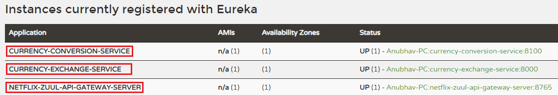
Step 6: Invoke the URL http://localhost:8000/currency-exchange/from/EUR/to/INR. We get the response, but the request does not go through the Zuul API Gateway.
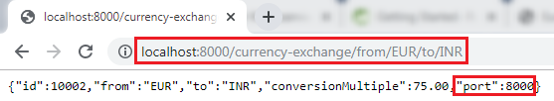
Let's invoke the request through the Zuul API Gateway. We use the following URL: http://localhost:8765/{application-name}/{uri}. The port 8765 is the default port for the Zuul API Gateway server.
In our case, the application name is currency-exchange-service, and the URI is /currency-exchange/from/EUR/to/INR. So the complete URL will look like the following:
http://localhost:8765/currency-exchange-service/currency-exchange/from/EUR/to/INR
Step 7: Copy the above URL and paste it in the browser. We get the same response as above, but at this time, the request is going through the Zuul API Gateway.
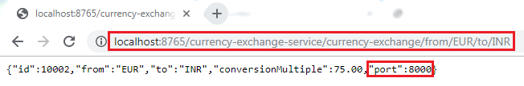
We can also see the content of the request that is printed on the Zuul API Gateway server. The request prints the request URI.
We have sent the request through the Zuul API Gateway, instead of directly calling the microservices.

Setting up Zuul API Gateway between microservices invocations

In the previous step, we have used a direct URL to execute the currency-exchange-service through the Zuul API Gateway proxy. When we use the URL http://localhost:8765/currency-exchange-service/currency-exchange/from/EUR/to/INR, it uses port 8765 that is proxy for API Gateway.
In this section, we will call the currency-calculation-service (currency-conversion-service) that calls the currency-exchange-service. So far, we were calling the service directly. Now, we will call it through the Zuul API Gateway instead of directly calling the currency-exchange-service.
Step 1: Select the project currency-conversion-service.
Step 2: Open the CurrencyExchangeServiceProxy.java file.
Step 3: Enable the Feign by using the annotation @FeignClient with the attribute name="netflix-zuul-api-gateway-server".
- @FeignClient(name="netflix-zuul-api-gateway-server")
Remember: Remove or comment all other annotations @FeignClient in CurrencyExchangeServiceProxy.java file.
Step 4: Define the mapping for the Zuul API Gateway server.
- @GetMapping("/currency-exchange-service/currency-exchange/from/{from}/to/{to}")
Remember: Remove or comment the mapping for currency-exchange-service.
Step 5: Run the netflix-eureka-naming-server, currency-exchange-service, currency-conversion-service, and netflix-zuul-api-gateway-server in the same order in which we have written.
Remember: Ensure that all four services are running properly.
Step 6: Open the browser and invoke the URL http://localhost:8100/currency-converter-feign/from/USD/to/INR/quantity/1000. It returns the following response:
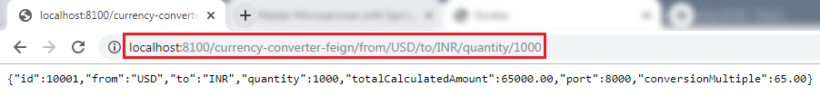
Let's see the log for NetflixZullApiGatewayServerApplication.
Step 7: Click on the arrow that is beside the console icon and select the NetflixZullApiGatewayServerApplication.
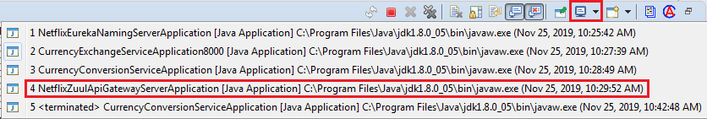
It shows a couple of logs, as shown in the following image.
Step 8: Refresh the URL again. It shows a single log on the console.
Whenever we call the CurrencyClaculationService (currency-converter-service) through Feign, it routed through the API Gateway server. The Gateway executes a filter called ZuulLoggingFilter that invokes the currency-exchange-service.
Now let's intercept the calls between currency converter-service and currency-exchange-service. It means the API Gateway executes two times when we invoke the URL.
- The first time, API Gateway executes when we call the currency-conversion-service. It means before the execution of the currency-conversion-service. The currency-conversion-service routed through the API Gateway.
- The second time, API Gateway executes when the currency-conversion-service calls the currency-exchange-service. It means after the execution of currency-conversion-service and before the execution of currency-exchange-service. The currency-exchange-service also routed through the API Gateway.
Let's implement the interception in our project.
Send the request http://localhost:8765 through the API Gateway. The URI will be /{application-name}/{uri}. The complete URL will look like the following:
http://localhost:8765/currency-conversion-service/currency-converter-feign/from/USD/to/INR/quantity/1000
Invoke the above URL. It returns the same response as the URL http://localhost:8100/currency-converter-feign/from/USD/to/INR/quantity/1000 returns.
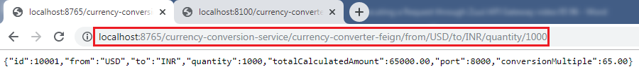
We can see in the log that the logging filter executes two times. The first time it calls the currency-converter-service and the second time when the currency-converter-service calls the currency-exchange-service.

Introduction to Distributed Tracing
Distributed Tracing
Distributed tracing is a technique to monitor and profile the applications, especially those built using microservice architecture. It is also known as distributed request tracing. Developers use distributed tracing to debug and optimize the code.
Distribute tracing provides a place where we can see that "what is happening with a specific request?" It is important because there are a variety of components that are involved in the microservices.
If we want to solve a problem or debug a problem, we need a centralized server. So the term distributed tracing comes into existence.
In this section, we will use Spring Cloud Sleuth with Zipkin. Spring Cloud Sleuth assigns a unique Id to each request that we have made. We can trace all the requests based on unique Ids across all the components.

Spring Cloud Sleuth
Spring Cloud Sleuth is a Spring Cloud library that provides the ability to track the progress of subsequent microservices by adding trace and span Ids on the appropriate HTTP request headers. The Sleuth library is based on the MDC (Mapped Diagnostic Context) concept, where we can easily extract values, put to context, and display them in the log.

Zipkin
Zipkin is an open-source, Java-based distributed tracing system. It has a management console that provides a mechanism for sending, receiving, storing, and visualizing traces details of the subsequent services.
With the help of the Zipkin server, we can put all the logs of all the components in the MQ (RabbitMQ). We send the logs to the Zipkin server where the logs consolidate. After doing this, we can monitor different requests. We can also find what is happening to a specific request?
Implementing distributed tracing Using Spring Cloud Sleuth
In this step, we will add Spring Cloud Sleuth for all the microservices. It adds a unique Id to all the requests. It is used to generate and attach the trace Id, span Id to the logs so that tools (Zipkin) can use these ids.
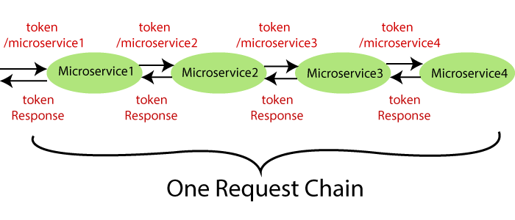
The Spring Cloud Sleuth token has the following components:
- Application name: The name of the application that is defined in the properties file.
- Trace Id: The Sleuth adds the Trace Id. It remains the same in all services for a given request.
- Span Id: The Sleuth also adds the Span Id. It remains the same in a unit of work but different for different services for a given request.
- Zipkin Export Flag: It indicates a boolean value. It can be either true or
The following figure shows the Spring Cloud Sleuth token.
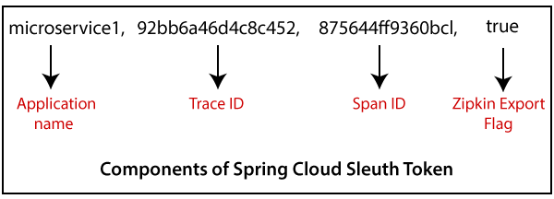

Let's implement the Spring Cloud Sleuth in our projects.
Step 1: Select the project netflix-zuul-api-gateway-server.
Step 2: Open pom.xml and add the Sleuth dependency.
- <dependency>
- <groupId>org.springframework.cloud</groupId>
- <artifactId>spring-cloud-starter-sleuth</artifactId>
- </dependency>
Now we need to trace all the requests. If we want to trace all the requests, we would need to create ALWAYS_SAMPLE. We can create a Sampler by using a Bean.

Sampler
Distributed tracing may have a very high volume of data, so the sampling is important in distributed tracing. Spring Cloud Sleuth provides a Sampler strategy. With the help of Sampler, we can implement the sampling algorithm that provides control of the algorithm. By default, we get a procedure that continuously performs the tracing if a span (correlation: is an individual operation) is already active.
But the newly created spans are always marked as non-exportable. If all the applications are running with the Sampler, we can see trace (end-to-end latency graph that is composed of spans) in the log, not in any remote location. By default, Spring Cloud Sleuth sets all spans to non-exportable.
When we export span data to the Zipkin or Spring Cloud Stream, Spring Cloud Sleuth provides AlwaysSampler class that exports everything to the Zipkin. It also provides a PercentageBasedSampler class that samples a fixed fraction of span.
Remember: If you are using Spring 2.0.0 or above versions, use the following Sampler. We have used the same because we are using Spring version 2.2.1.

- @Bean
- public Sampler defaultSampler()
- {
- return Sampler.ALWAYS_SAMPLE;
- }

Step 3: Open NetflixZuulApiGatewayServerApplication.java file and define a Bean.
NetflixZuulApiGatewayServerApplication.java
package com.in28minutes.microservices.netflixzuulapigatewayserver;

import org.springframework.boot.SpringApplication;
import org.springframework.boot.autoconfigure.SpringBootApplication;
import org.springframework.cloud.client.discovery.EnableDiscoveryClient;
import org.springframework.cloud.netflix.zuul.EnableZuulProxy;
import org.springframework.context.annotation.Bean;

import brave.sampler.Sampler;

@SpringBootApplication
@EnableZuulProxy
@EnableDiscoveryClient
public class NetflixZuulApiGatewayServerApplication {

public static void main(String[] args) {
SpringApplication.run(NetflixZuulApiGatewayServerApplication.class, args);
}

@Bean
public Sampler defaultSampler() {
return Sampler.ALWAYS_SAMPLE;
}

}

In the above code, we have added Spring Cloud Sleuth to the Zuul API Gateway server.
Now we have to define Bean in currency-exchange-service and currency-conversion-service also.

Step 4: Open pom.xml of currency-exchange-service and add the Sleuth dependency.
- <dependency>
- <groupId>org.springframework.cloud</groupId>
- <artifactId>spring-cloud-starter-sleuth</artifactId>
- </dependency>

Step 5: Open CurrencyExchangeServiceApplication.java file and define a Bean.

CurrencyExchangeServiceApplication.java
package com.in28minutes.microservices.currencyexchangeservice;

import org.springframework.boot.SpringApplication;
import org.springframework.boot.autoconfigure.SpringBootApplication;
import org.springframework.boot.autoconfigure.domain.EntityScan;
import org.springframework.cloud.client.discovery.EnableDiscoveryClient;
import org.springframework.context.annotation.Bean;
import org.springframework.data.jpa.repository.config.EnableJpaRepositories;

import brave.sampler.Sampler;

@SpringBootApplication(scanBasePackages = {"bean","controller","repository"})
@EntityScan(basePackages = {"bean","controller","repository"})
@EnableJpaRepositories({"repository"})
@EnableDiscoveryClient
public class CurrencyExchangeServiceApplication {

public static void main(String[] args) {
SpringApplication.run(CurrencyExchangeServiceApplication.class, args);
}

@Bean
public Sampler defaultSampler() {
return Sampler.ALWAYS_SAMPLE;
}

}

Step 6: Similarly, Open the pom.xml of currency-conversion-service and add the Sleuth dependency.

- <dependency>
- <groupId>org.springframework.cloud</groupId>
- <artifactId>spring-cloud-starter-sleuth</artifactId>
- </dependency>

Step 7: Open CurrencyConversionServiceApplication.java file and define a Bean.

CurrencyConversionServiceApplication.java
package com.in28minutes.microservices.currencyconversionservice;

import org.springframework.boot.SpringApplication;
import org.springframework.boot.autoconfigure.SpringBootApplication;
import org.springframework.cloud.client.discovery.EnableDiscoveryClient;
import org.springframework.cloud.openfeign.EnableFeignClients;
import org.springframework.context.annotation.Bean;

import brave.sampler.Sampler;

@SpringBootApplication(scanBasePackages = {"bean","controller","service"})
@EnableFeignClients("service")
@EnableDiscoveryClient
public class CurrencyConversionServiceApplication {

public static void main(String[] args) {
SpringApplication.run(CurrencyConversionServiceApplication.class, args);
}

@Bean
public Sampler defaultSampler() {
return Sampler.ALWAYS_SAMPLE;
}

}

Now we have three applications that are connect to Spring Cloud Sleuth.
Step 8: Launch the applications in the following order:
netflix-eureka-naming-server
- Open the browser and invoke the URL http://localhost:8761. It returns the Eureka interface, as shown below.
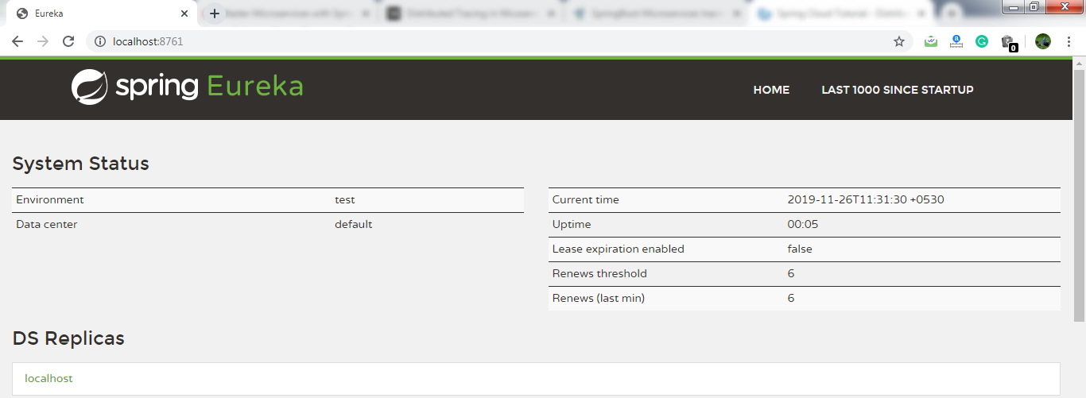
currency-exchange-service (on port 8000)
currency-conversion-service
netflix-zuul-api-gateway-server
Remember: After launching each service, refresh the Eureka server.
It shows all the instances currently registered with the Eureka server.
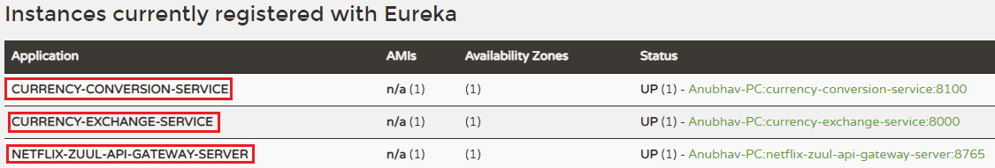
Step 9: Open CurrencyExchangeController.java file and add a logger into it.

CurrencyExchangeController.java
package controller;

import java.math.BigDecimal;

import org.slf4j.Logger;
import org.slf4j.LoggerFactory;
import org.springframework.beans.factory.annotation.Autowired;
import org.springframework.core.env.Environment;
import org.springframework.web.bind.annotation.GetMapping;
import org.springframework.web.bind.annotation.PathVariable;
import org.springframework.web.bind.annotation.RestController;

import bean.ExchangeValue;
import repository.ExchangeValueRepository;

@RestController
public class CurrencyExchangeController {

private Logger logger=LoggerFactory.getLogger(this.getClass());

@Autowired
private Environment environment;

@Autowired
private ExchangeValueRepository repository;

@GetMapping("/currency-exchange/from/{from}/to/{to}")
public ExchangeValue retrieveExchangeValue(@PathVariable String from, @PathVariable String to) {
ExchangeValue exchangeValue= repository.findByFromAndTo(from, to);
exchangeValue.setPort(Integer.parseInt(environment.getProperty("local.server.port")));
logger.info("{} " +exchangeValue);
return exchangeValue;
}

}

Similarly, we will add logger into CurrencyConversionContoller.
Step 10: Open CurrencyConversionContoller.java file and add a logger into it.

CurrencyConversionContoller.java
package controller;

import java.math.BigDecimal;
import java.util.HashMap;
import java.util.Map;

import org.slf4j.Logger;
import org.slf4j.LoggerFactory;
import org.springframework.beans.factory.annotation.Autowired;
import org.springframework.http.ResponseEntity;
import org.springframework.web.bind.annotation.GetMapping;
import org.springframework.web.bind.annotation.PathVariable;
import org.springframework.web.bind.annotation.RestController;
import org.springframework.web.client.RestTemplate;

import bean.CurrencyConversionBean;
import service.CurrencyExchangeServiceProxy;

@RestController
public class CurrencyConversionController {

private Logger logger=LoggerFactory.getLogger(this.getClass());

@Autowired
private CurrencyExchangeServiceProxy proxy;

@GetMapping("/currency-converter/from/{from}/to/{to}/quantity/{quantity}")
public CurrencyConversionBean convertCurrency(@PathVariable String from,
@PathVariable String to, @PathVariable BigDecimal quantity ) {

Map<String, String>uriVariables=new HashMap<>();
uriVariables.put("from", from);
uriVariables.put("to", to);

ResponseEntity<CurrencyConversionBean> responseEntity = new RestTemplate().getForEntity("http://localhost:8000/currency-exchange/from/{from}/to/{to}",
CurrencyConversionBean.class,uriVariables);

CurrencyConversionBean currencyConversionBean=responseEntity.getBody();
return new CurrencyConversionBean(currencyConversionBean.getId(),from,to,currencyConversionBean.getConversionMultiple(),
quantity,quantity.multiply(currencyConversionBean.getConversionMultiple()),currencyConversionBean.getPort());
}

@GetMapping("/currency-converter-feign/from/{from}/to/{to}/quantity/{quantity}")
public CurrencyConversionBean convertCurrencyFeign(@PathVariable String from,
@PathVariable String to, @PathVariable BigDecimal quantity ) {

CurrencyConversionBean currencyConversionBean=proxy.retrieveExchangeValue(from, to);

logger.info("{} " +currencyConversionBean);

return new CurrencyConversionBean(currencyConversionBean.getId(),from,to,currencyConversionBean.getConversionMultiple(),
quantity,quantity.multiply(currencyConversionBean.getConversionMultiple()),currencyConversionBean.getPort());
}
}

Step 12: Execute the request http://localhost:8100/currency-converter-feign/from/EUR/to/INR/quantity/100. It returns the following response, as shown below.
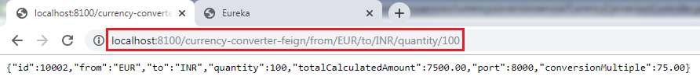
Let's see the log of currency-conversion-service in the console. The currency-conversion-service shows the following log:
We can also see the log of currency-exchange-service. The currency-exchange-service shows the following log:
Similarly, we can see the log for netflix-zuul-api-gateway-server.
Let's have a close look at the above three logs for different services. We find that all three services have the same trace Id (533f8d3966d8f4e7).
Spring Cloud Sleuth assigns a trace Id to the request. We can use this Id to trace the requests across multiple components. But there is a problem that this log is distributed in multiple places. We use Zipkin to remove this problem. With the help of Zipkin, we can centralize the logs in one place.

Distributed Tracing with Zipkin

We have installed Spring Cloud Sleuth dependency in currency-conversion-service, currency-exchange-service, and netflix-zuul-api-gateway-server. We have seen that a unique Id was being assigned to each request. We use these Id to trace the request across the logs of these multiple services.
However, we face a challenge in tracing. If we want to trace a request, we have to check the log of the individual application. The solution to this problem is called centralized logs.
We need to centralize all the logs from all the microservices. We can search through Id assigned by Spring Cloud Sleuth. At the centralized place, we will able to search and find out what is happening to a specific request.
There are the following solutions for centralize logging:
- ELK Stack (Elastic Search)
- Kibana
- Zipkin

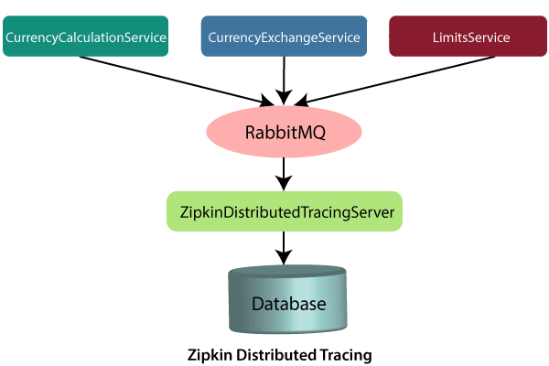

In this distributed tracing, we will use Zipkin distribute tracing server. It gives us a consolidated view of all the microservices. We get all the logs messages form the individual microservices. The Zipkin server collects the log messages. All the microservices puts the log messages on the queue called RabbitMQ, and the Zipkin picks these log messages from the RabbitMQ. The Zipkin tracing server is connected with the database.
In our case, we use the in-memory database. We will pull log messages from the database. In the next step, we will install RabbitMQ.

Installing RabbitMQ Server
RabbitMQ
RabbitMQ is widely deployed open-source message broker software that implements Advanced Message Queuing Protocol (AQMP). It is lightweight and easy to deploy in the cloud. It supports multiple messaging protocols. It can be deployed in a distributed environment to meet high-scale and high-availability requirements. It is modeled on the AMQP standard. The RabbitMQ is written in the Erlang programming language. It is developed on the Open Telecom Platform (OTP) framework for clustering and failover.
RabbitMQ runs on different operating systems and cloud environments. It provides a large number of platforms like Java, .NET, Python, etc.

Advantagesof RabbitMQ
- Fast performance
- Polyglot (using several languages)
- Easy Management
- No Erlang knowledge needed
- Great documentation
AMQPdefines:
- Where to send messages (Routing)
- How to get there (Delivery)
- What goes in must come out (Fidelity)

Message broker
A message broker sits between the machine and the distributed computing system. Instead of passing the messages directly to the receiver, the messages are first sent to the message broker (RabbitMQ). The message broker orders the messages in an optimized queue and passes them to the receiving machine when the machines are ready to process the messages.
A message might be a command to process an order, run a specified task, a pull request made to a database.
The machine that sends the message is called the producer. The machine that receives the message is called the consumer. The bit in the middle is called thebroker.

Message broker does the following:
- Decouple the message publisher and consumer
- Store the message
- Routing the message
- Monitoring and management of message
- Transform message format between producer and consumer

Erlang
Erlang is a compiled, fault-tolerant, concurrent, dynamically typed programming language. It is used to build a massively scalable, real-time system with requirements on high availability. It is used in banking, e-commerce, telecom, computer telephony, and instant messaging.
OTP
OTP stands for Open Telecom Platform. It is a collection of Erlang libraries and design principles. It provides middleware to develop these systems. It includes its own tools such as distributed database, applications to interface towards other languages, debugging and release handling tools.

How to install RabbitMQ on Windows

Remember: Before installing RabbitMQ, we need to install Erlang.
Step 1: Download and install Erlang from https://erlang.org/download/otp_win64_22.1.exe.
Step 2: Download and install RabbitMQ from https://github.com/rabbitmq/rabbitmq-server/releases/download/v3.8.1/rabbitmq-server-3.8.1.exe.
Step 3: Open the command prompt and run the following commands one by one:
- c:\>cd\
- c:\>cd Program Files
- c:\Program Files>cd RabbitMQ Server
- c:\Program Files\RabbitMQ Server>dir
- c:\Program Files\RabbitMQ Server>cd rabbitmq_server-3.8.1
- c:\Program Files\RabbitMQ Server\rabbitmq_server-3.8.1>dir
- c:\Program Files\RabbitMQ Server\rabbitmq_server-3.8.1>cd sbin
- c:\Program Files\RabbitMQ Server\rabbitmq_server-3.8.1\sbin>dir
- c:\Program Files\RabbitMQ Server\rabbitmq_server-3.8.1\sbin>rabbitmq-plugins enable rabbitmq_management
Step 4: Press the Windows key and type services or press Windows key+R and type services.msc.
Step 5: Select the RabbitMQ service->right-click -> Restart.
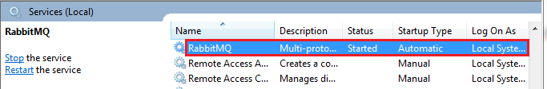
Step 6: Open the browser and type http://localhost:15672. By default, the management plug-in runs on port 15672.
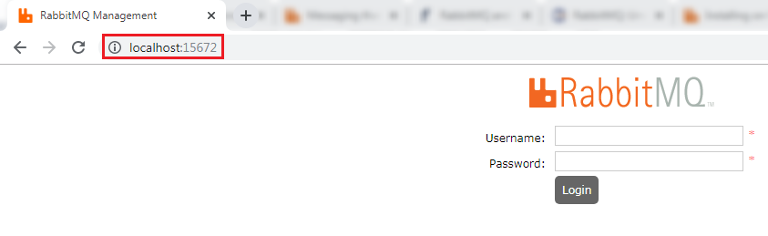
Step 7: Provide the Username and Password and click on Login button. The default username and password is guest.
The following page shows the RabbitMQ user interface.
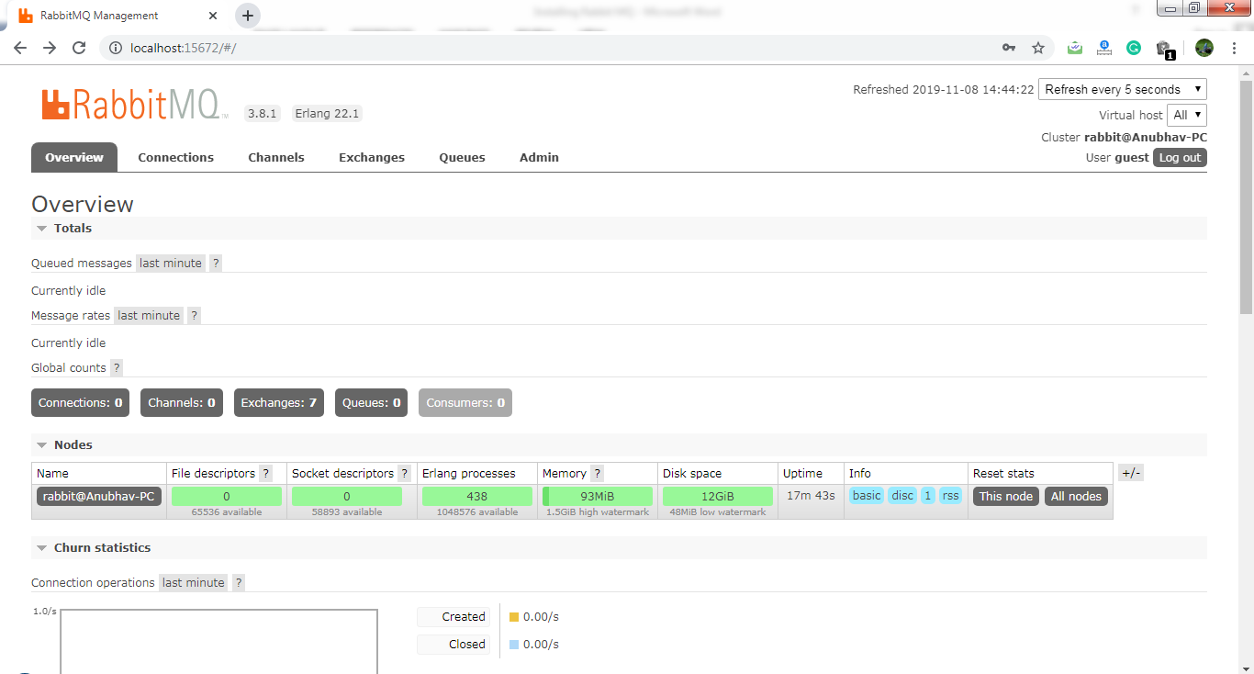

Distributed tracing using Zipkin

What is distributed tracing?
Distributed tracing is a technique used to profile and monitor applications, especially those built using the microservice architecture. Distributed tracing, also called distributed request tracing. IT and DevOps teams can use distributed tracing to monitor applications.
It identifies the failed microservices or the services having performance issues when there are many services call within a request. It is very useful when we need to track the request passing through the multiple microservices. It is also used for measuring the performance of the microservices.



In the above figure, the ZipkinDistributedTracingServer connected to the in-memory database. All the microservices will put the messages in the RabbitMQ server. ZipkinDistributedTracingServer consumes the messages from the RabbitMQ server.
In this section, we will focus on installing ZipkinDistributedTracingServer and will connect it with both the RabbitMQ server and the in-memory database.
Let’s see how to connect the Zipkin server to other servers.
Step 1: Download the Zipkin server.
Search Zipkin quickstart on Google. Click on the link Quickstart OpenZipkin. We get the two options to quick start Zipkin, one is Docker, and the other is Java. But we will use the Java approach.
Step 2: Download the zipkin-server-2.12.9-exec.jar file from https://search.maven.org/remote_content?g=io.zipkin&a=zipkinserver&v=LATEST&c=exec.
Step 3: Copy the JAR file and paste it into any folder or drive. We have pasted the JAR file in the C drive directly.
Step 4: Open the Command Prompt and run the following commands:
- C:\> java -jar zipkin-server-2.12.9-exec.jar
The command launches the Zipkin server.
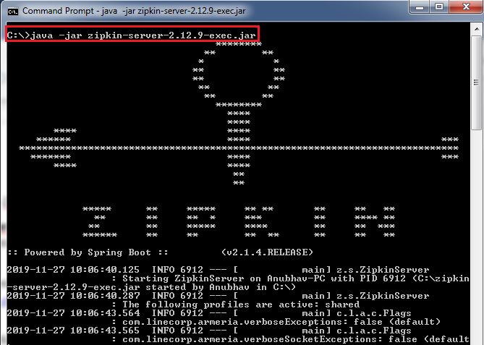
Let’s check the Zipkin server is running or not.
Step 5: Open the browser and type http://localhost:9411/zipkin/. It shows the dashboard of the Zipkin server. Here, the port 9411 is the default port of the Zipkin server.
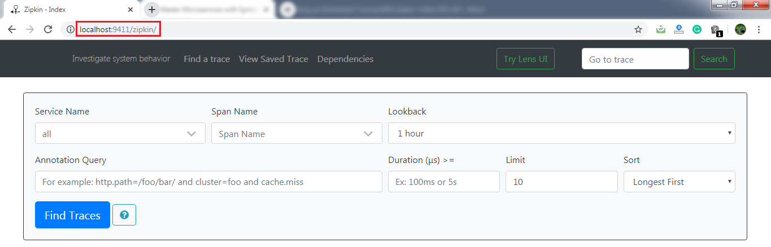
Here, the most important thing is that the Zipkin server must listen over the RabbitMQ server. So we have to start the RabbitMQ server in the background.
Step 6: Kill the Zipkin server by pressing the keys Ctrl+c.
Step 7: Run the following commands in the Command Prompt:
- C:\>SET RABBIT_URI=amqp://localhost
- C:\> java -jar zipkin-server-2.12.9-exec.jar
The commands again start the Zipkin server along with the RabbitMQ server.
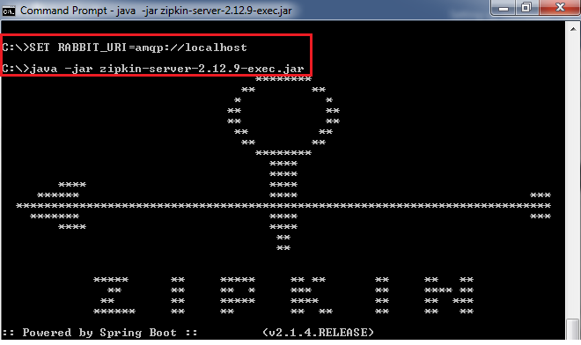
In this section, we have installed the Zipkin server. We have also started the RabbitMQ server and connect it to the Zipkin server. Now the Zipkin server is listening over the RabbitMQ server. But the microservices are not putting the trace messages in the RabbitMQ.

Connecting Microservices to Zipkin
we will connect microservices to put their trace messages on the RabbitMQ. Once we place the messages on the RabbitMQ, it will be picked up by the Zipkin server.
Let’s connect the currency-conversion-service, currency-exchange-service, and the netflix-zuul-api-gateway-server to the RabbitMQ server.
Step 1: Open the pom.xml file of currency-conversion-service, currency-exchange-service, and the netflix-zuul-api-gateway-server and add the following dependencies:
We want to create a message in the format that it excepts. We need to add Zipkin dependency.
<dependency>
<groupId>org.springframework.cloud</groupId>
<artifactId>spring-cloud-starter-zipkin</artifactId>
</dependency>
We will send the message to Zipkin that uses amqp message protocol. So we need to add the amqp dependency. Adding the dependency of amqp, we get the connection of RabbitMQ into currency-conversion-service, currency-exchange-service, and the netflix-zuul-api-gateway-server.
<dependency>
<groupId>org.springframework.amqp</groupId>
<artifactId>spring-rabbit</artifactId>
</dependency>

Now, we will try to run all the services together.
Using Zipkin UI Dashboard to trace the request

In this step, we will fire a request. But before firing a request, make sure that the five services are running correctly. We must run these five services in the following order. Otherwise, we get errors or incorrect responses.
Step 1: Run the following services in the same order as we have listed.
- NetflixEurekaNamingServerApplication.java
- ZipkinDistributedTracingServerApplication (run from the Command Prompt)
- CurrencyExchangeServiceApplication.java (on port 8000)
- CurrencyConversionServiceApplication.java (on port 8100)
- NetflixZuulApiGatewayServerApplication.java
Remember: Make sure that all the five applications are running correctly.
Step 2: Invoke the request http://localhost:8100/currency-converter-feign/from/EUR/to/INR/quantity/100. It returns the response properly.
But we are interested to know what is happening in the background.
Step 3: Open the Zipkin UI. It shows all the three services that we have connected to Zipkin.
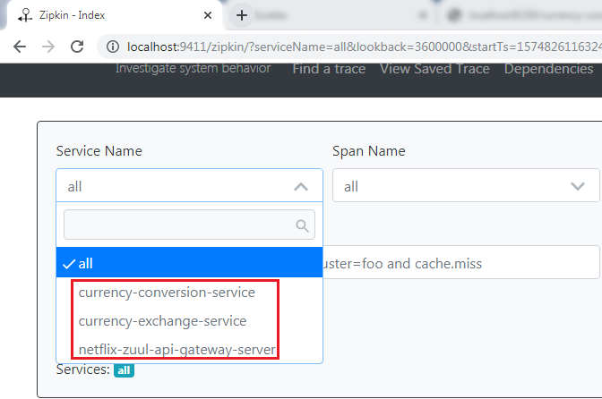
Step 4: Select any one service from the dropdown list and click on the Find Traces button. We have selected a currency-conversion-service. It shows the list of different execution of currency-conversion-service.
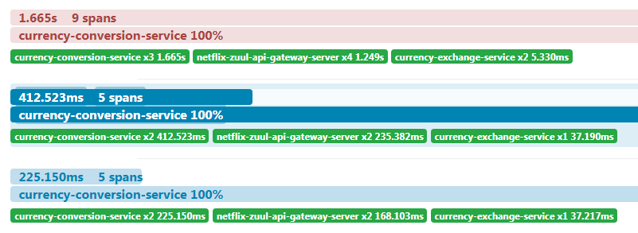
Step 5: Select any one of them. It shows the entire trace of a service.
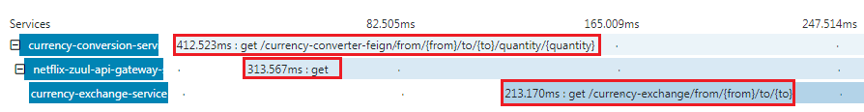
In the above figure, when we invoke the currency-converter-feign, the request first goes to the API Gateway, and the API Gateway sends the request to the currency-exchange-service.
We can also see the detail of the services. In the following image, we have shown the details of the currency-exchange-service.
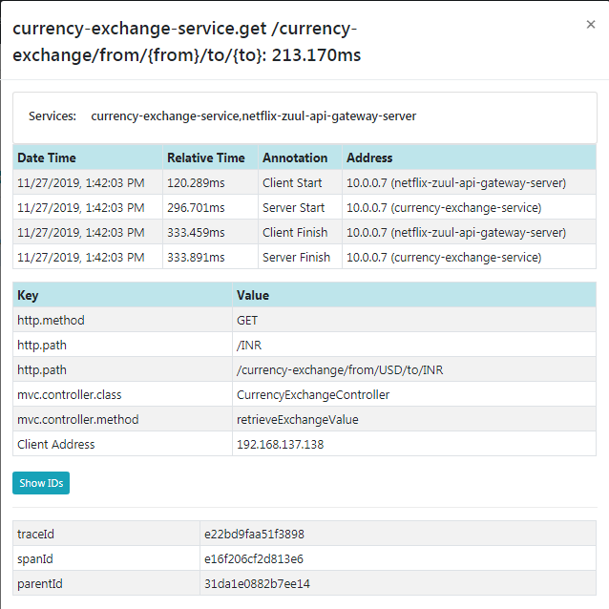
The most important challenge in microservices is to bring visibility (what is happening in the background). Hence, the Zipkin server enables the visibility of the services.

Understanding the need for Spring Cloud Bus
Step 1: Select the project spring-cloud-config-server and run the SpringCloudConfigServerApplication.java file.
Step 2: Select the project limits-service and run the LimitsServiceApplication.java file.
Step 3: Open the browser and type https://localhost/8080/limits. It returns the following response:

- {"maximum":222,"minimum":2}
We are getting these values from the limits-service-qa.properties file, because we have configured this file into the bootstrap.properties file of the limits-service.
In the next step, we will create one more instance of LimitsServiceApplication.
Step 4: Create an instance of LimitsServiceApplication.
Right click on the limits-service project -> Run As -> Run Configurations… -> Right-click on the LimitsServiceApplication -> Duplicate -> Rename the application name to LimitsServiceApplication8081 -> Click on the Arguments tab -> Provide the VM arguments: -Dserver.port=8081 -> Run.
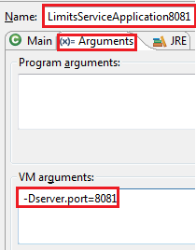
An instance of LimitsServiceApplication will run on port 8081.
Step 5: Open the browser and invoke the URL http://locahost:8081/limits. It returns the same response as the original limits-service sends.
- {"maximum":222,"minimum":2}
The two instances of limits-service up and running.
Step 6: Make the changes in the limits-service-qa.properties, we have changed the minimum value from 2 to 22.
limits-service-qa.properties
- limits-service.minimum=22
- limits-service.maximum=222
We are required to commit the changes.
Step 7: Open the Git Bash and run the following commands:
- $ cd git-localconfig-repo
- $ git add *
- $ git commit –m "qa minimum to 22"
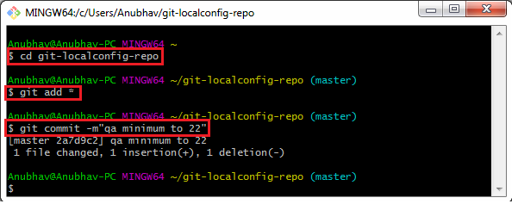
Again, invoke the URLs http://localhost:8080/limits and http://localhost:8081/limits. Both the URLs return the old values, while we have committed the values in the Git repository. It does not reflect the values in the limits-service. To make the changes in the limits-service, we will use Postman.
Note: Before moving to the next step, remove the security from the limits-service.
Step 8: Open limits-service.properties file and disable the security by using the following statement.
- management.security.enabled=false
Again, set the old values in the limits-service-qa.properties file and commit the changes.

Step 9: Open the Postman and send a POST request with the URL http://localhost:8080/application/refresh.
Note: If you are invoking the URL http://localhost:8080/limits and it does not return the new values. So to get the new values on invoking the URL http://localhost:8081/limits, you have to do the following:
Open the Postman and send a POST request with the URL http://localhost:8081/application/refresh.
Step 10: Invoke the URLs http://localhost:8080/limits and http://localhost:8081/limits. Now both the URLs return the changed value.
- {"maximum":222,"minimum":22}
We have created the two instances of the limits-service. Suppose there are a hundred instances of the limits-services that are running in parallel. We need to invoke a hundred URLs to refresh the configuration from the Git repository.
Invoking a hundred URLs is not as easy as the number of limits-service increases. Along with this, the maintenance headache for the service also grows.
Whenever we make the changes in the configurations, it must reflect changes in the microservices. Here, the Spring Cloud Bus provides the solution for this, so we do not need to call hundred URLs.
Spring Cloud Bus provides a URL for all the hundred instances. When we invoke that URL, all the instances of the microservices would be updated with the latest values from the Git configuration.
In the next step, we will implement the Spring Cloud Bus.

Implementing Spring Cloud Bus
In this section, when we make the changes in the Git repository, we have to hit multiple instances of the limits-service to refresh the configuration.
We will invoke one URL, and it will reflect all the hundred instances of the microservices. Here we will use Spring Cloud Bus. There are many options available in the Spring Cloud Bus: Apache Kafka, RabbitMQ, etc. In this section, we will use RabbitMQ.
Note: Before moving to the next step, make sure that the RabbitMQ server is running in the background.
Let’s implement the Spring Cloud Bus in limits-service and spring-cloud-config-server.
Step 1: Open the pom.xml file of limits-service and spring-cloud-config-server project. Add the amqp dependency and save the file to reflect the changes.
- <dependency>
- <groupId>org.springframework.cloud</groupId>
- <artifactId>spring-cloud-starter-bus-amqp</artifactId>
- </dependency>
Step 2: Open bootstrap.properties file and disable the management security by adding the following statement:
dependency and save the file to reflect the changes.
- management.security.enabled=false
- spring.cloud.bus.enabled=true
- management.endpoints.web.exposure.include=bus-refresh
Step 3: First, run the SpringCloudConfigServerApplication.java file and then run the two instances of limits-service: LimitsServiceApplication and LimitsServiceApplication8081.
Step 5: Invoke the URL http://localhost:8080/limits. It returns the following response:
dependency and save the file to reflect the changes.
- {"maximum":222,"minimum":22}
Now, invoke the URL http://localhost:8081/limits. It also returns the same response.
Step 6: Open the limits-service-qa.properties file and change the minimum value from 22 to 29.
Now we have to commit the changes.
Step 7: Open the Postman and send a POST request with the URL http://localhost:8080/bus/refresh.
Note: If you are using Spring Boot 2.0.0 or above versions, use the following URL:
http://localhost:8080/actuatror/bus-refresh
Step 8: Open the browser and invoke both instances (http://localhost:8080/limits and http://localhost:8081/limits) of limits-service. Both the URLs return the updated value that we have configured in the limits-service-qa.properties file.
- {"maximum":222,"minimum":29}
We have seen that the minimum value changes to 29. Here, you can notice that we have not committed the changes in the Git repository manually, but the changes reflect in both instances of limits-service.
Instead of committing the Git repository, we have invoked a URL http://localhost:8080/actuator/bus-refresh. All this happening due to Spring Cloud Bus.
In the specific instance, we have run the Spring Cloud Bus over RabbitMQ. When we start the application, it also starts with that. After starting the Spring Cloud Bus, all the microservices registers with the Bus.
When we make changes in configuration, and the changes are called on any of the instances, the microservice sends an event over the Spring Cloud Bus. The Spring Cloud Bus propagates that event to all the microservice instances that are registered with it.
In this section, we have solved the problem of calling multiple instances of microservices

Fault Tolerance with Hystrix
Microservices must be extremely reliable because they depend on each other. The microservice architecture contains a large number of small microservices. These microservices communicate with each other in order to fulfill their requirements.
The instances of microservices may go up and down frequently. As the number of interactions between microservices increases, the chances of failure of the microservice also increases in the system.
Fault Tolerance
Consider a scenario in which six microservices are communicating with each other. The microservice-5 becomes down at some point, and all the other microservices are directly or indirectly depend on it, so all other services also go down.
Volume 0%

The solution to this problem is to use a fallback in case of failure of a microservice. This aspect of a microservice is called fault tolerance.
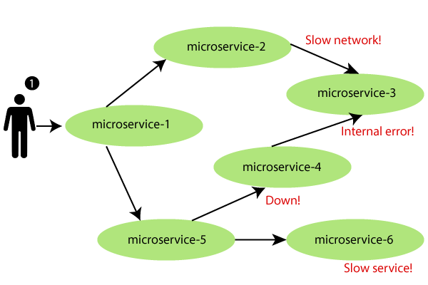
Fault tolerance can be achieved with the help of a circuit breaker. It is a pattern that wraps requests to external services and detects when they fail. If a failure is detected, the circuit breaker opens. All the subsequent requests immediately return an error instead of making requests to the unhealthy service. It monitors and detects the service which is down and misbehaves with other services. It rejects calls until it becomes healthy again.
Hystrix
Hystrix is a library that controls the interaction between microservices to provide latency and fault tolerance. Additionally, it makes sense to modify the UI to let the user know that something might not have worked as expected or would take more time.
Implementing Fault Tolerance with Hystrix
Step 1: Open the pom.xml file of limits-service and add the Hystrix dependency
- <dependency>
- <groupId>org.springframework.cloud</groupId>
- <artifactId>spring-cloud-starter-netflix-hystrix</artifactId>
- </dependency>
Step 2: Open LimitsServicesApplication.java file and enable Hystrix by using the annotation @EnableHystrix.
LimitsServicesApplication.java
- package com.javatpoint.microservices.limitsservice;
- import org.springframework.boot.SpringApplication;
- import org.springframework.boot.autoconfigure.SpringBootApplication;
- import org.springframework.cloud.netflix.hystrix.EnableHystrix;
- @SpringBootApplication
- @EnableHystrix
- public class LimitsServiceApplication
- {
- public static void main(String[] args)
- {
- SpringApplication.run(LimitsServiceApplication.class, args);
- }
- }
Step 3: Open the LimitsConfigurationController.java file and create a Get method.
- @GetMapping("/fault-tolerance-example")
- //configuring a fallback method
- @HystrixCommand(fallbackMethod="fallbackRetrieveConfigurations")
- public LimitConfiguration retrieveConfigurations()
- {
- throw new RuntimeException("Not Available");
- }
- //defining the fallback method
- public LimitConfiguration fallbackRetrieveConfigurations()
- {
- //returning the default configuration
- return new LimitConfiguration(999, 9);
- }
Let’s understand what is happening in the above method.
In the above method, we have created a Get mapping for fault tolerance. In the next line, we have used an annotation @HystrixCommand to configure the fallback method. We have defined a method with the name fallbackRetrieveConfigurations() that returns the default value if any fault occurs.
Fallback method
The fallback method is a method that invokes when a fault occurs. Hystrix allows us to define a fallback method for each service method. Here one question arises that if the method throws an exception, what should be returned to the consumer?
So answer is that if retrieveConfiguraions() fails, the method fallbackRetrieveConfigurations() is called. The fallback method returns the hardcoded LimitConfiguration instance.
Step 4: Open the browser and invoke the URL http://localhost:8080/fault-tolerance-example. It returns the values that we have returned in the fallbackRetrieveConfigurations() method.
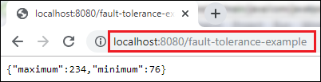

Note:--

Ports
Application | Port
Limits Service | 8080, 8081, ...
Spring Cloud Config Server | 8888
Currency Exchange Service | 8000, 8001, 8002, ..
Currency Conversion Service | 8100, 8101, 8102, ...
Netflix Eureka Naming Server | 8761
Netflix Zuul API Gateway Server | 8765
Zipkin Distributed Tracing Server | 9411
URLs
Application | URL
Limits Service | http://localhost:8080/limits http://localhost:8080/actuator/refresh (POST)
Spring Cloud Config Server | http://localhost:8888/limits-service/default http://localhost:8888/limits-service/dev
Currency Converter Service - Direct Call | http://localhost:8100/currency-converter/from/USD/to/INR/quantity/10
Currency Converter Service - Feign | http://localhost:8100/currency-converter-feign/from/EUR/to/INR/quantity/10000
Currency Exchange Service | http://localhost:8000/currency-exchange/from/EUR/to/INR http://localhost:8001/currency-exchange/from/USD/to/INR
Eureka | http://localhost:8761/
Zuul - Currency Exchange & Exchange Services | http://localhost:8765/currency-exchange-service/currency-exchange/from/EUR/to/INR http://localhost:8765/currency-conversion-service/currency-converter-feign/from/USD/to/INR/quantity/10
Zipkin | http://localhost:9411/zipkin/
Spring Cloud Bus Refresh | http://localhost:8080/actuator/bus-refresh (POST)
Ranga Local Instructions
brew install rabbitmq
/usr/local/sbin/rabbitmq-server
curl -X POST localhost:8080/actuator/refresh
curl -X POST localhost:8080/actuator/bus-refresh
Zipkin Installation
Quick Start Page
- https://zipkin.io/pages/quickstart
Downloading Zipkin Jar
- https://search.maven.org/remote_content?g=io.zipkin.java&a=zipkin-server&v=LATEST&c=exec
Command to run
RABBIT_URI=amqp://localhost java -jar zipkin-server-2.12.9-exec.jar
VM Argument
-Dserver.port=8001
Commands
mkdir git-configuration-repo
cd git-configuration-repo/
git init
git add -A
git commit -m "first commit"
Spring Cloud Configuration
spring.cloud.config.failFast=true

Let's take an example of e-commerce application developed with microservice architecture. In this example, each microservice is focused on single business capability. Search, Rating & Review and Payment each have their instance (server) and communicate with each other.
Microservices architecture:-

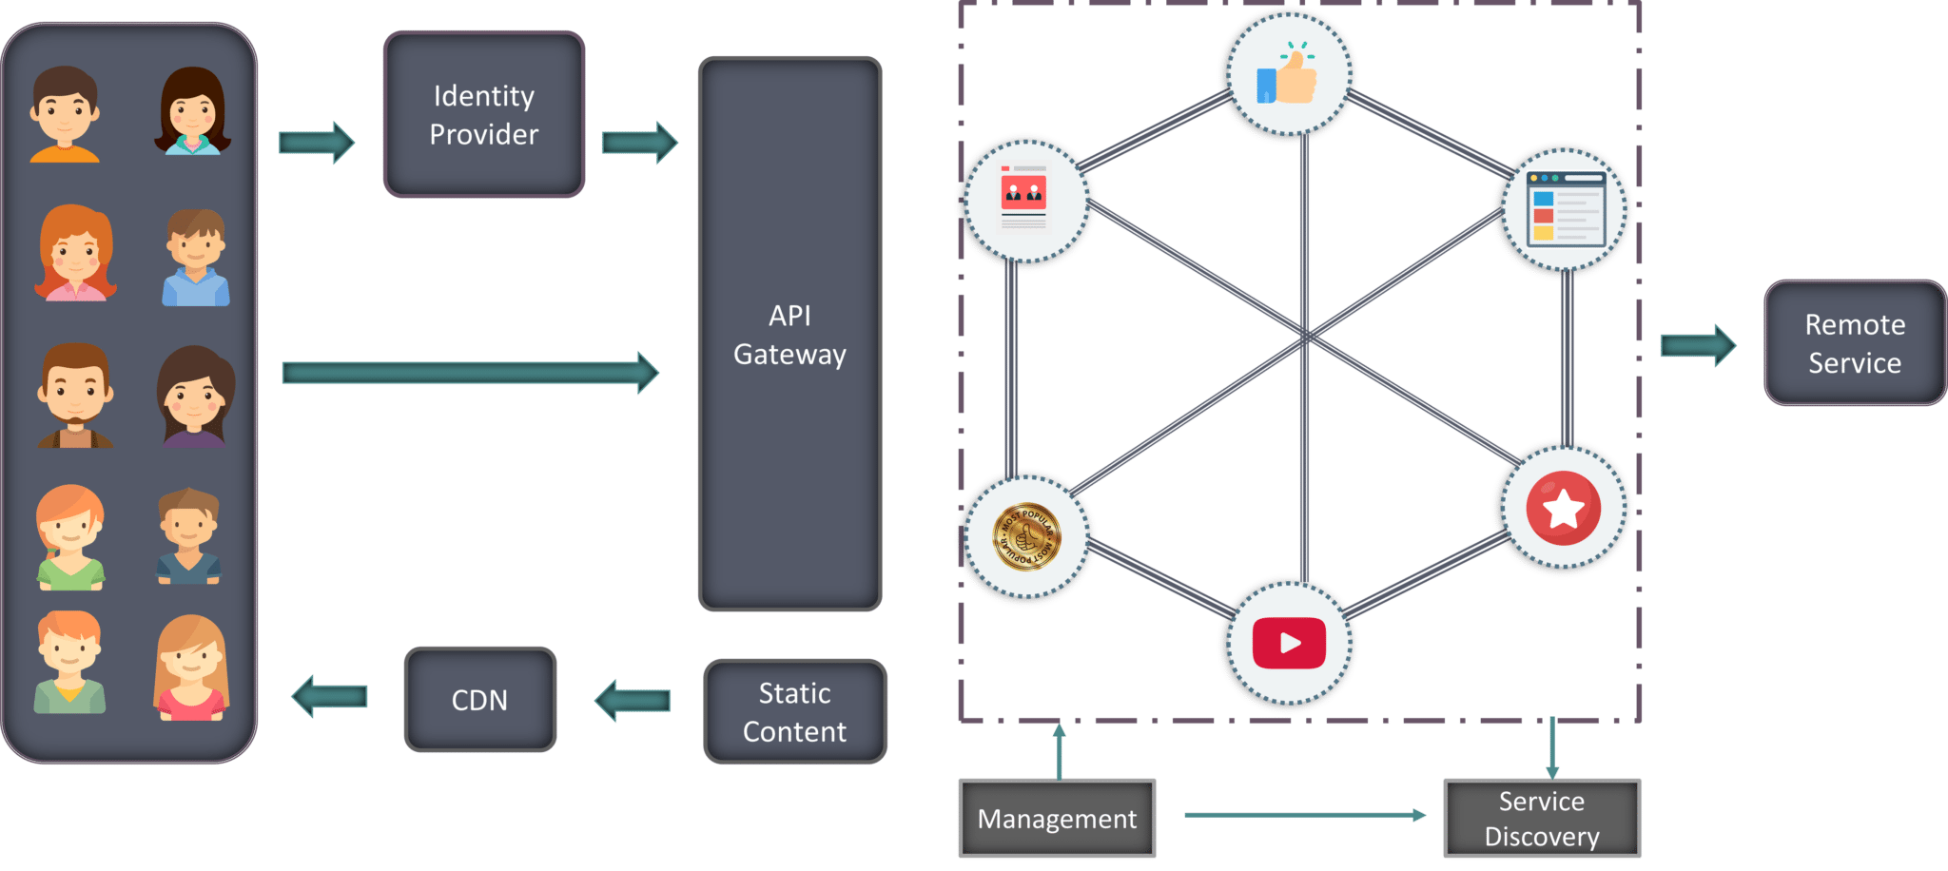

In microservices, service is small ,dependent and loosely coupled. Each of the services have separate code base which can be managed by small development team and it is deployed into. All the services are running in one instance. Team can update existing service without rebuilding and deploying an entire application. Service is responsible for persisting their own data or external state. Internal implementation details of each services are hidden from other services,moreover don’t want to share any technologies.

Management:-responsible for placing services on nodes, identifying failures and rebalancing services across nodes.
Service discovery: maintain list of services and which nodes are located.it enables service lookup to define endpoint service

API gateway:-Entry point of client. Handles client requests.

Features of Microservices:-
- Small Focused:- simplicity
- Loosely coupled:-
- Language neutral
- Bounded context

The architecture consists of various users who sent requests from various devices. These requests are authenticated by identity provider and passed on the API gateway. API gateway entry point for all client request and passes the request to the specific microservices to be processed. Apart from the main component architecture has other parts called static content which helps all the content from the system .
Service discovery which acts as to find the road of the communication between microservices
Creates roadmap for microservices to communicate with each other. It also maintains a list of services on which nodes are located
CDN -which is basically distributed networks of proxy servers and data centers.

Containers:-
Each microservice is assigned to container. Containers are a good way to manage microservice based application develop and deploy them individually.
Microservices communicate between each other through a stateless server i.e HTTP REST/ Message Bus

Clients cannot call the services directly.
API gateway acts as an entry point for the clients to forward requests to appropriate microservices.
Advantages of API gateway:-
All the services can be updates without the clients knowing.
Services can also use messaging protocols that are not web friendly.
API gateway can perform cross cutting functions such as providing security , load balancing etc
Benefits:-
- A set of loosely coupled,collaborating service
- Highly maintainable and testable
- Loosely coupled with other services
- Independently deployable
- Capable of being developed by a small team
- Services can be developed independent of each other
- Communicating among services via HTTP/REST/AMQP

Login application using microservices

Notes:-

Spring Boot Actuator. Spring Boot Actuator is a sub-project of the Spring Boot Framework. ... It contains the actuator endpoints (the place where the resources live). We can use HTTP and JMX endpoints to manage and monitor the Spring Boot application.

