Microservices Interview Questions and Answers:-

- List down the advantages of Microservices Architecture.
Advantages of Microservices Architecture
Advantage | Description
Independent Development | All microservices can be easily developed based on their individual functionality
Independent Deployment | Based on their services, they can be individually deployed in any application
Fault Isolation | Even if one service of the application does not work, the system still continues to function
Mixed Technology Stack | Different languages and technologies can be used to build different services of the same application
Granular Scaling | Individual components can scale as per need, there is no need to scale all components together

- What do you know about Microservices?
Microservices is an architecture where in all the components of the system are put into individual components, which can be built, deployed, and scaled individually.

- What are the features of Microservices?

- Multiple Individually Deployable Components.
- Service Distribution based on Business Capabilities.
- Decentralized Data Management.
- DevOps Implementation.
- Technical Independence.
- Hidden Component Complexity to avoid unnecessary microservices dependencies.

3 a. What are the features of Microservices?
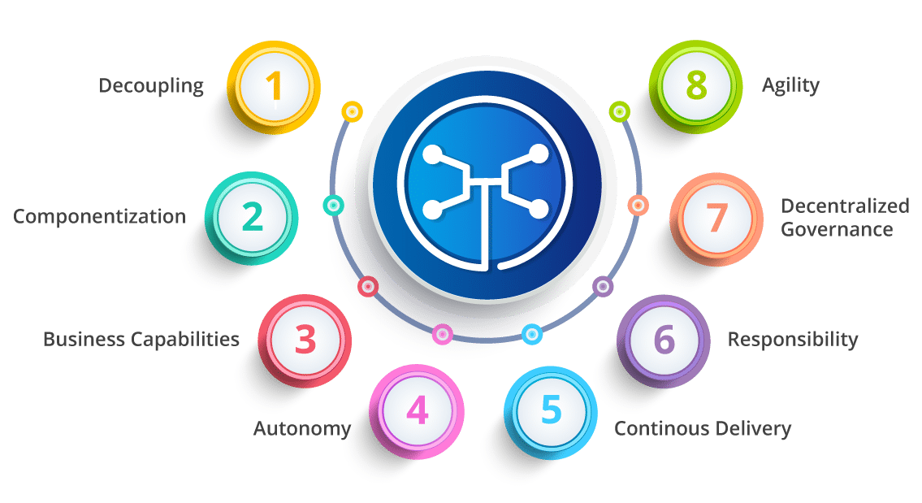
Fig 3: Features of Microservices – Microservices Interview Questions
- Decoupling – Services within a system are largely decoupled. So the application as a whole can be easily built, altered, and scaled
- Componentization – Microservices are treated as independent components that can be easily replaced and upgraded
- Business Capabilities – Microservices are very simple and focus on a single capability
- Autonomy – Developers and teams can work independently of each other, thus increasing speed
- Continous Delivery – Allows frequent releases of software, through systematic automation of software creation, testing, and approval
- Responsibility – Microservices do not focus on applications as projects. Instead, they treat applications as products for which they are responsible
- Decentralized Governance – The focus is on using the right tool for the right job. That means there is no standardized pattern or any technology pattern. Developers have the freedom to choose the best useful tools to solve their problems
- Agility – Microservices support agile development. Any new feature can be quickly developed and discarded again

Architecture of Microservices
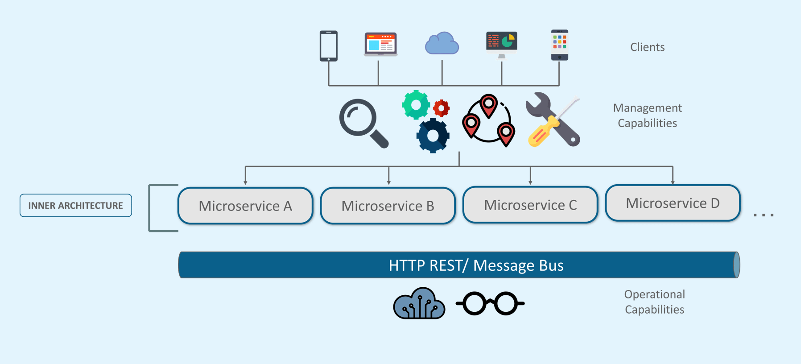
Figure 4: Architecture
- Different clients from different devices try to use different services like search, build, configure and other management capabilities
- All the services are separated based on their domains and functionalities and are further allotted to individual microservices
- These microservices have their own load balancer and execution environment to execute their functionalities & at the same time captures data in their own databases
- All the microservices communicate with each other through a stateless server which is either REST or Message Bus
- Microservices know their path of communication with the help of Service Discovery and perform operational capabilities such as automation, monitoring
- Then all the functionalities performed by microservices are communicated to clients via API Gateway
- All the internal points are connected from the API Gateway. So, anybody who connects to the API Gateway automatically gets connected to the complete system

Q4. What are the best practices to design Microservices?
The following are the best practices to design microservices:
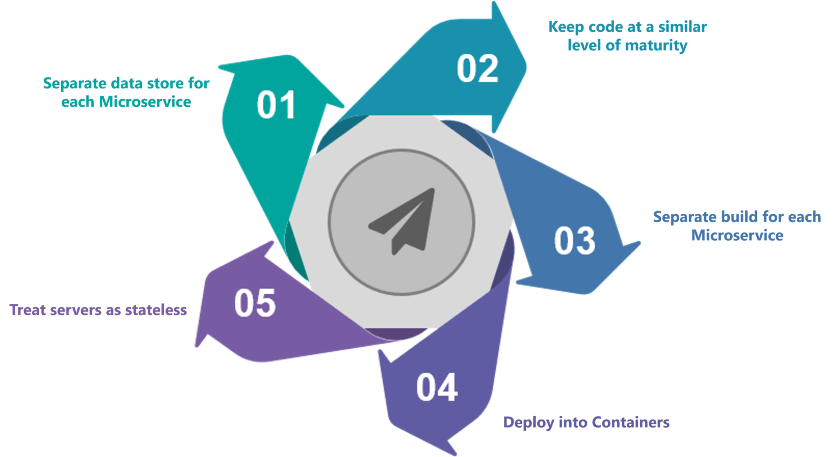
Fig 4: Best Practices to Design Microservices – Microservices Interview Questions
Q5. How does Microservice Architecture work?
A microservice architecture has the following components:
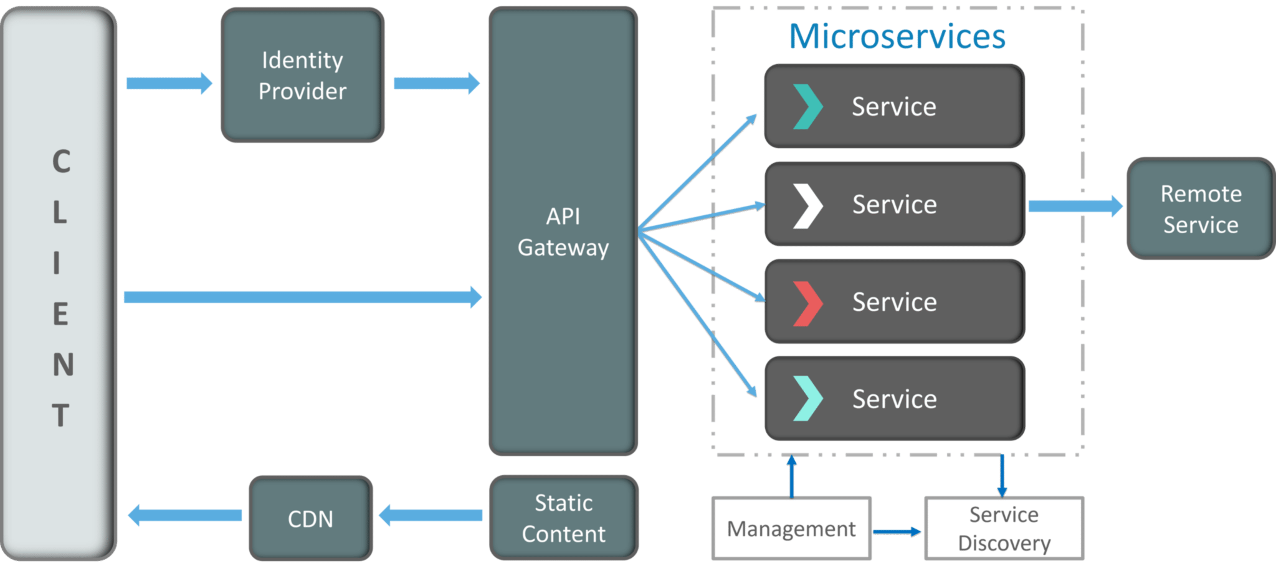
Fig 5: Architecture of Microservices – Microservices Interview Questions
- Clients – Different users from various devices send requests.
- Identity Providers – Authenticates user or clients identities and issues security tokens.
- API Gateway – Handles client requests.
- Static Content – Houses all the content of the system.
- Management – Balances services on nodes and identifies failures.
- Service Discovery – A guide to find the route of communication between microservices.
- Content Delivery Networks – Distributed network of proxy servers and their data centers.
- Remote Service – Enables the remote access information that resides on a network of IT devices.

What are the pros and cons of Microservice Architecture?

Pros of Microservice Architecture | Cons of Microservice Architecture
Freedom to use different technologies | Increases troubleshooting challenges
Each microservices focuses on single capability | Increases delay due to remote calls
Supports individual deployable units | Increased efforts for configuration and other operations
Allow frequent software releases | Difficult to maintain transaction safety
Ensures security of each service | Tough to track data across various boundaries
Mulitple services are parallelly developed and deployed | Difficult to code between services

Q7. What is the difference between Monolithic, SOA and Microservices Architecture?
- Monolithic Architecture is similar to a big container where in all the software components of an application are assembled together and tightly packaged.
- A Service-Oriented Architecture is a collection of services which communicate with each other. The communication can involve either simple data passing or it could involve two or more services coordinating some activity.
- Microservice Architecture Microservices is an architecture where in all the components of the system are put into individual components, which can be built, deployed, and scaled individually.

Q8. What are the challenges you face while working Microservice Architectures?
Challenges with building Microservices
- Identifying Microservice Boundaries - Implementing Bounded Context
- Having Proper Configuration Management
- Implementing Technology for Dynamic Scale Up And Scale Down
- Ensuring High Visibility
- Ensuring High Fault Tolerance

- Automate the Components: Difficult to automate because there are a number of smaller components. So for each component, we have to follow the stages of Build, Deploy and, Monitor.
- Perceptibility: Maintaining a large number of components together becomes difficult to deploy, maintain, monitor and identify problems. It requires great perceptibility around all the components.
- Configuration Management: Maintaining the configurations for the components across the various environments becomes tough sometimes.
- Debugging: Difficult to find out each and every service for an error. It is essential to maintain centralized logging and dashboards to debug problems.

Bounded Context:-
We are aware that in a microservices architecture, instead of single big monolith application, we build several independent microservices talking with each other:
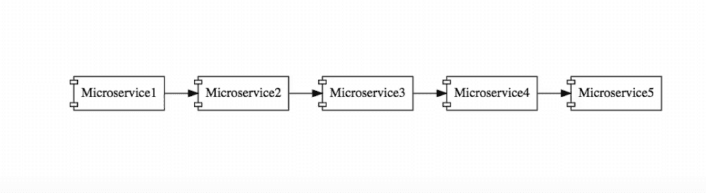
Usually we face difficulty in designing microservices a and also defining the boundaries of individual microservices. And also it is very difficult to decide what one service does and what it should not do?
This is particularly difficult for a new application, as there may not be enough business knowledge to establish the right boundaries.
The task of deciding the boundaries of microservices is an evolving process. It is not something you necessarily get right the first time.
It often involves using domain driven design while playing around the functionality of the microservices. As you gain design knowledge, you need to put that knowledge back into the microservices architecture.
The best practices include following domain driven design.

Having Proper Configuration Management
Configuration management poses quite a stiff challenge in implementing microservices.
Suppose that in our system, we have a few microservices, each of which has multiple instances in each environment: 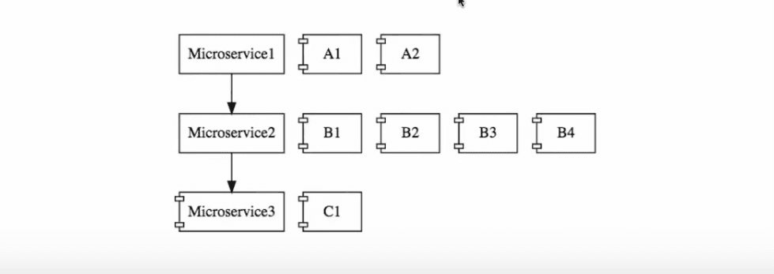
In a slightly larger system, there could be 10 microservices with 5 environments, and 50 instances at the least. We are talking about tons of configuration here!
This will involve a lot of work for the operations team, just to maintain all these configurations.
Typically, centralized configuration helps you manage configuration.

Implementing Technology for Dynamic Scale Up And Scale Down
For a microservices architecture, establishing the technology to do dynamic scaling of infrastructure, is a mountain to scale in itself.
The loads on different microservices could be different, at different instances of time: 
At a particular point of time, you may need 2 instances of Microservice2. However at a later point in time, that need may go up to 4. Again, it could shoot up to 10 later. In essence, we need to bring up new instances of a microservices when they are in demand, and bring them down when no longer needed.
All this scaling needs to be done with dynamic load balancing. At the point of time shown in the diagram, the load from Microservice1 needs to be distributed among the 4 instances of Microservice2. Later, when there are 10 instances of Microservice2, there needs to be another load redistribution among those 10 instances.
Building an architecture for this involves a number of technical components - Naming Server, Load Balancers, Monitoring tools to identify whether to scale in or scale out.

Ensuring High Visibility
Ensuring visibility is one of the most important challenges that needs to be addressed.

If we say that the functionality of the above system needs to be distributed among 10 microservices, but there is a bug, how do you identify where the bug is? There is clearly a need for a centralized log, where we need to find out what happened with a specific request.
We also need to have effective monitoring across the microservices.

Ensuring High Fault Tolerance
If not well designed, a microservices architecture can behave like a pack of cards. A microservice at the end of such a chain would be fundamental to the system behaving well.
Therefore, it is very important for you to have sufficient fault tolerance in place, in your system.

Q9. What are the key differences between SOA and Microservices Architecture?

The key differences between SOA and microservices are as follows:
SOA | Microservices
Follows “share-as-much-as-possible” architecture approach | Follows “share-as-little-as-possible” architecture approach
Importance is on business functionality reuse | Importance is on the concept of “bounded context”
They have common governance and standards | They focus on people collaboration and freedom of other options
Uses Enterprise Service bus (ESB) for communication | Simple messaging system
They support multiple message protocols | They use lightweight protocols such as HTTP/REST etc.
Multi-threaded with more overheads to handle I/O | Single-threaded usually with the use of Event Loop features for non-locking I/O handling
Maximizes application service reusability | Focuses on decoupling
Traditional Relational Databases are more often used | Modern Relational Databases are more often used
A systematic change requires modifying the monolith | A systematic change is to create a new service
DevOps / Continuous Delivery is becoming popular, but not yet mainstream | Strong focus on DevOps / Continuous Delivery

Q10. What are the characteristics of Microservices?
- Services split up and organized around business functionality.
- Separate modules handled and owned by different development teams.
- Decentralized Framework. i.e. Eliminate the need for a centralized service bus.
- Maintenance of respective modules by respective development teams.
- Separate modules may be maintained by different databases.
- Modules in a Microservice Architecture are separately deployable. They can be updated, enhanced, or deleted without disrupting the entire architecture.
- Real-time monitoring of the application.

You can list down the characteristics of microservices as follows:
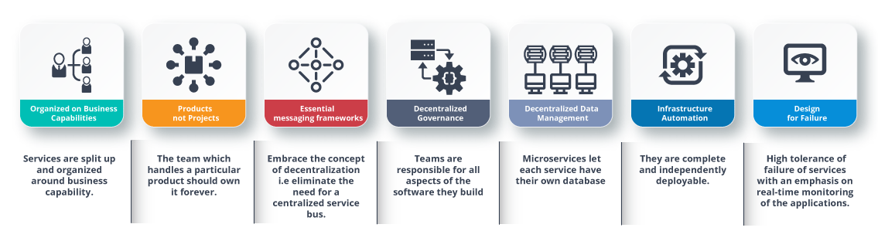
Fig 7: Characteristics of Microservices – Microservices Interview Questions

11. Name three commonly used tools for Microservices
The three commonly used tools for Microservices are:
Docker: Docker is a tool that lets developers set up apps in lightweight, portable containers in an automated way. It helps put the microservices and their dependencies into containers. This makes sure that the microservices are the same in all environments and makes it easier to launch and grow them.
Kubernetes: Kubernetes is a powerful tool for managing, scaling, and automating the launch of Docker containers. It does this by orchestrating how containers work together. It has important tools for running microservices in a live setting, such as load balancing, service discovery, self-healing, and automatic scaling.
Spring Boot: Spring Boot is a famous platform built on Java that makes it easier to build and launch microservices. It has features like built-in web servers, auto-configuration, and measures that are ready for production, which make it easier for developers to build, test, and launch microservices.
Q12. What is Monolithic Architecture?
Monolithic architecture is a traditional way of making software, in which all of an application’s parts and functions are tightly tied together and packaged as a single unit. In a monolithic program, the user interface, business logic, and data access layer all live in the same codebase and are delivered as a single unit. In the early days of software creation, this method was often used.
Key characteristics of a Monolithic Architecture:
- Single Codebase: The entire application is developed and maintained within a single code repository.
- Tight Coupling : Components and modules within the application are tightly interconnected, making it difficult to modify or replace individual parts without impacting the entire system.
- Scalability Challenges : Scaling a monolithic application can be challenging as all components need to be scaled together, even if only a specific part requires more resources.
- Monolithic Deployment : The application is deployed as a whole, which can lead to longer deployment cycles and increased downtime during updates.
- Technology Stack : Monolithic applications often use a uniform technology stack for the entire system.
- Development and Testing : The development and testing of monolithic applications can become complex and time-consuming as the codebase grows.
- Failure Impact : A failure in one component can potentially bring down the entire application.
Even though monolithic design has some problems, it has been used successfully for many years, especially for smaller applications and projects that aren’t too big or complicated. But as applications get bigger and more complicated and as the need for faster development processes and better scalability grows, monolithic design can become limited. This led to the rise of microservices design, in which systems are broken up into smaller, loosely connected services that can be built, deployed, and scaled separately.

Q13. In a Microservices setting, how useful are reports and dashboards?
In a Microservices setting, reports and dashboards are incredibly useful and often vital for the effective operation and management of the distributed system. Here are some reasons why reports and dashboards are essential in a Microservices environment:
- Visibility into Microservices : Microservices design can be made up of many different services, each of which is responsible for a different set of functions. Reports and dashboards give a consolidated view of these services, making it easier for devs, management teams, and users to track and understand the health and performance of the system as a whole.
- Service Monitoring and Debugging : Reports and graphs let you keep an eye on the response times, mistake rates, and resource usage of each microservice in real time. This makes it easier to find speed problems, bottlenecks, and errors in individual services and fix them quickly.
- End-to-End System Performance : Dashboards show how a program works as a whole, including how the microservices work together. This end-to-end view makes it easier to find problems caused by exchanges between services and makes sure that services work well together.
- Scalability and Resource Management :Monitoring how each microservice uses its resources helps with capacity planning and making the best use of resources. Reports and tools help teams find services that need more resources and change them so they can handle more traffic.
- Alerting and Incident Response : Dashboards can be set up to send alerts based on predetermined limits, which makes it possible to respond to incidents in a timely manner. Teams can get alerts in real time, which lets them act right away when important events or service breakdowns happen.
- Versioning and Deployment Analysis : When updates or changes are made to microservices, reports and graphs can help compare how well the different versions of the service work. This lets teams figure out how changes will affect things and make sure deployments go smoothly and work well.
- Business Metrics and Decision Making : Metrics that are important to a business, like user interaction, sales, and conversion rates, can be shown in reports and screens. These insights help stakeholders make choices based on data, understand how microservices affect business performance, and decide which changes to make first.
- Security and Compliance Monitoring : Centralizing security logs and data in reports and dashboards makes it easier to find and deal with possible security risks and make sure that security policies are being followed.
- User Behavior Analysis : Analyzing user interactions with various microservices gives significant information into user behavior and preferences. This knowledge helps improve the user experience and make services fit the wants of the user.
Overall, reports and dashboards are very important in a Microservices setting because they provide clarity, track system success, and make it easier to make good decisions. They make it easier to see what’s going on and let teams react to problems before they happen. This makes microservices-based apps more stable, scalable, and reliable.
Q14.Tell me the name of some famous companies which are using Microservice architecture.
There are several famous companies that have adopted the Microservices architecture to build their applications and services. Some of these companies include:
- Netflix : Netflix is a well-known entertainment streaming platform that heavily relies on Microservices architecture. It uses hundreds of individual microservices to handle different aspects of its platform, such as user authentication, content recommendation, and video streaming.
- Amazon : Amazon, one of the largest e-commerce and cloud computing companies in the world, has adopted a Microservices approach for various services, including Amazon Prime, AWS (Amazon Web Services), and other online retail functionalities.
- Uber : Uber, the popular ride-hailing service, employs Microservices architecture to manage its vast and complex operations, which include real-time location tracking, ride dispatching, payment processing, and more.
- Twitter : Twitter, the social media platform, has shifted to a Microservices architecture to handle its millions of users, tweets, and real-time interactions efficiently.
- Spotify : Spotify, the music streaming service, employs Microservices architecture to manage its vast music library, user preferences, and personalized playlists.
- Google : Google, the multinational technology company, uses Microservices for various products and services, including Google Search, Gmail, and Google Maps.
- LinkedIn : LinkedIn, the professional networking platform, utilizes Microservices architecture to manage user profiles, job listings, and networking features.
- eBay : eBay, the popular online marketplace, has adopted Microservices architecture to handle its extensive product catalog, user accounts, and payment processing.
- PayPal : PayPal, the digital payment platform, uses Microservices to manage transactions, user accounts, and security features.
- Airbnb : Airbnb, the online hospitality service, employs Microservices to handle booking management, search functionality, and user reviews.
It’s important to remember that a company’s use of Microservices design can change, and some parts of their systems may still be built with other methods. Also, the technology world is always changing, so new companies may have started using Microservices design since the last time I wrote about it.

What is Domain Driven Design?
Domain-Driven Design is an architectural style based on Object-Oriented Analysis Design concepts and principles. It helps in developing a complex system by connecting the related components of the software system into a continuously evolving system. Domain-Driven Design is based on three core principles:
- Focus on the core domain and domain logic.
- Base complex designs on models of the domain.
- Regularly collaborate with the domain experts to improve the application model and resolve any emerging domain-related issues.
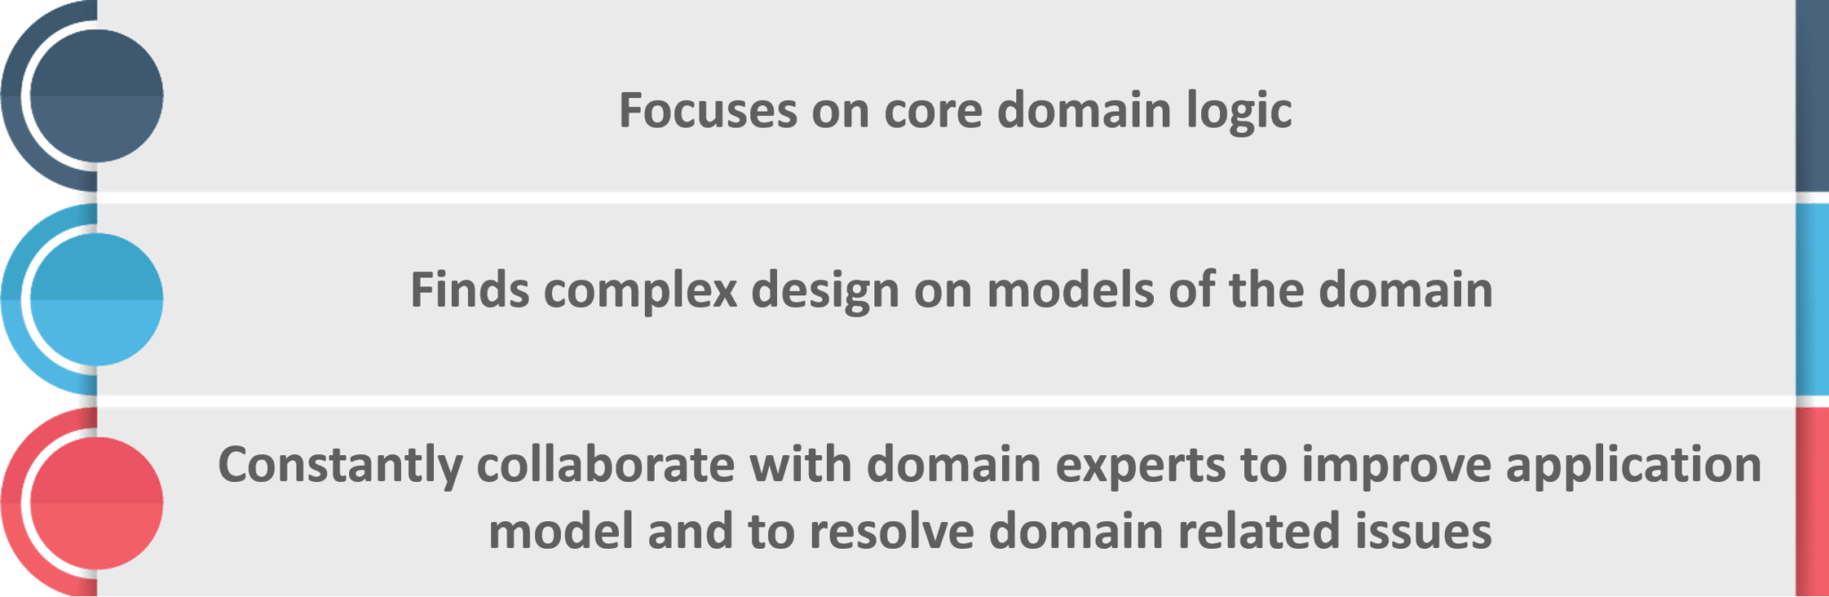

Why there is a need for Domain Driven Design (DDD)?
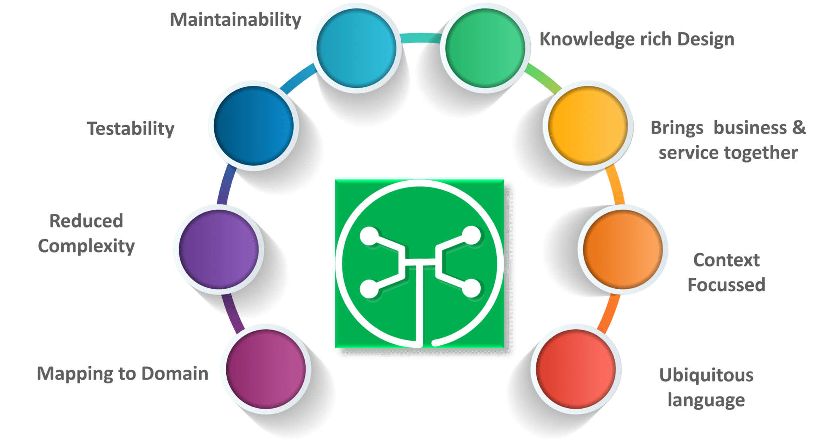

Q14. What is Cohesion?
The degree to which the elements inside a module belong together is said to be cohesion.
Q15. What is Coupling?
The measure of the strength of the dependencies between components is said to be coupling. A good design is always said to have High Cohesion and Low Coupling.

. Give the major difference between Cohesion and Coupling?
Answer: Coupling is the relationship between two modules while cohesion is the relationship between two or more parts within a module.
What is spring cloud?
Spring cloud is an Integration software that integrates with external systems. It allows microservices framework to build applications which perform restricted amounts of data processing.
Spring Cloud provides tools for developers to quickly build some of the common patterns in distributed systems (e.g. configuration management, service discovery, circuit breakers, intelligent routing, micro-proxy, control bus, one-time tokens, global locks, leadership election, distributed sessions, cluster state)

What problems are solved by Spring Cloud?
While developing distributed microservices with Spring Boot we face few issues which are solved by Spring Cloud.
- The complexity associated with distributed systems – This includes network issues, Latency overhead, Bandwidth issues, security issues.
- Ability to handle Service Discovery – Service discovery allows processes and services in a cluster to find each other and communicate.
- Solved redundancy issues – Redundancy issues often occur in distributed systems.
- Load balancing – Improves the distribution of workloads across multiple computing resources, such as a computer cluster, network links, central processing units.
- Reduces performance issues – Reduces performance issues due to various operational overheads.

Q22. Can you give a gist about Rest and Microservices?
REST
Though you can implement microservices in multiple ways, REST over HTTP is a way to implement Microservices. REST is also used in other applications such as web apps, API design, and MVC applications to serve business data.
Microservices
Microservices is an architecture wherein all the components of the system are put into individual components, which can be built, deployed, and scaled individually. There are certain principles and best practices of Microservices that help in building a resilient application.
In a nutshell, you can say that REST is a medium to build Microservices.
Q23. What are different types of Tests for Microservices?
While working with microservices, testing becomes quite complex as there are multiple microservices working together. So, tests are divided into different levels.
- At the bottom level, we have technology-facing tests like- unit tests and performance tests. These are completely automated.
- At the middle level, we have tests for exploratory testing like the stress tests and usability tests.
- At the top level, we have acceptance tests that are few in number. These acceptance tests help stakeholders in understanding and verifying software features.
Q24. What do you understand by Distributed Transaction?
Distributed Transaction is any situation where a single event results in the mutation of two or more separate sources of data which cannot be committed atomically. In the world of microservices, it becomes even more complex as each service is a unit of work and most of the time multiple services have to work together to make a business successful.
Q25. What is an Idempotence and where it is used?
Idempotence is the property of being able to do something twice in such a way that the end result will remain the same i.e. as if it had been done once only.
Usage: Idempotence is used at the remote service, or data source so that, when it receives the instruction more than once, it only processes the instruction once.
Q26. What is Bounded Context?
Bounded Context is a central pattern in Domain-Driven Design. It is the focus of DDD’s strategic design section which is all about dealing with large models and teams. DDD deals with large models by dividing them into different Bounded Contexts and being explicit about their inter-relationships.

Q27. What is Two Factor Authentication?
Two-factor authentication enables the second level of authentication to an account log-in process.
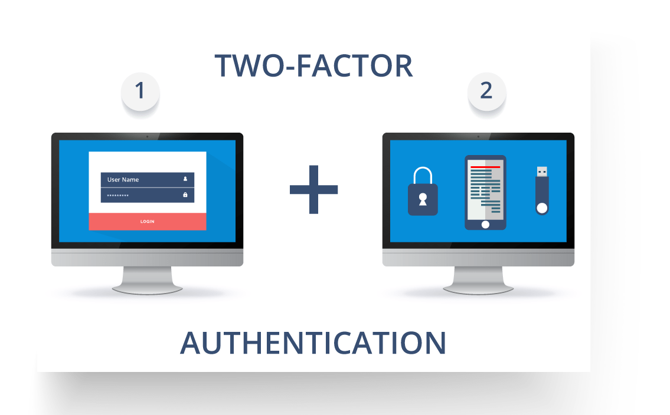
Fig11: Representation of Two Factor Authentication – Microservices Interview Questions
So suppose a user has to enter only username and password, then that’s considered a single-factor authentication.
Q28. What are the types of credentials of Two Factor Authentication?
The three types of credentials are:
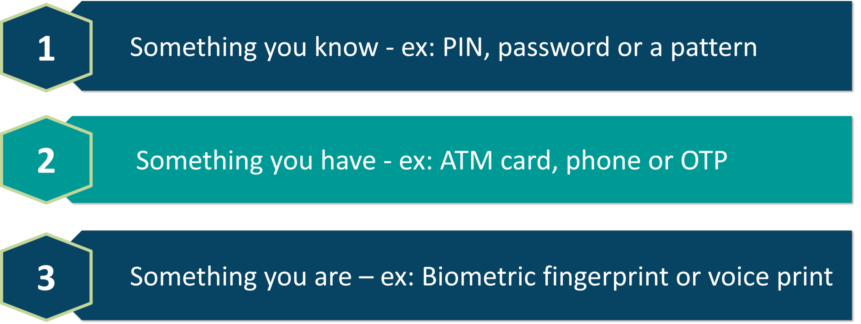
Fig 12: Types of Credentials of Two Factor Authentication – Microservices Interview Questions
Q29. What are Client certificates?
A type of digital certificate that is used by client systems to make authenticated requests to a remote server is known as the client certificate. Client certificates play a very important role in many mutual authentication designs, providing strong assurances of a requester’s identity.
Q30. What is the use of PACT in Microservices architecture?
PACT is an open source tool to allow testing interactions between service providers and consumers in isolation against the contract made so that the reliability of Microservices integration increases.
Usage in Microservices:
- Used to implement Consumer Driven Contract in Microservices.
- Tests the consumer-driven contracts between consumer and provider of a Microservice.
Q31. What is OAuth?
OAuth stands for open authorization protocol. This allows accessing the resources of the resource owner by enabling the client applications on HTTP services such as third-party providers Facebook, GitHub, etc. So with this, you can share resources stored on one site with another site without using their credentials.
Q32. What is Conway’s law?
“Any organization that designs a system (defined broadly) will produce a design whose structure is a copy of the organization’s communication structure.” – Mel Conway
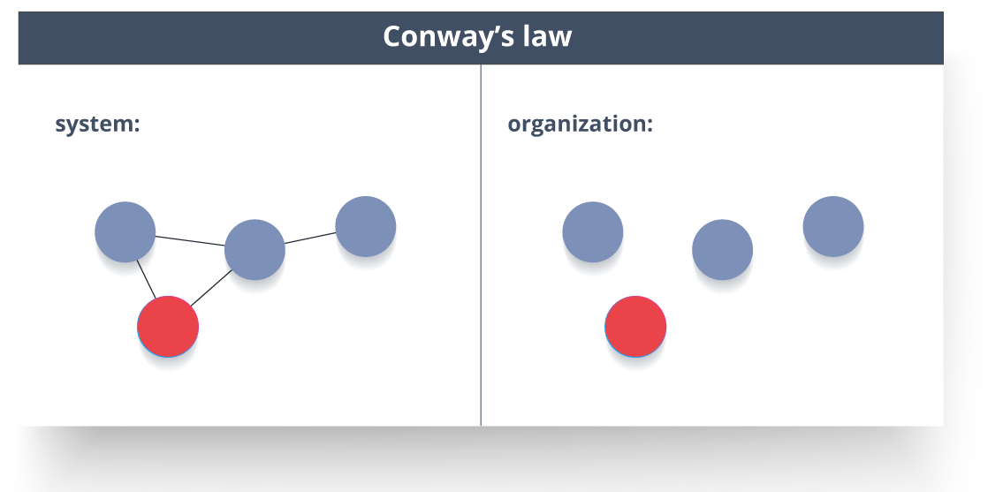
Fig 13: Representation of Conway’s Law – Microservices Interview Questions
This law basically tries to convey the fact that, in order for a software module to function, the complete team should communicate well. Therefore the structure of a system reflects the social boundaries of the organization(s) that produced it.

Q33. What do you understand by Contract Testing?
According to Martin Flower, contract test is a test at the boundary of an external service which verifies that it meets the contract expected by a consuming service.
Also, contract testing does not test the behavior of the service in depth. Rather, it tests that the inputs & outputs of service calls contain required attributes and the response latency, throughput is within allowed limits.
Q34. What is End to End Microservices Testing?
End-to-end testing validates each and every process in the workflow is functioning properly. This ensures that the system works together as a whole and satisfies all requirements.
In layman terms, you can say that end to end testing is a kind of tests where everything is tested after a particular period.
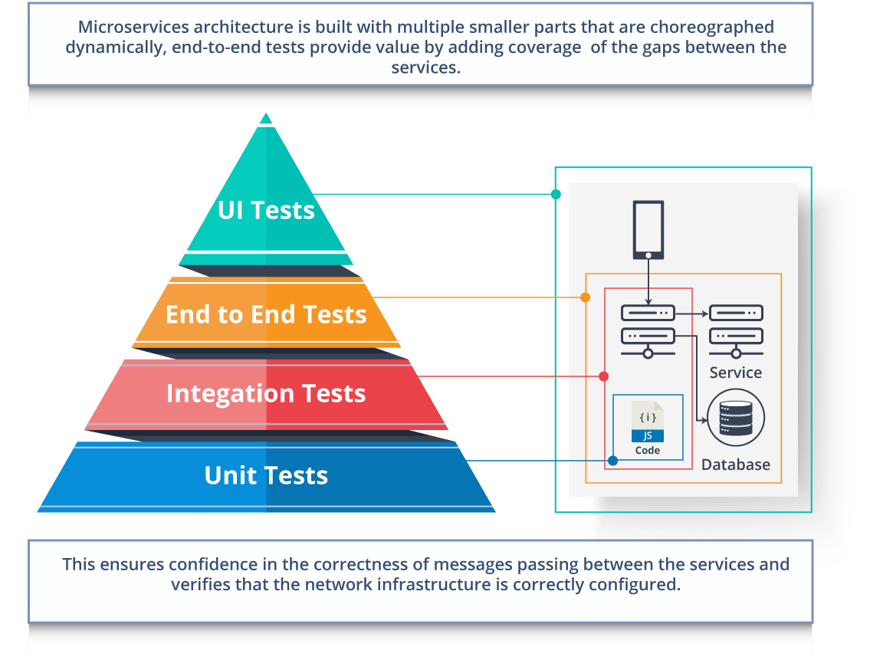
Fig 14: Hierarchy of Tests – Microservices Interview Questions
Q35. What is the use of Container in Microservices?
Containers are a good way to manage microservice based application to develop and deploy them individually. You can encapsulate your microservice in a container image along with its dependencies, which then can be used to roll on-demand instances of microservice without any additional efforts required.
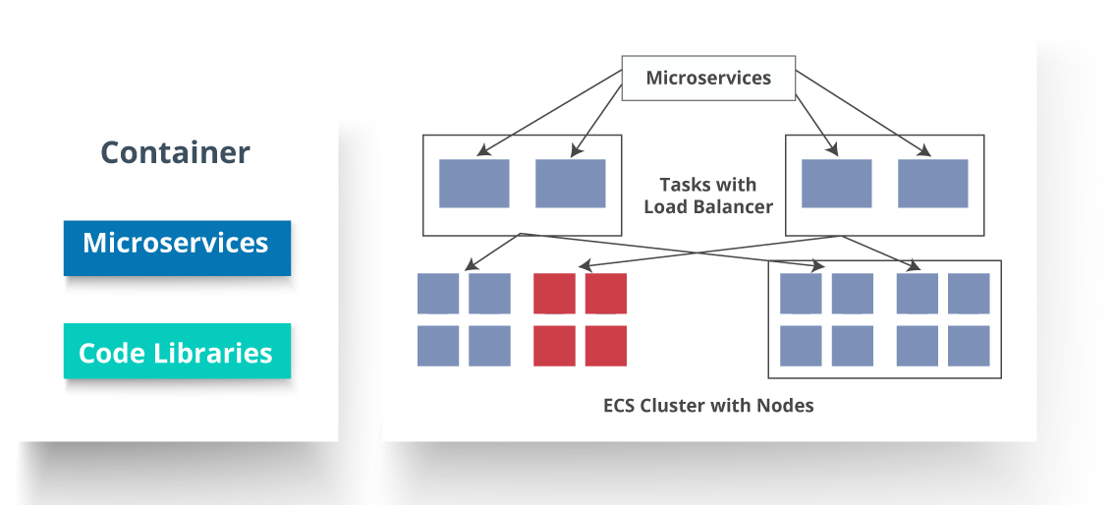
Fig 15: Representation of Containers and How they are used in Microservices – Microservices Interview Questions

Q36. What is DRY in Microservices architecture?
DRY stands for Don’t Repeat Yourself. It basically promotes the concept of reusing the code. This results in developing and sharing the libraries which in turn result in tight coupling.
Q37. What is a Consumer-Driven Contract (CDC)?
This is basically a pattern for developing Microservices so that they can be used by external systems. When we work on microservices, there is a particular provider who builds it and there are one or more consumers who use Microservice.
Generally, providers specify the interfaces in an XML document. But in Consumer Driven Contract, each consumer of service conveys the interface expected from the Provider.
Q38. What is the role of Web, RESTful APIs in Microservices?
A microservice architecture is based on a concept wherein all its services should be able to interact with each other to build a business functionality. So, to achieve this, each microservice must have an interface. This makes the web API a very important enabler of microservices. Being based on the open networking principles of the Web, RESTful APIs provide the most logical model for building interfaces between the various components of a microservice architecture.
Q39. What do you understand by Semantic monitoring in Microservices architecture?
Semantic monitoring, also known as synthetic monitoring combines automated tests with monitoring the application in order to detect business failing factors.
Q40. How can we perform Cross-Functional testing?
Cross-functional testing is a verification of non-functional requirements, i.e. those requirements which cannot be implemented like a normal feature.
Q41. How can we eradicate non-determinism in tests?
Non-Deterministic Tests (NDT) are basically unreliable tests. So, sometimes it may happen that they pass and obviously sometimes they may also fail. As and when they fail, they are made to re-run to pass.
Some ways to remove non-determinism from tests are as follows:
- Quarantine
- Asynchronous
- Remote Services
- Isolation
- Time
- Resource leaks
Q42. What is the difference between Mock or Stub?
Stub
- A dummy object that helps in running the test.
- Provides fixed behavior under certain conditions which can be hard-coded.
- Any other behavior of the stub is never tested.
For example, for an empty stack, you can create a stub that just returns true for empty() method. So, this does not care whether there is an element in the stack or not.
Mock
- A dummy object in which certain properties are set initially.
- The behavior of this object depends on the set properties.
- The object’s behavior can also be tested.
For example, for a Customer object, you can mock it by setting name and age. You can set age as 12 and then test for isAdult() method that will return true for age greater than 18. So, your Mock Customer object works for the specified condition.
Q43. What do you know about Mike Cohn’s Test Pyramid?
Mike Cohn provided a model called Test Pyramid. This describes the kind of automated tests required for software development.
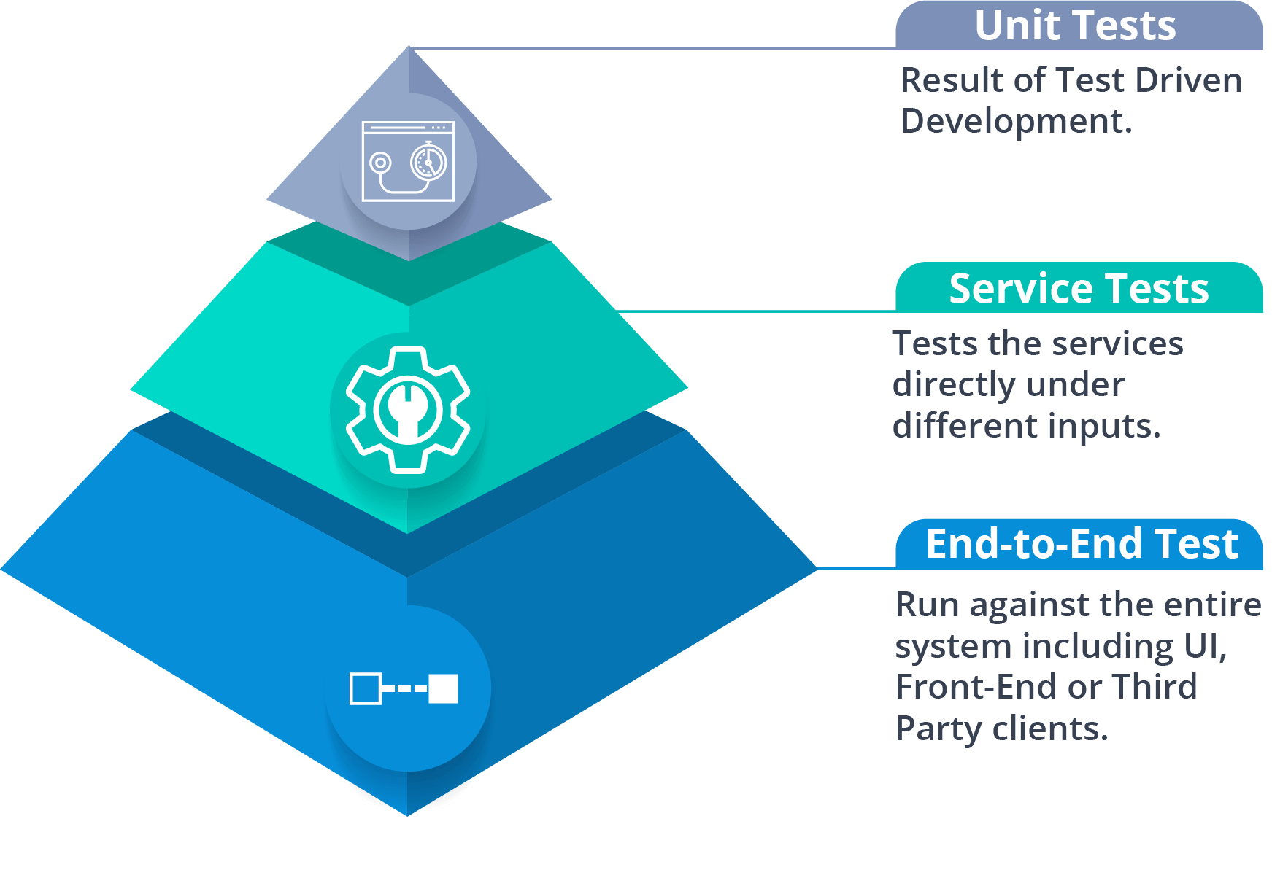
Fig 16: Mike Cohn’s Test Pyramid – Microservices Interview Questions
As per pyramid, the number of tests at first layer should be highest. At service layer, the number of tests should be less than at the unit test level, but more than at the end-to-end level.
Q44. What is the purpose of Docker?
Docker provides a container environment that can be used to host any application. In this, the software application and the dependencies which support it are tightly-packaged together.
So, this packaged product is called a Container and since it is done by Docker, it is called Docker container!
Q45. What is Canary Releasing?
Canary Releasing is a technique to reduce the risk of introducing a new software version in production. This is done by slowly rolling out the change to a small subset of users before giving it out to the entire infrastructure, i.e. making it available to everybody.
Q46. What do you mean by Continuous Integration (CI)?
Continuous Integration (CI) is the process of automating the build and testing of code every time a team member commits changes to version control. This encourages developers to share code and unit tests by merging the changes into a shared version control repository after every small task completion.
Q47. What is Continuous Monitoring?
Continuous monitoring gets into the depth of monitoring coverage, from in-browser front-end performance metrics, through application performance, and down to host virtualized infrastructure metrics.
Q48. What is the role of an architect in Microservices architecture?
An architect in microservices architecture plays the following roles:
- Decides broad strokes about the layout of the overall software system.
- Helps in deciding the zoning of the components. So, they make sure components are mutually cohesive, but not tightly coupled.
- Code with developers and learn the challenges faced in day-to-day life.
- Make recommendations for certain tools and technologies to the team developing microservices.
- Provide technical governance so that the teams in their technical development follow principles of Microservice.
Q49. Can we create State Machines out of Microservices?
As we know that each Microservice owning its own database is an independently deployable program unit, this, in turn, lets us create a State Machine out of it. So, we can specify different states and events for a particular microservice.
For Example, we can define an Order microservice. An Order can have different states. The transitions of Order states can be independent events in the Order microservice.
Q50. What are Reactive Extensions in Microservices?
Reactive Extensions also are known as Rx. It is a design approach in which we collect results by calling multiple services and then compile a combined response. These calls can be synchronous or asynchronous, blocking or non-blocking. Rx is a very popular tool in distributed systems which works opposite to legacy flows.

Q57. What are the 3 C’s of microservices?
The “Three C’s” of Microservices refer to three essential principles or characteristics that are often associated with Microservices architecture. These principles help guide the design and development of Microservices-based applications to ensure their effectiveness and success. The Three C’s are:
- Componentization: This concept says that a monolithic program should be broken up into smaller parts, called Microservices, that can be deployed and managed on their own. Each Microservice is in charge of a certain business capability or function, which gives teams the freedom to build, test, and launch them on their own. Componentization encourages a modular and independent architecture, which makes the program easier to manage and grow.
- Communication: In a Microservices design, it’s important for services to talk to each other so that the whole system works well. Services talk to each other through well-defined APIs, which often use lightweight protocols like HTTP/REST or message systems like Kafka or RabbitMQ. Communication patterns must be designed in a way that allows free linking and flexibility, so that services can change on their own without affecting the whole system.
- Containerization: Containerization is the process of putting apps and the things they need into separate containers, like Docker containers. Containers provide a consistent and portable setting that makes sure Microservices run the same way on different devices and environments. Containerization makes it easy to launch, scale, and handle Microservices. For this reason, it is a core part of many Microservices architectures.
These Three C’s—Componentization, Communication, and Containerization—help organizations adopt a Microservices architecture successfully. They promote flexibility, scalability, and maintainability, allowing development teams to build complex and distributed applications that can evolve and adapt to changing business needs efficiently.

What are the components of microservices?
Spring Cloud Config Server
Spring Cloud Config Server provides the HTTP resource-based API for external configuration in the distributed system. We can enable the Spring Cloud Config Server by using the annotation @EnableConfigServer.
Netflix Eureka Naming Server
Netflix Eureka Server is a discovery server. It provides the REST interface to the outside for communicating with it. A microservice after coming up, register itself as a discovery client. The Eureka server also has another software module called Eureka Client. Eureka client interacts with the Eureka server for service discovery. The Eureka client also balances the client requests.
Hystrix Server
Hystrix server acts as a fault-tolerance robust system. It is used to avoid complete failure of an application. It does this by using the Circuit Breaker mechanism. If the application is running without any issue, the circuit remains closed. If there is an error encountered in the application, the Hystrix Server opens the circuit. The Hystrix server stops the further request to calling service. It provides a highly robust system.
Netflix Zuul API Gateway Server
Netflix Zuul Server is a gateway server from where all the client request has passed through. It acts as a unified interface to a client. It also has an inbuilt load balancer to load the balance of all incoming request from the client.
Netflix Ribbon
Netflix Ribbon is the client-side Inter-Process Communication (IPC) library. It provides the client-side balancing algorithm. It uses a Round Robin Load Balancing:
- Load balancing
- Fault tolerance
- Multiple protocols(HTTP, TCP, UDP)
- Caching and Batching
Zipkin Distributed Server
Zipkin is an open-source project m project. That provides a mechanism for sending, receiving, and visualization traces.

What are the advantages of using Spring Cloud ?
When developing distributed microservices with Spring Boot we face the following issues-
- Complexity associated with distributed systems-
This overhead includes network issues, Latency overhead, Bandwidth issues, security issues.
- Service Discovery-
Service discovery tools manage how processes and services in a cluster can find and talk to one another. It involves a directory of services, registering services in that directory, and then being able to lookup and connect to services in that directory.
- Redundancy-
Redundancy issues in distributed systems.
- Loadbalancing-
Load balancing improves the distribution of workloads across multiple computing resources, such as computers, a computer cluster, network links, central processing units, or disk drives.
- Performance issues-
Performance issues due to various operational overheads.
- Deployment complexities-
Requirement of Devops skills.

What is spring cloud config server?
SpringCloudConfigServer is that it stores configuration for multiple services. It can also store configuration for each of the services for different environments.

What are the steps to configure spring cloud config server?
We can enable the Spring Cloud Config Server by using the annotation @EnableConfigServer.
We created already Limits-service as microservice. Now will configure the spring cloud config server.
First create spring cloud config server service using spring boot.
Install git and link to the spring cloud config server
configure the location of git repository where we are storing all our configuration files in application.properties.
Ex:In spring-cloud-config server project , open the application .properties and configure as below.
application.properties:-
spring.application.name=spring-cloud-config-server
server.port = 8888
spring.cloud.config.server.git.uri=file:///F:/vani/work/springboot-microservices/git-localconfig-repo
Now annotate the entry point class with @EnableConfigServer in spring cloud config server service .
EX:- In my class below

package com.in28minutes.microservices.springcloudconfigserver;

import org.springframework.boot.SpringApplication;
import org.springframework.boot.autoconfigure.SpringBootApplication;
import org.springframework.cloud.config.server.EnableConfigServer;

@EnableConfigServer
@SpringBootApplication
public class SpringCloudConfigServerApplication {

public static void main(String[] args) {
SpringApplication.run(SpringCloudConfigServerApplication.class, args);
}

}

That’s it. This is all you need to do to create Spring Cloud Config Server and you just need to add application-specific config files in the git repository.
Refactor Limits-service to use spring cloud config server
Our Limits-service will become client for Spring cloud config server. So let us add config client client starter to limit-service which will add the below dependency if not added.
<dependency>
<groupId>org.springframework.cloud</groupId>
<artifactId>spring-cloud-starter-config</artifactId>
</dependency>
While using Spring Cloud Config Server the properties loading process happens at multiple stages, first loading bootstrap.properties/yml and then from config server.
So, let’s rename application.properties to bootstrap.properties and update it to have the following properties.
spring.application.name=limits-service
spring.cloud.config.uri=http://localhost:8888

Here, we have configured the location of our Config Server and gave the name as limits-service to our application using spring.application.name.

Now we need to add all the properties of our limits-service in limits-service.properties and commit/push it to our git repo git-local-config-repo.
git-localconfig-repo/limits-service.properties
limits-service.minimum=88
limits-service.maximum=8888
You can also add separate config files for different files like limits-service-qa.properties, limits-service-dev.properties etc.
Now first start spring-cloud-config Server application and then limits-service application. This should work fine. You can check the console logs that catalog-service is fetching the properties from config server http://localhost:8888/ at startup.

Q: What does one mean by Service Registration and Discovery ? How is it implemented in Spring Cloud?
When we start a project, we usually have all the configurations in the properties file.
As more and more services are developed and deployed, adding and modifying these properties become more complex. Some services might go down, while some the location might change. This manual changing of properties may create issues.
Eureka Service Registration and Discovery helps in such scenarios. As all services are registered to the Eureka server and lookup done by calling the Eureka Server, any change in service locations need not be handled and is taken care of.
Eureka naming server is a REST-based server that is used in the AWS Cloud services for load balancing and failover of middle-tier service.
Eureka naming server is an application that holds information about all client service applications. It is also known as Discovery Server.
Service Registration- The registration of microservice with the naming server is called Service Registration.
Service Discovery- The process of providing instances to other services is called Service Discovery.
- We created two microservices and one microservices call another microservices.
- To invoke another microservice or external service first approach is Rest Template.
- We use RestTemplate() constructor to invoke an external service. We need to call
getForEntity(): It is a method of RestTemplate class that retrieves an entity by using the HTTPGET method for the specified URL. It converts and stores the response in the ResponseEntity. It returns the ResponseEntity.
Parameters: It accepts two parameters:
URL: The URL.
responseType: The type of the return value.
ResponseEntity<CurrencyConversionBean>responseEntity=new RestTemplate().getForEntity("http://localhost:8000/currency-exchange/from/{from}/to/{to}", CurrencyConversionBean.class, uriVariables);

Ex: In controller class we need to do the following

@GetMapping("/currency-converter/from/{from}/to/{to}/quantity/{quantity}")
public CurrencyConversionBean convertCurrency(@PathVariable String from,
@PathVariable String to, @PathVariable BigDecimal quantity ) {

Map<String, String>uriVariables=new HashMap<>();
uriVariables.put("from", from);
uriVariables.put("to", to);

ResponseEntity<CurrencyConversionBean> responseEntity = new RestTemplate().getForEntity("http://localhost:8000/currency-exchange/from/{from}/to/{to}",
CurrencyConversionBean.class,uriVariables);

CurrencyConversionBean currencyConversionBean=responseEntity.getBody();
return new CurrencyConversionBean(currencyConversionBean.getId(),from,to,currencyConversionBean.getConversionMultiple(),
quantity,quantity.multiply(currencyConversionBean.getConversionMultiple()),currencyConversionBean.getPort());
}

- Run both services independently and you see the responses.

The drawback of this is when we were developing service; how difficult it was to call the REST service. There is a lot of manuals that we have to do to call a very simple service. But still we have written a lot of code for it.
When we work with microservices, there will be a lot of calls to other services

To over come this issue we need to use Feign:-
The Feign is a declarative web service (HTTP client) developed by Netflix. Its aim is to simplify the HTTP API clients. It is a Java to HTTP client binder. If you want to use Feign, create an interface, and annotate it. It provides pluggable annotation support, including Feign annotations and JAX-RS annotations.
It is a library for creating REST API clients. It makes web service clients easier. The developers can use declarative annotations to call the REST services instead of writing representative boilerplate code.
Feign also supports pluggable encoders and decoders. Spring Cloud adds support for Spring MVC annotations and for using the same HttpMessageConverters used by default in Spring Web. Spring Cloud integrates Eureka, as well as Spring Cloud LoadBalancer to provide a load-balanced http client when using Feign.
Spring Cloud OpenFeign
Spring Cloud OpenFeign provides OpenFeign integrations for Spring Boot apps through auto-configuration and binding to the Spring Environment. Without Feign, in Spring Boot application, we use RestTemplate to call the User service. To use the Feign, we need to add spring-cloud-starter-openfeign dependency in the pom.xml file.

Important Spring Cloud Modules
Dynamic Scale Up and Down. Using a combination of
- Naming Server (Eureka)
- Ribbon (Client Side Load Balancing)
- Feign (Easier REST Clients)
Visibility and Monitoring with
- Zipkin Distributed Tracing
- Netflix API Gateway
Configuration Management with
- Spring Cloud Config Server
Fault Tolerance with
- Hystrix

What is API gateway?
An API stands for Application Program Interface. It is a set of instructions, protocols, and tools for building software applications. It specifies how software components should interact.
The API Gateway is a server. It is a single entry point into a system. API Gateway encapsulates the internal system architecture. It provides an API that is tailored to each client. It also has other responsibilities such as authentication, monitoring, load balancing, caching, request shaping and management, and static response handling.

How to achieve server side load balancing using Spring Cloud?
A: Server side load balancing can be achieved using Netflix Zuul.
Zuul is a JVM based router and server side load balancer by Netflix.
It provides a single entry to our system, which allows a browser, mobile app, or other user interface to consume services from multiple hosts without managing cross-origin resource sharing (CORS) and authentication for each one. We can integrate Zuul with other Netflix projects like Hystrix for fault tolerance and Eureka for service discovery, or use it to manage routing rules, filters, and load balancing across your system.

API Gateway is used if you want to implement common features like security,authentication or logging then we can use of API gateway.
Also /it also used to route all the requests of the microservices through an API.
ZuulAPI is a popular API gateway .

What is Zuul API gateway?

Zuul Server is an API Gateway application. It handles all the requests and performs the dynamic routing of microservice applications. It works as a front door for all the requests. It is also known as Edge Server.
Zuul is built to enable dynamic routing, monitoring, resiliency, and security. It can also route the requests to multiple Amazon Auto Scaling Groups.
For Example, /api/products are mapped to the product service and /api/user is mapped to the user service. The Zuul Server dynamically routes the requests to the respective backend application.

Why we use Zuul?
The volume and variety of Netflix API traffic sometimes result in production issues that arises quickly and without warning. So we need a system that allows us to rapidly change behavior in order to react to these situations.
Zuul provides a range of different types of filters that allows us to quickly and nimbly apply functionality to our edge service. The filters perform the following functions:
- Authentication and Security: It provides authentication requirements for each resource.
- Insights and Monitoring: It tracks meaningful data and statistics that give us an accurate view of production.
- Dynamic Routing: It dynamically routes the requests to different backed clusters as needed.
- Stress Testing: It increases the traffic to a cluster in order to test performance.
- Load Shedding: It allocates capacity for each type of request and drops a request that goes over the limit.
- Static Response Handling: It builds some responses directly at the edge instead of forwarding them to an internal cluster.
Multi-region Resiliency: It routes requests across AWS regions in order to diversify our ELB usage.

- Microservice call without Netflix Zuul
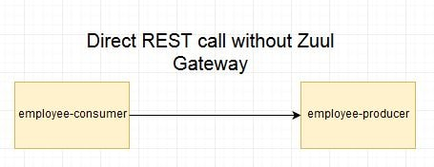
- Microservice call with Netflix Zuul
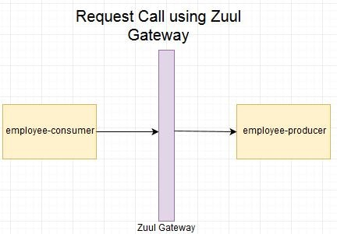
- Microservice call with Netflix Zuul + Netflix Eureka
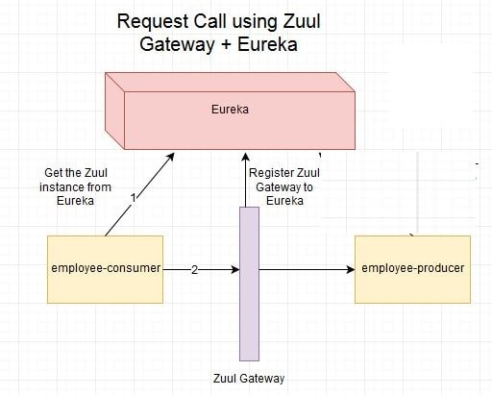

How will you trace or monitor the request in Microservices?

Distributed tracing is used to monitor or trace the request.

Distributed tracing is a technique to monitor and profile the applications, especially those built using microservice architecture. It is also known as distributed request tracing. Developers use distributed tracing to debug and optimize the code.
If we want to solve a problem or debug a problem, we need a centralized server. So the term distributed tracing comes into existence.

Spring Cloud Sleuth with Zipkin. Spring Cloud Sleuth assigns a unique Id to each request that we have made. We can trace all the requests based on unique Ids across all the components.

Spring Cloud Sleuth is a Spring Cloud library that provides the ability to track the progress of subsequent microservices by adding trace and span Ids on the appropriate HTTP request headers. The Sleuth library is based on the MDC (Mapped Diagnostic Context) concept, where we can easily extract values, put to context, and display them in the log.

Zipkin
Zipkin is an open-source, Java-based distributed tracing system. It has a management console that provides a mechanism for sending, receiving, storing, and visualizing traces details of the subsequent services.
With the help of the Zipkin server, we can put all the logs of all the components in the MQ (RabbitMQ). We send the logs to the Zipkin server where the logs consolidate. After doing this, we can monitor different requests. We can also find what is happening to a specific request.

Implementing distributed tracing Using Spring Cloud Sleuth
In this step, we will add Spring Cloud Sleuth for all the microservices. It adds a unique Id to all the requests. It is used to generate and attach the trace Id, span Id to the logs so that tools (Zipkin) can use these ids.
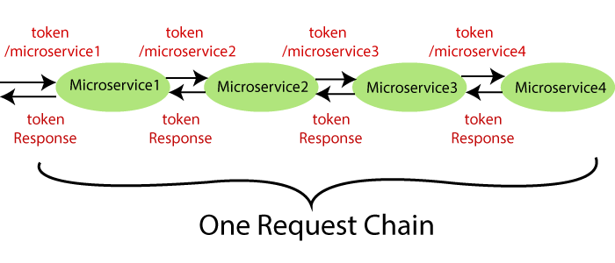
The Spring Cloud Sleuth token has the following components:
- Application name: The name of the application that is defined in the properties file.
- Trace Id: The Sleuth adds the Trace Id. It remains the same in all services for a given request.
- Span Id: The Sleuth also adds the Span Id. It remains the same in a unit of work but different for different services for a given request.
- Zipkin Export Flag: It indicates a boolean value. It can be either true or
The following figure shows the Spring Cloud Sleuth token.
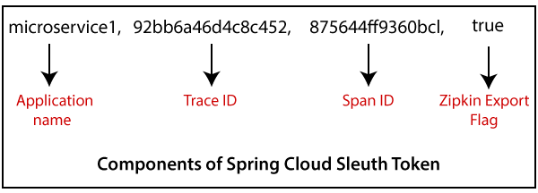

Steps:-

  - Select the project which you implemented the gateway server. Open the pom.xml file add the following dependency.

<dependency>
<groupId>org.springframework.cloud</groupId>
<artifactId>spring-cloud-starter-sleuth</artifactId>
</dependency>

  - Now we need to trace all the requests. If we want to trace all the requests, we would need to create ALWAYS_SAMPLE. We can create a Sampler by using a Bean.
  - Sampler:-

Distributed tracing may have a very high volume of data, so the sampling is important in distributed tracing. Spring Cloud Sleuth provides a Sampler strategy. With the help of Sampler, we can implement the sampling algorithm that provides control of the algorithm. By default, we get a procedure that continuously performs the tracing if a span (correlation: is an individual operation) is already active.
When we export span data to the Zipkin or Spring Cloud Stream, Spring Cloud Sleuth provides AlwaysSampler class that exports everything to the Zipkin. It also provides a PercentageBasedSampler class that samples a fixed fraction of span.
- @Bean
- public Sampler defaultSampler()
- {
- return Sampler.ALWAYS_SAMPLE;
- }

  - Open a main gateway application and add the above sampler code.

  - Same steps repeat for all the microservices running in your project.

  - If you not added the logger then add the logger for specific request.

  - Launch the application in the order.

  - And check the response in the console.

Spring Cloud Sleuth assigns a trace Id to the request. We can use this Id to trace the requests across multiple components. But there is a problem that this log is distributed in multiple places. We use Zipkin to remove this problem. With the help of Zipkin, we can centralize the logs in one place.

We have installed Spring Cloud Sleuth dependency in gateway and microservices application. We have seen that a unique Id was being assigned to each request. We use these Id to trace the request across the logs of these multiple services.
However, we face a challenge in tracing. If we want to trace a request, we have to check the log of the individual application. The solution to this problem is called centralized logs.
We need to centralize all the logs from all the microservices. We can search through Id assigned by Spring Cloud Sleuth. At the centralized place, we will able to search and find out what is happening to a specific request.

There are the following solutions for centralize logging:
- ELK Stack (Elastic Search)
- Kibana
- Zipkin

Zipkin is used to centralize the logs which is easy to trace the requests. In this distributed tracing, we will use Zipkin distribute tracing server. It gives us a consolidated view of all the microservices. We get all the logs messages form the individual microservices. The Zipkin server collects the log messages. All the microservices puts the log messages on the queue called RabbitMQ, and the Zipkin picks these log messages from the RabbitMQ. The Zipkin tracing server is connected with the database.

RabbitMQ:-
RabbitMQ is widely deployed open-source message broker software that implements Advanced Message Queuing Protocol (AQMP). It is lightweight and easy to deploy in the cloud. It supports multiple messaging protocols. It can be deployed in a distributed environment to meet high-scale and high-availability requirements. It is modeled on the AMQP standard. The RabbitMQ is written in the Erlang programming language. It is developed on the Open Telecom Platform (OTP) framework for clustering and failover.

Message broker
A message broker sits between the machine and the distributed computing system. Instead of passing the messages directly to the receiver, the messages are first sent to the message broker (RabbitMQ). The message broker orders the messages in an optimized queue and passes them to the receiving machine when the machines are ready to process the messages.
A message might be a command to process an order, run a specified task, a pull request made to a database.
The machine that sends the message is called the producer. The machine that receives the message is called the consumer. The bit in the middle is called thebroker.

Message broker does the following:
- Decouple the message publisher and consumer
- Store the message
- Routing the message
- Monitoring and management of message
- Transform message format between producer and consumer

- Download install Rabbit MQ
- Start the Rabbit MQ server
- Download and install Zipkin server and check the zipkin server is running or not.
- Open the browser and type http://localhost:9411/zipkin/. It shows the dashboard of the Zipkin server. Here, the port 9411 is the default port of the Zipkin server.
Note:-
Here, the most important thing is that the Zipkin server must listen over the RabbitMQ server. So we have to start the RabbitMQ server in the background. If you have not started then start by typing the below commands
Kill the Zipkin server by pressing the keys Ctrl+c.
Run the following commands in the Command Prompt:
- C:\>SET RABBIT_URI=amqp://localhost
- C:\> java -jar zipkin-server-2.12.9-exec.jar

- Start the Zipkin server
- Now connect the Microservices to zipkin. Open all the microservices pom.xml file and add the dependencies below

We want to create a message in the format that it excepts. We need to add Zipkin dependency.
<dependency>
<groupId>org.springframework.cloud</groupId>
<artifactId>spring-cloud-starter-zipkin</artifactId>
</dependency>
We will send the message to Zipkin that uses amqp message protocol. So we need to add the amqp dependency. Adding the dependency of amqp, we get the connection of RabbitMQ into currency-conversion-service, currency-exchange-service, and the netflix-zuul-api-gateway-server.
<dependency>
<groupId>org.springframework.amqp</groupId>
<artifactId>spring-rabbit</artifactId>
</dependency>

- Now will try to run all the microservices in the order.
- Invoke the request consider the example http://localhost:8100/currency-converter-feign/from/EUR/to/INR/quantity/100. It returns the response properly.
- Open the Zipkin UI. It shows all the three services that we have connected to Zipkin.

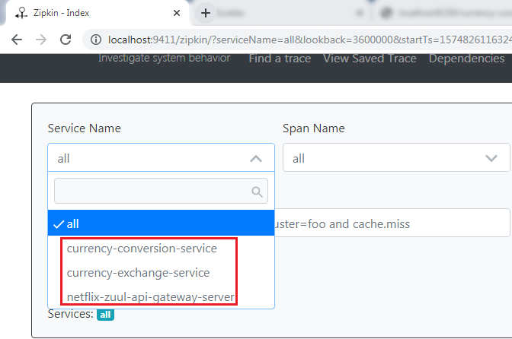
- Select any one service from the dropdown list and click on the Find Traces button. We have selected a currency-conversion-service. It shows the list of different execution of currency-conversion-service.
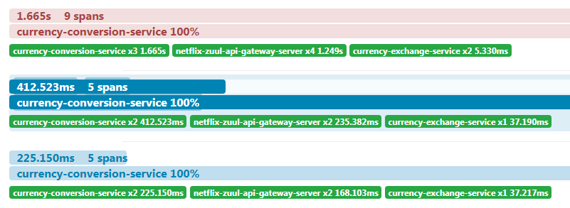
- Select any one of them. It shows the entire trace of a service.
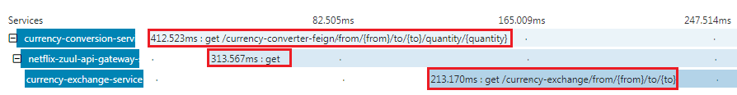
In the above figure, when we invoke the currency-converter-feign, the request first goes to the API Gateway, and the API Gateway sends the request to the currency-exchange-service.
We can also see the detail of the services. In the following image, we have shown the details of the currency-exchange-service.
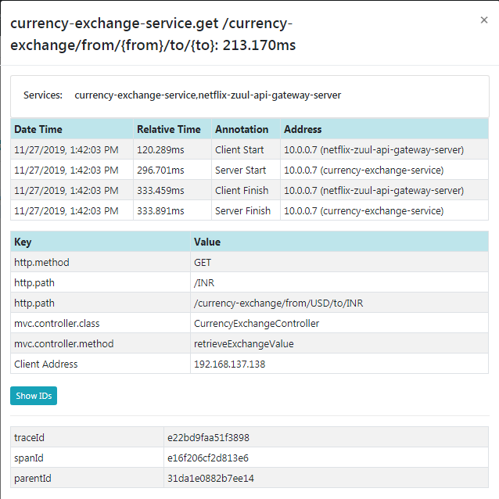
The most important challenge in microservices is to bring visibility (what is happening in the background). Hence, the Zipkin server enables the visibility of the services.

What is Spring Cloud Bus? Need for it?
A: Consider the scenario that we have multiple applications reading the properties using the Spring Cloud Config and the Spring Cloud Config in turn reads these properties from GIT.
Consider the below example where multiple employee producer modules are getting the property for Eureka Registration from Employee Config Module.
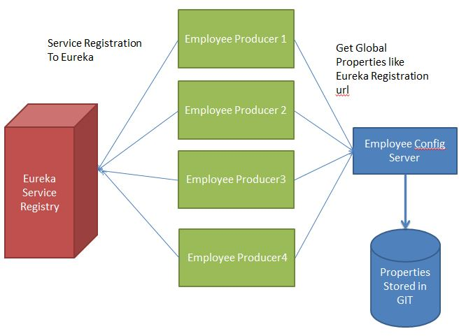
What will happen if suppose the eureka registration property in GIT changes to point to another Eureka server. In such a scenario we will have to restart the services to get the updated properties. There is another way of using Actuator Endpoint /refresh. But we will have to individually call this url for each of the modules. For example if Employee Producer1 is deployed on port 8080 then call http://localhost:8080/refresh. Similarly for Employee Producer2 http://localhost:8081/refresh and so on. This is again cumbersome. This is where Spring Cloud Bus comes into picture.
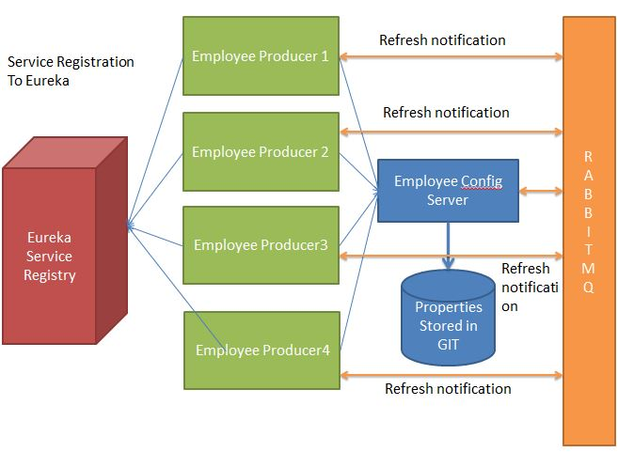
The Spring Cloud Bus provides feature to refresh configurations across multiple instances. So in above example if we refresh for Employee Producer1, then it will automatically refresh for all other required modules. This is particularly useful if we are having multiple microservice up and running. This is achieved by connecting all microservices to a single message broker. Whenever an instance is refreshed, this event is subscribed to all the microservices listening to this broker and they also get refreshed. The refresh to any single instance can be made by using the endpoint /bus/refresh.

Implementing Spring Cloud Bus
In this section, when we make the changes in the Git repository, we have to hit multiple instances of the limits-service to refresh the configuration.
We will invoke one URL, and it will reflect all the hundred instances of the microservices. Here we will use Spring Cloud Bus. There are many options available in the Spring Cloud Bus: Apache Kafka, RabbitMQ, etc. In this section, we will use RabbitMQ.
Note: Before moving to the next step, make sure that the RabbitMQ server is running in the background.
Let’s implement the Spring Cloud Bus in limits-service and spring-cloud-config-server.
Step 1: Open the pom.xml file of limits-service and spring-cloud-config-server project. Add the amqp dependency and save the file to reflect the changes.
- <dependency>
- <groupId>org.springframework.cloud</groupId>
- <artifactId>spring-cloud-starter-bus-amqp</artifactId>
- </dependency>
Step 2: Open bootstrap.properties file and disable the management security by adding the following statement:
dependency and save the file to reflect the changes.
- management.security.enabled=false
- spring.cloud.bus.enabled=true
- management.endpoints.web.exposure.include=bus-refresh
Step 3: First, run the SpringCloudConfigServerApplication.java file and then run the two instances of limits-service: LimitsServiceApplication and LimitsServiceApplication8081.
Step 5: Invoke the URL http://localhost:8080/limits. It returns the following response:
dependency and save the file to reflect the changes.
- {"maximum":222,"minimum":22}
Now, invoke the URL http://localhost:8081/limits. It also returns the same response.
Step 6: Open the limits-service-qa.properties file and change the minimum value from 22 to 29.
Now we have to commit the changes.
Step 7: Open the Postman and send a POST request with the URL http://localhost:8080/bus/refresh.
Note: If you are using Spring Boot 2.0.0 or above versions, use the following URL:
http://localhost:8080/actuator/bus-refresh
Step 8: Open the browser and invoke both instances (http://localhost:8080/limits and http://localhost:8081/limits) of limits-service. Both the URLs return the updated value that we have configured in the limits-service-qa.properties file.
- {"maximum":222,"minimum":29}
We have seen that the minimum value changes to 29. Here, you can notice that we have not committed the changes in the Git repository manually, but the changes reflect in both instances of limits-service.
Instead of committing the Git repository, we have invoked a URL http://localhost:8080/actuator/bus-refresh. All this happening due to Spring Cloud Bus.
In the specific instance, we have run the Spring Cloud Bus over RabbitMQ. When we start the application, it also starts with that. After starting the Spring Cloud Bus, all the microservices registers with the Bus.
When we make changes in configuration, and the changes are called on any of the instances, the microservice sends an event over the Spring Cloud Bus. The Spring Cloud Bus propagates that event to all the microservice instances that are registered with it.

In which business scenario to use Netflix Hystrix ?

Hystrix is a library that controls the interaction between microservices to provide latency and fault tolerance.
Usually for systems developed using Microservices architecture, there are many microservices involved. These microservices collaborate with each other.
Consider the following microservices-
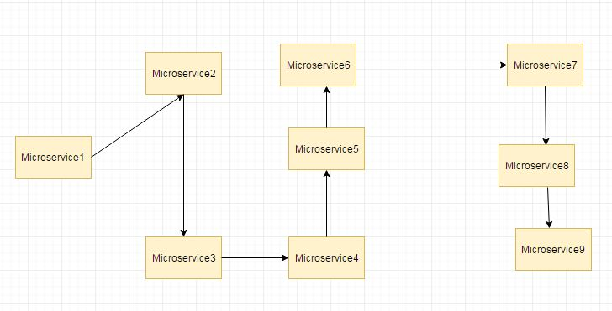
Suppose if the microservice 9 in the above diagram failed, then using the traditional approach we will propagate an exception. But this will still cause the whole system to crash anyways.
This problem gets more complex as the number of microservices increase. The number of microservices can be as high as 1000. This is where hystrix comes into picture-
We will be using two features of Hystrix-
- Fallback method
- Circuit Breaker

Implementing Fault Tolerance with Hystrix
Step 1: Open the pom.xml file of limits-service and add the Hystrix dependency
- <dependency>
- <groupId>org.springframework.cloud</groupId>
- <artifactId>spring-cloud-starter-netflix-hystrix</artifactId>
- </dependency>
Step 2: Open LimitsServicesApplication.java file and enable Hystrix by using the annotation @EnableHystrix.
LimitsServicesApplication.java
- package com.javatpoint.microservices.limitsservice;
- import org.springframework.boot.SpringApplication;
- import org.springframework.boot.autoconfigure.SpringBootApplication;
- import org.springframework.cloud.netflix.hystrix.EnableHystrix;
- @SpringBootApplication
- @EnableHystrix
- public class LimitsServiceApplication
- {
- public static void main(String[] args)
- {
- SpringApplication.run(LimitsServiceApplication.class, args);
- }
- }
Step 3: Open the LimitsConfigurationController.java file and create a Get method.
- @GetMapping("/fault-tolerance-example")
- //configuring a fallback method
- @HystrixCommand(fallbackMethod="fallbackRetrieveConfigurations")
- public LimitConfiguration retrieveConfigurations()
- {
- throw new RuntimeException("Not Available");
- }
- //defining the fallback method
- public LimitConfiguration fallbackRetrieveConfigurations()
- {
- //returning the default configuration
- return new LimitConfiguration(999, 9);
- }
Let’s understand what is happening in the above method.
In the above method, we have created a Get mapping for fault tolerance. In the next line, we have used an annotation @HystrixCommand to configure the fallback method. We have defined a method with the name fallbackRetrieveConfigurations() that returns the default value if any fault occurs.
Fallback method
The fallback method is a method that invokes when a fault occurs. Hystrix allows us to define a fallback method for each service method. Here one question arises that if the method throws an exception, what should be returned to the consumer?
So answer is that if retrieveConfiguraions() fails, the method fallbackRetrieveConfigurations() is called. The fallback method returns the hardcoded LimitConfiguration instance.
Step 4: Open the browser and invoke the URL http://localhost:8080/fault-tolerance-example. It returns the values that we have returned in the fallbackRetrieveConfigurations() method.
