Actions are the mechanism used to provide workflow automation within the GitHub environment.
They're often used to build continuous integration (CI) and continuous deployment (CD) solutions.
However, they can be used for a wide variety of tasks:
- Automated testing.
- Automatically responding to new issues, mentions.
- Triggering code reviews.
- Handling pull requests.
- Branch management.
They're defined in YAML and stay within GitHub repositories.
Actions are executed on "runners," either hosted by GitHub or self-hosted.

Explore Actions flow
Completed100 XP
- 1 minute
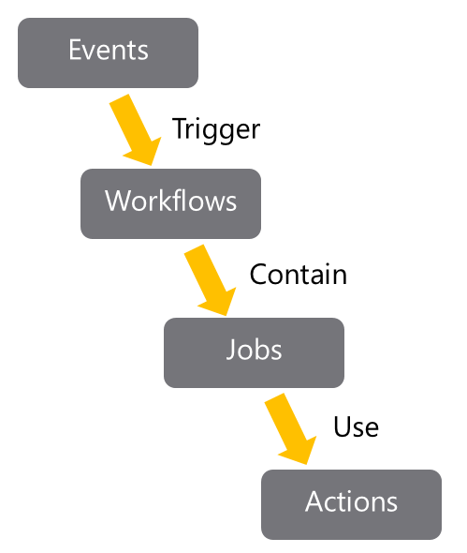
GitHub tracks events that occur. Events can trigger the start of workflows.
Workflows can also start on cron-based schedules and can be triggered by events outside of GitHub.
They can be manually triggered.
Workflows are the unit of automation. They contain Jobs.
Jobs use Actions to get work done.

Understand workflows
Completed100 XP
- 2 minutes
Workflows define the automation required. It details the events that should trigger the workflow.
Also, define the jobs that should run when the workflow is triggered.
The job defines the location in which the actions will run, like which runner to use.
Workflows are written in YAML and live within a GitHub repository at the place .github/workflows.
Example workflow:
YAMLCopy
# .github/workflows/build.yml
name: Node Build.

on: [push]

jobs:
mainbuild:

runs-on: ${{ matrix.os }}

strategy:
matrix:
node-version: [12.x]
os: [windows-latest]

steps:

- uses: actions/checkout@v1
- name: Run node.js on latest Windows.
uses: actions/setup-node@v1
with:
node-version: ${{ matrix.node-version }}

- name: Install NPM and build.
run: |
npm ci
npm run build

You can find a set of starter workflows here: Starter Workflows.
You can see the allowable syntax for workflows here: Workflow syntax for GitHub Actions.

Workflows include several standard syntax elements.
- Name: is the name of the workflow. It's optional but is highly recommended. It appears in several places within the GitHub UI.
- On: is the event or list of events that will trigger the workflow.
- Jobs: is the list of jobs to be executed. Workflows can contain one or more jobs.
- Runs-on: tells Actions which runner to use.
- Steps: It's the list of steps for the job. Steps within a job execute on the same runner.
- Uses: tells Actions, which predefined action needs to be retrieved. For example, you might have an action that installs node.js.
- Run: tells the job to execute a command on the runner. For example, you might execute an NPM command.

Explore events
Completed100 XP
- 2 minutes
Events are implemented by the on clause in a workflow definition.
There are several types of events that can trigger workflows.

Scheduled events
With this type of trigger, a cron schedule needs to be provided.
YAMLCopy
on:
schedule:

- cron: '0 8-17 * * 1-5'

Cron schedules are based on five values:
- Minute (0 - 59)
- Hour (0 - 23)
- Day of the month (1 - 31)
- Month (1 - 12)
- Day of the week (0 - 6)
Aliases for the months are JAN-DEC and for days of the week are SUN-SAT.
A wild card means any. (* is a special value in YAML, so the cron string will need to be quoted)
So, in the example above, the schedule would be 8 AM - 5 PM Monday to Friday.

Code events
Code events will trigger most actions. It occurs when an event of interest occurs in the repository.
YAMLCopy
on:
pull_request

The above event would fire when a pull request occurs.
YAMLCopy
on:
[push, pull_request]

The above event would fire when either a push or a pull request occurs.
YAMLCopy
on:
pull_request:
branches:

- develop

The event shows how to be specific about the section of the code that is relevant.
In this case, it will fire when a pull request is made in the develop branch.

Manual events
There's a unique event that is used to trigger workflow runs manually. You should use the workflow_dispatch event.
Your workflow must be in the default branch for the repository.

Webhook events
Workflows can be executed when a GitHub webhook is called.
YAMLCopy
on:
gollum

This event would fire when someone updates (or first creates) a Wiki page.

External events
Events can be on repository_dispatch. That allows events to fire from external systems.

Explore jobs
Completed100 XP
- 2 minutes
Workflows contain one or more jobs. A job is a set of steps that will be run in order on a runner.
Steps within a job execute on the same runner and share the same filesystem.
The logs produced by jobs are searchable, and artifacts produced can be saved.

Jobs with dependencies
By default, if a workflow contains multiple jobs, they run in parallel.
YAMLCopy
jobs:
startup:
runs-on: ubuntu-latest
steps:

- run: ./setup_server_configuration.sh
build:
steps:

- run: ./build_new_server.sh

Sometimes you might need one job to wait for another job to complete.
You can do that by defining dependencies between the jobs.
YAMLCopy
jobs:
startup:
runs-on: ubuntu-latest
steps:

- run: ./setup_server_configuration.sh
build:
needs: startup
steps:

- run: ./build_new_server.sh

Explore runners
Completed100 XP
- 2 minutes
When you execute jobs, the steps execute on a Runner.
The steps can be the execution of a shell script or the execution of a predefined Action.
GitHub provides several hosted runners to avoid you needing to spin up your infrastructure to run actions.
Now, the maximum duration of a job is 6 hours, and for a workflow is 72 hours.
For JavaScript code, you have implementations of node.js on:
- Windows
- macOS
- Linux
If you need to use other languages, a Docker container can be used. Now, the Docker container support is only Linux-based.
These options allow you to write in whatever language you prefer.
JavaScript actions will be faster (no container needs to be used) and more versatile runtime.
The GitHub UI is also better for working with JavaScript actions.

Self-hosted runners
If you need different configurations to the ones provided, you can create a self-hosted runner.
GitHub has published the source code for self-hosted runners as open-source, and you can find it here: https://github.com/actions/runner.
It allows you to customize the runner completely. However, you then need to maintain (patch, upgrade) the runner system.
Self-hosted runners can be added at different levels within an enterprise:
- Repository-level (single repository).
- Organizational-level (multiple repositories in an organization).
- Enterprise-level (multiple organizations across an enterprise).

GitHub strongly recommends that you don't use self-hosted runners in public repos.
Doing it would be a significant security risk, as you would allow someone (potentially) to run code on your runner within your network.

Examine release and test an action
Completed100 XP
- 4 minutes
Actions will often produce console output. You don't need to connect directly to the runners to retrieve that output.
The console output from actions is available directly from within the GitHub UI.
Select Actions on the top repository menu to see a list of executed workflows to see the output.
Next, click on the job's name to see the steps' output.
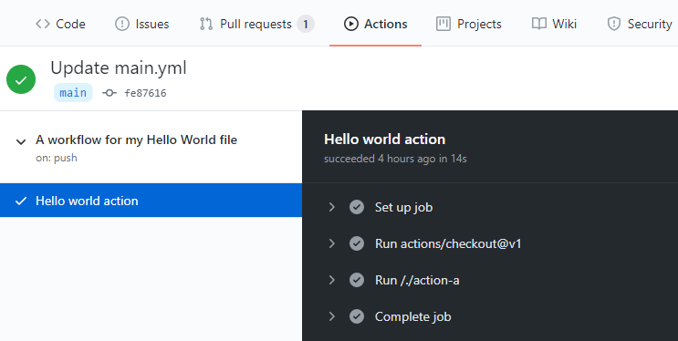
Console output can help debug. If it isn't sufficient, you can also enable more logging. See: Enabling debug logging.

Release Management for Actions
While you might be happy to retrieve the latest version of the action, there are many situations where you might want a specific version of the action.
You can request a specific release of action in several ways:

Tags
Tags allow you to specify the precise versions that you want to work.
YAMLCopy

steps:
-uses: actions/install-timer@v2.0.1

SHA-based hashes
You can specify a requested SHA-based hash for an action. It ensures that the action hasn't changed. However, the downside to this is that you also won't receive updates to the action automatically either.
YAMLCopy
steps:
-uses: actions/install-timer@327239021f7cc39fe7327647b213799853a9eb98

Branches
A common way to request actions is to refer to the branch you want to work with. You'll then get the latest version from that branch. That means you'll benefit from updates, but it also increases the chance of code-breaking.
YAMLCopy
steps:
-uses: actions/install-timer@develop

Test an Action
GitHub offers several learning tools for actions.
GitHub Actions: hello-world
You'll see a basic example of how to:
- Organize and identify workflow files.
- Add executable scripts.
- Create workflow and action blocks.
- Trigger workflows.
- Discover workflow logs.

What is GitHub?
Completed100 XP
- 8 minutes
In this unit, we review the following learning objectives:
- Brief overview of the GitHub Enterprise Platform
- How to create a repository
- Adding files to a repository
- How to search for repositories
- Introduction to gists and wikis

GitHub

GitHub is a cloud-based platform that uses Git, a distributed version control system, at its core. The GitHub platform simplifies the process of collaborating on projects and provides a website, command-line tools, and overall flow that allows developers and users to work together.
As we learned earlier GitHub provides an AI powered developer platform to build, scale, and deliver secure software. Let’s break down each one of the core pillars of the GitHub Enterprise platform, AI, Collaboration, Productivity, Security and Scale.

AI
Generative AI is dramatically transforming software development as we speak.
The GitHub Enterprise platform is enhancing collaboration through AI-powered pull requests and issues, productivity through Copilot, and security by automating security checks faster.

Collaboration
Collaboration at its core of everything GitHub does. We know inefficient collaboration results in wasted time and money. We counteract that with a suite of seamless tools that allow collaboration to happen effortlessly.
Repositories, Issues, Pull Requests, and other tools help to enable developers, project managers, operation leaders, and others at the same company to work faster together, cut down approval times, and ship more quickly.

Productivity
Productivity is accelerated with automation that the GitHub Enterprise Platform provides. With built-in CI/CD tools directly integrated into the workflow, the platform gives users the ability to set tasks and forget them, taking care of routine administration, and speeding up day-to-day work. This gives your developers more time to focus on what matters most: creating innovative solutions.

Security
GitHub focuses on integrating security directly into the development process from the start. GitHub Enterprise platform includes native, first-party security features that minimize security risk with a built-in security solution. Plus, your code remains private within your organization, and at the same time you are able to take advantage of security overview and Dependabot.
GitHub has continued to make investments to ensure that our features are enterprise-ready. We’re backed by Microsoft, trusted by highly regulated industries, and meet compliance requirements globally.

Scale
GitHub is the largest developer community of its kind. With real-time data on over 100M+ developers, 330M+ repositories, and countless deployments, we’ve been able to understand the shifting needs of developers and make changes to our product to match.
This has translated into an incredible scale that is unmatched and unparalleled by any other company on the planet. Everyday we are gaining more and more insights from this impressive community and evolving the platform to meet their needs.
In essence the GitHub Enterprise Platform focuses on the developer experience–it has the scale to provide industry-changing insights, collaboration capabilities for transformative efficiency, the tools for increased productivity, security at every step, and AI to power it all to new heights in a single, integrated platform.
Now let’s get into the backbone of GitHub, repositories.

Introduction to repositories
Let’s first review:
- What is a repository?
- How to create a repository
- Adding files to a repository
- How to search for repositories
- Introduction to gists, wikis, and GitHub pages

What is a repository?
A repository contains all of your project's files and each file's revision history. It is one of the essential parts that helps you collaborate with people. You can use repositories to manage your work, track changes, store revision history and work with others. Before we dive too deep, let’s first start with how to create a repository.

How to create a repository
You can create a new repository on your personal account or any organization where you have sufficient permissions.
Let’s tackle creating a repository from github.com.
- In the upper-right corner of any page, use the drop-down menu, and select New repository.
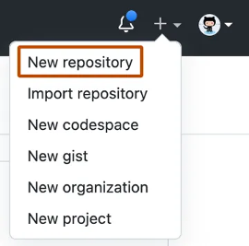
- Use the Owner dropdown menu to select the account you want to own the repository.
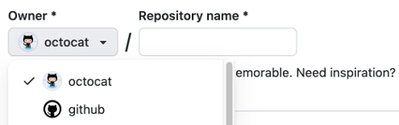
- Type a name for your repository, and an optional description.
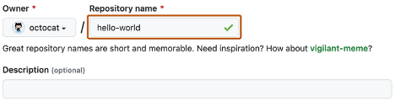
- Choose a repository visibility.
  - Public repositories are accessible to everyone on the internet.
  - Private repositories are only accessible to you, people you explicitly share access with, and, for organization repositories, certain organization members.
- Click Create repository and congratulations! You just created a repository!
Next up, let’s review how to add files to your repository.

How to add a file to your repository
Files in GitHub can do a handful of things, but the main purpose of files is to store data and information about your project.
Let’s review how to add a file to your repository.
But before we begin, it is worth knowing in order to add a file to a repository you must first have minimum Write access within the repository you want to add a file.
- On GitHub.com, navigate to the main page of the repository.
- In your repository, browse to the folder where you want to create a file.
- Above the list of files, select the Add file ᐁ dropdown menu, then click ᐩ Create new file. Alternatively, you can click ᐩ in the file tree view on the left.
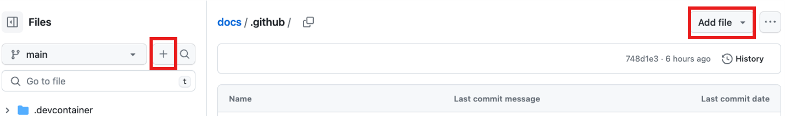
- In the file name field, type the name and extension for the file. To create subdirectories, type the / directory separator.
- In the file contents text box, type content for the file.
- To review the new content, above the file contents, click Preview.
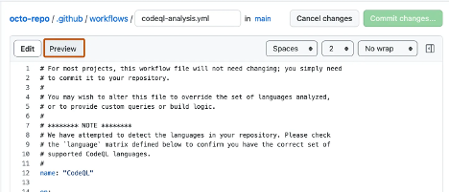
- Click Commit changes...
- In the "Commit message" field, type a short, meaningful commit message that describes the change you made to the file. You can attribute the commit to more than one author in the commit message.
- If you have more than one email address associated with your account on GitHub.com, click the email address drop-down menu and select the email address to use as the Git author email address. Only verified email addresses appear in this drop-down menu. If you enabled email address privacy, then [username]@users.noreply.github.com is the default commit author email address.
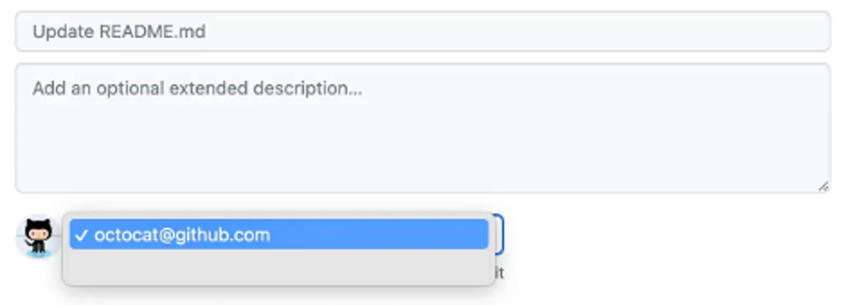
- Below the commit message fields, decide whether to add your commit to the current branch or to a new branch. If your current branch is the default branch, you should choose to create a new branch for your commit and then create a pull request.
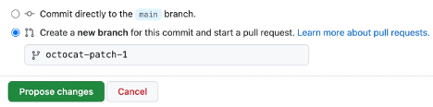
- Click Commit changes or Propose changes.
Congratulations you just created a new file in your repository! You have also created a new branch and made a commit!
But before we review branches and commits in the next unit, let’s quickly review gists, wikis, and GitHub pages because they are similar to repositories.

What are gists
Now that we have a good understanding of repositories, we can review gists. Similarly to repositories, gists are a simplified way to share code snippets with others.
Every gist is a Git repository, which you can fork and clone and can be either public or secret.
Public gists are displayed publicly where people can browse new ones as they’re created. Public gists are also searchable.
Conversely, secret gists are not searchable, but they aren’t entirely private. If you send the URL of a secret gist to a friend, they'll be able to see it.
To learn more about gists see the linked article in our Resources section at the end of this module titled, Creating Gists.

What are wikis?
Every repository on GitHub.com comes equipped with a section for hosting documentation, called a wiki.
You can use your repository's wiki to share long-form content about your project, such as how to use it, how you designed it, or its core principles.
While a README file quickly tells what your project can do, you can use a wiki to provide additional documentation.
It’s worth a reminder that if your repository is private only people who have at least read access to your repository will have access to your wiki.

Components of the GitHub flow
Completed100 XP
- 8 minutes
In this unit, we're reviewing the following components of the GitHub flow:
- Branches
- Commits
- Pull Requests
- The GitHub Flow

What are branches
In the last section, we created a new file in the last section, along the way to you also created a new branch in your repositories.
Branches are an essential part to the GitHub experience because they're where we can make changes without affecting the entire project we're working on.
Your branch is a safe place to experiment with new features or fixes. If you make a mistake, you can revert your changes or push more changes to fix the mistake. Your changes won't update on the default branch until you merge your branch.
Note
Alternatively, you can create a new branch and check it out by simply using git in a terminal the command would be git checkout -b newBranchName

What are commits
As you might have noticed in the previous unit, adding in a new file into the repository, you needed to push a commit.
Let’s briefly review what commits are.
A commit is a change to one or more files on a branch. Every time a commit is created, it's assigned a unique ID and tracked, along with the time and contributor. Commits provide a clear audit trail for anyone reviewing the history of a file or linked item, such as an issue or pull request.
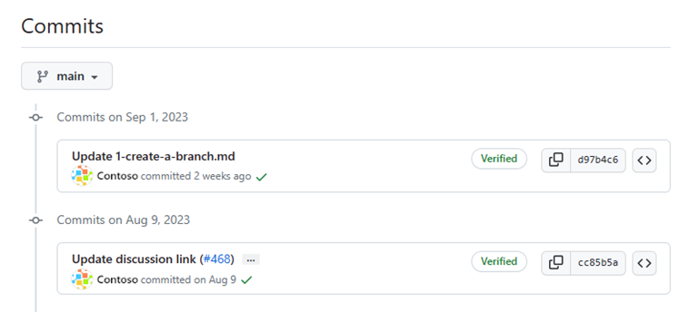
Within a git repository, a file can exist in several valid states as it goes through the version control process:
The primary states for a file in a Git repository are:
Untracked: An initial state of a file when it isn't yet part of the Git repository. Git is unaware of its existence.
Tracked: A tracked file is one that Git is actively monitoring. It can be in one of the following substates:
- Unmodified: The file is tracked, but it hasn't been modified since the last commit.
- Modified: The file has been changed since the last commit, but these changes aren't yet staged for the next commit.
- Staged: The file has been modified, and the changes have been added to the staging area (also known as the index). These changes are ready to be committed.
- Committed: The file is in the repository's database. It represents the latest committed version of the file.
These states and substates are important to collaborating with your team to know where each and every commit is in the process of your project.
Now let’s move on to pull requests.

What are pull requests?
Now that we know what a commit is, let’s review a pull request.
A pull request is the mechanism used to signal that the commits from one branch are ready to be merged into another branch.
The team member submitting the pull request requests one or more reviewers to verify the code and approve the merge. These reviewers have the opportunity to comment on changes, add their own, or use the pull request itself for further discussion.
Once the changes have been approved (if approval is required), the pull request's source branch (the compare branch) is merged into the base branch.
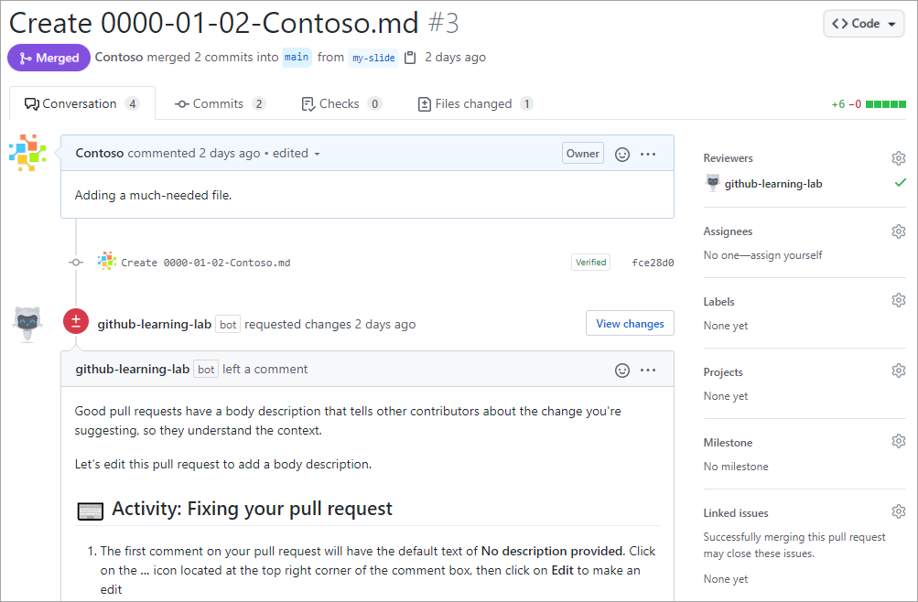
Now that we know of all the ingredients, let’s review the GitHub flow.

The GitHub flow
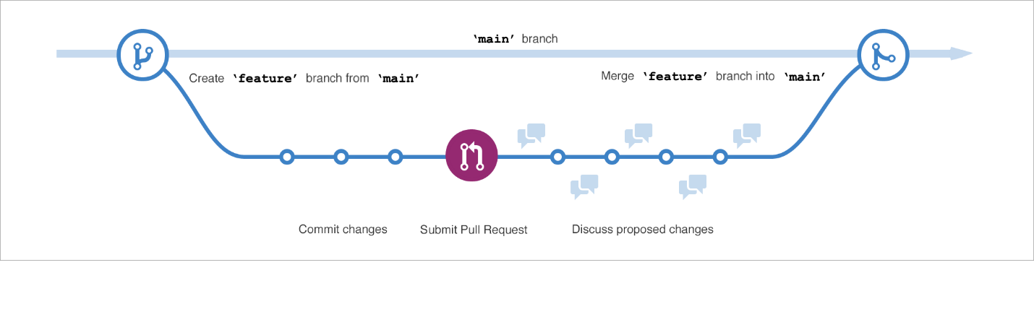
The GitHub flow can be defined as a lightweight workflow that allows for safe experimentation. You can test new ideas and collaboration with your team by using branching, pull requests, and merging.
Now that we know the basics of GitHub we can walk through the GitHub flow and its components.
- The first step of the GitHub flow is creating a branch so that the changes, features, and fixes you create don't affect the main branch.
- The second step is to make your changes. We recommend deploying changes to your feature branch before merging into the main branch. Doing so ensures the changes are valid in a production environment.
- The third step is to create a pull request to ask collaborators for feedback. Pull request review is so valuable that some repositories require an approving review before pull requests can be merged.
- Next is the fourth step of reviewing and implementing your feedback from your collaborators.
- The fifth step, once you’re feeling great about your changes now it's time to get your pull request approved and merge it into the main branch.
- The sixth and final step is to delete your branch. Deleting your branch signals your work on the branch is completed and prevents you or others from accidentally using old branches.
And that’s it, you’ve been through a GitHub flow cycle!
Let’s move onto the next section where we’ll cover the differences between issues and discussions.

GitHub is a collaborative platform
Completed100 XP
- 8 minutes
Like we mentioned earlier, collaboration is at its core of everything GitHub does.
We went over repositories in the first unit of the module and learned that repositories help you organize your project and its files.
The last unit, we learned about pull requests, a way to keep track of changes made to your project.
In this unit, we're learning about issues and discussions, two other pieces that contribute to the collaborative nature of the GitHub Enterprise Platform.

Issues
GitHub Issues were created to track ideas, feedback, tasks, or bugs for work on GitHub.
Issues can be created in various ways, so you can choose the most convenient method for your workflow.
For the walk-through in the next portion, we'll go over how to create an issue from a repository but just know there are a myriad of ways. Here's a list of all the ways you can create issues from.
The different ways to create an issue from:
- a repository
- an item in a task list
- a note in a project
- a comment in an issue or pull request
- a specific line of code
- or a URL query

Creating an issue from a repository
- On GitHub.com, navigate to the main page of the repository.
- Under your repository name, select Issues.
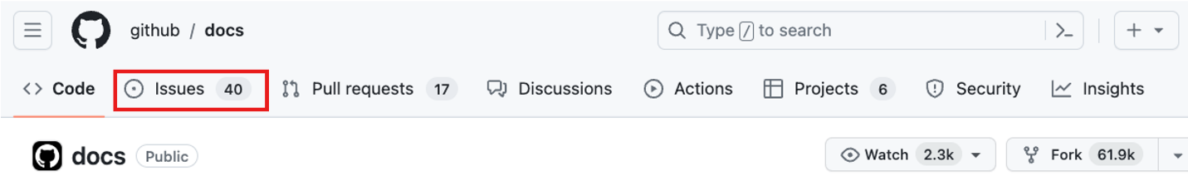
- Select New issue.
- If your repository uses issue templates, next to the type of issue you'd like to open, select Get started.
If the type of issue you'd like to open isn't included in the available options, select Open a blank issue.
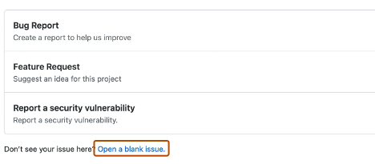
- In the Add a title field, enter a title for your issue.
- In the Add a description field, type a description of your issue.
- If you're a project maintainer, you can assign the issue to someone, add it to a project board, associate it with a milestone, or apply a label.
- When you're finished, select Submit new issue.
Some conversations are more suitable for GitHub Discussions.
You can use GitHub Discussions to ask and answer questions, share information, make announcements, and conduct or participate in conversations about a project.
In the next section, we’ll review Discussions and how to best utilize the feature.

Discussions
Discussions are for conversations that need to be accessible to everyone and aren't related to code. Discussions enable fluid, open conversation in a public forum.
In this section we're going over:
- Enabling a discussion in your repository
- Creating a new discussion and various discussion categories
Let’s dive into enabling a discussion in your repository.

Enabling a discussion in your repository
Repository owners and people with Write access can enable GitHub Discussions for a community on their public and private repositories. The visibility of a discussion is inherited from the repository the discussion is created in.
When you first enable GitHub Discussions, you're invited to configure a welcome post.
- On GitHub.com, navigate to the main page of the repository.
- Under your repository name, select Settings.
- Scroll down to the Features section and under Discussions, select Setup discussions.
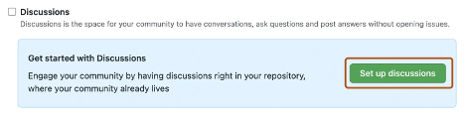
- Under Start a new discussion, edit the template to align with the resources and tone you want to set for your community.
- Select Start discussion.
You're now ready to create a new discussion.

Create a new discussion
Any authenticated user who can view the repository can create a discussion in that repository.
Similarly, since organization discussions are based on a source repository, any authenticated user who can view the source repository can create a discussion in that organization.
- On GitHub.com, navigate to the main page of the repository or organization where you want to start a discussion.
- Under your repository or organization name, select Discussions.
- On the right side of the page, select New discussion.
- Select a discussion category by selecting Get started. All discussions must be created in a category. For repository discussions, people with maintain or admin permissions to the repository define the categories for discussions in that repository.
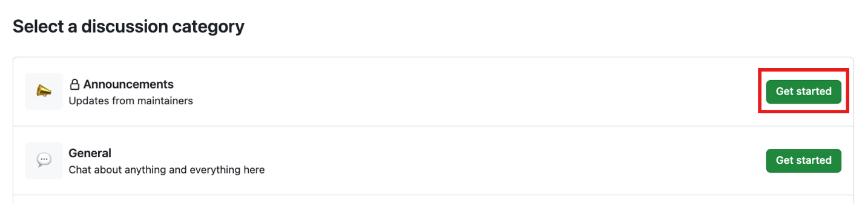
Each category must have a unique name and emoji pairing, and a detailed description stating its purpose. Categories help maintainers organize how conversations are filed and are customizable to help distinguish categories that are Q&A or more open-ended conversations. The following table shows the default categories for discussions and their purpose.
Expand table
Category | Purpose | Format
📣 Announcements | Updates and news from project maintainers | Announcement
#️⃣ General | Anything and everything relevant to the project | Open-ended discussion
💡 Ideas | Ideas to change or improve the project | Open-ended discussion
🗳️ Polls | Polls with multiple options for the community to vote for and discuss | Polls
🙏 Q&A | Questions for the community to answer, with a question/answer format | Question and Answer
🙌 Show and tell | Creations, experiments, or tests relevant to the project | Open-ended discussion
- Under Discussion title enter a title for your discussion, and under Write enter the body of your discussion.
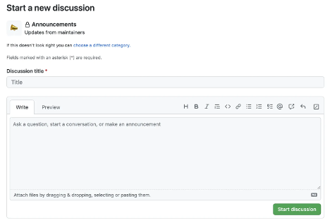
- Select Start discussion.
That covers a little about how GitHub inspires collaboration. Now let's move to how you can manage notifications, subscribe to threads, and get started with GitHub pages.

GitHub platform management
Completed100 XP
- 4 minutes
Now that you know the basics of the GitHub platform, let’s go over some platform management.
In this unit, we're covering:
- Managing notifications and subscriptions
- Subscribing to threads and finding threads you're mentioned in
- Publicizing your or your organization on GitHub pages

Managing notifications and subscriptions
You can choose to receive ongoing updates about specific activity on GitHub.com through a subscription. Notifications are the updates that you receive for specific activity that you're subscribed to.

Subscription options
You can choose to subscribe to notifications for:
- A conversation in a specific issue, pull request, or gist.
- All activity in a repository.
- CI activity, such as the status of workflows in repositories set up with GitHub Actions.
- Repository issues, pull requests, releases, security alerts, or discussions (if enabled).
In some instances, certain scenarios automatically subscribe you to conversations on GitHub. For example, opening a pull request or issue, commenting on a thread, and being assigned to an issue or pull request.
If you're no longer interested in a conversation, you can unsubscribe, unwatch, or customize the types of notifications you'll receive in the future.
If you are ever interested in issues that mention a certain user, you can use “mentions:” as the qualifier to find those specific issues.

What are GitHub Pages?
To round out our journey of GitHub, let’s tackle GitHub pages.
You can use GitHub Pages to publicize and host a website about yourself, your organization, or your project directly from a repository on GitHub.com.
GitHub Pages is a static site hosting service that takes HTML, CSS, and JavaScript files straight from a repository on GitHub. Optionally, you can run the files through a build process and publishes a website.
Just edit and push your changes and voila, your project is live for the public in a visually organized way.
Next up, we'll walk through an exercise to get you started with GitHub.
You will:
- Create a new repository
- Create a new branch
- Commit a file
- Open a pull request
- And merge a pull request

How does GitHub Actions automate development tasks?
Completed100 XP
- 10 minutes
Here, we'll introduce GitHub Actions and workflows. You'll learn the types of actions you can use and where to find them. You'll also look at examples of these types of actions and how they fit in a workflow.

GitHub decreases time from idea to deployment
GitHub is designed to help teams of developers and DevOps engineers build and deploy applications quickly. There are many features in GitHub that enable this, but they generally fall into one of two categories:
- Communication: Consider all of the ways that GitHub makes it easy for a team of developers to communicate about the software development project: code reviews in pull requests, GitHub issues, project boards, wikis, notifications, and so on.
- Automation: GitHub Actions lets your team automate workflows at every step in the software-development process, from integration to delivery to deployment. It even lets you automate adding labels to pull requests and checking for stale issues and pull requests.
When combined, these features have allowed thousands of development teams to effectively decrease the amount of time it takes from their initial idea to deployment.

Use workflow automation to decrease development time
We'll focus on automation in this module, so let's take a moment to understand how teams can use automation to reduce the amount of time it takes to complete a typical development and deployment workflow.
Consider all of the tasks that must happen after the code is written, but before you can reliably use the code for its intended purpose. Depending on your organization's goals, you'll likely need to perform one or more of the following tasks:
- Ensure the code passes all unit tests
- Perform code quality and compliance checks to make sure the source code meets the organization's standards
- Check the code and its dependencies for known security issues
- Build the code integrating new source from (potentially) multiple contributors
- Ensure the software passes integration tests
- Version the new build
- Deliver the new binaries to the appropriate filesystem location
- Deploy the new binaries to one or more servers
- If any of these tasks don't pass, report the issue to the proper individual or team for resolution
The challenge is to do these tasks reliably, consistently, and in a sustainable manner. This is an ideal job for workflow automation. If you're already relying on GitHub, you'll likely want to set up your workflow automation using GitHub Actions.

What is GitHub Actions?
GitHub Actions are packaged scripts to automate tasks in a software-development workflow in GitHub. You can configure GitHub Actions to trigger complex workflows that meet your organization's needs; each time developers check new source code into a specific branch, at timed intervals, or manually. The result is a reliable and sustainable automated workflow, which leads to a significant decrease in development time.

Where can you find GitHub Actions?
GitHub Actions are scripts that adhere to a yml data format. Each repository has an Actions tab that provides a quick and easy way to get started with setting up your first script. If you see a workflow that you think might be a great starting point, just select the Configure button to add the script and begin editing the source yml.
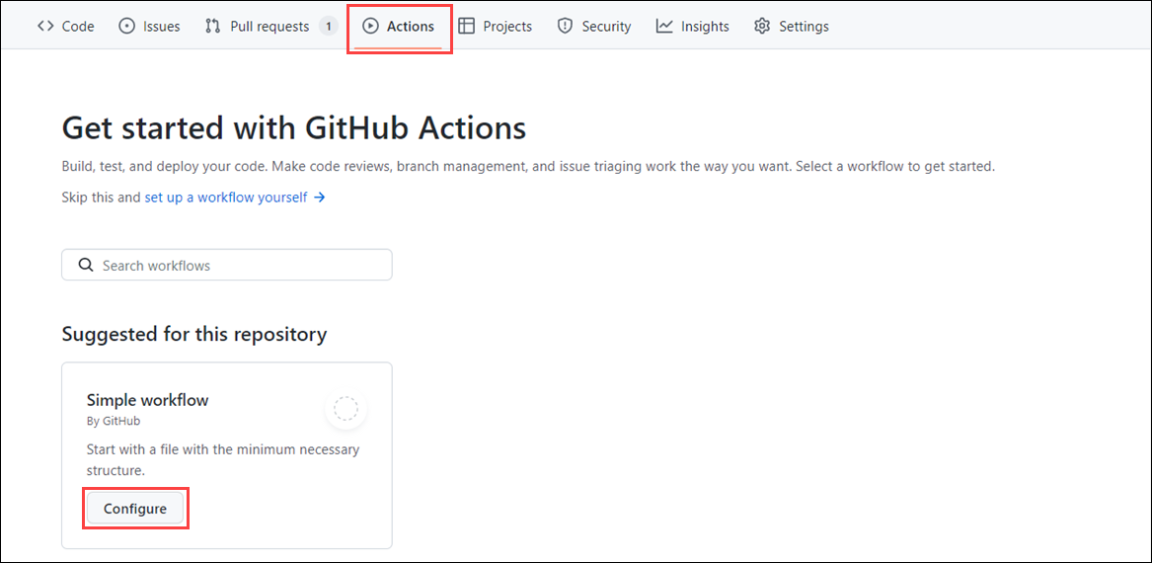
However, beyond those GitHub Actions featured on the Actions tab, you can:
- Search for GitHub Actions in the GitHub Marketplace. The GitHub Marketplace allows you to discover and purchase tools that extend your workflow.
- Search for open-source projects. For example, the GitHub Actions organization features many popular open-source repos containing GitHub Actions you can use.
- Write your own GitHub Actions from scratch. Furthermore, if you want, you could make them open source, or even publish them to the GitHub Marketplace.

Using open-source GitHub Actions
Many GitHub Actions are open source and available for anyone who wants to use them. However, just like with any open-source software, you need to carefully check them before using them in your project. Similar to recommended community standards with open-source software—such as including a README, code of conduct, contributing file, and issue templates, just to name a few—you can follow these recommendations when using GitHub Actions:
- Review the action's action.yml file for inputs, outputs, and to make sure the code does what it says it does.
- Check if the action is in the GitHub Marketplace. This is a good check, even if an action does not have to be on the GitHub Marketplace to be valid.
- Check if the action is verified in the GitHub Marketplace. This means that GitHub has approved the use of this action. However, you should still review it before using it.
- Include the version of the action you're using by specifying a Git ref, SHA, or tag.

Types of GitHub actions
There are three types of GitHub actions: container actions, JavaScript actions, and composite actions.
With container actions, the environment is part of the action's code. These actions can only be run in a Linux environment that GitHub hosts. Container actions support many different languages.
JavaScript actions don't include the environment in the code. You'll have to specify the environment to execute these actions. You can run these actions in a VM in the cloud or on-premises. JavaScript actions support Linux, macOS, and Windows environments.
Composite actions allow you to combine multiple workflow steps within one action. For example, you can use this feature to bundle together multiple run commands into an action, and then have a workflow that executes the bundled commands as a single step using that action.

The anatomy of a GitHub action
Here's an example of an action that performs a git checkout of a repository. This action, actions/checkout@v1, is part of a step in a workflow. This step also builds the Node.js code that was checked out. We'll talk about workflows, jobs, and steps in the next section.
ymlCopy
steps:
- uses: actions/checkout@v1
- name: npm install and build webpack
run: |
npm install
npm run build
Suppose you want to use a container action to run containerized code. Your action might look like this:
ymlCopy
name: "Hello Actions"
description: "Greet someone"
author: "octocat@github.com"

inputs:
MY_NAME:
description: "Who to greet"
required: true
default: "World"

runs:
uses: "docker"
image: "Dockerfile"

branding:
icon: "mic"
color: "purple"
Notice the inputs section. Here, you're getting the value of a variable called MY_NAME. This variable will be set in the workflow that runs this action.
In the runs section, notice you specify docker in the uses attribute. When you do this, you'll need to provide the path to the Docker image file. Here, it's called Dockerfile. We won't get into the specifics of Docker here, but if you'd like more information, check out the Introduction to Docker Containers module.
The last section, branding, personalizes your action in the GitHub Marketplace if you decide to publish it there.
You can find a complete list of action metadata at Metadata syntax for GitHub Actions.

What is a GitHub Actions workflow?
A GitHub Actions workflow is a process that you set up in your repository to automate software-development lifecycle tasks, including GitHub Actions. With a workflow, you can build, test, package, release, and deploy any project on GitHub.
To create a workflow, you add actions to a .yml file in the .github/workflows directory in your GitHub repository.
In the exercise coming up, your workflow file, main.yml, will look like this:
ymlCopy
name: A workflow for my Hello World file
on: push
jobs:
build:
name: Hello world action
runs-on: ubuntu-latest
steps:
- uses: actions/checkout@v1
- uses: ./action-a
with:
MY_NAME: "Mona"
Notice the on: attribute. This is a trigger to specify when this workflow will run. Here, it triggers a run when there's a push event to your repository. You can specify single events like on: push, an array of events like on: [push, pull_request], or an event-configuration map that schedules a workflow or restricts the execution of a workflow to specific files, tags, or branch changes. The map might look something like this:
ymlCopy
on:
# Trigger the workflow on push or pull request,
# but only for the main branch
push:
branches:
- main
pull_request:
branches:
- main
# Also trigger on page_build, as well as release created events
page_build:
release:
types: # This configuration does not affect the page_build event above
- created
An event will trigger on all activity types for the event unless you specify the type or types. For a comprehensive list of events and their activity types, see: Events that trigger workflows in the GitHub documentation.
A workflow must have at least one job. A job is a section of the workflow associated with a runner. A runner can be GitHub-hosted or self-hosted, and the job can run on a machine or in a container. You'll specify the runner with the runs-on: attribute. Here, you're telling the workflow to run this job on ubuntu-latest.
Each job will have steps to complete. In our example, the step uses the action actions/checkout@v1 to check out the repository. What's interesting is the uses: ./action-a value, which is the path to the container action that you build in an action.yml file. We looked at the contents of an action.yml file in the What is GitHub Actions? section.
The last part of this workflow file sets the MY_NAME variable value for this workflow. Recall the container action took an input called MY_NAME.
For more information on workflow syntax, see Workflow syntax for GitHub Actions

GitHub-hosted versus self-hosted runners
We briefly mentioned runners as being associated with a job. A runner is simply a server that has the GitHub Actions runner application installed. In the previous workflow example, there was a runs-on: ubuntu-latest attribute within the jobs block, which told the workflow that the job will run using the GitHub-hosted runner that's running in the ubuntu-latest environment.
When it comes to runners, there are two options from which to choose: GitHub-hosted runners or self-hosted runners. If you use a GitHub-hosted runner, each job runs in a fresh instance of a virtual environment that's specified by the GitHub-hosted runner type you define, runs-on: {operating system-version}. With self-hosted runners, you need to apply the self-hosted label, its operating system, and the system architecture. For example, a self-hosted runner with a Linux operating system and ARM32 architecture would look like the following: runs-on: [self-hosted, linux, ARM32].
Each type of runner has its benefits, but GitHub-hosted runners offer a quicker, simpler way to run your workflows, albeit with limited options. Self-hosted runners are a highly configurable way to run workflows in your own custom local environment. You can run self-hosted runners on-premises or in the cloud. You can also use self-hosted runners to create a custom hardware configuration with more processing power or memory to run larger jobs, install software available on your local network, and choose an operating system not offered by GitHub-hosted runners.

GitHub Actions may have usage limits
GitHub Actions has some usage limits, depending on your GitHub plan and whether your runner is GitHub-hosted or self-hosted. For more information on usage limits, check out Usage limits, billing, and administration in the GitHub documentation.

ub Actions
Completed100 XP
- 3 minutes
Here, you'll learn about the basic components of a GitHub Actions workflow file.

The components of GitHub Actions
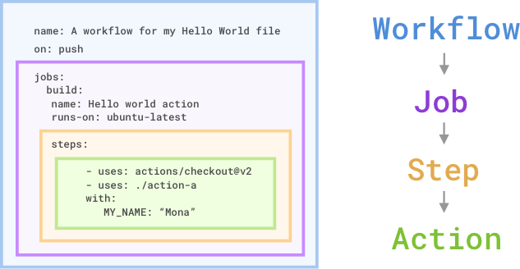
There are several components that work together to run tasks or jobs within a GitHub Actions workflow. In short, an event triggers the workflow, which contains a job. This job then uses steps to dictate which actions will run within the workflow. To better see how these components work together, let's take a quick look at each one.

Workflows
A workflow is an automated process that you add to your repository. A workflow needs to have at least one job, and different events can trigger it. You can use it to build, test, package, release, or deploy your repository's project on GitHub.

Jobs
The job is the first major component within the workflow. A job is a section of the workflow that will be associated with a runner. A runner can be GitHub-hosted or self-hosted, and the job can run on a machine or in a container. You'll specify the runner with the runs-on: attribute. Here, you're telling the workflow to run this job on ubuntu-latest. We'll talk more about runners in the next unit.

Steps
A step is an individual task that can run commands in a job. In our preceding example, the step uses the action actions/checkout@v2 to check out the repository. What's interesting is the uses: ./action-a value. This is the path to the container action that you'll build in an action.yml file.

Actions
The actions inside your workflow are the standalone commands that are executed. These standalone commands can reference GitHub actions such as using your own custom actions, or community actions like the one we use in the preceding example, actions/checkout@v2. You can also run commands such as run: npm install -g bats to execute a command on the runner.

Configure a GitHub Actions workflow
Completed100 XP
- 10 minutes
Here, you'll learn some common configurations within a workflow file. You'll also explore the categories of event types, disabling and deleting workflows, and using specific versions of an action for security best practices.

Configure workflows to run for scheduled events
As mentioned previously, you can configure your workflows to run when specific activity occurs on GitHub, when an event outside of GitHub happens, or at a scheduled time. The schedule event allows you to trigger a workflow to run at specific UTC times using POSIX cron syntax. This cron syntax has five * fields, and each field represents a unit of time.

For example, if you wanted to run a workflow every 15 minutes, the schedule event would look like the following:
ymlCopy
on:
schedule:
- cron: '*/15 * * * *'
And if you wanted to run a workflow every Sunday at 3:00am, the schedule event would look like this:
ymlCopy
on:
schedule:
- cron: '0 3 * * SUN'
You can also use operators to specify a range of values or to dial in your scheduled workflow. The shortest interval you can run scheduled workflows is once every five minutes, and they run on the latest commit on the default or base branch.

Configure workflows to run for manual events
In addition to scheduled events, you can manually trigger a workflow by using the workflow_dispatch event. This event allows you to run the workflow by using the GitHub REST API or by selecting the Run workflow button in the Actions tab within your repository on GitHub. Using workflow_dispatch, you can choose on which branch you want the workflow to run, as well as set optional inputs that GitHub will present as form elements in the UI.
ymlCopy
on:
workflow_dispatch:
inputs:
logLevel:
description: 'Log level'
required: true
default: 'warning'
tags:
description: 'Test scenario tags'
In addition to workflow_dispatch, you can use the GitHub API to trigger a webhook event called repository_dispatch. This event allows you to trigger a workflow for activity that occurs outside of GitHub, and essentially serves as an HTTP request to your repository asking GitHub to trigger a workflow off an action or webhook. Using this manual event requires you to do two things: send a POST request to the GitHub endpoint /repos/{owner}/{repo}/dispatches with the webhook event names in the request body, and configure your workflow to use the repository_dispatch event.
BashCopy
curl \
-X POST \
-H "Accept: application/vnd.github.v3+json" \
https://api.github.com/repos/octocat/hello-world/dispatches \
-d '{"event_type":"event_type"}'
ymlCopy
on:
repository_dispatch:
types: [opened, deleted]

Configure workflows to run for webhook events
Lastly, you can configure a workflow to run when specific webhook events occur on GitHub. You can trigger most webhook events from more than one activity for a webhook, so if multiple activities exist for a webhook, you can specify an activity type to trigger the workflow. For example, you can run a workflow for the check_run event but only for the rerequested or requested_action activity types.
ymlCopy
on:
check_run:
types: [rerequested, requested_action]

Use conditional keywords
Within your workflow file, you can access context information and evaluate expressions. Although expressions are commonly used with the conditional if keyword in a workflow file to determine whether a step should run or not, you can use any supported context and expression to create a conditional. It's important to know that when using conditionals in your workflow, you need to use the specific syntax ${{ <expression> }}, which tells GitHub to evaluate an expression rather than treat it as a string.
For example, a workflow that uses the if conditional to check if the github.ref (the branch or tag ref that triggered the workflow run) matches refs/heads/main in order to proceed with the following steps in the workflow would look something like this:
ymlCopy
name: CI
on: push
jobs:
prod-check:
if: github.ref == 'refs/heads/main'
runs-on: ubuntu-latest
steps:
...
Notice that in this example, the ${{ }} are missing from the syntax. With some expressions, as in the case of the if conditional, you can omit the expression syntax. GitHub automatically evaluates some of these common expressions, but you can always include them in case you forget which expressions GitHub automatically evaluates.
For more information about workflow syntax and expressions, check out Workflow syntax for GitHub Actions.

Disable and delete workflows
After adding a workflow to your repository, you might find a situation where you want to temporarily disable the workflow. You can stop a workflow from being triggered without having to delete the file from the repo, either on GitHub or through the GitHub REST API. When you wish to enable the workflow again, you can easily do it using the same methods.

Disabling a workflow can be useful in some situations, for example:
- An error on a workflow is producing too many or wrong requests impacting external services negatively.
- You want to temporarily pause a workflow that isn't critical and is consuming too many minutes on your account.
- You want to pause a workflow that's sending requests to a service that is down.
- You're working on a fork and you don't need all the functionality of some workflows it includes (like scheduled workflows).
You can also cancel a workflow run that's in progress in the GitHub UI from the Actions tab or by using the GitHub API endpoint DELETE /repos/{owner}/{repo}/actions/runs/{run_id}. Keep in mind that when you cancel a workflow run, GitHub will cancel all of its jobs and steps within that run.

Use an organization's templated workflow
If you have a workflow that multiple teams use within an organization, instead of re-creating the same workflow for each repository, you can promote consistency across your organization by using a workflow template that's defined in the organization's .github repository. Any member within the organization can use an organization template workflow, and any repository within that organization has access to those template workflows.
You can find these workflows by navigating to the Actions tab of a repository within the organization, selecting New workflow, and then finding the organization's workflow template section titled "Workflows created by organization name". For example, the organization called Mona has a template workflow as shown below.

Use specific versions of an action
When referencing actions in your workflow, we recommend that you refer to a specific version of that action rather than just the action itself. By referencing a specific version, you're placing a safeguard from unexpected changes pushed to the action that could potentially break your workflow. Here are several ways you can reference a specific version of an action:
ymlCopy
steps:
# Reference a specific commit
- uses: actions/setup-node@c46424eee26de4078d34105d3de3cc4992202b1e
# Reference the major version of a release
- uses: actions/setup-node@v1
# Reference a minor version of a release
- uses: actions/setup-node@v1.2
# Reference a branch
- uses: actions/setup-node@main
Some references are safer than others. For example, referencing a specific branch will run that action off of the latest changes from that branch, which you might or might not want. By referencing a specific version number or commit SHA hash, you're being more specific about the version of the action you're running. For more stability and security, we recommend that you use the commit SHA of a released action within your workflows.

Introduction
Completed100 XP
- 1 minute
GitHub Actions can be used to implement continuous integration (CI) for code that is maintained in GitHub repositories. CI is the practice of using automation to build and test software every time a developer commits changes to version control. CI helps teams discover issues early in the development process and fix them quickly.
Suppose you want to set up a CI pipeline for your team. The team is developing a website to improve the experience customers have when they contact product support. A number of features are under development and you want to make sure the team can build and test them easily so that each one can be quickly added to the website. Because the code for the project is stored in a GitHub repository, you decide to use GitHub Actions for your CI project.
In this module, you learn how to implement continuous integration using GitHub Actions and workflows in your GitHub repositories.

How do I use GitHub Actions to create workflows for CI?
Completed100 XP
- 9 minutes
Here, you'll learn about GitHub Actions and workflows for CI.
You'll learn how to:
- Create a workflow from a template
- Understand the GitHub Actions logs
- Test against multiple targets
- Separate build and test jobs
- Save and access build artifacts
- Automate labeling a PR on review

Create a workflow from a template
To create a workflow, you start by using a template. A template has common jobs and steps pre-configured for the particular type of automation you're implementing. If you're not familiar with workflows, jobs, and steps, check out the Automate development tasks by using GitHub Actions module.
On the main page of your repository, select the Actions tab to create a new workflow. You'll see that you can choose from many different templates. Two examples are the Node.js template, which does a clean install of node dependencies, builds the source code and runs tests across different versions of Node; and the Python package template, which installs Python dependencies and runs tests, including lint, across different versions of Python.
In the search box, enter Node.js.
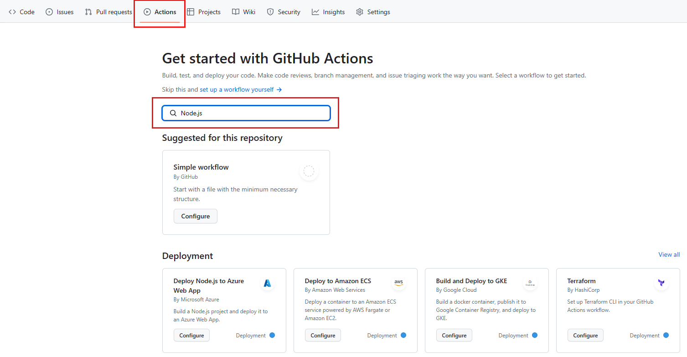
In the search results, in the Node.js pane, select Configure.
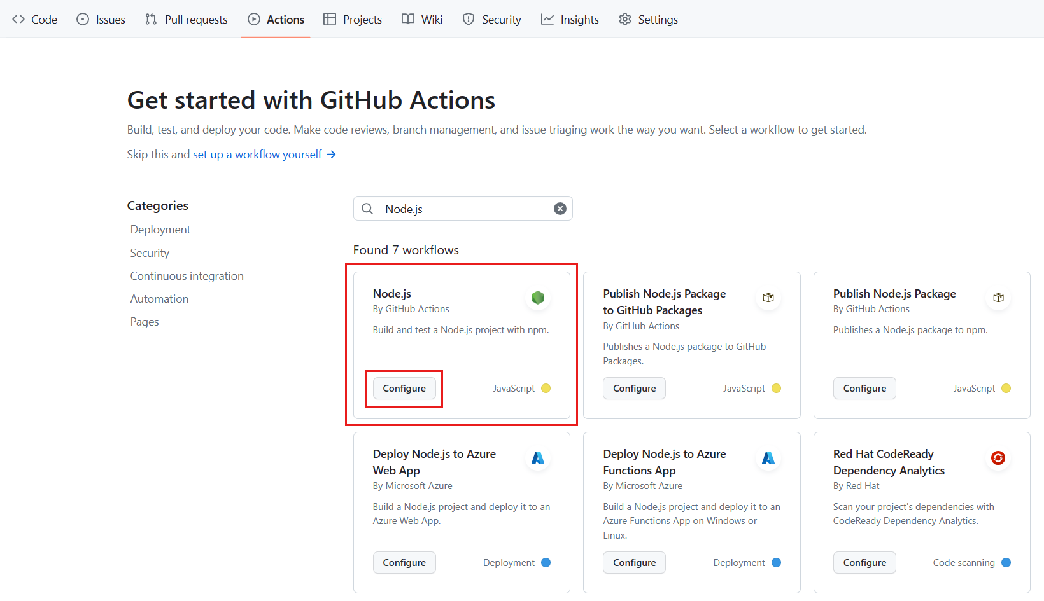
You'll see this default Node.js template workflow, in the newly created file node.js.yml.
ymlCopy
name: Node.js CI

on:
push:
branches: [ "main" ]
pull_request:
branches: [ "main" ]

jobs:
build:

runs-on: ubuntu-latest

strategy:
matrix:
node-version: [14.x, 16.x, 18.x]

steps:
- uses: actions/checkout@v3
- name: Use Node.js ${{ matrix.node-version }}
uses: actions/setup-node@v3
with:
node-version: ${{ matrix.node-version }}
cache: 'npm'
- run: npm ci
- run: npm run build --if-present
- run: npm test
Notice the on: attribute. This workflow is triggered on a push to the repository, as well as when a pull request is made against the main branch.
There is one job in this workflow. Let's review what it does.
The runs-on: attribute specifies that, for the operating system, the workflow runs on ubuntu-latest. The node-version: attribute specifies that there will be three builds, one each for Node version 14.x, 16.x, and 18.x. We'll describe the matrix portion in depth later, when we customize the workflow.
The steps in the job use the GitHub Actions actions/checkout@v3 action to get the code from your repository into the VM, and the actions/setup-node@v3 action to set up the right version of Node.js. We specify that we're going to test three versions of Node.js with the ${{ matrix.node-version }} attribute. This attribute references the matrix we previously defined. The cache attribute specifies a package manager for caching in the default directory.
The last part of this step executes commands used by Node.js projects. The npm ci command installs dependencies from the package-lock.json file, npm run build --if-present runs a build script if it exists, and npm test runs the testing framework. Notice that this template includes both the build and test steps in the same job.
To learn more about npm, check out the npm documentation:
- npm install
- npm run
- npm test

Action Logs for the build
When a workflow runs, it produces a log that includes the details of what happened and any errors or test failures.
If there is an error or if a test has failed, you see a red ✖ rather than a green check mark ✔ in the logs. You can examine the details of the error or failure to investigate what happened.
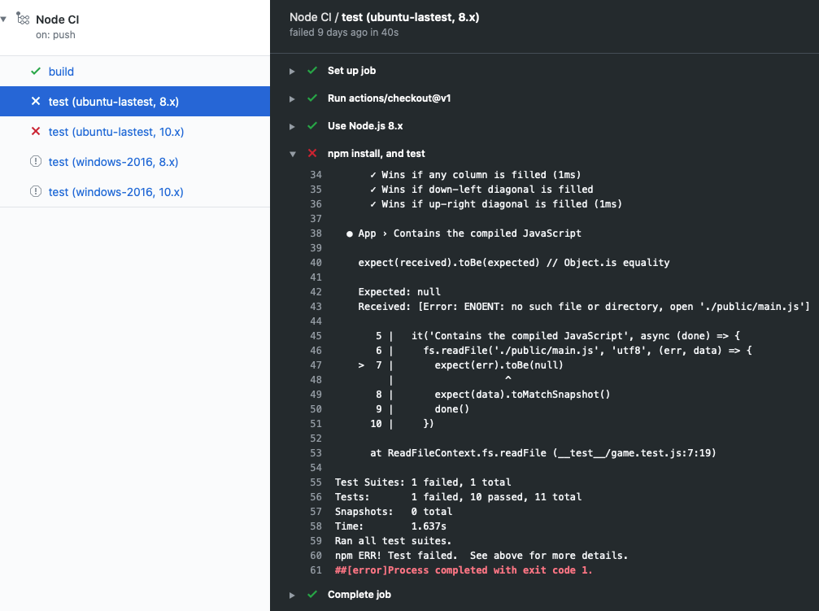
In the exercise, you'll identify failed tests by examining the details in the logs. You can access the logs from the Actions tab.

Customize workflow templates
At the beginning of this module, we described a scenario where you need to set up CI for your team. The Node.js template is a great start, but you want to customize it to better suit your own team's requirements. You want to target different versions of Node and different operating systems. You'll probably also want the build and test steps to be separate jobs.
Let's take a look at how you customize a workflow.
ymlCopy
strategy:
matrix:
os: [ubuntu-latest, windows-latest]
node-version: [16.x, 18.x]
Here, we configured a build matrix for testing across multiple operating systems and language versions. This matrix will produce four builds, one for each operating system paired with each version of Node.
Four builds, along with all their tests, will produce quite a bit of log information. It might be difficult to sort through it all. In the sample below, we show you how to move the test step to a dedicated test job. This job tests against multiple targets. Separating the build and test steps makes it easier to understand the log.
ymlCopy
test:
runs-on: ${{ matrix.os }}
strategy:
matrix:
os: [ubuntu-latest, windows-latest]
node-version: [16.x, 18.x]
steps:
- uses: actions/checkout@v3
- name: Use Node.js ${{ matrix.node-version }}
uses: actions/setup-node@v3
with:
node-version: ${{ matrix.node-version }}
- name: npm install, and test
run: |
npm install
npm test
env:
CI: true

What are artifacts?
When a workflow produces something other than a log entry, it's called an artifact. For example, the Node.js build will produce a Docker container that can be deployed. This artifact, the container, can be uploaded to storage by using the action actions/upload-artifact and later downloaded from storage by using the action actions/download-artifact.
Storing an artifact preserves it between jobs. Each job uses a fresh instance of a virtual machine (VM), so you can't reuse the artifact by saving it on the VM. If you need your artifact in a different job, you can upload the artifact to storage in one job and download it for the other job.

Artifact storage
Artifacts are stored in storage space on GitHub. The space is free for public repositories and some amount is free for private repositories, depending on the account. GitHub stores your artifacts for 90 days.
In the following workflow snippet, notice that in the actions/upload-artifact@main action there is a path: attribute. This is the path to store the artifact. Here, we specify public/ to upload everything to a directory. If it were just a single file that we wanted to upload, we'd use something like public/mytext.txt.
ymlCopy
build:
runs-on: ubuntu-latest
steps:
- uses: actions/checkout@v3
- name: npm install and build webpack
run: |
npm install
npm run build
- uses: actions/upload-artifact@main
with:
name: webpack artifacts
path: public/
To download the artifact for testing, the build must have completed successfully and uploaded the artifact. In the following code, we specify that the test job depends on the build job.
ymlCopy
test:
needs: build
runs-on: ubuntu-latest
In the following workflow snippet, we download the artifact. Now the test job can use the artifact for testing.
ymlCopy
steps:
- uses: actions/checkout@v3
- uses: actions/download-artifact@main
with:
name: webpack artifacts
path: public
For more information about using artifacts in workflows see Storing workflow data as artifacts in the GitHub documentation.

Automate reviews in GitHub using workflows
So far, we've described starting the workflow with GitHub events such as push or pull-request. We could also run a workflow on a schedule, or on some event outside of GitHub.
Sometimes, we want to run the workflow only after a person performs an action. For example, we might only want to run a workflow after a reviewer has approved the pull request. For this scenario, we can trigger on pull-request-review.
Another action we could take is to add a label to the pull request. In this case, we use the pullreminders/label-when-approved-action action.
ymlCopy
steps:
- name: Label when approved
uses: pullreminders/label-when-approved-action@main
env:
APPROVALS: "1"
GITHUB_TOKEN: ${{ secrets.GITHUB_TOKEN }}
ADD_LABEL: "approved"
Notice the block called env:. This is where you set the environment variables for this action. For example, you can set the number of approvers needed. Here, it's one. The secrets.GITHUB_TOKEN authentication variable is required because the action must make changes to your repository by adding a label. Finally, you supply the name of the label to add.
Adding a label could be an event that starts another workflow, such as a merge. We'll cover this in the next module on continuous delivery with GitHub Actions.

Customize your workflow with environment variables and artifact data
Completed100 XP
- 12 minutes
Here, you'll learn how to use default and custom environment variables, custom scripts, cache dependencies, and pass artifact data between jobs. You'll also learn how to access the workflow logs from both the GitHub website and REST API endpoints.

Default environment variables and contexts
Within the GitHub Actions workflow, there are several default environment variables that are available for you to use, but only within the runner that's executing a job. These default variables are case-sensitive, and they refer to configuration values for the system and for the current user. We recommend that you use these default environment variables to reference the filesystem rather than using hard-coded file paths. To use a default environment variable, specify $ followed by the environment variable's name.
ymlCopy
jobs:
prod-check:
steps:
- run: echo "Deploying to production server on branch $GITHUB_REF"
In addition to default environment variables, you can use defined variables as contexts. Contexts and default variables are similar in that they both provide access to environment information, but they have some important differences. While default environment variables can only be used within the runner, context variables can be used at any point within the workflow. For example, context variables allow you to run an if statement to evaluate an expression before the runner is executed.
ymlCopy
name: CI
on: push
jobs:
prod-check:
if: github.ref == 'refs/heads/main'
runs-on: ubuntu-latest
steps:
- run: echo "Deploying to production server on branch $GITHUB_REF"
This example is using the github.ref context to check the branch that triggered the workflow. If the branch is main, the runner is executed and prints out "Deploying to production server on branch $GITHUB_REF". The default environment variable $GITHUB_REF is used in the runner to refer to the branch. Notice that default environment variables are all uppercase where context variables are all lowercase.

Custom environment variables
Similar to using default environment variables, you can use custom environment variables in your workflow file. To create a custom variable, you need to define it in your workflow file using the env context. If you want to use the value of an environment variable inside a runner, you can use the runner operating system's normal method for reading environment variables.
ymlCopy
name: CI
on: push
jobs:
prod-check:
if: github.ref == 'refs/heads/main'
runs-on: ubuntu-latest
steps:
- run: echo "Nice work, $First_Name. Deploying to production server on branch $GITHUB_REF"
env:
First_Name: Mona

Scripts in your workflow
In the preceding workflow snippet examples, the run keyword is used to simply print a string of text. Because the run keyword tells the job to execute a command on the runner, you use the run keyword to run actions or scripts.
ymlCopy
jobs:
example-job:
steps:
- run: npm install -g bats
In this example, you're using npm to install the bats software testing package by using the run keyword. You can also run a script as an action. You can store the script in your repository, often done in a .github/scripts/ directory, and then supply the path and shell type using the run keyword.
ymlCopy
jobs:
example-job:
steps:
- name: Run build script
run: ./.github/scripts/build.sh
shell: bash

Cache dependencies with the cache action
When building out a workflow, you'll often find the need to reuse the same outputs or download dependencies from one run to another. Instead of downloading these dependencies over and over again, you can cache them to make your workflow run faster and more efficiently. This can dramatically reduce the time it takes to run certain steps in a workflow, because jobs on GitHub-hosted runners start in a clean virtual environment each time. Caching dependencies will help speed up the time it takes to recreate these dependency files.
To cache dependencies for a job, use GitHub's cache action. This action retrieves a cache identified by a unique key that you provide. When the action finds the cache, it then retrieves the cached files to the path that you configure. To use the cache action, you'll need to set a few specific parameters:
Expand table
Parameter | Description | Required
Key | Refers to the key identifier created when saving and searching for a cache. | Yes
Path | Refers to the file path on the runner to cache or search. | Yes
Restore-keys | consists of alternative existing keys to caches if the desired cache key is not found. | No
ymlCopy
steps:
- uses: actions/checkout@v2

- name: Cache NPM dependencies
uses: actions/cache@v2
with:
path: ~/.npm
key: ${{ runner.os }}-npm-cache-${{ hashFiles('**/package-lock.json') }}
restore-keys: |
${{ runner.os }}-npm-cache-
In the preceding example, the path is set to ~/.npm and the key includes the runner's operating system and the SHA-256 hash of the package-lock.json file. Prefixing the key with an ID (npm-cache in this example) is useful when you are using the restore-keys fallback and have multiple caches.

Pass artifact data between jobs
Similar to the idea of caching dependencies within your workflow, you can pass data between jobs within the same workflow. You can do this by using the upload-artifact and download-artifact actions. Jobs that are dependent on a previous job's artifacts must wait for the previous job to complete successfully before they can run. This is useful if you have a series of jobs that need to run sequentially based on artifacts uploaded from a previous job. For example, job_2 requires job_1 by using the needs: job_1 syntax.
ymlCopy
name: Share data between jobs
on: push
jobs:
job_1:
name: Upload File
runs-on: ubuntu-latest
steps:
- run: echo "Hello World" > file.txt
- uses: actions/upload-artifact@v2
with:
name: file
path: file.txt

job_2:
name: Download File
runs-on: ubuntu-latest
needs: job_1
steps:
- uses: actions/download-artifact@v2
with:
name: file
- run: cat file.txt
The preceding example has two jobs. job_1 writes some text into the file file.txt and then uses the actions/upload-artifact@v2 action to upload this artifact and store the data for future use within the workflow. job_2 requires job_1 to complete by using the needs: job_1 syntax, then uses the actions/download-artifact@v2 action to download that artifact and then print the contents of file.txt.

Enable step debug logging in a workflow
In some cases, the default workflow logs won't provide enough detail to diagnose why a specific workflow run, job, or step has failed. For these situations, you can enable additional debug logging for two options: runs and steps. Enable this diagnostic logging by setting two repository secrets that require admin access to the repository to true:
- To enable runner diagnostic logging, set the ACTIONS_RUNNER_DEBUG secret in the repository that contains the workflow to true.
- To enable step diagnostic logging, set the ACTIONS_STEP_DEBUG secret in the repository that contains the workflow to true.

Access the workflow logs from the user interface
When you think about successful automation, you aim to spend the least amount of time looking at what’s automated so you can focus your attention on what’s relevant. But sometimes, things don’t go as planned, and you need to review what happened. That debugging process can be frustrating, but GitHub provides a clear layout structure that enables a quick way to navigate between the jobs while keeping the context of the currently debugging step. To view the logs of a workflow run in GitHub, you can follow these steps:
- Navigate to the Actions tab in your repository.
- In the left sidebar, click the desired workflow.
- From the list of workflow runs, select the desired run.
- Under Jobs, select the desired job.
- Read the log output.
If you have several runs within a workflow, you can also select the Status filter after choosing your workflow and set it to Failure to only display the failed runs within that workflow.

Access the workflow logs from the REST API
In addition to viewing logs using GitHub, you can also use GitHub's REST API to view logs for workflow runs, re-run workflows, or even cancel workflow runs. To view a workflow run's log using the API, you need to send a GET request to the logs endpoint. Keep in mind that anyone with read access to the repository can use this endpoint. If the repository is private, you must use an access token with the repo scope.
For example, a GET request to view a specific workflow run log would follow this path:
HTTPCopy
GET /repos/{owner}/{repo}/actions/runs/{run_id}/logs

Introduction
Completed100 XP
- 2 minutes
Continuous Delivery (CD) is the practice of using automation to build, test, configure, and deploy from the build environment all the way to the final production environment.
Suppose that your development team is working on the company's product support website. You previously set up continuous integration (CI) by using GitHub Actions and workflows. Now you need to implement CD. Your CI workflow saves a container image. Your CD workflow must deploy this container to your staging and production environments. You talked with IT about how to create and tear down these environments as needed. You all decided to use GitHub Actions and workflows to support infrastructure as code.
In this module, you learn how to use GitHub Actions and workflows to implement a CD solution that deploys to Microsoft Azure Web Apps. The deployment uses a GitHub Action from the GitHub Marketplace. You also automate the creation and teardown of the deployment environments by using a workflow.

How do I use GitHub Actions to deploy to Azure?
Completed100 XP
- 8 minutes
This unit discusses how to use GitHub actions to deploy a container-based web app to Microsoft Azure Web Apps. It covers some options for triggering a workflow. Next, learn how to work with conditionals in the workflow. Finally, learn about how to create and delete Azure resources by using GitHub Actions.

Options for triggering a CD workflow
There are several options for starting a CD workflow. In the previous module on CI with GitHub Actions, you learned how to trigger a workflow from a push to the GitHub repository. However, for CD, you might want to trigger a deployment workflow on some other event.
One option is to trigger the workflow with ChatOps. ChatOps uses chat clients, chatbots, and real-time communication tools to run tasks. For example, you might leave a specific comment in a pull request that can kick off a bot. That bot might comment back with some statistics or run a workflow.
Another option, and the one we use in our example, is to use labels in your pull request. Different labels can start different workflows. For example, add a stage label to begin a deployment workflow to your staging environment. Or, add a spin up environment label to run the workflow that creates the Microsoft Azure resources for you to deploy to. To use labels, your workflow looks like this:
ymlCopy
on:
pull_request:
types: [labeled]

Control execution with a job conditional
Often, you only want to run a workflow if some condition is true.
GitHub workflows provide the if conditional for this scenario. The conditional uses an expression that is evaluated at runtime. For example, you want to run this workflow if a stage label is added to the pull request.
ymlCopy
if: contains(github.event.pull_request.labels.*.name, 'stage')

Store credentials with GitHub Secrets
You never want to expose sensitive information in the workflow file. GitHub Secrets is a secure place to store sensitive information that your workflow needs. Here's an example.
In order to deploy to an Azure resource, the GitHub Action must have permission to access the resource. You don't want to store your Azure credentials in plain sight in the workflow file. Instead, you can store your credentials in GitHub Secrets.
To store information in GitHub Secrets, create a secret on the portal.

Then, use the name of the secret you created in your workflow wherever you need that information. For example, use the Azure credential that was stored in GitHub Secrets in the creds: attribute of an Azure login action.
ymlCopy
steps:
- name: "Login via Azure CLI"
uses: azure/login@v1
with:
creds: ${{ secrets.AZURE_CREDENTIALS }}

Deploy to Microsoft Azure using GitHub Actions
The GitHub Marketplace has several actions that help you automate Azure-related tasks.

You can also search and browse GitHub Actions directly in a repository's workflow editor. From the sidebar, you can search for a specific Action, view featured Actions, and browse featured categories.
To find an Action:
- In your repository, browse to the workflow file that you want to edit.
- Select the Edit icon in the upper right corner of the file view.
- Use the GitHub Marketplace sidebar to the right of the editor to browse Actions.
Suppose you want to deploy a container-based web app to Azure Web Apps. If you search the GitHub Marketplace, you find these actions:
- azure/webapps-container-deploy@v1
- azure/login@v1 that we saw previously
- azure/docker-login@v1
If you add these actions to the Deploy-to-Azure job, your workflow looks like this:
ymlCopy
Deploy-to-Azure:
runs-on: ubuntu-latest
needs: Build-Docker-Image
name: Deploy app container to Azure
steps:
- name: "Login via Azure CLI"
uses: azure/login@v1
with:
creds: ${{ secrets.AZURE_CREDENTIALS }}

- uses: azure/docker-login@v1
with:
login-server: ${{env.IMAGE_REGISTRY_URL}}
username: ${{ github.actor }}
password: ${{ secrets.GITHUB_TOKEN }}

- name: Deploy web app container
uses: azure/webapps-container-deploy@v1
with:
app-name: ${{env.AZURE_WEBAPP_NAME}}
images: ${{env.IMAGE_REGISTRY_URL}}/${{ github.repository }}/${{env.DOCKER_IMAGE_NAME}}:${{ github.sha }}

- name: Azure logout
run: |
az logout
Notice that this job depends on a previous job, Build-Docker-Image. The previous job creates the artifact that gets deployed.
The azure/login@v1 action needs credentials to sign in to your Azure account so that it can access the Azure resources that you want to deploy to. Here, use the credentials that we stored in GitHub Secrets.
The same is true for the azure/docker-login@v1 action. Since you're deploying a container image, you need to sign in to your private container registry.
The azure/webapps-container-deploy@v1 action performs the deployment. It depends on the two preceding actions.

Create and delete Azure resources by using GitHub Actions
Because CD is an automated process, you already decided to use infrastructure as code to create and take down the environments you deploy to. GitHub Actions can automate these tasks on Azure, and you can include these actions in your workflow.
Note
Remember that it's important to tear down resources that you're no longer using as soon as possible to avoid unnecessary charges.
One option is to create a new workflow with two jobs, one that spins up resources and one that deletes them. Then, use a conditional to run only the job you want. In this example, the conditional looks for a label in the pull request and runs the set-up-azure-resources job if the label is spin up environment and the destroy-azure-resources job if the label is destroy environment.
ymlCopy
jobs:
set-up-azure-resources:
runs-on: ubuntu-latest

if: contains(github.event.pull_request.labels.*.name, 'spin up environment')

...

destroy-azure-resources:
runs-on: ubuntu-latest

if: contains(github.event.pull_request.labels.*.name, 'destroy environment')

...
The jobs use the Azure CLI to create and destroy the Azure resources. For more information about Azure CLI, see Overview of Azure CLI.
Here's an example of the steps in the set-up-azure-resources job:
ymlCopy
steps:
- name: Checkout repository
uses: actions/checkout@v2

- name: Azure login
uses: azure/login@v1
with:
creds: ${{ secrets.AZURE_CREDENTIALS }}

- name: Create Azure resource group
if: success()
run: |
az group create --location ${{env.AZURE_LOCATION}} --name ${{env.AZURE_RESOURCE_GROUP}} --subscription ${{secrets.AZURE_SUBSCRIPTION_ID}}
- name: Create Azure app service plan
if: success()
run: |
az appservice plan create --resource-group ${{env.AZURE_RESOURCE_GROUP}} --name ${{env.AZURE_APP_PLAN}} --is-linux --sku F1 --subscription ${{secrets.AZURE_SUBSCRIPTION_ID}}
- name: Create webapp resource
if: success()
run: |
az webapp create --resource-group ${{ env.AZURE_RESOURCE_GROUP }} --plan ${{ env.AZURE_APP_PLAN }} --name ${{ env.AZURE_WEBAPP_NAME }} --deployment-container-image-name nginx --subscription ${{secrets.AZURE_SUBSCRIPTION_ID}}
- name: Configure webapp to use GitHub Packages
if: success()
run: |
az webapp config container set --docker-custom-image-name nginx --docker-registry-server-password ${{secrets.GITHUB_TOKEN}} --docker-registry-server-url https://docker.pkg.github.com --docker-registry-server-user ${{github.actor}} --name ${{ env.AZURE_WEBAPP_NAME }} --resource-group ${{ env.AZURE_RESOURCE_GROUP }} --subscription ${{secrets.AZURE_SUBSCRIPTION_ID}}

Notice that you use GitHub actions to check out the repository and to sign in to Azure. After that, you create the resources you need and deploy the container by using the Azure CLI.

Remove artifacts, create status badges, and configure environment protections
Completed100 XP
- 5 minutes
In this unit, learn how to remove workflow artifacts from GitHub and change the default retention period. Next, learn how to create a workflow status badge and add it to your README.md file. Finally, identify some important workflow environment protections and learn how to enable them.

Remove workflow artifacts from GitHub
By default, GitHub stores any build logs and uploaded artifacts for 90 days before it deletes them. You can customize this retention period based on the type of repository and the usage limits set for your specific GitHub product. There's a lot more information about usage limits and artifact retention. For more information, see Usage limits, billing, and administration.
But suppose you're reaching your organization's storage limit for GitHub artifacts and packages. You want to remove old artifacts without increasing your usage limits and blocking your workflows. You can reclaim used GitHub Actions storage by deleting artifacts before they expire on GitHub. You can do this two ways, as described in the following sections. Both methods require write access to the repository.
Warning
Keep in mind that once you delete an artifact, it can't be restored.

Manually delete artifacts from your repository
To manually delete an artifact on GitHub, navigate to the Actions tab, select the workflow from the left sidebar, and then select the run you want to see.
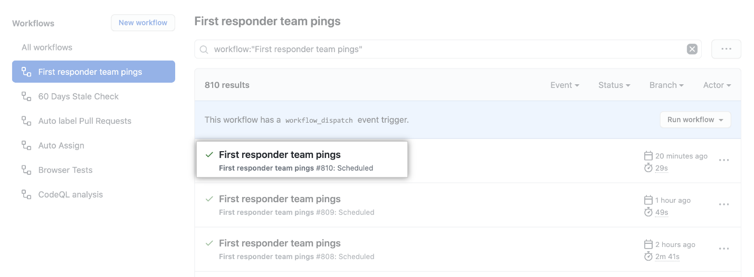
Under Artifacts, delete the artifact you want to remove.
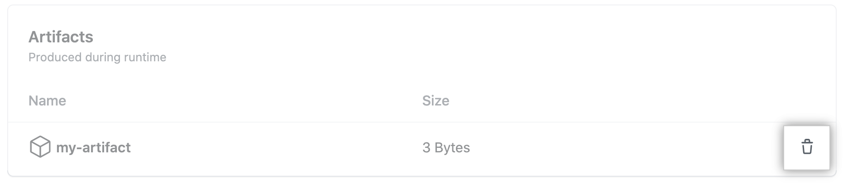
You can also use the Artifacts REST API to delete artifacts. This API also allows you to download and retrieve information about work artifacts.

Change the default retention period
You can change the default artifact and log retention period for your repository, organization, or enterprise account. Keep in mind that changing the retention period only applies to new artifacts and log files. It doesn't apply to existing objects. The process to configure these settings is a bit different for a repository, organization, or enterprise. Check the summary at the end of this module for more information on configuring artifacts and log retentions.
In addition to configured settings across a repository, organization, or enterprise, you can define a custom retention period for individual artifacts right within the workflow file. This practice is good for individual use cases where you want a specific artifact's retention to be different than the default or configured setting. You can do this using a retention-days value within the step with the upload-artifact action.
The following example uploads an artifact that persists for 10 days instead of the default 90 days:
ymlCopy
- name: 'Upload Artifact'
uses: actions/upload-artifact@v2
with:
name: my-artifact
path: my_file.txt
retention-days: 10

Add a workflow status badge to your repository
It's helpful to know the status of a workflow without having to visit the Actions tab to see if it successfully completed. Adding workflow status badges to your repository README.md file allows you to quickly see if your workflows are passing or failing. While it's common to add a status badge to a repository README.md file, you can also add it any web page. By default, status badges display the workflow statuses on your default branch, but you can also display workflow status badges on other branches using the branch and event parameters.
Here's an example of what you need to add to a file to see a workflow status badge:
ymlCopy
![example branch parameter.](https://github.com/mona/special-octo-eureka/actions/workflows/grading.yml/badge.svg?branch=my-workflow)
For example, adding the branch parameter along with the desired branch name at the end of the URL shows the workflow status badge for that branch instead of the default branch. This practice makes it easy to create a table-like view within your README.md file to display workflow statuses based on branches, events, services, or environments to name a few.
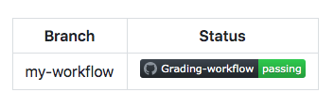
You also have the ability to create a status badge using GitHub. Navigate to the workflows section within the Actions tab and select a specific workflow. The Create status badge option allows you to generate the markdown for that workflow and set the branch and event parameters.
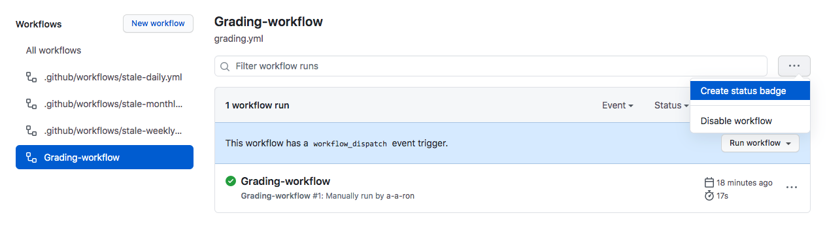

Add workflow environment protections
Security is a big deal, so it makes sense to configure your workflow environment with protection rules and secrets. With these elements in place, a job doesn't start or access any defined secrets in the environment until all of the environment's protection rules pass. Currently, protection rules and environment secrets only apply to public repositories.
There are two environment protection rules that you can apply to workflows within public repositories, required reviewers and wait timer.
- Required reviewers allow you to set a specific person or team to approve workflow jobs that reference the job's environment.
- Wait timer can be used to delay a job for a specific amount of time after the job has been triggered.
Suppose you need to create a workflow to a production environment that a dev team needs to approve before the deployment occurs. Use the following steps:
- Create a production environment within the repository.
- Configure the required reviewers environment protection to require an approval from the specific dev team.
- Configure the specific job within the workflow to look for the production environment.
You can create and configure new repository environments from the repository's Settings tab under Environments.

Introduction
Completed100 XP
- 2 minutes
GitHub Script is a workflow action that provides you with access to the GitHub API from within your GitHub Actions. It offers convenient support for any API usage available in octokit/rest.js.
Suppose you maintain a vibrant GitHub repository. Your project has a substantial number of consumers and contributors, and you want to make sure they have a welcoming experience. You also find that the responsibilities of managing the team's planning and workload can really add up. You need a solution that allows you to hand off some of the mundane tasks to automation so that you can focus on areas where you really add value. You know that GitHub offers an API that will let you automatically reply to new issues and begin the triage workflow for new bug reports. You just haven't invested the time in figuring it all out, until now.
In this module, you'll learn how to interact with the GitHub API from a GitHub Actions workflow by using GitHub Script.

What is GitHub Script?
Completed100 XP
- 8 minutes
Here, we'll discuss how GitHub Script lets you automate common GitHub processes using GitHub Actions workflows.

What is GitHub Script?
GitHub Script is an action that provides an authenticated octokit client and allows JavaScript to be written directly in a workflow file. It runs in Node.js, so you have the power of that platform available when writing scripts.

What is octokit?
octokit is the official collection of clients for the GitHub API. One of these clients, rest.js, provides JavaScript access to GitHub's REST interface.
You have always been able to automate the GitHub API via octokit/rest.js, although it could be a chore to properly set up and maintain. One of the great advantages to using GitHub Script is that it handles all of this overhead so you can immediately start using the API. You don't need to worry about dependencies, configuration, or even authentication.

What can octokit/rest.js do?
The short answer is that it can do virtually anything with respect to automating GitHub. Not only do you have access to commits, pull requests, and issues, but you also have access to users, projects, and organizations. You can retrieve lists of commonly used files, like popular licenses or .gitignore files. You can even render Markdown.
If you're building something that integrates GitHub, the odds are good that you'll find what you're looking for in the full octokit/rest.js documentation.

How is using GitHub Script different from octokit/rest.js?
The main difference in usage is that GitHub Script provides you with a preauthenticated octokit/rest.js client named github.
So instead of:
octokit.issues.createComment({
You'd use:
github.issues.createComment({
In addition to the github variable, the following variables are also provided:
- context is an object containing the context of the workflow run.
- core is a reference to the @actions/core package.
- io is a reference to the @actions/io package.

Building a workflow that uses GitHub Script
GitHub Script actions fit into a workflow like any other action. As a result, you can even mix them in with existing workflows, such as those you may already have set up for CI/CD. To illustrate its convenience, we'll now construct a complete workflow that uses GitHub Script to automatically post a comment to all newly created issues.
We'll start off with a name and an on clause that specifies that this workflow runs when issues are opened.
YAMLCopy
name: Learning GitHub Script

on:
issues:
types: [opened]
Next, we'll define a job named comment that runs on Linux with a series of steps.
YAMLCopy
jobs:
comment:
runs-on: ubuntu-latest
steps:
In this case, there's only one step: the GitHub Script action.
YAMLCopy
- uses: actions/github-script@0.8.0
with:
github-token: ${{secrets.GITHUB_TOKEN}}
script: |
github.issues.createComment({
issue_number: context.issue.number,
owner: context.repo.owner,
repo: context.repo.repo,
body: "🎉 You've created this issue comment using GitHub Script!!!"
})
Using GitHub Actions can really help automate the events that take place in your repositories. Imagine that a repository visitor opened a new issue containing information about a critical bug. You might want to thank them for bringing that to your attention; however, this simple task can become overwhelming as your repository attracts more visitors. By automating an issue comment, you could automate the process of thanking visitors every single time.

Using actions/github-script@0.8.0
The actions/github-script@0.8.0 action, also known as GitHub Script, does all the heavy lifting for our integration with the GitHub API.
This action requires a github-token that's provided at runtime so that requests are authenticated. This is automatically done for you, so you can use that code as-is.
The script parameter can be virtually any JavaScript that uses the octokit/rest/js client stored in github. In this case, it's just one line (split across multiple lines for readability) that creates a hardcoded comment.
After the workflow is run, GitHub Script logs the code it executed for review on the Actions tab.
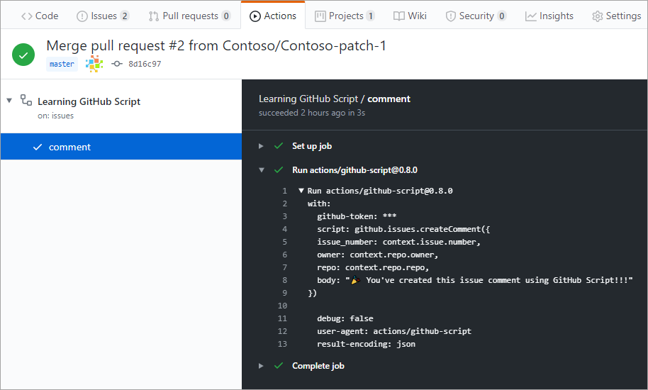

Running from a separate file
Sometimes, you might need to use significant code to fulfill your GitHub Script scenario. When that happens, you can keep the script in a separate file and reference it from the workflow instead of putting all the script inline.
Here's an example of a simple workflow that does this:
YAMLCopy
on: push

jobs:
echo-input:
runs-on: ubuntu-latest
steps:
- uses: actions/checkout@v2
- uses: actions/github-script@v2
with:
script: |
const path = require('path')
const scriptPath = path.resolve('./path/to/script.js')
console.log(require(scriptPath)({context}))
Check out more GitHub Script examples.

Exercise - Using GitHub Script in GitHub Actions
Completed100 XP
- 11 minutes
In this unit, you'll learn more about how you can use the GitHub Script to improve your workflow.

Add issues to a project board
In addition to using octokit/rest.js to create comments and open pull requests, you can also use octokit/rest.js to manage GitHub Projects. In the code sample below, you'll create a workflow that runs whenever anyone adds a new issue to the repository. This adds the issue to a project board, making it easier for you to triage your work.
Copy
name: Learning GitHub Script
on:
issues:
types: [opened]
jobs:
comment:
runs-on: ubuntu-latest
steps:
- uses: actions/github-script@0.8.0
with:
github-token: {% raw %}${{secrets.GITHUB_TOKEN}}{% endraw %}
script: |
github.issues.createComment({
issue_number: context.issue.number,
owner: context.repo.owner,
repo: context.repo.repo,
body: "🎉 You've created this issue comment using GitHub Script!!!"
})
github.projects.createCard({
column_id: {{columnID}},
content_id: context.payload.issue.id,
content_type: "Issue"
});
The first section of this workflow creates a comment whenever a new issue is created, which we covered in the previous unit. The next section creates a card based on this issue and adds it to the project board.

Separate workflow into steps
One benefit of using actions is that you can separate jobs into smaller units of work called steps. In the preceding example workflow, you can separate the workflow into two steps.
One advantage of breaking the current workflow into multiple steps is that it allows you to use expressions to apply logic. Using steps allows you to create rules around when steps are allowed to run and can help optimize your workflow run.
To separate the example workflow into steps:
- Name each step so you can track it from the Actions tab.
- Use expressions to determine whether a step should execute (optional).
In this example, the two tasks in the original workflow file have been separated into individual steps.
Copy
name: Learning GitHub Script
on:
issues:
types: [opened]
jobs:
comment:
runs-on: ubuntu-latest
steps:
- name: Comment on new issue
uses: actions/github-script@0.8.0
with:
github-token: {% raw %}${{secrets.GITHUB_TOKEN}}{% endraw %}
script: |
github.issues.createComment({
issue_number: context.issue.number,
owner: context.repo.owner,
repo: context.repo.repo,
body: "🎉 You've created this issue comment using GitHub Script!!!"
})
- name: Add issue to project board
if: contains(github.event.issue.labels.*.name, 'bug')
uses: actions/github-script@0.8.0
with:
github-token: {% raw %}${{secrets.GITHUB_TOKEN}}{% endraw %}
script: |
github.projects.createCard({
column_id: {{columnID}},
content_id: context.payload.issue.id,
content_type: "Issue"
});
Each step includes a descriptive name element that also helps you track it from the Actions tab.
The Add issue to project board step also includes an if statement that specifies the issue should only be added to the project board if it's labeled bug.

Use the Node.js environment
The GitHub Script also grants you access to a full Node.js environment. While the GitHub Script isn't recommended for writing the logic for complex actions, you can use it to add more functionality to the octo/rest.js API.
One example would be to use the Node.js to display a contribution guide whenever an issue is opened. You can use the Node.js File System to read a file and use it as the body of the issue comment. To access files within the repository, include the actions/checkout action as the first step in the workflow.
The example below makes the following changes to the workflow file:
- Adds the action/checkout action to read the templated response file located at .github/ISSUE_COMMENT/comment.md
- Adds JavaScript to use the Node.js File System module to place the contents of our templated response as the body of the issue comment
Copy
name: Learning GitHub Script
on:
issues:
types: [opened]
jobs:
comment:
runs-on: ubuntu-latest
steps:
- name: Checkout repo
uses: actions/checkout@v2
- name: Comment on new issue
uses: actions/github-script@0.8.0
with:
github-token: {% raw %}${{secrets.GITHUB_TOKEN}}{% endraw %}
script: |
const fs = require('fs')
const issueBody = fs.readFileSync(".github/ISSUE_RESPONSES/comment.md", "utf8")
github.issues.createComment({
issue_number: context.issue.number,
owner: context.repo.owner,
repo: context.repo.repo,
body: issueBody
})
- name: Add issue to project board
if: contains(github.event.issue.labels.*.name, 'bug')
uses: actions/github-script@0.8.0
with:
github-token: {% raw %}${{secrets.GITHUB_TOKEN}}{% endraw %}
script: |
github.projects.createCard({
column_id: {{columnID}},
content_id: context.payload.issue.id,
content_type: "Issue"
});
The GitHub Script helped you create a comprehensive response to a new issue being opened. This response is also based on a template in the repository, so it's easy to change in the future. Finally, you also included a trigger to add the issue to the project board so you can easily triage it for future work.

What is GitHub Packages?
Completed100 XP
- 3 minutes
GitHub Packages is a package-management service that makes it easy to publish public or private packages next to your source code.
Note
If you are not already familiar with GitHub, check out the Introduction to GitHub Learn module.

GitHub Packages is a package registry
GitHub Packages allow you to share your project dependencies within your organization or publicly.
When you work on a project that has package dependencies, it’s important for you to trust them, understand their code, and connect with the community who built them. Within organizations, you also need to be able to quickly find what’s been approved for your use.
GitHub Packages make it easy to use the same familiar GitHub interface to find public packages anywhere on GitHub, or private packages within your organization or repositories.

A standard package manager
GitHub Packages is compatible with common package-management clients, so you can publish packages with your choice of tools. If your repository is more complex, you may need to publish multiple packages of different types. You can also use webhooks or GitHub Actions to fully customize your publishing and post-publishing workflows.
Are you publishing an open-source package? Most open-source projects store their code on GitHub, so you can publish prerelease versions of your packages for testing within your community, then easily promote specific versions to the public registry of your choice.
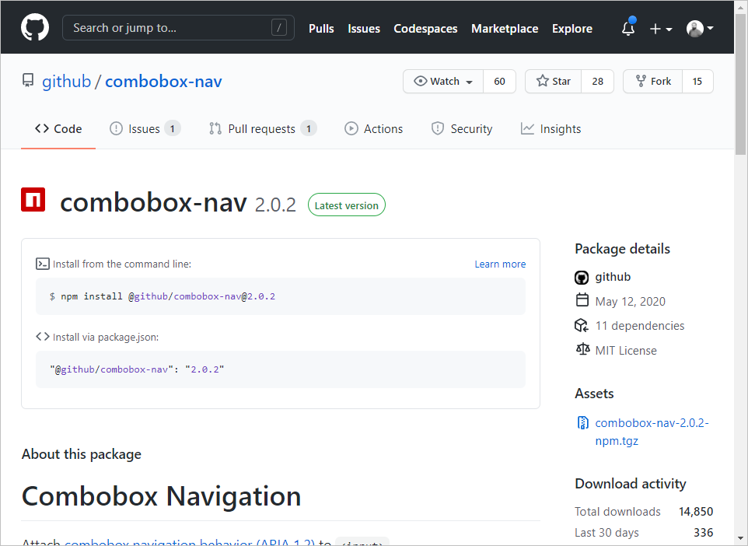
At the time of writing, GitHub Packages is compatible with the following package managers:
- npm, a NodeJS package manager
- NuGet, the .NET package manager
- RubyGems
- Maven and Gradle, two package managers for Java

GitHub Packages is also a container registry
From complete applications to CLI utilities, containers are another form of distributing code. GitHub Packages allow you to publish and distribute container images. Once published (in public or in private) you can use these images from anywhere, including:
- In your local development environment
- As a base image from your GitHub Codespaces development environment
- As a step to execute into your Continuous Integration (CI) / Continuous Deployment (CD) workflow with GitHub Actions
- On a server or a cloud service
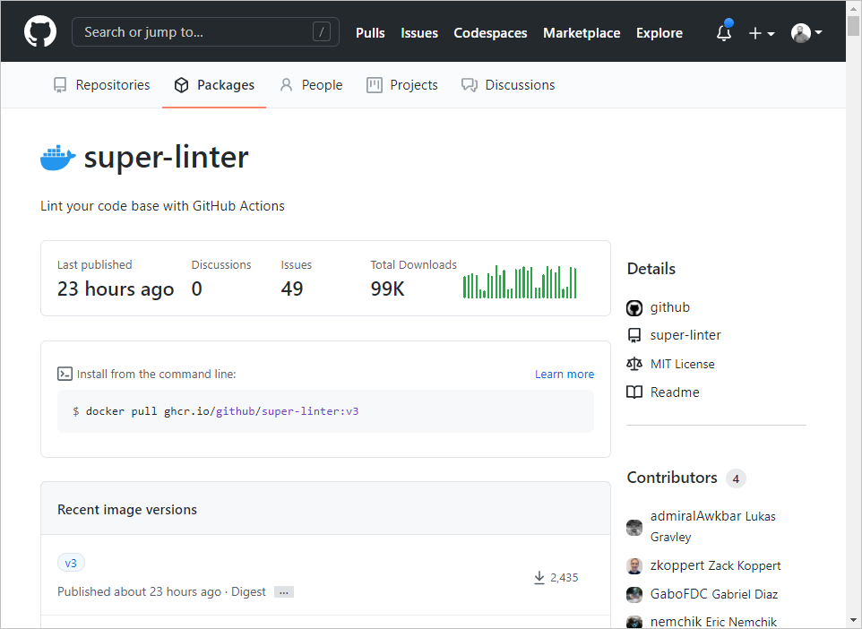

Compare GitHub Packages to GitHub Releases
GitHub Packages are used to publish releases of your libraries to a standard package feed or a container registry. They are meant to leverage the ways the specific package-management client works with that feed, like linking back to the repository in which the package was created as well as the version of the code that was used.
GitHub Releases are used to release a bundle of packaged software, along with release notes and links to binary files. You can download those releases directly from their unique URL and track them back to the specific commit they were created from. You can only download releases as tarballs or ZIP files.

Unified identity and permissions
Let's say you're working on a project using GitHub for hosting source code: JavaScript for the front end, with npm and Java for the back end. You now maintain at least three different sets of user credentials and permissions: for Git, npm, and Maven repositories.
With GitHub Packages, you can use a single set of credentials across your source-code repository, your private npm registry, and your Maven or Gradle private registry. Packages published through GitHub inherit the visibility and permissions assigned at the repository level. A new team member needs read access to a package and its code? Give them read access to the repository and it's done!

Build and publish packages from GitHub
GitHub Actions is another GitHub feature that allows you to automate your software workflows. You can build, test, and deploy your code right from GitHub.
Tip
If you want to learn more about GitHub Actions, checkout Build continuous integration (CI) workflows by using GitHub Actions Learn module.
By combining GitHub Actions and GitHub Packages, you can build a workflow that will build and test your code, and then publish it to GitHub Packages by simply pushing code to your repository.
In the next unit, we'll learn how to use our workflow to publish to GitHub Packages and GitHub Container Registry.

Publish to GitHub Packages and GitHub Container Registry
Completed100 XP
- 3 minutes
Here, you'll learn the basics of using a workflow to publish to GitHub Packages, and the necessary steps to build, authenticate, tag, and push a Docker image to the GitHub Container Registry.

Use a workflow to publish to GitHub Packages
GitHub Packages let you securely publish and consume packages, store your packages alongside your code, and share your packages privately with your team or publicly with the open-source community. You can also use GitHub Actions to automate your packages.
Following is an example of a basic workflow that runs whenever a new release is created in a repository. If the tests pass, then the package is published to GitHub Packages.
ymlCopy
name: Node.js Package

on:
release:
types: [created]

jobs:
build:
runs-on: ubuntu-latest
steps:
- uses: actions/checkout@v2
- uses: actions/setup-node@v1
with:
node-version: 12
- run: npm ci
- run: npm test

publish-gpr:
needs: build
runs-on: ubuntu-latest
steps:
- uses: actions/checkout@v2
- uses: actions/setup-node@v1
with:
node-version: 12
registry-url: https://npm.pkg.github.com/
- run: npm ci
- run: npm publish
env:
NODE_AUTH_TOKEN: ${{secrets.GITHUB_TOKEN}}
First, the workflow file must exist in the .github/workflows directory. It's common practice to name a workflow that publishes a new package whenever a new release is created something like release-package.yml, to make it easy for project collaborators to understand its purpose without navigating to the workflow file.
The preceding workflow does a few things after a new release is created:
- A job named build runs npm ci (named after Continuous Integration) to install dependencies directly from the package-lock.json file, as well as the tests for the project.
- Once the build job succeeds, the job named publish-gpr publishes the package.
- The workflow publishes the package to the registry-url: https://npm.pkg.github.com/ using an access token for authentication.

Use GitHub Container Registry to host and manage Docker container images
GitHub Packages support the use of containers, Kubernetes, and other cloud-native technologies to manage their entire application lifecycle including production operations, development, release, and deployment. GitHub Packages also offers a container registry designed to support the unique needs of container images. You can use GitHub Container Registry to seamlessly host and manage Docker container images in your GitHub organization or personal user account. GitHub Container Registry allows you to configure who can manage and access packages using fine-grained permissions.
With the container registry, you can:
- Store container images within your organization and user account rather than a repository.
- Set fine-grained permissions for the container images.
- Access public container images anonymously.
After you've built the image and authenticated and signed in to the GitHub Container Registry service at ghcr.io, you can then tag and push the latest version of the image to the container registry using these commands:
BashCopy
echo $GITHUB_TOKEN | docker login ghcr.io -u USERNAME --password-stdin

docker tag IMAGE_ID ghcr.io/OWNER/IMAGE_NAME:latest

docker push ghcr.io/OWNER/IMAGE_NAME:latest
Note
To authenticate using a GitHub Actions workflow, you can use a GITHUB_TOKEN:
- For package registries at PACKAGE-REGISTRY.pkg.github.com.
- For the container registry at ghcr.io/OWNER/IMAGE-NAME.

itHub Packages for code packages
Completed100 XP
- 3 minutes
In the previous unit, you saw how to use GitHub Actions to build and publish container images.
In this unit, we'll take a look at the other packages supported by GitHub Packages. GitHub Packages work with your current project's ecosystem tooling: npm for npm packages; nuget.exe, or the dotnet CLI for NuGet packages, etc.

Authenticate to GitHub Packages
The way you authenticate into your package manager will depend on your project's ecosystem. Whichever ecosystem you're working with, you'll need three pieces of information:
- Your GitHub username
- A Personal Access Token
- The GitHub Packages endpoint for your package ecosystem

Generate a Personal Access Token
To install, publish, or delete a package, you need an access token. When using your package manager, you must generate a Personal Access Token (PAT). You can generate a PAT via your profile settings.
Warning
Treat your tokens like passwords and keep them secret.

Log in into GitHub Packages
Before publishing or installing packages from GitHub Packages, you'll need to authenticate in your package manager. The endpoint will look like https://PACKAGE_TYPE.pkg.github.com/OWNER/REPOSITORY, where PACKAGE_TYPE is the type of package ecosystem you're using.
The following table shows you the command to run in order to authenticate to GitHub Packages based on your package ecosystem:
Expand table
Your package ecosystem | Command line to authenticate to GitHub Package
NuGet | dotnet nuget add source https://nuget.pkg.github.com/OWNER/index.json -n github -u OWNER -p [Your PAT Token]
npm | bash npm login --registry=https://npm.pkg.github.com
RubyGems | echo ":github: Bearer GH_TOKEN" >> ~/.gem/credentials
Maven & Gradle | You can directly authenticate while pushing.
If you want to learn more about how to use GitHub Packages with your project's environment, you can read the documentation here.

Install a package
When you're authenticated, you can easily use published packages in your projects. Each package home page shows you the command to run, depending on your project environment.
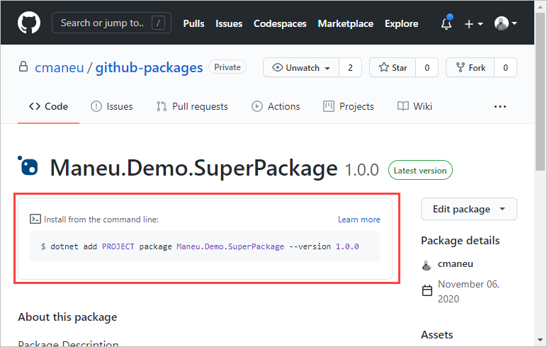

Manage packages
GitHub Packages offer you several ways to easily manage your packages lifecycle and workflows.
You can manage GitHub Packages through the GitHub API and the GraphQL API. These APIs allows you to support advanced integrations scenarios. For example, with GitHub's Webhook feature, you can run code when a new package is published. Imagine you're a maintainer of an open-source project. With webhooks, you could automatically publish a new Tweet or a blog post when a new package is published.
Last but not least, you can use GitHub Actions to automate package management. With the delete-package-versions action, you can automatically prune the oldest version of your packages while publishing a new version.

