- How to setup symbolic links in linux?
A symbolic link, also known as a symlink or soft link, is a special type of file that points to another file or directory.
Symbolic link can used using ln command.
ln is a command-line utility for creating links between files. By default, the ln command creates hard links. To create a symbolic link, use the -s (--symbolic) option.
Syntax:
ln -s [OPTIONS] FILE LINK
Copy
- If both the FILE and LINK are given, ln will create a link from the file specified as the first argument (FILE) to the file specified as the second argument (LINK).
- If only one file is given as an argument or the second argument is a dot (.), ln will create a link to that file in the current working directory . The name of the symlink will be the same as the name of the file it points to.
By default, on success, ln doesn’t produce any output and returns zero.
Creating Symlink To a File
To create a symbolic link to a given file, open your terminal and type:
ln -s source_file symbolic_link
Replace source_file with the name of the existing file for which you want to create the symbolic link and symbolic_link with the name of the symbolic link.
The symbolic_link parameter is optional. If you do not specify the symbolic link, the ln command will create a new link in your current directory:
In the following example, we are creating a symbolic link named my_link.txt to a file named my_file.txt:
ln -s my_file.txt my_link.txtCopy
To verify that the symlink was successfully created, use the ls command:
ls -l my_link.txtCopy
The output will look something like this:
lrwxrwxrwx 1 linuxize users 4 Nov 2 23:03 my_link.txt -> my_file.txt
The l character is a file type flag that represents a symbolic link. The -> symbol shows the file the symlink points to.
Creating Symlinks To a Directory
The command for creating a symbolic link to a directory is the same as when creating a symbolic link to a file. Specify the directory name as the first parameter and the symlink as the second parameter.
For example, if you want to create a symbolic link from the /mnt/my_drive/movies directory to the ~/my_movies directory you would run:
ln -s /mnt/my_drive/movies ~/my_movies

- Vi editor commands – Eg: How to search, replace, show line numbers, go a certain line number, go to top or end of file, etc.

- The vi editor is the most popular and commonly used Unix text editor
- It is usually available in all Linux Distributions.
- It works in two modes, Command and Insert
- Command mode takes the user commands, and the Insert mode is for editing text
vi Search:
In command mode, with the help of '/' , string can be searched in forward direction and with the help of ? , string can be searched in backward direction. For example, /abc will do a forward search for string abc whereas ?abc will do a backward search for string abc.
/string
Here string has to be replaced by the searching word.
The /string allows us to do forward search for a string. If the same string is placed before and after the cursor, it will only indicate the string after the cursor. When you'll start typing /string in command mode, at lower left corner, typed word will be seen.
Example:
/readable
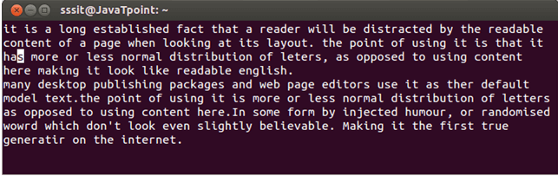
Look at the above snapshot, this is our normal script. We have to search word readable from this script.
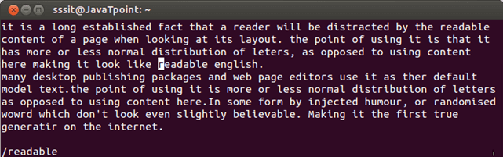
Look at the above snapshot, after typing /readable and pressing enter, mentioned word on its first occurence will be automatically highlighted. Please note here, first occurence is in forward search. The string readable is also present before the cursor, but it searches forward.
?string
The ?string allows us to do backward search for a string. If the same string is placed before and after the cursor, it will only indicate the string before the cursor. When you'll start typing ?string in command mode, at lower left corner, typed word will be seen.
Example:
/readable
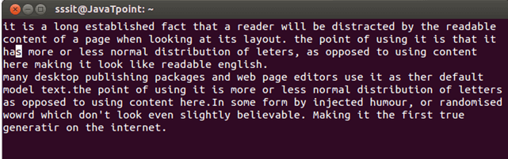
Look at the above snapshot, this is our normal script. We have to search word readable from this script.
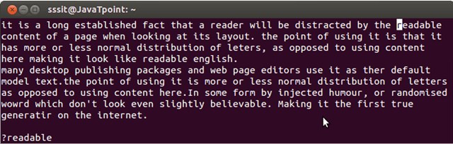
Look at the above snapshot, after typing ?readable and pressing enter, mentioned word on its first occurence will be automatically highlighted. Please note here, first occurence is in backward search. The string readable is also present after the cursor, but it searches backward.
/^string
This command searches a string in forward direction but at the beginning of a line. If no such word is present at the beginning of the line, it will show a no match message.
Example:
/^readable
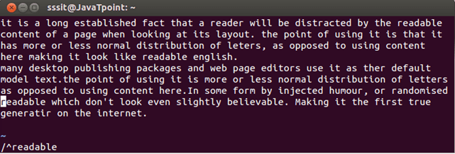
Look at the above snapshot, after typing /^readable, cursor moved to the string which is at the starting of the line.
/string$
This command searches string in forward direction but at the end of a line. If no such word is present at the end of the line, it will show a no match message.
Example:
/readable$
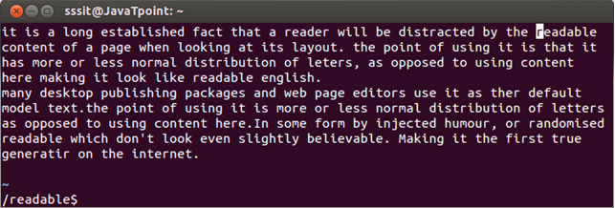
Look at the above snapshot, after typing /readable$, cursor moved to the string which is at the end of the line.
n
The n command indicates the next occurence of the searched string.
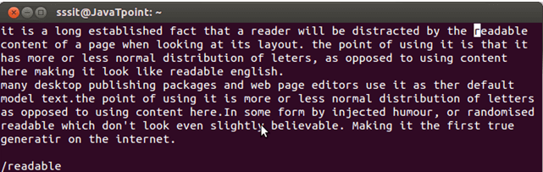
Look at the above snapshot, cursor is at first occurence of string.
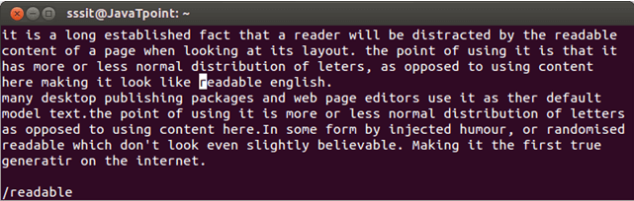
Look at the above snapshot, after pressing n, cursor is at next occurence of the string.
/\
This command only searches for specifically the word enclosed in <>.
Example 1:
/\
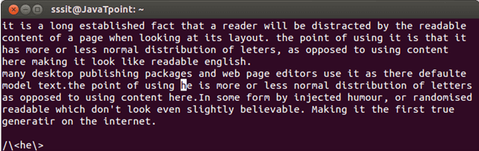
Look at the above snapshot, after typing /\<he\> command, we got the word he.
Example 2:
/he
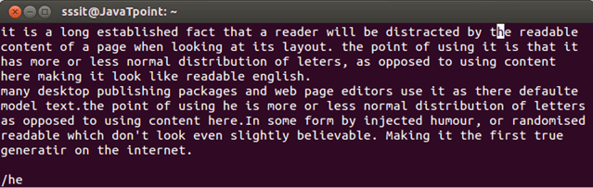
Look at the above snapshot, after searching for he with command /he, cursor has highlighted he from the word.
/pl[abc]ce
This command is helpful when you are in doubt with the spelling of a word. Here you can write all the possibilities related to your search.
Example:
/cont[ae]nt
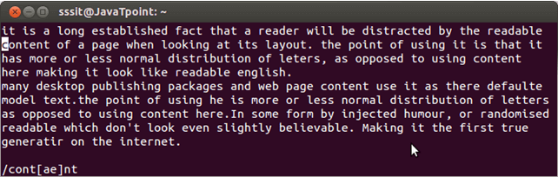 Look at the above snapshot, after typing command /cont[ae]nt, word content is highlighted.
Vi jump :show line numbers, go a certain line number
When you move around a file you need to switch from one line to another line. Although you can do this with j,k keys or arrow keys. But when your file is too large, you can use G command. If you'll type a number before G then you'll be directed to the typed line number. And if you'll type only G then you'll be directed to the last line of the file.
One important command in vi editor is (``). it will help you to come back at the earlier position in the file. For example, if you are on line 4, by using 10G command you reach at line 10. But you forgot to edit something in line 4 and want to go back to line 4, here you can use `` which will redirect you to line 4.
nG
Here n denotes a number. You can type a number before G to jump to a particular line.
Example:
7G
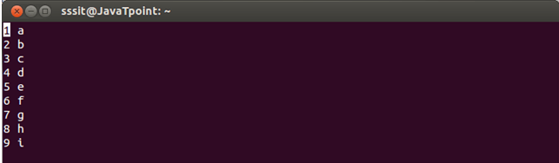
Look at the above snapshot, our cursor is at line 1 and we want to go to the line 7.
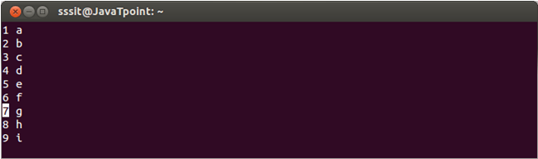
Look at the above snapshot, in command mode after typing 7G (you'll not be able to see the typed command 7G on the screen), we're at 7th line.
G
If you'll not type any number before G, then you'll be directed to last line of the file.
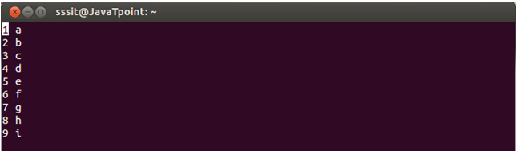
Look at the above snapshot, our cursor is at line 1.
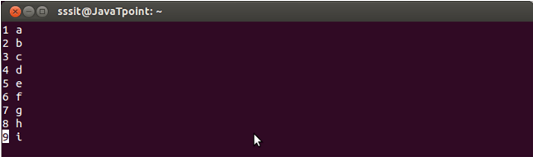
Look at the above snapshot, after pressing G, we're at the last line of the file.
``
This command allows us to move to the previous position in the file.
Example:
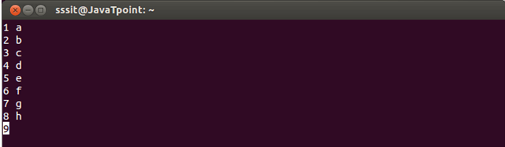
Look at the above snapshot, we are at line number 9.
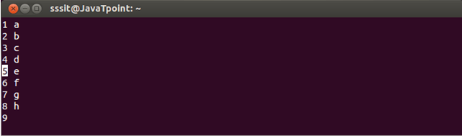
Look at the above snapshot, we are at line 5 but forgot to write something on line 9.
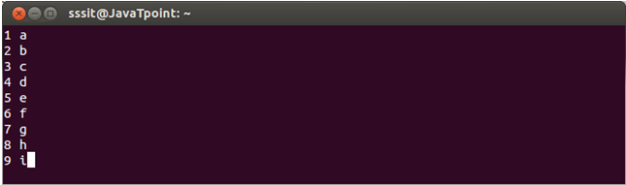
Look at the above snapshot, after typing `` we moved back to line 9.

vi move: go to top or end of file

In command mode, we can move to different parts of a file with h,j,k,l commands. These (h,j,k,l) keys are used because at the time of vi invention, arrow keys were not invented. Although, we can use arrow keys also. Arrow keys and h,j,k,l keys work same.
j
The j command works same as the downward arrow. You can move to the below lines.
Example:
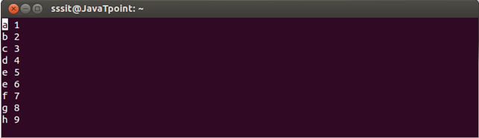
Look at the above snapshot, letter e is repeated twice. To correct that we need to go to that line.
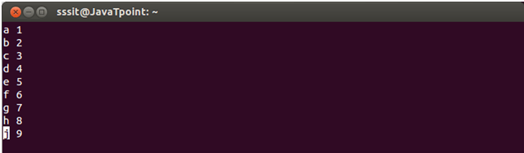
Look at the above snapshot, after pressing either j key or downward key, we moved to that line and corrected it.
k
The k command works same as the upward arrow. You can move to the above lines.
Example:
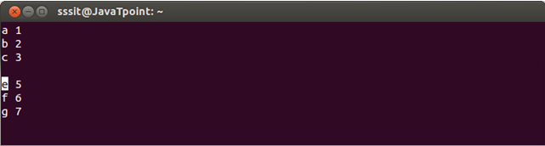
Look at the above snapshot, our cursor is at letter e and we want to move up at the blank line to write something.
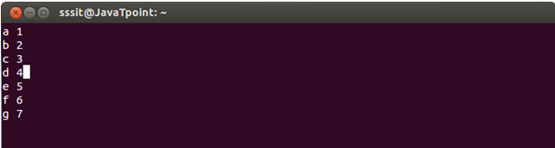
Look at the above snapshot, after pressing either k key or upward key, we moved to the upper line and have written over there.
h
The h command works same as the leftward arrow. You can move in leftwards direction.
Example:
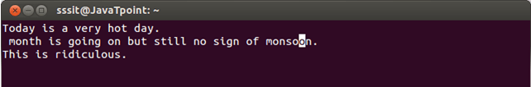
Look at the above snapshot, our cursor is at the end and we want to move to the starting of the second line.
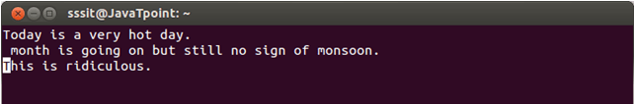
Look at the above snapshot, after pressing either h key or leftward key, we're at starting of the second line.
l
The l command works same as the rightward arrow. You can move in rightwards direction.
Example:
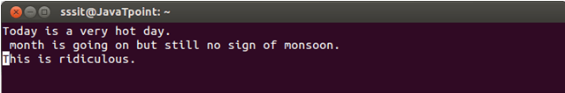
Look at the above snapshot, we are at starting and we want to move to the end of the last line
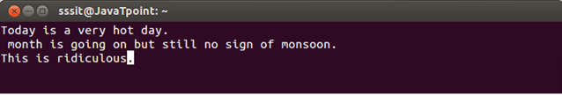
Look at the above snapshot, after pressing either l key or rightward arrow, we're at the end of the last line.

To learn more about vi editor commands below is the cheat sheet link.
https://www.atmos.albany.edu/daes/atmclasses/atm350/vi_cheat_sheet.pdf

- What is an inode? What commands to check the inode of file? Issues bcs of inode.
An inode is a file data structure that stores information about any Linux file except its name and data.

An inode contains different information, including:
- File permissions
- File size
- Group and User IDs of a file
- Timestamps for creating, reading, and writing a file.
- Location of the data
- Hard and soft links
- File types

Commands used to check the inode of file:
Checking inode Numbers
You can check the number of inodes in a file system or even for a specific file. To check for a file system, use the command below.
$ df -ih
In the output below, you can note the specific file system and its different statistics, including free and used percentages.
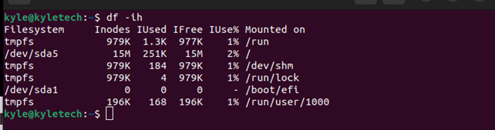
Alternatively, you can specify a specific file system to check. For instance, to check for /sda5, we can use the command below.
$ df -ih /dev/sda5
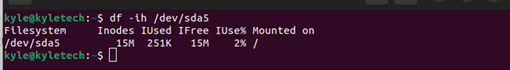
To check the inode number for a specific file, you can list its contents using the ls -il or stat command. The stat command displays the statistics of a given file, such as the inode number. For our example, our file is test.txt, and our command is shown below.
$ stat test.txt
Other file details, such as the creation date, get displayed with the stat command.
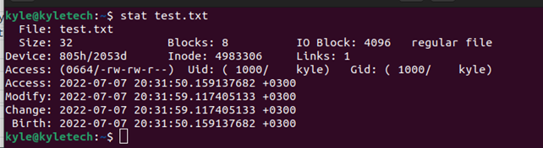
Similarly, listing the contents of the current directory displays the number of blocks of a specific file.
$ ls -li | grep test.txt
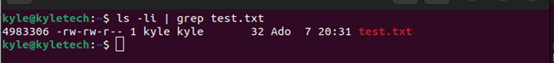
For this case, the inode number is 4983306.
To check the directory-level inode, add the -d flag to the command of checking the inode of files.
The new command will be:
$ ls -ldi ~/Desktop
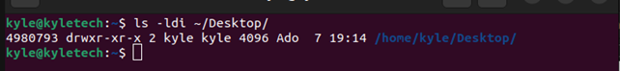

Issues bcs of inode:
https://support.huaweicloud.com/intl/en-us/trouble-ecs/ecs_trouble_0323.html

- Permissions of a file, – eg: what does 777 permission means on a file.
The basic Linux permissions model works by associating each system file with an owner and a group and assigning permission access rights for three different classes of users:

The file owner.
The group members.
Others (everybody else).
File ownership can be changed using the chown and chgrp commands.

Three file permissions types apply to each class of users:
- The read permission.
- The write permission.
- The execute permission.

To view the file permissions, use the ls command:

ls -l file_name

-rw-r--r-- 12 linuxize users 12.0K Apr 28 10:10 file_name
|[-][-][-]- [------] [---]
| | | | | | |
| | | | | | +-----------> 7. Group
| | | | | +-------------------> 6. Owner
| | | | +--------------------------> 5. Alternate Access Method
| | | +----------------------------> 4. Others Permissions
| | +-------------------------------> 3. Group Permissions
| +----------------------------------> 2. Owner Permissions
+------------------------------------> 1. File Type

The first character indicates the file type. It can be a regular file (-), directory (d), a symbolic link (l), or other special types of files. The following nine characters represent the file permissions, three triplets of three characters each. The first triplet shows the owner permissions, the second one group permissions, and the last triplet shows everybody else permissions.
In the example above (rw-r--r--) means that the file owner has read and write permissions (rw-), the group and others have only read permissions (r--).

File permission can be represented in a numeric or symbolic format
The permission number can consist of three or four digits, ranging from 0 to 7.
When 3 digits number is used, the first digit represents the permissions of the file’s owner, the second one the file’s group and the last one all other users.

The write, read, and execute permissions have the following number value:
- r (read) = 4
- w (write) = 2
- x (execute) = 1
- no permissions = 0
The permissions digit of a specific user class is the sum of the values of the permissions for that class.
Each digit of the permissions number may be a sum of 4, 2, 1 and 0:
- 0 (0+0+0) – No permission.
- 1 (0+0+1) – Only execute permission.
- 2 (0+2+0) – Only write permission.
- 3 (0+2+1) – Write and execute permissions.
- 4 (4+0+0) – Only read permission.
- 5 (4+0+1) – Read and execute permission.
- 6 (4+2+0) – Read and write permissions.
- 7 (4+2+1) – Read, write, and execute permission.

To view the file’s permissions in the numeric (octal) notation, use the stat command:

stat -c "%a" filename
644

- Few Unix commands
- touch -> touch command is a way to create empty files (there are some other methods also). You can update the modification and access time of each file with the help of touch command.
Syntax: touch <filename>
Example:
touch myfile1
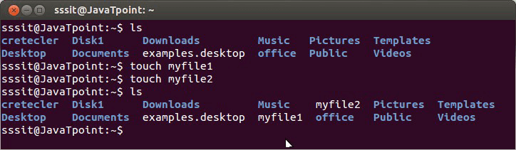
Look above, we have created two files namely 'myfile1' and 'myfile2' through touch command. To create multiple files just type all the file names with a single touch command followed by enter key. For example, if you would like to create 'myfile1' and 'myfile2' simultaneously, then your command will be:
touch myfile1 myfile2

touch Options
Option | Function
touch -a | To change file access and modification time.
touch -m | It is used to only modify time of a file.
touch -r | To update time of one file with reference to the other file.
touch -t | To create a file by specifying the time.
touch -c | It does't create n empty file.

cp 'cp' means copy. 'cp' command is used to copy a file or a directory.
To copy a file into the same directory syntax will be,
- cp <existing file name> <new file name>
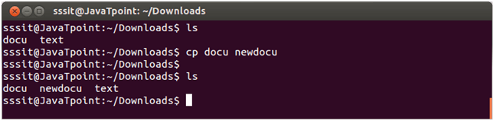
In above snapshot, we have created a copy of 'docu' and named it as 'newdocu'. If in case, (in our case it is 'newdocu') alreade exists, then it will simply over write the earlier file.

To copy a file in a different directory
We have to mention the path of the destination directory.
In the snapshot below, earlier there is no 'text' file. After giving the command, 'text' file has been copied to the destination directory that is 'Desktop'.
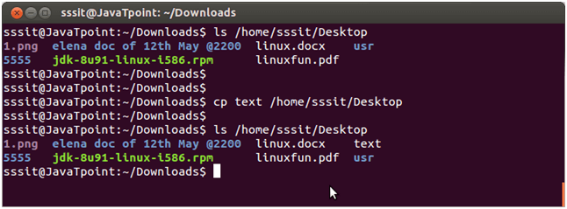

cp Options
Option | Function
cp -r | To copy a directory along with its sub dirctories.
cp file1 file 2 directory name | To copy multiple file or directories in a directory.
cp -backup | To backup the existing file before over writing it.
cp -i | Asks for confirmtion.
cp -l | To create hard link file.
cp -p | Preserves attribute of a file.
cp -u -v | To make sure source file is newer then destination file.

When copying a file, the new file is owned by the user running the command. Use the -p option to preserve the file mode, ownership , and timestamps :
$ cp -p file.txt file_backup.txt

Copying Directories with cp Command
To copy a directory, including all its files and subdirectories, use the -R or -r option.
In the following example, we are copying the directory Pictures to Pictures_backup:
cp -R Pictures Pictures_backupCopy
The command above creates the destination directory and recursively copy all files and subdirectories from the source to the destination directory.
If the destination directory already exists, the source directory itself and its content are copied inside the destination directory.
To copy only the files and subdirectories but not the source directory, use the -T option:
cp -RT Pictures Pictures_backupCopy
Another way to copy only the directory’s content but not the directory itself is to use the wildcard character (*). The disadvantage of the following command is that it does not copy the hidden files and directories (the ones starting with a dot .):
cp -RT Pictures/* Pictures_backup/Copy
All the options we used in the previous section when copying files can also be used when copying directories. The main difference is that when copying directories, you always need to use the -R option.

rm
The 'rm' means remove. This command is used to remove a file. The command line doesn't have a recycle bin or trash unlike other GUI's to recover the files. Hence, be very much careful while using this command. Once you have deleted a file, it is removed permanently.
Syntax:
rm <filename>
Example:
rm myfile1
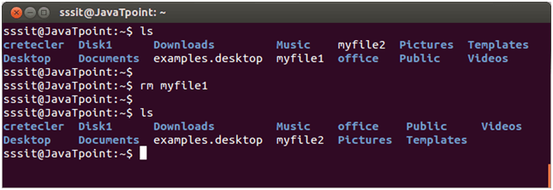
In above snapshot, we have removed file myfile1 permanently with the help of 'rm' command.

rm Options
Option | Description
rm *extension | Used to delete files having same extension.
rm -r or R | To delete a directory recursively.
rm -i | Remove a file interactively.
rm -rf | Remove a directory forcefully.

mv->
Linux mv command is used to move existing file or directory from one location to another. It is also used to rename a file or directory. If you want to rename a single directory or file then 'mv' option will be better to use.

How To Rename a File
While renaming a file the inode number of both the files will remain the same.
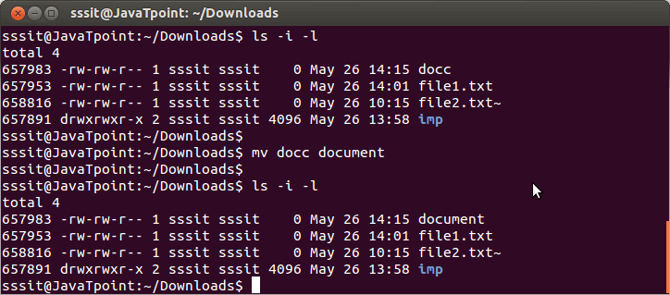
In the above example, we have renamed file 'docc' into 'document'. But inode number of both the files remains the same.
How To Rename a Directory
Directories can be renamed in the same way as the files. In this case also inode number will remain the same.
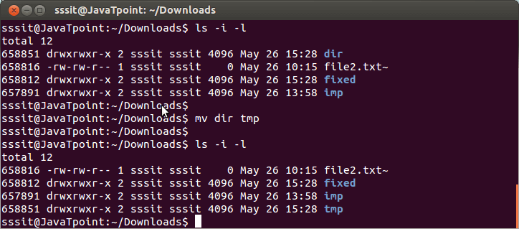

mv Options
Option | Function
mv -i | Asks for permission to over write.
mv * | Move multiple files to a specific directory.
mv --suffix | Used to take backup before over writing.
mv -u | Only move those files that doesn't exist.

ls->
The ls is the list command in Linux. It will show the full list or content of your directory. Just type ls and press the enter key. The whole content will be shown.

Example:
ls
Below, you can see, after entering ls command, we got the whole content list of /home/sssit directory.
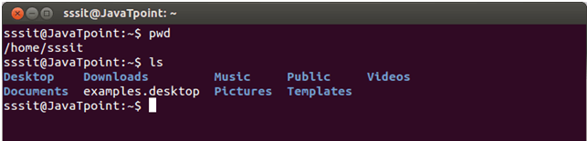

Linux ls command options
ls option | Description
ls -a | In Linux, hidden files start with . (dot) symbol and they are not visible in the regular directory. The (ls -a) command will enlist the whole list of the current directory including the hidden files.
ls -l | It will show the list in a long list format.
ls -lh | This command will show you the file sizes in human readable format. Size of the file is very difficult to read when displayed in terms of byte. The (ls -lh)command will give you the data in terms of Mb, Gb, Tb, etc.
ls -lhS | If you want to display your files in descending order (highest at the top) according to their size, then you can use (ls -lhS) command.
ls -l - -block-size=[SIZE] | It is used to display the files in a specific size format. Here, in [SIZE] you can assign size according to your requirement.
ls -d */ | It is used to display only subdirectories.
ls -g or ls -lG | With this you can exclude column of group information and owner.
ls -n | It is used to print group ID and owner ID instead of their names.
ls --color=[VALUE] | This command is used to print list as colored or discolored.
ls -li | This command prints the index number if file is in the first column.
ls -p | It is used to identify the directory easily by marking the directories with a slash (/) line sign.
ls -r | It is used to print the list in reverse order.
ls -R | It will display the content of the sub-directories also.
ls -lX | It will group the files with same extensions together in the list.
ls -lt | It will sort the list by displaying recently modified filed at top.
ls ~ | It gives the contents of home directory.
ls ../ | It give the contents of parent directory.
ls --version | It checks the version of ls command.

top Display tasks and system status in Unix/Linux.
top is a basic Unix command which is very useful for observing the current state of your Unix system, by default presenting you the list of top users of your system’s resources – CPU shares and memory.

By default, you run top without any parameters, and it shows you a full screen (or full window of your terminal) with the current status of your system and a list of processes using most of its CPU:

ubuntu$ top
top - 13:29:09 up 2 days, 7:13, 4 users, load average: 0.07, 0.02, 0.00
Tasks: 148 total, 1 running, 147 sleeping, 0 stopped, 0 zombie
Cpu(s): 0.6%us, 0.5%sy, 0.0%ni, 97.3%id, 1.6%wa, 0.0%hi, 0.0%si, 0.0%st
Mem: 4051792k total, 4026104k used, 25688k free, 359168k buffers
Swap: 4096492k total, 24296k used, 4072196k free, 2806484k cached
PID USER PR NI VIRT RES SHR S %CPU %MEM TIME+ COMMAND
7629 greys 20 0 749m 291m 28m S 1 7.4 16:51.40 firefox
19935 greys 20 0 133m 14m 10m S 0 0.4 2:38.52 smplayer
1 root 20 0 4020 880 592 S 0 0.0 0:00.96 init
2 root 15 -5 0 0 0 S 0 0.0 0:00.00 kthreadd
3 root RT -5 0 0 0 S 0 0.0 0:00.04 migration/0
4 root 15 -5 0 0 0 S 0 0.0 0:00.90 ksoftirqd/0
5 root RT -5 0 0 0 S 0 0.0 0:00.00 watchdog/0
6 root RT -5 0 0 0 S 0 0.0 0:00.06 migration/1
7 root 15 -5 0 0 0 S 0 0.0 0:01.32 ksoftirqd/1
8 root RT -5 0 0 0 S 0 0.0 0:00.00 watchdog/1
9 root 15 -5 0 0 0 S 0 0.0 0:02.14 events/0
10 root 15 -5 0 0 0 S 0 0.0 0:01.44 events/1
11 root 15 -5 0 0 0 S 0 0.0 0:00.00 khelper
44 root 15 -5 0 0 0 S 0 0.0 0:01.26 kblockd/0
45 root 15 -5 0 0 0 S 0 0.0 0:01.98 kblockd/1
48 root 15 -5 0 0 0 S 0 0.0 0:00.00 kacpid
49 root 15 -5 0 0 0 S 0 0.0 0:00.00 kacpi_notify
153 root 15 -5 0 0 0 S 0 0.0 0:00.00 kseriod
203 root 15 -5 0 0 0 S 0 0.0 0:03.56 kswapd0
246 root 15 -5 0 0 0 S 0 0.0 0:00.00 aio/0
247 root 15 -5 0 0 0 S 0 0.0 0:00.00 aio/1
1595 root 15 -5 0 0 0 S 0 0.0 0:00.00 ksuspend_usbd
1601 root 15 -5 0 0 0 S 0 0.0 0:00.02 khubd
1612 root 15 -5 0 0 0 S 0 0.0 0:00.08 ata/0
1615 root 15 -5 0 0 0 S 0 0.0 0:08.28 ata/1
1616 root 15 -5 0 0 0 S 0 0.0 0:00.00 ata_aux

df
Linux df command is used to display the disk space used in the file system. The 'df' stands for "disk filesystem." It defines the number of blocks used, the number of blocks available, and the directory where the file system is mounted.
Syntax:
df [OPTION]... [FILE]...

To display the disk space usage, execute the df command without any argument. It will show the disk space usage in a tabular form. The df command is useful for discovering the available free space on a system or file system.

Execute the below command:
df
The above command will produce the output as follows:
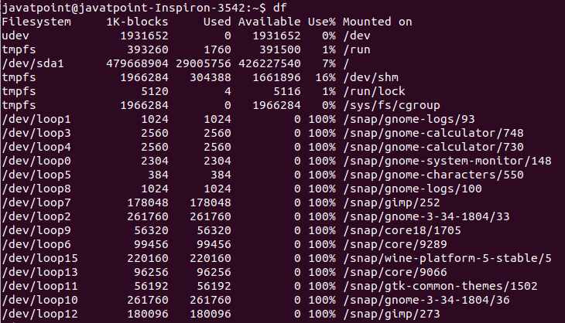
From the above output, we can see the file system, the size of the file system in 1k block, used space, available space, the percentage applied by the file system, and mount point, respectively

Options:
-a, --all: It is used to include pseudo, duplicate, remote file systems.
-B, --block-size=SIZE: It is used to scale sizes by SIZE before printing them, for example, the '-BM' option prints sizes in units of 1,048,576 bytes.
-h, --human-readable: It is used to display sizes in powers of 1024 (e.g., 1023M).
-H, --si: It is used to show sizes in powers of 1000 (e.g., 1.1G)
-i, --inodes: It is used to list inode information instead of block usage
-l, --local: It is used to limit the listing to local file systems.
--no-sync: It is used for not invoking sync before getting usage info (default).
--output[=FIELD_LIST]: This option used if we want to use the output format defined by FIELD_LIST or print all fields if FIELD_LIST is omitted.
-P, --portability: It is used to use the POSIX output format.
--total: It is used to exclude all entries insignificant to available space, and produce a total.
-t, --type=TYPE: It is used to limit the listing to file systems of type TYPE.
-T, --print-type: It is used to display the file system type.
-x, --exclude-type=TYPE: It is used to limit the listing to file systems, not of type TYPE.
--help: It is used to display the help manual having brief information about the supported options.
--version: It is used to display the version information of the df command
du
Command du stands for Disk Usage. It is used to check the information of disk usage of files and directories on a system.
Command du display a list of all the files along with their respective sizes. By default, size given is in kilobytes.
File names are used as arguments to get the file size.
Syntax:
- du
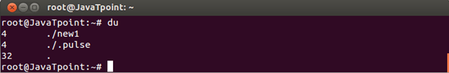
Look at the above snapshot, du command display number of disk blocks in current directory file.
It does not display all files, only files occupying some disk space are displayed.
Here, first column display the size of disk space.
Options
Command | Option
du -a | List all files and directories size
du -h | Display in human readable format
du -c | Display grand total in the output
du -s | Display only total
du -0/td> | End output with null byte
du --block-size=<size> | Specify block size
du --time | Display time modification

find
The find command helps us to find a particular file within a directory. It is used to find the list of files for the various conditions like permission, user ownership, modification, date/time, size, and more.
Syntax:
find <location> <comparison-criteria> <search-term>
The following symbols are used to specify the directory:
(.) : For current directory name
(/) : For the root directory

Ex: Find files by name
We can search all the files ending with the extension '.txt.' To do so, execute the below command:
- find . -name "*.txt"
The above command will list all the text files from the current working directory. Consider the below output:
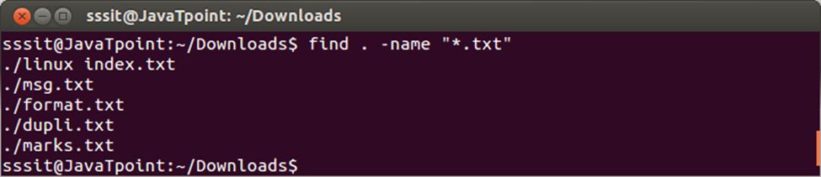
From the above output, all the files having '.txt' extension are listed with the find command.
locate
The locate command and find command is used to search a file by name. But, the difference between both commands is that locate command is a background process and searches the file in the database whereas, find command searches in the filesystem. The locate command is much faster than find command.
If you are unable to find a file with locate command, then it means that your database is out of date, and you can update your database with the "updatedb" command.
Syntax:
locate [OPTION]... PATTERN...
Options:
Some useful command line options are as following:
-A, --all: It is used to display only entries that match all PATTERNs instead of requiring only one of them to match.
-b, --basename: It is used to match only the base name against the specified patterns.
-c, --count: It is used for writing the number matching entries instead of writing file names on standard output.
-d, --database DBPATH: It is used to replace the default database with DBPATH.
-e, --existing: It is used to display only entries that refer to existing files during the command is executed.
-L, --follow: If the '--existing' option is specified, It is used for checking whether files exist and follow trailing symbolic links. It will omit the broken symbolic links to the output. This is the default behavior. The opposite behavior can be specified using the "--nofollow" option.
-h, --help: it is used to display the help documentation that contains a summary of the available options.
-i, --ignore-case: It is used to ignore case sensitivity of the specified patterns.
-p, --ignore-spaces: It is used to ignore punctuation and spaces when matching patterns.
-t, --transliterate: It is used to ignore accents using iconv transliteration when matching patterns.
-l, --limit, -n LIMIT: If this option is specified, the command exit successfully after finding LIMIT entries.
-m, --mmap: It is used to ignore the compatibility with BSD, and GNU locate.
-0, --null: It is used to separate the entries on output using the ASCII NUL character instead of writing each entry on a separate line.
-S, --statistics: It is used to write statistics about each read database to standard output instead of searching for files.
-r, --regexp REGEXP: It is used for searching a basic regexp REGEXP.
--regex: It is used to describe all PATTERNs as extended regular expressions.
-V, --version: It is used to display the version and license information.
-w, --wholename: It is used for matching only the whole path name in specified patterns.
Locate command is a useful utility for searching the files. It is pretty straight forward to use, just execute the command as follows:
locate <file name>
Consider the below output:
Limiting Search Queries
We can limit the search results to avoid redundancy by using the "-n" option.
For example. To display the just 5 results from our queries, execute the command as follows:
locate -n 5 "*.txt"
The above command will display the first five text files. Consider the below output:
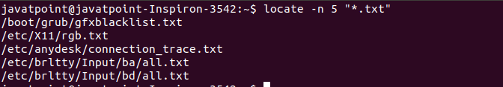

grep
The 'grep' command stands for "global regular expression print". grep command filters the content of a file which makes our search easy.
grep with pipe
The 'grep' command is generally used with pipe (|).
Syntax:
- command | grep <searchWord>
Example:
- cat marks.txt | grep 9
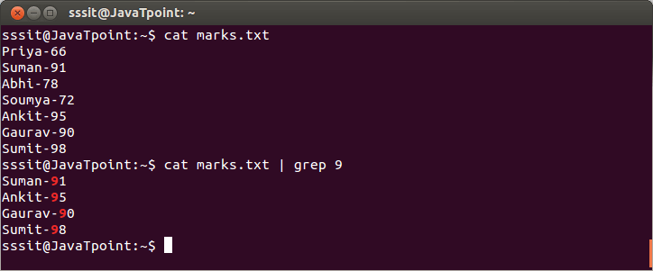
Look at the above snapshot, grep command filters all the data containing '9'.

grep without pipe
It can be used without pipe also.
Syntax:
- grep <searchWord> <file name>
Example:
- grep 9 marks.txt
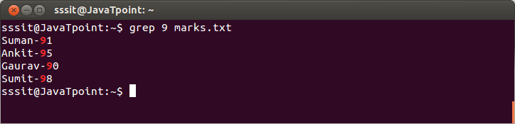
Look at the above snapshot, grep command do the same work as earlier example but without pipe.

grep options
- grep -vM: The 'grep -v' command displays lines not matching to the specified word.
Syntax:
  - grep -v <searchWord> <fileName>
Example:
  - grep -v 9 marks.txt
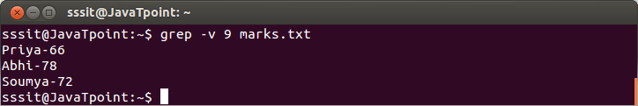
Look at the above snapshot, command "grep -v 9 marks.txt" displays lines hwich don't contain our search word '9'.
- grep -i: The 'grep -i' command filters output in a case-insensitive way.
Syntax:
  - grep -i <searchWord> <fileName>
Example:
  - grep -i red exm.txt
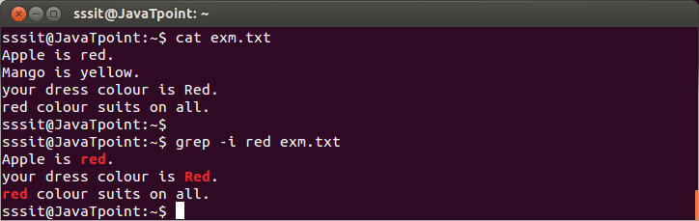
Look at the above snapshot, command "grep -i red exm.txt" displays all lines containing 'red' whether in upper case or lower case.
- grep -A/ grep -B/ grep -C
grep -A command is used to display the line after the result.
grep -B command is used to display the line before the result.
grep -C command is used to display the line after and line before the result.
You can use (A1, A2, A3.....)(B1, B2, B3....)(C1, C2, C3....) to display any number of lines.
Syntax:
  - grep -A<lineNumber> <searchWord> <fileName>
  - grep -B<lineNumber> <searchWord> <fileName>
  - grep -C<lineNumber> <searchWord> <fileName>
Example:
  - grep -A1 yellow exm.txt
  - grep -B1 yellow exm.txt
  - grep -C1 yellow exm.txt
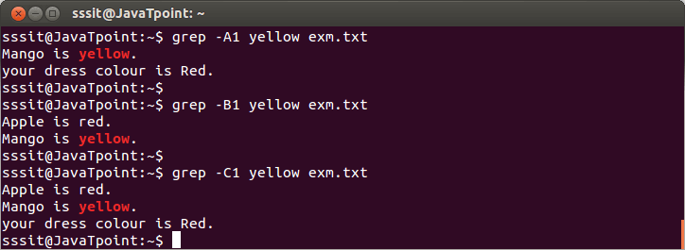
Look at the above snapshot, command "grep -A1 yellow exm.txt" displays searched line with next succeeding line, command "grep -B1 yellow exm.txt" displays searched line with one preceding line and command "grep -C1 yellow exm.txt" displays searched line with one preceding and succeeding line.
whoami
whoami command is used both in Unix Operating System and as well as in Windows Operating System.
- It is basically the concatenation of the strings “who”,”am”,”i” as whoami.
- It displays the username of the current user when this command is invoked.
- It is similar as running the id command with the options -un.

Syntax:
vwantmu@HP~: whoami

Output :
Vwantmu
Example:
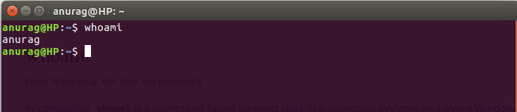
which
The Linux which command is used to locate the executable files or location of a program from the file system. It displays the path where the specified file or command is stored.
Syntax:
which <program name>
The above command will display the path of specified filename or command.
The which command facilitates with only one option that is the '-a' option. It is used to display all the paths for the specified command. In some cases, our machine contains two different paths for the same program. For example, it can be "/usr/bin/program" or "/usr/local/bin/program". The '-a' option will display both the paths for the specified command.
Syntax:
which -a <program_name>
display the path of any executable files such as programs and commands, simply execute the which command followed by the program name.
For example, to display the path of node executable files, execute the command as follows:
which node
It will display the path of node executable files. Consider the below output:
Similarly, for Java executable files, execute the command as follows:
Ex:
which java
It will display the path of Java executable files.
Which command only displays the path of executable files, so execute commands only with the arguments available in the machine. If we pass any illegal argument (which our machine doesn't contain), it will not give any output.
stat
The stat is a command which gives information about the file and filesystem. Stat command gives information such as the size of the file, access permissions and the user ID and group ID, birth time access time of the file. Stat command has another feature, by which it can also provide the file system information.
Syntax :
stat --options filenames
Stat can accept one or more filenames as an input to the stat command.
stat /etc/resolv.conf
Output:
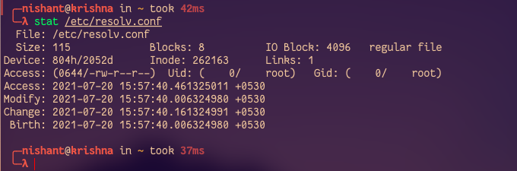
The information we get from stat
Following is the information we get about the file when we run the stat command.
- File: The name of the provided file. If the provided file is a symlink, then the name will be different.
- Size: The size of a given file in Bytes.
- Blocks: Total number of allocated blocks to the file to store on the hard disk.
- IO Block: The size of every allocated block in bytes.
- File type: The file may be of the following types: Regular files, special files, directories, or symbolic links.
- Device: Device number in hexadecimal format.
- Inode: Inode number of the file.
- Links: Number of hard links of the file.
- Access: Access permissions in the numeric and symbolic methods.
- Context: The field stores SELinux security context.
- Access: The last time at which the file was accessed.
- Modify: The last time at which file was modified.
- Change: The last time the at which file’s attribute or content was changed.
- Birth: The time at which the file was created.

Chown
Linux chown command is used to change a file's ownership, directory, or symbolic link for a user.
or group. The chown stands for change owner. In Linux each file is associated with a corresponding owner or group.
Syntax:
Below is the general syntax of the chown command:
chown [OPTION]... [OWNER][:[GROUP]] FILE...
Options:
Following are the command-line options of the chown command:
-c, --changes: It is used to display the detailed output like verbose, but it is reported when only a change is made.
-f, --silent, --quiet: It is used to suppress the error messages.
-v, --verbose: It is used to display a diagnostic for every processed file.
--dereference: It is used to affect the referent of each symbolic link.
-h, --no-dereference: It is used to affect the symbolic links instead of any referenced file.
--from=CURRENT_OWNER:CURRENT_GROUP: It is used to change the specific owner and group.
--no-preserve-root: It is used for not treating the backslash ('/') especially.
--preserve-root: If the chown is failed to operate recursively on backslash ('/').
--reference=RFILE: It is used to specify the RFILE's owner and group rather than their values.
-R, --recursive: It is used to perform operations on files and directories recursively.
--help: It is used to display the help manual having a brief description of the usage and options.
--version: It is used to display the version information.

Display the UID, GID, and Groups
To display all the groups, execute the groups command as follows:
groups
The above command will list all the existing groups from your Linux system. Consider the below output:
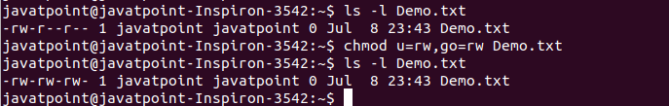
To list the UID and GID, execute the id command as follows:
id
The above command will list all the UID and GID of their corresponding users and groups. Consider the below output:
Display the User and Group Ownership of a File
To display the user and group owner of a file, execute the "ls -l" command with a specific file name. Consider the below command:
ls -l Demo.txt
The above command will display the user and group ownership of the 'Demo.txt.' Consider the below output:
Change the owner of a File (Using user name)
To change the owner of a file, pass the user name (new owner) with the chown command as follows:
sudo chown <username> <File name>
Consider the below command:
sudo chown jtp Demo.txt
The above command will set the jtp as the owner of the file 'Demo.txt'. Consider the below output:
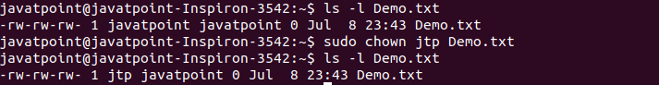
From the above output, the owner of the given file has changed.
Change the Owner of a File (Using UID)
We can change the owner of a file or directory using the UID of a user. To change the ownership by using the UID, pass the UID with chown command as follows:
sudo chown 1000 Demo.txt
The above command will change the ownership of the 'Demo.txt'. Consider the below output:
Change the Group of a File
To change the group of a file, specify group name or GID with the chown command. It represents similar behavior as chgrp command. Execute the chown command specifying the group name separated by a colon as follows:
sudo chown :groupname Demo.txt or
sudo chown :GID Demo.txt
Consider the below command:
- sudo chown :adm Demo.txt
The above command will change the group of 'Demo.txt.' Consider the below output:
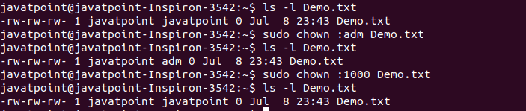
From the above output, we have changed the group using the group name in the first command. In the second command, we have changed the group name using the GID.
Change the User and Group Name
We can change the user and group names together. To change the user and group name at once, execute the chown command as follows:
sudo chown <User name/UID>:<Group name/GID> <File name>
Consider the below command:
sudo chown jtp:adm Demo.txt
The above command will change the specified user name and group name together. Consider the below output:

chmod
Linux chmod command is used to change the access permissions of files and directories. It stands for change mode. It can not change the permission of symbolic links.
In the Linux file system, each file is associated with a particular owner and have permission access for different users. The user classes may be:
- owner
- group member
- Others (Everybody else)
The file in Linux are the following three types:
- read (r)
- write (w)
- execute (x)
Let's see how to change the file permission using the chmod command.
Syntax:
The basic syntax of chmod command is as follows:
- chmod <options> <permissions> <file name>
Options:
The chmod command supports the following command-line options:
-c, --changes: It is similar to the verbose option, but the difference is that it is reported if a change has been made.
-f, --silent, --quiet: It is used to suppress the error messages.
-v, --verbose: It is used to display a diagnostic for every processed file.
--no-preserve-root: It is used for not treating the backslash symbol ('/'), especially (the default).
--preserve-root: If this option is used, it will fail to operate recursively on backslash ('/').
--reference=RFILE: It is used to specify the RFILE's mode alternatively MODE values.
-R, --recursive: It is used to change files and directories recursively.
--help: It is used to display the help manual having a brief description of usage and support options.
--version: It is used to display the version information.
File Permission Syntax
If you are a new user, you may get confused with the different types of letters used to set the file permission. So, Before proceeding further with the chmod command, let's understand the file permission syntax.
To set the permission of a file or directory, we have to specify the following things:
- Who: Who we are. (user)
- What: What change are we going to made ( Such as adding or removing the permission)?
- Which: Which of the permissions?
The permission statement is represented in indicators such as u+x, u-x. Where 'u' stands for 'user,' '+' stands for add, '-' stands for remove, 'x' stands for executable (which).
The user value can be:
u: the owner of the file
g: group member
o: others
a: all
The permission types can be r, w, and x.
Setting and Updating the Permissions
To set the permission of a file, execute a permission statement with the chmod command. For example, we want to set the read and write permission for all users and groups of file 'Demo.txt.' We have to pass the "u=rw,go=rw Demo.txt" permission statement with chmod command. To display the file permission, execute the below command:
- ls -l Demo.txt
The above command will display the file's current file permission of the 'Demo.txt' file.
To change the permission, execute the below command:
- chmod u=rw,go=rw Demo.txt
Consider the below output:
From the above output, the access permission of 'Demo.txt' has changed.
Setting Permissions for Multiple Files
We can set permission for multiple files at once by using the chmod command. To change the file permission of multiple files, specify the file pattern with the chmod command. For example, if we want to set read and write permission for all text files, specify the *. txt pattern with chmod command.
To view the permission of all text file from the current working directory, execute the below command:
- ls -l *.txt
It will list all the text files with their permission mode. Consider the below output:
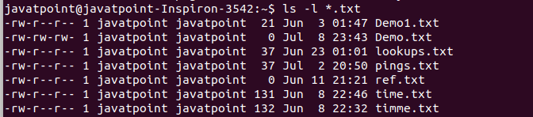
From the above output, many files have only read permission for other users.
To set the read and write permission for other users, execute the below command:
- chmod o+w *.txt
It will set the read and write permission for other users of the text files. Consider the below output:
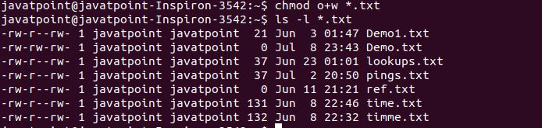
Numerical Shorthand
We can use the numeric values instead of letters to specify the permissions. A three-digit value is used to specify the permission. The leftmost digit represents the owner (u), and the middle digit represents the group members (g). The rightmost digit represents the others (o).
The following table represents the digits and their permissions:
Digits | Permissions
000 | No permission
001 | Execute permission
010 | Write permission
011 | Write and execute permissions
100 | Read permission
101 | Read and execute permissions
110 | Read and write permissions
111 | Read, write, and execute permissions

ACL
What is ACL ?
Access control list (ACL) provides an additional, more flexible permission mechanism for file systems. It is designed to assist with UNIX file permissions. ACL allows you to give permissions for any user or group to any disc resource.
Use of ACL :
Think of a scenario in which a particular user is not a member of group created by you but still you want to give some read or write access, how can you do it without making user a member of group, here comes in picture Access Control Lists, ACL helps us to do this trick.
Basically, ACLs are used to make a flexible permission mechanism in Linux.
setfacl and getfacl are used for setting up ACL and showing ACL respectively.
For example :
getfacl test/declarations.h
Output:
# file: test/declarations.h
# owner: mandeep
# group: mandeep
user::rw-
group::rw-
other::r--
List of commands for setting up ACL :
1) To add permission for user
setfacl -m "u:user:permissions" /path/to/file

2) To add permissions for a group
setfacl -m "g:group:permissions" /path/to/file

3) To allow all files or directories to inherit ACL entries from the directory it is within
setfacl -dm "entry" /path/to/dir

4) To remove a specific entry
setfacl -x "entry" /path/to/file

5) To remove all entries
setfacl -b path/to/file
For example :
setfacl -m u:mandeep:rwx test/declarations.h
Modifying ACL using setfacl :
To add permissions for a user (user is either the user name or ID):
# setfacl -m "u:user:permissions"
To add permissions for a group (group is either the group name or ID):
# setfacl -m "g:group:permissions"
To allow all files or directories to inherit ACL entries from the directory it is within:
# setfacl -dm "entry"

Example :
setfacl -m u:mandeep:r-x test/declarations.h
See below image for output :
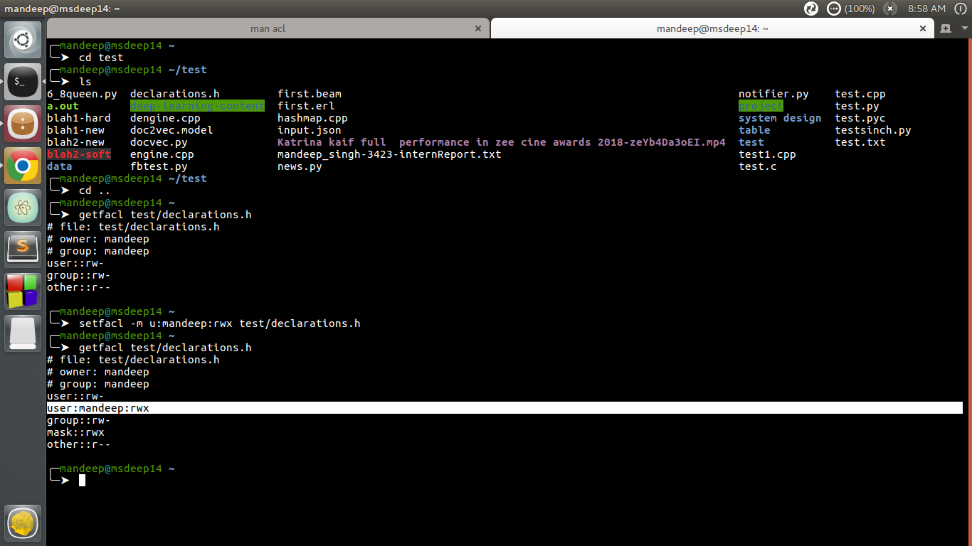
setfacl and getfacl
View ACL :
To show permissions :
# getfacl filename
Observe the difference between output of getfacl command before and after setting up ACL permissions using setfacl command.
There is one extra line added for user mandeep which is highlighted in image above.
Output:
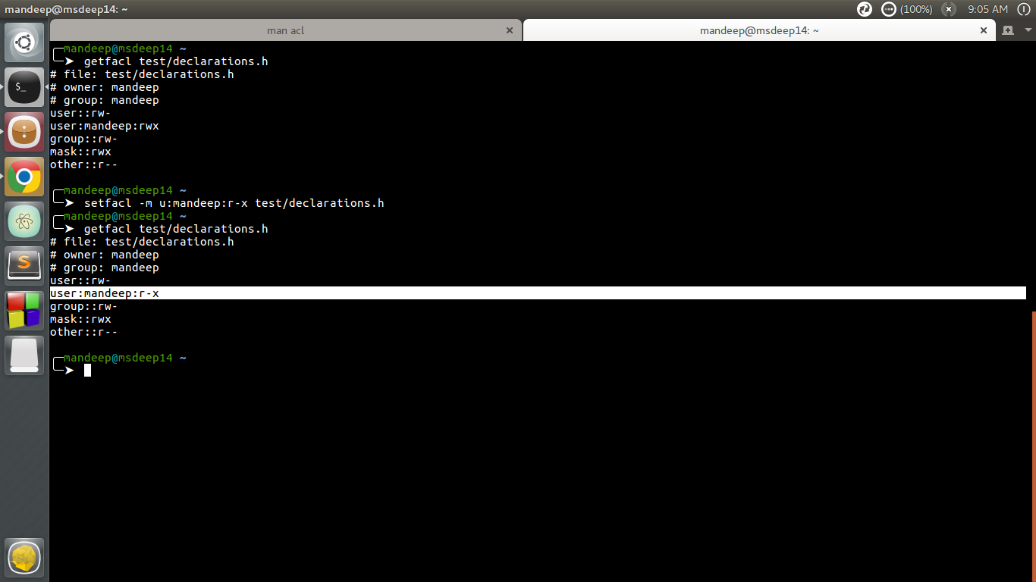
change permissions
The above command change permissions from rwx to r-x
Remove ACL :
If you want to remove the set ACL permissions, use setfacl command with -b option.
For example :
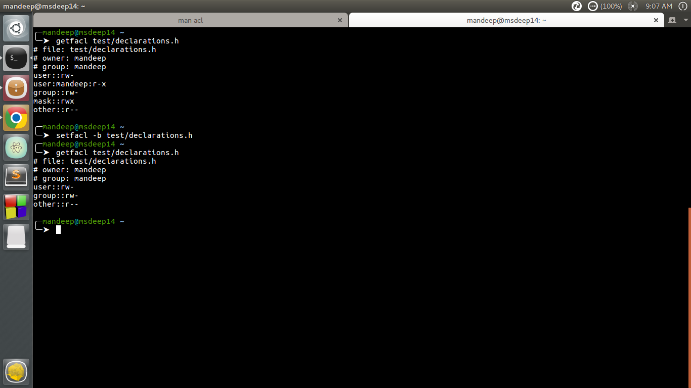
remove set permissions
If you compare output of getfacl command before and after using setfacl command with -b option, you can observe that there is no particular entry for user mandeep in later output.
You can also check if there are any extra permissions set through ACL using ls command.
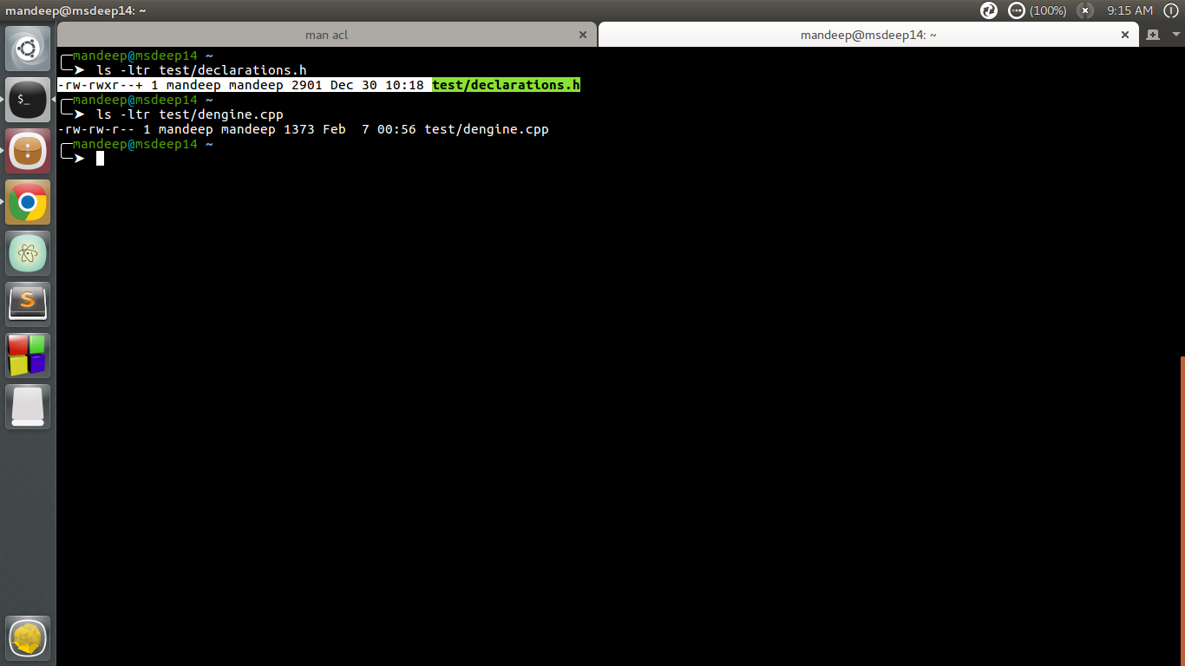
check set acl with ls
Observe the first command output in image, there is extra “+” sign after the permissions like -rw-rwxr–+, this indicates there are extra ACL permissions set which you can check by getfacl command.
Using Default ACL :
The default ACL is a specific type of permission assigned to a directory, that doesn’t change the permissions of the directory itself, but makes so that specified ACLs are set by default on all the files created inside of it. Let’s demonstrate it : first we are going to create a directory and assign default ACL to it by using the -d option:
$ mkdir test && setfacl -d -m u:dummy:rw test

What is swap memory and how to check if its full?
Swap memory or swap space is the on-disk component of the virtual memory system. It is pre-configured as a swap partition or a swap file when Linux is first installed, but can also be added later.
Check swap usage size and utilization in Linux
The procedure to check swap space usage and size in Linux is as follows:
- Open a terminal application.
- To see swap size in Linux, type the command: swapon -s.--> turn on the swap which we should not run.
- You can also refer to the /proc/swaps file to see swap areas in use on Linux.
- Type free -m to see both your ram and your swap space usage in Linux.
- Finally, one can use the top or htop command to look for swap space Utilization on Linux too.
How to Check Swap Space in Linux using /proc/swaps file
Type the following cat command to see total and used swap size:
# cat /proc/swaps
Sample outputs:
Filename Type Size Used Priority
/dev/sda3 partition 6291448 65680 0
Another option is to type the grep command as follows:
grep Swap /proc/meminfo
SwapCached: 0 kB
SwapTotal: 524284 kB
SwapFree: 524284 kB
Look for swap space in Linux using swapon command
Type the following command to show swap usage summary by device
# swapon -s
Sample outputs:
Filename Type Size Used Priority
/dev/sda3 partition 6291448 65680 0
Use free command to monitor swap space usage
Use the free command as follows:
# free -g
# free -k
# free -m
Sample outputs:
total used free shared buffers cached
Mem: 11909 11645 264 0 324 8980
-/+ buffers/cache: 2341 9568
Swap: 6143 64 6079
See swap size in Linux using vmstat command
Type the following vmstat command:
# vmstat
# vmstat 1 5
Sample outputs:
procs -----------memory---------- ---swap-- -----io---- -system-- ----cpu----
r b swpd free buff cache si so bi bo in cs us sy id wa
1 9 1209512 101352 1504 127980 0 3 11 20 60 55 3 1 95 1
2 11 1209640 101292 1508 134132 844 424 5608 964 23280 15012 2 8 20 70
0 10 1210052 108132 1532 125764 648 660 10548 916 22237 18103 3 10 11 77
1 13 1209892 106484 1500 128052 796 240 10484 980 24024 12692 2 8 24 67
1 9 1209332 113412 1500 124028 1608 168 2472 620 28854 13761 2 8 20 70
Note down the following output from swap field:
- si: Amount of memory swapped in from disk (/s).
- so: Amount of memory swapped to disk (/s).
top/atop/htop/glances command
Type the following commands:
# atop
# htop
# top
# glances
Sample outputs from top command:
top - 02:54:24 up 15:24, 4 users, load average: 0.45, 4.84, 6.75
Tasks: 266 total, 1 running, 264 sleeping, 0 stopped, 1 zombie
Cpu(s): 3.2%us, 1.4%sy, 0.0%ni, 94.4%id, 1.0%wa, 0.0%hi, 0.1%si, 0.0%st
Mem: 8120568k total, 7673584k used, 446984k free, 4516k buffers
Swap: 15859708k total, 1167408k used, 14692300k free, 1151972k cached

PID USER PR NI VIRT RES SHR S %CPU %MEM TIME+ COMMAND
13491 vivek 20 0 1137m 279m 6692 S 10 3.5 19:17.47 firefox
5663 vivek 10 -10 1564m 1.1g 59m S 8 14.5 5:10.94 vmware-vmx
2661 root 20 0 352m 185m 8604 S 6 2.3 65:40.17 Xorg
3752 vivek 20 0 3566m 2.6g 12m S 6 33.6 63:44.35 compiz
4798 vivek 20 0 900m 50m 4992 S 2 0.6 0:11.04 chrome
5539 vivek 20 0 1388m 838m 780m S 2 10.6 1:45.78 VirtualBox
6297 root 20 0 0 0 0 S 2 0.0 0:00.15 kworker/2:0
6646 root 20 0 19252 1404 936 R 2 0.0 0:00.01 top
1 root 20 0 8404 644 608 S 0 0.0 0:03.32 init
2 root 20 0 0 0 0 S 0 0.0 0:00.03 kthreadd
3 root 20 0 0 0 0 S 0 0.0 0:02.30 ksoftirqd/0
6 root RT 0 0 0 0 S 0 0.0 0:00.00 migration/0
7 root RT 0 0 0 0 S 0 0.0 0:00.24 watchdog/0
37 root 0 -20 0 0 0 S 0 0.0 0:00.00 cpuset
38 root 0 -20 0 0 0 S 0 0.0 0:00.00 khelper
39 root 20 0 0 0 0 S 0 0.0 0:00.00 kdevtmpfs
40 root 0 -20 0 0 0 S 0 0.0 0:00.00 netns
Sample outputs from htop command:
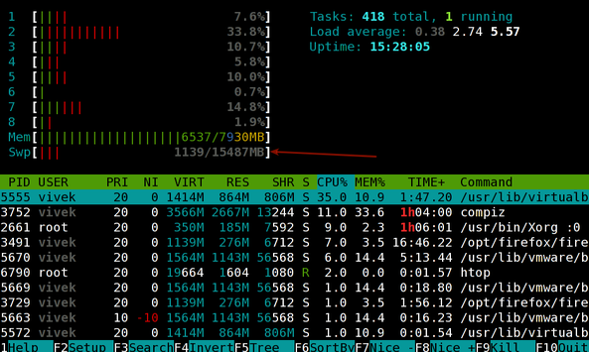
Fig.01: Linux: Swap Memory Usage Command
Sample outputs from glances command:
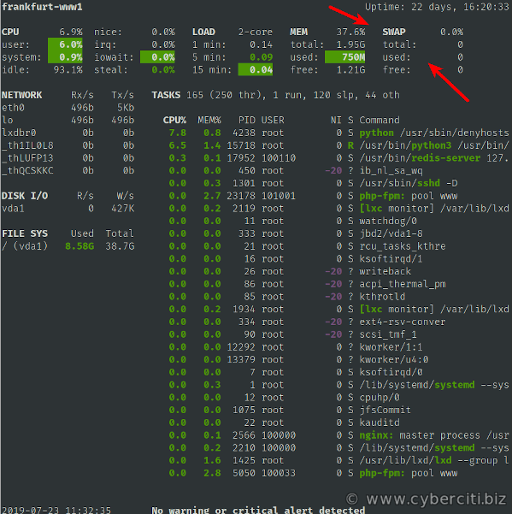

Note:
Before running any of the commands please check the command details by typing the below command
Ex: man swapon

db2 connect to $DB2DBDFT user
crtflm -M APSP.DAPS90CR.SFINPSD.P00 MASTERCAT "\$SEQFILES/APSP/APSP.DAPS90CR.SFINPSD.P00" -t FS -g 20
inqcat <filename> - to verify if updated in SQLite DB
crtflm -M <file_name> <Catalog_Name> "\<filepath>" -t <file_type> -g <gen_number>
Take BKUP of $FILEMAP
Run extr_catalog.sh from scripts directory(/PROD-SRC/GAP/INTR/bin/scripts)
now grep for file in $FILEMAP to verify the changes again
Job1- seqfile changes in DB - extr_catalog - $FILEMAP
Job2- parmfile change in DB - will not run extr as current time is same as last time
if last time > current time :
only then extr_catalog runs

https://myidentity.gapinc.com/identityiq/home.jsf

Manjunath Vrishabendrappa <Manjunath_Vrishabendrappa@gap.com>
looks like VP have approved, so hope she will have access by today or tomorrow.
Activities:
  - Setting downtime in nazios— refer weekly clerity maintetnace doc(try it in PRE—PROD change the id’s )
  - How to start and stop the regions and BPE nodes? -— refer weekly clerity maintetnace doc
  - Restarting ATMI service? -— refer weekly clerity maintetnace doc
  - Quesing the agent? -— refer weekly clerity maintetnace doc
  - Restarting security services?--> refer confluence page -prod-clerity service start (unisecure)stop(https://gapinc.atlassian.net/wiki/spaces/clar/pages/990151374/PROD+Clerity+Services+Start+Stop)

Refer fail over :
https://gapinc.atlassian.net/wiki/spaces/clar/pages/990151079/Clerity+App+and+DB+Failover

questions to ask:
- Once the downtime is done? Is is required to quesing the agent?

