Why System Design?
System design is crucial for several reasons:
- Career Growth: Many companies, especially tech giants, place a significant emphasis on system design during interviews. Understanding system design can help you land your dream job.
- Scalability: As your user base grows, your system needs to handle increased load without degrading performance. Good system design ensures scalability.
- Reliability: A well-designed system can handle failures gracefully, ensuring high availability and reliability.
System Design in Career Growth
Real-World Example:
Consider running a bookstore. Initially, you might handle everything manually – tracking inventory, managing orders, and so on. However, as your business grows, this approach becomes impractical. You need a system to automate these tasks, ensuring that your business can scale efficiently. This is where system design comes in.
The Importance of System Design Interviews
System design interviews are a critical part of the hiring process for many tech roles. They assess your ability to:
- Analyze requirements: Understand the problem and define the scope of the system.
- Design components: Identify key components and their interactions.
- Scale systems: Ensure the system can handle varying loads and data volumes.
- Consider trade-offs: Balance factors like performance, cost, and complexity.

Scalability:-
Scalability refers to the ability of a system to handle increasing amounts of workload or requests without sacrificing performance or incurring excessive costs. It’s crucial to understand scalability in system design because it directly impacts the system’s ability to grow and adapt to changing requirements over time. Failing to design for scalability can lead to bottlenecks, performance issues, and ultimately, system failures as demand increases.
Scaling Concepts: Horizontal vs. Vertical Scaling
Let’s take a closer look at the two main types of scaling through the lens of both a physical bookstore and a web application.
- Horizontal Scaling: Adding more machines or instances to handle increased load.
- Vertical Scaling: Adding more resources (CPU, RAM, disk space) to an existing machine.
Example:
Imagine your bookstore initially runs out of a small shop. As the number of customers grows, you face two options to handle the increased load:
- Vertical Scaling:
  - Move to a larger building.
  - This improves your capacity but has limits. There’s only so big a single building can get.
- Horizontal Scaling:
  - Open new branches in different locations.
  - This approach offers better scalability and redundancy, as each branch can serve local customers and share the load.
Now, let’s compare this with a web application.
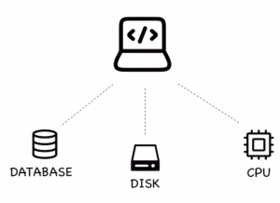A web application can be scaled vertically by using better components
- Vertical Scaling:
  - Upgrade your server with more CPU, RAM, and disk space.
  - This can handle more users and requests, but there’s a limit to how much you can upgrade a single server.
- Horizontal Scaling:
  - Deploy your application across multiple servers or data centers around the world.
  - This allows you to handle more traffic, provides redundancy, and reduces latency by serving users from the nearest location.
Comparison Table:
Aspect | Bookstore Example | Web Application Example
Horizontal Scaling | Open multiple branches in various locations | Deploy app to multiple servers/data  centers
Vertical Scaling | Expand to a bigger building | Increase CPU/RAM/Disk on a single  server
Pros of Horizontal | Redundancy, scalable | Redundancy, scalable, reduced  latency
Cons of Horizontal | Management complexity | Load balancing, synchronization
Pros of Vertical | Simpler to implement | Easier management
Cons of Vertical | Limited by physical space | Limited by hardware capacity

https://www.geeksforgeeks.org/system-design-horizontal-and-vertical-scaling/

Understanding the Client-Server Model
What is the Client-Server Model?
The Client-Server Model is a distributed application structure that partitions tasks or workloads between providers of a resource or service, called servers, and service requesters, called clients. Typically, clients and servers communicate over a network, making it possible for users to access services and resources remotely.
Real-World Example:
Imagine a bookstore where customers (clients) come to purchase books, and the cashier (server) processes their transactions. The customers do not need to know how the books are organized in the store or how the transactions are recorded; they just interact with the cashier to complete their purchases.
How it Relates to Web Applications:
In a web application, the client is usually a web browser or mobile app, and the server is a remote computer that hosts the application and database. The client sends requests to the server, which processes these requests and sends back the appropriate responses.
Components of the Client-Server Model
- Client:
  - Definition: The client is a device or application that initiates a request for a service or resource.
  - Examples: Web browsers, mobile apps, desktop applications.
  - Function: Clients interact with users and send requests to servers on their behalf.
- Server:
  - Definition: The server is a device or application that provides resources or services to clients.
  - Examples: Web servers, database servers, application servers.
  - Function: Servers process client requests, perform necessary operations, and send back the requested data or service.
Bookstore Example:
In our bookstore example:
- Client: The customer who walks into the store and wants to buy a book. They request information or services, such as the price of a book or the total cost of their purchase.
- Server: The cashier who processes the customer’s requests. The cashier looks up book prices, calculates totals, and completes the sale. The customer does not need to know the internal workings of the bookstore’s inventory system; they only interact with the cashier to get what they need.
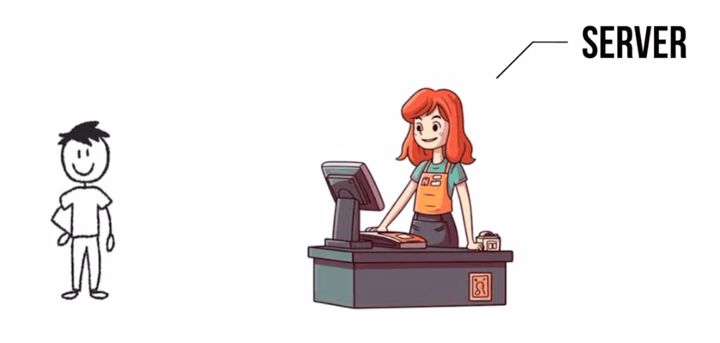Fig: A customer is a client, and a cashier is a server
Web Application Example:
When you use your web browser to access a website:
- Client: Your web browser, which sends an HTTP request to the web server.
- Server: The web server, which processes the request, retrieves the necessary data from a database, and sends back the web page to your browser.
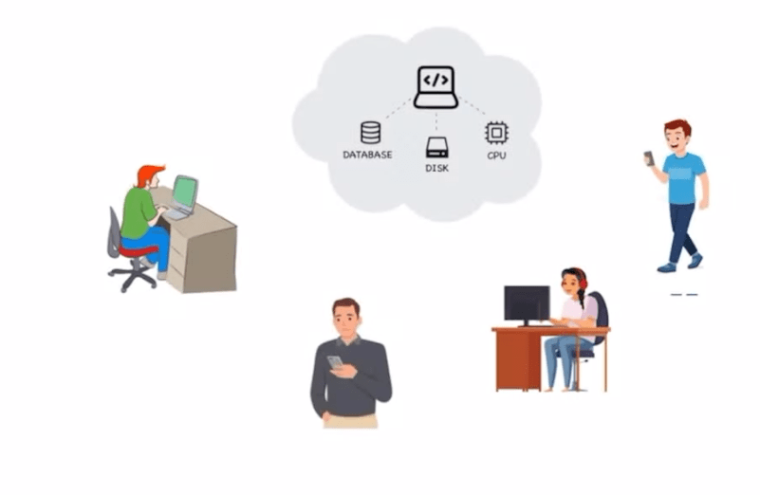Fig: A web server hosts an application, and any client can connect to it
Interaction Process
The interaction between a client and server can be broken down into the following steps:
- Request: The client sends a request to the server for some resource or service.
- Processing: The server processes the request. This may involve querying a database, performing computations, or interacting with other services.
- Response: The server sends the requested resource or the result of the computation back to the client.
Example:
In our bookstore scenario:
- Request: A customer asks the cashier for the price of a specific book.
- Processing: The cashier checks the price in the store’s inventory system.
- Response: The cashier tells the customer the price.
For a web application:
- Request: Your web browser requests a web page from a server.
- Processing: The server retrieves the page from its storage and possibly performs some computations (like fetching user-specific data).
- Response: The server sends the web page back to your browser.
Advantages of the Client-Server Model
- Centralization: Servers centralize the business logic, making it easier to maintain and update the system.
- Scalability: Clients can be easily added or removed without significantly affecting the server.
- Security: Servers can enforce security policies and control access to resources.
What is a Load Balancer?
A Load Balancer is a device or software that distributes incoming network traffic across multiple servers. The goal is to ensure that no single server becomes overwhelmed, thus improving the performance and reliability of the application.
Real-World Example:
Imagine our bookstore experiencing a surge of customers during a holiday sale. If only one cashier is available, the line will grow long, and customers will become frustrated. To handle the increased load, we could add more cashiers and distribute customers evenly among them. This way, no single cashier is overwhelmed, and customers are served more efficiently.
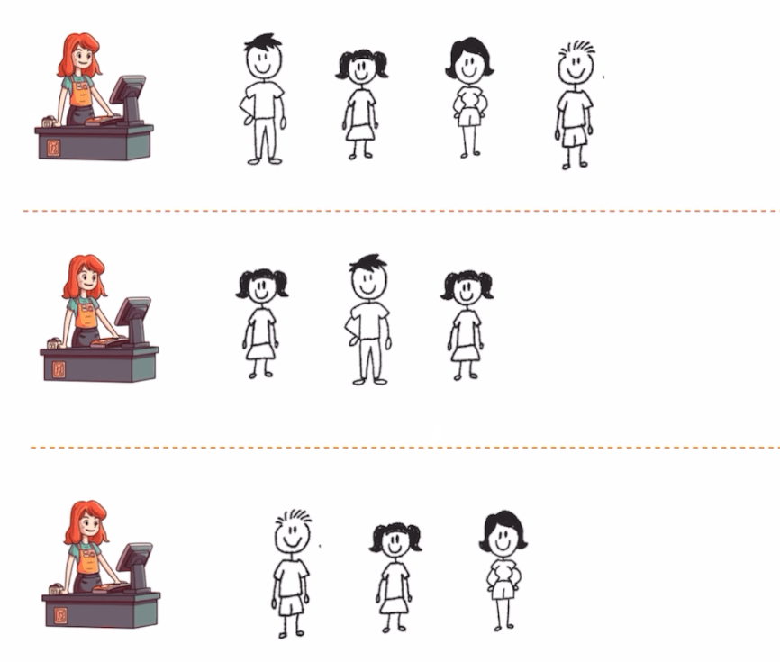Fig: Balancing customers at a bookstore
How it Relates to Web Applications:
In a web application, a load balancer distributes incoming requests across multiple servers. This ensures that no single server handles too many requests, which could slow down the application or cause it to crash. By distributing the load, the application remains responsive and reliable.
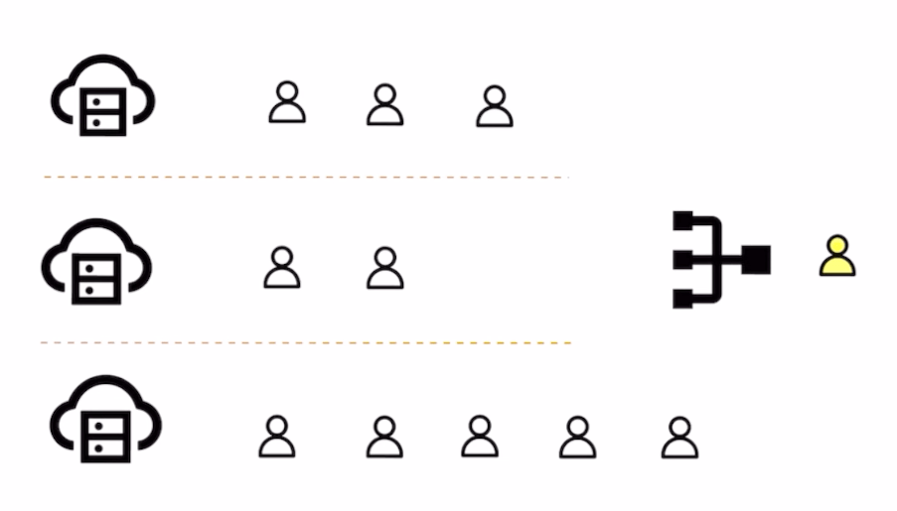Fig: A load balancer helps navigate new traffic
Types of Load Balancers
- Hardware Load Balancers:
  - Definition: Physical devices dedicated to load balancing tasks.
  - Pros: High performance, dedicated resources, and robust security features.
  - Cons: Expensive, requires physical space, and can be complex to manage.
- Software Load Balancers:
  - Definition: Software solutions that perform load balancing tasks.
  - Pros: Cost-effective, flexible, and easy to deploy.
  - Cons: Can be limited by the hardware they run on, may require more management.
- Cloud Load Balancers:
  - Definition: Load balancing services provided by cloud platforms.
  - Pros: Scalable, managed by cloud providers, and integrates well with cloud services.
  - Cons: Dependent on the cloud provider, can incur additional costs.
Load Balancing Algorithms
Load balancers use various algorithms to decide how to distribute incoming traffic:
- Round Robin:
  - Definition: Distributes requests sequentially across servers.
  - Pros: Simple and effective for equally powerful servers.
  - Cons: Does not account for server load or capacity.
- Least Connections:
  - Definition: Directs traffic to the server with the fewest active connections.
  - Pros: Balances load more efficiently, especially with varying server capacities.
  - Cons: Can lead to uneven distribution if not managed properly.
- IP Hash:
  - Definition: Distributes requests based on the client’s IP address.
  - Pros: Ensures that requests from the same client go to the same server.
  - Cons: Can cause uneven load distribution if client requests are not evenly distributed.
Example: Load Balancer in Action
Imagine your web application is experiencing a surge in traffic due to a successful marketing campaign.
- Without Load Balancer:
  - All requests go to a single server.
  - The server becomes overwhelmed and starts responding slowly or crashes.
  - Users experience delays or errors.
- With Load Balancer:
  - Requests are distributed across multiple servers.
  - Each server handles a manageable amount of traffic.
  - The application remains responsive, and users have a smooth experience.
Comparison Table:
Aspect | Bookstore Example | Web Application Example
Without Load Balancer | One cashier handles all customers | One server handles all requests
With Load Balancer | Multiple cashiers with managed queues | Multiple servers with distributed requests
Pros of Load Balancer | Faster service, no overwhelmed cashier | Improved performance, reliability, and scalability
Cons of Load Balancer | Requires coordination among cashiers | Requires setup and management
Importance of Load Balancers
- Scalability: They allow your application to handle more traffic by distributing the load.
- Reliability: They ensure your application remains available even if some servers fail.
- Performance: They improve response times by preventing any single server from becoming a bottleneck.
Challenges
- A load balancer can get very complex and it is not easy to setup.
- It can become a single point of failure. We need to make sure that it gets rotated.
- In case of a security attack, the entire system can go down.
Caching:
What is Caching?
Caching is a technique where systems store frequently accessed data in a temporary storage area, known as a cache, to quickly serve future requests for the same data. This temporary storage is typically faster than accessing the original data source, making it ideal for improving system performance.
Real-World Example:
In our bookstore example, think of the “Bestseller” section near the entrance. This section contains the most popular books that customers frequently ask for. Instead of having customers search through the entire store, they can easily find bestsellers in one convenient location. By keeping these popular books readily available, the store improves customer satisfaction and speeds up the shopping process.
A bestseller section is a wonderful example of caching in a bookstore
How it Relates to Web Applications:
In a web application, caching works similarly by storing frequently accessed data (like user profiles or product listings) in a cache memory. When a user requests this data, the application first checks the cache. If the system finds the data (a cache hit), it returns the data quickly, avoiding slower operations like database queries. If the system doesn’t find the data (a cache miss), it retrieves the data from the database, stores it in the cache for future use, and then returns it to the user.
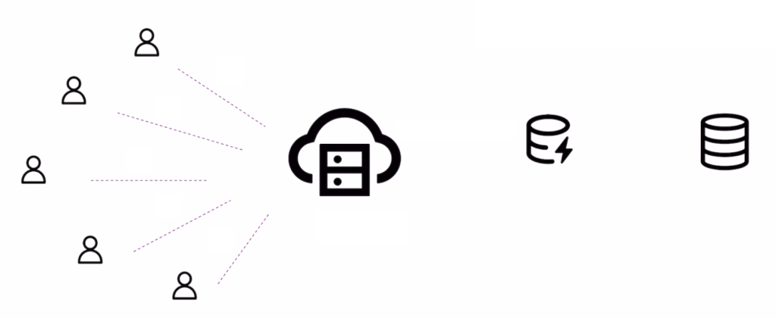Adding a cache layer between server and database
Types of Cache
- Memory Cache:
  - Definition: Cache stored in RAM, which is much faster than retrieving data from a disk or over a network.
  - Examples: In-memory data stores like Redis and Memcached.
  - Use Cases: Storing session data, user authentication tokens, and frequently accessed database queries.
- Disk Cache:
  - Definition: Cache stored on a disk, typically slower than RAM but more persistent.
  - Examples: Browser cache for storing web pages and images, operating system disk cache.
  - Use Cases: Storing large media files, web pages, or data that doesn’t fit entirely in memory.
Cache Hit and Cache Miss
- Cache Hit: Occurs when the requested data is found in the cache. This results in faster data retrieval, improving the overall performance of the application.
- Cache Miss: Occurs when the requested data is not found in the cache, forcing the system to fetch it from the original data source. Cache misses are slower and can negatively impact performance.
Importance of Cache Hit/Miss Ratio:
To measure the effectiveness of a caching strategy, analysts often look at the cache hit/miss ratio. A high cache hit ratio indicates that the system serves most data requests from the cache, resulting in faster response times and reduced load on the backend servers. Conversely, a low cache hit ratio indicates that the cache is not effectively storing the needed data, resulting in more frequent cache misses and slower performance.
Cache Eviction Policies
Caches have limited storage capacity. When the cache is full, some data must be removed to make room for new data. This process is known as cache eviction. Several strategies are used for cache eviction:
- Random Eviction:
  - Definition: Randomly selects and removes items from the cache to make space.
  - Pros: Simple to implement.
  - Cons: Not efficient, as important data might be evicted.
- FIFO (First-In-First-Out):
  - Definition: Evicts the oldest items (those that entered the cache first).
  - Pros: Easy to understand and implement.
  - Cons: May remove frequently accessed data that entered the cache early.
- LFU (Least Frequently Used):
  - Definition: Evicts the items accessed the least number of times.
  - Pros: Keeps frequently accessed data in the cache.
  - Cons: Requires tracking access frequency, which can add overhead.
- LRU (Least Recently Used):
  - Definition: Evicts the items that have not been accessed for the longest time.
  - Pros: Balances recency and frequency, commonly used and effective.
  - Cons: Requires tracking the access order, which can add complexity.
Challenges of Caching
While caching offers significant performance benefits, it also comes with challenges:
- Staleness: Cached data can become outdated if the underlying data changes. Managing cache consistency and ensuring that users see the most recent data is crucial.
- Overhead: Caching requires memory and processing power. Choosing what to cache and managing the cache efficiently is critical to avoid excessive resource consumption.
- Consistency:Maintaining consistency between cached data and the original data source is essential, especially in distributed systems that involve multiple caches.
Example Challenges in Bookstore:
- Staleness: A bestseller is no longer popular, but it still takes up space in the front section.
- Overhead: Deciding how much space to allocate for the bestseller section without cluttering the store.
- Consistency: Ensuring that the bestseller section is updated regularly with the most popular books.
Example Challenges in Web Applications:
- Staleness: Showing outdated product prices or information due to stale cache data.
- Overhead: Allocating sufficient memory for caching without impacting the overall system performance.
- Consistency: Keeping cached user data in sync with the database to avoid showing incorrect information.

What is a Database?
A database allows users to easily access, manage, and update a structured collection of data. It serves as a digital ledger, storing information in an organized way, allowing quick retrieval and manipulation of data.
Real-World Example:
In our bookstore example, think of a database as the ledger where the system records all book transactions. This ledger keeps track of the inventory, sales, customer details, and more. Every time a book is sold, the system makes a new entry, updates the stock, and records the sale. This helps the bookstore maintain an accurate record of all its operations.
A ledger can be a perfect example of managing data in a bookstore
How it Relates to Web Applications:
In a web application, a database works similarly by storing user data, product information, transaction records, etc. It ensures that all the data is available, organized, and retrievable whenever needed. For example, an online bookstore might use a database to store information about books, authors, customers, orders, and payments.
Advantages of Using a Database
- Efficient Data Retrieval:
  - Databases are designed to retrieve data quickly and efficiently. By using indexing and optimized query languages, databases can fetch the required data without scanning the entire dataset, saving time and resources.
  - Bookstore Example: Quickly finding the details of a particular book, such as its price, author, or stock availability, without going through the entire ledger.
- Data Integrity:
  - Databases ensure that the data is accurate and consistent. Integrity constraints prevent incorrect or inconsistent data from being entered.
  - Bookstore Example: Ensuring that the number of books sold does not exceed the available stock.
- Handling Complex Queries:
  - Databases can handle complex queries that involve multiple tables and relationships. They allow for data aggregation, filtering, sorting, and joining, making it possible to analyze and extract meaningful insights from the data.
  - Bookstore Example: Generating a sales report for a particular genre or author over a specific time period.
Challenges of Using Databases
- Scalability:
  - As the amount of data grows, scaling a database can become challenging. Databases must be designed to handle increasing loads without compromising performance.
- Consistency:
  - Maintaining consistency across distributed databases can be difficult. When the system replicates data across multiple locations, ensuring that all copies are updated simultaneously becomes challenging.
- Availability:
  - Ensuring that the database is always available and operational is crucial. Downtime can lead to lost sales and a poor user experience.
SQL vs. NoSQL Databases
Databases come in various types, but the two primary categories are SQL and NoSQL databases. Each has its strengths and use cases, depending on the nature of the data and the application’s requirements.
- SQL Databases (Relational Databases):
  - Definition: SQL databases use structured query language (SQL) to define and manipulate data. They are relational, meaning the system stores data in tables with predefined schemas and establishes relationships between tables using foreign keys.
  - Examples: MySQL, PostgreSQL, Oracle, SQL Server.
  - Use Case: Ideal for structured data with clear relationships. They ensure data integrity and support complex transactions.
  - Real-World Example: Think of SQL databases like a detailed bank statement. The system records every transaction in a structured format, with specific fields for date, description, amount, and balance. The system highly organizes the data and easily queries it to provide insights such as total monthly expenses or specific transaction details.
- NoSQL Databases (Non-Relational Databases):
  - Definition: NoSQL databases handle unstructured data. They do not use a fixed schema, making them flexible and scalable. The system stores the data in formats like key-value pairs, documents, graphs, or wide-column stores.
  - Examples: MongoDB, Cassandra, DynamoDB, Couchbase.
  - Use Case: Ideal for large volumes of unstructured or semi-structured data. They are often used in applications that require high scalability and fast data retrieval.
  - Real-World Example: Imagine a NoSQL database as the comment section on Instagram. Comments vary widely in content and structure (text, images, emojis), and the system needs to quickly retrieve and display them to users without predefined schemas or relationships.
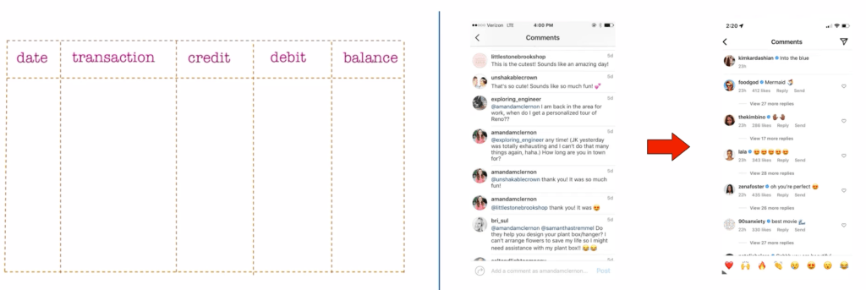Fig: Using relational database for a bank, whereas No-SQL for something like comments
Comparison Table: SQL vs. NoSQL
Feature | SQL Databases | NoSQL Databases
Data Model | Relational (tables, rows, columns) | Non-relational (key-value, documents)
Schema | Fixed schema | Dynamic schema
Scalability | Vertical scaling (adding more power) | Horizontal scaling (adding more nodes)
Use Case | Structured data, complex queries | Unstructured data, scalability needs
Examples | MySQL, PostgreSQL | MongoDB, DynamoDB
Real-World Example | Bank statement (structured records) | Instagram comments (unstructured data)

What is Indexing?
Indexing is like creating a shortcut for finding the right data quickly. Instead of scanning the entire database, the index helps you jump directly to the location of the data you need, improving the performance of your queries.
Real-World Example:
Let’s go back to our bookstore analogy. Imagine you want to find a particular book in a large bookstore. Instead of going through every single shelf, you check the index of book categories at the store’s entrance. This index tells you exactly which aisle to head to for a particular genre or author, saving you time. The bookstore’s index improves efficiency and helps customers find their desired books faster.
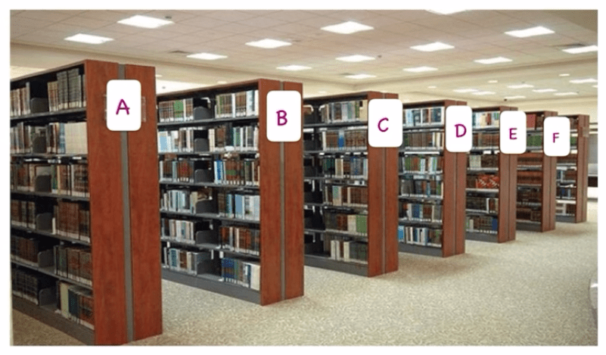Fig: Indexing in a bookstore
Actual Example in a Book:
Another familiar example of indexing is in the back of a physical book. The index section lists important terms, topics, or names and provides the exact page numbers where you can find them. Instead of flipping through the entire book, you refer to the index, which quickly directs you to the right page.
Types of Indexes in Databases
In databases, there are several types of indexes that help structure and optimize data retrieval.
- Primary Index: The system creates a primary index on the primary key of a table, which uniquely identifies each record.
- Secondary Index: A secondary index is created on non-primary key columns, allowing you to search based on fields other than the primary key.
- Composite Index: A composite index is an index that involves multiple columns. It’s useful when you need to search for data based on multiple attributes.
- Hash Index: A hash index uses a hash function to convert the index values into a specific address in memory. This type of index is very efficient for equality searches but less effective for range-based queries.
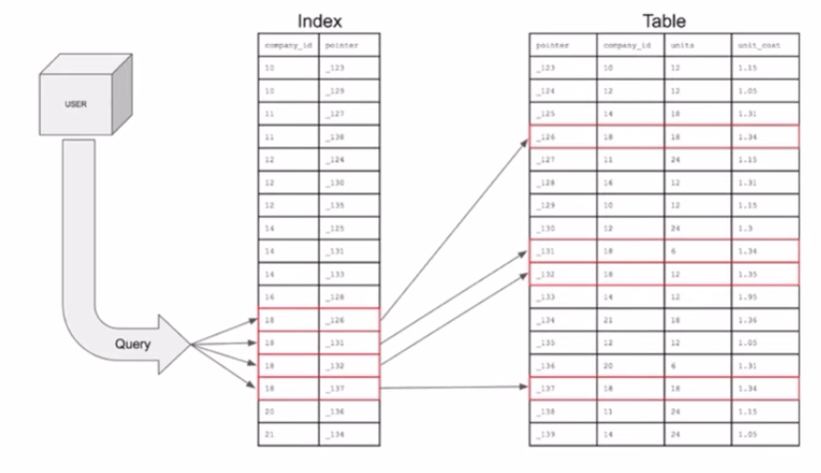Fig: Using an extra table as an index in a database
Challenges of Indexing
While indexing improves query performance, it also introduces a few challenges that need to be considered in system design.
- Extra Write Operations:
  - Every time you insert, update, or delete data, the corresponding index also needs to be updated. This can add overhead to write operations, making them slower.
- Unused Indexes:
  - Over time, certain indexes may become unused, yet they still consume storage and processing power. Regular auditing is required to identify and remove such indexes.
- Complexity of Managing Indexes:
  - As the number of indexes grows, the database becomes harder to manage. Too many indexes can slow down the system, as every write operation needs to update all relevant indexes.

What is a Proxy?
A proxy is essentially an intermediary that sits between a client and a server, forwarding requests and responses between the two. It can be used for various purposes such as load balancing, security, caching, and more.
Real-World Example:
Imagine a bookstore where some books are stored in the main shop, and others are kept in a warehouse. As a customer, you don’t have direct access to the warehouse. Instead, when you request a book that isn’t on the shelves, a staff member (the intermediary) goes to the warehouse, retrieves the book, and hands it to you. This staff member acts as a proxy between you (the client) and the warehouse (the server), ensuring that the system fulfills the request efficiently without you needing to navigate through the entire storage facility.
How a Typical Connection Works Without a Proxy
Without a proxy, the client (the person requesting the book) establishes a direct connection with the server (the warehouse or the server hosting a website). While this setup works, it comes with a few limitations:
- Efficiency: Each client interacts directly with the server, potentially overwhelming the server with requests.
- Security: Exposing the server directly to the client may lead to security vulnerabilities, as the server’s IP address is publicly visible.
- Scalability: As more clients make requests, the server may struggle to handle all the traffic, causing slowdowns.
In a real-world scenario, imagine if every customer at the bookstore had direct access to the warehouse. It would lead to chaos, with people wandering around, possibly damaging items or getting lost, and creating bottlenecks.
Forward Proxy: Acting on Behalf of the Client
A forward proxy sits between the client and the server, forwarding the client’s requests to the server and returning the server’s responses to the client. It essentially acts on behalf of the client, masking the client’s identity from the server.
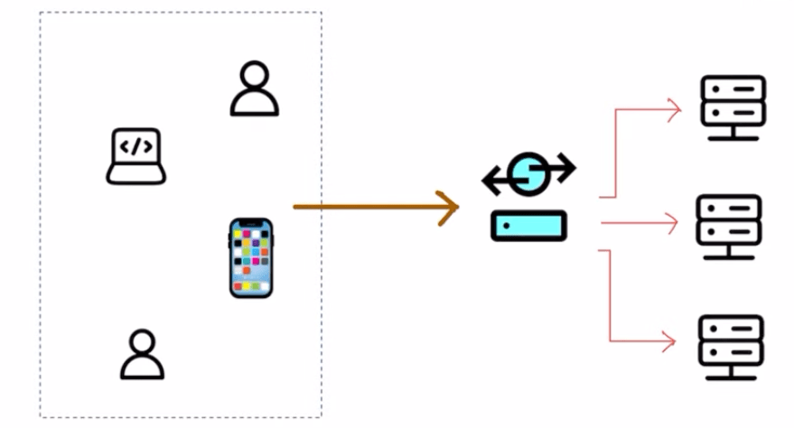Fig: A forward proxy acts on behalf of clients
Benefits of Forward Proxy:
- Privacy & Anonymity: The forward proxy hides the client’s identity. This is useful for privacy, as the server won’t know who exactly is making the request.
  - Example: When you browse the internet using a proxy, websites won’t see your IP address. Instead, they will see the proxy’s IP.
- Content Filtering & Caching: The proxy can filter requests, blocking access to certain content or caching frequently requested items, reducing load times.
  - Example: In a bookstore, the staff member (proxy) could know that certain books are in high demand and retrieve them in advance, ensuring faster service.
- Security: Forward proxies can add an extra layer of security, protecting clients from malicious servers by filtering harmful content.
Reverse Proxy: Acting on Behalf of the Server
A reverse proxy sits in front of the server, intercepting client requests and forwarding them to the appropriate server. It acts on behalf of the server, masking the server’s identity from the client.
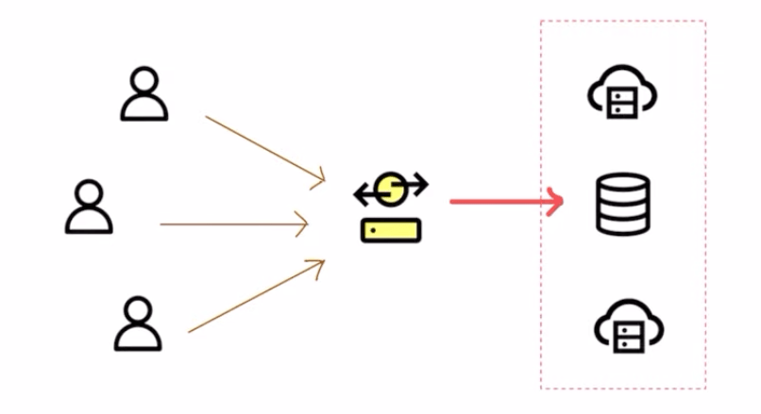Fig: Reverse Proxy works on behalf of the servers
Benefits of Reverse Proxy:
- Load Balancing: It can distribute incoming requests across multiple servers to prevent any single server from being overloaded.
- Security: Reverse proxies mask the identity of the server, adding a layer of protection. Clients never know the true IP address of the server, reducing the risk of direct attacks.
- SSL Termination: Reverse proxies can handle encryption and decryption for SSL (HTTPS) traffic, reducing the load on the backend servers.
Working from Home Example: When you work from home, you often connect to your company’s network through a reverse proxy. This routes your requests to the correct server within the company’s internal network, ensuring that your communication is secure and that external users can’t directly access the company’s servers.
Challenges of Using Proxies
While proxies provide numerous benefits, they also introduce some challenges.
- Latency: Adding a proxy introduces an additional step in the communication process. This can lead to increased latency if not optimized properly.
- Single Point of Failure: If the proxy goes down, it can bring the entire system to a halt, as both clients and servers depend on it to relay messages.
- Complex Configuration: Proxies can add complexity to the overall system design, requiring careful configuration and maintenance.

What is a Message Queue?
A message queue is a system that allows different parts of a system to communicate with each other in an asynchronous manner. It acts as a buffer between a producer (the part that sends messages) and a consumer (the part that processes messages), allowing the producer to continue sending messages even if the consumer isn’t ready to process them immediately.
Real-World Example:
Let’s relate this to our bookstore analogy. Imagine there’s a high demand for a particular book in your store. The staff at the counter (producer) takes customer orders and places them in a queue. The warehouse workers (consumers) fulfill these orders as they become available. The orders pile up in the queue, but the staff at the counter doesn’t need to wait for each order to be fulfilled before taking the next one. Instead, they continue adding new orders to the queue, and the warehouse processes them at its own pace.
Components of a Message Queue
- Producer:
  - The producer is responsible for creating and sending messages to the queue.
- Queue:
  - The queue is where the messages are stored until they are processed.
- Consumer:
  - The consumer is responsible for processing the messages.
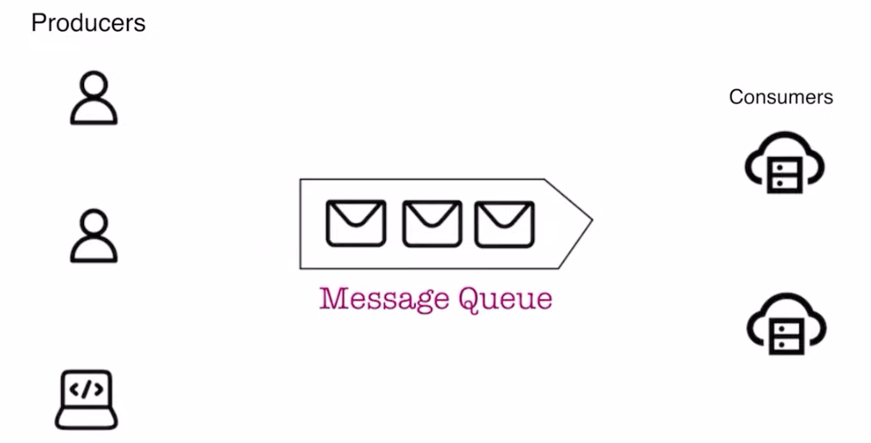Fig: Producers, Consumers and a Message Queue
Advantages of Message Queues
- Decoupling:
  - Message queues decouple the producer and consumer. This means the producer can continue its work without having to wait for the consumer to be available.
- Scalability:
  - Since message queues can handle a high volume of messages, they enable systems to scale more easily. Multiple consumers can process messages simultaneously, helping balance the load.
- Fault Tolerance:
  - Message queues can ensure that no message is lost even if the consumer goes offline temporarily. Messages remain in the queue until they are processed.
Challenges of Message Queues
While message queues provide benefits, they also introduce a few challenges that the system needs to address.
- Ordering:
  - Ensuring the correct order of message processing can be a challenge, especially in distributed systems. Messages may not always be processed by the system in the order they were sent.
- Duplicates:
  - Sometimes, messages may be processed more than once, leading to duplicates. This can happen due to retries or errors in the system.
- Latency:
  - There can be delays between when a message is sent and when it is processed. If the queue becomes too long, it may take some time for a message to reach the consumer.

CAP Theorem:
    - Consistency: The system should deliver the same results no matter how and from where we query.
    - Availability:

• Designed and implemented RESTful APIs for automated telecom diagnostics and repair services using Spring Boot (Java).
• Developed APIs for modem reboot, ONT status checks, modem diagnostics, outage detection, and line status monitoring.
• Implemented Secret Manager (externalized configuration) for APIs using GCP Security Manager.
• Deployed APIs on Google Cloud Run, ensuring scalability, high availability, and efficient cloud execution.
• Implemented error handling, logging, and monitoring mechanisms to ensure API reliability and performance.
• Worked in an agile development environment, ensuring continuous improvements and feature enhancements.

• Integrated backend APIs with Google Cloud Contact Center AI (CCAI) to enable intelligent, automated interactions for telecom troubleshooting workflows.
• Worked closely with conversational AI and virtual agent teams to ensure seamless real-time diagnostics and customer query resolution.
• Implemented structured response formats and status codes to support dynamic interactions between automated repair services and CCAI-based virtual agents.
• Contributed to enhancing customer experience by reducing manual interventions and enabling AI-powered self-healing mechanisms for common network issues.

Designed and implemented RESTful APIs for automated telecom diagnostics and repair services using Spring Boot (Java).
Developed APIs for modem reboot, ONT status checks, modem diagnostics, outage detection, and line status monitoring to enhance troubleshooting capabilities.
Implemented Secret Manager (externalized configuration) for APIs using GCP Security Manager to enhance security and configuration management.
Deployed APIs on Google Cloud Run, ensuring scalability, high availability, and efficient cloud execution.
Implemented error handling, logging, and monitoring mechanisms to ensure API reliability and performance.
Worked in an agile development environment, ensuring continuous improvements and feature enhancements.
Hands-on experience designing CCAI workflows including agent setup, fulfillment integration, and flow versioning.
Contributed to BrightSpeed’s CCAI team by integrating backend Spring Boot APIs with Dialogflow CX to enable intelligent, automated telecom troubleshooting.

Create a brief summary to put in my resume use the following content:
I have academic skills on AI and ML as I did PGP program with UT Austin
I have gone through internal training on ccai
I have some experience creating basic workflows using ccai : Agent and workflow design, fulfillment and webhook integration and creating flow versions etc
I was working past one year with brightspeed CCAI team where we Integrated backend APIs with Google Cloud Contact Center AI (CCAI) to enable intelligent, automated interactions for telecom troubleshooting workflows.

overview of Google CCAI, covering its purpose, high-level architecture, and key components—Dialogflow for virtual agent workflows, Agent Assist for real-time support, and Insights for analytics—along with their conversational AI features, intent recognition, entity extraction, fulfillment integration, and customer experience enhancements, also know how to integration of spring boot backend aPI with Webhook, request and response parameters in webhook request and response.

