Spring Boot Interview Questions:-

- What is Spring Boot?
Spring Boot is a module of Spring Framework. It allows us to build a stand-alone application with minimal or zero configurations. It is better to use if we want to develop a simple Spring-based application or RESTful services.
- What are the important Goals of Spring Boot?
- Quick Start to Spring
- Be opinionated
- Non functional features
- No code generation

- What are the important Features of Spring Boot?
- Auto-Configuration - No need to manually configure dispatcher servlet, static resource mappings, property source loader, message converters etc.
- Dependency Management - The different versions of commonly used libraries are pre-selected and grouped in different starter POMs that we can include in your project. By selecting one Spring Boot version we are implicitly selecting dozens of dependencies that we would have to otherwise select and harmonize ourself. Example-
- Advanced Externalized Configuration - There is a large list of bean properties that can be configured through application.properties file without touching java or xml config.
- Production support- We get health checking, application and jvm metrics, jmx via http and a few more things for free.
- Runnable Jars - We can package your application as a runnable jar with embedded tomcat included so it presents a self-contained deployment unit

- Compare Spring Boot vs Spring?

Spring | Spring Boot
Spring Framework is a widely used Java EE framework for building applications. | Spring Boot Framework is widely used to develop REST APIs.
It aims to simplify Java EE development that makes developers more productive. | It aims to shorten the code length and provide the easiest way to develop Web Applications.
The primary feature of the Spring Framework is dependency injection. | The primary feature of Spring Boot is Autoconfiguration. It automatically configures the classes based on the requirement.
It helps to make things simpler by allowing us to develop loosely coupled applications. | It helps to create a stand-alone application with less configuration.
The developer writes a lot of code (boilerplate code) to do the minimal task. | It reduces boilerplate code.
To test the Spring project, we need to set up the sever explicitly. | Spring Boot offers embedded server such as Jetty and Tomcat, etc.
It does not provide support for an in-memory database. | It offers several plugins for working with an embedded and in-memory database such as H2.
Developers manually define dependencies for the Spring project in pom.xml. | Spring Boot comes with the concept of starter in pom.xml file that internally takes care of downloading the dependencies JARs based on Spring Boot Requirement.

- Compare Spring Boot vs Spring MVC?

Spring Boot | Spring MVC
Spring Boot is a module of Spring for packaging the Spring-based application with sensible defaults. | Spring MVC is a model view controller-based web framework under the Spring framework.
It provides default configurations to build Spring-powered framework. | It provides ready to use features for building a web application.
There is no need to build configuration manually. | It requires build configuration manually.
There is no requirement for a deployment descriptor. | A Deployment descriptor is required.
It avoids boilerplate code and wraps dependencies together in a single unit. | It specifies each dependency separately.
It reduces development time and increases productivity. | It takes more time to achieve the same.

- What is the importance of @SpringBootApplication?
It is a combination of three annotations @EnableAutoConfiguration, @ComponentScan, and @Configuration.
A single @SpringBootApplication annotation can be used to enable those three features, that is:
- @EnableAutoConfiguration: enable Spring Boot’s auto-configuration mechanism. Spring Boot auto-configuration attempts to automatically configure your Spring application based on the jar dependencies that you have added. For example, if HSQLDB is on your classpath, and you have not manually configured any database connection beans, then Spring Boot auto-configures an in-memory database.
- @ComponentScan: enable @Component scan on the package where the application is located (see the best practices). Spring Boot application scans all the beans and package declarations when the application initializes.
- @Configuration: allow to register extra beans in the context or import additional configuration classes

- What is Auto Configuration?
Spring boot looks at frameworks available on the classpath, Existing beans configuration for the application. Based on these, spring boot provides basic configuration needed to configure the application with these frameworks. This is called autoconfiguration.
Spring Boot autoconfiguration represents a way to automatically configure a Spring application based on the dependencies that are present on the classpath.

- How can we find more information about Auto Configuration?
## Implementation
- spring-boot-autoconfigure.jar
- To get more details
- Turn on Debug logging ```logging.level.org.springframework: DEBUG```
- Use Spring Boot Actuator

- What is an embedded server? Why is it important?
An embedded server is embedded as part of the deployable application.
If we talk about Java applications, that would be a JAR.
The advantage with this is you don’t need the server pre-installed in the deployment environment.

- What is the default embedded server with Spring Boot?
Tomcat

- What are the other embedded servers supported by Spring Boot?
Jetty and UnderTow.

- What are Starter Projects?

Starters are a set of convenient dependency descriptors that you can include in your application.
> For example, if you want to get started using Spring and JPA for database access, just include the spring-boot-starter-data-jpa dependency in your project, and you are good to go.

- Can you give examples of important starter projects?
## Starters
- spring-boot-starter-web-services - SOAP WebServices
- spring-boot-starter-web - Web & RESTful applications
- spring-boot-starter-test - Unit, Integration Testing
- spring-boot-starter-jdbc - Traditional JDBC
- spring-boot-starter-hateoas - HATEOAS features
---
## Starters
- spring-boot-starter-security - Authentication and Authorization using Spring Security
- spring-boot-starter-data-jpa - Spring Data JPA with Hibernate
- spring-boot-starter-cache - Enabling Spring Framework’s caching support
- spring-boot-starter-data-rest - Expose Simple REST Services using Spring Data REST
---
- spring-boot-starter-actuator - To use advanced features like monitoring & tracing to your application out of the box
- spring-boot-starter-undertow, spring-boot-starter-jetty, spring-boot-starter-tomcat - To pick your specific choice of Embedded Servlet Container
- spring-boot-starter-logging - For Logging using logback
- spring-boot-starter-log4j2 - Logging using Log4j2

- What is Starter Parent?
The spring-boot-starter-parent is a project starter. It provides default configurations for our applications. It is used internally by all dependencies. All Spring Boot projects use spring-boot-starter-parent as a parent in pom.xml file.
- <parent>
- <groupId>org.springframework.boot</groupId>
- <artifactId>spring-boot-starter-parent</artifactId>
- <version>1.4.0.RELEASE</version>
- </parent>

- What are the different things that are defined in Starter Parent?
Parent Poms allow us to manage the following things for multiple child projects and modules:
- Configuration: It allows us to maintain consistency of Java Version and other related properties.
- Dependency Management: It controls the versions of dependencies to avoid conflict.
- Source encoding
- Default Java Version
- Resource filtering
- It also controls the default plugin configuration

- How does Spring Boot enforce common dependency management for all its Starter projects?

The spring-boot-starter-parent dependency inherit from the spring-boot-dependencies, it shares all these characteristics as well. Hence the Spring Boot manages the list of the dependencies as the part of the dependency management.

- <properties>
- <activemq.version>5.13.4</activemq.version>
- ...
- <ehcache.version>2.10.2.2.21</ehcache.version>
- <ehcache3.version>3.1.1</ehcache3.version>
- ...
- <h2.version>1.4.192</h2.version>
- <hamcrest.version>1.3</hamcrest.version>
- <hazelcast.version>3.6.4</hazelcast.version>
- <hibernate.version>5.0.9.Final</hibernate.version>
- <hibernate-validator.version>5.2.4.Final</hibernate-validator.version>
- <hikaricp.version>2.4.7</hikaricp.version>
- <hikaricp-java6.version>2.3.13</hikaricp-java6.version>
- <hornetq.version>2.4.7.Final</hornetq.version>
- <hsqldb.version>2.3.3</hsqldb.version>
- <htmlunit.version>2.21</htmlunit.version>
- <httpasyncclient.version>4.1.2</httpasyncclient.version>
- <httpclient.version>4.5.2</httpclient.version>
- <httpcore.version>4.4.5</httpcore.version>
- <infinispan.version>8.2.2.Final</infinispan.version>
- <jackson.version>2.8.1</jackson.version>
- ....
- <jersey.version>2.23.1</jersey.version>
- <jest.version>2.0.3</jest.version>
- <jetty.version>9.3.11.v20160721</jetty.version>
- <jetty-jsp.version>2.2.0.v201112011158</jetty-jsp.version>
- <spring-security.version>4.1.1.RELEASE</spring-security.version>
- <tomcat.version>8.5.4</tomcat.version>
- <undertow.version>1.3.23.Final</undertow.version>
- <velocity.version>1.7</velocity.version>
- <velocity-tools.version>2.0</velocity-tools.version>
- <webjars-hal-browser.version>9f96c74</webjars-hal-browser.version>
- <webjars-locator.version>0.32</webjars-locator.version>
- <wsdl4j.version>1.6.3</wsdl4j.version>
- <xml-apis.version>1.4.01</xml-apis.version>
- </properties>
- <prerequisites>
- <maven>3.2.1</maven>
- </prerequisites>

- What is Spring Initializr?
Spring Initializr http://start.spring.io/ is great tool to bootstrap your Spring Boot projects.

- What is application.properties?
application.properties is used to configure your Spring Boot Application

- What are some of the important things that can customized in application.properties?
## Example Configuration
```
logging.file=
logging.level.*=
spring.autoconfigure.exclude=
spring.profiles.active=
server.error.path=/error
server.port=8080
spring.http.converters.preferred-json-mapper=Jackson

- What is Spring Initializr?
Spring Initializr is a web-based tool provided by the Pivotal Web Service. With the help of Spring Initializr, we can easily generate the structure of the Spring Boot Project.
> Spring Initializr http://start.spring.io/ is great tool to bootstrap your Spring Boot projects.

- How do you externalize configuration using Spring Boot?
Spring Boot allows you to externalize your configuration so you can work with the same application code in different environments. You can use properties files, YAML files, environment variables and command-line arguments to externalize configuration
- How can you add custom application properties using Spring Boot?
- What is @ConfigurationProperties?

@ConfigurationProperties allows to map the entire Properties and Yaml files into an object easily. It also allows to validate properties with JSR-303 bean validation. By default, the annotation reads from the application.properties file. The source file can be changed with @PropertySource annotation.

http://zetcode.com/springboot/configurationproperties/

- What is a profile?
A profile is a set of configuration settings. Spring Boot allows to define profile specific property files in the form of application-{profile}. properties . It automatically loads the properties in an application.
Used to Configure Resources - Databases, Queues, External Services.

- How do you define beans for a specific profile?

Profiles help to have different application configuration for different environments.
Using @Profile annotation we can indicate the active profile in which a specific bean should be created.

Ex:
@Profile("dev")
@Bean
public String devBean() {
return "dev";
}

@Profile("qa")
@Bean
public String qaBean() {
return "qa";
}

@Profile("prod")
@Bean
public String prodBean() {
return "prod";
}

- How do you create application configuration for a specific profile?
- Using -Dspring.profiles.active=prod in VM Arguments
- Use spring.profiles.active=prod in application.properties

- How do you have different configuration for different environments?
# Profile
- application-dev.properties
- application-qa.properties
- application-stage.properties
- application-prod.properties
- application.properties

- What is Spring Boot Actuator?
Spring Boot Actuator is a sub-project of the Spring Boot Framework. It includes a number of additional features that help us to monitor and manage the Spring Boot application. It contains the actuator endpoints (the place where the resources live). Spring Actuator is a Spring Boot sub-module and provides built-in endpoints that we can enable and disable for our application.

- How do you monitor web services using Spring Boot Actuator?

Let's add monitoring service in our Spring Boot project.
Step 1: Open pom.xml and add the following dependencies:
Spring Boot Starter Actuator: It provides a lot of monitoring facilities around your services.
- <dependency>
- <groupId>org.springframework.boot</groupId>
- <artifactId>spring-boot-starter-actuator</artifactId>
- </dependency>
Spring Data Rest HAL Browser: HAL makes our API exportable, and its documentation easily discoverable from within the API itself.
- <dependency>
- <groupId>org.springframework.data</groupId>
- <artifactId>spring-data-rest-hal-browser</artifactId>
- </dependency>
Hypertext Application Language (HAL) is a simple language that gives a consistent and easy way to hyperlink between resources in API. The spring boot starter actuator is actually in the HAL format. HAL browser searches for APIs and identifies the links. It shows the link on the screen so that we can easily browse through the API.
Step 2: Restart the application.
Start 3: Type the URL localhost:8080/actuator in the browser and hit the enter key. If it does not work, use the URL localhost:8080/application.
It launches the actuator that shows the three URLs: self, health, and info.
- {"_links":{"self":{"href":"http://localhost:8080/actuator","templated":false},"health":{"href":"http://localhost:8080/actuator/health","templated":false},"health-component":{"href":"http://localhost:8080/actuator/health/{component}","templated":true},"health-component-instance":{"href":"http://localhost:8080/actuator/health/{component}/{instance}","templated":true},"info":{"href":"http://localhost:8080/actuator/info","templated":false}}}
When we click on the health URL, it shows the health of the application. In the following image, status up denotes that application is running.
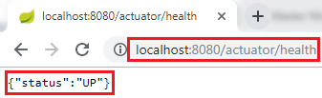
When we click on the info URL, it shows the information of the application. A pair of blank curly braces denote that there is no information is available.
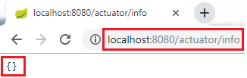
To enable the information, we need to configure the property.
- Open application.properties file and enable web exposure.
- management.endpoints.web.exposure.include=*
- Restart the application.
- Restart the actuator by using the URL localhost:8080/actuator.
It shows a lot of URLs.
The HAL Browser
To access the HAL browser, type localhost:8080 in the browser and hit the enter key.
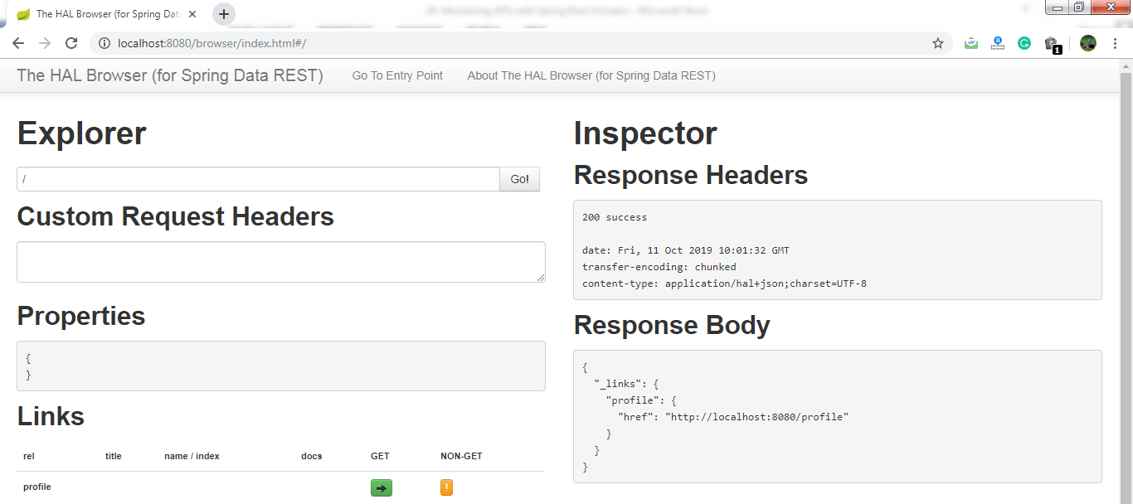
Now we can access the actuator through the HAL browser.
Type /actuator in the Explorer's text box and click on the Go button.
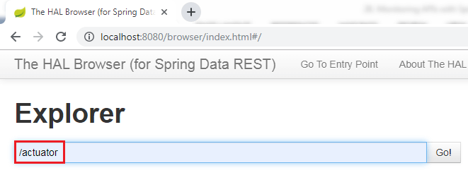
It shows all the things related to the actuator. The most important thing in the actuator is beans.
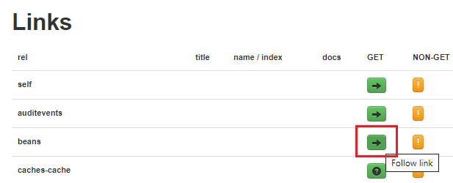
When we click on the bean's arrow, it shows all the beans configured in the spring boot project.
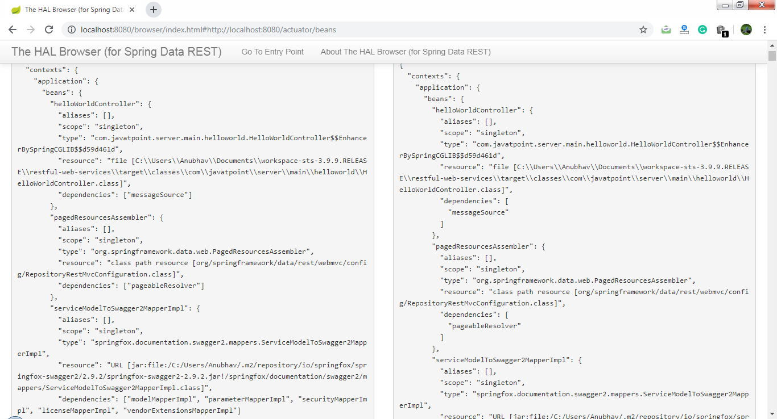
If we want to check the status of the application, we can click on the health link.
It shows the health of the application.
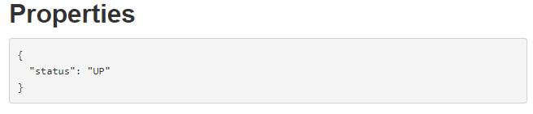
There is another link in the actuator named metrics. It shows the list of valid metrics.
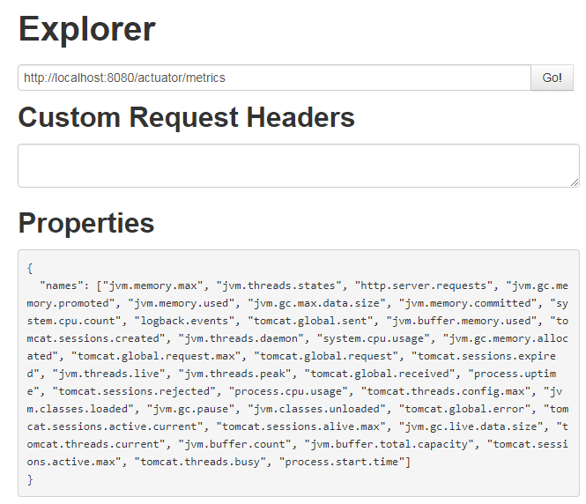
Suppose we want to know how much memory is used by the application. We have accessed /jvm.memory.max.
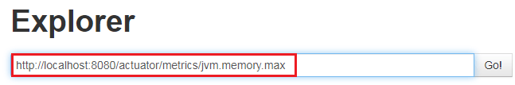
In the following image, the value indicates the maximum memory used by the application.
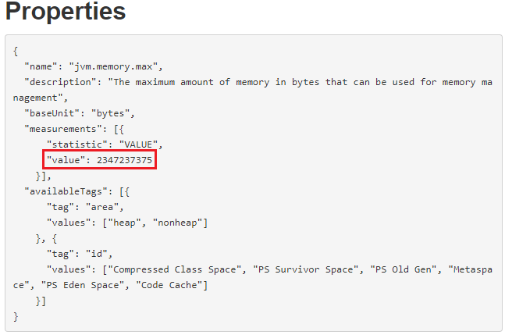
There are two important links httptrace and mapping that are present in the actuator.
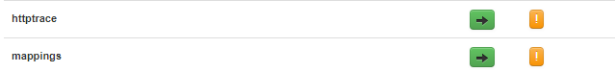
The httptrace shows all the requests that we have executed earlier. We can see all the details of previously executed requests, as shown below:
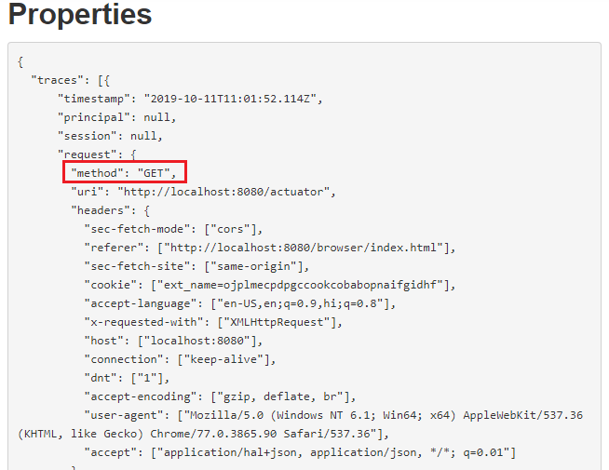
The mapping shows all the different things that are mapped to URLs. Whenever we are creating web services or web applications, we are mapping a lot of URLs.

- What is a CommandLineRunner?

CommandLineRunner is an interface used to indicate that a bean should run when it is contained within a SpringApplication. A Spring Boot application can have multiple beans implementing CommandLineRunner. These can be ordered with @Order.
Example of commandLineRunner refer below link
http://zetcode.com/springboot/commandlinerunner/

## Spring Boot Interview Questions and Answers (10 Years Experience)

This document contains a compilation of Spring Boot interview questions and answers suitable for candidates with around 10 years of experience. The questions delve into advanced concepts, architectural considerations, performance tuning, security, testing, and best practices within the Spring Boot ecosystem.

**I. Core Spring Boot Concepts and Architecture**

1. **Question:** Explain the core principles behind Spring Boot. How does it simplify Spring application development compared to traditional Spring?
**Answer:** Spring Boot's core principles are:
* **Opinionated Defaults:** Provides sensible default configurations for common scenarios, reducing the need for extensive manual configuration.
* **Auto-Configuration:** Automatically configures Spring applications based on the dependencies present in the classpath.
* **Standalone Applications:** Enables the creation of self-contained, production-ready applications that can be run directly using embedded servers (e.g., Tomcat, Jetty, Undertow).

Compared to traditional Spring, Spring Boot simplifies development by:
* **Reduced Boilerplate:** Minimizes XML configuration and the need for manual bean setup.
* **Simplified Dependency Management:** Leverages the Starter POMs to manage related dependencies with a single dependency declaration.
* **Easy Deployment:** Facilitates the creation of executable JARs or WARs for straightforward deployment.
* **Developer-Friendly Features:** Offers built-in tools for monitoring, health checks, and externalized configuration.

2. **Question:** What is Spring Boot auto-configuration? How does it work internally? Can you provide an example of a custom auto-configuration?
**Answer:** Spring Boot auto-configuration automatically configures your Spring application based on the JAR dependencies you've added. Internally, it works through:
* **`@EnableAutoConfiguration`:** This annotation (often implicitly included via `@SpringBootApplication`) triggers the auto-configuration process.
* **`spring.factories`:** Spring Boot looks for `META-INF/spring.factories` files in the classpath, which list classes annotated with `@Configuration` that should be considered for auto-configuration.
* **Conditional Configuration:** These configuration classes use `@ConditionalOnClass`, `@ConditionalOnMissingBean`, `@ConditionalOnProperty`, and other conditional annotations to determine if they should apply their configurations based on the presence of specific classes, beans, properties, etc.

**Example of Custom Auto-Configuration:**
```java
// MyService.java
public class MyService {
public String message() {
return "Hello from MyService";
}
}

// MyServiceProperties.java
import org.springframework.boot.context.properties.ConfigurationProperties;

@ConfigurationProperties("myservice")
public class MyServiceProperties {
private boolean enabled = true;

public boolean isEnabled() {
return enabled;
}

public void setEnabled(boolean enabled) {
this.enabled = enabled;
}
}

// MyServiceAutoConfiguration.java
import org.springframework.boot.autoconfigure.condition.ConditionalOnProperty;
import org.springframework.boot.context.properties.EnableConfigurationProperties;
import org.springframework.context.annotation.Bean;
import org.springframework.context.annotation.Configuration;

@Configuration
@ConditionalOnProperty(prefix = "myservice", name = "enabled", havingValue = "true", matchIfMissing = true)
@EnableConfigurationProperties(MyServiceProperties.class)
public class MyServiceAutoConfiguration {

@Bean
public MyService myService() {
return new MyService();
}
}

// META-INF/spring.factories
org.springframework.boot.autoconfigure.EnableAutoConfiguration=\
com.example.myservice.MyServiceAutoConfiguration
```
This example creates a simple `MyService` that is auto-configured if the `myservice.enabled` property is not set to `false`.

3. **Question:** What are Spring Boot Starters? How do they simplify dependency management? Can you name some commonly used Spring Boot Starters and explain their purpose?
**Answer:** Spring Boot Starters are dependency descriptors that bundle together all the common dependencies needed for a specific functionality. They simplify dependency management by eliminating the need to individually declare multiple related dependencies. By adding a single Starter dependency, you pull in all the necessary libraries and transitive dependencies.

Commonly used Spring Boot Starters include:
* **`spring-boot-starter-web`:** For building web applications, including Spring MVC, Tomcat, and Jackson.
* **`spring-boot-starter-data-jpa`:** For using Spring Data JPA with Hibernate for database access.
* **`spring-boot-starter-security`:** For integrating Spring Security for authentication and authorization.
* **`spring-boot-starter-thymeleaf`:** For using Thymeleaf as the server-side template engine.
* **`spring-boot-starter-test`:** For writing unit and integration tests, including JUnit, Spring Test, and Mockito.
* **`spring-boot-starter-actuator`:** For enabling monitoring and management endpoints for your application.
* **`spring-boot-starter-jdbc`:** For using JDBC with HikariCP connection pooling.
* **`spring-boot-starter-data-redis`:** For using Spring Data Redis.
* **`spring-boot-starter-amqp`:** For using Spring AMQP with RabbitMQ.
* **`spring-boot-starter-oauth2-client` / `spring-boot-starter-oauth2-resource-server`:** For OAuth 2.0 client and resource server implementations.

4. **Question:** Explain the Spring Boot Actuator. What are some important endpoints it provides, and how can you secure them in a production environment?
**Answer:** Spring Boot Actuator provides built-in endpoints that expose operational information about your running application, such as health, metrics, info, and more. It's crucial for monitoring and managing applications in production.

Important endpoints include:
* `/health`: Shows the health status of the application.
* `/info`: Displays general application information (can be customized).
* `/metrics`: Exposes various application metrics (memory usage, thread count, HTTP requests, etc.).
* `/env`: Shows the application's environment properties.
* `/beans`: Lists the Spring beans in the application context.
* `/configprops`: Displays the application's configuration properties.
* `/threaddump`: Provides a snapshot of the JVM thread stack.
* `/heapdump`: Dumps the JVM heap.
* `/loggers`: Allows viewing and modifying the log levels of loggers.

Securing Actuator endpoints in production is essential to prevent unauthorized access to sensitive information. Common security measures include:
* **Using Spring Security:** Configure Spring Security to authenticate and authorize access to specific Actuator endpoints based on roles or IP addresses.
* **Custom Management Port:** Expose Actuator endpoints on a separate port that can be protected with different firewall rules.
* **Disabling Sensitive Endpoints:** Disable endpoints that are not needed or expose highly sensitive information using `management.endpoints.web.exposure.include` and `management.endpoints.web.exposure.exclude` properties.
* **HTTP Basic Authentication:** A simple form of authentication that can be enabled for Actuator endpoints.
* **API Keys/Tokens:** Implement custom authentication mechanisms using API keys or tokens.

5. **Question:** How does Spring Boot handle externalized configuration? What are the different sources of configuration it supports, and what is the order of precedence?
**Answer:** Spring Boot provides a flexible mechanism for externalizing configuration, allowing you to configure your application in various environments without modifying the code. It supports multiple configuration sources, and they are loaded in a specific order of precedence (lower numbers have higher precedence):

1. Command-line arguments (e.g., `--server.port=8081`)
2. Java system properties (`-Dserver.port=8081`)
3. OS environment variables
4. Profile-specific application properties (`application-{profile}.properties` or `application-{profile}.yml`)
5. Application properties (`application.properties` or `application.yml`) loaded from the current directory
6. Packages in the classpath (`/config` subdirectory)
7. Packages in the classpath (the root)
8. Configuration classes annotated with `@ConfigurationProperties` and `@PropertySource`
9. Default properties specified in Spring Boot auto-configurations

Spring Boot supports properties files (`.properties`) and YAML files (`.yml` or `.yaml`) for configuration. YAML offers a more structured and readable format for complex configurations.

6. **Question:** Explain the concept of Spring Profiles in Spring Boot. How are they used to manage environment-specific configurations? Provide an example of how to activate and use profiles.
**Answer:** Spring Profiles provide a way to register different sets of bean definitions and configurations that are active only under specific conditions. This allows you to tailor your application's behavior for different environments (e.g., development, testing, production).

You can create profile-specific configuration files by appending the profile name to the base `application.properties` or `application.yml` file (e.g., `application-dev.properties`, `application-prod.yml`). Beans annotated with `@Profile("profileName")` will only be created when the specified profile is active.

**Example:**
```properties
# application.properties (default configuration)
server.port=8080
common.message=Default Message

# application-dev.properties (development profile)
server.port=8081
common.message=Development Message
database.url=jdbc:h2:mem:devdb

# application-prod.properties (production profile)
server.port=80
common.message=Production Message
database.url=jdbc:postgresql://prodserver:5432/proddb
```

**Activating Profiles:**
* **`spring.profiles.active` property:** Set this property in your default `application.properties` or via environment variables or command-line arguments (e.g., `spring.profiles.active=dev,logging`). Multiple profiles can be activated.
* **`@ActiveProfiles` annotation (for testing):** Used in integration tests to specify which profiles should be active during the test execution.

**Using Profiles in Code:**
```java
@Service
public class MyService {

@Value("${common.message}")
private String message;

@Autowired
private Environment env;

public void printMessage() {
System.out.println("Current Message: " + message);
if (env.acceptsProfiles(Profiles.of("dev"))) {
System.out.println("Running in development mode.");
}
}
}
```

7. **Question:** How does Spring Boot handle bean creation and dependency injection? Are there any specific considerations or best practices when working with beans in a Spring Boot application?
**Answer:** Spring Boot leverages the underlying Spring Framework's powerful bean management and dependency injection (DI) capabilities. Beans are typically defined using annotations like `@Component`, `@Service`, `@Repository`, `@Controller`, and `@Configuration` (with `@Bean` methods). Spring Boot's auto-configuration also contributes to bean creation based on classpath dependencies and configuration.

**Considerations and Best Practices:**
* **Constructor Injection:** Prefer constructor injection over field injection for required dependencies. It promotes immutability, makes dependencies explicit, and simplifies testing.
* **Singletons by Default:** Spring beans are singletons by default. Be mindful of stateful beans in concurrent environments and consider prototype scope if necessary.
* **Component Scanning:** Ensure your main Spring Boot application class (annotated with `@SpringBootApplication`) is in a top-level package to enable efficient component scanning of your application's beans. You can also use `@ComponentScan` to specify specific packages to scan.
* **Lazy Initialization:** For beans that are not immediately needed, consider using `@Lazy` to improve startup time.
* **Conditional Bean Creation:** Use `@ConditionalOnClass`, `@ConditionalOnMissingBean`, `@ConditionalOnProperty`, etc., to create beans only when specific conditions are met. This is crucial for auto-configuration and environment-specific configurations.
* **Avoid Circular Dependencies:** Design your beans to avoid circular dependencies, which can lead to startup failures. If unavoidable, consider using setter injection or `@Lazy`.
* **Proper Bean Scopes:** Understand and utilize different bean scopes (`singleton`, `prototype`, `request`, `session`, `application`, `websocket`) appropriately based on the bean's lifecycle and sharing requirements.

**II. Web Development with Spring Boot**

8. **Question:** How do you build RESTful APIs using Spring Boot? What are some key annotations and best practices to follow?
**Answer:** You build RESTful APIs in Spring Boot using Spring MVC and annotations like:
* **`@RestController`:** A convenience annotation that combines `@Controller` and `@ResponseBody`. It indicates that the class handles incoming web requests and returns data directly in the response body (typically JSON or XML).
* **`@RequestMapping`:** Maps HTTP requests to handler methods. Can be used at the class level (for a base path) and method level (for specific paths and HTTP methods).
* **`@GetMapping`, `@PostMapping`, `@PutMapping`, `@DeleteMapping`, `@PatchMapping`:** HTTP method-specific shortcuts for `@RequestMapping`.
* **`@PathVariable`:** Extracts values from URI path variables.
* **`@RequestParam`:** Extracts values from query parameters.
* **`@RequestBody`:** Binds the HTTP request body to a method parameter (typically used for JSON or XML data).
* **`@ResponseBody`:** Indicates that the return value of a method should be written directly to the HTTP response body.
* **`@ResponseStatus`:** Sets the HTTP status code of the response.
* **`@CrossOrigin`:** Enables Cross-Origin Resource Sharing (CORS).

**Best Practices:**
* **Use HTTP methods correctly:** Employ GET for retrieval, POST for creation, PUT/PATCH for updates, and DELETE for removal.
* **Follow REST principles:** Be stateless, use resource-based URIs, and leverage HTTP methods and status codes effectively.
* **Implement proper error handling:** Use `@ExceptionHandler` and `ResponseEntity` to return meaningful error responses with appropriate status codes.
* **Validate request data:** Use `@Valid` and `@Validated` with Bean Validation API annotations (`@NotNull`, `@Size`, etc.).
* **Implement pagination and filtering:** For APIs that return large datasets.
* **Consider API versioning:** To manage changes to your API over time.
* **Secure your APIs:** Implement authentication and authorization mechanisms (e.g., Spring Security, OAuth 2.0).
* **Document your APIs:** Use tools like SpringDoc (Swagger/OpenAPI) to generate API documentation.
* **Use HATEOAS (Hypermedia as the Engine of Application State):** To make your APIs more discoverable (optional but recommended for mature REST APIs).

9. **Question:** How does Spring Boot handle data validation? Explain the use of `@Valid` and Bean Validation API annotations. How can you implement custom validation?
**Answer:** Spring Boot integrates seamlessly with the Bean Validation API (JSR-380) for data validation. You can annotate your request body objects (typically using `@RequestBody`) with validation constraints using annotations from `javax.validation.constraints`.

* **`@Valid`:** This annotation is placed on the method parameter that you want to validate. It triggers the validation process for the annotated object.
* **Bean Validation API Annotations:** Common annotations include `@NotNull`, `@NotEmpty`, `@NotBlank`, `@Size`, `@Min`, `@Max`, `@Email`, `@Pattern`, etc., to define validation rules for fields.

**Example:**
```java
@PostMapping("/users")
public ResponseEntity<User> createUser(@Valid @RequestBody User user) {
// ... process the valid user ...
return ResponseEntity.status(HttpStatus.CREATED).body(user);
}

public class User {
@NotNull(message = "Name cannot be null")
@Size(min = 2, max = 100, message = "Name must be between 2 and 100 characters")
private String name;

@Email(message = "Invalid email format")
private String email;

// ... getters and setters ...
}
```
If validation fails, Spring will throw a `MethodArgumentNotValidException`, which can be handled globally using `@ExceptionHandler` to return appropriate error responses (typically with a 400 Bad Request status).

**Custom Validation:**
You can implement custom validation logic by:
1. **Creating a custom annotation:** Define an annotation with `@Constraint` that specifies a validator class.
2. **Implementing a `ConstraintValidator`:** Create a class that implements the `ConstraintValidator<YourAnnotation, FieldType>` interface. This class contains the validation logic in the `isValid()` method.

**Example:**
```java
// @ValidPassword.java (Custom Annotation)
import javax.validation.Constraint;
import javax.validation.Payload;
import java.lang.annotation.*;

@Documented
@Constraint(validatedBy = PasswordConstraintValidator.class)
@Target({ElementType.FIELD})
@Retention(RetentionPolicy.RUNTIME)
public @interface ValidPassword {
String message() default "Invalid password";
Class<?>[] groups() default {};
Class<? extends Payload>[] payload() default {};
}

// PasswordConstraintValidator.java (Constraint Validator)
import javax.validation.ConstraintValidator;
import javax.validation.ConstraintValidatorContext;

public class PasswordConstraintValidator implements ConstraintValidator<ValidPassword, String> {
@Override
public boolean isValid(String value, ConstraintValidatorContext context) {
return value != null && value.matches("^(?=.*[0-9])(?=.*[a-z])(?=.*[A-Z])(?=.*[@#<span class="math-inline">%^&\+\=\]\)\(?\=\\\\S\+</span>).{8,}$");
// Example: Password must contain at least one digit, one lowercase, one uppercase, one special character, and be at least 8 characters long.
}
}

public class User {
@ValidPassword

Spring Data:-

- What is Spring Data?
Spring Data is a high level SpringSource project whose purpose is to unify and ease the access to different kinds of persistence stores, both relational database systems and NoSQL data stores.
- What is the need for Spring Data?
> Common Abstractions to store and retrieve data from data stores
- Independent of type of data store

The goal of Spring Data repository abstraction is to significantly reduce the amount of boilerplate code required to implement data access layers for various persistence stores.
- What is Spring Data JPA?
Spring Data JPA is not a JPA provider. It is a library/framework that adds an extra layer of abstraction on the top of our JPA provider (like Hibernate).
Spring Data JPA extends Spring Data for connecting to JPA
Ex:-
## Using Spring Data JPA
```java
public interface StudentRepository extends CrudRepository<Student, Long> {
}
```

```java
public interface PassportRepository extends CrudRepository<Passport, Long> {
}
- What is a CrudRepository?
- It is the interface which provides CRUD operations for the managed entity.
- It offers standard create, read, update, and delete It contains method like findOne(), findAll(), save(), delete(), etc.

- What is a PagingAndSortingRepository?
It extends the CrudRepository and adds the findAll methods. It allows us to sort and retrieve the data in a paginated way.

- What is JPARepository?
It is a JPA specific repository which is defined in Spring Data Jpa. It extends the both repository CrudRepository and PagingAndSortingRepository. It adds the JPA-specific methods, like flush() to trigger a flush on the persistence context.

