VISOKA ŠKOLA STRUKOVNIH STUDIJA ZA INFORMACIONE I KOMUNIKACIONE TEHNOLOGIJEINTERNET TEHNOLOGIJE

DOKUMENTACIJA

PRODAVNICA RAČUNARA

SADRŽAJ

Sadržaj

Možete i samo **CTRL+F** i kucate fajl koji Vas interesuje. (npr Word)

**Uvod3**

Korisceni programski jezici3.1

Funkcionalnosti3.2

**Mapa sajta4**

Organizaciona sema5

Slika baze podataka10

Struktura baze podataka11

**Kodovi13**

Root – index.php 13

**Config**

Config – .env 15

Config – config.php 15

Config – connection.php 16

**Views**

Views/fixed – head.php 18

Views/fixed – header.php 19

Views/fixed – footer.php 24

Views/fixed – script.php 24

Views/pages – about.php 25

Views/pages – admin-nav.php 26

Views/pages – admin-panel.php 27

Views/pages – contact.php 36

Views/pages – korisnik.php 38

Views/pages – login.php 40

Views/pages - registracija.php 41

Views/pages - shop.php 42

**Models**

brisanje.php 44

dodavanje.php 44

excel.php 45

filter.php 46

functions.php 48

korpa.php 54

logout.php 56

logovanje.php 56

poslajiPorudzbinu.php 58

posecenost.php 59

registracija.php 61

sort.php 63

update.php 65

word.php 66

Možete i samo **CTRL+F** i kucate fajl koji Vas interesuje. (npr Word)

1. **Uvod**
   1. Korisceni programski jezici

* HTML 5
* CSS 3
* JavaScript
* PHP
* Bootstrap
  1. Opis funkcionalnosti
* Responsive
* Login, Register, SignOut
* Sadrzaj na sajtu je dinamicki ispisan, a podaci se nalaze u bazi
* Upareno filtriranje I sortiranje
* Prilagodljivost stranice u odnosu na URL adresu
* Razlicit prikaz u SEKCIJI PROFIL u zavinosti od ulogovanog korisnika(svako ima svoju korpu)
* Upotreba statusnih kodova
* Admin moze da doda, brise korisnika
* Moze da menja cenu proizvoda
* Da dodaje proizvod
* Statistika na admin panelu – Koliko se ljudi registrovalo, koliko je dnevna poseta sajta, koliko je ljudi (bez obzira da li su registrovani ili ne. posetili stranicu)
* Excel podaci se nalaze na admin panelu I prikazuju korisnike I njihove podatke
* Word fajl
* Ako pokusate da budete zlonamerni Radule ce vas obavestiti da ne bi trebalo to da radite

1.3 Template

Template je preuzte sa FreeCSS.com

1. **Mapa sajta**
   1. **Organizaciona sema**

**Index.php**

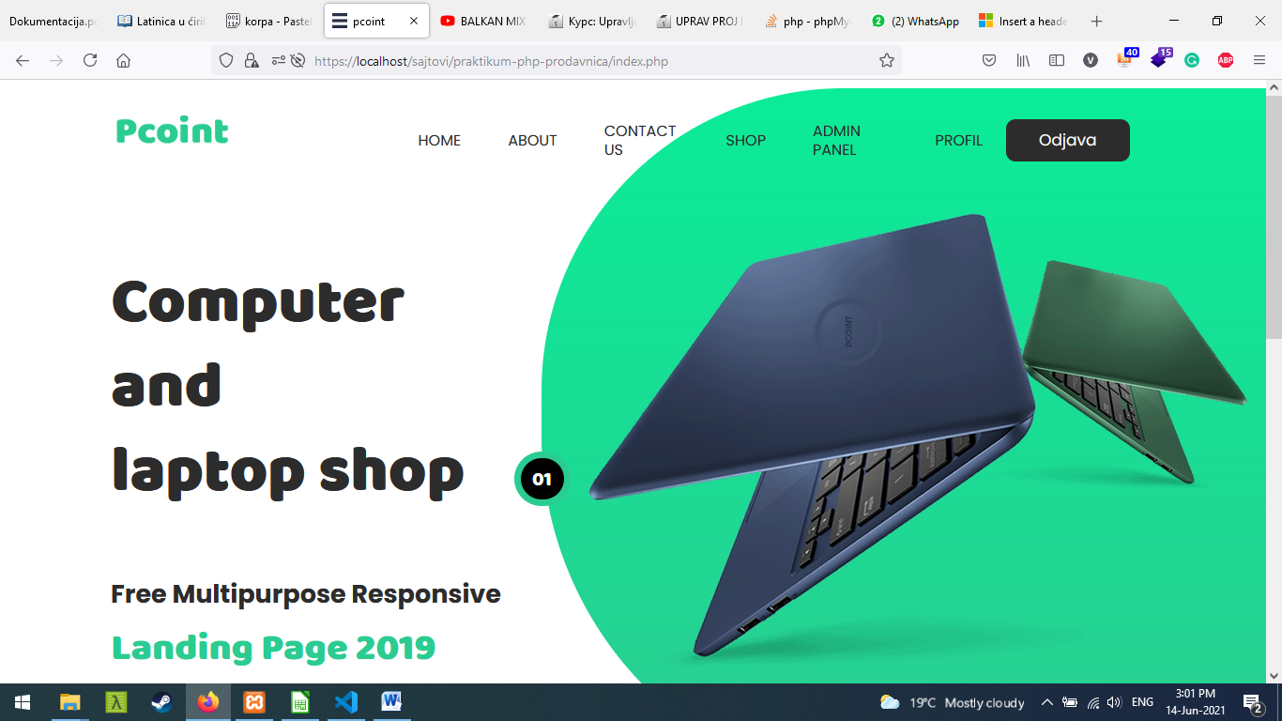

Ovaj slider se ucitava na svakoj stranici I u zavisnosti da li ste registrovani ili ne navigacioni meni ce malo biti izmenjen.

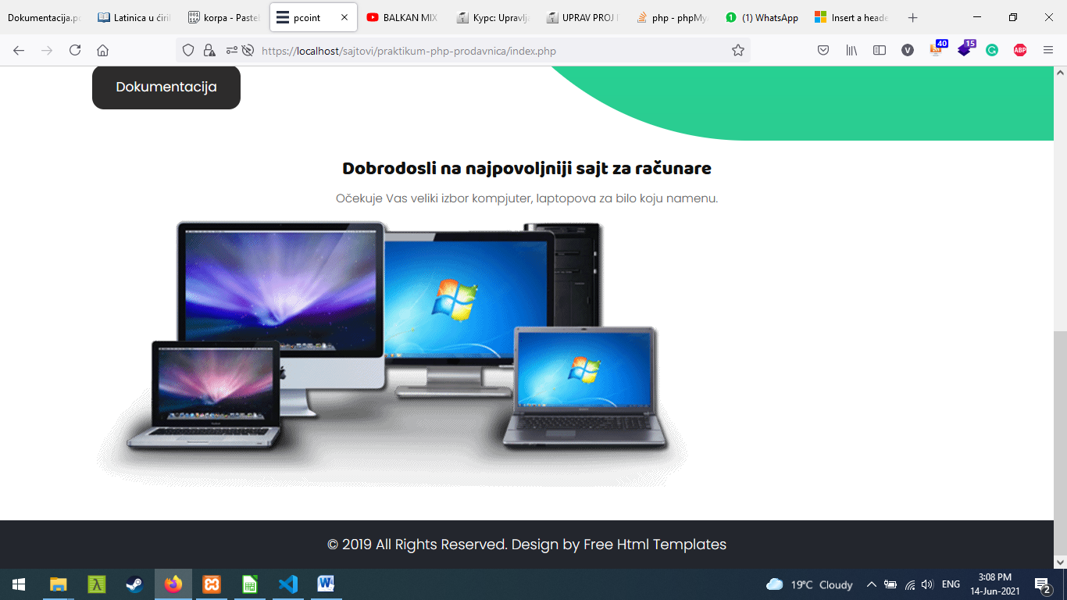

Ovo je sredina indexa. Nista posebno, cisto neki mini uvod.

Footer se dinamicki ispisuje na svim stranicama isto kao I blok iznad.

**Shop.php**

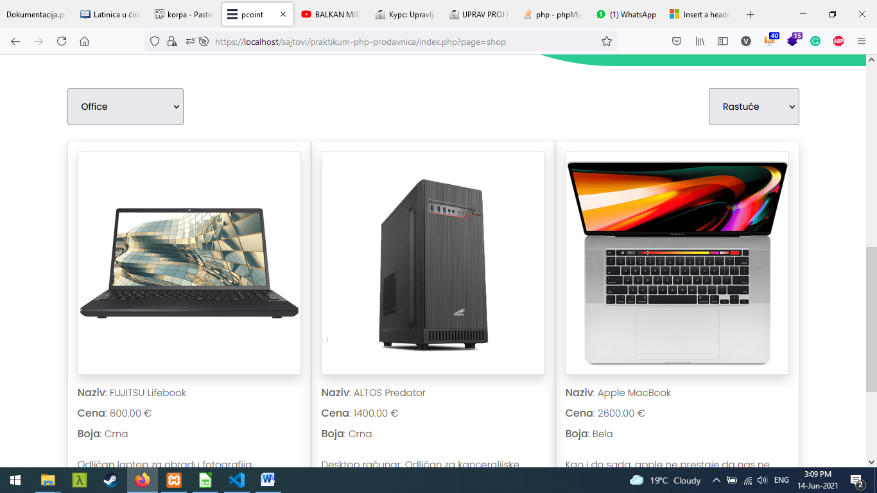

Centralni deo stranice je izmenjen I mozemo da vidimo proizvode I iznad njih da su filtrirani po kategoriji office I sortirani rastuce.

Admin-panel.php

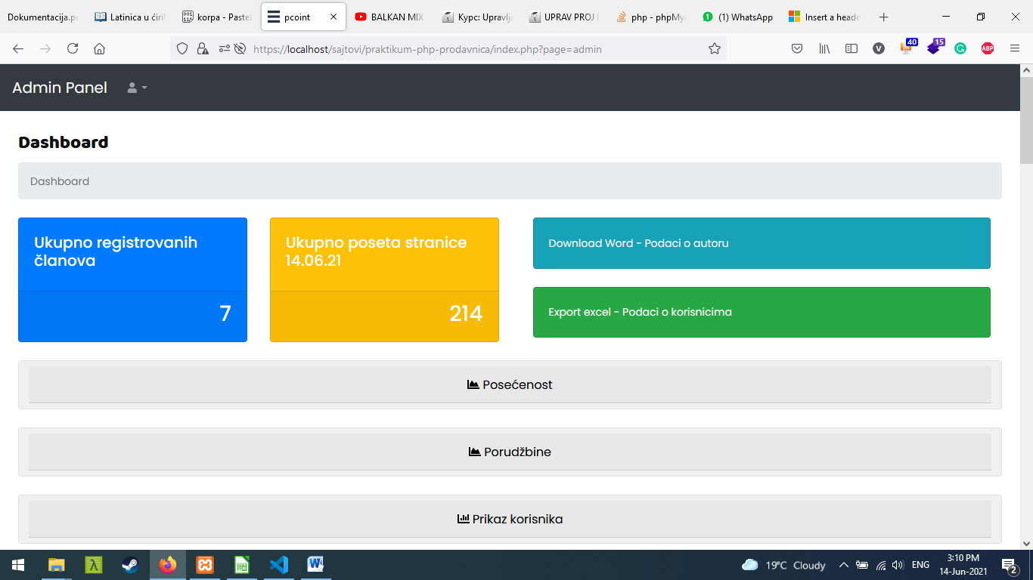

Admin panel ima nesto drugaciji izgled. Imamo 4 kartice, Word I excel su klikabilne.

Ispod njih imamo sekcije koje su minimizirane, uvecavaju se klikom na dugme(koje je sirine 100%)

P.S prve 3 sekcije su klikabilne, ostale nisu.

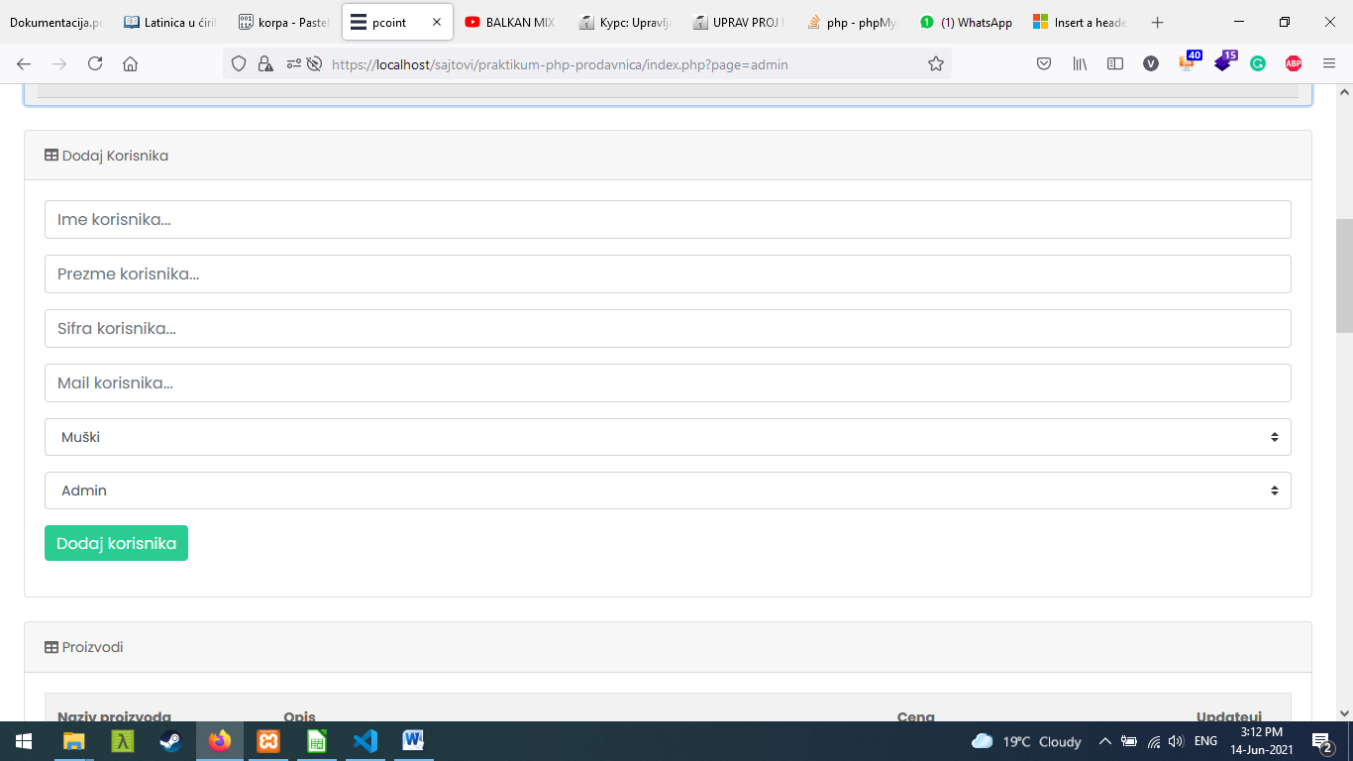

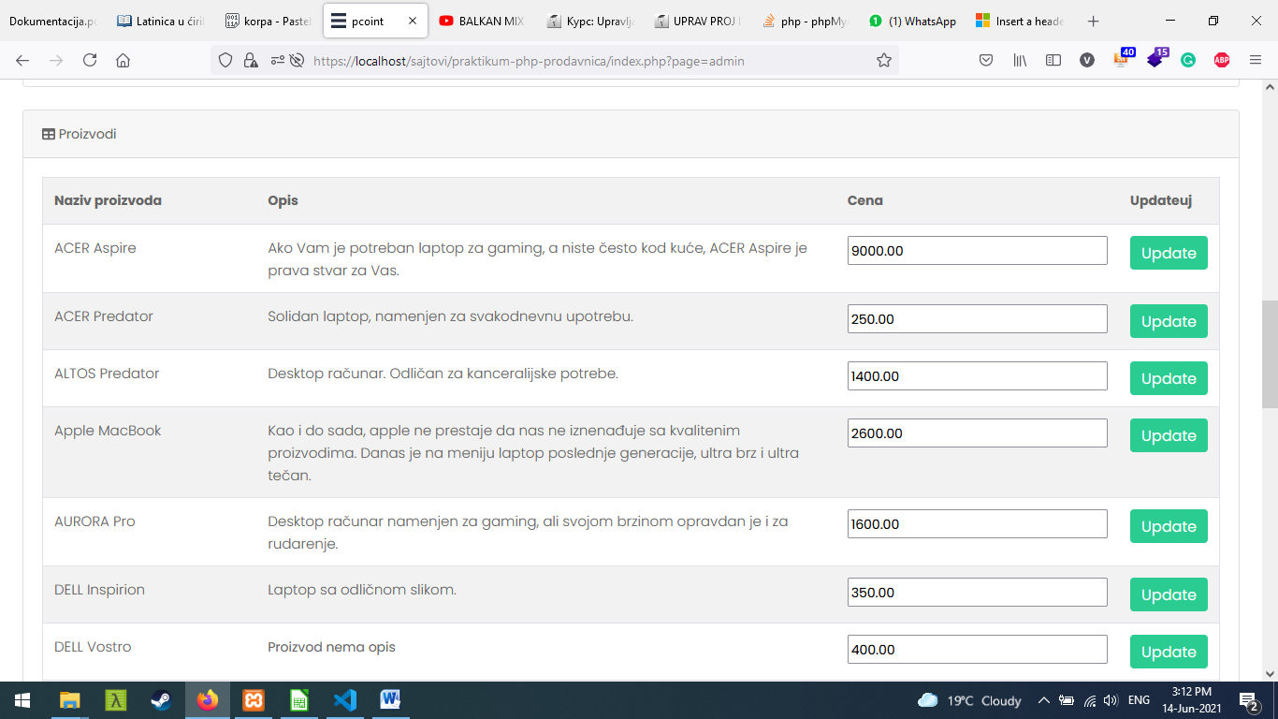

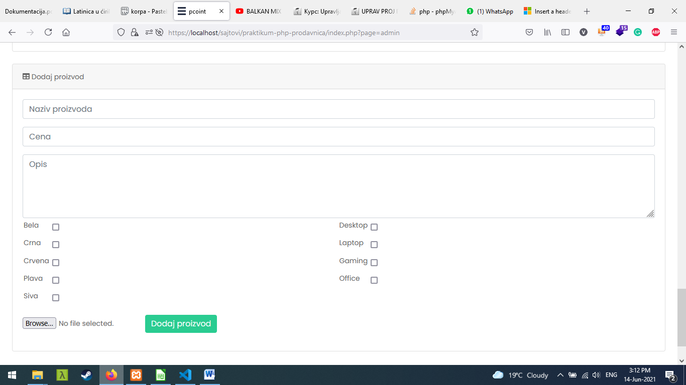

Register.php

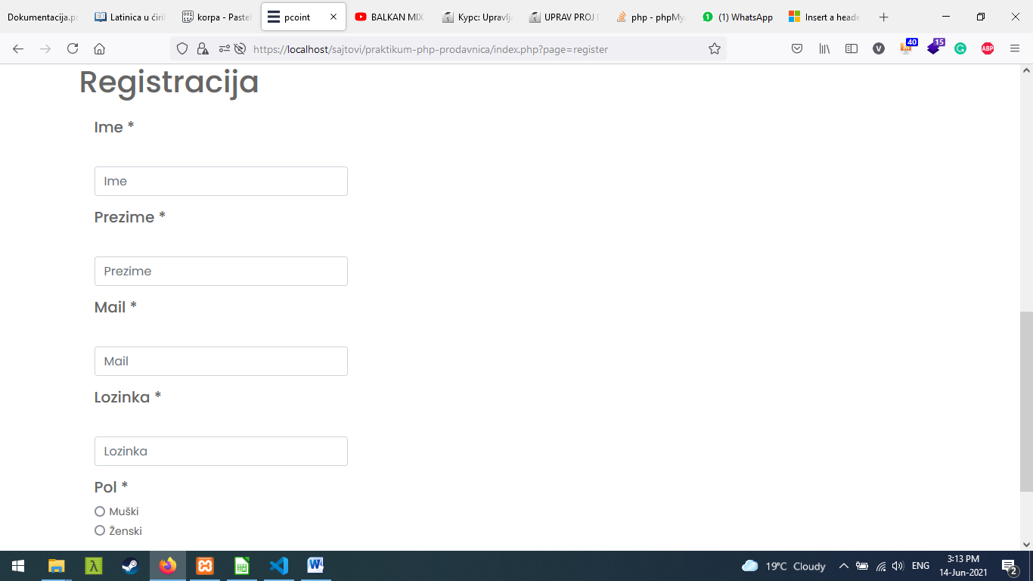

Zasticeno je I na klijentksom I serverskom nivou.

Login.php

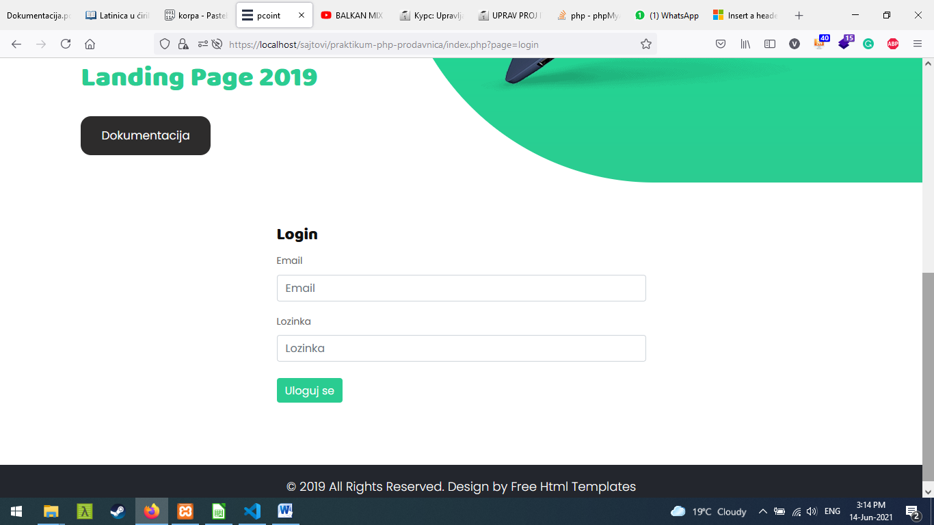

Slika baze podataka

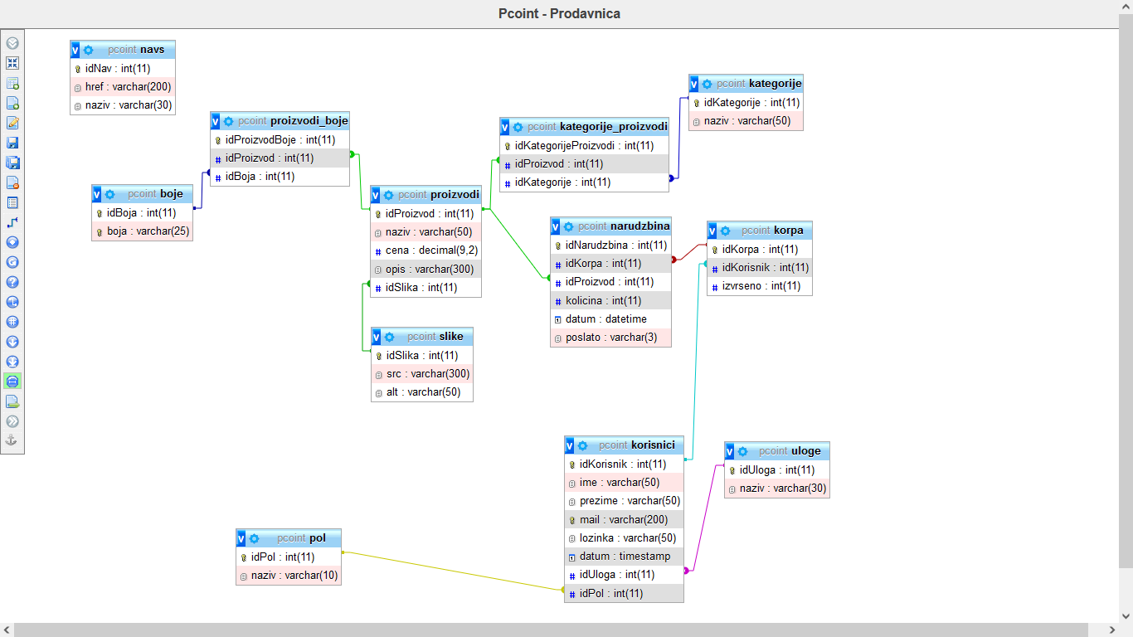

* 1. **Struktura fajlova**

3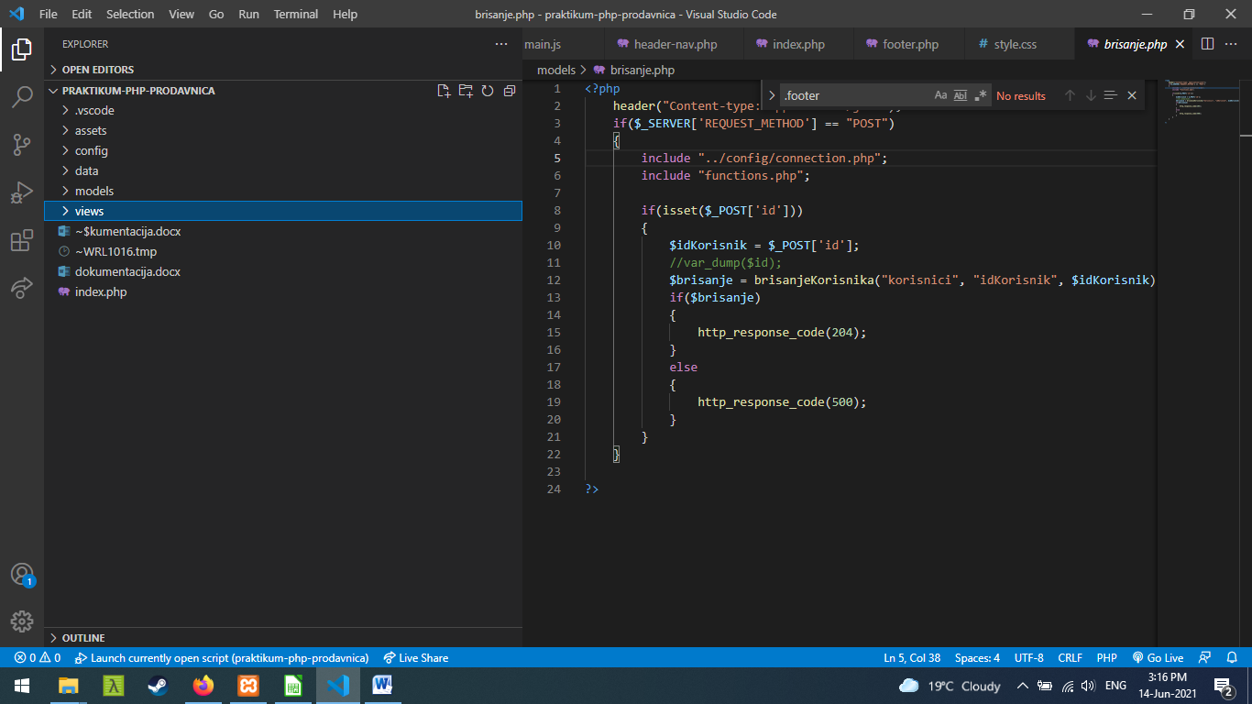

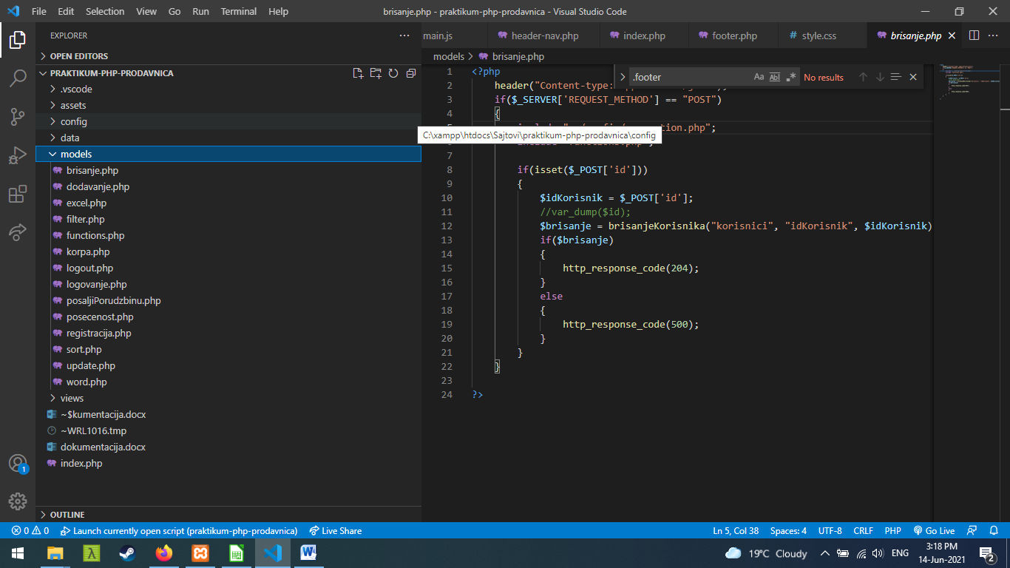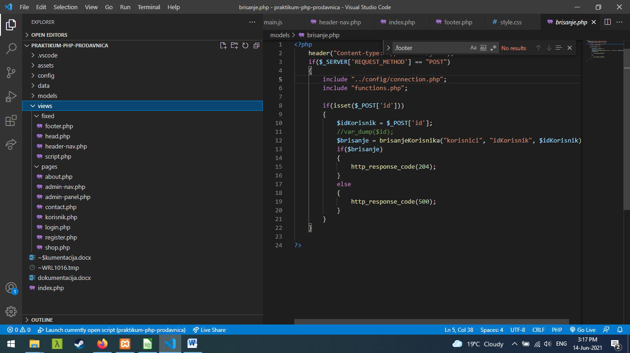

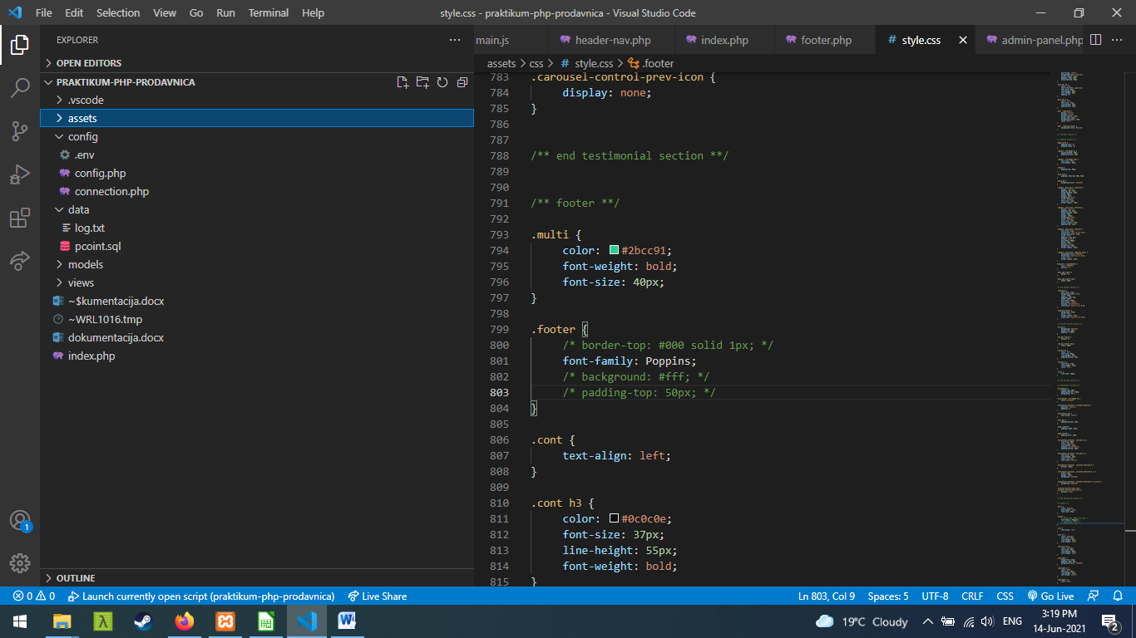

1. **Kodovi**

**3.1 Root – index.php**

<?php

   require_once "models/functions.php";

   require_once "views/fixed/head.php";

   require_once "config/connection.php";

?>

   <!-- body -->

   <body class="main-layout">

                        <!-- loader  -->

                        <!-- <div class="loader_bg">

                           <div class="loader"><img src="assets/images/loading.gif" alt="#" /></div>

                        </div> -->

                        <!-- end loader -->

      <!-- header -->

      <?php

         // require_once "views/fixed/header-nav.php";

      ?>

      <!-- end banner -->

      <?php

         if(isset($_GET['page']))

         {

            switch($_GET['page'])

            {

               case "about":

                  require_once "views/fixed/header-nav.php";

                  require_once "views/pages/about.php";

                  break;

               case "contact":

                  require_once "views/fixed/header-nav.php";

                  require_once "views/pages/contact.php";

                  break;

               case "shop":

                  require_once "views/fixed/header-nav.php";

                  require_once "views/pages/shop.php";

                  break;

               case "register":

                  require_once "views/fixed/header-nav.php";

                  require_once "views/pages/register.php";

                  break;

               case "login":

                  require_once "views/fixed/header-nav.php";

                  require_once "views/pages/login.php";

                  break;

               case "korisnik":

                  require_once "views/fixed/header-nav.php";

                  require_once "views/pages/korisnik.php";

                  break;

               case "admin":

                  require_once "views/pages/admin-panel.php";

                  break;

            }

         }

         else

         {

            require_once "views/fixed/header-nav.php";

?>

            <div class="container">

            <div class="row">

               <ul class="mt-2 w-100">

                  <li><h1 class='text-center'>Dobrodosli na najpovoljniji sajt za računare</h1></li>

                  <li><p class='text-center mb-3'>Očekuje Vas veliki izbor kompjuter, laptopova za bilo koju namenu.</p></li>

               </ul>

               <img src="assets/images/about_img.png" alt="About" class="img-fluid"/>

            </div>

         </div>

<?php

         }

?>

      <!-- two_box section -->

      <!-- end two_box section -->

      <!--  footer -->

      <?php

         require_once "views/fixed/footer.php";

      ?>

      <!-- end footer -->

      <!-- Javascript files-->

      <?php

         require_once "views/fixed/script.php";

      ?>

   </body>

</html>

**3.2 Folder config**

**.env**

**SERVER=localhost**

**DATABASE=pcoint**

**USERNAME=root**

**PASSWORD=**

**Config.php**

<?php

    define("SERVER", env("SERVER"));

    define("DATABASE", env("DATABASE"));

    define("USERNAME", env("USERNAME"));

    define("PASSWORD", env("PASSWORD"));

    function env($marker)

    {

        $niz = file(__DIR__ . "/.env");

        $trazenaVrednost = "";

        foreach($niz as $red){

            $red = trim($red);

            list($identifikator, $vrednost) = explode("=", $red);

            if($identifikator == $marker){

                $trazenaVrednost = $vrednost;

                break;

            }

        }

        return $trazenaVrednost;

    }

?>

**Connection.php**

<?php

session_start();

logActionOrError("Upis u log fajl", false);

// $_SESSION["user"] = ["id" => 1, "username" => "Korisnik"];

require_once "config.php";

try {

    $conn = new PDO("mysql:host=".SERVER.";dbname=".DATABASE.";charset=utf8", USERNAME, PASSWORD);

    $conn->setAttribute(PDO::ATTR_DEFAULT_FETCH_MODE, PDO::FETCH_OBJ);

    $conn->setAttribute(PDO::ATTR_ERRMODE, PDO::ERRMODE_EXCEPTION);

}

catch(PDOException $ex){

    echo $ex->getMessage();

}

function executeQuery($query){

    global $conn;

    return $conn->query($query)->fetchAll();

}

function logActionOrError($message, $error = false){

    if($error){

        $file = fopen(dirname(__DIR__, 1) . '/data/error.txt', "a+");

    } else {

        $file = fopen(dirname(__DIR__, 1) . '/data/log.txt', "a+");

    }

    if(isset($_GET['page']))

    {

        $stranica = $_GET["page"];

    }

    else

    {

        $stranica = "index";

    }

    // var_dump($korisnik->ime);

    $ip = $_SERVER['REMOTE_ADDR'];

    $datum = date('d-m-Y H:i:s');

    if(isset($_SESSION['korisnik']))

    {

        $korisnik = $_SESSION["korisnik"];

        if($korisnik->naziv == "Korisnik" && $stranica == "admin")

        {

            $upis = "$korisnik->ime\t$korisnik->prezime\t$korisnik->naziv\t$stranica\t$ip\t$datum\tNeautorizovan korisnik je pokušao da pristupi admin panelu\n";

        }

        else

        {

            $upis = "$korisnik->ime\t$korisnik->prezime\t$korisnik->naziv\t$stranica\t$ip\t$datum\t$message\n";

        }

    }

    else

    {

        $korisnik = "Gost";

        if(isset($_GET['page']))

        {

            if($_GET['page'] == "admin")

            {

                $upis = "$korisnik\t/\tGost\t$stranica\t$ip\t$datum\tNeautorizovan korisnik je pokušao da pristupi admin panelu\n";

            }

            else

            {

                $upis = "$korisnik\t/\tGost\t$stranica\t$ip\t$datum\t$message\n";

            }

        }

        else

        {

            $upis = "$korisnik\t/\tGost\t$stranica\t$ip\t$datum\t$message\n";

        }

    }

    fwrite($file, $upis);

    fclose($file);

}

**3.3 Folder views/fixed**

**Head.php**

<!DOCTYPE html>

<html lang="en">

   <head>

      <!-- basic -->

      <meta charset="utf-8">

      <meta http-equiv="X-UA-Compatible" content="IE=edge">

      <!-- mobile metas -->

      <meta name="viewport" content="width=device-width, initial-scale=1">

      <meta name="viewport" content="initial-scale=1, maximum-scale=1">

      <!-- site metas -->

      <title>pcoint</title>

      <meta name="keywords" content="">

      <meta name="description" content="">

      <meta name="author" content="">

      <!-- bootstrap css -->

      <link rel="stylesheet" href="assets/css/bootstrap.min.css">

      <!-- style css -->

      <link rel="stylesheet" href="assets/css/style.css">

      <!-- Responsive-->

      <link rel="stylesheet" href="assets/css/responsive.css">

      <!-- fevicon -->

      <link rel="icon" href="assets/images/menu_icon.png" type="image/gif" />

      <!-- Scrollbar Custom CSS -->

      <link rel="stylesheet" href="assets/css/jquery.mCustomScrollbar.min.css">

      <!-- Tweaks for older IEs-->

      <link rel="stylesheet" href="https://netdna.bootstrapcdn.com/font-awesome/4.0.3/css/font-awesome.css">

      <link rel="stylesheet" href="https://cdnjs.cloudflare.com/ajax/libs/fancybox/2.1.5/jquery.fancybox.min.css" media="screen">

      <link href="https://cdn.jsdelivr.net/npm/simple-datatables@latest/dist/style.css" rel="stylesheet" />

      <script src="https://cdnjs.cloudflare.com/ajax/libs/font-awesome/5.15.3/js/all.min.js" crossorigin="anonymous"></script>

      <!--[if lt IE 9]>

      <script src="https://oss.maxcdn.com/html5shiv/3.7.3/html5shiv.min.js"></script>

      <script src="https://oss.maxcdn.com/respond/1.4.2/respond.min.js"></script><![endif]-->

   </head>

**Header.php**

<?php

    if(isset($_SESSION))

    {

        @$korisnik = $_SESSION['korisnik']; //Stavio sam @ da ne izlazi greska

    }

?>

<header>

    <!-- header inner -->

    <div  class="head_top">

        <div class="header">

            <div class="container">

                <div class="row">

                    <div class="col-xl-3 col-lg-3 col-md-3 col-sm-3 col logo_section">

                    <div class="full">

                        <div class="center-desk">

                            <div class="logo">

                                <a href="index.php"><img src="assets/images/logo.png" alt="logo" /></a>

                            </div>

                        </div>

                    </div>

                    </div>

                    <div class="col-xl-9 col-lg-9 col-md-9 col-sm-9">

                    <nav class="navigation navbar navbar-expand-md navbar-dark ">

                        <button class="navbar-toggler" type="button" data-toggle="collapse" data-target="#navbarsExample04" aria-controls="navbarsExample04" aria-expanded="false" aria-label="Toggle navigation">

                        <span class="navbar-toggler-icon"></span>

                        </button>

                        <div class="collapse navbar-collapse" id="navbarsExample04">

                            <ul class="navbar-nav mr-auto d-flex align-items-center">

                                <?php

                                    if($conn)

                                    {

                                        $navs = vratiSve("navs");

                                        foreach($navs as $nav)

                                        {

                                            if($korisnik)

                                            {

                                                if($nav->naziv == "Register")

                                                {

                                                    echo "

                                                    <li class='nav-item sign_btn'>

                                                        <a href='models/logout.php'>Odjava</a>

                                                    </li>";

                                                }

                                                else if($nav->naziv == "Login")

                                                {

                                                    if($korisnik->naziv == "Korisnik")

                                                    {

                                                        echo "<li class='nav-item'>

                                                            <a class='nav-link' href='index.php?page=korisnik'>Profil</a>

                                                        </li>";

                                                    }

                                                    else

                                                    {

                                                        echo "<li class='nav-item'>

                                                            <a class='nav-link' href='index.php?page=admin'>Admin Panel</a>

                                                        </li><li class='nav-item'>

                                                        <a class='nav-link' href='index.php?page=korisnik'>Profil</a>

                                                    </li>";

                                                    }

                                                }

                                                else

                                                {

                                                    echo "

                                                    <li class='nav-item'>

                                                        <a class='nav-link' href='$nav->href'>$nav->naziv</a>

                                                    </li>";

                                                }

                                            }

                                            else

                                            {

                                                if($nav->naziv == "Register")

                                                {

                                                    echo "

                                                    <li class='nav-item sign_btn'>

                                                        <a href='$nav->href'>$nav->naziv</a>

                                                    </li>";

                                                }

                                                else

                                                {

                                                    echo "

                                                    <li class='nav-item'>

                                                        <a class='nav-link' href='$nav->href'>$nav->naziv</a>

                                                    </li>";

                                                }

                                            }

                                        }

                                    }

                                ?>

                                <!-- <li class='nav-item'>

                                <a class='nav-link' href='index.html'> Home  </a>

                                </li>

                                <li class="nav-item">

                                <a class="nav-link" href="#about">About</a>

                                </li>

                                <li class="nav-item">

                                <a class="nav-link" href="#contact">Contact us</a>

                                </li>

                                <li class="nav-item sign_btn">

                                    <a href="#">Sign in</a>

                                </li> -->

                            </ul>

                        </div>

                    </nav>

                    </div>

                </div>

            </div>

        </div>

        <!-- end header inner -->

        <!-- end header -->

        <!-- banner -->

        <section class="banner_main">

            <div class="container-fluid">

                <div class="row d_flex">

                    <div class="col-md-5">

                    <div class="text-bg">

                        <h1>Computer and <br>laptop shop</h1>

                        <strong>Free Multipurpose Responsive</strong>

                        <span>Landing Page 2019</span>

                        <a href="dokumentacija.pdf">Dokumentacija</a>

                    </div>

                    </div>

                    <div class="col-md-7 padding_right1">

                    <div class="text-img">

                        <figure><img src="assets/images/top_img.png" alt="#"/></figure>

                        <h3>01</h3>

                    </div>

                    </div>

                </div>

            </div>

        </section>

    </div>

</header>

**Footer.php**

<footer>

    <div class="footer">

        <div class="copyright">

            <div class="container">

                <div class="row">

                    <div class="col-md-12">

                    <p>© 2019 All Rights Reserved. Design by <a href="https://html.design/"> Free Html Templates</a></p>

                    </div>

                </div>

            </div>

        </div>

    </div>

</footer>

**Script.php**

<script src="https://ajax.googleapis.com/ajax/libs/jquery/3.5.1/jquery.min.js"></script>

<script src="assets/js/jquery.min.js"></script>

<script src="assets/js/popper.min.js"></script>

<script src="assets/js/bootstrap.bundle.min.js"></script>

<!-- <script src="assets/js/jquery-3.0.0.min.js"></script> -->

<script src="assets/js/plugin.js"></script>

<!-- sidebar -->

<script src="assets/js/jquery.mCustomScrollbar.concat.min.js"></script>

<script src="assets/js/custom.js"></script>

<script src="assets/js/main.js"></script>

<!-- <script src="https:cdnjs.cloudflare.com/ajax/libs/fancybox/2.1.5/jquery.fancybox.min.js"></script> -->

**3.4 views/pages**

**About.php**

<!-- about -->

<div id="about" class="about">

    <div class="container">

        <div class="row">

            <div class="col-md-12">

                <div class="titlepage">

                    <h2>Student</h2>

                    <p class="h1 text-white">Vanja Veapi</p>

                    <p class="h2 text-white">244/19 Visoka ICT</p>

                    <h2 class="mt-5">Skills</h2>

                    <ul class="text-white">

                        <li class="h4">Web Designer</li>

                        <li class="h4">Front-end developer</li>

                        <li class="h4">Back-end developer</li>

                        <li class="h4">Grpahic Design</li>

                    </ul>

                </div>

            </div>

        </div>

        <div class="row">

            <div class="col-md-8 offset-md-2 ">

                <div class="about_box ">

                    <figure><img src="assets/images/profilna.png" class="img-fluid" width=500 alt="Profilna"/></figure>

                    <a class="btn btn-success pl-4 pr-4" href="dokumentacija.pdf"><p class="h5">Dokumentacija</p></a>

                    <a class="btn btn-info pl-4 pr-4" href="models/word.php"><p class="h5">Download Word</p></a>

                </div>

            </div>

        </div>

    </div>

</div>

<!-- about -->

**Admin-nav.php**

<div class="col-xl-9 col-lg-9 col-md-9 col-sm-9">

    <nav class="navigation navbar navbar-expand-md navbar-dark ">

        <button class="navbar-toggler" type="button" data-toggle="collapse" data-target="#navbarsExample04" aria-controls="navbarsExample04" aria-expanded="false" aria-label="Toggle navigation">

        <span class="navbar-toggler-icon"></span>

        </button>

        <div class="collapse navbar-collapse" id="navbarsExample04">

            <ul class="navbar-nav mr-auto d-flex align-items-center">

                <?php

                    if($conn)

                    {

                        $navs = vratiSve("navs");

                        foreach($navs as $nav)

                        {

                            echo "

                            <li class='nav-item'>

                                <a class='nav-link' href='$nav->href'>$nav->naziv</a>

                            </li>";

                        }

                    }

                ?>

                <!-- <li class='nav-item'>

                <a class='nav-link' href='index.html'> Home  </a>

                </li>

                <li class="nav-item">

                <a class="nav-link" href="#about">About</a>

                </li>

                <li class="nav-item">

                <a class="nav-link" href="#contact">Contact us</a>

                </li>

                <li class="nav-item sign_btn">

                    <a href="#">Sign in</a>

                </li> -->

            </ul>

        </div>

    </nav>

</div>

**Admin-panel.php**

<?php

    if($_SERVER['REQUEST_METHOD'] == "GET")

    {

        // session_start();

        @$korisnik = $_SESSION['korisnik'];

        if($korisnik)

        {

        // var_dump($korisnik);

            if($korisnik->naziv == "Admin")

            {//Pocetak

        ?>

        <!-- HTML KOD ADMIN PANEL -->

        <body class="sb-nav-fixed">

        <nav class="sb-topnav navbar navbar-expand navbar-dark bg-dark">

            <!-- Navbar Brand-->

            <a class="navbar-brand ps-3" href="index.php">Admin Panel</a>

            <ul class="navbar-nav mr-auto d-flex align-items-center">

                <li class="nav-item dropdown">

                    <a class="nav-link dropdown-toggle" id="navbarDropdown" href="#" role="button" data-bs-toggle="dropdown" aria-expanded="false"><i class="fas fa-user fa-fw"></i></a>

                    <ul class="dropdown-menu dropdown-menu-end" aria-labelledby="navbarDropdown">

                        <!-- <li><a class="dropdown-item" href="#!">Settings</a></li>

                        <li><a class="dropdown-item" href="#!">Activity Log</a></li>

                        <li><hr class="dropdown-divider" /></li>

                        <li><a class="dropdown-item" href="#!">Logout</a></li> -->

                        <?php

                            $navs = vratiSve("navs");

                            foreach($navs as $nav)

                            {

                                if($nav->naziv == "Login")

                                {

                                    continue;

                                }

                                if($nav->naziv == "Register")

                                {

                                    echo "<li><hr class=dropdown-divider/></li><li><a class='dropdown-item' href='models/logout.php'>Odjava</a></li>";

                                }

                                else

                                {

                                    echo "<li><a class='dropdown-item' href='$nav->href'>$nav->naziv</a></li>";

                                }

                            }

                        ?>

                    </ul>

                </li>

            </ul>

        </nav>

        <div id="layoutSidenav">

            <div id="layoutSidenav_content">

                <main>

                    <div class="container-fluid px-4">

                        <h1 class="mt-4">Dashboard</h1>

                        <ol class="breadcrumb mb-4">

                            <li class="breadcrumb-item active">Dashboard</li>

                        </ol>

                        <div class="row">

                            <div class="col-xl-3 col-md-6">

                                <div class="card bg-primary text-white mb-4">

                                    <div class="card-body h5">Ukupno registrovanih članova</div>

                                    <div class="card-footer d-flex align-items-center justify-content-end">

                                        <?php

                                            if($conn)

                                            {

                                                $ukupanBrojKorisnika = ukupnoKorisnika();

                                                // echo $ukupanBrojKorisnika;

                                                echo "<p class='h3'>$ukupanBrojKorisnika->brojKorisnika</p>";

                                            }

                                        ?>

                                       <!-- <p class="h4">30</p> -->

                                    </div>

                                </div>

                            </div>

                            <div class="col-xl-3 col-md-6">

                                <div class="card bg-warning text-white mb-4">

                                    <div class="card-body h5">Ukupno poseta stranice<?php echo " ".date("d.m.y")?></div>

                                    <div class="card-footer d-flex align-items-center justify-content-end">

                                        <?php

                                            require_once "models/posecenost.php";

                                            if($datum == date("d-m-Y"))

                                            {

                                                echo "<p class='h3'>$ukupnaPoseta</p>";

                                            }

                                        ?>

                                    </div>

                                </div>

                            </div>

                            <div class="col-xl-6 align-items-center">

                                <div class="col-xl-12">

                                    <div class="card bg-info text-white mb-4">

                                        <a href="models/word.php" class="text-white"><div class="card-body">Download Word - Podaci o autoru</div></a>

                                    </div>

                                </div>

                                <div class="col-xl-12">

                                    <div class="card bg-success text-white mb-4">

                                        <a href="models/excel.php" class="text-white"><div class="card-body">Export excel - Podaci o korisnicima</div></a>

                                    </div>

                                </div>

                            </div>

                        </div>

                        <div class="row">

                            <div class="col-xl-12">

                                <div class="card mb-4">

                                <button class="btn" type="button" data-toggle="collapse" data-target="#collapseExample" aria-expanded="false" aria-controls="collapseExample"><div class="card-header">

                                        <i class="fas fa-chart-area me-1"></i>

                                        Posećenost

                                    </div></button><!--Ceo card-header je klikabilan-->

                                    <div class="collapse" id="collapseExample">

                                        <div class="card-body">

                                        <table class="table table-striped">

                                            <tr>

                                                <th>Stranica</th>

                                                <th>Ukupno poseta stranice</th>

                                                <th>Dnevno poseta</th>

                                                <th>Poseta izražena u procentima</th>

                                            </tr>

                                            <?php

                                                echo "<tr><td>Index</td><td>$indexPosecenost</td><td>$dnevnaPosetaIndexStr</td><td>$indexProcenat %</td></tr>";

                                                echo "<tr><td>Shop</td><td>$shopPosecenost</td><td>$dnevnaPosetaShopStr</td><td>$shopProcenat %</td></tr>";

                                                echo "<tr><td>About</td><td>$aboutPosecenost</td><td>$dnevnaPosetaAboutStr</td><td>$aboutProcenat %</td></tr>";

                                                echo "<tr><td>Register</td><td>$registerPosecenost</td><td>$dnevnaPosetaRegisterStr</td><td>$registerProcenat %</td></tr>";

                                                echo "<tr><td>Login</td><td>$loginPosecenost</td><td>$dnevnaPosetaLoginStr</td><td>$loginProcenat %</td></tr>";

                                                echo "<tr><td>Contact</td><td>$contactPosecenost</td><td>$dnevnaPosetaContactStr</td><td>$contactProcenat %</td></tr>";

                                                echo "<tr><td>Korisnik</td><td>$korisnikPosecenost</td><td>$dnevnaPosetaKorisnikStr</td><td>$korisnikProcenat %</td></tr>";

                                                echo "<tr><td>Admin</td><td>$adminPosecenost</td><td>$dnevnaPosetaAdminStr</td><td>$adminProcenat %</td></tr>";

                                            ?>

                                        </table>

                                        </div>

                                    </div>

                                </div>

                            </div>

                            <div class="col-xl-12">

                                <div class="card mb-4">

                                    <button class="btn" type="button" data-toggle="collapse" data-target="#porudzbine" aria-expanded="false" aria-controls="porudzbine">

                                        <div class="card-header">

                                            <i class="fas fa-chart-area me-1"></i>

                                            Porudžbine

                                        </div>

                                    </button><!--Ceo card-header je klikabilan-->

                                    <div class="collapse" id="porudzbine">

                                        <div class="card-body">

<table class="table table-striped">

<tr>

    <th>Ime Prezime</th>

    <th>Naziv proizvoda</th>

    <th>Cena</th>

</tr>

<?php

    $prikaziKorpu = prikaziPorudzbine();

    if($prikaziKorpu)

    {

        foreach($prikaziKorpu as $korpa)

        {

            echo "<tr>

                <td>$korpa->ime $korpa->prezime</td>

                <td>$korpa->naziv</td>";

            if($korpa->ulogaNaziv == "Admin")

            {

                echo "<td>".($korpa->cena*0.5)."</td>";

            }

            else if($korpa->ulogaNaziv == "Korisnik")

            {

                echo "<td>".($korpa->cena)."</td>";

            }

            "</tr>";

        }

    }

?>

</table>

                                        </div>

                                    </div>

                                </div>

                            </div>

                            <div class="col-xl-12">

                                <div class="card mb-4">

                                    <button class="btn" type="button" data-toggle="collapse" data-target="#prikazKorisnika" aria-expanded="false" aria-controls="prikazKorisnika">

                                        <div class="card-header">

                                            <i class="fas fa-chart-bar me-1"></i>

                                            Prikaz korisnika

                                        </div>

                                    </button>

                                    <div class="collapse" id="prikazKorisnika">

                                        <div class="card-body">

                                            <table class="table table-striped">

                                                <tr>

                                                    <th scope="col">ID</th>

                                                    <th scope="col">Ime</th>

                                                    <th scope="col">Prezime</th>

                                                    <th scope="col">Mail</th>

                                                    <th scope="col">Pol</th>

                                                    <th scope="col">Uloga</th>

                                                    <th scope="col">Obriši korisnika</th>

                                                </tr>

                                                <?php

                                                    $korisnici = prikazKorisnika();

                                                    foreach($korisnici as $korisnik)

                                                    {

                                                        echo "<tr>

                                                        <td>$korisnik->idKorisnik</td>

                                                        <td>$korisnik->ime</td>

                                                        <td>$korisnik->prezime</td>

                                                        <td>$korisnik->mail</td>

                                                        <td>$korisnik->polNaziv</td>

                                                        <td>$korisnik->ulogaNaziv</td>

                                                        <td><input type='button' class='btn btn-success btnDelete' name='$korisnik->idKorisnik' value='Obriši korisnika'/></td>

                                                        </tr>";

                                                    }

                                                ?>

                                            </table>

                                        </div>

                                    </div>

                                </div>

                            </div>

                            <div class="col-xl-12">

                                <div class="card mb-4">

                                    <div class="card-header">

                                        <i class="fas fa-table me-1"></i>

                                        Dodaj Korisnika

                                    </div>

                                    <div class="card-body">

                                        <form action="" method="POST">

                                            <input type="text" name="ime" id="ime" class="form-control mb-3" placeholder="Ime korisnika..."/>

                                            <input type="text" name="prezime" id="prezime" class="form-control mb-3" placeholder="Prezme korisnika..."/>

                                            <input type="password" name="lozinka" id="lozinka" class="form-control mb-3" placeholder="Sifra korisnika..."/>

                                            <input type="text" name="mail" id="mail" class="form-control mb-3" placeholder="Mail korisnika..."/>

                                            <select name="pol" id="pol" class="custom-select mb-3">

                                                <option value="1">Muški</option>

                                                <option value="2">Ženski</option>

                                            </select>

                                            <select name="uloga" id="uloga" class="custom-select">

                                                <option value="1">Admin</option>

                                                <option value="2">Korisnik</option>

                                            </select>

                                            <input type="button" id="btnDodaj" value="Dodaj korisnika" class="btn btn-success mt-3 mb-3"/>

                                        </form>

                                        <div id="odgovor"></div>

                                    </div>

                                </div>

                            </div>

                            <div class="col-xl-12">

                                <div class="card mb-4">

                                    <div class="card-header">

                                        <i class="fas fa-table me-1"></i>

                                        Proizvodi

                                    </div>

                                    <div class="card-body">

                                        <div id="podaci-prodavnica" class="w-100 m-auto">

                                            <table class='table table-striped border'>

                                                <tr>

                                                    <th class="col w-25">Naziv proizvoda</th>

                                                    <th class="col">Opis</th>

                                                    <th class="col">Cena</th>

                                                    <th class="col">Updateuj</th>

                                                </tr>

                                            <?php

                                                $proizvodi = vratiSve("proizvodi");

                                                foreach($proizvodi as $proizvod)

                                                {

                                                    echo "<tr><td clasx='w-25'><p>$proizvod->naziv</p></td>";

                                                            if($proizvod->opis == null)

                                                            {

                                                                echo "<td>Proizvod nema opis</td>";

                                                            }

                                                            else

                                                            {

                                                                echo "<td><p>$proizvod->opis</p></td>";

                                                            }

                                                            echo "<td><input type='text' value='$proizvod->cena'/></td>

                                                            <td><input type='button' class='btn btn-success btnUpdate' name='$proizvod->idProizvod' value='Update'/>

                                                        </tr>";

                                                }

                                            ?>

                                            </table>

                                        </div>

                                    </div>

                                </div>

                            </div>

                            <div class="col-xl-12">

                                <div class="card mb-4">

                                    <div class="card-header">

                                        <i class="fas fa-table me-1"></i>

                                        Dodaj proizvod

                                    </div>

                                    <div class="card-body">

                                        <form action="" method="POST" enctype="multipart/form-data" name="uploadform">

                                            <input type="text" name="naziv" id="naziv" class="form-control mb-3" placeholder="Naziv proizvoda">

                                            <input type="text" name="cena" id="cena" class="form-control mb-3" placeholder="Cena">

                                            <textarea name="opis" id="opis" cols="60" class="form-control" rows="4" placeholder="Opis"></textarea>

                                            <div class="row">

                                            <?php

                                                if($conn)

                                                {

                                                    $boje = vratiSve("boje");

                                                    echo "<div class='w-50'><table>";

                                                    foreach($boje as $boja)

                                                    {

                                                        echo "<tr><td><label class='ml-3 mr-1'>$boja->boja</label></td><td><input type='checkbox' id='$boja->idBoja' name='$boja->boja' class='mr-3' value='$boja->idBoja'></td></tr>";

                                                    }

                                                    echo "</table>";

                                                    echo "</div>";

                                                    echo "<br/>";

                                                    $kategorije = vratiSve("kategorije");

                                                    echo "<div class='w-50'><table>";

                                                    foreach($kategorije as $kategorija)

                                                    {

                                                        echo "<tr><td><label class='mr-1'>$kategorija->naziv</label></td><td><input type='checkbox' id='$kategorija->idKategorije' name='$kategorija->naziv' class='mr-3' value='$kategorija->idKategorije'/></td></tr>";

                                                    }

                                                    echo "</table>";

                                                    echo "</div>";

                                                    echo "<br/>";

                                                }

                                            ?>

                                            </div>

                                            <input type="file" name="slika"/>

                                            <input type="button" id="btnDodajProizvod" value="Dodaj proizvod" class="btn btn-success mt-3 mb-3">

                                        </form>

                                    </div>

                                </div>

                            </div>

                        </div>

                    </div>

                </main>

            </div>

        </div>

        <script src="https://cdn.jsdelivr.net/npm/bootstrap@5.0.1/dist/js/bootstrap.bundle.min.js" crossorigin="anonymous"></script>

    </body>

        <!-- KRAJ ADMIN PANELA -->

        <?php

            }//Kraj if-a za naziv

        }

        else

        {

            die("<h3>Pokušali ste da pristupite, a niste admin. Srrrrram Vas bilo!</h3><br/>

            <video width='320' height='240' controls autoplay>

            <source src='assets/video/radule3.mp4' type='video/mp4'>

            <source src='assets/video/radule3.ogg' type='video/ogg'>

            <source src='../../assets/video/radule3.mp4' type='video/mp4'>

            <source src='../../assets/video/radule3.ogg' type='video/ogg'>

          Your browser does not support the video tag.

          </video>");

        }

    }

?>

**Contact.php**

<!-- request -->

<div id="contact" class="request">

    <div class="container">

    <div class="row">

        <div class="col-md-12">

            <div class="titlepage">

                <h2>Request a Call back</h2>

                <span>Lorem ipsum dolor sit amet, consectetur adipiscing elit, sed do eiusmod tempor <br>

                incididunt ut labore et dolore magna</span>

            </div>

        </div>

    </div>

    <div class="row">

        <div class="col-sm-12">

            <div class="black_bg">

                <div class="row">

                <div class="col-md-7 ">

                    <form class="main_form">

                        <div class="row">

                            <div class="col-md-12 ">

                            <input class="contactus" placeholder="Nmae" type="text" name="Nmae">

                            </div>

                            <div class="col-md-12">

                            <input class="contactus" placeholder="Phone number" type="text" name=" Phone number">

                            </div>

                            <div class="col-md-12">

                            <input class="contactus" placeholder="Email" type="text" name="Email">

                            </div>

                            <div class="col-md-12">

                            <textarea class="textarea" placeholder="Message" type="text" name="Message "> Message </textarea>

                            </div>

                            <div class="col-sm-12">

                            <button class="send_btn">Send</button>

                            </div>

                        </div>

                    </form>

                </div>

                <div class="col-md-5">

                    <div class="mane_img">

                        <figure><img src="assets/images/mane_img.jpg" alt="#"/></figure>

                    </div>

                </div>

                </div>

            </div>

        </div>

    </div>

    </div>

</div>

<!-- end request -->

**Korisnik.php**

<?php

    if($_SERVER['REQUEST_METHOD'] == "GET")

    {

        // session_start();

        @$korisnik = $_SESSION['korisnik']; //Stavio sam @ ako izadje greska

        if($korisnik)

        {

            $idKorisnik = $korisnik->idKorisnik;

            // var_dump($korisnik);

            echo "<h1 class='ml-4'>Pozdrav $korisnik->ime, dobrodošli nazad.</h1>

            <input type='hidden' id='idKorisnik' value='$korisnik->idKorisnik'/>";

            $prikaziKorpu = prikaziKorpu($idKorisnik);

            // var_dump($prikaziKorpu);

            foreach($prikaziKorpu as $korpa1){}

            if($prikaziKorpu && $korpa1->izvrseno == 0)

            {

                echo "<h2 class='ml-4'>Korpa</h2>";

?>

<div class="container">

<table class='table table-striped text-center'>

                <tr>

                    <th>Slika</th>

                    <th>Naziv</th>

                    <th>Cena</th>

                    <th>Količina</th>

                    <th>Ukupna cena</th>

                </tr>

<?php

                foreach($prikaziKorpu as $korpa)

                {

                    if($korisnik->naziv == "Korisnik")

                    {

                        echo "<tr><td><img src='assets/images/shop/$korpa->src' alt='$korpa->alt' width='100'/></td>

                        <td>$korpa->naziv</td><td>$korpa->cena &euro;</td><td>$korpa->kolicina</td><td>".$korpa->cena*$korpa->kolicina." &euro;</td></tr>";

                    }

                    else

                    {

                        echo "<tr>

                        <td><img src='assets/images/shop/$korpa->src' alt='$korpa->alt' width='100'/></td>

                        <td>$korpa->naziv</td>

                        <td>$korpa->cena &euro;</td>

                        <td>$korpa->kolicina</td><td>".(($korpa->cena*$korpa->kolicina)*0.5)." &euro;</td></tr>";

                    }

                }

                echo "</table><input type='hidden' id='idKorpa' value='$korpa->idKorpa'/>";

                echo "<div class='d-flex justify-content-end'><button type='button' id='btnPorudzbina' class='btn btn-success mt-4 mb-4'>Pošalji porudžbinu</button></div></div>"; //Drugi div je kraj containera, prvi je kraj flex-a

            }

            else

            {

                echo "<p class='h3'>Vaša korpa je prazna!</p>";

            }

        }

        else

        {

            die("<h3>Pokušali ste da pristupite, a niste se log-inovali. Srrrrram Vas bilo!</h3><br/>

            <video width='320' height='240' controls autoplay>

            <source src='assets/video/radule3.mp4' type='video/mp4'>

            <source src='assets/video/radule3.ogg' type='video/ogg'>

          Your browser does not support the video tag.

          </video>");

        }

    }

    else

    {

        die("Greska");

    }

?>

**Login.php**

<?php

    if(!isset($_SESSION))

    {

        session_start();

    }

?>

 <div class="container">

    <div class="row">

        <div id="login" class="col-6 mx-auto py-5">

            <h1>Login</h1>

            <form action="" method="POST">

                <label for="">Email</label>

                <input type="text" id="mail" name="mail" class="form-control" placeholder="Email"/>

                <label for="" class="mt-3">Lozinka</label>

                <input type="password" id="lozinka" name="lozinka" class="form-control" placeholder="Lozinka"/>

                <input type="button" value="Uloguj se" id="btnLogin" name="btnLogin" class="btn btn-success mt-4"/>

            </form>

            <div id="odgovor"></div>

            <?php

                if(isset($_SESSION['korisnik']))

                {

                    $korisnik = $_SESSION['korisnik'];

                    // var_dump($korisnik);

                    // var_dump($_SESSION['korisnik']);

                    if($korisnik->naziv == "Admin")

                    {

                        // header_remove();

                        // header("location:index.php?pages=admin-panel");

                        echo "<a href='index.php?page=admin'>Stranica za admina</a>";

                    }

                    if($korisnik->naziv == "Korisnik")

                    {

                        // header("Location:index.php?page=korisnik");

                        echo "<a href='index.php?page=korisnik'>Stranica za korisnika</a>";

                    }

                }

            ?>

        </div>

    </div>

</div>

**Registracija.php**

<?php

    if(!isset($_SESSION))

    {

        session_start();

    }

?>

<div class="container">

    <div class="row mb-3">

        <p class="h1">Registracija</p>

    </div>

    <div class="row">

        <form action="" id="registracija" method="POST" class="form-check">

            <label class="h5">Ime *</label>

            <p id="imeGreska" class="invisible mb-2">Ime nije napisano u dobrom formatu</p>

            <input type="text" id="ime" name="ime" class="form-control" placeholder="Ime"/>

            <label class="h5 mt-3">Prezime *</label>

            <p id="prezimeGreska" class="invisible mb-2">Ime nije napisano u dobrom formatu</p>

            <input type="text" id="prezime" name="prezime" class="form-control" placeholder="Prezime"/>

            <label class="h5 mt-3">Mail *</label>

            <p id="mailGreska" class="invisible mb-2">Ime nije napisano u dobrom formatu</p>

            <input type="text" id="mail" name="mail" class="form-control" placeholder="Mail"/>

            <label class="h5 mt-3">Lozinka *</label>

            <p id="lozinkaGreska" class="invisible mb-2">Ime nije napisano u dobrom formatu</p>

            <input type="password" id="lozinka" name="lozinka" class="form-control" placeholder="Lozinka"/>

            <label class="h5 mt-3">Pol *</label>

            <div class="form-check">

                <input type="radio" name="pol" class="form-check-input" value="1"/><label class="form-check-label">Muški</label>

            </div>

            <div class="form-check">

                <input type="radio" name="pol" class="form-check-input" value="2"/><label class="form-check-label">Ženski</label>

            </div>

            <input type="button" id="btnRegister" name="btnRegister" value="Registruj se" class="btn btn-success mt-4"/>

        </form>

        <div id="obavestenje"></div>

    </div>

</div>

**Shop.php**

<?php

    // session_start();

?>

<div class="container">

    <div class="row d-flex justify-content-between mt-4">

            <?php @$korisnik = $_SESSION['korisnik'];?>

        <select id="kategorije" name="kategorije" class="form-select p-3">

            <option value="selected" selected>Izaberi kategoriju</option>

            <?php

                $kategorije = vratiSve("kategorije");

                foreach($kategorije as $kategorija)

                {

                    echo "<option value='$kategorija->idKategorije'>$kategorija->naziv</option>";

                }

            ?>

        </select>

        <select id="sort" name="kategorije" class="form-select p-3">

            <option value="ASC">Rastuće</option>

            <option value="DESC">Opadajuće</option>

        </select>

        <input type="hidden" id="korisnikId" value="<?=@$korisnik->idKorisnik?>"/>

    </div>

    <div id="proizvodi" class="row mt-4">

        <!-- <div id="shop" class="w-100 d-flex"> -->

            <!-- <div class="col-lg-4 border shadow rounded pt-3 pb-3 ">

                <div class="img border shadow mb-3">

                    <img src="assets/images/shop/ACER-Aspire.png" alt="ACER" class="img-fluid"/>

                </div>

                <p class="mb-2">Naziv: Laptop</p>

                <p class="mb-2">Cena: 400e</p>

                <p class="mb-2">Boja: crna</p>

                <p class="mb-4 mt-4">Opis lorem ipsum ide gas majku ti tvoj, crni gruja, komunizam i renesansa</p>

                <input type="button" value="Add to cart" class="btn btn_cart"/>

            </div> -->

            <?php

                if($conn)

                {

                    $proizvodi = prikaziSveProizvode();

                    ispisiSveProizvode($proizvodi);

                }

            ?>

        <!-- </div> -->

    </div>

</div>

**Models**

**Brisanje.php**

<?php

    header("Content-type: application/json");

    if($_SERVER['REQUEST_METHOD'] == "POST")

    {

        include "../config/connection.php";

        include "functions.php";

        if(isset($_POST['id']))

        {

            $idKorisnik = $_POST['id'];

            //var_dump($id);

            $brisanje = brisanjeKorisnika("korisnici", "idKorisnik", $idKorisnik);

            if($brisanje)

            {

                http_response_code(204);

            }

            else

            {

                http_response_code(500);

            }

        }

    }

?>

**Dodavanje.php**

<?php

    header("Content-type: application/json");

    if($_SERVER['REQUEST_METHOD'] == "POST")

    {

        include "../config/connection.php";

        include "functions.php";

        try

        {

            $ime = $_POST['ime'];

            $prezime = $_POST['prezime'];

            $mail = $_POST['mail'];

            $lozinka = $_POST['lozinka'];

            $idPol = $_POST['pol'];

            $idUloga = $_POST['uloga'];

            $sifrovanaLozinka = md5($lozinka);

            $unosKorisnika = unosKorisnika($ime, $prezime, $mail, $sifrovanaLozinka, $idUloga, $idPol);

            if($unosKorisnika)

            {

                $odgovor = ["poruka" => "Uspesno ste se dodali korisnika u bazu", "kod" => true];

                echo json_encode($odgovor);

                http_response_code(201);

            }

        }

        catch(PDOExcepction $ex)

        {

            http_response_code(500);

        }

    }

    else

    {

        http_response_code(404);

    }

?>

**Excel.php**

<?php

    include "../config/connection.php";

    include "functions.php";

    if($conn)

    {

        @$korisnik = $_SESSION['korisnik'];

        if(@$korisnik->naziv == "Admin")

        {

            $filename = "Podaci o korisnicima - Excel";

            $prikazKorisnika = prikazKorisnika();

            header("Content-Type: application/xls; charset=UTF-8");

            header("Content-Disposition: attachment; filename=$filename.xls");

            header("Pragma: no-cache");

            header("Expires: 0");

            echo pack("CCC",0xef,0xbb,0xbf);

            echo "ID Korisnika\tIme\tPrezime\tMail\tUloga\tPol\n";

            foreach($prikazKorisnika as $korisnik)

            {

                echo "$korisnik->idKorisnik\t$korisnik->ime\t$korisnik->prezime\t$korisnik->mail\t$korisnik->ulogaNaziv\t$korisnik->polNaziv\n";

            }

        }

        else

        {

            die("<h3>Pokušali ste da skinete excel fajl, a niste Admin! Srrrrram Vas bilo!</h3><br/>

            <video width='320' height='240' controls autoplay>

            <source src='../assets/video/radule3.mp4' type='video/mp4'>

            <source src='../assets/video/radule3.ogg' type='video/ogg'>

          Your browser does not support the video tag.

          </video>");

        }

    }

    else

    {

        die("Nema konekcije s bazom");

    }

?>

**Filter.php**

<?php

    // header("Content-type: application/json");

    if(isset($_GET['kategorijaPhp']))

    {

        include "../config/connection.php";

        include "functions.php";

        if($conn)

        {

            try

            {

                $kategorija = $_GET['kategorijaPhp'];

                $sortType = $_GET['sortPhp'];

                if($sortType != "ASC" && $sortType != "DESC")

                {

                    $poruka = ["poruka" => "Pokusali ste da izmenite tip sortiranja"];

                    echo json_encode($poruka);

                    http_response_code(404);

                    die("Pokusali ste da izmenite tip sortiranja");

                }

                if($kategorija == "selected")

                {

                    // echo "true true true true true";

                    $filtriraniProizvodi = sortirajProizvod($sortType);

                }

                else

                {

                    // $filtriraniProizvodi = filtrirajProizvode($kategorija); Ovo radi

                    $filtriraniProizvodi = filterSortProizvod($sortType, $kategorija);

                }

                echo json_encode($filtriraniProizvodi);

                http_response_code(201);

            }

            catch(Excepction $ex)

            {

                http_response_code(501);

            }

        }

        else

        {

            http_response_code(404);

        }

    }

    else

    {

        http_response_code(404);

        die("Greska");

    }

?>

**Functions.php**

<?php

    function vratiSve($tabela)

    {

        global $conn;

        $upit = "SELECT * FROM $tabela";

        $result = $conn->query($upit)->fetchAll();

        return $result;

    }

    function prikaziSveProizvode()

    {

        global $conn;

        $upit = "SELECT p.*, pb.*, s.*, b.*

        FROM proizvodi AS p

        INNER JOIN proizvodi_boje AS `pb` ON pb.idProizvod = p.idProizvod

        INNER JOIN slike AS s ON p.idSlika = s.idSlika

        INNER JOIN boje AS b ON pb.idBoja = b.idBoja";

        $result = $conn->query($upit)->fetchAll();

        return $result;

    }

    function ispisiSveProizvode($products)

    {

        foreach($products as $proizvod)

        {

            if($proizvod->opis == null)

            {

                echo "<div class='col-lg-4 border shadow rounded pt-3 pb-3 '>

                <div class='img border shadow mb-3 d-flex justify-content-center'>

                    <img src='assets/images/shop/$proizvod->src' alt='$proizvod->alt' class='img-fluid'/>

                </div>

                <p class='mb-2'><b class='h6'>Naziv</b>: $proizvod->naziv</p>

                <p class='mb-2'><b class='h6'>Cena</b>: $proizvod->cena &euro;</p>

                <p class='mb-2'><b class='h6'>Boja</b>: $proizvod->boja</p>

                <p class='mb-4 mt-4'>Proizvod nema opis</p>

                <input id='$proizvod->idProizvod' type='button' value='Add to cart' class='btn btn_cart btnCart'/></div>";

            }

            else

            {

                echo "<div class='col-lg-4 border shadow rounded pt-3 pb-3 '>

                <div class='img border shadow mb-3 d-flex justify-content-center'>

                    <img src='assets/images/shop/$proizvod->src' alt='$proizvod->alt' class='img-fluid'/>

                </div>

                <p class='mb-2'><b class='h6'>Naziv</b>: $proizvod->naziv</p>

                <p class='mb-2'><b class='h6'>Cena</b>: $proizvod->cena &euro;</p>

                <p class='mb-2'><b class='h6'>Boja</b>: $proizvod->boja</p>

                <p class='mb-4 mt-4'><b class='h6'>Opis</b>: $proizvod->opis</p>

                <input id='$proizvod->idProizvod' type='button' value='Add to cart' class='btn btn_cart btnCart'/></div>";

            }

        }

    }

    /**

     * Funkcija kojom prosledjujem idKategorije koji se nalazi u selectu

     *

     */

    function filtrirajProizvode($idKategorije)

    {

        global $conn;

        $upit = "SELECT k.*, kp.*, p.*, s.*, b.* FROM

        kategorije AS k INNER JOIN kategorije_proizvodi AS kp ON kp.idKategorije = k.idKategorije

        INNER JOIN proizvodi AS p ON kp.idProizvod = p.idProizvod

        INNER JOIN slike AS s ON s.idSlika = p.idSlika

        INNER JOIN proizvodi_boje AS pb ON pb.idProizvod = p.idProizvod

        INNER JOIN boje AS b ON pb.idBoja = b.idBoja

        WHERE k.idKategorije = $idKategorije";

        // $priprema = $conn->prepare($upit);

        // $priprema->bindParam(":idKategorije", $idKategorije);

        // $rezultat = $priprema->execute();

        $result = $conn->query($upit)->fetchAll();

        return $result;

    }

    function sortirajProizvod($vrstaSortiranja)

    {

        global $conn;

        $upit = "SELECT p.*, pb.*, s.*, b.*

        FROM proizvodi AS p

        INNER JOIN proizvodi_boje AS `pb` ON pb.idProizvod = p.idProizvod

        INNER JOIN slike AS s ON p.idSlika = s.idSlika

        INNER JOIN boje AS b ON pb.idBoja = b.idBoja

        ORDER BY p.cena $vrstaSortiranja";

        $result = $conn->query($upit)->fetchAll();

        return $result;

    }

    function pretragaProzivod($pretraga)

    {

        global $conn;

        $upit = "SELECT p.*, pb.*, s.*, b.*

        FROM proizvodi AS p

        INNER JOIN proizvodi_boje AS `pb` ON pb.idProizvod = p.idProizvod

        INNER JOIN slike AS s ON p.idSlika = s.idSlika

        INNER JOIN boje AS b ON pb.idBoja = b.idBoja

        WHERE p.naziv LIKE LOWER('%".$pretraga."%')";

        $proizvodi = $conn->query($upit)->fetchAll();

        return $proizvodi;

    }

    function pretragaSort($vrstaSortiranja, $pretraga)

    {

        global $conn;

        $upit = "SELECT k.*, kp.*, p.*, s.*, b.* FROM

        kategorije AS k INNER JOIN kategorije_proizvodi AS kp ON kp.idKategorije = k.idKategorije

        INNER JOIN proizvodi AS p ON kp.idProizvod = p.idProizvod

        INNER JOIN slike AS s ON s.idSlika = p.idSlika

        INNER JOIN proizvodi_boje AS pb ON pb.idProizvod = p.idProizvod

        INNER JOIN boje AS b ON pb.idBoja = b.idBoja

        WHERE p.naziv LIKE LOWER('%".$pretraga."%')

        ORDER BY p.cena $vrstaSortiranja";

        // $priprema = $conn->prepare($upit);

        // $priprema->bindParam(":idKategorije", $idKategorije);

        // $rezultat = $priprema->execute();

        $result = $conn->query($upit)->fetchAll();

        return $result;

    }

    /**

     * Kada imam upareno filtriranje i sortiranje koristi se ova funkcija

     */

    function filterSortProizvod($vrstaSortiranja, $idKategorije, $pretraga = null)

    {

        global $conn;

        $upit = "SELECT k.*, kp.*, p.*, s.*, b.* FROM

        kategorije AS k INNER JOIN kategorije_proizvodi AS kp ON kp.idKategorije = k.idKategorije

        INNER JOIN proizvodi AS p ON kp.idProizvod = p.idProizvod

        INNER JOIN slike AS s ON s.idSlika = p.idSlika

        INNER JOIN proizvodi_boje AS pb ON pb.idProizvod = p.idProizvod

        INNER JOIN boje AS b ON pb.idBoja = b.idBoja

        WHERE k.idKategorije = $idKategorije

        ORDER BY p.cena $vrstaSortiranja";

        // $priprema = $conn->prepare($upit);

        // $priprema->bindParam(":idKategorije", $idKategorije);

        // $rezultat = $priprema->execute();

        $result = $conn->query($upit)->fetchAll();

        return $result;

    }

    function unosProizvodaUKorpu($kolicina, $idKorisnik, $idProizvod)

    {

        global $conn;

    }

    function prikaziKorpu($idKorisnik)

    {

        global $conn;

        $upit = "SELECT k.*, p.*, s.*, n.kolicina FROM korpa k INNER JOIN narudzbina n ON n.idKorpa = k.idKorpa,

        proizvodi p INNER JOIN slike s ON s.idSlika = p.idSlika

        WHERE idKorisnik = :idKorisnik AND n.idProizvod = p.idProizvod AND k.izvrseno = 0";

        $priprema = $conn->prepare($upit);

        $priprema->bindParam(":idKorisnik", $idKorisnik);

        $priprema->execute();

        $rezultat = $priprema->fetchAll();

        return $rezultat;

    }

    function prikaziPorudzbine()

    {

        global $conn;

        $upit = "SELECT k.*, p.*, s.*, ko.ime, ko.prezime, u.naziv AS ulogaNaziv, n.kolicina FROM proizvodi p

        INNER JOIN slike s ON p.idSlika = s.idSlika, korpa k INNER JOIN

        korisnici ko ON k.idKorisnik = ko.idKorisnik

        INNER JOIN narudzbina n ON n.idKorpa = k.idKorpa

        INNER JOIN uloge u ON ko.idUloga = u.idUloga

        WHERE n.idProizvod = p.idProizvod AND k.izvrseno = 1";

        $rezultat = $conn->query($upit)->fetchAll();

        return $rezultat;

    }

    function unosKorisnika($ime, $prezime, $mail, $sifrovanaLozinka, $idUloga, $idPol)

    {

        global $conn;

        $upit = "INSERT INTO korisnici (ime, prezime, mail, lozinka, idUloga, idPol)

                 VALUES (:ime, :prezime, :mail, :lozinka, :idUloga, :idPol)";

        $priprema = $conn->prepare($upit);

        $priprema->bindParam(':ime', $ime);

        $priprema->bindParam(':prezime', $prezime);

        $priprema->bindParam(':mail', $mail);

        $priprema->bindParam(':lozinka', $sifrovanaLozinka);

        $priprema->bindParam(':idUloga', $idUloga);

        $priprema->bindParam(':idPol', $idPol);

        $rezultat = $priprema->execute();

        return $rezultat;

    }

    function proveraLogovanja($email, $sifrovanaLozinka)

    {

        global $conn;

        $upit = "SELECT * FROM korisnici k INNER JOIN uloge u ON k.idUloga = u.idUloga

        WHERE k.mail = :email AND k.lozinka = :lozinka";

        $priprema = $conn->prepare($upit);

        $priprema->bindParam(':email', $email);

        $priprema->bindParam(':lozinka', $sifrovanaLozinka);

        $priprema->execute();

        $rezultat = $priprema->fetch();

        return $rezultat;

    }

    function ukupnoKorisnika()

    {

        global $conn;

        $upit = "SELECT COUNT(*) AS brojKorisnika FROM korisnici";

        $rezultat = $conn->query($upit)->fetch();

        return $rezultat;

    }

    function prikazKorisnika()

    {

        global $conn;

        $upit = "SELECT k.*, u.*, p.*, p.naziv AS polNaziv, u.naziv AS ulogaNaziv FROM korisnici k

        INNER JOIN uloge u ON k.idUloga = u.idUloga

        INNER JOIN pol p ON k.idPol = p.idPol";

        $rezultat = $conn->query($upit)->fetchAll();

        return $rezultat;

    }

    function brisanjeKorisnika($nazivTabele, $kolona, $id)

    {

        global $conn;

        $upit = "DELETE FROM $nazivTabele WHERE $kolona = :id";

        $delete = $conn->prepare($upit);

        $delete->bindParam(":id", $id);

        $rezultat = $delete->execute();

        return $rezultat;

    }

?>

**Korpa.php**

<?php

    header("Content-type: application/json");

    if($_SERVER['REQUEST_METHOD'] == "POST")

    {

        include "../config/connection.php";

        include "functions.php";

        if($conn)

        {

            if(isset($_POST['idProizvod']))

            {

                $idProizvod = $_POST['idProizvod'];

                // $idUser = $_POST['idKorisnikPHP'];

                @$korisnik = $_SESSION['korisnik'];

                $idKorisnik = $korisnik->idKorisnik;

                $izvrseno = 0;

                $kolicina =  1;

                $poslato = "Ne";

                $resenje = executeQuery("SELECT * FROM korpa WHERE idKorisnik = $idKorisnik AND izvrseno = 0");

                if(empty($resenje))

                {

                    $upit = $conn->prepare("INSERT INTO korpa (idKorisnik, izvrseno) VALUES(?,?)");

                    $upit->execute([$idKorisnik, $izvrseno]);

                    $idKorpa = $conn->lastInsertId();

                }

                else

                {

                    foreach($resenje as $r)

                    {

                        $idKorpa = $r->idKorpa;

                    }

                }

                try

                {

                    $resenja2 = executeQuery("SELECT * FROM narudzbina WHERE idKorpa=$idKorpa AND idProizvod=$idProizvod");

                    $conn->beginTransaction();

                    // var_dump($resenja2);

                    if(count($resenja2) == 0)

                    {

                        $upit2 = $conn->prepare("INSERT INTO narudzbina (idKorpa, idProizvod, kolicina, poslato) VALUES(?,?,?,?)");

                        $upit2->execute([$idKorpa, $idProizvod, $kolicina, $poslato]);

                        $key = 1;

                    }

                    else

                    {

                        $key = 2;

                        $upit3 = executeQuery("SELECT kolicina FROM narudzbina WHERE idKorpa = $idKorpa AND idProizvod = $idProizvod");

                        foreach($upit3 as $u3)

                        {

                            $kolicinaIzKorpe = $u3->kolicina;

                        }

                        $kolicina += (int)$kolicinaIzKorpe;

                        $upit2 = $conn->prepare("UPDATE narudzbina SET kolicina=?, poslato=? WHERE idKorpa=$idKorpa AND idProizvod=$idProizvod");

                        $upit2->execute([$kolicina, $poslato]);

                    }

                    $conn->commit();

                    $odgovor = ["poruka" => "$korisnik->ime, uspešno ste stavili proizvod u korpu. Korpa se nalazi u sekciji PROFIL.", "key" => $key];

                    echo json_encode($odgovor);

                    http_response_code(201);

                }

                catch(Excepction $ex)

                {

                    http_response_code(500);

                }

            }

            else

            {

                $odgovor = ["poruka" => "Morate biti ulogovani da biste stavili proizvod u korpu."];

                echo json_encode($odgovor);

                http_response_code(404);

                die();

            }

        }

        else

        {

            http_response_code(404);

        }

    }

?>

**Logout.php**

<?php

session_start();

if(isset($_SESSION['korisnik']))

{

    unset($_SESSION['korisnik']);

    header("location:../index.php");

}

?>

**Logovanje.php**

<?php

    // session_start();

    header("Content-type: application/json");

    if($_SERVER['REQUEST_METHOD'] == "POST")

    {

        include "../config/connection.php";

        include "functions.php";

        try

        {

            $error_message = "";

            $email = $_POST['mail'];

            $lozinka = $_POST['lozinka'];

            $sifrovanaLozinka = md5($lozinka);

            if(empty($email))

            {

                $error_message .= "Polje email je prazno<br/>";

            }

            if(empty($lozinka))

            {

                $error_message .= "Polje lozinka je prazno!<br/>";

            }

            if(strlen($error_message) > 0)

            {

                $poruka = ["poruka" => $error_message, "kod" => false];

                echo json_encode($poruka);

                // echo $error_message;

                die();

            }

            $korisnikObj = proveraLogovanja($email, $sifrovanaLozinka);

            if($korisnikObj)

            {

                // var_dump($korisnikObj);

                $_SESSION['korisnik'] = $korisnikObj;

                $_SESSION['korisnik_ime'] = $korisnikObj->ime;

                $_SESSION['uloga'] = $korisnikObj->idUloga;

                $poruka = ["poruka" => "Uspesno ste se loginovali $korisnikObj->ime", "uloga" => "$korisnikObj->idUloga", "kod" => true];

                echo json_encode($poruka);

                http_response_code(200);

            }

            else

            {

                $odgovor = ["poruka" => "Niste ispravno napisali mail ili sifru", "kod" => false];

                echo json_encode($odgovor);

            }

        }

        catch(PDOExcepction $ex)

        {

            http_response_code(500);

        }

    }

    else

    {

        http_response_code(404);

    }

?>

**posaljiPorudzbinu.php**

<?php

    if($_SERVER['REQUEST_METHOD'] == "POST")

    {

        include "../config/connection.php";

        $korisnik = $_SESSION['korisnik'];

        $idKorisnik = $_POST['idKorisnik'];

        $idKorpa = $_POST['idKorpa'];

        $izvrseno = 1;

        // var_dump($idKorisnik);

        if($korisnik->idKorisnik == $idKorisnik)

        {

            try

            {

                $upit=$conn->prepare("UPDATE korpa set  izvrseno=?, idKorisnik=? WHERE idKorpa=?");

                $upit->execute([$izvrseno,$idKorisnik,$idKorpa]);

                header("Content-type: application/json");

                $message = 'Uspesno ste narucili proizvod.';

                echo json_encode($message);

                http_response_code(200);

            }

            catch(PDOExcepction $ex)

            {

                header("Content-type: application/json");

                $message = 'Vasa porudzbina nije poslata';

                echo json_encode($message);

                http_response_code(500);

            }

        }

        else

        {

            die("Pokušali ste da izmenite id! sram Vas bilo");

        }

    }

    else

    {

        http_response_code(404);

    }

?>

**Posecenost.php**

<?php

    $logovi = file("data/log.txt");

    $countLog = count($logovi);

    $ukupnaPoseta = 0;

    //============[Ukupna posecenost]==================//

    $korisnikPosecenost = 0; //1

    $adminPosecenost = 0; //2

    $registerPosecenost = 0; //3

    $loginPosecenost = 0; //4

    $shopPosecenost = 0; //5

    $indexPosecenost = 0; //6

    $contactPosecenost = 0; //7

    $aboutPosecenost = 0; //8

    //============[Ukupna posecenost KRAJ]=============//

    //============[Dnevna posecenost]==================//

    $dnevnaPosetaKorisnikStr = 0; //1

    $dnevnaPosetaAdminStr = 0; //2

    $dnevnaPosetaRegisterStr = 0; //3

    $dnevnaPosetaLoginStr = 0; //4

    $dnevnaPosetaShopStr = 0; //5

    $dnevnaPosetaIndexStr = 0; //6

    $dnevnaPosetaContactStr = 0; //7

    $dnevnaPosetaAboutStr = 0; //8

    //============[Ukupna posecenost KRAJ]=============//

    for($i = 0; $i < $countLog; $i++)

    {

        $pocepan = explode("\t", $logovi[$i]);

        $stranica = $pocepan[3];

        $datumIvreme = $pocepan[5];

        $datumIvremePocepano = explode(" ", $datumIvreme);

        $datum = $datumIvremePocepano[0];

        if($datum == date("d-m-Y"))

        {

            $ukupnaPoseta++;

        }

        if($stranica == "index")

        {

            $indexPosecenost++;

            if($datum == date("d-m-Y")){

                $dnevnaPosetaIndexStr++;

            }

        }

        else if($stranica == "admin")

        {

            $adminPosecenost++;

            if($datum == date("d-m-Y")){

                $dnevnaPosetaAdminStr++;

            }

        }

        else if($stranica == "korisnik")

        {

            $korisnikPosecenost++;

            if($datum == date("d-m-Y")){

                $dnevnaPosetaKorisnikStr++;

            }

        }

        else if($stranica == "login")

        {

            $loginPosecenost++;

            if($datum == date("d-m-Y")){

                $dnevnaPosetaLoginStr++;

            }

        }

        else if($stranica == "shop")

        {

            $shopPosecenost++;

            if($datum == date("d-m-Y")){

                $dnevnaPosetaShopStr++;

            }

        }

        else if($stranica == "contact")

        {

            $contactPosecenost++;

            if($datum == date("d-m-Y")){

                $dnevnaPosetaContactStr++;

            }

        }

        else if($stranica == "about")

        {

            $aboutPosecenost++;

            if($datum == date("d-m-Y")){

                $dnevnaPosetaAboutStr++;

            }

        }

        else if($stranica == "register")

        {

            $registerPosecenost++;

            if($datum == date("d-m-Y")){

                $dnevnaPosetaRegisterStr++;

            }

        }

        $indexProcenat = round($indexPosecenost / $countLog * 100, 2);

        $shopProcenat = round($shopPosecenost / $countLog * 100, 2);

        $aboutProcenat = round($aboutPosecenost / $countLog * 100, 2);

        $registerProcenat = round($registerPosecenost / $countLog * 100, 2);

        $loginProcenat = round($loginPosecenost / $countLog * 100, 2);

        $contactProcenat = round($contactPosecenost / $countLog * 100, 2);

        $korisnikProcenat = round($korisnikPosecenost / $countLog * 100, 2);

        $adminProcenat = round($adminPosecenost / $countLog * 100, 2);

        // echo "<br/>$datum<br/>";

        // // var_dump($pocepan);

        // echo "<p>Uloga:".strtoupper($pocepan[2])." $pocepan[0] Stranica:$stranica $pocepan[4]</p>";

    }

?>

**Registracija.php**

<?php

    header("Content-type: application/json");

    if($_SERVER['REQUEST_METHOD'] == "POST")

    {

        include "../config/connection.php";

        include "functions.php";

        try

        {

            $ime = $_POST['ime'];

            $prezime = $_POST['prezime'];

            $mail = $_POST['mail'];

            $lozinka = $_POST['lozinka'];

            $pol = $_POST['pol'];

            // var_dump($pol);

            $sifrovanaLozinka = md5($lozinka);

            // var_dump($ime, $prezime, $mail, $lozinka, $pol);

            $reFirstLastName = "/^[A-Z][a-z]{2,14}(\s[A-Z][a-z]{2,14})*$/";

            $rePassword="/^(?=.[A-Za-z])(?=.\d)(?=.[@$!%#?&])[A-Za-z\d@$!%*#?&]{8,}$/";

            $reMail="/^[a-z][a-z\d\_\.\-]+\@[a-z\d]+(\.[a-z]{2,4})+$/";

            $rePassword = "/^[A-z]{4,20}[0-9]{1}/";

            $error_message = "";

            if(!preg_match($reFirstLastName, $ime))

            {

                $error_message.= "Polje ime nije u dobrom formatu<br/>";

            }

            if(!preg_match($reFirstLastName, $prezime))

            {

                $error_message.= "Polje prezime nije u dobrom formatu<br/>";

            }

            if(!preg_match($reMail, $mail))

            {

                $error_message.= "Polje email nije u dobrom formatu<br/>";

            }

            if(!preg_match($rePassword, $lozinka))

            {

                $error_message.= "Polje lozinka nije u dobrom formatu<br/>";

            }

            if($pol != "1" && $pol != "2")

            {

                $error_message.= "Ne mozete izmeniti pol!<br/>";

            }

            if($pol == "undefined")

            {

                $error_message.= "Polje pol je obavezno<br/>";

            }

            if(strlen($error_message) > 0)

            {

                $odgovor = ["poruka" => $error_message, "kod" => false];

                echo json_encode($odgovor);

                // echo $error_message;

                die();

            }

            //Unos korisnika

            $unosKorisnika = unosKorisnika($ime, $prezime, $mail, $sifrovanaLozinka, 2, $pol);

            if($unosKorisnika)

            {

                $odgovor = ["poruka" => "Uspesno ste se registrovali", "kod" => true];

                echo json_encode($odgovor);

                http_response_code(201);

                header('Location:index.php?page=login.php');

                exit;

            }

        }

        catch(Excepction $ex)

        {

            http_response_code(500);

        }

    }

    else

    {

        http_response_code(404);

    }

?>

**Sort.php**

<?php

    if(isset($_GET['sort']))

    {

        include "../config/connection.php";

        include "functions.php";

        if($conn)

        {

            try

            {

                $sortType = $_GET['sort'];

                $kategorije = $_GET['kategorija'];

                // var_dump($sort, $kategorije);

                if($sortType != "ASC" && $sortType != "DESC")

                {

                    $poruka = ["poruka" => "Pokusali ste da izmenite tip sortiranja"];

                    echo json_encode($poruka);

                    http_response_code(404);

                    die("Pokusali ste da izmenite tip sortiranja");

                }

                if($kategorije == "selected")

                {

                    $sortProduct = sortirajProizvod($sortType);

                }

                else

                {

                    $sortProduct = filterSortProizvod($sortType, $kategorije);

                }

                // var_dump($sortProduct);

                echo json_encode($sortProduct);

                http_response_code(201);

            }

            catch(Excepction $ex)

            {

                http_response_code(500);

            }

        }

    }

    else

    {

        http_response_code(404);

    }

?>

**Update.php**

<?php

    header("Content-type: application/json");

    if($_SERVER['REQUEST_METHOD'] == "POST")

    {

        include "../config/connection.php";

        include "functions.php";

        try

        {

            if(isset($_POST['id']))

            {

                if($conn)

                {

                    $cena = $_POST['cena'];

                    $idProizvod = $_POST['id'];

                    if($cena <= 200 || $cena >= 10000)

                    {

                        $odgovor = ["poruka" => "Cena ne sme da bude manja od 200 dinara ili veća od 10000 dinara. IlI ste pokušali da unesete nedozvoljene karaktere"];

                        echo json_encode($odgovor);

                    }

                    else

                    {

                        $upit = "UPDATE proizvodi

                            SET cena = :cena

                            WHERE idProizvod = :id";

                        $priprema = $conn->prepare($upit);

                        $priprema->bindParam(":cena", $cena);

                        $priprema->bindParam(":id", $idProizvod);

                        $priprema->execute();

                        $odgovor = ["poruka" => "Uspesno ste izmenili podatke"];

                        echo json_encode($odgovor);

                    }

                }

            }

        }

        catch(PDOExcepction $ex)

        {

            http_response_code(500);

        }

    }

    else

    {

        http_response_code(404);

    }

?>

**Word.php**

<?php

    $filename = 'Autor.doc';

    header("Content-Type: application/force-download");

    header( "Content-Disposition: attachment; filename=".basename($filename));

    header( "Content-Description: File Transfer");

    @readfile($filename);

    $content = '<html xmlns:v="urn:schemas-microsoft-com:vml" '

        .'xmlns:o="urn:schemas-microsoft-com:office:office" '

        .'xmlns:w="urn:schemas-microsoft-com:office:word" '

        .'xmlns:m="http://schemas.microsoft.com/office/2004/12/omml"= '

        .'xmlns="http://www.w3.org/TR/REC-html40">'

        .'<head><meta http-equiv="Content-Type" content="text/html; charset=Windows-1252">'

        .'<title></title>'

        .'<!--[if gte mso 9]>'

        .'<xml>'

        .'<w:WordDocument>'

        .'<w:View>Print'

        .'<w:Zoom>100'

        .'<w:DoNotOptimizeForBrowser/>'

        .'</w:WordDocument>'

        .'</xml>'

        .'<![endif]-->'

        .'<style>

        @page

        {

            font-family: Arial;

            size:215.9mm 279.4mm;  /* A4 */

            margin:14.2mm 17.5mm 14.2mm 16mm; /* Margins: 2.5 cm on each side */

        }

        h2 { font-family: Arial; font-size: 18px; text-align:center; }

        p.para {font-family: Arial; font-size: 16.5px; text-align:center;}

        </style>'

        .'</head>'

        .'<body>'

        .'<h2>Podaci o autoru</h2><br/>'

        .'<p class="para">'

        .'<b>Ime</b>: Vanja<br/>

        <b>Prezime</b>: Veapi<br/>

        244/19 <b>Visoka ICT</b><br/>

        <b>Skills</b>: Web Developer, Front-end developer, Back-end developer, Graphic Design'

        .'</p>'

        .'</body>'

        .'</html>';

    echo $content;

?>