Exercises (cooking recipes)
Using supercomputer to run a PCR-GLOBWB

For this exercise, we will use snellius as our supercomputer. PS: Some of you may not have a Snellius account. If this is the case, please join others (or you can also use eejit as well).
- Please login to Snellius.

$ ssh -XY edwin@snellius.surf.nl

- Understanding your supercomputer, login nodes and computational nodes, see the picture below. Please also type “sview” (then, Edwin will give some explanation).

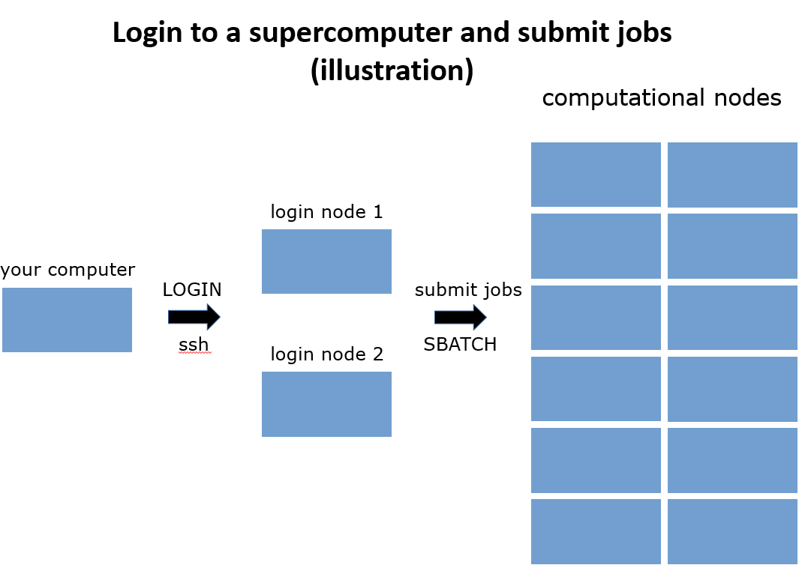

Note: Please do not execute your computations (especially large ones) on login nodes! These login nodes are used by all cartesius users (so don’t make them mad).

- Please type the following commands (that are available for Snellius only).

# to check your account information, remaining budget (SBUs), etc
$ accinfo
# to check the SBUs that were used (not always up to date)
$ accuse
$ accuse -d
# to check the status of SBUs (better, including running jobs)
$ budget-overview

- We will use the file “sbatch_example.sh” that is located on “/home/edwin/jobs/example/”. Please copy it to your directory and open it using geany. Edwin will explain the content.

# copy the file to your own directory currently running)
$ pwd
/home/edwinmod/tmp
$ cp /home/edwin/jobs/example/sbatch_example.sh .
# open it using geany
$ geany sbatch_example.sh

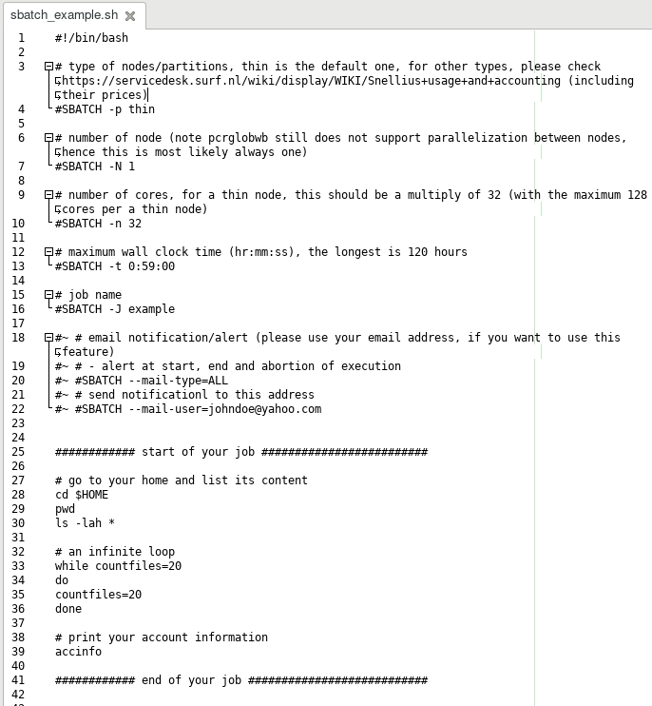

- Please submit the “sbatch_example.sh” job using the following sbatch command.

$ sbatch sbatch_example.sh
sbatch: Single node jobs run on a shared node by default. Add --exclusive if you want to use a node exclusively.
sbatch: You will be charged for 0.25 node. A full node consists of 128 CPU cores, 229376 MiB of memory and 0 GPUs and can be shared by up to 4 jobs.
Submitted batch job 1859254

- You can check its status, by using the following “squeue” command.

# squeue
JOBID PARTITION NAME USER ST TIME NODES NODELIST(REASON)
1859254 thin example edwinmod PD 0:00 1 (Priority)
# at this moment the job was still queueing

# after a while, please check it again
$ squeue
JOBID PARTITION NAME USER ST TIME NODES NODELIST(REASON)
1849203 staging touch-ed edwinmod PD 0:00 1 (BeginTime)
1859254 thin example edwinmod R 0:26 1 tcn81
# now it was already running; this job, which contains an infinite loop, would run until its wall clock time finished (59 mins)

- Please check the slurm output of the job (for example using geany).

# geany slurm-<your_job_id>.out
$ geany slurm-1859254.out

- If your job is still running, you may want to cancel it using the following command

# to cancel a job: scancel <your_job_id>
$ scancel 1859254

- Exercise: Please replace the infinite loop part of the above “sbatch_example.sh” with some command lines to execute a PCR-GLOBWB run (you may want to check your previous exercises).
Some clues:
- Do not forget to load all software packages/modules required for running PCR-GLOBWB. You can use the bash file “/home/edwin/load_all_default.sh”
- You can use the PCR-GLOBWB input files that are stored on the directory “/projects/0/dfguu/data/hydroworld/pcrglobwb2_input_release/version_2019_11_beta_extended/pcrglobwb2_input”
- For the output folder, you can use “/scratch-shared/<your_user_name>” (example: /scratch-shared/edwin)

