Express Rento
Initial Wireframes

Last updated on March 21 2019

Table of Contents

1) Submitting Product Listing by Lender 3
2) Login for Lenders and Sellers 4
3) Marketing Website – Homepage / Listing View 5
4) Single Product View 6
5) Payment Screen 7
6) Uploading Listing from mobile 8
7) Marketing Page 2 9
8) Product Renting View 10
9) Renting Multiple Products View 11
10) Products Search and Category View 12
11) Final Checkout and Deposit Payment 13
12) Registration Screen 14

Submitting Product Listing by Lender
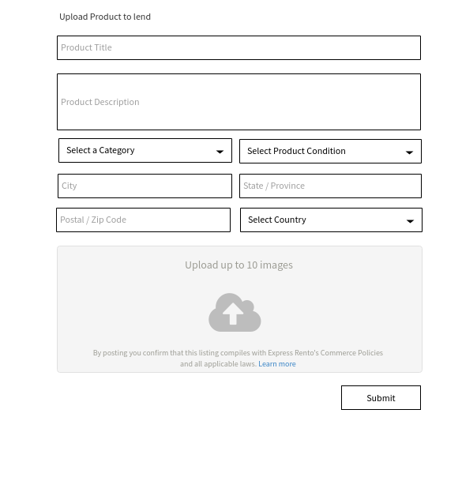

Login for Lenders and Sellers

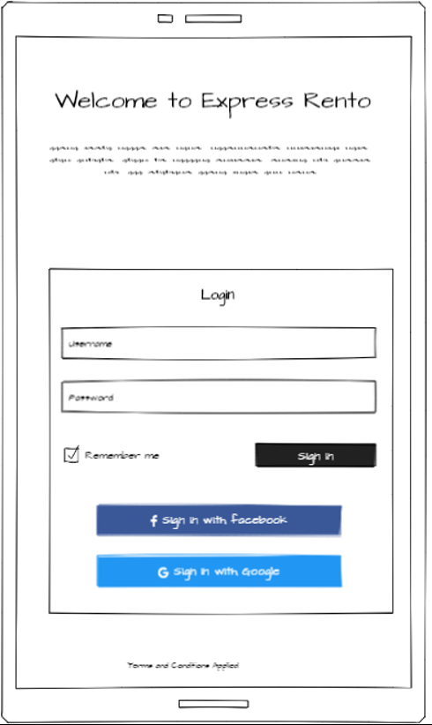

Marketing Website – Homepage / Listing View

Single Product View

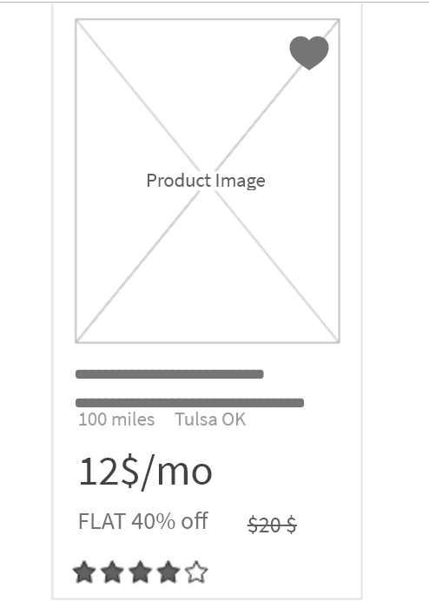

Payment Screen

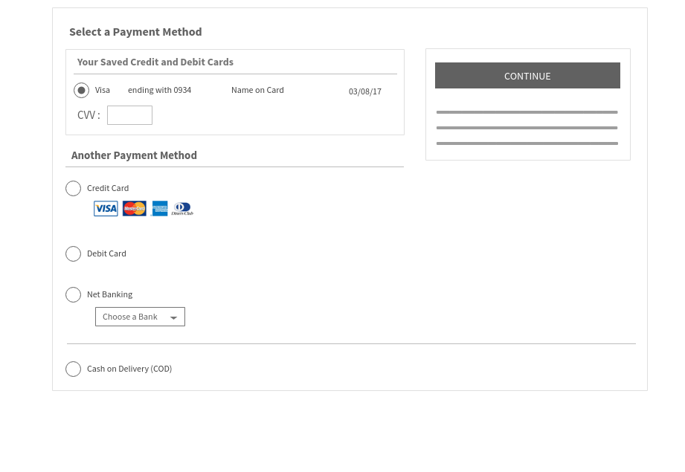

Uploading Listing from mobile

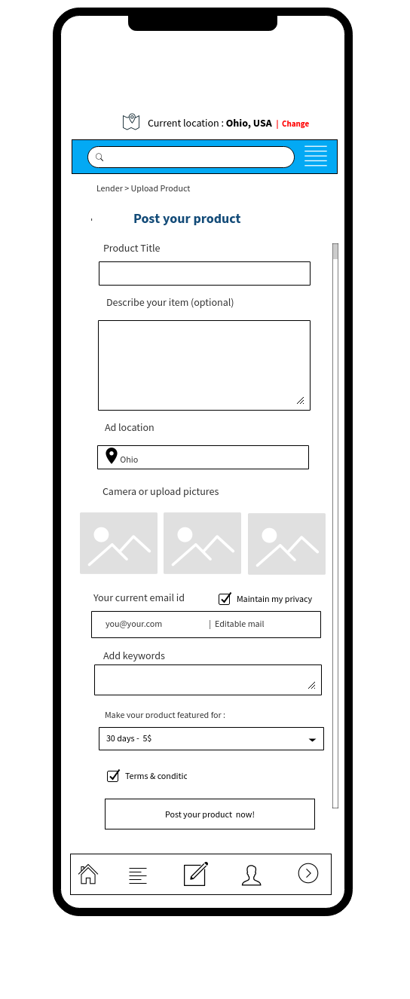

Marketing Page 2

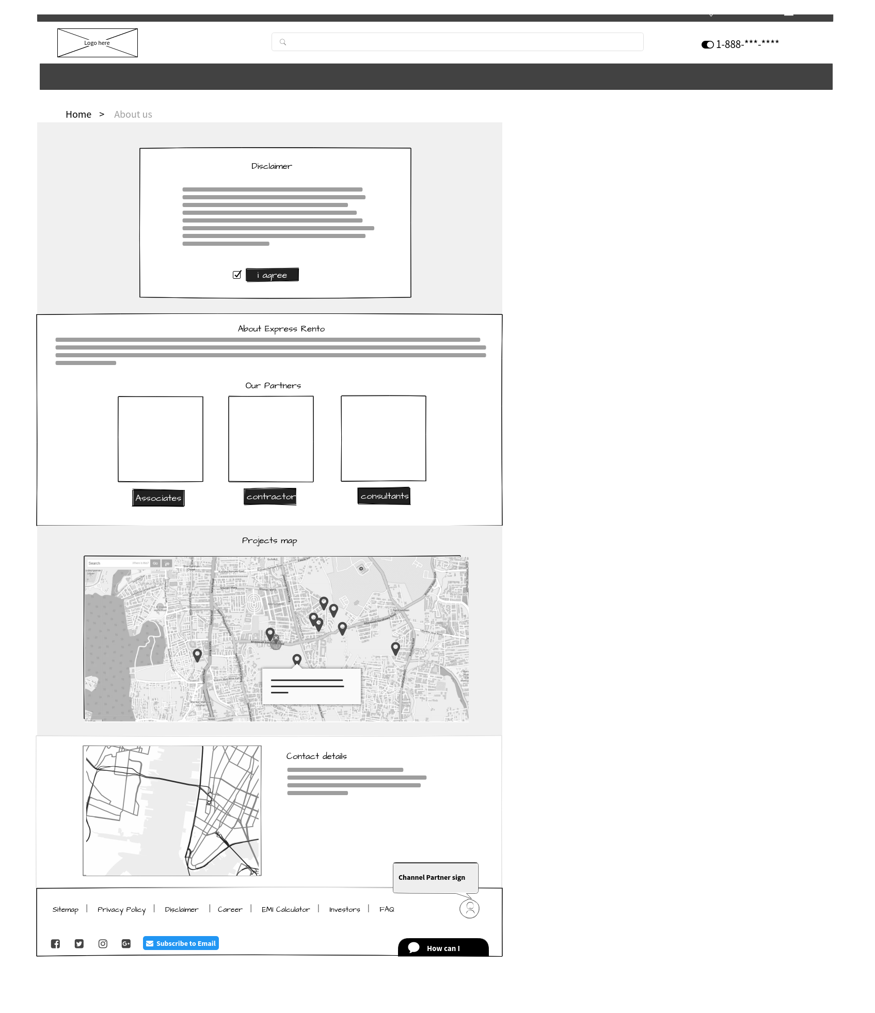

Product Renting View

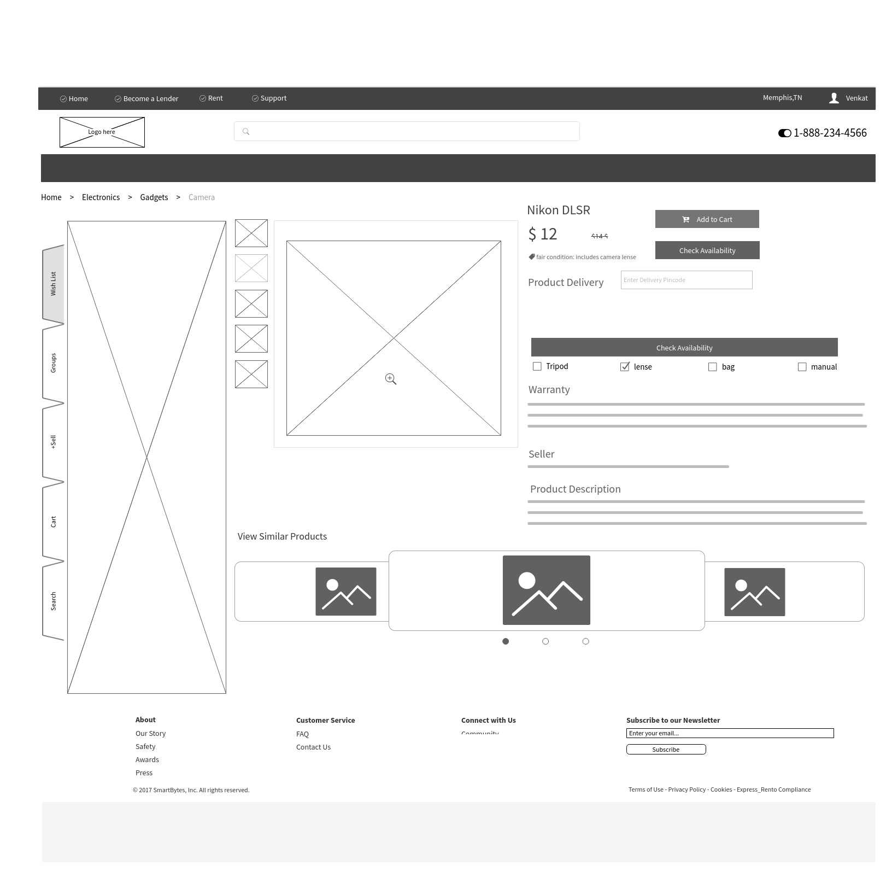

Renting Multiple Products View

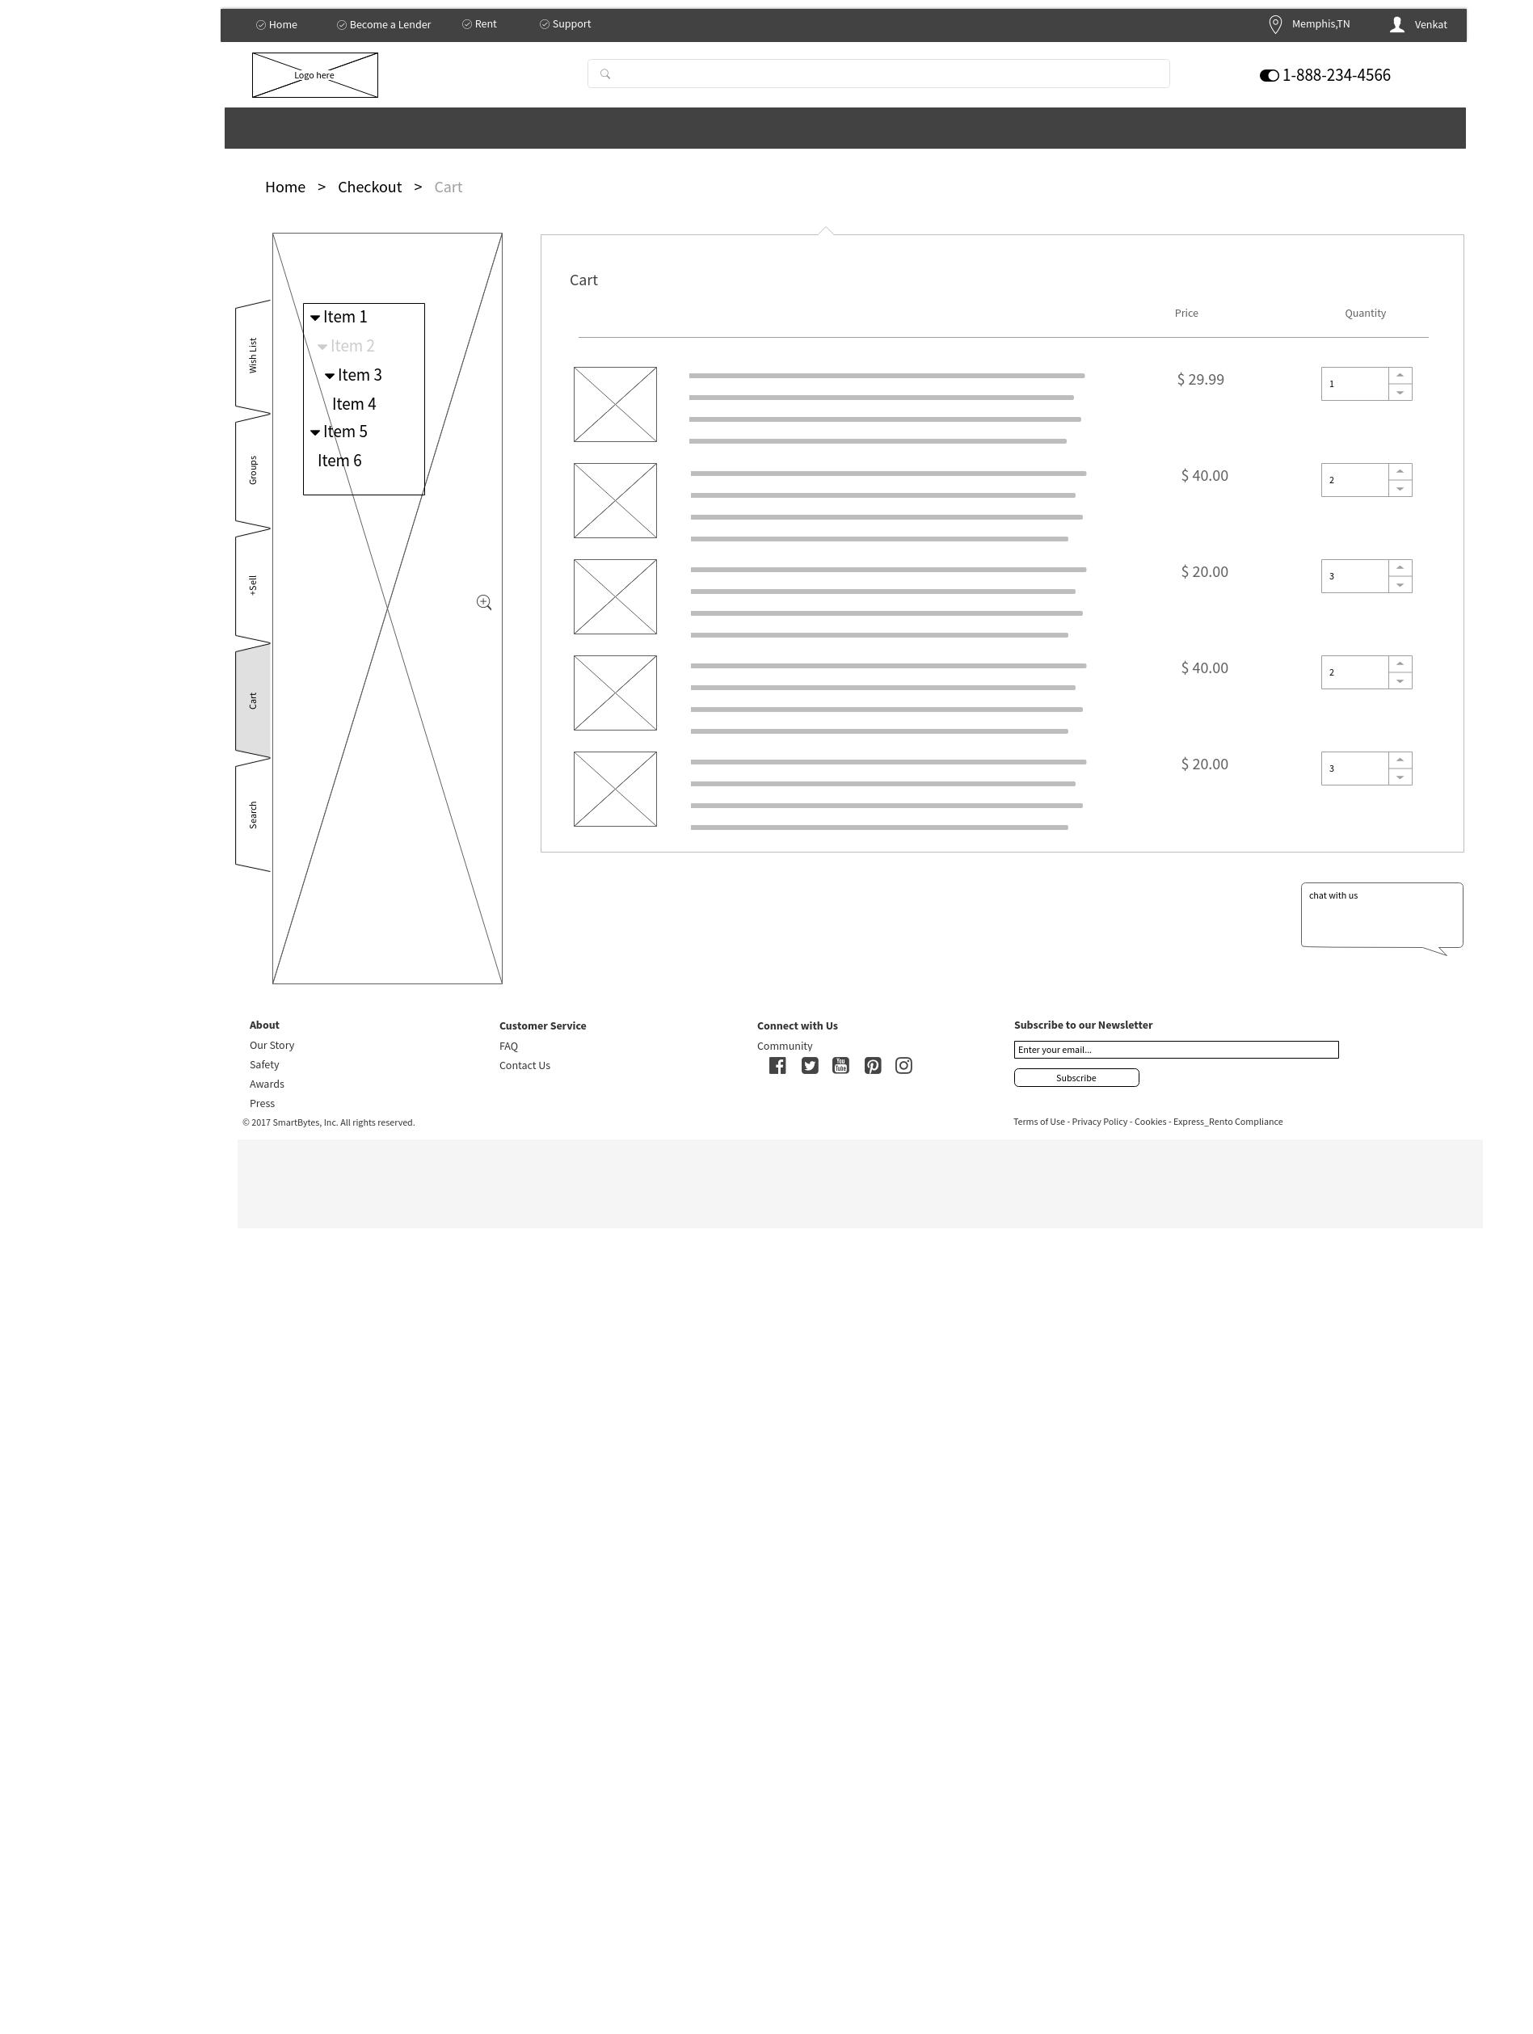

Products Search and Category View

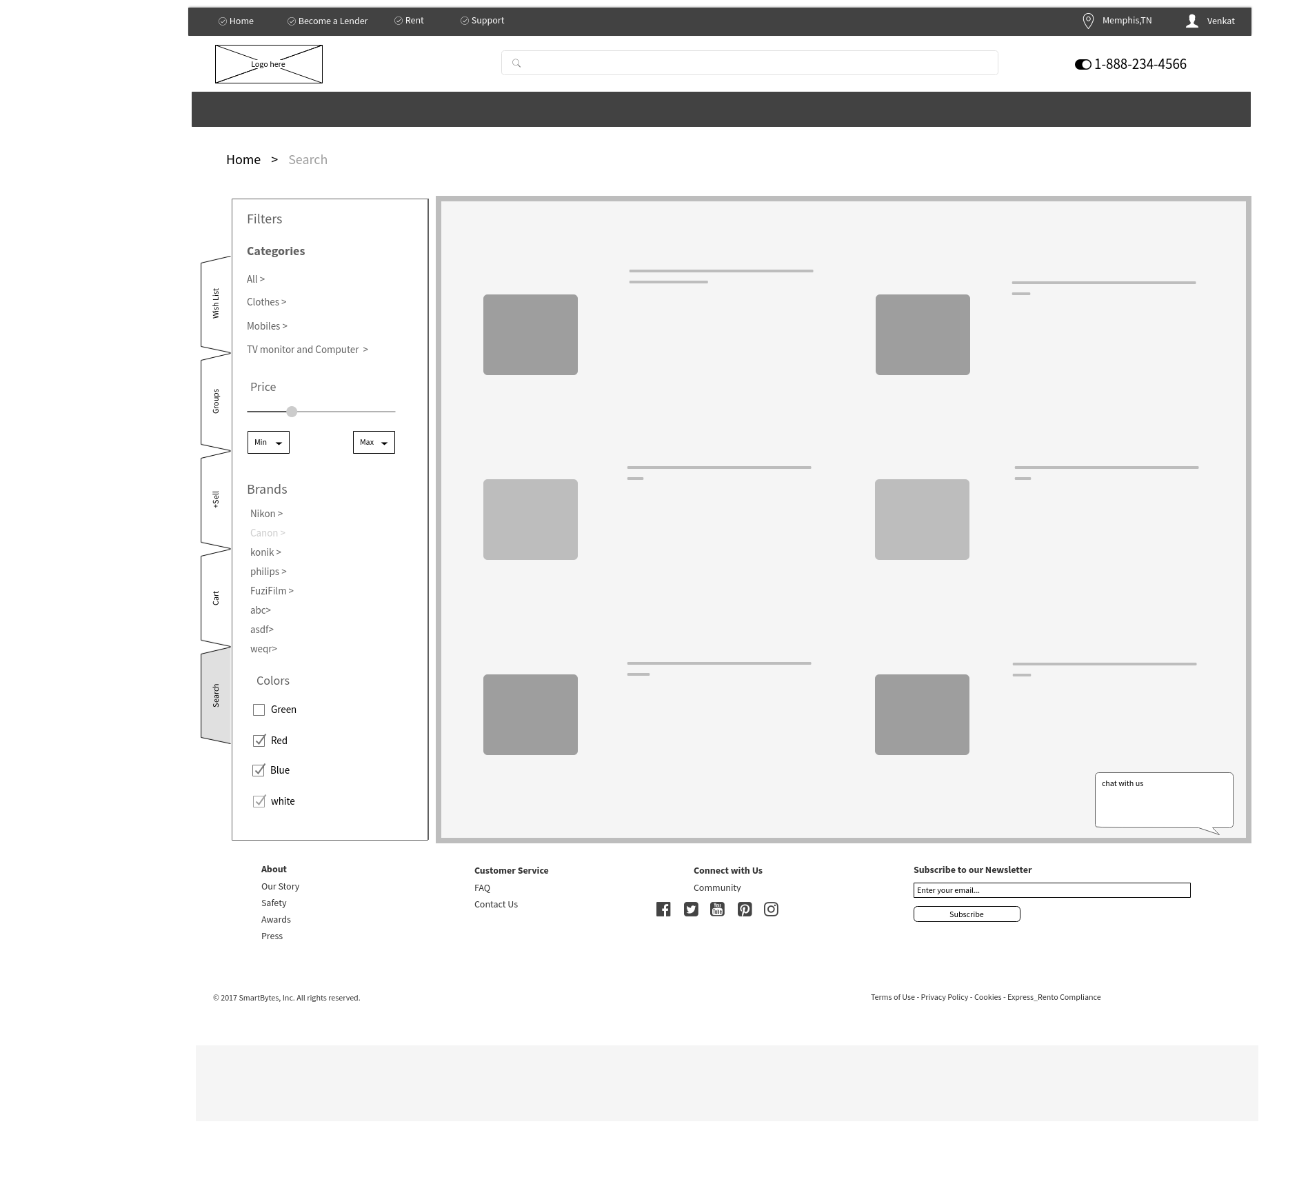

Final Checkout and Deposit Payment

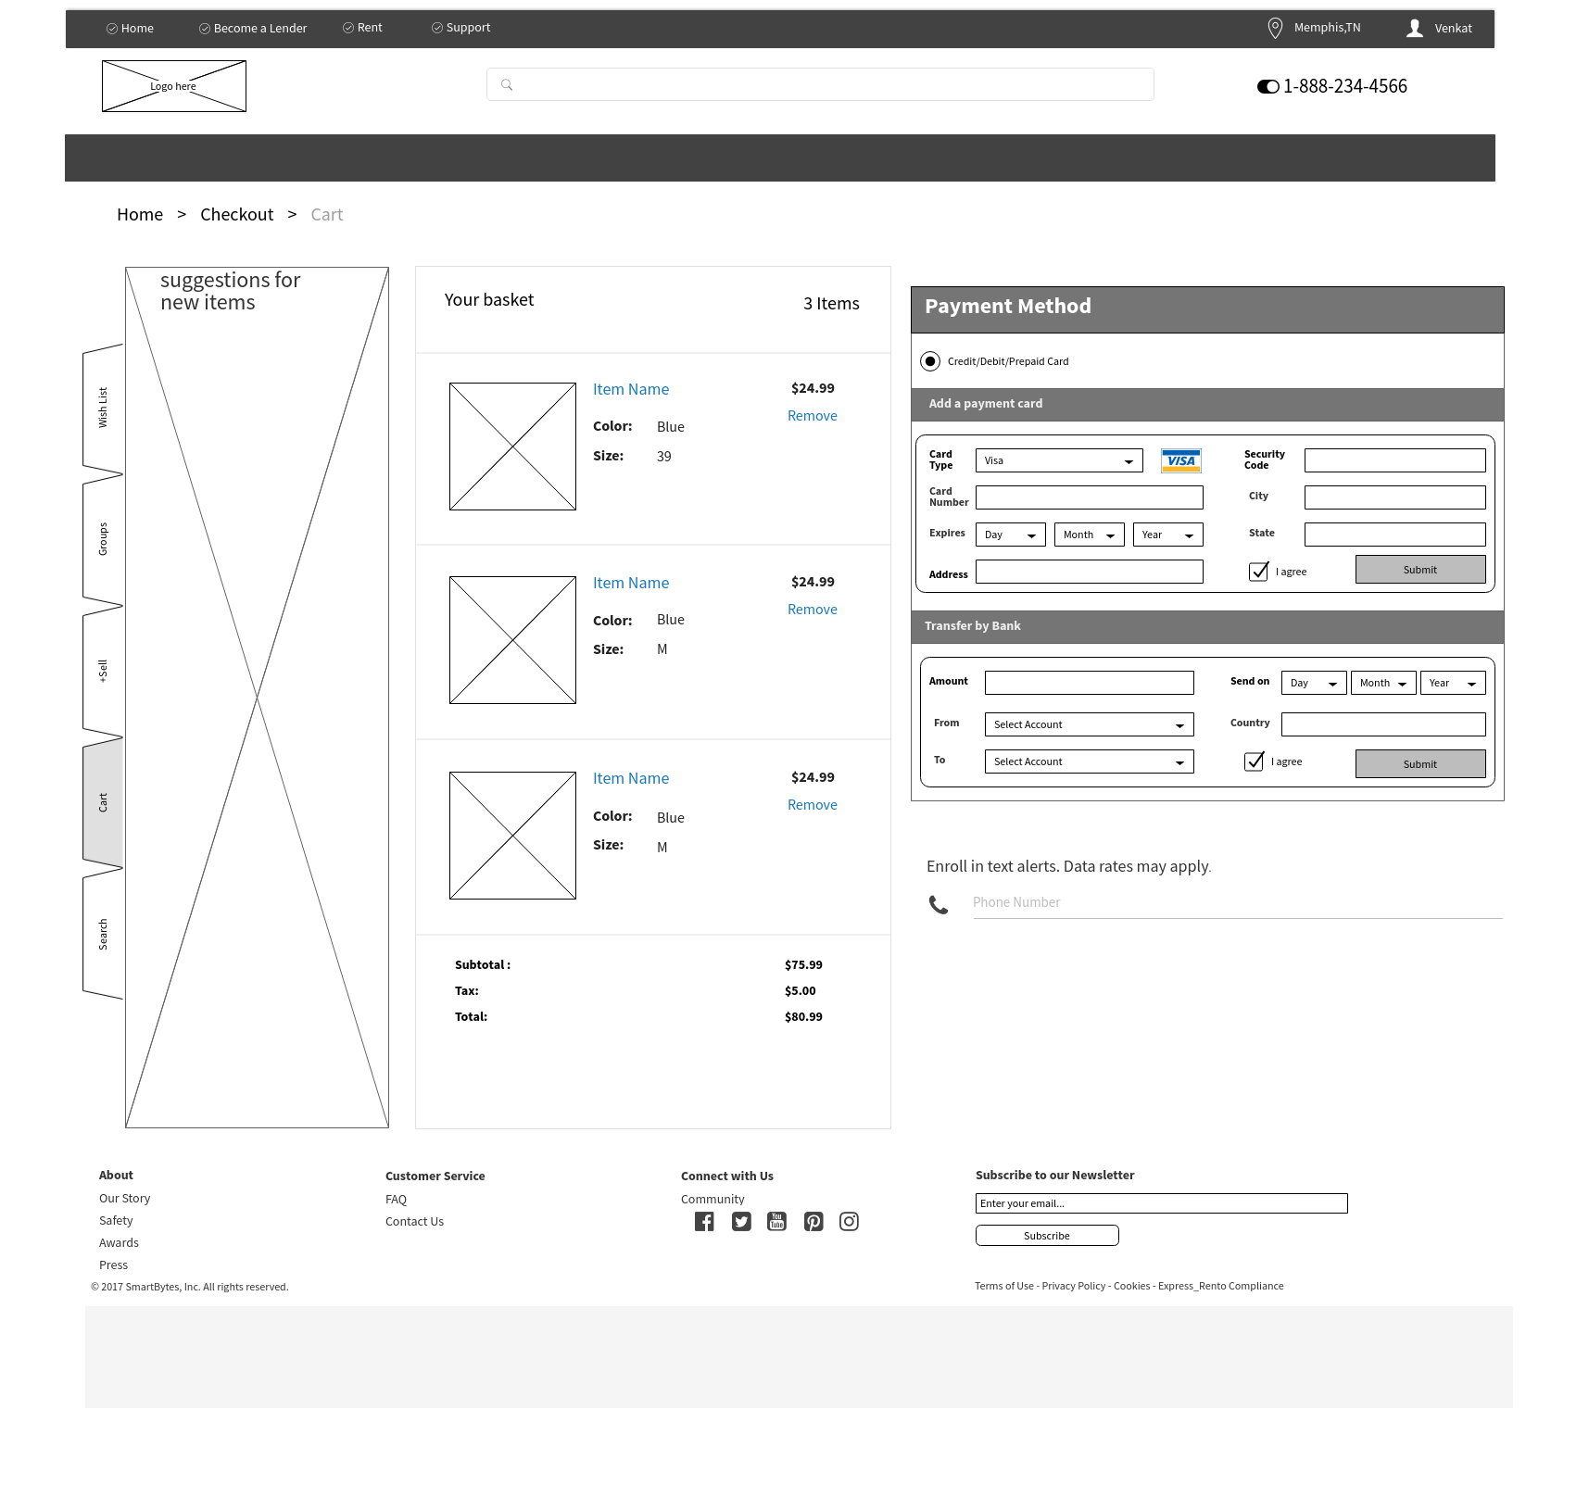

Registration Screen

