Design Document V1.0

Votary Softech Solutions Pvt. Ltd.
Plot No: 76, Lumbini layout,
Near Euro school,
Gachibowli-I (V), Hyderabad,
Telangana - 500032,
India.

Revision History
Version | Date of Revision | Description of Change | Reason for Change | Affected Sections | Approved By
0.1

Approval History
Version | Prepared By | Reviewed Date | Approved By/Date

Table Of Contents
Acronyms
1. Overview
1.1 Block Diagram
1.2 Description
1.3 Platforms and Tools
2. Design Approach
2.1 Gateway
2.2 Storage management
2.3 User Application
3. Delivarables
4. BLE /BT stack flow diagrams
5. Sequence diagram
6. Gate way API’s
7. Table Format
8. Refernces

ACRNOYMS

The terms in use in the document are explained below
Acronym | Description
BLE | Bluetooth Low Energy
BT | Bluetooth Classic
HCL | Host Controller Interface
SC | Smart Campus
SQL | Structured Query Language

GATEWAY
APLLICATION

1.Overview:
The aim of this project is to create IoT technology platform, to track and scan the BT/BLE tags, collect the information and store it on database. Access the database through application as per the requirement.

1.1 Block Diagram:

BLE 1
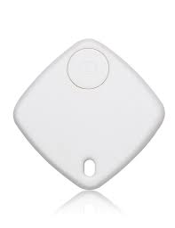
Phase 1:

BT 1

CSR8510A10
BT 4.0

BT 2

BLE 2

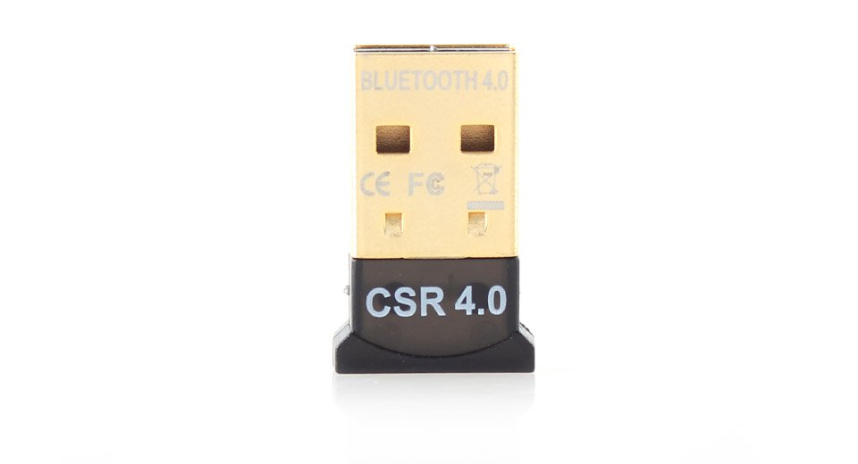

MULTIPLE MOBILE BT CLASSIC (OR) BLE

MULTIPLE BEACONSTAC
BLE M1-AA


DATABASE APPLICATION

HCI PROTOCOL
LINUX (Ubuntu)

MYSQL

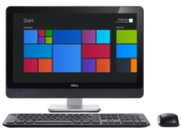
DATABASE

1.2 Description :

CSR8510A10 :
The CSR8510 chipset is a Bluetooth v4.0 single-chip radio and baseband IC for PCs and consumer electronics devices.

BLUETOOTH CLASSIC:
Bluetooth is a wireless technology standard for exchanging data over short distances (using short-wavelength UHF radio waves in the ISM band from 2.4 to 2.485 GHz) from fixed and mobile devices, and building personal area networks (PANs). Present mobiles acts as both BT and BLE.The key new feature of Bluetooth 4.0 is its low-energy technology. This lets device manufacturers replace proprietary sensor technology with Bluetooth, which is a more widely adopted standard.

BEACONSTAC:
Beacons are low-cost, low-powered transmitters equipped with Bluetooth Low Energy or BLE (also called Bluetooth 4.0 or Bluetooth Smart) that can be used to deliver proximity-based, context-aware messages. A beacon transmits signals which allows another device to determine its proximity to the broadcaster. In a retail store, a beacon lets a customer’s app determine that it’s close to a particular aisle in a particular department. Beacons don’t transmit content, they simply transmit signals that let a user’s phone or tablet figure out its proximity to the beacon.

HCI PROTOCOL:
The pseudo-protocol referring to any standardized communication between the host stack (e.g., a PC or mobile phone OS) and the controller (the Bluetooth IC). An HCI decouples the host from the controller, allowing either to be swapped without affecting the other. Bluetooth defines several HCI standards, each for a different hardware interface to transfer the same commands, events, and data packets.

PHASE 2 :

RASBERRY PI

BT 1 BLE1

BT 2 BLE2
CSR8510A10
BT 4.0

MULTIPLE BEACONSTAC
BLE M1-AA

MULTIPLE MOBILE BT CLASSIC (OR) BLE
GATEWAY
APLLICATION
.... .....

LINUX (Ubuntu)

HCI PROTOCOL

MYSQL
DATABASE

DATABASE APPLICATION

BLUEZ:
A Bluetooth stack is software that refers to an implementation of the Bluetooth protocol stack. Bluetooth stacks can be roughly divided into two distinct categories:
- General-purpose implementations that are written with emphasis on feature-richness and flexibility, usually for desktop computers. Support for additional Bluetooth profiles can typically be added through drivers.
- Embedded system implementations intended for use in devices where resources are limited and demands are lower, such as Bluetooth peripheral devices.

RASBERRY PI :
The Raspberry Pi 3 Model B is out now. This latest model includes 802.11n WiFi, Bluetooth 4.0, and a quad-core 64-bit ARM Cortex A53 running at 1.2 GHz. It’s a usable desktop computer.The Raspberry Pi 3 Model B features a quad-core 64-bit ARM Cortex A53 clocked at 1.2 GHz. This puts the Pi 3 roughly 50% faster than the Pi 2.the Pi 3 now includes on-board 802.11n WiFi and Bluetooth 4.0. WiFi, wireless keyboards, and wireless mice now work out of the box.

Database(Mysql):
MySQL is an open source relational database management system (RDBMS) based on Structured Query Language (SQL).MySQL runs on virtually all platforms, including Linux, Unix and Windows. Using this language we have created a SC database, tables with BT and BLE information which can be used by any client device.

1.3 Platform and Tools:

Platform | Linux (Ubuntu)
Tools | Debugging : QT,Ctags  Version Control : GIT

2. Design Approach/ System Overview:

The different modules used in this system are Gateway, Database and User Application.

2.1 Gateway (DM):

Gateway Module – Provides the capability to scan continuously for nearby BLE/BT devices and publishes data to storage module.

2.2 Database:
Storage Module – Stores the received BLE/BT data in a specific format and provides access to application to query the required data.

2.3 Application:
Application Module – It provides as interface where end user can query required data i.e locate, in/out time.

3. Deliverables:

Digital Campus Gateway (raspberry pi)

SQL Database

User Application (Desktop/Mobile)

4. BLE/BT Stack:
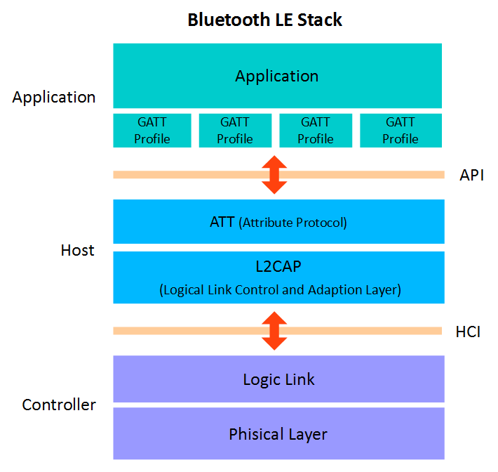

Bluetooth stack
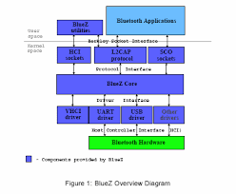

5. Sequence Diagram:
Sensor to Gateway
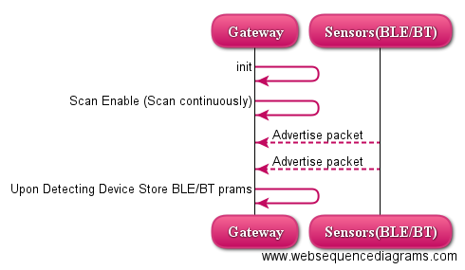

-> Gateway should capture BLE/BT params i.e macID, DeviceType, Rssi, TimeStamp

Gateway to DB to User Application
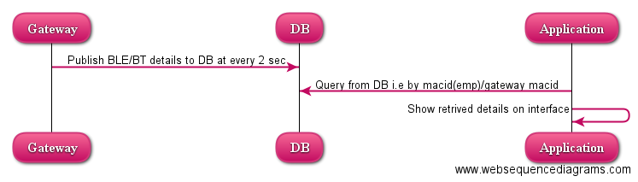

-> Gateway should publish BLE/BT params to DB i.e BLE/BT macID, DeviceType, Rssi, TimeStamp,GatewaymacID

6. Gate way -API’s :
--> void Initialise(int *dev_id,int *sock)
Initialise API will create device id and socket number for the bluetooth device.
int hci_get_route(bdaddr_t * addr)------it searches for local bluetooth adapter,and returns the device id of the given bdaddr_t, you can pass NULL so it returns the first available device.
If you know the device's address you want to use you can pass it to this function.
int hci_open_dev(int adapter_id)-----using this you can open resources to use the device you choose.
-->inquiry_info * bt_scan(int adapter_id,int len,int *num_rsp)
This ApI will scan the bluetooth classic devices and returns the number of scanned devices and its information.
int hci_inquiry(int adapter_id, int len, int max_rsp, const uint8_t * lap , inquiry_info ** devs , long flags)--------sends an inquiry signal to receive information about the devices to respond.
- adapter_id = the adapter you choose before
- len = inquiry time, the standard is about 8 * 1.24 (so len = 8)
- max_rsp = maximum devices response (usually 255)
- flags = usually IREQ CACHE FLUSH, if you pass 0 then previous inquiry info may be returned
- lap = determine the type of inquiry, if you don't care give it NULL.
- devs=is structure which stores the scanned device info

-->Process_BT_data(int num_rsp,inquiry_info *scanned_info_ptr,int sock,char* mac_id)
This API is used to process the bluetooth scanned devices information (name,devaddr).
ba2str---------convert bdaddr to a string
int hci_read_remote_name(int sock, const bdaddr_t *bdaddr, int len, char *name, int time_out)-----gives devices friendly name

-->int read_rssi(int sock)
This API is used to read the signal strength of the scanned bluetooth classic devices.

-->BT_abort
bt_abort------abort the scanning.

-->void push_to_database(char * dev_type, char* addr, int rssi, char* mac_id)
This API is used to connect to the specific database and make queries to insert or extract information from that database.
mysql_init-----allocates or initialises a MYSQL object suitable for mysql_real_connect() function.
mysql_real_connect-----establishes a connection to the database
mysql_query------mysql_query() function call to both create a table and insert data into it.

-->void ble(int sock, char* mac_id)
This API is used to scan and process all the ble devices information.
-->void find_mac_id(char* mac_id)
This function is used to get the gateway mac id.

8.Table Format:

BLE/BT Details:
BLE/BT macID | DeviceType | Rssi | TimeStamp | GatewayID

Employee Name Dump Data Table:
Employee Name | BLE/BT macID

Gateway Name Dump Data Table:
Gateway Name | Gateway macID

