Business Sales Performance Analytics

Project Overview
This project analyzes business sales performance using a public-style sales dataset. The analysis focuses on revenue trends, category performance, top-selling products, and regional insights.

Key Findings
Highest Revenue Region: West
Highest Revenue Category: Electronics
Top-Selling Product: Notebook

Regional Performance Chart
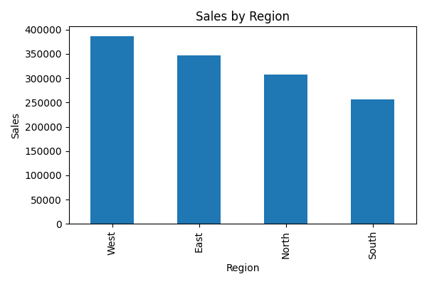

Category Performance Chart
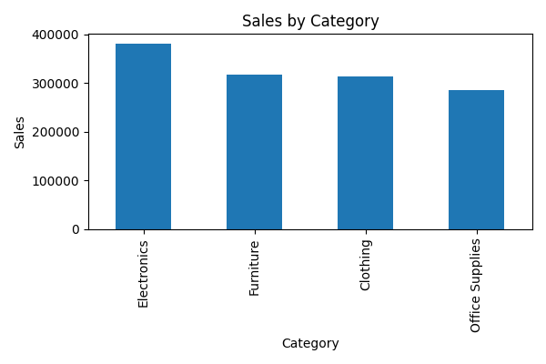

Recommendations
1. Expand sales strategies in high-performing regions.
2. Promote best-selling products with targeted campaigns.
3. Improve low-performing categories using discounts and bundles.

