**Ivan Markov, 18107990**

**Recap of learned in classes (week 3-5):**

(3rd week we also learned about non-anonymous, anonymous functions and the difference in declaring, using each. How events could be used to add interactivity to node, elements from user input. Loops and timers were also mentioned.)

4th week was all about animations and working with foreign libraries. We installed the foreign library from Greensock to use it for animation in Javascript via externam script in the code and locally.

We also learned what .to and .from stand for, the difference between the two in regards to the postion.

Using the library, we learned the varioations of what you can do with the library like chaining, offsetting and repeating and that we can also repeat the code itself.

Of course, finally we learned making the interactive buttons via using the “this” build-in function.

5th week was all about making a clock and using the build-in Date type. We learned ways to showcase and create the dates, via using date methods as well. Using build-in functionalities like hours, minutes, second, day, month, year, etc. we learned how the display and also compare these variables as well as how to declare and use them. Of course, because of semantical reasons comparing variables proved to be impossible. We can also do arithmetics with these variables if we decide that having only a standard display for these functions isn’t the way we want to use time. Using the

**Explanation of assignment 2 (“Clock – interface for Elon Musk”):**

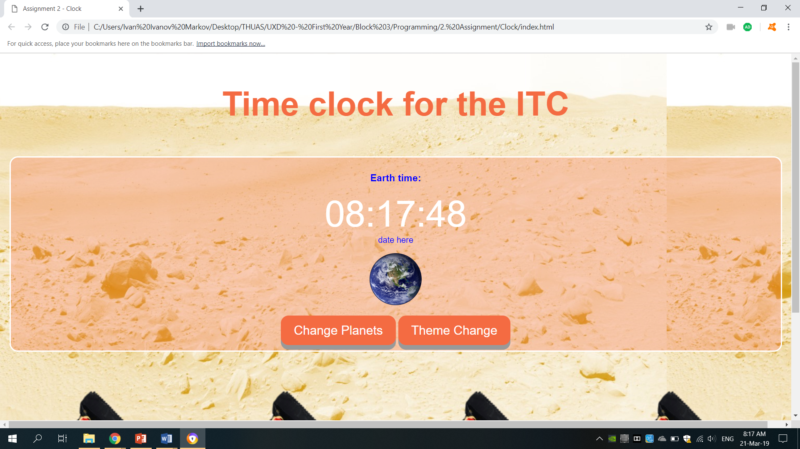

The interface for this clock is very simple. The main clock and labels are put in a red colored form. The time is displayed in UTC real-time at the moment.

The looks are more simplistic with red and white colors, in the style of Mars itself.

There are only 2 functional buttons:

Change Planets is a button when pressed upon will change the planets from Earth to Mars in the form of text. Changing the picture is also a desired effect for the online version. Used the button in Javascript to change the text and possible the image of the Planet

Theme Change is a button for changing the overall theme of the text and form – it varies between red, blue and yellow in order to make up for changing the theme when the martians are bored. Using a button and manipulating the DOM with the color of the body and header to change

The background image also changes depending on the the time of the day   
Before 12pm is morning

Before 5pm is day

And after that is the night background.

This was done via a simple if statement and a counter to check which hour of the day is.

There is also option for the Date to be put below the clock with the time frame.

There was also opportunity to use the TweenMax for the effect for the clock upon entering the frame.

Below there is a built-in animation effect where Mars bars are shown hovering through the bottom part of the screen which makes up for the full “Mars” experience. This was done using the animation software and library.

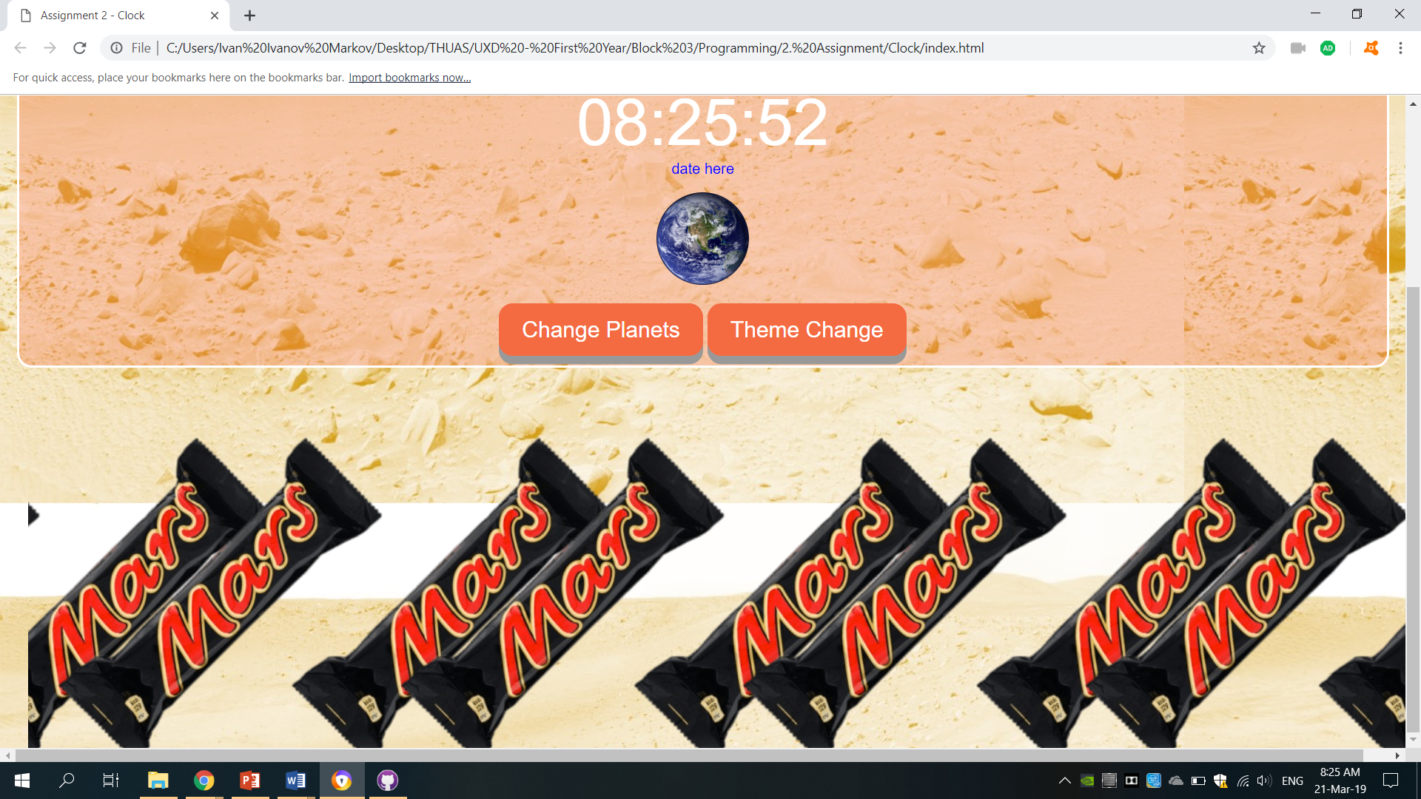

Lots of symbol were used as well as a title screen via internal linking, semantic html and css flex bar navigation.

Link to website: <https://vankata99.github.io/>