PYTHON ACTIVITY-BASED LEARNING (ABL)
Last 10 Case Studies: 91–100
Prepared according to the circular requirements

How to use this assignment
This document covers case studies 91 to 100 from the supplied case-study list. Each case study contains the problem statement, objectives, assumptions, algorithm, text flowchart, pseudocode, Python source code, test cases, sample output, and conclusion. The output panels are sample terminal outputs; run the code in Python/VS Code and capture your own screenshots for submission.
Important: Case-study rules and sample data are illustrative where the circular does not specify exact values. If your faculty gives different thresholds or formats, replace the assumptions and update the code accordingly.

Case Study 91: Advanced String-Based Registration Record Analyzer

1. Problem Statement
A college stores registration details as strings in the format YEAR-BRANCH-ROLLNO-NAME. Write a Python program to validate each record, extract its fields, identify duplicate registration IDs, and report invalid records.

2. Objectives
- Use string methods such as split(), strip(), isdigit(), and upper().
- Validate field count and basic field formats.
- Detect duplicate registration IDs using a list.

3. Assumptions
- Format is YEAR-BRANCH-ROLLNO-NAME, for example 2026-CSE-104-ANU.
- Year must contain four digits; branch must be CSE, ECE, or AIML; roll number must be numeric; name must not be empty.
- The sample rules are academic assumptions and can be changed if the faculty provides a different format.

4. Algorithm
1. Start.
2. Create a list of registration strings and an empty list of seen IDs.
3. For each record, remove extra spaces and split it using '-'.
4. Check that there are four fields and validate each field.
5. If valid, report extracted details and check for duplicate IDs; otherwise report INVALID.
6. Stop.

5. Flowchart
START → Read records → Split each record → Validate fields? → No: Report invalid → Yes: Check duplicate ID → Display result → Next record → STOP

6. Pseudocode
START
records ← sample registration strings
seen ← empty list
FOR each record IN records
fields ← split stripped record using '-'
IF field count and formats are valid THEN
IF registration ID is in seen, report duplicate
ELSE add ID to seen and report valid details
ELSE report invalid record
END FOR
STOP

7. Python Source Code
records = [
"2026-CSE-104-Anu",
"2026-ECE-205-Ravi",
"2026-CSE-104-Anu",
"26-ABC-X7-",
"2026-AIML-309-Sita"
]

seen_ids = []

for record in records:
fields = record.strip().split("-")

if len(fields) != 4:
print(record, "-> INVALID: expected 4 fields")
continue

year, branch, roll, name = fields
branch = branch.upper()

valid = (
len(year) == 4 and year.isdigit()
and branch in ["CSE", "ECE", "AIML"]
and roll.isdigit()
and name.strip() != ""
)

if not valid:
print(record, "-> INVALID: field format")
elif roll in seen_ids:
print(record, "-> DUPLICATE roll number:", roll)
else:
seen_ids.append(roll)
print("VALID:", year, branch, roll, name)

8. Test Cases
Input / Test | Expected result
2026-CSE-104-Anu | Valid record
2026-CSE-104-Anu (second time) | Duplicate roll number
26-ABC-X7- | Invalid field format

9. Sample Output (Screenshot-style)
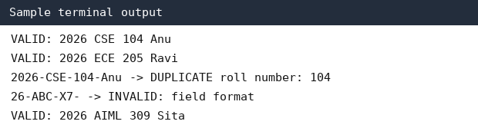
Note: This is a sample output illustration. Run the code and capture the actual output from your Python environment.

10. Conclusion
The program validates structured registration strings, extracts their parts, and flags duplicate roll numbers using basic string and list operations.

Case Study 92: Multi-Event Sports Scheduling and Scoring

1. Problem Statement
Store event schedules and team scores using lists and tuples. Detect events scheduled at the same time, calculate team points, and display a ranking.

2. Objectives
- Represent event details with tuples.
- Find timetable clashes using loops.
- Calculate points and rank teams.

3. Assumptions
- Each event is stored as (event_name, time, team).
- A time clash occurs when two events have the same time.
- Win = 3 points, draw = 1 point, loss = 0 points; sample results are supplied in the code.

4. Algorithm
1. Start.
2. Store event tuples and check every pair for matching times.
3. Store team results and calculate points.
4. Sort team totals in descending order.
5. Display clashes and rankings.
6. Stop.

5. Flowchart
START → Read event tuples → Compare event times → Report clashes → Calculate team points → Sort ranking → Display → STOP

6. Pseudocode
START
FOR each pair of events
IF their times match, report clash
FOR each team result
Add points based on result
Sort teams by points, highest first
Display clashes and rankings
STOP

7. Python Source Code
events = [
("Cricket", "10:00", "Team A"),
("Chess", "11:00", "Team B"),
("Quiz", "10:00", "Team C")
]

print("Schedule clashes:")
for i in range(len(events)):
for j in range(i + 1, len(events)):
if events[i][1] == events[j][1]:
print(events[i][0], "and", events[j][0], "at", events[i][1])

results = [
("Team A", "win"),
("Team B", "draw"),
("Team C", "win"),
("Team B", "win")
]

points = {}
for team, result in results:
if team not in points:
points[team] = 0
if result == "win":
points[team] += 3
elif result == "draw":
points[team] += 1

ranking = sorted(points.items(), key=lambda item: item[1], reverse=True)
print("\nTeam ranking:")
for rank, (team, score) in enumerate(ranking, start=1):
print(rank, team, "-", score, "points")

8. Test Cases
Input / Test | Expected result
Cricket and Quiz at 10:00 | Clash detected
Team A has two? | Team A receives 3 points from one win
Team B draw + win | Team B receives 4 points

9. Sample Output (Screenshot-style)
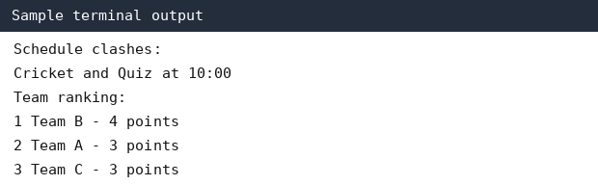
Note: This is a sample output illustration. Run the code and capture the actual output from your Python environment.

10. Conclusion
The program detects schedule clashes and produces a points-based team ranking using tuples, loops, dictionaries, and sorting.

Case Study 93: Smart Public Transport Fare Reconciliation

1. Problem Statement
Calculate expected fares for passengers using route and passenger-category rates, compare them with collected revenue, and identify any difference.

2. Objectives
- Use conditions to select fare rates.
- Calculate total expected revenue using loops.
- Compare expected and collected amounts.

3. Assumptions
- Routes have fixed base fares given in the program.
- Student passengers receive a 50% concession; regular passengers pay full fare.
- Collected revenue is a sample value entered in the program.

4. Algorithm
1. Start.
2. Store route fares and passenger records.
3. For each passenger, find the route fare and apply category concession.
4. Add each fare to expected revenue.
5. Compare expected revenue with collected revenue.
6. Display totals and difference.
7. Stop.

5. Flowchart
START → Load route fares and passengers → Calculate each fare → Add expected total → Compare collected amount → Report difference → STOP

6. Pseudocode
START
expected ← 0
FOR each passenger
fare ← route fare
IF category is student, fare ← fare × 0.5
expected ← expected + fare
difference ← collected − expected
Display expected, collected, difference
STOP

7. Python Source Code
route_fares = {"A": 30, "B": 50, "C": 40}
passengers = [
("A", "regular"),
("B", "student"),
("C", "regular"),
("A", "student")
]
collected = 82.5
expected = 0

for route, category in passengers:
fare = route_fares[route]
if category == "student":
fare = fare * 0.5
expected += fare
print(route, category, "fare =", fare)

difference = collected - expected
print("Expected revenue:", expected)
print("Collected revenue:", collected)
print("Difference:", difference)
if difference == 0:
print("Revenue matched")
else:
print("Revenue discrepancy found")

8. Test Cases
Input / Test | Expected result
Route A, regular | Fare = 30
Route B, student | Fare = 25
Expected total | 110
Collected = 82.5 | Difference = 7.5

9. Sample Output (Screenshot-style)
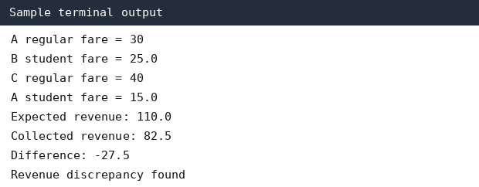
Note: This is a sample output illustration. Run the code and capture the actual output from your Python environment.

10. Conclusion
The program calculates fares using route and passenger type, then compares expected revenue with collected revenue to identify discrepancies.

Case Study 94: Disaster Relief Supply Allocation

1. Problem Statement
Compare the stock available with the requirements of different relief areas. Allocate limited supplies in priority order and report any unmet demand.

2. Objectives
- Use lists to store area-wise demand.
- Allocate stock using loops and conditions.
- Calculate remaining stock and unmet demand.

3. Assumptions
- Areas are processed in the priority order shown in the list.
- Available stock is shared for one type of supply.
- The program allocates as much as possible to each area before moving to the next.

4. Algorithm
1. Start.
2. Set available stock and area-wise demands.
3. For each area, allocate the smaller of available stock and demand.
4. Update remaining stock and unmet demand.
5. Display allocation summary.
6. Stop.

5. Flowchart
START → Set stock and demand → Process highest-priority area → Allocate available amount → Update stock and shortage → Next area → Display summary → STOP

6. Pseudocode
START
stock ← available quantity
FOR each area and demand in priority order
allocation ← minimum(stock, demand)
shortage ← demand − allocation
stock ← stock − allocation
Display area, allocation, shortage
Display remaining stock
STOP

7. Python Source Code
available_stock = 120
requirements = [
("Area North", 70),
("Area East", 50),
("Area South", 40)
]

for area, demand in requirements:
allocation = min(available_stock, demand)
shortage = demand - allocation
available_stock -= allocation
print(area, "| demand:", demand,
"| allocated:", allocation,
"| shortage:", shortage)

print("Remaining stock:", available_stock)

8. Test Cases
Input / Test | Expected result
North demand 70 | Allocate 70; shortage 0
East demand 50 | Allocate 50; shortage 0
South demand 40 | Allocate 0; shortage 40
Initial stock 120 | Remaining stock 0

9. Sample Output (Screenshot-style)
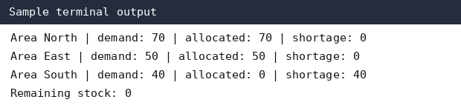
Note: This is a sample output illustration. Run the code and capture the actual output from your Python environment.

10. Conclusion
The program allocates limited supplies according to a priority order and clearly reports shortages for each area.

Case Study 95: Integrated Manufacturing Production Planner

1. Problem Statement
Check whether available raw materials are enough to produce the required quantities. Calculate defective units and identify batches that exceed a defect threshold.

2. Objectives
- Calculate material requirements.
- Use arithmetic and conditions to check feasibility.
- Calculate defect percentages and flag poor-quality batches.

3. Assumptions
- Each finished unit requires 2 kg of raw material.
- Defect threshold is 5%.
- All quantities are non-negative integers and the data is hypothetical.

4. Algorithm
1. Start.
2. Read raw material stock, production demand, and batch data.
3. Calculate required material as demand multiplied by 2.
4. Check if production is feasible.
5. For each batch, calculate defect percentage and compare it with 5%.
6. Display results.
7. Stop.

5. Flowchart
START → Read stock and demand → Calculate material needed → Check feasibility → Calculate batch defect % → Compare with threshold → Display report → STOP

6. Pseudocode
START
required ← demand × material_per_unit
IF stock ≥ required, report feasible ELSE report shortage
FOR each batch
defect_percent ← defects / produced × 100
IF defect_percent > threshold, flag batch
STOP

7. Python Source Code
raw_material = 500
demand_units = 220
material_per_unit = 2
required = demand_units * material_per_unit

print("Material required:", required, "kg")
if raw_material >= required:
print("Production feasible")
else:
print("Material shortage:", required - raw_material, "kg")

batches = [("Batch A", 100, 3), ("Batch B", 80, 8)]
threshold = 5

for name, produced, defective in batches:
defect_percent = defective / produced * 100
print(name, "defect rate:", round(defect_percent, 2), "%")
if defect_percent > threshold:
print("Quality alert:", name)

8. Test Cases
Input / Test | Expected result
Stock 500 kg; demand 220 units | Required 440 kg; feasible
Batch A: 3/100 | 3%; no alert
Batch B: 8/80 | 10%; quality alert

9. Sample Output (Screenshot-style)
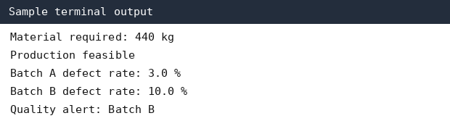
Note: This is a sample output illustration. Run the code and capture the actual output from your Python environment.

10. Conclusion
The program checks raw-material feasibility and monitors manufacturing quality by calculating defect percentages for each batch.

Case Study 96: Multi-Criteria Library Resource Distribution

1. Problem Statement
Distribute available copies of books among library branches based on their demands and a given priority order. Report copies allocated and unmet demand.

2. Objectives
- Store branch requirements using lists and tuples.
- Allocate book copies with a loop.
- Calculate unmet demand and remaining copies.

3. Assumptions
- A single book title is being distributed.
- Branches are listed from highest to lowest priority.
- Copies cannot be allocated beyond available stock or branch demand.

4. Algorithm
1. Start.
2. Set available copies and branch demands.
3. Allocate copies to each branch in priority order.
4. Update remaining stock and shortage.
5. Display the distribution report.
6. Stop.

5. Flowchart
START → Read available copies → Read branch demands → Allocate by priority → Update remaining copies → Report shortages → STOP

6. Pseudocode
START
copies ← available copies
FOR each branch, demand
allocated ← minimum(copies, demand)
shortage ← demand − allocated
copies ← copies − allocated
Display branch report
Display remaining copies
STOP

7. Python Source Code
available_copies = 45
branches = [
("Main Library", 25),
("Engineering Block", 15),
("Hostel Library", 12)
]

for branch, demand in branches:
allocated = min(available_copies, demand)
shortage = demand - allocated
available_copies -= allocated
print(branch, "demand =", demand,
"allocated =", allocated,
"shortage =", shortage)

print("Copies remaining:", available_copies)

8. Test Cases
Input / Test | Expected result
Main Library demand 25 | 25 allocated
Engineering demand 15 | 15 allocated
Hostel demand 12 | 5 allocated, shortage 7
Initial copies 45 | 0 remaining

9. Sample Output (Screenshot-style)
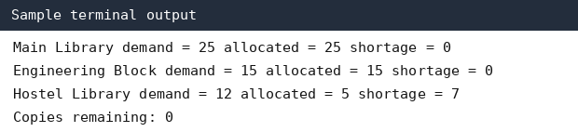
Note: This is a sample output illustration. Run the code and capture the actual output from your Python environment.

10. Conclusion
The program distributes limited library copies according to branch priority and identifies the demand that remains unfulfilled.

Case Study 97: Smart Campus Incident and Maintenance Prioritization

1. Problem Statement
Classify maintenance reports using severity, location, and frequency. Assign priority scores and display incidents from highest to lowest priority.

2. Objectives
- Represent incident details in tuples.
- Calculate a priority score from supplied rules.
- Sort incidents by score.

3. Assumptions
- Severity is rated from 1 to 5.
- Frequency is the number of reports for the same issue.
- Priority score = severity × 2 + frequency; larger scores are handled first.

4. Algorithm
1. Start.
2. Store incident tuples.
3. Calculate each incident priority score.
4. Store incident and score pairs.
5. Sort by score in descending order.
6. Display the prioritized list.
7. Stop.

5. Flowchart
START → Read incident tuples → Calculate priority score → Sort descending → Display priority list → STOP

6. Pseudocode
START
scored ← empty list
FOR each incident
score ← severity × 2 + frequency
Add incident and score to scored
Sort scored by score descending
Display ranked incidents
STOP

7. Python Source Code
incidents = [
("Broken lab power socket", "Lab 2", 5, 3),
("Projector not working", "Room 104", 3, 4),
("Water tap leakage", "Block B", 2, 2)
]

scored = []
for issue, location, severity, frequency in incidents:
score = severity * 2 + frequency
scored.append((score, issue, location))

scored.sort(reverse=True)

print("Maintenance priority list:")
for score, issue, location in scored:
print(score, "-", issue, "at", location)

8. Test Cases
Input / Test | Expected result
Severity 5, frequency 3 | Score = 13
Severity 3, frequency 4 | Score = 10
Severity 2, frequency 2 | Score = 6

9. Sample Output (Screenshot-style)
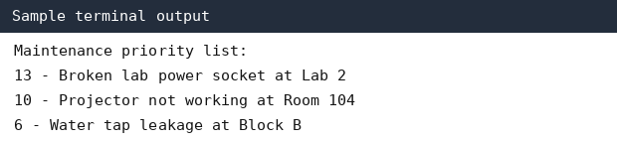
Note: This is a sample output illustration. Run the code and capture the actual output from your Python environment.

10. Conclusion
The program calculates a priority score for each maintenance report and ranks incidents so that higher-priority issues are considered first.

Case Study 98: University Academic Progression Audit

1. Problem Statement
Use semester marks, attendance, subject pass status, and prerequisite completion to decide whether each student can progress to the next semester. Report all unmet requirements.

2. Objectives
- Combine student information stored in lists and tuples.
- Apply multiple eligibility conditions.
- Display a reason-wise audit.

3. Assumptions
- A student needs at least 40 marks, 75% attendance, all subjects passed, and prerequisites completed.
- The data is illustrative; use the official university rules if they differ.

4. Algorithm
1. Start.
2. Store each student's marks, attendance, pass status, and prerequisite status.
3. Check every progression condition.
4. Collect all failed conditions.
5. Display eligible or not eligible with reasons.
6. Stop.

5. Flowchart
START → Read student record → Check marks → Check attendance → Check subject passes → Check prerequisites → Display decision and reasons → Next student → STOP

6. Pseudocode
START
FOR each student record
reasons ← empty list
IF marks < 40, add marks reason
IF attendance < 75, add attendance reason
IF not all subjects passed, add subject reason
IF prerequisites incomplete, add prerequisite reason
IF reasons empty, report eligible ELSE report not eligible and reasons
STOP

7. Python Source Code
students = [
("Anu", 68, 82, True, True),
("Balu", 35, 80, True, True),
("Charan", 55, 68, False, True),
("Divya", 72, 90, True, False)
]

for name, marks, attendance, all_passed, prerequisites in students:
reasons = []
if marks < 40:
reasons.append("marks below 40")
if attendance < 75:
reasons.append("attendance below 75%")
if not all_passed:
reasons.append("pending subject")
if not prerequisites:
reasons.append("prerequisites incomplete")

if len(reasons) == 0:
print(name, "-> ELIGIBLE")
else:
print(name, "-> NOT ELIGIBLE:", ", ".join(reasons))

8. Test Cases
Input / Test | Expected result
Anu: 68 marks, 82% attendance, all passed, prerequisites complete | Eligible
Balu: 35 marks | Not eligible: marks below 40
Charan: 68% attendance and pending subject | Both reasons shown
Divya: prerequisite incomplete | Not eligible: prerequisite incomplete

9. Sample Output (Screenshot-style)
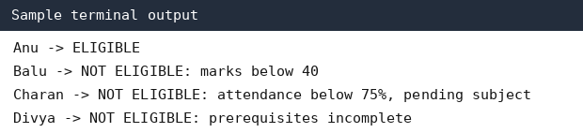
Note: This is a sample output illustration. Run the code and capture the actual output from your Python environment.

10. Conclusion
The program audits several academic conditions and gives a clear eligibility decision with every unmet requirement.

Case Study 99: Integrated E-Commerce Order Processing and Reconciliation

1. Problem Statement
Process customer orders, apply discounts, update inventory after dispatch and returns, calculate revenue, and flag cases where ordered quantities cannot be fulfilled.

2. Objectives
- Use lists and dictionaries to track stock and orders.
- Apply a discount condition.
- Update inventory for dispatches and returns.

3. Assumptions
- A 10% discount applies when the pre-discount order value is at least ₹1,000.
- Only available stock can be dispatched.
- A returned item is added back to stock; this simple model assumes returned items are resalable.

4. Algorithm
1. Start.
2. Set product prices and stock.
3. For each order, calculate value and apply discount if eligible.
4. Check stock and dispatch possible quantity.
5. Update stock after dispatch and returns.
6. Calculate final revenue and display reconciliation.
7. Stop.

5. Flowchart
START → Load prices and stock → Calculate order value → Apply discount → Check stock → Dispatch/update stock → Process return → Report revenue and stock → STOP

6. Pseudocode
START
FOR each order
subtotal ← price × quantity
IF subtotal ≥ 1000, discount ← 10% of subtotal ELSE discount ← 0
IF stock < quantity, report unfulfilled quantity
dispatch feasible quantity and reduce stock
add returned quantity back to stock
revenue ← revenue + discounted dispatched value
Display revenue and stock
STOP

7. Python Source Code
prices = {"Notebook": 100, "Bag": 800}
stock = {"Notebook": 20, "Bag": 3}
orders = [
("Notebook", 5, 1), # product, quantity ordered, quantity returned
("Bag", 2, 1),
("Bag", 2, 0)
]
revenue = 0

for product, quantity, returned in orders:
subtotal = prices[product] * quantity
discount = subtotal * 0.10 if subtotal >= 1000 else 0
dispatch = min(quantity, stock[product])
unfulfilled = quantity - dispatch
stock[product] -= dispatch
stock[product] += returned
sale_value = (prices[product] * dispatch) - discount
if sale_value < 0:
sale_value = 0
revenue += sale_value
print(product, "ordered:", quantity, "dispatched:", dispatch,
"unfulfilled:", unfulfilled, "returned:", returned,
"stock left:", stock[product])

print("Recorded revenue:", revenue)
print("Final stock:", stock)

8. Test Cases
Input / Test | Expected result
5 notebooks at ₹100 | Subtotal ₹500; no discount
2 bags at ₹800 | Subtotal ₹1600; 10% discount
Bag order exceeds remaining stock | Unfulfilled quantity reported
Returned quantity 1 | Stock increases by 1

9. Sample Output (Screenshot-style)
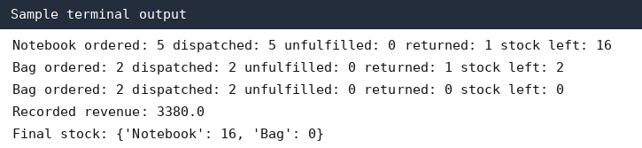
Note: This is a sample output illustration. Run the code and capture the actual output from your Python environment.

10. Conclusion
The program demonstrates order billing, discount application, dispatch feasibility, return handling, and inventory reconciliation. For a real system, discount allocation should be adjusted when only part of an order is dispatched.

Case Study 100: Comprehensive Smart Campus Management Simulation

1. Problem Statement
Build a simple menu-driven program that manages student records, attendance, marks, and event registrations. It should allow repeated operations and display a summary.

2. Objectives
- Use a while loop for a menu.
- Store student details using dictionaries and lists.
- Use conditions to handle menu choices and validate input.

3. Assumptions
- Student roll numbers are unique.
- Attendance is entered as a percentage from 0 to 100.
- Marks are entered from 0 to 100.
- This is a basic classroom simulation and does not save data after the program closes.

4. Algorithm
1. Start with an empty student list.
2. Display the menu repeatedly.
3. For Add Student, read and validate details, then store them.
4. For View Students, display saved records.
5. For Register Event, add an event to the student's event list.
6. For Exit, stop the loop.
7. Stop.

5. Flowchart
START → Display menu → Read choice → Add student / View records / Register event / Exit → Return to menu unless Exit → STOP

6. Pseudocode
START
students ← empty list
REPEAT
Display menu
Read choice
IF choice = 1, read and store student record
ELSE IF choice = 2, display all student records
ELSE IF choice = 3, find student and add event
ELSE IF choice = 4, exit
ELSE display invalid choice
UNTIL choice = 4
STOP

7. Python Source Code
students = []

while True:
print("\n1. Add student")
print("2. View students")
print("3. Register event")
print("4. Exit")
choice = input("Enter choice: ").strip()

if choice == "1":
roll = input("Roll number: ").strip()
if any(student["roll"] == roll for student in students):
print("Roll number already exists")
continue
name = input("Name: ").strip()
attendance = float(input("Attendance percentage: "))
marks = float(input("Marks: "))

if not (0 <= attendance <= 100 and 0 <= marks <= 100):
print("Attendance and marks must be between 0 and 100")
continue

students.append({
"roll": roll,
"name": name,
"attendance": attendance,
"marks": marks,
"events": []
})
print("Student added successfully")

elif choice == "2":
if not students:
print("No student records")
for student in students:
print(student)

elif choice == "3":
roll = input("Enter student roll number: ").strip()
found = False
for student in students:
if student["roll"] == roll:
event = input("Event name: ").strip()
student["events"].append(event)
print("Event registered")
found = True
break
if not found:
print("Student not found")

elif choice == "4":
print("Exiting campus management system")
break

else:
print("Invalid choice. Try again.")

8. Test Cases
Input / Test | Expected result
Choice 1 with valid student details | Student added successfully
Add same roll number again | Duplicate roll number rejected
Choice 2 | Student records displayed
Choice 3 with existing roll | Event registered
Choice 4 | Program exits

9. Sample Output (Screenshot-style)
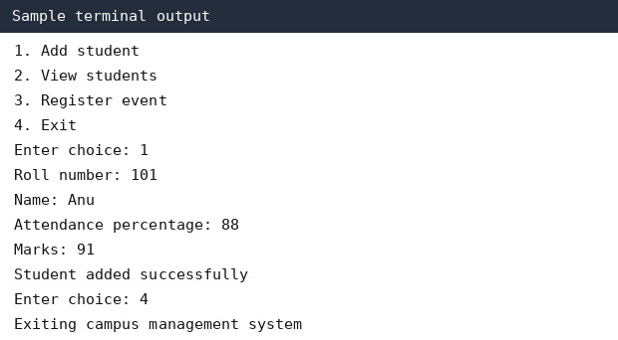
Note: This is a sample output illustration. Run the code and capture the actual output from your Python environment.

10. Conclusion
The menu-driven program combines student records, attendance, marks, and event registration using loops, conditions, lists, and dictionaries.

Final submission checklist
- Check that all 10 Python programs run without errors.
- Replace illustrative assumptions with faculty-provided rules if required.
- Capture actual output screenshots from Python IDLE or VS Code for each program.
- Add your name, roll number, branch, and section to README.md.
- Create a GitHub repository named Python-Activity-Based-Learning.
- Upload the 10 programs, report, flowcharts/pseudocode, test cases, and actual screenshots.
- Submit the repository URL to your Python faculty member / lab mentor after the holidays.

