Project Title
Delivery Route Optimizer Using Dijkstra's Algorithm and Priority Queue
Project Report submitted for the partial fulfilment of grade for the course
Data Structures and Algorithms -3 (25CS2103E)
in
A.Y. 2026-2027
Submitted by
B. Neha-2520090013
V. Siri Chandana-2520090198
Team Number: 10
Section: 11
Under the guidance of
Mrs. Ch. Anitha
Asst. Professor, CS&IT

Hyderabad-500090, Telangana, India.

K L (Deemed to be) University
DEPARTMENT OF COMPUTER SCIENCE AND INFORMATION TECHNOLOGY

DECLARATION
The Mini Project Report entitled “Delivery Route Optimizer Using Dijkstra's Algorithm and Priority Queue” is a record of Bonafide work of B. Neha – 2520090013, V. Siri Chandana – 2520090198, submitted in partial fulfillment for the award of B.Tech in Computer Science and Information Technology to the K L University. The results embodied in this report have not been copied from any other departments/University/Institute.
B. Neha-2520090013
V. Siri Chandana-2520090198

K L (Deemed to be) University
DEPARTMENT OF COMPUTER SCIENCE AND INFORMATION TECHNOLOGY
CERTIFICATE
This is to certify that the mini project based report entitled “Delivery Route Optimizer Using Dijkstra's Algorithm and Priority Queue” is a bonafide work done and submitted by B. Neha – 2520090013, V. Siri Chandana – 2520090198, in partial fulfillment of the requirements for the award of the degree of BACHELOR OF TECHNOLOGY in Department of Computer Science and Information Technology, K L (Deemed to be University), during the academic year 2026-2027.
Signature of the Supervisor

Signature of the HOD Signature of the External Examiner

ACKNOWLEDGEMENT
The success of this project would not have been possible without the timely help and guidance rendered by many people. We wish to express our sincere thanks to all those who have assisted us in one way or the other in the completion of our project.
Our greatest appreciation goes to our guide, Mrs. Ch. Anitha, Assistant Professor, Department of Computer Science and Information Technology, whose tremendous support, encouragement and guidance cannot be expressed in words.
We express our gratitude to Dr. Khaja Shareef, Head of the Department of Computer Science and Information Technology, for providing us with adequate facilities, ways and means by which we were able to complete this project-based lab.
We thank all the members of the teaching and non-teaching staff who have assisted us directly or indirectly in the successful completion of this project. Finally, we sincerely thank our parents, friends and classmates for their kind help and cooperation during our work.
B. Neha-2520090013
V. Siri Chandana-2520090198

TABLE OF CONTENTS
S.No. Contents Page no.
1. Abstract 6
2. Introduction 7
3. Literature survey 8
4. Problem Statement and Objectives 9
5. Hardware and Software requirements 10
6. Implementation 11
7. Results & Discussion 14
8. Conclusion & Future Scope 21
9. References 22

1. ABSTRACT
The Delivery Route Optimizer is a project designed to find the shortest and fastest route between a delivery location and multiple destinations, similar to real-world applications like Google Maps, Swiggy, Zomato, and Blinkit. The system models the road network as a graph, where intersections are represented as nodes and roads as weighted edges based on distance or travel time. Using Dijkstra's Shortest Path Algorithm implemented with a Priority Queue (Min Heap), the project efficiently computes the optimal delivery route while minimizing travel time and fuel consumption. Core data structures such as Adjacency Lists, Arrays, and Hash Maps support efficient storage of location and route information, while the Greedy approach ensures optimal path selection at every step. Key features include adding locations and roads, calculating the shortest route, displaying the total distance, and visualizing the optimized delivery path, making the project a practical demonstration of core DSA concepts.
Team Members:
1. B. Neha-2520090013
2. V. Siri Chandana-2520090198

2. INTRODUCTION
Efficient delivery route planning is important for e-commerce and food/grocery delivery platforms such as Swiggy, Zomato, and Blinkit, as well as navigation applications such as Google Maps. Manually selected or naive routes can result in longer travel time, higher fuel consumption, and delayed deliveries.
The proposed Delivery Route Optimizer represents a road network as a weighted graph. Intersections or locations are treated as nodes, while roads are represented as edges whose weights indicate distance or travel time. The system applies Dijkstra’s Shortest Path Algorithm with a Priority Queue (Min-Heap) to select the optimal route from a delivery hub to a destination.
The project focuses on demonstrating graph representation, shortest-path computation, efficient priority-based selection, and route interpretation. The intended outcome is a scalable route optimization approach that reduces travel time and fuel consumption while presenting the optimized delivery path clearly.

3. LITERATURE SURVEY
Dijkstra’s Shortest Path Algorithm is a foundational graph algorithm for finding shortest paths in weighted graphs. The project uses this concept for modeling delivery roads and selecting an optimal route. A Priority Queue or Min-Heap can be used to efficiently select the currently closest node during the algorithm.
Google Maps provides navigation and route-related services based on geographic road networks. Its mapping ecosystem demonstrates the practical importance of route computation and location-based path planning. The project uses this type of real-world navigation application as a conceptual reference.
Swiggy is a food and convenience delivery platform where efficient delivery operations are important. The project uses delivery platforms as practical examples of why route optimization can reduce delays and operational effort.
Zomato is a food delivery platform that provides doorstep delivery services. Its use case motivates the need for efficient movement between delivery locations and destinations.
Blinkit provides hyperlocal delivery of groceries and other daily essentials. Its quick-delivery use case illustrates why shortest and faster routes are valuable in delivery systems.
The PPT also identifies A* Search and Bellman-Ford as related algorithms. A* can provide faster directed search with a suitable heuristic, while Bellman-Ford supports graphs with negative edge weights. For the present project, Dijkstra’s Algorithm is selected because the modeled road weights represent non-negative distance or travel time.

4. PROBLEM STATEMENT AND OBJECTIVES

Problem Statement
Manually chosen or naive delivery routes fail to consistently find the shortest and fastest path from a hub to its destinations, causing delays, wasted fuel and higher delivery costs.

Problem Description
Given a road network of locations and roads with distances or travel times, the system must efficiently compute the least-cost route from a delivery hub to a chosen destination and present it clearly to the user.

Objectives
Purpose of the project: Delivery platforms such as Swiggy, Zomato and Blinkit depend on fast, low-cost routing; inefficient routes increase travel time, fuel consumption and late deliveries. This project was initiated to show how core Data Structures and Algorithms (graphs, priority queues and the greedy approach) can solve this business problem. The objectives are:
- To model the road network as a weighted graph using Adjacency Lists, with locations as nodes and roads as edges weighted by distance or travel time.
- To implement Dijkstra's Algorithm with a Priority Queue (Min-Heap) for efficient shortest-path computation in O((V+E) log V) time.
- To support dynamic addition, editing and deletion of delivery locations and roads (including one-way roads).
- To calculate and display the total distance, estimated travel time and estimated fuel use of the optimized route, along with an alternative route.
- To visualize the computed delivery path and the step-by-step working of the algorithm (heap contents, distances and predecessors) for better interpretability.
- To plan deliveries with multiple stops using shortest paths between stops.

5. HARDWARE AND SOFTWARE REQUIREMENTS

5.1 Hardware Requirements
- Processor: Intel i3 (or equivalent) and above
- RAM: 4 GB minimum (8 GB recommended)
- Storage: 500 MB free disk space
- Standard input/output devices such as keyboard, mouse, and monitor

5.2 Software Requirements
- Operating System: Windows / Linux / macOS
- Programming Language: C++ / Java / Python (this project: Java, plus HTML/CSS/JavaScript for the web version)
- IDE / Code Editor: VS Code, Eclipse, or equivalent
- Libraries/Structures: Standard Template Library (STL) or built-in Priority Queue and graph data structures (this project: Java Swing for the GUI, with a self-written binary min-heap)

6. IMPLEMENTATION
The project is implemented in Java (desktop application using Swing) and as an equivalent HTML/JavaScript web page. The main modules of the Java code are given below.

Module 1: Graph Representation (Adjacency List)
Locations are nodes and roads are weighted edges. The adj() method builds an adjacency list (HashMap of ArrayLists); two-way roads add an edge in both directions and one-way roads in one direction only.
/* ---- Basic building blocks of the graph ---- */
class Loc { String id, name; int x, y; } // a location (node)
class Road { String a, b; double d, t; boolean ow; } // road: from, to, km, min, one-way?
class Edge { String to; double d, t; Road r; } // adjacency-list entry

/** Adjacency list: two-way roads add an edge in each direction,
one-way roads only a -> b. */
Map<String,List<Edge>> adj(){
Map<String,List<Edge>> m = new HashMap<>();
for (Loc l : locs) m.put(l.id, new ArrayList<>());
for (Road r : roads) {
if (!m.containsKey(r.a) || !m.containsKey(r.b)) continue;
m.get(r.a).add(new Edge(r.b, r.d, r.t, r));
if (!r.ow) m.get(r.b).add(new Edge(r.a, r.d, r.t, r));
}
return m;
}

Module 2: Priority Queue (Binary Min-Heap)
A min-heap is implemented using an ArrayList. push() sifts a new entry up and pop() removes the smallest-distance entry and sifts down, both in O(log n).
/** Binary min-heap stored in an ArrayList. push/pop are O(log n). */
class MinHeap {
final ArrayList<Entry> a = new ArrayList<>();
int size(){ return a.size(); }

void push(double k, String v){
a.add(new Entry(k, v));
int i = a.size() - 1;
while (i > 0) { // sift-up
int p = (i - 1) / 2;
if (a.get(p).k <= a.get(i).k) break;
Collections.swap(a, p, i);
i = p;
}
}

Entry pop(){
Entry top = a.get(0), last = a.remove(a.size() - 1);
if (!a.isEmpty()) {
a.set(0, last);
int i = 0;
for (;;) { // sift-down
int l = 2*i + 1, r = l + 1, m = i;
if (l < a.size() && a.get(l).k < a.get(m).k) m = l;
if (r < a.size() && a.get(r).k < a.get(m).k) m = r;
if (m == i) break;
Collections.swap(a, m, i);
i = m;
}
}
return top;
}
}

Module 3: Dijkstra's Algorithm
The nearest unvisited node is extracted from the min-heap and all its outgoing edges are relaxed. The distance and predecessor maps are updated; stale heap entries are skipped (lazy deletion). Complexity: O((V+E) log V).
/** Dijkstra with a binary min-heap (lazy deletion).
time=true uses travel time as weight, otherwise distance.
ban = a road to ignore (used to find an alternative route). */
Res dijkstra(String src, boolean time, boolean record, Road ban){
Res r = new Res();
Map<String,List<Edge>> adj = adj();
for (Loc l : locs) r.dist.put(l.id, INF); // all distances = infinity
if (!adj.containsKey(src)) return r;

MinHeap H = new MinHeap();
Set<String> vis = new LinkedHashSet<>();
r.dist.put(src, 0.0); // source distance = 0
H.push(0, src);
// (when record == true, step snapshots for the visualiser are
// also stored here - omitted from this listing)

while (H.size() > 0) {
Entry e = H.pop(); String u = e.v; // extract-min
if (vis.contains(u) || e.k > r.dist.get(u)) continue; // stale entry
vis.add(u); // u is now finalised

for (Edge ed : adj.get(u)) { // relax all outgoing edges
if (ed.r == ban || vis.contains(ed.to)) continue;
double w = time ? ed.t : ed.d;
double nd = e.k + w, old = r.dist.get(ed.to);
if (nd < old) {
r.dist.put(ed.to, nd); // better distance found
r.prev.put(ed.to, u); // remember predecessor
H.push(nd, ed.to);
}
}
}
return r;
}

Module 4: Path Reconstruction and Route Computation
The shortest path is rebuilt from the predecessor map and its total km/minutes are calculated. An alternative route is found by blocking each road of the shortest path in turn and keeping the best result.
/** Rebuild the path source -> destination from the predecessor map. */
List<String> pathOf(Res r, String s, String d){
Double x = r.dist.get(d);
if (x == null || x == INF) return null; // unreachable
LinkedList<String> p = new LinkedList<>();
p.add(d);
while (!p.getFirst().equals(s)) {
String q = r.prev.get(p.getFirst());
if (q == null) return null;
p.addFirst(q);
}
return p;
}

/** Total km / minutes of a path, segment by segment. */
Info info(List<String> p, boolean time){
Map<String,List<Edge>> adj = adj();
Info in = new Info(); in.path = p;
for (int i = 1; i < p.size(); i++) {
String u = p.get(i-1), v = p.get(i); Edge best = null;
for (Edge e : adj.get(u))
if (e.to.equals(v) && (best == null || (time ? e.t < best.t : e.d < best.d))) best = e;
in.segs.add(new Object[]{u, v, best.d, best.t, best.r});
in.km += best.d; in.min += best.t;
}
in.tot = time ? in.min : in.km;
return in;
}

/** Shortest route + best alternative (shortest path avoiding one road). */
Route compute(String s, String d, boolean time){
Route rt = new Route(); rt.time = time;
if (loc(s) == null || loc(d) == null) { rt.err = "Choose valid source and destination."; return rt; }
if (s.equals(d)) { rt.err = "Source and destination are the same - distance is 0."; return rt; }
List<String> p = pathOf(dijkstra(s, time, false, null), s, d);
if (p == null) { rt.err = "No route exists from " + nm(s) + " to " + nm(d); return rt; }
rt.main = info(p, time);
for (Object[] sg : rt.main.segs) { // block each road in turn
List<String> p2 = pathOf(dijkstra(s, time, false, (Road) sg[4]), s, d);
if (p2 != null) {
Info i2 = info(p2, time);
if (rt.alt == null || i2.tot < rt.alt.tot) rt.alt = i2;
}
}
return rt;
}

7. RESULTS & DISCUSSION
The screenshots below are taken from the web version of the application using the built-in sample road network of 12 locations around Bachupally, Kukatpally and HITEC City. The distances and times are illustrative sample data, not live navigation data.
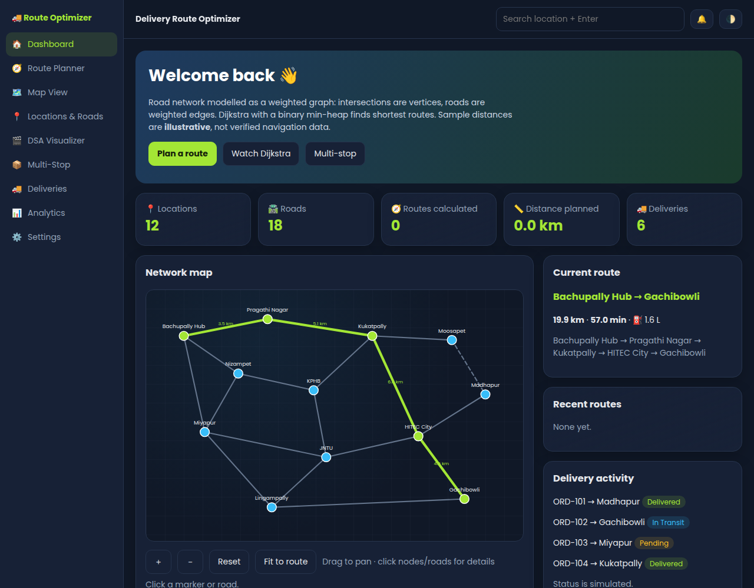
Fig 7.1: Dashboard
The dashboard shows the road network as a graph of 12 locations and 18 roads, with live counters for routes calculated and planned distance. Quick buttons open the Route Planner, DSA Visualizer and Multi-Stop planner.
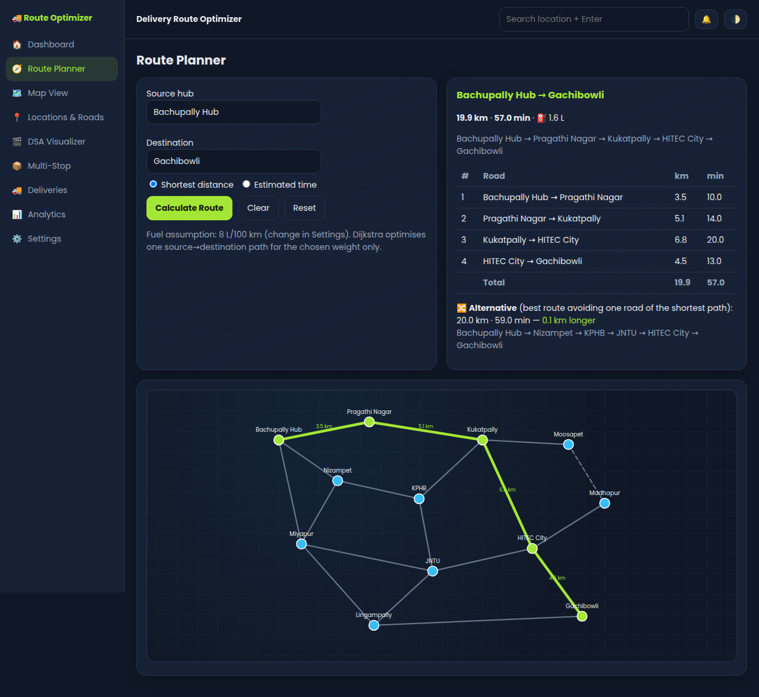
Fig 7.2: Route Planner – shortest distance (Bachupally Hub to Gachibowli)
Dijkstra returns Hub → Pragathi Nagar → Kukatpally → HITEC City → Gachibowli with a total of 19.9 km, 57.0 min and 1.6 L fuel. The segment table, alternative route and highlighted path are shown.
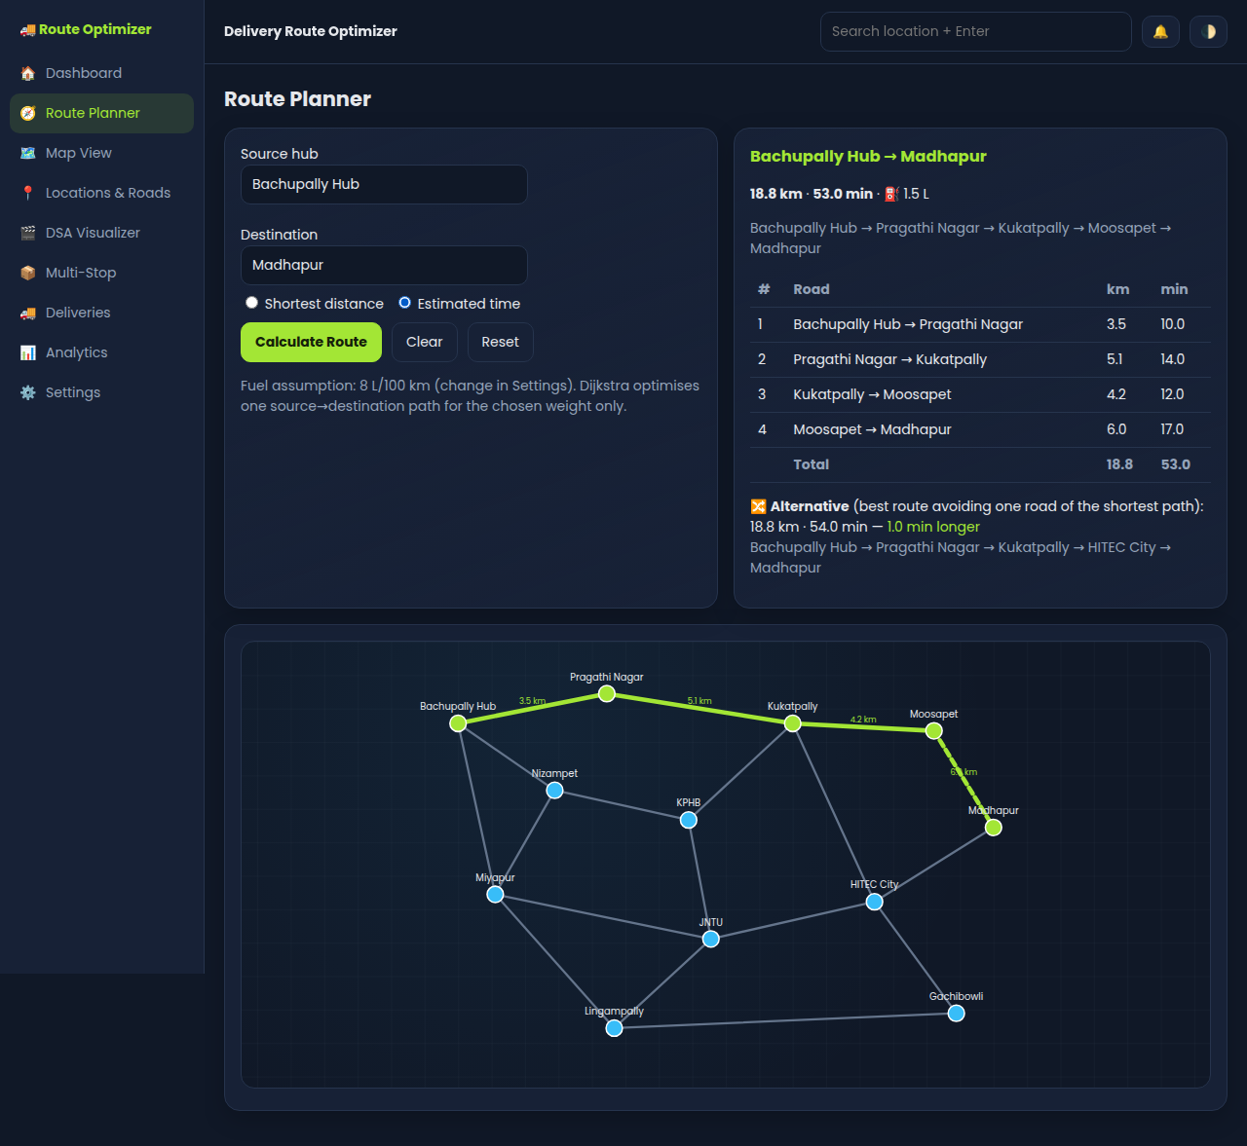
Fig 7.3: Route Planner – estimated time (Bachupally Hub to Madhapur)
With "Estimated time" selected, edge weights switch to minutes and the best route is 53.0 min (18.8 km). An alternative avoiding one road is 1.0 min longer.
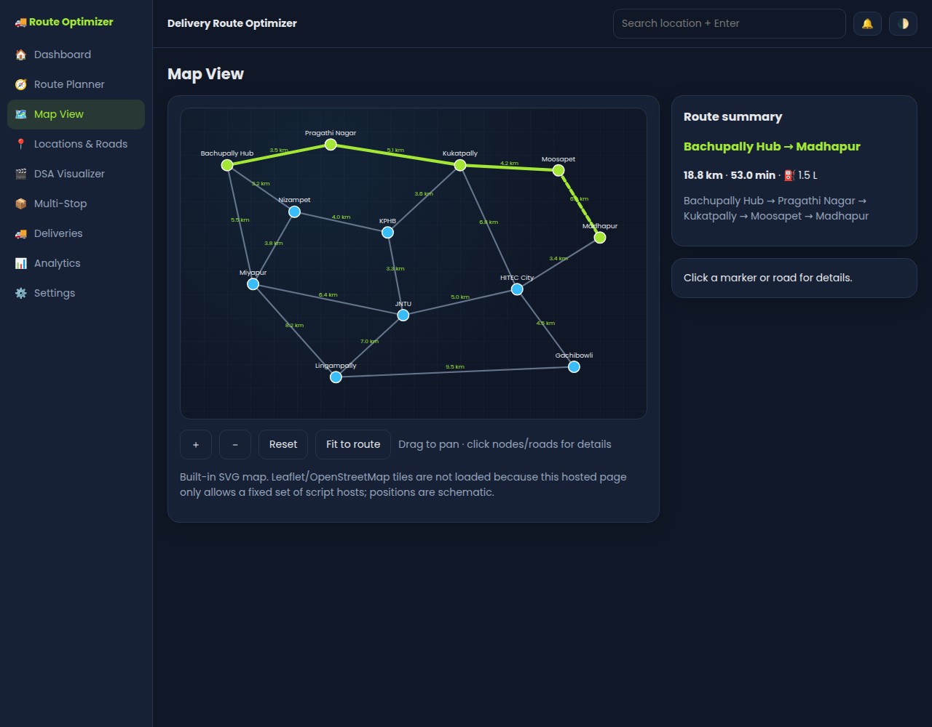
Fig 7.4: Map View
The calculated route is drawn in green over the schematic road map with distance labels on every road. The map supports zoom, pan and fit-to-route, and clicking a node or road shows its details.
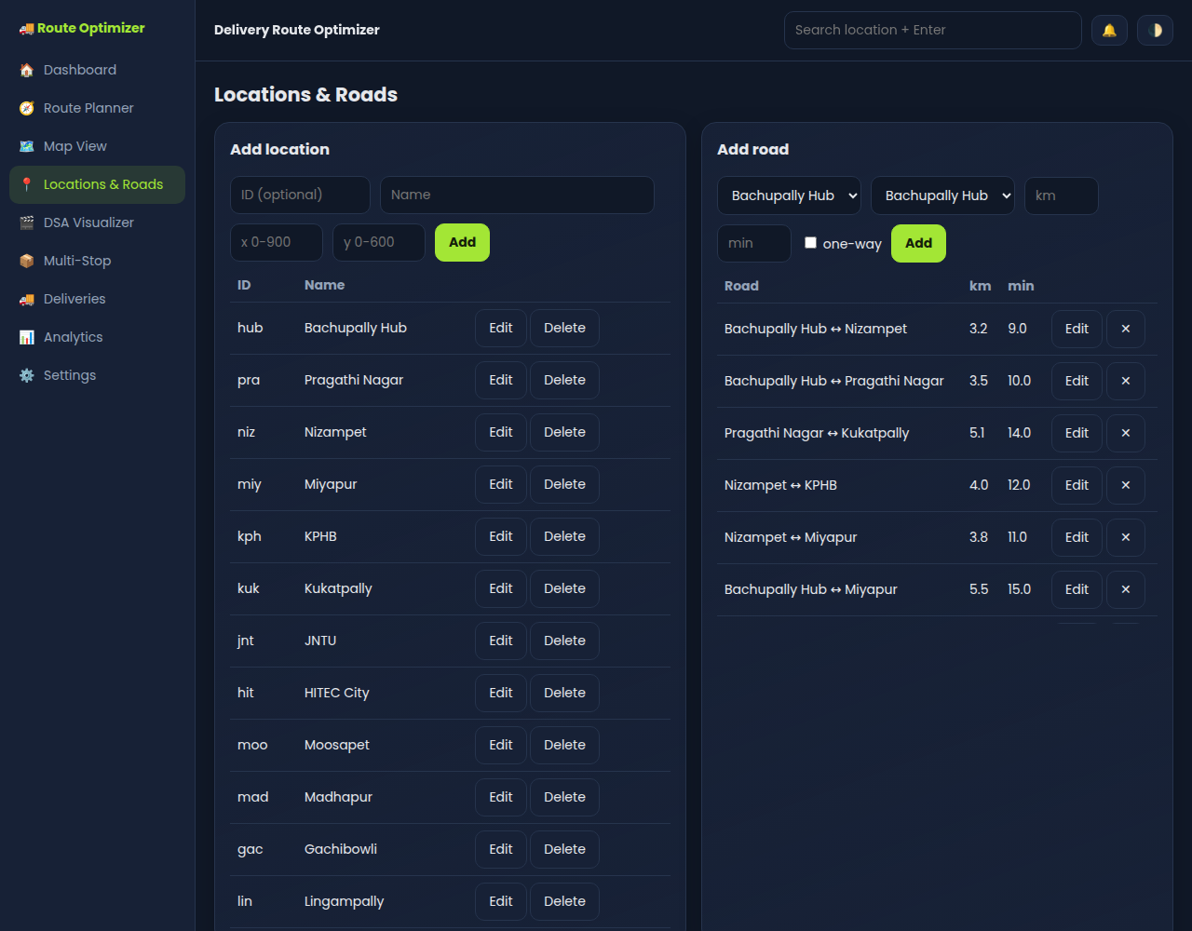
Fig 7.5: Locations & Roads
New locations and roads (with distance, time and one-way option) can be added, edited or deleted. Input validation rejects duplicates and invalid weights.
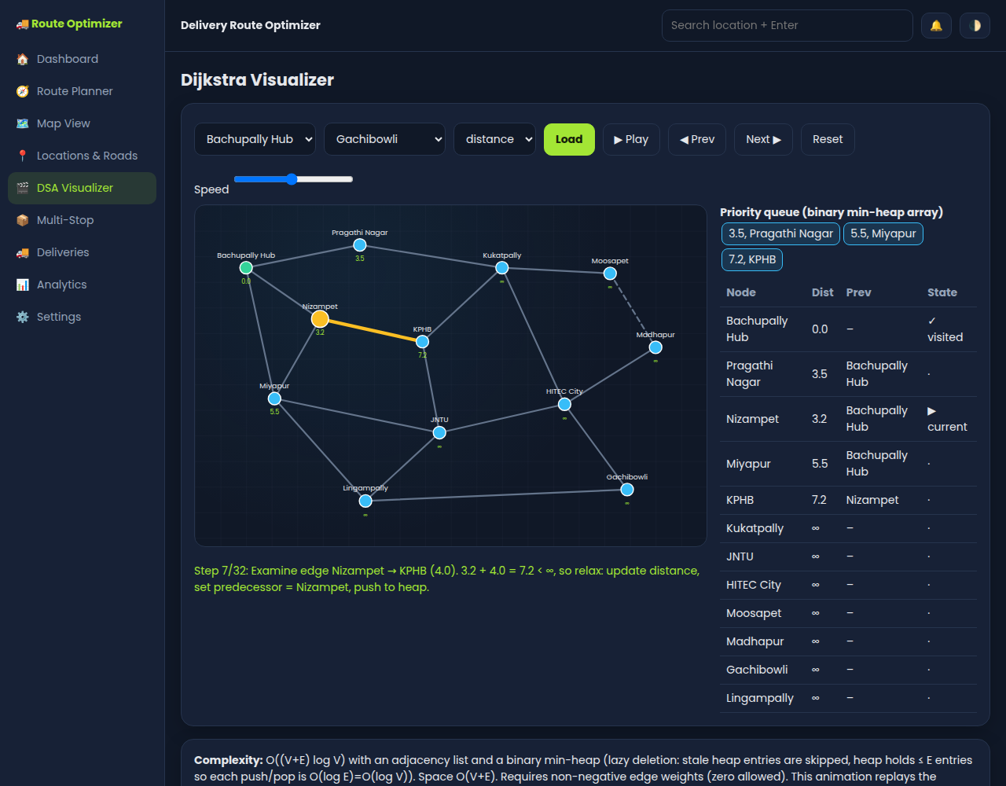
Fig 7.6: DSA Visualizer – Dijkstra in progress
The animation shows the current node, the relaxed edge, the min-heap contents and the distance/predecessor table at every step. Here, Nizampet → KPHB is relaxed: 3.2 + 4.0 = 7.2 < ∞.
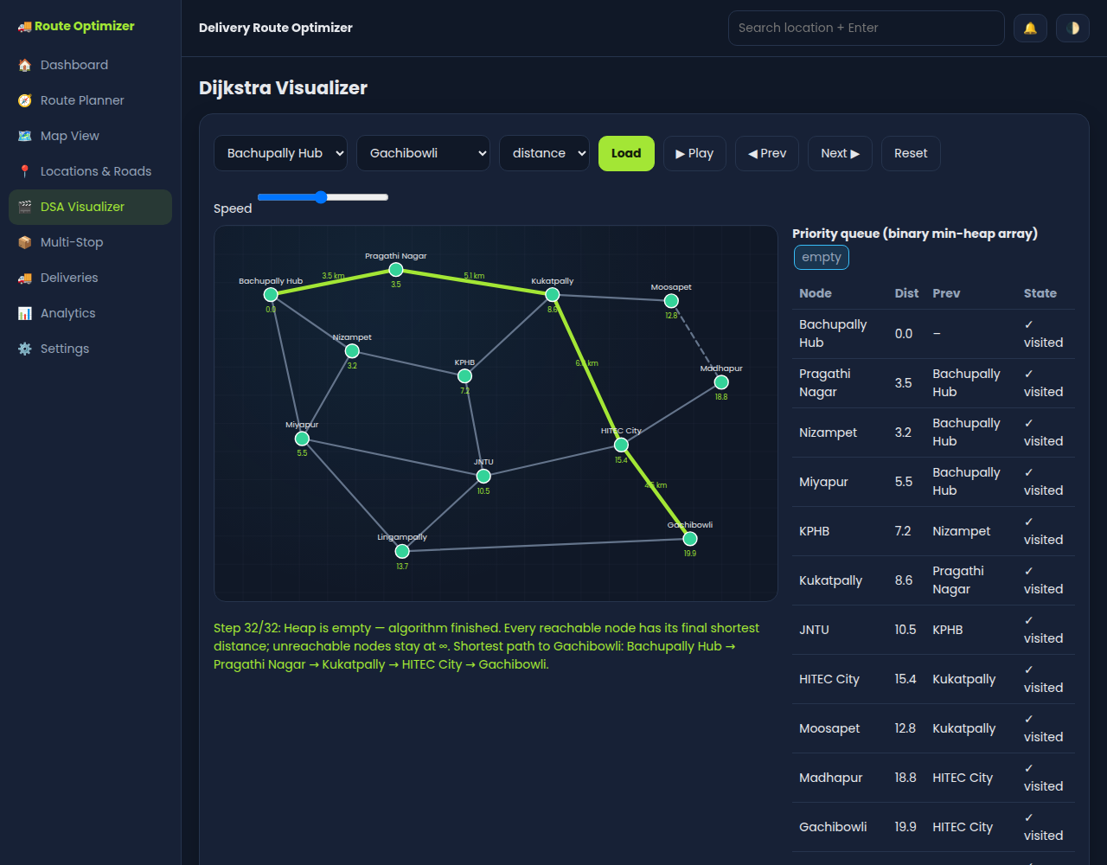
Fig 7.7: DSA Visualizer – algorithm finished
The heap is empty and every node has its final shortest distance. The shortest path to Gachibowli (19.9 km) is highlighted using the predecessor links.
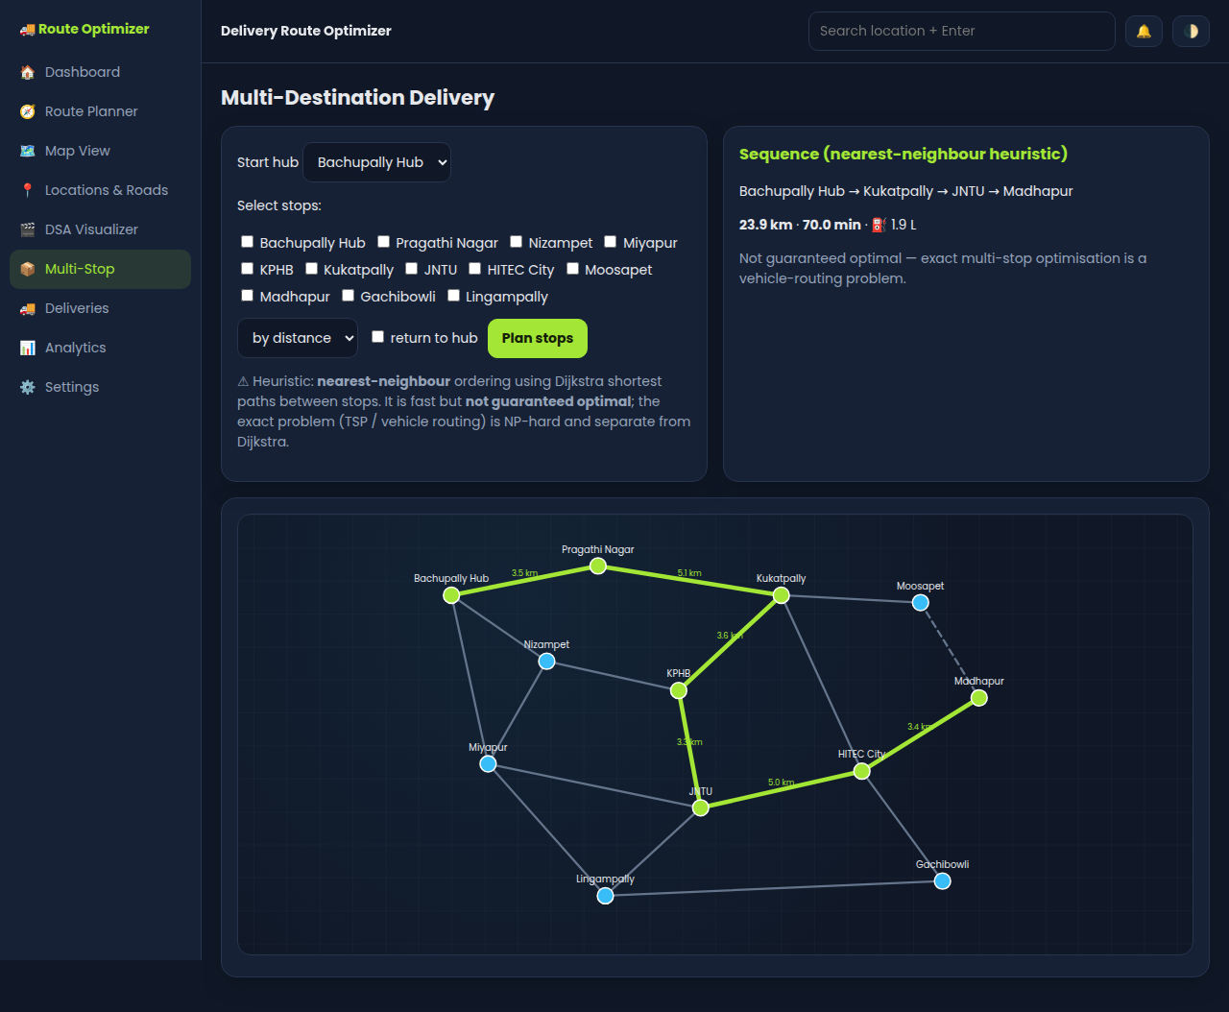
Fig 7.8: Multi-Stop delivery planning
Stops (Kukatpally, JNTU, Madhapur) are ordered using a nearest-neighbour heuristic over Dijkstra shortest paths, giving 23.9 km, 70.0 min and 1.9 L. This ordering is not guaranteed optimal.
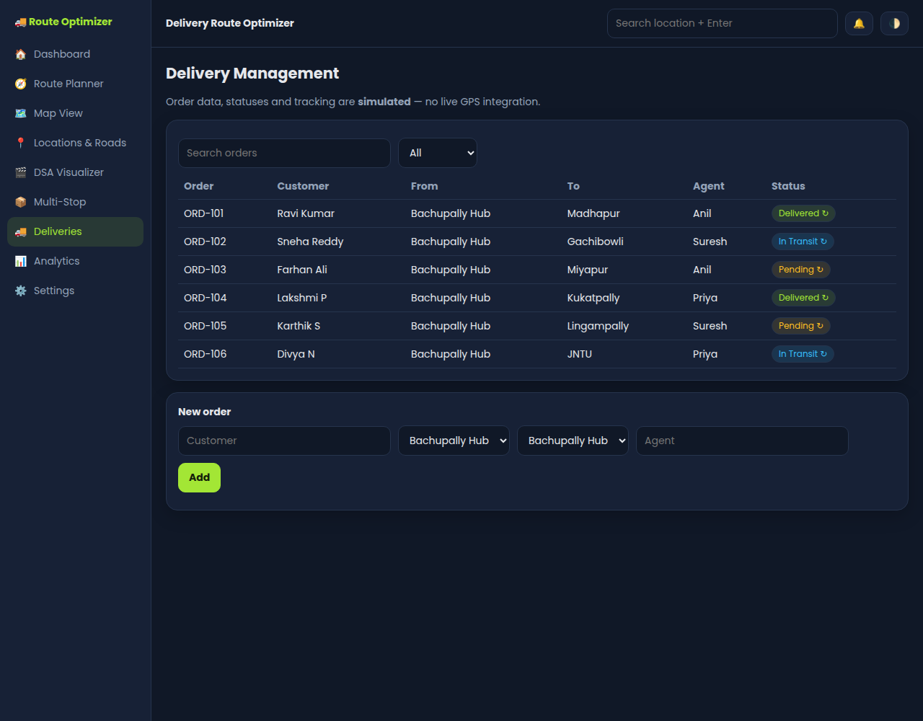
Fig 7.9: Delivery management
Orders can be searched and filtered by status, new orders can be added, and status can be advanced Pending → In Transit → Delivered. Tracking data is simulated.
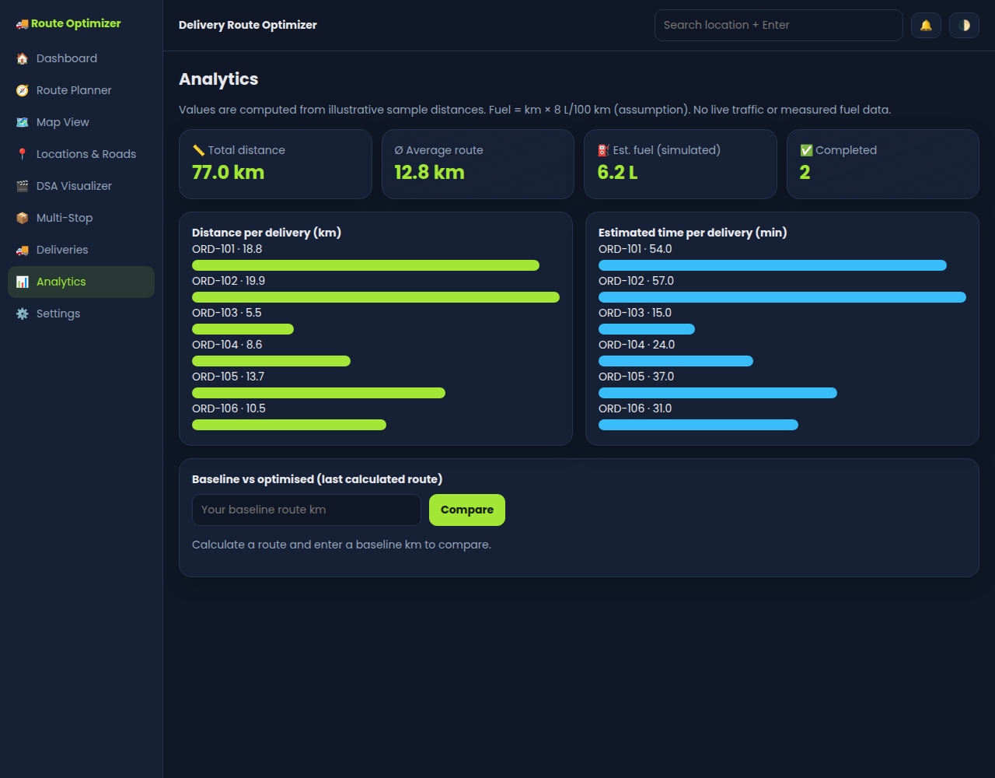
Fig 7.10: Analytics
Bar charts show the optimised distance and estimated time for each delivery, along with total distance, average route length and estimated fuel. A baseline route can be compared with the optimised one.

Discussion
The system correctly computes the shortest route for both distance and time weights, handles one-way roads, and reports errors for invalid cases such as the same source and destination or an unreachable location. Because the min-heap always returns the closest unvisited node in O(log V), the algorithm runs in O((V+E) log V) and scales better than a linear-search version (O(V²)). The visualizer confirms that each node is finalised only once and that the shortest path is rebuilt from predecessor links. Multi-stop planning uses a nearest-neighbour heuristic, which is fast but not guaranteed optimal, since exact multi-stop routing is a separate vehicle-routing (TSP-like) problem.

8. CONCLUSION & FUTURE SCOPE

8.1 Conclusion
The Delivery Route Optimizer successfully demonstrates how graph theory and Dijkstra’s Algorithm can be applied to a practical route optimization problem. The use of a Priority Queue (Min-Heap) makes shortest-path computation more efficient as the road network grows. Adjacency Lists, Arrays, and Hash Maps support efficient storage and processing of route information. The project therefore demonstrates how core Data Structures and Algorithms concepts can contribute to reliable delivery route planning and help minimize travel time and fuel consumption.

8.2 Future Scope
- Integrate real-time traffic data to dynamically update travel times and reroute deliveries.
- Extend the system to handle multiple delivery agents and multiple destinations simultaneously as a Vehicle Routing Problem.
- Incorporate A* Search or bidirectional Dijkstra for faster performance on very large road networks.
- Add a map-based graphical user interface for more intuitive route visualization.
- Factor in additional constraints such as delivery time windows, vehicle capacity, and road conditions.

9. REFERENCES
1. Dijkstra’s Algorithm – background on shortest-path computation and priority-queue use.
https://en.wikipedia.org/wiki/Dijkstra%27s_algorithm
2. Google Maps – navigation and location-based mapping reference.
https://www.google.com/maps/
3. Google Maps Platform – geospatial and mapping platform reference.
https://mapsplatform.google.com/intl/en_in/
4. Swiggy – food and grocery delivery platform reference.
https://www.swiggy.com/
5. Zomato – food delivery platform reference.
https://www.zomato.com/
6. Blinkit – hyperlocal delivery platform reference.
https://blinkit.com/

