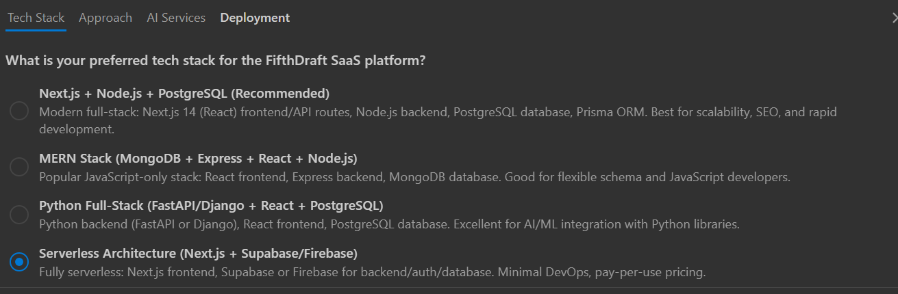

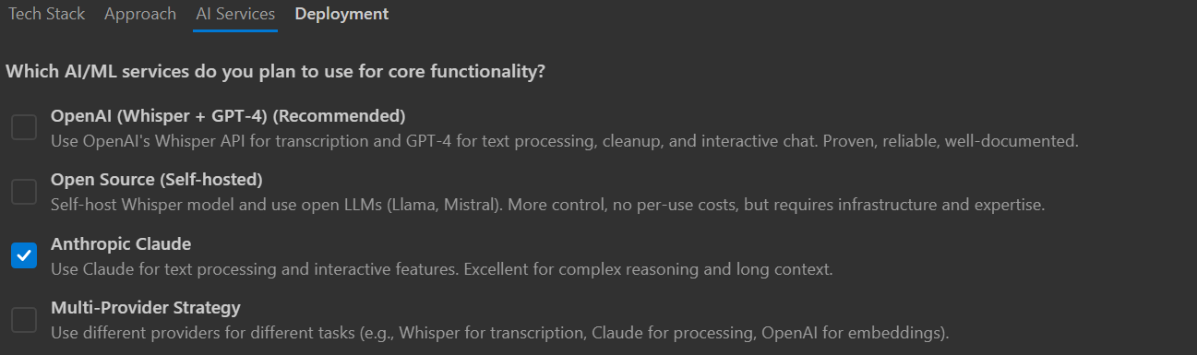

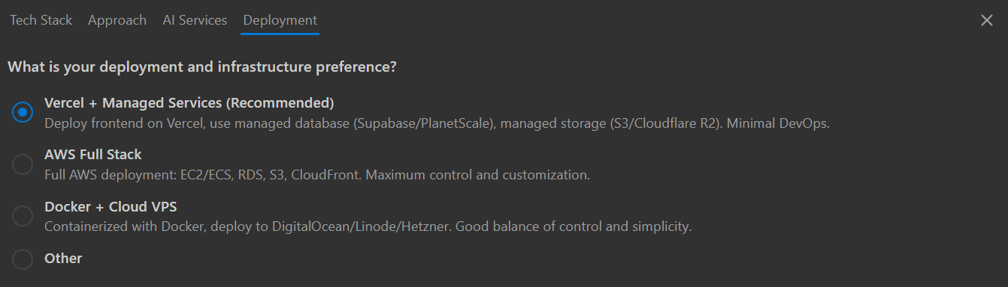
Superbase DB password: NewLife$050511

