**Bài 1**

| **Chức năng** | **Nút dùng** |
| --- | --- |
| Tiêu đề “Quán ăn nhanh Hưng Thịnh” | Label |
| Các món ăn, nước uống | Button |
| Chọn bàn | ComboBox |
| Hiện thị món đã ăn | ListView |
| Xoá danh sách | Button |
| Order | Button |

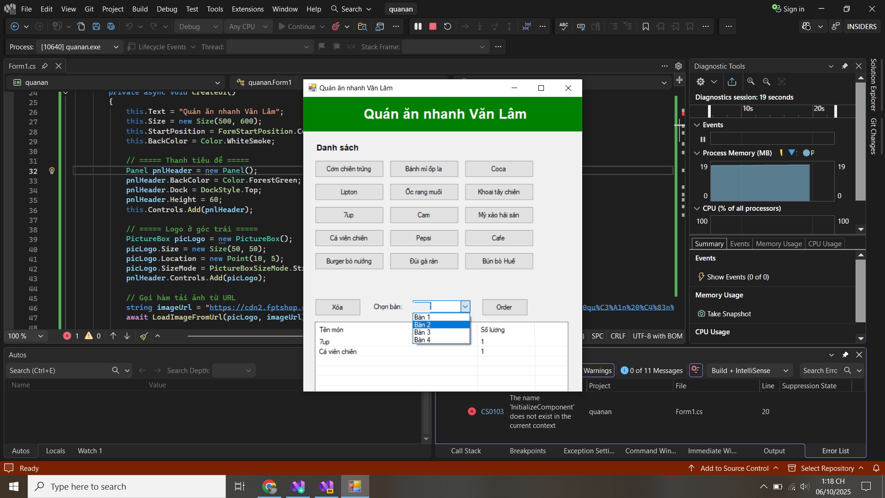

using System;

using System.Collections.Generic;

using System.Drawing;

using System.IO;

using System.Net.Http;

using System.Threading.Tasks;

using System.Windows.Forms;

namespace quanan

{

public partial class Form1 : Form

{

private ComboBox cbBan;

private Button btnOrder, btnXoa;

private ListView lvOrder;

private Dictionary<string, int> orderItems = new Dictionary<string, int>();

public Form1()

{

InitializeComponent();

CreateUI();

}

private async void CreateUI()

{

this.Text = "Quán ăn nhanh Văn Lâm";

this.Size = new Size(500, 600);

this.StartPosition = FormStartPosition.CenterScreen;

this.BackColor = Color.WhiteSmoke;

// ===== Thanh tiêu đề =====

Panel pnlHeader = new Panel();

pnlHeader.BackColor = Color.ForestGreen;

pnlHeader.Dock = DockStyle.Top;

pnlHeader.Height = 60;

this.Controls.Add(pnlHeader);

// ===== Logo ở góc trái =====

PictureBox picLogo = new PictureBox();

picLogo.Size = new Size(50, 50);

picLogo.Location = new Point(10, 5);

picLogo.SizeMode = PictureBoxSizeMode.StretchImage;

pnlHeader.Controls.Add(picLogo);

// Gọi hàm tải ảnh từ URL

string imageUrl = "https://cdn2.fptshop.com.vn/unsafe/Uploads/images/tin-tuc/178763/Originals/t%C3%AAn%20qu%C3%A1n%20%C4%83n%20hay%202.jpg";

await LoadImageFromUrl(picLogo, imageUrl);

// ===== Tiêu đề =====

Label lblTitle = new Label();

lblTitle.Text = "Quán ăn nhanh Hưng Thịnh";

lblTitle.ForeColor = Color.White;

lblTitle.Font = new Font("Arial", 18, FontStyle.Bold);

lblTitle.AutoSize = true;

lblTitle.Location = new Point(70, 15);

pnlHeader.Controls.Add(lblTitle);

// ===== Danh sách món =====

Label lblDanhSach = new Label();

lblDanhSach.Text = "Danh sách món ăn:";

lblDanhSach.Font = new Font("Arial", 10, FontStyle.Bold);

lblDanhSach.Location = new Point(20, 80);

this.Controls.Add(lblDanhSach);

// ===== Các món =====

string[] items = {

"Cơm chiên trứng", "Bánh mì ốp la", "Coca", "Lipton",

"Ốc rang muối", "Khoai tây chiên", "7up", "Cam",

"Mỳ xào hải sản", "Cá viên chiên", "Pepsi", "Cafe",

"Burger bò nướng", "Đùi gà rán", "Bún bò Huế"

};

int x = 20, y = 110;

int count = 0;

foreach (var item in items)

{

Button btn = new Button();

btn.Text = item;

btn.Size = new Size(120, 30);

btn.Location = new Point(x, y);

btn.Click += Btn_Click;

this.Controls.Add(btn);

x += 130;

count++;

if (count % 3 == 0)

{

x = 20;

y += 40;

}

}

// ===== Nút xóa, chọn bàn, order =====

btnXoa = new Button();

btnXoa.Text = "Xóa";

btnXoa.Location = new Point(20, y + 40);

btnXoa.Size = new Size(80, 30);

btnXoa.BackColor = Color.LightCoral;

btnXoa.Click += BtnXoa_Click;

this.Controls.Add(btnXoa);

Label lblChonBan = new Label();

lblChonBan.Text = "Chọn bàn:";

lblChonBan.Location = new Point(120, y + 47);

this.Controls.Add(lblChonBan);

cbBan = new ComboBox();

cbBan.Location = new Point(190, y + 43);

cbBan.Size = new Size(100, 25);

cbBan.Items.AddRange(new string[] { "Bàn 1", "Bàn 2", "Bàn 3", "Bàn 4" });

cbBan.SelectedIndex = 0;

this.Controls.Add(cbBan);

btnOrder = new Button();

btnOrder.Text = "Order";

btnOrder.Location = new Point(310, y + 40);

btnOrder.Size = new Size(80, 30);

btnOrder.BackColor = Color.LightGreen;

btnOrder.Click += BtnOrder_Click;

this.Controls.Add(btnOrder);

// ===== ListView =====

lvOrder = new ListView();

lvOrder.Location = new Point(20, y + 80);

lvOrder.Size = new Size(420, 150);

lvOrder.View = View.Details;

lvOrder.FullRowSelect = true;

lvOrder.GridLines = true;

lvOrder.Columns.Add("Tên món", 250);

lvOrder.Columns.Add("Số lượng", 100);

this.Controls.Add(lvOrder);

}

// 🖼️ Hàm tải ảnh từ URL

private async Task LoadImageFromUrl(PictureBox pictureBox, string url)

{

try

{

using (HttpClient client = new HttpClient())

{

var response = await client.GetAsync(url);

if (response.IsSuccessStatusCode)

{

using (Stream stream = await response.Content.ReadAsStreamAsync())

{

pictureBox.Image = Image.FromStream(stream);

}

}

else

{

pictureBox.BackColor = Color.Orange;

}

}

}

catch

{

pictureBox.BackColor = Color.Orange;

}

}

private void Btn_Click(object sender, EventArgs e)

{

Button btn = sender as Button;

string tenMon = btn.Text;

if (orderItems.ContainsKey(tenMon))

orderItems[tenMon]++;

else

orderItems[tenMon] = 1;

LoadListView();

}

private void LoadListView()

{

lvOrder.Items.Clear();

foreach (var kvp in orderItems)

{

var item = new ListViewItem(kvp.Key);

item.SubItems.Add(kvp.Value.ToString());

lvOrder.Items.Add(item);

}

}

private void BtnXoa_Click(object sender, EventArgs e)

{

orderItems.Clear();

lvOrder.Items.Clear();

}

private void BtnOrder_Click(object sender, EventArgs e)

{

if (orderItems.Count == 0)

{

MessageBox.Show("Bạn chưa chọn món!");

return;

}

string ban = cbBan.SelectedItem.ToString();

MessageBox.Show($"Đơn hàng cho {ban} đã được ghi nhận.\nTổng số món: {orderItems.Count}");

}

}

}

**Bài 2**

| **Chức năng** | **Nút dùng** |
| --- | --- |
| Button | thêm, xoá, sửa, thoát |
| Groupbox | chứa DataGridView, thông tin sinh viên |
| DataGridview | hiển thị danh sách |
| DateTimePicker | chọn ngày sinh cho sinh viên |
| Label | chức năng, địa chỉ, ngày sinh, lớp, họ tên, danh mục sinh viên |
| textbox | nhập thông tin : lớp, họ tên, địa chỉ |

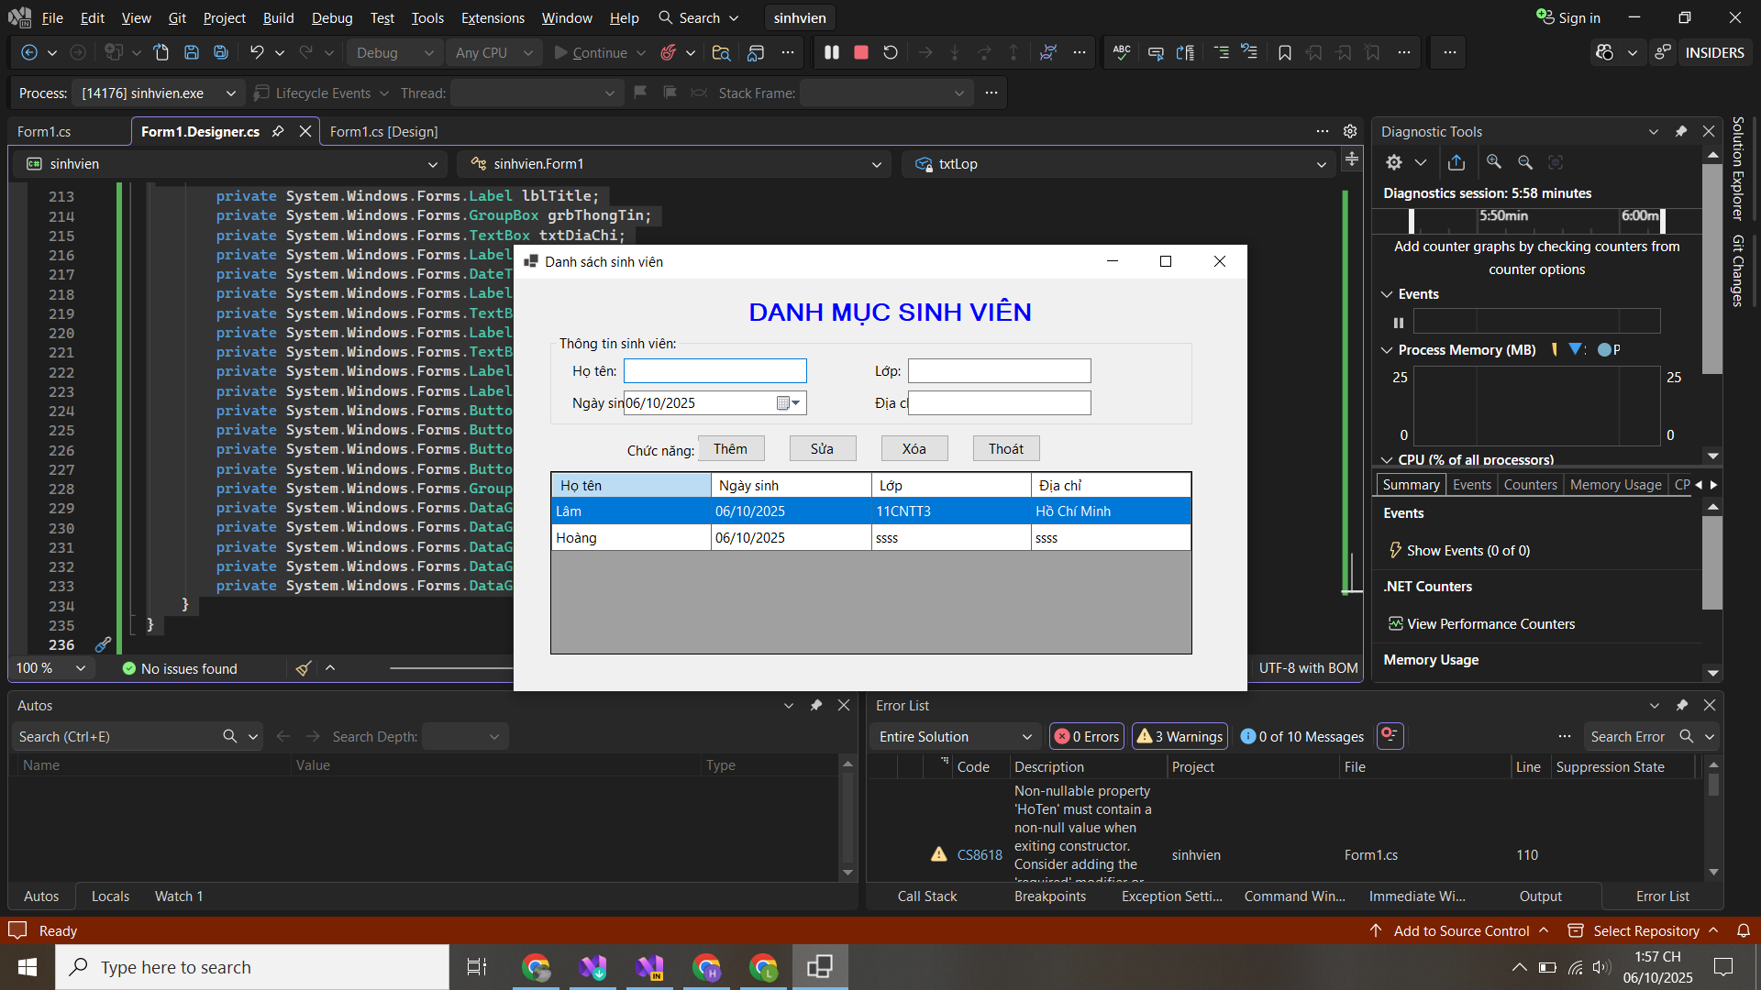

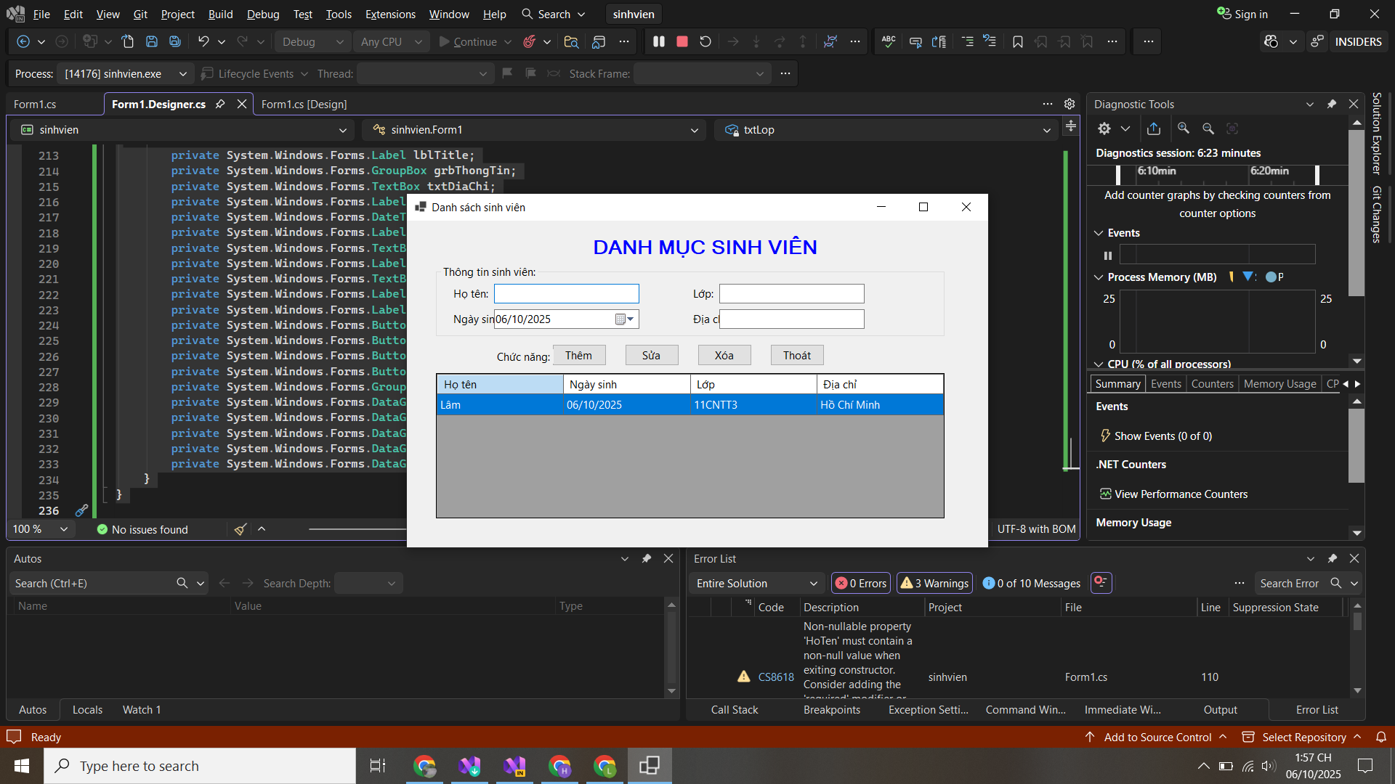

| [Form.cs](http://form.cs) |
| --- |
| using System;  using System.Collections.Generic;  using System.Windows.Forms;  namespace sinhvien  {  public partial class Form1 : Form  {  // Danh sách lưu sinh viên trong bộ nhớ  private List<SinhVien> danhSach = new List<SinhVien>();  public Form1()  {  InitializeComponent();  }  private void HienThiDanhSach()  {  dgvSinhVien.Rows.Clear();  foreach (var sv in danhSach)  {  dgvSinhVien.Rows.Add(sv.HoTen, sv.NgaySinh.ToString("dd/MM/yyyy"), sv.Lop, sv.DiaChi);  }  }  private void btnThem_Click(object sender, EventArgs e)  {  if (string.IsNullOrWhiteSpace(txtHoTen.Text) || string.IsNullOrWhiteSpace(txtLop.Text))  {  MessageBox.Show("Vui lòng nhập đầy đủ Họ tên và Lớp!", "Thiếu dữ liệu");  return;  }  SinhVien sv = new SinhVien  {  HoTen = txtHoTen.Text.Trim(),  NgaySinh = dtpNgaySinh.Value,  Lop = txtLop.Text.Trim(),  DiaChi = txtDiaChi.Text.Trim()  };  danhSach.Add(sv);  HienThiDanhSach();  ClearInput();  }  private void btnSua_Click(object sender, EventArgs e)  {  if (dgvSinhVien.CurrentRow == null)  {  MessageBox.Show("Chọn một sinh viên để sửa.");  return;  }  int index = dgvSinhVien.CurrentRow.Index;  danhSach[index].HoTen = txtHoTen.Text.Trim();  danhSach[index].NgaySinh = dtpNgaySinh.Value;  danhSach[index].Lop = txtLop.Text.Trim();  danhSach[index].DiaChi = txtDiaChi.Text.Trim();  HienThiDanhSach();  }  private void btnXoa_Click(object sender, EventArgs e)  {  if (dgvSinhVien.CurrentRow == null)  {  MessageBox.Show("Chọn một sinh viên để xóa.");  return;  }  int index = dgvSinhVien.CurrentRow.Index;  danhSach.RemoveAt(index);  HienThiDanhSach();  ClearInput();  }  private void btnThoat_Click(object sender, EventArgs e)  {  var result = MessageBox.Show("Bạn có chắc muốn thoát?", "Xác nhận", MessageBoxButtons.YesNo, MessageBoxIcon.Question);  if (result == DialogResult.Yes)  Application.Exit();  }  private void dgvSinhVien_SelectionChanged(object sender, EventArgs e)  {  if (dgvSinhVien.CurrentRow == null || dgvSinhVien.CurrentRow.Index >= danhSach.Count)  return;  var sv = danhSach[dgvSinhVien.CurrentRow.Index];  txtHoTen.Text = sv.HoTen;  dtpNgaySinh.Value = sv.NgaySinh;  txtLop.Text = sv.Lop;  txtDiaChi.Text = sv.DiaChi;  }  private void ClearInput()  {  txtHoTen.Clear();  txtLop.Clear();  txtDiaChi.Clear();  dtpNgaySinh.Value = DateTime.Now;  txtHoTen.Focus();  }  }  // Lớp SinhVien  public class SinhVien  {  public string HoTen { get; set; }  public DateTime NgaySinh { get; set; }  public string Lop { get; set; }  public string DiaChi { get; set; }  }  } |

| [form.designer.cs](http://form.designer.cs) |
| --- |
| using System.Windows.Forms;  using System.Drawing;  namespace sinhvien  {  partial class Form1  {  private System.ComponentModel.IContainer components = null;  protected override void Dispose(bool disposing)  {  if (disposing && (components != null)) components.Dispose();  base.Dispose(disposing);  }  #region Windows Form Designer generated code  private void InitializeComponent()  {  this.lblTitle = new System.Windows.Forms.Label();  this.grbThongTin = new System.Windows.Forms.GroupBox();  this.txtDiaChi = new System.Windows.Forms.TextBox();  this.lblDiaChi = new System.Windows.Forms.Label();  this.dtpNgaySinh = new System.Windows.Forms.DateTimePicker();  this.lblNgaySinh = new System.Windows.Forms.Label();  this.txtLop = new System.Windows.Forms.TextBox();  this.lblLop = new System.Windows.Forms.Label();  this.txtHoTen = new System.Windows.Forms.TextBox();  this.lblHoTen = new System.Windows.Forms.Label();  this.lblChucNang = new System.Windows.Forms.Label();  this.btnThem = new System.Windows.Forms.Button();  this.btnSua = new System.Windows.Forms.Button();  this.btnXoa = new System.Windows.Forms.Button();  this.btnThoat = new System.Windows.Forms.Button();  this.grbDanhSach = new System.Windows.Forms.GroupBox();  this.dgvSinhVien = new System.Windows.Forms.DataGridView();  this.colHoTen = new System.Windows.Forms.DataGridViewTextBoxColumn();  this.colNgaySinh = new System.Windows.Forms.DataGridViewTextBoxColumn();  this.colLop = new System.Windows.Forms.DataGridViewTextBoxColumn();  this.colDiaChi = new System.Windows.Forms.DataGridViewTextBoxColumn();  this.grbThongTin.SuspendLayout();  this.grbDanhSach.SuspendLayout();  ((System.ComponentModel.ISupportInitialize)(this.dgvSinhVien)).BeginInit();  this.SuspendLayout();  //  // lblTitle  //  this.lblTitle.AutoSize = true;  this.lblTitle.Font = new System.Drawing.Font("Microsoft Sans Serif", 16F, System.Drawing.FontStyle.Bold);  this.lblTitle.ForeColor = System.Drawing.Color.Blue;  this.lblTitle.Location = new System.Drawing.Point(250, 20);  this.lblTitle.Name = "lblTitle";  this.lblTitle.Size = new System.Drawing.Size(270, 26);  this.lblTitle.Text = "DANH MỤC SINH VIÊN";  //  // grbThongTin  //  this.grbThongTin.Controls.Add(this.txtDiaChi);  this.grbThongTin.Controls.Add(this.lblDiaChi);  this.grbThongTin.Controls.Add(this.dtpNgaySinh);  this.grbThongTin.Controls.Add(this.lblNgaySinh);  this.grbThongTin.Controls.Add(this.txtLop);  this.grbThongTin.Controls.Add(this.lblLop);  this.grbThongTin.Controls.Add(this.txtHoTen);  this.grbThongTin.Controls.Add(this.lblHoTen);  this.grbThongTin.Location = new System.Drawing.Point(40, 60);  this.grbThongTin.Name = "grbThongTin";  this.grbThongTin.Size = new System.Drawing.Size(700, 100);  this.grbThongTin.TabStop = false;  this.grbThongTin.Text = "Thông tin sinh viên:";  //  // lblHoTen  //  this.lblHoTen.AutoSize = true;  this.lblHoTen.Location = new System.Drawing.Point(20, 30);  this.lblHoTen.Text = "Họ tên:";  //  // txtHoTen  //  this.txtHoTen.Location = new System.Drawing.Point(80, 27);  this.txtHoTen.Size = new System.Drawing.Size(200, 22);  //  // lblLop  //  this.lblLop.AutoSize = true;  this.lblLop.Location = new System.Drawing.Point(350, 30);  this.lblLop.Text = "Lớp:";  //  // txtLop  //  this.txtLop.Location = new System.Drawing.Point(390, 27);  this.txtLop.Size = new System.Drawing.Size(200, 22);  //  // lblNgaySinh  //  this.lblNgaySinh.AutoSize = true;  this.lblNgaySinh.Location = new System.Drawing.Point(20, 65);  this.lblNgaySinh.Text = "Ngày sinh:";  //  // dtpNgaySinh  //  this.dtpNgaySinh.Format = System.Windows.Forms.DateTimePickerFormat.Short;  this.dtpNgaySinh.Location = new System.Drawing.Point(80, 62);  this.dtpNgaySinh.Size = new System.Drawing.Size(200, 22);  //  // lblDiaChi  //  this.lblDiaChi.AutoSize = true;  this.lblDiaChi.Location = new System.Drawing.Point(350, 65);  this.lblDiaChi.Text = "Địa chỉ:";  //  // txtDiaChi  //  this.txtDiaChi.Location = new System.Drawing.Point(390, 62);  this.txtDiaChi.Size = new System.Drawing.Size(200, 22);  //  // lblChucNang  //  this.lblChucNang.AutoSize = true;  this.lblChucNang.Location = new System.Drawing.Point(120, 177);  this.lblChucNang.Name = "lblChucNang";  this.lblChucNang.Size = new System.Drawing.Size(72, 16);  this.lblChucNang.Text = "Chức năng:";  //  // Buttons  //  this.btnThem.Text = "Thêm";  this.btnThem.Location = new System.Drawing.Point(200, 170);  this.btnThem.Size = new System.Drawing.Size(75, 30);  this.btnThem.Click += new System.EventHandler(this.btnThem_Click);  this.btnSua.Text = "Sửa";  this.btnSua.Location = new System.Drawing.Point(300, 170);  this.btnSua.Size = new System.Drawing.Size(75, 30);  this.btnSua.Click += new System.EventHandler(this.btnSua_Click);  this.btnXoa.Text = "Xóa";  this.btnXoa.Location = new System.Drawing.Point(400, 170);  this.btnXoa.Size = new System.Drawing.Size(75, 30);  this.btnXoa.Click += new System.EventHandler(this.btnXoa_Click);  this.btnThoat.Text = "Thoát";  this.btnThoat.Location = new System.Drawing.Point(500, 170);  this.btnThoat.Size = new System.Drawing.Size(75, 30);  this.btnThoat.Click += new System.EventHandler(this.btnThoat_Click);  //  // grbDanhSach  //  this.grbDanhSach.Controls.Add(this.dgvSinhVien);  this.grbDanhSach.Location = new System.Drawing.Point(40, 210);  this.grbDanhSach.Size = new System.Drawing.Size(700, 200);  this.grbDanhSach.TabStop = false;  this.grbDanhSach.Text = "Thông tin danh sách sinh viên:";  //  // dgvSinhVien  //  this.dgvSinhVien.AllowUserToAddRows = false;  this.dgvSinhVien.AllowUserToResizeRows = false;  this.dgvSinhVien.AutoSizeColumnsMode = System.Windows.Forms.DataGridViewAutoSizeColumnsMode.Fill;  this.dgvSinhVien.ColumnHeadersHeightSizeMode = System.Windows.Forms.DataGridViewColumnHeadersHeightSizeMode.AutoSize;  this.dgvSinhVien.Columns.AddRange(new System.Windows.Forms.DataGridViewColumn[] {  this.colHoTen, this.colNgaySinh, this.colLop, this.colDiaChi  });  this.dgvSinhVien.Dock = System.Windows.Forms.DockStyle.Fill;  this.dgvSinhVien.MultiSelect = false;  this.dgvSinhVien.RowHeadersVisible = false;  this.dgvSinhVien.SelectionMode = System.Windows.Forms.DataGridViewSelectionMode.FullRowSelect;  this.dgvSinhVien.Size = new System.Drawing.Size(700, 200);  this.dgvSinhVien.SelectionChanged += new System.EventHandler(this.dgvSinhVien_SelectionChanged);  //  // Columns  //  this.colHoTen.HeaderText = "Họ tên";  this.colHoTen.MinimumWidth = 60;  this.colHoTen.Name = "colHoTen";  this.colNgaySinh.HeaderText = "Ngày sinh";  this.colNgaySinh.MinimumWidth = 60;  this.colNgaySinh.Name = "colNgaySinh";  this.colLop.HeaderText = "Lớp";  this.colLop.MinimumWidth = 40;  this.colLop.Name = "colLop";  this.colDiaChi.HeaderText = "Địa chỉ";  this.colDiaChi.MinimumWidth = 80;  this.colDiaChi.Name = "colDiaChi";  //  // Form1  //  this.ClientSize = new System.Drawing.Size(800, 450);  this.Controls.Add(this.lblTitle);  this.Controls.Add(this.grbThongTin);  this.Controls.Add(this.lblChucNang);  this.Controls.Add(this.btnThem);  this.Controls.Add(this.btnSua);  this.Controls.Add(this.btnXoa);  this.Controls.Add(this.btnThoat);  this.Controls.Add(this.grbDanhSach);  this.Name = "Form1";  this.StartPosition = System.Windows.Forms.FormStartPosition.CenterScreen;  this.Text = "Danh sách sinh viên";  this.grbThongTin.ResumeLayout(false);  this.grbThongTin.PerformLayout();  this.grbDanhSach.ResumeLayout(false);  ((System.ComponentModel.ISupportInitialize)(this.dgvSinhVien)).EndInit();  this.ResumeLayout(false);  this.PerformLayout();  }  #endregion  private System.Windows.Forms.Label lblTitle;  private System.Windows.Forms.GroupBox grbThongTin;  private System.Windows.Forms.TextBox txtDiaChi;  private System.Windows.Forms.Label lblDiaChi;  private System.Windows.Forms.DateTimePicker dtpNgaySinh;  private System.Windows.Forms.Label lblNgaySinh;  private System.Windows.Forms.TextBox txtLop;  private System.Windows.Forms.Label lblLop;  private System.Windows.Forms.TextBox txtHoTen;  private System.Windows.Forms.Label lblHoTen;  private System.Windows.Forms.Label lblChucNang;  private System.Windows.Forms.Button btnThem;  private System.Windows.Forms.Button btnSua;  private System.Windows.Forms.Button btnXoa;  private System.Windows.Forms.Button btnThoat;  private System.Windows.Forms.GroupBox grbDanhSach;  private System.Windows.Forms.DataGridView dgvSinhVien;  private System.Windows.Forms.DataGridViewTextBoxColumn colHoTen;  private System.Windows.Forms.DataGridViewTextBoxColumn colNgaySinh;  private System.Windows.Forms.DataGridViewTextBoxColumn colLop;  private System.Windows.Forms.DataGridViewTextBoxColumn colDiaChi;  }  } |