

**DOI:** <https://doi.org/10.37811/cl_rcm.vxix.xxx>

The Effect of Teaching English Grammar Bilingually to True Beginners at a University in Ecuador

**Manuel Francisco Morales Haz**

mfmorales@uteq.edu.ec

**Karina Fernanda Sotomayor Cantos**

ksotomayor@uteq.edu.ec

**Héctor Enrique Valverde Moreira**

hvalverde@uteq.edu.ec

**Esperanza Monserrate Heredia Mendoza**

eherediam@uteq.edu.ec

**Jorge Rosendo Flores Herrera**

rflores@espol.edu.ec

Universidad Técnica Estatal de Quevedo

Quevedo - Ecuador

## ABSTRACT

This study looked into how teaching grammar bilingually affected the performance of students English as a Foreign Language (EFL) on grammar examination at an Ecuadorian institution of higher education. Research to date has predominantly focused on the attitudes and preferences of instructors and students about the use of the first language, how it is distributed during class, how it helps learners work together to complete tasks, and how teacher and student interactions take place in the classroom. Research on the impact of L1 use on L2 learning has mostly examined vocabulary learning. In the current study, 71 students, aged 17 to 36, enrolled in a preparation course prior to university classes were randomly assigned to a condition in which the L2 grammar was taught bilingually or a condition in which the L2 grammar was explained using only the L2, and their performance on grammar was tested and compared. The results of this study suggest that grammar learning was enhanced by both the bilingual condition and the L2-only condition. The results demonstrate that there were not significant differences on both immediate and delayed posttests between the bilingual instruction condition and the L2-only condition. There are some suggested explanations for these findings.

## Keywords: effect; teaching; language; students.

Correspondencia:

Artículo recibido: día mes 2022. Aceptado para publicación: día mes 2022.

Conflictos de Interés: Ninguna que declarar

Todo el contenido de **Ciencia Latina Revista Científica Multidisciplinar**, publicados en este sitio están disponibles bajo Licencia [Creative Commons](https://creativecommons.org/licenses/by/4.0/deed.es) [https://revistacientifica.uamericana.edu.py/public/site/images/aduarte/cc2.png](https://creativecommons.org/licenses/by/4.0/deed.es).

Como citar: Apellidos de autores (año). Título del artículo. Ciencia Latina Revista Científica Multidisciplinar, Volumen(Número), página inicio-página final. DOI: <https://doi.org/10.37811/cl_rcm.vxix.xxx>

The Effect of Teaching English Grammar Bilingually to True Beginners at a University in Ecuador

## RESUMEN

Este estudio analizó cómo la enseñanza bilingüe de la gramática inglesa afectó el desempeño de los estudiantes de inglés como lengua extranjera (EFL) en las pruebas de gramática en una institución de educación superior ecuatoriana. La investigación hasta la fecha se ha concentrado en las actitudes y preferencias de los instructores y estudiantes sobre el uso de la lengua natal, cómo se distribuye durante la clase, cómo ayuda a los estudiantes a trabajar juntos para completar las tareas, cómo se dan las interacciones entre maestros y estudiantes en el salón de clases, y el impacto en el aprendizaje de vocabulario L2. En este estudio, 71 estudiantes, de 17 a 36 años de edad, matriculados en un curso preuniversitario, fueron asignados aleatoriamente a una condición en la que la gramática L2 se enseñaba de forma bilingüe o una condición en la que la gramática L2 se explicaba utilizando solo la L2, y se evaluó y comparó el desempeño en gramática. Los resultados sugieren que el aprendizaje de la gramática mejoró en ambas condiciones y no hubo diferencias significativas entre las pruebas posteriores inmediatas y tardías entre los grupos. Se presentan en este documento algunas posibles explicaciones sobre estos hallazgos.

***Palabras clave:*** efecto; enseñanza; idioma; estudiantes.

**COMPLETAR DATOS DE CONTACTO**

**Correo principal para contacto: mfmorales@uteq.edu.ec**

**Número de WhatsApp o Telegrama (incluir código país): 593-99-857-1264**

## INTRODUCTION

Although there are currently theoretical advancements, research findings, and prominent writers of English Language Teaching (ELT) methodology that attribute the learner's first language (L1) a role in learning a second language (L2) such as Newton and Nation (2021), Nation and Macallister (2021), and Scrivener (2017), there is still the perception among some English language teachers that excluding the learners' L1 from the classroom is associated with good standards in the discipline. This misconception could lead to the formal implementation of practices that could deprive learners and teachers from a very important mediating tool. As an example, current laws governing higher education in Ecuador mandate that undergraduates reach a level of proficiency in English language equivalent to the B1 level of the Common European Framework of Reference for Languages. Thus, decision makers at universities, based on wrong assumptions about L1 use in the L2 classroom, could adopt policies and guidelines that suppress the learners' L1 during L2 instruction. This could make more difficult for learners to reach the B1 level of proficiency. Therefore, it is very important to teach learners with current teaching practices based on research, and not on opinions.

In this vein, this study attempts to provide stakeholders important insights about the role of the learners’ L1 in L2 acquisition and demystify its use in the classroom. This research-based information will also support administrators and teachers in their decisions and daily teaching. In addition, since the learners’ L1 is valued and recognized, lessons will be authentically student-centered. But first, we have to take a look at the current state of knowledge on this respect.

Some scholars have made a literature review on the use of the L1 in the L2 classroom. For instance, Almoayidi (2018) concluded that even though there are numerous studies that claim that using the L1 does contribute to L2 learning, other studies suggest that the best way to learn an L2 is by using the L2 as the language of the instruction, and that the decision to use one or the other will depend on several factors such as the type of learners, the instructor’s L2 level of proficiency, the learner’s purposes of learning the L2, and government or school regulations. Zulfilkar (2019) states that using the L1 in the L2 classroom is inevitable and it does not impede L2 learning and has a facilitating and key role in learning and teaching language. Shin et al. (2020) made a review of published empirical literature on the use of the L1 in the FL classroom from 2011 to 2018. They found that the majority of studies support judicious L1 use in L2 instruction. By that it’s meant not only the amount and frequency of L1, but also its purpose, content, and type of tasks to maximize L2 learning.

Other researchers have conducted interviews and collected data from questionnaires and semi-structured interviews administered to learners to get insights regarding their views on L1 use in the L2 classroom. These studies have in common that they found that learners have a favorable use of the L1 for learning the L2. For instance, Shariati (2019), found that lower-level proficiency learners have a better attitude towards L1 use than upper-level learners. Participants reported they used the L1 to ask new language topics, to find correct English words, and to explain grammar points to their classmates. They also believed that teachers should use the L1 to explain difficult vocabulary, grammar, and for class management. Galali and Cinkara (2017) found similar responses from their student participants, but with the difference that advanced learners preferred the L2 because it is more conducive to L2 learning. Only in Saburlu’s study (2019) learners reported negative views on L1 use, arguing that they can learn faster and easily when they are exposed to the L2 more often.

Similarly, other researchers have aimed to study the teachers’ perspectives on L1 use in teaching the L2 through questionnaires and semi-structured interviews, too. Georgious and Krulatz (2018) reported from surveys that 92% of the 24 in-service elementary and middle-school EFL teachers in Norway employed the L1 in L2 teaching. In the same way, data from questionnaires provided to foreign language teachers in England and Spain by Molway, Arcos, and Macaro (2022) showed that both groups used their corresponding L1 in classes. Furthermore, teachers mostly used the L1 at lower levels of proficiency (Taşçı & Ataç, 2020; Algazo, 2022). Among the reasons teachers use the L1 for L2 teaching, Taşçı and Ataç (2020) obtained the following from semi-structured interviews and class observations of three primary school teachers in Turkey: to give instructions, to teach grammar, to teach difficult vocabulary, to manage the classroom, to check understanding, to draw students’ attention, to elicit, and to provide feedback. Likewise, Perdani’s (2021) research showed that four high school English language teachers from Indonesia provided information through questionnaires and semi-structured interviews that they use the L1 because it was easier for them to interact with their students, to explain L2 grammar, clarify meaning, and teach difficult words. From İnal and Turhanlı’s (2019) questionnaires and semi-structured interviews, 18 EFL university teachers from Turkey expressed, despite they believe the L1 has several functions such as teaching grammar, explaining vocabulary, dealing with disciplinary issues, and raising students’ awareness of the differences and similarities between English and their L1, they thought the L1 should not be used when teaching the four skills.

A third group of researchers attempted to find both the teachers’ and learners’ perceptions on using the L1 in L2 lessons. In a study conducted by Tajgozari (2017) at an English language institute in Iran, 56 EFL learners at elementary, intermediate, and advance levels, and 11 EFL teachers responded through questionnaires (the students) and interviews (teachers) that they had a positive perception of L1 use although most teachers stated their unwillingness to use it in the L2 classroom. In addition, ninety percent of elementary students, 73.3% of intermediate ones, and 52.1% of advanced students demonstrated positive opinions on L1 use in English classes. By the same token, Mahmud (2018) reported from the questionnaires and interviews administered to 10 teachers and 60 students at a university in Bangladesh that these pedagogical functions of L1 use were found: explanation of meaning, grammar, and complex patterns of language, and building rapport with learners. However, teachers recommended judicious use of the L1 (Bangla). Another reason why teachers have to recur to L1 use to teach the L2 is due to an important number of challenges teachers have to face such as insufficient time to complete the syllabus and learners’ weak linguistic background (Rasheed, Zeeshan, & Zaidi, 2017)

As seen so far, there is an important amount of empirical evidence that supports L1 use in the L2 classroom. Nevertheless, aversion towards the use of the L1 in learning the L2 still prevails. Moreover, the results of some research could be misleading in favor of total ban of the L1 in the L2 lesson. For example, Septianasari, Huznatul, and Baihaqui (2019) concluded that the L1 grammar and phonology interferes with L2 learning. However, as educators, we have to make a balance of the advantages and disadvantages of using the L1 for L2 teaching.

To summarize, the insights obtained from recent empirical evidence shows there is a role for the L1 in L2 learning and teaching. Since one of the uses for the L1 was to teach grammar, this research tried to contribute to the current scientific literature by attempting to find whether there is a difference in pretest and posttest scores of grammar achievement tests between a group of beginner-level students enrolled in preparatory courses prior to enter college that received grammar instruction bilingually and another group with the same type of students that received the same grammar instruction only in English. Therefore, the null hypotheses were the following:

(1) there is no difference in the scores of post-tests between pre-A1 EFL learners who are taught grammar using the L1 and pre-A1 EFL learners who are taught in L2-only; (2)

there is no difference in the scores of delayed tests between pre-A1 EFL learners who are taught grammar using the L1 and pre-A1 EFL learners who are taught in L2-only.

## METHODS

This paper aligns to a positive research paradigm and adopted a quantitative research method. The research design was quasi-experimental and involved a pretest/posttest control group design, and a delayed test for each group after two weeks from the final instructional session. The data obtained from grammar tests were scored and statistical analysis was conducted.

The participants were originally 71 students enrolled in a preparation course prior to be admitted to a university located in Quevedo city, in Ecuador. After obtaining authorization from the corresponding officials from the university, students from 33 classrooms were invited to be part of the research. They were provided with detailed information about the study through an Informed Consent Form (IFC). A different version that required parents or custodians’ approval was given to minors. A total of 142 students signed the IFC and took a placement test on a different day. This instrument was part of the course book used at the university. The publisher authorized the use of its materials for this research. Because the study focused on true beginners or pre-A1 learners, only participants who were placed at level 1A or 1B were selected, which was a total of 71 people. According to the table provided by the course book, students who are placed at those levels are on the way to attain an A1 level. The ages of the final participants ranged from 17 to 23, but one of them was 36. Then they were randomly placed in an experimental group or in a control group with a matching process based on gender. After that, there were a total of 35 participants in the control group, and 36 participants in the experimental group. The number of participants decreased during the study up to 9 people for the experimental group and 14 people for the control one in the last session in week 4.

The instructional material was the same coursebook used for level 1 students at the university. The grammar topics for this study included the following: 1) The simple present of the verb be and possessive adjectives; 2) singular subject pronouns and yes-no questions with be; 3) plural subject pronouns and wh-questions with be; 4) *Who* and *How old* with be; 5) demonstratives, articles *a* and *an*, and plurals; 6) possessive pronouns, whose, and possessive nouns; 7) simple present statements; 8) simple present yes-no questions.

The research took place in six weeks in January and February in 2017. In the first four weeks, participants attended two 2-hour class sessions a week. The experimental group attended lessons on Mondays and Wednesdays from 8:30 a.m. to 10:30 a.m. The control group attended on Tuesdays and Thursdays from 8:30 a.m. to 10:30 a.m. Two weeks after the final session, participants took another test to measure the mid-term effect of both types of instruction.

Before and after each class, a pretest and a posttest were given to the control group and experimental group to measure the effect of grammar instruction between groups and within groups. Even though the testing instrument was part of the material of the course book, which was designed by a worldwide publisher from one of the top five universities in the world, we confirmed the tests measured the grammar topics to be taught in each session.

All lessons were taught in English by the same teacher in the same way, except for the experimental group, who received English grammar instruction by using translation through the sequence L2-L1-L2, for each word, phrase, or sentence. The rest of the lesson was completely in English and taught in the same way as the control group. Both groups were taught by using the Presentation-Practice-Production (PPP) approach.

Before each lesson started, participants were given a grammar test about the topics to be explained on that day. Participants were given 8 minutes to complete them. After that, each lesson for both groups began by introducing new vocabulary explicitly through contextualization, cognates, drawings, pictures, and verbal and written explanations delivered only in English. Then an audio recording containing a conversation was played. The conversation included the vocabulary introduced previously and the new grammar, which was presented implicitly and contextualized. After that, grammar was explained through the use of a table that highlighted in bold letters the new structures to help learners to notice them. Grammar was explained in English, but the experimental group received an explanation bilingually by using the sequence L2-L1-L2 for words, phrases, or sentences. After concept check questions, participants completed a sheet of grammar exercises individually, and help was provided during that activity. Later, the teacher and students checked the answers in class. Then participants were given a semi-controlled speaking activity. Assistance and feedback were offered at the request of participants or the teacher interrupted a conversation if a mistake was so important that could impede communication in the future.

Once the speaking activity was over, the grammar posttest was administered using the same instrument from the course book. Lessons were only for four weeks. Two weeks after the final session, participants took a delayed test in order to measure the mid-term effect of both types of grammar instruction.

Then the tests were marked, and scores were obtained and entered in a Microsoft Excel spreadsheet. Next, the scores were registered by session, by group, and by the type of test (pretest/posttest/delayed test). After that, it was necessary to standardize the scores over 10 points in order to make valid quantitative comparisons.

The *t* statistic was selected for the inferential analysis because the type of scale was nominal and the sample size was less than 30. Since we wanted to make comparisons of grammar test scores between groups (independent measures) and within groups (repeated measures), we had to consider if certain statistical assumptions were met in order to choose the correct *t* test.

According to Gravetter and Wallnau (2017), before using the *t* test for independent measures, three assumptions must be taken into consideration: 1) the data must come from two independent samples; 2) the two populations of the sample must have a normal distribution; and 3) the variances of the two populations of the samples must be equal. As for the first criteria, we confirmed it was met since the samples came from two different groups (the control and experimental ones). With respect to the second assumption, we believed the two samples came from populations with a normal discribution since the total amount of pre-university students was around 1,200 people, and data have a tendency to create a normal curve as the number of observations increases (Gravetter & Wallnau, 2017). As with the third assumption, it was difficult to know whether the variance from the two populations were equal, thus, according to Larson-Hall (2012), when the equal variance criteria cannot be met, Welch’s *t* test is recommended. As a consequence, in order to compare test scores between the control and experimental groups, we selected that type of *t* test, also known as *t* test for unequal variances.

As regards with the statistic to compare grammar test scores within each group (repeated-measures or within-subject design), we chose Wilcoxon test based on the following rationale. Because the participants’ mortality increased during the study (n < 30), we initially considered the dependent *t* test. There are two assumptions to meet before using thistest: 1) the observations must be independent within each treatment; 2) the population’s difference scores must have a normal distribution and it should not be a concern if the sample size is large enough (Gravetter & Wallnau, 2017). In our study, the first assumption was met since the treatment applied to the same participants took place at different times. As for the second assumption, we believed it was not fulfilled, given that the sample size decreased during the period of the study. Nevertheless, when either of the above assumptions cannot be satisfied for dependent sample *t* test, the Wilcoxon test is suggested (Gravetter & Wallnau, 2017).

We used IBM SPSS version 23 to obtain the statistics and elaborate the tables showed below. To corroborate the results given by the SPSS software, we used the calculator provided at www.socscistatistics.com/tests. On the other hand, we calculated Cohen’s *d* on a MS Excel spreadsheet by using the formula presented by Gravetter and Wallnau (2017). Finally, we also used the online calculator at https://lbecker.uccs.edu/ to verify Cohen’s *d* calculations.

## RESULTS AND DISCUSSION

In order to test the first hypothesis, we administered both groups a pretest and a posttest for every session. For the second hypothesis, we only used a posttest after two weeks from the last instructional session. For this reason, we divided this section in two types of analysis: analysis by session and delayed posttest analysis. In turn, the analysis by session is divided in four types of analysis: control group and experimental group pretest, control group pretest-posttest, experimental group pretest-posttest, and control group and experimental group posttest. It is also important to mention that although there were a couple of outliers, they were not removed from the data since the conclusions were not different from the ones in which they were taken out.

Table 1

Analysis by session: control group vs experimental group pretest analysis.

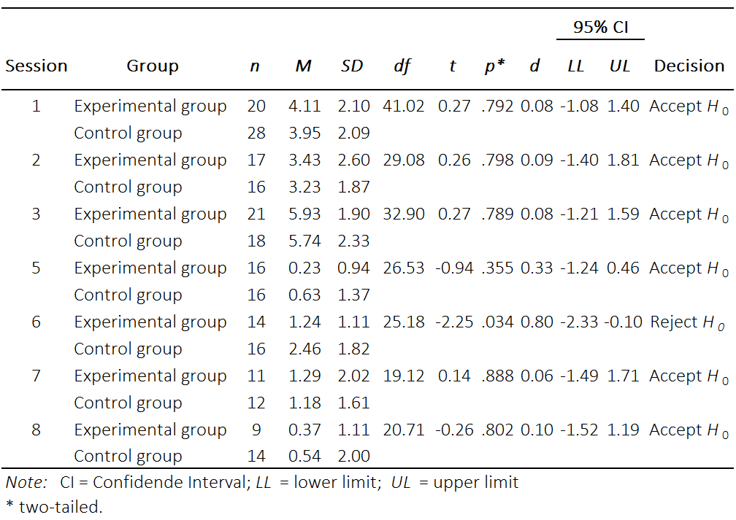

For the purpose of internal validity, it was necessary to verify that participants from the experimental and control groups do not have a different level of knowledge of English grammar prior to each of the teaching sessions. The way to do so was by administering a test just before every teaching session (pretest). The results from the *t* test not assuming homogeneous variances (Welch’s *t* test), as showed in Table 1, indicated that, except for session 6, most grammar tests scores before every instructional session were not statistically different between both control and experimental groups, showing that neither group had an advantage over the other with respect to the level of grammar knowledge before the treatment.

Table 2

Analysis by session: control group pretest-posttest analysis.

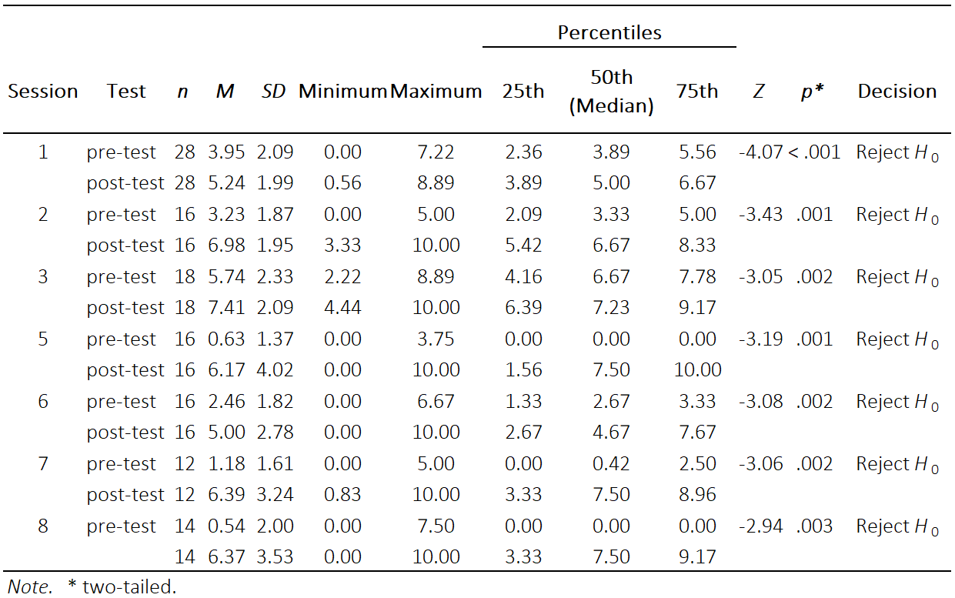

In addition, a pretest-posttest analysis for each group was necessary to conduct in order to measure the effect of instruction independent of the type of treatment. The results obtained from the control group, as showed in Table 2, indicate that the null hypothesis (there is no difference in grammar test scores before and after receiving the lessons totally in English) was rejected. The results from the Wilcoxon test showed that the value of *p* was always much less than the level of significance of 0.05.

Table 3

Analysis by session: experimental group pretest-posttest analysis.

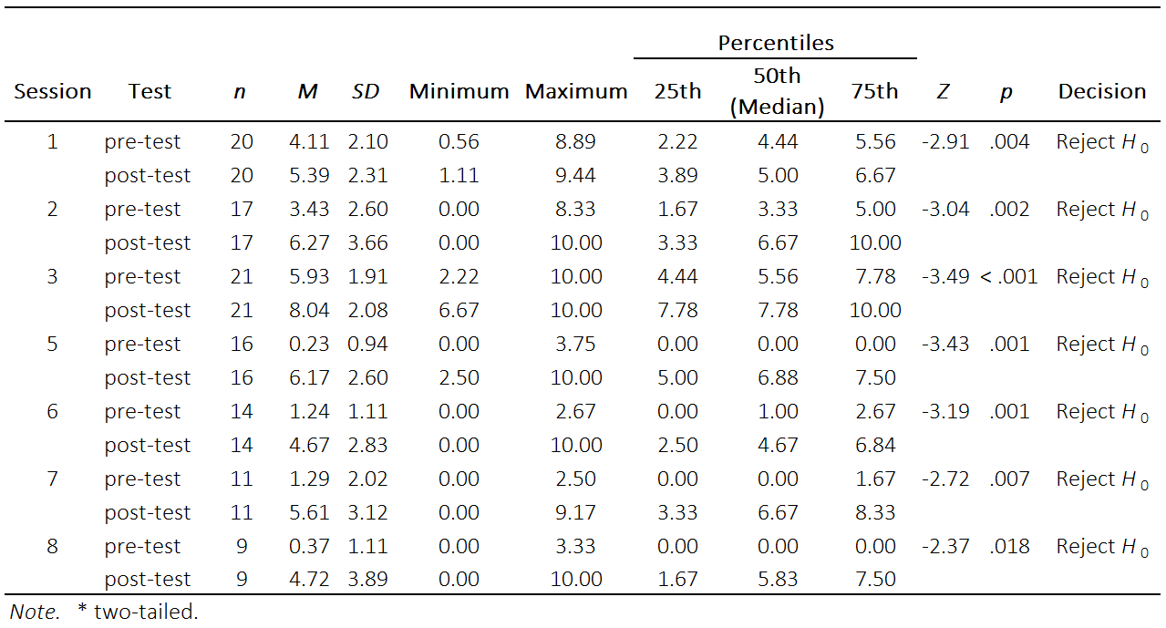

The results from the pretest-posttest analysis by session of the experimental group showed in Table 3 were similar to the control group. The values of *p* obtained from Wilcoxon test were very low, much less than the level of significance of 0.05. Therefore, the null hypothesis for each session was rejected. In other words, there were significant differences in grammar test scores within the experimental group before and after instruction in all eight sessions.

So far, we have seen that both types of grammar instruction, both monolingually (English-only) and bilingually (English and Spanish), did have a positive effect in learning English grammar. Now, in Table 4, we compared the grammar test scores at the end of each instructional session between the control group and experimental group, to determine if a possible difference could be explained by the treatment on the experimental group (bilingual grammar instruction).

Table 4

Analysis by session: control group vs experimental group posttest analysis.

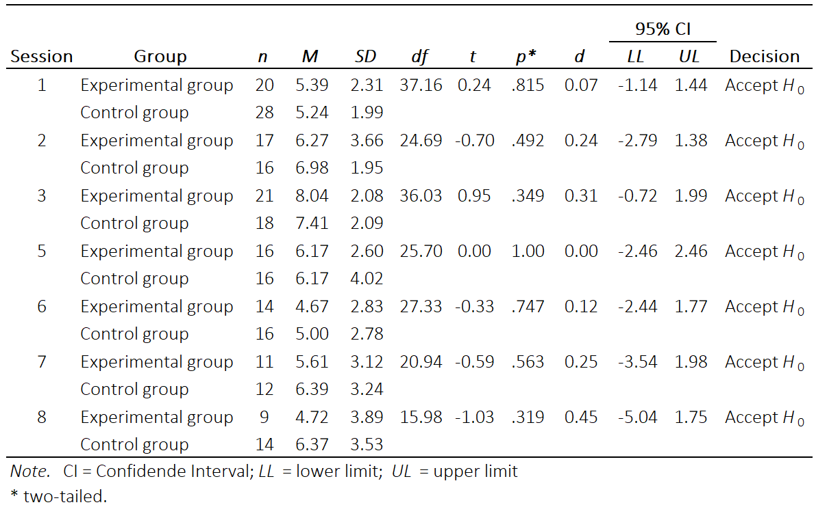

The inferential analysis displayed in Table 4 showed that the null hypothesis is accepted i.e., in all eight sessions there was no significant statistical difference between the grammar posttest scores from the experimental group and the grammar posttest scores from the control group. Therefore, participants who received English grammar instruction did not outperformed participants who received the same type of instruction but in English only or vice versa. However, we still have to show the results from the delayed posttest analysis.

Table 5

*Delayed posttest analysis*

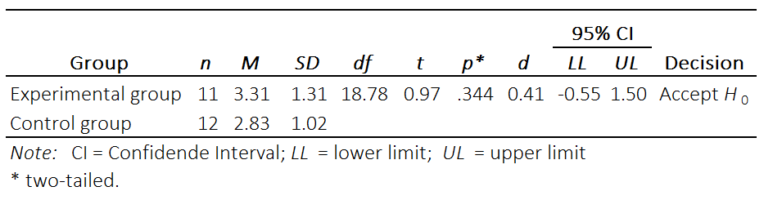

Finally, in Table 5, the statistical analysis from the delayed posttest that took place two weeks after the last teaching session in order to find out whether there was a mid-term effect on English grammar learning showed that no significant statistical difference between the two groups’ mean scores was found.

In contrast with similar studies (Alijani & Barjesteh, 2018; Arshad et al., 2015;

de la Fuente & Goldenberg, 2020; Navidinia et al., 2020; Shabaka-Fernández, 2021) in which the experimental group, the one that received L2 instruction both in the L1 and L2, outperformed the control, that was taught the L2 by using the very same language as a mediating tool, in our study there was no difference in the performance score of both groups not even in posttests for every session nor in the delayed posttest. Therefore, bilingual grammar instruction had a similar effect to L2-only grammar instruction.

A possible explanation for this outcome is that the participants were intrinsically motivated to learn English. They accepted to participate in the study in their free time even though they had the responsibility of passing their pre-university course. As the number of participants dropped down throughout the research, maybe the most motivated ones stayed and put a lot of effort to learn the topics taught and it did not matter for them if they were delivered only in the L2 or bilingually. Moreover, since there was no consequence for them if they did not learn the grammar topics such as failing the class or paying extra fees, they felt comfortable enough to the point that it was conducive to learning.

Another possible explanation could be that the grammar topics taught in this study were not too complex. They can successfully be explained in the L2 through charts, drawings, realia, cognates, etc. In contrast, structures that carry more abstract meaning could have been more difficult to teach by the instructor and understand by the learners by using only the L2. For instance, teaching more advanced grammar such as the third conditional or the structure *I wish* + simple past would have required the use of the L1 to confirm meaning. As in Taigozari’s (2017) study, a majority (73.3%) of intermediate-level English language students and almost half (52.1%) of the advanced-level students of English reported through questionnaires that they had a favorable use of the L1. However, the complexity of the grammar topic could not be a possible explanation of the lack of effect of the treatment. In Arshad et al. (2015), they did not find a significant difference between the results of grammar tests administered to experimental and control groups of upper-intermediate learners.

A third possible explanation could be that a combination of the teaching material and the teacher’s background contributed to the same positive impact in learning from the two ways of grammar teaching. The activities and exercises provided by the course book perhaps were engaging enough so that learning took place, and together with the teacher’s qualifications and experience did not make a difference in the way grammar was taught. Furthermore, the number of participants was smaller after every session, which allowed them to have more attention by the teacher for answering their questions and obtaining feedback. In addition, all lessons were delivered in the allotted time. Having insufficient time to complete the syllabus and insufficient teaching training were some of the reasons teachers interviewed by Rasheed et al. (2017) reported that they had to recur to the L1.

## CONCLUSIONS

This study aimed to determine whether there is a difference in the results of English grammar tests administered to beginners of English (pre-A1) between a group that received grammar instruction completely in English and another group that received grammar instruction using Spanish (L1) and English. The results will have implications for teaching practices, teaching guidelines and rules elaborated by principals and government officials, and the learners’ resources they can bring to the classroom to achieve a B1 level of proficiency.

The results of the study showed there was a positive impact on grammar learning by using the L2-only and the L1 and L2 together, and that this impact was similar in both types of teaching. These results do not coincide with the ones from similar studies that measured both type of instructions. However, our results also indicate that using the L1 does not hinder L2 grammar learning. Therefore, it could be used in the classroom and would allow teachers and learners to have at their disposal this facilitating tool.

Nevertheless, we do not prescribe indiscriminate use of the L1, but judicious use of it. As research have demonstrated (Algazo, 2022; Galali & Cinkara, 2017; Georgious & Krulatz, 2018; İnal & Turhanlı, 2019; Mahmud, 2018; Perdani, 2021; Shariati, 2019; Tajgozari, 2017; Taşçı & Aksu Ataç, 2020), teachers and learners prefer using the L1 to teach grammar, explain difficult vocabulary, confirm meaning, and classroom management, and particularly with learners at lower levels of proficiency.

## REFERENCES

Algazo, M. (2022). Teachers’ Perspectives on the Role of L1 in Jordanian EFL Classes. *Education and Linguistics Research*, *8*(1), 28. https://doi.org/10.5296/elr.v8i1.19378

Alijani, A., & Barjesteh, H. (2018). The Impact of Using L1 for Teaching Grammar among Iranian EFL Learners. *English Literature and Language Review*, *4*(3), 26–31. http://arpgweb.com/?ic=journal&journal=9&info=aims

Almoayidi, K. A. (2018). The Effectiveness of Using L1 in Second Language Classrooms: A Controversial Issue. *Theory and Practice in Language Studies*, *8*(4), 375–379. https://doi.org/10.17507/tpls.0804.02

Amadi, N. (2016). The effects and effectiveness of contrastive form-focused instruction on mastering tense-aspect. *Vigo International Journal of Applied Linguistics*, *13*, 9–30. https://revistas.uvigo.es/index.php/vial/article/view/73

Arshad, Z., Abdolrahimpour, M., & Najafi, M. R. (2015). The Use of L1 as a Consciousness-raising Tool in Teaching Grammar to Beginner and Upper-intermediate EFL Students. *Journal of Language Teaching and Research*, *6*(3), 633. https://doi.org/10.17507/jltr.0603.21

de la Fuente, M. J., & Goldenberg, C. (2020). Understanding the role of the first language (L1) in instructed second language acquisition (ISLA): Effects of using a principled approach to L1 in the beginner foreign language classroom. *Language Teaching Research*. https://doi.org/10.1177/1362168820921882

Galali, A., & Cinkara, E. (2017). The Use of L1 in English as a Foreign Language Classes: Insights from Iraqi Tertiary Level Students. *Advances in Language and Literary Studies*, *8*(5), 54. https://doi.org/10.7575/aiac.alls.v.8n.5p.54

Georgious, N., & Krulatz, A. (2018). An Investigation into Norwegian Teachers’ Perspectives on the Use of Students’ Mother Tongue in the EFL Classroom. *Journal of Linguistics and Language Teaching*, *9*(2), 169–187. https://sites.google.com/site/linguisticsandlanguageteaching/home-1/volume-9-2018-issue-2

Gravetter, F. J., & Wallnau, L. B. (2017). Statistics for the behavioral sciences. Cengage Learning.

Harmer, J. (2015). The practice of English language teaching. Pearson/Longman.

İnal, S., & Turhanlı, I. (2019). Teachers ’ opinions on the use of L1 in EFL classes. *Journal of Language and Linguistic Studies*, *15*(3), 861–875. https://doi.org/10.17263/jlls.631526

Larson-Hall, J. (2012). How to run statistical analysis. In A. Mackey & S. Gass (Eds.), *Research methods in second language acquisition: a practical guide* (pp. 245-274). Chichester, U.K. Malden, Mass: Wiley-Blackwell

Mahmud, S. (2018). Should teachers use L1 in EFL classroom? *Journal of NELTA*, *23*(1–2), 25–39. https://doi.org/10.3126/nelta.v23i1-2.23346

Molway, L., Arcos, M., & Macaro, E. (2022). Language teachers’ reported first and second language use: A comparative contextualized study of England and Spain. *Language Teaching Research*, *26*(4), 642–670. https://doi.org/10.1177/1362168820913978

Nation, I.S.P. & Macalster, J. (2021). Teaching ESL/EFL Reading and Writing. New York:Routledge.

Navidinia, H., Khoshhal, M., & Mobaraki, M. (2020). Exploring the effectiveness of using L1 in teaching grammar to English as a foreign language learner. *The Asian Journal of English Language & Pedagogy*, *8*(1), 31–40. https://ejournal.upsi.edu.my/index.php/AJELP/article/view/3349

Newton, J.M. & I.S.P. Nation (2021). Teaching ESL/EFL Listening and Speaking. New York:Routledge.

Perdani, Y.D. (2021). English Language Teachers’ Perspective of Using the First Language (L1) in teaching a foreign language (TEFL) Class. *Lingua Cultura*, *15*(1), 59–66. https://doi.org/10.21512/lc.v15i1.7165

Rasheed, S., Zeeshan, M., & Zaidi, N. A. (2017). Challenges of Teaching English Language in a Multilingual Setting: An Investigation at Government Girls Secondary Schools of Quetta, Baluchistan, Pakistan. *International Journal of English Linguistics*, *7*(4), 149. https://doi.org/10.5539/ijel.v7n4p149

Saburlu, Z. Ç. (2019). Students’ Perceptions Towards the Use of First Language in the Foreign Language Classroom. *European Journal of Foreign Language Teaching*, *4*(2), 44–61. https://doi.org/10.5281/zenodo.3238664

Scrivener, J. (2017). Learning teaching: The essential guide to english language teaching. Macmillan Education.

Septianasari, L., Huznatul, F., & Yasmika Baihaqui. (2019). Mother Tongue Issues and Challenge in Learning English As Foreign Language. *IJIET (International Journal of Indonesian Education and Teaching)*, *3*(2), 204–214. https://doi.org/10.24071/ijiet.v3i2.1941

Shabaka-Fernández, S. (2021). The effect of teacher language use in Spanish EFL classrooms. *The Language Learning Journal*. https://doi.org/10.1080/09571736.2021.1970794

Shariati, M. (2019). Students ’ Attitudes Towards the Use of L1 in EFL Classrooms : A Case Study at an English Language School in Iran. *Journal of Applied Linguistics and Language Research*, *6*(2), 198–217. http://www.jallr.com/index.php/JALLR/article/view/1001

Shin, J.-Y., Dixon, L. Q., & Choi, Y. (2020). An updated review on use of L1 in foreign language classrooms. *Journal of Multilingual and Multicultural Development*, *41*(5), 406–419. https://doi.org/10.1080/01434632.2019.1684928

Tajgozari, M. (2017). Factors Contributing to the Use of L1 in English Classrooms: Listening to the Voice of Teachers and Students in Iranian Institutes. *International Journal of Research in English Education*, *2*(2), 63–75. https://doi.org/10.18869/acadpub.ijree.2.2.63

Taşçı, S., & Aksu Ataç, B. (2020). L1 use in L2 teaching: The amount, functions, and perception towards the use of L1 in Turkish primary school context. *International Online Journal of Education and Teaching (IOJET)*, *7*(2), 655–667. https://iojet.org/index.php/IOJET/article/view/816

Zulfikar, Z. (2019). Rethinking the Use of L1 in L2 Classroom. *Englisia Journal*, *6*(1), 42. https://doi.org/10.22373/ej.v6i1.2514