1. Overloading

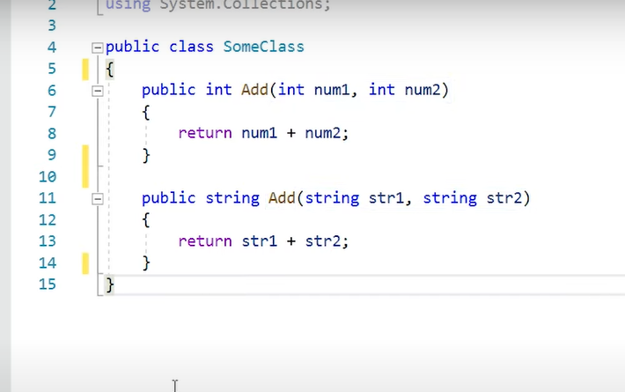

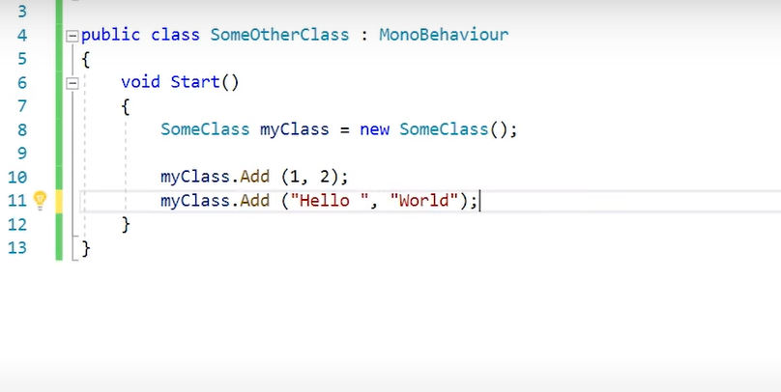

1. Overriding

* A parent method in a child class
* Parent class ( virtual )

* Child class của humanoid

* Child class của enemy

* When you call method

