Su dung vector xoay

1. Truong hop 1

Pitago =

C^2 = A^2 + B^2

Y = do dai stick o goc 90 ( stick muon quay xuong thi phai < do dai cu no o goc 90 so voi col) = khoang cua x tu stick den col

C= Y + duong kinh qua

A= Khoang chach x tu 2 col

* B

1. Truong hop 2

dep nhat

* Truong hop nay ran dom thoa mai

* Vi khi ma stick dai hon ca thi no cos the tuy chinh
* Trong khang

//

A(-0.0357786751,0.06453105)

B(-0.0357786751,-10.55453)

Vector AB = (0, -10.61906105) VTCP

Vecotor n = ( 10.61906105,0)

10.61906105 x +10.61906105\* 0.0357786751

Có R = 2.06748045 lấy scale của worldpace

I(-1.978059, 0.2134819)

* PTDT: ( x+1.978059)^2 + ( y- 0.2134819)^2 = 2.06748045^2
* X^2 + 2\*x\*1.978059 + 1.978059^2 + Y^2 – 2\*y\*0.2134819+0.2134819^2 -2.06748045^2=0

(-0.0357786751)^2 + 2\*-0.0357786751\*1.978059 + 1.978059^2+0.2134819^2 -2.06748045^2 ==?

Y^2 – 2\*y\*0.2134819 -0.45644802901=0

* Y1= 0.922017 và X1 = -0.0357786751
* (-0.0357786751 , 0.922017)
* Graphical user interface, text, application, chat or text message

  Description automatically generated

* (-0.0357786751 , 0.922017)

Vector a = (-1.978059-1.965, 0.2134819-2.5831)

Vector a= ( 0, -2.3696181)

Vector b = (-1.978059 +0.0357786751 , 0.2134819-0.922017) = ( -1.9422803249, -0.7085351)

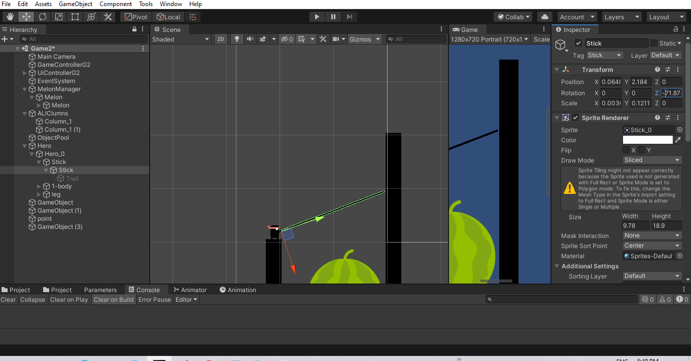

* Đã tính được góc => ok cách này có thể dùng được

TH1: cot ngan hon

1. Giao diem co y>= y tru

