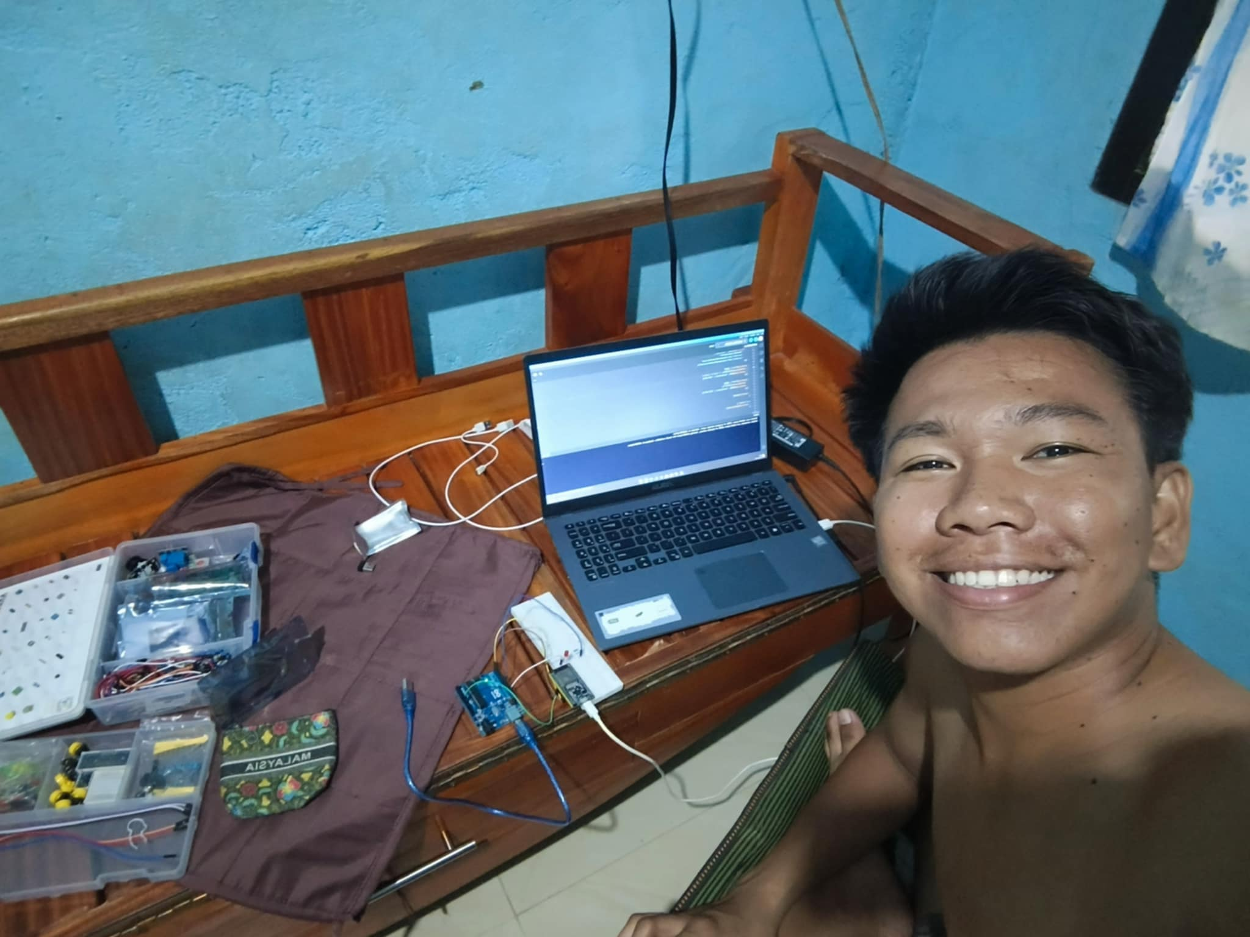
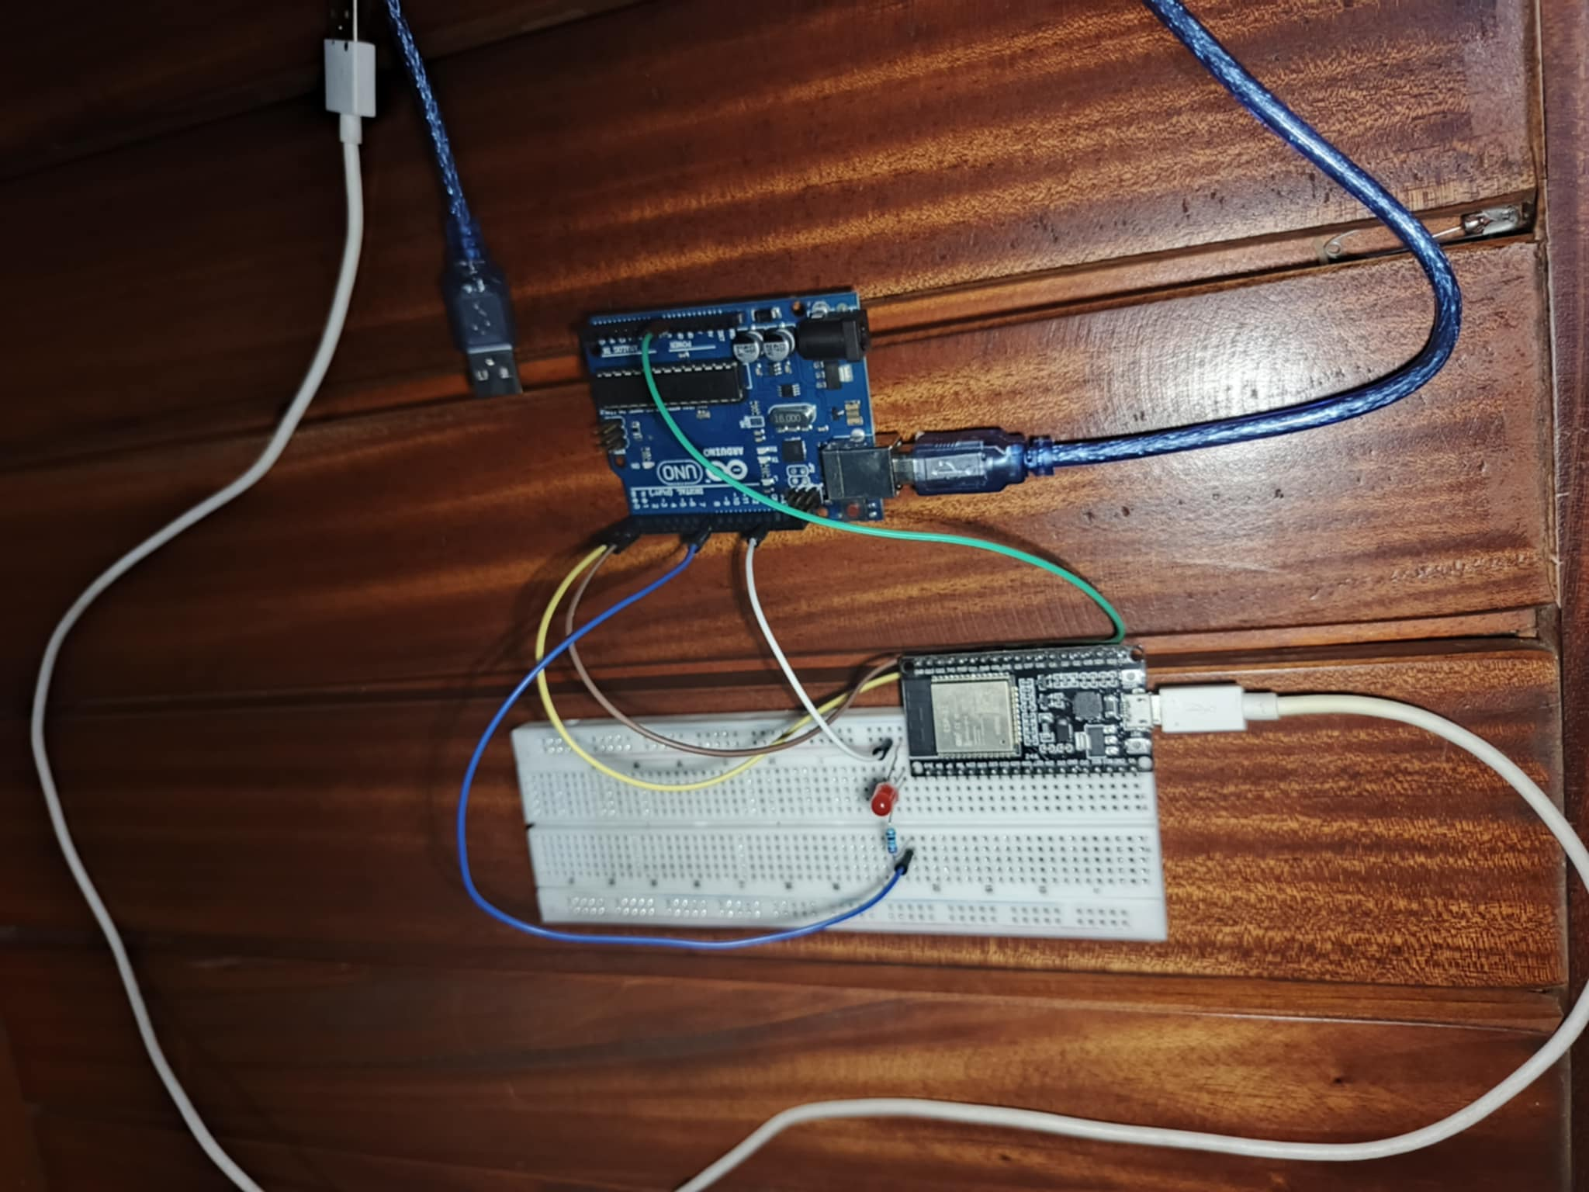
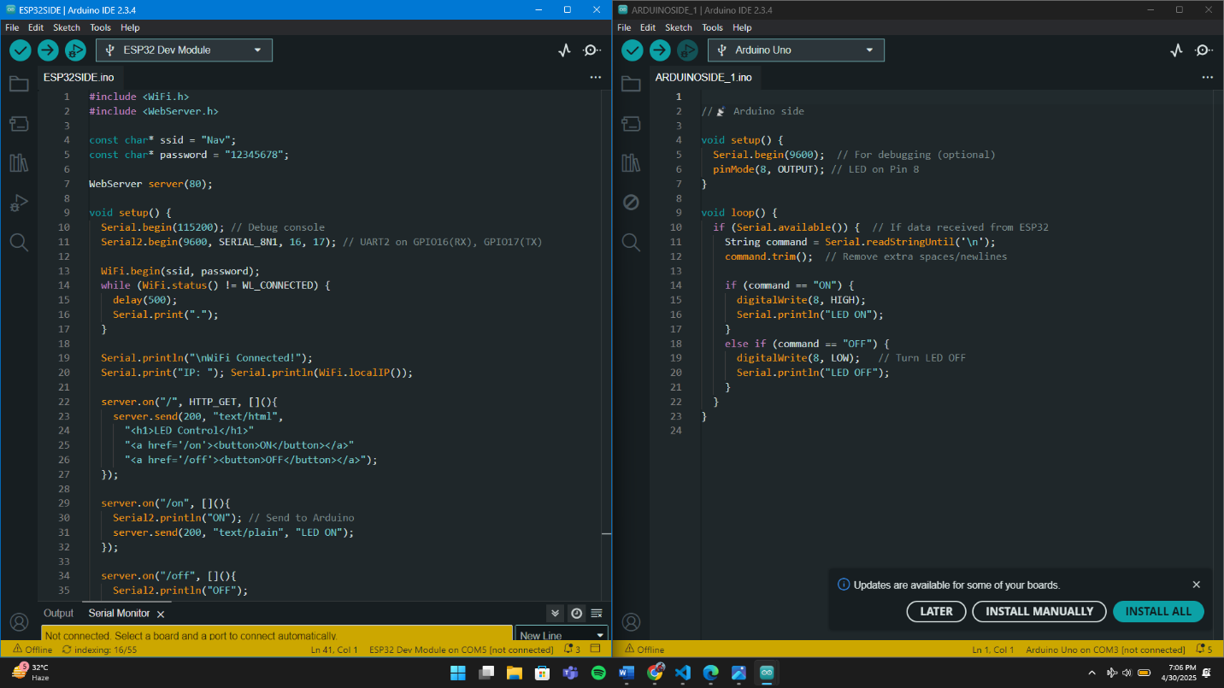
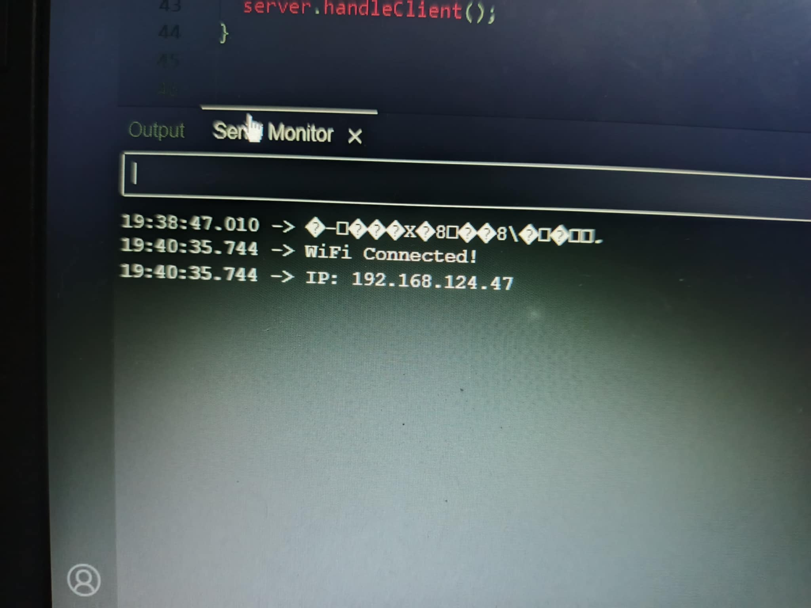

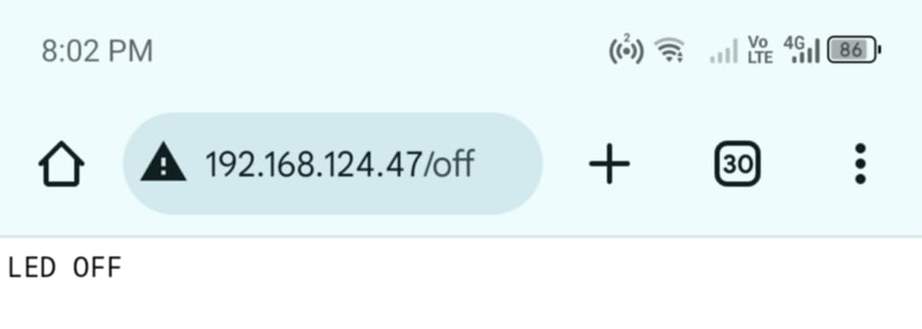
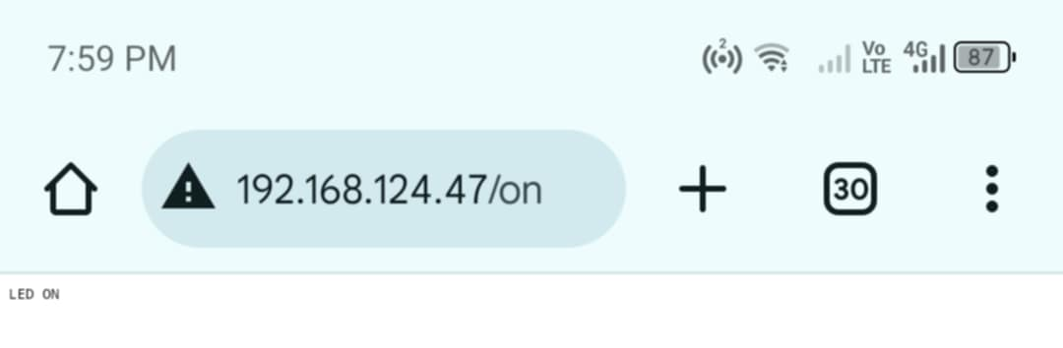
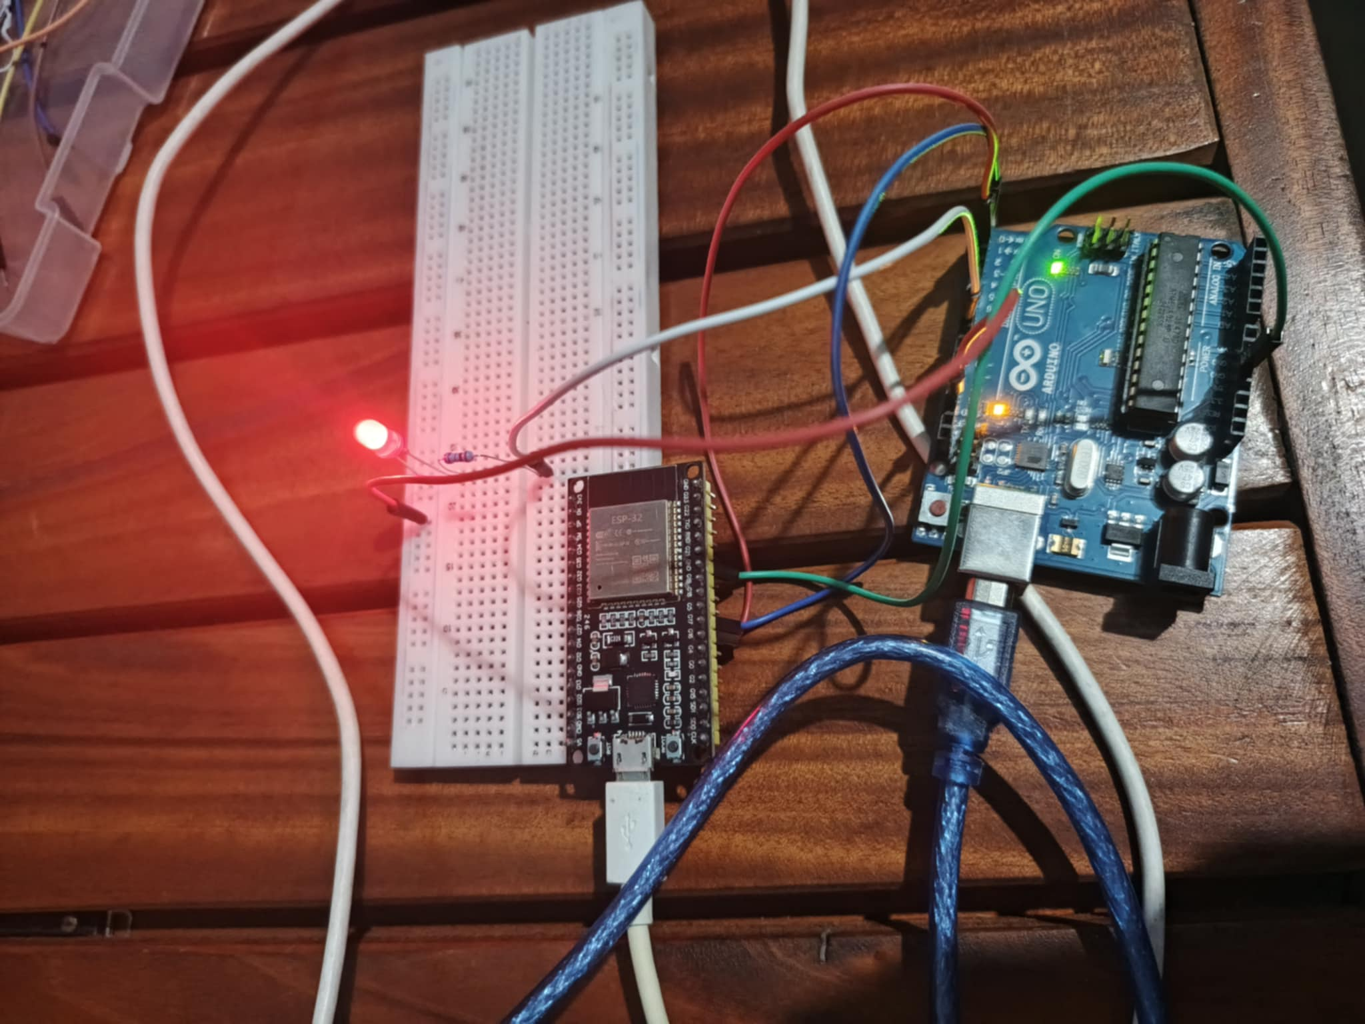
ESP32_CODE
#include <WiFi.h>
#include <WebServer.h>

const char* ssid = "Nav";
const char* password = "12345678";

WebServer server(80);

void setup() {
Serial.begin(9600); // Debug console
Serial2.begin(9600, SERIAL_8N1, 16, 17); // UART2 on GPIO16(RX), GPIO17(TX)

WiFi.begin(ssid, password);
while (WiFi.status() != WL_CONNECTED) {
delay(500);
Serial.print(".");
}

Serial.println("\nWiFi Connected!");
Serial.print("IP: "); Serial.println(WiFi.localIP());

server.on("/", HTTP_GET, [](){
server.send(200, "text/html",
"<h1>LED Control</h1>"
"<a href='/on'><button>ON</button></a>"
"<a href='/off'><button>OFF</button></a>");
});

server.on("/on", [](){
Serial2.println("ON"); // Send to Arduino
server.send(200, "text/plain", "LED ON");
});

server.on("/off", [](){
Serial2.println("OFF");
server.send(200, "text/plain", "LED OFF");
});

server.begin();
}

void loop() {
server.handleClient();
}

ARDUINO_ CODE

void setup() {
Serial.begin(9600); // For debugging (optional)
pinMode(8, OUTPUT); // LED on Pin 8
}

void loop() {
if (Serial.available()) { // If data received from ESP32
String command = Serial.readStringUntil('\n');
command.trim(); // Remove extra spaces/newlines

if (command == "ON") {
digitalWrite(8, HIGH);
Serial.println("LED ON");
}
else if (command == "OFF") {
digitalWrite(8, LOW); // Turn LED OFF
Serial.println("LED OFF");
}
}
}

