CHAPTER – l

**HEAITH HUB CLINIC**

INTRODUCTION

Within the broader health system, there are various levels or domains of health care practice. They are often described as a pyramidal structure, with three or sometimes four tiers of health care representing increasing degrees of specialisation and technical sophistication, generally with increasing costs of care. The greatest number of patients are seen at the first level of primary care that is typically their first contact with the healthcare system, with diminishing numbers of patients seen as they are filtered out of this first level into higher levels of specialised care at secondary, tertiary and now even quaternary care.

Primary, secondary, tertiary and quaternary care refer to the complexity and severity of health challenges that are addressed, as well as the nature of the patient-provider relationship. The healthcare providers who are part of these four levels of healthcare, together provide medical services such as evaluation, diagnostics, provision of treatment or onward referrals to the next level of care based on the specific health needs.

As health care systems attempt to meet the needs of populations living longer and with more complex health needs, and with health service delivery being shifted to the community, there has been an increasing emphasis on primary health care and it is generally recognised as the part of the health system that people use most and may be provided by a wide range of health care professionals. Continuity of care is a key characteristic of primary care, as patients usually prefer to consult the same practitioner for routine check-ups and preventive care, health education, and every time they require an initial consultation about a new health problem. So in many cases, the relationship between the patient and provider can often occur over a long period of time in primary health care versus secondary and tertiary care settings, with providers often following a patient’s development and medical history for several years and sometimes most of their lifetime.

Health Care is the specialist treatment and support provided by doctors and other health professionals for patients who have been referred to them for specific expert care, most often provided in hospitals. Secondary care services are usually based in a hospital or clinic, though some services may be community-based. They may include planned operations, specialist clinics such as cardiology or renal clinics, or rehabilitation services such as physiotherapy. Secondary healthcare includes a wide range of specialists such as psychiatrists, cardiologists, obstetricians, dermatologists, paediatricians and gynaecologists.

**PURPOSE OF HEALTH HUB CLINIC:**

* **Patient Care:** A patient’s records provide the documented basis for planning patient care and treatment.
* **Communication:** A patient’s records are an important means by which physicians, nurses, and others communicate with one another about patient needs.
* **Legal Documentation:** A patient’s record becomes a legal document to that patient’s health and care.
* **Billing and Reimbursement:** A patient’s records provide documentation of what the patient has paid and what insurance has paid, and what services were rendered.
* **Research and Quality Management:** A patient’s records are used in many facilities for research purposes and for monitoring the quality of care.

CHAPTER-2

**EMPATHY MAP**

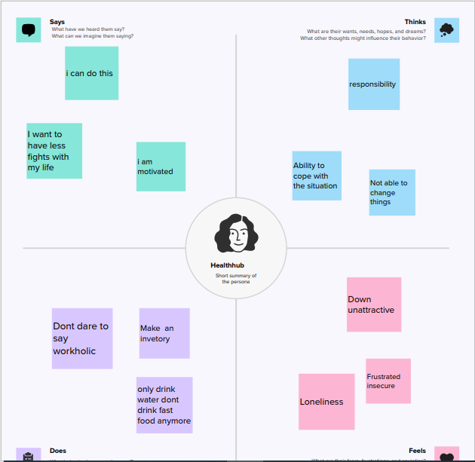

**BRAINSTOMING**

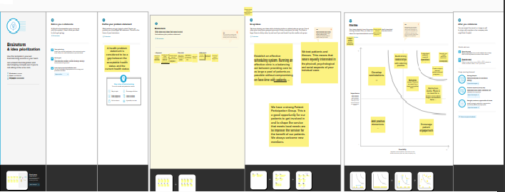

CHAPTER-3

**PROFIT AND LOSS ACCOUNT**

**RESULTS**



BALANCESHEET

CHAPTER- 4

**ADVANTAGES OF MEDICAL CLINIC :**

1. Low cost of medical procedures in comparison with the higher cost of healthcare services in the US or the country you reside in
2. Access to all types of medical procedures that might not be offered in your country or region.
3. Medical tourism gives patients quicker access to medical care with shorter to no waiting period when they can’t receive immediate care in a domestic hospital in their place of residence. When your health is on the line, waiting is not an option.
4. Medical tourism gives patients a chance to explore a new destination and a new culture.
5. When you do not have insurance coverage or your health insurance does not cover the full cost of a procedure, medical travel gives you the opportunity to go abroad where the savings are between 30%- 90%.
6. International travel is more reasonably priced
7. Global standards of care and technological advancements in healthcare are rapidly improving worldwide.
8. Medical travel allows you to have your medical procedure performed abroad where you don’t have to worry about unwanted family, friends .

**DISADVANTAGES OF MEDICAL CLINIC :**

1. Cultural and language barriers. Sometimes people who choose medical travel don’t like the fact that they can’t personally communicate one on one with foreign healthcare professionals or staff during their visit.
2. Medical travel can sometimes be time consuming. Finding time in your busy schedule or receiving time off from your job is not always easy.
3. Additional cost such as flight, hotel, transportation, food, tours, etc., must be factored into your trip along with the cost of your medical procedure.
4. Environmental hazards and travel alerts in certain countries
5. If something goes wrong during the medical procedure, sometimes you have little recourse depending on the medical provider and the country you choose.
6. Traveling too soon after surgery can sometimes cause serious complications such as pulmonary embolisms, blood clots, swelling or infection.
7. The food you eat in foreign hospitals and the quality of the water can be different which may upset a person with a sensitive stomach. If you develop diarrhea, vomiting or postoperative nausea before or after the surgery this can be a very unpleasant experience.

**CHAPTER – 5**

**APPLICATION FOR HEALTHHUB MEDICAL CLINIC**

With world-renowned brands such as the registered trademarks Leukoplast, JOBST, Cutimed, Actimove and Delta-Cast, Essity is among the global market leaders in a number of therapeutic areas. The company is committed to creating best-in-class offerings that confirm the trust of its customers and brand promise.

What sets Essity apart is not only consistently high quality and the continuous development, incorporating the latest technologies and materials. It is also that the products in the various therapeutic areas mesh into seamless therapy solutions – like the Advanced Wound Care assortment, covering all phases of the healing process. Or where adhesive fixation of dressings, tubes or catheters is required, Essity's range of skin-friendly products has the right solution for any situation.

This approach allows medical specialists to tailor therapies to individual patient´s needs. This is particularly valuable for those suffering from venous and lymphatic diseases.

Moreover, Essity is known for high-quality and cost-effective solutions, which is of particularly high importance for orthopedic products for strains, sprains and fractures.

And Essity takes an important step forward, supporting medical specialists with integrated therapy solutions. These form the basis of a holistic approach to treat medical conditions such as venous leg ulcers, offering both compression garments and wound dressings, to support optimal wound healing.

**CHAPTER – 6**

**CONCULSION FOR HEALTHHUB MEDICAL CLINIC**

Throughout the course of this study, the committee has been extremely aware of the fact that the topic addressed by this report concerns one of the most critical issues confronting HCFA, health care plans and providers, and patients today. The Medicare+Choice regulations focus on the most vulnerable populations in need of medical care and other services—those with serious or complex medical conditions. Caring for these highly vulnerable populations poses a number of challenges.

In the absence of a fully developed research and clinical knowledge base, combined with the time and resource constraints of this study, the committee chose what it believes is the most prudent and thoughtful approach to its charge. Specifically, the committee has chosen to provide guidance to HCFA and health care plans to support initial steps to address the major issues confronting health care plans and their beneficiaries with serious and complex medical conditions. This guidance is supported by presentation of possible strategies that might be used to screen enrollees for the presence of serious and complex medical conditions. Health care plans are encouraged to be innovative in their initial efforts to develop case-screening methodologies. As plans develop experience with different screening modalities, information can be shared nationally. It is the committee's intent that this will lead to the identification of best practices and subsequent standardized methods for ongoing screening of beneficiaries for serious and complex conditions. The committee also recommends strategies to ensure that the care offered to persons with serious and complex conditions is responsive to the diverse, multidisciplinary needs for services to address a full spectrum of medical, social, and mental health issues. Finally, the committee feels strongly that evaluation and research efforts must occur simultaneously with the implementation of the guidance and recommendations concerning screening and care of patients with serious and complex medical conditions. As HCFA and health care plans develop the necessary expertise and resources to provide comprehensive, multidisciplinary care to patients with serious and complex conditions, this knowledge can be generalized to address the needs of patients with serious but not complex and complex but not serious medical conditions. The following conclusions and recommendations are based on consideration of these diverse issues.

**CHAPTER -7**

**FUTURE SCOPE OF HEAITHHUB MEDICAL CLINIC**

The term clinical trial refers to the entire record of any test article from its initiation in the lab to its introduction to the market and beyond. Once the promising molecule is identified in the lab, it is subjected to more per-clinical studies to get an idea about different aspects of the test article. Clinical research is often conducted at academic medical centers and recognized research centers.

Many believe that informed consent makes clinical research ethical. However, informed consent is not sufficient. Drawing on the basic philosophies there are some requirements that systematically explain a logical framework for evaluating the ethics of clinical research studies. The requirements are universal and they must be adapted to the various fields in which clinical research is conducted.

**A Clinical Research Associate (CRA)** is a health-care professional who performs activities related to clinical trials. They are the soul in the field of Clinical Research. The experts find their place in various organizations such as pharmaceutical companies, medical research institutes and government agencies. Depending on the organization’s policies different education and certification requirements may be necessary to practice as a Clinical Research Associate.

**Clinical data management (CDM)** is a critical phase in clinical research. CDM leads to generation of superior quality, dependable, and statistically well informed data from clinical trials. The ultimate goal of CDM is to assure a well maintained data support conclusions drawn from research and thus achieving this goal protects public health and creates confidence in the world of therapeutics.

**Clinical Research Organisation (CRO)**A CRO landscape is vast; using a CRO’s expertise you can maximize the efficiency of your clinical trials, but only if you choose the right one for the project at hand.

Typically, a CRO will organize and conduct clinical trials to check the test molecule in humans.