**Types of CSS Selectors in Selenium**

*https://bstackdemo.com/*

1. ID

* driver.findElement(By.cssSelector(“<tagname>#<id value>”));

*Example: driver.findElement(By.cssSelector("a#offers"));*

* driver.findElement(By.cssSelector(“#<id value>”));

*Example: driver.findElement(By.cssSelector("#offers"));*

* driver.findElement(By.cssSelector(“<tagname>[id=’<id value>’]”));

*Example: driver.findElement(By.cssSelector("a[id='offers']"));*

1. **Class**

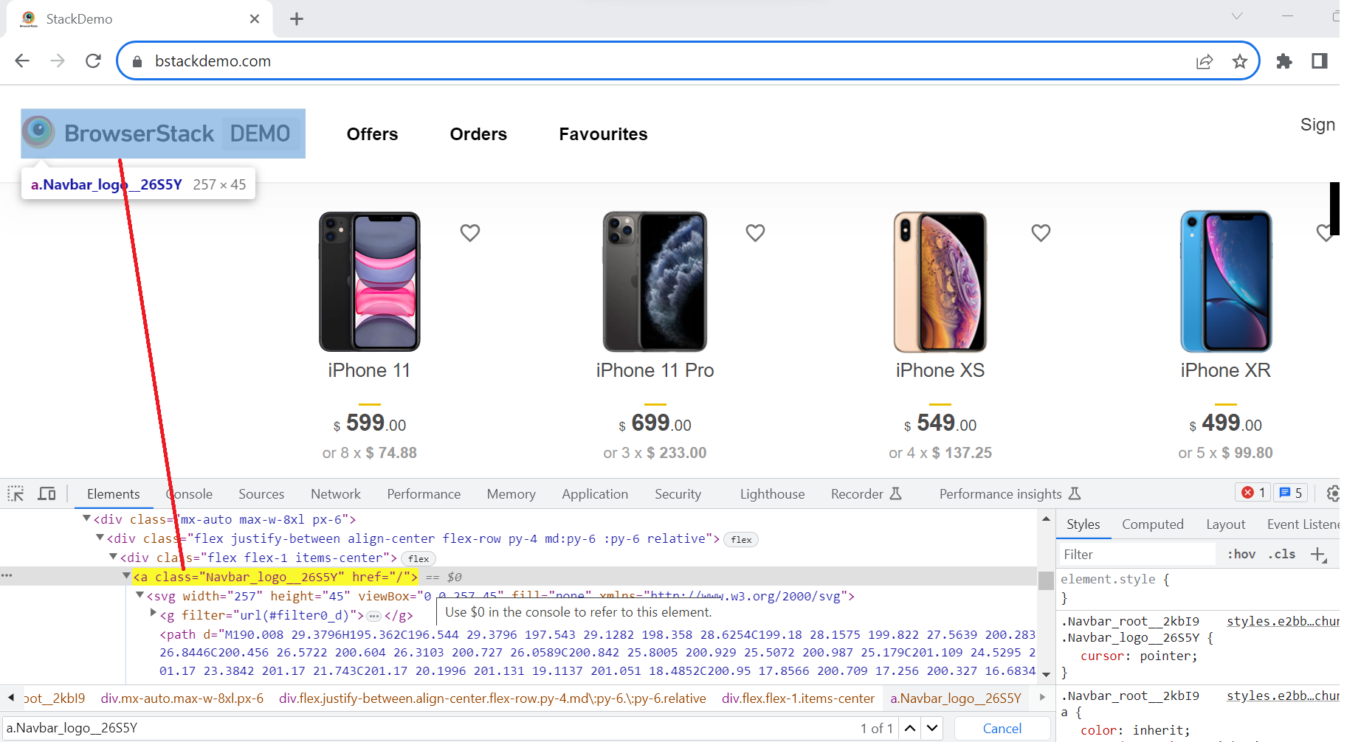

* driver.findElement(By.cssSelector(“<tagname>.<class value>”));

*Example: driver.findElement(By.cssSelector("a.Navbar_logo__26S5Y"));*

* driver.findElement(By.cssSelector(“.<class value>”));

*Example: driver.findElement(By.cssSelector(".Navbar_logo__26S5Y"));*

* driver.findElement(By.cssSelector(“<tagname>[class=’<class value>’]”));

*Example:* *driver.findElement(By.cssSelector("a[class='Navbar_logo__26S5Y']"));*

*XPATH: //a[contains(@class,"Navbar_logo")]*

1. **Attribute**

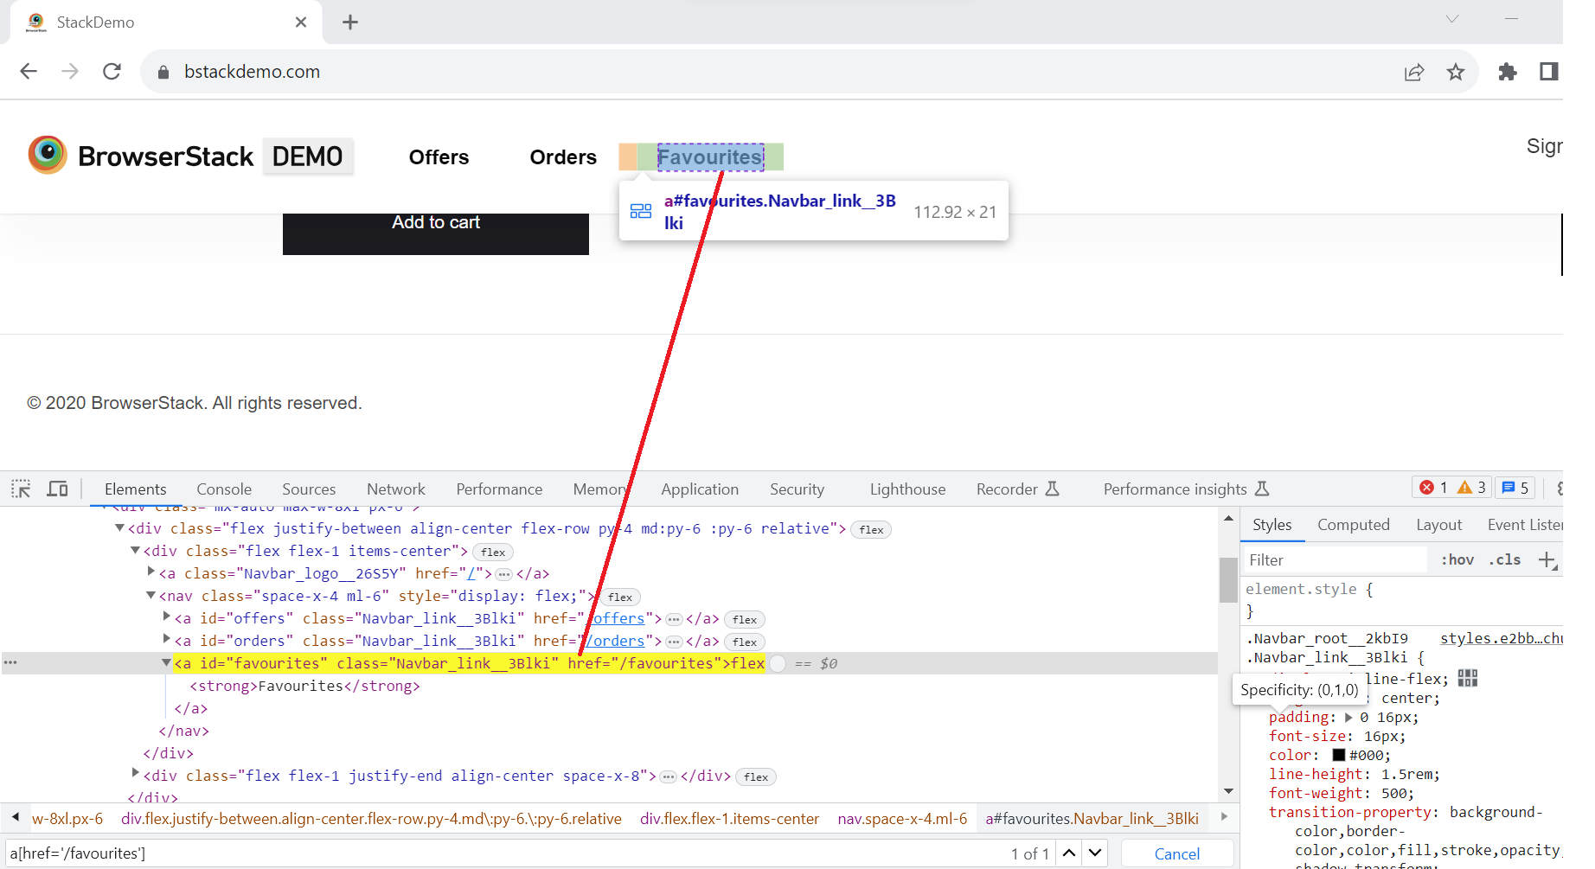

driver.findElement(By.cssSelector(“<tagname>[href=’<href value>’]”));

*Example: driver.findElement(By.cssSelector("a[href='/favourites']"));*

1. Combining Attributes

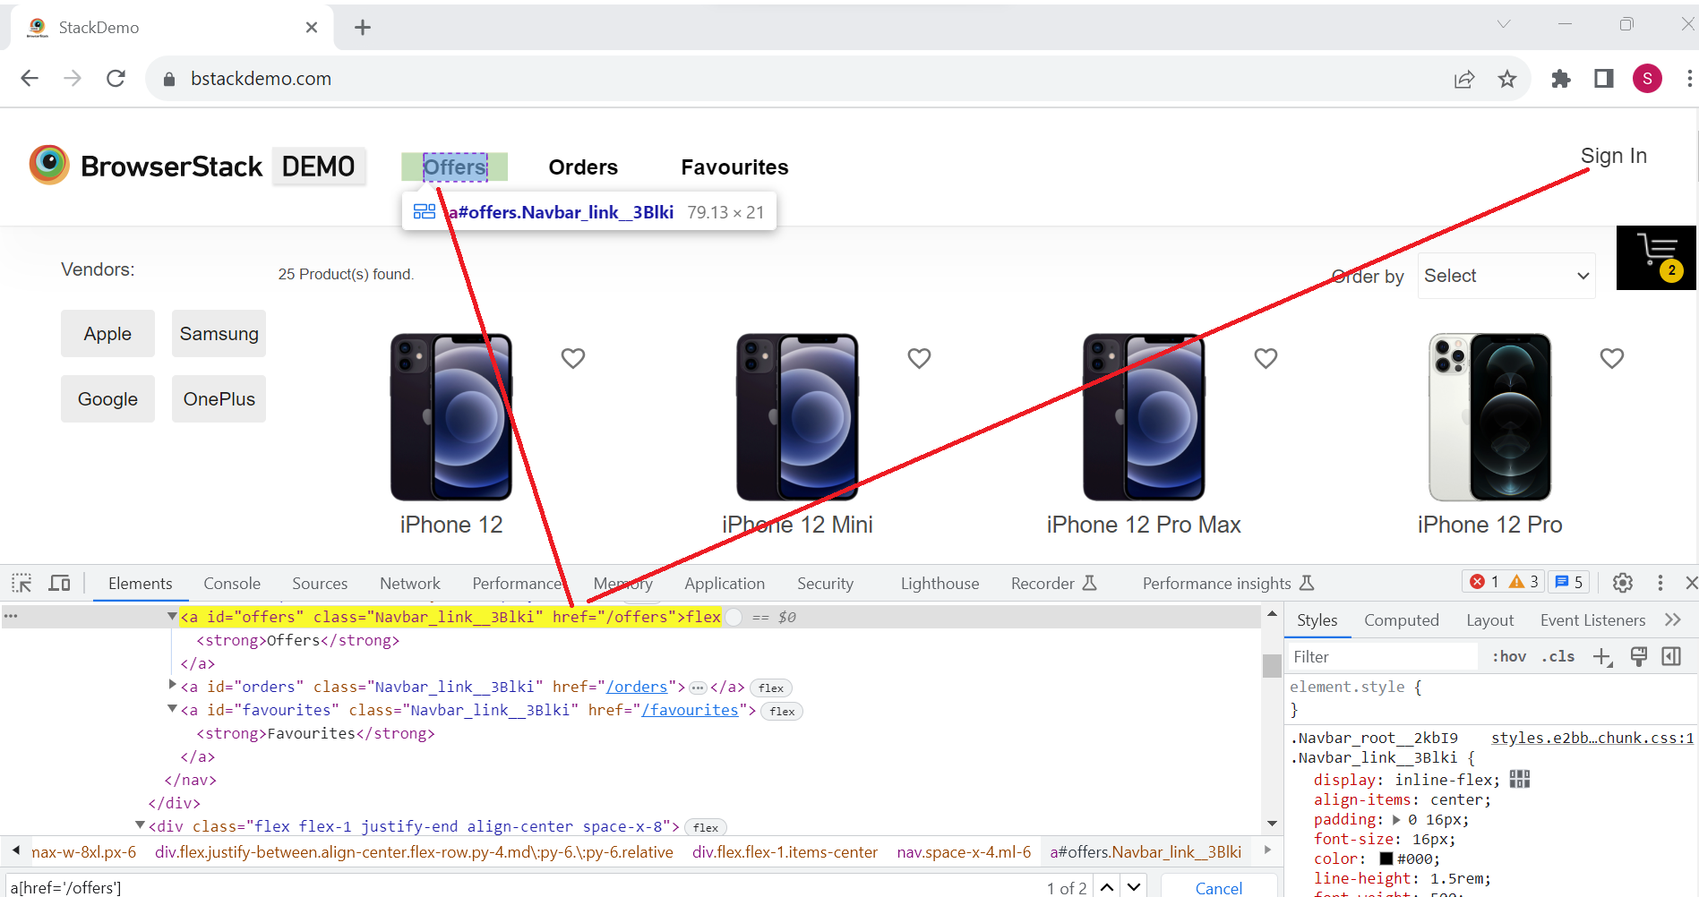

* 1. Id and attribute example:

driver.findElement(By.cssSelector(“<tagname>#<id value>[href=’<href value>’]”));

*Example: driver.findElement(By.cssSelector("a#offers[href='/offers']"));*

* 1. Class and attribute Example:

driver.findElement(By.cssSelector(“<tagname>.<class value>[href=’<href value>’]”));

*Example: driver.findElement(By.cssSelector("a.Navbar_link__3Blki[href='/orders']"));*

1. Substring
   1. **Matching a prefix (Starts with: ^):**

driver.findElement(By.cssSelector(“<tagname>[<attribute>^=’prefix of the string’]”));

*Example: a[class^='Navbar_logo_']*

* 1. **Matching a suffix (Ends with: $):**

driver.findElement(By.cssSelector(“<tagname>[<attribute>$=’suffix of the string’]”));

*Example: a[class$='26S5Y']*

* 1. **Matching a substring (contains: *):**

driver.findElement(By.cssSelector(“<tagname>[<attribute>*=’substring’]”));

*Example: a[class*='logo_']*