**Лабораторная работа №4.**    
«Сложные SQL запросы»

**Задание 1 (NF)**

1. Привести ненормализованную таблицу из задания к 1NF и создать таблицу с данными для ее

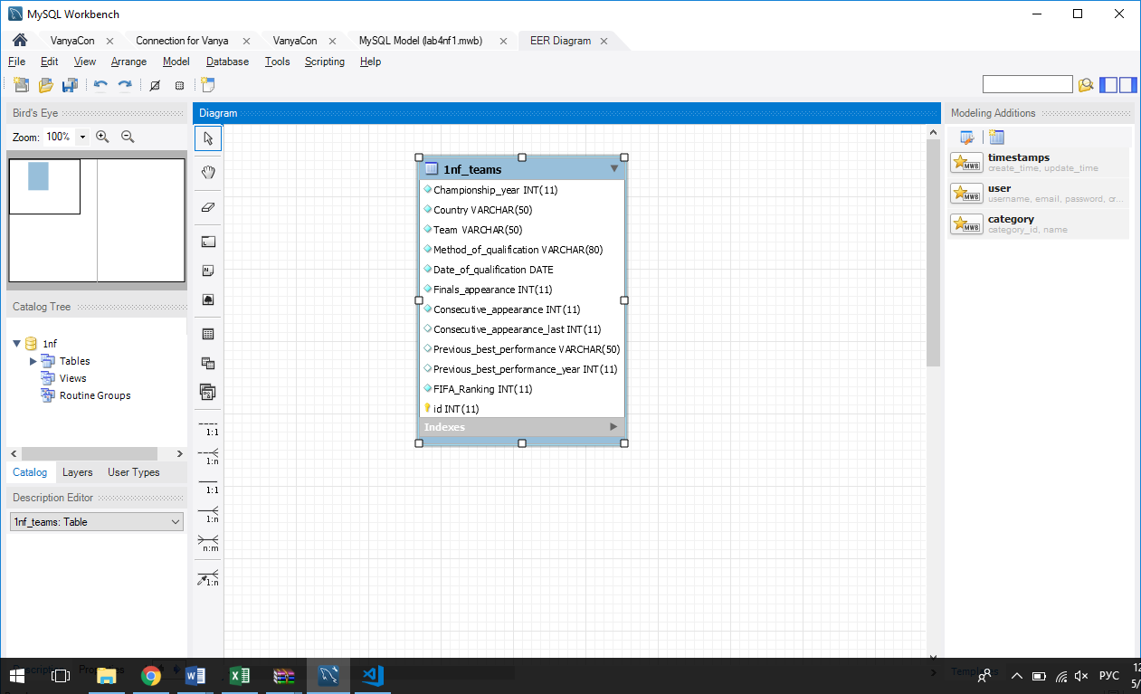

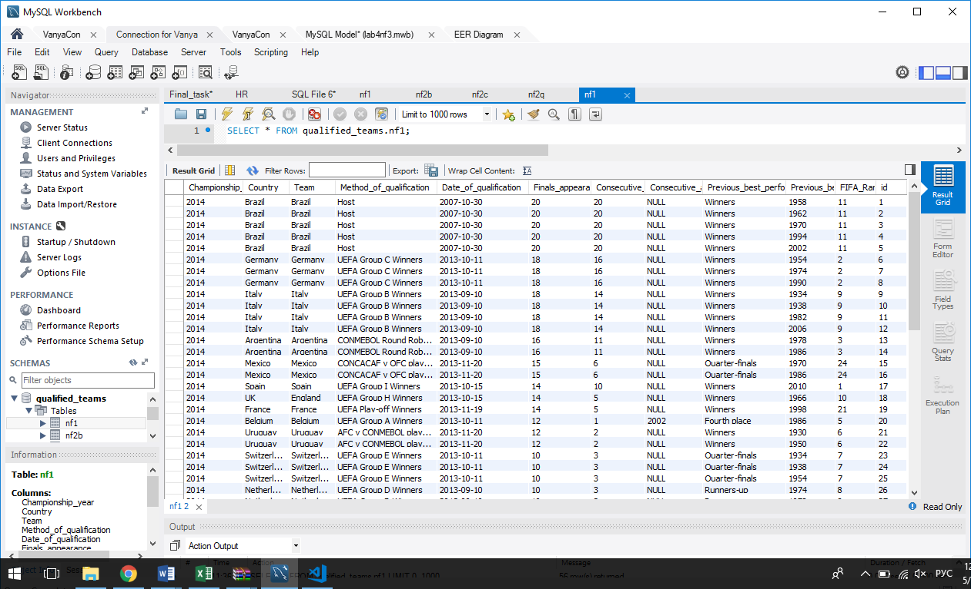

1. Привести 1NF к 2NF, а 2NF к 3NF

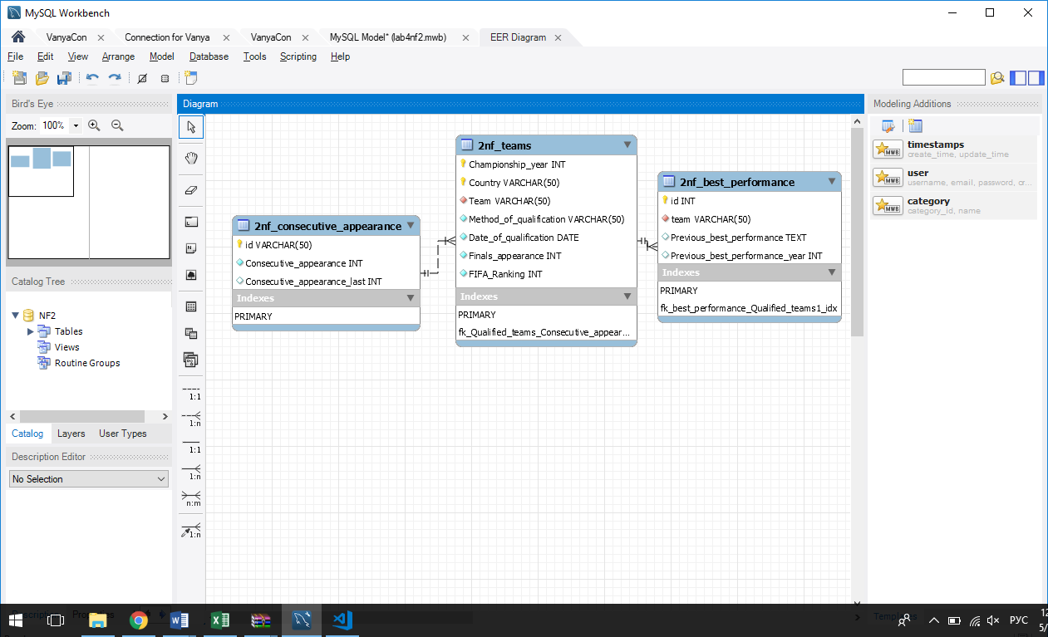

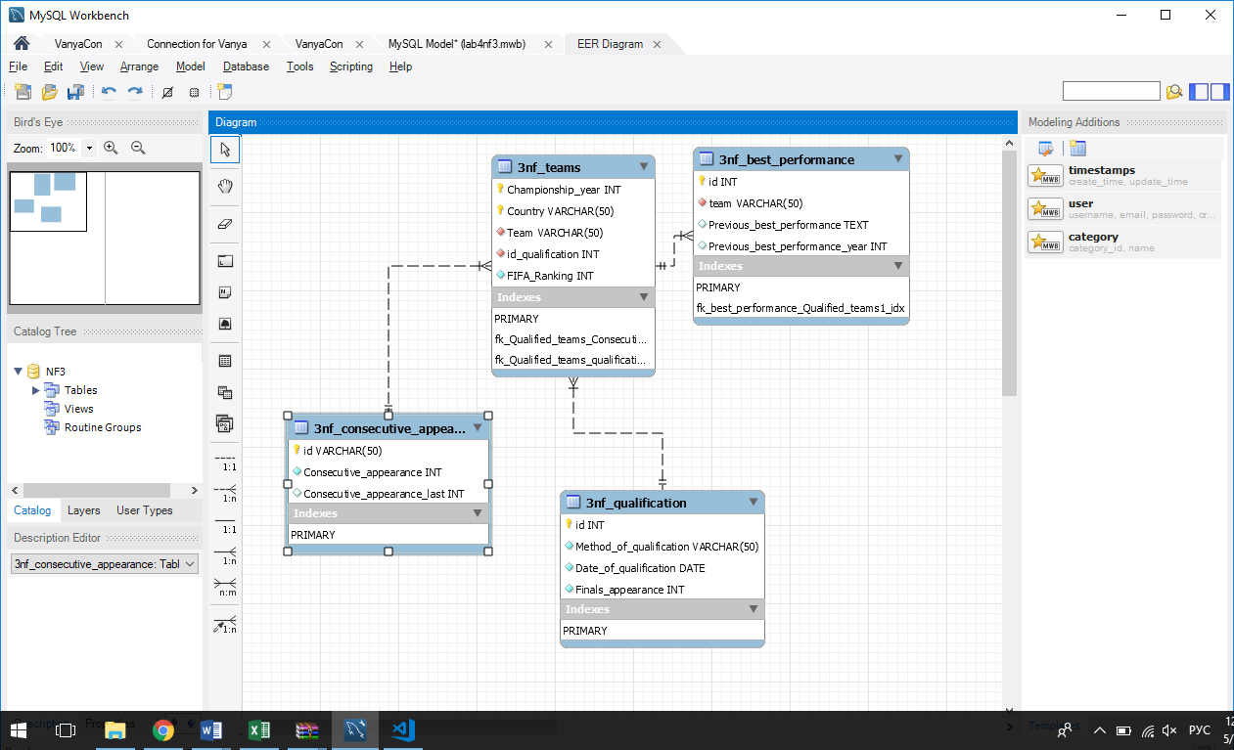

**Задание 2 (views)**

1. На основании 1NF создать представления представляющие собой 2NF

CREATE

ALGORITHM = UNDEFINED

DEFINER = `root`@`localhost`

SQL SECURITY DEFINER

VIEW `1nf`.`2nf_best_performance` AS

SELECT

`1nf`.`1nf_teams`.`Team` AS `team`,

`1nf`.`1nf_teams`.`Previous_best_performance` AS `Previous_best_performance`,

`1nf`.`1nf_teams`.`Previous_best_performance_year` AS `Previous_best_performance_year`

FROM

`1nf`.`1nf_teams`

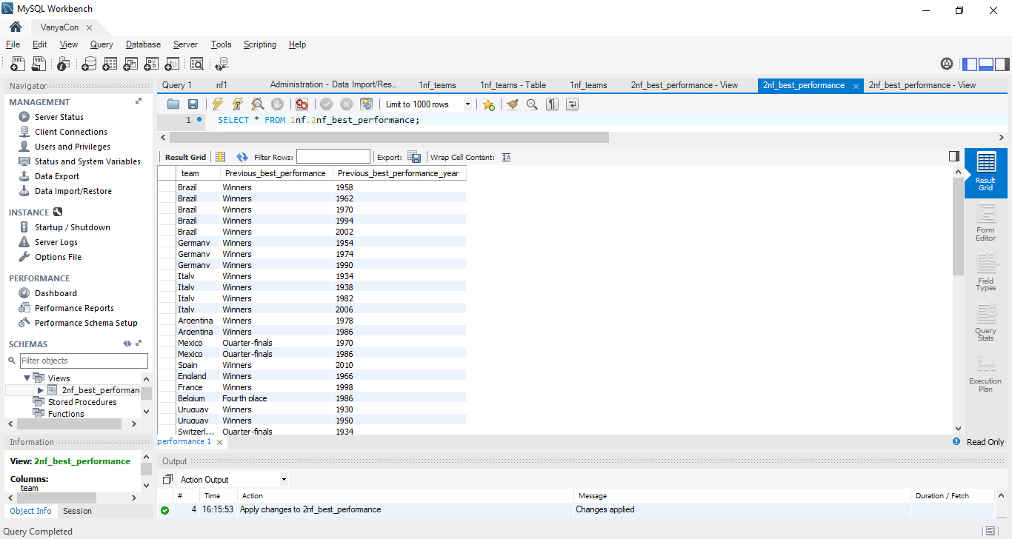

CREATE

ALGORITHM = UNDEFINED

DEFINER = `root`@`localhost`

SQL SECURITY DEFINER

VIEW `1nf`.`2nf_consecutive_appearance` AS

SELECT DISTINCT

`1nf`.`1nf_teams`.`Team` AS `id`,

`1nf`.`1nf_teams`.`Consecutive_appearance` AS `Consecutive_appearance`,

`1nf`.`1nf_teams`.`Consecutive_appearance_last` AS `Consecutive_appearance_last`

FROM

`1nf`.`1nf_teams`

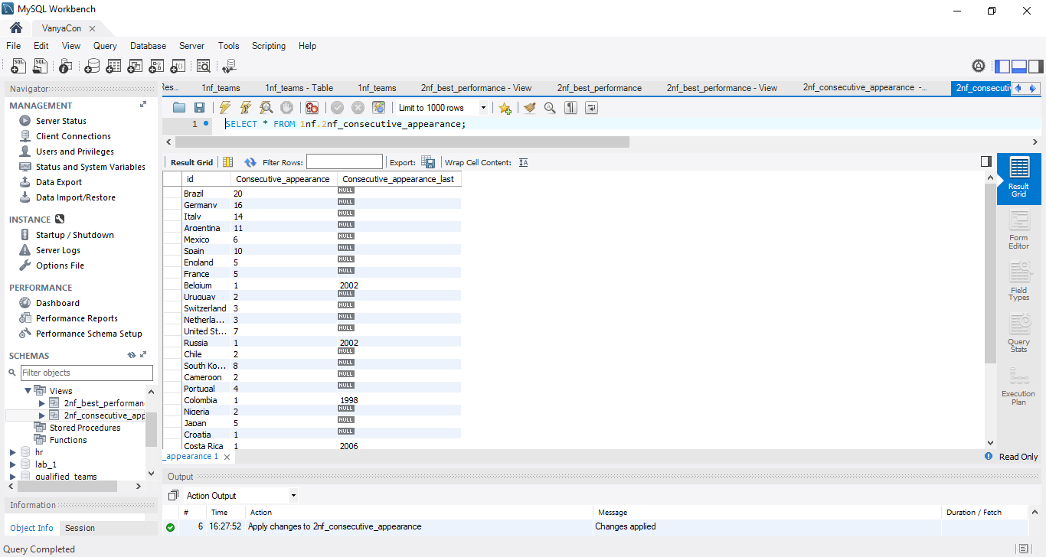

CREATE

ALGORITHM = UNDEFINED

DEFINER = `root`@`localhost`

SQL SECURITY DEFINER

VIEW `1nf`.`2nf_teams` AS

SELECT DISTINCT

`1nf`.`1nf_teams`.`Championship_year` AS `Championship_year`,

`1nf`.`1nf_teams`.`Country` AS `Country`,

`1nf`.`1nf_teams`.`Team` AS `Team`,

`1nf`.`1nf_teams`.`Method_of_qualification` AS `Method_of_qualification`,

`1nf`.`1nf_teams`.`Date_of_qualification` AS `Date_of_qualification`,

`1nf`.`1nf_teams`.`Finals_appearance` AS `Finals_appearance`,

`1nf`.`1nf_teams`.`FIFA_Ranking` AS `FIFA_Ranking`

FROM

`1nf`.`1nf_teams`

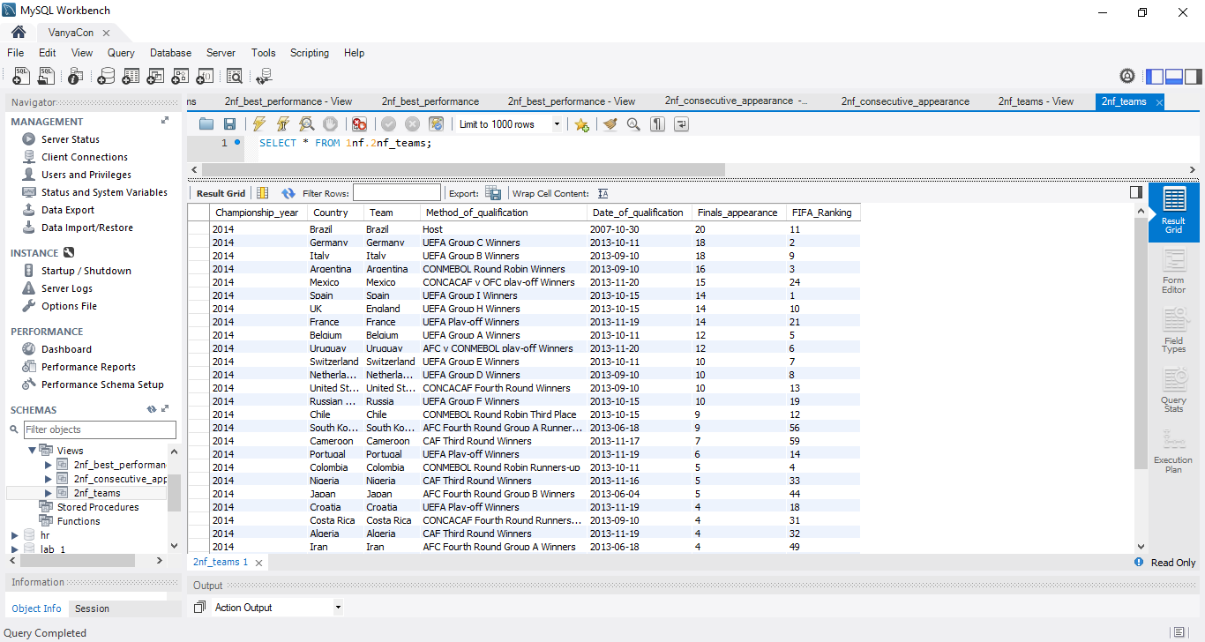

1. На основании представлений 2NF создать представления представляющие собой 3NF

CREATE

ALGORITHM = UNDEFINED

DEFINER = `root`@`localhost`

SQL SECURITY DEFINER

VIEW `1nf`.`3nf_best_performance` AS

SELECT

`2nf_best_performance`.`team` AS `team`,

`2nf_best_performance`.`Previous_best_performance` AS `Previous_best_performance`,

`2nf_best_performance`.`Previous_best_performance_year` AS `Previous_best_performance_year`

FROM

`1nf`.`2nf_best_performance`

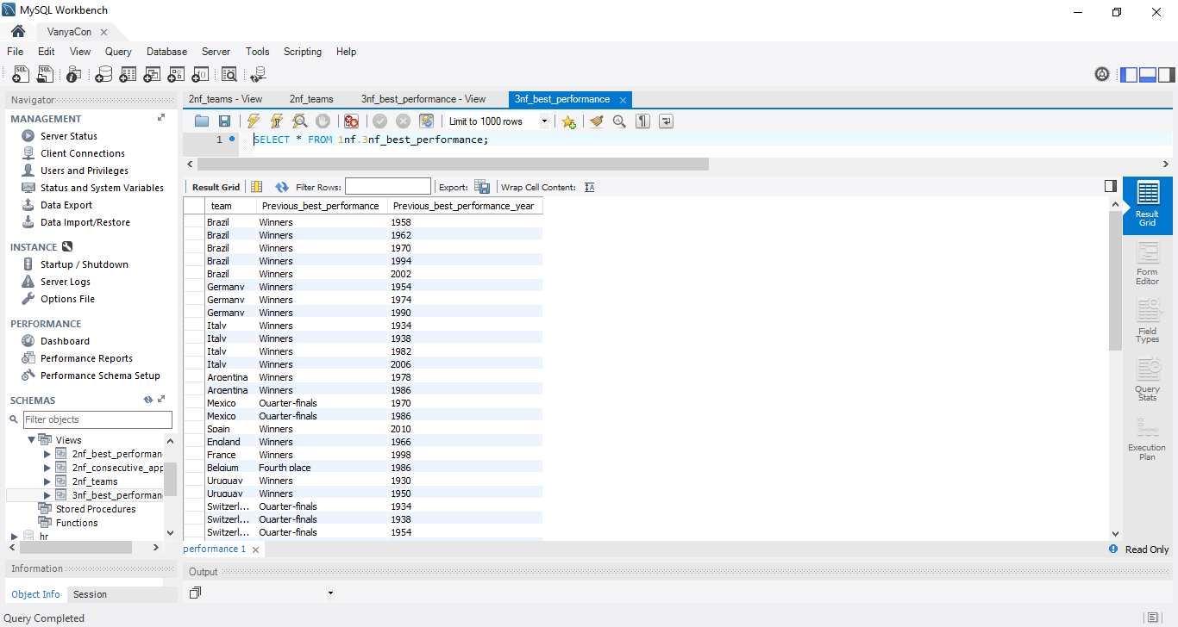

CREATE

ALGORITHM = UNDEFINED

DEFINER = `root`@`localhost`

SQL SECURITY DEFINER

VIEW `1nf`.`3nf_consecutive_appearance` AS

SELECT

`2nf_consecutive_appearance`.`id` AS `id`,

`2nf_consecutive_appearance`.`Consecutive_appearance` AS `Consecutive_appearance`,

`2nf_consecutive_appearance`.`Consecutive_appearance_last` AS `Consecutive_appearance_last`

FROM

`1nf`.`2nf_consecutive_appearance`

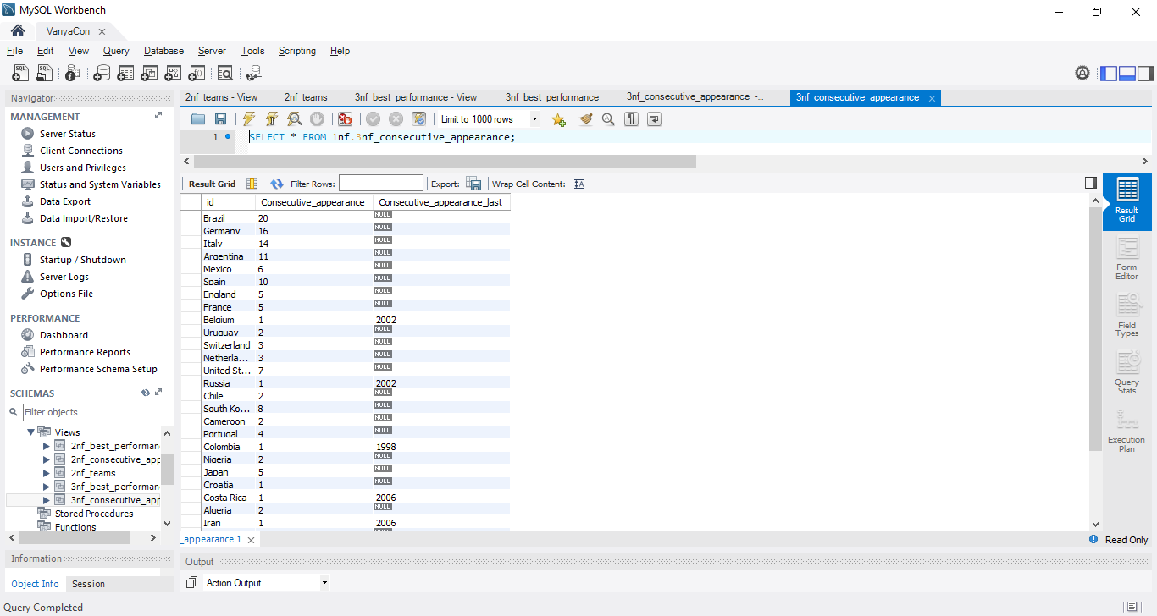

CREATE

ALGORITHM = UNDEFINED

DEFINER = `root`@`localhost`

SQL SECURITY DEFINER

VIEW `1nf`.`3nf_qualification` AS

SELECT

`2nf_teams`.`Team` AS `Team`,

`2nf_teams`.`Method_of_qualification` AS `Method_of_qualification`,

`2nf_teams`.`Date_of_qualification` AS `Date_of_qualification`,

`2nf_teams`.`Finals_appearance` AS `Finals_appearance`

FROM

`1nf`.`2nf_teams`

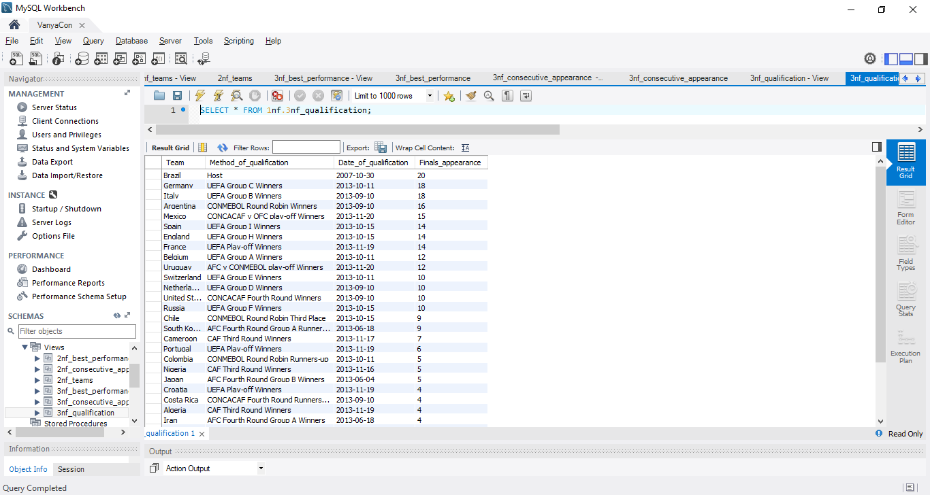

CREATE

ALGORITHM = UNDEFINED

DEFINER = `root`@`localhost`

SQL SECURITY DEFINER

VIEW `1nf`.`3nf_teams` AS

SELECT

`2nf_teams`.`Championship_year` AS `Championship_year`,

`2nf_teams`.`Country` AS `Country`,

`2nf_teams`.`Team` AS `Team`,

`2nf_teams`.`FIFA_Ranking` AS `FIFA_Ranking`

FROM

`1nf`.`2nf_teams`

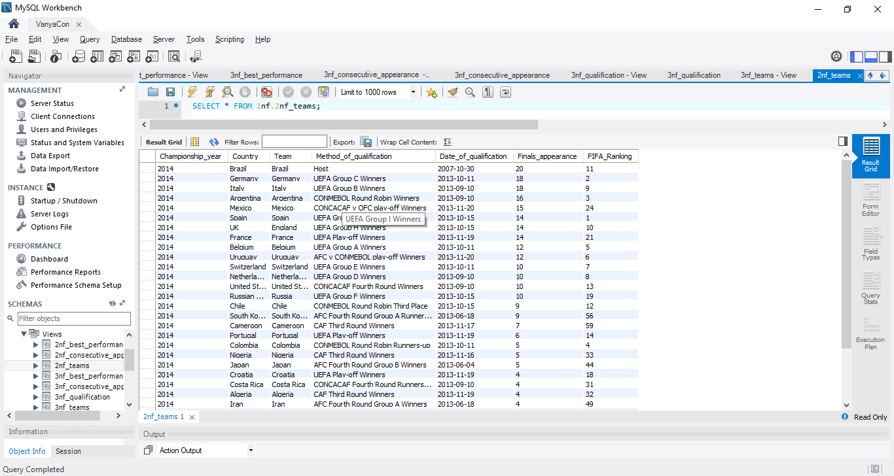

**Задание 3 (подзапросы, добавление данных)**

1. На основании представлений из 3NF создать таблицы и вставить данные в таблицы для 3NF с необходимыми FK для этой нормальной формы.

CREATE TABLE `3nf_consecutive_appearance_t` (

`id` varchar(50) NOT NULL,

`Consecutive_appearance` int(11) NOT NULL,

`Consecutive_appearance_last` int(11) DEFAULT NULL,

PRIMARY KEY (`id`)

) ENGINE=InnoDB DEFAULT CHARSET=utf8

SELECT * FROM `3nf_consecutive_appearance`;

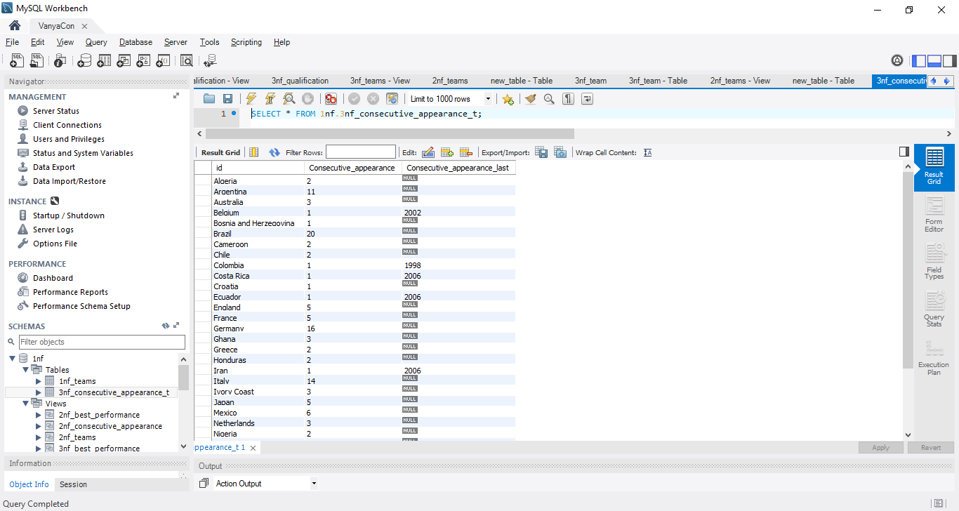

CREATE TABLE `3nf_qualification_t` (

`id` int(11) NOT NULL AUTO_INCREMENT,

`Method_of_qualification` varchar(50) NOT NULL,

`Date_of_qualification` date NOT NULL,

`Finals_appearance` int(11) NOT NULL,

PRIMARY KEY (`id`)

) ENGINE=InnoDB DEFAULT CHARSET=utf8

SELECT * FROM `3nf_qualification`;

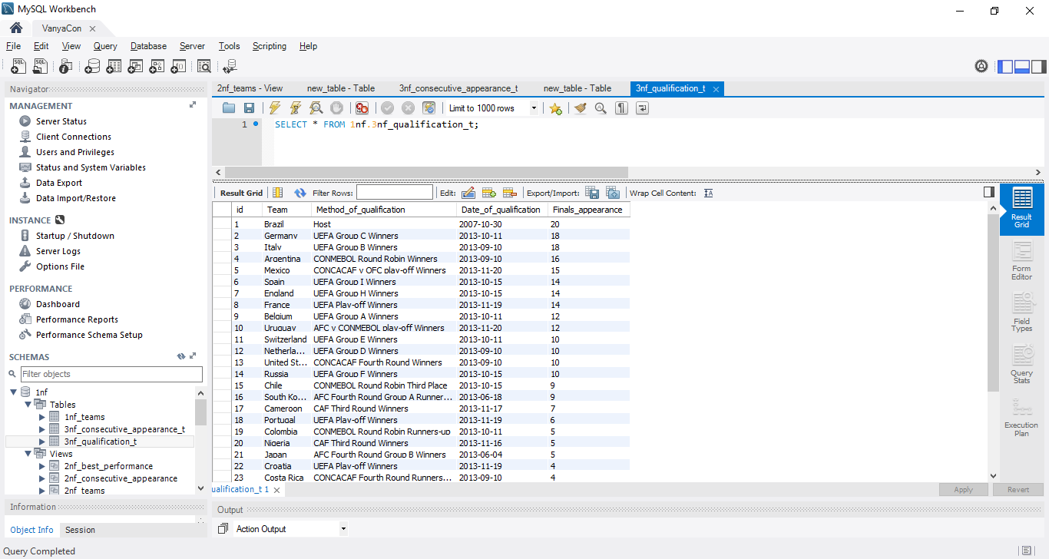

CREATE TABLE `3nf_teams_t` (

`Championship_year` int(11) NOT NULL,

`Country` varchar(50) NOT NULL,

`Team` varchar(50) NOT NULL,

`id_qualification` int(11) NOT NULL AUTO_INCREMENT,

`FIFA_Ranking` int(11) NOT NULL,

PRIMARY KEY (`Championship_year`,`Country`),

FOREIGN KEY (`Team`) REFERENCES `3nf_consecutive_appearance_t` (`id`),

FOREIGN KEY (`id_qualification`) REFERENCES `3nf_qualification_t` (`id`)

) ENGINE=InnoDB DEFAULT CHARSET=utf8

SELECT * FROM `3nf_teams`;

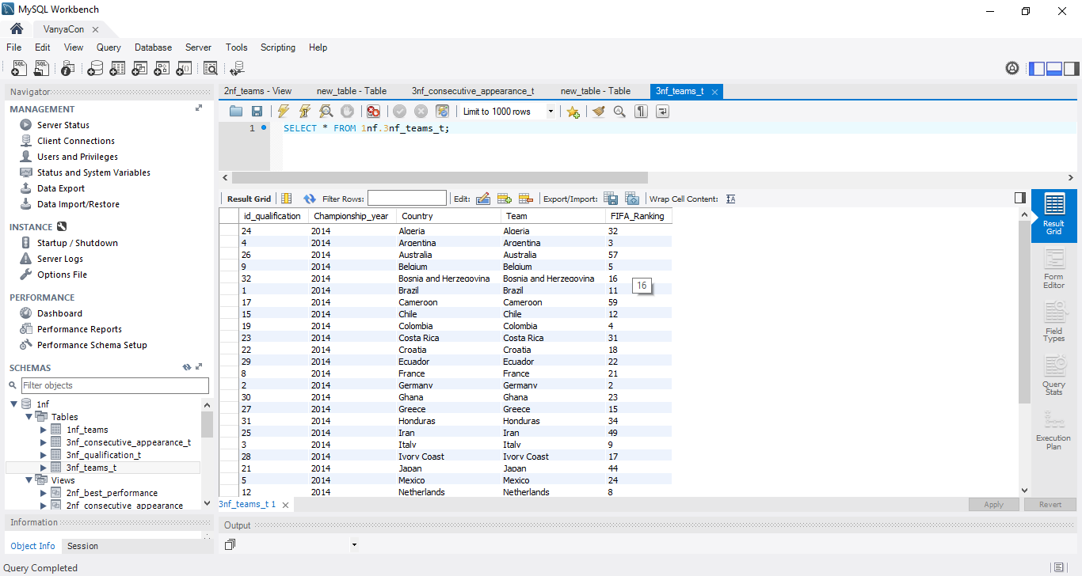

CREATE TABLE `3nf_best_performance_t` (

`id` int(11) NOT NULL AUTO_INCREMENT,

`team` varchar(50) NOT NULL,

`Previous_best_performance` text,

`Previous_best_performance_year` int(11) DEFAULT NULL,

PRIMARY KEY (`id`),

FOREIGN KEY (`team`) REFERENCES `3nf_teams_t` (`Team`)

) ENGINE=InnoDB DEFAULT CHARSET=utf8

SELECT * FROM `3nf_best_performance`;

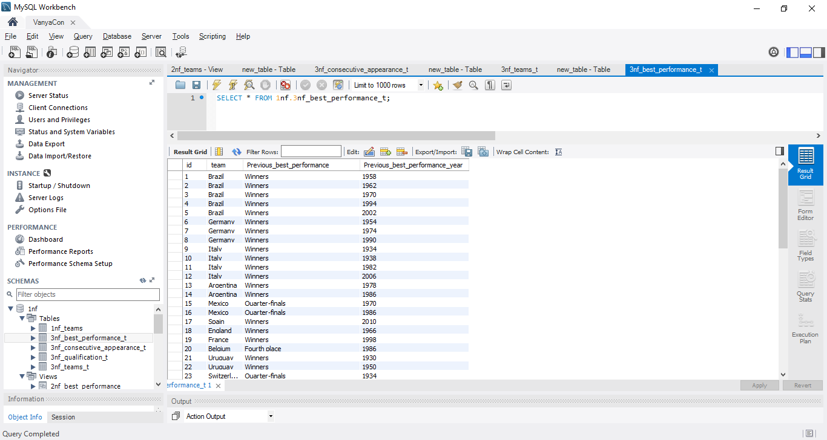

1. Создать представление выводящее базу данныx в 1NF на основании данных из таблиц для 3NF.

CREATE

ALGORITHM = UNDEFINED

DEFINER = `root`@`localhost`

SQL SECURITY DEFINER

VIEW `1nf_view` AS

SELECT

`3t`.`Championship_year` AS `Championship_year`,

`3t`.`Country` AS `Country`,

`3t`.`Team` AS `Team`,

`3q`.`Method_of_qualification` AS `Method_of_qualification`,

`3q`.`Date_of_qualification` AS `Date_of_qualification`,

`3q`.`Finals_appearance` AS `Finals_appearance`,

`3c`.`Consecutive_appearance` AS `Consecutive_appearance`,

`3c`.`Consecutive_appearance_last` AS `Consecutive_appearance_last`,

`3b`.`Previous_best_performance` AS `Previous_best_performance`,

`3b`.`Previous_best_performance_year` AS `Previous_best_performance_year`,

`3t`.`FIFA_Ranking` AS `FIFA_Ranking`,

`3b`.`id` AS `id`

FROM

(((`3nf_consecutive_appearance_t` `3c`

JOIN `3nf_teams_t` `3t` ON ((`3c`.`id` = `3t`.`Team`)))

JOIN `3nf_best_performance_t` `3b` ON ((`3t`.`Team` = `3b`.`team`)))

JOIN `3nf_qualification_t` `3q` ON ((`3t`.`id_qualification` = `3q`.`id`)));

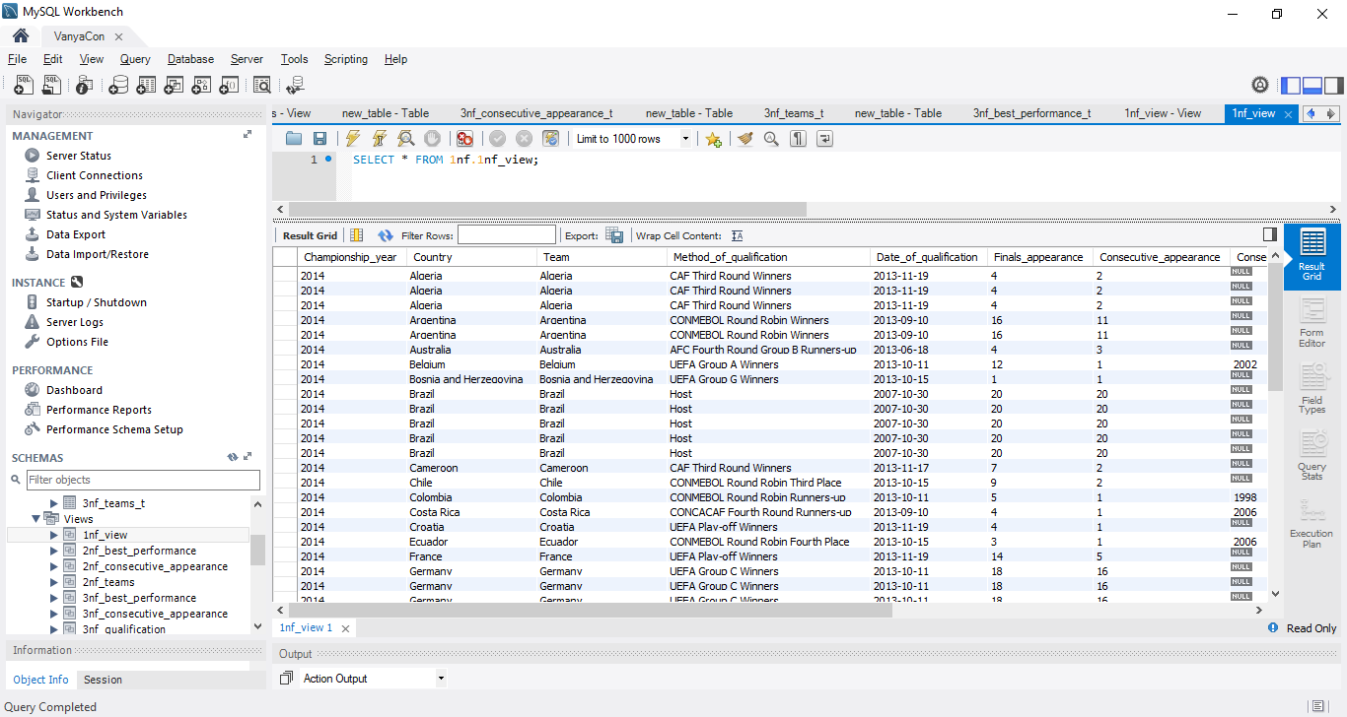

1. Написать запрос сравнивающий данные из представления для 1NF (см. Зад 2.1) и данные в таблице для 1NF и разницу вывести на экран.

SELECT

*

FROM

1nf_view

LEFT JOIN

1nf_teams ON 1nf_view.id = 1nf_teams.id

WHERE

1nf_view.id IS NULL OR 1nf_teams.id IS NULL;

