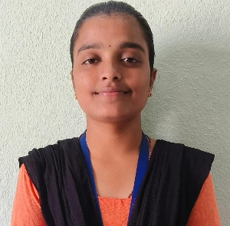

VANNALLI SRIKANYA

1-120,MAIN ROAD,chintharlapalli,515761
Contact No: 8639351946,6303337876
Email Id:
kanyavannallisrikanya@gmail.com
23691A31G7@mits.ac.in
LinkedIn id: www.linkedin.com/in/srikanya-vannalli-0231b6349V

TECHNICAL COMPETENCIES

OS: Windows
Languages: C | Python
Databases: MySQL
Other Interests: Cloud Computing
INTERPERSONAL SKILLS

Self-motivation |Positive Thinking
INTERESTS & HOBBIES

Sports | writing | Painting
LANGUAGES KNOWN

English | Telugu |Kannada

PERSONAL DETAILS

Mother’s Name: V. Parijatha
Father’s Name: V. Nagaraju
D.O.B:02-05-2005

EDUCATION

Bachelors of Technology In Computer Science Engineering (AI)|Madanapalle Institute of Technology & Science, Kadiri Road, Andhra Pradesh|Session: 2023-2027 | Score: 7.52 CGPA
Intermediate (BIE) | SLN jr college, Anantapuramu, Andhra Pradesh
Session: 2021-2023 | Percentage: 8.19%
Matriculation (SSC) | AP.Model School, Settur , Andhra Pradesh
Session: 2020-2021| Percentage: 83%

TRAINING & PROJECTS

Duration: 6 Weeks

Environment: Google Colab

Languages/Database:Python,Machine Learning

The diabetes prediction System efficiently applies machine learning to support early detection and prevention of diabetes with enhanced accuracy and reliability. By utilizing algorithm such as Logistics Regression Trained on patient health.

ACADEMIC ACHIEVEMENTS

- I had participated in essay writing and got 3rd price.

CERTIFICATIONS

- Achieved NPTEL certifications.
- I Attended Domain Specific Workshop on Expert-Led Google Cloud AI Bootcamp
- I Successfully completed the 4-week Quantum Fundamentals Program jointly conducted by Amaravati Quantum Valley

EXTRA CURRICULAR & CO-CURRICULAR ACHIEVEMENTS

- I won 2nd price in an art competition.
- Received a medal in Hand ball held in college

