% vann
% Project 1
% Finding Feigenbaum Delta and Alpha constants
% 02/25/2011

clear all;
clc;

bifurcations = [];
bif_count = 0;
p = [];
p(1) = 0.5;
superstables = [];
superstables_count = 0;
superstables_r = [];
for r = 3:0.001:3.65

% Calculate P-values
iterations = 2048;
for i = 2:iterations
p(i) = r*p(i-1)*(1 - p(i-1));
end

% Find the bifurcation points in order to calculate delta.
if(is_bifurcation(p, bif_count))
bif_count = bif_count + 1;
bifurcations(bif_count) = r;
end
r

% I'm taking the last 512 elements of the calculate P-values.
for i = 1:512
trim_values(i) = p(length(p) - (1024-i));
end

% Find the superstable positions in order to calculate alpha.
if superstables_count < bif_count
for i = 1:512
if nearly_equal2(0.5, trim_values(i))
superstables_count = superstables_count + 1;
period_type = 2^(bif_count);
unique_period_values = [];
for j = 1:period_type
unique_period_values(j) = abs(trim_values(j) - 0.5);
end
unique_period_values(i) = 999; % This is the bifurcating point equal to 0.5. % I need to ignore it so I set it high so it % won't ever be noticed by min().
superstables(superstables_count) = min(unique_period_values);
superstables_r(superstables_count) = r;
break;
end
end
end

end
disp 'Calculated Deltas';
calc_dels(bifurcations)
disp 'Calculated Alphas';
calc_alphas(superstables)

function [ does_it_split ] = is_bifurcation( p, known_bifs )
%IS_BIFURCATION checks to see if a given set P is a bifurcation point. It
%does this by comparing the values of P and judging the behavior that it
%exhibits (2-Period, 4-Period, etc.). If the behavior has not been
%observed previously, then the point, r, for which P was calculated, is
%judged to be a bifurcation point.

does_it_split = 0;
period_type = 0;

trim_values = [];
for i = 1:1024
trim_values(i) = p(length(p) - (1024-i));
% I'm taking the last 1024 elements, this means I can compare for up
% to 2^9 elements, 512 period?
end

known_bifs = known_bifs + 1; % I'm looking for the next bifurcation, I know there are known_bifs already so I need to look for known_bifs + 1.
period_type = 2^known_bifs;

for i = 1:period_type
if ~nearly_equal(trim_values(i), trim_values(i + period_type))
% This is checking to see if a period type is exhibited. i.e.
% a 2-period type should have equal 1-3, 2-4. a 4-period type
% should have equal 1-5, 2-6, 3-7, 4-8.

%disp 'not alike'
%i
break;
end
does_it_split = 1;
end

for i = 1:period_type-1
if nearly_equal(trim_values(1), trim_values(i + 1))
% This is checking to make sure that the period type has not
% been seen before. In the main program, I count every time a
% bifurcation is found and return to this function the number
% of known bifurcations. So if I'm looking for a 4-period, I
% need to know I'm not observing a 2-period. i.e. a 4-period
% should have NOT equal, 1-2,3,4.

%disp 'too alike'
does_it_split = 0;
break;
end
end

end

function [ are_they_equal ] = nearly_equal( a, b )
%NEARLY_EQUAL checks to see if two numbers are equal within some tolerance
%value.

are_they_equal = 0;
if abs(a-b) < 0.0001
are_they_equal = 1;
end

end

function [ are_they_equal ] = nearly_equal2( a, b )
%NEARLY_EQUAL2 checks to see if two numbers are equal within some tolerance
%value. NEARLY_EQUAL2 is distinct from NEARLY_EQUAL only because the
%tolerance needs to be less when searching for superstable points orelse
%I'm not able to catch the correct superstable point (The tolerance of
%NEARLY_EQUAL is too strict).

are_they_equal = 0;
if abs(a-b) < 0.0005
are_they_equal = 1;
end

end

function [ alphas ] = calc_alphas( superstables )
%CALC_ALPHAS calculates the alpha constant given a set of superstable
%points.

alphas = [];

for i = 1:length(superstables) - 1
if isequal(superstables(i + 1), 0)
break;
end
alphas(i) = superstables(i)/superstables(i+1);
end

end

function [ dels ] = calc_dels( bifurcations )
%CALC_DELS calculates the delta constant given a set of bifuraction points.

dels = [];

for i = 1:length(bifurcations) - 2
dels(i) = (bifurcations(i+1) - bifurcations(i))/(bifurcations(i+2) - bifurcations(i+1));
end

end

These functions were used to plot the points onto the bifurcation diagram using the calculated lamdas from new_feigenbaum.

function [ x, y ] = assemble_xy(bifurcations)
%ASSEMBLE_XY Summary of this function goes here
% Detailed explanation goes here
x = [];
y = [];
x_count = 0;

for i = 1:length(bifurcations)
period_type = 2^i;
for j = 1:period_type
x_count = x_count + 1;
x(x_count) = bifurcations(i);
end
end

y = calc_unique_y(bifurcations);

end

function [ unique_y ] = calc_unique_y( r_values )
%CALC_UNIQUE_Y Summary of this function goes here
% Detailed explanation goes here

unique_y = [];

r_values = r_values - 0.001;
for t = 1:length(r_values)

r = r_values(t);
bifurcations = [];
bif_count = 0;
p = [];
p(1) = 0.5;

% Calculate P-values
iterations = 2048;
for i = 2:iterations
p(i) = r*p(i-1)*(1 - p(i-1));
end

% I'm taking the last 512 elements of the calculate P-values.
for i = 1:512
trim_values(i) = p(length(p) - (1024-i));
end

% Find the unique values of p for each r, and append to unique_y
period_type = 2^(t);
for j = 1:period_type
unique_y = [unique_y, trim_values(j)];
end

end

end

function [ ] = draw_points( x, y )
%DRAW_POINTS Plots points on the Bifucation Diagram.

for i = 1:length(x) - 3
plot(x,y,'ro')
hold on;
end
plot(x(127),y(127),'bo')
plot(x(128),y(128),'bo')
plot(x(129),y(129),'bo')
refline(0, 0.5);

xlabel('Lamdas');
ylabel('P');
title('Bifurcation Diagram');
end

RESULTS
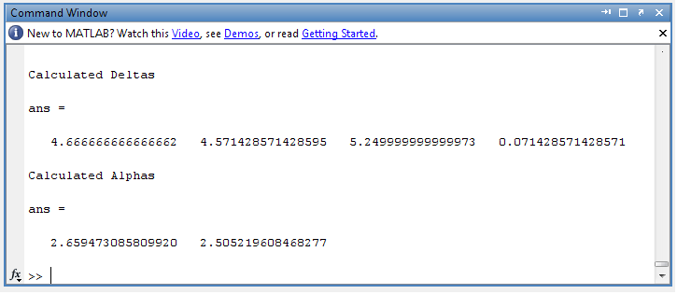
Figure 1: Calculated values for the delta and alpha constants.

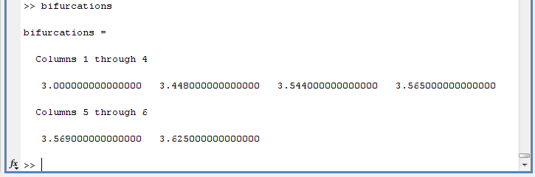
Figure 2: Calculated Bifurcation Points

Table 1: Calculated Bifurcation Points
3.0000
3.4480
3.5440
3.5650
3.5690
3.6250

Table 2: Calculated Delta Constants
4.6667
4.5714
5.2500
0.0714

Table 3: Calculated Alpha Constants
2.6595
2.5052

For this project I used the more general equation, P_{n+1} = R * P_{n} * (1 - P_{n}). This is equivalent to the form given in class X_{n+1} = 4λ * X_{n} * (1 - X_{n}) except that the form in class limited the domain to 0 ≤ x ≤ 4. This makes sense to do because chaos occurs for 4λ > 3.6. This means that my λ’s are represented by R and are not necessarily in the domain 0 ≤ λ ≤ 1; in fact I have limited them to a domain between 3 ≤ R ≤ 3.65.
My program works by calculating values for the equation and then comparing the calculated values to search for a periodic behavior. If it finds that the values match within a given tolerance, this indicates a certain behavior (2-Period, 4-Period, etc.) Once it finds an existing behavior, it begins to search for the next higher period (i.e. Once it finds a 2-Period, it begins to search for a 4-Period.) Because I am searching for lamdas instead of calculating them, this limits the accuracy drastically. In fact, looking at the calculated values for delta, we see that the delta values actually diverge. This is because my program can’t notice all of the bifurcation points – the fineness tolerance is simply too low to yield high accuracy without costing exponentially greater run-times. I obtained better results when calculating the alpha constant and it actually converges to near the expected value.
Bearing in mind my previous statement, I was still able to find both the delta and the alpha constants within reasonable margins of error. I found = 4.667 and = 2.5052. Comparing these to the actual values of = 4.6692… and = 2.5029… we see that they are within a reasonable margin of error.

References

- http://mathworld.wolfram.com/FeigenbaumConstant.html
- http://classes.yale.edu/fractals/chaos/Feigenbaum/FeigenbaumAlpha.html
- http://highlyrefined.net/benwei/logistic/

