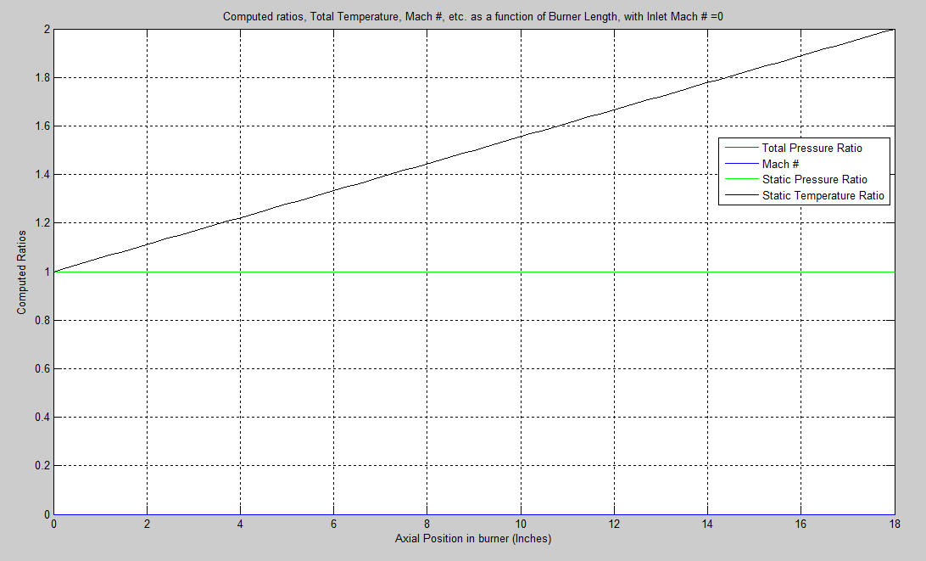
Figure 1: Computed ratios for an inlet Mach = 0. Note that because M = 0, total pressure and static pressure are equal throughout the burner. Their lines overlap in the plot. The Mach # is also M = 0 throughout the burner.

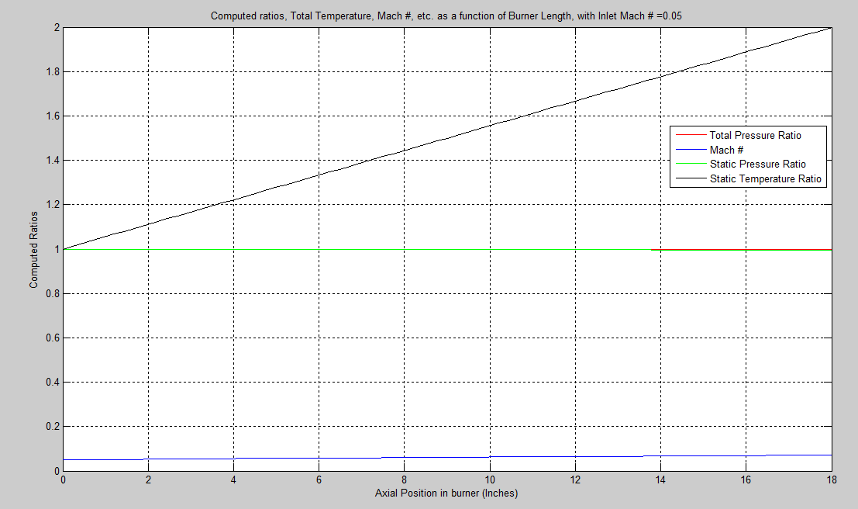
Figure 2: Computed ratios for an inlet Mach = 0.05. Note that the total pressure and static pressure are nearly overlapping.
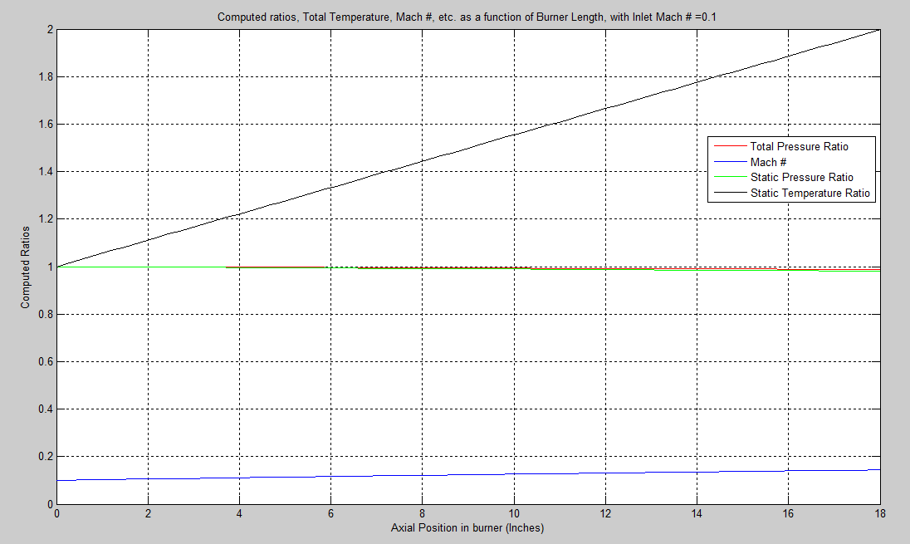
Figure 3: Computed ratios for an inlet Mach = 0.10

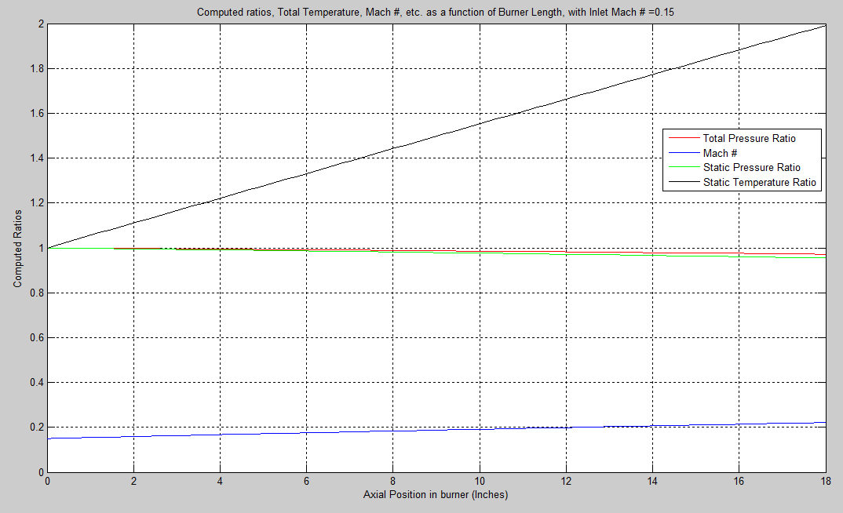
Figure 4: Computed ratios for an inlet Mach = 0.15
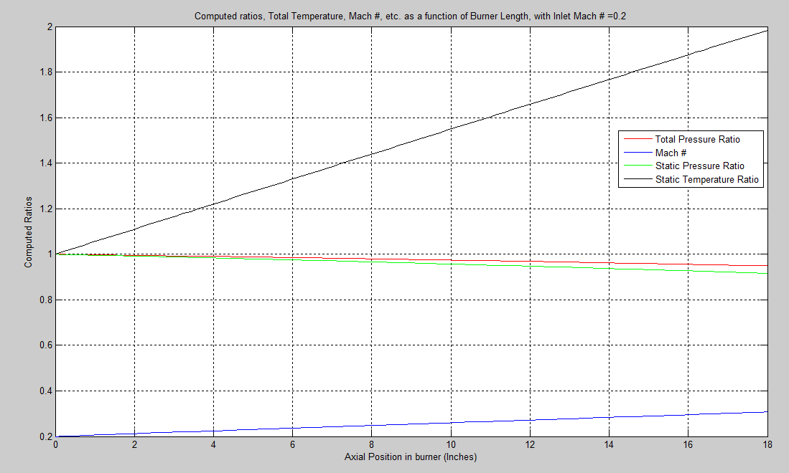
Figure 5: Computed ratios for an inlet Mach = 0.20

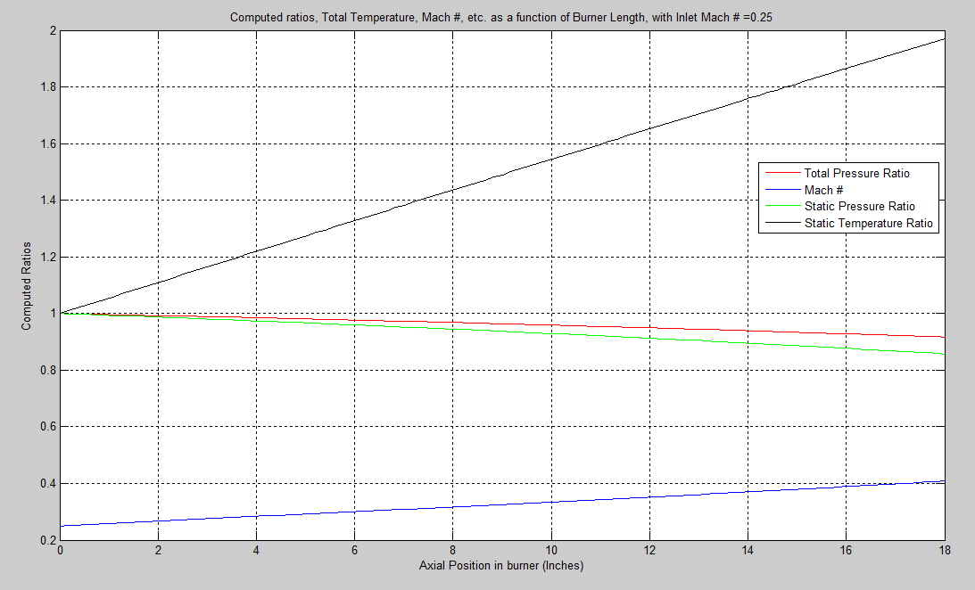
Figure 6: Computed ratios for an inlet Mach = 0.25
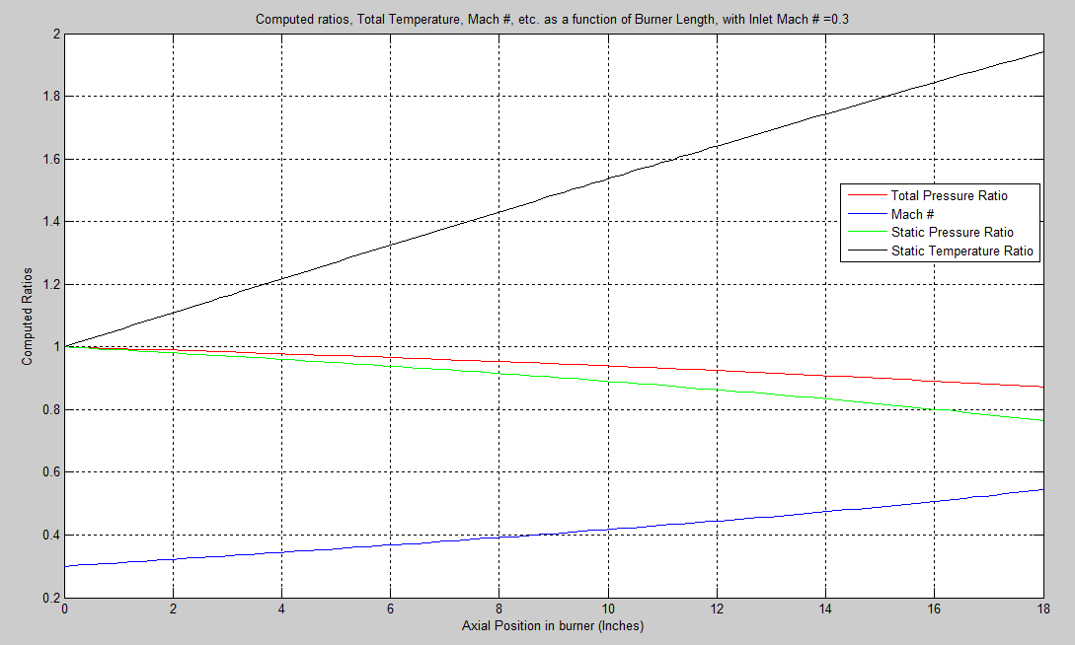
Figure 7: Computed ratios for an inlet Mach = 0.30

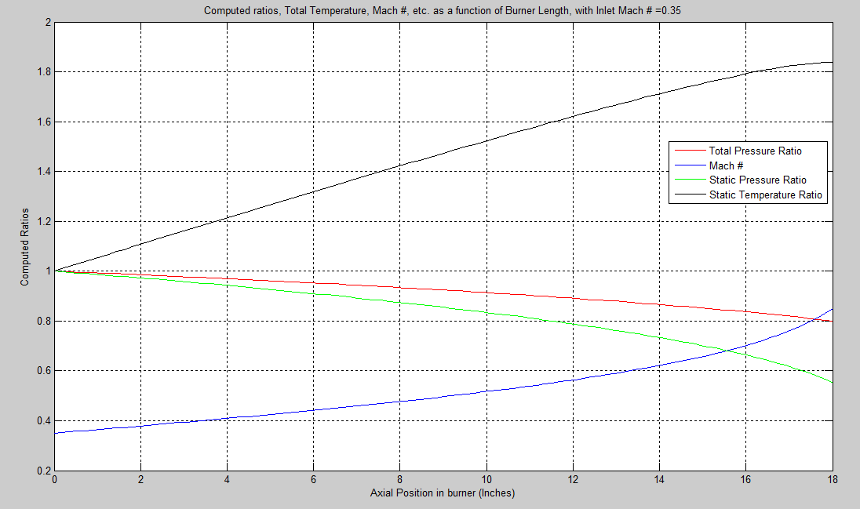
Figure 8: Computed ratios for an inlet Mach = 0.35
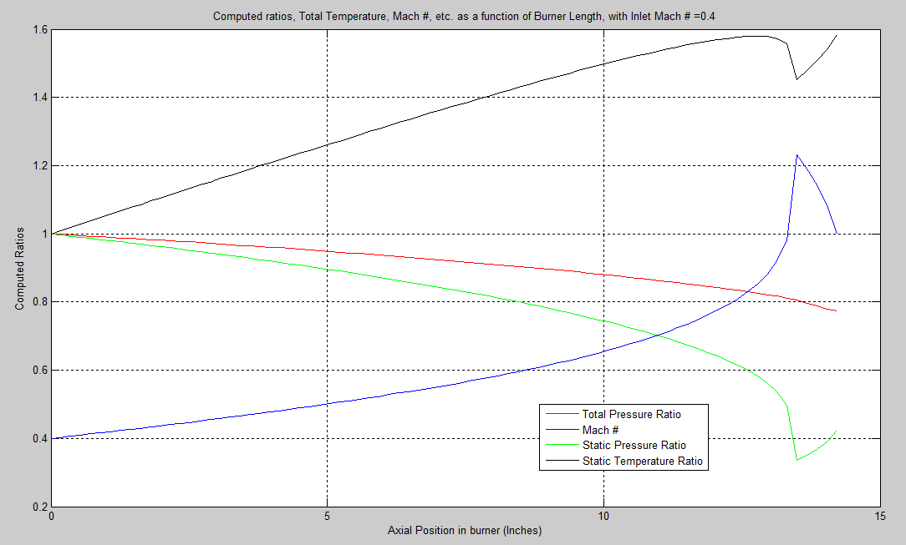
Figure 9: Computed ratios for an inlet Mach = 0.40. Notice that the entire length of the nozzle is not plotted. This is because the flow becomes sonic at around L = 13.34 inches. This is a position which isn’t calculated and so this creates a case where NaN’s arise (due to infinities). I don’t think it would make much sense to plot these and so, in this case only, I have trimmed the data and plotted only the data for which NaN’s did not appear. For a plot of the results with the NaN’s plotted, see Figure 10.

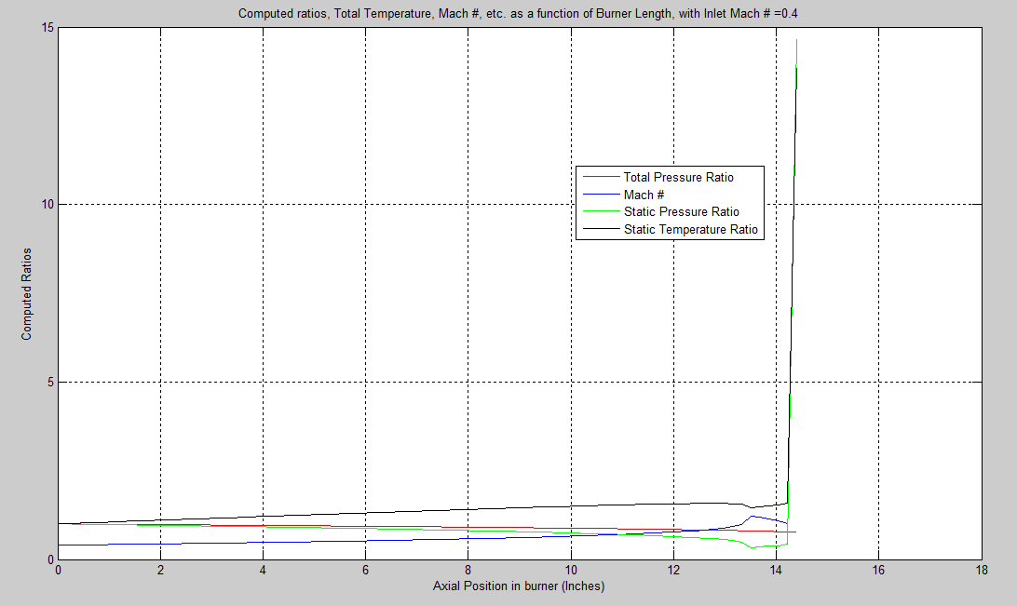
Figure 10: Computed ratios for an inlet Mach = 0.40. Notice the effect the NaN's have on the plot, as compared to that of Figure 9.

Please note that these MATLAB scripts were used solely for the purpose of importing the FORTRAN generated data, and plotting that data.

% vann
% Air Breathing Computer Project
% 03/17/2011

clear all;
clc;
datasets = inputdlg('Enter number of data files to process', 'Process Data Files', 1);
datasets = str2num(datasets{1});

test_data = cell(1,1);
for i = 1:datasets
test_data{i,1} = Lab1_DataReader; % This is reading the data in from text file versions of the excel spreadsheet
end
%%

for i = 1:length(test_data)
% This is extracting the individual data sets for each case from the cell.
mach_inlet = test_data{i,1};

%%
% Now I need to extract the actual data that I need to plot from each
% matrix.

increment = mach_inlet(:,1);
machs = mach_inlet(:,2);
total_pressure_ratio = mach_inlet(:,3);
static_temp_ratio = mach_inlet(:,4);
static_pressure_ratio = mach_inlet(:,5);

%%
%increment = increment.*0.18;
figure(i);
plot(increment, total_pressure_ratio, 'r', increment, machs, 'b', increment, static_pressure_ratio, 'g', increment, static_temp_ratio, 'k');
xlabel('Axial Position in burner (Inches)');
ylabel('Computed Ratios');
title(strcat('Computed ratios, Total Temperature, Mach #, etc. as a function of Burner Length, with Inlet Mach # = ', num2str(machs(1))));
grid on;
legend('Total Pressure Ratio', 'Mach #', 'Static Pressure Ratio', 'Static Temperature Ratio')
end

% vann
% Experimental Aero, Lab 1
% This reads in data from a text file
function [data_from_file] = Lab1_DataReader()
my_file_home = pwd;
cd('C:\Users\vann\Desktop\');
[datafile, datapath] = uigetfile('*.txt', 'Select Data Text File');
cd(datapath);
data_from_file = dlmread(datafile);
cd(my_file_home);
end

