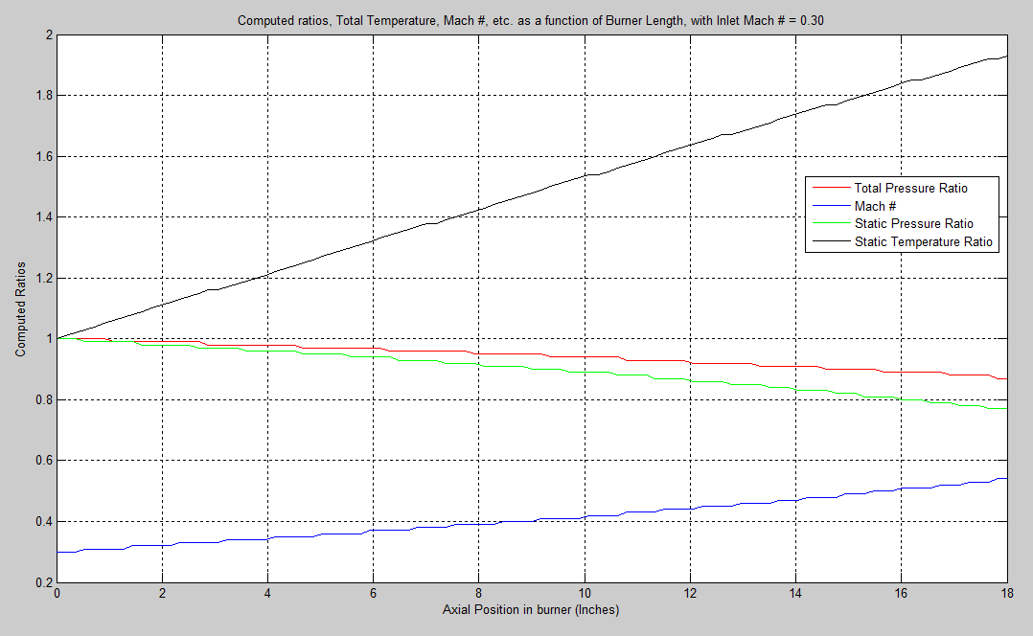
Figure 1: LOLCODE has the unfortunate limitation of only providing output to a precision of 2 decimals. This results in my plot appearing as a step function. This necessitated that I rewrite everything in FORTRAN.

