%%
%vann
%Nozzle Design Term Project - Design of minimum length 2-D Nozzle by
%Method Of Characteristics
%%
clear all
clc

num_char_lines = 30;
gamma = 1.22;
%This is not the actual gamma or mach @ exit, we still need to find this
mach_exit = 2.46;
noz_char_matrix = [];

%Find the total corner angle, theta_w_max
theta_w_max = find_prandtl_meyer(gamma, mach_exit)/2;

%This is creating the values as column vectors for the initial
%characteristic lines
theta_initial = (linspace(0.01, theta_w_max, num_char_lines)');
v_initial = theta_initial;
k_plus_initial = theta_initial - v_initial;
k_minus_initial = theta_initial + v_initial;

%%
%This is creating the values as column vectors for the remaining (i.e. not
%the initial ones) characteristic lines
k_plus = [];
k_minus = [];
thetas = [];
stepAngle = theta_initial(2,1) - theta_initial(1,1);
[m,n] = size(k_minus_initial);

for a = 2:m
%This first loop is running through each of the points, starting at the
%second point
for b = 1:((m+1)-a)
%This loop is decreasing the number of times (by 1) that the first
%loop runs through the point. The entire loop is appending
%k_plus at each point(loop 1) by the number of times for that point (loop 2)
%It's also doing the same thing for the thetas
k_plus = [k_plus; (-1 * (k_minus_initial(a, 1)))];
thetas = [thetas; (b-1)*stepAngle];
end
%This is simply appending the last element twice for the specific point
k_plus = [k_plus; (-1 * (k_minus_initial(a, 1)))];
thetas = [thetas; (b-1)*stepAngle];
end
%%
k_minus = 2.*thetas - k_plus;
prandtl_v = (k_plus.*-1) + (thetas);

%Repeating the last elements in the initial characteristic column vectors.
[m,n] = size(theta_initial);
theta_initial = [theta_initial; theta_initial(m, 1)];
v_initial = [v_initial; v_initial(m, 1)];
k_plus_initial = [k_plus_initial; k_plus_initial(m, 1)];
k_minus_initial = [k_minus_initial; k_minus_initial(m, 1)];

%Appending the secondary characteristic vectors to the initial
%characteristic vectors

[m,n] = size(thetas);
noz_points = ((1:(m+1+num_char_lines))');
noz_k_minus = [k_minus_initial; k_minus];
noz_k_plus = [k_plus_initial; k_plus];
noz_thetas = [theta_initial; thetas];
noz_prandtl_v = [v_initial; prandtl_v];
[noz_machs, noz_mus] = find_machs_and_mus(gamma, noz_prandtl_v);

noz_char_matrix = [noz_char_matrix noz_points noz_k_minus noz_k_plus noz_thetas noz_prandtl_v noz_machs noz_mus];

%This is counting up the number of total characteristic lines, not just the
%initial lines, num_char_lines.

total_lines = 0;
for a = (num_char_lines + 1):-1:2
total_lines = total_lines + a;
end

%This is making matrices of the slopes for the theta lines and the left
%characteristic lines
slopes_theta = [];
slopes_theta = [slopes_theta; theta_w_max];
char_slopes_left = [];

%This is extracting the theta values from the theta matrix. It is
%also computing the angles of the left characteristic lines using
%angle = theta + mu
a = (num_char_lines + 1);
b = num_char_lines;
while a <= total_lines
slopes_theta = [slopes_theta; noz_thetas(a, 1)];
char_slopes_left = [char_slopes_left; noz_thetas(a, 1) + noz_mus(a, 1)];
a = a + b;
b = b - 1;
end

%This is computing the characteristic slopes for the theta lines
%(lines along the contour) as an average of the theta values
%previously extracted
char_slopes_theta = [];

for a = 1:num_char_lines
theta_avg = (0.5)*(slopes_theta(a,1) + slopes_theta(a+1,1));
char_slopes_theta = [char_slopes_theta; theta_avg];
end

%This here is actually creating the slope matrices. Previously the
%matrices contained values representing angles from +x axis
char_slopes_theta = tand(char_slopes_theta);
char_slopes_left = tand(char_slopes_left);

%This is finding the x and y coordinates of points of interest (points
%where characteristic lines intercept) along the nozzle contour. These
%points will then be plotted to produce the nozzle contour.
points_x = [];
points_y = [];
left_y_int = -1;
right_y_int = 1;

points_x = [points_x; 0];
points_y = [points_y; 1];

for a = 1:num_char_lines

x = (right_y_int - left_y_int)/(char_slopes_left(a,1) - char_slopes_theta(a,1));
y = (char_slopes_theta(a,1)*x) + right_y_int;
points_x = [points_x; x];
points_y = [points_y; y];
if a < num_char_lines
right_y_int = y - (char_slopes_theta(a+1,1)*x);
end
end

%This is plotting the nozzle contour
plot(points_x, points_y, points_x, -1.*points_y)
axis('equal');

function [ mach ] = find_mach( gamma, v )
%Finds and returns the Mach number (to practicality, it's iterative and will only search from Mach 1 through Mach 50)
%given the values of gamma and the Prandtl-Meyer function, v in degrees
% If it fails to loacte the Mach number then it returns Mach = 0
mach = 0;
for i = 1 : 0.01 : 50
prandtl = find_prandtl_meyer(gamma, i);
if prandtl > (v - 0.15) && prandtl < (v + 0.15)
mach = i;
break;
end
end

end

function [ mu ] = find_mu( mach )
%This funaction finds the mach angle, mu in degrees, given the mach number
% Detailed explanation goes here

mu = asind(1/mach);

end

function [ machs, mus ] = find_machs_and_mus( gamma, v_column )
%Creates the columns of machs and mus given the value of gamma and the
%column of Prandtl-Meyer values, v
% Returns two column vectors of size equal to the size of the
% Prandtl-Meyer matrix, v, provided as input

[m,n] = size(v_column);
machs = [];
mus = [];
for i = 1:m
machs = [machs; find_mach(gamma, v_column(i,1)) ];
end
for i = 1:m
mus = [mus; find_mu(machs(i,1)) ];
end

end

function [ v ] = find_prandtl_meyer( gamma, mach )
%Finds and returns the Prandtl-Meyer function, v in degrees, given the values of gamma and the Mach
%number
% Detailed explanation goes here

a = (gamma + 1)/(gamma - 1);
v = ((a)^.5 * atand(((1/a)*((mach^2) - 1))^.5)) - atand(((mach^2) - 1)^.5);

end

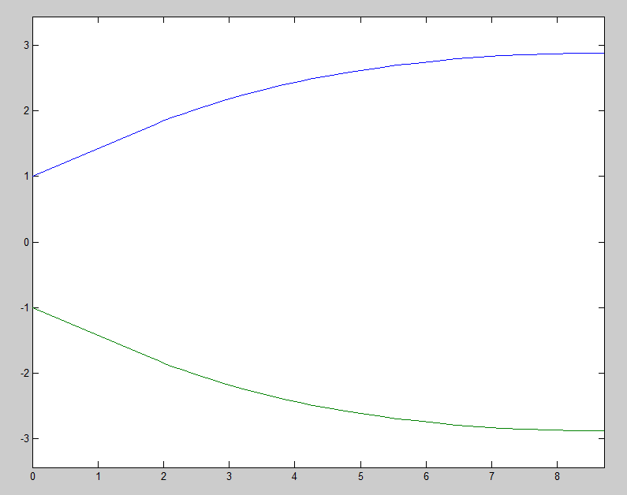

Figure 1: Nozzle Designed for Mach = 2.46, Gamma = 1.22, Characteristic lines = 30

Area ratio: 2.8814

X and Y Coordinates Defining Contour
X | Y | -Y
0 | 1 | -1
1.7743 | 1.7542 | -1.7542
1.8929 | 1.8037 | -1.8037
2.0152 | 1.8527 | -1.8527
2.1424 | 1.9016 | -1.9016
2.2973 | 1.9587 | -1.9587
2.4359 | 2.0076 | -2.0076
2.5802 | 2.0564 | -2.0564
2.7304 | 2.1048 | -2.1048
2.9115 | 2.1603 | -2.1603
3.0754 | 2.2082 | -2.2082
3.2462 | 2.2555 | -2.2555
3.4506 | 2.309 | -2.309
3.6372 | 2.3552 | -2.3552
3.8316 | 2.4004 | -2.4004
4.0628 | 2.4509 | -2.4509
4.2755 | 2.4942 | -2.4942
4.4972 | 2.5361 | -2.5361
4.7593 | 2.582 | -2.582
5.002 | 2.621 | -2.621
5.2552 | 2.658 | -2.658
5.5527 | 2.6974 | -2.6974
5.8301 | 2.7302 | -2.7302
6.1548 | 2.7641 | -2.7641
6.4588 | 2.7916 | -2.7916
6.8135 | 2.8186 | -2.8186
7.147 | 2.8395 | -2.8395
7.4951 | 2.8564 | -2.8564
7.8994 | 2.8704 | -2.8704
8.2814 | 2.8783 | -2.8783
8.7237 | 2.8814 | -2.8814

Table 1: This table shows the X, Y, and -Y coordinates defining the shape of the nozzle contour shown in Figure 1. These points were found using 30 characteristic lines.

Points | K- = θ + v | K+ = θ - v | θ | v | M | mu
1 | 0.02 | 0 | 0.01 | 0.01 | 1 | 90
2 | 7.6932 | 0 | 3.8466 | 3.8466 | 1.2 | 56.4427
3 | 15.3664 | 0 | 7.6832 | 7.6832 | 1.33 | 48.7535
4 | 23.0396 | 0 | 11.5198 | 11.5198 | 1.44 | 43.983
5 | 30.7128 | 0 | 15.3564 | 15.3564 | 1.56 | 39.8683
6 | 38.386 | 0 | 19.193 | 19.193 | 1.67 | 36.7842
7 | 46.0592 | 0 | 23.0296 | 23.0296 | 1.78 | 34.1802
8 | 46.0592 | 0 | 23.0296 | 23.0296 | 1.78 | 34.1802
9 | 7.6932 | -7.6932 | 0 | 7.6932 | 1.33 | 48.7535
10 | 15.3664 | -7.6932 | 3.8366 | 11.5298 | 1.44 | 43.983
11 | 23.0396 | -7.6932 | 7.6732 | 15.3664 | 1.56 | 39.8683
12 | 30.7128 | -7.6932 | 11.5098 | 19.203 | 1.67 | 36.7842
13 | 38.386 | -7.6932 | 15.3464 | 23.0396 | 1.78 | 34.1802
14 | 46.0592 | -7.6932 | 19.183 | 26.8762 | 1.89 | 31.9447
15 | 46.0592 | -7.6932 | 19.183 | 26.8762 | 1.89 | 31.9447
16 | 15.3664 | -15.3664 | 0 | 15.3664 | 1.56 | 39.8683
17 | 23.0396 | -15.3664 | 3.8366 | 19.203 | 1.67 | 36.7842
18 | 30.7128 | -15.3664 | 7.6732 | 23.0396 | 1.78 | 34.1802
19 | 38.386 | -15.3664 | 11.5098 | 26.8762 | 1.89 | 31.9447
20 | 46.0592 | -15.3664 | 15.3464 | 30.7128 | 2 | 30
21 | 46.0592 | -15.3664 | 15.3464 | 30.7128 | 2 | 30
22 | 23.0396 | -23.0396 | 0 | 23.0396 | 1.78 | 34.1802
23 | 30.7128 | -23.0396 | 3.8366 | 26.8762 | 1.89 | 31.9447
24 | 38.386 | -23.0396 | 7.6732 | 30.7128 | 2 | 30
25 | 46.0592 | -23.0396 | 11.5098 | 34.5494 | 2.11 | 28.2899
26 | 46.0592 | -23.0396 | 11.5098 | 34.5494 | 2.11 | 28.2899
27 | 30.7128 | -30.7128 | 0 | 30.7128 | 2 | 30
28 | 38.386 | -30.7128 | 3.8366 | 34.5494 | 2.11 | 28.2899
29 | 46.0592 | -30.7128 | 7.6732 | 38.386 | 2.22 | 26.7726
30 | 46.0592 | -30.7128 | 7.6732 | 38.386 | 2.22 | 26.7726
31 | 38.386 | -38.386 | 0 | 38.386 | 2.22 | 26.7726
32 | 46.0592 | -38.386 | 3.8366 | 42.2226 | 2.34 | 25.2995
33 | 46.0592 | -38.386 | 3.8366 | 42.2226 | 2.34 | 25.2995
34 | 46.0592 | -46.0592 | 0 | 46.0592 | 2.46 | 23.9854
35 | 46.0592 | -46.0592 | 0 | 46.0592 | 2.46 | 23.9854

Table 2: The table defining properties of the nozzle at points along the characteristic lines. This table was made using 7 characteristic lines rather than 30 as the previous Nozzle plot used.

